Mission itinerary and persons interviewed
Final Evaluation of the Sustainable Rangeland Management Project, 9-14 April 2012

Date and time Topic of the meeting Persons interviewed
9 April 2012 Meetings in Almaty
9:00 -13:00 Technical meeting with project staff
Bakhtyar Sadyk, National project manager
Alimayev I.I., Research Institute for Livestock and Feed Production of the KazAgroInnovation Centre
Sharip Yermek, Project expert on rangelands monitoring
12:30-13:00 Meeting with the Kazak Research Institute for Livestock and Feed Production Abdrakhman Ombayev, Director
14.00-18.00 Meeting with Farmer Foundation of Kazakhstan Levin V., Director General
14:00-18:00 Meeting with the Agency for Land Resources Management
Duseinbekov S., First Deputy Director of Almaty Branch
10 April 2012 Field visit to Shien project area
09:30-11.00 Meeting with GIZ office Goertz Rainer, Country Director
Elena Kazachkova , Project Assistant
12:00-13:00 Meeting with Akimat of Zhambyl rayon Karayev K., Head of agriculture department
Enkeleshov D., Senior expert of agriculture department
Galina Alzhanova – Head of the Center for Women Support
14:00 -18:00 Meetings in Shien rural district with Akim of rural district and members of Pasture Committee, farmers and beneficiaries of pilot projects. Baysariev A., Akim of rural district of Shien and Mayor of settlement
Bayshelekov T., Chairman of Pasture Committee of Shien

Date and time Topic of the meeting Persons interviewed
11 April 2012 Field visit to Ulguli project area
09:00 -13:00 Meeting with Akim of Ulguli rural district, members of Ulguli agriculture cooperative, farmers and beneficiaries of pilot projects Kasymov E, Akim of Ulguli rural district
Nasyrov B., Chairman of Ulguli agriculture cooperative

15:00- 17:00 Meeting with members of Ulguli agriculture cooperative, farmers and beneficiaries of pilot projects Nasyrov B., Chairman of Ulguli agriculture cooperative
Kukumov, Owner of farm and member of Ulguli agriculture cooperative
12 April 2012 Meetings in Astana
12:00- 13:00 Meeting with key partners in Ministry of Environmental Protection Kerey B., Director of Division for Strategic Management and Analysis
Tulebayeva R., Deputy Director
15:00-16:00
Meetings with the Focal Point of United Nations Convention to Combat Desertification and
UNDP/GEF/GTZ/GM CACILM CPP: Multi-country capacity building project Bolat Bekniyaz

Zhumabayev Y., National Coordinator
13 April 2012 Work in Astana
9:00-10:00
Meeting with key partners in Ministry of Agriculture Nasirkhanova B., National Project Coordinator
11:00-12:00 Meeting with the Agency for Land Resources Management Tazhmagambet T., Head of department for land registration
14:30-16:30 Meetings with UNDP Yerzhan Baltaev, Previous project manager
Stanislav Kim, Head of Energy and Environment Unit
Paniklova E., Deputy Resident Representative
18:00- 18:30 Meeting with JSC “KAzagroinnovation Kenenbayev S., Director General
Abssatar T., Department of dissemination of knowledge
14 April 2012,
16:00- 18:00 Working meeting in Almaty between the project manager and evaluation team Bakhtyar Sadyk, National project manager
Lamia Mansour, International expert for project evaluation
Gaziz Sarbasov, National expert for project evaluation

Summary report of field visits of the SRM Project Final Evaluation mission

Tuesday, April 10 2012. Visit of the Shien rural district.

The visit started with a meeting in Uzunagash, the capital of Zhambul district of the Almaty region, with the agriculture department of the district administration. The administration officials confirmed the importance of improving the pasture infrastructure, according to them , 25 wells were rehabilitated in the remote rangeland to support grazing activities, and this was reflected a priority activity for communities in the district. The agriculture department of the district is working on disseminating the project experience among the all districts of the Almaty region, Government subsidies for livestock production and for feed production can be obtained in this regards.

In Shien, meetings were held with the Akim of Shien rural district, the Chairman of the Public fund “Shien agro” and former Pasture Committee, and with the members of Public fund of “Shien agro” in the office of the Akim of the Shien rural district. There were more than 10 persons members of the Pasture Committee. The members confirmed their willingness to use the pasture on the base of agreement between the members of the Public Fund and on the base of project recommendations. They clarified that thanks to the project, they were developing remote rangeland more than 100 km from the settlement. They indicated that the project provided the following support:
- rehabilitated wells in remote pasture
- solar cell battery as a source of energy, i.e. the project created suitable conditions to be on the remote pasture
- yurts (nomad traditional house) for living in remote pasture.
- planted 30 ha of sainfoin, 100 ha of alfalfa and 100 ha of wheat grass on the degraded land
- the number of livestock increased and as consequence the welfare of the population improved.

The members of the pasture committee confirmed its readiness to continue the cooperation with the project. The committee meets every season to discuss all points in terms of pasture management.

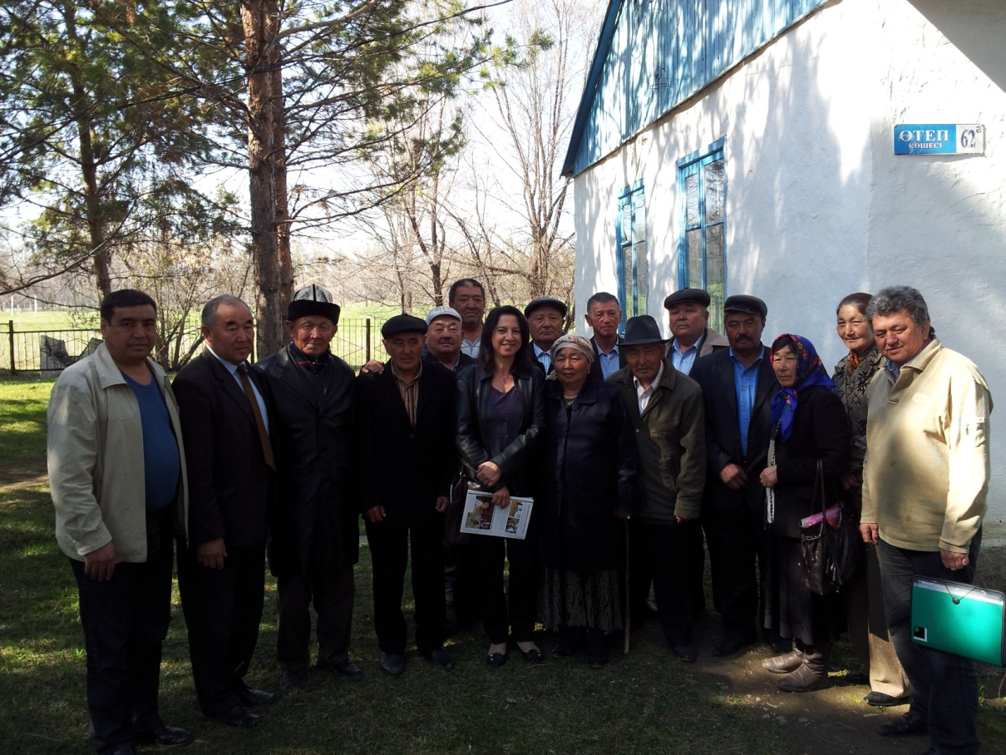
Figure A4.1. Group photo of the members of the Shien Pasture Committee
Wednesday, April 11 2012. Visit of the Ulguli rural district.

The visit started with a meeting of the Akim of Ulguli rural district and of the Chairman of Ulguli agriculture cooperative. The mission team visited an area 20 ha of arable irrigated land which belongs to Ulguli agriculture cooperative and which was planted alfalfa and which yield is harvested three times per season. The cooperative clarified that it includes 21 family living in Ulguli. The cooperative was created following the establishment of the Pasture Committee as the Pasture Committee does not have a legal status, and it could not engage into commercial activities. Being officially registered as a cooperative is an opportunity for obtaining Government loans, subsidies in addition to having commercial operations. The cooperative plans to use an additional 100 ha of non-irrigated land to plant different type of agricultural crops.
The forage plantations support the families in the settlements to provide forage to their cattle and have significantly improved their living conditions.

The evaluation team also visited the remote areas of Ulguli, where the project has provided several infrastructure investments including:
- Rehabilitation of the well
- Rehabilitation of the watering facility
- Electricity generator to operate the well
- Photovoltaic solar panel for domestic energy use

The evaluation team could confirm that the infrastructure is well managed and is serving for livestock grazing on the pasture around the well. The owner of the farm clarified that several wells around the remote pasture areas were rehabilitated by the project according to norms and needs of water consumption, and that this improved their livelihood.

From his side, the Chairman of the cooperative clarified that it would be possible to provide facilities to improve processing of milk farm in the settlement and to plant more crops. He confirmed that the activities initiated by the project can now be pursued by the cooperative and can be made successful and sustainable.

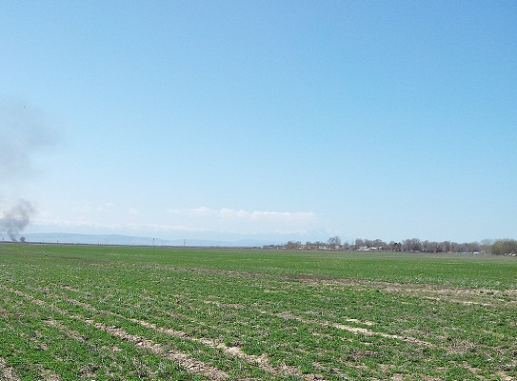 | 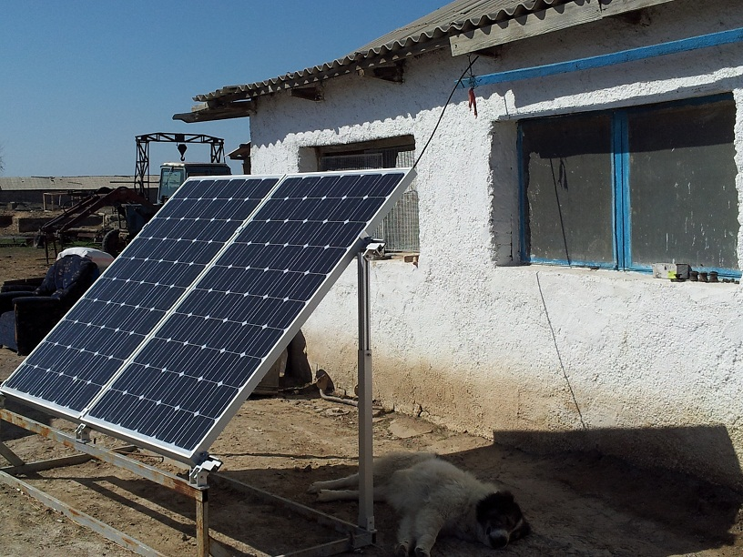
Figure A4.2. Forage plantation near Ulguli settlement | Figure A4.3. Photovoltaic panel in remote rangelands of Ulguli

