

**MID-TERM EVALUATION REPORT**

**Kyrgyzstan, UNDP and UNEP partnership initiative for the integration of sound management of chemicals considerations into development plans and processes**

Prepared by: Bakytbek Satybekov

**March 2012**

**CONTENT**

**Acronyms and abbreviations…………………………………………………………….…4**

# 1. executive summary………………………………………………………………5

## Brief description of project…………………………………………………………………..5

## Evaluation objectives…………………………………………………………………………5

## Main conclusions, recommendations and lessons learned………………………………5

# introduction………………………………………………………………………7

## Project justification and its goals……………………………………………………………7

## Purpose of the evaluation……………………………………………………………………12

## Key issues addressed…………………………………………………………………………12

## Methodology of the evaluation……………………………………………………………...12

## Structure of the evaluation…………………………………………………………………..13

1. **(Form A) Independent M&E Information…………………………………14**
2. **(Form B) OVERALL PROJECT ASSESSMENT……………………………………16** 
   1. Methodology…………………………………………………………………………16
   2. Narrative report on the monitoring and evaluation of the project……………………16

## The Project start and its duration…………………………………………….…16

## Implementation status…………………………………………………………….16

## Problems that the project seeks to address………………………………….…18

## Immediate and development objectives of the project………………………..18

## Main stakeholders……………………………………………………………..….19

## Potential stakeholders…………………………………………………………….19

## Expected results……………………………………………………………………19

## Analysis of the situation with regard to outcomes, outputs and partnership strategy…………………………………………………………………………..…20

* 1. Links with QSP objective and strategic priorities…………………………………...21
  2. Main conclusions and lessons learned………………………………………………..21

1. **(Form C) STAKEHOLDER INVOLVEMENT……………………………………....24**
2. **(Form D) PROJECT OBJECTIVES…………………………………………………..28**

**Annexes**

Annex 1: Terms of Reference………………………………………………………………….34

Annex 2: SAICM QSP TF Guidelines for Independent Monitoring and Evaluation………….37  
Annex 3: Project rating………………………………………………………………………...44

Annex 4: Annual Work Plan 2011……………………………………………………………..45

Annex 5: List of documents reviewed………………………………………………………….51

Annex 6: Summary of field visits………………………………………………………………51

Annex 7: Comments by the stakeholders………………………………………………………51

Annex 8: Questionnaire used (if any) and summary of results...………………………………51

Annex 9: List of persons interacted…………………………………………………………….52

**Acronyms and abbreviations**

|  |  |
| --- | --- |
| APR | Annual Project Review |
| AWP | Annual Work Plan |
| CO | Country Office |
| DDT | Dichlorodiphenyltrichloroethane |
| DEX | Direct execution modality |
| DSES | Department of Sanitation and Epidemiological Surveillance |
| GEF | Global Environment Facility |
| HELI | the Health and Environment Linkages Initiative |
| IA | Implementing Agency |
| ICCM | the International Council on Chemicals Managements |
| ICDP | Integrating chemicals management into development planning |
| ICM | National Interagency Coordinating Mechanism |
| IFC | International Finance Corporation |
| KR | Kyrgyz Republic |
| M&E | Monitoring & Evaluation |
| MA | Ministry of Agriculture |
| MDGs | the Millennium Development Goals |
| MPU | Montreal Protocol Unit |
| MTE | Mid-Term Evaluation |
| NAP | National Action Plan |
| NEX | National execution modality |
| NGO | Non-Government Organization |
| NIP | National Implementation Plan |
| NP | National Plan |
| NPMU | National Project Management Unit |
| ODS | Ozone Depleting Substances |
| PCB | Polychlorinated biphenyl |
| POPs | Persistent Organic Pollutants |
| PTS | Potent and toxic substances |
| QSP | Quick Start Programme |
| SAEPF | State Agency of Environment Protection and Forestry under the Government of the Kyrgyz Republic |
| SAICM | the Strategic Approach to International Chemicals Management |
| SAPS | Sulfur, phosphorus, sulfate ash |
| SB | Senior beneficiary |
| SMC | the Sound Management of Chemicals |
| SPl | the first strategic priority |
| TF | Trust Fund |
| ToR | Terms of Reference |
| UNDP | United Nations Development Programme |
| UNEP | United Nations Environment Programme |
| UNEPIDTIE | Division for Technology, Industry and Economics |
| USD | United States Dollar |
| WHO | World Health Organization |
| WSSD | World Summit on Sustainable Development |

# 1. executive summary

## 1.1. Brief description of project

With the support of the Strategic Approach to International Chemicals Management (SAICM) Quick Start Programme (QSP) Trust Fund, UNDP works with the Government of the Kyrgyz Republic – and calls upon the expertise of the Chemicals Branch of the United Nations Environment Programme, Division for Technology, Industry and Economics (UNEPIDTIE) - to assist the country in addressing the second and third strategic priorities (SP2/SP3) of section IV of the SAICM Overarching Policy Strategy **(**[**http://www.chem.unep.ch/saicm/**](http://www.chem.unep.ch/saicm/)**), namely:**

- Development and strengthening of national chemicals management institutions, plans, programmes and activities to implement the Strategic Approach, building upon work conducted to implement international chemicals-related agreements and initiatives; and,

- Undertaking analysis, interagency coordination, and public participation activities directed at enabling the implementation of the Strategic Approach by integrating - i.e. mainstreaming – the sound management of chemicals in national strategies, and thereby informing development assistance cooperation priorities.

Extensive experience has been gathered and can be shared between countries with respect to the first strategic priority (SPl), that is to develop or update national chemicals profiles2, but much less experience has been accumulated with respect to the two other strategic priorities. In order to best support the Government of the Kyrgyz Republic to:

* assess their sound management of chemicals regime relative to the strategic objectives of the SAICM Overarching Policy Strategy and put in place a plan to begin addressing gaps in the national regime; and,
* help improve the incorporation of national sound management of chemicals priorities into the National development planning agenda, UNDP will apply guidance contained in its Technical Guide for Mainstreaming the Sound Management of Chemicals (SMC) in MDG-Based Policies and Plans, to assist the government and the UN Country Team to recognize and assess opportunities for incorporating SMC into national development policies and planning in support of the Millennium Development Goals (MDGs).

UNEP Chemicals will lend its expertise to the implementation of the project through guidance contained in the Health and Environment Linkages (HELI) Initiative, developed jointly with the WHO. The HELI initiative promotes an inter-sectoral approach to decision-making that includes consideration of the full range of environment a1 and health impacts of decisions and emphasizes that efforts to protect environmental health should be integrated with, and support, national development plans as well as sustainable development objectives.

## 1.2. Evaluation objectives

The objective of the consultancy is to perform an independent evaluation of the project implementation. The evaluation is focusing on the effectiveness, efficiency and timeliness of the project implementation; highlighting issues requiring decisions and actions; presenting lessons learned about project design, implementation and management and identifying course correction.

## 1.3. Main conclusions, recommendations and lessons learned

• Due to political instability in Kyrgyzstan in 2010, the project start-up had to be postponed and the actual project implementation started in July, 2011.

• The project was approved in 2011; the Project Manager was hired in July, 2011. There was a delay in project staff recruitment, which contributed to the delay of project implementation for 2 months.

• Due to the fact that the project implementation depended on political situation in the country, the extension of the project life is necessary to accomplish the remainder activities for having a logical completion of the major activities. Thus, the non-cost extension of the project for 10 months was suggested.

• Management of the project is based on trusting, professional relationship between the stakeholders, and the project experts have a responsible attitude towards producing the significant results for the country

• The project activities must take into account the gender issues, as well as the harmful effects of chemicals on the poor, since the cases of illegal excavations of landfills of obsolete POPs- pesticides and waste by the poor of Jalalabad and Naryn oblasts take place. The project is planning and already partially implementing the partnership with the EKOIS NGO and other partners, who assist in addressing such a situation.

• The participation of relevant stakeholders from other states should be broadened, so that they also have a feeling of ownership over the project results.

• It is required to raise public awareness, in order to attract its attention to the problem of sound management of chemicals. Project should enhance the Media Campaign on Environmental issues in the next implementation phase. This will create the enabling environment for successful project implementation.

• Each deliverable produced by experts within the project framework should be discussed and published on the web sites and other media. This will promote the dissemination of information among all the stakeholders, including NGOs, private sector, government agencies, local governments, as well as their participation in the project implementation process.

• Upon completion of the ongoing reorganization of the Government, it will be necessary to provide the new participants with an opportunity to maintain the institutional memory for the continued participation in the implementation.

• Since POPs-pesticide landfills are unsecured, it is required to undertake activities to provide the safe storage; for this purpose, the activities should be carried out in close cooperation with the Ministry of Finance to mobilize funds or help addressing the problem by sending the toxic waste materials for disposal in other countries. The POPs National Plan # 371 of 3.07.06 has a provision for this issue.

• Organization of trainings, workshops and round table discussions should be continued, so that more stakeholders are involved and could be consulted and trained.

• The draft Regulation on Interagency Coordination Committee, the draft Order of the Prime Minister and justification certificate to the Order have been prepared. The documents have been agreed upon and submitted to the Government for approval. Due to the Government restructuring, establishment of the new agencies requires again amendments and consultations.

• Preliminary assessment of the links between environment and health has been conducted; the review has been developed and discussed at the round table meeting. Unfortunately, it is difficult to detect the direct impact of the environment on human health, since there have been no specialized studies conducted in this field. The project intends to include this work into the SMC National Plan to attract potential donors.

• Draft National Review of Chemicals Management Situation has been developed within the evaluated period. However, the Review should be supplemented by justification of the selected priorities and the results of conducted cost-benefit analysis that requires further studies and discussions, in particular with the Ministry of Finance.

• International Consultant has been hired to assist in preparation and summarizing of the international practices materials and resource mobilization activities for the SMC objectives. The Review of International Experiences applicable to Kyrgyzstan is being published. The project proposal on unintentional POPs releases has been developed; the proposal has been supported by the GEF Focal Point in Kyrgyzstan and is currently on finalization stage. . The efforts towards resource mobilization and integration of the best practices of other countries should be continued.

• The project has integrated the SMC issues into the country mid-term development programme for 2012-2014. But currently, the strategic mid-term sectoral plans and programmes are being developed and it is therefore necessary to direct the SMC integration efforts to these plans and programmes through development of specific proposals and increased cooperation with the stakeholders in this direction

• The project has been collaborating with the GEF/UNDP project “Management and disposal of PCBs” and has established the joint Project Board to address the main issues of planning and reporting, conduct joint trainings, as well as address the most important issues of both projects. It is required to continue this work and collaboration with other projects and programmes.

# introduction

## 2.1. Project justification and its goals

In February 2006, more than 100 environmental and health ministers, heads of delegation and representatives of civil society and the private sector remarked in the Dubai Declaration on International Chemicals Management upon the significant contribution that SMC can make toward achievement of the MDGs, observing that "the sound management of chemicals is essential if we are to achieve sustainable development, including the eradication of poverty and disease, the improvement of human health and the environment and the elevation of the standard of living in countries at all levels of development."

SAICM supports the achievement of the WSSD goal to ensure that, by the year 2020, chemicals are produced and used in ways that minimize significant adverse impacts on the environment and human health. Four major value-added features of the Strategic Approach, relative to the international management of chemicals work that preceded it, are:

i. A strengthened focus on improved cross-sectoral governance for the sound management of chemicals at the national and local levels (i.e. rather than addressing chemicals on a chemical-by-chemical for chemicals class basis exclusively);

ii. An acknowledgement that the sound management of chemicals is essential for achievement of sustainable development, including the eradication of poverty and disease, the improvement of human health and the environment and the elevation and maintenance of the standard of living in countries at all levels of development;

iii. Recognition that for sound management of chemicals to be advanced significantly beyond the pre-SAICM situation, there will need to be much stronger links established with the development planning priorities, processes and plans of developing countries with the goal of integrating chemicals management into development planning (ICDP) and,

iv. Addressing, in a more comprehensive / holistic manner, the increasing gap in the capacity of developed and developing countries to manage risks posed by chemicals. In support of these prominent value-added features of SAICM, UNDP and UNEP have developed the 'Partnership Initiative for the Integration of SMC Considerations into Development Planning Processes' in order to facilitate the integration of SMC, as part of the poverty environment linkage, into national development planning processes to support sustainable development in developing countries and countries with economies in transition.

It is important for countries that recognize opportunities for incorporating SMC into MDG-based plans to take into consideration planning cycles (whether these are national MDG plans, Common Country Assessments, Poverty Reduction Strategies, etc.), as this can maximize opportunities to synchronize SMC mainstreaming activities, reduce administrative costs, improve results and enhance funding opportunities. To this end, governments typically need to create formal mechanisms and linkages between national SMC planning and MDG based planning. More experience is needed to guide countries in how to carry out such work effectively, an effort to which implementation of this project, supported by the UNDP mainstreaming guidance and the UNEP-WHO HELI Initiative, will contribute.

To date, most linkages noted between SMC and MDGs have focused on MDG-7 (ensuring environmental sustainability). However, there are many other examples of SMC linkages with MDGs that should be the subject of demonstration through case studies. Strong SMC can contribute to achievement of all of the MDGs, while weak SMC has the potential to impede achievement of the goals. Appreciation for the breadth and depth of issues involved with SMC has been limited in many developing countries and countries with economies in transition, owing in large measure to its highly technical nature.

The Government of the Kyrgyz Republic recognizes that environmental degradation is taking place at the global level and that environmental sustainability can only be reached if pursued multilaterally. It is therefore that the country is committed to promoting environmental protection at an international level. The challenges encountered in instituting environmental policies in an international setting given current economic pressures are a complex task. The Kyrgyz Republic has been actively participating in international, sub-regional and regional cooperation by signing and ratifying a number of conventions, which include:

***List of international documents ratified and initiated for ratification by the Government of the Kyrgyz Republic***

|  |  |  |
| --- | --- | --- |
| № | International Document | Year of ratification |
| 1 | Stockholm Convention on Persistent Organic Pollutants | Law of KR on ratification dated 13.06.2006 |
| 2 | Base1 Convention on the Control of Transboundary Movements of Hazardous Wastes and their Disposal | Resolution of KR Parliament on ratification dated 30.11.1995 (No. 225-1) Resolution of KR Parliament on joining dated 18.01.1996 (No. 304.1) |
| 3 | Rotterdam Convention on the prior informed consent procedure regarding several hazardous chemical substances and pesticides in international trade | Law of KR on ratification dated 15.01.2000 (No. 15) |
| 4 | Aarhus Convention on Access to Information, Public Participation in Decision Making and Access to Justice on environmental issues | Law of KR on ratification dated 1.01.2001 (No. 5) |
| 5 | UN Framework Convention on Climate Change | Law of KR on joining dated 14.01.2000 (No. 11) |
| 6 | Kyoto Protocol to the UN Framework Convention on the Climate Change | Law of KR on ratification dated 15.01.2003 |
| 7 | Convention on Long-range Transboundary Air Pollution | Law of KR on ratification dated 15.01.2000 (No. 16) |
| 8 | Vienna Convention for the Protection of the Ozone Layer and Montreal Protocols on Ozone Depleting Substances | Law of KR on ratification dated 15.01.2000 (No. 16) |
| 9 | Convention on environmental impact assessments in the trans-boundary context | Law of KR on joining dated 12.01.2001 (No. 6) |
| 10 | United Nations Convention to combat desertification incountries experiencing serious drought and/or desertification, particularly in Africa | Law of KR on ratification dated 21.06.1999 (No. 85) |

Although the country has been working intensively on the reduction and elimination of Ozone Depleting Substances (ODS) and on the management of Persistent Organic Pollutants (POPs), it has not yet finalized the formulation of the National Chemical Profile, though work is underway. Therefore, the development and formulation of its National Chemical Profile has been included as one of the objectives and proposed activities of the project.

Through creation of the coordinating National Ozone Center, the Ministry of Emergency Situations established a basis for the successful management of ODS in the country. Within a period of seven years (2002-2009), over 96% of ODS consumption was eliminated in different areas of their application (refrigeration, flexible and rigid foams production, agriculture, fire extinguishers, etc).

In order to implement the project GEF /UNEP № GEL-2328-2971- 4714 “Assistance to the Kyrgyz Republic in drafting National Implementation Plan for the Stockholm Convention on POPs”, the Government of the Kyrgyz Republic issued the Resolution № 688-p, dated November 14, 2003, which provided for the establishment of a Coordinating Committee to promote the Stockholm Convention on POP in Kyrgyzstan. The Resolution nominated the Ministry of Environment and Emergency Situations of the Kyrgyz Republic as the coordinating and implementing agency.

The NIP was prepared under the guidance of the National Coordinating Committee with multi-stakeholder participation. The NIP was adopted by the Government of the Kyrgyz Republic in June 2006 and obliged the State Agency on Environmental Protection and Forestry under the Government of the Kyrgyz Republic to ensure the coordination with respect to fulfillment of the obligations of the Kyrgyz Republic towards the Stockholm Convention on Persistent Organic Pollutants.

The Decree No 462 of the President of the Kyrgyz Republic “On improvement of the structure of state governance agencies of the Kyrgyz Republic”, dated October 15, 2005, provided for establishment of the State Agency on Environmental Protection and Forestry under the Government of the Kyrgyz Republic (hereinafter referred to as the Agency) on the basis of the State Forestry Service of the Kyrgyz Republic and the National Center for the development of mountainous regions. This Agency assumed environment protection functions, appropriate personnel and financing from the Ministry of Environment and Emergency Situations of the Kyrgyz Republic. The Agency serves as a successor of the above mentioned public institutions as well as a responsible structure for the implementation of commitment of the Kyrgyz Republic toward the international environmental conventions, these functions are envisaged pursuant the Regulations on the State Agency on Environmental Protection and Forestry under the Government of the Kyrgyz Republic, approved by the Resolution No 617 of the Kyrgyz Government, dated December 26, 2005 “Issues of the State Agency on Environmental Protection and Forestry under the Government of the Kyrgyz Republic”.

The Agency is a republican state structure in charge of environment protection and management of forestry resources, which conducts unified policy in the area of environment protection, preserving bio-diversity, rational use of natural resources, development of mountainous regions, forestry and hunting and ensuring environmental safety of the country. It also acts as an executive agency in implementing the commitment of the Kyrgyz Republic towards the international environmental conventions.

The Department of Chemicals, Plant Protection and quarantine of the Ministry of Agriculture is responsible for regulation of pesticides and chemicals, permitted to use in the Kyrgyz Republic, as well as maintaining the state register.

Control over the circulation of potent and toxic substances (PTS) is implemented by the Agencies of the Ministry of Internal Affairs. The Ministry of Emergency Situations is responsible for control over the storage, registration and use of the SAPS in industry.

The Agency keeps a cadastre of waste dividing it into four classes – extremely toxic, highly toxic, dangerous and less dangerous.

The Ministry of Emergency Situations maintains register of waste storage sites and landfills, which contain the waste of mining industry enterprises.

The Ministry of Health of the Kyrgyz Republic regulates the circulation of medicines and performs their state registration.

Potentially toxic chemicals (PTC), except for pharmaceutical preparations, manufactured on the territory of the Republic, as well as those procured abroad for the domestic and business activity, are subject to the state registration.

The state registration of PTC is implemented by the Department of Sanitation and Epidemiological Surveillance (DSES) of the Ministry of Health of the Kyrgyz Republic. Priostanovlena s 2009 g.

The monitoring of contamination of environment, food products and human body with persistent toxic substances was started in the 70s of the XX century by the Hydro-Meteorological Service of the Republic as well as by the Agencies of the Ministries of Agriculture and Health of the Republic.

The Kyrgyzhydromet had been conducting systematic surveys of meteorological and hydrological conditions affecting the crops and pastures, it had also been conducting the analyses of tendencies, forecasts of extremely high levels of pollution, thereafter notifying the state agencies and businesses. For a long time the Kyrgyzhydromet had been detecting the concentration of the DDT and its breakdown products in water and soil. The samples of water and soil had been taken from the test areas with pre-defined time intervals.

The Ministry of Agriculture has in its structure the Department of Chemicals, Plant Protection and Quarantine, which has two control and toxicological laboratories. This Service is responsible for control over the safe storage, transportation and economically and environmentally sound usage of plant protection substances and mineral fertilizers. The laboratories were in charge of defining the residual quantity of DDT as well as its breakdown products, such as aldrin, chlordane and hexachlorbenzol. Seasonal studies had been conducted in four test areas. Currently all these activities are terminated due to sharp reduction of their funding.

The Ministry of Health of the Kyrgyz Republic is responsible for organization and maintenance of the national registry of potentially toxic chemicals, it also approves the rules of transportation, storage and use of dangerous substances as well as sanitary and hygienic standards for levels of pesticides in the environment and food.

The toxicological monitoring within the system of the Ministry of Health of the Kyrgyz Republic is performed by two organizations: the DSES and scientific production association “Preventive medicine”. The DSES is in charge of toxicological control over the livestock and crops raw products as well as foodstuffs, implements supervision of imported and exported products by issuing certificates of conformance. Products sold in domestic market are subject to sample control throughout the country. The control measures include detection of concentration level of DDT and its breakdown products, such as hexachlorbenzol, aldrin and heptachlor. The scientific production association “Preventive medicine”, due to the nature of its activities, conducted a number of toxicological studies.

During the period of 1985 to 1995, the studies of quality of drinking and surface water, soil and air in respect of the level of DDT and hexachlorbenzol had been conducted in Suzak district of the Osh region. Currently the laboratory of the scientific production association “Preventive medicine” does not exist.

The State Agency on Environment Protection and Forestry, the Ministry of Health and the Ministry of Agriculture are responsible for the management of chemicals, including protection of human health and the environment from their negative impact. The management of toxic chemicals, plant protection chemicals and their residues, as well as drafting of the legislation, inspections and international cooperation on chemicals management are also among the responsibilities.

The Ministry of Health is responsible for development of regulations with regard to poison management. It provides guidance and procedures for: plant protection substance management; classification of new poisonous chemical substances; and their inclusion to the list of approved chemicals. Its Pharmaceuticals Department prepares the primary and secondary regulations on poisons and plant protection substance residues, contained in goods. The State Sanitary Inspectorate / Department of Sanitary and Epidemiologic Surveillance of the Ministry of Health of the KR are also involved in the procedure. The Ministry of Health is also involved in poison and plant protection related inspections.

Laboratory analysis on plant protection substance residues is performed by the State Sanitary Inspectorate under the Ministry of Health.

The Department of Chemical Protection and Quarantine Plant Protection undertakes the first phase on plant protection substance registration (toxicological assessment of active ingredients and preparation and classification in the right toxicity groups). The enforcement of the above mentioned regulations is under the MA.

The objectives of the Kyrgyz Republic in this project are to work with UNDP and under support of UNEP Chemicals in implementing the generic next steps[1] for strengthening the national sound management of chemicals’ (SMC) regime consistent with SAICM, including:

a) Development of Initial National Chemicals Profile and accumulation of basic data on areas of high/risk/exposure for the environment and human health within the country;

b) Qualification of the links between priority major chemical management problem areas and human health and environmental quality in the country, and quantification of the costs of inaction/benefits of action in planning/finance/economic language regarding major chemical management problem areas;

c) Identification of the areas of its national SMC governance regime that need strengthening most urgently and development of a realistic phased plan to address these needs;

d) Strengthen its national capacity relative to SMC and enhance general knowledge and understanding on SMC issues amongst decision makers, managers, the industry, NGOs and the public;

e) Propose a path forward for the country to mainstream the highest priority SMC issues in the country's development planning processes and plans and prepare a strategic national document which will express Government commitment towards the implementation of environmentally sound chemicals management; and

f) Development and formulation of a National Plan (NP) on the implementation of SAICM's Global Plan of Action.

These project objectives are entirely consistent with advancing the overall objective of the QSP to use trust fund resources to "support initial enabling capacity-building and implementation activities in developing countries, in particular least developed countries, Small Island Developing States, and countries with economies in transition".

The country further acknowledges that the QSP Trust Fund does not contain sufficient resources to fund the initial SAICM enabling activities of all eligible countries, and that building case study examples will help donor and recipient countries to better assess how to mobilize and target additional resources for implementation of SAICM going forward. For this reason, this project advances the country's national objectives in the implementation of SAICM and will allow the country to contribute replicable examples that will benefit other countries under SAICM.

According to the Project Document, the total project budget is 400,000 USD, of which 250,000 USD will be funded by SAICM QSP TF, 150,000 USD in-kind by the Government.

This medium-size project is implemented by UNDP CO in Kyrgyzstan; Implementing Partner is Ministry of Agriculture and Melioration.

The Project Document was signed in April 11, 2011 and is to be valid for twenty four months.

In July 11, 2011 the Project Manager was hired. In July 30, 2011 the Administrative Finance Assistant was hired. In July 27, 2011 the Work Plan was approved and the project implementation started.

In November 15, 2011, the project Inception Seminar took place. The Project Document and planned project activities have been discussed again in detail with the project partners.

## 2.2. Purpose of the evaluation

This mid-term evaluation has been performed upon request of the UNDP Country Office in Kyrgyzstan, which serves as a project Implementation Agency. The mid-term evaluation has been conducted in February-March 2012.

The objective of this evaluation is to provide managers (at the level of Project Implementation Unit, UNDP Kyrgyzstan Country Office and UNDP-UNEP) with strategy and policy options for more effective and efficient achievement of the expected project results and for replication of successful project results. It also provides the basis for learning and accountability for managers and project stakeholders.

According to the ToR, the MTE is intended to identify potential problems of project design, assess the progress towards the achievement of objective, identify and document lessons learned (including the lessons that might improve design and implementation of other UNDP-UNEP projects), and to make recommendations regarding specific actions that might be taken to improve the project. It is expected to serve as means of validating or filling in the gaps in the initial assessment of relevance, effectiveness and efficiency obtained from monitoring. The MTE provides an opportunity to assess early signs of project success or failure and prompt necessary adjustments.

## 2.3. Key issues addressed

The following key issues have been addressed in the mid-term evaluation:

*Relevance* of the project to national development priorities and its appropriateness,

*Effectiveness* of the development project and partnership strategies,

*Contribution* and worth of the project to national development priorities

*Key drivers and success factors* enabling successful, sustained and scaled-up development initiatives, alternative options and comparative advantages of UNDP

*Efficiency* – cost-effectiveness of funds spent to reach project objectives and results

*Risk factors* and risk management strategies

*Sustainability* - level of national ownership and measures to enhance national capacity for sustainability of results

*Impact* of the implemented project on human development

The purpose of the mid-term evaluation is to provide an advice for future implementation of the project on how to:

1. strengthen the adaptive management and monitoring function of the project;
2. ensure accountability for the achievement of the UNEP objective;
3. enhance organizational and development learning; and
4. enable informed decision-making.

Specific attention has been paid, in addition to the project implementation itself, to the Logical Framework matrix, definition of indicators and targets, and assumptions used.

## 2.4. Methodology of the evaluation

The review of the project has been carried out during total of 28 days, February 13 - March 12, 2012. The main methods used included:

* Desk study of project documents, and reports.
* Meetings with the stakeholders, such as the Ministry of Agriculture and Melioration, the State Agency on Environment Protection and Forestry under the Government of the Kyrgyz Republic, NGO “EKOIS”, NGO “Independent Ecological Expertise”, the Ministry of Health of the Kyrgyz Republic, and the Managers of other related projects.
* Discussions with Project Manager and other staff (in person and through e-mail).
* Review of meeting/workshop minutes.
* The draft report was again circulated among all stakeholders to provide them with the information on complete report and also to provide them further with an opportunity to place their comments/ suggestions on the report and addressing feed backs report was finalized.

A list of persons contacted is included in Annex 9.

## 2.5. Structure of the evaluation

This mid-term evaluation follows the structure and content as specified in the Terms of Reference and according to the evaluation template of the Handbook on Planning, Monitoring and Evaluation of Development Results.

Report document 0

**3. (Form A) Independent M&E Information**

|  |  |  |  |  |  |  |  |
| --- | --- | --- | --- | --- | --- | --- | --- |
| **Name of the M&E organization:** | | | | **Status:**  Government  NGO  Research centre  Independent consultant  University  Other (please specify) _____________ | | | |
| **Contact person:** Mr. Satybekov Bakytbek Erkinovich  **Title:** National Consultant for Independent Monitoring and Evaluation  **Address:** bld# 22, apt# 12, Molodaya Gvardiya St., Bishkek | | | | **Email:** b.satybekov@gmail.com  **Phone:** +996 312 654322  **Fax:** | | | |
| **Background information on the organization/expert:** The Independent Consultanthas over 5 years of work experience in the area of Environment and conducting of analysis and evaluation.The Consultant worked in GEF environmental projects as a National Consultant on evaluation. | | | | | | | |
| **Project reviewed:** UNDP Project “Kyrgyzstan, UNDP and UNEP partnership initiative for the integration of sound management of chemicals considerations into development plans and processes” | | | **Country:** Kyrgyzstan | | | **Reporting period:** July-December, 2011 | |
| ***List of report documents*** | | | | | | | |
| *Document* | Report document number | Title | | | Related documents | | Remarks |
| Form B:  Overall project assessment | 1 |  | | |  | |  |
| Form C:  Stakeholder involvement | 2 |  | | |  | |  |
| Form D:   Project objectives | 3 |  | | |  | |  |
| Annex 1 |  | Terms of Reference | | |  | |  |
| Annex 2 |  | SAICM QSP TF Guidelines for Independent Monitoring and Evaluation | | |  | |  |
| Annex 3 |  | Project rating | | |  | |  |
| Annex 4 |  | Annual Work Plan 2011 | | |  | |  |
| Annex 5 |  | List of documents reviewed | | | Semi-Annual Project ReportsProject Implementation ReviewProject Board Meeting minutesWorkshop, training and round table discussion minutesTraining module on Sound Management on Hazardous Chemicals.Training module on Management of PCBs in Kyrgyz Republic.Analysis of necessities and defining mechanisms for effective information dissemination on SAICM among main stakeholders.Research study on situation in Kyrgyzstan in the area of information dissemination on SAICM among main stakeholders. | |  |
| Annex 6 |  | Summary of field visits | | |  | |  |
| Annex 7 |  | Comments by the stakeholders | | |  | |  |
| Annex 8 |  | Questionnaire used (if any) and summary of results | | |  | |  |
| Annex 9 |  | List of persons interviewed/ interacted | | |  | |  |

**4. (Form B) OVERALL PROJECT ASSESSMENT**

|  |  |  |
| --- | --- | --- |
| **Name of the M&E organization:**  Mr. Satybekov Bakytbek Erkinovich, Independent Consultant | | |
| **Project reviewed:** UNDP Project “Kyrgyzstan, UNDP and UNEP partnership initiative for the integration of sound management of chemicals considerations into development plans and processes” | **Country:** Kyrgyzstan | **Reporting period:** July-December, 2011 |

* 1. **Methodology**

The review of the project has been carried out during total of 28 days, February 13 - March 12, 2012. The main methods used included:

* Desk study of project documents, and reports.
* Meetings with the stakeholders, such as the Ministry of Agriculture and Melioration, the State Agency on Environment Protection and Forestry under the Government of the Kyrgyz Republic, NGO “EKOIS”, NGO “Independent Ecological Expertise”, the Ministry of Health of the Kyrgyz Republic, and the Managers of other related projects.
* Discussions with Project Manager and other staff (in person and through e-mail).
* Review of meeting/workshop minutes.
* The draft report was again circulated among all stakeholders to provide them with the information on complete report and also to provide them further with an opportunity to place their comments/ suggestions on the report and addressing feed backs report was finalized.

*Please, see* Annex 2: SAICM QSP TF Guidelines for Independent Monitoring and Evaluation

* 1. **Narrative report on the monitoring and evaluation of the project**

## The Project start and its duration

The Project Document has been signed in April 11, 2011 and is to be valid for twenty four months.

The Project Manager was hired in July 11, 2011. In July 27, 2011 the Work Plan was approved and the project implementation started.

In November 15, 2011, the project Inception Seminar took place. The project goals, objectives and planned project activities have been discussed with the project partners.

## Implementation status

At the time of the mid-term evaluation, the project was on its 19th month of projected 24 months of implementation, i.e. 79% of the time planned in the Project Document. But due to the project implementation 12 months delay and according to the approved Work Plan for 2011, the evaluation was performed for 5 months, i.e. 29.17% of the implementation time .

In light of the situation that the Project implementation had to start in July, 2011, as of December 2011, the total project expenditures were 65,203.00 USD, i.e. 28.2% of the total budget of 231,481.00 USD. However, according to the approved Work Plan, the project budget expenditures are very proportional to the period of implementation, which actually started in July 2011 (94.1%).

Based on the review of Annual Work Plan, Annual Review report and personal communication with the stakeholders and project staff, following was the situation of the project implementation:

**Output 1:** **Functional national cross-sectoral, inter-ministerial coordination body in support of sustainable SMC main- streaming established and streng­thened**

In July 2011 the Project team was hired, the Annual Work Plan 2011 was discussed with major stakeholders and approved, and contact persons and major partners were identified through the meetings.

Interested organizations and participants, which would facilitate the project implementation, were identified in August 2011.

Inception Seminar was conducted with participation of the major stakeholders and International Consultant in November 2011.

**Output 2:** **Links between priority chemical management problems and human health and environmental effects qualified**

Regulation on Interagency Coordination Committee on Sound Management of Chemicals, draft Order of Government of the Kyrgyz Republic and justification certificate to the Order were developed and discussed. The draft documents were endorsed by the respective Ministries and Agencies. The endorsed materials are pending until the Government restructuring is completed.

**Output 3:** **Requirements for strengthening SMC governance regime identified**

Collection, analysis and evaluation of information on legislative and institutional basis for Chemicals Management, considering the gender aspect, were conducted and recommendations were developed. The materials were included as a separate section into the draft Review of SMC situation in Kyrgyzstan.

The draft review of SMC situation was developed and is in the process of discussion with the stakeholders.

The draft review of the links between chemicals management, environment and human health, considering the gender aspect, was developed and discussed with the major stakeholders.

**Output 4: A phased plan for strengthening national SMC governance regime developed**

The training module on Sound Management of Chemicals was developed and tested. 20 copies of the Module were published and disseminated among potential trainers. The training for trainers for capacity building for the SMC issues was conducted for 16 trainers. 35 specialists, working in the field of chemicals management, were involved in capacity building through participation in seminars, round table meetings and trainings; 45 % of the specialists were women.

For awareness raising purposes, a script for educational film on chemicals management in the country was developed, a project leaflet was developed and 300 copies were published in 2 languages, and 5 articles were posted on the CARNet website and in “Slovo Kyrgyzstana” local newspaper.

**Output 5:** **Costs of inaction/benefits of action in management of chemical issues quantified**

Methodology for cost/benefit SMC planning analysis has been studied and recommendations were prepared on development of necessary economic mechanisms to facilitate integration of SAICM. The work will be continued next year when the collaboration with the Finance and Planning authorities of the country will be realized.

**Output 6:** **Priority SMC issues in national development policies and plans mainstreamed**

Analysis and evaluation of the existing plans, programmes and projects in the area of chemicals management were conducted; gaps and issues were identified; recommendations on addressing them were developed for inclusion into the National Plan. The SMC priorities for further inclusion into the National Plan were identified and will be discussed in 2012.

Composition of the interagency team on development of the SMC National Action Plan and its Structure will be completely formed and will begin working in 2012.

A road map for integration of SAICM into development plans and processes will be developed and discussed with the key stakeholders in 2012.

Proposal on inclusion of SMC into the Country Mid-term Development Program for 2012-2014 has been reflected in this Programme, approved by the Order # 540 of the Government, but the implementation was put on hold due to the Government restructuring.

Assessment of the existing Country Development Programs was conducted; it will be aimed at seeking potential opportunities for integration of the SMC issues into development processes. The findings will be used for development of the National Plan.

**Output 7: Replicable results produced**

2 project concepts on chemicals management, environment and human health were developed. Potential donors have been identified.

Review of Best International Practices in SMC was prepared for publication. The document will be published in the 1st quarter of 2012.

## Problems that the project seeks to address

* There is no uniform state policy and programs, aimed at sound management of chemicals
* Insufficient control over the import of chemicals
* Imperfect legislation
* Uncoordinated fragmented institutional management
* Inadequate accounting and reporting
* No national register of chemicals
* Improper performance of an action plan on POPs
* Fragmented and difficult to access information
* Lack of monitoring and special sites for safe disposal

## Immediate and development objectives of the project

The main goal of the project is to support the Government to assess its sound management of chemicals (SMC) regime and to put a plan to begin addressing gaps in the national regime, and to help improve the incorporation of national sound management of chemicals into the national development planning agenda. More specific objectives of the project are:

a) Development of an Initial National Chemicals Profile and accumulation of basic data on areas of high/risk/exposure for the environment and human health within the country;

b) Qualification of the links between priority major chemical management problem areas and human health and environmental quality in the country, and quantification of the costs of inaction/benefits of action in planning/finance/economic language regarding major chemical management problem areas;

c) Identification of the areas of its national SMC governance regime that need strengthening most urgently and development of a realistic phased plan to address these needs;

d) Strengthen its national capacity relative to SMC and enhance general knowledge and understanding on SMC issues amongst decision makers, managers, the industry, NGOs and the public;

e) Propose a path forward for our country to mainstream the highest priority SMC issues in our country's development planning processes and plans and prepare a strategic national document which will express Government commitment towards the implementation of environmentally sound chemicals management; and

f) Development and formulation of a National Plan (NP) on the implementation of SAICM's Global Plan of Action.

## Main stakeholders

The main stakeholders identified by the project are as follows:

* Ministry of Agriculture of the KR
* State Agency of Environment Protection and Forestry under the Government of the Kyrgyz Republic (KR)
* Ministry of Energy of the KR
* Ministry of Health of the KR
* Ministry of Economy and Antimonopoly policy of the KR
* Ministry of Emergency Situations of the KR
* Ministry of Natural Resources of the KR
* State Customs Service under the Government of the KR
* National Academy of Science
* Private sector
* NGOs
* UNDP country office

## Potential stakeholders

Below are the names of few stakeholders that are relevant to this project, whose involvement could strengthen the project activities:

* Relevant projects of other donors
* Stakeholders from other states

## Expected results

The partners for this initiative acknowledge that the SAICM QSP does not contain sufficient resources to fund the initial SAICM enabling activities of all eligible countries, and that building case study examples using other sources of financing will help donor and recipient countries to better assess how to mobilize and target additional resources for future implementation of SAICM, including in support achievement of the MDGs. For this reason, the pilot project is proposed to advance national objectives in the implementation of SAICM and allow all partners to contribute to replicable examples that will benefit other countries under SAICM, and in support of the MDGs.

Indicators of success for this initiative are:

1. Wide distribution and use by client countries and UN Country Teams and Bretton Woods institutions of the revised and refined UNDP guidance document, UNEP/WHO resources and UNDP/UNEP resources resulting from the pilot project;

2. The country giving fuller consideration to SMC issues directly within its MDG-based national development planning processes; and

3. Wide dissemination of the results and practical lessons learned from this project to facilitate replication in other developing countries, including as part of the UNDP MDGS.

UNDP will actively monitor and be able to report on these indicators within one year of the completion of this project.

## Analysis of the situation with regard to outcomes, outputs and partnership strategy

The project design has properly identified country’s needs and opportunities and has defined focus of the project on improved cross-sectoral governance for the sound management of chemicals at the national and local levels; an acknowledgement that the sound management of chemicals is essential for achievement of sustainable development, including the eradication of poverty and disease, the improvement of human health and the environment and the elevation and maintenance of the standard of living in countries at all levels of development; recognition that for sound management of chemicals to be advanced significantly beyond the pre-SAICM situation, much stronger links need to be established with the development planning priorities, processes and plans of developing countries with the goal of integrating chemicals management into development planning (ICDP) and, addressing, in a more comprehensive / holistic manner, the increasing gap in the capacity of developed and developing countries to manage risks posed by chemicals.

The Project first major activity focused on establishing a Cross-sectoral, Multi-Stakeholder Coordinating Mechanism for SMC and, due to this, the key stakeholders were indentified and actively involved. The main project partner –implementing partner – is Ministry of Agriculture of the Kyrgyz Republic. A number of state Ministries and Agencies, NGOs and private sector representatives are other stakeholders. The draft Government Resolution and the draft Regulation on the Coordination Committee on sound management of chemicals were developed and are in the process of approval at present.

Collection, analysis and evaluation of legislative and institutional frameworks of management of chemicals, considering the gender aspect, were done and recommendations another main issue of the Project. The current situation on SMC Review was developed and is in the process of approval now; the draft review of the relationship between health and the environment, considering the gender aspect, was also prepared and discussed.

Capacity building and awareness raising are also covered by the Project activities. For this purpose, the training module on sound management of chemicals was prepared, tested, and distributed among the stakeholders; 35 experts in the field of hazardous chemicals management were trained, 45% of the experts were women. The script for the educational film about management of hazardous chemicals was developed. The project leaflet was prepared and published in 2 languages. 300 copies are being distributed. Five articles were published on the CARNet website and in the “Slovo Kyrgyzstana” newspaper.

The analysis and evaluation of existing plans, programmes and projects in the area of chemicals management were conducted, gaps and challenges were identified, and relevant recommendations were developed. The SMC priorities were selected for inclusion to the National Plan.

The composition of the inter-ministerial group on preparation of the NAP on SMC is defined and its structure is determined. Plan for preparation of the SMC National Plan was developed and approved by the Government Decree № 540, but implementation is suspended due to restructuring of the Government. Prepared and submitted a proposal for inclusion of the SMC to the Country Development Programme for the years of 2012-2014.

Demonstration of examples of economic analysis/design for the implementation of specific priorities of SMC into national development plans also very important and, for that, the cost-benefit analysis of planning the proper management of chemicals was done. Recommendations for developing necessary economic mechanisms for SAICM are promoting.

The Project should offer a road map (National Plan) for integration of high-priority SMC issues into national development processes and evaluation of existing programs of country development, industries with a view to finding opportunities for the introduction of issues SMC.

* 1. **Links with QSP objective and strategic priorities**

Kyrgyzstan has developed and updated the national chemical profile in 2009. By the time of the project initiation, particular sections of the Profile needed some corrections. These corrections have been included into the Chemicals Management Situation Review.

The analysis of institutional and legislative framework has been conducted for sound management of chemicals, and recommendations have been prepared, including with regard to the issues of capacity building and raising public awareness.

Analysis and assessment of the existing plans and programmes related to chemicals management have been conducted; the gaps have been identified; cooperation opportunities with other programmes and projects, working in the area of international chemicals conventions and initiatives, have been identified. The priorities have been selected based on the analysis and assessment; recommendations have been prepared on improvement of specific legislative acts, ensuring sound management of chemicals.

Analysis and assessment of interagency coordination for SMC have been conducted; of all existing interagency committees and their regulations. Based on the results of the analysis, the draft Order of Government on establishment of Interagency Coordination Committee and the draft Regulation have been developed and submitted to all Ministries and Agencies for endorsement as per existing procedures. The NGO representatives have been included into the Interagency Coordination Committee’s composition, and their participation is compulsory in all trainings and round table meetings. The leaflet on the project activities has been developed and disseminated among the stakeholders and public. 5 articles about the project activities have been posted to the CARNet website and in “Slovo Kyrgyzstana” local newspaper during the reporting period.

* 1. **Main conclusions and lessons learned**

Due to political instability in Kyrgyzstan in 2010, the project start-up had to be postponed and the actual project implementation started in July, 2011.

• The project was approved in 2011; the Project Manager was hired in July, 2011. There was a delay in project staff recruitment, which contributed to the delay of project implementation for 2 months.

• Due to the fact that the project implementation depended on political situation in the country, the extension of the project life is necessary to accomplish the remainder activities for having a logical completion of the major activities. Thus, the non-cost extension of the project for 10 months was suggested.

• Management of the project is based on trusting, professional relationship between the stakeholders, and the project experts have a responsible attitude towards producing the significant results for the country

• The project activities must take into account the gender issues, as well as the harmful effects of chemicals on the poor, since the cases of illegal excavations of landfills of obsolete POPs- pesticides and waste by the poor of Jalalabad and Naryn oblasts take place. The project is planning and already partially implementing the partnership with the EKOIS NGO and other partners, who assist in addressing such a situation.

• The participation of relevant stakeholders from other states should be broadened, so that they also have a feeling of ownership over the project results.

• It is required to raise public awareness, in order to attract its attention to the problem of sound management of chemicals. Project should enhance the Media Campaign on Environmental issues in the next implementation phase. This will create the enabling environment for successful project implementation.

• Each deliverable produced by experts within the project framework should be discussed and published on the web sites and other media. This will promote the dissemination of information among all the stakeholders, including NGOs, private sector, government agencies, local governments, as well as their participation in the project implementation process.

• Upon completion of the ongoing reorganization of the Government, it will be necessary to provide the new participants with an opportunity to maintain the institutional memory for the continued participation in the implementation.

• Since POPs-pesticide landfills are unsecured, it is required to undertake activities to provide the safe storage; for this purpose, the activities should be carried out in close cooperation with the Ministry of Finance to mobilize funds or help addressing the problem by sending the toxic waste materials for disposal in other countries. The POPs National Plan # 371 of 3.07.06 has a provision for this issue.

• Organization of trainings, workshops and round table discussions should be continued, so that more stakeholders are involved and could be consulted and trained.

• The draft Regulation on Interagency Coordination Committee, the draft Order of the Prime Minister and justification certificate to the Order have been prepared. The documents have been agreed upon and submitted to the Government for approval. Due to the Government restructuring, establishment of the new agencies requires again amendments and consultations.

• Preliminary assessment of the links between environment and health has been conducted; the review has been developed and discussed at the round table meeting. Unfortunately, it is difficult to detect the direct impact of the environment on human health, since there have been no specialized studies conducted in this field. The project intends to include this work into the SMC National Plan to attract potential donors.

• Draft National Review of Chemicals Management Situation has been developed within the evaluated period. However, the Review should be supplemented by justification of the selected priorities and the results of conducted cost-benefit analysis that requires further studies and discussions, in particular with the Ministry of Finance.

• International Consultant has been hired to assist in preparation and summarizing of the international practices materials and resource mobilization activities for the SMC objectives. The Review of International Experiences applicable to Kyrgyzstan is being published. The project proposal on unintentional POPs releases has been developed; the proposal has been supported by the GEF Focal Point in Kyrgyzstan and is currently on finalization stage. . The efforts towards resource mobilization and integration of the best practices of other countries should be continued.

• The project has integrated the SMC issues into the country mid-term development programme for 2012-2014. But currently, the strategic mid-term sectoral plans and programmes are being developed and it is therefore necessary to direct the SMC integration efforts to these plans and programmes through development of specific proposals and increased cooperation with the stakeholders in this direction

• The project has been collaborating with the GEF/UNDP project “Management and disposal of PCBs” and has established the joint Project Board to address the main issues of planning and reporting, conduct joint trainings, as well as address the most important issues of both projects. It is required to continue this work and collaboration with other projects and programmes.

1. **(Form C) STAKEHOLDER INVOLVEMENT**

|  |  |  |  |  |  |  |  |  |
| --- | --- | --- | --- | --- | --- | --- | --- | --- |
| **Name of the M&E organization:**  Mr. Satybekov Bakytbek Erkinovich, Independent Consultant | | | | | | | | |
| **Project reviewed :**  UNDP Project “Kyrgyzstan, UNDP and UNEP partnership initiative for the integration of sound management of chemicals considerations into development plans and processes” | | | **Country:** Kyrgyzstan | | | | **Reporting period**  July-December, 2011 | |
| ***Please list contacts and information on project stakeholders interviewed, or which filled questionnaires.*** | | | | | | | | |
| *Name* | Title | Organization -sector | | Responsibility | Role in project | Contact information | | Nature/outcome of interview- questionnaire |
| Ms. T. Filkova, | Project Manager UNDP Project “Kyrgyzstan, UNDP and UNEP partnership initiative for the integration of sound management of chemicals considerations into development plans and processes” | UNDP | | Management of the project | Project Manager | Tel. (312) 623692  tatiana.filkova@undp.org | |  |
| Mr. M. Ilyazov | Project Manager GEF/UNDP project “Management and disposal of PCBs | UNDP | |  | Cooperation in the area of chemicals safety and environment protection | Tel. (312) 623692  mirbek.ilyazov@undp.org | | Joint Project Board; conducting joint trainings and development of training module; joint Interagency Coordination Committee and Technical Regulations.  Recommendation: continue the cooperation on these issues |
| Mr. O. Elemanov, Project Manager, GEF/UNDP project “Capacity building for improved national financing of global environmental management in Kyrgyzstan” |  | UNDP | |  | Cooperation in the area of development of financial instruments for environment protection | Tel. (312) 623692  omurbek.elemanov@undp.org | | In terms of collection of pollution charges, including that by chemicals  Recommendation: ensure participation in the trainings |
| Mr. A. Chyngojoev, State Secretary, the State Agency on Environment Protection and Forestry | State Secretary | SAEP&F KR | | Deputy Head of the Project Board | Coordination of the partners and promotion of the project goals on the government level | Tel.: (312) 352727 | | Work on the establishment of the ICM  Organization of the Project Board meeting; review of the reports for the year 2011 and work plans for 2012.  Recommendation: finalize the work on establishment of the ICM and organization of its activities |
| Ms. I.Jakypova, | Head | NGO “ EKOIS” | | Issues of reburial of the obsolete pesticides | Participation in development of the database on obsolete pesticides; | Tel.: (312) 565062 | | Verification of the data and preparation of the hazardous chemicals management situation review.  Recommended to involve the NGO in development of the SMC National Pan |
| Ms. N. Vashneva, |  | the Ministry of Health | | Links between health and environment | Assessment of the work on the status of the research on chemicals effects on human health | Tel: (312) 323215 | | The Expert noted that the research in Kyrgyzstan is typically conducted on a single rather than regular basis, in order to detect the direct impact of particular types of pollution on human heath.  Recommendation: include the issues of conducting such research on a systematic basis, into the National Plan; promote the accounting and reporting of occupational diseases |
| Mr. O. Pechenyuk, NGO |  | “Independent Ecological Expertise” | | SAICM NGO focal point; IPEN member | Facilitation of the SAICM issues at the 7th  International Ministerial Conference in KZ;  Issues of the SAICM integration on the regional level; cooperation with NGOs of KG and KZ in the area of chemicals management | Tel.: (312) 578 372 | | Attract public attention to the SMC issues; priority selection has been performed; interagency coordination; participation in conducting the trainings;  Recommendation: continue increasing public awareness; capacity building of the specialists working in chemicals area; these issues should be emphasized in the National Plan and the Road map |
| Mr. V.Pak, | Deputy Director, Department of Chemicalization and Plant Protection, the | The Ministry of Agriculture and Melioration | | Main National Implementing partner | Monitoring of the project activities; planning and coordination of the project stakeholders activities | Tel.: (312) 352546 | | The project conducted all the necessary activities to start the project implementation:  Inception Seminar; Project Board meeting; recruitment of International Consultant; main partners identified; recruitment of National Experts, who collected the basic data for producing the main project results for 2012;  Recommendation: continue working on formation of the Working Group for development of the National Plan and priority selection; make efforts to start the ICC operation; work on improvement of legislation in the SMC area; enhance resource mobilization into SMC area; implement activities on SAICM integration into sectoral and country development programmes, taking into account that their development is scheduled for the 1st half of 2012. |
| Mr. K. Kylychev | Programme Associate, Environment and Disaster Risk Management | UNDP | |  |  | Tel.: (312) 611211 (ext. 161)  kumar.kylychev@undp.org | |  |

|  |  |  |  |  |  |  |  |  |
| --- | --- | --- | --- | --- | --- | --- | --- | --- |
| **Form D: 6. (Form D) PROJECT OBJECTIVES** | | | |  | | | | |
| **Name of the M&E organization:** | | | |  | | | | |
| **Project reviewed :**  UNDP Project “Kyrgyzstan, UNDP and UNEP partnership initiative for the integration of sound management of chemicals considerations into development plans and processes” | | **Country:** Kyrgyzstan | | | **Reporting period**  July-December, 2011 | | | |
| **Project Objective:**  The main goal of the project is to support the Government to assess its sound management of chemicals (SMC) regime and to put a plan to begin addressing gaps in the national regime, and to help improve the incorporation of national sound management of chemicals into the national development planning agenda.  More specific objectives of the project are:  a) development of an Initial National Chemicals Profile and gathering of data on areas of high/risk/exposure for the environment and human health within the country;  b) qualification of links between priority major chemicals problem areas and human health and environmental quality in the country, and quantification of the costs of inaction/benefits of action in planning/finance/economic language regarding major chemical management problem areas;  c) identification of the areas of its national SMC governance regime that need strengthening most urgently and development of a realistic phased plan to address these needs;  d) strengthening its national capacity relative to SMC and enhance general knowledge and understanding on SMC issues amongst decision makers, managers, the industry, NGOs and the public; e) proposing a path forward for our country to mainstream the highest priority SMC issues in our country's development planning processes and plans and prepare a strategic national document which will express Government commitment towards the implementation of environmentally sound chemicals management;  f) development and formulation of a National Plan on the implementation of SAICM's Global Plan of Action. | | | | **Status of the objective fulfilment:**  The accomplished activities are listed in the table below. | | | | |
| List all activities and actions identified in the work plan and expected to have been completed at the time of reporting. | | | | | | | | |
| **Activities and/or Actions** | **Status** | | **Means of Verification** | | | **Remarks** | **Ranking\*** | |
| a.  **Project Initiation:**  **Designating a National Project manager** | Completed  Ongoing  Delayed  Cancelled | | Project Manager is hired | | |  | MS | |
| Completed  Ongoing  Delayed  Cancelled | | Project Administrative Finance Assistant is hired | | |  | MS | |
| Completed  Ongoing  Delayed  Cancelled | | Project document is approved | | |  | S | |
| Completed  Ongoing  Delayed  Cancelled | | Annual Work Plan 2011 is discussed with major stakeholders and approved | | |  | S | |
| Completed  Ongoing  Delayed  Cancelled | | Contact persons and major partners are identified through meetings (minutes of 15 meetings are available). | | |  | HS | |
| Completed  Ongoing  Delayed  Cancelled | | Interested organizations and participants which will facilitate the project implementation are identified. | | |  | HS | |
| Completed  Ongoing  Delayed  Cancelled | | Inception Seminar is conducted with participation of major stakeholders and International consultant. | | |  | HS | |
| b.  **Establishment of the Cross-sectoral, Multi-Stakeholder Coordinating Mechanism** | Completed  Ongoing  Delayed  Cancelled | | Regulation on Coordination Committee on Sound Management of Chemicals, draft Order of Government of the Kyrgyz Republic and its justification are developed, discussed and finalized. | | | The endorsed materials are pending until the Government restructuring is completed. | MS  MS | |
| Completed  Ongoing  Delayed  Cancelled | | The draft documents are endorsed by respective Ministries and Agencies. | | |
| c.  **Research, Analysis and Planning in Support of Improved SMC Governance Consistent with the Strategic Objectives of SAICM** |  | |  | | |  |  | |
| ***Major Task 3 (a):***  *Information gathering and analysis to develop an updated ('National SMC Situation Report" (Consultations/Communication Document)* | Completed  Ongoing  Delayed  Cancelled | | Collection, analysis and evaluation of information on legislative and institutional basis for Chemical Management, considering gender aspect is conducted; Recommendations are prepared. | | | The materials are included as a separate section into the draft Review of SMC situation in Kyrgyzstan. | S | |
| Completed  Ongoing  Delayed  Cancelled | | Draft review of SMC situation is developed | | | The draft Review is in the process of discussion with the stakeholders | MS | |
| Completed  Ongoing  Delayed  Cancelled | | Draft review of linkages between chemical management, environment and human health, considering gender aspect is developed and discussed with the major stakeholders | | |  | MS | |
| e ***Major Task 3 (b):***  *Multi-stakeholder Consultation and Awareness Raising Workshop* | Completed  Ongoing  Delayed  Cancelled | | Training module on Sound Management of Chemicals is developed and tested | | | 20 copies of the Module are published and disseminated among potential trainers | S | |
| Completed  Ongoing  Delayed  Cancelled | | Training for trainers on SMC issues is conducted | | | Capacity building activities will be continued. | S | |
| Completed  Ongoing  Delayed  Cancelled | | Capacity of 35 specialists working in the field of chemical management is increased; 45 % of trainees are women | | |  | S | |
| Completed  Ongoing  Delayed  Cancelled | | A script for educational film on chemical management in the country is developed | | | A film will be broadcasted in 2012. | S | |
| Completed  Ongoing  Delayed  Cancelled | | A project leaflet is developed and published in 2 languages. | | | 300 copies of the leaflet are being disseminated to the stakeholders. | | S |
|  | Completed  Ongoing  Delayed  Cancelled | | 5 articles were posted to the CARNet website and in “Slovo Kyrgyzstana” local newspaper | | | Activities on public awareness raising will be continued in 2012. | | S |
| ***Major Task 3 (c):*** *Identification of National SMC-Specific Opportunities and Priorities to Address Gaps in the*  *National SMC Regime and Other Major Chemical Management Problems/Opportunities* | Completed  Ongoing  Delayed  Cancelled | | Analysis and evaluation of the existing plans, programmes and projects in the area of chemical management are conducted; gaps and issues are identified; recommendations on addressing them are developed | | | Based on the conducted analysis, the outstanding gaps and pending activities are identified which further recommended for inclusion into the National Plan. | | S |
| Completed  Ongoing  Delayed  Cancelled | | SMC priorities for further inclusion into the National Plan are identified. | | | The priorities will be discussed with the major stakeholders in the 1st quarter of 2012. | | MS |
| **Planning To Implement Priority Actions, Including Via Mainstreaming In National Development Plans** |  | |  | | |  | | MS |
| ***Major Task 4 (a):***  *A**Phased Plan for Addressing Priority Gaps in the National SMC Regime and Qualitative Rational for Mainstreaming Certain of the Highest Priority SMC Issues in National Development Plans* | Completed  Ongoing  Delayed  Cancelled | | Composition of the interagency team on development of SMC National Plan of Actions and its Structure are defined | | | The team will be completely formed in the 1st quarter of 2012, since there have been changes in the Government structures. | | MS |
| Completed  Ongoing  Delayed  Cancelled | | A road map of SMC National Plan development is developed | | | The road map will be discussed in February 2012 | | MS |
| Completed  Ongoing  Delayed  Cancelled | | Proposal on inclusion of SMC into draft Country Development Program for 2012-2014 is developed and submitted. The proposal is reflected in the draft Program | | | Approved by the Order # 540 of the Government, but implementation is put on hold due to the Government restructuring. | | MS |
| Completed  Ongoing  Delayed  Cancelled | | 2 project concepts on chemical management, environment and human health are developed | | | Potential donors are being identified. | | MS |
| Completed  Ongoing  Delayed  Cancelled | | Review on Best International Practices in SMC is prepared for publication | | | The document will be published in 1st quarter of 2012. | | MS |
| ***Major Task 4 (b):*** *Demonstration Of Building An Economic Analysis/Development Case For Mainstreaming*  *Certain Of The Highest Priority SMC Issues In National Development Plans* | Completed  Ongoing  Delayed  Cancelled | | Assessment of benefits/costs of SMC planning is conducted. Recommendations on development of necessary economic mechanisms to facilitate SAICM are prepared. | | | The activity will be continued to acquire support for recommendations and applied methodology from finance and planning authorities of the country. | | MS |
| ***Major Task 4 (c):***  *Proposing a Road Map (National Plan) for Mainstreaming the Highest Priority SMC Issues*  *in the Country's Development Planning Process* | Completed  Ongoing  Delayed  Cancelled | | Assessment of the existing Country Development Programs aiming at seeking of potential opportunities for  integration of SMC issues | | | The findings will be used to develop National Plan | | MS |

* Status of project outcomes will be rated as follows:

* *Highly Satisfactory (HS):* The project has no shortcomings in the achievement of its objectives.
* *Satisfactory (S):* The project has minor shortcomings in the achievement of its objectives.
* *Marginally Satisfactory (MS):* The project has moderate shortcomings in the achievement of its objectives.
* *Marginally Unsatisfactory (MU)*: The project has significant shortcomings in the achievement of its objectives.
* *Unsatisfactory (U):* The project has major shortcomings in the achievement of its objectives.
* *Highly Unsatisfactory (HU):* The project has severe shortcomings in the achievement of its objectives.

**Annexes**

Report document no 2

**Annex 1: Terms of Reference**

|  |  |
| --- | --- |
| **TERMS OF REFERENCE**  **For National Consultant for Independent Monitoring and Evaluation** | |
| Project Name | Kyrgyzstan, UNDP and UNEP Partnership Initiative for the Integration of Sound Management of Chemicals Considerations into Development Plans and Processes (SAICM). (00076614) |
| Short title of Assignment | **National Consultant for Independent Monitoring**  **and Evaluation** |
| Duty station | Bishkek, Kyrgyz Republic |
| Application deadline | n/a |
| Type of Contract | IC |
| Duration of Contract | 1 month |
| **BACKGROUND** | |
| With the support of the Strategic Approach to International Chemicals Management (SAICM) Quick Start Programme (QSP) Trust Fund, UNDP will work with the Government of the Kyrgyz Republic – and call upon the expertise of the Chemicals Branch of the United Nations Environment Programme, Division for Technology, Industry and Economics (UNEPIDTIE) - to assist the country in addressing strategic priorities of the SAICM Overarching Policy Strategy.  Development and strengthening of national chemicals management institutions, plans, programmes and activities to implement the Strategic Approach, building upon work conducted to implement international chemicals related agreements and initiatives.  In order to implement this goal following should be done:   * to assess sound management of chemicals regime relative to the strategic objectives of the SAICM Overarching Policy Strategy and put in place a plan to begin addressing gaps in the national regime; * help improve the incorporation of national sound management of chemicals priorities into the National development planning agenda, UNDP will apply guidance contained in its Technical Guide for Mainstreaming the Sound Management of Chemicals (SMC) in MDG-Based Policies and Plans.   UNEP Chemicals will lend its expertise to the implementation of the project through guidance contained in the Health and Environment Linkages (HELI) Initiative.  SAICM, supports the achievement of the WSSD goal to ensure that, by the year 2020, chemicals are produced and used in ways that minimize significant adverse impacts on the environment and human health. | |
| **OBJECTIVE** | |
| The objective of the consultancy is to perform an independent evaluation of the project implementation. The evaluation will focus on the effectiveness, efficiency and timelines of the project implementation; will highlight issues requiring decisions and actions; will present lessons learned about project design, implementation and management and will identify course correction if needed. | |
| **SCOPE OF WORK** | |
| The consultant shall:   * Develop an evaluation plan that should indicate the arrangements for the independent monitoring and evaluation on the project implementation set the different steps for monitoring and the final evaluation. The evaluation plan must also indicate the frequency and schedule of monitoring arrangements and the timeframe of the final evaluation, explain how project activities and progress will be monitored and how results will be measured and identify qualitative or quantitative indicators or targets that will help determine whether objectives have been met. * Conduct a Mid-Term Evaluation   - The Mid-Term Evaluation will determine the progress being made towards the achievement of outcomes and will identify course correction if needed. It will focus on the effectiveness, efficiency and timeliness of project implementation; will highlight issues requiring decisions and actions; and, will present initial lessons learned about project design, implementation and management. Findings of this review will be incorporated as recommendations for enhanced implementation during the final half of the project’s term.   * Conduct regular communication with the involved parties and relevant stakeholders * Organize various meetings with relevant stakeholders * Review the reports produced within the project | |
| **EXPECTED DELIVERABLES** | |
| |  |  |  | | --- | --- | --- | | **PRODUCT** | **DEADLINE** | **PAYMENT STRUCTURE** | | Final report based on results of the conducted mid-term evaluation of the project | 12.03.2012 | 100% payment after completion of all planned tasks | | |
| **REPORTING REQUIREMENTS** | |
| The evaluation reports should be submitted to the UNDP CO. The consultant is expected to maintain regular communication with the Project Manager, via direct communication, email and/or phone, and work with specialists, stakeholders and UNDP CO. | |
| **QUALIFICATION AND COMPETENCY REQUIREMENTS** | |
| * University degree in Economics, Business Administration or relevant fields * At least 5 years of professional experience in Environment and/or Economics; * Previous experience in progress monitoring and evaluation; * Excellent knowledge of the environmental issues; * Excellent knowledge of global environmental conventions would be a strong asset; * Experience in data collection, preparation and development of scientific studies, research and maintenance of databases; * Experience in developing strategic documents and action plans in areas relevant to the project; * Excellent computer (MS Office; Windows XP), communication, negotiation, report writing and analytical skills. * Language proficiency in both written and oral Russian and English | |
| **SUBMISSION OF APPLICATIONS** | |
| n/a | |
| **EVALUATION PROCESS** | |
| Direct contracting | |
| **ADDITIONAL REQUIREMENTS FOR RECOMMENDED CONTRACTORS** | |
| In addition to the Statement of Good Health, consultants who are expected to travel within or outside the country of their residence, shall be additionally required to submit from a recognized physician a statement certifying that’s/he is in a good health, is fit to travel and has received all required inoculations for the country or countries to which the consultant is to travel.  Contracted Consultants are required to have vaccinations/inoculations at their own expense when traveling to certain countries, as designated by the UN Medical Director. A copy of the list should be provided to the subscriber prior to signing the agreement so that his/her personal physician can attest to the required vaccinations/inoculations having been performed, as part of the certification described above. | |
| **TRAVEL REQUIREMENTS** | |
| The assignment does not include any trips. | |
| **UNDP INPUT** | |
| UNDP will provide the Individual Consultant with organizational & logistical support in organization of events. | |

**Annex 2: SAICM QSP TF Guidelines for Independent Monitoring and Evaluation**

**0. Background**

The International Conference on Chemicals Management (ICCM) decided in resolution I/4 to invite the United Nations Environment Programme (UNEP) to establish a voluntary, time-limited trust fund to provide seed money to support the objective and strategic priorities of the QSP. The objective of the QSP is to “support initial enabling capacity building and implementation activities in developing countries, least developed countries, small island developing States and countries with economies in transition”.

Governments of developing countries and countries with economies in transition are eligible for support through the QSP trust fund for project between $50,000 and $250,000, which are of a maximum duration of 24 months. Proposals may be presented by SAICM participating Governments that have given appropriate formal recognition to SAICM, at a minimum by having designated an official SAICM national focal point. On an exceptional basis, civil society networks participating in SAICM can also be eligible to present project proposals.

The terms of reference for the QSP Trust Fund set out in resolution I/4 of the ICCM provide that “independent monitoring and evaluation and reporting on project implementation to the QSP Trust Fund Implementation Committee[2] will be the responsibility of project proponents.”

The QSP Executive Board[3] recommended that monitoring and evaluation be undertaken in an appropriately simple and “light” fashion, commensurate with the size of the projects concerned. The Board directed that experience in this regard should be kept under review by the Trust Fund Implementation Committee in the early stages of the trust fund’s operation and reported to the Board.

**1. Purpose of the independent monitoring and evaluation**

The purpose of the independent monitoring and evaluation (M&E) of QSP Trust Fund projects is to provide a neutral third party assessment of project implementation, to identify project achievements and challenges, to measure project performance against objectives and to provide indications of progress.

* **Monitoring** is considered to be the continuous process of assessing the status of project implementation in relation to the project work plan. It is considered as a means to suggest performance improvements and the achievement of results.
* **Evaluation** is understood as a way of determining as systematically and objectively as possible the relevance, efficiency, effectiveness and impact of the project’s activities in relation to its objective.

The M&E should be undertaken using evidence-based information that is credible, reliable and useful, thereby permitting the incorporation of conclusions, recommendations and lessons

The following guidelines provide general information for the selection of the M&E arrangements, including as annex terms of reference, and a suggested standard guidance and format for M&E reporting to be used by all third party evaluators. It is intended to be generic and can be adapted for each project.

**2. M&E role**

The M&E aims to support project accountability by reporting on activities funded through the QSP trust fund to the SAICM secretariat, UNEP as trust fund administrator, the QSP Trust Fund Implementation Committee and the QSP Executive Board. The M&E is expected to provide advice to project managers and the implementing agency on achievements, shortcomings, lessons learned and to recommend follow-up actions.

It is important that the personnel undertaking the M&E are not involved in the project implementation and do not rely exclusively on, or collaborate with, the implementing agency in the process of reporting.[4] The M&E is expected to follow progress, activities and outcomes of the project based on documentation and information provided by the project implementing organization, stakeholders or other relevant actors involved in chemicals management activities.

The M&E is expected to provide a **progress report after 12 months of project activities** and a **final report** at the end of the project.[5] Reports can only be submitted in English. The report is expected to comprise the following documents, for which detailed explanations are provided in section 5 of the present guidelines:

* Form A: independent M&E information
* Form B: overall project assessment
* Form C: stakeholder involvement
* Form D: project objective(s)

Upon completion, the report shall be submitted to the SAICM secretariat and to the project executing agency, if any. The SAICM secretariat will review the reports and forward them to the project implementing agency and to the QSP Trust Fund Implementation Committee.

**3. Qualifications of the selected individual/organization:**

Applicants to the QSP trust fund are required to have identified an arrangement for monitoring and evaluation before submitting their applications. The application guidance provides that the independent monitoring and evaluation should be undertaken **by a person or an organization, which has no ties to the project development and implementation.** It is further suggested that that applicants identify, for example, an academic institution, a research centre, an independent consultant, or a non-governmental organization.

It is expected that the person or organization has **relevant experience and expertise** in project management, in particular in the field of chemicals. Participation and experience in similar chemicals projects would be an important asset. For example, the persons or organizations may have been involved in projects for the implementation of Multilateral Environment Agreements, such as the Basel Convention on the Control of Transboundary Movements of Hazardous Wastes and their Disposal, the Montreal Protocol on Substances That Deplete the Ozone Layer, the Rotterdam Convention on the Prior Informed Consent Procedure for Certain Hazardous Chemicals and Pesticides in International Trade, the Stockholm Convention on Persistent Organic Pollutants, as well initiatives such as International Code of Conduct on the Distribution and Use of Pesticides, the Green Customs Initiative or Cleaner Production.[6]

The M&E person should have **general knowledge of the national chemicals situation** or should have access to such information when available. He or she should also have **general knowledge of activities of relevant stakeholders**, such as Government Ministries and institutions, civil society groups, industry and intergovernmental organizations.

Alternatively, the monitoring and evaluation person should demonstrate strong skills and background in the monitoring and evaluation of international projects relating to different sectors, such as agriculture, development, environment, health, industry and labour.

**4.**  **Subcontracting arrangements**

It is expected that the M&E **arrangements will have been set up before the project started**. The person or organizations identified in the application should be sub-contracted and terms of reference agreed upon.

* The specific **tasks** described in the annex to the present document may be used as example for the terms of reference. The present monitoring and evaluation guidelines and forms may provide additional information to identify exactly the description of the work to be undertaken.
* The **budget** for the work to be undertaken should also be agreed upon before the implementation of the project and should reflect the budget provisions in the project management agreement signed with UNEP, or where appropriate the project executing agency. Any significant increase should be endorsed by the SAICM secretariat or where relevant the project executing agency.

Although the tasks of monitoring and evaluation will be subcontracted by the funding recipient, the monitoring and evaluation expert and/or organization should remain impartial and independent. Sub contracting arrangements cannot be used to influence the work and substance of the monitoring and evaluation report(s). Any attempt to undermine the accountability of the project implementation should be denounced to the SAICM secretariat.

**5. Detailed guidance for using the M&E template forms**

* **Form A: Independent M&E information**

The purpose of this form is to provide background information on the M&E body and the documents provided in the report. A contact person should be identified on the form, as well as all relevant contact details. Summary information about the M&E institution or expert should be given, including experience in similar projects, demonstrated expertise in chemicals management or relevant monitoring and evaluation skills. The project title, geographical coverage and reporting period should be indicated.

All documents that form part of the report should be listed, including the main M&E reporting forms and supporting documents such as meeting reports, publications, information materials, press clippings or any other relevant material used for the M&E. Lines can be added as necessary.

Titles of documents/materials should be indicated. Numbers should be given to all report documents. Where relevant, indications should be given to related documents, in particular documentation supporting reports on activities and outcomes.

* **Form B: Overall Project Assessment**

The purpose of this form is to provide a summary of the findings of the M&E. The form should first provide an overview of the **methodology** used for the M&E. This section should indicate the principal means to gather information on the project, such as the conducting of interviews and the use of a questionnaire, meetings and other relevant reports. If appropriate, the section should highlight means of verification and the availability and reliability of information provided. The section should be concise and sources should be listed under forms A and C.

The **narrative report** is expected to describe and analyse the general performance of the project and the achievement of its specific objectives. Such information should co-relate to the “project objectives” forms. Interim M&E reports provided after 12 months should focus on immediate results and compliance with the original project work plan. Final M&E reports should refer to the main conclusions of the interim progress report and should contain information on the achievement of objectives, results and outputs. The M&E narrative should also consider factors such as stakeholders’ and sectoral involvement in the project implementation, sustainability of the project and proposed follow-up, and the contribution of the project to the national chemicals management framework.

The section relating to **links with the QSP objective and strategic priorities** should indicate how the project has generally supported the aim of the QSP to “support initial enabling capacity-building and implementation activities in developing countries, in particular least developed countries, small island developing States, and countries with economies in transition”. References should also be made to the relevance of the project’s outcomes to the three strategic priorities of the QSP, which are:

- The development or updating of national chemical profiles and the identification of capacity needs for sound chemicals management;

- The development and strengthening of national chemicals management institutions, plans, programmes and activities to implement SAICM, building upon work conducted to implement international chemicals-related agreements and initiatives;

- The undertaking of analysis, interagency coordination, and public participation activities for integrating – i.e., mainstreaming – the sound management of chemicals in national strategies, and development assistance priorities.

The **main conclusions** of the M&E should be indicated as a summary of the outcomes of the assessment, balancing achievements and shortcomings. Positive outcomes and challenges faced in the undertaking of project activities or the achievement of expected results should be listed in this section. The section should also refer to the “project objectives” forms. In M&E progress reports, provided after 12 months of activities, conclusions may also take the form of recommendations for remedial follow-up actions.

**Lessons learned** during the project, which may be touched upon in previous sections of the report, should be highlighted in this section. Positive as well as negative conclusions on the implementation of the project should be objectively reported. Such lessons aim to provide useful information for other QSP projects or for the further implementation of the present project.

* **Form C: Stakeholders involvement**

A key indicator for assessing the project is its capacity to reach target beneficiaries and in particular actors involved in chemicals management. Relevant stakeholders include Governments, regional economic integration organizations, intergovernmental organizations, non-governmental organizations and individuals from all relevant sectors, including, but not limited to, agriculture, environment, health, industry, relevant economic activity, development cooperation, labour and science. Individual stakeholders include consumers, disposers, employers, farmers, producers, regulators, researchers, suppliers, transporters and workers.

Interviews with or questionnaires completed by individuals involved in the project are a useful source of information in relation to multi-stakeholder and multi-sectoral involvement, as well as about the progress and achievements of project activities and objectives. The undertakers of the M&E may wish to contact meeting participants, members of the project steering committee, Government officials from different relevant Ministries or agencies, non-governmental organizations or industry groups. Contacts may be facilitated by the project implementing organization. The form should indicate under “organization- sector” and “responsibility” relevant background information, such as the position of the person interviewed within the organization, as well as the group or interests represented by the organization and/or sector. Also separately indicate the role and function the person interviewed had in the project, for example by indicating if the individual was a meeting participant, a member of the project steering committee, a project staff, an outside Government official, etc.

* **Form D: Project Objectives**

The purpose of the Project Objective form(s) is to establish a framework for the M&E. A number of specific objectives should be identified from the project description. Each identified objective requires a separate form and should be identified with a number. Several pages can, however, be used for the same objective.

**Project objectives** should be explicitly defined in the project description developed by the project implementing agency. Based on this information, the M&E may identify similar or adapted overall project objectives. Project objectives can be adapted if, for example, they are too specific or if there is significant overlap of objectives in the project description. It is recommended that objectives remain as broad as possible and are not mixed with activities. Clearly indicate under the “objective” box, which project objective the form refers to. In the neighbouring field “Fulfilment of the objective”, please indicate whether the objective has been met or not. Briefly highlight how the project activities have contributed to the achievement of its objectives.

All **activities and actions** identified in the project description and/or work plan and expected to have been completed at the time of reporting should be listed. A specific objective is expected to have numerous activities and/or supporting actions. It is possible for the same activity or action to correspond to multiple project Objectives. In this case it is possible to repeat these in several “objective forms”. The **status** section should indicate the situation of planned activities at the time of reporting. Please check “completed” if the activity or action undertaken as planned in the project proposal. Please check “ongoing” if the activity is still undertaken at the time of reporting in compliance with the work plan. Check “delayed” if the activity is ongoing but does not follow the planned schedule or if it has been postponed. Check “cancelled” for activities which were planned not could not take place. Please us the “Notes” section for clarification or justification on “delayed” and “cancelled” activities.

The **means of verification** field is used to document how the actions and/or activities were verified. These may include interviews with stakeholders, meeting reports, research reports, field visits, etc. Please attach all related documentation cited in this section, list them under form, Independent M&E information, and provide them with a report document number. Also list interviews undertaken in form C. In the **remarks** section, provide any complementary or explanatory information, including on completion status, future corresponding activity information, links to other objectives, etc. Use also this section to indicate successes, good practices, challenges or shortcomings.

**6. Questions and submission of reports**

The SAICM secretariat can be contacted at any time to provide further guidance on the M&E, as well as additional information about SAICM and the QSP trust fund. The person undertaking the M&E is also invited to report any important matter before of after the submission of progress and final reports.

**Once completed, reports should be sent to the SAICM secretariat:**   
SAICM secretariat  
c/o Chemicals Branch, UNEP/DTIE,   
11-13 chemin des Anémones,   
International Environment House   
CH-1219 Geneva, Switzerland  
Fax: (+41 22) 797 34 60  
E-mail: saicm@chemicals.unep.ch

**Annex:**

**Sample terms of reference for independent monitoring and evaluation**

**1. QSP trust fund project:**

- Project name and number:

- Summary description of the project:

- Start date:

- Duration:

- Date of submission of the first monitoring and evaluation report:

- Date of submission of the final monitoring and evaluation report:

**2. Objectives and outputs**

The objective of the independent monitoring and evaluation of QSP trust fund projects is to provide a neutral third party assessment of project implementation, to identify project achievements and challenges, to measure project performance against objectives and to provide indications of progress.

The monitoring and evaluation consultant or firm is expected:

* to follow progress, activities and outcomes of the project based on documentation and information provided by the project implementing organization, stakeholders or other relevant actors involved in chemicals management activities.
* to provide a progress report after 12 months of project activities and a final report at the end of the project[7].

Reports can only be submitted in English and will be developed using specific templates and forms. The progress and/or final report(s) shall be submitted to the SAICM secretariat once completed.

**3. Specific tasks and responsibilities:**

The tasks for the development and submission of the monitoring and evaluation report(s) include:

* Study of project background materials, including the project description, work plan and application to the QSP trust fund, the guidelines and forms for monitoring and evaluation of QSP trust fund projects, SAICM texts and QSP general materials.
* Study of general national chemicals management information, including, when available, a National Chemicals Profile, existing relevant policies and legislation and reports of other relevant international and national projects.
* Monitoring of the project activities and outcomes, through contact with the project management and/or other relevant stakeholders, in order to regularly gather information and documentation on implementation of planned project activities, including meeting documents, reports and participants’ lists, developed public information and training materials, publication and other relevant reports.
* Undertaking interviews of and/or sending questionnaires to stakeholders involved in the project in preparation of the monitoring and evaluation report(s), using the guidelines and suggested format of the SAICM secretariat.
* Drafting of the monitoring and evaluation report(s) using all previously obtained information and documents in relation of the project and by filling the specific templates provided by the SAICM secretariat.
* Timely submission of the finalized progress and/or final report to the SAICM secretariat on the agreed dates, after 12 months of project activities and/or upon completion of all project activities.
* Availability to provide additional information or correction on the report(s) after submission.

**Annex 3: Project rating**

|  |  |
| --- | --- |
| **Aspects** | **Rating \*** |
| Project relevance, country ownership/drivenness | Highly Satisfactory |
| Stakeholder involvement | Satisfactory |
| Management arrangements | Satisfactory |
| Project budget and duration | Satisfactory |
| Design of project M&E system | Satisfactory |
| Project’s adaptive management | Satisfactory |
| Stakeholder participation, partnership strategy | Satisfactory |
| **Sustainability** |  |
| Financial resources | Moderately Likely |
| Socio-political | Moderately Likely |
| Institutional framework and governance | Moderately Likely |
| Environmental | Likely |
|  |  |
| **Progress towards achievement of intended outputs, outcomes/measurement of change** |  |
| Relevance | Satisfactory |
| Effectiveness | Satisfactory |
| Efficiency | Satisfactory |

*\* - Likely (L):* There are no or negligible risks that affect this dimension of sustainability.

*- Moderately Likely* (ML): There are moderate risks that affect this dimension of sustainability.

*- Moderately Unlikely* (MU): There are significant risks that affect this dimension of sustainability

*- Unlikely* (U): There are severe risks that affect this dimension of sustainability.

**Annex 4: Annual Work Plan 2011**

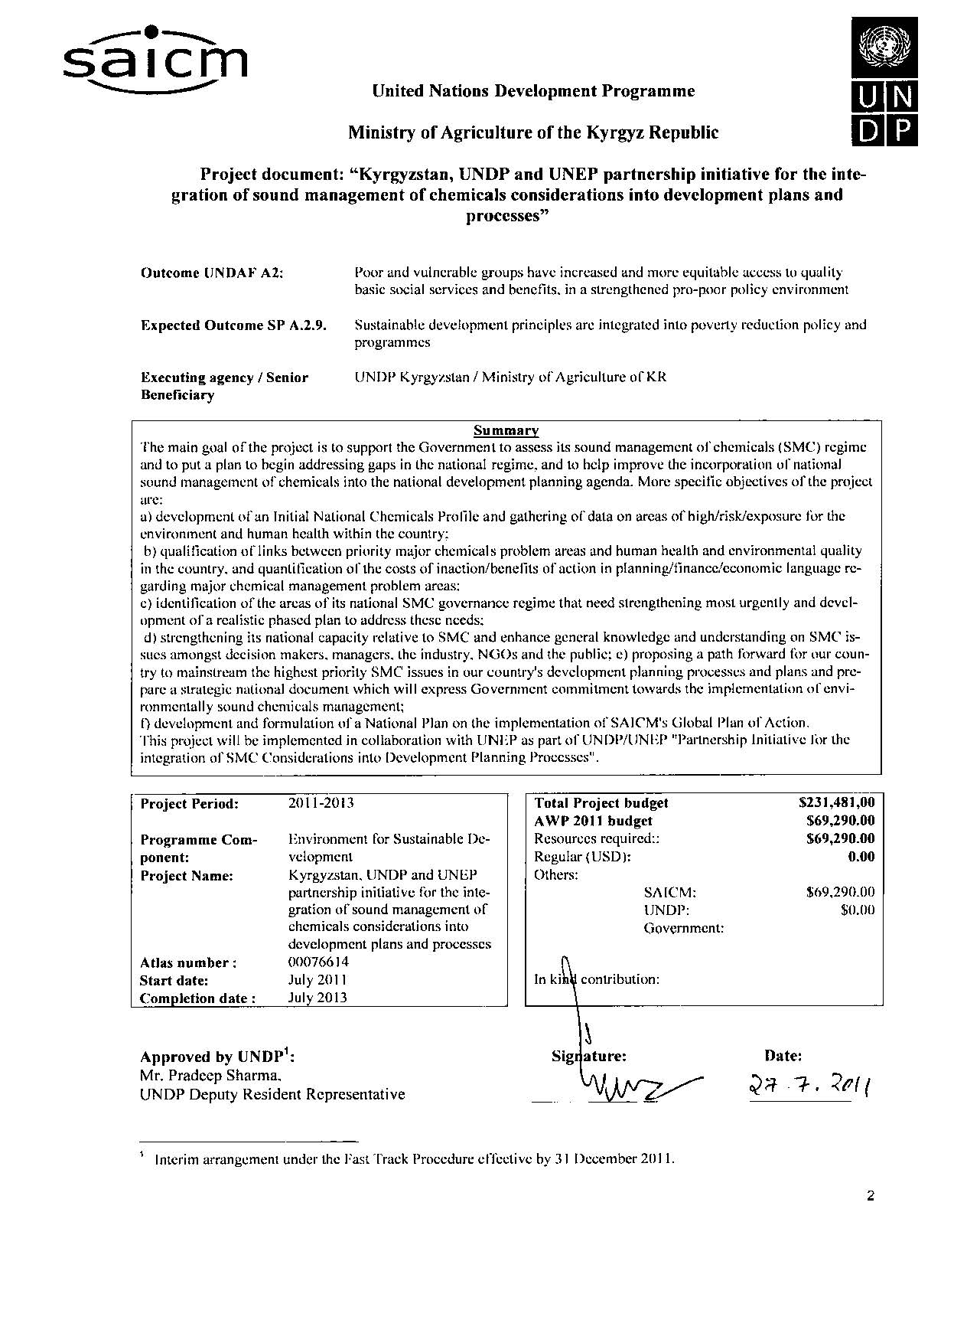

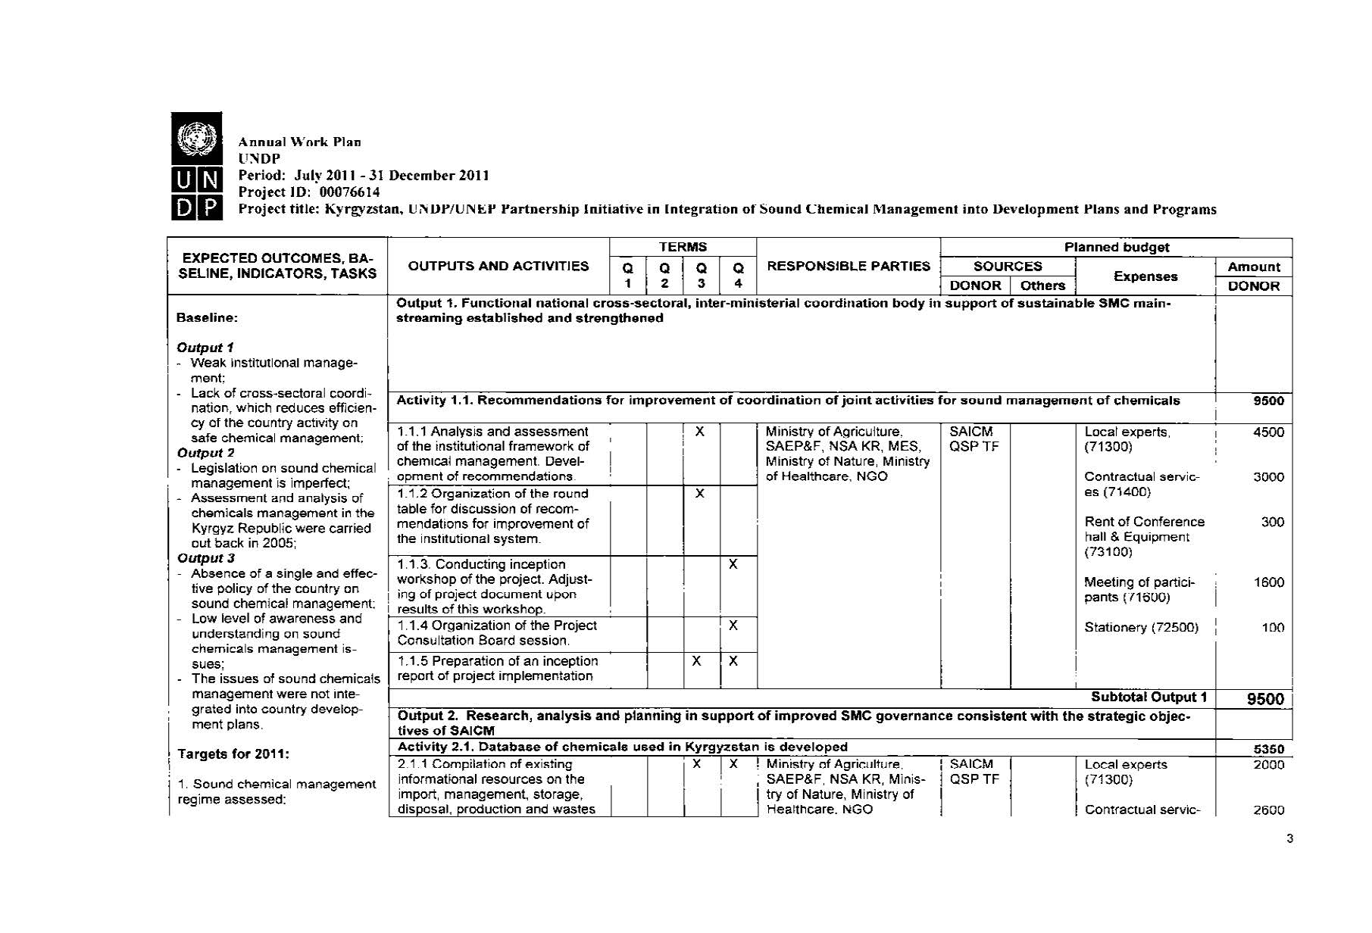

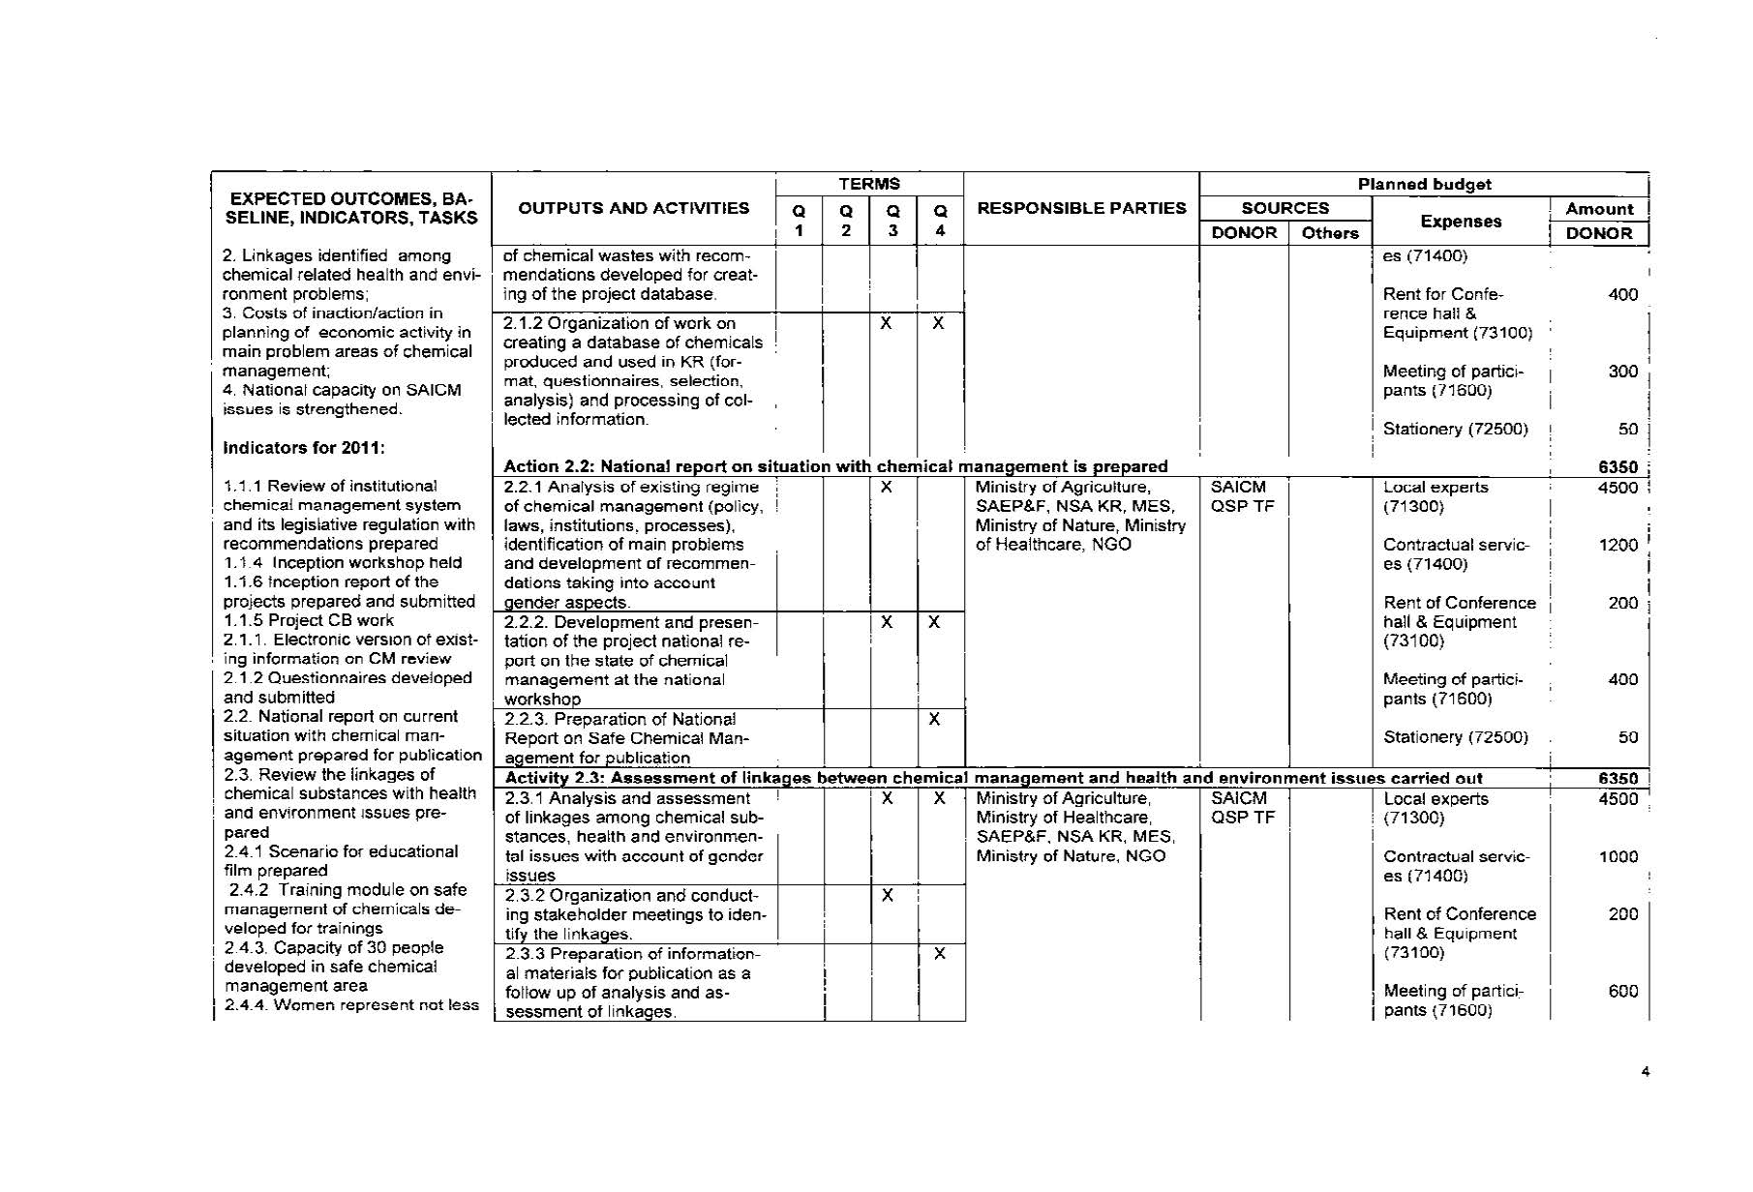

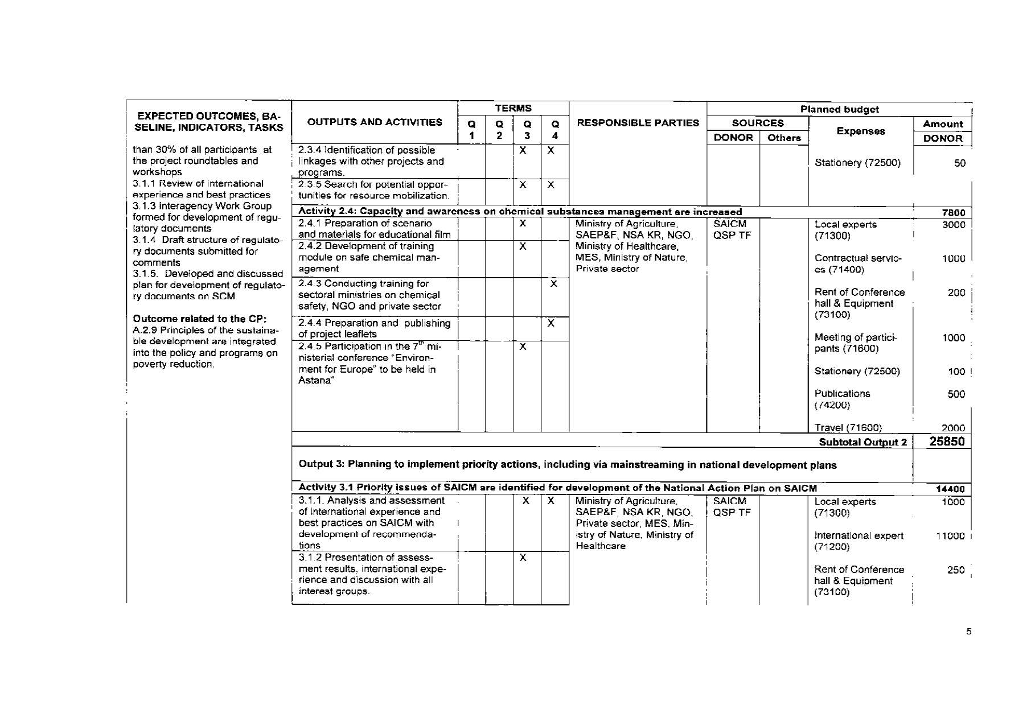

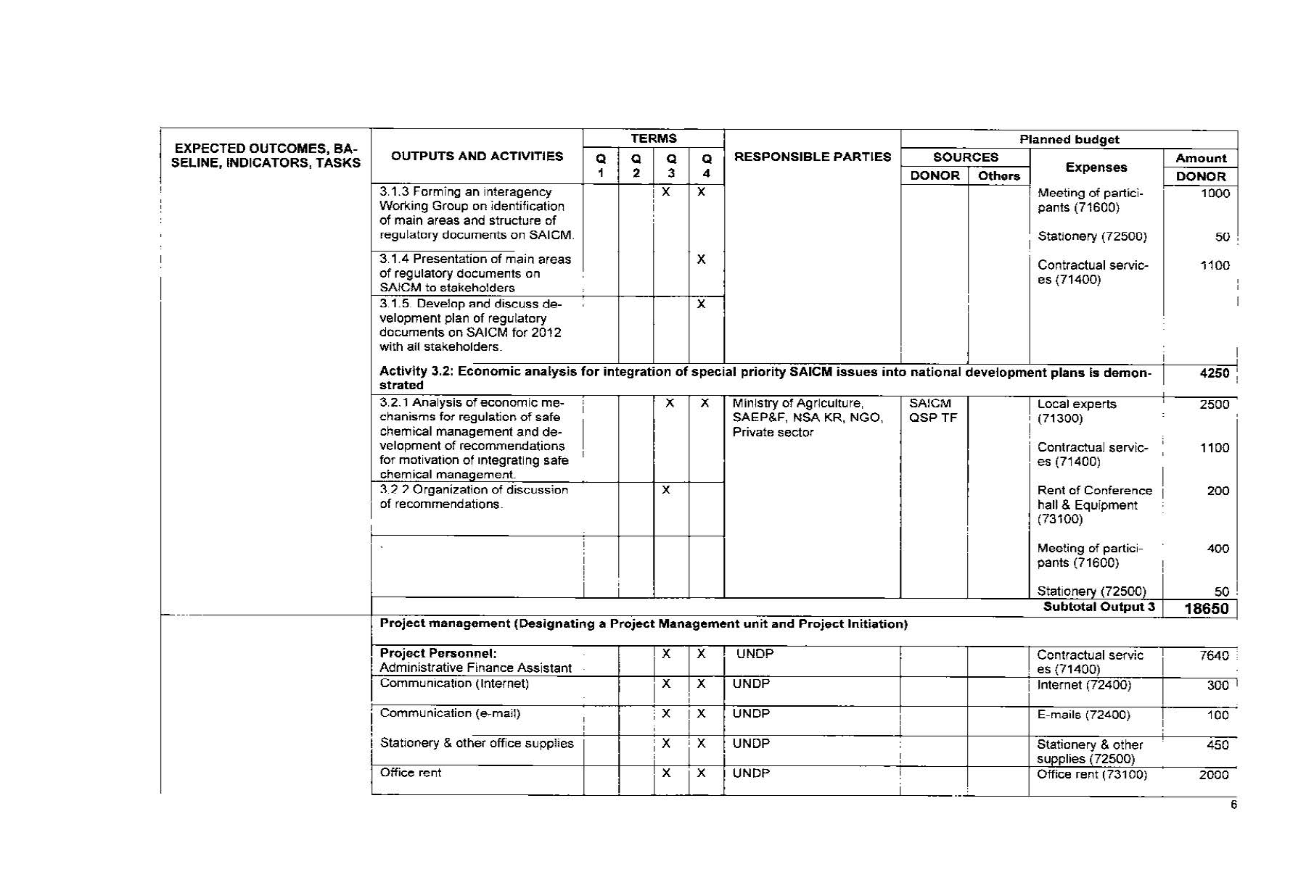

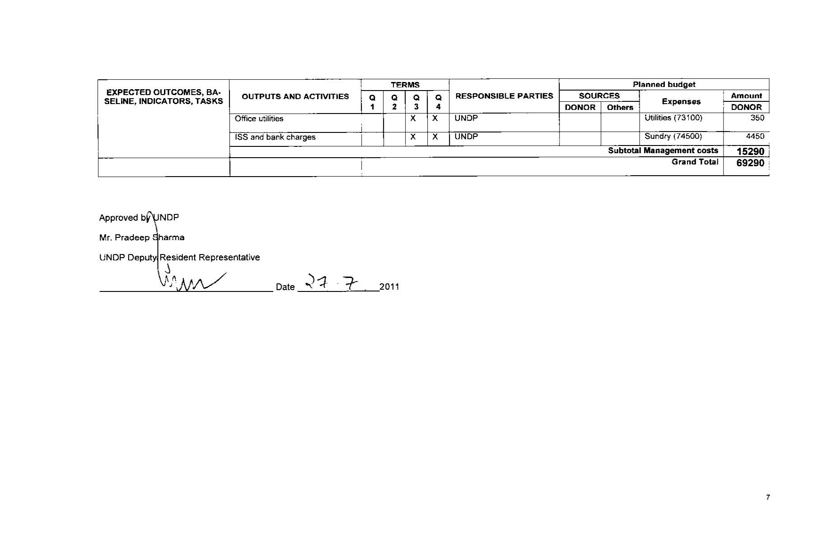

**Annex 5: List of documents reviewed**

**General documentation**

* UNDP Programme and Operations Policies and Procedures
* UNDP Handbook for Monitoring and Evaluating for Results

**Project documentation**

* Project document Kyrgyzstan, UNDP and UNEP partnership initiative for the integration of sound management of chemicals considerations into development plans and processes.
* Work plan 2011
* Semi-Annual Project Reports
* Project Implementation Review
* Steering Committee (Project Board) Meeting minutes
* Workshop, training and round table discussion minutes
* Training module on Sound Management on Hazardous Chemicals.
* Training module on Management of PCBs in Kyrgyz Republic.
* Analysis of necessities and defining mechanisms for effective information dissemination on SAICM among main stakeholders.
* Research study on situation in Kyrgyzstan in area of information dissemination on SAICM among main stakeholders.

**Annex 6: Summary of field visits**

No field visits were made.

**Annex 7: Comments by the stakeholders (only in case of discrepancies with evaluation findings and conclusions)**

Stakeholders that were interacted were very positive to the project activities and are very interested in the subject. Since their role was acknowledge and involved in active participation they were very ready for cooperation in the future also.

**Annex 8: Questionnaire used (if any) and summary of results**

No specific questionnaire prepared but communication were focused on stakeholders views on the project, evaluation of past and future cooperation, communication and coordination between implementing agencies, management and steering committee, management arrangements, monitoring arrangements, achievements, risks etc.

**Annex 9: List of persons interacted**

|  |  |  |
| --- | --- | --- |
| **Name/position** | **Meeting date** | **Meeting venue** |
| Ms. T. Filkova, Project Manager | 20/02/2012 | Office of the UNDP Environment Programme |
| Mr. M. Ilyazov, Project Manager, GEF/UNDP project “Management and disposal of PCBs” | 20/02/2012 | Office of the UNDP Environment Programme |
| Mr. O. Elemanov, Project Manager, GEF/UNDP project “Capacity building for improved national financing of global environmental management in Kyrgyzstan” | 20/02/2012 | Office of the UNDP Environment Programme |
| Mr. A. Chyngojoev, the State Secretary, the State Agency Environment Protection and Forestry | 24/02/2012 | The State Agency on Environmental Protection and Forestry |
| Ms. I.Jakypova, NGO “ EKOIS” | 27/02/2012 | Office of NGO “EKOIS” |
| Ms. N. Vashneva, the Ministry of Health | 27/02/2012 | Office of the UNDP Environment Programme |
| Mr. O. Pechenyuk, NGO “Independent Ecological Expertise” | 27/02/2012 | Office of Independent Environmental Expertise NGO |
| Mr. V.Pak, Deputy Director, Department of Chemicalization and Plant Protection, the Ministry of Agriculture | 29/02/2012 | Office of the UNDP Environment Programme |
| Mr. K. Kylychev, Programme Associate, Environment and Disaster Risk Management, UNDP Kyrgyzstan | 9/03/2012 | Country Office of UNDP in Kyrgyzstan |

1. Countries typically go through certain steps to advance their national sound management of chemicals regime. These steps are described by UNDP as (a) Development of Initial Chemicals Profiles/Inventories (i.e. what chemicals, where, how much, produced, used etc.); (b) Accumulation of basic data on areas of high/risk/exposure for the environment and human health within the country (e.g. serious chemical contamination of a major fishery, contaminated sites impacting food production, stockpiles destroying ground water, etc.); (c) Quantification of the links between major chemical problem areas and human health and environmental quality (i.e. analyzing and explaining the linkages in understandable language for policy decision makers); (d) Developing or filling-out an integrated chemicals management program (i.e. understanding what is needed to enhance SMC related governance capacity relative to the countries chemicals profiles so that current problems can be addressed and future problems prevented); (e) Quantification/estimation of the costs of inaction/benefits of action in major chemical risk areas from (c) above (i.e. the economic analysis that can be compelling for national planning and finance ministries; speaking the development planner's language); and (f) Mainstreaming in development planning to foster national budget commitments in partnership with donor assistance to address the most serious problems/potential benefits at the nexus between sound management of chemicals and sustainable forms of development.
2. The ICCM invited representatives of the participating organizations of the Inter-Organization Programme on the Sound Management of Chemicals (IOMC) and the United Nations Development Programme to form a Trust Fund Implementation Committee. This Committee is responsible for appraising and approving projects to be financed by the QSP trust fund and meets twice a year.
3. The QSP Executive Board consists of two government representatives of each of the United Nations regions and all the bilateral and multilateral donors and other contributors to the QSP. The Board meets once a year to review progress and provides operational guidance on the implementation of the programme.
4. The project implementing agency may however be contacted to obtain documents, lists of relevant contacts, reports or general information on the project.
5. For projects of less than 12 months, only one final report is required.
6. In particular, involvement in the implementation of projects for the development of the Stockholm Convention National Implementation Plans, a national Chemicals Profile and those implemented through the Multilateral Fund for the Implementation of the Montreal Protocol and the Global Environment Facility would be very relevant.
7. For projects of less than 12 months, only one final report is required.