  bundp20mm

*Adaptation to the effects of climate variability and change in Agro-ecological Regions I and II in Zambia (CCAP)*

Mid-term Evaluation

– FINAL 18 JULY 2013 -

April/May 2013

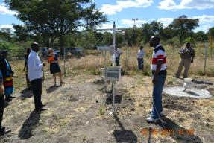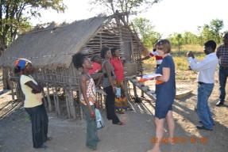

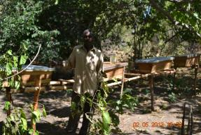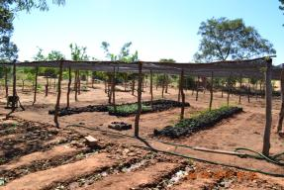

Juliane Zeidler (PhD)

Integrated Environmental Consultants Namibia (IECN)

Windhoek, Namibia

[j.zeidler@iecn-namibia.com](mailto:j.zeidler@iecn-namibia.com)

Tel: +264 61 249204

**Project information summary table**

|  |  |
| --- | --- |
| **Category** | **Information** |
| Name of the UNDP/GEF project | Adaptation to the effects of climate variability and change in Agro-ecological Regions I and II in Zambia (CCAP) |
| UNDP and GEF project ID#s | Project ID: 3942  Award/Project Ids: 00058205/ 00072197 (ZMB 10) |
| Evaluation time frame and date of evaluation report | April/May 2013 |
| Region and countries included in the project | Zambia |
| GEF Operational Program/Strategic Program | Climate Change, LDCF |
| Executing Agency and project partners | Ministry of Agriculture and Livestock |
| Evaluation team members | Dr. Juliane Zeidler |

**Acknowledgements**

Thank you to all the interviews that took out the time to participate in this evaluation. In the communities individuals travelled long distances to be at the briefings and community conversations. The support from the project team, MAL and UNDP staff is highly appreciated.

Table of Contents

Executive Summary 6

Conclusions, recommendations & lessons 7

PART 1: Evaluation context 11

**1.1** **Introduction** 11

***1.1.1*** *Purpose of the evaluation* 11

***1.1.2*** *Key issues addressed* 11

***1.1.3*** *Methodology of the evaluation* 12

***1.1.4*** *Structure of the evaluation* 14

***1.1.5*** *Evaluation Team* 15

***1.1.6*** *Ethics* 15

**1.2** **Project Description and development context** 15

PART 2: Findings 17

2.1 Project Formulation 17

*2.1.1 Analysis of LFA (Project logic /strategy; Indicators)* 17

*2.1.2 Assumptions and Risks* 17

*2.1.3 Lessons from other relevant projects (e.g., same focal area) incorporated into project implementation* 19

*2.1.4 Stakeholder participation (*)* 19

*2.1.5 Replication approach* 20

**2.2** **Project Implementation** 21

*2.2.1 The logical framework used during implementation as a management and M&E tool* 21

*2.2.3 Finance/co-finance* 26

*2.2.4 M&E* 29

*2.2.5 Coordination and operational issues: IA and EA execution* 29

**2.3** **Project Results** 33

*2.3.1* *Attainment of objectives/ Results* 33

*2.3.2* *Country ownership* 33

*2.3.3* *Mainstreaming* 33

*2.3.4* *Sustainability* 34

*2.3.5* *Catalytic Role* 35

*2.3.6* *Impact* 35

**2.4** **Summary of evaluation ratings** 36

PART 3: Conclusions, recommendations & lessons 39

3.1 **Corrective actions for the design, implementation, monitoring and evaluation of the project** 39

3.2 **Actions to follow up or reinforce initial benefits from the project** 48

3.3 **Proposals for future directions underlining main objectives** 49

3.4 **Best and worst practices in addressing issues relating to relevance, performance and success**

Annexes 54

Annex 1: Terms of Reference (TOR) for Mid-term Evaluation 55

Annex 2: Itinerary for MTE 69

Annex 3: Reported achievements at output and outcome level at the three visited sites (based on reports by the DACOs) 71

Annex 4: Raning of site performance by two project Key Informants to inform the MTE of the representativeness of the three sites visited. 76

Annex 5: List of interviewees 77

Annex 6: Site visit reports 79

Annex 7: List of documents consulted in support of MTE 95

Annex 8: Planning and budget allocations for 2013 97

Annex 9: Co-financing commitments 99

Annex 10: Code of conduct agreement form 100

**Acronyms and Abbreviations**

|  |  |
| --- | --- |
| ADC | Area Development Committee |
| AER | Agro-Ecological Region |
| AMAT | Adaptation Monitoring and Assessment Tool |
| APR | Annual Project Report |
| ASIP | Agriculture Sector Investment Programme |
| AWP | Annual Work Plan |
| AWS | Automatic Weather Station |
| CA | Conservation Agriculture |
| CASPP | Conservation Agriculture Scaling up for Increased Productivity and Production |
| CBD | Convention on Biological Diversity |
| CC | Climate Change |
| CCA | Climate Change Adaptation |
| CCAP | Climate Change Adaptation Project |
| CCFU | Climate Change Facilitation Unit |
| CRM | Climate Risk Management |
| DACO | District Agricultural Coordinator |
| DDCC | District Development Coordinating Committee |
| DSSAT | Decision Support System for Agro-Technology Transfer |
| EEG | Environment and Energy Group |
| EIA | Environmental Impact Assessment |
| EWS | Early Warning System |
| GEF | Global Environmental Facility |
| GRZ | Government of the Republic of Zambia |
| HACT | Harmonized Approach to Cash Transfer |
| HQ | Headquarters |
| IDRC | International Development and Research Centre |
| IECN | Integrated Environmental Consultants Namibia |
| LDC | Least Developed Countries |
| LDCF | Least Developed Countries Fund |
| LFA | Logical Framework Analysis |
| M&E | Monitoring and Evaluation |
| MAL | Ministry of Agriculture and Livestock |
| MDG | Millennium Development Goal |
| MLNREP | Ministry of Lands, Natural Resources and Environmental Protection |
| MT | Metric tons |
| MTE | Mid-term Evaluation |
| NAIS | National Agricultural Information Services |
| NAP | National Agricultural Policy |
| NAPA | National Adaptation Programme of Action |
| NAPSSFZ | National Association for Peasant and Small Scale Farmers of Zambia |
| NDMP | National Disaster Management Policy |
| NGO | Non-governmental organisation |
| NPE | National Policy on Environment |
| PACO | Provincial Agricultural Coordinator |
| PIF | Project Identification Form |
| PIR | Project Implementation Report |
| PPD | Policy and Planning Department |
| PPG | Project Preparation Grant |
| PS | Permanent Secretary |
| TOR | Terms of References |
| UNDP | United Nations Development Programme |
| UNDG | United Nations Development Group |
| UNEG | United Nations Evaluation Group |
| UNFCCC | United Nations Framework Convention on Climate Change |
| VAC | Vulnerability Assessment Committee |
| ZMD | Zambia Meteorological Department |
|  |  |

# Executive Summary

***Project Description and development context***

Climate change and variability affect agricultural production in Zambia adversely. Many Zambian small scale farmers who are the majority lack the capacity, resources and financial assistance to adapt to the negative effects of climate change. Most communities in Zambia are vulnerable to the adverse effects of climate change ranging from floods, droughts, and prolonged dry spells. The result of these impacts is crop failure, food and water insecurity and unsustainable livelihood. The project is thus aimed at reducing the vulnerability of communities in these regions to climate change impacts. This will involve integration of adaptation considerations into agricultural planning at national, district and community levels in order to protect and improve agricultural incomes from the adverse effects of climate change.

Specifically, the project aims to contribute to the achievement of the following four outcomes and associated outputs:

**Table 1:** LFA for project. Source project document.

|  |  |
| --- | --- |
| **Outcome 1:** Climate change risks integrated into critical decision making processes for agricultural management at the local, sub-national and national levels | **Output 1.1:** Institutional capacity to support climate risk management in the agric sector at the national, district, village level developed |
| **Output 1.2:** Effective EWS(s) developed to enhance preparedness and reduce climate related risks |
| **Output 1.3:** Economic impact assessment of the value of climate risk information to farmers |
| **Outcome 2:** Agricultural productivity in the pilot sites made resilient to the anticipated impacts of climate change | **Output 2.1:** Techniques for soil and water conservation as well as soil improvement tested for their ability to improve the productivity of small-scale agriculture |
| **Output 2.2:** Crop diversification practices tested for their ability to improve resilience of farmers to drought |
| **Output 2.3:** Alternative livelihoods tested for their ability to diversify incomes away from maize production |
| **Output 2.4:** Community-based water capacity and irrigation systems improved or developed to test their ability to raise agricultural productivity |
| **Outcome 3:** National fiscal, regulatory and development policy revised to promote adaptation responses in the agricultural sector | **Output 3.1:** Awareness of climate change risks and to the economic value of adaptation responses raised among policy- and decision-makers |
| **Output 3.2:** National policy dialogues conducted to discuss project findings in relation to cost-effectiveness of piloted adaptation options |
| **Output 3.3:** Policies that require adjustments to promote adaptation identified and reviewed |
| **Outcome 4:** Lessons-learned and knowledge management component developed | **Output 4.1:** Knowledge and lessons learned to support implementation of adaptation measures compiled and disseminated |

The project is funded by the Least Developed Countries Fund, a UNFCCC fund managed by the GEF.

The implementing partner is the Ministry of Agriculture and Livestock (MAL). Under the above four Outcomes, the project is aimed at benefitting at least 1000 farmers across eight project sites. Key partners with MAL, is the ZMD as a collaborator for outcome 1 of this project. The National Agriculture Information Services (NAIS) within MAL are a key partner for the implementation of outcome 4. Implementation begun in January 2010 and is due to close in December 2013.

***Purpose of the evaluation***

This is a scheduled standard mid-term evaluation (MTE) of a UNDP implemented GEF LDCF project. It is conducted by an independent evaluator.

The MTE’s objectives are to assess:

1. Progress made at mid-point since commencement of its implementation,
2. Challenges encountered at mid-point since commencement of implementation,
3. Recommendations on needed corrective actions to achieve the project’s planned outcomes,
4. Sustainability issues and “exit strategy”.

The intended target audience of the evaluation are:

* The project team and decision makers in the Ministry of Agriculture and Livestock(MAL) and Zambia Meteorological Department (ZMD)
* The GEF and UNFCCC Operational Focal Points
* The project partners and beneficiaries
* UNDP in Zambia as well as the regional and headquarter (HQ) office levels
* The GEF Secretariat.

***Methodology of the evaluation***

The evaluation is based on:

* *A document review*
* *In-country evaluation visit: t*he evaluator undertook a 10 day evaluation mission to Zambia. Focal interviews were conducted in Lusaka and site visits were organised and conducted to three out of eight districts with project intervention sites, namely Kazungula, Siavonga and Chongwe districts.
* *Focal interviews with key project partners*
* *Review process of draft evaluation*

# Conclusions, recommendations & lessons

Part 3 follows the Table of Content outlined in the TORs for the MTE and comprises of four sections. All four should be read in conjunction with one another.

Section 3.1 identifies specific corrective actions for the design, implementation, monitoring and evaluation of the project, and as such entails specific recommendations for follow-up immediately after the MTE. Table 7 below summarizes the key recommendations and action points from this section.

The other three sections summarize lessons learnt and observations stemming from the MTE in a longer-term and more strategic context, and as such contribute to adaptation learning resulting from the project experience.

Section 3.2 “Actions to follow up or reinforce initial benefits from the project” highlights specific approach elements that should be furthered in the remaining project period.

Section 3.3 “Proposals for future directions underlining main objectives” points to lessons learnt that the Government of Zambia might like to address in their follow-on adaptation planning and in future activities addressing climate change resilience building in the agriculture sector. The section reflects on sustainability elements beyond the current project.

Section 3.4 identifies best and worst practices in addressing issues relating to relevance, performance and success at MTE.

**Table 7:** Summary of recommendations on section 3.1

| **Key issues and recommendations** | **Key Actions** | **Timeframe** | **Responsible Units** |
| --- | --- | --- | --- |
| 1. No-cost project extension | No cost project extension granted and planned for | Immediately (July 2013) | MAL & UNDP |
| 2. Financial adjustments for 2013 plan at Management Response | Budget reallocated across new (extended) project period; reconsider all locations for dam building and ensure that adaptation learning is sufficiently funded | Immediately (July 2013) | MAL & UNDP |
| 3. For Outcome 1, MET stations not operational | Improved concept for linkages to data use (EWS), weather stations made operational | Between now and December 2013 | ZMD |
| 4. For Outcome 1, improve concept for EWS | Draft concept from Mark Tadross (via RTA) reviewed, improved in terms of end user utilisation; and implemented | Concept: September 2013  Implementation: until new project end | ZMD |
| 5. For Outcome 1, climate knowledge – need to invest in more trainings and professional updating | Develop clear training and professional updating plan  Implement plan | Plan: October 2013  Implementation: over remaining project period | PMU with ZMD and MAL; external expertise |
| 6. For Outcome 2, develop district level corrective action plans to incorporate gender equity, application of national environmental impact assessment requirements and training needs | Develop corrective measures as action plans at district level and implement actions at pilot sites  Implement, including through awareness raising sessions, with DACO  Monitor effectiveness (integration into reporting guidelines) | July 2013  From July 2013 until project end  Ongoing | PMU  PMU – MAL  PMU - MAL |
| 7. For Outcome 2, develop sustainability exit plans for the district level pilots (assisting the farmers in sustainability planning, which will include marketing training and support) | Develop sustainability exit plans, including marketing support (amongst others) at district pilot level  Implement, through farmer training, amongst other, the plans  Monitor effectiveness and adapt | July – August 2013  From September 2013 until project end  Ongoing | PMU  PMU – MAL  PMU – MAL |
| 8. For Outcome 2, capacity support to all (eight) pilot districts (particularly the four which have not been cleared by HACT) on financial management and M&E | Conduct financial and M&E training sessions with districts | Immediately | PMU – MAL |
| 9. For Outcome 3, the National Agriculture Policy climate change integration | Undertake final climate change resilience screening once revised draft policy is available  Convene policy dialogue on climate change in the agriculture sector with relevant stakeholders as part of Outcome 3 | Once final policy is ready for review  ASAP – best in line with policy process | PMU  PMU |
| 10. For Outcome 3, need to identify practical policy opportunities (to ensure sustainability) | Develop a clear action and entry point concept for Outcome 3 under newly extended timeline (if extension is granted)  Implement plan | Immediately  According to new extended project timeline (if extension is granted) | PMU |
| 11. For Outcome 3, conduct and integrate cc into policy dialogues | Linked to the aforementioned action points – include in plan – set realistic target for such policy dialogues and plan in manger that they are taking advantage of windows of opportunity aligned to ongoing policy processes | See previous, align to action and entry point concept for Outcome 3 | PMU |
| 12. For Outcome 3, make stronger links with ongoing climate change processes | Develop a concept of key policy points to be convened at the various climate change fora – develop clear strategy on how to e.g. influence the Interim Climate Change Secretariat on climate resilience building in the agriculture sector | Table concept at next SC meeting | PMU and MAL |
| 13. For Outcome 4, mobilise the lessons learnt and development of management components | Develop detailed plan of action how to address the output under this outcome, including on expertise needed to make its implementation a success | July 2013 for extended project period | PMU with NAIS |
| 14. Management regarding M&E | Review M&E framework and develop reporting guidelines that more clearly track impact indicators set out  Develop first M&E report according to plan for October 2013 | August 2013  October 2013 | PMU  PMU with inputs from DACO |
| 15. Re-engagement of the Steering Committee | Develop a clear strategy for SC meetings – set dates for the remaining project implementation period with clear technical agenda points that bring forward Outcome 3 of the project  Plan exposure visits e.g. to Kasaya and implement as learning and advocacy opportunity under Outcomes 3 and 4 | July 2013  September 2013 | PMU  PMU |

**PART 1: Evaluation context**

* 1. **Introduction**
     1. *Purpose of the evaluation*

This is a scheduled standard mid-term evaluation (MTE) of a UNDP implemented GEF LDCF project. It is conducted by an independent evaluator.

The MTE’s objectives are to assess:

1. Progress made at mid-point since commencement of its implementation,
2. Challenges encountered at mid-point since commencement of implementation,
3. Recommendations on needed corrective actions to achieve the project’s planned outcomes,
4. Sustainability issues and “exit strategy”.

The project commenced its implementation in January 2010 and is, according to the project plan, due to close in December 2013. Due to a slow implementation start, the mid-term evaluation was delayed to April/May 2013.

The intended target audience of the evaluation are:

* The project team and decision makers in the Ministry of Agriculture and Livestock(MAL)
* The GEF and UNFCCC Operational Focal Points
* The project partners and beneficiaries
* UNDP in Zambia as well as the regional and headquarter (HQ) office levels
* The GEF Secretariat.
  + 1. *Key issues addressed*

The full scope of the evaluation is set out in the Terms of Reference (TORs; Annex 1) for this evaluation. A detailed set of questions provided led the evaluation.

The specific key issues addressed include:

* Review of the activities that are undertaken in the project, set out through the project results framework.
* Evaluate the efficiency of project management, including delivery of outputs and activities in terms of quality, quantity, timeliness and cost efficiency.
* Progress towards achievement of outcomes and where possible impacts.
* Identify key lessons learned.
* Diagnose and analyse priority issues identified i.e. by this evaluation.
* Formulate a concrete and viable set of recommendations.
* Determine the likely outcomes and impact of the project in relation to its specified goals and objectives.

* + 1. *Methodology of the evaluation*

*Document review*

A suite of background documents were available by the project team and UNDP. These were reviewed in preparation of the in-country evaluation visit. Additional documents were solicited during the visit and reviewed on an ongoing basis.

*In-country evaluation visit*

The evaluator undertook a 10 day evaluation mission to Zambia. Focal interviews were conducted in Lusaka and site visits were organised and conducted to three out of eight districts with project intervention sites, namely Kazungula, Siavonga and Chongwe districts.

The site visit programme is included in Annex 2.

*Focal interviews with key project partners*

Focal interviews were conducted in groups or individually with the project team and project partners. The guiding questions set out in the TORs laid the foundation for the interviews. Results are presented in an anonymous manner. Summary transcripts of the site visits are included in Annex 6.

At a national level the following key informants were interviewed:

* UNDP: Winnie Musonda, Head EEG, Assistant UNDP Resident Representative; Georgina Fekete, Deputy Country Director (Programmes), Jessica Troni (RTA)
* UNDP/CCAP Project Officer: Biston Mbewe
* MAL/CCAP Focal Points: Rasford Kalamatila Evaristo Nyanoka (current Project Coordinator)
* MAL: Mary Chipili (Director- Department of Agriculture), Peter K. Lungu (Acting Deputy Director – Technical Services Branch), Reynolds K. Shula (Acting Chief Agricultural Specialist – Land Husbandry
* MLNREP: Godwin F. Gondwe; GEF & UNFCCC Focal Point and Director – Natural Resources and Environmental Protection Department.
* ZMD: Zambia Meteorological Department Jacob Nkomoki (Director), Dr. Joseph Kanyanga (Chief Meteorological Officer), Edson Nkonde (Meteorologist), Riedner Mumbi (Meteorologist)

Provincial, District, Block and Camp level staff of MAL were interviewed; see Annex 5 for a full list of interviewees. Southern and Lusaka Provinces were covered.

It should be noted that only one MAL staff member of all interviewed/part of the evaluation team was a female!

*Site visits and community conversations*

Overall project sites are situated across eight districts in ago-ecological zones I and II, namely Shangombo, Luangwa, Senanga, Kazungula, Chongwe, Chama, Mambwe and Siavonga.



**Figure 1:** Map indicating the project pilot districts (8). Three districts were visited during the MTE. Source: Project document

In the scope of this MTE three out of eight project sites were visited.

*Kazungula District*

* *Kasaya site*

*Siavonga District*

* *Lusitu site*

*Chongwe District*

* *Kabeleka site*

Community conversations were conducted in a group, and elaborated in more depths through specific site visits illustrating the on-site project investments.

The conservations were structured to cover the following:

1. Engagement of community and individuals in specific project activities and progress
2. Overall CC and CCA understanding – interpretation of project interventions in climate context
3. What worked very well (covering those issues from all assessment areas that were self-identified by the groups as priority)
4. What did not work too well (covering those issues from all assessment areas that were self-identified by the groups as priority)

Female and male community representatives were included in the consultations and participated actively in the conversations. It was notable that i.e. at Kazungula a healthy cut across age groups was actively involved in the conversations – not always the case elsewhere. The documentation of the field visits are included in Annex 6.

It is noted that MAL and project staff were present at all consultations and conversations. This may have impacts on the results, however, through the overall gauging of partnership “moods” and the level of team interactions it was found by the evaluator that a joint conversation about the project would still be unconstrained.

It is also noted that all three sites visited passed the HACT assessment and receive direct funds. None of those sites that are not cleared for a direct transfer modality was visited.

*Discussions of key findings and triangulation of results*

Strong stakeholder engagement in “fact finding” and discussions with project team were conducted. Joint brainstorming of possible recommendations for the remaining project period took place with stakeholders and the project team.

The findings from the evaluation visits were presented and discussed with technical project staff and management level representatives of key project partner institutions. Triangulation of findings with different project partners and at different sites (unless site specific) was specifically undertaken, specially where findings were not unequivocal.

The draft evaluation report was circulated to the project team, MAL and UNDP CO and the UNDP RTA. All comments received were considered and reviewed balancing different views from different stakeholders.

* + 1. *Structure of the evaluation*

The report is presented and structured in three parts.

Part 1: Evaluation context: provides a very short background to the project and its design. More details can be accessed in the project document.

Part 2: Findings: A summary of the findings of the consultations at field level and at site, districts, provincial and national level are provided. Transcripts of relevant consultations are provided in relevant Annexes. The findings are organised by project performance per se and impacts on a more strategic level.

Part 3: Conclusions, recommendations and lessons: Based on the findings practical recommendations are made for addressing through the management response to the MTE. Initial lessons learned are distilled and documented.

* + 1. *Evaluation Team*

This evaluation was carried out by Dr. Juliane Zeidler. She has lived and worked for 25 years in Africa, working on natural resources management issues. She is a rangeland ecologist with wide ranging experience in rural development. She specialises in developing, implementing and evaluating GEF projects for several focal areas, including for the LDCF.

* + 1. *Ethics*

The evaluation follows the UNEG “Ethical Guidelines for Evaluators”, and follows international best practice for evaluations.

* 1. **Project Description and development context**

Climate change and variability affect agricultural production in Zambia adversely. Many Zambian small scale farmers who are the majority lack the capacity, resources and financial assistance to adapt to the negative effects of climate change. Most communities in Zambia are vulnerable to the adverse effects of climate change ranging from floods, droughts, and prolonged dry spells. The result of these impacts is crop failure, food and water insecurity and unsustainable livelihood. The project is thus aimed at reducing the vulnerability of communities in these regions to climate change impacts. This will involve integration of adaptation considerations into agricultural planning at national, district and community levels in order to protect and improve agricultural incomes from the adverse effects of climate change.

Specifically, the project aims to contribute to the achievement of the following four outcomes and associated outputs:

**Table 1:** LFA for project. Source project document.

|  |  |
| --- | --- |
| **Outcome 1:** Climate change risks integrated into critical decision making processes for agricultural management at the local, sub-national and national levels | **Output 1.1:** Institutional capacity to support climate risk management in the agric sector at the national, district, village level developed |
| **Output 1.2:** Effective EWS(s) developed to enhance preparedness and reduce climate related risks |
| **Output 1.3:** Economic impact assessment of the value of climate risk information to farmers |
| **Outcome 2:** Agricultural productivity in the pilot sites made resilient to the anticipated impacts of climate change | **Output 2.1:** Techniques for soil and water conservation as well as soil improvement tested for their ability to improve the productivity of small-scale agriculture |
| **Output 2.2:** Crop diversification practices tested for their ability to improve resilience of farmers to drought |
| **Output 2.3:** Alternative livelihoods tested for their ability to diversify incomes away from maize production |
| **Output 2.4:** Community-based water capacity and irrigation systems improved or developed to test their ability to raise agricultural productivity |
| **Outcome 3:** National fiscal, regulatory and development policy revised to promote adaptation responses in the agricultural sector | **Output 3.1:** Awareness of climate change risks and to the economic value of adaptation responses raised among policy- and decision-makers |
| **Output 3.2:** National policy dialogues conducted to discuss project findings in relation to cost-effectiveness of piloted adaptation options |
| **Output 3.3:** Policies that require adjustments to promote adaptation identified and reviewed |
| **Outcome 4:** Lessons-learned and knowledge management component developed | **Output 4.1:** Knowledge and lessons learned to support implementation of adaptation measures compiled and disseminated |

The project is funded by the Least Developed Countries Fund, a UNFCCC fund managed by the GEF.

The implementing partner is the Ministry of Agriculture and Livestock (MAL). Under the above four Outcomes, the project is aimed at benefitting at least 1000 farmers across eight project sites. Key partners with MAL, is the ZMD as a collaborator for outcome 1 of this project. The National Agriculture Information Services (NAIS) within MAL are a key partner for the implementation of outcome 4. It began implementation in January 2010 and is due to close in December 2013.

**PART 2: Findings**

* 1. **Project Formulation**

*2.1.1 Analysis of LFA (Project logic /strategy; Indicators)*

The project document was particularly well articulated, with a great level of detail and depths. Technically the LFA is sound and follows a strategic rational. Overall the project design is clear, logical and feasible within the set timeframe.

What is absent is a critical review of environmental and social impacts of some of the adaptation measures suggested (safeguards), and the MTE finds that the implementation of certain measures may have negative impacts and may lead to mal adaptive practices (see Part 3, section 3.2).

The indicator framework is well developed, however, for the intended user groups perhaps too ambitious and complex. Reportedly, at inception phase the framework was simplified. However, the inception report does not clearly spell out such a simplified indicator framework.

There were voices that indicated that the project was rather ambitious for the partnership arrangement set out – both in terms of national partner as well as UNDP Country Office. Expectations of MAL were to receive cash advancements without HACT Assessment[1] – which created delays at the onset of the project. They previously implemented a GEF LD project with the World Bank, a project to which the HACT modality did not apply.

The minutes of the inception workshop for the project, which took place in July 2010 lacks important details setting out the work plan for the project – probably as the project document was so detailed and well articulated. This may have led to different understandings of alignments of project activities to ongoing MAL and ZMD activities and may have exacerbated the slow taking off of project implementation.

*2.1.2 Assumptions and Risks*

An impressive list of 15 risks was identified during the PPG phase of this project. Four of these 15 risks seem to have very high relevance at time of MTE, partially explaining the current implementation status, partially being identified as continued risks which need further risk management.

These are represented in Table 2.

**Table 2:** Risks particularly relevant at time of MTE.

|  |  |  |  |
| --- | --- | --- | --- |
| Risk | Risk rating (in prodoc) | Risk Mitigation Measure (in prodoc) | Risk Mitigation measure proposed at MTE |
| Slow pace of policy modification may mean that identified policy changes are not implemented in a timely fashion | High | * The project will take advantage of the current impetus within the GRZ on mitigating climate change impacts. * Identify and work with champions for policy change in GRZ. * Research-based evidence and systematic feasibility assessment reports will be supplied to the CCFU to enhance their lobbying capacity and speed up the process. * Continuous sensitization on the benefits of adaptation through NAIS programmes on radio and television will also ensure full support of the general public for policy adjustments | * Focus on a more practical policy instrument level such as camp and district plans in the pilot regions, which will communicate upwards and eventually feed into upstream policy processes * Support work under outcome 3 with a strong communication strategy and activities; building awareness on best practices will have longterm policy influence * Implement strategic policy influencing events such as policy dialogues as set out in detailed LFA; ensure high quality and high impact planning and delivery as the remaining project time frame is very short |
| Agriculture and water management interventions at the pilot sites are not cost effective | Low | * Interventions will be designed according to affordable levels of cost recovery. * Cost recovery analysis of water management measures will be a central component of the cost-effectiveness analyses. Cost recovery should be clearly linked to agricultural productivity increases. | * Need critical review of larger scale dam intervention at Siavonga in terms of social and environmental risks/impacts relevant mitigation measures and overall cost * Also address overall safeguards issues. * Implement a range and water resources management programme to ensure that already severe erosion due to overgrazing will not be worsened. * Track experience as adaptation learning for future replications |
| Delays in the release of funds could impede progress and prevent deliverables being achieved on time | Medium | * Effective administrative planning will overcome this risk. | * This has been a critical issue, which caused major delays in project implementation esp. outcome 2 * Steps taken (HACT assessment), capacity support must be furthered to get remaining 4 pilot districts up to standard * Invest in more financial management training and M&E training at district level |
| Failure to address gender equity and women’s empowerment | Medium | * Capacity building in gender analysis, accountability and mainstreaming. * Adopting gender affirmative action in all project activities. | * Gender report with strategy guidelines commissioned in 2013, a bit late to influence project design and implementation * Identify very practical steps aligned to project design to implement priority activities based on report recommendations * Include M&E component on gender |

*2.1.3 Lessons from other relevant projects (e.g., same focal area) incorporated into project implementation*

The project document takes up lessons from relevant project implemented in Zambia and adaptation learning from elsewhere in Africa.

Absent are specific safe guards and screenings against negative environmental or social impact of the on-the-ground adaptation solutions. The danger of promoting mal adaptive practices through following a very strongly demand-led planning without implementing safeguards are not identified as a risk in the risk table included the project document.

*2.1.4 Stakeholder participation (*)*

Extensive stakeholder participation and consultation took place during the project preparation. A great deal of detailed participatory project planning took place at community level, with preferred adaptation solutions being clearly identified by the local farmers themselves.

During the inception phase the stakeholder commitment was renewed.

The stakeholder analysis and stakeholder involvement plans as set out in the prodoc are detailed and adequate. Stakeholder engagement and partnership arrangements especially on the district level, where extension officers from various Ministries collaborate is strong, and was visible at all project sites visited.

However, a number of stakeholders identified in the prodoc are not currently taking an active part in project implementation – which may be caused by various reasons, such a no interest, or no specific engagement by project management. Mostly the Office of the Vice President (Disaster Management and Mitigation Unit, DMMU) and the Ministry of Lands, Natural Resources and Environmental Protection (MLNREP) are marginally involved in the project at this time, although MLNREP is an active Steering Committee member.

The PIR of (Q2 2012) does highlight a number of partners that actively promote interventions at the pilot site level (Box 1), however during the evaluation visit none of these partners were met. No specific mention of such partners working on the sites was made during the field consultations. This might be a short coming of the evaluation methodology or simply could not be established.

The project steering committee (SC) – which is a good platform for engaging important stakeholders at the national level - has met three times during the project implementation period to date (November 2011, January 2012, December 2012).One is scheduled to discuss the findings of the MTE in the near future. Overall it is found that the SC has not been very active and only convened a relatively few times. Although the December 2012 minutes request to schedule four meetings during 2013, up to end of June 2013 no such meeting has taken place.

The low numbers of meeting and engagement may be partially attributed to the slow project start - it did not show significant results and activity for the first two years, however, the SC could become more engaged and meetings could be convened more frequently - a tool to foster the working relationships for outcomes 3 and 4, in particular.

It is clear from the project document, that this project was designed to focus strongly internally on government structures – and certain recommendations for reaching out to other additional stakeholders in a next step of project are made in the below (i.e. Part 3 of this report).

It should be indicated that since project formulation re-organisation and renaming of Ministry structures (now MAL) took place, which may have led to stakeholders “reshuffling”.

It is observed that the “Gender in Development Division” was indicated as a stakeholder at project design – however, no accounts of their involvement could be found during the MTE. Whilst a gender specific report was recently commissioned it is clear that gender focused project implementation mostly takes place on an ad hoc basis, mostly guided by the project’s M&E plan rather than by strategic approaches to women empowerment, for example.

**Box 1:** Indication of institutional partnerships at pilot sites PIR Q2 2012

* Mambwe: Easter Youth climate change forum promoting public education and awareness on CC through local community radio
* Luangwa: Zambia Relief and development foundation conducting trainings in the promotion of sustainable development and climate change.
* Shangombo: Green EnviroWatch has been promoting youth participation in climate change and development through sensitisation and public awareness. Peace Parks Foundation through Kavango Zambezi Transfrontier project have confirmed their willingness to support the project through fencing off the proposed irrigation scheme in Sioma project site
* Red Cross has been promoting conservation agriculture technologies and disaster risk reduction in Kazungula project site through trainings and provision of starter input packs
* Senanga: Zambia Alliance of Women has been promoting food security and sustainable development of women through supporting individual women initiatives
* Community Markets for Conservation have been contacted and have confirmed their willingness to provide market linkages as well as management and processing of the produce in the bee keeping and rice production intervention areas. This is covering Mambwe and Chama districts of eastern province.

*2.1.5 Replication approach*

A clear strategy for up-scaling and replication is incorporated into the project design. By piloting adaptation responses to the broadest possible range of climate risks and vulnerabilities in agro-ecological zones I and II, critical adaptation learning relevant to other districts in these zones ought to be generated.

The capacity development focus of the project interventions are aimed to support replication beyond the project’s time horizon. Targeted especially at MAL staff (and local communities) the broad awareness raising on climate change and adaptation are aimed to build a foundation for further replication of the adaptation approaches in the long-term.

* 1. **Project Implementation**

*2.2.1 The logical framework used during implementation as a management and M&E tool*

The logical framework set out in the project document is being closely observed and followed in terms of project implementation, monitoring and reporting of progress, as well as adaptive management. At least since the project has gained implementation momentum in 2012.

Activity reporting from the three at MTE visited districts is summarized in Annex 3. Table 3 provides a synthesis report on status of implementation according to the project design, based on the detailed reports presented during the field consultations at these districts. Detailed transcripts of the site visits are included in Annex 6.

It is observed that reference was made by several interviewees to the inception meeting of the project, which was held in July 2010 in Lusaka. At the meeting, apparently specific discussions revolved around how the EWS under outcome 1 were to be developed (led by ZMD), as well as it was indicated that the M&E plan was reviewed – and simplified during that meeting. However, the actual Inception Workshop report is not particularly detailed, and no specific references to either aspect were captured. It is therefore assumed that the discussions and recommendations from the inception workshop were not specifically followed-up on or implemented.

No other changes to the project design or arrangements were brought to the attention of the evaluator at MTE The PIRs reviewed did indicate no significant changes in terms of adaptive management, other than in staffing. The APR 2012 includes a decision to delay the MTE to 2013, based on a recommendation by the RTA in July 2012.

**Table 3:** Tracking output level implementation status of project interventions.

|  |  |  |  |
| --- | --- | --- | --- |
| **Outcome** | **Output** | **Implementation status** | **Comments** |
| Outcome 1: Climate change risks integrated into critical decision making processes for agricultural management at the local, sub-national and national levels | Output 1.1: Institutional capacity to support climate risk management in the agric sector at the national, district, village level developed | * Trainings at national, district and site level took place | * Content of training strongly focused on weather; needs to be furthered in CC and CR context * Need further professional updating for extension staff * Need to invest into best quality content of such trainings and high impact training/professional updating processes (few days, best trainers available, demand led – to name just a few principles) |
| Output 1.2: Effective EWS(s) developed to enhance preparedness and reduce climate related risks | * Automatic weather stations set up at all eight sites but not fully operational * ZMD has established channels for EWS information dissemination * Convincing concept for EWS absent * A draft concept presented by the Climate Change Group at UCT (Mark Tadross) was presented to the country partners, although no specific feedback was ever received by the Group or the RTA | * Need to develop EWS concept with relevant partners, not only ZMD * Should review experiences and best practices from elsewhere; use draft concept developed (Mark Tadross) as foundation, but further the community use of data aspect more clearly * Even if a functional EWS cannot be achieved during project period at least a national debate on the approaches should be supported |
| Output 1.3: Economic impact assessment of the value of climate risk information to farmers | * Not done yet, requires output 1.2 to be functional | * See above |
| Outcome 2: Agricultural productivity in the pilot sites made resilient to the anticipated impacts of climate change | Output 2.1: Techniques for soil and water conservation as well as soil improvement tested for their ability to improve the productivity of small-scale agriculture | * Underway at eight pilot sites (see Annexes 3,4 & 6) | * Good interventions and beneficiary enthusiasm at pilot sites, however drought conditions this year prohibited full demonstration success |
| Output 2.2: Crop diversification practices tested for their ability to improve resilience of farmers to drought | * Underway at eight pilot sites (see Annexes 3, 4 & 6) | * Good interventions and beneficiary enthusiasm at pilot sites. Certain drought resistant crops showed success during this years’ drought condition * A big drawback was that most farming implements and seeding materials were available at certain sites (Luangwa. Kazungula, Kabeleka) very late into the planting season as the project rolled out very slowly – needs to be improved on |
| Output 2.3: Alternative livelihoods tested for their ability to diversify incomes away from maize production | * Underway at eight pilot sites (see Annexes xxx, xxx & xxx) | * Good interventions and beneficiary enthusiasm at pilot sites * Greater innovations could be promoted more generally – e.g. where Mango trees are common product development such as production of jams or dried fruit could be promoted where no markets for fresh fruits exist etc. * Future support must focus on product development, marketing etc. – the initial “tools” are now in place (e.g. bee hives), but to turn such hand-outs into real household economics supporting alternative livelihoods a lot more must be done |
| Output 2.4: Community-based water capacity and irrigation systems improved or developed to test their ability to raise agricultural productivity | * Underway at eight pilot sites (see Annexes xxx, xxx & xxx) | * Good interventions and beneficiary enthusiasm at pilot sites about water infrastructure * The piloting aspect of the approach of the various adaptation responses should be highlighted. For example, implementing water infrastructure solutions should be monitored carefully for adaptive advances or mal practices and difficulties – and finally findings should be presented as part of evidence based adaptation learning * Some water interventions have evolved quite differently as intended in the project concept (more expensive, larger etc.) – this has raised some red flags as some sites and critical social and environmental safeguards and other may not have been observed (see section 3.4) * Specific recommendations are made in support of the further implementation of this output (See Part 3 of this report) |
| Outcome 3: National fiscal, regulatory and development policy revised to promote adaptation responses in the agricultural sector | Output 3.1: Awareness of climate change risks and to the economic value of adaptation responses raised among policy- and decision-makers | * No specific activities implemented | * Specific recommendations are made in support of the further implementation of this output (See Part 3 of this report) |
| Output 3.2: National policy dialogues conducted to discuss project findings in relation to cost-effectiveness of piloted adaptation options | * No specific activities implemented; outcome 2 results just emerging | * Specific recommendations are made in support of the further implementation of this output (See Part 3 of this report) |
| Output 3.3: Policies that require adjustments to promote adaptation identified and reviewed | * Inputs into the review of the National Agriculture Policy given * Issues paper was submitted to the Department of Policy and Planning commenting on the Draft Agriculture Policy | * The National Agriculture Policy has not yet been finalised; it is unclear in how far CC considerations are incorporated and the quality thereof * The project should ask permission for a final CC screening – if at all possible and engage relevant national and international expertise in the review incl. from within UNDP * Other policy opportunities should be uncovered and capitalised on (e.g. bottom up planning – camp level etc. at pilot sites) * Specific recommendations are made in support of the further implementation of this output (See Part 3 of this report) |
| Outcome 4: Lessons-learned and knowledge management component developed | Output 4.1: Knowledge and lessons learned to support implementation of adaptation measures compiled and disseminated | * Few specific activities implemented at this point; outcome 2 results just emerging * NAIS engaged in some initial outreach activities and covered project information | * This outcome and output should receive much attention in the remaining project period * It is clear that i.e. outcome 3 results as well as sustainability and replication effects will strongly depend on the quality and intensity of implementation approaches and activities under this outcome * Specific recommendations are made in support of the further implementation of this output (See Part 3 of this report) |

*2.2.2 Effective partnerships arrangements established for implementation of the project with relevant stakeholders involved in the country/region*

Under outcome 2 some strong collaborative working partnerships seem to have evolved between the extension services of various government entities. For example, representatives of the Forestry Department are actively involved in supporting the development of the bee keeping interventions at the pilot sites (e.g. Kazungula & Chongwe), and an expert from the Department of Water Affairs joined the field visit to the Kabeleka site (Chongwe) and critically advised on the ground water situation in the area. At other sites such collaborations did not emerge as obviously and for example the dam intervention at Lusitu was developed by the agriculture irrigation engineer without the involvement of the Department of Water Affairs – which apparently is common practice.

The lead institutions responsible for the implementation of the project MAL and ZMD reported some dissatisfaction with the partnership arrangements overall and with UNDP in particular. It seems that especially the negotiations around the HACT Assessment and the related modalities set out a difficult working relationship. Already at the 1st Steering Committee held in November 2011, major discussions revolved around the HACT[2].

Although it can be quite normal to experience initial “setting up” problems especially for projects that follow specific guidelines as is the case for the LDCF and work with the GEF, but such problems must be addressed as major project impacts will only materialise if the project context is well contextualised by all partners (see Part 3) – and up to the MTE unclarities and misunderstandings do still prevail[3].

A great resistance to involving “outside” expertise in project implementation and delivery was voiced by a number of MAL and ZMD interviewees. There is a strong feeling that the internal human resources are adequate to implement the project activities successfully.

However, the MTE found that especially climate risk related knowledge and management capacity was very lowly represented in the project. This could be because project partners e.g. in ZMD were not fully engaged in the implementation of outcome 1 at this point, for example. In any event it is critical for the success of the project to focus more strongly on the climate change context than the business-as-usual meteorological and agricultural contexts. Further discourses and also professional updating and training approaches are urgently required to improve on this – with national and international expertise support.

*2.2.3 Finance/co-finance*

At the time of the MTE the following expenditures were made (Table 4). Table 5 below indicates the budget allocations for 2013. From these two tables it is clear that significant amounts of funding are still available to request a no-cost extension, with US$ 937,563.88 unprogrammed at official programme end in December 2013, and the remaining allocations for 2013 still being quite flexible with potential for certain reallocations to 2014 or longer.

However, it is recommended to additionally review the 2013 allocations at time of Management Response to the MTE to decide which priorities should be funded from the LDCF and how the remaining funds should be allocated for achieving the intended project results and impacts. Part 3 includes specific recommendations in this regards stemming from the MTE.

Annex 9 includes the co-financing figures for the project to date. Site specific investments could be seen (in terms of staff engagement, office support etc.) during site visits. Additional opportunity for co-financing e.g. water infrastructure and irrigation investments intended at several pilot sites can be envisaged. Investments by several partners at the pilot site level have been reported in PIRs (see Box 1), and could potentially be incorporated into co-financing assessments. Notably, during this assessment mission these partnerships were not brought to attention.

**Table 4:** Summary of project expenditures to date, disaggregated by year and project outcome.

|  |  |  |  |  |  |  |  |
| --- | --- | --- | --- | --- | --- | --- | --- |
|  |  | **Total budget allocation (US$)** | **Spending (US$)** | | | | **Total to date (US$)** (excl. already committed funds for 2013 (Table5)) |
| **2010** | **2011** | **2012** | **2013 (April/ May)** |
| **Outcome 1** | GEF | 350,000 | **107,914.79** | **76,932.68** | **39,941** | **60,713** | **285,501** |
| **Outcome 2** | GEF | 2,641,038 | **32,979.31** | **190,080.65** | **287,703** | **33,318** | **544,080.96** |
| UNDP | *100,000 |  |  | **100,771** |  | **100,771** |
| **Outcome 3** | GEF | 258,962 | **0** | **0** | **0** | **2,828** | **2,828** |
| **Outcome 4** | GEF | 165,000 | **0** | **0** | **62,728** | **557** | **63,285** |
| **Project management** | GEF | 380,000 | **0** | **0** | **345,950** | **63,043** | **408,993** |
| UNDP-CO | 175,000 | **597.04** | **19,746.96** | **31,786** | **27,842** | **79,972** |
| **TOTAL** | GEF & UNDP | (3,970,000 + *100,000 = **4,070,000**) | **141,491.14** | **286,760.29** | **868,879** | **188,301** | **1,485,431.43** |

**Table5:** Allocated funds for project year 2013

|  |  |  |  |  |  |  |  |
| --- | --- | --- | --- | --- | --- | --- | --- |
|  | **Adjustment of Outcome (key activity) allocations** | | | | | |  |
|  | **Adaptation to the effects of drought and climate change in Agro-ecological Regions I and II** | | | | | |  |
| **Outcome** |  | | | | | | |
| **Current outcome budgets /allocations** | | |  | **Proposed outcome budgets / allocations** |  |  |
| **Total budget over 4 years** | **Cumulative expenditure from 2010 to 2012 and the budget balance / programmable funds** | | **Budget 2013 by outcome** | | **Proposed revision of outcome budget allocations to avoid 2013 budget shortfalls (for outcomes 1 and 5)** | |
| **Expenditure up to 2012** | **Programmable Budget Balance for 2013 (final year)** | **Actual Budget 2013** | **Projected budget Balance 2013** | **Outcome budgets** | **Projected unprogrammed funds by 31 Dec 2013** |
| **1** | **350,000.00** | **311,653.77** | **38,346.23** | 118,500.00 | -80,153.77 | **430,153.77** | - |
| **2** | **2,641,038.00** | **390,321.98** | **2,250,716.02** | 1,289,000.00 | **961,716.02** | **2,382,384.23** | 703,062.25 |
| **3** | **258,962.00** | **-** | 258,962.00 | 65,000.00 | **193,962.00** | **185119.09** | 120,119.09 |
| **4** | **165,000.00** | **15,617.46** | **149,382.54** | 35,000.00 | **114,382.54** | **165,000.00** | 114,382.54 |
| **5** | **380,000.00** | **453,842.91** | -73,842.91 | 178,500.00 | **-252,342.91** | **632,342.91** | - |
| **Total** | **3,795,000.00** | **1,171,436.12** | **2,623,563.88** | **1,686,000.00** | **937,563.88** | **3,795,000.00** | **937,563.88** |

*2.2.4 M&E*

Table 6 reproduces the Strategic Results Framework (SRF) with the specified project performance indicators. It should be noted that the project was prepared before the AMAT was introduced and consequently the indicators are formulated on different levels. The framework seems simple enough to be achieved and tracked. At time of the MTE only commentaries are provided, as not all project sites were visited.

Reporting at district (DACO) level including on community interventions and national level reporting (i.e. Quarterly reports by the project manager since 1st quarter 2012) is conducted against the logical framework. A reporting template is provided by the project secretariat. Additionally reporting is geared towards the set performance targets according to the M&E plan and its indicators. Reports against the project indicators and annual targets are included in the ARP.

PIRs and APRs have been submitted regularly, although limited content was produced due to the slow project start during the first two years.

It was reported by UNDP and MAL that the SRF and M&E framework set out in the project document was revisited and changed during the inception workshop. However, the available documentation has no record of these changes and it is unclear if such changes are reflected in the reporting templates.

The timing of the MTE was delayed into the official final project year (2013) based on the fact that project start was slow, and on the background that a no-cost project extension may be required.

### *2.2.5 Coordination and operational issues: IA and EA execution*

Overall it is observed that there is a high level of dissatisfaction at MAL senior management with the project implementation arrangements. Whilst the major issue seems to lay in the difficulty to reach buy in by the national partner for the modalities of the required HACT Assessment for cash transfers – in this case directly to the district level, there seems to be an imperfect working relationship between MAL and UNDP at the top level which may have, more generally, contributed to the significant project implementation delays.

Generally it was communicated that MAL is used to manage much larger funds from donors that are willing to integrate more fully within the Ministry established processes and procedures. On the other hand safeguard standards at UNDP dictate especially financial flows. Some senior management representatives voiced dissatisfaction with the major bureaucratic components that come along with GEF funding. This is the first LCDF project MAL is working with and the nature of “small” strategic and catalytic programming is a slightly different approach to business-as-usual at MAL.

ZMD, a major implementation partner for outcome 1, voiced dissatisfaction about a lack of ownership in the project, and it seemed that the same “problem” areas as between MAL and UNDP were at play. Financial flows were seen as restrictive and “de-motivating” at both institutions.

The project management team (project hired project manager and MAL focal point) are based in MAL and seem to have established a good working relationship at the operational level within MAL, which greatly contributes to effective implementation of project activities since 2012. Similarly a good working relationship with operational staff at ZMD has been established.

UNDP support as IA has been of significance, and although being bureaucratic and slow, progress has been made i.e. on the financial disbursement level, amongst other.

In terms of technical support it is noted that UNDP in-house must coordinate their recommendations. For example, there were differing views on the appropriateness of some of the water infrastructure investments. As UNDP has no comparative advantage advising on such investments technically, internal responses including engagement with relevant expertise should be sought for. The Country Office, in consultation with the Regional Technical Advisor (RTA), have the responsibility to address such issues. The RTA highlighted the need to follow EIA procedures in the BToR of July 2012: recommendation #4.

It was mentioned by several interviewees that they thought the technical oversight of UNDP could be stronger. Notably the quality of the inception workshop report and other items could have been improved if more stringent quality control was exerted by UNDP. Reviews of various reports, such as quarterly and annual reports as well as specific consultants’ reports were undertaken by UNDP CO as well as the RTA.

Backstopping from UNDP CO seems to be there, but on an ad hoc basis. More hands-on follow-up on recommendations such as e.g. the EWS concept submitted by Mark Tadross as just one example, should be carried out by UNDP CO. Strategic guidance on technical issues such as on CR knowledge and understanding continuously needs to be reinforced by UNDP to ensure that relevant outputs and targets are met by the project.

Overall the performance assessment of the IA and EA both is rated as marginally satisfactory only. Although the project team at MAL is now quite functional it is clear that still major improvements are needed to ensure that the project performs to standard – with will only be possible with a no-cost extension. Leadership for successful implementation of the MTE recommendations will be required form the project team.

**Table 6:** Project Strategic Results Framework SRF) as set out in project document, including comments on progress at MTE.

|  |  |  |  |  |
| --- | --- | --- | --- | --- |
| **Project Strategy** | **Indicators** | **Baseline Value** | **Targets and benchmarks** | **Comments at MTE** |
| **Objective: to develop adaptive capacity of subsistence farmers and rural communities to withstand climate change in Zambia** | 1. Number of subsistence farmers in the rural communities who have successful adopted adaptation measures.  2. No of policy-level activities that enable policy adjustments for replication of cost-effective adaptation measures.  3. No of knowledge products generated that promote replication of cost-effective adaptation approaches. | 1. At present, adaptation measures have not been adopted by subsistence farmers.  2. Limited mainstreaming of adaptation into national planning processes and policies.  3. Limited documented information on cost-effectiveness of adaptation responses, and promotion of adaptation. | 1. By the end of the project, at least 1000 subsistence farmers adopt at least one adaptation measure.  2. By the end of the project, 5 key sectoral policies and 2 provincial and district plans are revised to promote adaptation.  3. By the end of the project, at least 20 key project lessons are documented and disseminated in local, national and international fora and media. | 1. Likely to be achieved  2. Seems unlikely, as there are not sufficient sectoral policies under review at this point  3. Possible |
| **Outcome 1:**  **Climate change risks integrated into decision-making processes for agricultural management at the local, sub-national and national levels** | 1. Number of government planners and extension staff that include climate risk information in their decision processes.  2. EWS developed and applied effectively in three pilot sites. | 1.At present, climate risk information is not included in decision-making processes.  2. Zambia’s National Disaster Management Policy identifies gaps affecting its functionality and measures that need to be undertaken to improve disaster risk management. | 1. By the end of the project, 250 government planners and extension staff trained to routinely include climate risk information in their decision processes.  2. Farmers’ incomes in 3 pilot sites protected against the effects of extreme weather events. | 1. Critical CR information currently not accessed – must be ameliorated  2. Indicator not clear – how does this link to EWS? |
| **Outcome 2:**  **Agricultural productivity in the pilot sites made resilient to the anticipated impacts of climate change** | 1. Number of interventions in selected pilot sites implemented, with appropriate management (including cost recovery) plans in place, agreed by all stakeholders, for sustainability beyond the project grant.  2. Percentage increase in agricultural incomes in the pilot sites.  3. Number of women involved in interventions in the pilot sites. | 1. At present, although there are a number of measures that the government and other donors are implementing. However, these do not take climate change into consideration; neither are they monitored for their adaptation value**.** | 2. 10% increase in agricultural incomes.  3. At least 50% of the people involved in the interventions at each pilot site are women (this includes management committees). | 1. No indicator for 1, however, based on project LFA easy to track  2. Currently limited reporting related to income impacts in place; DACO should include such a measure from now onwards that relevant actions are in place at the pilot site level  3. Easy to measure from DACO reports – project manager should synthesise reports accordingly; APRs do make relevant reference |
| **Outcome 3: National fiscal, regulatory and development policy revised to promote adaptation responses in the agricultural sector.** | 1. The number of policies that are adapted to take into account climate change risks.  2. Awareness level of rural population in pilot sites and local/national government of climate change and its impacts improved. | 1. At present, the national policies as well as the provincial and district development plans that are available do not address climate change and adaptation issues in an integrated manner.  2. At present, rural populations’ understanding of climate change and its impacts is minimal**.** | 1. By the end of the project, 2 provincial plans and district plans and 5 key national policies are revised to promote sustainable climate resilient development.  2. By the end of the project, rural populations within the eight pilot sites will have been exposed to climate change information and adaptation training with catalytic intentions. | 1. Seems unlikely, as there are not sufficient sectoral policies under review at this point; need benchmarks measuring “climate resilient” (e.g. National Agriculture Policy)  2.Easy to measure from DACO and project reports – project manager should synthesise reports accordingly; no impact indicator though |
| **Outcome 4. Lessons learned and knowledge management component established.** | 1. Number of proposals, papers and other documents that incorporate learning from the project.  2. Number of lessons included in the ALM.  3, Number of regional and national workshops conducted for dissemination of project lessons.  4. The number of awareness campaigns conducted on the need to incorporate adaptation needs in policy. | 1. Development projects currently do not systematically benefit from learning practices and project lessons on community-based adaptation. | 1. By the end of the project, at least four proposed or ongoing projects draw on lessons and knowledge generated by the LDCF project.  2. By the end of the project, at least 20 key project lessons are captured and disseminated in the ALM.  3. By the end of the project, at least 1 national and 1 international workshop on adaptation to effects of drought and climate change is conducted.  4. By the end of the project, at least two campaigns have been conducted | 1. Likely  2. Possible  3. Possible – and should be done also in CR context  4. Possible |

* 1. **Project Results** 
     1. *Attainment of objectives/ Results*

The overarching goal of this project is to “*to improve food security through enhanced adaptive capacity to respond to the risks posed by the effects of climate change (including variability) in AER I and II of Zambia”*. The objective of the project is “*to develop adaptive capacity of subsistence farmers and rural communities to withstand climate change in Zambia*”.

At this point it can be said that initial steps towards the project goal and objectives have been made, but at the time of the MTE significant additional work is required to make a significant impact. If the project is to end by December 2013 it seems unlikely that the intended objective will be met other than through punctuated investments at eight pilot sites.

* + 1. *Country ownership*

The project was developed very closely responding to country development priorities and plans. This also resonated from the various consultations had. Placing the project directly into the MAL was seen to be of great benefit and ownership is strong. However, there were complaints from senior management of MAL on some of the modalities that came with the project. It seems that the expectations on getting donor support are high and not necessarily in line with the intentions of GEF or LDCF support. MAL seemed to wish for more direct budget support rather than project bound interventions.

Despite this issue, which mostly is regarded as a management issue and should be addressed (see Part 3) country relevance and ownership are rated highly.

A shortcoming created by the delay in project action is that the Steering Committee (SC), although established, has only met a few times. Representatives of the SC interviewed strongly recommended that more engagement be fostered – and there seem to be many opportunities for this i.e. through the policy dialogues and an extended project implementation period.

* + 1. *Mainstreaming*

At this point the mainstreaming impacts are only detectable on the pilot site level, but with great potential to be absorbed more systematically on different levels with especially project outcomes 3 and 4 being implemented and followed-up on more actively in the coming months. It could be anticipated that building stronger links with climate change governance processes outside of MAL i.e. the National Climate Change Strategy could enhance mainstreaming impacts.

A project no-cost extension is likely to benefit mainstreaming efforts.

In terms of gender, it can be said that naturally, but also specifically “enforced” through the project women empowerment plays a role on the pilot intervention level. By requesting gender disaggregated reporting on activities, support interventions and impacts as per the SRF some steps are taken towards addressing gender mainstreaming.

Recently a specific study was commissioned on gender mainstreaming tools under this project. Even if the emerging guidelines and tools may not have any more impact specifically on this project in a larger scale, they could form a strong foundation for future programming.

* + 1. *Sustainability*

At time of MTE there are concerns about sustainability of project impacts. The limited time remaining for project implementation without a no cost extension raise the risk of non-sustainability.

The major concern is the lack of financial allocations to continue project like interventions within MAL at this point. District level staffs fear that once the project support is ceasing they will not be able to continue support to the pilot sites, or up-scale the adaptation learning to others systematically. This is why policy mainstreaming is so important – which links directly to outcomes 3 and 4. Of course they feel they themselves have learned a good deal through the project and they would apply it - e.g. if other projects came their way.

Within other institutions such as ZMD no specific budget allocations to CRM were made, however, the ZMD generally strives to source funding to improve climate data and information throughout Zambia.

The functions of MNR in terms of climate change coordination were cut down, with the functions of the former CCFU having been absorbed within the Interim Climate Change Secretariat, which is housed in the Ministry of Finance. Some of the staff seconded to the secretariat e.g from DMMU and Ministry of Transport is now working from the Secretariat at MOF.

It is noted that conservation farming and small-scale irrigation programmes supported by Government especially MAL are ongoing and other stakeholder such as the Zambia Farmers Union have adopted conservation farming as a primary approach. However, it is not clear in how far such investments and alignments are either linked to climate change adaptation thinking per se or to this project in particular.

At pilot site level sustainability potential of the made investments is good. A peer learning effect amongst a wider set of community members is likely going to take place naturally. However, climate change learning is of importance, especially concerning the continued capacity support aimed at enhancing resilience. The sustainability rating is suggested for this segment as satisfactory.

The institutional framework and governance are considered marginally satisfactory at this point. Limited impacts have been made to date on changing MAL internal policies and views on climate change resilience building, which can be particularly attributed to the slow implementation of the project and limited implementation of outcomes 3 and 4 to date. The strong focus of the project on government and MAL in particular seems to limit the overall sustainability potential. Involvement of other stakeholders such as industry, commercial farmers and business, farmers unions and other seem future possibilities for enhancing systematic resilience building to climate change in the agricultural sector. Relevant recommendations for follow-up are made in Part 3 of this report.

Environmental sustainability seems to be given in the case of most of the project interventions, and promoted activities seem in line with best practices. Conservation agriculture has proven positive impacts on agricultural biodiversity, soil biodiversity and ecosystem services.

The water infrastructure and irrigation interventions – as long as appropriately managed – may have limited negative impacts, and no new land clearings, for example, are supported by the project. Relevant impact screenings should take place and environmental sustainability must be an ongoing concern and criteria for the tracking of further site specific interventions, i.e. the rangeland management issue at Lusitu (flagged in Part 3 of the report).

* + 1. *Catalytic Role*

The potential for having a catalytic role is there – although not yet fully capitalised on. The project intends to produce a public good in terms of climate resilient policy instruments. Demonstrations are in place and some significant impacts can be seen – with a good potential to further this during the remaining project period.

There is potential for replication and up-scaling, but to date limited evidence of these aspects being delivered on are visible at MTE. This of course could be improved with strategic climate change adaptation learning and capacity support at pilot district level.

* + 1. *Impact*

At this point no systematic information on actual household economic impacts of the demonstration projects at the eight pilot sites are available. It is recommended that such information be collected in the future through the existing reporting templates, as the pilot projects are starting to generate financial returns.

The very positive feedback especially from the Kasaya site demonstrate that the project has impacted on the project beneficiaries already – motivating them for more action and setting good examples to other farmers not directly involved in the project. These are promising indications and they should be fostered to generate similar impacts at other sites and beyond.

Impacts stemming from the other project activities under outcomes 1, 3 and 4 have the potential to create impacts – however, at this point they are rather limited.

* 1. **Summary of evaluation ratings**

The ratings are: Highly Satisfactory, Satisfactory, Marginally Satisfactory, Unsatisfactory

|  |  |  |
| --- | --- | --- |
| **Table 6: Rating Project Performance** | | |
|  | | |
| **Monitoring and Evaluation** | | **Comments** |
| Overall quality of M&E | Srate | Good foundations are in place, and good reporting from pilot site level (DACO). Aggregation of data in APRs. |
| *M&E design at project start up* | Srate | Detailed design; although M&E framework relatively complex it seems to be practical enough to be followed in-depth |
| *M&E Plan Implementation* | Srate | Although mention was made b y several sources, that the M&E plan was adjusted during the inception meeting, no reference of this could be found. The M&E plan set out in the project document is being followed the SRF is being used mostly for outcome level reporting, which is being done in a professional manner by DACO. |
|  | |  |
| **IA & EA Execution** | |  |
| Overall Quality of Project Implementation/Execution | MSrate |  |
| *Implementing Agency Execution* | MSrate | HACT Assessment modalities played a major role in project implementation delays; UNDP did invest into trying to move the assessment forward as well as into maintaining the working relationship with the national partners, esp. MAL.  The roles and responsibilities of the UNDP CO and the RTA have been fulfilled; however, more specific engagement in quality control would be helpful for guiding more effective project implementation. It is observed that several recommendations made e.g. by the RTA (EWS, environmental safeguards) were not responded to by the project team. It is important to follow-up on such recommendations more stringently. |
| *Executing Agency Execution* | MSrate | The project management team at MAL is motivated and now that the project is gaining momentum in project implementation achieves satisfactory project performance.  On the district level very active MAL engagement is strong and highly visible, at least at the project sites visited.  Overall leadership and understanding of the climate change adaptation context is not yet fully embraced at the MAL management and senior policy making level and a focus on delivering on outcomes 1, 3 and 4 in this regard is important. |
|  | |  |
| **Outcomes** | |  |
| Overall Quality of Project Outcomes | MSrate | Note that the ratings for the criteria are tentative as they are based on the slow performance on project implementation to date. Overall, from a design point of you – all outcomes are relevant and of high quality. |
| *Relevance* | MSrate | Few outcomes and outputs achieved as yet; outcome 2 now on way, but outcomes 1, 3 and 4 mostly still to be addressed. |
| *Effectiveness* | MSrate | See above |
| *Efficiency* | MSrate | See above |
|  | |  |
| **Catalytic Role** | |  |
| *Production of a public good* | **yes**/no | Improved and climate resilient agricultural policies and outreach will support especially subsistence farmers with public goods that reduces their climate risks. |
| *Demonstration* | **yes**/no | Strong demonstration value esp. through outcome 2. |
| *Replication* | yes/**no** | To be seen; potential is there, however at this point it is unclear how MAL will replicate – particularly given funding constraints. It is recognised that approaches such as conservation agriculture, crop diversification and soil and water conservation are part of the overall MAL programme – however, ion how far these approaches are promoted and further developed in a CRM and CCA context remains unclear or questionable. Also not enough climate change adaptation learning has taken place toward especially demonstration of what works. |
| *Scaling up* | yes/**no** | See above – to be seen; especially at the district level it was voiced that without specific project support scaling-up of activities would not be possible. |
|  | |  |
| **Sustainability** | |  |
| Overall likelihood of risks to Sustainability: | MS rate | It needs to be noted that the ratings are focusing on the tangible achievements stemming from this particular project intervention – with a clear CRM and CCA element. |
| *Financial resources* | MSrate | No specific resources allocated for CC; Conservation Agriculture now included as main business of MAL, as well as irrigation and crop diversification are promoted – however, the CRM and CCA contexts are not clear and must be contextualised further. At this point especially the district level clearly indicates that they fear that without specific financial support no dedicated climate change adaptation and resilience building will be possible at that level. |
| *Socio-economic* | Srate | At pilot sites – esp. where positive demonstrations can be seen – adaptation responses will continue - and be up-scaled |
| *Institutional framework and governance* | MSrate | Government focus for CCA alone will not provide the necessary institutional framework for building resilience in the agriculture sector; more specific investments into reaching out to other partners are necessary to build a comprehensive institutional framework and governance for climate resilient decision-making in the agriculture sector. The project document had set out relevant partnerships that should be followed-up on. |
| *Environmental* | MSrate | Most adaptation interventions seem to be environmentally sustainable; at sites with water infrastructure development resource access, regulation etc. will have to be managed. There are a number of red flags that were identified (see p. 22) & section 3.4, which need urgent attention. |
|  | |  |
| **Overall Project Results** | MS rate |  |

# PART 3: Conclusions, recommendations & lessons

Part 3 follows the Table of Contents outlined in the TORs for the MTE and comprises of four sections. All four should be read in conjunction with one another.

Section 3.1 identifies specific corrective actions for the design, implementation, monitoring and evaluation of the project, and as such entails specific recommendations for follow-up immediately after the MTE (Table 7).

The other three sections summarize lessons learnt and observations stemming from the MTE in a longer-term and more strategic context, and as such contribute to adaptation learning resulting from the project experience.

Section 3.2 “Actions to follow up or reinforce initial benefits from the project” highlights specific approach elements that should be furthered in the remaining project period.

Section 3.3 “Proposals for future directions underlining main objectives” points to lessons learnt that the Government of Zambia might like to address in their follow-on adaptation planning and in future activities addressing climate change resilience building in the agriculture sector. The section reflects on sustainability elements beyond the current project.

Section 3.4 identifies best and worst practices in addressing issues relating to relevance, performance and success at MTE.

* 1. **Corrective actions for the design, implementation, monitoring and evaluation of the project**

1. **Recommend for a no-cost extension**

First and foremost the key recommendation at MTE is to grant the project a no-cost extension of a minimum of a year to one year and a half to cover two additional growing seasons[4]. With over 50% of the project funds still available at mid-term, a great deal of activities not yet achieved, but to some extend already started should be seen through over a longer time period.

The project experienced serious delays in kick-off and real action on the ground. Staffing issues, as well as disagreements about the HACT modalities between UNDP and MAL played a role. Corrective actions were mostly taken, especially after undertaking HACT Assessments at all districts, now allowing four out of eight districts to qualify for direct financial disbursements – which seem to be a good foundation for intensified actions on the ground. Corrective measures that will allow cash transfers to all districts are still underway.

1. **Financial adjustments for 2013 plan at Management Response**

Although there is a significant amount of funds not allocated by end of project foreseen for December 2013 (over 0.9 Mio US$), it is recommended to re-budget the 2013 allocations if a no-cost extension is requested. It must be revisited if the high costs of the water and irrigation infrastructure are justified at this point of project, where major focus should be on generating adaptation learning. It is clear that the dam project at Lusitu is already near completion, however, building of additional dams should be reconsidered.

Water infrastructure provision and irrigation development must be informed by CC projections in order to justify LDCF support. The water and irrigation infrastructure investments seem to be strategic items to be covered from MAL co-financing sources – and to date MAL has not yet pledged their full co-financing allocated to this project (Annex 9). At Chongwe such co-financing already took place with MAL allocating extra funding to irrigation development (although extension personnel indicated that these funds are not necessarily expended at Kabeleka at this point).

1. **For Outcome 1, Met stations at this point – not operational**

It is clear that at this point the established automatic weather stations are not fully operational. Almost one year after purchase the stations still do not transmit the relevant data to ZMD. Local farmers cannot see a direct value of the information as they are current time and have no prognostic value. ZMD reported that difficulties in procurement have contributed to the stations not being functional, with a key element – the central data receiver not included in the order. At this point ZMD is receiving support from COMESA for some additional automatic weather stations and ZMD management suggests to harmonise data reception through a reconfiguration of the DELTA machines purchased from this project.

Several technical solutions to the problem seem to be possible and should be discussed with project management and ZMD. It should be a priority to ensure that these stations will feed continuous data into the national climate observation system, with direct data transfer to ZMD. Specific proposals are currently being discussed within ZMD.

1. **For Outcome 1, EWS – need for a good concept**

At MTE it was found that a good concept for farmers’ relevant EWS was lacking. Although ZMD was pointing to a proposal worked out during the inception workshop in this regard, the evaluation could not find any such documentation.

It is clear that at this point no meaningful EWS is in place. It is therefore recommended to invest as a matter of priority into the formulation of an action plan and concept in this regard. It is further recommended to seek expert inputs from elsewhere (national and international) on EWS. There is some excellent work done in the sub-region on this matter and work emerging from Zimbabwe and South Africa, amongst other should be reviewed (e.g. by the Climate Systems Analysis Group of the University of Cape Town; <http://www.csag.uct.ac.za/>).

Notably the RTA submitted a correspondence from 2012 that includes a proposal made by Mark Tadross of CSAG in terms of better operationalising the weather stations. No follow-up on this correspondence by the project team could be found. The proposal should be reconsidered – and improved for end-user utilisation – as a matter of priority.

It is also noted that Zambia has developed an umbrella proposal on EWS – and explicit linkages to this project should be established.

Even if the project period may not allow for the establishment of a fully functional EWS at this point, it seems important to support the overall debates on how a useful and user focused system could look.

RANET, a project housed at ZMD, is a community radio based information systems currently under implementation in several districts in Zambia could be a useful collaboration for effective information distribution. Similarly links to National Agricultural Information Service (NAIS) within MAL may offer opportunities for outreach.

1. **For Outcome 1, climate knowledge – need to invest in more trainings and professional updating**

Overall a lack of internalizing climate related knowledge into project actions and execution emerged as a major concern. At this point the project is largely implemented as an agriculture and food security intervention by MAL, with limited integration of climate risks (CR) and relevant responses. Systematic integration of existing CR information is not taking place, and at all levels of MAL decisions are taking place in the absence of such information.

There is a need to invest more specifically into professional updating of national, provincial and district level and extension staff of MAL, but also other collaborating extension services. It is important to ensure that best practice and high caliber updating sessions be invested in. Existing global, regional and national knowledge needs to be prepared in a manner that MAL staff will have an excellent learning opportunity. Lengthy meaningless training workshops are to be avoided at all cost – already a high resistance to “trainings” was observed – other than that people requested opportunities to travel abroad for such.

Especially for linking to impacts under outcome 3 it is critical to work on this understanding to ensure that long-term policy changes and integration of climate resilient planning will be included in decision-making the agricultural and food security sectors in Zambia.

1. **For Outcome 2, develop district level corrective action plans to incorporate gender equity, application of national environmental impact assessment requirements and training needs**

*Environmental and social impact assessments needed for water infrastructure investments*

Although arguably the water infrastructures supported by this project are “small”, it is important to screen for potential environmental and social impacts. This is particularly true in the context of climate change adaptation – where poorly sighted investments may lead to maladaptive practices. Section 3.4 makes a detailed case about the possible impacts of the dam in Lusitu – which is considered as relatively dry, as well as land degradation is seen to be a major environmental problem in the area.

If a full EIA or SIA must be conducted or a specific comprehensive screening is investment specific and must be decided by the project team in lie with national legislation – as well as in accordance with the UNDP Safeguards Policy. It is recommended that the initial infrastructure plans developed by MAL be reviewed and where necessary at least Environmental and Social Management Plans and impact mitigation strategies be considered for each site.

*Guard against maladaptive practices*

The promotion of maladaptive practices can have serious impacts on vulnerability of communities and the agriculture sector. Although we may have the best intensions with a project intervention we must be mindful that the climate risk specific context must guide the adaptive practices on site.

It is recommended that – as part of the ongoing adaptation learning – all types of adaptive measure be reviewed in terms of possible maladaptive effects. A specific technical brochure should be developed raising awareness about the dangers of maldaptation – and how one can systematically screen for potentially maladaptive measures e.g. at the stage of planning adaptation responses. Such an information material should be included under outcome 3 activities, but should also be shared with stakeholder at the pilot sites and DACO.

*Gender equity must be reinforced systematically and as a matter of priority*

There are some very good practices in terms of gender sensitive, disaggregated and specific interventions within this project. However, a more systematic approach to gender analysis and follow-up in terms of gender equity in project implementation n must be taken. Especially when it comes to monitoring the impacts of the local level adaptation actions in terms of income generation a gender specific analysis should be undertaken to generate important gender specific information for adaptation learning. The recommendations of a recent gender study undertaken as part of this project should be utilized in developing specific gender sensitive and gender equity related actions to issues such as land allocation around the water infrastructure for irrigation.

*Sustainability planning is critical*

Currently a suite of commendable community level adaptive measures are under implementation, however, as documented in Annex 6, many of these are still in a early phase. For example, the introduction of bee keeping as climate resilient alternative livelihood opportunity is popular amongst many of the beneficiaries. However, no income has been generated to date from the investments. Limited knowledge exists currently amongst the “young” bee keepers about marketing possibilities for their products, limited understanding of how much income can be generated from the few bee hives gotten is evident. Is there a need to reinvest – e.g. into more hives? How much to invest into product development? What type of standards must the products meet to fetch a good price? For all interventions it is critical that the project now focuses on assisting the farmers in sustainability planning, which will include marketing training and support, amongst other.

*Implementation of corrective measures*

Based on the recommendations from the MTE, but also incorporating information from tracking M&E information and problems arising regularly, develop corrective measures action plans for implementation at pilot sites. Implement these corrective measures including through awareness raising sessions with DACO. Monitor effectiveness i.e. through integration into reporting guidelines.

1. **For Outcome 2, develop sustainability exit plans for the district level pilots (assisting farmers in sustainability planning, which will include marketing training and support)**

Continued support needs to be geared towards sustainability and self-running systems. Activities such as assisting famers in sustainability planning need to be part of the overall capacity support system. The market opportunities needs to be a focus of support, e.g. support for product development, market identification, pricing and other – perhaps even in terms of supporting business development plans.

1. **For Outcome 2, capacity support to all pilot districts (particularly the four which have not been cleared by HACT) on financial management and M&E**

During the MTR mission, it was made clear that four of the districts pilots had not been cleared by HACT in terms of their financial management and monitoring and evaluation procedures. It would be beneficial for all eight districts to undergo basic training principles on financial management and M&E components.

1. **For Outcome 3, integrate climate change into the Agriculture Policy**

The project should ask permission for a final CC screening – if at all possible and engage relevant national and international expertise in the review incl. from within UNDP. If this is not acceptable it might be possible to organise one policy dialogue specifically on this policy – including other relevant agriculture policy instruments e.g. from the private sector as a discussion item.

1. **For Outcome 3, need to identify practical policy opportunities (to ensure sustainability)**

Although project staff have been actively involved in the review of the newly revised Agricultural Policy, it is not clear in how far climate resilience issues are covered by this national policy instrument. It is clear that due to the delay in project implementation the timeline to incorporate project learning into the policy may have been missed.

It appears that other policy opportunities can be identified. For example, best practices and demonstrations identified form the pilot sites may find their way into camp plans, and feed up into provincial and national planning processes within MAL.

1. **For Outcome 3, using Policy dialogues – a good opportunity**

Overall very limited actions have taken place under this outcome to date. It is recommended as a matter of priority to step up the Policy Dialogues included under the project design. Innovative concepts on how to conduct meaningful and high-impact policy dialogues with the leadership of MAL should be designed. It is critical to ensure that such policy dialogues are conducted in a highly professional manner and outside expertise should be sought for, investing into high caliber facilitation.

A schedule of policy debates should be set up, in line with policy opportunities but also addressing key issues of concern to Zambia. This is an excellent opportunity for the agriculture sector to provide leadership on climate related issues that clearly have affected the country – such as through prolonged droughts.

The policy dialogues can additionally help build climate action leadership in Zambia – such leadership will – naturally – lead to policy changes, even if in the longer-term.

1. **For Outcome 3, make stronger links with ongoing Zambian CC processes**

At this point the LDCF project is mostly housed at MAL. Although MAL staff are seconded to national climate change policy processes a strategy is needed to better capitalize on policy influencing strategies in terms of building a more climate resilient agriculture sector. It is important that the lessons learnt from the agriculture sector find their way into national debates on climate change. It is recommended that the project team developed a clear strategy on which policy messages emerge out of this LDCF project and where to engage strategically with national policy processes. The Climate Change Specialist at UNDP could help to establish the relevant linkages, in particular and engage the project team in such processes.

It is noted that MAL project staff will be seconded to the Interim Climate Change Secretariat once it is fully established, and is also a member of the UN-REDD Steering Committee. As such linkages to national climate change policy development processes are made. However, at this point it seems that links to policy opportunities are not fully exploited – and outcome 3 of the project is to date lagging behind in terms of implementation of results.

1. **For Outcome 4, mobilise the lessons-learnt and knowledge management component developed**

To date limited activities have taken place under this outcome, mostly as project implementation was delayed and initial lessons learnt are only just emerging.

For the implementation of this - very important – it is recommended to develop a more detailed plan of action of how to address the output underlying this outcome. It is appreciated that NAIS will play a significant role in the processing of lessons learnt, as well as dissemination – however, additionally it is clear that for this outcome to be successful clear leadership by the project management is needed.

Innovative ideas are needed to reach out to the various intended target groups. These include peer exchange at community level to spark replication, but to a large extent such communications must be geared at the policy and decision-maker levels at Mal and other to ensure that outcomes 1 and 3 can be more effectively achieved. Especially the intended results of outcome 3 are depended on a strong performance of outcome 4.

As such it is recommended to invest into high caliber support for the implementation of outcome 4, in association and in support of NAIS. NAIS has established channels of communication and a good outreach network to MAL and other agricultural players – however, efforts need to be stepped up to ensure maximum analysis and use of the project learning.

1. **Management – M&E**

Corrective measures in terms of M&E and reporting are proposed. Although the DACO reporting seems to be rather well organized and executed, with reporting templates leading into the project M&E plan, this information has to date not been processed formally to respond to the set out indicators and targets.

It is recommended that until now collected data be processed specifically to report to the M&E framework. This would have been a nice contribution of this evaluation, however, data were still too scattered and available for all sites at time of write-up – thus it is recommended that the project manager undertakes this as part of his next reporting cycle.

Guidance needs to be given to the DACO offices to especially track impacts of outcome 2 activities on household incomes.

1. **Reengagement of the Steering Committee**

The project steering committee (SC) – which would potentially engage some of the relevant stakeholder at the national level has not been very active and only convened a few times. The SC should be reengaged as matter of priority from this point forward – also a good opportunity to make progress on outcome 3. Sustainability of impacts are likely positively affected if the SC members are more engaged in the project processes and decisions-making. Organising a SC meeting e.g. at Kasaya site to have members see firsthand the type of local level impacts that can be generated could be a powerful approach to building ownership. It is noted that the minutes make reference to site visits by SC members, and though they are framed as M&E visits, they could be utilised as tools to rally support of outcomes 3 and 4 too.

**Table 7:** Summary of recommendations on section 3.1

| **Key issues and recommendations** | **Key Actions** | **Timeframe** | **Responsible Units** |
| --- | --- | --- | --- |
| 1. No-cost project extension | No cost project extension granted and planned for | Immediately (July 2013) | MAL & UNDP |
| 2. Financial adjustments for 2013 plan at Management Response | Budget reallocated across new (extended) project period; reconsider all locations for dam building and ensure that adaptation learning is sufficiently funded | Immediately (July 2013) | MAL & UNDP |
| 3. For Outcome 1, MET stations not operational | Improved concept for linkages to data use (EWS), weather stations made operational | Between now and December 2013 | ZMD |
| 4. For Outcome 1, improve concept for EWS | Draft concept from Mark Tadross (via RTA) reviewed, improved in terms of end user utilisation; and implemented | Concept: September 2013  Implementation: until new project end | ZMD |
| 5. For Outcome 1, climate knowledge – need to invest in more trainings and professional updating | Develop clear training and professional updating plan  Implement plan | Plan: October 2013  Implementation: over remaining project period | PMU with ZMD and MAL; external expertise |
| 6. For Outcome 2, develop district level corrective action plans to incorporate gender equity, application of national environmental impact assessment requirements and training needs | Develop corrective measures as action plans at district level and implement actions at pilot sites  Implement, including through awareness raising sessions, with DACO  Monitor effectiveness (integration into reporting guidelines) | July 2013  From July 2013 until project end  Ongoing | PMU  PMU – MAL  PMU - MAL |
| 7. For Outcome 2, develop sustainability exit plans for the district level pilots (assisting the farmers in sustainability planning, which will include marketing training and support) | Develop sustainability exit plans, including marketing support (amongst others) at district pilot level  Implement, through farmer training, amongst other, the plans  Monitor effectiveness and adapt | July – August 2013  From September 2013 until project end  Ongoing | PMU  PMU – MAL  PMU – MAL |
| 8. For Outcome 2, capacity support to all (eight) pilot districts (particularly the four which have not been cleared by HACT) on financial management and M&E | Conduct financial and M&E training sessions with districts | Immediately | PMU – MAL |
| 9. For Outcome 3, the National Agriculture Policy climate change integration | Undertake final climate change resilience screening once revised draft policy is available  Convene policy dialogue on climate change in the agriculture sector with relevant stakeholders as part of Outcome 3 | Once final policy is ready for review  ASAP – best in line with policy process | PMU  PMU |
| 10. For Outcome 3, need to identify practical policy opportunities (to ensure sustainability) | Develop a clear action and entry point concept for Outcome 3 under newly extended timeline (if extension is granted)  Implement plan | Immediately  According to new extended project timeline (if extension is granted) | PMU |
| 11. For Outcome 3, conduct and integrate cc into policy dialogues | Linked to the aforementioned action points – include in plan – set realistic target for such policy dialogues and plan in manger that they are taking advantage of windows of opportunity aligned to ongoing policy processes | See previous, align to action and entry point concept for Outcome 3 | PMU |
| 12. For Outcome 3, make stronger links with ongoing climate change processes | Develop a concept of key policy points to be convened at the various climate change fora – develop clear strategy on how to e.g. influence the Interim Climate Change Secretariat on climate resilience building in the agriculture sector | Table concept at next SC meeting | PMU and MAL |
| 13. For Outcome 4, mobilise the lessons learnt and development of management components | Develop detailed plan of action how to address the output under this outcome, including on expertise needed to make its implementation a success | July 2013 for extended project period | PMU with NAIS |
| 14. Management regarding M&E | Review M&E framework and develop reporting guidelines that more clearly track impact indicators set out  Develop first M&E report according to plan for October 2013 | August 2013  October 2013 | PMU  PMU with inputs from DACO |
| 15. Re-engagement of the Steering Committee | Develop a clear strategy for SC meetings – set dates for the remaining project implementation period with clear technical agenda points that bring forward Outcome 3 of the project  Plan exposure visits e.g. to Kasaya and implement as learning and advocacy opportunity under Outcomes 3 and 4 | July 2013  September 2013 | PMU  PMU |

* 1. **Actions to follow up or reinforce initial benefits from the project**

As most benefits to date are emerging from the implementation of outcome 2, all recommendation under this section are geared towards the local level pilot interventions.

**Continued support to pilot sites needed**

Since last year significant progress has been made in delivering practical support to local communities, and the investments clearly translate into local level adaptation actions. Especially promising are the results to date achieved in Kasaya, and reportedly there are other high performing communities esp. in Chikowa and Mundalanga.

However, it is clear that community support must be continued, and strategic plans on how each community will be accompanied over the potentially extended project period should be developed. Critical aspects of the support are:

1. To generate visible demonstrations to leverage excitement (this can include sharing best practices from other communities, e.g. through exchange visits),
2. To continue support for the successful implementation of already started activities. At the two or three dam sites that will definitely go ahead this will include support to the dam management committees, integrating gender aspects, addressing possible range and livestock management conflicts etc.
3. To further the overall understanding – and adaptive capacity to the specific climate risks by equipping DACO staff with the relevant knowledge capacity to provide relevant information and guidance.

**Marketing must be a focus of support**

The expectations for the alternative income portfolio, but also the increased productivity from improved soil and water conservation techniques and crop diversification – are very high. Now that production seems to be underway in several places it is critical to provide further support to overcome the next challenges – to turn production into revenue and increased household incomes!

Support for product development (e.g. honey), market identification, pricing, etc. are all needed. MAL expressed that they have the relevant capacity to support communities in this area available in house. However, it should be explored if specific external support should be sought for in certain cases. For example, Kasaya seems to have an explicit opportunity to market the various bee products, but especially the honey to the thriving tourism industry around Livingstone. The honey would need to be well packed, and perhaps labeled as “climate resilience building community support project” (or other) to feed into a niche market. Contact with local hotels and souvenir shops could be established to create a high value niche market for the produce.

Some innovative thinking should guide the interventions and community support in this regard.

**Lack of critical background knowledge: e.g wild foods research**

At Lusitu it became clear that food security very much rests on the collection and use of wild veld fruits. However, no specific knowledge on consumption patterns, sustainability of harvesting methods etc. were available when requested. It seems that rather than simply investing in traditional agricultural production in a marginal dryland area with high levels of land degradation, innovative alternatives should be explored to build long term adaptive capacity. In this vein it is recommended to invest into a novel study on wild veld fruits in the Lusitu area, which can be used as one element to inform climate change resilience and agricultural sector policy debates, for example.

Pursuing this type of adaptation option – in parallel to the dam and irrigation development - will potentially provide interesting inputs into an informed debate about building long-term climate resilience in an area that is marginal in many aspects, and informative discussions around potential mal-adaptive practices could be nicely developed.

Concerns have been raised that the remaining project time and funds will not allow for such an intervention; however it is argued that for adaptation sustainability achievements alternative adaptation measures to simply providing a dam should be invested in as a matter of priority.

**More peer learning would be useful!**

The power of peer learning could be much more strongly capitalized on now that a number of very impressive community projects are under implementation and the motivation of the project beneficiaries is high.

It is recommended to invest into peer exchange visits amongst the project communities to learn from one another and share experiences.

**Sustainability planning**

At this point it seems likely that those activities that generate income and interest amongst the community members will continue in a self driven manner. However, replication and up-scaling may be difficult once project funding ends.

It is therefore recommended to further invest in sustainability planning activities especially with local communities and DACO. Possibilities for a continued up-scaling e.g. through tapping relevant micro credit schemes of Farmers Associations should be investigated.

It would be desirable to have such discussions with communities to strengthen the “self-help” capacities.

Additionally it would be good for MAL to further investigate such sustainability opportunities to be able to address them systematically under outcome 3 of this project – and with a view of leading further climate change resilience building programmes in Zambia (See also next section).

* 1. **Proposals for future directions underlining main objectives**

**Sustainability – next steps**

It is clear that this was the first CC project in the agriculture sector in Zambia – and some useful results from it can be expected. However, it is also clear that traditional sectors such as agriculture and food security – although much exposed to disaster risks – do not yet fully integrate and absorb systematic climate change information and knowledge. Resilience building of the sector must be a process.

It is suggested that a debate on “the next steps” in building climate resilience in the agriculture sector be facilitated by this project – paving the way for a constructive way ahead – past the project duration.

**Explore more and new partnerships**

The above suggested sustainability discussions should also focus on the larger agriculture sector and more and new stakeholders and partnerships should be envisaged. Whilst this first LDCF project focused specifically on working from within the MAL, MAL could exert their own influence over other sectors partners stepping up the climate change resilience building efforts beyond the Ministry. Whilst continued support to the small scale farmer should be pursued – perhaps in new ways with additional sustainability mechanisms in place (see section 3.2 above), commercial farming entities and industry should not be forgotten. Acknowledging the importance of Zambia’s food production nationally but also throughout the SADC region should be a priority.

**Planning NOW for a new CCA project (LDCF. Adaptation Fund, other)**

It is recommended to start now planning for a new follow-up project to further the started in ways on building CC resilience in the agriculture sector in Zambia. Although MAL indicated that they had some reservations about the GEF modalities (see next section), another LDCF intervention could be planned[5]. Considering that Zambia not yet has established the necessary modalities qualifying for the Adaptation Fund, this might be most appropriate option. It would be strategic if a “follow-on” project could be ready for implementation and pick up the policy level dialogues and lessons learnt from this project immediately – without losing traction, buy-in and momentum. The proposed sustainability and partnership suggestions could be picked up on for a relevant focus of such a follow-on proposal.

* 1. **Best and worst practices in addressing issues relating to relevance, performance and success**

**The MAL - UNDP – GEF nexus**

One of the success factors of this project is the great ownership of MAL staff of it. The involvement of DACO and PACO staff is commendable, and the direct financial modalities have contributed to raising the positive moods about the project intervention at these levels.

However, it is also clear that at the same time an imperfect working relationship between MAL and UNDP led to significant project implementation delays.

Generally it was communicated that MAL is used to manage much larger funds from donors that are willing to integrate more fully within in the Ministry established processes and procedures. On the other hand safeguard standards at UNDP dictate especially regarding financial flows. Some senior management representatives voiced dissatisfaction with the major bureaucratic components that come along with GEF funding. It must be noted that the UNDG’s requirement for HACT modalities are still poorly understood in Zambia and especially by MAL. This has placed some serious constraints to project implementation and execution by UNDP and MAL.

Continued dialogue between the various partners is needed to ensure that the project will achieve its potential within the project time frame. It is strongly recommended that at the time of the “management response” to the MTE all partners come around the table and agree to the way ahead.

It is clear that the project team will have an enormous work pressure over the remaining project period, and special efforts have to be made to mobilize partners at all levels. An enthusiastic and competent project team is a key to such a success and relevant designations have to be made.

A short note should be made about the working relationship with ZMD for deliverables under outcome 1. ZMD management voiced dissatisfaction about a lack of ownership in the project, and it seemed that the same “problem” areas as between MAL and UNDP were at play. Financial flows were seen as restrictive and “de-motivating” at both institutions.

Managing expectations generally can be a difficult task, but it is clear that a project manager should be in a position to do exactly that – and have the acceptance by management of any partner institution to guide project execution in line with the requirements of the LDCF.

**Inception workshop and report – not well captured and not followed-up on**

In stark contrast to the high quality project document stand the reports that came out of the inception phase and which should have built the foundation for the partnership implementation of the various project outcomes. For example the working concept for the implementation of the farmers EWS headed by ZMD was not to be found in the inception report – and all partners interviewed had no other documentation for this planning. Stronger follow-up on such short coming in terms of M&E and quality control e.g. from side of the UNDP country office could potentially have ameliorated such short comings, although it is recognized that generally UNDP CO has supported reporting and follow-up on actions as reflected in the various reports (PIRs, APRs). Staff turn-over and changes in project management seem to have impacted on project performance in this regard as well.

**Water infrastructure investments – what makes sense?**

Zambia has a wealth of water resources, still a majority of people have no access to safe drinking water. It is therefore clear that water provision must be a key to national development agendas. Additionally the irrigation potential in Zambia is generally seen to be good and agricultural production can be intensified if relevant water sources can be developed.

The project document and planning phase identified certain water infrastructure investments for each pilot site and made “equal” financial allocations to each site in terms of support investments. Finally, in project execution, initially proposed interventions were re-planned, partially based on feasibility studies conducted. As such some dams proposed were not recommended for technical difficulties and high cost estimates. The feasibility reports are in the possession of MAL and could not be scrutinized at the time of MTE.

The dam under construction at Lusitu raised a few red flags when visiting the project site. The lack of water is reportedly the most significant challenge to local farmers at this site. Although tap water is available for i.e. drinking water provision at some sites, the supply has not always been stable. To water home gardens and practice dryland irrigation additional water sources should be developed, according to the local population and the MAL.

To capture rainfall run-off from a sizeable ephemeral stream, the project is supporting the building of a dam. Foreseen water uses are mainly for dryland irrigation and for livestock watering. There are extremely high expectations amongst the local communities for this additional water source.

However, from the site visit and discussions with the technical personnel of MAL and the contractor, concerns related to dam sightings, costing and sustainability arose. The dam could very well turn out to be a mal-adaptive investment in the longer term, promoting agricultural and livestock husbandry alternatives that are not appropriate to the arid environment, especially taking into account climate projections for the area indicating a possible reduction in rainfall and available moisture.

Key concerns revolving around the dam at Lusitu include:

* No environmental or social screening information could be accessed at the time of the MTE. Such information apparently is part of the project design within MAL.
* Rainfall data and longterm climate scenarios were only marginally incorporated into the dam sighting and design, confirmed by interviews with the relevant MAL staff involved in the design; a low in flow could lead to the dam never really filling up, whilst dramatic flash floods may wash away the dam wall. There are differing technical views on this issue, with MAL noting “You may wish to consider that sighting of the dam is based on the existing basin in the area and rainfall data was taken into account during design. Further filling of the dam is depended on the amount of rainfall received, this is not the issue whether the dam is filled in one year or two years. What is important is that water is conserved and is made available for use”. At the time of the MTE no specific reports could be accessed to clarify in detail the basis of decision-making and clearly information provided was “diverse” and “conflicting”.
* The price of the dam building operations severely overshot the money allocated for water infrastructure development per site. Approximate 214,000 US$ were allocated in the project document per water infrastructure at each site – at the time of the visit the cost for the dam alone – without associated irrigation infrastructure was estimated at above 550,000 US$ by the contractors and the technical MAL staff. It is noted that MAL says “Please consider revising in view of the fact that the project providing equal amounts for dam construction for each site was an indicative figure given that each site has different conditions and therefore the cost could not be the same.”The view is that the magnitude of funding allocated per site should be considered – and distributed more equally. A transparent record of decision-making that has led to the reallocation of such funding was not provided during the evaluation visit.
* Considering the already poorly managed rangelands in the surrounding areas suggest that improved livestock and rangeland management will have to be key to the continued project interventions at this site to avoid further degradation.

**Need to follow-up on gender report recommendations – in a practical way**

Recently a gender study was commissioned as part of the LDCF project. Considering the extreme gender differences in Zambia, including very traditional governance and value systems and laws that do discriminate against women, it is clear that gender should be a major aspect in project planning and implementation. This is also a requirement of GEF and UNDP.

The gender study conducted has some good elements in it, however is terribly impractical in terms of what the project could do NOW to better take on board gender considerations. It would be very helpful if very specific actions should be identified as per pilot site that would address major gender components – and prioritize support to women!

Overall the current version of the gender consultancy would be very useful for the planning of a next CCA project and should definitely be used in this spirit.

It seems absolutely necessary to address gender – and women support in particular – during the remaining project period to ensure that the most vulnerable segments of the local populations are being supported in building adaptive capacities. The dam committees, for example, could be advised to incorporate gender considerations into their resource use by-laws and other.

# Annexes

**Annex 1: Terms of Reference (TOR) for Mid-term Evaluation**

**Annex 2: Itinerary for MTE**

**Annex 3: Reported achievements at output and outcome level at the three visited sites (based on reports by the DACOs)**

**Annex 4: Raking of site performance by two project Key Informants to inform the MTE of the representativeness of the three sites visited.**

**Annex 5: List of interviewees**

**Annex 6: Site visit reports**

**Annex 7: List of documents consulted in support of MTE**

**Annex 8: Planning and budget allocations for 2013**

**Annex 9: Co-financing commitments**

**Annex 10: Code of conduct agreement form**

## Annex 1: Terms of Reference (TOR) for Mid-term Evaluation

_____________________________________________________________________________

**Invitations for applications**

Applications are invited for consideration for a consultant to conduct an independent midterm evaluation of a UNDP/GEF supported project (*Adaptation to the effects of climate change and variability in Agro-ecological Regions I and II)* of the Ministry of Agriculture and Livestock.

1.0 Background

Many Zambian small scale farmers who are the majority lack the capacity, resources and financial assistance to adapt to the negative effects of climate change. Most communities in Zambia are vulnerable to the adverse effects of climate change ranging from floods, droughts, and prolonged dry spells. The result of these impacts is crop failure, food and water insecurity and unsustainable livelihood. The project is thus aimed at reducing the vulnerability of communities in these regions to climate change impacts. This will involve integration of adaptation considerations into agricultural planning at national, district and community levels in order to protect and improve agricultural incomes from the adverse effects of climate change. Specifically, the project will contribute to the achievement of the following four outcomes:

1. Climate change risks integrated into critical decision-making processes for agricultural management at the local, sub-national and national levels
2. Agricultural productivity in the pilot sites made resilient to the anticipated impacts of climate change
3. National fiscal, regulatory and development policy revised to promote adaptation responses in the agricultural sector
4. Knowledge and lessons learned to support implementation of adaptation measures compiled and disseminated.

The project is funded by the Least Developed Countries Fund, a UNFCCC fund managed by the GEF.

The implementing partner is the Ministry of Agriculture and Livestock (MAL). Under the above four Outcomes, the project is aimed at benefitting at least 1000 farmers across eight project sites. It began implementation in January 2010 and is due to close in December 2013. The project has used less than 20% of its $4.6m budget which includes the Zambian Government and UNDP cash co-financing. In line with GEF’s requirement, the project produced its first ***Project Implementation Review report*** (PIR), i.e., for the period of July 2010 – June 2011.

*2 Objectives of the mid-term evaluation (MTE)*

The MTE will mainly assess the project’s status in terms of:

* Progress made at mid-point since commencement of implementation,
* Challenges encountered at mid-point since commencement of implementation,
* Recommendations on needed corrective actions to achieve the project’s planned outcomes.
* Sustainability issues and 'exit strategy’.

**3The MTE’s target audience will be**

* the project team,
* GEF Operational Focal Point,
* The project partners and beneficiaries,
* UNDP in Zambia as well as at the regional and HQ office levels,
* GEF Secretariat

*4 Scope of the Evaluation*

The MTE will:

* Cover all the activities that are undertaken in the *Adaptation to Drought and Climate Change* framework of the Project.
* Evaluate the efficiency of project management, including delivery of outputs and activities in terms of quality, quantity, timeliness and cost efficiency.
* Progress towards achievement of outcomes and where possible impacts
* Identify lessons learned,
* diagnose and analyse issues
* Formulate a concrete and viable set of recommendations.
* Determine the likely outcomes and impact of the project in relation to its specified goals and objectives.

Specifically, the following questions should be covered by the evaluation:

* 1. Attainment of Project Results
* An assessment of the extent of achievement of project outputs.
* An assessment of the progress towards attainment toward project outcomes and where possible, impacts
* The logical framework used during implementation as a management and M&E tool
* Whether the budget and timelines were sufficient for the delivery of planned outputs
* Feasibility of the anticipated theory of change (or results logic)

**4.2 Project formulation**

* Were the project’s objectives, design and components clear, logical, practicable and feasible within its time frame?
* Were the capacities of the executing institution(s) and its counterparts properly considered when the project was designed?
* Were lessons from other relevant projects properly incorporated in the project design?
* Were the partnership arrangements properly identified and roles and responsibilities negotiated prior to project approval?
* Were counterpart resources (funding, staff, and facilities), enabling legislation, and adequate project management arrangements in place at project entry?
* Were the project assumptions and risks well articulated in the PIF and project document?

**4.3 Assumptions and risks**

* An assessment of the stated assumptions and risks, whether they are logical and robust, and have helped to determine activities and planned outputs.
* Externalities (i.e. effects of climate change, global economic crisis, etc.) which are relevant to the findings.

**4.4 Project implementation**

* Effective partnerships arrangements established for implementation of the project with relevant stakeholders involved in the country/region
* Lessons from other relevant projects (e.g., same focal area) incorporated into project implementation Feedback from M&E activities used for adaptive management.

**4.4.1 Finance/co-finance**

The evaluation report should:

* Clarify the financial particulars of the project, including extent of co-financing across the portfolio. Project cost and funding data should be presented, including annual expenditures. Variances between planned and actual expenditures should be assessed and explained. Observations from financial audits as available should be considered.
* Present a table that shows planned and actual co-financing commitments, as set out in Annex 3. Evaluators during their fact finding efforts should request assistance from the Project Team to fill in the table, and the Evaluator should then follow up through interviews to substantiate. The evaluator should briefly describe the resources the project has leveraged since inception and indicate how these resources are contributing to the project’s ultimate objective.
* Determine the reasons for differences in the level of expected and actual co-financing, and the extent to which project components supported by external funders was well integrated into the overall project. The evaluation should consider the effect on project outcomes and/or sustainability from the extent of materialization of co-financing.

**4.4.2 IA and EA execution*:***

The evaluator will assess and rate **(R)** the quality of Implementing Agency execution (refer to Annex 1 for the ratings table). The assessment should be established through consideration of the following issues:

* Whether there was an appropriate focus on results by the implementing and executing agencies
* The adequacy of IA & EA supervision
* The quality of risk management
* Responsiveness of the managing parties to significant implementation problems (if any)
* Quality and timeliness of technical support to the project team
* Candor and realism in supervision reporting
* Suitability of chosen executing agency for project execution
* Any salient issues regarding project duration, for instance to note project delays, and how they may have affected project outcomes and sustainability

**4.4.3 Monitoring and evaluation:**

The evaluator will assess and rate **(R)** the quality of monitoring and evaluation (refer to Annex 1 for the ratings table). The evaluation team should be expected to deliver an M&E assessment that provides:

* An analysis of the M&E plan at project start up, considering whether baseline conditions, methodology and roles and responsibilities are well articulated. Is the M&E plan well conceived? Is it articulated sufficient to monitor results and track progress toward achieving objectives?
* The quality of M&E plan implementation: Was the M&E plan sufficiently budgeted and funded during project preparation and implementation?
* The effectiveness of monitoring indicators from the project document for measuring progress and performance;
* Compliance with the progress and financial reporting requirements/ schedule, including quality and timeliness of reports;
* The value and effectiveness of the monitoring and evaluation reports and evidence that these were discussed with stakeholders and project staff;
* The extent to which follow-up actions, and/or adaptive management, were taken in response to monitoring reports (PIRs) ;

**4.4.4 Stakeholder involvement:**

The evaluation will include findings on the role and involvement of key project stakeholders. Two aspects can be considered:

* A review of the quality and thoroughness of the stakeholder plan presented in the PIF and project document which should be reviewed for its logic and completeness.
* The level of stakeholder participation during project implementation.

**Questions regarding stakeholder participation include:**

* + Did the project involve the relevant stakeholders through information sharing and consultation and by seeking their participation in project design, implementation, and M&E? For example, did the project implement appropriate outreach and public awareness campaigns?
  + Did the project consult with and make use of the skills, experience, and knowledge of the appropriate government entities, nongovernmental organizations, community groups, private sector entities, local governments, and academic institutions in the design, implementation, and evaluation of project activities?
  + Were the perspectives of those who would be affected by project decisions, those who could affect the outcomes, and those who could contribute information or other resources to the process taken into account while taking decisions? Were the relevant vulnerable groups and powerful supporters and opponents of the processes properly involved?

**4.4.5 Adaptive *management***

The evaluation will take note whether there were changes in the project framework during implementation, why these changes were made and what was the approval process. In addition to determining the reasons for change. The evaluator should also determine how the changes were instigated and how these changes then affected project results. A few key questions to consider:

* Did the project undergo significant changes as a result of recommendations annual project reviews and steering committee meetings? Or as a result of other review procedures? Explain the process and implications.
* If the changes were extensive, did they materially change the expected project results?
* Were the project changes articulated in writing and then considered and approved by the project steering committee?

**4.5 Project results**

Results as measured by broader aspects such as: country ownership, mainstreaming, sustainability, catalytic role and impact.

**4.5.1 Country ownership***:*

* Was the project concept in line with development priorities and plans of the country (or countries)?
* Were the relevant country representatives from government and civil society involved in project implementation, including as part of the project steering committee?
* Was an intergovernmental committee given responsibility to liaise with the project team, recognizing that more than one ministry should be involved?
* Has the government(s), enacted legislation, and/or developed policies and regulations in line with the project’s objectives?

**4.5.2 Mainstreaming:**

The section on mainstreaming should assess:

* Whether it is possible to identify and define positive or negative effects of the project on local populations (e.g. income generation/job creation, improved natural resource management arrangements with local groups, improvement in policy frameworks for resource allocation and distribution, regeneration of natural resources for long term sustainability).
* If the project objectives conform to agreed priorities in the UNDP country programme document (CPD) and country programme action plan (CPAP).
* Whether there is evidence that the project outcomes have contributed to better preparations to cope with natural disasters.
* Whether gender issues had been taken into account in project design and implementation, (i.e. project team composition, gender-related aspects of pollution impacts, stakeholder outreach to women’s groups, etc). If so, indicate how.[6]

**4.5.3 Sustainability:**

The evaluator should assess and rate **(R)** the overall risks to sustainability (refer to Annex 1 for the ratings table). Sustainability is considered to be the likelihood of continued benefits after the GEF project ends. Consequently the assessment of sustainability considers the risks that are likely to affect the continuation of project outcomes. The GEF Guidelines establish four areas for considering risks to sustainability: Financial risks;, socio-economic risk; institutional framework and governance risks; and environmental risks. Each should be separately evaluated and then rated on the likelihood and extent that risks will impede sustainability.

Relevant factors to improve the sustainability of project outcomes include:

* Development and implementation of a sustainability strategy.
* Establishment of the financial and economic instruments and mechanisms to ensure the ongoing flow of benefits once the GEF assistance ends (from the public and private sectors, income generating activities, and market transformations to promote the project’s objectives).
* Development of suitable organizational arrangements by public and/or private sector.
* Development of policy and regulatory frameworks that further the project objectives.
* Incorporation of environmental and ecological factors affecting future flow of benefits.
* Development of appropriate institutional capacity (systems, structures, staff, expertise, etc.).
* Identification and involvement of champions (i.e. individuals in government and civil society who can promote sustainability of project outcomes).
* Achieving social sustainability, for example, by mainstreaming project activities into the economy or community production activities.
* Achieving stakeholders’ consensus regarding courses of action on project activities.

**4.5.4 Catalytic effect**

The evaluator will complete the ratings table **(R)** on whether or not the project has had a catalytic effect (refer to Annex 1 for the ratings table). The reviewer should consider the extent to which the project has demonstrated: a) production of a public good, b) demonstration, c) replication, and d) scaling up. Replication can have two aspects, replication proper (lessons and experiences are replicated in different geographic area) or scaling up (lessons and experiences are replicated within the same geographic area but funded by other sources). Examples of replication approaches include:

* Knowledge transfer (i.e., dissemination of lessons through project result documents, training workshops, information exchange, a national and regional forum, etc).
* Expansion of demonstration projects.
* Capacity building and training of individuals, and institutions to expand the project’s achievements in the country or other regions.
* Use of project-trained individuals, institutions or companies to replicate the project’s outcomes in other regions.

**4.5.5 Impact**

The evaluator should discuss the extent to which projects are achieving impacts or are progressing toward the achievement of impacts among the project beneficiaries. Impacts in the context of adaptation projects refer to the extent to which vulnerability to climate change has decreased, as measured by the indictors included in the Results Framework, and other quantitative and qualitative information. Process indicators, such as regulatory and policy changes, can also be used to measure impact.

**4.6 Conclusions, Recommendations and Lessons**

Conclusions should be comprehensive and balanced, and highlight the strengths, weaknesses and outcomes of the project. They should be well substantiated by the evidence and logically connected to the evaluation findings. They should respond to key evaluation questions and provide insights into the identification of and/or solutions to important problems or issues pertinent to project beneficiaries, UNDP and GEF.

The evaluation report should provide practical, feasible recommendations directed to the intended users of the evaluation about what actions to take and decisions to make. The recommendations should be specifically supported by the evidence and linked to the findings and conclusions around key questions addressed by the evaluation.

The evaluation report should include, if available, lessons that can be taken from the evaluation, including best (and worst) practices that can provide knowledge gained from the particular circumstance (programmatic and evaluation methods used, partnerships, financial leveraging, etc.) that are applicable to other GEF and UNDP interventions.

**5. Outputs**

* An inception report should be prepared by the evaluation team prior to the main evaluation mission. It should detail the evaluators’ understanding of the project being evaluated and why, showing how each evaluation question (detailed in Section 3 of this ToR) will be answered by way of: proposed methods, proposed sources of data and data collection procedures. The inception report should include a proposed schedule of tasks, activities and deliverables, designating a team member with the lead responsibility for each task or product. The inception report should annex the signed code of conduct agreement form – attached at Annex 4.
* A draft Midterm evaluation report,which includes the evaluation scope and method, findings, conclusions and recommendations. The report should cover the following five major criteria: relevance, efficiency, effectiveness, results and sustainability, applied to a) project formulation b) project implementation and c) project results.
* A final Midterm evaluation report**.**

Annex 2 contains the sample outline report. The draft report is considered complete, in contractual terms, only when it has achieved acceptable standards.

**6 Conduct of work**

A detailed plan for the mission should be included in the MTE inception report, which should be revised based on CO, project team and OFP inputs.

The MTE will properly examine and assess the perspectives of the various stakeholders. Interviews should include a wide array of interested persons including civil society, NGOs and the private sector, local ministry officials as relevant, and national ministry officials (in addition to the OFP).

Field visits are expected to the project site or a select sampling if there are multiple sites. The decision on which sites to visit should be done jointly with the CO and project team.

Data analysis should be conducted in a systematic manner to ensure that all the findings, conclusions and recommendations are substantiated by evidence. Appropriate tools should be used to ensure proper analysis (e.g. including a data analysis matrix that records, for each evaluation question/criteria, information and data collected from different sources and with different methodology).

By the end of the MTE mission and prior to submitting a first draft MTE report, a wrap up discussion should be organized with the country office and project team to present initial findings and request additional information as needed. A template for the evaluation report is provided in Annex 2.

Following the review of the draft MTE report, the evaluation team should indicate how comments have been addressed in the revised evaluation report.

***7 Implementation Arrangements***

This section should consist of details about the following:

* Management arrangements - specifically the role of UNDP country offices (consultation with the offices and their prior approval when the evaluation is being initiated by headquarters);
* Realistic time frame for the evaluation process-specifically including time breakdown for :
* desk review of project document, work plans, outputs, monitoring reports (e.g. Inception report, minutes of steering committee meetings, other relevant meetings, quarterly reports and other internal documents including consultant and financial reports)
* briefings for evaluators
* visits to the field (including allocation for travel), interviews, questionnaires
* debriefings
* validation of preliminary findings with stakeholders through circulation of initial reports for comments, meetings, and other types of feedback mechanisms
* preparation of final evaluation report (length, format and content should be specified)
* Resources required and logistical support needed- how many consultants and experts are needed and for how long, what kind of travel will be required and what kind of materials will be needed.

**6 Required skills and experience**

**6.1 Education**

Masters degree in agricultural economics, agricultural sciences, economics, natural resources management, development studies or other relevant social or natural sciences field.

**6.2 Experience**

A minimum of at least 5 years relevant work experience in:

* Conducting independent evaluation of rural/agricultural development projects, especially donor-funded projects.
* Project management cycle (designing, implementation, monitoring and evaluation)
* Working with the Government, NGOs, donors or the UN system in the Southern Africa is an added advantage.

**6.3 Competency profile**

* Demonstrated solid knowledge of climate change adaptation or development.
* Demonstrated experience in project development, implementation or management.
* Good understanding of climate change, environment and food security issues.
* Conversant with monitoring and evaluation of projects, including developing results-oriented targets and indicators and collecting quantitative and qualitative data.
* Good communication, writing and editing skills in English.

**7 Location**

The consultant will be located at the Project Secretariat at the Ministry of Agriculture and Livestock.

**8 Duration of the assignment**

The duration of the assignment is six weeks

**9 Remuneration:** Negotiable.

**10 Method of applying**

Interested candidates should submit their applications including their curriculum vitae (CV) and a cover letter not later than 30th April 2012.

**- - -- - - - - - - - - - - - - - - - - -**

**- - - - - - - - - - - - - - - - - - - - -**

**- - - - - - - - - - - - - - - - - - - - - -**

Or by e-mail to: - - - - - - - - - - - - - - - - -

All applications must be clearly marked “MTE – CC Adaptation Project on the envelope or e-mail subject field. Applications that are not properly marked will not be considered.

***Qualified female candidates are encouraged to apply.***

**ANNEX 1: Annex 1: Ratings table**

The ratings should be based on a six point scale:

* **Highly Satisfactory** (HS): no shortcomings
* **Satisfactory** (S): minor
* **Moderately Satisfactory** (MS):moderate
* **Moderately Unsatisfactory** (MU): significant
* **Unsatisfactory** (U): major
* **Highly Unsatisfactory** (HU): severe

|  |  |  |
| --- | --- | --- |
| **Table 3. Rating Project Performance** | | |
|  | | |
| **Monitoring and Evaluation** | | **Comments** |
| Overall quality of M&E | rate |  |
| *M&E design at project start up* | rate |  |
| *M&E Plan Implementation* | rate |  |
|  | |  |
| **IA & EA Execution** | |  |
| Overall Quality of Project Implementation/Execution | rate |  |
| *Implementing Agency Execution* | rate |  |
| *Executing Agency Execution* | rate |  |
|  | |  |
| **Outcomes** | |  |
| Overall Quality of Project Outcomes | rate |  |
| *Relevance* | rate |  |
| *Effectiveness* | rate |  |
| *Efficiency* | rate |  |
|  | |  |
| **Catalytic Role** | |  |
| *Production of a public good* | yes/no |  |
| *Demonstration* | yes/no |  |
| *Replication* | yes/no |  |
| *Scaling up* | yes/no |  |
|  | |  |
| **Sustainability** | |  |
| Overall likelihood of risks to Sustainability: | rate |  |
| *Financial resources* | rate |  |
| *Socio-economic* | rate |  |
| *Institutional framework and governance* | rate |  |
| *Environmental* | rate |  |
|  | |  |
| **Overall Project Results** | rate |  |

**ANNEX 1: Annex 2: Sample Evaluation report outline**

|  |
| --- |
| **Title and opening page**  Provide the following information:   * Name of the UNDP/GEF project * UNDP and GEF project ID#s. * Evaluation time frame and date of evaluation report * Region and countries included in the project * GEF Operational Program/Strategic Program * Executing Agency and project partners * Evaluation team members * Acknowledgements |
| **Executive Summary**  2 -3 pages that:   * Briefly describe the project evaluated * Explain the purpose and objectives of the evaluation, including the audience * Describes key aspects of the evaluation approach and methods * Summarizes principle conclusions, recommendations and lessons |
| **Acronyms and Abbreviations**  (See: UNDP Editorial Manual[7]) |
| **Introduction**   * Purpose of the evaluation   + Briefly explain why the terminal evaluation was conducted (the purpose), why the project is being evaluated at this point in time, why the evaluation addressed the questions it did, and the primary intended audience. * Key issues addressed   + Providing an overview of the evaluation questions raised . * Methodology of the evaluation   + Clear explanation of the evaluation’s scope, primary objectives and main questions. The Evaluation ToR may also elaborate additional objectives that are specific to the project focal area and national circumstances, and which may address the project's integration with other UNDP strategic interventions in the project area   + Stakeholders’ engagement in the evaluation, including how the level of stakeholder involvement contributes to the credibility of the evaluation findings, conclusions and recommendations. * Structure of the evaluation   + Acquaint the reader with the structure and contents of the report and how the information contained in the report will meet the purposes of the evaluation and satisfy the information needs of the report’s intended users * Evaluation Team   + Briefly describing the composition of the evaluation team, background and skills and the appropriateness of the technical skill mix, gender balance and geographical representation. * Ethics   + The evaluators should note the steps taken to protect the rights and confidentiality of persons interviewed (see UNEG ‘Ethical Guidelines for Evaluators’ for more information).[8] Attached to this report should be a signed 'Code of Conduct' form from each of the evaluators. |
| **Project Description and development context**   * Project start and duration * Problems that the project seeks to address * Immediate and development objectives of the project * Main stakeholders |
| **Findings**  (In addition to a descriptive assessment, all criteria marked with (*) should be rated[9]) |
| **Project Formulation**   * Analysis of LFA (Project logic /strategy; Indicators) * Assumptions and Risks * Lessons from other relevant projects (e.g., same focal area) incorporated into project implementation * Stakeholder participation (*) * Replication approach * Cost-effectiveness * UNDP comparative advantage * Linkages between project and other interventions within the sector, including management arrangements |
| **Project Implementation**   * The logical framework used during implementation as a management and M&E tool * Effective partnerships arrangements established for implementation of the project with relevant stakeholders involved in the country/region * Feedback from M&E activities used for adaptive management   + Financial Planning   + Monitoring and evaluation (*)   + Execution and implementation modalities   + Management by the UNDP country office   + Coordination and operational issues |
| **Project Results**   * Attainment of objectives/ Results(*) * Country ownership * Mainstreaming * Sustainability (*) * Catalytic Role * Impact |
| Conclusions, recommendations & lessons   * Corrective actions for the design, implementation, monitoring and evaluation of the project * Actions to follow up or reinforce initial benefits from the project * Proposals for future directions underlining main objectives * Best and worst practices in addressing issues relating to relevance, performance and success |
| Annexes   * TOR * Itinerary * List of persons interviewed * Summary of field visits * List of documents reviewed * Questionnaire used and summary of results * Evaluation Consultant Agreement Form |

**ANNEX 1: Annex 3: Co-finance table**

**ANNEX 1: Annex 4: Code of conduct agreement form:**

Evaluators:

1. Must present information that is complete and fair in its assessment of strengths and weaknesses so that decisions or actions taken are well founded
2. Must disclose the full set of evaluation findings along with information on their limitations and have this accessible to all affected by the evaluation with expressed legal rights to receive results.
3. Should protect the anonymity and confidentiality of individual informants. They should provide maximum notice, minimize demands on time, and: respect people’s right not to engage. Evaluators must respect people’s right to provide information in confidence, and must ensure that sensitive information cannot be traced to its source. Evaluators are not expected to evaluate individuals, and must balance an evaluation of management functions with this general principle.
4. Sometimes uncover evidence of wrongdoing while conducting evaluations. Such cases must be reported discreetly to the appropriate investigative body. Evaluators should consult with other relevant oversight entities when there is any doubt about if and how issues should be reported.
5. Should be sensitive to beliefs, manners and customs and act with integrity and honesty in their relations with all stakeholders. In line with the UN Universal Declaration of Human Rights, evaluators must be sensitive to and address issues of discrimination and gender equality. They should avoid offending the dignity and self-respect of those persons with whom they come in contact in the course of the evaluation. Knowing that evaluation might negatively affect the interests of some stakeholders, evaluators should conduct the evaluation and communicate its purpose and results in a way that clearly respects the stakeholders’ dignity and self-worth.
6. Are responsible for their performance and their product(s). They are responsible for the clear, accurate and fair written and/or oral presentation of study limitations, findings and recommendations.
7. Should reflect sound accounting procedures and be prudent in using the resources of the evaluation.

**Evaluation Consultant Agreement Form[10]**

**Agreement to abide by the Code of Conduct for Evaluation in the UN System**

**Name of Consultant:** __     _________________________________________________

**Name of Consultancy Organization** (where relevant)**:** ________________________

**I confirm that I have received and understood and will abide by the United Nations Code of Conduct for Evaluation.**

Signed at (place)on

Signature: ________________________________________

## Annex 2: Itinerary for MTE

|  |  |  |  |  |  |  |
| --- | --- | --- | --- | --- | --- | --- |
| **Date/Time** | **Activity** | | **Venue** | **Participants** | **Purpose** | **Comment** |
| **Tuesday 30th April 2013** | | | | | | |
|  | Reports for Work | | UNDP |  |  |  |
| 14:00 | Meeting with the ARR Env. | | ARR’s office | Winnie Musonda | Briefing on MTE and proposed way forward |  |
| 16:00 | Meeting with Senior Management | | UNDP small conference room | Georgina Feneke – Deputy Country Director UNDP  Winnie Musonda |  |  |
| **Wednesday 1st May 2013** | | | | | | |
| 08:00 | Travel to Livingstone | Night in Livingstone | | Juliane, Biston, Rasford. |  |  |
| **Thursday 2nd May** | | | | | | |
| 08:00 | Meeting the District Team in Livingstone | | DACOs Office | Biston, Rasford, Juliane, DACO, SAO |  |  |
| 10:00 | Leave for Kazungula | | Kasaya: Visiting farmers who received support from the project | Biston, Rasford, Juliane, DACO, SAO. | Assess project implementation status in the field |  |
| 17:00 | Travel back to Livingstone | | Night in Livingstone |  |  |  |
| Friday 3rd May | | | | | | |
| 08:00 | Travel to Siavonga. Stop over in Choma for a meeting with Provincial Team | | PACOs Office | PACO, SAS-LH, SIE, Biston, Juliane, Rasford | Briefing on the MTE and getting Project implementation overview from the Provincial Admin |  |
| 13:00 | Travel to Siavonga | |  | Biston, Rasford, Juliane, |  |  |
| 16:00 | Meeting the DACO and District Team | | DACO’s Office | Biston, Rasford, Juliane, DACO, SAO, | Briefing on the MTE and getting Project implementation overview from the District Admin |  |
| Saturday 4th May | | | | | | |
| 08:00 | Site visit to the project area at Lusitu; visit the Siankapu dam site and other projects | | Lusitu | Biston, Rasford, Juliane, | Assess project implementation status in the field |  |
| Sunday 5th May. In Lusaka | | | | | | |
|  |  | |  |  |  |  |
| Monday 6th May | | | | | | |
| 08:00 | Travel to Chongwe | |  | Biston, Rasford, Juliane, |  |  |
| 09:00 | Meeting the District Team | | DACOs Office | Biston, Juliane, DACO, SAO | Briefing on the MTE and getting Project implementation overview from the District Admin |  |
| 10:00 | Visit the project site in Kabeleka | | Kabeleka | Biston, Rasford Juliane, DACO, SAO | Assess project implementation status in the field |  |
| 16:00 | Travel back to Lusaka | | Lusaka | Biston, Juliane, Rasford |  |  |
| Tuesday 7th May | | | | | | |
| 10:00 | Meeting with ZMD | |  | Jacob Nkomoki (Director), Dr. Kanyanga, Edson Nkonde |  |  |
| 15:00 | Debriefing at UNDP | | UNDP | Georgina, Juliane, Winnie |  |  |
| Wednesday 8th May | | | | | | |
| 09:00 | Meeting with the Director – Agriculture | | Ministry of Agriculture and Livestock | Juliane, Winnie, P.K. Lungu (DD TSB), R.K. Shula (CAS-LH), B. Mbewe (Project Officer), E. Nyanoka (Project Coordinator) |  |  |
| 11:00 | Meeting with the GEF Focal Point and Director – Natural Resources and Environmental Protection Dpt. | | Department of Natural Resources and Environmental Protection | Mr. Godwin Gondwe, Juliane, Winnie, Biston. |  |  |

## Annex 3: Reported achievements at output and outcome level at the three visited sites (based on reports by the DACOs)

| **Outcomes** | **Output** | **Achievements by Mid-Term Evaluation** |
| --- | --- | --- |
| **Outcome 1:** Climate change risks integrated into decision-making processes for agricultural management at the local, sub-national and national level | **Output 1.1 (a):** Effective Early Warning System (EWS) developed to enhance preparedness and reduce climate related risks | **KAZUNGULA DISTRICT (Kasaya Site):**   * Installation of one automatic weather station (for configured for data collection, analysis and dissemination of EWS information mainly to farmers) by Zambia Meteorological Department * Orientation for two officers on reading and collecting daily averages air and soil temperature, wind speed and direction, relatively humidity, rainfall and solar radiation   **SIAVONGA DISTRICT:**   * 240 Farmers trained on EWS * Automatic weather station has been installed and is operational * Two trained officials (Camp Extension Officer and Community Care Taker) in daily data collection at automatic weather station * Maintenance of AWS surroundings by Community Care Taker   **CHONGWE DISTRICT**   * Installation of functioning weather station with appropriate equipment and software for weather data collection |
| **Output 1.1 (b):** Number f government planners and private sector trained on climate risk management for improved agricultural productivity | **KAZUNGULA DISTRICT (Kasaya Site):**   * Ninety (38 female and 52 males) farmers trained on matching weather and climate trends for good crop harvest, increased livestock production and better honey yield   **SIAVONGA DISTRICT:**   * 240 Farmers trained on climate risk management through field pegging, contour line making and construction of stone buds * Two trained officials (Camp Extension Officer and Community Care Taker) in daily data collection at automatic weather station * Eight Follow up visits on the existing demonstration of crops rotation, strip cropping and cover crops   **CHONGWE DISTRICT**   * Sensitization of farmers on climate change, effects and adaptation techniques |
| **Output 1.2:** Institutional Capacity to support Climate Risk in the agriculture sector at the National, District and Village developed | **KAZUNGULA DISTRICT:**   * No action by Mid-Term Evaluation   **SIAVONGA DISTRICT:**   * Two trained (Camp Extension Officer and Community Care Taker) in daily data collection at Automatic Weather Station (AWS) * Automatic Weather Station has been installed and is operational * Maintenance of AWS surroundings by Community Care Taker   **CHONGWE DISTRICT:**   * Sensitization of farmers on climate change, effects and adaptation techniques * Installation of functioning weather station with appropriate equipment and software for weather data collection |
| **Outcome 2:** Agricultural productivity in the pilot sites made resilient to the anticipated impacts of climate change. | **Output 2.1:** Soil and water conservation and soil improvement techniques tested for their ability to improve the productivity of small-scale agriculture | **KAZUNGULA DISTRICT –Kasaya Site:**   * Two (1 male and 1 female) trained on Conservation Agriculture (CA) * 30 famers (15 females and 15 males) trained in Conservation Agriculture (CA) technology, and supported with CA tools and implements –sprayer, ripper, and Chaka hoe   **SIAVONGA DISTRICT:**   * 32 farmers trained in soil and water conservation, grass/tree nursery establishment and on-farm seed multiplication * Three on-farm/hands on farmers training in Chilindi, Machavika and Kayuni * Three sensitization meeting on the need for community members commitment on the project activities were implemented * Four training workshops conducted on participatory land use planning in zone 1&2, 3&4, 5&6, and 7&8 of the camp * Procurement and distribution of soil and water conservation demonstration material and equipment * Water tank installed and connected to the community water reticulation system at Chilindi Primary School Tree Seedling Nursery * The establishment of a vegetable garden demonstration plot at Chilindi Primary Scholl Tree Seedling Nursery   **CHONGWE DISTRICT:**   * 34 (23 female and 11 male) farmers trained on CA * 25x5 kg maize seed packs 7x20 knapsack sprayers, 25 litres of herbicide for 25 farmers purchased and distributed to 30 farmers for diversification * Sunhemp, 100kg Velvet beans and 20kg Tephroia procured and distributed for soil fertility improvement and crop seeds |
| **Output 2.2:** Crop diversification practices tested to improve the resilience of farmers to drought | **KAZUNGULA DISTRICT –Kasaya Site:**   * 30 famers (15 females and 15 males) trained crop diversification and supported with crop diversification seeds reliance from drought and floods effects; * Ten farmers (6 females and 4 males) selected for local seed multiplication of drought and floods tolerate crop varieties for resilience and adaptation purpose.   **SIAVONGA DISTRICT:**   * 20kg foundation seed procured for seed production and 150kg seed-co maize seed * 15 visits made to inspect seed crop fields   **CHONGWE DISTRICT:**   * 30 (19 females and 21 males) farmers trained in crop diversification techniques * 25 (15 females and 10 males) farmers benefited from the one-off starter pacts of seed maize * 90 (57 females and 33 males) farmers trained in vegetable gardening |
| **Output 2.3:** Alternative livelihoods tested for their ability to diversify livelihoods away from maize production | |
| **Output 2.3a:** Beekeeping and goat rearing tested for their ability to diversify incomes away from maize production | **KAZUNGULA DISTRICT –Kasaya Site:**   * 30 beneficiaries (9 females, 21 males) trained in beekeeping production and management; thirty beneficiaries provided with starter beekeeping tools and equipments; currently there are 14 beehives working progress that have bees * Three beekeeping farmer group committees were formed to easy sharing of knowledge and skills on production, health, marketing and farmer to farmer extension * Thirty farmers (14 females and 16 males) trained in goat production and management by the Department of livestock production. Thirty farmers supported with starter pack of tow goats, sprayer, acaricide and dewormer * Three goat farmer group committees were formed * Both beekeepers (30) and goat farmers (30) were trained on farming as a business to enhance their skills in farming as a business.   **CHONGWE DISTRICT**:   * 30 (22 females and 8 males) farmers trained in beekeeping * 30 demonstration on beehive settings conducted * 1 beekeeping management group formed * 24 (13 females and 11 males) farmers trained in small livestock management * 25 (13 females and 13 males) farmers trained in mushroom growing * 150 beehives, 30 Bee brushes, 30 brushes, 30 overalls, 3o Gloves, 3o gumboots, 30 Veils, 30 Swarm boxes, 30 steel knives, 30 smokers, 4 weighing scales and 60 Bee Wax were distributed and benefited 30 farmers (8 females and 22 males) * 150 beehives of which all have been occupied by bees – ongoing * 30 farmers targeted to be trained in honey processing and marketing and it is expected to be done this quarter. |
| **Output 2.3b:** Rice farming tested for its ability to diversify incomes away from maize production | **KAZUNGULA DISTRICT –Kasaya Site:**   * Ten farmers were trained in rice production and management, and supported with rice varieties * Sikaunzwe Rice Growers Association was formed for the Upland and paddy rice growers and an interim committee (6 males and 4 females) was elected. For sustainability purpose, the association included the rice growers within and outside project area. |
| **Output 2.4:** Community-based water storage and irrigation system improved or developed to test their ability to raise agricultural productivity. | **KAZUNGULA DISTRICT –Kasaya Site:**   * Two storm water were constructed in 2010 in Zimbwe village covering more than 40 farm households   **SIAVONGA DISTRICT:**   * Two monitoring visits were made to target zones by technical team to draw up required materials * One visit made to Lusaka to collect quotations for materials * Well ring mould metal sheet taken for bending and fabrication – ongoing and it is in final stage * Designing and irrigation layout sketch drawing – ongoing * One awareness meeting on importance of community participation in the project was conducted |
|  | **Output 2.5:** Backstopping, Supervision, and Monitoring of Project Activities | **SIAVONGA DISTRICT:**   * One monitoring and backstopping visit made by the provincial project team members * One audit by the provincial MAL intern Auditor was conducted * Three visits made by District project team members to supervise existing soil and water conservation * One visit made by Provincial Technical Supervisor to monitor the construction of Siankapu dam –ongoing * One junior Technical Officer with vast experience in earth dam construction from Kalomo deployed on site to ensure the adherence to dam construction specification * Local Irrigation Technician has been assigned to monitor dam construction specification   **CHONGWE DISTRICT:**   * Two areas were targeted, but only one site where feasibility assessment has been done * One survey and dam design completed * Formation of dam management committees - to be done this quarter * Ninety (57 female and 33 male) farmers trained (training of community in dam management and maintenance) * One dam to be constructed for Kabeleka site –Mal HQ is yet to procure the contract * 24 visits are still on-going in the provincial project – Kabeleka pilot * 44 ongoing visits by District project members to the Kabeleka site * 240 ongoing visits to project site and beneficiaries by the Field staff |

## Annex 4: Ranking of site performance by two project Key Informants to inform the MTE of the representativeness of the three sites visited.

To aide a more balanced assessment of performance of the eight pilot sites although only three were physically visited, two key informants were asked to rank the performance of the eight sites against one another. Assessment areas were (i) understanding of climate risk context, (ii) ability to contextualise adaptation responses to the risks, (iii) motivation to implement pilot activities and success thereof, (iv) overall performance of “site”.

The following rating was the result, with Kasaya clearly standing out as the best performing community. Lusitu and Kebeleka were rated as “medium” performers.

All three sites visited are currently under direct cash transfer and were “approved” through the HACT assessment process. It could not be established conclusively whether the cash transfer modality positioned these sites for better performance through the MTE, but a follow-up study could potentially be conducted to review this.

|  |  |  |
| --- | --- | --- |
| **Project sites** | **Rating Key Informant 1** | **Rating Key Informant 2** |
| Chikowa | 2 | 3 |
| Kabeleka | 5 | 4 |
| Kasaya | 1 | 1 |
| Kataba | 7 | 7 |
| Lusitu | 4 | 5 |
| Mundalanga | 3 | 2 |
| Sioma | 6 | 6 |
| Zalapango | 8 | 8 |

## Annex 5: List of interviewees

Names of district level extension personnel included. Community meetings were conducted, but not specific name list were compiled.

**Chongwe District**

|  |  |  |  |
| --- | --- | --- | --- |
| **Name** | **Position** | **Tel No.** | **Email** |
| Biston Mbewe | Project officer UNDP | 0978887399 | [mbewebiston@yahoo.com](mailto:mbewebiston@yahoo.com) |
| Francis Kubi | Technical officer mal change | 0979478204 |  |
| Chanda Bwalya | Crops officer mal | 0978135251 | [chandab2005@yahoo.co.uk](mailto:chandab2005@yahoo.co.uk) |
| John Lungu | SAO | 0977805594 |  |
| Dennis Mbita Mwinanzi | JT.O | 0977279866 | [dennismbitamwinanzi@yahoo.com](mailto:dennismbitamwinanzi@yahoo.com) |
| Zamiwe Mbewe | District water officer  Department of water affairs | 0977941913 | [zamiwembewe@yahoo.com](mailto:zamiwembewe@yahoo.com) |
| David M. Malasa | Irrigation Engineer IES | 0977753772, 0966077784 | [davidmalasa@yahoo.com](mailto:davidmalasa@yahoo.com), [malasadavid@gmail.com](mailto:malasadavid@gmail.com) |
| Whiteson Kasuba | District farm management officer | 0977563607 | [wkasuba@yahoo.com](mailto:wkasuba@yahoo.com) |
| Kingsley Mwemena | Forestry | 0979388235 |  |
| Chintu Chintu | Agricultural specialist Irrigation | 0979008148 | [chifumbe@yahoo.com](mailto:chifumbe@yahoo.com) |
| Rasford Kalamatila | Principal agriculture specialist-MAL HQ | 0977606600 | [raskalamati@gmail.com](mailto:raskalamati@gmail.com) |
| Charles Simulundu | DACO- Chongwe | 0977379383 |  |

**Livingstone**

|  |  |  |  |
| --- | --- | --- | --- |
| **Name** | **Position** | **Tel No.** | **Email** |
| Rasford Kalamatila | Principle agriculture specialist | 0977606600 | [raskalamati@gmail.com](mailto:raskalamati@gmail.com) |
| Joy Sinyangwe | Senior agriculture specialist | 0963446199 |  |
| Biston Mbewe | Project officer UNDP | 0978887399 | [mbewebiston@yahoo.com](mailto:mbewebiston@yahoo.com) |
| Martin Simasiku | Livestock officer | 0977825669 | [martinsimasiku@yahoo.com](mailto:martinsimasiku@yahoo.com) |
| Lubumbe Donald | District forest officer | 0977527028 | [donlubumbe@yahoo.com](mailto:donlubumbe@yahoo.com) |
| Alexander Mutali | Principal technical officer  (Focal point person) | 0977859852 |  |
| Silvasy Shibulo | Crop husbandry officer | 0977693125 | [sshibulo@yahoo.com](mailto:sshibulo@yahoo.com) |
| Kaonga Tundu | Senior Agriculture officer | 0977665832 | [tkaonga@gmail.com](mailto:tkaonga@gmail.com) |

**Siavonga**

|  |  |  |  |
| --- | --- | --- | --- |
| **Name** | **Position** | **Tel No.** | **Email** |
| Kelvin Siisii | Technical director | 0977198554 | [cckelvin@gamail.com](mailto:cckelvin@gamail.com) |
| Brita Chikabukaa | Technical director | 0977327411 |  |
| Andrew Songiso | Senior irrigation engineer | 097764105 | [sipawa@yahoo.com](mailto:sipawa@yahoo.com) |
| Katupa Chongo | Daco | 0977712017 |  |

**Lusaka**

|  |  |  |  |
| --- | --- | --- | --- |
| **Name** | **Position** | **Tel No.** | **Email** |
| Winnie Musonda | UNDP |  | Winnie.musonda@undp.org |
| Georgina Feneke | UNDP |  | Georgina.feneke@undp.org |
| Excellent Hachileka | UNDP |  | Excellent.hachileka@undp.og |
| Jessica Troni | UNDP-RTA |  | Jessica.troni@undp.org |
| Mary Chipili | MAL |  |  |
| E. Nyanoka | MAL |  |  |
| R.K. Shula | MAL |  |  |
| Godwin Gondwe | MNR |  |  |
| Jacob Nkomoki | ZMD | 977883189 | jnkomoki@yahoo.com |
| Joseph Kanyanga | ZMD | 977698781 | jk_kanynga@yahoo.com |
| Edson Nkonde | ZMD |  | chiluf@yahoo.com |
| Riedner Mumbi | ZMD | 979313499 | rgmumbi@gmail.com |

## Annex 6: Site visit reports

**Zambia LDCF MTE**

**Site visit summaries**

1. **Kasaya site, Kazungula District**

**Brief site description Kazungula district**

* Population size of 94 289 (Central Statistics Office (CSO), 2008)
* Livelihood zone has a generally semi-arid climate, with periodic drought and flooding (especially in the valleys). The main economic activities include crop and livestock production, formal employment, trading, curios (related to tourism), fishing and sale of wild fruits.
* It covers a 90,000-km2 transboundary area with important terrestrial and freshwater ecosystems and is a prime African wildlife and tourism area
* The area has low annual average rainfall of less than 700 mm
* Soils are poorly drained, very deep, very dark grey, very firm, calcareous, cracking, fine clays
* Suitable crops include cotton, maize, millet, sorghum, Virginia tobacco, burley tobacco, vegetables, oil seeds, bananas and sunflower

**Project implementation support at district level**

* Integrated team of forestry, met services and other active on site
* Committed staff at all levels with good understanding of CC context
* Good M&E and reporting capacity
* HACT – direct financial disbursement modality
* Very engaged and thinking while doing – high level of adaptation learning observed
* Concerns about sustainability and replication potential of demonstration approach voiced within MAL – may have to look for outside mechanisms such as engaging loan facilities of the farmers unions more systematically

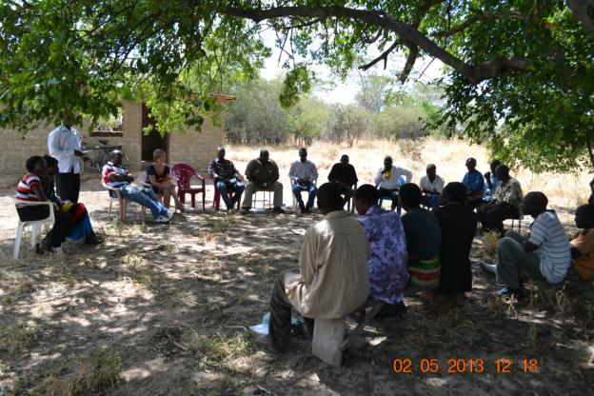

**Picture 1:** Community meeting at Kasaya – discussions on CRM and various project interventions

**Climate risks – and understanding**

* Perceived worsening of climatic conditions, with more pronounced dry spells. A change in seasonal onsets of rains observed. Seasonal flooding in strong rain years.
* Observe a reduction in agricultural productivity, which farmers’ link to climatic variability. Mention of possibly reduced soil fertility.
* Flooding a problem to livestock production and during 2005/06 rainy season many animals were lost to disease; livestock had to be moved and significant losses to households occurred.
* In “disaster” times farmers have to sell all their farming implements and belongings – and they have no savings for new start ups after a difficult period – this makes them very vulnerable to shocks. It was reported that many farmers had not recovered after the 2005/06 flood impacts.
* They are used to relief support and say it was needed. Hunger was still noted as a major problem in many households.
* Overall all adaptation activities promoted through the project are very well interpreted in a climate change context by community members.
* The overall awareness and understanding of weather, climate, climate change, climate change impacts and possible adaptation responses seems to be good amongst community members, including both women and men.
* MAL extension personnel seemed to have a satisfactory level of understanding of climate change and how to interpret adaptation actions in a climate change context.

***Outcome 1: Climate change risks integrated into critical decision making processes for agricultural management at the local, sub-national and national levels***

* An automatic weather station has been set up. It is not yet transmitting data to ZMD in Lusaka, although efforts have been made to operationalise the system.
* The MAL extension officer services the station on a regular basis.
* Training of community members in basic weather related topics was conducted by the district level ZMD.
* Amongst community members there are expectations as to what a EWS should deliver – early information on seasonal forecasts, predicted onset of rains, etc.
* The community had no idea what EWS information they would receive through the project, and were not aware about what the weather station could deliver aside improving the national observation system.

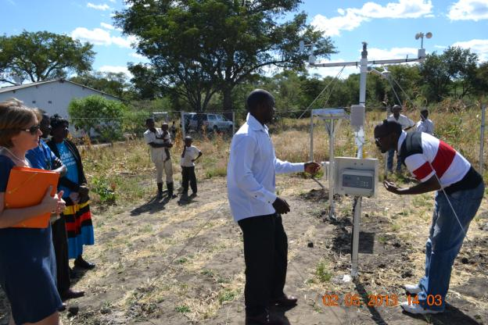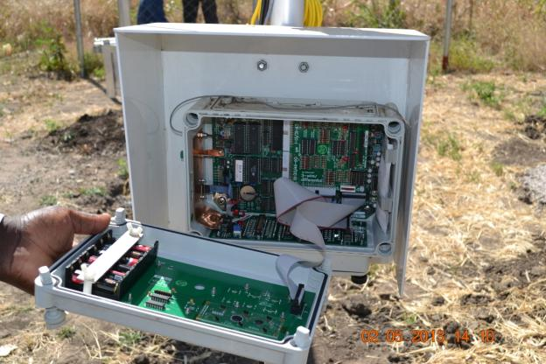

**Pictures 2 & 3:** The automatic weather station at Kasaya is set up. No data are currently automatically transferred. There is no electricity for a computer and modem to be run on a regular basis.

***Outcome 2: Agricultural productivity in the pilot sites made resilient to the anticipated impacts of climate change***

Project interventions in Kasaya focus on:

* Soil and water conservation & soil improvement
* Crop diversification
* Alternative livelihoods
* Community water (not seen and not clearly understood)
* Support to group building

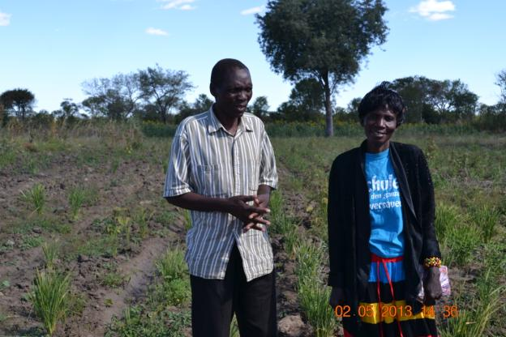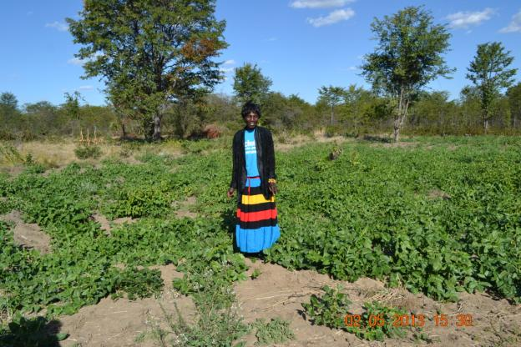

**Pictures 4 & 5:** Demonstrations of conservation agriculture and crop diversification interventions

The MAL extension officers had provided trainings and site specific support to soil and water conservation, and demonstrations of application were found throughout the study site. Farmers were also supported with specific farm implements such as rippers used for conservation agriculture, amongst other. Farmers indicated that the yields from their fields had increased although no specific measures were given of this. Overall there was great enthusiasm about the interventions and a high level of demonstration effects was reported.

Soil and water conservation practices were applied in the context of crop diversification as well. And both adaptation measures were usually applied in an integrated manner.

In Kasaya, rice has been promoted in certain areas that are prone to seasonal flooding and other areas considered good for highland rice production. Other crops promoted included sorghum, cowpeas, groundnuts and sunflower.

Diversifying the crop production from mostly maize to include rice is seen as a good adaptive strategy by the local farmers. A rice production group has been established, sharing technical knowledge and farmers learning. Joint marketing of rice is being considered, if sufficient amounts of rice can be cultivated for sale.

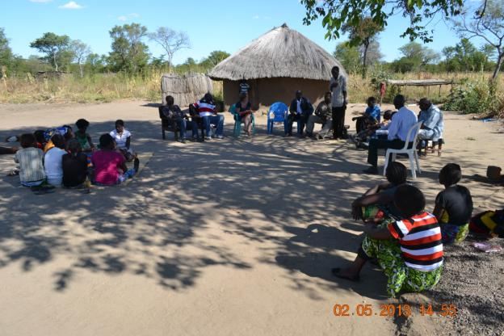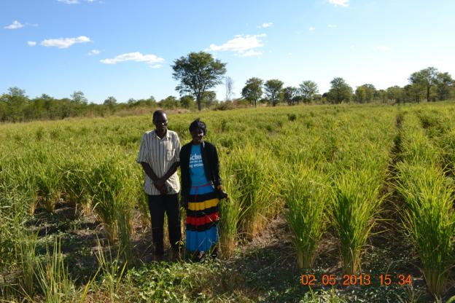

**Pictures 6 & 7:** The rice producers groups and a demonstration of growing highland rice varieties in Kazungula district

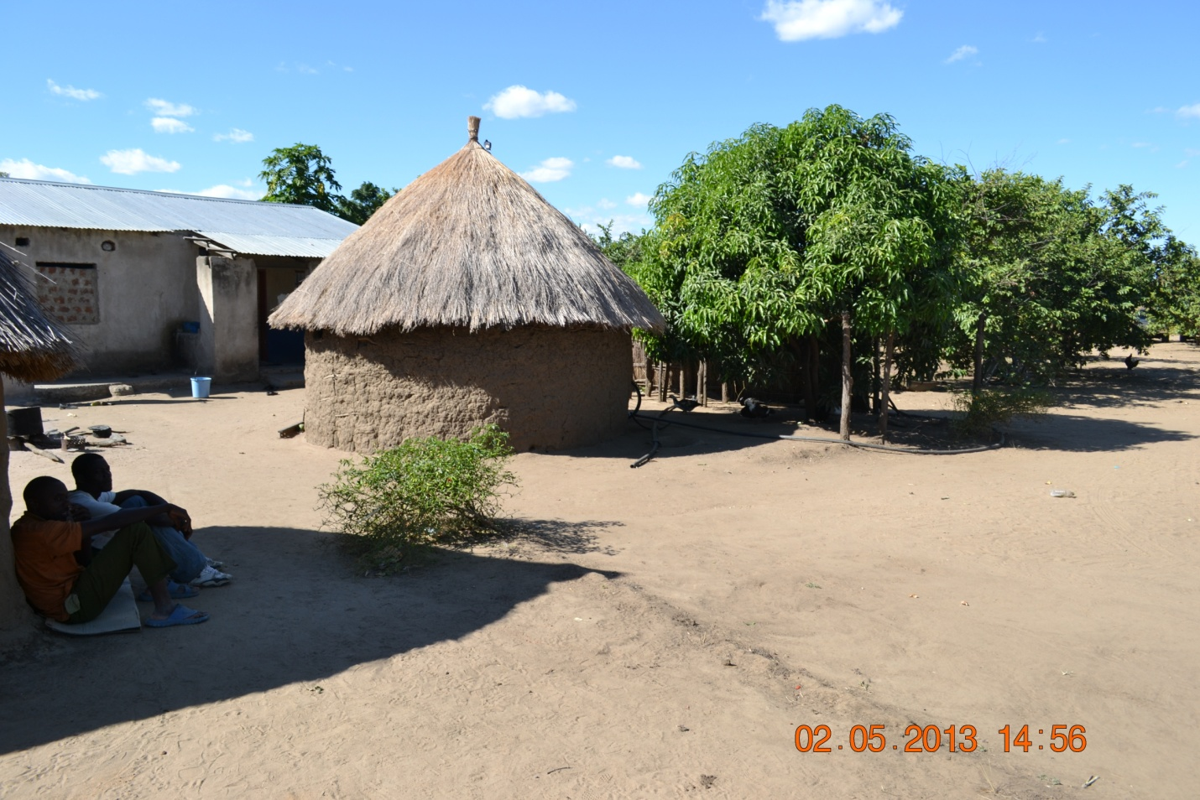

**Picture 8:** Other naturally occurring diversifications such as growing fruit trees

There was a clear demonstration and peer learning effect observed at this site – and local coping strategies were pointed out – mostly related to generally a more diversified production base, including home gardens with fruit trees and other.

Notably farmers made efforts to calculate yields from the various crops they planted and expected earnings. For example, one farmer said she would be able to produce 4 to 5 x 50 kg bags of sorghum on 0.5 acres of land this season. One 50 kg bag will sell for 60 KWS - thus she expected an income of around 250 to 300 KWS from her production. (This seems to be on the low side and needs to be verified).

Building of local seed banks was only a marginal topic at this time. Although most farmers complained that the delivery of implements from the project (and/or Government) is not always timely, and climate resilient seeding material is not always available developing own seed banks seemed not to have been addressed specifically as an integrated topic. Post harvest losses also featured very lowly during the discussions.

Two main areas of alternative livelihoods supported by the projects are (i) bee keeping and (ii) small stock production i.e. goats. Small producer groups have formed for each product line.

At this point no specific increase in household income was reported, as the interventions were mostly still at an early stage. No full honey harvest had taken place as yet and bee hives were still being populated by local bees. Overall there was an understanding that various products could be gotten from the bee hives, including honey and wax. There were some great assumptions about how much revenue could be generated e.g. per litre of honey produced. However, no sales were made and market and marketing research were rather low. Specific requests for support for the producer groups (both bees and small stock) indentified needs for training in product development and marketing, in particular. Livingstone with its great tourism industry was identified as a potential market, but besides food safety standards, professional packaging, labelling and market development were seen to be of importance. Relevant NGOs or individual supported may need to be identified to help the community in this regards. It was suggested to organise exposure trips to communities where honey production has become a viable and meaningful income source.

MAL indicated they would have the necessary capacity to assist the communities with marketing training.

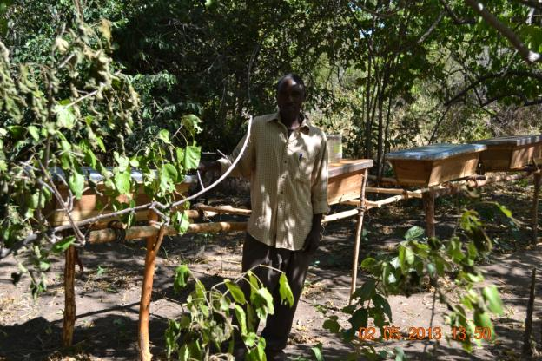 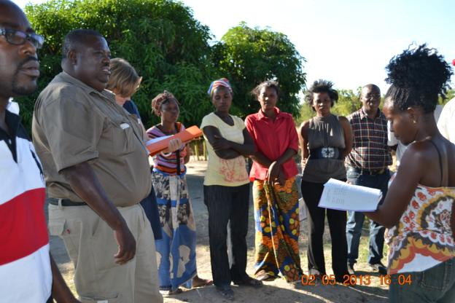

**Pictures 9 & 10:** Demonstrations of livelihoods diversification pilots (bees) and the goat producers group

Small stock interventions included the provision of breeding animals for group members, and one ram for the entire site. The small stock group organised their own innovative system of how the ram would rotate through a “ruffle” system. Initial off spring were born and there was a lot of excitement about the prospects to build up sizeable herds. No sales had been made to date and thus no information on increases of household incomes are available at this time. The farmers were trained in building goat dens that would not submerge under water during the rainy season, and training in basic veterinary needs and acre was provided through MAL.

It was observed that overall bee keeping was mostly practiced by men, whilst a visible number of women engaged actively in the small stock production and producer group.

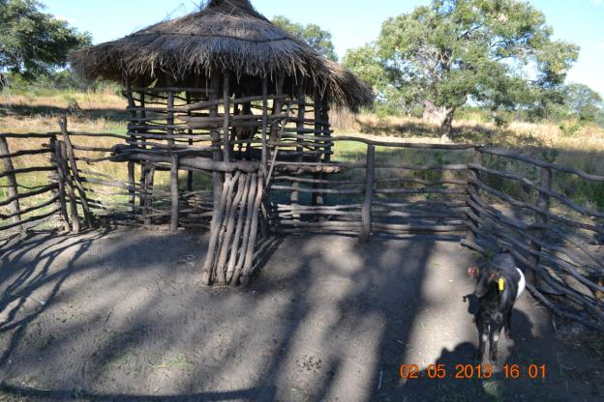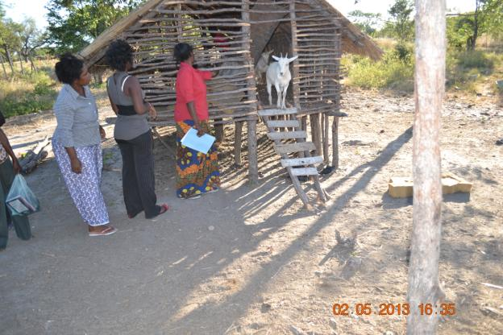

**Pictures 11 & 12:** Demonstrations of goat keeping as alternative livelihood strategy. Several women-headed households benefited from this activity.

Overall the need for water was highlighted. Although water related project interventions were promised and spoken about they did not materialise to date. Household level rainwater harvesting is currently not much explored as an option.

***Outcome 4: Lessons-learned and knowledge management component developed***

* At Kasaya NAIS undertook some initial activities documenting local actions and sharing them.

|  |  |
| --- | --- |
| **What worked well** | **What did not work so well** |
| * Great learning opportunity for community members * Access to start-up opportunities and demonstrations * Conservation agriculture techniques show immediate productivity improvements * Provision of implements * MAL extension team promotes self-help capacity amongst farmers to enhance sustainability potential | * Project inputs and implements did not come in time – seeding materials arrived after the planting season * Are not sure about marketing, pricing etc. – and would need further support * Automatic weather stations – need electricity for downloading – better to have a direct data transfer to Lusaka |

1. **Lusitu site, Siavongo District**

**Brief site description Siavonga district**

* Population size of 58,864
* Along the Kariba dam, Siavonga is home to Zambia's kapenta fishing industry, an important high protein staple food supplied mainly to the Zambian market. Crocodile farming also takes place, supplying some of the best quality skins to the fashion industries throughout the world. Commercial fish farming of tilapia, the quarrying and cutting of natural stone
* Climate is mostly hot and dry, with average rainfall of about 600-700 mm per year
* The livelihood pattern in this zone is one of small-scale subsistence agriculture and livestock rearing. The main food crops cultivated are sorghum, millet and maize. Cotton is the main cash crop and vegetable cultivation is an income source for some households during the dry season. The main livestock kept are cattle, goats and chickens and these are important income sources at household level. Cattle are also essential for ploughing.
* The region contains a diversity of soil types ranging from slightly acidic Nitosols, to alkaline Luvisols, with pockets s of Vertisols, Arenosols, Leptosols and, Solonetz.
* Lusitu specifically is a resettlement location with relocations of people some 50 years ago when Lake Kariba was built; still get subsidised water (taps) from the Zambezi river; land degradation a major problem; overall area arid to semi-arid with poor arenosols

**Project implementation support at district level**

* Only met MAL staff (DACO); no representation of other potentially relevant extension services
* Committed staff at all levels with some understanding of CC context, but largely agricultural mind set
* Good M&E and reporting capacity
* HACT – direct financial disbursement modality

**Climate risks – and understanding**

* Observed changes in rainfall patterns. This years’ rainy season particularly bad – are experiencing a drought.
* Later onset of the rainy season. Go-stop-go-stop patterns which make crops wither and any sort of agricultural activity a gamble.
* Need to have all necessary agricultural implements at hand well in advance so that they can practice adaptive – and reactive responses i.e. immediate planting at first rains. Soils have to be prepared before.
* Climate related pests on increase: army worms and armoured crickets.
* Livestock management must be practiced according to rainfall – and emerging agricultural opportunities. Free ranging animals must be restricted before the rain starts to allow fields to be prepared. Although most farmers keep livestock herds as “banks/savings” there seems to be a conflict between pastoralists and agricultural lists interests.

**Project interventions descriptions/evaluations**

Project interventions in Lusitu focus on:

* Soil and water conservation & soil improvement
* Reforestation and erosion control
* Water provision (dam) and conservation agriculture (drip irrigation)
* Community committee formations

***Outcome 1: Climate change risks integrated into critical decision making processes for agricultural management at the local, sub-national and national levels***

* An automatic weather station has been set up. It is not yet transmitting data to ZMD in Lusaka, although efforts have been made to operationalise the system.
* Two community volunteers do weather readings four times daily and record the data in a data book. They transfer the data regularly to ZMD in Lusaka, however do never get feedback on their data submitted. A great sense of ownership, responsibility and expectation was expressed by the one community volunteer doing regular weather readings.
* Community members expressed that they hoped the local weather station will help provide them with timely early warning information that they could apply to their agricultural practices and aide in decision making e.g. on which crops to plant and when.

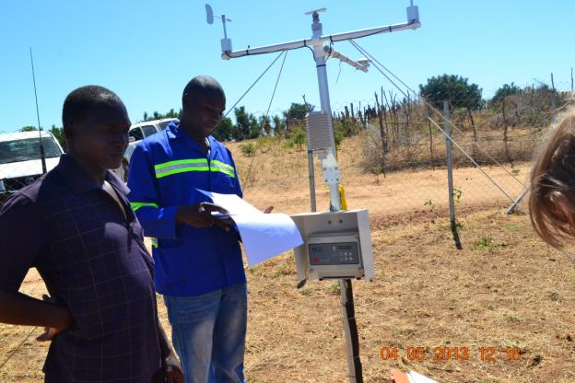 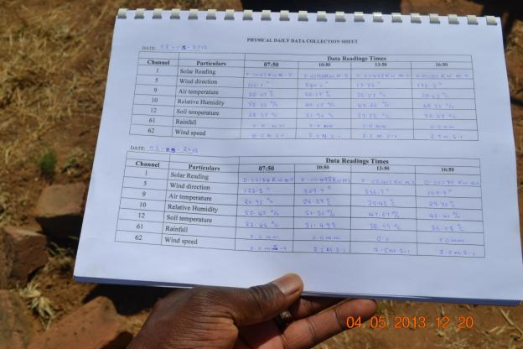

**13 & 14:** The automatic weather station at Lusitu is set up and two community volunteers make readings four times daily and transfer the data to ZMD in Lusaka regularly.

***Outcome 2: Agricultural productivity in the pilot sites made resilient to the anticipated impacts of climate change***

The establishment of tree and plant nurseries is being promoted as one adaptation response in arid Lusitu. Land degradation is pertinent and deforestation and gully erosion two of the major challenges observed in the area. Although it is recognised that overstocking and poor livestock management and rangeland management practices are at the core of the problems, the MAL extension services indicate that these issues are simply too difficult to address directly.

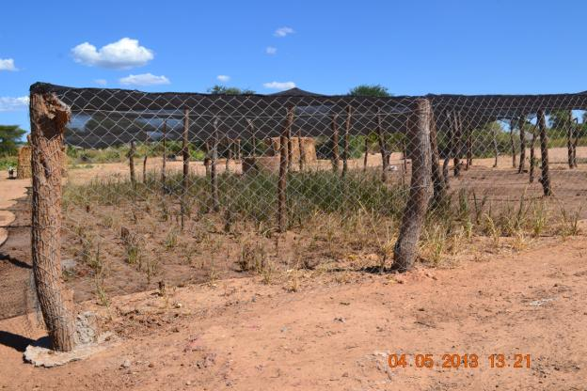 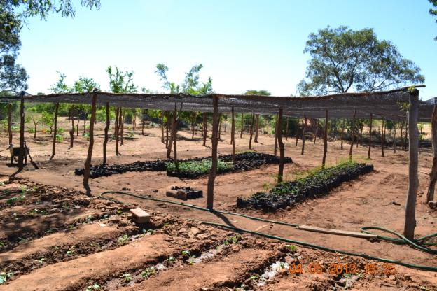

**Pictures 15 &16**: Tree and grass nurseries were set up with differing degrees of success. Working with a local school was particularly successful.

Although several tree nurseries were established and management committees established, only one nursery at Chilindi worked out really well. Here the management of the nursery was linked to the local school. The children and also their parents get involved in work in the nursery and ownership is strong. Integrating environmental management topics such as the need for tree planting to stabilize soils in the children’s’ learning generates good learning impacts also at the overall home. Running competitions such as “Who’s tree is growing best” encourage actions. Soil & water conservation practices are being demonstrated in the nursery for replication in home gardens.

The DACO office enrolled all project nurseries at Lusitu into a national programme that is seeking the supply of a specific amount of plants for rehabilitation and other purposes against cost. Thus a financial incentive will be created to foster ownership and performance. Overall there was a debate if a privatisation of the nurseries would be a more sustainable approach rather than managing them through community committees.

The extension officers described Lusitu generally as a community used to “relief” and outside support. Due to the historical situation of being the descendants of previously dislocated people (see above) self help motivation is regarded to be very low.

The school garden, for example, benefits from water supply from the tap – a situation not granted at all the other nursery sites.

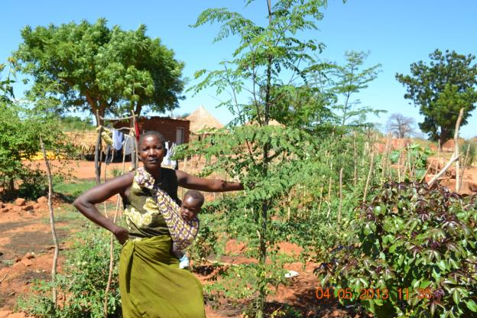 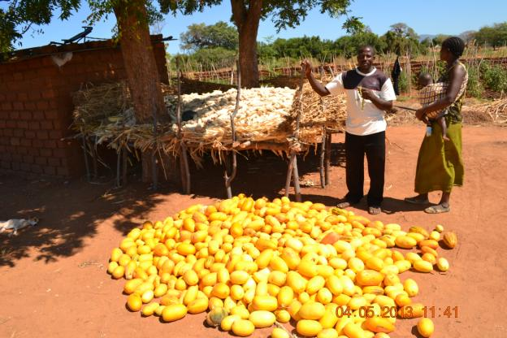

**Pictures 17 & 18**: A demonstration of a tree seedling received from the local nursery by school aged children beard fruits, and produce from a household garden.

The planting – and nurturing – of shade trees is very popular. Local families have requested also the provision of fruit trees, although it is clear that water needs for most fruit trees may not be appropriate for the site.

Trees, shrubs and grasses are used for the stabilisation of erosion gullies. There are often “broken” through stone walls and micro water situations created that will enhance vegetation establishment. A problem is that erosion is so widely spread in the area that there won’t be sufficient rocks available to fill all gullies up. For this project, for example, a demonstration has been selected protecting a local main “track” used by vehicles. Erosion can become so harsh that the “roads” have to be changed and that vehicles cannot pass.

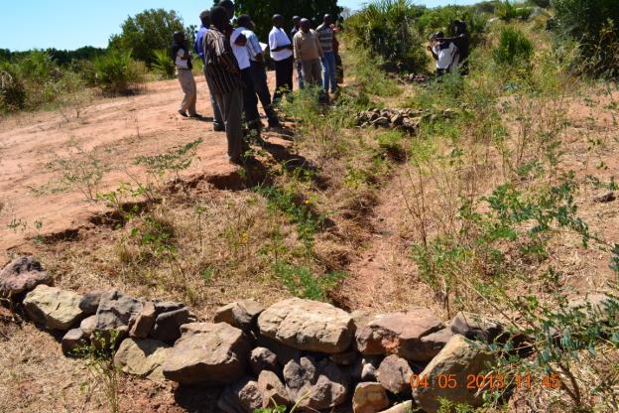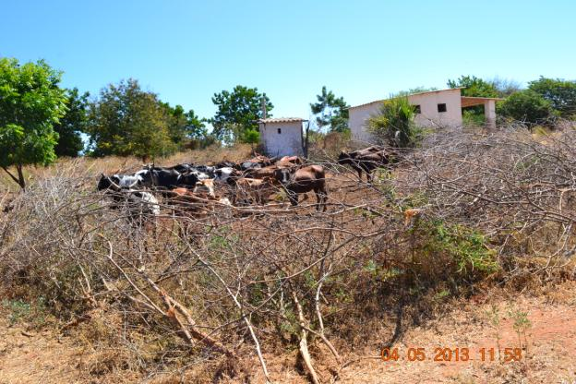

**Pictures 19 & 20**: Erosion control interventions: building gyres and controlling livestock movements.

It is considered a problem that large amounts of livestock roam freely in the rangeland as they uproot any newly planted tree if not specifically protected. Similarly – as already reported above – livestock are feared for destroying agricultural areas and gardens.

Surprisingly there is very limited reported use of the livestock for food security reasons. Mostly the small and large stock are kept as “savings”. Considering the large negative environmental impact they have on soil condition the trade off costs seem to be high.

Local diets are reportedly mostly made of local crop production. Maize is popular as higher amounts of produce on a piece of land can be achieved in good rainfall years compared to other crops such as millet or sorghum. However, the local farmers do recognise that maize is a highly drought sensitive crop – which has led to years of very poor harvest. Much of the local produce is consumed at home. Veld fruits and gardening produce supplement porridge to a very significant level. Wild veld fruits are reportedly very popular and critical to the local diets.

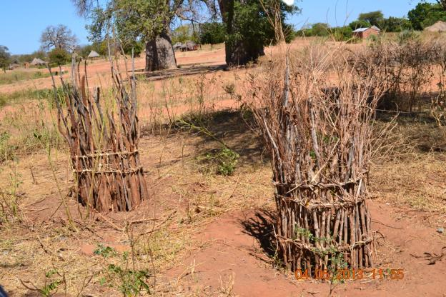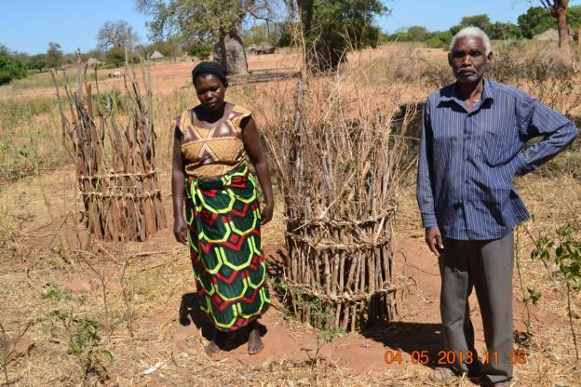

**Pictures 21 & 22**: Protecting the tree seedlings from livestock impacts.

The lack of water is reportedly the most significant challenge to local farmers. Although tap water is available for i.e. drinking water provision at some sites, the supply has not always been stable. To water home gardens and practice dryland irrigation additional water sources should be developed, according to the local population and the MAL.

To capture rainfall run-off from a sizeable ephemeral stream, the project is supporting the building of a dam. Foreseen water uses are mainly for dryland irrigation and for livestock watering. There are extremely high expectations amongst the local communities for this additional water source.

However, from the site visit and discussions with the technical personnel of MAL and the constructor, a few red flags related to dam sightings, costing and sustainability arose. The dam could very well turn out to be a mal-adaptive investment in the longer term, promoting agricultural and livestock husbandry alternatives that are not appropriate to the arid environment, especially taking into account climate projections for the area indicating a possible reduction in rainfall and available moisture.

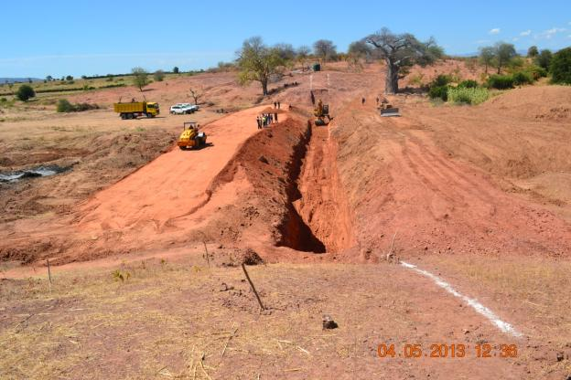

**Picture 23**: Construction works at the Lusitu dam

Key concerns revolving around the dam at Lusitu include:

* No environmental or social screening information could be accessed at the time of the MTE. Such information apparently is part of the project design within MAL.
* Rainfall data and longterm climate scenarios were not strongly incorporated into the dam sighting and design; a low in flow could lead to the dam never really filling up, whilst dramatic flash floods my wash away the dam wall.
* The price of the dam building operations severely overshot the money allocated for water infrastructure development per site. Approximate 214,000 US$ were allocated in the project document per water infrastructure at each site – at the time of the visit the cost for the dam alone – without associated irrigation infrastructure was estimated at above 550,000 US$ by the constructors and the technical MAL staff.
* Considering the already poorly managed rangelands in the surrounding areas suggest that improved livestock and rangeland management will have to be key to the continued project interventions at this site to avoid further degradation.

|  |  |
| --- | --- |
| **What worked well** | **What did not work so well** |
| * School co-management approach brought about very nice results and motivation * Can achieve CCA through EE in the wider sense through changing attitudes and demonstrations | * Project inputs and implements did not come in time – seeding materials arrived after the planting season * Automatic weather station not yet fully operational * Responsiveness of community not so strong - dam is considered a “maker or breaker” for getting more buy-in |

1. **Kabeleka site, Chongwe District**

**Brief site description of Chongwe District**

* Population size of 137,461
* Has good access to markets and is highly productive in terms of crops and livestock; close proximity to Lusaka.
* Normal rainfall is about 800 mm per year.
* Farming livelihood zone with maize produced as the staple crop, sweet potatoes and pumpkins as supplements and groundnuts as a component of both relish and snacks. Contract cotton has become the most important cash crop followed by localized production of cassava. Cowpeas, beans and sunflower are also grown in relatively small quantities, primarily for consumption. Goats are the main livestock reared, though cattle and pigs are also.
* Most common soil types in the area are Leptosols which are very shallow, extremely stony or gravelly and well drained soils. Lixisols, a soil type with high-base status having higher clay content in the subsoil than in the topsoil as a result of soil forming (pedogenetic) processes, 3. Vertisols, heavy clay soils with a high proportion of swelling clays, are found in the poorly drained unconsolidated deposits.

**Project implementation support at district level**

* Integrated team of forestry, met services and other active on site
* Committed staff with very limited understanding of CC context; mostly agricultural mindset
* Good M&E and reporting capacity
* HACT – direct financial disbursement modality
* Peer discussions amongst technocrats from different disciplines and institutions; example – water availability discussion

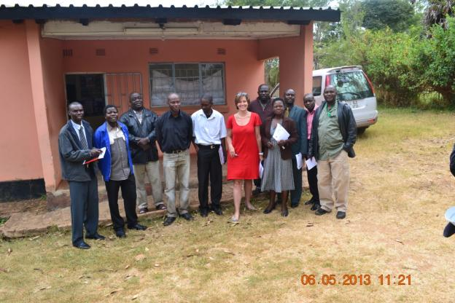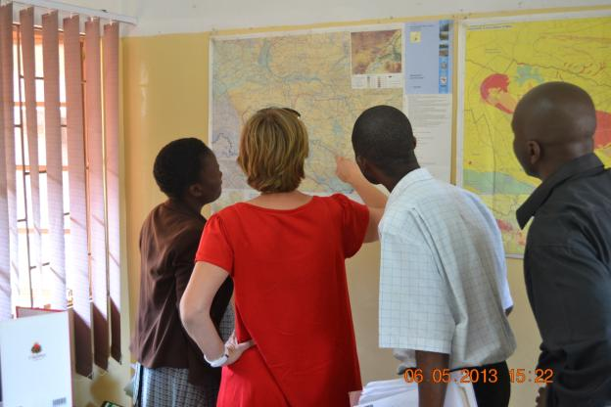

**Pictures 24 & 25**: Collaborations amongst the extension team at Chongwe. Information based decision making in the office of the water specialist.

**Climate risks – and understanding**

* Rainfall very erratic; later onsets of rains. This year considered a drought year.
* Last year – observed frost damage – not considered “normal” in the area by farmers
* Climate related outbreaks of pests – army worms destroyed the harvest in two consecutive years
* In the past rains were expected in October, then the agricultural calendar moved the planting season into early November, and now it is end of November- if rains arrive at all
* Rainfall scarcity affects ground water table and water accessibility and quality
* Specific types of crops are considered high risk, as they depend on good rainfall

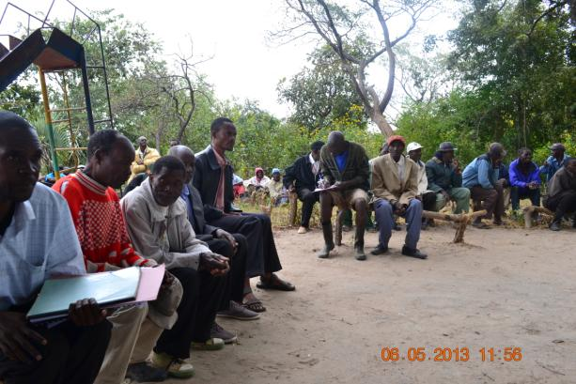 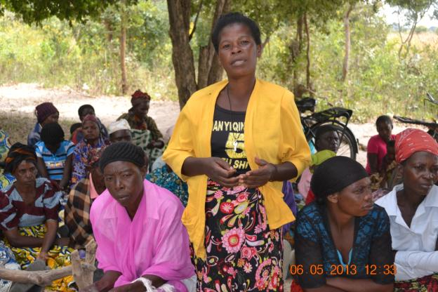

**Pictures 26 & 27: C**ommunity meetings at Kabeleka. Women spoke out too.

**Project interventions descriptions/evaluations**

Project interventions in Kabeleka focus on:

* Soil and water conservation & soil improvement
* Crop diversification
* Alternative livelihoods
* Water provision (dam) and conservation agriculture (drip irrigation)
* Community committee formations

***Outcome 1: Climate change risks integrated into critical decision making processes for agricultural management at the local, sub-national and national levels***

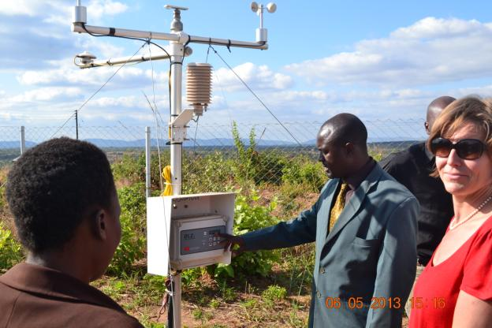

**Picture 28:** Weather station at Chongwe

* The automatic weather station is situated near the DACO office in Chongwe and is manned from there.
* As elsewhere it is not fully operational.
* The sighting of teh station is poor as it is now enclosed by some new buildings.
* The station is far removed from the community which did not make any connections to the weather station; generally awareness about the EWS component of the project was very low

***Outcome 2: Agricultural productivity in the pilot sites made resilient to the anticipated impacts of climate change***

For the community the most important project intervention is the promised building of the dam. A relatively smaller dam will be constructed near the main village and irrigation infrastructure be developed for small gardens. An annually emerging stream will be dammed, and rainfall run-off be captured.

Overall the dam site at Kabeleka seems less controversial than in Lusitu, which has overall much higher rainfall figures. The district water affairs officer checked the water conditions for the area and suggested that even some boreholes could be developed, as the newly developed hydrological map for the district suggests that a sustainable aquifer borders the village. The boreholes water could be used for human consumption in particular.

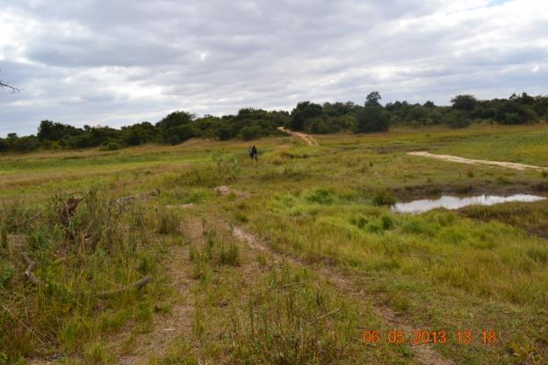

**Picture 29:** Sighting of a small dam infrastructure at Kabeleka

The cost of the dam is also envisaged to be higher than the allocations for the site, and currently stand at least 350,000 US$. Design queries have to be addressed and costed.

Other water usages for the dam were suggested as follows:

* Irrigation – vegetable production
* Winter maize
* Water or livestock
* Fish farming

A dam management committee has been established and it is operational – looking at issues such as land and water user rights and regulations, and so forth.

Soil and water conservation practices as well as crop diversification have been introduced through the project. With the making available of implements such as rippers good demonstration effects could be rendered even in a poor rainfall season.

Productivity is said to have increased, however, no mathematical information was available to track actual or even possible increases in household incomes.

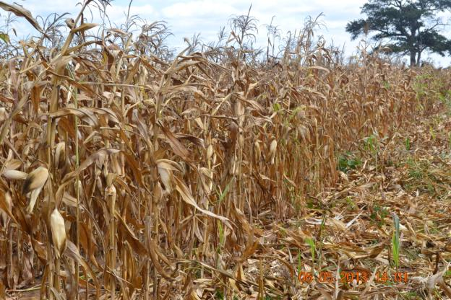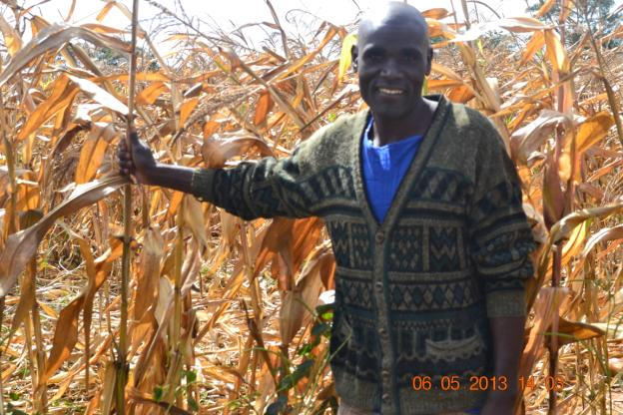

**Pictures 30 & 31:** Demonstrations of conservation agriculture and crop diversification

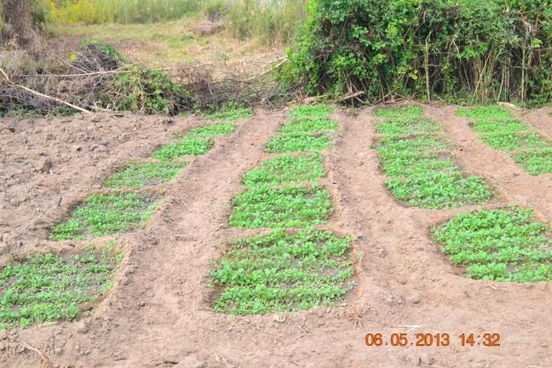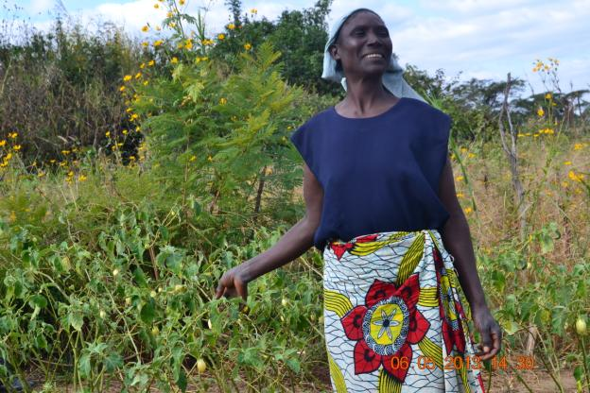

**Pictures 32 & 33:** Demonstrations of conservation agriculture and crop diversification

Market access for sales of produce i.e. from irrigation is relatively easy from Kabeleka. The road system is currently being improved and the overall proximity to Lusaka is considered a real opportunity.

Several farmers have received bee keeping training and equipment. Overall bee keeping is considered a highly successful alternative income investment, although no actual figures on production and sales were available.

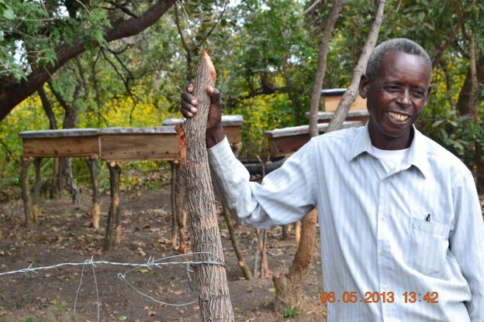

**Picture 34:** Bee keeping intervention as climate resilient alternative livelihood opportunity

|  |  |
| --- | --- |
| **What worked well** | **What did not work so well** |
| * Payment method greatly appreciated by DACO * Got 2 Mio KWS in counterpart funding from MAL for irrigation development in Chongwe * The DAM - people are extremely excited about the dam! | * Timeframes – procurement and payments take too long (direct payment now better) * Use of vendor forms too complicated – should rather follow established Government procurement systems * Project inputs and implements did not come in time – seeding materials arrived after the planting season * Bee keeping cloths not in right sizes (too small for larger people) * No really impressive demonstrations due to the poor rainy season – demotivation of farmers |

## Annex 7: List of documents consulted in support of MTE

*Enhancing gender mainstreaming in the project: Adaptation to effects of climate variability and change in Agro-Ecological regions I and II Zambia.* (No date). Zambia government

Global Environmental Facility. (2008). *Project identification form: Adaptation to the effects of drought and climate change in agro-ecological zones 1 and 2 in Zambia.* Washington: Global Environmental Facility.

Global Environmental Facility. (2008). *Request for project preparation grant: Adaptation to the effects of drought and climate change in agro-ecological zones 1 and 2 in Zambia.* Washington: Global Environmental Facility.

Government of the Republic of Zambia. (Undated). *Adaptation to the effects of drought and climate change in Agro-ecological Regions I and II in Zambia: Project Document.* UNDP: New York

Kalamatila, R. (2010).*Adaptation to the effects of drought/flood and climate change in agro- ecological regions 1 and 2 in Zambia.*(Inception workshop procedings). Lusaka: Ministry of Agriculture and Cooperatives

Mambwe farmer training report. (2012). *Conservation Agriculture, Beekeeping and Crop diversification.*

Ministry of Agriculture and Cooperatives. (2009). *Inception workshop report on the: Adaptation to the effects of drought/flood and climate change in agro-ecological regions 1 and 2 in Zambia.* Lusaka: Zambia

Ministry of Agriculture and Cooperatives. (2012). *Inception workshop report on the: Adaptation to the effects of drought/flood and climate change in agro-ecological regions 1 and 2* (1st Quarter report)(Ed). Lusaka: Zamibia

Ministry of Agriculture and Cooperatives. (2012). *Inception workshop report on the: Adaptation to the effects of drought/flood and climate change in agro-ecological regions 1 and 2* (2nd Quarter report). Lusaka: Zamibia

Ministry of Agriculture and Cooperatives. (2012). *Inception workshop report on the: Adaptation to the effects of drought/flood and climate change in agro-ecological regions 1 and 2* (3rd Quarter report). Lusaka: Zamibia

Ministry of Agriculture and Cooperatives. (2012). *Inception workshop report on the: Adaptation to the effects of drought/flood and climate change in agro-ecological regions 1 and 2 in Chongwe district Kabeleka Zambia* (Fourth Quarter Report)*.* Lusaka: Zambia

Ministry of Agriculture and Livestock. (2012). *Adaptation to the effects of Climate Variability in Agro-Ecological region in Mambwe* (Fourth quarter report)*.* UNDP: New York

Ministry of Agriculture and Livestock. (2013). *Adaptation to the effects of Climate Variability in Agro-Ecological region in Chama: First quarter report.* UNDP: New York

Ministry of Agriculture and Livestock. (2013). *Adaptation to the effects of Climate Variability in Agro-Ecological region in Chongwe*. UNDP: New York

Ministry of Agriculture and Livestock. (2013). *Adaptation to the effects of Climate Variability in Agro-Ecological region in Chongwe: Quarterly report*. UNDP: New York

Ministry of Agriculture and Livestock. (2013). *Adaptation to the effects of Climate Variability and change Agro-Ecological region in Kazungula district.* UNDP: New York

Ministry of Agriculture and Livestock. (2013). *Adaptation to the effects of Climate Variability and change Agro-Ecological region in Siavonga district: First quarter report.* UNDP: New York

Ministry of Agriculture and Livestock. (2013). *Adaptation to the effects of Climate Variability and change Agro-Ecological region in Siavonga district.* UNDP: New York

Munachonga, M (2013). *Practical Guideline for Gender Mainstreaming into LDCF Climate project* (2nd draft report). UNDP: New York

Siamiyoba, P. Nyanoka, E. & Kalamatila, R. (2013). *Field visit report for Lusaka (Chongwe and Luangwa) and Eastern (Mambwe and and Chama) Provinces.* Ministry of Agriculture and Livestock: Zambia

THEWO. (2012). *Climate change adaptation programme: Consultancy to Assess Financial Management Capacity Cash Transfer to Pilot Sites.*(Final Report). Chartered Accountants of Zambia: Lusaka

THEWO. (2012). *Climate change adaptation programme: Consultancy to Assess Financial Management Capacity Cash Transfer to Pilot Sites.*(Pre-final Daft). Chartered Accountants of Zambia: Lusaka

UNDP. (2012). *Bureau for development policy: One page mission report summary*

UNDP Zambia. (2012). *Mission report template*

## Annex 8: Planning and budget allocations for 2013

**2013 Deliverables - not necessarily Outputs as these can be achieved cumulatively over two or more years**

|  |  |  |  |
| --- | --- | --- | --- |
| **Outcome1** | 1.0 Climate change risks integrated into critical decision-making processes for agricultural management at the local, sub-national and national levels. | (a) 2013 Pre-and post season farmer survey report - an evaluation of income gains from the use of seasonal weather forecasts.  (b) An additional 240 small-scale farmers in all sites trained in climate change adaptation techniques with each farmer expected to subsequently adopt at least one adaptation technology. The training will also include crop diversification (drought tolerant, early maturing & multiple cropping to spread risks).  **(c) Report on EWS capacity needs assessment of PDCC/DDCC for effective early warning services at all sites to enhance communication of climate risk information to end users. A series of meetings /workshops will be held (2 at HQ level for 20 staff; 4 at PDCC level for 120 members; and 8 at DDCC level for 160 members / stakeholders.** | Budget: **$118,500.00** |
| **Outcome2** | Agricultural productivity in the pilot sites made resilient to the anticipated impacts of climate change | (a) Enhanced multiplication of drought tolerant and improved seed within the project's target communities.  (b) Farmers / community members trained in bee keeping and honey and wax processing and marketing at the project's Chikowa, Mundalanga, Kabeleka and Kasaya sites.  (c) Rehabilitated fish ponds at Kataba site are re-stocked with suitable fish breeds - one-off starter pack support.  (d) Rice milling equipment for farmers in Kataba, Kasaya, Sioma and Mundalanga provided as a one-off starter pack. (4 mills). This will include farmer training in rice marketing.  (e) Water holding and /or reticulation facilities developed as follows:   1. Irrigation system constructed in Sioma; 2. An earth dam constructed each at: Zalapango, Chikowa, Lusitu; 3. An irrigation system established at Lusitu in addition to an earth dam. | Budget: **$1289000.00** |
| **Outcome3** | **National fiscal and development policy revised to promote adaptation responses in the agricultural sector.** | 1. **Report on the sensitization of 40 government staff (policy and decision makers) on economic benefits of adaptation through regular dialogue between them and stakeholders implementing adaptation responses. This will be achieved through a series of four meetings / workshops at national level.** 2. **Two Provincial Plans on climate resilient development prepared after a series of dialogue meetings between stakeholders implementing adaptation responses on the one hand and Govt policy and decision makers o the other. Dialogue will involve 120 members of PDCC and 160 members of DDCC plus some of the 40 govt staff in 1 above.** | Budget: **$65,000.00** |
| **Outcome 4:** | Lessons-learned and knowledge management component established. | (a) Project specific information dissemination through public media broadcasting on both radio and television and publication of reports. This also includes linking project information into the existing MAL/other websites.  (b) Papers prepared and disseminated on lessons learned for policy adjustments. This includes disseminating such lessons to countries potentially facing similar climate change problems through international conferences and workshops. | Budget: **$35,000.00** |
| **Outcome** | Project management | Progress reviews (meetings at national and sub-national levels); travel to sites; equipment maintenance at national and sub- national levels; management costs (incl. salaries for two staff); communication and reporting costs; etc | Budget: **$178,500.00** |
| **Total Budget** | | | Budget: **$1,686,000.00** |

## Annex 9: Co-financing commitments

|  |  |  |
| --- | --- | --- |
| **Institution** | **Co-financing** | **Expenditure to date** |
| ZMD: | US$500,000 | USD$260,000 |
| CCFU: | USD$2,600,000 | USD$2,746,085.6 |
| FAO (CASPP) | USD$5,000,000 | USD$5,716,000 |
| GRZ(MACO) | USD$1,529,000 | USD$212,945.6 |
| UNDP-CO (Cash) | USD$175,000 | USD$78,624.08 |
| **Total** | **US$9,804,000** | **USD$9,013,655.28** |

## Annex 10: Code of conduct agreement form

Evaluators:

1. Must present information that is complete and fair in its assessment of strengths and weaknesses so that decisions or actions taken are well founded
2. Must disclose the full set of evaluation findings along with information on their limitations and have this accessible to all affected by the evaluation with expressed legal rights to receive results.
3. Should protect the anonymity and confidentiality of individual informants. They should provide maximum notice, minimize demands on time, and: respect people’s right not to engage. Evaluators must respect people’s right to provide information in confidence, and must ensure that sensitive information cannot be traced to its source. Evaluators are not expected to evaluate individuals, and must balance an evaluation of management functions with this general principle.
4. Sometimes uncover evidence of wrongdoing while conducting evaluations. Such cases must be reported discreetly to the appropriate investigative body. Evaluators should consult with other relevant oversight entities when there is any doubt about if and how issues should be reported.
5. Should be sensitive to beliefs, manners and customs and act with integrity and honesty in their relations with all stakeholders. In line with the UN Universal Declaration of Human Rights, evaluators must be sensitive to and address issues of discrimination and gender equality. They should avoid offending the dignity and self-respect of those persons with whom they come in contact in the course of the evaluation. Knowing that evaluation might negatively affect the interests of some stakeholders, evaluators should conduct the evaluation and communicate its purpose and results in a way that clearly respects the stakeholders’ dignity and self-worth.
6. Are responsible for their performance and their product(s). They are responsible for the clear, accurate and fair written and/or oral presentation of study limitations, findings and recommendations.
7. Should reflect sound accounting procedures and be prudent in using the resources of the evaluation.

**Evaluation Consultant Agreement Form[11]**

**Agreement to abide by the Code of Conduct for Evaluation in the UN System**

**Name of Consultant:** __     _________________________________________________

**Name of Consultancy Organization** (where relevant)**:** ________________________

**I confirm that I have received and understood and will abide by the United Nations Code of Conduct for Evaluation.**

Signed at (place)on

Signature: ________________________________________

1. The Harmonized Approach to Cash Transfers (HACT) approach has been introduced but the UN Development Group (UNDG) in 2005, and various UN agencies including UNDP are implementing the approach as a further step in implementing the Rome Declaration on Harmonization and Paris Declaration on Aid Effectiveness, which call for a closer alignment of development aid with national priorities and needs. The approach aims to focus efforts more on strengthening national capacities for management and accountability, with a view to gradually shift to utilizing national systems. The implementation of HACT required a suite of assessments be undertaken of the financial systems of the national partner institution and specific standards to be met. See more details at http://www.undg.org/index.cfm?P=255
2. Minutes of the 1st Steering Committee meeting, November 2011.
3. The consultations with Ms Chipichi, Director, MAL indicated that the context of the HACT modalities are still poorly understood and appreciated, which has negative impacts on the working relationship between MAL and UNDP.
4. The project design had planned for three growing seasons.
5. It is noted that currently Zambia has allocated all resources under GEF 5.
6. Both UNDP and GEF are focusing greater attention to ensure that gender issues are taken into account in project formulation and implementation, (see UNDP Gender Equality Strategy 2008-2011).
7. UNDP Style Manual, Office of Communications, Partnerships Bureau, updated November 2008
8. UNEG, ‘Ethical Guidelines for Evaluation’, June 2008. Available at: http://www.uneval.org/search/index.jsp?q=ethical+guidelines
9. The ratings are: Highly Satisfactory, Satisfactory, Marginally Satisfactory, Unsatisfactory
10. www.unevaluation.org/unegcodeofconduct
11. www.unevaluation.org/unegcodeofconduct