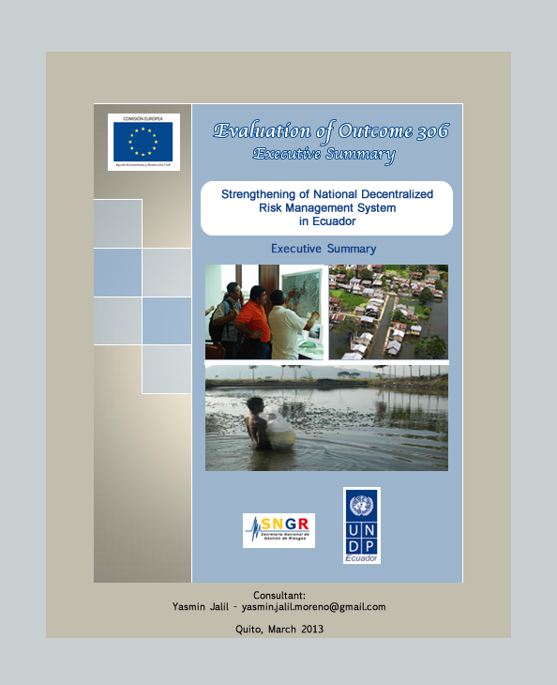

"I am extremely pleased with the support received from UNDP. It has been very respectful of Ecuador’s international cooperation policy and national legislation. We have been supported with specialized training and technology transfer. It has also facilitated the linkages among national government and local governments, as well as with other stakeholders. UNDP’s support has been demand-driven and efficient and interventions have been jointly defined"
(Pilar Cornejo, National Secretary of Risk Management).

Executive Summary

The United Nations Program for Development (UNDP), jointly with the Government of Ecuador, agreed to conduct an external evaluation of the progress and achievements of the Outcome 306: "Strengthening the National Decentralized Risk Management System (SNDGR –for its acronyms in Spanish) in Ecuador". The objective of the evaluation was to "assess the contributions of the initiatives and projects that UNDP has been implementing in the area of risk management and how they have generated changes and strengthened the SNDGR." The following criteria have been prioritized for the evaluation: effectiveness, pertinence, relevance, value added, sustainability, coherence with the goals of the Hyogo Framework for Action, knowledge generation, scaling-up and contribution of partnerships to achieve results and products. Even though Outcome 306 started in 2010, this evaluation assesses UNDP’s Risk Management Division contributions for strengthening the SNDGR, from 2008 to 2012.
During this period eight projects were implemented by UNDP, in alliance with national and subnational partners. The analysis of the main contributions of these projects to strengthen SNDGR, including significant results, good practices, obstacles, stakeholders, alliances and lessons learned, is the basis for this evaluation. Regarding the methodology, the evaluation started with a review of secondary sources. This allowed the identification of main intervention results, key stakeholders involved in processes, as well as strategic issues that were afterwards examined through interviews to prioritized stakeholders.

In quantitative terms, from 2008 to 2012, UNDP and its donors and partners contributed with USD 6'567600 for prioritized interventions. Geographical coverage of 19 provinces and 76 municipalities of the country was achieved. Capacities of 472 organizations were strengthened (including SNGR, Situation Rooms, universities, research institutes, educational institutions, community organizations, among others). Direct beneficiaries amounted to 42,527 people, while 6'463051 inhabitants indirectly benefited from the project.

From a qualitative perspective, main contributions of UNDP, in alliance with its partners, to strengthen the SNDGR, can be summarized as follow:

• Risk management regulatory framework strengthening
At national level, UNDP supported an advocacy process that achieved the inclusion of a comprehensive and decentralized risk management approach within the Constitution (through two key Articles). It also financed specialized technical support for the formulation of a draft National Strategy for Disaster Risk Management, as well as technical and legal advice to prepare the draft National Risk Management Law and its regulations. At local level, it has promoted the formulation of local ordinances in several municipalities. The remaining challenge is to enact and implement national regulations and further strengthen local regulatory frameworks, ensuring risk management mainstreaming in local planning processes and tools.

• Institutional framework reinforcement
To develop capacities of National Secretariat for Risk Management (SNGR –for its acronyms in Spanish), scientific institutions, universities, local decentralized governments and social organizations, as well as to strengthen linkages among SNDGR stakeholders and to test innovative alliances.

• Consolidation of the National Information Risk Management System
In order to support the System reengineering: National and local Situation Rooms have been better-equipped and provided with methodologies and tools. Technical entities responsible for the generation of specialized information, as INAHMI and IG-EPN, have improved their skills and strengthened their communication mechanisms with potential users of the information. UNDP has also contributed with the generation of local specialized information (vulnerability studies in 21 municipalities, contingency plans, etc.) and the reinforcement of early warning systems.

• Support national and local authorities during national emergencies
UNDP has efficiently advised and co-financed response strategies, adding value through the implementation of early recovery pilot projects.

• Generate and validate risk reduction strategies in urban contexts
To pilot-test innovative models for comprehensive risk reduction in urban contexts, including recovery planning, joint emergency planning among community committees and local municipalities and DRR plans in vulnerable schools.

• Knowledge management
To develop and validate high-quality DRR and DRM methodologies and tools, accredited and institutionalized by risk management governing institutions.

Regarding the accomplishment of UNDP risk management projects’ logical frameworks during this period, the evaluation process reached the following findings:

• UNDP interventions have been defined according to national and local risk management policies and priorities and have been able to adjust their strategies in a flexible manner according to contextual changes.

• Projects have added value to existing DRR strategies, through innovative approaches of risk management areas (early recovery, recovery planning, urban risk management) or by facilitating access to specialized expertise within the country and abroad.

• Interesting levels of scaling-up have taken place and certain results have been institutionalized, ensuring sustainability.

• Non-conventional alliances have been achieved among SNDGR stakeholders (for instance, local governments have cooperated with universities to implement municipal vulnerability studies; or scientific institutions have established partnerships with media and private sector to disseminate climatic information).

• Results, products, indicators and targets have been efficiently met.

Despite all achievements from this period, the strengthening of SNDGR still faces many challenges. In order to achieve them, several recommendations have been identified by stakeholders who have been involved in UNDP-supported risk management initiatives during this period:

- Implement strategies to mainstream risk management in policies and institutional agendas of sectorial ministries, coordinating ministries and local governments.

- Advocate for the effective decentralization of risk management competencies to municipalities and provide sustained support to this government level that still faces critical challenges within their territories.

- Promote and facilitate dialogue among municipalities and SNGR.

- Ensure the sustainability of initiatives, promoting the institutionalization and follow-up of achievements.

- Disseminate successful experiences and seek mechanisms for their institutionalization and scaling-up.

- Promote greater use of methodologies and tools that have been generated, especially by SNGR and municipalities.

- Create a Risk Management National Observatory in order to identify good practices and achievements, to monitor the performance of the System and as a mechanism for citizenry enforcement.

- Develop an institutionalized academic offer on the issue, capable of generating a critical mass of risk management professionals and able to evolve along with demand.

Some internal recommendations for UNDP include:

- Formulate a strategic plan for Risk Management Division that identifies strategic issues for SNDGR strengthening. UNDP interventions shall focus on key topics and territories according to national priorities.

- Ensure UNDP’s projects in all areas mainstream risk management approach.

- Strengthen Risk Management Division Team, so as to facilitate a closer backstopping and follow-up of interventions.

- Mainstream gender approach in all risk management interventions, testing innovative strategies that satisfactorily respond to women’s differentiated needs and interests regarding the topic.

- Strengthen internal mechanisms for information management and develop a knowledge management strategy that allows the Division and interventions to capitalize learning and good practices.

- Streamline administrative and financial processes of the area so that they do not constitute an obstacle for the operationalization of project activities.

