Project Final Evaluation

“2222 - Action Plan for Removing Barriers to the Full Scale Implementation of Wind Power in Mexico (Phase I)

Prepared by

Alejandro López Marmolejo y Edgar Rodolfo Rello Salvador (PROBIDE)

México, 2012

1. Executive Summary

1.1 Project Summary

Project name: | Action Plan for Removing Barriers to the Full Scale Implementation of Wind Power in Mexico
Project Number GEF: | PIMS 222 |  | Monto programado  (US $) | Monto real  (US $)
Project Number  UNDP: | 0013582 | GEF Financing | 4’736,000 | 4’736,000
Country: | México | Otros: | 4’860,000 | 4’860,000
Area: | Latin America | Goverment | 2’216,000 | 2’536,000
Focused Area: | Latin America | UNDP:
Operation Program: | Climate Change | Total cofinancing: | 7’076,000 | 7’396,000
Implementation  Agency: | OP-6 (Renewable Energies ) | Project Total Cost: | 11’812,000 | 12’132,000
Other Agencies involved: | Institute for Electric Investigations (IIE) | ProDoc Signature Date (Project Initiation): | 6 Nov. 2003
Type of project: | ----- | Closure Date of project: | Propuesta:  31 Dic. 2005 | Real:  Julio 2010
 | Full Size Project (FSP)

1.2 Brief description of the project

This full size project has been developed for about six and a half years (2004 – 2010). The approximate investment that has been contributed during this period of time is about USD $12’132,000, part of this amount USD $4’7360,000 has been provided by the GEF-UNDP associations, this amount was used in the Strategic Program for the climate change mitigation projects.

The development objective of the Project was defined to “to reduce global CO2 emissions by 4 million tonnes (Mt) per year by promoting the development of a commercial wind energy market in Mexico with a target of 2,000 MW of installed wind power capacity in ten years”. As inmmediate goals, the project proposed to eliminate the institutional barriers for the long term wind energy implementation in Mexico; so this would facilitate the installation and operation for three wind generation plants models connected to the National Electrical System in Mexico (SEN Mx. abbrev).

The Project Document (ProDoc) was approved and signed on December 2003. The project implementation was originally referred to last no more than two years. The project was due to be accomplished on July 2010, after seventy nine months from the project approval. The Project components and activities advance and achievement have been reviewed through the UNDP-CO and IIE Monitoring Tools during the Project implementation. These tools include the Project Implementation Report Annual Project Review, the Project implementation Review, the Project Quarterly Reports and the Annual Operation Programs. The comments and data consistency that are consigned are a testimonial for the project property, thus the validation of the commitments made.

The original established length of the Project was 24 months, and it was extended because of circumstances beyond the control of the IIE’s implementation and the UNDP-CO’s supervision. Among these circumstances, one of the most representative, was that the territory donation process in the wind development area was too long, and due to this the Wind Technology Center was delayed for three years; also the delivery times for the turbine acquisition were settled in periods of two or more years of the original estimated date. The second stage of the Project includes objectives related to the national wind resource evaluation follow up, the new wind Projects development formulation, the three business models construction and the proper development for the Mexican Energy Market and that way to increase it. This stage will not be continued by the implementing agency because of two reasons: the first one was already contemplated in section C of the Project Document, where it indicated that of the World Bank advanced successfully with the Government funded initiative denominated “Long Term Renewable Energy Exploitation Special Program” (PERGE Mx abbr), it wouldn’t be necessary continue with the second stage because the same objectives were contemplated in the PERGE.

On the other hand, on June 2007 the APR, the GEF-UNDP notified through the UNDP-CO to the IIE that they will not continue with the second stage due to the GEF CEO’s decision, who was initiating its management at the time, dictated that all second phases of all projects were cancelled. In special cases, the second stages would have opportunity to be developed and managed like new projects. De facto, this second stage was contemplated “not to be completed” in GEF-UNDP official documents since 2008.

As a strategy for the appropriation of the Project some promotion and communication goals were established among the actors involved in the project. At this point, the work convening capacity of the IIE, the participants’ interest and the support from different actors such as the State Government in Oaxaca achieved the approximate assistance of 1800 people in different seminaries, symposiums, workshops, courses and forums.

The Project has received substantial support by the local co financing with an approximate amount of usd$7.4 million. Different cooperation and exchange alliances have allowed to consolidate a technical assimilation strategy that has consolidated IIE and enforced the local capacities to face the future local human resources and energetic development.

1.3 The Evaluation background and objective

This Project Terminal evaluation was developed as an expressed request by the local UNDP local office in Mexico, as a mandated requirement for the GEF-UNDP projects. The period of time in which this evaluation was carried out was in September 2012, when the wind electric generator was restarted to be settled after some minor adjustments by the technological supplier.

1.4 The Main recommendations, learned lessons and Conclusions

1.4.1 Conclusions

Even when there were different federal, state and municipal public administration changes, not enough communication and cooperation between federal and state departments at the end of 2006 and 2007; and the delayed delivery results, this Project reached successful levels and learned lessons that will serve as a platform for future projects with different results.

The Project has contributed to modify the legal and regulatory environment which has “soften the road” to the long term wind energy in Mexico, with the government staff support and the GOM energetic strategy.

We have to mention at this point about the support given by the SENER, the CRE and the SHCP agencies which promoted the Interconnection Services Agreements as collective sources for the renewable energy or the short term efficiency on the co generative collective systems, 2004; the accelerated depreciation policies for environmentally friendly investments on 2004; the renewable energy generation law and the Energetic Transition Financing on 2008; the climate change Special Program on 2009; the Renewable Energy Generation Special Program on 2009; and the General Regulations for the national electrical system interconnection for generators or concessionaries with renewable energy sources or efficient generation on 2012, among others.

There is no doubt that we have a lot to do, but there was an open opposition or a perceived slowness shown by the three different government levels, that now has changed completely in a few years.

These shown results wouldn’t be possible to be completed because of the Project manager leadership and determination, he had the technological knowledge and talent to combine both, and his abilities to understand and address the needs, which always were changing, most of all with all the people involved in the regional environment.

There are some barriers that still are perceived according to develop these projects. The same barriers are a challenge for the energetic development because the public officer’s are beginning their management at the end of this year.

In the worst scenario, the impact goals for the Project as it was designed will be reached in two years. This is because at the beginning the natural gas Price of 1000 cubic feet was about usd$4.00 to usd$6.00 on May 2001 and we were mistaken. At this moment when this Final Evaluation Project is written (2012) the Price is usd$2.69 and it may vary in a short term to usd$2.20 or usd$2.18.

This, of course, makes very competitive the electrical energy generation with combined cycle platforms, these use natural gas, their Electricity Production leveled Price is a reference for the Electrical Energy Public Service Law, this reference is used by the CFE to purchase the electricity coming from energy independent producers, and as the mandatory interpretation of the Electrical Energy Public Service Law Report. Added to this, the fact that Mexico is located in the worldwide third place with natural gas resources in mudstones; and really close to the bigger consumption centers with the main importation points of such input from de US.

There were some data that were able to obtain from international financing institutions under the scheme of the Mexican south east wind Project, the internal rates backup were settled in levels between 8 to 15% after tax payments, without considering the carbon positioning. This deserved that some global investment qualifiers have been granted a BBB investment to the last wind electrical projects in the area which have settled public debt instruments.

At this last point, we will have to wait to know the resulting regulatory change for the climate change General Law that was issued on June; and from which we expect to contribute to deliver more veracity for these projects investment.

This leads to evaluate the Financial Sustainability as Probable.

Financial Sustainability
4. Probable | 3. Moderately Probable | 2. Moderately non probable | 1. Non probable

For 2015 the Project Document fixed goal to have an installed capacity of electricity production with wind electricity with an equivalent wind generation of 2,000 MW; this may be reached at the end of 2013.

Despite of this huge investment advance on the wind electric generation investment, the applications to obtain the generation permissions with this technology have decreased, so the visualized investments cannot be reached further 2014. This can be explained as a sign to wait until the knowledge of the GOM federal administration which begins at the end of 2012; this would modify the current legal framework.

For this, the socioeconomic sustainability will be qualified as Modestly Probable.

Socioeconomic Sustainability
4. Probable | 3. Moderately Probable | 2. Moderately Non probable | 1. None probable

Despite of all the progress obtained in the legal and regulatory framework, the appropriation for this generated technology may be weaken if the Electricity Federal Commission do not achieve the socioeconomic issues of the referred prices, with the regional breakdown in the RLSPEE contract, due to the legal contract interpretation to choose because “the long term total economic cost would be less”. This is the main risk of the Project: The Federal electricity Commission appropriation lost, due to the wind energy electricity generation for the next federal administration which begins on December 2012.

So, the Sustainability Institutional Framework qualifies as Moderately Probable.

Insititutional framework sustainability
4. Probable | 3. Moderately Probable | 2. Moderately None probable | 1. None probable

About the Environmental topic, we know that there are activities of some organized groups around the animal biodiversity; they tried to stop the wind electric projects development in the most powerful wind area in the country. We have settled different participation agreements among academic institutions, the investors, and the people living in the area associations and the three levels public administration organizations to establish monitoring programs based on condensed methodologies of participation to corroborate the animal biodiversity impact in the area. These monitoring programs are reviewed every five years to define the prevention assertive criteria and slow them if necessary. The first review will take place at the end of 2013.

Due this, the Environmental Sustainability qualifies as Moderate Probable

Environmental sustainabilityl
4. Probable | 3. Moderately Probable | 2. Moderately None probable | 1. None probable

By the year 2020 the private and public wind generation will reach a capacity of 12 to 15 thousand MW if the procedures of the CRE are published by the end of this year or at the beginning of 2013 about the renewable energy; and the GOM public administration management maintains the changes made by the CFE and the SHCP. To this based scenario, this wind electric generation will be equivalent to a reduction of the GG for more than 20 MTCO2 per year.

Viewed as a whole the “dimensions” described in the precedent sections we conclude that the Project sustainability is moderated Probable.

Project Sustainability
4. Probable | 3. Moderately Probable | 2. Moderately None probable | 1. None probable

The Project qualifications, its design and result are summarized in the following table:

GEF-UNDP specific elements identified | Assigned qualification by the reached terms results.
Project formulation | SUCCESSFUL
Conception and Design | SUCCESSFUL
National Apropiation | HIGHLY SUCCESSFUL
Involved participation | MODERATELY SUCCESSFUL
Project Implementation | SUCCESSFUL
Implementation development | HIGHLY SUCCESSFUL
Evaluation and Monitoring | MODERATE SUCCESSFUL
Involved Participation | SUCCESSFUL
Results | HIGHLY SUCCESSFUL
Objectives Achievement | HIGHLY SUCCESSFUL
Project Global Qualification | SUCCESSFUL

Due this, the Project achievement results and the visualized impact in a short term may qualify the overall performance as Successful.

1.4.2 The Learned lessons and Recommendations

It was mentioned in regulatory terms that there is a lot to do. Some of the Mexican investors and academics have proposed the need to ensure the “game” rules which may be planned in a long term, especially in a strategically topic for any country: the energy generation and transmission.

Some of the specific points that are necessary to keep working on are:

The Chamber of Deputies needs to have a peremptory legal term to approve or suggest modifications to the National Energy Strategy. (ENE mx ).

To update the strategically planning of the National Electrical System transmission and distribution, with regional disaggregation and the diffusion need by the CFE and SENER of the official documents to the electrical section planning.

That the academics, SENER, CFE and important involved organizations agree to calculate a methodology for the generation costs for the electricity generation with the different energy sources and different technologies, as the Electricity Production Level Price with regional disaggregation.

An estimate to define the electricity transmission cost for the regional fee scheme.

Mexico has chosen to initiate its experiences on the wind energy production technological development in one of the “highest” wind regimen areas for this purpose. This has produced technical difficulties that challenge the best worldwide designers which have taken it to an internalizing knowledge apparently “slow”.

These experiences properly exploited, however, may allow that this curves on the wind generation technology development for the electrical energy will be quite short and assertive, in case of reproduce these projects in slow wind areas. So, these projects that are taking place in Tamaulipas and Baja California may reach excellent results in a short term.

It is noteworthy in this regard, the opportunity that this represents for Mexico, as it has been done in Europe, China and India, explore as an alternative for the small villages with medium economic development, the Distributed Generation. The main advantages when the distributed generation is used are:

Distribution and transmission networks loss reductions.

The increase on the reliability of the electric power supply,

Control on the reactive energy and the voltage regulation in the distribution network.

Greater facility to incorporate generated energy by renewable sources; and

Capacity Release in the transmission lines that feed the distribution area, in consequence, the increase reliance to reinforce the capacity of the transformation and transmission system.

Implement medium and long term investments as they may be required to generate and transmit the electrical power, need minimal legal and financing certainty levels during the evaluation which may reduce the risk perceptions to “settle” the discount rates for the commercial partners in Mexico. This may allow that many investment projects for Mexico that were considered as non profitable because of the actual risk surcharges now would be taken profitable.

The Lessons learned

The social integration for any Project face different contemplated and none contemplated conditions; at the same time, it has different effects but, also, effects that were not expected. There are some elements identified for the development and design for future projects, this is with the purpose to inherit this experience acquired. These are the lessons learned:

The Project design was simple, flexible and logical, and with this was easier to adequate the times and reach the intermediate targets for the development conditions.

Ensure the participation, also in the design, of all the involved in the Project development.

The Project development in a time frame which do not exceed the management periods of the local public administration, it must include an extra time to “alleviate” the deadlines which increase because of the changing regulatory procedures or the applications accumulation to be processed.

Invest in the Itsmo de Tehuantepec area requires to set, in the project design, some susceptible options for the land acquisition for the implementation.

Use the programs and services that are offered by other government agencies.

The lack of Human Resources for the Project development increases its costs.

The components with high technological contents prices and delivery times are subject to economic cycles.

Take advantage of the opened “spaces” because of the opposition and critics for the Project to generate community support.

The opportunities generation for the cooperation networks creation.

Elaborate a document for Better Practices.

2. Introduction

2.1 Project Background

The idea to explore some wind powerful places in Mexico to produce electricity comes from the 80’s decade. In the middle of that decade, some IIE investigators said that the Itsmo de Tehuantepec area had the outstanding characteristics to take advantage of the wind.

On the 90’s, in the beginning, it was planned the idea to install a wind electrical generation center in that area. In 1994, the CFE (Electrical Federal Commission) hired a builder for the first center in Mexico, with wind electricity, in the middle of La Venta, a place in Oaxaca. So La Venta I the first wind electricity center was born.

The operative results of such center corroborate what the IIE was anticipating some time ago, the plant factors that were reached in La Venta I were higher than the reported as the highest in the world. Despite of the results, that in theory allow generating the benefits to assist the economic viability for a project, the private investors did not visualize that this was enough to trespass the associated costs to the barriers that formed the current regulatory framework at that time. The same CFE didn’t continue with the wind electric generation development in that area for several years.

The current regulatory framework at that moment, contemplate as a basic premise the electrical power generation, conduction, transformation, distribution and catering for the public service provision, this is an exclusive faculty from the Federal Electricity Commission. In the catering category, the private initiative participation, cogeneration and energy independent producer (PIE), were authorized by the 1992 reformation. Only accomplished on 2003, this proposal for “social participation”, would represent the electricity production under those modalities just 8% from the national electricity production.

At that time, the national energetic plan scenario, the baseline scenario, contemplated for the second decade in the middle of the XX1 century, that the wind electric generation will increase a Little more of 20 times, 22700%, while the combined cycle technology generation would be a Little less than three times, 271%. This huge difference on growth rates, however, and the national generation with CC technologies will maintain a higher proportion of a hundred times of the wind electrical generation. Check Chart 1.

To this baseline scenario and contemplating what was reported on 1997 in Mexico, concerning to its greenhouse gas inventory (GGI), with a 23% figure participation in the electricity production in the national GGI generation, arise the idea to look for alternative, renewable energy generation sources scheme search.

Chart 1 Prospective comparison of electricity generation technology, scenario 2004.

GENERATION TYPE | Power generation Exploration (GWh/año) |  | CHANGE  (%)
 | 2003 | 2013
Wind power | 6 | 1,422 | 23,700
Combination Cycle | 36,877 | 155,490 | 371

Source: SENER data own elaboration (2004), p. 106.

So the Ministry of Environmental Improvement and Natural Resources and the Ministry of Energy decide to pose a collaborative effort to develop a transversal policy not only to the energetic safety elements, also, the development area and the greenhouse gas reduction.

On the other hand, the IIE on its effort to develop a national electricity production programme through the wind generation and searched for international agencies collaboration for the cooperation to the development. Is this way how the IIE got in touch with the GEF through the UNDP.

In the proposed Project development by the IIE, it is contemplated a parallel effort to impulse which assist the reduction of investment and commercialization barriers from the produced electricity with wind generation.

The GEF-UNDP agencies agreed to participate in the IIE Project when it integrate the energetic safety topics, region development, greenhouse gas reduction; and the investment and commercialization barriers reduction for the wind electric power.

The Project was denominated as “Action plan to eliminate the long term development barriers for the wind energy in Mexico” and it was accepted in the Renewable Energies Operation Program on October 15th, 2002. The Project document (ProDoc) was signed as agreed by all the participants on November 6th, 2003. The Project development objective was defined as: Reduce the Mexico’s greenhouse gas annual emission, through the long term commercial wind generators installation and operation. The strategically objective is to reach an installed capacity of 2,000 MW in a term of 10 years which will reduce annually the equivalent of 4 Mt CO₂.

The outlined project in the Document has an assigned total budget of USD$11’812,000 composed by a direct GEF contribution of $USD$4’736,000 and a Mexican private and public co financing of USD$7’076,000.

2.1.1 Project design modifications.

In general terms the Project was developed reaching the planned goals in the Project Document. The second component and all the connected activities to it, however, had a chronic disparity for different circumstances which were out of reach from the implementing agency, the IIE and the local UNDP office.

After the first 6 months the original planning, after de Project Document was signed, should have accomplished even the land acquisition as the federal, state and local authorizations and permissions obtainment for the Wind Technology Regional Center construction. And, by the 15th month, the basic infrastructure of the Center should be built and operating.

Figure 1.Oaxaca state land ownership.

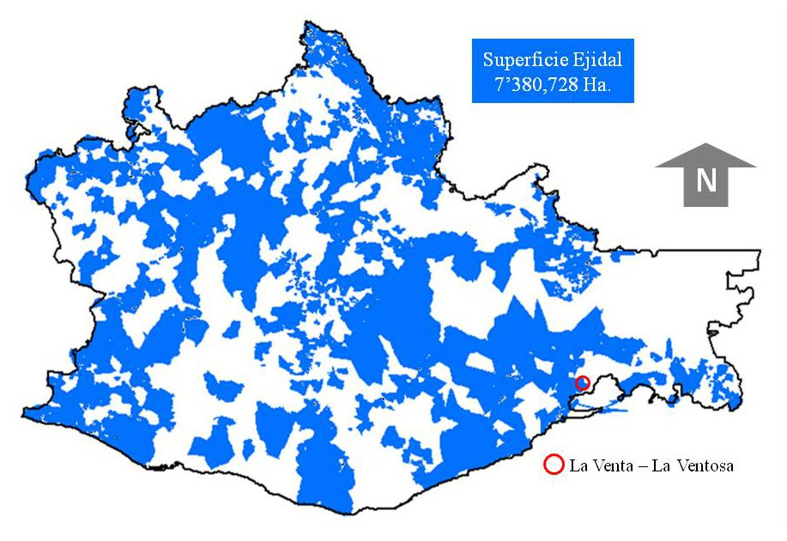

Source: Own elaboration including FIPP, PA data 2012.

The land ownership distribution in Oaxaca has a centralization called social property, common lands and communal property; this is equivalent to the 77% of the total area. Besides, the 47% of the area is regularized only. The Itsmo de Tehuantepec area is where the CERTE was desired to be built. La distribución de la tenencia de la tierra en el estado de Oaxaca tiene una concentración en la llamada propiedad social, ejidos y propiedad comunal, equivalente a poco más del 77% de la superficie total. Además, sólo está regularizada el 47% de la superficie total. La región del Istmo de Tehuantepec, en dónde se deseaba instalar el CERTE, padece en niveles graves de esta situación, ver Figura 1.

The original option was to remove the installations and land domination of the Forest, Agricultural and Livestock National Institute at Juchitan, Oax., which was not in operation. This was a complicated and long process and it was initiated by the IIE with some good successful expectative. This removal was modified by the federal legislation, however, and the process was more complicated and took a long time; the Oaxaca government moved forward with this process and that way the process was achieved by GOM, then that property was given to the Itsmo University by the president decision.

Under this circumstance, the IIE and the UNDP-CO initiate approaches exposing the Project strategy. The government offered to donate the land and the only request was that this process would not be under any social property regime.

The land was localized and the donation process was initiated with the government, it was achieved in the first trimester on 2006, twenty-seven months after the Project document was signed. During that time, the UNDP-CO was reporting to the APR the need to postpone the Project execution term to twelve months. This led to the project closing date to December 2006. This could not be accomplished because the land donation was delayed nine months.

The Annual Project Review (APR) in the middle of 2006, when the land property was ensured is planned as a second date for the closing date review on December 31th, 2007. But the participant’s absence during the bidding processes for the wind electrical generator buying, which is part of the second component in the process, or the subsequent abandonment of the few participants caused that in the middle of 2007 this was reconsidered in the respective APR, the project closing date to 2008.

For the APR on 2008, the Project closing date is shifted to December 2009, for fourth time, because after the Project bidding process is concluding is define to recruit to Komai company, in the first trimester on 2008, for the wind electric generator design, construction and operation. It is contemplated to start on October, 2009. .

In the middle of 2008, in the same APR is considered to be made a mid-term evaluation to the end of the same year.

On 2009 during the annual review, the wind electric generator delivery advance reaches a 90% and is not reported the completion of the MTE.

The wind electric generator starts operation on July 1st. 2010 and is reported in the APR during that year.

In fact, the closing date can be considered on July 1st., 2010, even when there were three formal activities that were not accomplished: The CERTE opening by the Mexico’s President that has not been accomplished, the MTE completion and the Interconnection General Rules official publication to the national concessionaires and generators electrical system with renewable energy sources or efficient generation, that was made on May, 2012.

Therefore, the Project execution took 78 months instead of 24 that were contemplated.

2.1.1.1 Operative Annual Plans

The operative annual plans (POA) include more detailed activities that may allow adapting the original logistic contemplated to reach the fixed goals in the Document Project.

Above all these are the new activities that were included:

The Regulatory Environment:

The IIE Collaboration with the CRE in the Contract model definition for the interconnection contract for electricity generation plants with renewable sources, CIFER.

The IIE Collaboration with the CONAE to make the “Negotiation Guides to develop an Electric Generation Plant which uses Renewable Energy in Mexico”.

Official Mexican Standard Project, NOM-S/N-SEMARNAT-2012, in which are established the technical specifications for the environmental protection during the site selection and preparation, wind electric facilities construction, operation and abandonment in low environmental impact areas. The Collaboration with the Interconnection general rules in the drafting to the national electricity system for generators with renewable energy sources or efficient generation.

The Management to government agencies:

Procure with the Oaxaca state the land donation for the CERTE construction.

Procure with government agencies coming from three different politics institutions.

Re start the procurement and management processes with new government administrations because of changes during the management legal terms in the beginning and ending processes.

With proactive solution offers procure the decisions made by officers for “typical” paperwork. Monitoring migratory and resident’s birds and bats in the CERTE Project area.

Support and participation at V International Symposium for the Wind Corridor Development of the Itsmo de Tehuantepec.

Diffusion:

Formal and informal diffusion activities increment about the wind electric generation benefits to: To raise awareness to the three government levels officers, encourage interest to investors, attract attention and support of academic institutions and people in general, etc. In a formal way the diffusion has reached about 1,800 people assistance.

There was a Symposium about the Birdlife and the wind electric generators operation.

2.1.2 The country development context.

During the seven years that this Project was created, Mexico experienced huge changes in the Energetic Regulatory framework. At the beginning of this execution period, the regulatory barriers were seen as an insurmountable wall because of the permanent contradiction that is common in two of the legal groups and between the mediate positioning in favor to the GEI reduction and a negative practice to modify the regulatory structure and legislation in the energetic, environmental and financial general areas.

At that time, the wind electric generation market was authentically incipient. Actually, even it can be said that the market have reached full maturation, the investment in wind projects have increased considerably, so much so that the proposed goal for 2015 will be reached at the end of 2013 with the wind electricity generation installed capacity.

The success in this matter have been a result of different participants, among them we have to distinguish to the President Calderon support to the renewable energy, the different federal agencies coordination to move forward the regulatory reform proposals. Another huge factor has been the interest given by big electricity consumers to consolidate their position about the Social Responsibility topic, contributing with the electricity production through renewable sources. Companies like Peñoles, Cemex, Femsa, Bimbo, etc., are part of self-supply societies which have invested in the Itsmo de Tehuantepec area with wind electric projects. See Chart 2.

Chart 2. Self-supply societies with investments in the Itsmo de Tehuantepec area.

Company | Self-suply Society | Installed Capacity (MW) | Electricity consumption estimated proportion.  (%)
BIMBO | Mexican Wind Developments (DEMEX) | 90 | 100
CEMEX | Eurus | 334 | 30
FEMSA | Renewable Mareña | 396 | 85
PEÑOLES | Wind Force from the Itsmo | 80 | 20

Source: Self-elaboration.

Is needed to be said, in this matter, that the overall approach of SENER, CRE and CFE, done in 2007 during the open Season, and which was agreed to develop a mechanism to determine the transmission capacity that the investors would be able to set apart under firm and irrevocable commitments, and whose omission would be penalized with performance guarantees, ease to the CFE justify the distribution and transmission lines investments that would allow to connect the wind generation to SEN. The success obtained was huge during this announcement that was necessary to develop a second stage in that open season.

All the above has permitted that the investor’s efforts in this kind of projects were able to be crystallized in international development finance institution credits syndicated with several private bank institutions. See attachment 8.

2.2 Evaluation Purpose.

This Project Final Evaluation has been performed by expressed request by GEF-UNDP under contract to provide services resulting by tendering RFQ-61-2011. The period of time that this evaluation was performed was on September 2012, 26 months after the last component of the project was delivered. The general objective of this Evaluation is analyze the Stage 1 project development, all the achievements, results and reached impacts.

The evaluation structure was developed under five areas:

Evaluation and monitoring about the results and achieved impacts.

Analyze and evaluate the Project results that have obtained during its execution, compare them against of what was planned in the Document project.

Identify the clue elements while the decisions are taken.

Evaluate the efficiency during the processes performed in the Project development as well as the Project partner’s commitment and involvement.

Promote the delivering reports about the use of resources.

Identify processes and deliverables with which the Project achieve its commitments to answer and equilibrate the needs of all the people involved, in both its processes on the decisions taken as well as the activities development and the deliverables satisfaction.

Documenting and disseminating the lessons learned.

This will include the results and lessons learned sustainability, analysis about the strategies used and the development arrangements which could be relevant for other projects in both the country and the rest of the world.

Measure the converge level with other ONU projects and the UNDP priorities.

Especially about what was referred in the Cooperation Framework Development of the United Nations.

2.3 Key elements identification

These key elements have been proposed to ponder the achievement of the objectives:

Relevance

The level of connection with national development priorities, regional or sections, and ownership of those involved.

Effectiveness

The ability to achieve the objectives outlined in the project.

Contribution

The project added value or results multiplication to achieve the national or regional development objectives.

Incentive and key success factors

Initiatives, options and comparative and competitive advantages which allow the objective performance, improve their quality, reduce costs and/or ensure sustainability.

Efficiency

The tangible and intangible inputs proportion to achieve all the objectives.

Risk factors

Circumstances, events or omissions which avoid the objective management, reduce its quality, increase their costs or delay its achievement.

Sustainability

The appropriation of the results, of those involved, as well as the measurements which secure its permanence on time.

Impact

Approximate weighting results to social changes of second order.

2.4 Evaluation methodology.

The methodology used for this Project Final Evaluation is structured in accordance with mandates by the GEF-UNDP evaluation and monitoring policies, the final evaluations key objectives and the key elements to weight those objectives that are written in the last point.

This Project Final Evaluation is developed in the next steps:

The documents review and Data Entry

At the cabinet level an investigation was made to collect the data with the purpose to become familiar with the agencies and institution participating time frame, specific objectives, legal framework, evaluation and monitoring practices, previous evaluations, etc. This material has allowed elaborating the three main problems to become the three main objectives and the logical main framework. With this Logical Framework Closer is describing the logical intervention that underlies the theory of change planned. This Logical Framework Closer, however, is the basic analytic tool that designs the questionnaires for the different involved groups.

The visit to the field

There was a visit field included in the EFP to the CERTE and to the central wind electric generation area with the purpose to know, out loud, the opinions, suggestions and relevant comments about the Project development.

When this visit took place, specifically, the following activities were:

The Project manager introduced the Project development general context, the achievements and main activities, the changes on the Project design, problems that took place during the process and the measures and actions to solve them and the mitigation of their consequences.

The relevant information was analyzed about the Project development: information, reports, publications, diffusion material, etc.

There were interviews with technicians from the wind electric generator supplier.

There were interviews with operators and maintenance companies from wind electric generation effective operation.

The interviews with those overriding involved.

There were a series of interviews with those main involved which because of their influence have contributed to the project objectives achievement.

These interviews took place in Mexico, Cuernavaca and Monterrey. The Schedule with the interviewed people is described in the attachment 3.

The additional information collection and Ex – post clarifications

In the report preliminary version drafting there was additional information and some clarifications were made with some members from the Project crew and with those overriding involved.

Preliminary version report

There was a report version distributed among the GEF-UNDP CO members and the Project management to read it, its partial approval and suggestions about content, clarification, modification and/or correction.

The final version report delivery

Suggestions were incorporated for clarification, modification and / or correction made ​​by members of the GEF-UNDP CO and project management.

2.5 The evaluation structure.

This Project Final Evaluation has been structured as the Reference Terms specification, see attachment 1; as well as the UNDP suggested template in the attachment 7 from its Evaluation and Plan Manual.

3. The Project and its development context.

3.1 The Project beginning and termination.

The Project design stage took almost one decade, since the Project plan formal efforts were initiated, programmed and budget definition until the Document Project was signed.

The following list realizes the outstanding facts:

1994 | The formal efforts are initiated about the wind electric Project plans.
1997 | The IIE initiates the Geographic information System development for the Renewal Energies commissioned by CONAE. (SIGER).
2000 | The SENER instructs to the IIE to develop a Pilot Plan to impulse the Renewable Energies Development.
2001 | At Cocoyoc, Mor., takes place the international workshop “Best Practices on  Renewable Energy: Sharing some Experiences”, participating some staff from IEA, REWP, GEF and UNDP.
2002 | The GEF registers the complete range Project as “Action Plan to eliminate barriers for the long term wind energy development in Mexico”.
2003 | The Project document is signed as agreed. The GEF assigns the project code: PIMS 2222.

The Project implementation stage, to be made originally during 24 months was extended along 84 months. The initial budget assigned by GEF-UNDP was not modified.
2003 | November: Project implementation formal initiation.
2004 | May: The Project inception workshop.
2004 | November: The first of 15 anemometric stations engaged is installed.
2005 | March: Wind electric Project first document about the Wind Corridor at the Itsmo de Tehuantepec.
2005 | March: A document “Improvement to the legal, regulatory and institutional framework proposal and analysis which influence to the wind electric generation development in Mexico” is delivered.
2005 | August: Feasibility Study about a Wind electric Center for Baja California Sur (with the CFE collaboration).
2005 | October: Wind Forum at the Oaxaca Technological Institute.
2005 | November: Participation and support at the International Colloquium V for the Wind Corridor Development at the Istmo de Tehuantepec.
2005 | November: Evaluation workshop about wind potential in Zacatecas (Zacatecas Independent University).
2006 | March: Environmental Impact manifestation and SEMARNAT authorization.
2006 | March: Construction land for the Wind Technology Regional Center (CERTE).
2006 | April: Recollection and analysis about worldwide studies made about the birdlife impact, construction activities and wind electric central operations.
2006 | June: Project Authorization CERTE construction.
2006 | August: CERTE authorization program about the environmental follow up.
2006 | August: Management guide complement to develop the electric generation plants in Mexico which use the renewable energies.
2006 | September: Birdlife and wind generators symposium.
2006 | September: Obtaining Construction License (Juchitán city council).
2006 | September: Obtaining Access Project authorization (SCT).
2007 | January: Wind Resource Evaluation and basic indicators generation about wind generation self-supply viability (Stakeholder Peñoles Industrial Services).
2007 | January: Obtaining interconnection permit in Small producer modality (CRE)
2007 | February: The publication and diffusion of “Better practices guide for the wind projects development”.
2007 | June: Migratory and residents birds and bats monitoring in the CERTE Project influence area.
2007 | August: One complete year data file diffusion per each anemometric station.
2007 | September: Wind resource punctual map in promising areas with reference stations.
2008 | April: The CERTE basic infrastructure construction.
2010 | February: Signing of purchase-sale electricity contract with CFE.
2010 | February: First wind generation acquisition, installation and operation at CERTE.
2010 | July: Obtaining the CERTE commercial operation authorization.
2012 | May: Interconnection general rules for the national electric system generators and concessionaires with renewable energy sources and efficient generation.

3.2 The implementation

The Project has attracted a local co financing substantial amount equivalent to USD$7’396,000.

During this Project Final Evaluation processed on September, 2012, some of the Project activities pending to be made were: The formal opening by the president; and the Official Mexican Standard Project publication, , NOM-###-SEMARNAT-2012, in which are established the technical specifications about the environmental protection and the site preparation, construction, operation and abandonment of wind electric installations at low environmental areas.

These activities, specially the second, will continue to be promoted by the IIE, CRE and SENER, even if the GEF-UNDP terminate and close the PIMS-2222 project.

3.3 The Problems that the Project seeks to address

In the Project document were identified the problems addressed and these are defined as:

Institutional and legal framework

The need of adequate the legal framework and create the ad hoc regulations for the renewable energies and particularly the winds, which provide the incentives to develop investment projects.

Guaranteed Price

Determine which ones are the price mechanisms appropriate for Mexico, to encourage the increased supply of wind projects.

The Financial Constraints

What increases the risk surcharges are the commercial experiences absence during the wind electric Project developments in Mexico, joined with the regulatory barriers, become a financial restriction which perpetuates the associated perception to these projects with highly preparation costs and without an implementation guarantee in reasonable timing.

Market Structure and Human Resources

Well trained personnel significant absence in both wind electric technology equipments operation and maintenance.

Technical Barriers and access information

The wind resource available data in Mexico are general, with low space resolution and non sufficient pre-invested studies.

There are no recommended practices, specifications and national techniques for the wind Project developments in Mexico.

Besides, there is a significant absence of knowledge by the energetic sector and state and municipal officials about the potential benefits to implement the wind electric generation.

3.4 The Project development and immediate objectives.

The Project was designed with the idea to remove the key barriers in long term wind energy in Mexico, the established objectives in the design stage are clear and consistent in both the United Nations cooperation global strategy and the own GOM.

The development objective was defined as:

Reduce the Annual Emission of Greenhouse gas in Mexico through the commercial wind generators installation and operation in long term. The strategically objective is to reach an installed capacity of 2000 MW during a 10 year term which annually would reduce the equivalent of 4 Mt CO2.

As long as the Project objective is specified as follows:

Reducing Barriers to market identified wind power in order to:

1) Facilitate the three wind generation plants model operation and installation in Mexico connected to the distribution central network.

2) Create an wind energy sustainable market in Mexico.

The fourth stage I deliverable Project components are:

1st. Component

Institutional Improved legal and regulatory framework for wind energy generation.

2nd. Component

The Establishment of national and regional abilities to support the development of wind energy as viable supply source for the electricity market.

3rd. Component

Wind resources evaluated in the most potential development areas in Mexico and complete feasibility studies for three wind plants.

6th. Component

The relevant information promotion for electricity wind production based in probed financing and institutional mechanisms.

The correspondent description Activities are included in the attachment 2.

3.5 The main agencies Involved

The Project interacted with a wide variety of agencies involved including:

Secretaría de Hacienda y Crédito Público,

Secretaría de Energía,

Secretaría de Mejoramiento del Ambiente y Recursos Naturales,

Secretaría de Comunicaciones y Transportes,

Comisión Federal de Electricidad,

Comisión Reguladora de Energía,

Comisión Federal de Mejora Regulatoria,

Comisión Nacional para el Ahorro de Energía,

Comisión Nacional para el Conocimiento y Uso de la Biodiversidad,

Programa de las Naciones Unidas para el Desarrollo,

Fondo para el Medio Ambiente Mundial,

Instituto de Investigaciones Eléctricas,

Diferentes instancias del Gobierno del Estado de Oaxaca de Juárez,

Diferentes instancias del Municipio de Juchitán de Zaragoza,

Diferentes instancias del Municipio de Unión Hidalgo,

Funcionarios de gobiernos estatales con sitios con potencial eólico,

Asociación Mexicana de Energía Eólica

Academia Mexicana de Derecho Ambiental

Desarrolladores de proyectos de generación eoloeléctrica,

Empresas contratistas locales,

Medios de información locales,

Instituciones de enseñanza media y superior locales: Universidad del Istmo, Instituto Tecnológico del Istmo, etc.,

Instituciones de enseñanza superior de otros estados,

Fabricantes de pailería y estructuras,

Desarrolladores inmobiliarios,

Organizaciones no gubernamentales,

There was an interaction with other countries, also:

Agencia Internacional de Energía, | Energy International Agency
Banco Interamericano de Desarrollo, | Inter American Development Bank
Administración de la Información de Energía, | Management of Energy information
Desarrolladores de proyectos de generación eoloeléctrica, | Wind electric generation Project developers
Fabricantes de turbinas de generación eoloeléctrica, | Wind electric generation turbine builders
Administradores de fondos para proyectos, | Project funds managers
Funcionarios gubernamentales de países centroamericanos, | Government officials from Central American countries
Desarrolladores de resorts | Resorts’ development companies

3.6 The Expected Results

The main expected results at the end of the Project such as the specified with the objective indicators and the Document Project component were quite accurately defined in both, the basic lines and its goals.

As follow are defined the expected results with the specific goals and indicators:

Development objective: Reduce the greenhouse gas anual emission in Mexico.

Indicator: GEI Emission Reductions

Unit: Mt CO₂ Esq. / year

Basic Line: 0

Goal: 4

Project objective: Reduce the barriers for wind energy commercialization

Indicator 1: Feasibility Studies and Contest basis

Unit: Porcentaje (Estudios realizados / Estudios programados)

Basic line: 0

Goal: 100

Indicator 2: Wind production total capacity.

Unit: MW

Basic line: 1.6

Goal 135

Component 1: Improving the legal and regulatory framework for wind energy generation.

Indicator 3: Regulatory framework review

Unit: Percentage (Laws, rules and analyzed processes/ Total laws, rules and processes) s)

Basic line: 0

Goal: 100

Indicator 4: Legal and Regulatory modification proposals

Unit: Percentage (Design modification proposals/Selected modification proposals)

Basic Line: 0

Goal: 100

Indicator 5: Promotional Campaign

Unit: Percentage (not indicated to quantify variables to calculate this indicator)

Basic Line: 0

Goal: 100

Component 2: Regional and national capacities establishment for wind electrical development.

Indicator 6: Site preparation, design and obtained permissions.

Unit: Percentage (not indicated to quantify variables to calculate this indicator)

Basic Line: 0

Goal: 100

Indicator 7: Procurement, Construction and Testing in Vacuum

Unit: Percentage (Volume of completion / Total volume of the work)

Basic Line: 0

Goal: 100

Indicator 8: Technical Institutions included courses in curriculum

Unit: Percentage (Included courses / 2 courses per inclusion)

Basic line: 0

Goal: 100

Indicator 9: Workshops given by CERTE

Unit: Percentage (Workshops given / 2 Workshops to be conducted)

Basic Line: 0

Goal: 100

Indicator 10: Manual of best practices

Unit: Percentage (Manual published / 1 Manual to be published)

Basic Line: 0

Goal: 100

Indicator 11: Wind technology comprehension by the main actors.

Unit: Percentage (not indicated to quantify variables to calculate this indicator)

Basic line: 0

Goal: 100

Component 3: Evaluated wind resources and three wind plants feasibility studies.

Indicator 12: Generic Studies which facilitte the wind Project process

Unit: Percentage (Generic Studies made/ 3 generic studies to be made)

Basic Line: 0

Goal: 100

Indicator 13: Specific Studies for La Ventosa

Unit: Percentage (Specified studies made for para La Ventosa/ 4 Specific Studies to be made for La Ventosa)

Basic Line: 0

Goal: 100

Indicator 14: Prospective monitoring

Unit: Percentage (Anemometric Stations in operation / 15 Anemometric Stations)

Basic Line: 0

Goal: 100

Indicator 15: Wind resource evaluation for a year.

Unit: Percentage (Anemometric stations that are in operation during a year / 15 anemometric stations operating during one year)

Basic Line: 0

Goal: 100

Indicator 16: Access to wind resource information

Unit: Percentage (Information about anemometric stations to the public during a year / 15 anemometric stations annual information)

Basic Line: 0

Goal: 100

Indicator 17: Feasibility studies on

Unit: Percentage (Feasibility studies made / 3 feasibility studies to be made)

Basic Line: 0

Goal: 100

Indicator 18: Basis for the contest

Unit: Percentage (Basis for the contest made / 3 Basis for the contest to be made)

Basic Line: 0

Goal: 100

Component 6: Relevant information promotion based on proved financial and institutional mechanisms.

Indicator 19: Promotion about Relevant information

Unit: Percentage (Promotion events made / 8 promotion events to be made)

Basic Line: 0

Goal: 100

4. The Accomplishments

Although when in the mediatic speech have been highlighted the wind electric generation projects importance and need; the facts belie overwhelmingly, what is said. This was the reality of what the Project faced:

4.1 Project formulation

4.1.1 Concept / Design

The Project design was motivated by different initiatives confluence:

On one side the financial cooperation searching, on the other by the IIE to develop an wind technology investigation center.

On the other side because the GOM commitment to reduce the greenhouse gas emissions like the Oaxaca development lags.

At the same time the UNDP that in the United Nations cooperation framework with Mexico has an objective to assist the institutes abilities during the development on the matter of innovation, science and technology, and the natural resources and energy efficient management and integration. The state of Oaxaca government wishes to develop the wind electric centers investment in the Itsmo to reinforce the employment generation and economic development in the area; and

Among other objectives the UNDP, the World Bank, the SENER and the IIE cooperation synergy is to make load flows and stability in the electric transmission network from the wind electric centers connections to the SEN; and detail the technological and socioeconomic wind electric generation benefits in Mexico.

UNDP participations were incorporated to the Project formulation to the Mexico state level. These resulted insufficient because of the total atypical situation that the Oaxaca state went through during 2004-2006. Enough to remember the electoral journey which result effervescent on August 2004 that took to a public situation to discontent which difficulties the municipal government relationship, issued by an opposition party to both, the outgoing and elected governors and the republic president.

The local political pressure and the management consequent paralysis with the municipal and state government agencies constitute a wall almost unsafe for the land acquisition where the CERTE would be built. This led to differ in the 2nd component during its activity 1, from 18 to 37 months.

In some way this topic was contemplated in the Project design as one of the assumptions to the 2nd component: Regional and national capabilities establishment which support the wind generation development as a viable supply source for the electricity market.

At the same time and due to a indifferent action sometimes opposing from different CFE local agencies, is inferred that a lack of the problem definition was included to important personnel from this company. Its contribution about the internal procedures framework would allow visualizing an informal dedication barrier that required to be considered. A situation also, that in a way was included in the Project design as supposed in both the Component 1: Institutional Improved legal and regulatory framework for wind energy generation, as well as in the Component 3: Wind resources evaluated in the most potential development areas in Mexico and complete feasibility studies for three wind plants.

It is concluded that in the Logical Framework Approach that was made by the design crew there were incorporated objectives from different problem visualization perspectives, with what was enriched and posed a wider modification theory and with complementary objectives one another; that would allow visualize consistency in its results chain.

Already mentioned above, the proposed indicators in the Logical Framework Approach are, in general, commensurate with the posed objectives and its definition included in both the basic lines as well as the Project goals. Likewise, the verification methods suggested allow the Project crew establishes the posed objectives evaluation and monitoring with a SUCCESFUL approach to the importance, relevance and transparency balance.

In respect to the established proposed for each objective levels are referred punctually and clear which are the critical risks which could impede that the respective activities and components would not be enough to achieve the results “chaining”. There is no doubt that some of the assumptions included in the Project design are a specific contribution about the learned lessons from another UNDP intervention. Assumptions that, while the Mexican democratic transition do not complete its maturation, will remain in effect in most of the interventions which involve the three government levels or the CFE.

The Project design and concept is therefore, SUCCESFUL.

Project Design and Concept.
6. Highly SUCCESFUL | 5. SUCCESFUL | 4. Moderately SUCCESFUL | 3. Moderately None SUCCESFUL | 2. None SUCCESFUL | 1. Highly None SUCCESFUL

4.1.2 The National Appropriation

The proposed objectives in the Logical Framework Approach clearly respond to some of the outlined strategies in the Development plan. In respect of the Axis 2: Competitive and employment generator economy. There are:

STRATEGY 4.1 Promote state policies that encourage the labor relations productivity and the national economy competitiveness to attract investments and generate formal and qualified employment.

STRATEGY 5.1 Integrate a competitiveness national agenda which involve to the three Union Powers, the three government levels and the private sector in order to generate the reform needed and translated them to tangible results in short and medium terms.

STRATEGY 5.2 Design sector agendas for the competitiveness of economic sectors with high added value and technological content, and precursor sectors, as well as the traditional sectors reconversion to generate better paid jobs.

STRATEGY 5.3 Reduce the costs of businesses opening and operation through a regulatory improvement.

STRATEGY 5.5 Deepen and ease the scientific investigation, technological innovation and adoption to increase the national economy productivity.

STRATEGY 9.2 Link together the development and investigation activities with the rural areas needs.

STRATEGY 9.7 Promote the generation of profitable companies in the rural sector.

STRATEGY 11.3 Cooperate with the state governments to implement policies focused in the rural sector.

STRATEGY 13.1 Encourage intergovernmental coordination mechanisms among the different government levels and the same sectors in the state governments and inside the Federal Administration giving more responsibilities and competitions to the counties and states and also allowing them to develop integral actions.

STRATEGY 13.2 Assist to the states and counties in the institutional abilities enforcement and the public servants human crews education, which will allow a better action in all the government levels.

STRATEGY 13.3 Encourage the competitiveness in all the areas with particular emphasis in the most disadvantaged areas, the small and medium businesses and high impact sectors like the touristic and agricultural.

STRATEGY 13.4 Ensure that there is the needed infrastructure so every Mexican may have the adequate Access to the energy, to the regional, national and international markets and to the communications.

STRATEGY 15.9 Develop the required infrastructure to the electrical power service provision with a high level of reliability, making investments which allow attending the demand requirements in the different segments and encouraging the Project developments under the arrangements that are not public.

STRATEGY 15.12 Diversify the primary sources of generation..

STRATEGY 15.14 Encourage the renewable energy sources and biological fuels generating a legal framework to establish the state faculties to guide its aspects and promoting investments which promote the country potential in this matter.

STRATEGY 15.16 Take advantages of the energetic sector investigation activities strengthening the investigation sector institutes, orientating its programs, among others, to the renewable sources development and energetic efficiency.

STRATEGY 15.17 Strengthening the powers of sector regulatory institutions.

Regarding to Axis 3. Equal opportunities, we have:

STRATEGY 2.5 Take actions to create employment in zones where the expulsion of people is generated, seeking to convert them in inversion receptors.

STRATEGY 15.1 Constitute the attention to the natives in a strategically transversal objective for the Federal Public Administration.

Axis 4. Environmental Sustainability, we have:

STRATEGY 5.1 Impulse clearer and friendly technology instruments with the environment among the productive sectors in the country.

STRATEGY 10.1 To promote the efficiency and clean technologies impulse (including renewable energy) for power generation.

STRATEGY 11.1 To promote the inclusion of aspects of climate change adaptation planning and work of the various sectors of society.

Finally, from Axis 5. Effective democracy and responsible foreign policy, we have:

STRATEGY 7.4 Coordinate the efforts of the Federal Government in the field of international cooperation for development.

The qualification of the National appropriation is then: Highly SUCCESFUL.

The National Appropiation
6. Highly SUCCESFUL | 5. SUCCESFUL | 4. Moderately SUCCESFUL | 3. Moderately None SUCCESFUL | 2. None SUCCESFUL | 1. Highly None SUCCESFUL

4.1.3 Those involved participation during the design stage.

Those involved participation in the Project design held at cabinet level with some remote contributions from regional level involved, that is summarized as:

The SENER participation in general terms is Highly SUCCESFUL.

The Oaxaca government state administration participation was SUCCESFUL.

The municipality administrations are inferred as not included.

The CFE participation was marginal; it was contemplated in fact as the assumptions.

The ONG’s participation is inferred as not included.

The technologic suppliers are inferred as indirect and remote.

The qualification of those involved in the design stage is then as moderately SUCCESFUL.

Participation of those involved in the design stage
6. Highly SUCCESFUL | 5. SUCCESFUL | 4. Moderately SUCCESFUL | 3. Moderately None SUCCESFUL | 2. None SUCCESFUL | 1. Highly None SUCCESFUL

4.2 The Project Implementation.

4.2.1 The Implementation Development.

It has already commented the implemented strategy by the Project management crew before both key circumstances that differed during the Project development, specifically in the Component 2, Establishment of national and regional abilities to support the development of wind energy as viable supply source for the electricity market. And despite of the prevalescent circumstances the established goals were achieved in the design stage.

The qualification for the Implementation Development is Highly SUCCESFUL.

The Implementation Development
6. Highly SUCCESFUL | 5. SUCCESFUL | 4. Moderately SUCCESFUL | 3. Moderately None SUCCESFUL | 2. None SUCCESFUL | 1. Highly None SUCCESFUL

4.2.2 The Evaluation and Monitoring

The Project components and activities advance and achievement have been reviewed through the Follow up Tools used by the UNDP-CO and the IIE along all the implementation process. These tools include the Annual Project Review, the Project Implementation Reports, the Quarterly Progress Reports and the Annual Operative Program. The comments and data consistency that are consigned are a Project appropriation testimony and then, from the validity of the commitments made.

Since the Project design was raised in general, a clear idea that the variables would be used to define the result indicators. It was the same with the basic lines, the goals and the verification methods.

The timeliness with which the Follow up tools was reported was Highly SUCCESFUL and the reported data were consistent. In the chart 3 is summarized what was reported in its moment with the tools already mentioned.

The Middle Term Evaluation (MTE), mandated by the GEF in its Evaluation Manual was not made as it was suggested because of an external consulting hiring that audit month by month the project development during its last implementation period; this was a reason redundant and inefficient for the hiring and put in practice a Middle Term Evaluation, what was consulted in time and approved by the GEF. On the other hand the Final Project Evaluation was made after one year in respect of what was recommended by the GEF-UNDP.

The qualification for those involved participation is, then, Moderately SUCCESFUL.

Participation in Monitoring and Evaluation Implementation
6. Highly SUCCESFUL | 5. SUCCESFUL | 4. Moderately SUCCESFUL | 3. Moderately None SUCCESFUL | 2. None SUCCESFUL | 1. Highly None SUCCESFUL

4.2.3 The Participation of those involved.

In previous sections it is being already said about the participation topic of those involved during the Project implementation, the same that can be summarized as:

In general terms the participation of the SENER, the CRE and the SHCP is highly SUCCESFUL, Relevant and significant.

The participation of government administrations Oaxaca State were from SUCCESFUL to Moderately SUCCESFUL because there was a takeover.

The participation of municipality administrations was from Moderately SUCCESFUL to moderately none SUCCESFUL because there were two takeovers.

There were different instances both cooperative and sub regional during the participation of the CFE; it was from SUCCESFUL to none SUCCESFUL.

There were different instances during the participation of ONG’s; it was from SUCCESFUL to none SUCCESFUL.

The participation of the technologic supplier was highly SUCCESFUL.

Chart 3. Summary of what was reported to the Monitoring Tools
Indicator |  | Basic Line |  |  | Goal 2007 |  | ADVANCE
UNDP  ID | Description | Year | Unit | Valor | Valor | June 2005 | June 2006 | June 2007 | June 2008 | June 2009 | June 2010
 | Emission Reduction of GEI (GG) | 2005 | Mt CO₂ eq |  |  |  |  |  | 0.34 | 0.51 | 1.57
1 | The feasibility Studies and the Contest Basis | 2005 | % | 0 | 100 | 40 | 40 | 100 | 100 | 100 | 100
2 | Wind production capacity | 2005 | MW | 1.6 | 135 | 0 | 0 | 62 | 164.8
3 | The review of the regulatory framework | 2005 | % | 0 | 100 | 90 | 100 | 100 | 100 | 100 | 100
4 | The Regulatory and legal modification | 2005 | % | 0 | 100 | 45 | 60 | 100 | 100 | 100 | 100
5 | The Promotional Campaign | 2005 | % | 0 | 100 | 15 | 100 | 100 | 100 | 100 | 100
6 | Site preparation, design and Permit | 2005 | % | 0 | 100 | 55 | 90 | 100 | 100 | 100 | 100
7 | The recruitment, construction and testing of vacuum. | 2005 | % | 0 | 100 | 5 | 20 | 70 | 70 | 90 | 100
8 | 2 Courses included in the curricula of Technical Institutes. | 2005 | % | 0 | 100 | 0 | 50 | 100 | 100 | 100 | 100
9 | 2 workshops imparted at the CERTE | 2005 | % | 0 | 100 | 0 | 0 | 100 | 100 | 100 | 100
10 | 1 Manual of Best Practices | 2005 | % | 0 | 100 | 0 | 80 | 100 | 100 | 100 | 100
11 | Wind technology comprehension improvement by all the principal sectors. (1 Seminar) | 2005 | % | 0 | 100 | 0 | 0 | 50 | 100 | 100 | 100
12 | Generic Studies that ease the wind Project process. | 2005 | % | 0 | 100 | 0 | 100 | 100 | 100 | 100 | 100
13 | Generic Studies for La Ventosa (4) | 2005 | % | 0 | 100 | 0 | 75 | 100 | 100 | 100 | 100
14 | Monitoring prospective anemometric installation of 15 stations | 2005 | % | 0 | 100 | 0 | 147 | 147 | 100 | 100 | 100
15 | One year Wind resource evaluation | 2005 | % | 13 | 100 | 0 | 80 | 100 | 100 | 100 | 100
16 | Wind resource assessment, access to wind resource information | 2005 | Sitios | 0 | 15 | 0 | 9 | 22 | 100 | 100 | 100
17 | Three wind Project models, Feasibility studies. | 2005 | % | 0 | 100 | 0 | 50 | 100 | 100 | 100 | 100
18 | Three wind Project models, Contest Basis. | 2005 | % | 0 | 100 | 0 | 10 | 100 | 100 | 100 | 100
19 | Promotion of relevant information for development of wind generation (symposia, seminars, publications, etc.) | 2005 | Eventos | 0 | 8 | 0 | 21 | 24 | 26

Source: Own elaboration with MT data.

The Project made some informative products for diffusion, the same that were known, consulted and at the same time, distributed by those involved to/with other involved, or at least, interested. Local authorities, state and federal public administration staff, teachers, investigators and higher education institute students were included.

As an additional diffusion route it was enabled an electronic access link in a website http://planwindo.iie.org.mx/iieUNDP.htm, this included electronic links to publications, work documents, forums, information notes, etc. In the same website there was free Access to anemometric information in the wind electric potential sites.

It should be mentioned that the informal conversation interaction with those involved was an element that permitted in the long run to generate enrichment synergies that included experience interchange: in administrative issues, identify the reliable local suppliers, technical solutions, etc. The informal transference of the lessons learned by the same projects is one of the elements that have allowed that the area accept the wind electric investments, reduce the learning curves, etc.

The qualification of the participation of those involved in the implementation is then SUCCESFUL.

The participation of those involved during the implementation
6. Highly SUCCESFUL | 5. SUCCESFUL | 4. Moderately SUCCESFUL | 3. Moderately None SUCCESFUL | 2. None SUCCESFUL | 1. Highly None SUCCESFUL

4.2.4 Financial Planning

The Project financial budgets and plans were regularly updated in the Annual Operation Programs with a level of disaggregation that corresponded to the Project AML. In the other follow-up tool, the Annual Project Review, there were consigned overall figures.

The chart 4 summarizes the exercised budget by GEF, itemized per Project component, and the distribution of its disposition in the time. There are observable variations that may be appreciated between of the originally proposed in the Document Project and what was exercised by object, they are comprised in a range under the 10%.

Chart 4. Excercised budget by GEF,

Itemized Components

(thousands USD)
Component | ProDoc | 2004  Real | 2005  Real | 2006  Real | 2007  Real | 2008  Real | 2009  Real | 2010  Real | 2011  Real | 2012  Real | TOTAL
Component 1  The Improvement of institutions | 551 | 0 | 164 | 131 | 143 | 17 | 0 | 0 | 0 | 0.0 | 455
Component 2  Establishment of capacities which support the wind generation | 2,637 | 54 | 137 | 127 | 888 | 1,152 | 184 | 20 | 1 | 0.0 | 2,563
Component 3  Evaluation of wind resources | 660 | 274 | 198 | 164 | 63 | 0 | 0 | 0 | 0 | 0.0 | 699
Component 6  the promotion of relevant information | 30 | 4 | 1 | 18 | 18 | 0.2 | 0 | 0 | 0 | 0 | 41.2
The administration of the Project | 857 | 113 | 157 | 393 | 140 | 88 | 33 | 0 | 0 | 0 | 924.0
Source: Own elaboration with OAP data |  |  |  |  |  |  |  | TOTAL |  | 4,681.2

In respect of the composition of the source about the total exercised funds in the Project, the same that are itemized in the Chart 5.

Chart 5. Budget executed by funding source.

(thousands, US Dólares)

PROJECT FINANCING
(US$ millions)
 |  |  |  | Donation | Loan | Credit | Own Investment | In kind | Total
A. GEF |  | Proposed |  | 4.736 |  |  |  |  | 4.736
 |  | Real |  | 4.736 |  |  |  |  | 4.736

B. Co-Financiamiento:
UNDP |  |  | Proposed
UN another agency |  |  | Proposed
Government |  |  | Proposed |  |  |  |  | 2.216 | 2.216
Bilateral Donation |  |  | Proposed
Multilateral Donation |  |  | Proposed
Regional Banks |  |  | Proposed
NGOs |  |  | Proposed
Private initiative |  |  | Proposed |  |  |  |  | 4.860 | 4.860
Another |  |  | Proposed
Total |  |  | Proposed |  |  |  |  | 7.076 | 7.076
 | Actual cumulative 2004
 | Actual cumulative 2005 |  |  | 0.637
 | Actual cumulative 2006 |  |  | 1.580 |  |  |  | 3.792 | 5.372
 | Actual cumulative 2007 |  |  | 2.470 |  |  |  | 3.792 | 6.262
 | Actual cumulative 2008 |  |  |  |  |  |  |  | 7.370
 | Actual cumulative 2009 |  |  | 4.621 |  |  |  | 3.890 | 8.510
 | Actual cumulative 2010 |  |  | 4.678 |  |  |  | 3.890 | 8.568
 | Actual cumulative 2011 |  |  | 4.683 |  |  |  | 1112.490 | 1117.173
TOTAL FUNDING |  |  |  |  |  |  | Propuesto |  | 11.812
 |  |  |  |  |  |  | Real |  | 1117.173

Source: Self elaboration with APR data

The financing approved by GEF was of 4’736,000, the same that has been exercised along the project implementation period.

The Project has contributed with the GOM strategy to impulse the wind electric generation development in the country. The public and private investments at the end of the Project implementation period begin to take the form as wind projects in La Venta area—La Ventosa, the area that the CERTE is located.

The investment projects reached amounts over a thousand one hundred million dollars, which in contrast of the GEF financing, represent a leverage relation of 235:1. Definitively, this suggests that the GEF contribution has an efficient cost relation that may qualify as Highly SUCCESFUL.

4.3 The Results

4.3.1 The impact.

As follows, and with the purpose to accurately evaluate this category, there is a specific description of each one of the goals and the results obtained in each one of the defined indicators in the Project Document.

Development objective: Reduce the Greenhouse Gas Effect Annual Emission in Mexico.

Indicator | Unit | Basic Line | Goal | Real  2011 | Fullfillment
The reduction of GG Emission | Mt CO₂ eq / año | 0 | 1.36 | 1.35 | 99.26 %

The Project objective: Reduce the barriers for the wind power commercialization.

Indicator | Unit | Basic Line | Goal | Real  2011 | Fullfillment
Feasibility studies and contest basis. | Percentage | 0 | 100 | 100 | 100 %
The total capacity of Wind Production | MW | 1.6 | 135 | 570 | 422%

Component 1: The regulatory and legal framework improvement for the wind power generation.

Indicator | Unit | Basic Line | Goal | Real  2011 | Fullfillment
The review of Regulatory framework | Percentage | 0 | 100 | 100 | 100
The Regulatory and legal framework modification purposes | Percentage | 0 | 100 | 100 | 100
The promotional Campaign. | Percentage | 0 | 100 | 100 | 100

Component 2: Regional and national capacities establishment for the wind generation development.
Indicator | Unit | Basic Line | Goal | Real  2011 | Fullfillment
The Site preparation, design and Permit | Percentage | 0 | 100 | 100 | 100
The recruitment, the construction and the vacuum tests | Percentage | 0 | 100 | 100 | 100
Curriculum included courses in Technical Institutions | Percentage | 0 | 100 | 100 | 100
The imparted workshops at CERTE | Percentage | 0 | 100 | 100 | 100
The better practices manual | Percentage | 0 | 100 | 100 | 100
The wind technology comprehension by every people involved. | Percentage | 0 | 100 | 100 | 100

Component 3: Evaluated wind resources and feasibility studies for three wind plants.
Indicator | Unit | Basic Line | Goal | Real  2011 | Fullfillment
The generic studies which ease the wind projects process | Percentage | 0 | 100 | 100 | 100
The specific Studies for La Ventosa | Percentage | 0 | 100 | 100 | 100
Prospective monitoring | Percentage | 0 | 100 | 100 | 100
The one year evaluation of wind resource | Percentage | 0 | 100 | 100 | 100
The wind resource information Access | Percentage | 0 | 100 | 100 | 100
The feasibility studies | Percentage | 0 | 100 | 100 | 100
The contest basis. | Percentage | 0 | 100 | 100 | 100

Component 6: The relevant information promotion, based on proved financial and institutional mechanisms.
Indicator | Unit | Basic Line | Goal | Real  2011 | Fullfillment
The relevant information promotion | Percentage | 0 | 100 | 100 | 100

All the Project goals have been reached. The results, however, do not reflect the work done by the project implementation crew. It is needed to be said how the timing has been reduced in some of the authorization processes, more than thirty, to invest in the wind electric generation project. Five years ago this regulatory framework, formal and informal, was unthinkable.

4.3.2 Effectiveness

As it was proposed in the last paragraph, the Project reached all the defined goals in the design stage. In the impact terms it is visualized as follows.:

In a short term: The goal is to reduce the GG emission, in respect of the basic scenario, to 4 Mt CO₂ eq / year, amount achieved with an wind electric generation equipments with an installed capacity of 2 MW, this will be reached in 2013, two years before as proposed.

In a medium term: the huge electricity national consumers, the petrochemical, steel and cement, participate in co generation schemes o in the self-supplier. The wind electric projects are contemplated in a self-supplier scheme and participate in companies of steel and most of all in the cement.

Practically, the cement companies have depleted its interest in these projects. Some other consumers are participating already and the growth opportunity, in a medium term, is visualized just in the potential development that offers other areas in the country. The CERTE roll, in this matter, is of strategic character.

An interesting opportunity is explore as alternative for small towns of medium economic development, the distributed Generation. The main advantages of the distributed Generation are: Lost reduction in the transmission and distributions networks,

Increase reliability in the electric power supply,

The reactive energy control and the voltage regulation in the distribution network,

Greater facility to incorporate generated energy by renewable sources; and,

Capacity release in the transmission lines which feed the distribution area and, consequently, the increase reliability to reinforce the transmission and transformation capacity on the system.

Once more, the CERTE roll, which counts with distributed generation studies, is of strategic character.

In a long term: the development of more wind projects has an important reference in the competence that sustain with the combined cycle plants generation, which use natural gas. The original consideration is that the Price of 1000 cubic feet of this input would be in a range from 4 to 6 USD, current prices on May 2001; it is actually USD2.69, with a variation range from 2.20 to 3.18 USD in a short term, prices on 2012.

Above, of course, makes really competitive the electric power generation with combined cycle plants, which use natural gas, which the Electricity Production Leveled Price is the used reference by the CFE to contract the purchase electricity from energy independent producers, depending to the common interpretation as mandated in the regulation from the Electric Power Public Service. Besides, the fact that Mexico is located in the third global reserve of natural gas in shales; and really close to huge national energetic consumption centers with the main importation points of that input from the USA.

All of which, in this moment, allows to estimate a scenario with less growth rates in the wind elctric investment, from 2014-2016, unless the legal scheme crystallizes with the figure Cap and Trade, whose regulatory framework is not yet defined in Mexico.

4.3.3 Efficiency

Such as it was already commented in the last paragraph, the leveraging fund that was achieved is in extreme outstanding, 235:1.

In respect of the efficiency with which the GEF fund was used, it is appreciated that the implemented activities correspond in accordance of what was in the budget. In despite of the processes delay, some of them reflect the serious acquisitions procedure and the clear purpose to equilibrate the competitiveness in the price with the quality products delivery.

4.3.4 The global environmental benefits.

The calculation methodology of the equivalent CO₂ emissions reduction, proposed in the Project Document from the POISE 2000-2009, contemplates an equivalence of 0.766 Kg CO₂ per KWh of produce electric power. Considering this equivalence number, which corresponds to the national average, it could be said that the GG emission reduction goal for 2011, in respect of the based scenario, has been reached.

Taking into account three factors, however:

The electric power consumption is given first in the closest consumption points from the generation connection point.

Most of the electricity generation centers, in the southeastern consumption from SEN, are hydroelectrically and combined cycle technologies.

The main wind electric generation projects in Mexico, in this stage, are in the southeast.

A roughly analysis of what has been said proposed that the real GG emissions reduction equivalence in respect of the based scenario in the southeast projects, is in the range of 0.5 a 0.6 Kg CO₂eq. by KWh. Where it would be concluded, in the facts that the GG emissions reduction reached in 2011 equals to 0.97 ↓MtCO₂/year. However, and even under this consideration, the impact goals proposed for 2015 in the GG emission reductions will be reached ahead of current trends in the short term. Sin embargo, y aún bajo esta consideración, las metas de impacto planteadas para el 2015, en la reducción de emisiones de GEI, serán alcanzadas con antelación de seguir la tendencia actual en el corto plazo.

4.3.5 The contribution to the development capacity.

The Project has been highly successful contributing to develop the regional and local appropriation. A good part of the Project activities were design and increased by a “denoted” demand for the benefits diffusion, acceptance of the project and, why not say it, a channel of dialogue between the parties, etc. There is no doubt that the CERTE construction pretended a number of important repercussions in the results chain for the AML in the area; but, with this success, we conclude that it could not be dimensioned what has been deprecated in the mood and expectative from all the involved.

4.3.6 Sustainability

The Project implementation has among its guidelines to encourage the Sustainability about the GG reduction through the wind electric generation national appropriation. This objective has four dimensions, clearly established by the GEF, and include the related aspects with the financing, socioeconomic, institutional framework and environment.

4.3.6.1 Financial Sustainability

This dimension was evaluated contemplating, in a general manner, two elements: in one side the technology assimilation and the human resources development; and on the other, the economic viability of future projects.

In respect of the first point it can be concluded that the collaboration perspectives, local and international, with which the CERTE counts in this moment allow us to provide that even the technology assimilation as the human resources formation have a solid platform which allow ensure the development of these projects with less technical setbacks. It is worth noting in this point, that are still to be needed Project developers, electrical and electronic engineers who participate in the development of this kind of projects. .

About the future Project viability there were some financial runs with the obtained data from different investors, consigned in the Chart 6.

Chart 6.Investment Assumptions wind power projects.
CONCEPT | VALUE
The Investment cost | 1,500 | USD/KW
Generation Capacity | 2,000 | KW
Plant Factor | 39.2%
Lifetime | 30 | years
Maintenance costs | 0.006 | USD/KW
Operation Costs (includes land lease) | 0.005 | USD/KW
Technological renovation cost | 112,500 | USD
Year of the update | 10
Equity participation | 20%
Debt | 80%
Term | 12 | years
Interest rate | 7.50%
Profit participation | 10%
Inciome tax (ISR) | 29%
Build time | 2 | años
Time for full operation | 0.6 | años
Sale Price | 0.0610 | USD/KWh
Short term total cost CFE ($/KWH),  South east January 2012 | 0.1257 | USD/KWh

The obtained results are summarized as follows, in terms of the project Internal rate return, after tax payments:

Change in amount of investment | -15% | -10% | -5% | 0% | 5% | 10% | 15%
TIR | 22.20% | 21.06% | 20.01% | 19.10% | 18.18% | 17.37% | 16.61%

From the previous data the TIR sensivity that is appreciated is practically-1, in respect of the investment amount change. Then, per each percentage point that increase the investment the TIR will reduce, in proportion, a percentage point as well.
Change in the Electricity Sales Price | -15% | -10% | -5% | 0% | 5% | 10% | 15%
TIR | 15.46% | 16.75% | 17.92% | 19.10% | 20.18% | 21.28% | 22.36%

In respect of the change in the electricity sales Price, the viability sensitivity, measured as TIR, is a Little more but positive, in the case of the Investment amount.

Delay in projects, years | 0 | 1 | 2 | 3 | 4
TIR | 19.10% | 13.25% | 9.04% | 5.53% | 2.78%

Finally, it is appreciated that the delay in the Project execution has a significant impact in the TIR. Easily to sense subject, if it is taken in account that when a Project do not produce, there will be no income but there will be obligations to pay.

It is worth to mention that if the CFE would by the electricity to the self-supply societies, an equivalent of 70% from its Short term total cost, reported to the south east area on January 2012, the TIR would be 28.3%.

However, the above data, some financial institutions have reported that the TIR for these projects in the area, are between 8 and 15%. This, analyzed in a Ex post manner, may be explained fundamentally by the projects common denominator that have been implemented until this date: Delay in the project execution and the operation costs increment. In this last category, during the financial runs proposed made there was considered a 25% overrun with respect of the international average.

It is worth noting at this point that the national bank participation has increased in the funding of these projects. There is no doubt that the incentive has been the fact that the foreign financial institutions have participated with attractive and innovative schemes for the invertors. In the attachment 6 is included a list of all the financial institutes, national and international, that have participated with the loans for the wind generation projects.

Then, the Financial Sustainability is evaluated as Probable.

Financial Sustainability
4. Probable | 3. Moderately Probable | 2. Moderately None probable | 1. None probable

4.3.6.2 The Socioeconomic Sustainability

The GOM federal administration that is about to finish its term, has fully materialized its decision to impulse the GG reduction in a national level. The established incentives have clear orientation signs to the market, the same that in a global level have had as a result a faster and stable national appropriation.

The answer that some of the state governments have given to this initiative have contributed so the national investors visualize the opportunity to reinforce their regional presence in Social Responsibility terms. Enough to mention, in this regard, that the CRE has wind electric generation projects registered until August 30th, 2012, as follows:

Wind Electric Generation Projects | 32
Nominal Capacity Authorized | 3,410 | MW
Energy Production Authorized | 11,684 | GWh
Investment | $6,685.6 | USD (Millions)

The investment companies list in wind electric generation projects, with permit given, is shown in the Attachment 7.

Despite of this positive response of the wind electric generation Project investment, the applications to obtain the generations permits with this technology have decreased, in a such manner that are not displayed the investments with implementation beyond 2014. This can be explained as a sign to wait until know if the GOM federal administration, which initiates at the end of 2012, will modify the current legal framework.

Then, the Socioeconomic Sustainability is qualified as Moderately Probable.

Socioeconomic Sustainability
4. Probable | 3. Moderately Probable | 2. Moderately None probable | 1. None probable

4.3.6.3 The institutional framework Sustainability.

However all the advance made in the legal and regulatory framework, the appropriation of this generation technology may be weakened if the CFE do not incorporate the socioeconomic aspects of the reference prices, with regional disaggregation as it is mandated in the RLSPEE, to its interpretation from the legal mandate to choose that the “total economic cost in a long term be less”. This is precisely, the main Project risk: the CFE appropriation loss, in respect to the wind electric generation for the next federal administration that initiates on December 2012.

So, the Institutional Framework Sustainability is qualified as Moderately Probable.

Institutional Framework Sustainability
4. Probable | 3. Moderately Probable | 2. Moderately None probable | 1. None probable

4.3.6.4 The Environmental Sustainability

The wind electric generators operation has taken, like European and North American countries, that some groups warning of the risks increment of birds and bats extinct danger.

In the beginning of Project implementation, the IIE, made seminars to inform to conservation groups, local authorities, academics, etc. In part this contributes to be mitigated the opinion to prohibiting the wind electric generation operation, this extreme position was gaining some followers.

This topic, like many others similar, generates polarized positions. The GOM federal authorities in charge of the ecological topic have permitted these project operations with the commitment from the companies, to implement causalities monitoring in species groups, birds and bats. Some groups have pressured to this monitoring be extended in periods from 15-20 years, but the authorities have circumscribed it to 15 days evaluations, in the results function, to establish new guidelines.

4.3.6.4.1 The birds

In respect to wind projects in the Oaxaca area, during the last public diffusion report about the migratory and resident birds, are mention the number of species found for the different bird categories:

SEASONAL | Number of Species
Resident (all the year) | 101
Wintering birds | 92
Transients | 21
Summer Resident | 4
Vagabonds | 6

From all the identified species, just 18 are catalogued as protected species:

CATEGORY NOM-059-2010 | Number of species
Endangered species (P) | 1
Threatened (A) | 3
Special Protection (Pr) | 14  (11 species are predatory)

From the observations made, it is noted that “more of the 99% birds that were observed correspond to 4 species”, any of the catalogued under the category P, A ó Pr. In respect of the migratory prey birds: “they commonly fly more than 300 meters high and the collision risks are very low”, though is recommended a posterior monitoring to corroborate that what has been seen are part of the normal flight pattern.

When the “Project potential impact” was defined just one species is identified: Aimophila sumichrasti, the itsmo oaxacan sparrow. But the menace to this species is not about the flight collision potential, is against the wind turbines blades. The menace has several sources, among of them are the anthropogenic activities, being the main their habitat loss.

Figure 2. The Birds’ fatalities proportional distribution

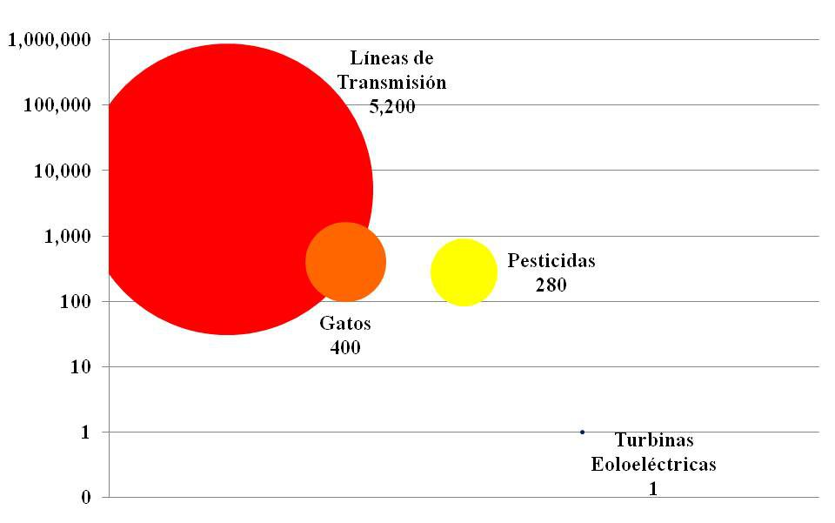

Transmission lines 5,200. Cats 400, Pesticides 280, Wind electric turbines blades 1

Source: Self Elaboration with Awea data.

To this respect it is worth to observe that as revealed in the last promoted congresses by conservationist research and energy generators, the birds’ fatalities nearby the wind generation p arks have a similar distribution as is shown in the figure 2.

By itself, the chart is self-explanatory. Per each bird registered fatality in a wind park, the pesticides kill 280 birds, the transmission lines, 5200: and the cats, 400. In this distributional analysis there is not included the collision fatalities, the car collision fatalities, communication towers, etc. which all of them represent approximately 3380 fatalities.

The pesticides action on the birds is not totally studied. But there is evidence that most of the pesticides used in Latin America affect the birds ‘central nervous system making them fail, eventually, their respiratory system until they died. The pesticides also, have negative effects on the nesting/hatching success rate.

From all the previous studies that were made in the Oaxaca area, concerning with the birds’ fatalities registered in wind parks, in any of the cases is mentioned the toxicology study made into the bodies to determine the pesticide level. Simply, the fatalities were attributed to the wind turbine blade collisions.

The wind electric generation area is plagued with municipal waste dumps. In the same proliferates harmful fauna as rats, cats and dogs. These species include in their daily diet, specially the cats, the birds consumption. Unfortunately, there is no data about the area but, if we consider what has been studied in the north of the country by the Parques de vida Silvestre de Nuevo Leon organization, where it has been demonstrated the reduction of some bird species by the cats and the dogs hunting, domestic and wild; it can be said that is the same in the rest of the country and Oaxaca is not an exception.

This phenomenon of illegal hunting, feline and canine, has been taken, in other parts of the world, to promote campaigns about the bird conservation, inviting to keep the referred pets confined. The wind electric parks objectors in Oaxaca and, occasionally, in other parts of the country, have not mentioned any about this topic.

From above it is concluded that there is no evidence in the wind parks in Mexico, which takes to conclude that its operation puts them at risk of extinction to the different birds species, residents and migratory. The ecological authorities and the investing companies, however, have decided maintain their birdlife monitoring programs.

4.3.6.4.2 Bats

There is not a wide variety of studies in Mexico about the relationship between the wind parks operation and the bats wind turbine blade collisions. They are just inferred as causality and the extreme number mentioned are the “killing of 6000 bats in a year” by the Wind Park at La Venta II. These data, invented or fake, are used as a “social” pressure element for pecuniary purposes.

Is until 2007, in an established agreement among SEMARNAT, the CFE and the INE, where is defined a Wildlife Monitoring Manual (Birds and Chiropteran), the same that was put in practice since 2008, specifically to the La Venta II park.

In the reports that makes the CFE to UNFCCC, with topics which include the wildlife fatalities monitoring (Birds and Chiropteran) at the La Venta II wind park operation, shown in the Chart 7, it can be appreciated that the parametrical data are 1.15 bat fatalities and 0.35 bird fatalities, both are annualized by NW of the wind electric generation Installed Capacity.

Chart 7. The annual wildlife Fatality (Birds and Chiropteran)

During the operation at La Venta II wind park.
 | BATS |  | BIRDS
PERIOD | COLLISIONS | IDENTIFIED  SPECIES | COLLISIONS | IDENTIFIED SPECIES
2007 - 2008 | 89 | 11 | 43 | 20
2008 - 2009 | 145 | 26 | 32 | 16
2009 - 2010 | 54 | 16 | 12 | 8
PROMEDIO | 96 | 17.7 | 29 | 14.7
PARAMETRIC  (Fatality/MW year) | 1.15 |  | 0.35

Source: Self elaboration with consulted data at http://cdm.unfccc.int/Projects/DB/AENOR1168204945.7/view

Analyzing the study made at the US, in which are synthesized the monitoring reports of almost fifty installations, in different moments among 1998-2008, there are parametric data: 7.3 bat fatalities and 2.8 birds’ fatalities, annualized by NW with wind electric generation capacity.

Even when contrast both groups of parametric data is obtained what has been reported in Mexico equivalents between 13 to 16% of what was reported in the US, we cannot make a conclusion. It should be noted that the monitoring made in Mexico, the same in another wind areas in the world, the community representatives participate, as well as, ecologic authorities, none government organizations, local authorities, etc.

However, there are still some groups that struggle to stop the wind parks operation during the high season of the birdlife migration, and at nights in the rain season to “protect” to the bats.

The agreed monitoring programs stipulate to review the results every five years to define the assertive prevention and mitigation criteria if necessary. The first peer review will take place at end of 2013.

For all these reasons, the environmental sustainability is qualified as Moderately Probable.

Environmental Sustainability
4. Probable | 3. Moderately Probable | 2. Moderately None probable | 1. None probable

Viewed as a whole the “dimenssions” described in the previous paragraphs, it can be conclude that the Project Sustainability is Moderately probable.

The Project Sustainability
4. Probable | 3. Moderately Probable | 2. Moderately None probable | 1. None probable

4.3.7 The Reproducibility

During the implementation the municipal and state authorities from other areas in the country and also in other Central American countries, have expressed their interest to reproduce the Project strategies and activities with the purpose to reduce the GG emission through the provision of incentives to produce wind electric power. To “crystallize” this kind of projects is necessary to consider the following success factors:

The success factors

To develop a regional center of investigation in wind electric power requires not only the technologic knowledge, it is also required a commitment that goes beyond of the labor. Add leadership and passion to spread it to the other crew members to share the same expectative and aspirations.

Contribute to reduce the barriers for the wind electric power implementation in Mexico, has required a decisive commitment and support from the different government agencies; the job done to this respect has paid off and there is still a lot to do.

To know which the regulatory and legal framework is in both, the informal process and the formal, in especial the regional, which allows define the involved, their needs and potential. Only that way it can be made an objectives approach whose logical “chain”, the AML, allows ensuring the impact results.

A no minor topic is to impulse the diagnostic in wind potential areas. For such effect is recommended to establish a technical rule that specify the technical characteristics of the anemometric stations that keep pertinent information.

4.3.8 Sinergies with other projects.

This Project financed by the GEF has contributed with the GOM efforts to impulse the regional development and reduce the GG emission through the wind generation Project investment.

Additionally, the Project is contributing with the GEF objectives which has been implementing with the GOM through projects with other agencies like the Development Interamerican Bank and the World Bank.

Among the projects that the BID is administrating in Mexico, there is the Wind Technologies Development and Promotion in Mexico, ME-X1011, which counts with a contribution from GEF of 5 million dollars and a national co-financing of 33.6 million dollars. The Project, aproved in May 2012, has as a purpose to develop and certified the Mexican Wind Machine, the same that it is supposed to operate in the wind regime Class IA, which is the typical, found in the Itsmo de Tehuantepec area. This development will allow covering, at least, 20% of the equipments which are estimated to come into operation in Mexico to cover the electricity demand in the Distributed Generation modality.

The Project will be developed by the IIE as the implementing agency. This assignation sustain among other points, described in the Project document, by the granted experience by the IIE in the Distributed Generation, the need to develop the local market of wind electric generation manufacturing, the IIE ability to execute this kind of projects, sustained mainly in its project participation part of this Final Evaluation.

The World Bank, on its part, is administrated with GEF funds in Mexico dedicated to the renewable sources energy development. Out among other projects is the Long term renewable Energy development Project. This Project identified as P077717, has as the purpose to support Mexico to stimulate and accelerate the renewable sources energy market commercialization to reduce the GG emission.

The Project is contemplated in two stages: In the first is constituted the Technical Assistance for the development about a system stimulation model which contemplates different sensitivity variables centered in it, public policies development, technical regulations establishment, impulse of a generation Project by an Independent producer and the UNDP complementary activities coordination. In this point is noticed, the complementarily monitoring and the lessons learned internalization that the Project could have in this Final Evaluation. All of it that is going to be used as a “catalyze” in the second stage of the Project, which include to give a monetary incentive to the Independent Producer for the contest wind Project, by KWh delivered by SEN.

The document Project, as well, notices the IIE participation as a key actor to the Project implementation and development.

In summary, the development of this Project has complementarities with other GEF projects developed in Mexico and its lessons have been incorporated, also, to the design and the implementation correction of other projects. All this will take to Mexico to GG emission reduction levels which will place it as leader among all the integrated countries as no-members in the Attachment I of the Framework Convention for the United Nations climate change.

5. Conclussions

The Project, in spite of the federal, state and municipal public administration changes, the reduced communication and cooperation among the federal agencies that the country lived at the end of 2006 and the beginning of 2007; the delay in the delivery results, reached SUCCESFUL performance levels and lessons learned that will serve as platform to structure the future projects with more assertiveness.

Its contribution to identify the main “bottlenecks” from the regulatory and legal framework, allowed to “exploring” the opportunity areas with which the modification initiatives were impulse and designed to that regulatory and legal framework.

5.1 Direct Results

Are noticed as direct results, attributable to the Project execution, the following:

The implementation of alternative solutions to the attainment of the Project key products: the land donation, technologic supplier’s development, collaboration agreements with wind parks operators and technicians, technological collaboration agreements with academic institutions, etc.

Effective mitigation of risk to stop growth of the wind power generation projects by an alleged threat of extinction of wildlife, birds and chiropteran wildlife, resident and migratory in the Ithsmus of Tehuantepec area.

The IIE positioning and enforcement as an actor and important referent in the national agenda development to energetic topics, in special the ones referred to the power generation technologies use through renewable sources.

Complementarily, with the project "cascade" of GEF in Mexico to reduce GHG generation through environmentally friendly power generation.

5.2 Indirect Results

At the same time, the Project has contributed, contributing as an indirect way to the decided action of the SENER, The CRE and the SHCP to:

Reduce the authorization times in the wind electric projects. This was achieved promoting the contract models of the Interconnection Service for collective sources of renewable energy or efficient cogeneration collective systems in short term, 2004;

Count with a depreciation policy accelerated for friendly environmental investments, 2004;

To Impulse the renewable Energies Exploitation Law and the Energetic Transition Finance, 2008; established some mitigation laws, in respect of the based scenario for the energy production, in the Special climate change program, 2009;

Established the Special Renewable Energies Exploitation Program goals, 2009;

Define the national electric system interconnection general rules for generators or concessionaries with efficient generation or renewable energy sources, 2012;

With the CRE collaboration define the Interconnection Contract Model for electricity generation plants with renewable sources, CIFER;

With the CONAE collaboration, make the “Management Guide to implement an electric Generation Plant which uses renewable Energy in Mexico”;

Constitute the Mexican Official Regulation Project, NOM-S/N-SEMARNAT-2012, in which will be established the technical specifications for the environment protection during the site selection and preparation, construction, operation or wind electricity facilities abandonment in low environmental impact areas;

The Interconnection general rules drafting to the national electric systems for generators and concessionaries with renewable energy or efficient generation resources, etc.

No doubt that there is still a lot to do, but the open opposition or slowness that existed in different fronts of the three government levels; federal, state and municipal, have changed completely in a few years. Reduce these barriers is a task that is part of the energetic development challenge with the public officials that will begin their management at the end of this year.

The impact goals of the Project as it was designed, in the worst scenario, will be reached with a delay of a couple of years. We will have to wait to know the resultant regulatory framework of the climate change General Law, issued on the past June.

The fixed goal for the 2015, however, to count with an installed electricity production capacity with wind generation equivalent to almost 2,000 MW; will be reached at the end of 2013.

The Project qualifications, its design and results are summarized in the next chart:
Specific elements identified by GEF-UNDP | Asssigned qualification in terms on the results achieved
The Project Formulation | SUCCESFUL
Concept and Design | SUCCESFUL
National Appropriation | HIGHLY SUCCESFUL
Those involved Participation | MODERATELY SUCCESFUL
Project Implementation | SUCCESFUL
Implementation Development | HIGHLY SUCCESFUL
Monitoring and Evaluation | MODERATELY SUCCESFUL
Those Involved Participation | SUCCESFUL
Results | HIGHLY SUCCESFUL
The objectives Achievement | HIGHLY SUCCESFUL
The Project Global Qualification | SUCCESFUL

Then, the results achieved by the Project, with the impact that is visualized in a short term, allow us to qualify the overall performance as SUCCESFUL.

6. The Lessons Learned

The social inclusion in any Project faces even expected conditions as well as the no contemplated; at the same time, it has expected effects but, also, not expected. Here are summarized these elements with the purpose of incorporate this experience in the future projects design and implementation. The approximation used is the generally accepted in the United Kingdom public organizations.

6.1 The fulfillment insertion objectives of the Project.

The design of the Project was simple, logic and flexible, which facilitated the suitability of time and the immediate goals achievement to the conditions that circumscribed the implementation. The success in a Project, greatly, is ensured since its design. The knowledge, the experience, and the peer agreement, of those who design the Project, allowed to contribute a development scheme with strategically direction, with specific and clear goals, this facilitated its implementation.

Ensure, since the design, the participation of all the involved in the Project implementation. Every Project has a risk that any of the involved in the implementation skip their participation, and this could increase the costs and the expected times for execution; or even, impede the project success.

The Project implementation suffered a proactive participation, in a regional level, from the CFE, which led to delays in one of the projective objectives: the CERTE to SEN interconnection..

The implementation of a Project in a time frame which exceeds the management periods from the local public administration must include an extra period of time to “mitigate” the deadlines that are increased because of the regulatory procedures of change or the accumulation of applications to process. About future interventions, is recommended that when the implementation development of a Project is in the middle of a federal, state or municipal administration change will be included an extra time margin which allows to mitigate the laxity impact that comes with these processes, being for delay in the application course, procedures of change, etc.

To invest in the Itsmo de Tehuantepec requires constituting, in the Project design, some options about the acquisition of susceptible lands for the implementation. The lack of instruments which allow to define the tenancy, legal and technical, of the land, in the state of Oaxaca, proven by the complaint of the investors and the wind project developers in the Itsmo de Tehuantepec area, and potentially could be repeated in other parts of the country, was a real headache for the project implementation. This uncertainty has contributed, with other regulatory elements, for all the wind electric investment projects in the Itsmo, at the moment, have incurred in lags in its boot that goes from one until four years.

Particularly, the Project implementation had a one year lag because there were not contemplated different options for the land acquisition. In a way that, when the wished option was lost it was necessary to dedicate time for searching, process an acquisition of the new land alternative.

Use the services and programs offered by other government agencies. In respect of the last point, was observed that the Procuraduria Agraria, counts with a Program “Fomento a la Inversión en la Propiedad Rural” (FIPP), its purpose is to “go along with” not only with the land holders also the investors, all along of a process which structure is based on the common elements search for the development, to find the association ways which allow, so the land holders do not translate the domination of their lands, and the investors productive union.

From the last nineteen authorized projects in the Itsmo area, just five applied for the FIPP services. It is worth to mention that three of these projects were the same members from the agricultural nucleus who applied for the PA intervention.

The lack of Human resources for the implementation of a Project increases the cost of it. It has been typical that some of the people in the area express that the wind projects do not generate employment for the area; and, on the other hand the investors emphasize that they have had to bring people from other areas of the country. In a strict sense they are talking about the same problem: There is a lack of Human Resources in the area.

The problem is common in many areas of the country. The best prepared people, the ones that may be integrated to the production chains secondary and tertiary, search for opportunities in areas where they can take advantage of their capacity and, that way develop their potential.

The wind projects require in their employment staff, mostly, college graduates in mechanical engineer, electric and systems. In the Project implementation it was necessary, because the absence of candidates in the area, to take people from the center of the country. This involved costs not contemplated in the Project design.

The components with high technological content have prices and times subject to economic cycles. In the Project developments, and in special the stages that goes from the basic engineering development to the construction stage, it is necessary to identify those elements that require a periodical monitoring, to ensure that the costs, quality and delivery times be maintained in the planned range. There are going to b especial cases, also, which require maintaining updated information in respect of the macroeconomic environment scenarios, commodities and specialties prices, exchange rates, etc.

The saturation of manufacturing applications of wind electric generation in the world market, led to the implementation of the wind electric generation had a delay for more than a year.

6.2 Extension of Project impacts.

Take advantage of the “spaces” that are opened by the oppositions and detractors action for the community support generation. All Project implementation will have opposition. There is opposition because is perceived a potential affectation, real or fake, for particular or collective interests. Always those opposition expressions are manifested, especially in massive diffusion forums as radio programs, television, council meetings, local public administration accountability events, etc., there is a great opportunity to transmit the direct and indirect benefits of the project insertion, facilitate the sustain debate in data “rough” and open the ways to the constructive social negotiation

When the chance was given to introduce the purpose of this Project, received the community acceptance and appropriation. It is worth to mention that the inner relation that has been generated with the regional scholar community, not just with the higher education institutions but also with the elementary and middle age schools, have contributed that the community accept better the wind electric investment projects. This has eased the way to new investments.

The opportunity generation for the cooperation networks creation.

In the projects implementation tend to be present unique situations and no contemplated, simply because there is not previous similar experience with other projects. So, the Project implementation had to face situations that the CFE had not contemplated, and when “the road was open” have motivated to other developers to consult, formal and informal, as it was made by the project crew to solve the procedures, solve the technical problems, etc. All this have contributed to some technicians and wind electric park operation companies center in the CERTE the ability to call for the diffusion of technical and no technical topics searching for common solutions.

6.3 Status Modification

Take advantage of the acquired lessons and from other projects for the new Project design. This is a Perogrullo truth that, frequently and unfortunately, is forgotten to apply. In the design Project for the Mexican Wind Machine, the IIE undeniably has contemplated some of the lessons learned so that in its implementation will have fewer uncertainties.

The Best Practices document elaboration. When there is a certainty that a Project will be reproduce in different occasions, it is mandatory to elaborate a document that constitute which were the Best Practices; that is to say, which decisions allow to influence in the circumstances and which elements ensure the efficiency and quality of the objective that led to the success of the project. The document concept and design must be guide considering that this will be a guide, frequently consulted, for the new wind electric projects investors or academics interested in the topic.

7. Recommendations

It has been commented that, in regulatory terms, there is still a lot to do. Some of the investors and academics in Mexico have contributed to the need to ensure the clear “game” rules, which allow to plan in a long term, especially in a strategically topic for any country: The energy generation and transmission..

Some of the specific points in which are necessary to keep working on are:

That the strategic plan of the transmission and distribution in the National Electric System is updated, with regional disaggregation, and is diffused by the CFE or SENER.

That the academics, SENER, CFE and all the important people involved agree in a methodology to calculate both the electricity generation costs with the different energy sources and the different technologies, as well as the Electricity Production Leveled Price with regional disaggregation.

That the calculation defining the charge per transmission is maintained in the regional fee scheme

Lines above was explained how in the medium term the wind electric investments will be affected by the electricity generation competence with combined cycle technologies, which consume natural gal. However, it is necessary that Mexico, as Europe, China and India have done, explore the alternative, for small towns of medium economic development, of the Distributed Generation.

The main advantages of the distributed generation are:

Loss reduction in the transmission and distribution networks,

The increase on the reliability of the electric power supply,

Reactive energy control and voltage regulation in the distribution network,

Ease the incorporation of renewable sources generated energy; and

Capacity release in the transmission lines which feed the distribution area and,

Consequently, increase on the reliability to reinforce the capacity of the transformation and transmission system.

Finally it is recommended to elaborate a document which updates the Better Practices in Mexico for the electric power production Project development with wind generation which emphasize these learned lessons and include, like in other countries, a “prontuario” which describe in a simple way the processes, procedures and terms that involves a Project process of this nature.

Would be convenient that this document of Better Practices, as well as other agencies in Mexico do with resources like mines or forest, include as minimal elements: the breakdown, with matrix analysis tools, the identification of wind potential areas; juridical certainty in land ownership; the proximity of consumption areas (housing, industrial, etc,); as well as the capacity and generation prospective, electric power transmission and consumption, etc.

8. Anex

Anexo 1 Terms of Reference

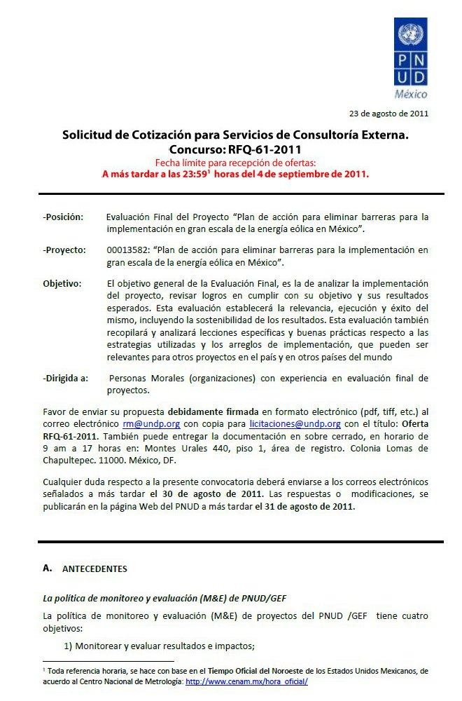
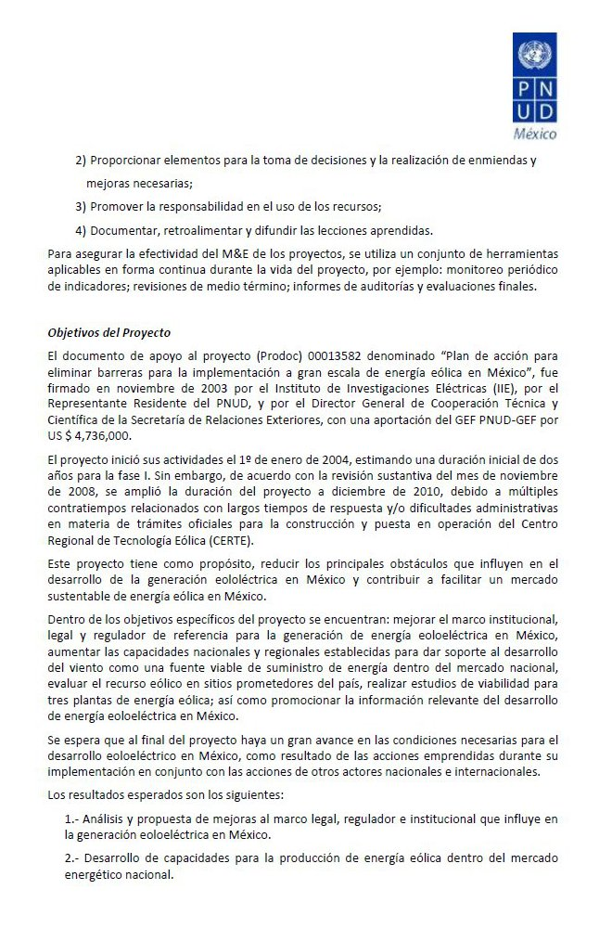
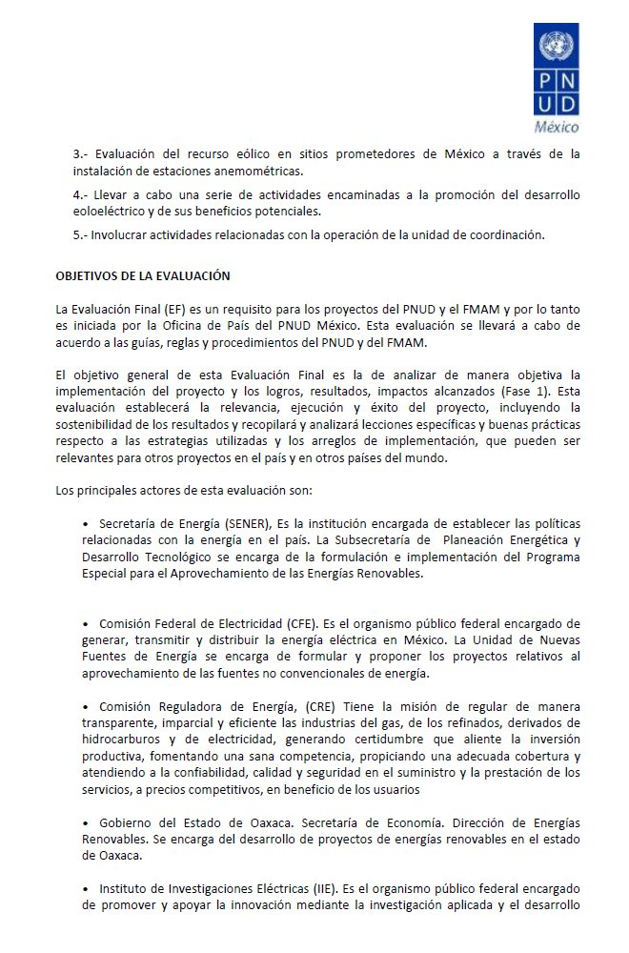
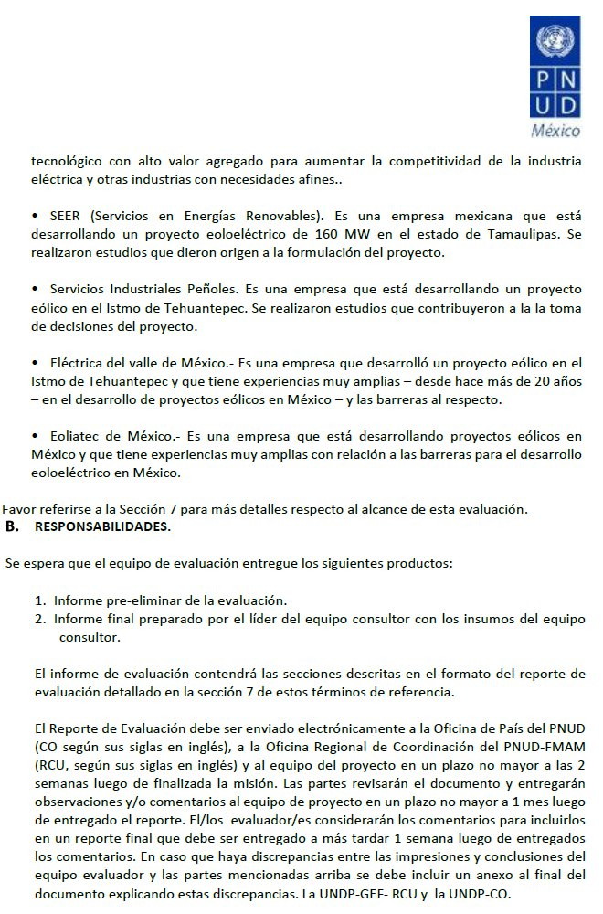
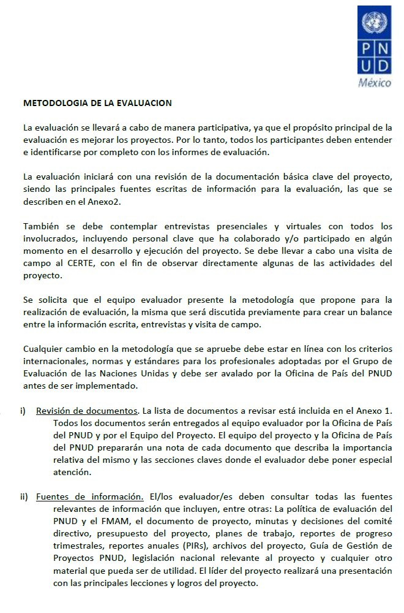
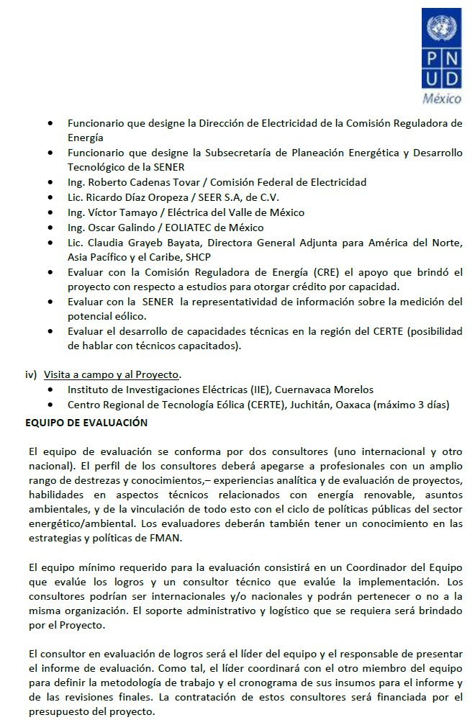
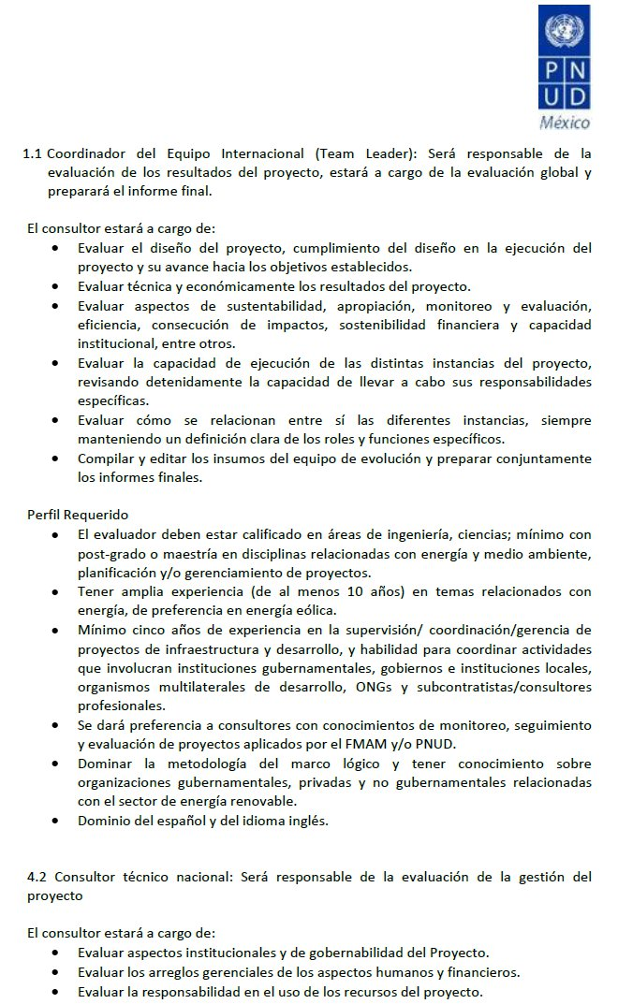
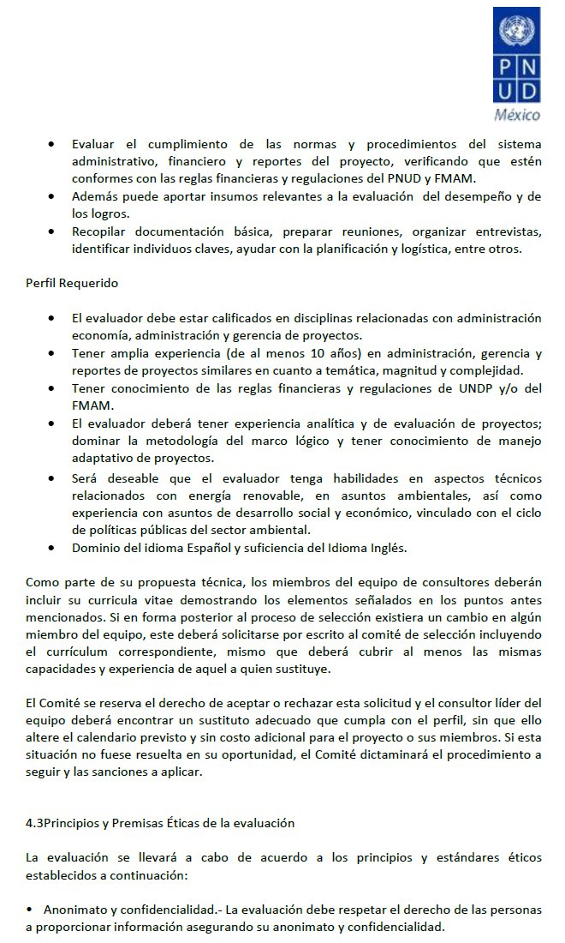
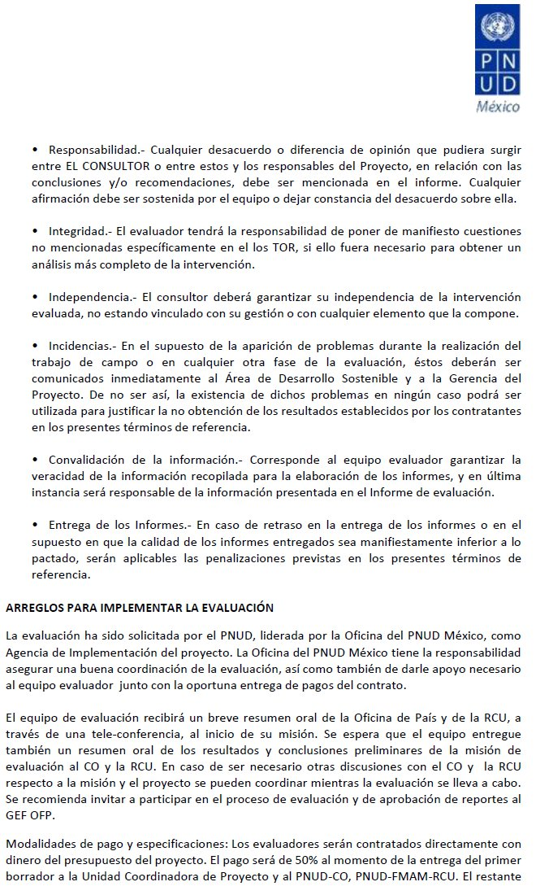
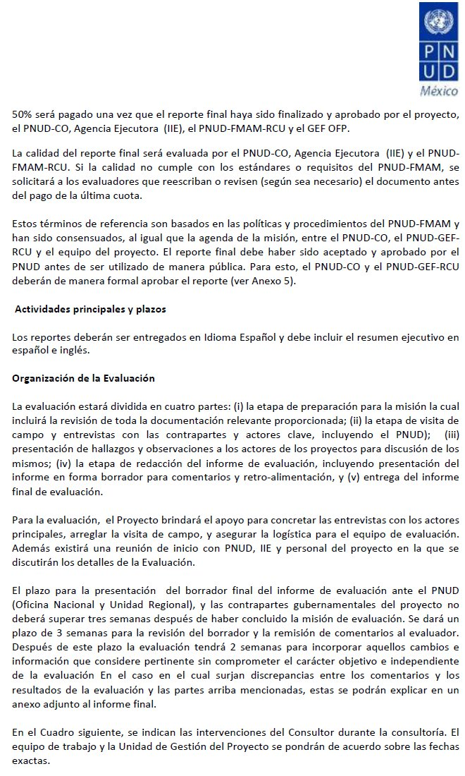
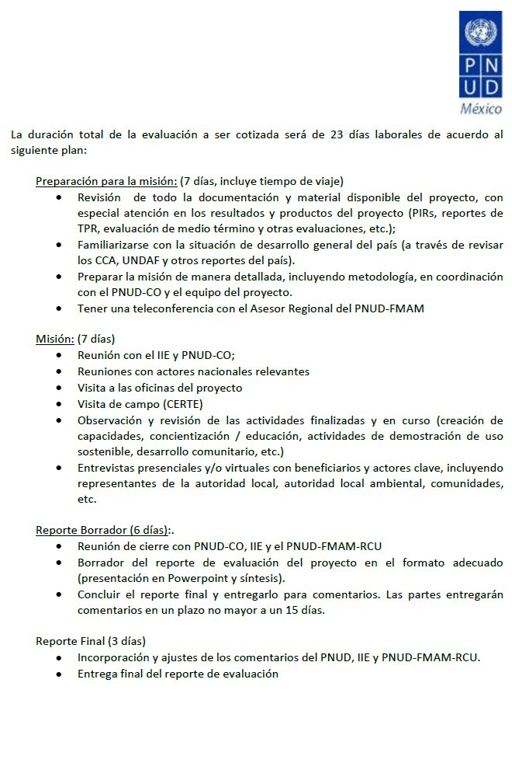
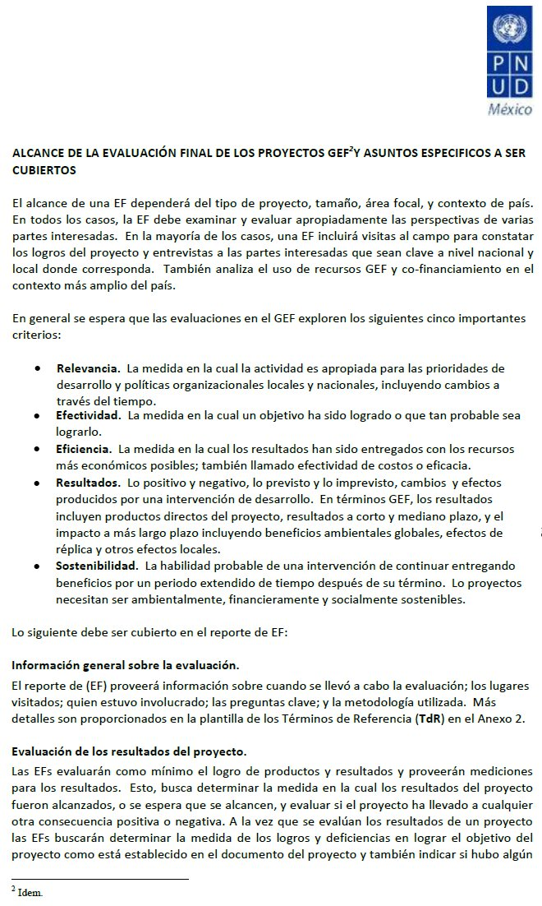
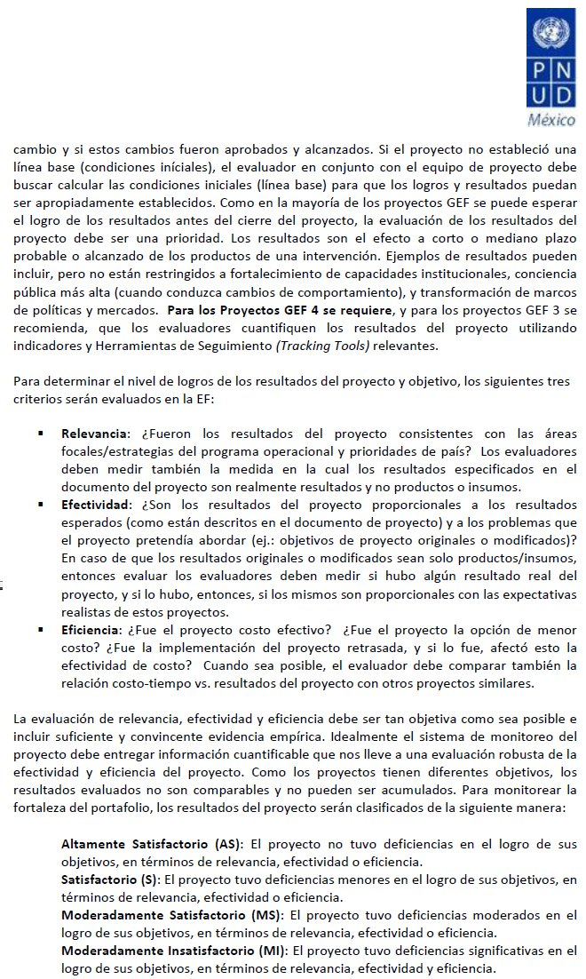
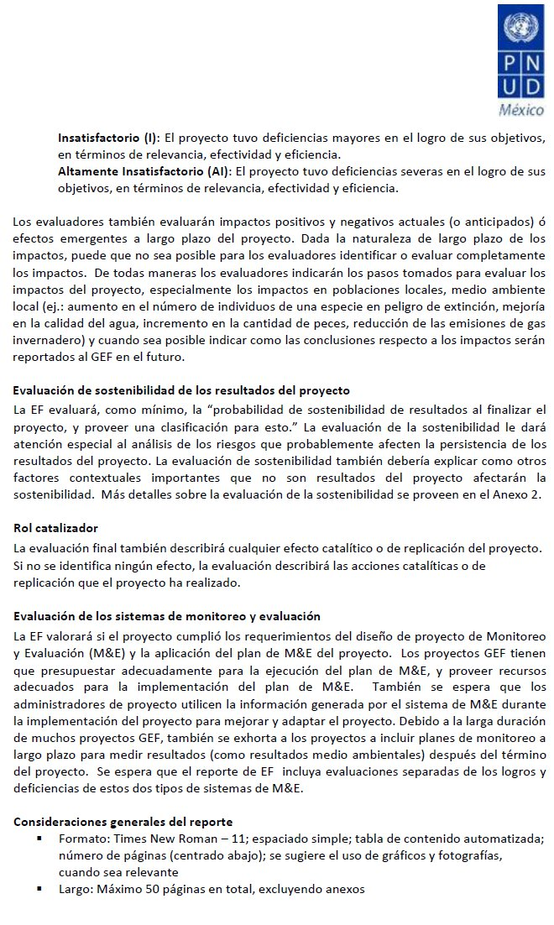
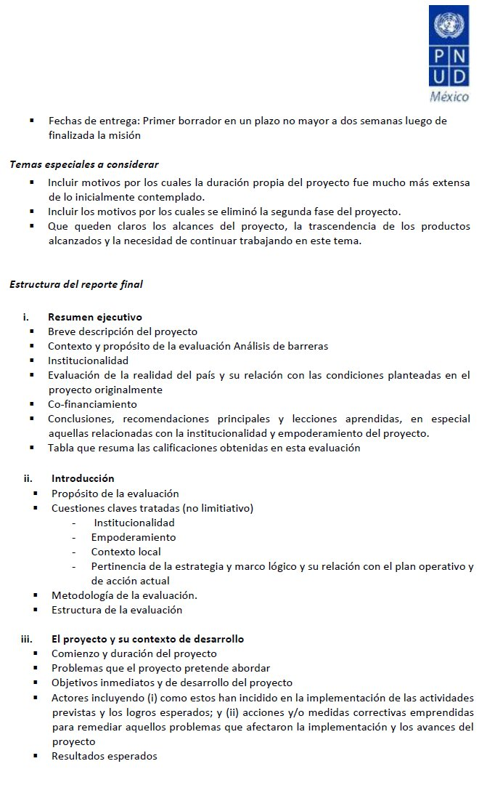
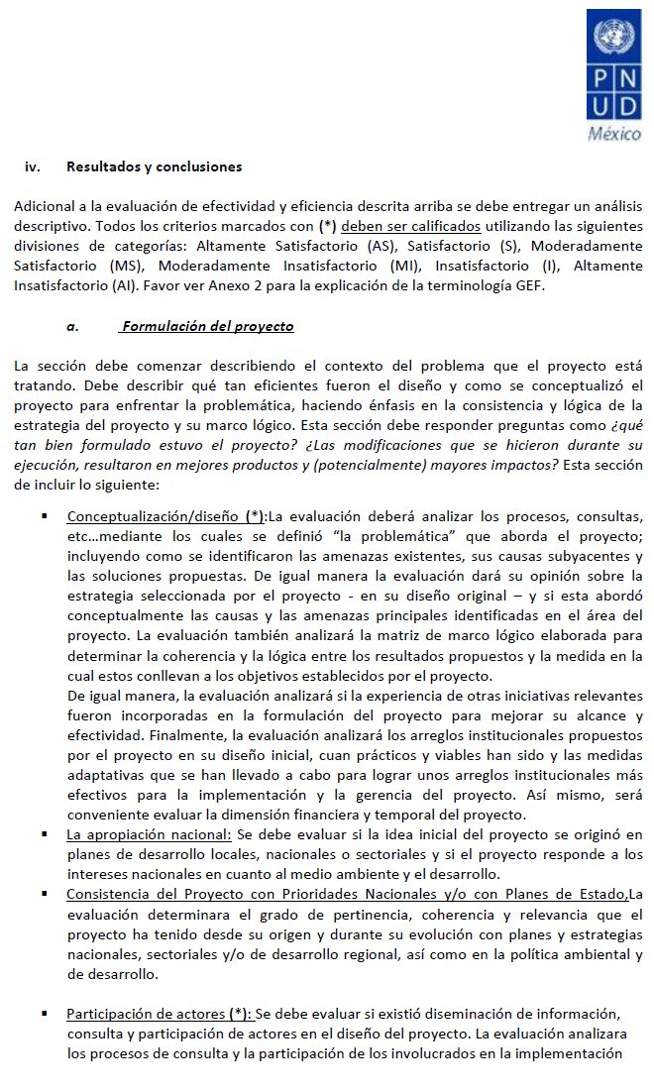
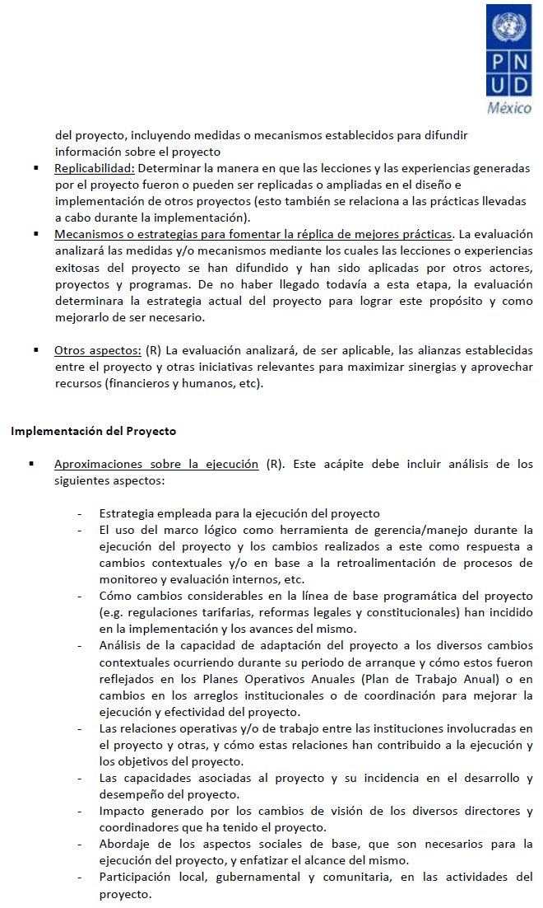
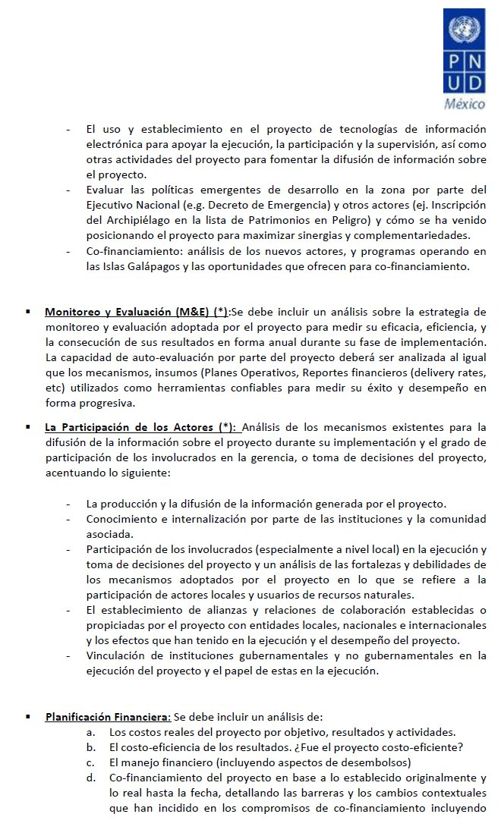
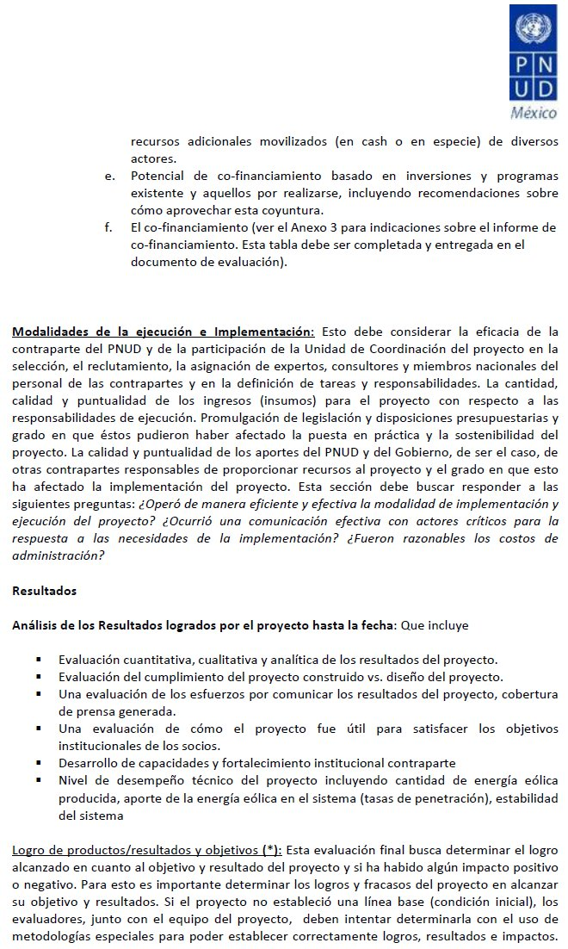
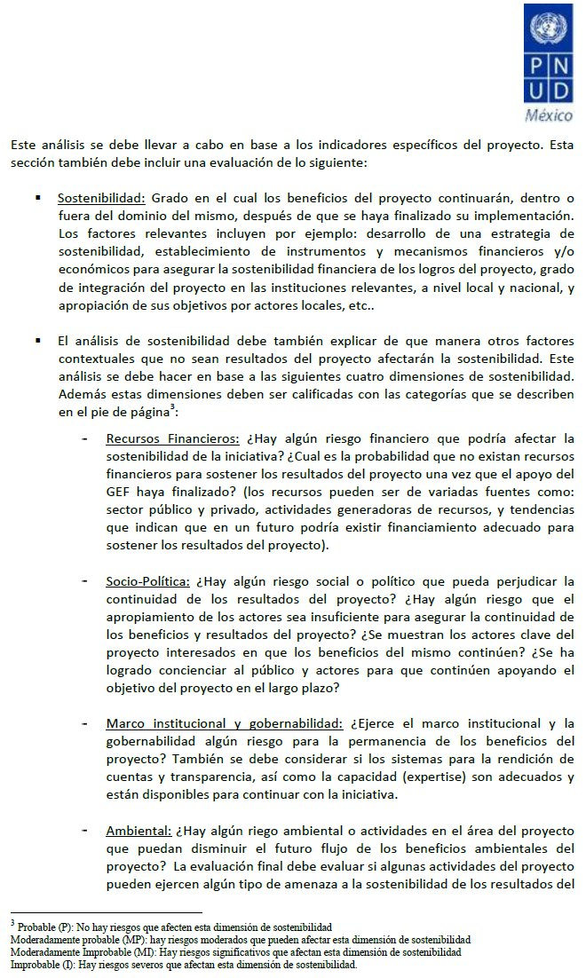
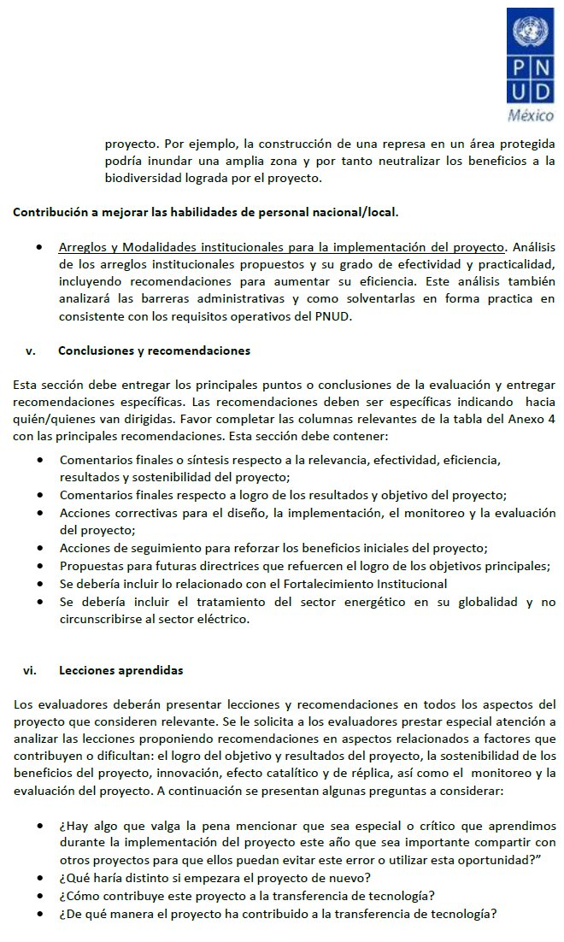
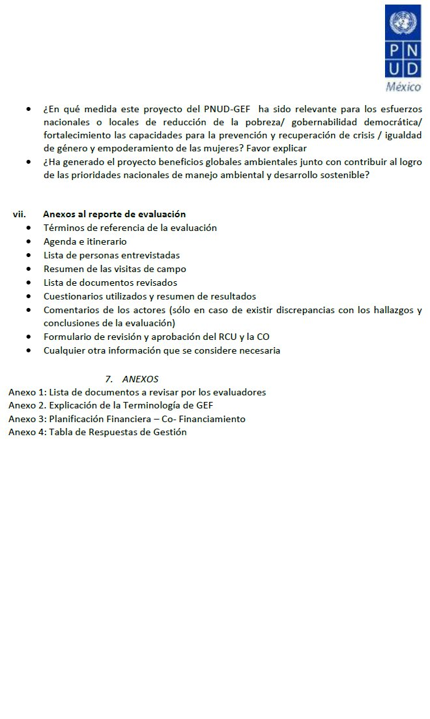
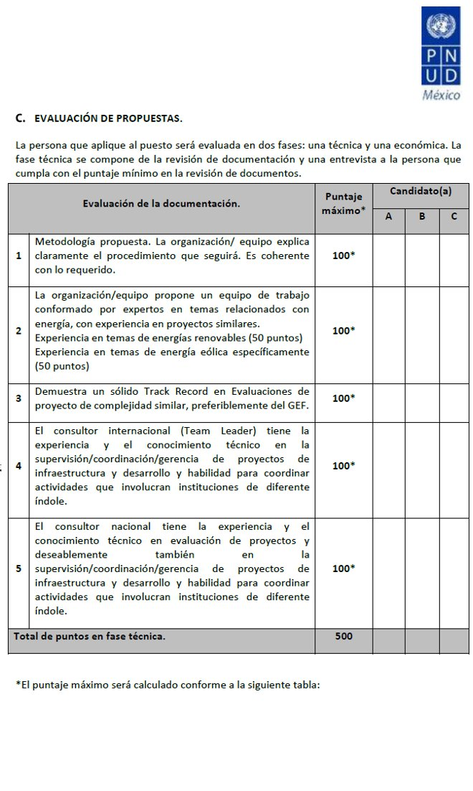
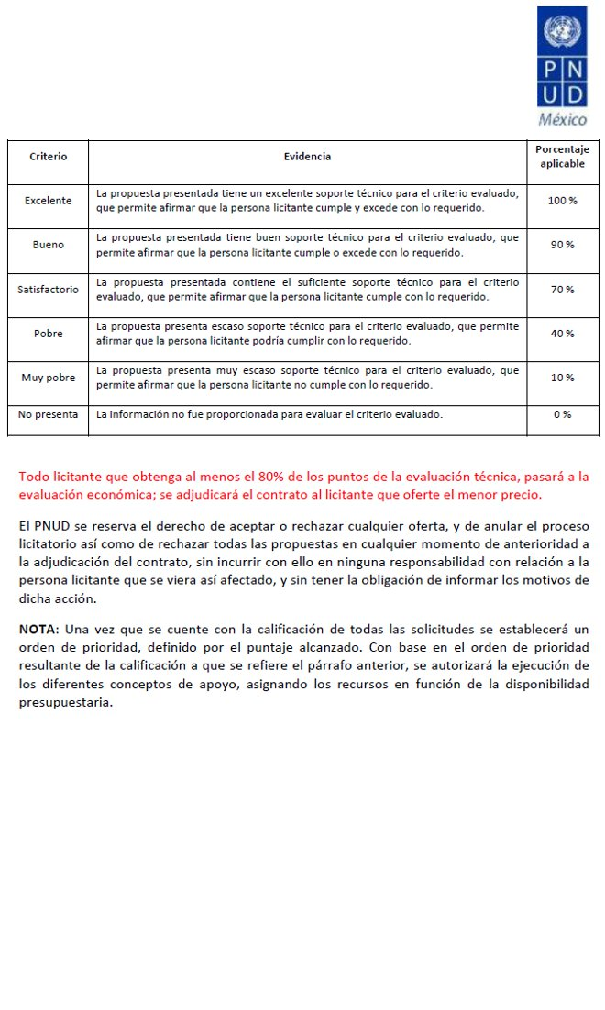
Anexo 2 Definición de objetivos de proyecto, componentes y actividades

Objetivo de Desarrollo

Reducir la Emisión anual de Gases de Efectos Invernadero (GEI) de México, a través de la instalación y operación de generadores eólicos comerciales a gran escala. El Objetivo estratégico es alcanzar una capacidad instalada de 2000 MW, en un plazo de 10 años, que reducirían anualmente 4 Mt CO2 equivalente.

Objetivos inmediatos, componentes y actividades

Se omiten los componentes y actividades comprendidos en la Fase 2.

Objetivo inmediato 1

Reducir las Barreras identificadas para la comercialización de energía eólica con el objeto de:
- Facilitar la instalación y operación de tres modelos de plantas de generación eólica en México conectadas a la red central de distribución.
- Crear un mercado sustentable de energía eólica en México.

Componente 1
Mejora institucional del marco legal y regulatorio para la generación eólica de energía.

Actividad 1.1
Revisión del marco institucional legal y regulatorio.

Actividad 1.2
Propuestas de enmienda o mejora del marco institucional legal y regulatorio.

Actividad 1.3
Campaña promocional.

Actividad 1.4
Monitoreo y Evaluación de los productos y actividades.

Componente 2
Establecimiento de capacidades nacionales y regionales que apoyen el desarrollo de la generación eólica como fuente de suministro viable para el mercado de la electricidad.

Actividad 2.1
Proceso de Autorización.

Actividad 2.2
Subcontratos para la construcción del CeRTE.

Actividad 2.3
Construcción y arranque del CeRTE.

Actividad 2.4
Inclusión de cursos en la programación de las Instituciones Técnicas.

Actividad 2.5
Primeros Talleres en el CeRTE.

Actividad 2.6
Manual de Mejores Prácticas.

Actividad 2.7
Mejora de la comprensión de la Tecnologia de Generación Eólica, de parte de los actores principales.

Actividad 2.8
Monitoreo y Evaluación de los Componentes y Actividades.

Actividad 2.9
Entrenamiento en operación y mantenimiento de plantas de generación eólica.

Actividad 2.10
Disponibilidad de Datos de desempeño de las turbinas eólicas.

Componente 3
Recursos eólicos evaluados en las zonas de mayor potencial de desarrollo comercial en México, y estudios completos de factibilidad para 3 plantas eólicas.

Actividad 3.1
Estudios Genéricos para facilitar el procesamiento de proyectos eólicos.

Actividad 3.2
Instalación de estaciones anemométricas de referencia para la Evaluación del recurso energético eólico.

Actividad 3.3
Evaluación, de un año, del recurso energético eólico.

Actividad 3.4
Estudios de Factibilidad para tres proyectos modelo de generación eólica.

Actividad 3.5
Bases de Concurso para proyectos modelo.

Actividad 3.6
Estudios genéricos para La Ventosa.

Actividad 3.7
Accesibilidad a recursos de información eólica.

Actividad 3.8
Monitoreo y Evaluación de Componentes y Actividades.

Componente 6
Promoción de la información relevante para la generación eólica de lectricidad basados en mecanismos institucionales y financieros probados.

Actividad 6.1
Apoyo a actividades promocionales de vinculación.

Actividad 6.2
Monitoreo y evaluación de Componentes y Actividades.

Actividad 6.4
Manual de Mejores Prácticas y Guías para la Implementación Comercial de Proyectos de generación eólica en México.

Anexo 3 Escalas de Valoración

Conforme a la recomendación del FMAM, el PNUD evalúa la Relevancia, Eficacia y Eficiencia de los proyectos acorde con la siguiente Escala de Calificación:

Altamente Insatisfactoria (AI): | El Proyecto presentó severas deficiencias.
Insatisfactoria (I): | El desarrollo del proyecto presentó deficiencias mayores.
Marginalmente Insatisfactoria (MI): | El Proyecto presentó deficiencias significativas.
Marginalmente Satisfactoria (MS): | El Proyecto presentó deficiencias moderadas.
Satisfactoria (S): | El Proyecto presentó deficiencias menores.
Altamente Satisfactoria (AS): | Sin deficiencias.

Y, tocante a la Sustentabilidad, la Escala de Calificación es como sigue:

Improbable (I) | Riesgo severo de que los Resultados del proyecto así como sus productos clave no serán sustentables.
Moderadamente Improbable (MI) | Riesgos substanciales de que los Resultados clave no se realizarán concluido el proyecto; sin embargo, algunos Resultados y actividades se lograrán.
Moderadamente Probable (MP) | Riesgos moderados, pero con expectativas de que al menos algunos resultados serán sustentables.
Probable (P) | Riesgos para la Sustentabilidad prácticamente despreciables, con Resultados clave esperados en el futuro previsible.

Anexo 4 Itinerario y Personas Entrevistadas

Fecha | Reunión | Lugar
27 Agosto 2012 | 13:00 – 14:30  Entrevista con Mtra. Verónica Irastorza, Subsecretaria de Planeación Energética y Desarrollo Tecnológico, SENER;  Ing. Julio Valle; Gerente de Energías Renovables, SENER | México, D.F.
28 Agosto 2012 | 10:30  Reunión virtual con:  Verania Chao, Gerente del Programa PNUD-CO;  María José Mesén, Punto Focal PNUD-CO para el proyecto;  Analisa Munich, Punto Focal FMAM para América Latina;  Ing. Alejandra Lugo, Gerente de Administración del Proyecto, IIE; e,  Ing. Marco Borja, Gerente de Proyecto | Cuernavaca
3 Septiembre 2012 | 13:00  Junta de Inicio con funcionarios PNUD-CO  Verania Chao, Gerente del Programa PNUD-CO;  María José Mesén, Gerente de Programa desarrollo Sustentable, PNUD-CO;  Francisco Hernández S., Seguimiento Administrativo PNUD-CO | México
10 Septiembre 2012 | 15:00 – 19:30  Desplazamiento a Juchitán  Conversación con Ing. Marco Borja para detallar elementos sobre el origen, la definición y desarrollo general del proyecto | Huatulco-Juchitán
11 Septiembre 2012 | 9:00 – 11:00  Visita al CERTE  11:00 – 12:00  Reunión con proveedores de la turbina de generación del CERTE, Ings. Hozomi y Yukoku, de la empresa japonesa Komaihaltec, Ltd.  12:30 – 14:30  Visita a Parques Eólicos de la Región La Venta – La Ventosa  15:00 – 16:30  Reunión con gerentes de operación y mantenimiento de Eléctrica del Valle de México | Juchitán
12 Septiembre 2012 | 9:00 – 19:00  Entrevista con Ing. Marco Borja, Gerente de proyecto IIE. | Juchitán
13 Septiembre 2012 | 10:00 -14:00  Traslado a Huatulco  Comentarios sobre perspectivas en el corto plazo del CERTE. | Juchitán-Huatulco
18 Septiembre 2012 | 13:00 – 15:00  Entrevista con Arq. José Ramón de Legarreta, Director del Programa de Fomento a la Inversión en la Propiedad Rural (FIP) | México, D.F.
24 Septiembre 2012 | 9:30 – 12:00  Entrevista con Dr. Alejandro Peraza, Director General de Electricidad y Energías Renovables, Comisión Reguladora de Energía  13:30- 15:00  Entrevista con Ing. Alejandro Carrión, Jefe Proyectos Eólicos, Subdirección de Construcción Proyectos Termoeléctricos | México, D.F.

Anexo 5 Lista de Documentos Revisados

Borja, M., Jaramillo, O. y Mimiaga, F. Primer Documento del Proyecto Eoloeléctrico del Corredor Eólico del Istmo de Tehuantepec. México.

Climate Investment Funds (2009). Clean Technology Fund Investment Plan for Mexico. Washington, 2009.

CONUEE, CRE y GTZ (2010). Estudio sobre la Cogeneración en el Sector Industrial en México. México.

EWEA (2009). The Economics of Wind Energy. Brussels.

FMAM (2010). Política de Seguiiento y Evaluación del FMAM, 2010. Washington.

GTZ y SENER (2009). Energías Renovables para el Desarrollo Sustentable en México. México.

GWEC (2010). Global Wind Energy Outlook 2010. Brussels.

IIE (2005). Taller de Ruta Tecnológica de la Energía Eólica en México para los Próximos 25 años, Informe de Resultados. Cuernavaca.

SENER (2009). Programa Especial para el Aprovechamiento de Energías Renovables. México.

SENER (2012). Estrategia Nacional de Energía 2012-2026. México.

UNDP (2002). Second country cooperation framework for Mexico (2002-2005). Executive Board of the United Nations Development Programme and of the United Nations Population Fund. New York.

UNDP (2010). Manual para realizar una Evaluación de necesidades en materia de tecnología para el cambio climático. New York.

UNEP, AFD e IMCO (2012). Programa Especial de Cambio Climático para el período 2012-2020 con acciones adicionales y análisis de potencial. New York.

USAID (2009). Análisis Comparativo del Marco Eléctrico Legal y Regulatorio de EE.UU. y México para la promoción de la Energía Eólica. Washington.

World Bank (2012). State and Trends of the Carbon Market 2012. Washington.

World Economic Forum (2011). Scaling up Renewables, Developing Renewable Energy Capacity – Addressing Regulatory and Infrastructure Challenges in Emerging Markets. Geneva.

Anexo 6 Instituciones financieras participantes

En el financiamiento reciente de los proyectos de generación eoloeléctrica en México han participado las siguientes instituciones:

- Bancomext, México
- Banorte, México
- Banco Interamericano de Desarrollo
- Banco Mundial
- Banobras, México
- BBVA Bancomer, México y España
- Crédite Agricole and Investment Bank, Francia
- Espirito Santo Bank, Portugal
- HSBC, México
- Kredit Fonden Eksport, Dinamarca
- La Caixa, España
- Macquire Capital
- Mitsubishi, Japón
- Proparco, Francia
- Nafinsa, México
- PGGM, Holanda
- Santander, México y España

Anexo 7 Permisos otorgados para desarrollo de Proyectos de Generación Eoloeléctrica

PERMISIONARIOS  (al 30 de Agosto de 2012) | CAPACIDAD AUTORIZADA (MW)
FUERZA EÓLICA DEL ISTMO, S.A. DE C.V. | 80.0
ELÉCTRICA DEL VALLE DE MÉXICO, S. DE R.L. DE C.V. | 67.5
PARQUES ECOLÓGICOS DE MÉXICO, S.A. DE C.V. | 99.5
EOLIATEC DEL ISTMO, S.A.P.I. DE C.V. | 164.0
EURUS, S. A. P. I. DE C.V. | 300.0
BII NEE STIPA ENERGÍA EÓLICA, S.A. DE C.V. | 26.4
INSTITUTO DE INVESTIGACIONES ELÉCTRICAS | 5.0
EOLIATEC DEL PACÍFICO, S. A. P. I. DE C. V. | 160.0
EÓLICA SANTA CATARINA, S. DE R. L. DE C. V. | 22.0
FUERZA Y ENERGÍA BII HIOXO, S. A. DE C. V. | 234.0
ENERGÍA ALTERNA ISTMEÑA, S. DE R. L. DE C. V. | 215.7
DESARROLLOS EÓLICOS MEXICANOS DE OAXACA 1, S. A. DE C. V. | 90.0
ENERGÍAS AMBIENTALES DE OAXACA, S. A. DE C. V. | 102.0
ENERGÍAS RENOVABLES VENTA III, S. A. DE C. V. | 102.9
MUNICIPIO DE MEXICALI | 10.0
CE OAXACA DOS, S. DE R. L. DE C. V. | 102.0
CE OAXACA CUATRO, S. DE R. L. DE C. V. | 102.0
CE OAXACA TRES, S. DE R. L. DE C. V. | 102.0
FUERZA EÓLICA DE SAN MATÍAS, S. A. DE C. V. | 20.0
COMPAÑÍA EÓLICA DE TAMAULIPAS, S. A. DE C. V. | 54.0
MPG RUMOROSA, S. A. P. I. DE C. V. | 72.0
ENERGÍA EÓLICA MAREÑA, S.A. DE C.V. | 180.0
GRUPO SOLUCIONES EN ENERGÍAS RENOVABLES SOE DE MÉXICO, S.A. DE C.V. | 161.0
DOMINICA ENERGÍA LIMPIA, S. DE R.L. DE C.V. | 200.0
FUERZA VIENTO PAPALOAPAN, S. A. P. I. DE C. V. | 40.0
STIPA NAYAA, S. A. DE C. V. | 74.0
VENTIKA, S. A. DE C. V. | 126.0
EÓLICA DE ARRIAGA, S. A. P. I. DE C. V. | 28.8
ENERGÍA SIERRA JUÁREZ, S. DE R. L. DE C. V. | 156.0
VENTIKA II, S. A. DE C. V. | 126.0
DESARROLLOS EÓLICOS MEXICANOS DE OAXACA 2, S. A. P. I. DE C. V., PARQUE EÓLICO PIEDRA LARGA FASE 2 | 137.5
COMPAÑÍA EOLOELÉCTRICA DE CIUDAD VICTORIA, S. A. DE C. V. | 50.0
TOTAL | 3,410.0

Anexo 8 Lista de Publicaciones

CONAE (2006). Guía de Gestiones para Implementar una Planta de Generación
Eléctrica que Utiliza Energías renovables en México. México

EIA (2012). Short-term Energy Outlook. Consultado en http://www.eia.gov/forecasts/steo/pdf/steo_full.pdf

GEF (2006). The GEF Monitoring and Evaluation Policy. New York.

GEF y UNDP (2008). Promotion of Wind Energy: Lessons Learned from International Experience and UNDP-GEF Projects. New York.

IDB (2012). Promotion and Development of Local Wind Technologies in Mexico. Washington.

IEA (2011). World Energy Outlook 2011,Special Report: Are we entering a golden age of gas? Paris.

IEA (2012). IEA WIND, 2011 Annual Report. Paris.

IEC (2005). International Standard IEC 61400-1, Wind Turbines- Part 1: Design requirements. Geneva.

INE y CFE (2006). Manual de vigilancia de la fauna (aves y quirópteros) en la zona de influencia de la Central Eólica La Venta II, Municipio de Juchitán, Oaxaca. México.

MIT (2011). MIT Study on the Future of Natural Gas. Consultado en http://mitei.mit.edu/system/files/NaturalGas_Report.pdf

Montejo, E. (2011). Reporte Final del Estudio de Aves Residentes y Migratorias del Proyecto Eólico “Bii Nee Stipa II”, La Ventosa, Oaxaca. Xalapa.

SENER (2004). Prospectiva del sector eléctrico 2004-2013. México.

SEMARNAP (1997). México, Primera Comunicación Nacional ante la Convención Marco de las Naciones Unidas sobre el Cambio Climático. México.

UNDP e IIE (2003). ProDoc “Action Plan for Removing Barriers to the Full Scale Implementation of Wind Power in Mexico”. Mexico.

UNDP (2009). Handbook on Planning, Monitoring and Evaluating for Development Results. New York.

UNDP CPA (2008). Country Programme Action Plan Mexico, 2008 - 2012.

UNDAF MEXICO. Marco de Cooperación de las Naciones Unidas para el Desarrollo 2008-2012.

UNDP (2010). Manual para Realizar una Evaluación de Necesidades en Materia de Tecnología para el Cambio Climático. Nueva York.

UNDP Evaluation Office (2012). Guidance for Conducting Terminal Evaluations of Undp-Supported, Gef-Financed Projects. New York.

World Bank (2003). Mexico Large-scale Renewable Energy Development Project. Washington D.C

GEF (2006).
UNDP Evaluation Office (2012), p. 4.
IEA (2012), p.132.
Idem.
En este mecanismo se reconocen las externalidades negativas de la generación eléctrica a partir de combustibles fósiles, estableciendo un límite máximo de producción con ese esquema y “negociando”, con incentivos fiscales, regulación, etc. la producción a partir de fuentes renovables.
UNDP e IIE (2003), p. 9.
En los informes que realiza la CFE para reportar la operación del parque eólico La Venta II al UNFCCC, el factor utilizado es de 0.6257 Kg CO₂ eq por KWh.
Conforme a la NOM-059-SEMARNAT-2010.
Go to http://movil.noticiasnet.mx/oaxaca/general/agropecuarias/118733-exigen-huaves-al-banco-desarrollo-cancelar-credito-para-parque-e
Was not referred methodology applied for this period.
La capacidad nominal de generación de La Venta II es 83.3 MW.
La lección, para la PA y otras instancias gubernamentales, es que requieren incrementar la difusión de sus programas y su presencia en foros de inversión y de promoción económica regional, entre otros.
UNDP Evaluation Office (2012), p. 25.
Idem, p. 22.

