|  |  |  |
| --- | --- | --- |
|  |  |  |

Energy Efficiency in Buildings

Project GEF-UNDP

PIMS No. 3829 ATLAS No. 70467

September-November 2013

Colombia

CC-SP1 "Promoting energy efficiency in residential and commercial buildings"

Mines and Energy Planning Unit (UPME)

**Final Evaluation Report**

Evaluation Team:

Leonardo José Ramírez Leiva

German Andrés Pernett Feria

**INDEX**

Acknowledgements 1

Executive Summary 2

Description of the project 2

Overview of the Project 3

Major findings of the Final Evaluation 5

Table of Qualifications of Project Performance 9

Summary of Findings, Recommendations and Lessons Learned 10

Abbreviations and Acronyms 12

1. Introduction 14

1.1. Purpose of the evaluation 14

1.2. Scope and methodology 14

1.3. Structure of the evaluation report 15

2. Project description and context of development 17

2.1. Project´s immediate and development objectives 17

2.2. Starting date and duration of the project 18

2.3. Barriers addressed by the Project 18

2.4. Reference indicators and expected outcomes 19

2.5. Key stakeholders 20

3. Results and findings of the evaluation 23

3.1 Design and formulation of the project 23

3.1.1 Analysis of the PRODOC and the Logical Framework of Outcomes 23

3.1.2 Assumptions and risks 27

3.1.3 Lessons from other relevant projects incorporated in the design of the Project 31

3.1.4 Planned stakeholders participation 31

3.1.5 Replicability Approach 32

3.1.6 Comparative Advantage of UNDP 32

3.1.7 Links between the Project and other interventions within the sector 33

3.1.8 Administrative Provisions 37

3.2 Execution of the Project 41

3.2.1 Adaptative Management 41

3.2.2 Partnership Agreements (with relevant national or regional key players) 43

3.2.3 Feedback of the M&E activities used for adaptative management 44

3.2.4 Financing and co financing of the Project 44

3.2.5 Monitoring and Evaluation: entry design and implementation 50

3.2.6 Coordination of the implementation and execution of UNDP and partner for implementation and operational issues 55

3.3 Project Results 57

3.3.1 Overall Outcomes (objectives achieved) 57

3.3.2 Relevance 68

3.3.3 Effectiveness and specific outcomes 73

3.3.4 Efficiency 80

3.3.5 Sustainability 84

3.3.6 National Involvement 91

3.3.7 Integration 94

3.3.8 Impact 95

4. Conclusions, recommendations, and lessons learned 99

4.1. Overall Conclusions 99

4.2. Corrective measures for the design, execution, monitoring, and evaluation of the Project 101

4.2.1. Corrective measures for the design of the Project: 101

4.2.2. Corrective measures for the implementation of the Project: 102

4.2.3. Corrective measures for monitoring and evaluation of the Project: 103

4.3. Actions to follow-up or reinforce the initial benefits of the Project 103

4.4. Proposals for future guidelines which emphasize the main goals 105

4.5. The best and worst practices to address issues related to relevance, performance, and success 105

Annexes 106

Annex 1: Terms of Reference 106

Annex 2: Assessment Questions 139

Annex 3: Itinerary 151

Annex 4: Answers from Key Players 152

Annex 5: List of persons interviewed 169

Annex 6: List of Revised Documents 170

Appendix 7: Project Benchmark Indicators 175

Annex 8: Actions taken in relation to the recommendations of the MTE 179

Annex 9: Analysis of energy audits 184

Annex 10: List of products generated by the Project 186

Annex 11: List of seminars and workshops conducted by the Project 189

Annex 12: Indicators, targets and results achieved by the Project 192

Annex 13: Agreement Form and Code of Conduct 203

# Acknowledgements

The Evaluation Team expresses its sincere thanks to the Project Team, especially to its Coordinator Mr. Elkin Eduardo Ramirez Prieto, for the time, dedication, information and materials provided. Also, we want to make special mention of the UPME´s Coordination Group of URE and Alternative Sources, for their support during the evaluation, and the Director of the UPME, Ms. Angela Inés Cadena Monroy. Also, special thanks to UNDP- Colombia for all the support received, especially to Ms. Johanna Zilliacus and Ms. Jimena Puyana.

It is also important to acknowledge the entities that received the Evaluation Team missions in Bogotá, Medellin and Cucuta and to the stakeholders interviewed, who devoted their valuable time to the meetings. Finally, an acknowledgement from us to the administrative staff of the Project, for making an excellent job in coordinating all logistical and operational aspects that enabled a successful and efficient field mission.

# Executive Summary

## Description of the project

This report corresponds to the Final Evaluation (FE) of the GEF-UNDP PIMS No. 3829 ATLAS Project No. 70467 "Improvement of Energy Efficiency in Buildings" (“The Project"), within the provisions of the policies and procedures of monitoring and evaluation (M&E) of the UNDP and the Global Environment Facility Fund (GEF).

The main objective of the evaluation is reviewing, documenting and evaluating the results obtained by the Project against the expected ones, as established in its corresponding PRODOC, considering the criteria of relevance, effectiveness, efficiency, sustainability and impact. In addition, it strives to review and evaluate the actions of the Executing Agency (UPME/MME) and of the Implementing Agency (UNDP-Colombia).

The evaluation team used a participatory and consultative approach that ensured the close involvement with Project Team members, representatives of UNDP located in Bogotá and other key players that were interviewed. The team also visited several buildings that received technical assistance (energy audits) as part of the Project.

The information presented in this document is based on information obtained from available documents, interviews and field missions, using the guidelines, standards and procedures requested in the Terms of Reference received, as well as by the UNDP and GEF´s "*Evaluation Guidance for UNDP GEF-Financed Projects*".

The summary table of the Project, with its Overall Result, Objective, five outcomes and outputs, appears below:

## Overview of the Project

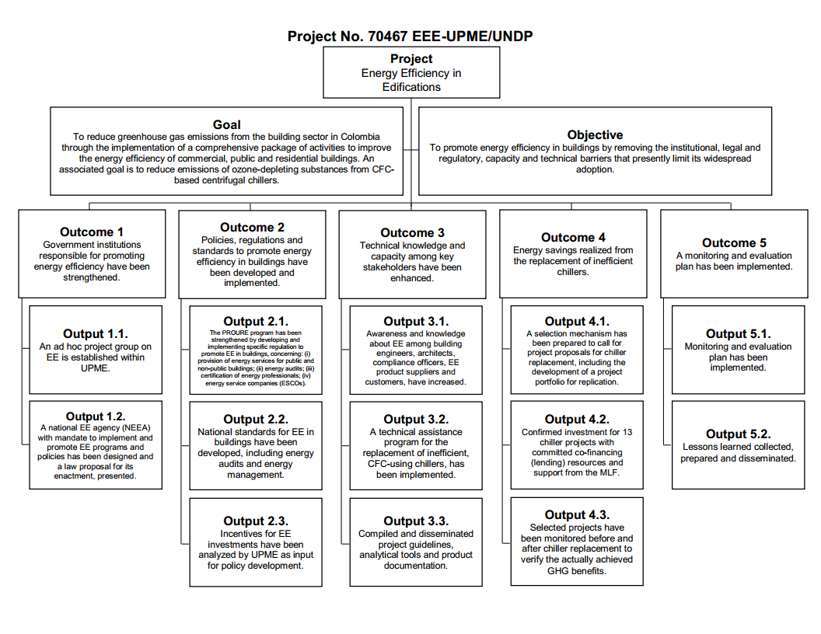

For each outcome and output a series of indicators, baselines, and ultimate goals is established, but lacking intermediate targets or milestones with their corresponding deadlines for compliance.

With regard to the environmental benefits, the project aimed to achieve emissions reductions of CO2 from the Colombian electrical sector, directly related to the replacement of 13 large chillers, by the amount of 62,000 Ton CO2 avoided during the economic life of the investment (20 years), corresponding to a volume of electricity saved of 88,600 MWh. These environmental benefits of the project would contribute to the GEF priority SP1 Climate Change Strategy.

At the time of its design (PIF, December 2007), the Project aimed to respond to the Colombian National Energy Plan 2006-2025, to the strategic objective GEF-4: Promoting energy efficiency technologies and practices in equipment and buildings sectors, and to the strategic program SP1: "Promotion of energy efficiency in homes and commercial buildings".

The Project formally began operations on June 28, 2010, when the Startup Workshop (“Taller de Inicio”) of the Project was held (8 months after the PRODOC was signed), with a term of three years (until November 2012). However, with the approval of the Steering Committee and UNDP, the final closure date was moved to November 30th, 2013. With this extension, the project operated for a total of 40 months. In October 2012, the Mid-Term Evaluation (MTE) was carried on.

The design of the Project was developed with the active participation of three key players: UPME/MME, OTU/MADS, and UNDP. To interact with other institutional players at the inter-agency level, it was envisaged that UPME would support the presentation of the project and its progress at the Inter-ministerial Committee meetings of CIURE.

Total budget for the Project, according to the PRODOC, amounted to US$ 5,420,000, coming from 5 different sources. The following table shows the planned contribution from each of these sources according to the PRODOC:

|  |  |
| --- | --- |
| **Sources of funding (US$)** | |
| GEF | $ 975.000 |
| UNDP CO (in kind) | $ 150.000 |
| Colombian government (in kind) | $ 965.000 |
| Multilateral Fund MLF Ozone (cash) | $ 1,000,000 |
| Private Sector (cash) | $ 2,330,000 |
| **Total** | **$ 5,420,000** |

## Major findings of the Final Evaluation

As a product of this final assessment, the Evaluation Team arrived at the following findings:

The PRODOC Design

It is believed that some outputs of the logical framework of the PRODOC were not fully adequate, especially by: a) The lack of intermediate milestones with their corresponding dates for compliance, that would make it possible to better control the progress toward the ultimate goals; especially, in order to separate activities related to the preparation of proposals, from activities related to the implementation  of these proposals (case in point is the establishment of the NEEA -National Energy Efficiency Agency- and the issuance of several regulations), (b) The lack of mitigation plans  in the event that some outcomes could not be run according to the planned activities (case in point is the establishment of the NEEA), considering that since the beginning major political risks had been already identified, c) A poor design of Outcome 2 (policies and regulations improvement), which created some confusion between different outputs and their indicators (see Section 3.1.1 for more clarity), (d) Some goals that relied heavily on the willingness and interest of other institutions different from UPME and those that were represented at the Steering Committee (case in point is the establishment of the NEEA, the issuance of rules and regulations, and the replacement of the chillers), (e) Inappropriate design of Outcome 4 (pilot project for chillers replacement), due to the change that had already occurred in the base line, the total dependence on other institution and other Project, the lack of intermediate milestones and deadlines, and the lack of a mitigation plan, f) An approach heavily focused on one technology (chillers), instead of trying to integrate other saving measures related to a better architectural design (bioclimatic design) and with other EE technologies, (g) For the topic of breaking barriers to new deployment models and financing, the PRODOC puts much stress on regulations, but lacks the incorporation of other means to stimulate the supply of energy services by ESCOs and specialists in EE.

Budget Execution

The execution of the various funding sources, projected by the closing date of the Project (November 30th, 2013), is detailed below:

**Funding Execution Summary**



( * ) Includes amounts paid, as well as committed amounts to be paid prior to the closing date of the Project.

Source: Own preparation based on figures provided by the Project managers, UNDP and OTU. Figures in US$.

At time of preparation of this report, the CDR 2013 had not been issued by UNDP, which will be ready after the first quarter of 2014. Therefore, the execution figures for 2013 that were used for the table above are preliminary, prepared on the basis of preliminary information delivered by the Project Coordinator.

Note the importance of having extended the term of the project until November 2013, which made it possible to boost the execution of GEF funds from the 58.4% achieved by the date of the Mid-Term Evaluation (August-October 2012), to the current 99.97% shown.

The main deviation with respect to the original budget of the PRODOC was the lack of implementation of the pilot project for replacement of chillers. Many of the old inefficient chillers were effectively replaced by their owners, without the intervention of the Project. For some of them the Project managed to determine the energy savings that produced such a substitution, as a part of the research included in the energy audits that were made; for example, in the Banco de la Republica building in Barranquilla where the replacement of the chiller resulted in savings of 8% in power consumption, and in the University of Antioquia building where the replacement brought savings of 19%.

A significant achievement is the creation of the Thermal Project District of Alpujarra in Medellin, supported by the Ozone Technical Unit (OTU), the Ministry of Environment, the Swiss Cooperation and the company EPM. Part of this project is the buildings of Alcaldia de Medellin (Office of the City Mayor), Concejo Municipal (City Council), Gobernación de Antioquia (local government), Asamblea Departamental (local congress), Area Metropolitana, Dirección de Impuestos y Aduanas Nacionales (DIAN, Tax and Customs Agency) and the new offices of UNE. This project was signed in the first days of November 2013. The Project No. 70467 conducted energy audits that included the replacement of chillers in three of the buildings mentioned: Mayor of Medellin, Antioquia Government and Area Metropolitana. This project would require private investment of at least US$ 6 million.

Co financing Reached

**Summary of Co financing**



Source: Own preparation based on figures provided by the Project managers, UNDP and OTU. Figures in U$.

The data of "UNDP" correspond to the office in Colombia. The data of "Government" correspond to the UPME. The data from "other sources" (donations) correspond to the OTU/MADS (Project No. 74467, Chillers Replacement), and equity investments or loans (reimbursable instruments) that would be related to the replacement of the 13 chillers of the pilot project. The achieved co financing index is 2.23 : 1 (Co financing: GEF).

Adaptive Management of the Administration

Based on the analysis of the various AWP (POA) reports and the QPR (Quarterly Project Reports), it is clear that the PMU (Project Management Unit) and the Executing Agency (UPME) sought to direct their actions according to the objectives and strategic results described in the PRODOC. In spite of this, the Evaluation Team believes that some of the decisions came late, in part due to the effect of repeated change of the General Director of UPME during the first two years of operation of the Project (three different directors). The following are considered important milestones of the Project that were not achieved or that were achieved at a late stage, affecting the final results of the Project: (a) the creation of the NEEA (Outcome 1), (b) the issuance of new rules and regulations (Outcome 2), (c) the restructuring of Outcome 4 (replacement of chillers), and (d) the execution of the Mid-Term Evaluation (Outcome 5).

Participation of Stakeholders

According to PRODOC, the design of the Project was developed with the active participation of three key players: UPME/MME, OTU/MADS, and UNDP. In fact, Outcome 4 of Project No. 70467 (Replacement of 13 chillers) corresponds exactly with Outcome 2 of Project No. 74760 (Replacement of chillers using a market strategy). Also, Output 3.2 of Project No. 70467 (Technical Assistance for the replacement of inefficient and CFC-based chillers) corresponds with Output 3 of Project No. 74760 (Technical Assistance for the replacement of 13 chillers).

The Evaluation Team believes that there were other important stakeholders who should have participated more actively in the design and monitoring of the Project, in order to have facilitated the achievement of certain goals that were totally dependent on the willingness of those other actors. For example, Outcome 2 of Project No. 70467 (Policies, regulations and standards to promote energy efficiency in buildings developed and implemented) had as its goal the deployment of several regulations which were of direct competition not only from the MME, but also of other institutions such as the Ministry of Housing (Regulations for residential buildings) or the Ministry of Environment and Sustainable Development (Regulations for environmentally sustainable buildings in a general way) .These two ministries were a single one at the start of the Project (Ministry of Environment, Housing and Territorial Development), but then were divided into two.

Apart from the above, it is noted a relative low participation of the private sector during the execution of the project.

Replicability

The main focus of replicability included in the original design of the Project (PRODOC) was the pilot project for replacing 13 chillers, since its deployment would serve as a stimulus for replacement of the remaining part of the original chiller inventory of the OTU (58 in total). It was also expected an additional replication by effect of the market transformation that would bring the incorporation and operation of the NEEA.

As none of the two preceding objectives were fulfilled, replicability was limited. However, a remarkable achievement of the Project is the proposal for a Regulation of Technical Energy Efficiency for Social Interest Housing (RETEVIS) that presents a novel approach based on the combination of an index of consumption and a comfort index (lighting, temperature, air movement and noise). This Regulation is in the process of validation and once it has been discussed and approved, it could be taken as a basis for reference or replicated in other countries. In addition, some actions of replication in the industrial sector could be achieved, under the new agreement that is expected to be signed between the MME and ANDI. In addition, replicability could be expected from the implementation of energy saving projects identified in the energy audits (for instance, the Thermal Project District of Alpujarra in Medellin).

Agreements with Other Actors

The following agreements reached with the direct or indirect support of the Project are highlighted:

* Triangular Cooperation Agreement between Germany, Mexico and Colombia, in sustainable housing in the area of energy efficiency and environment, which aims to replicate the “Green Mortgage” program of INFONAVIT Mexico in Colombia, as well as a new program for EE in buildings.
* Working together with the OTU/MADS, to coordinate with Project No. 74760.
* Memorandum of Understanding (still to be signed) between MME and ANDI, for shaping the industrial section of the NEEA.

Environmental Impact of Emissions (Mitigation)

If the implementation of the measures of energy savings identified in the 31 energy audits is carried out, this could reduce a total of **154,500 MWh**, and avoid the emission of a total of **104,727 Ton CO2** over the lifetime of the measures (20 years, that are translated into 13.4 actual years, considering a change of 33% in the baseline), by the effect of good practices, change of technology and architectural measures.

The calculation of the mentioned projections (104,727Ton CO2) is based on a “marginal” Emissions Factor (EF), i.e., based on the utilization of natural gas and coal for the national interconnected power grid, which was only used on a few of the energy audits carried out, but that was used in the PIF/GEF and PRODOC. Therefore, for purposes of comparison of actual vs. planned results, the marginal EF was used. However, if the average EF from the energy audits is used (sample of 11 of them), the avoided emissions would amount to **47,620 Ton CO2**. This is because the average EF used in the audits was 0.3082 kg CO2/kWh (very similar to the average of the national interconnected grid), while the marginal EF is 0.6778 kg CO2/kWh (very similar to the original 0.70 of the PIF and PRODOC).

Assuming a marginal EF, the potential of avoided CO2 emissions if all the saving measures recommended in the audits were implemented, would be superior to the original target from the replacement of the 13 chillers. This is because the audits looked at energy savings measures additional to the replacement of chillers, and because they correspond to 31 buildings and not only to13 chillers.

To verify compliance of this alternative target, UPME would have to perform a follow-up to the implementation of the energy saving projects identified in the energy audits, subsequent to the termination of the Project.

## Table of Qualifications of Project Performance

Chapter 3 of this report describes the results and findings of the evaluation, including those related to the design and formulation of the project (PRODOC) and to the quality of execution of UNDP as the implementing agency and UPME and the PMU as executing agencies. Also, the results achieved by the project in relation to the anticipated goals. The Evaluation Team used the criteria defined in the Terms of Reference received, and the "*Evaluation Guidance for UNDP GEF-Financed Projects*". Following is a summary table with the qualifications of performance of the Project in accordance with the requested criteria. The support and justification for each one of these qualifications are listed in the appropriate sections of this report.

|  |  |  |  |
| --- | --- | --- | --- |
| **Qualifications of Project Performance** | | | |
| **1. Monitoring and Evaluation** | **Rating** | **2. Implementation of the IA and the EA** | **Rating** |
| Original Design of M&E | Satisfactory  (S) | Quality of implementation of the implementing agency | Satisfactory  (S) |
| Implementation of the M&E plan | Satisfactory  (S) | Quality of execution of the executing agency | Satisfactory  (S) |
| **Overall quality of M&E** | Satisfactory  (S) | **Overall quality of implementation and execution** | Satisfactory  (S) |
| **3. Evaluation of Results** | **Rating** | **4. Sustainability** | **Rating** |
| Relevance | Relevant  (R) | Financial Resources | Somewhat Likely  (SL) |
| Effectiveness | Somewhat Satisfactory (SS) | Socio-political | Somewhat Likely  (SL) |
| Efficiency | Satisfactory  (S) | Institutional Framework and Governance | Somewhat Likely  (SL) |
| Impact | Minimum (M) | Environmental | Likely  (L) |
| **Overall Rating of Results** | Somewhat Satisfactory (SS) | **Overall probability of sustainability** | Somewhat Likely  (SL) |

To better understand the qualifications presented above, the basis of ratings used is shown as follows (as required by UNDP and GEF):

|  |  |  |
| --- | --- | --- |
| **Qualifications of results, effectiveness, efficiency, M&E and execution of the IA&EA:**  6. Very Satisfactory (VS): No deficiencies identified.  5. Satisfactory (S): Minor deficiencies.  4. Somewhat Satisfactory (SS)  3. Somewhat Unsatisfactory (SU): Significant deficiencies.  2. Unsatisfactory (U): Significant deficiencies.  1. Very Unsatisfactory (VU): Serious deficiencies. | **Qualifications of sustainability:**  4. Likely (L): Insignificant risks for sustainability.  3. Somewhat Likely (SL): Moderate risks.  2. Somewhat Unlikely (SU): Significant risks.  1. Unlikely (U): Serious risks. | **Qualifications of relevance:**  2. Relevant (R)  1. Not Relevant (NR)  **Qualifications of impact:**  3. Significant (S)  2. Minimum (M)  1. Insignificant (I) |

## Summary of Findings, Recommendations and Lessons Learned

The Project No. 70467 EEE contributed towards the institutional strengthening related with energy efficiency in buildings (especially at UPME), the development of new national regulations (at least at the level of well-founded proposals), and the development of technical skills and knowledge on this topic in the market players.

The Project was well aligned with the national government strategies and with the existing national and global strategies of UNDP and GEF, related with energy.

At the national level, the project responds to what is contemplated in Law 697/2001, of October 3rd, 2001, called "Law for the Promotion of Energy Efficiency and Renewable Energy", and in the "Program for Rational and Efficient Use of Energy and Renewable Sources" (PROURE). The overall objective of the PROURE is "to promote the rational and efficient use of energy and other forms of non-conventional energy, which contributes to ensuring the full and timely energy supply, the competitiveness of the Colombian economy, consumer protection and the promotion of the use of non-conventional energies in a sustainable manner with the environment and natural resources."  Project No. 70467 contributes especially to the strategic sub-programs SPE_1 (institutional strengthening), SPE_2 (Education and capacity-building) and SPE_3 (financial strategy and impulse to the market) of the PROURE.

The Project contributes to the compliance of the thematic area "A: overcoming poverty, Millennium development goals and sustainable development" mentioned in the draft document of the Colombia Program (2008 2012), DP/DCP/COL/ 1; and the "direct effect" of the UNDAF 2012-2014 Framework called "2.4.National and territorial capacity strengthened for mitigation and adaptation to climate change." In addition, the Project responds to the strategic objectives of the GEF focal area of climate change and the objectives of the Strategic Program CC-SP1: Promotion of Energy Efficiency in homes and commercial buildings.

The main objective of the Project was to remove barriers and create enabling conditions, not so much to reduce direct emissions. Although it was planned the execution of a pilot project that would combine reductions of GHG and SAO (through the replacement of 13 large chillers), the change in the baseline of that goal prevented the same to be achieved. This, however, was not a bad thing for the country, because the replacement of many inefficient and CFC-based chillers was actually executed, at the initiative of the same actors of the market and without the intervention of the Project. The Project missed a better documentation of the environmental impact related with replacing these chillers, because only in the case of some buildings such as Bank of the Republic in Barranquilla and University of Antioquia, the consultants gathered data from energy savings before and after the replacement of the respective chillers.

Despite the fact that many of the barriers identified at the start of the Project still persist, it is undeniable the contribution made by the Project to mitigate them. The different actions taken that still remain pending have a clear strategy to continue, if UPME assumes them as theirs and achieve the political support internally from the MME and externally from other institutions such as the MVCT, the MADS and ICONTEC.

The main achievements of the Project were: Research and definition of a proposal for the creation of the National Energy Efficiency Agency (NEEA), the preparation of a proposal for  the RETEVIS (Technical regulations for energy efficiency in social interest housing), the study of the energy characteristics of materials, the guide for the replacement and selection of chillers, contributions to the definition of the Colombian Environmental Seal for Sustainable Buildings that promotes the MADS and the Code of Sustainable Construction that promotes the MVCT, the formulation of financing schemes for EE and RE projects and technical assistance to Bancoldex for the design of new financial products aimed at this market, the support to activities covered under the Tripartite Agreement Mexico-Colombia -Germany, several training events, and a group of energy audits in large buildings (especially public ones).

Chapter 4 of this report presents a series of recommendations and lessons learned.

# Abbreviations and Acronyms

|  |  |
| --- | --- |
| ACAIRE | Colombian Association of Air Conditioning and Refrigeration |
| ACIEM | Colombian Association of Engineers |
| ANDESCO | National Society of Services and Communication Enterprises |
| ANDI | National Association of Colombian Businesspeople |
| NEEA | National Energy Efficiency Agency (ANEE in Spanish) |
| APP | Public Private Partnership |
| APR | Annual Project Report |
| BANCOLDEX | Banco de Comercio Exterior de Colombia S.A. |
| CAMACOL | Colombian Construction Chamber |
| CCCS | Colombian Councel for Sustainable Construction |
| CCEE | Colombian Councel for Energy Efficiency |
| CFC | Chlorofluorocarbon |
| CIURE | Intersectorial Commission for URE and FNCE |
| CLCDS | Colombian Low Carbon Development Strategy |
| CONOCE | Program for Standardization, Accreditation, Certification and Labeling |
| CONPES | National Councel for Economic and Social Policy |
| CORANTIOQUIA | Antioquia´s Regional Autonomous Corporation |
| CORPAMAG | Magdalena´s Regional Autonomous Corporation |
| Corpocesar | Cesar´s Regional Autonomous Corporation |
| Corpoguajira | Guajira´s Regional Autonomous Corporation |
| Corponor | Santander´s Regional Autonomous Corporation |
| CPAP | Country Program Action Plan |
| CPD | Country Program Document |
| CRA | Atlantico´s Regional Autonomous Corporation |
| CVC | Cauca´s Regional Autonomous Corporation |
| DNP | Departamento de Planeación Nacional |
| EE | Energy Efficiency |
| EEE | Energy Efficiency in Buildings |
| ESCO | Energy Services Company |
| FIDE | Trust for Electric Energy Savings |
| FINDETER | Financiera del Desarrollo Territorial |
| FMAM | Fondo para el Medio Ambiente Mundial- Global Environment Fund |
| FML | Multilateral Fund for Montreal Protocol Implementation |
| FNA | Savings National Fund |
| FNCE | Non Conventional Energy Sources, NCES |
| GEF | Global Environment Fund |
| GIZ | German Cooperation Agency |
| HVAC | Heating, Ventilation, Air Conditioning |
| ICONTEC | Colombian Institute of Technical Norms and Certification |
| IFC | International Finance Corporation |
| INFONAVIT | National Fund for Workers´ Housing Institute (México) |
| MADS | Minister of Environment and Sustainable Development |
| MAVDT | Minister of Environment, Housing, and Territorial Development |
| MLF | Montreal´s Implementation Multilateral Fund |
| MME | Minister of Mines and Energy |
| MOU | Memorandum of Understanding |
| MVCT | Minister of Housing, Cities and Territory |
| NAMAs | National Appropriate Mitigation Actions |
| ODM | Millenium Development Goals |
| OPEN | Market Opportunities for Clean Energies and Efficiency |
| PIF | Project Identification Format |
| PIR | Project Implementation Report |
| PNUD | Programa de las Naciones Unidas para el Desarrollo- UNDP |
| POA | Annual Operative Plan |
| PRODOC | Project Document |
| PROURE | Program for Rational and Efficient Use of Energy |
| RAEE | Electric and Electronic Devices Residues |
| RETEVIS | Technical Regulations for Energy Efficiency in Social Interest Homes |
| RMT | Mid Term Evaluation |
| SAO | Ozone Depleting Substances |
| SCI | Colombian Society of Engineers |
| UGP | Project Management Unit |
| UNDAF | United Nations Development Assistance Framework |
| UNDP | United Nations Development Program |
| UPME | Mining and Energy Planning Unit |
| URE | Rational and Efficient Use of Energy |
| OTU | Ozone Technical Unit |
| VIS | Social Interest Homes |

# 1. Introduction

## 1.1. Purpose of the evaluation

This report, Final Evaluation of the Project GEF-UNDP PIMS No. 3829 ATLAS No. 70467 “Energy Efficiency in Buildings”, seeks, as part of the monitoring and evaluation procedures of UNDP and GEF, to submit the Project to a final evaluation when it is approaching its conclusion.

The main objective of the evaluation is to review, document, and evaluate the results obtained by the Project based on the expected results, as established in its corresponding PRODOC, considering the criteria of relevance, effectiveness, efficiency, sustainability, and impact. In addition, the evaluation seeks to review and evaluate the actions of the Project’s Team throughout the execution of the Project, including the actions taken when confronted with unexpected changes found during its execution, and with the recommendations suggested in the Mid-Term Evaluation.

The Final Evaluation report is expected to be credible, reliable, and useful; it should allow reviewing and evaluating the Project from its formulation and execution to its corresponding conclusion. In addition, this report allows gathering the lessons learned to use them when designing other projects supported by UNDP and GEF, and by the Colombian government itself.

## 1.2. Scope and methodology

This report seeks to analyze the achievement of project’s results in comparison with established expectations, and extract lessons that can improve the sustainability of its benefits, based on the criteria of relevance, effectiveness, efficiency, sustainability, and impact.

The Evaluation Team focused on the following topics:

a) Evaluate and assess the Project outputs:

* + - Evaluation of the design, execution, and general quality of the policies and procedures of monitoring and evaluation (M&E).
    - Evaluation of the quality of UNDP´s performance as the implementation agency, and of the UPME as the executing agency (application and execution quality).
    - Evaluation of the results in regards to relevance, effectiveness, efficiency, and general quality.
    - Evaluation of the sustainability in regards to the financial and sociopolitical resources, institutional framework and governability, environmental regulations, and the general probability of sustainability.

b) Assess the key financial aspects of the Project, including the extent of the planned and accomplished co financing, as well as the corresponding evaluation and explanation of the differences between planned and real expenses.

c) Assess the integration level of the Project with other UNDP priorities (among them, reducing poverty, improving governability, the prevention and recovery from natural disasters, and gender).

d) Determine the advance of the Project towards the accomplishment of the desired impacts.

e) Conclusions, recommendations, and lessons learned.

The Final Evaluation took place between the end of September and the end of November of 2013. The evaluation activities prepared by the Evaluation Team included:

* + - Review of the Reference Terms given to the consultants. See Annex 1: Reference Terms.
    - Review of the documents on evaluation and objectives: UNDP Evaluation Guidance for GEF-Financed Projects; Manual for Planning, Monitoring and Results Evaluation (UNDP); Report of the Mid-Term Review; Project Document of the UNDP Program for Colombia (2008-2012); United Nations Development Assistance Framework (UNDAF) for 2008-2012; and UNDAF Matrix 2012-2014.
    - Revision and organization of all relevant documents of the Project: PIF, PRODOC, Startup Workshop Report, AWPs, CDRs, APR/PIRs, Quarterly Plans and Reports, Records of the Steering Committee Meetings, Records of Project Follow-Up.
    - Revision and organization of documents detailing on the products of the Project.
    - Design of the evaluation tools to be used. See Annex 2: Matrix of Evaluation Questions.
    - Identification and Selection of key players.
    - On-site visits with the purpose of interviewing key players and visiting relevant locations (samples of buildings where energy audits were done). See Annex 3: Itinerary, and Annex 4: Answers Obtained from Key Players.

The Evaluation Team used a participatory and consultative approach that ensured the close involvement with the Project Team members, representatives of UNDP in Bogota, and other stakeholders. See the list of persons and institutions interviewed in Annex 5: List of People Interviewed.

The information presented in this document is based on information obtained from available documents, interviews, and field missions, using the guidelines, standards, and procedures established by UNDP and GEF according to the “*UNDP Evaluation Guidance for GEF-Financed Projects*”. See Annex 6: List of Revised Documents.

## 1.3. Structure of the evaluation report

The structure of the Final Evaluation report is based on the Reference Terms that were provided to the consultants, and incorporates the required aspects according to the *UNDP Evaluation Guidance for GEF-Financed Projects*.

The report begins with an Executive Summary, which provides valuable information allowing the reader to understand the Project, its objective, development, and achievements. It also includes a summary Table of the results and scores (ratings). Then, in Chapters 1 and 2, the document introduces and describes the Project as it was originally designed, in order to count on the necessary basis to make an assessment of real project results, developed in the following sections. In Chapter 3, consisting of three sections, the Evaluation Team seeks to document and evaluate in detail their findings, starting with the design and formulation of the Project, following with the analysis of the execution of the Project, and ending with a detailed and thorough analysis of the results achieved and the causes of deviations in regards to the anticipated goals. Next, the document includes Chapter 4, which seeks to identify and document conclusions, recommendations, and lessons learned found by the Evaluation Team. The report ends with the Annex section, where additional material that justifies, supports, and details more information of the document can be found.

# 2. Project description and context of development

## 2.1. Project´s immediate and development objectives

Project No. 70467 (“Energy Efficiency in Buildings”), in charge of the UPME/MME as the executing agency and of the UNDP-Colombia as the implementing agency, was designed to promote energy efficiency in buildings and to strengthen the development of a market approximation strategy for the implementation of energy efficient projects in existing buildings.

The general objective of the Project was “To promote energy efficiency in buildings by eliminating institutional, legal, and regulatory barriers, as well as the technical capacity that currently limits its widespread adoption.”

The general outcome of the Project was “To reduce the greenhouse gas emissions from the buildings sector in Colombia, through the implementation of an integrated group of activities that improves energy efficiency in commercial, public, and residential buildings”. An associated goal was “to reduce the emissions of ozone depleting substances from chillers that use CFC”. This goal would be accomplished through the interaction of Project No. 70467 of UPME/MME with Project No. 74760 (“A demonstration project for the integral development of the chillers subsector in Colombia”) of OTU/MADS.

The Project would contribute to the implementation of the actions foreseen under the National Program for Rational and Efficient Use of Energy and for Renewable Energies (PROURE, 2010-2015), and under Law 697/2001 “Law for the Promotion of Energy Efficiency and Renewable Energies” of October 3rd, 2001. Within them, an important objective of the Project was the advance towards the establishment of a National Energy Efficiency Agency (NEEA), which would be responsible of ensuring everything related to this topic in the country. Other important objectives would be to improve the incentive policies and specific regulations to stimulate the development of energy efficiency projects in buildings, the development of knowledge and skills among market stakeholders, the execution of a pilot project to replace 13 large, inefficient, CFC-based chillers, and the corresponding placement of an existing line of credit (Bancoldex-URE) to finance the replacing of those chillers.

The pilot project to substitute 13 big chillers was intended to boost a replication in the national universe of owners of inefficient, CFC-based chillers, which was estimated at 58 units in 2005, but at the starting date of the Project (2010) the number had already dropped significantly.

To accomplish its objective, the Project was designed around the following five main Outcomes: Government institutional strengthening, development of policies and specific regulations to stimulate EE, development of technical capabilities among market stakeholders, execution of a pilot investment project (replacement of 13 inefficient, CFC-based chillers), monitoring and evaluation of the Project.

In regard to the environmental benefits, the Project was aimed to achieve emissions reductions of CO2 in the Colombian electrical sector. The emissions reductions would be direct and indirect:(A) Direct due to the replacement of 13 large chillers; (B) Indirect due to: (i) the replication of the pilot project to replace other chillers; and (ii) associated with the contribution of the project to the transformation of the market towards EE technologies in the construction sector and, specifically, to the creation of the National Agency of EE. The direct benefits were estimated at 62.000 tons of CO2 avoided during the economic life of the investment (20 years), which corresponds to a volume of 88.600 MWh of electricity saved. The indirect benefits, as a result of the replication to replace the chillers, would mean 124.000 tons of avoided CO2, which corresponds to 177.200 MWh saved. Furthermore, additional indirect benefits were assumed, as a result of the transformation of the market, in the amount of 150.000 tons of CO2 (a conservative estimate), which corresponds to 214.400 MWh saved. These environmental benefits of the Project would contribute to the GEF priority SP1 from its Climate Change Strategy.

## 2.2. Starting date and duration of the project

The chronology of events for Project GEF-UNDP PIMS No. 3829 ATLAS No. 70467 “Energy Efficiency in Buildings” is presented as follows:

* The Project Identification Format (PIF) was signed on January 17th, 2008. The PIF sets October 2008 as the starting date of the Project and April 2011 as the closing date, for a total of 31 execution months.
* The Project Document (PRODOC) was signed by the parties on November 3rd, 2009, establishing a three-year term (2009-2012).
* However, the real starting date took place 8 months later. The Startup Workshop of the Project was held on June 28th, 2010. This marked the official start-up of the Project.
* The first disbursement of GEF funds took place on July 28th, 2010.
* The original closing date was set for November 4th, 2012.
* After several extensions, the definite closing date of the Project was set on November 30th, 2013, with the authorization of the Steering Committee and the UNDP[1]. Therefore, the Project operated for a total of 40 months.

## 2.3. Barriers addressed by the Project

The Project addressed the following four main problems or barriers for the widespread implementation of EE in Colombia, which formulation was taken from the PRODOC:

* **Institutional and political barriers**

The UPME represents an administrative unit linked to the MME without counting on a clear mandate to implement EE policies and programs. Without a properly placed agency with skills to prepare and execute EE programs, market players will not change their attitudes. The country needs specific regulations to create the appropriate environment, provide awareness, stimulate demand, and support the economic viability of investments in EE measures and equipment. A stable and clear regulatory framework is essential to reduce financial risks associated with EE investments so that market players do not continue to choose conventional solutions.

* **Technical capacities barriers**

In the absence of a demand for EE solutions, professionals lack incentives to develop the technical knowledge that would allow them to analyze opportunities, cost and benefits of new EE technologies and energy management in buildings. Because EE is not included in the current constructive code and the necessary technical inputs do not exist, builders ignore EE. In addition, since there is no demand in the market, EE does not form part of the sales strategy of equipment suppliers. The lack of options for technical training is clearly identified; this is due to the fact that few universities and technical schools offer some kind of training on EE. The lack of standards and corresponding application represents a technical barrier because without specific references on the energy quality and performance of equipment and buildings, there will not be a transformation in the market towards more efficient technical solutions.

* **Information and awareness barriers**

In the absence of a proper political framework and applied technical standards, the demand of EE solutions cannot be developed; the market players and the general public do not receive a clear message. Furthermore, promotional and informative materials on electric equipment do not include information on EE and their environmental impact. In the case of home equipment, end-users lack clear, standardized information because they depend on information provided by manufacturers and retailers, which, especially with imported equipment, tend to confuse the buyer.

* **Implementation model and financial barriers**

There is a lack of experience related to financing EE contracts or to provide direct financing of EE equipment and EE improvements in the industry, due to the fact that banks and financial institutions are not aware nor do they have technical knowledge to decide on EE investments. The lack of demand and the low energy prices make it impossible to develop the market for performance contracts for HVAC equipment. It is necessary to develop consistent policies, ideally under the leadership of a new national entity that allows the development of a proactive approach that increases the access to financing under favorable conditions. In regard to the construction sector, the lack of demand for services and EE technologies is accompanied by a lack of general skills and support services, such as professional assistance on behalf of the equipment suppliers and independent consultants, energy audits, and energy-service companies (ESCOs); therefore, a wide range of services for every customer’s profile is required.

## 2.4. Reference indicators and expected outcomes

According to the PRODOC, the Project has 5 outcomes and 13 outputs. All of them are described below:

* **Outcome 1:** Government institutions responsible of promoting energy efficiency have been strengthened.
* **Output 1.1.** An ad-hoc EE project group is established within UPME.
* **Output 1.2.** A National EE Agency, with mandate to implement and promote EE programs and policies, has been designed and a law proposal for its creation has been presented.
* **Outcome 2:** Policies, regulations, and standards developed and implemented to promote energy efficiency in buildings.
* **Output 2.1.** The PROURE program has been strengthened to develop and implement specific regulations to promote EE in buildings, including: (i) provision of energy services for public and non-public buildings; (ii) energy audits; (iii) certification for energy professionals; (iv) energy-service companies (ESCOs).
* **Output 2.2.** National standards for EE in buildings have been developed, including energy audits and energy management.
* **Output 2.3.** Incentives for investments in EE have been analyzed by UPME as input for the development of policies.
* **Outcome 3:** Technical knowledge and skills of key stakeholders have been enhanced.
* **Output 3.1.** Awareness and knowledge about EE among building engineers, architects, compliance officers, EE product suppliers, and consumers have increased.
* **Output 3.2.** A technical assistance program for the replacement of inefficient, CFC-based chillers has been implemented.
* **Output 3.3.** Project implementation guidelines compiled and distributed, as well as analytical tools and documents on EE products.
* **Outcome 4:** Energy savings realized from the replacement of large chillers.
* **Output 4.1.** A selection of mechanisms has been prepared to request project proposals for the replacement of pilot chillers, including the development of a project portfolio for replication.
* **Output 4.2.** Confirmed investments with committed co financing (credits) for the 13 pilot chiller projects, and support from the Multilateral Fund of the Montreal Protocol.
* **Output 4.3.** Documented reports on the operative performance of the replaced 13 chillers.
* **Outcome 5:** Monitoring and evaluation plan has been implemented.
* **Output 5.1.** Monitoring and evaluation plan has been implemented.
* **Output 5.2.** Lessons learned collected, prepared, and distributed.

Details on the performance indicators selected by the designer of the Project for each projected outcome and output, with their corresponding baseline and goals references, are featured in Annex 7: Established Reference Indicators.

## 2.5. Key stakeholders

The following institutions are considered key stakeholders of this Project.

* **The Mines and Energy Planning Unit (UPME, for its abbreviation in Spanish):**

It is the execution agency of the Project and manages a great deal of information about the domestic energy market. Its involvement is essential because it is the technical entity that handles the management of mines and energy planning in the country, linked to the Ministry of Mines and Energy. It would also be the main institution for financial and logistical support to the future NEEA.

The outcomes of Project EEE No. 70467 for UPME are considered a basic tool and a support for their planning strategies and for the design of standards and regulations for energy consumption in buildings, and for the promotion of energy efficient plans in the country in general.

* **Ministry of Mines and Energy:**

MinMinas (its name in Spanish) has, as one of its roles, to “Formulate, establish, manage, and coordinate the policy on the rational use of energy and the development of alternative energy sources and promote, organize, and guarantee the development of programs on the rational and efficient use of energy”. Under these guidelines, it is considered the most important entity of the country in all issues related to electricity and its efficient and rational use.

* **Ministry of Environment and Sustainable Development (MADS, for its**

**abbreviation in Spanish):**

It is the most important public agency dealing with the formulation of the national policy on environmental issues and renewable natural resources, and provides support to the other ministries and state agencies on the formulation of public policies that have environmental and sustainable development implications. MADS deals with everything related to audit and mitigation of GHG (Greenhouse Gases) emissions and ODS (Ozone Depleting Substances), which abundantly originate in buildings and in their air-conditioning equipment. In particular, the Office of Climate Change and the Ozone Technical Unit are highly interested in the outcome of the Project.

* **Ministry of Housing and Territorial Development:**

As the most important public agency dealing with the formulation of policies on urban renovation, neighborhood upgrading, housing quality, urban planning and sustainable housing construction, public spaces and equipment, this ministry is a key player in the design and development of standards and regulations for energy efficient buildings, which is part of the objectives of the Project.

* **UNDP and GEF:**

As multilateral agencies of technical and financial cooperation, these entities support the Colombian Government through their lines of work: Influencing public policies, reinforcing skills and generating knowledge and information; as well as with optimization projects on energy resources, seeking to reduce GHG and ODS emissions and environmental impacts due to inefficient uses of energy in buildings. For UNDP, this type of projects relate to the Thematic Area “A: Overcoming poverty, objectives of the Millenium development and sustainable development” mentioned in the project document of the Colombian Program (2008-2012), DP/DCP/COL/1, and with the “Direct Effect” of the UNDAF 2012-2014 Framework called “2.4. National and territorial capacity strengthened for mitigation and adaptation to climate change”. For GEF, the Project responds to the strategic objectives of the Climate Change Focal Area and the objectives of the Strategic Program CC-SP1: Promotion of Energy Efficiency in Homes and Commercial Buildings.

* **The national bank – BANCOLDEX:**

In its portfolio of services, Bancoldex, a second-tier bank, offers funds to promote the rational use of energy in the country. The outcome of this Project represents an input in the energy-saving market of the Colombian building sector, in the design of energy-saving projects that could be financed, and in the creation of an enabling environment, in general, for the development of this market, including the generation of energy-service companies (ESCOs), which this bank hopes to support.

* **The construction market in Colombia:**

This Project helps to create an enabling environment and opens up the prospect of the energy-saving market for builders and building owners, material and equipment suppliers, and designers (engineers, architects), for good practices of design and installation of efficient equipment; also, it provides awareness and technical training initiatives, and the generation of technical references for the designing of EE Projects.

* **The recipients of technical assistance:**

All institutions that own large buildings and inefficient chillers would benefit from the pilot Project (later replaced by the energy audit campaign).

# 3. Results and findings of the evaluation

## 3.1 Design and formulation of the project

### 3.1.1 Analysis of the PRODOC and the Logical Framework of Outcomes

The PRODOC and its Logical Framework of Outcomes were developed based on the PIF, with a two-year difference (the PIF was approved in December, 2007 yet the PRODOC was signed in November, 2009). The following comments arise from the revision of the projected outcomes and outputs in both documents:

1. Separation of Outcome 1 of the PIF in Outcomes 1 and 2 of the PRODOC:

* It was observed that the separation of Outcome 1 of the PIF (which included institutional strengthening and issuance of new policies and regulations in the same outcome), into two outcomes (1 and 2) in the PRODOC, was appropriate.
* The imperative need to count on an institution specially dedicated to the management of everything related to energy efficiency in Colombia is well justified in the PIF. The same need was picked up in the PRODOC and separated into two outputs: 1.1. The creation of skills in an ad-hoc group that would establish itself in the UPME as a prelude for the creation of the NEEA, and 1.2. The creation of the same agency afterwards. This was all considered appropriate.

1. The lack of a mitigation plan and the lack of intermediate milestones for Output# 1.2 (creation of the NEEA):

* The outstanding fact is that since 2007 (when the PIF was elaborated) Colombia has suffered from not having an agency specialized in EE, and at the conclusion of the Project #70467, seven years later, it still does not have an agency even though important studies for its design have been made. This is an important weakness that the Project has, not only in its design but also in its execution. In its design (PRODOC) because a mitigation plan was not anticipated, especially when the risk was already identified noticing that the political priorities of the country might not allow to make progress in this objective (which is exactly what took place). This mitigation plan could have been built around the creation of a Program in the MME, with a budget and permanent staff, for the Rational Use and Conservation of Energy.
* There was a weakness in the execution when too much time was dedicated to the process of defining the strategies for the creation of the NEEA and too little time was used to implement it. This could have been avoided if an intermediate milestone would have been established in the design of the PRODOC by separating the goal in two phases (with dates for compliance): One for the preparatory studies and the drafting of the proposal, and another one for the socialization and implementation of the proposal.

1. Inadequate design of Outcome 2:

* The design of Outcome 2 of the Logical Framework in the PRODOC causes some confusion, which seems to have had an impact in the poor compliance of some of its Outputs during project´s execution.
* Originally, the PIF included four Outputs for this Outcome: 2.1. Technical assistance for the replacement of 13 chillers; 2.2. Development of national standards for the elaboration of energy audits and for the certification of professionals who would execute them; 2.3. Development of skills to conduct energy audits in the national market, not only from the demands perspective (administrators and building owners) but also from supply perspective (ESCO companies and EE specialists), and 2.4. Guidelines (presumably about energy consumption) on air-conditioning equipment, available at selling points.
* Then, the PRODOC placed three Outputs for this Outcome: 2.1. The development and implementation of specific regulations for “the provision of energy services for buildings”, the energy audits, certification for professionals, and ESCOs; 2.2. Development of national standards for EE in buildings, including energy audits and energy management; and 2.3. Analysis of incentives for investments in EE, as input so that UPME could develop a policy regarding the issue.
* A confusion of the objectives was noticed between Output 2.1. and Output 2.2 of the PRODOC on the topic of emission standards and energy audits, which also reflects on the formulation of indicators, baselines, and goals of those Outputs in the Logical Framework. For example, Output 2.1. is lacking a better specification of the type of regulations intended, and of the institutions with whom those regulations would be worked out.
* It is doubtful that UPME could have the authority to certify professionals in EE. Usually, professional associations compete for that right. Once again, this is an Outcome that depends greatly on other institutions different from UPME or MME.
* An important objective of this Outcome seems to be (according to the analysis offered by the PIF and the PRODOC on technical barriers, implementation and financial barriers) supporting ESCOs and professionals in EE, through the development of skills and the design of financial incentives. But the design of this Outcome relies heavily on the design and implementation of regulations for them (which eventually could represent more barriers), and relies less on the development of incentives.
* Many of the Outputs established in the PRODOC depended greatly on the willingness of other institutions different from UPME and MME, which reduced the possibility of reaching the anticipated goals. For example, the emission of standards and regulations for EE in buildings (Output 2.2.) corresponds not only to MME but also to MVCT (residential buildings), to MADS (buildings in general), and to ICONTEC (regulations in general). This causes the RETEVIS to overlap with other regulations that are still undergoing a process, like the Sustainable Construction Code of MVCT and the Environmental Seal for Sustainable Buildings of MADS. Difficulties also arise because the process of consultation and socialization of the regulation proposal with all stakeholders affected by it, as well as its approval, signing, and compliance monitoring is not necessarily just the role of UPME. It is important to point out that the MVCT and MADS ministries worked as one at the beginning of the Project´s execution period (Ministry of Environment, Housing, and Territorial Development), but later they separated into two.
* Once again, it is necessary to point out the lack of intermediate milestones with deadlines of compliance for the Outputs of Outcome 2. This caused insufficient progress in the consultation and socialization process of the proposed regulations (as in the specific case of the RETEVIS, the regulation for EE in social interest housing developed by the Project).

1. Design of Outcome 3:

* The design of Outcome 3 of the Logical Framework of the PRODOC (improvement of knowledge and technical skills of key players) is considered adequate. This is reflected in the achievement of goals proposed for each Output.

1. Inappropriate design of Outcome 4:

* The design of Outcome 4 (replacement and monitoring of 13 chillers) is considered inappropriate for several reasons: The change of its baseline, the total dependency on another institution and Project, the lack of intermediate milestones and deadlines, and the lack of a mitigation plan.
* The change of the baseline is associated to the fact that a large part of the original inventory of inefficient, CFC-based chillers no longer existed at the start of the project. This was detected within a few months after the beginning of the project, and it was possibly already a fact when the PRODOC was developed at the end of 2009, since the original inventory had been calculated in 2005 (according to information provided by OTU). It is possible that this weakness in the PRODOC of the Project No. 70467 originated in the PRODOC of the Project No. 74760.
* The dependency on other institutions. Repeatedly, in several records of the Steering Committee meetings and Progress Reports of the Project, it was mentioned that this outcome was working "under the leadership of OTU". Given that this institution focuses more on ODS topics than on GHG topics, the decision to seek an alternative plan on the part of Project No. 70467, which would comply with its own outcomes and overall objectives (reduction of GHG emissions) was excessively delayed. Once again, having placed an intermediate milestone with a deadline during the life of the project would have enabled this decision to have been taken more promptly. This was a flaw in the design of the Logical Framework of the PRODOC.
* A mitigation plan (as was suggested for the Output related to the creation of the NEEA) would have allowed the Project to have a better probability of achieving the goals of reducing energy consumption and GHG emissions. For example, by extending Outcome 4 with the possibility of executing improvement actions (identified and analyzed through audits and feasibility studies) in a group of buildings, some of which could or could not have CFC-based chillers. For those with CFC-based chillers, there would be the financing facility from the MLF of the Montreal Protocol, and for those that do not have those types of chillers, they would have the credit support from Bancoldex. In fact, the PIF mentioned that there could be the possibility of implementing a mechanism with financial incentives as part of the Project: A mechanism of guarantees, a soft credit line, or a tax incentive. This was anticipated in Output 2.3 of the PRODOC (design of a document proposing financial incentives as input for UPME for the development of policies).

1. Design of Outcome 5:

* The design of Outcome 5 in the Logical Framework of the PRODOC (Monitoring and evaluation plan) is considered appropriate. Although, it would have been more effective during its application if the Logical Framework would have established intermediate milestones and compliance deadlines.

1. Overall Design of the PRODOC:

* The overall design of the PRODOC favored the action taken on some of the barriers identified in section I (Situation Analysis) and less on others.
* The design focused mainly on trying to break down the institutional and policy barriers (lack of a specialized agency and lack of regulations and standards), which represent Outcomes 1 and 2 of the PRODOC. Also, on taking action on the information and awareness barriers, but with Outputs (especially 3.2 and 3.3) too focused on the replacement of chillers and missing the opportunity to develop greater technical skills and materials on other topics and technologies relevant to EE in buildings. For example, on the topic of improved architectural design (bioclimatic) and tools for the evaluation of the thermal envelope. In this regard, it is considered that the integration of Project No. 74760 weighed heavily on the design and implementation of Project No. 70467.
* The design did little to favor breaking of financial barriers or for the deployment of financial models, that is to say, taking action on the provision of energy services by ESCOs and specialists in EE. The approach was too much focused on improving regulations. The incentive policies were only visualized in Output 2.3 of the PRODOC (design of a document proposing financial incentives as input for the UPME for the development of policies). A more ambitious Output could have been included, related to the possible definition of a financing program with Bancoldex, which was suggested but not well-articulated in the PRODOC.
* In general, it can be concluded that the design of the PRODOC and the Logical Framework met the criteria that the results ("outcomes") were specific, relevant and measurable. Nevertheless, many of them were not achievable, nor did they establish intermediate milestones with clear deadlines, that would have been very useful. In addition, some Outputs (as described above) were not sufficiently appropriate.

### 3.1.2 Assumptions and risks

**Table 1 Assumptions and risks**

| **Strategy of the Project** | | **Risks and Assumptions originally proposed**  **ExAnte** | | **Comments from the evaluators**  **ExPost** |
| --- | --- | --- | --- | --- |
| **Outcome** | Reduce greenhouse gas emissions from the buildings sector of Colombia through the implementation of an integrated package of activities that improve the energy efficiency of commercial, public, and residential buildings (an associated goal is to reduce the emissions of ozone depleting substances of the chillers that use CFCs). | | The medium and long term commitment of the government to maintain a favorable environment for policies beyond the temporary horizon of the intervention. | The government has shown a growing commitment towards the reduction of GHG emissions and ODS. However, it has been very slow in the emission of specific policies and regulations. |
| **Objective of the Project** | Promoting energy efficiency in buildings by eliminating institutional, legal, and regulatory barriers as well as the skills and techniques that currently restrict its widespread adoption. | | The Government perceives EE in buildings as one of its priorities and defines and implements a promotion policy and a legal framework, including specific instruments. Professionals in construction and the (potential) energy service companies are motivated to serve the market. | One of the causes of the delay in the implementation of some of the Outputs and Outcomes of the Project has been that the Government, despite being interested, has not given enough priority to achieve coordination between several ministries and institutions on the topic of energy efficiency. The best example is that there is not a NEEA operating yet, which is far from getting enough funds to begin operations. |
| **Outcome 1** | **Government institutions responsible for promoting energy efficiency have been strengthened** | | | |
| 1.1 | An ad-hoc group on EE is established within UPME | | The Government supports the Project and the UPME. | This was accomplished thanks to UPME’s support. |
| 1.2 | A National EE Agency with mandate to implement and promote EE programs and policies has been designed and a law proposal for its enactment is presented. | | The Government supports the Project and the UPME. The Project and the UPME will succeed in gathering enough political support in order to have a law proposal for the NEEA approved. | There has not been enough support at the highest-level of Government to prioritize the creation of the NEEA. One of the reasons that have influenced this situation is the repeated change of the heads of MME and UPME, during the time that the Project worked. |
| **Outcome 2** | **Policies, regulations, and standards to promote energy efficiency in buildings have been developed and implemented** | | | |
| 2.1 | The PROURE Program has been strengthened by developing and implementing specific regulations to promote EE in buildings, including: (i) provision of energy services for public and non-public buildings; (ii) energy audits; (iii) certification of professionals in energy; (iv) energy-service companies (ESCOs). | | Government support is necessary to define and maintain a detailed work program under PROURE. | This is an objective or Output that could have made more progress, at least in regard to the formulation of proposals (similar to what was done for the formulation of the proposal of the APP for the NEEA). From of these proposals, support could have been provided to the institutions that should approve or adjust these proposals. |
| 2.2 | National standards for EE in buildings have been developed, including energy audits and energy management. | | Government support is necessary to define and maintain a detailed work program under PROURE, especially to develop EE standards. | Here, other than the fact that the Government supported or not, the main risk is that the generation of different standards depended on other institutions different to UPME or MME. For example, a standard for the housing sector should have been launched not only with the participation of the MME, but also with the Ministry of Housing, which should have been involved more directly in the project, not only at the level of the CIURE or the Institutional Board. |
| 2.3 | Incentives for EE investments have been analyzed by UPME as input for the development of policies. | | Desk study: there are no risks or specific assumptions. | The study was developed, focusing on financial mechanisms for the provision of energy services. In the original design the launch of non-financial economic incentives, for example reduced taxes, was not contemplated. |
| **Outcome 3** | **Technical knowledge and skills of key stakeholders have been enhanced** | | | |
| 3.1 | Awareness and knowledge about EE among building engineers, architects, compliance officers, EE product suppliers, and customers have increased. | | It is assumed that the construction professionals show a genuine interest about training, in response to market signals. | The private sector actually showed interest in participating in the training events and in the development of guidelines (such was the case of ACAIRE, for example). |
| 3.2 | A technical assistance program for the replacement of inefficient, CFC-based chillers has been implemented. | | It is assumed that the technical and financial profile of the projects for chiller replacement would stimulate the market (suppliers, building owners, financiers) to cooperate in an extensive program of technical assistance and their subsequent investment. | It was not achieved, derived from the fact that Outcome 4 (replacement of chillers) was not carried out as planned. The technical assistance program was directed, instead, to an energy audits campaign, which multiplying effects in the market are still to be seen. The best possibility to see real outcomes is the project called “Thermal District of Alpujarra in Medellín”, where 3 of the 4 large buildings involved received audits with funds from the Project. |
| 3.3 | Complied and distributed project guidelines, analytical tools, and information about EE chiller products. | | There are no risks or specific assumptions. | The objetive was accomplished. |
| **Outcome 4** | **Energy savings realized from the replacement of inefficient chillers** | | | |
| 4.1 | A selection mechanism has been prepared to request project proposals for the replacement of chillers, including the development of a project portfolio for its replication. | | Support from the government and from financial sector encouraged investing in EE/CFC-free technology; the identified projects are technically and financially viable. | The strategy proposal was replaced by an energy audits campaign. The risk that really jeopardized the original strategy was not the lack of support from the government or the financial sector, but the time that elapsed between the development of the inventory of chillers (2005) and the start of operations of the Project (2010), which led to almost not having inefficient chillers operating. That is to say, a change in the baseline of this outcome. |
| 4.2 | Confirmed investments with committed co financing (credits) for 13 chiller replacement projects and support from the Multilateral Fund of the Montreal Protocol. | | It is assumed that at least 13 projects for chiller replacement are solid from the financial point of view, and apparently they can be completed within the time horizon of the intervention. | Since Outcome 4 was delayed and finally replaced, the Project did not have enough time to promote the implementation of the identified projects in the audits at the government level or with financial sector, However, by the end of November, the General Coordinator reported the possibility that the project called "Thermal District of Alpujarra" in Medellin could be materialized with the support of the Swiss cooperation, of the EPM company, and the government itself, with a total cost of US$12 million. |
| 4.3 | Documented reports on the operative performance of the 13 replaced chillers. | | There are no risks or specific assumptions. | It could not be done because the Project did not intervene, up until now, in the replacement of any chiller. It is something that could happen in the future, if any of the owners of the buildings audited, decides to implement the recommended saving measures. The Thermal District of Alpujarra Project could be a good example, when it happens. |
| **Outcome 5** | **Monitoring and evaluation plan has been implemented.** | | | |
| 5.1 | Monitoring and evaluation plan has been implemented. | | It is assumed that M&E principles of PNUD/GEF are well understood by the partners of the Project. | There were no problems. |
| 5.2 | Lessons learned data collected, prepared, and distributed | | It is assumed that M&E principles of PNUD/GEF are well understood by the partners of the Project. | Same |

### 3.1.3 Lessons from other relevant projects incorporated in the design of the Project

Project No. 70467 “Energy Efficiency of Buildings” executed by UPME is closely related to Project No. 74760[2] “A Demonstration Project of Replacement of Chillers”, executed by OTU (Ozone Technical Unit, Ministry of Environment and Sustainable Development), specifically with regard to Outcome 4 (Replacement of 13 chillers). Project No. 70467 is financed with GEF funds while Project No. 74760 is financed with funds from the MLF of the Montreal Protocol. In both projects the UNDP acts as the implementing agency.

The studies that were made for the design of Project No. 74760 were used as input for the design of Outcome 4 of Project No. 70467. However, these studies were outdated with regard to the real inventory of chillers that needed to be replaced, which is why, as it will be discussed later, these inputs rather created confusion in the definition of the baseline and the goals set for Outcome 4 of Project No. 70467.

The PRODOC does not mention any other project being used as input of data or lessons learned and incorporated into the design of Project No. 70467.

### 3.1.4 Planned stakeholders participation

According to the PRODOC, the design of the project was developed with the active participation of three key players: UPME/MME, OTU/MADS, and UNDP. In fact, Outcome 4 of Project No. 70467 (Replacement of 13 chillers) corresponds exactly with Outcome 2 of Project No. 74760 (Replacement of chillers using a market strategy). Also, Output 3.2 of Project No. 70467 (Technical Assistance for the replacement of inefficient, CFC-based chillers) corresponds with Outcome 3 of Project No. 74760 (Technical Assistance for the replacement of 13 chillers).

The evaluation team believes that there were other important players who should have participated more actively in the design and monitoring of the project, in order to have enabled the achievement of certain goals that the Project should have reached but that were totally dependent on the willingness of those other stakeholders. For example, Outcome 2 of Project No. 70467 (Policies, regulations and standards to promote energy efficiency in buildings, developed and implemented) had as its goal the deployment of several regulations that happened to be the direct competition not only of the MME, but also of other institutions such as the Ministry of Housing (Regulations for residential buildings) or the Ministry of Environment and Sustainable Development (Regulations for environmentally sustainable buildings in a general way).To interact with other stakeholders at a inter-agency level, it was intended that the UPME would support the presentation of the Project and its progress during the Interministry Committee of CIURE.

Aside from the information mentioned above, it is clear that the private sector had a relatively low involvement during the execution of the Project. It can practically only account for the interaction of the Project with ACAIRE (a guide for the selection and replacement of efficient chillers), the construction company Apyros (social interest housing project in Soacha), and the participation of representatives of this sector in the three training events that were organized and financed by the Project.

### 3.1.5 Replicability Approach

The main focus of replicability included in the design of the Project (PRODOC) was the pilot project for the replacement of 13 chillers, including the preinvestment activities (previous studies), deployment, financing, and monitoring of outcomes (electric measurements). It was expected that the project would generate technical guides to evaluate the replacement of chillers and financing models to allow the effective replacement of inefficient equipment by taking advantage of the existence of a credit line called Bancoldex-URE, that was offered by Bancoldex at the time the PRODOC was prepared (but then it was eliminated and replaced by another line of credit, more appropriate for this type of projects, thanks to the support of the Project No. 70467). It was also expected, within the timeframe of the project, to make energy consumption measurements on the new chillers, in order to compare their performance against the baseline. According to the PRODOC, the successful replacement of the first 13 chillers would result in the replacement of the majority of the remaining inventory of chillers (58 in total) identified by OTU to justify the objectives of Project No. 74760. All this would lead to a reduction of emissions related directly and indirectly to the Project.

Unfortunately, as it will be explained in greater detail below, the inventory prepared by OTU several years before the start of the Project had already become obsolete when the Project began operations in July, 2010. The causes of this were that many owners had made the replacement of chillers by their own means; while others (especially those belonging to the Colombian textile industry) had to shut down operations due to the economic crisis suffered by this sector. This hampered the compliance of all the goals related to Outcome 4 of Project No. 70467, as well as the strategy of replicability that had originally been designed.

However, from the point of view of replicability, a remarkable achievement of the Project is the proposal for Technical Regulation for Social Interest Housing (RETEVIS), which presents a novel approach based on the combination of an energy consumption index with a comfort index (lighting, temperature, ventilation, and noise). This Regulation is in the process of validation, and once it has been discussed and approved, it could be taken as a basis for reference or replication in other countries. In addition, some actions of replication in the industrial sector could be achieved, under the new agreement that is expected to be signed between MME and ANDI. In addition, replicability could be achieved from the execution of the energy saving projects identified in the energy audits, especially through the implementation of the Thermal District of Alpujarra Project in Medellin.

### 3.1.6 Comparative Advantage of UNDP

A key element in the strategy design of Project No. 70467 was its synergy with Project No. 70467 (Technical assistance for the replacement of inefficient, CFC-based chillers) jointly presented by the Ozone Technical Unit (OTU/MADS) and UNDP to the Multilateral Fund of the Montreal Protocol. Given the relationship between those two projects, it is considered positive that UNDP acted as a partner of UPME in Project No. 70467, in spite of the problems that in fact represented the inclusion of Outcome 4 (Replacement of 13 chillers) in Project No. 70467.

Furthermore, in the document named “Project Document of the Colombia Program (2008-2012)”[3], section III, Program Proposed, Subsection A "Overcoming poverty, Millennium development goals, and sustainable development" point 15 indicates that "The Office will continue to provide technical assistance to strengthen national skills to preserve the environmental sustainability due to the fact that it is a fundamental component for overcoming poverty. This includes the following: the strengthening of the authorities responsible for reducing the negative impact of climate change, and the support for policies to reduce emissions that deplete the ozone layer and the promotion of rational management of all types of waste contaminants." This statement proves how important Projects No. 70467 and No. 74760 are to UNDP-Colombia.

Also, the 2012-2014 UNDAF Matrix Document, in Axis 2 "Sustainable Development and Risk Management", Direct Effect 2.4 "National and territorial skills strengthened for the mitigation and adaptation to climate change," indicates the following products:

* 2.4.1 Strategies for the implementation of Conpes 3700 "Corporate Strategy for the articulation of policies and actions in the field of climate change in Colombia ".
* 2.4.2 Formulation and implementation of programs and projects on mitigation and adaptation to climate change through the strengthening of communities.
* 2.4.3 Institutions strengthened through the support for formulation and implementation of programs and projects on mitigation and adaptation to climate change.
* 2.4.4 Local and national stakeholders designing and implementing tools and strategies to promote energy efficiency and the use of renewable energy.

The products mentioned above have a direct relationship with several of the outcomes of Project No. 70467, especially with Outcome 1 (Institutional Strengthening), Outcome 2 (Policies and Regulations), and Outcome 3 (Development of Skills in Key Players).

### 3.1.7 Links between the Project and other interventions within the sector

The main link of Project No. 70467, since its conception, is with the "Program of Rational and Efficient Use of Energy and Non-conventional Sources" (PROURE). The overall objective of PROURE is "To Promote the Rational and Efficient Use of Energy and other Forms of Non-conventional Energy, which contributes to ensure the energy supply fully and in timely manner, the competitiveness of the Colombian economy, consumer protection, and the promotion of the use of non-conventional energies in a sustainable manner with the environment and natural resources."

The PROURE Indicative Action Plan 2010-2015 establishes the following Strategic Subprograms:

* SPE_1: Institucional strengthening
* SPE_2: Education and reinforcement of skills in research, technological development and innovation: R+D+I and knowledge management
* SPE_3: Financial strategy and its market launch
* SPE_4: Consumer protection and information rights
* SPE_5: Management and monitoring of potential, goals and indicators
* SPE_6: Promotion of the use of Non-conventional Energy Sources

The Project No. 70467 clearly contributes to the subprogram SPE_1, which states the following: "With the opportunities identified in the law, the international experience and the obvious need of an entity responsible for the topic in Colombia, visible, with the ability to summon and with the institutional and representative strength to promote the subprograms, it is recommended that the creation of a [EE] promoter of mixed or private nature be assessed in the short-term so that it is constituted as a link between PROURE and the market, and specifically with end users in all sectors."

Also, it relates to the following activities referred to in the subprograms:

SPE_2:

“g) Include aspects of planning, regulation, verification, and design of policies and market in advanced training for energy efficiency and NCES [non conventional energy sources].”

SPE_3:

“c) Promote and encourage new market arrangements based on performance agreements through the promotion of business settings and businesses like ESCOs (Energy Service Companies), adapted to our legal systems, for the design of contracts and agreements between the parties.”

“e) Identify and implement, on behalf of MME and in coordination with other relevant public entities, the models and funding sources for the management and implementation of PROURE.”

“f) Spread technical, economic, financial, and business knowledge for the structuring, design, and implementation of projects and build skills in the financial sector related to financing schemes.”

The other related project is Project No. 74760 of OTU/MADS/UNDP/MLF Montreal called "Demonstration project for the integral development of the chillers subsector in Colombia, prioritizing the implementation of CFC-free and energy efficient technologies for the replacement of CFC-based chillers" planned since October, 2005, which began operations almost simultaneously with Project No. 70467 in 2010.

Project No. 74760 was executed by OTU/MADS, implemented by UNDP Colombia, and financed by the Multilateral Fund of the Montreal Protocol. It has 4 main activities:

* R1: Inventory of the CFC-based chillers existing in the country.
* R2: Replacement of the CFC-based chillers through a market approach strategy.
* R3: Technical assistance for a pilot project to subtitute13 CFC- based chillers.
* R4: Reporting of Outcomes

The synergy between these two projects made it possible for Project No. 74760 to be included as a co financing counterpart to GEF funds of Project No. 70467. For example, for the energy audit campaign conducted under the modified Outcome 4 of Project No. 70467, OTU contributed US$140,000 to pay for audits plus US$120,000 for technical assistance (detailed designs for the replacement of CFC-based chillers) [4].

Other important links of the Project are the following:

* Within the national energy and construction sector, it has a potential influence on national regulations through the definition of standards for the design and energy consumption of buildings. This influence comes directly from the proposal named "Technical Regulation for Social Interest Housing" (RETEVIS) designed by UPME and Universidad Nacional, and on other currently proposed regulations such as "labeling". It has also influenced new policy design by MVCT, such as the "Code for Sustainable Construction", and regulations from MADS such as the "Green Seal".
* Through the participation of representatives of the Project in the Inter-institutional Committee (MME, MVCT, MADS, FNA, and UPME) periodic meetings, where national projects and strategies for the rational use of energy in buildings and projects of sustainable construction are discussed.

**Table 2. Links between the Project and other interventions within the sector**

| Project | Sectors or institutions of intervention | Incidence of intervention | | Description of intervention |
| --- | --- | --- | --- | --- |
| Total | Partial |
| Project No. 70467 EEE | PROURE | X |  | Programs at a national level. |
| Ministry of Mines and Energy | X |  | Design of the Technical Regulations for Social Interest Housing (RETEVIS).  “Labeling” Regulations, under development.  Study on the physical properties of construction materials. |
| Mines and Energy Planning Unit (UPME) |
| Ministry of Housing and Territorial Development |  | X | Contributions to the development of the "Code for Sustainable Construction", through the "materials" study. |
| Ministry of Environment and Sustainable Development,  Colombian Institute of Technical Regulations (ICONTEC) |  | X | Contributions to the development of the "Colombian Environmental Seal for Sustainable Buildings (SAC-ES) for non-residential solutions", through the "materials" study. |
| Ministry of Mines and Energy,  Ministry of Housing and Territorial Development,  Ministry of Environment and Sustainable Development,  National Savings Fund,  Mines and Energy Planning Unit | X |  | Creation of an interinstitutional committee for the analysis and study of sustainable construction in Colombia. |
| ANDI (National Entrepreneurs Association of Colombia) | X |  | Establishment of cooperation agreements aimed to the creation of the industry chapter of the National Energy Efficiency Agency (NEEA). |
| Ministry of Mines and Energy |
| Mexican International Cooperation Agency for Development and INFONAVIT (Mexico). | X |  | Participation on the “Agreement for triangular cooperation: Germany, Mexico, and Colombia on Sustainable Housing in the area of Energy Efficiency and Environment.” |
| German Development Cooperation (Germany) |
| Presidential Agency for International Cooperation of Colombia and National Savings Fund (Colombia) |

### 

### 3.1.8 Administrative Provisions

The Project was implemented under the UNDP´s National Execution modality (NEX), which implies that the Ministry of Mines and Energy through its Mines and Energy Planning Unit, as the Executing Agency of the Project, was responsible for its day-to-day management, its progress towards specific goals and for obtaining the general outcomes of the Project. UNDP is responsible before the GEF Council, acting as the Implementing Agency in charge of the financial management of the GEF funds, for the follow-up and monitoring of the Project’s progress and for ensuring the proper implementation so that the Project reaches the expected outcomes (for example, by implementing mechanisms of adaptive management).

In order to comply with their responsibilities, a Project Management Unit (PMU) was created, under the charge of a Project Coordinator. The organizational structure that was originally designed (from PRODOC), and the one that really operated from the start of activities until September 30th, 2013 was the following:

* **Project Level and Activities Level:**

Original design (PRODOC):

The PMU would be formed by a Coordinator and a Project Manager. The PMU would be operating within the offices of the UPME. The PMU would deal with the planning, monitoring, and management of the Project. The Coordinator would be responsible for the day-to-day management of the Project regarding operations, financial accounting, periodic reports to UNDP, and the proper disbursement of resources; in addition, he would be responsible for coordinating the external communications of the Project and for enabling periodic meetings between UPME and UNDP. The Coordinator would be hired full-time for three years, paid from the GEF budget in the first year, and in the following two years paid by the Colombian Government. The cost of the Administrator (Manager) would be paid from the GEF budget during the three years.

Aside from the PMU, the original design provided for the creation of a Project Working Group (PWG), which would work side by side with PMU on all technical issues of the Project. This would be composed of two professionals from UPME working full-time and having experience in EE, and complemented with two additional experts financed with the GEF budget. This PWG would be part of the Output Strategy of the project, since it was planned to form part of the future NEEA, upon its creation. The PWG would be led by a Technical Leader, which could be one of the two officials from UPME, or by one of the staff hired by the Project.

**Figure 1. Management Arrangements for the Project**

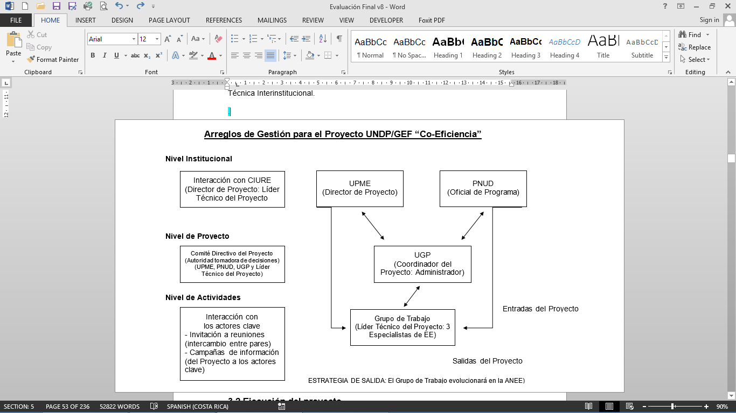

Actual structure used:

The PMU was formed by a Project Coordinator (Mr. Elkin Ramirez), a Project Manager (Mr. Mauricio Concha first, and later replaced by Mr. Alejandro Carrillo), and a Technical Assistant (Ms. Jenny Rios). The PMU worked in the offices of UPME. The PMU was in charge of carrying out duties originally designed for that purpose. The Coordinator of the Project executed the intended duties, many of them with the support he received from the UPME and the other two consultants hired. The Coordinator and the Manager were hired full time for three years, and paid according to what was planned.

UPME assigned two of its staff (Ms. Olga Victoria Gonzalez and Mr. Omar Baez) to the Project Working Group (PWG). Those professional officers had a lot of knowledge on EE issues and provided support to the Project, although not on a full-time basis. In addition, according to information provided by the Coordinator, there was support from two other UPME staff members (also part-time) on financial and technical issues. In practice, the role of Technical Leader was undertaken on a shared basis between Ms. Olga Victoria Gonzalez (UPME) and the Coordinator.

* **Institutional Level:**

Original design (PRODOC):

UNDP and UPME would assign a member of its staff to be responsible for the Project. For UNDP it would be the Program Officer in charge, and for UPME it would be a "Project Director".

The Project Steering Committee (PSC), the highest decision-making authority of the Project, would be formed by the Program Officer (UNDP), the Project Director (Government), the Project Coordinator, the Project Manager, and the Technical Leader of the Project, which would meet quarterly to review progress and obstacles and make decisions regarding strategic and/or critical issues.

To support interaction at inter-agency level, the Technical Leader of the Project (a UPME official) would be responsible for the introduction of the Project and its progress at the Interministry Committee of CIURE, which would be documented in the reports that would be delivered to the PMU.

Actual structure used:

In fact, there were two types of periodic follow-up meetings: the meetings of the Steering Committee which took place twice a year, and the quarterly follow-up meetings of the Technical Follow-up Committee. The first one was the ultimate decision-maker of the Project, such as for the approval of the Annual Operative Plan (AOP) and the Annual Budget. The second one (composed by the PMU, a UNDP representative, and a UPME representative) was in charge of monitoring the progress of the Project, following guidelines and towards the AOP and Budget approved by the Steering Committee.

Each UNDP and UPME assigned a member of their staff to be responsible for the Project. For UNDP, it was the Program Officer in charge (currently Ms. Jimena Puyana), and for UPME, it was the UPME Director (currently Ms. Angela Cadena).

The Project Steering Committee (PSC) was formed by the Program Officer (UNDP), the Director of the Project (the UPME Director), the Coordinator of the Project, and by a representative from OTU/MADS. According to UNDP-Colombia general guidelines, the Steering Committee should meet at least once a year, or more frequently if required. The Evaluation Team received a copy of the records of 5 PSC meetings during the three years that the Project operated.

In addition, complying with UNDP guidelines, there were quarterly follow-up meetings, in which representatives from the Executing Agency, the PMU, and UNDP participated to check on the progress of the Project. The Evaluation Team received a copy of records of 9 follow-up meetings between July, 2010 and October, 2013. The Technical Leader of the Project from UPME, the Coordinator and the Assistant Manager of the Project, and the Program Officer of UNDP normally participated in these meetings. Based on these meetings, the monitoring system of UNDP was updated with both financial and programmatic advances toward the expected outcomes, and the matrix of risks were also updated if new risks that could have an impact on the implementation of the Project were identified.

There is no documented evidence of the work done by the PMU or the Technical Leader of the Project in meetings before the CIURE, of which UPME enjoys the Technical Secretariat, because according to information provided by the Project Coordinator, since the end of 2011 no meetings of CIURE took place. However, the government intends to reactivate the CIURE meetings in 2014, and during the past two years there were other instances in which UPME reported the progress made by the Project, such as the Inter-agency Technical Committee. This was confirmed by some of the key players interviewed during the field mission (for example, at the Ministry of Housing or at the Ministry of Environment).

## 3.2 Execution of the Project

### 3.2.1 Adaptative Management

Adaptative Management refers to how the Project management reacted to changes in the original design assumptions and outcomes of the Project during its execution.

The information presented in the PRODOC and in the Logical Framework Matrix (or Logical Matrix of Outcomes), defined execution indicators, expected goals and strategic outcomes for the Project.

After an analysis of the various AWPs and Quarterly Implementation Reports, it is clear that the PMU sought to direct their actions according to the Objectives and Strategic Outcomes defined in PRODOC and Logical Framework. In spite of this, the Evaluation Team believes that some of the decisions came late, partly due to the repeated changes of the General Director of UPME in the first two years of operation of the Project (three different directors). The following are considered important milestones of the Project that were not achieved or that were achieved at a late stage, affecting the final outcomes of the Project:

* The creation of the NEEA (Outcome 1)
* The approval of new rules and regulations (Outcome 2)
* The restructuring of Outcome 4 (Replacement of Chillers)
* The execution of the Mid-Term Evaluation (Outcome 5)

a) Creation of the NEEA (Outcome 1):

From the beginning, the political risk involved in the achievement of this goal was identified because the idea of creating a new state agency implied an approval process in Congress, which would possibly be there with very low political priority and high risk of failure.

The strategic activities that were defined by the PMU were correct: Conduct a study on the relevant local legislation, international experiences with similar agencies, the analysis and recommendation on the best legal vehicle to use, and a feasibility study (including investment budgets). All of these activities correspond to a stage of design that was completed effectively at the beginning of 2012, when the third and final report for the creation of the NEEA was presented by consultants. From that date, the process of trying to execute the selected model, i.e. the creation of a Private-Public Partnership (PPP), proceeded very slowly. The only material advancement, the signing of an MOU between MME and ANDI, was still pending on the date this report was completed.

One of the reasons for this was the lack of incorporation of intermediate milestones (with their respective dates of compliance) in the design of the Logical Matrix of Outcomes, which led to the lack of time references for each of the major steps that would lead to the accomplishment of the goal (design, discussion/negotiation, signing of agreements).

b) Approval of new regulations (Outcome 2):

In the same way, the process of approving new regulations involved a very high political risk, especially since the emission of rules applicable to buildings are not only under the control of UPME and MME. The main effort carried out within this Outcome, the RETEVIS, was started very quickly in its stage of design because just seven months after the start of the Project, it already had a draft (February, 2011). From there on, the validation and discussion process should have started, until its eventual approval as a mandatory national regulation to be applied to all social interest housing. A couple of validation experiences were accomplished at the Archipelago of San Andres and the community of Soacha (on the outskirts of Bogotá). However, in the remaining 33 months that the Project operated, very little progress was made in the discussion process of the RETEVIS proposal. This, of course, had the disadvantage that MME could not have assumed this role on its own, but in combination with the Ministry of Housing[5], which implied a high-level political agreement between the two ministries that obviously did not take place. This may have been influenced by a number of factors in which the Project Team had little control of: The repeated change of the UPME Director (3 changes during the operation of the Project), changes in the head of the MME, the separation of the Ministry of Housing and Environment in two different ministries; and lack of clarity on what should be the role of the Project, and what the role of the ministries and ICONTEC.

In addition to what is mentioned above, it was also advisable to have set intermediate goals for this Outcome in the Logical Matrix of Outcomes, separating among the different stages: Prioritizing those regulations of major importance to the Project (in agreement with the respective Ministries and ICONTEC), design of the standard, discussion, and final approval.

c) The restructure of Outcome 4 (Replacement of Chillers)

Given that since late 2010 and early 2011 it was already known that this Outcome was obsolete (disappearance of a large portion of the inventory of large chillers that needed to be replaced), the Evaluation Team believes that the restructuring of this outcome took too long. The progress of this Outcome totally depended on what OTU would resolve and a long time was spent until deciding on replacing it with an energy audits campaign in large buildings, some of which still had chillers included in the original OTU inventory. As a result, the audits just begun on December 2012, leaving little or no time, nor resources, to monitor the real implementation of the energy-saving measures that were identified through those audits.

There were 31 energy audits financed with resources from Project No. 70467, according to information provided by the Project Coordinator; plus other 7 funded by Project No. 74760:

* Financed with GEF resources: 8 audits (MADS, MME, City Hall of Quibdo, Government of Antioquia, Corantioquia, Metropolitan Area, CVC Cali and Secretary of Health Cali).
* Financed with GEF resources, in buildings that included chillers: 4 audits (Bank of the Republic of Barranquilla, City Hall of Medellin, University of Antioquia and Palace of Justice of Medellin).
* Financed with UPME resources: 19 energy audits on the northern coast of the country.
* Financed with complementary resources of Project No. 74760: 7 audits (3 in the first summon, and 4 in the second one), all of them for buildings with chillers.

d) The execution of the Mid-Term Evaluation (Outcome 5)

As part of the monitoring and evaluation process (M&E), the Mid-Term Evaluation (MTE) was planned to take place when the project would have executed half of the budget. Since the execution of the budget was relatively slow in the first year and a half of operation (up until September, 2012 only 40% of the GEF budget had been executed), the MTE was assigned in August, 2012 and concluded in October, close to the original deadline of the Project. Fortunately, the Project was extended until November 2013, which allowed the Project to almost complete the execution of its budget. However, if the MTE had been done at the end of 2012 (halfway through the original deadline of the Project), even when half of the budget still had not been achieved, then corrective actions would be identified with more anticipation, especially with regards to the implementation of some outcomes beyond its preparation and design stage (e.g. creation of the APP for the NEEA, discussion of RETEVIS, starting the energy audits).

### 3.2.2 Partnership Agreements (with relevant national or regional key players)

Through Project No. 70467 "Energy Efficiency in Buildings", UPME and/or MME established some relevant agreements, both at a national and international level.

Within them is the “Convention of Triangular Cooperation between Germany, Mexico, and Colombia on Sustainable Housing regarding Energy Efficiency and the Environment”, whose participants are the following:

* Mexican International Cooperation Agency for Development (Mexico)
* Infonavit (Mexico)
* German Development Cooperation, GIZ and GMBH (Germany)
* Presidential Agency for International Cooperation of Colombia (Colombia)
* National Savings Fund (Colombia).

Another important agreement is the one with the Ozone Technical Unit/MADS, so that Projects #70467 and #74760 worked together towards common and complementary goals (mitigation of GHG emissions and ODS).

The third important agreement, which is yet to be signed, is the MOU between MME and ANDI, to take a first step (industrial chapter) towards the creation of a public-private entity that will take over some of the duties thought for the NEEA.

Also, the representatives of the Project have participated in the Interinstitutional Committee (Ministry of Mines and Energy, Ministry of Housing and Territorial Development, Ministry of Environment and Sustainable Development, National Savings Fund, Mining and Energy Planning Unit and United Nations Development Program) where projects and strategies for the rational use of energy in buildings and projects of sustainable construction, among others, are studied and where regular meetings are held once or twice a year.

### 3.2.3 Feedback of the M&E activities used for adaptative management

The main activities of monitoring and evaluation (M&E), which were used to guide decisions on adaptation to changes of the environment, were the Mid-term Evaluation (MTE) Report, as well as the PSC meetings and the Quarterly Follow-up meetings.

In Annex 8: Actions Taken in Relation to the Recommendations of the MTE, the actions carried out by the PMU in respond to the recommendations of the MTE are presented. As can be seen, a large part of the recommendations were accepted and executed by the PMU, to improve the implementation of the Project in the last year of operation. The extension of the deadline of the Project until November 2013 was very important. This enabled the Project to make progress in the pursuit of multiple goals and in the effective execution of almost 100% of GEF funds.

### 3.2.4 Financing and co financing of the Project

**a) Budget according to PRODOC:**

The total budget for the Project, according to PRODOC, amounted to US$ 5,420,000 coming from 5 different sources. The following table shows the planned contribution from each of these sources according to PRODOC:

|  |  |
| --- | --- |
| **Table 3. Funding Sources (US$)** | |
| GEF | $ 975,000 |
| UNDP CO (in kind) | $ 150,000 |
| Colombian Government (in kind) | $ 965,000 |
| Multilateral Fund MLF (cash) | $ 1,000,000 |
| Private Sector (cash) | $ 2,330,000 |
| **Total** | **$ 5,420,000** |
| Source: PRODOC. Figures in US$. | |

**b) Real budget execution summary:**

The execution of the various funding sources, projected by the closing date of the Project (November 30th, 2013), is detailed below:

**Table 4. Funding Execution Summary**



(*) Includes amounts paid, as well as committed amounts to be paid prior to the closing date of the Project; except for the figure for the Colombia Government, which is included up to October 30th, 2013.

Source: Self-elaborated data, based on figures provided by the Project. Figures in US$.

At time of preparation of this report, the CDR 2013 had not been issued; it would be ready after the first quarter of 2014. Therefore, the execution figures for 2013 that were used for the table above are preliminary and were prepared based on preliminary information issued by the Project Coordinator.

Note the importance of having extended the term of the Project until November 2013, which made it possible to boost the execution of GEF funds from the 58.4%, achieved by the date of the Mid-Term Evaluation (August-October 2012), to the current 99.97% shown now.

The level of execution achieved for each budget line of the Project, is presented as follows:

**c) Execution of GEF funds:**

With respect to GEF funds, a very high execution (99.97 %) was obtained, both at the aggregated level as well as per each Outcome, including some payment commitments to be disbursed in the last weeks of November 2013.

For Outcome 1 "Government institutions responsible for promoting energy-efficiency strengthened", an execution of $257,473.66 of the $278,000.00 originally projected in the PRODOC was achieved; therefore, the Outcome achieved an execution of 92.62%.

In terms of Outcome 2 "Policies, regulations, and standards to promote energy efficiency in buildings developed and implemented", an execution of $271,875.83 of the $250,000.00 originally projected in the PRODOC was obtained; so an execution of 108.75% was achieved.

For Outcome 3 "Improved technical knowledge and skills of key players", a budget of 235,000.00 according the PRODOC was originally projected and an execution of $237,483.78 was achieved, which implies an execution of 101.06 %.

For Outcome 4 "Energy savings from the replacement of chillers carried out", and considering that this outcome was modified (energy audit campaign in large buildings), an execution of $43,139.40 of the $55,000.00 originally projected in the PRODOC was accomplished; this represents an execution of 78.44%.

The budget for Outcome 5 "Monitoring and evaluation plan implemented", and for the "Management Unit of the Project” was projected jointly, which means that the $60,000.00 shown in the PRODOC for Outcome 5 were joined with the $97,000.00 projected in the same document for the Management Unit of the Project. Therefore, the total original budget for these items was $157,000.00, and an execution of $164,700.96 was achieved, which implies an execution of 104.91%.

As mentioned earlier, the Project achieved a very high execution of GEF funds, executing $974,673.63 of the $975,000.00 available. Below is the evolution of the execution of GEF funds for the Project over the years:

**Table 5. Evolution of the execution of GEF funds**

Source: Self-elaborated chart, based on the figures provided by the Project. Figures in US$.

In the figures shown above it was not taken into account that it was decided to increase by US$40,000 the allocation of resources for Outcome 3 related to energy audits, and decrease down by US$40,000[6] the allocation of resources for Outcome 1 referring to supporting the implementation of the NEEA.

Note the importance of having extended the deadline of the Project until November 2013, which made it possible to boost the GEF funds budget execution from the 58.4% paid or committed by the date of the Mid-Term Evaluation (August-October 2012) to the 99.97% shown at the end of the Project.

Note: The origin of the data presented in the previous table is described below:

Original Budget (PRODOC): File "PRODOC EEB Signed", which corresponds to the PRODOC of the Project.

Original budget (AWP):

* Year 2010: file "POA 2010 - Adjusted".
* Year 2011: file "AWP - Revisions UNDP" date of report 7/11/2011.
* Year 2012: file "AWP - Revisions UNDP" date of report 12/14/2012.
* Year 2013: file "AWP 2013".

These correspond to the AOP (Annual Operating Plan) of each year.

Budget Executed:

* Year 2010: file "CDR 2010-CDR 2011" which corresponds to the Combined Delivery Report of the year mentioned; while the division by Outcomes of expenditures in that year was clarified by the Project Coordinator in the "Request for information # 2 ".
* Year 2011: file "CDR 2010-CDR 2011" which corresponds to the Combined Delivery Report of the year mentioned.
* Year 2012: file "CDR 2012" which corresponds to the Combined Delivery Report of the year mentioned.
* Year 2013: To determine the execution of 2013 the "DWP COL70467_October 2013" file was used, and the indications provided verbally by the Project Coordinator were followed. Also, additional information via email was provided in the file "Detail of GEF Resources Executed" which refers to the executed amounts that do not appear in the file initially provided, and amounts that have been committed and that would be paid during the month of November 2013.

**d) Execution of the UNDP-CO funds:**

As part of the work carried out jointly between Project No. 70467 "Energy Efficiency in Buildings" and UNDP Project No. 72959 "Integrated Risk Management and Adaptation to Climate Change in the Caribbean", a pilot bioclimatic house with energy efficiency considerations was built; Project No. 72959 has invested an equivalent sum of US$134,215[7] .

As part of the budget executed, a subsidy was given to Ms. Johanna Zilliacus, an International Volunteer of the United Nations, corresponding to the time dedicated to the Project (14% of the total time) from September 2011 to September 2013.

In total, the execution of UNDP-CO funds reached 100% execution in regard to the US$150,000 (in kind) originally projected[8].

**e) Execution of the funds of the Government of Colombia (UPME):**

The Government of Colombia (UPME) made in-kind contributions for the amount of $852,561.48, plus additional resources in cash for $373,061.93 of which $231,532.53 were directly used for the implementation of 19 energy audits in large buildings. The total contribution of the Government of Colombia amounted to $1,225,623.41, compared with the $965,000 originally agreed upon in PRODOC. The back-up documents handed in by UPME to the evaluators helped to develop the following detail:

**Table 6: Detail of execution of funds from the Government of Colombia**

|  |  |
| --- | --- |
| **Description** | **Amount** |
| UPME Publications | $ 450,543.55 |
| Inventories | $ 104,286.76 |
| Advisers’ Wages | $ 73,376.54 |
| Studies | $ 106,382.98 |
| Public Services Consumption | $ 117,971.65 |
| **Total (in-kind contributions)** | **$ 852,561.48** |
| Contributions UPME 2011 - Project Technical Coordination | $ 44,505.50 |
| Contributions UPME 2012 - Project Technical Coordination | $ 59,966.68 |
| Contributions UPME 2012 - Energy Audits | $ 231,532.53 |
| Contributions UPME 2013 - Project Technical Coordination | $ 37,057.22 |
| **Total (cash)** | **$ 373,061.93** |
| **Total contributions** | **$ 1,225,623.41** |
| Source: Self-elaborated chart. Data provided by the  Project Coordinator (file "CoFinancing UPME"). Figures in US$. | |

**f) Execution of funds from the Multilateral Fund (MLF):**

The heading "Multilateral Fund MLF" of the PRODOC (US$ 1 million) corresponds to the total funding for the UNDP/MLF Project 74760 (OTU/MADS), which began at the same time as the GEF/UNDP/COL Project 70467 and will end in December 2014.

According to the verbal information provided by Ms. Lady Suarez (Coordinator of OTU) and Ms. Cristina Mariaca (OTU Professional) to the evaluators, 80% ($800,000) is expected to be executed by December 2013.

**g) Execution of the funds from the Private Sector:**

The heading "Private Sector" represents the original figure that corresponded to the investment required to replace the 13 chillers projected in the PRODOC. Given that the majority of these chillers were replaced or discharged before the Project started and considering that the equipment were replaced due to the initiative of their owners without any participation in the Project, it was considered that investments in return have not been made for this concept to the date. However, there is a good chance for investment of private funds in the Thermal District of Alpujarra Project in Medellin for more than US$6 million in the future.

**h) Summary of Co-financing:**

**Table 7: Summary of Co-financing**



Source: Self-elaborated chart, based on figures provided by the Project. Figures in US$.

The data for "UNDP" correspond to the office in Colombia. The "Government" data correspond to the UPME. The data for "Other Sources" (grants) correspond to the OTU/MADS (Project No. 74467, Replacement of Chillers), and equity investments or loans (reimbursable instruments) that would be related to the replacement of the 13 chillers of the pilot project. The achieved co financing index is 2.23:1 (Co-financing: GEF).

3.2.5 Monitoring and Evaluation: entry design and implementation

**Entry Design:**

According to PRODOC (entry design), the monitoring and evaluation of the Project will be led by the team of the Project and the UNDP Colombia Office with the support of the UNDP/GEF team; a list of the expected activities is shown below:

* Daily monitoring by the Project Management Unit (Project Coordinator).
* Quarterly monitoring by UNDP Colombia Office (Program Officer).
* Annual monitoring through the Tripartite Reviews (MME, UNDP Colombia and the UNDP/GEF team).
* Annual visits to the Project done by UNDP Colombia Office and the Regional UNDP/GEF Coordination Unit.
* Report of Start of the Project, prepared after the Startup Workshop by the Project Management Unit and sent to UNDP.
* Annual Progress Report/Project Implementation Review (APR/PIR) to be used by UNDP Colombia Office and the Regional UNDP/GEF Coordinating Unit to check on the progress of the Project.
* Quarterly progress reports (QPR) that emphasize the main advances of the Project.
* Final Report of the Project, prepared three months before the conclusion of the Project.
* A Mid-Term Evaluation to determine progress towards the outcomes and identify corrective measures if necessary, which must be incorporated as part of the second part of the Project. The Evaluation will approximately take place when the budget execution reaches 50% (18 months).
* A Final Evaluation, three months before the conclusion of the Project; this report should focus on the impact and sustainability of the outcomes, including the contribution of the Project to the development of skills and the achievement of the overall environmental goals.

**Execution:**

The revision of the documents given to the Evaluation Team has allowed determining the list of actions actually executed in regard to the Monitoring and Evaluation of the Project:

* An Initial Report was prepared based on the Startup Workshop of the Project; this report was dated June 28th, 2010. It is important to point out that the PRODOC was signed on November 3rd, 2009, while the Startup Workshop took place almost eight months later, which delayed the whole process.
* Three APR/PIR were prepared corresponding to 2011, 2012, and 2013.
* Four Annual Operational Plans (POA/AWP) were prepared corresponding to 2010, 2011, 2012, and 2013.
* There were eleven quarterly progress reports (QPR) whereas fourteen should have been prepared in the life of the project. The July-December 2010 report was carried out semi-annually. The October-December 2013 report is still pending and no evidence was found of the October-December 2011 report. The eleven reports received are the following:
* 2010 July - December
* 2011 January - March
* 2011 April - June
* 2011 July - September
* 2012 January - April
* 2012 April - June
* 2012 July - September
* 2012 October - December
* 2013 January - March
* 2013 April - June
* 2013 July - September
* There were eight quarterly plans of the fourteen expected. No evidence was found of the July-September 2010 plans, October-December 2010 plans, January-March 2011 plans, July-September 2011 plans, January-March 2012 plans, and January-March 2013 plans. The eight plans received are the following:
* 2011 April - June
* 2011 October - December
* 2012 April - June
* 2012 July - September
* 2012 October - December
* 2013 April - June
* 2013 July - September
* 2013 October - December
* There were five Project Steering Committee meetings, complying with the requirement set forth in the PRODOC:
* Act No. 1 "Startup Workshop" (June 28, 2010)
* Act No. 2 (January 26, 2011)
* Act No. 3 (December 09, 2011)
* Act No. 4 "Follow-up Meeting" (September 07, 2012)
* Act No. 5 (January 09, 2013)
* There were nine quarterly follow-up meetings of approximately thirteen which were expected to be carried out. However, sometimes there were no meetings at the end of the year because PSC meetings were held instead.
* Follow-up Meeting Report UNDP-UPME (September 17 , 2010)
* Act No. 2 (June 01, 2011)
* Act No. 3 (October 14 , 2011)
* Act No. 4 (Act No. 5) (April 18 , 2012)
* Act No. 5 (Act No. 6) (July 06, 2012)
* Act No. 6 (October 11, 2012)
* Act No. 7 (April 08, 2013)
* Act No. 8 (June 28, 2013)
* Act No. 9 (October 30, 2013)
* There is no evidence that the Final Report of the Project has been developed. The Coordinator of the Project is in charge of this report, and it must be developed before the conclusion of the Project.
* There is a Report of the Mid-Term Evaluation, which began on August 13th, 2012 and ended in October 2012. The MTE started 26 months into the implementation of the Project, mainly due to the lack of adequate offerors for the first tender issued. [9]. Also, it is presumed that the implementation of it was affected because of the delay in reaching 50% of the GEF budget.
* The handling of payments and accountancy of GEF funds is done by UNDP. UPME requests payments once the successful delivery of products or services is corroborated. Cost accounting of those funds is performed by UNDP. Although the PRODOC does not explicitly request it, an external audit of the Project was performed during the first half of 2013; the outcomes were delivered directly to UNDP.
* The Final Evaluation began in October 2013 and will end in November 2013. The current document is the report of this evaluation.

The following table shows a summary of the major milestones achieved by the Project during its execution:

**Table 8: Major milestones during the execution of the Project**

|  |  |  |
| --- | --- | --- |
|  | **Event** | **Date** |
| Documents of the Project | PRODOC | November 03, 2009 |
| Kick-off Workshop | June 28, 2010 |
| Annual Project Review (APR) / Project Implementation Review (PIR) 2011 | July 2011 |
| Annual Project Review (APR) / Project Implementation Review (PIR) 2012 | July 2012 |
| Mid-Term Review | October 2012 |
| Annual Project Review (APR) / Project Implementation Review (PIR) 2013 | July 2013 |
| Meetings | Steering Committee Meeting | June 2010 |
| Steering Committee Meeting | January 2011 |
| Steering Committee Meeting | December 09, 2011 |
| Steering Committee Meeting | September 07, 2012 |
| Steering Committee Meeting | January 09, 2013 |
| Quarterly Follow-up Meeting | September 17, 2010 |
| Quarterly Follow-up Meeting | June 2011 |
| Quarterly Follow-up Meeting | October 2011 |
| Quarterly Follow-up Meeting | April 2012 |
| Quarterly Follow-up Meeting | July 2012 |
| Quarterly Follow-up Meeting | October 2012 |
| Quarterly Follow-up Meeting | April 2013 |
| Quarterly Follow-up Meeting | June 2013 |
| Quarterly Follow-up Meeting | October 2013 |
| Products of the Project | RETEVIS (Initial) | October 2010 |
| RETEVIS (Final) | February 2011 |
| Liquid Water Cooler-Chillers. Guide on Energy and Environmental Efficiency | April 2012 |
| Studies finalize for the creation of the NEEA | May 2012 |
| Audits (Initial) | December 2012 |
| Audits (Final) | September 2013 |
| MOU MME –ANDI ready to be signed (APP for NEEA) | October 2013 |
| Seminars and Courses | Seminar on Financial Mechanisms and Instruments for Energy Efficiency Projects in Colombia | from May 12, 2011 to  May 13, 2011 |
| International Seminar on Energy Efficiency in Buildings | from November 02, 2011 to November 03, 2011 |
| Course on Energy Efficiency in Social Interest Housing | From October 17, 2012 to October 18, 2012 |

Next, an assessment of the M&E process is carried out based on the criteria established in UNDP´s Evaluation Guide for GEF-financed projects:

**Table 9: Criteria and Analysis of Monitoring and Evaluation**

| **Criteria** | **Analysis** |
| --- | --- |
| An analysis of the M&E plan at the beginning of the Project, by considering whether the conditions of the baseline, methodology, roles, and responsibilities are well articulated. Is the M&E plan well conceived? Is it sufficiently well articulated to monitor the outcomes and progress toward the achievement of the goals? | The design of Outcome 5 of the Logical Framework of the PRODOC (Monitoring and Evaluation plan) is considered to be well articulated; although, it could have been applied more effectively if the Logical Framework had been established its own intermediate milestones and deadlines for compliance, as well as clearer goals. |
| **Rating of the M&E entry design** | **Satisfactory (S)** |
| The quality of the implementation of the M&E plan: Was the M&E plan budgeted and financed well enough during the preparation and implementation of the project? | The allocated budget (PRODOC) of Outcome 5 was US$157,000 and the amount actually spent was US$164,700. In addition, UNDP made a contribution in kind, part of which was given to this activity. It is believed to have been enough. |
| The effectiveness of the monitoring indicators of PRODOC to measure progress and performance. | The indicators are considered adequate with the exception of two indicators of Output 2.2: Number of executed audits per year, and number of feasibility studies executed per year, which have no direct relationship with the respective output (which is focused on the enactment of standards and technical guides). |
| Accordance with the presentation of financial and progress reports required, including the quality and delivery at the right time. | They are considered to be adequate. However, no evidence was found of the execution of some quarterly reports (QPR), some quarterly plans, and some quarterly follow-up meetings; although, there were just a few that were missing. |
| Value and effectiveness of the monitoring and evaluation reports, and evidence that these were discussed with key players and the Project Team. | There is evidence that the M&E reports were discussed during the PSCs and quarterly monitoring meetings. The MTE report was also analyzed within the PSC, UPME, and UNDP. |
| The degree to which the follow-up actions and/or adaptive management was taken in response to monitoring reports (PIRs). | The PIR monitoring reports and the MTE outcomes were taken into account by the Project Management, especially to define the activities for the last year of the Project. |
| Corroborate that the self-ratings of the PIRs were consistent with the findings of the MTE and the FE. | The information of the PIR shows a mixture between the actual achievements of the Project and the anticipated achievements; therefore, some ratings seem to be over-estimated. However, the information submitted is considered transparent and honest. |
| Considerations on the analysis of the M&E in the MTE and if changes were made in the implementation of the Project as a result of the recommendations given in MTE. | The MTE rated the M&E (overall quality, initial design and implementation) as Satisfactory (S). The 2013 PIR and data gathered as part of the current FE show that many of the recommendations of the MTE were accepted and implemented during the last year of the Project. |
| **Execution rating of the M&E plan** | **Satisfactory (S)** |
| **Overall quality of M&E** | **Satisfactory (S)** |

3.2.6 Coordination of the implementation and execution of UNDP and partner for implementation and operational issues

In Project No. 70467, the executing agency is UPME and the implementing agency is UNDP-Colombia. The organizational structure adopted by the PMU for the implementation of the Project was the following:

**Figure 2: Organizational Chart for the Administration of the Project**

UPME

General Director

Ms. Angela Ines Cadena Monroy

UPME Support Group

(RUE and AES)

Project Coordinator

Ms. Olga Victoria Gonzalez Gonzalez

Mr. Omar Baez

Mr. Elkin Eduardo Ramirez Prieto

Junior

Technical Assistant

Administrative

Coordinator

Miss Yenny Carolin Rios Rivera

Mr. Mauricio Concha (previous)

Mr. Alejandro Carrillo (current)

RUE: Rational Use of Energy

AES: Alternative Energy Sources

The organizational chart actually used is different from the one planned (PRODOC). It is considered that it was enough for the Project Management to be able to work on the required technical and operational outcomes. However, it would have been advisable to count on an additional staff member with a less technical profile than the rest of the team; someone more experienced in political and legislative issues and negotiation of projects at the inter-agency level. It could have been a part-time consultant, hired for the second half of the Project. His/her main task would have been in charge of all the political management and the progress towards the outcomes based on the technical proposals that were formulated.

The following table shows the ratings for the quality of implementation and coordination between the PMU, UPME, and UNDP-Colombia over the operational period of the Project. The table also assigns an overall rating for I&E (Implementation and Execution):

**Table 10: Criteria and Analysis of Implementation and Execution (I&E of IA and EA)**

|  |  |
| --- | --- |
| **Criteria** | **Analysis** |
| If there was an appropriate approach in the outcomes of the executing agency and of the implementing agency | It is considered that, in general, there was an appropriate approach in the outcomes of the two agencies. |
| The adequate supervision from the implementing and executing agencies | It is considered that the supervision of the Project by both agencies was adequate. However, it would have been advisable that internal audits were carried out by UPME at least once a year. No evidence of accounting audits, whether internal or external, was found. |
| The quality of the risk management | The political risk (change of officials, change in the priorities of the Government, etc.) affected some outcomes of the Project very much, especially the goal of creating the NEEA. It is interesting to point out that the PIF (p. 49 of the PRODOC) mentioned that this risk was low. An adequate contingency plan was not established to mitigate it, neither at the design level of the PRODOC nor at the implementation level. |
| The level of response of the managers towards the most significant issues arisen during execution | The two most significant problems that arose were: a) The lack of greater interest of the Government to create the NEEA and to implement the regulations proposed (RETEVIS); and b) The change of the baseline for Outcome 4 (replacement of chillers). On the first item, the managers of the Project had little strength to change the situation. On the second issue, it is considered that managers took too much time to seek and implement an alternative project (the energy audits campaign).  In general, it is considered that some decisions were taken too slowly and a better planning of some activities on the part of the Executing Agency was needed. While on the part of the Implementing Agency they were slow in the paper work required to approve and disburse the funds related to some applications that were run by the Executing Agency. |
| The quality and timeliness of the technical support to the  Project Team | It is considered that they were adequate. |
| Candor and realism in the follow-up reports | It is considered that the follow-up reports were generally realistic. |
| Suitability of choosing the executing agency for the implementation of the Project | The UPME was the most suitable executing agency for this Project. |
| Any major issue related to the duration of the project, for example delays, which could have affected the achievement of the outcomes and the sustainability of the Project | The Project began relatively late once the PRODOC was signed. The management team was completed until a year later. This was possibly one of the reasons why the project required a deadline extension in order to complete the execution of the GEF funds and to be able to display greater progress in certain goals. However, it does not seem to have been one of the main causes for the lack of reaching certain goals; for example, the creation of the NEEA, the enactment of regulations, or the execution of financial incentives for the EE market. |
| **Rating of the execution quality of the IA** | **Satisfactory (S)** |
| **Rating of the execution quality of the EA** | **Satisfactory (S)** |
| **Rating of the overall quality of implementation and execution** | **Satisfactory (S)** |

3.3 Project Results

3.3.1 Overall Outcomes (objectives achieved)

According to the Logical Framework Matrix in the PRODOC, which repeats what was referred to in "Part II: Strategy" of the same document, the Goal and the Overall Outcome of the Project are the following:

**Goal:** To promote energy efficiency in buildings by eliminating institutional, legal, and regulatory barriers, as well as technical skills barriers, that currently limit its large-scale adoption.

**Overall Outcome:** To reduce greenhouse gas emissions from the buildings sector in Colombia through the implementation of an integrated package of activities that improve the energy efficiency of commercial, public, and residential buildings. An associated outcome would be the reduction of emissions of ozone-depleting substances of centrifugal, CFC-based chillers.

**Compliance with the Overall Outcome**

To measure the achievement of the **Overall Outcome**, in the Logical Framework of the PRODOC the following indicators and measurement parameters were established:

**Table 11: Indicators, Baseline, and Goal for the Overall Objective of the Project**

|  |  |  |  |
| --- | --- | --- | --- |
| **Indicator** | **Baseline** | **Goal** | **Sources of**  **Verification** |
| (1) Market  transformation (scale 1 ... 4)  (2) Adoption of policies (scale 1 ... 4).  (3) Energy saved: (MWh)  (4) Investment (US$)  (5) Number of lending institutions | (1) Market  transformation: 1  (2) Adoption of policies: 1  (3) Energy saved: 0 MWh  (4) Investment US$0  (5) Number of lending institutions: 1  (Bancoldex-URE) | 1) Market  Transformation: 3  (2) Adoption of policies: 4  (3) Energy saved: 88,600 MWh  (4) Investment (direct) US$3.2 M  (5) Number of lending institutions:1 (Bancoldex-URE) | 1 and 2) Analysis done by the Coordinator and independent evaluators  (3) Use annual savings as a proxy  (4). Project Reports, audits  (5) This GEF objective is not directly pursued by the Project (no verification required) |

The analysis shows the following outcomes:

1) Market Transformation:

The indicator provided to measure this parameter is quite undefined, and the PRODOC only mentions that the original situation (baseline) is 1, that the scale is from 1 to 4, and that the goal is 3. However, the main transformation of the market that can be interpreted for the Project, is directly related to the removal of institutional, legal, regulatory and technical skills barriers that limit the wide-scale adoption of energy efficiency in buildings.

In order to remove institutional barriers, the main strategy that was defined for the Project was the creation of an institution (public or private), which would be directly responsible for the promotion of energy efficiency in the country and would follow similar models that already existed in other countries. In this sense, the Project allowed a considerable progress with respect to the definition of the legal aspect of this entity, promoted the discussion among the different public and private institutions on how to create it, and developed a feasibility study, including an investment budget. There is also a MOU (negotiated and agreed upon, but not yet sign) between MME and ANDI for the creation of the NEEA. However, this institution has not been created yet, and it is not clear how it will be funded to achieve its sustainability, and the MOU is clear in the sense that the scope of the agreement with ANDI is only for the industrial sector. Therefore, if the goal was a rating of 3 (creating the NEEA with reasonable sustainability guarantees), the progress made to date is a rating of 2.

In order to remove legal and regulatory barriers, which also refer to "Indicator (2): Adoption of policies", the main strategy that was defined for the Project was the emission of a specific regulatory framework to "help create an enabling environment and awareness, promoting the demand, and supporting the economic viability of the investment on energy efficiency measures and equipment." In this sense, the Project has had an important role in regard to launching a proposal for a Technical Regulation of Energy Efficiency in Social Interest Housing (RETEVIS), and discussions on the draft Code for Sustainable Construction of the Ministry of Housing, and on the Environmental Seal for Sustainable Buildings of the Ministry of Environment. However, the RETEVIS has not been approved yet (it is not even in the process of a formal discussion between all the stakeholders that would be affected by it), and the two other documents belong to two other ministries and have not yet finalized. No specific regulations (or "national standards") were issued to develop energy audits for the certification of professionals in energy efficiency and the operation of ESCO companies in the country. Therefore, if the goal was a rating of 4 (counting with enforced specific regulations), the progress made to date is a rating of 2.

In order to remove technical skills barriers within the Project, two main strategies were defined as follows: Training for professionals, technicians, engineers, architects, and suppliers on the topic of energy efficiency in buildings, and the development of technical tools (standards, guides). In this sense, the Project organized and sponsored 3 seminars on energy efficiency in buildings. Their staff members participated as speakers in multiple training and awareness events sponsored by other institutions and achieved a large number of people in attendance (diversified among participants from the public, private, and academic sectors), well above the goal projected in the PRODOC (388 vs. 75 participants). In addition, a guide on Liquid Water Coolers (chillers) linked to an important industrial association (ACAIRE) and a guide on the Formulation of Financial Schemes for EE and NCES projects, which was used by Bancoldex to design a new green line of US$50 million to fund energy efficiency projects, were handed out. Also, 31 energy audits in large buildings of Colombia were conducted, 7 of which have chillers, and guides on the replacement of cooling systems for chillers were distributed nationwide by ACAIRE (the goal was 3 equipment suppliers) and directly by the Project in 4 cities of the country (Medellin, Barranquilla, Cartagena, and Cali), where the need for chillers had been identified. Therefore, if the goal of the Project was a rating of 3 (training and guides), the progress made to date is a rating of 3, even recognizing that there is still much to be done on the issue related to training, guides, and awareness to truly achieve a transformation of the market.

In summary, a rating of 2.33 (from a baseline of 1 and a goal of 3) can be given to the progress made on the "Market Transformation" parameter, i.e. 67% progress of the goal.

It is important to recognize that achieving the goal was difficult in regard to the creation of the NEEA and the enactment of mandatory regulations, due to the fact that the first aspect depends on a high-level political decision and the second aspect does not depend only on the willingness of the MME (which the Project belongs to). In the PRODOC this was recognized as a risk or limitation of the Project from the beginning.

2) Policies Adoption:

This was discussed in the previous paragraph. The progress made on the "Adoption of Policies" parameter was given a rating of 2 (from a baseline of 1 and a goal of 4), i.e. 33% progress of the goal. Once again, it is important to point out the difficulty of achieving a goal that depended on the political willingness and the strong support of other ministries that have the responsibility for generating these types of regulations (specifically, the Ministry of Housing and the Ministry of Environment).

3) Energy Saved and Emissions Avoided:

In the PRODOC it was estimated that 88,600 MWh would be saved, and 62,000 ton of CO2 would be directly avoided through the Project.

When the achievements of the Project were reviewed, it became clear that Outcome 4 "Energy savings from the replacement of chillers carried out" could not be accomplished by the Project, due to the following main reasons:

* **Change in the Base Line of this Outcome:** Of the sample of 13 chillers that had been selected by OTU for the UNDP Project #74760 when the Project initiated activities (2010), only 9 units could be located. They are listed below:[10]

**Table 12: Inefficient Chillers remaining and in operation (9) at the starting date of**

**the Project (December, 2010)**

**Name of the Company**

**City**

**Equipment**

**RT**

1

Centro Internacional de Agricultura Tropical

Palmira

1

280

2

National Tax and Customs Division

Bogotá /

Medellín

1

250

3

Vicente Uribe Rendón Building

Medellín

2

400

4

Government of Antioquia

Medellín

2

900

5

ISAGEN S.A. E.S.P.

Medellín

2

240

6

Intercontinental Hotel

Medellín

1

250

Total

9

2.320

**Amount of**

The other units had already been replaced or belonged to companies that no longer existed, especially textile mills that went bankrupt in the years prior to the start of the Project activities.[11]

**Table 13: Inefficient Chillers replaced (40) at the starting date of the Project (December, 2010)**

|  |  |  |  |  |
| --- | --- | --- | --- | --- |
|  | **Name of the Company** | **City** | **Equipment Units** | **RT** |
| 1 | Bank of the Republic | Barranquilla | 2 | 460 |
| 2 | Bank of the Republic | Cali | 1 | 250 |
| 3 | BBVA Cattle Bank | Medellin | 1 | 220 |
| 4 | Conventions Center | Cartagena | 3 | 825 |
| 5 | Coffee Building | Medellin | 2 | 700 |
| 6 | Edatel | Medellin | 1 | 294 |
| 7 | Enka of Colombia | Medellin | 4 | 2.800 |
| 8 | Exito – San Antonio/Poblado | Medellin | 2 | 320 |
| 9 | El Guavio Hydroelectric Co. | Bogota | 3 | 1.500 |
| 10 | San Carlos Hydroelectric Co. | Medellin | 2 | 640 |
| 11 | San Carlos Hydroelectric Co. | Medellin | 2 | 700 |
| 12 | Hilton Hotel | Cartagena | 2 | 350 |
| 13 | Intercontinental Hotel | Medellin | 1 | 235 |
| 14 | Interquim S.A. | Medellin | 1 | 180 |
| 15 | Isa – El Poblado | Medellin | 2 | 440 |
| 16 | Vanylon S.A. | Barranquilla | 3 | 1.050 |
| 17 | Colombina S.A. | Cali | 2 | 110 |
| 18 | National Chocolates Company | Rionegro | 2 | 150 |
| 19 | Miramar Ecopetrol Club | Barrancabermeja | 2 | 100 |
| 20 | Antioquia University | Medellin | 2 | 250 |
|  | Total | | 40 | 11.574 |

**Table 14: Inefficient Chillers with unknown whereabouts (40) at the starting date of the Project (December, 2010)**

|  |  |  |  |  |
| --- | --- | --- | --- | --- |
|  | **Name of the Company** | **City** | **Equipment Units** | **RT** |
| 1 | FEDERAL TEX | Valledupar | 2 | 800 |
| FEDERAL TEX | Valledupar | 2 | 610 |
| 2 | TEXPINAL S.A. | Espinal | 1 | 420 |
| TEXPINAL S.A. | Espinal | 1 | 380 |
| TEXPINAL S.A. | Espinal | 1 | 246 |
| TEXPINAL S.A. | Espinal | 1 | 221 |
|  | Total | | 8 | 2.677 |

Due to this change in the baseline of Outcome 4 of the Project, at the end of 2011 it was decided to replace the scope of this outcome so that a campaign of energy audits in large buildings in Colombia would replace it. Some of those buildings have inefficient chillers that still need to be replaced (and that were part of the original OTU inventory). Others have chillers which have already been replaced and there is a building that wants to install a new, efficient chiller. The audits executed with funds from Project #70467 (UNDP/UPME/GEF), where there were inefficient chillers (replaced, to be replaced, or installed), were the following:[12]

**Table 15: Energy audits executed with resources of Project #70467 (2013)**

|  |  |  |  |  |  |
| --- | --- | --- | --- | --- | --- |
|  | **Name of the Company** | **City** | **Equipment Units** | **RT** | **Condition** |
| 1 | Bank of the Republic | Barranquilla | 2 | 460 | Substituted |
| 2 | Antioquia Government | Medellin | 2 | 900 | Operating, to be substituted |
| 3 | Antioquia University | Medellin | 2 | 830 | Substituted |
| 4 | Medellin City Hall | Medellin | 3 | 743 | Operating, to be substituted |
| 5 | Palace of Justice | Medellin | 0 | - | No chiller, but one must be installed |
|  | Total | | 9 | 2.933 |  |

The buildings of the Government of Antioquia, City Hall of Medellin, and the Palace of Justice make up the Thermal District of La Alpujarra in Medellin. On the date of this Final Evaluation these audits had already been completed, as well as others that were executed with funds from Project No. 74760 (UNDP/OTU/MLF) for a total of 31 audits (28 were placed for revision by the Evaluation Team). However, replacement of chillers that has already been materialized cannot be accredited to the Project for now, because they were replaced by their owners’ own initiative.

A relevant fact in November, 2013 is the signing of an agreement to carry out the Thermal District of La Alpujarra Project in Medellin, with financial support from the Swiss Cooperation and the EPM electric utility, integrating the buildings of the Government of Antioquia, the City Hall of Medellin, DIAN, and the Metropolitan Area. This project would cost at least US$6 million, with the possibility of replication and additional investment in other cities of Colombia.

* **Poor Design of this Outcome:** The evaluation team believes that it would have been better to incorporate the replacement of chillers as part of a more integral Outcome 4, which would be designed to increase energy efficiency in the buildings where they were located, not only replacing the chillers  but also exploring and eventually implementing other energy-saving measures. Having incorporated an Outcome 4 mainly dealing with the reduction of ODS instead of an integral outcome that also sought the reduction of GHG, led to confusion as to the role that Project No. 70467 should have for Outcome 4, complementary to the OTU’s role in Project No. 74760. This confusion led the Team of Project No. 70467 to depend entirely on what the Team of Project No. 74760 would do, up until the moment when it was decided to launch an alternative Outcome 4 (the campaign for energy audits).
* **Slow pace on the Implementation of the Alternative Project:** The Project Team of identified the change of the baseline from the moment the OTU communicated it by the end of 2010-beginning of 2011. However, the proposal, approval and implementation of an alternative Outcome 4 (the execution of energy audits that would take into account not only the replacement of chillers, but also other energy-saving measures) took too long according to the criteria of the evaluation team. The execution of energy audits began at the end of 2012 during the extension of the deadline that was agreed upon after the Mid-Term Evaluation. Part of this delay could be due to the confusion mentioned in the previous point, and partly to the bureaucratic paperwork that led to the adoption of the alternative Outcome in an ever-changing environment in the Management of the UPME, until September 2012[13] when UPME pledged at least US$200,000 in cash for the financing of the audits.
* **Lack of Control on the Chillers Replacement:** This could also be considered a weakness of the original design of the Project according to the PRODOC. Given that the chillers belonged to a variety of stakeholders (different from UPME, MME, OTU, and MADS), it was very difficult to guarantee that all of them were going to be effectively replaced during the life of the Project. By putting the entire goal of the 88,600 MWh which would be saved and 62,000 ton of CO2 that would be reduced through the Project, based on what other entities would do, it is considered that there was a very large risk that the goal of the Project could not be fulfilled.

Therefore, even though the Project did not achieve any real progress on this goal, the evaluation team believes that the reasons mentioned above justify the low outcome achieved.

4) Investments (USD):

The PRODOC, in Output 4.2 of Outcome 4, assumed as a goal that the Project would have “definite investment for the 13 chillers projects with committed co-financing (credits) and support from the Multilateral Fund of the Montreal Protocol.” This meant that the 13 chillers were going to be replaced with financing from Bancoldex, co-financing from the MLF, and contributions from the owners adding up to a total value of US$3.33 million. For the same reasons mentioned in the previous point, this was not accomplished as a direct achievement of the Project to the date of this evaluation. However, for the future an investment of at least US$6 million is expected for the Thermal District of La Alpujarra in Medellin, which received technical assistance (energy audits) on behalf of the Project.

5) Number of lending institutions:

Even though the Logical Framework points out that “this goal of the GEF is not directly pursued by the Project (no verification required),” it is considered appropriate to mention that with the direct support of the Project, Bancoldex launched a new line of financing for energy efficiency in the amount of US$50 million, which is much better designed than the one originally mentioned within the baseline of the PRODOC (called "Bancoldex-URE"). The new credit line has input provided by the Project (especially, the Guide for the formulation of financial schemes for EE and NCES projects), and with permanent counseling from the staff of the Project. There are also new credit lines opened (although the Project does not have any relationship with them) in Bancolombia and in the National Savings Fund.

The summary of outcomes achieved for the Overall Goal of the Project is presented below:

**Table 16: Summary of outcomes achieved vs. Overall Goal of the Project**

|  |  |  |  |  |
| --- | --- | --- | --- | --- |
| **Indicator** | **Base Line** | **Goal** | **Achievement** | **Comments** |
| (1) Market transformation (scale 1...4) | (1) Market transformation: 1 | 1) Market transformation: 3 | 1) Market transformation: 2.33 | Based on the progress made on removing different kinds of barriers |
| (2) Adoption of policies  (scale 1...4) | (2) Adoption of policies: 1 | (2) Adoption of  policies: 4 | (2) Adoption of  policies: 2 | Based on the progress made on the issue of regulation |
| (3) Energy saved:  (MWh) | (3) Energy saved: 0 MWh | (3) Energy saved: 88,600 MWh | (3)Energy saved: 0 MWh | Based on the fact that the 13 projected chillers were not replaced, as a result of the Project |
| (4) Investment  (US$) | (4) Investment  US$0 | (4) Investment (direct)  US$ 3.2 M | (4) Investment  US$0 | Same |
| (5) Number of lending institutions | (5) Number of  lending institutions: 1  (Bancoldex-URE) | (5) Number of  lending institutions: 1  (Bancoldex-URE) | Not evaluated |  |
| **Overall Rating of the compliance with the Overall Goal** | | | | **Somewhat unsatisfactory (SU)** |

**Compliance with the Overall Outcome**

To measure the execution of the **Overall Outcome**, in the Logical Framework of the PRODOC the indicators and measurement parameters were established as follows:

**Table 17: Indicators, Baseline, and Goal for the Overall Outcome of the Project**

|  |  |  |  |
| --- | --- | --- | --- |
| **Indicator** | **Baseline** | **Goal** | **Sources of**  **Verification** |
| (1) Direct emissions of CO2 avoided (tons CO2)  (2) Indirect emissions of CO2 avoided (tons CO2) | (1) Direct emissions of CO2 not avoided  (2) Indirect emissions of CO2 not avoided | (1) Direct emissions avoided: 62,000 tons CO2  (2) Indirect emissions avoided due to replication: 124,400 tons CO2; due to the market transformation: 150.000 tons CO2 | There is no verification on the life of the Project. |

According to PRODOC (pages 7 and 53-PIF), the direct and indirect environmental benefits of the Project were calculated as follows:

Average Capacity of the chillers to be replaced:  304 RT

Current consumption of the equipment to be replaced: 1.10 kW/RT

Consumption of efficient equipment: 0.56 kW/RT

Hours of operation: 3,103 hours/year

Emission Factor of the network (marginal gas/coal): 0.70 Kg CO2/kWh

Energy Costs: US$0.08 /kWh

Based on the previous data, calculations were made for the following:

Savings of electricity per replaced chiller:  508,826 kWh/year

CO2 emissions avoided: 356.2 Ton CO2/year

For the calculation of energy savings and emissions avoided by the Project, an economic investment term of 20 years was considered, and a change in the baseline of 33% was assumed, resulting in 13.4 years of actual energy savings.

With the previous data, the direct environmental benefits of the Project resulting from the replacement of 13 chillers were calculated as follows:

Emissions of CO2 avoided per chiller: 356.2 Ton CO2/year

Effective Time: 13.4 years

Amount of chillers: 13

Amount of CO2 emissions avoided: 62,000 Ton CO2

Electrical energy savings: 88,600 MWh

The indirect benefits in the short term (5 years), resulting from the replication of the replacement of these chillers were calculated by applying a Replication Factor of 2, which implies 124,000 Ton CO2 and 177,200 MWh. The indirect benefits in the medium and long-term that should be obtained because of the market transformation resulting from the creation of the NEEA were estimated at about 300,000 Ton CO2 avoided and 1,370.000 MWh of energy savings. However, Project No. 70467 was assigned only with 50% of these amounts, assuming that the other 50% would be assigned to Project No. 74760 of the OTU and therefore the values would be set at 150,000 Ton CO2 avoided and 685,000 MWh of energy savings.

Therefore, the whole accomplishment of the goal of reducing direct emissions would come from the effective replacement of 13 large chillers and their efficient operation for 20 years. The indirect outcomes would come from the replication of those pilot replacements in the rest of the chiller inventory identified by OTU (58 chillers in total, inventory calculated in 2005, five years before the Project begun operations) and the expansion of similar projects due to the market transformation.

As mentioned in the previous section (see "Compliance with the Overall Goal"), a series of factors prevented the compliance with the replacement of 13 chillers. However, given that the Project Steering Committee approved the change of Outcome 4 to a campaign of energy audits in large buildings (including those containing chillers belonging to the original 13)[14], it was considered valid, as an Alternative Goal for this Overall Outcome, to calculate the reduction of emissions that would be obtained if all the energy-saving projects, identified and recommended in the audits, were effectively implemented.

The outcome is summarized below, and the details appear in Annex 9: Analysis of Energy Audits.

The potential for energy savings and GHG emissions avoided in the 31 buildings audited (Outcome 4 modified) because of good practices, changes in technology, and architectural measures, that would be obtained if all the savings measures identified in the audits were implemented, is the following:

**Table 18: Summary of energy savings and GHG emissions that would be avoided if projects identified in the audits (Outcome 4 modified) were executed**

|  |  |  |  |  |
| --- | --- | --- | --- | --- |
| **Audit #** | **Energy Savings kWh/year** | **CO2 Ton /year avoided** | **Emission Factor** | **Cost of the investment (US$)** |
| 1 | 722,511.24 | 209 | 0.2893 | 151,903 |
| 2 | 153,120.00 | 60 | 0.3918 | 71,197 |
| 3 | 64,915.20 | 44 | 0.6778 | 113,440 |
| 4 | 190,164.00 | 100 | 0.5259 | 203,558 |
| 5 | 262,742.76 | 65 | 0.2474 | 42,259 |
| 6 | 22,222.20 | 6 | 0.2700 | 10,601 |
| 7 | 121,709.28 | 32 | 0.2629 | 57,799 |
| 8 | 1,407,996.00 | 390 | 0.2770 | 1,347,791 |
| 9 | 908,660.04 | 300 | 0.3302 | 616,022 |
| 10 | 62,058.84 | 13 | 0.2095 | 45,547 |
| 11 | 175,138.08 | 42 | 0.2398 | 84,558 |
| **Total 11 audits** | **4,091,237.64** | **1,261.00** | **0.3082** | **2,744,675.52** |
| **Average per audit** | **371,930.69** | **114.64** |  | **249,515.96** |
| **Total 31 audits** | **11,529,851.39** | **3,553.84** |  |  |
| **20-year Potential** | **230,597,027.80** | **71,076.80** |  |  |
| **13.4-year Potential** | **154,500,008.60** | **47,620.00** |  |  |
| **Exchange rate: (COP/US$)** | 1,900.00 |  |  |  |

Source: Self-elaborated. COP: Colombian Pesos, the local currency.

For the calculation above, a sample of 11 energy audits (a third of the total of 31 executed) was selected to make a series of statistical calculations and to determine the average value of energy savings (kWh/year) and avoided emissions (Ton CO2/year) resulting from the implementation of energy efficiency improvements.

It must be noted that the 31 audits were distributed among a group of consultants, which did not necessarily use the same methodology nor the same assumptions, which is reflected in the different Factors of Emissions for the electric power grid that were used. The main difference is due to the fact that some consultants used the average EF of the national interconnected power grid, while others used the marginal EF. The latter was used by the analyst who calculated the effect of the replacement of chillers in the PRODOC and the PIF.

Therefore, in order to adjust the calculations mentioned above to the methodology originally used by the analyst of Project No. 70467, a change in the baseline of 33% (i.e., 13.4 effective years) and a marginal EF, which is the highest used in the selected sample, i.e. 0.6778 kg CO2/kWh  (very similar to the original 0.70), was assumed.

In applying these settings, the emissions avoided would be the following:

47,620 / 0.3082 x 0.6778 = **104,727 Ton CO2/kWh**

The corresponding energy savings would be **154,500 MWh**.

When comparing the total emissions avoided and the energy savings that would be obtained if all the savings projects recommended in the audits were implemented, the results are the following:

**Table 19: Summary of outcomes achieved vs. Overall Outcome of the Project**

|  |  |  |  |
| --- | --- | --- | --- |
| **Indicator** | **Baseline** | **Original Goal (replacement of**  **13 chillers)** | **Alternative Goal (execution of projects recommended in the energy audits)** |
| (1) Direct emissions of CO2 avoided (Tons CO2). | (1) Direct emissions of CO2 are not avoided. | (1) Direct emissions avoided: 62,000 Tons CO2, corresponding to 88,600 MWh | (1) Direct emissions that would be avoided: 104,727 Tons CO2, corresponding to 154,500 MWh saved.  It exceeds the goal in quantity, but there is uncertainty as to whether the savings projects will really be implemented. |
| **Overall Rating of the compliance with the General Outcome** | | | **Somewhat satisfactory (SS)** |

If the savings measures identified in the 31 energy audits are really implemented, a total of **154,500 MWh** would be reduced and a total emissions of **104,727 Tons CO2** would be avoided over the lifetime of those savings measures (20 years, which are actually 13.4 effective years considering a change of 33% in the Baseline) because of good practices, changes in technology, and architectural improvements.

The calculation of the emission reductions mentioned above (104,727 Tons CO2) supposedly represents a marginal Emission Factor (FE) (natural gas and coal) of the national interconnected power grid, which was only used in a few of the energy audits carried out, but it was initially used in the PIF/PRODOC. Therefore, for comparative purposes of the actual outcomes vs. the planned outcomes, the same EF criterion was kept. However, if the average EF of the audits (sample of 11 of them) is used, the avoided emissions would be **47,620 Tons CO2**. This is because the average EF used in the audits was 0.3082 kg CO2/kWh (very similar to the average of the grid), while the marginal EF is 0.6778 kg CO2/kWh (very similar to the original 0.70 of the PIF).

Assuming a marginal EF, the potential of CO2 emissions avoided, if all the saving measures recommended were implemented, would be higher than the original goal for the replacement of 13 chillers. This is because additional energy savings measures were considered besides the replacement of chillers, and also because there are 31 buildings and not only 13 chillers.

To verify the future compliance of the Alternative Goal, UPME would have to monitor the execution of the projects identified in the energy audits after the conclusion of the Project.

3.3.2 Relevance

The relevance of the Project was analyzed based on the following question:

How does the Project relate to the main goals of the area of interest of GEF and the development and environmental priorities at the local, regional, and national level?

**Table 20: Relevance**

|  |  |  |  |
| --- | --- | --- | --- |
| **Evaluation Criteria** | **Indicators** | **Sources** | **Methodology** |
| 1. Alignment with PROURE | * Number of regulations developed under PROURE guidelines or proposals to work on regulations * Number of activities that support PROURE | * Official Government Records (MME) * Reports of the Project | * Review of documents * Interviews |
| 1. Impact of the Project on the environment and energy strategy of UNDP Colombia and UNDAF | * Tools and/or incentives that support the strategy of the country’s UNDP office * Number of national institutions and local authorities that design and implement mitigation activities, programs, or projects of climate change with support from the Project | * Annual Reports of the Project | * Review of documents * Interviews with UNDP |
| 1. Alignment with the main goals of GEF (increase energy efficiency in built-up areas) | * Reduction in energy consumption and GHG emissions from buildings and artifacts | * Annual Reports of the Project | * Review of documents * Interview with the regional UNDP center |

**a) Alignment with PROURE:**

The Evaluation Team believes that the activities of the Project were fully aligned with PROURE. The regulations and activities executed to support PROURE include the following:

* The multiple institutional coordination with key stakeholders that were made on the topic of energy efficiency in buildings
* The participation of the PMU in the Technical Committee of the proposed Sustainable Construction Code of the Ministry of Housing
* Participation (input) of the chapters on non-residential buildings and input materials to the draft of the Colombian Environmental Seal ("green seal") of the MADS
* The proposal of technical regulation for social interest housing (RETEVIS)
* The design of software to model the behavior of energy in social interest housing
* The validation projects of RETEVIS in the San Andres islands and Soacha
* The proposal on the creation of an institution to deal with everything related to the topic of energy efficiency in Colombia, through a PPA. Signing the MOU between MME-ANDI would be the first step.
* The creation of skills in EE for a team of professionals within UPME, all of which (in some way) will continue to participate actively in these issues after the Project concludes (some as staff members or consultants of UPME; other as consultants of the new “labeling” project)
* The campaign of 31 energy audits in large buildings, aiming to have an impact on not only GHG mitigation topics, but also on ODS.
* The provision of inputs so that Bancoldex could launch shortly a new line of financing for EE in buildings (hotels and hospitals).
* The study on energy characteristics related with materials and building methods, which has been used as input for the RETEVIS proposal, the Sustainable Construction Code of MVCT (in preparation), and the Environmental Seal for Sustainable Buildings of MADS (in preparation).
* Support to sign the Triangular Cooperation Agreement (Colombia-Mexico-Germany).
* The Technical Guide for the replacement of chillers, developed jointly with ACAIRE.
* The methodology for the formulation of NAMAs related with the rehabilitation of buildings, as a contribution to MADS.
* Several studies and publications.
* Three national and international seminars about energy efficiency in buildings.

**b) Impact of the Project on the environment and energy strategy of UNDP Colombia and the UNDAF**

**Alignment with UNDP-Colombia:**

The Government of Colombia and the United Nations Development Program (UNDP) signed a Basic Cooperation Agreement on May 29th, 1974, which serves as the framework for this Project. One of the Millennium Development Goals established by UNDP is poverty reduction, where some direct activities of the Project could fit, such as the RETEVIS regulation and its validation on social interest housing in Colombia. This regulation seeks to promote an optimum combination of energy consumption and comfort for the household members, which will result in a better quality of life at a lower cost.

Another priority of UNDP that can be mentioned, where the Project also contributes to it, is the prevention of natural disasters, many of which have been linked in recent years to climate change.

Specifically, the Project contributes to the execution of the thematic area "A: Overcoming poverty, Millennium development goals, and sustainable development" mentioned in the draft document of the Colombia Program (2008-2012), DP/DCP/COL/1, clause 15 which mentions that "the Office will continue to provide technical assistance to strengthen the national efforts to preserve environmental sustainability, because it is a fundamental component to overcome poverty. This includes the following: the strengthening of the agencies responsible for reducing the negative impact of climate change and support for policies to reduce ozone-depleting emissions and encourage the sound management of all kinds of polluting wastes."

**Alignment with UNDAF-Colombia:**

In terms of the impact and alignment of the Project with the United Nations Development Assistance Framework (UNDAF-Colombia), the UNDAF Matrix 2012-2014 mentions in its Axis 2 "Sustainable Development and Risk Management", the following direct effects, which are clearly aligned with Project #70467:

**Table 21: Alignment with UNDAF-Colombia**

|  |  |  |
| --- | --- | --- |
| **Direct Effects** | **Products** | **Indicators** |
| 2.4 National and territorial efforts strengthened to mitigate and adapt to climate change. | 2.4.1 Defined strategies for the implementation of Conpes 3700 "Corporate Strategy for the coordination of policies and actions in the field of climate change in Colombia". | * Number of programs and projects that implement mitigation and adaptation measures to climate change. * Number of national institutions and local agencies with the support of the UNS that design and implement activities, programs, or projects for the mitigation and adaptation to climate change, with a community-based approach. * 5 Sectoral plans with the incorporation of policies on adaptation to climate change. * 4 Sectoral strategies of low-carbon development. |
| 2.4.3 Strengthened institutions through the support of the formulation and implementation of programs and projects of mitigation and adaptation to climate change. |
| 2.4.4 National and local stakeholders design and implement tools and strategies to encourage energy efficiency and the use of renewable energy. |

**National institutions benefited:**

The Project designed and implemented activities, programs and projects to mitigate climate change to support several national institutions and local agencies. The principal institutions benefited by the Project were the following:

* The Ministries of Mines and Energy (MME); Housing (MVCT); and Environment (MADS)
* Bancoldex
* ACAIRE
* OTU
* CIURE
* ICONTEC
* ANDI
* 31 beneficiaries of the energy audits (public and private owners of large buildings)
* The National Center of Clean Production

**c) Alignment with GEF´s main goals (Increase energy efficiency in built-up areas)**

From the point of view of the GEF strategy, the main contribution of the Project is to have improved the enabling conditions (discussions between key stakeholders, drafts of new regulations, training and awareness, proposal for the creation of the NEEA) on energy efficiency in buildings as a GHG mitigation strategy. In addition, even though the replacement of chillers (at least as an outcome attributable to the Project) could not be complied with, the campaign of energy audits carried out in large buildings (some of them still having inefficient chillers) obtained a potential outcome: If all the savings measures recommended in the audits were implemented, a total 154,500 MWh could be reduced and a total of 104,727 Tons CO2 emissions could be avoided over the lifetime of the measures.

Therefore, the project responds to the GEF strategic goals of the Focal Area of Climate Change and the goals of the Strategic Program CC-SP1: Promotion of Energy Efficiency in Residential and Commercial Buildings.

**d)  Relevance ratings:**

**Table 22: Relevance Ratings**

|  |  |  |
| --- | --- | --- |
| **Evaluation Criteria** | **Progress** | **Relevance Rating** |
| **a) Alignment with PROURE** | | **Relevant** |
| Number of regulations developed under PROURE guidelines or proposals to work on regulations | * The proposal of a regulation (RETEVIS) was developed and there was collaboration with two other initiatives (Green Seal and Sustainable Building Code). |
| Number of activities that support the PROURE | * At least 16 different types of activities identified |
| **b) Impact of the Project on the environmental and energy strategy of UNDP Colombia and UNDAF** | |
| Tools and/or incentives that support the strategy of the country’s UNDP office  and the UNDAF Matrix | * The Project contributes to the execution of the Thematic Area "A: Overcoming poverty, Millennium development goals, and sustainable development" mentioned in the Project Document of the Colombia Program (2008-2012), DP/DCP/COL/1. * The Project clearly responds to the "Direct Effect" of the UNDAF 2012-2014 Matrix called "2.4 National and territorial skills strengthened for mitigation and adaptation to climate change," in 3 of their 4 products. |
| Number of national institutions and local agencies that design and implement mitigation activities, programs, or projects of climate change with support from the Project | * There are about 40 institutions that have benefited from the Project to design mitigation actions for climate change. |
| **C) Alignment with the main goals of GEF (Increase energy efficiency in built-up areas)** | |
| Reduction in energy consumption and GHG emissions from buildings and artifacts | * The project responds to the GEF strategic goals of the Focal Area of Climate Change and the objectives of the Strategic Program CC-SP1: Promotion of Energy Efficiency in Residential and Commercial Buildings. * If all the money-saving measures recommended in the audits were implemented, a total 154,500 MWh would be reduced, and a total of 104,727 Tons CO2 emissions would be avoided over the lifetime of the measures. |

3.3.3 Effectiveness and specific outcomes

The Effectiveness of the Project was analyzed based on the following question:

Effectiveness: To what extent have the anticipated outcomes and goals of the Project been achieved? To answer this question, the following table found in the Logical Framework of the Project and the list of products generated by the Project were used. See Annex 10: List of Products Generated by the Project

**Table 23: Effectiveness and specific outcomes**

|  |  |  |  |
| --- | --- | --- | --- |
| **Evaluation**  **Criteria** | **Indicators** | **Sources** | **Methodology** |
| 1. Institutional strengthening on energy efficiency | * Degree of technical skills of the institutions related to EE increased * Number of technicians (architects, engineers, officials) trained in EE in buildings * Number of guides and tools available for the implementation of EE in buildings | * Official government records (MME) * Reports of the Project | * Review of documents * Interviews |
| 1. Promotion of energy efficiency policies | * Degree of execution of energy efficiency policies * Number of policies executed | * Official government records (MME) * Reports of the Project | * Review of documents * Interviews |
| 1. Achievement of goals by the Project | * % of indicators achieved by the Project | * Reports of the Project * Management Unit * UNDP-program | * Review of   Documents   * Interviews |

**a) Institutional strengthening on energy efficiency:**

a.1.) Degree of technical skills of the institutions related to EE, increased:

It can be concluded that the Project contributed to increasing the technical skills of the institutions related to EE, especially at UPME.

At the beginning of the Project, the Project Management Unit was established; it consisted of 3 professionals (an industrial engineer, an environmental engineer, and a manager). This team provided support for the coordination of URE and FNCE activities at UPME on the development of energy efficiency in general and specifically in buildings. The officials in charge of the Project received training and exposure to other national and international programs on this topic; for example, in energy performance of materials, legal and financial mechanisms for the implementation of EE projects, structuring of regulations, international experiences, expertise in EE in buildings, energy audits, efficient technologies, generation from renewable sources, training sessions offered by universities and the OLADE, etc.

On the other hand, these increased knowledge and experience would not have made sense if at the end of the Project these officials had left those institutions where they can apply and replicate the knowledge acquired. Fortunately, there is evidence that these officials will continue to work with UPME and/or on projects related to energy efficiency:

The Project Coordinator (Eng. Elkin Ramirez) will continue as Coordinator of the Project called "Standardization and Labeling of Energy Efficiency in Colombia” (N&E Colombia for its name in Spanish), sponsored by the Government of Colombia and UNDP with resources from GEF, whose executing agency is UPME/MME. The Project has as a priority to increase market penetration of energy efficiency  appliances in residential and commercial buildings, as well as electric motors, by using the application of standards and labeling of energy efficiency, as an instrument for market transformation.

The Technical Assistant of the Project, Eng. Yenny Rios, will also continue to form part of the technical team of the same project mentioned before.

The Administrative Project Coordinator, Lic. Alejandro Carrillo, was hired by UPME as its Administrative Director.

Aside from UPME and their current programs, it is considered that other public and private institutions increased their expertise in EE in buildings, such as:

* The Ministry of Housing through the Study of Materials and the RETEVIS proposal, as well as the validation exercises in homes on the San Andres islands and Soacha.
* The Ministry of Environment and ICONTEC, by means of the inputs provided by the Project for two chapters of the draft document on the Environmental Seal for Sustainable Buildings. Also, through a combined effort with Project #74760 (replacement of chillers that harm the ozone layer) of the OTU/MADS.
* CIURE, thanks to the formulation of the institutional arrangement for energy efficiency (proposal of the PPP for the NEEA). Methodological Proposal to adopt the RETEVIS. Proposal of an economic and financial model for the replacement of freezers.
* ACAIRE, by means of the guide for the replacement of chillers.
* Bancoldex, by means of the guide on financial mechanisms for EE projects.
* 32 public and private institutions that received energy audits, so that better plans can be made to invest on this issue.

a.2.) Number of technicians (architects, engineers, officials) trained in EE in buildings:

The accomplishment of this goal was achieved through the implementation of three international seminars sponsored by the Project, aside from the participation in other events sponsored by other institutions. The specific details of each event are listed in the Annex 11: List of Seminars and Workshops for the Project. The summary is the following:

**Table 24: Events sponsored by the Project**

|  |  |  |  |  |  |  |
| --- | --- | --- | --- | --- | --- | --- |
| **Event** | **Date** | **Location** | **Participants Total** | **Sector** | | |
| **Academic** | **Private** | **Public** |
| Seminar on Financial Mechanisms and Instruments for Energy Efficiency Projects in Colombia | November 2 and 3, 2011 | Marriot Hotel  (Bogota) | 179 | 43 | 103 | 34 |
| International Seminar on Energy Efficiency in Buildings | May 12 and 13, 2011 | Dann Carlton Hotel  (Bogota) | 144 | 1 | 117 | 26 |
| Course on Energy Efficiency in Social Interest Housing | October 17 and 18, 2012 | Estelar La Feria Hotel (Bogota) | 65 | 12 | 28 | 25 |
| Total Assistance | | | 388 | 56 | 248 | 85 |

In comparing the figures of participants (388) with the goal that appears in the Logical Framework (75 according to Output 3.1), it was concluded that the goal was widely exceeded.

When analyzing the impact of the Project regarding institutional strengthening, it is interesting to consider the information obtained by the Evaluation Team through interviews made to key stakeholders. The questions on the amount of full-time and part-time staff, which these stakeholders have, generated the following outcomes:

Question A: How many people are working full-time on EE-related topics?

Question B: How many people are working part-time on EE-related topics?

**Table 25: Answers to Question A and Question B**

|  |  |  |  |  |  |  |  |  |
| --- | --- | --- | --- | --- | --- | --- | --- | --- |
|  | Min Energy | DNP | UPME | Bancoldex | Climate Change UNDP | OTU | Min Environment | Total |
| QA | 3 | N/A | 4 | N/A | 3 | 0 | 0 | 14 |
| QB | 0 | N/A | 3 | N/A | 30 | 2 | 1 | 39 |

**Figure 3: Graph of Question A and Question B**

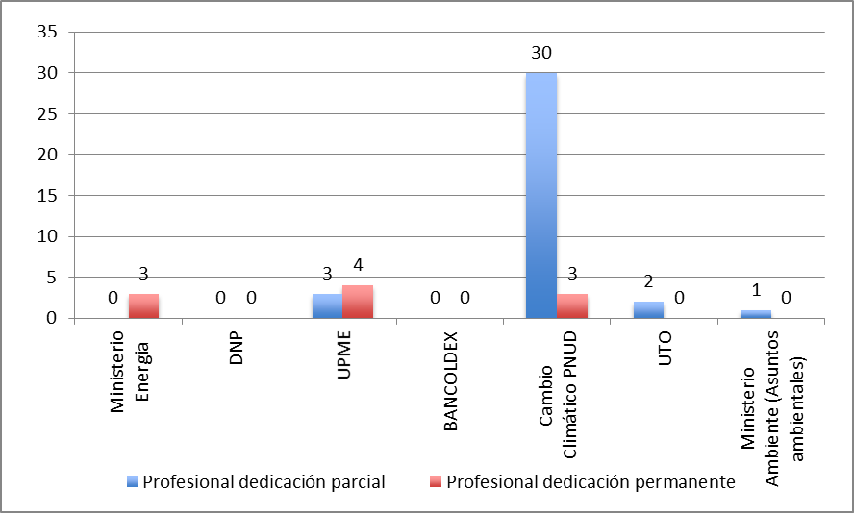

Source: Self-elaborated figure

As can be noted from the graph, the leading institutions have very little staff on energy efficiency issues except for the UNDP, which is an institution not belonging to the Colombian Government.

a.3.) Number of guides and tools available for the execution of EE in buildings:

The Project developed four guides and tools and was responsible for distributing them among public and private institutions:

* The OTU together with ACAIRE developed a technical guide for the replacement of chillers ("technical guide for water coolers - chillers").
* To benefit financial institutions and energy service companies, the document "Proposals on financial schemes applicable to projects on energy efficiency and non-conventional sources of energy" was developed.
* To benefit the MADS and other public and private organizations interested in the topic, the guide called "Methodology for the formulation of a NAMA for existing buildings" was developed with the support of the CAF.
* To enable the implementation of the RETEVIS, a software tool (based on MS Excel) was developed.

**b) The development of policies on energy efficiency:**

b.1.) Degree of execution of policies for energy efficiency:

This is one of the weaker outcomes of the Project, on the grounds that the implementation of policies, through mandatory compliance of new regulations to be issued, is something which the Project and UPME had little control over and depended on the willingness of other institutions involved, such as the Ministry of Housing (the regulation on energy efficiency in homes), the Ministry of Environment (regulation in buildings in general), or the ICONTEC (the regulation of standards in general).

The project was expected to develop and implement specific regulation applicable to buildings, in regard to the following: (i) Provision of energy services to public and private buildings; (ii ) Energy audits; iii) Certification of professionals in energy; (iv) Energy service companies (ESCOs).

In reviewing the achievements of the Project, it was noted that no proposals for this type of regulations were made, with the exception of RETEVIS and contributions made when discussing the Sustainable Construction Code of MVCT and the Environmental Seal for Sustainable Buildings of MADS. However, none has made it to the publication stage (socialization and discussion with all relevant stakeholders) to then continue with the approval phase as a mandatory compliance of regulation.

To execute the campaign of energy audits, terms of reference were developed; they could be the basis for a regulation, but they were not made for that purpose.

It is known that ICONTEC is certifying professionals in ISO 50001. This could not be credited to the Project, but the Project has given support to these training courses. It has also given support to the program OPEN (Market Opportunities for Clean Energy and EE).

b.2.) Number of policies implemented:

No policy or regulation was officially implemented thanks to the support of the Project by the completion date of this report. However, it can be mentioned the contributions made by Project staff to the discussions at CONPES.

**c) Level of execution of Project goals (percentage level of Project achievements according to indicators):**

To analyze the degree of execution of all the indicators of the Project, the indicators shown in the Logical Matrix of Outcomes (Logical Framework) were used. A table, complete with the Outcomes and Outputs, the indicators, the goals, and the progress made up to the date of this report, is presented at Annex 12: Indicators, Goals and Outcomes Achieved by the Project.

The summary of outcomes of the mentioned table is presented below.

**Table 26: Summary of outcomes achieved by the project**

| **Outcome** | **% Progress** | **Rating Effectiveness** |
| --- | --- | --- |
| **1. Government institutions responsible for promoting EE, strengthened** | | |
| 1.1 Establishment of an ad hoc group at UPME | * Assuming 3 persons at full-time employment by the Project and 2 persons from UPME at part-time (50%), a total of 4 people. That is to say 67% in compliance. | Satisfactory (S) |
| 1.2 A national agency (NEEA), with mandate to implement and promote EE programs and policies has been designed, and a law proposal for its incorporation has been submitted. | * Two of the three goals have been achieved. That is to say 67% in compliance. | Somewhat Satisfactory (SS) |
| **2. Policies, regulations, and standards to promote EE in buildings have been developed and implemented** | | |
| 2.1 The PROURE has been strengthened to develop and implement a specific regulation to promote EE in buildings, including: (i) provision of energy services for buildings; (ii ) energy audits; iii) certification of professionals in energy; (iv) energy companies (ESCOs). | * Progress was made in only one of the goals (specific regulation for social interest housing). That is to say 25% in compliance with the goals of this Output. | Unsatisfactory (U) |
| 2.2 Develop national standards for EE in buildings, including energy audits and energy management | * Considering that the Project contributed directly to the development of a national standard and partly or indirectly with the development of other two, that none of them has been agreed upon with the stakeholders and even less legally issued, that no protocol for the implementation of energy audits was generated, and that only one guide for energy efficiency management was developed, 33% is assigned in compliance with the goals of this Output. | Somewhat Unsatisfactory (SU) |
| 2.3 Incentives for investment in EE have been analyzed by UPME as input for the development of policies. | * The document was prepared and is already being used by financial institutions. That is to say 100% in compliance. | Very Satisfactory (VS) |
| **3. Technical knowledge and skills has been enhanced among stakeholders.** | | |
| 3.1 Knowledge on EE among engineers, architects, regulatory officials, suppliers of EE products, and end customers has increased. | * 100% compliance is considered to have been achieved. | Very Satisfactory (VS) |
| 3.2 A technical assistance program for the replacement of inefficient chillers, which also use CFCs, has been implemented. | * 100% compliance is considered to have been achieved. | Very Satisfactory (VS) |
| 3.3 Guides compiled and distributed, analytical tools, and documents of the Project. | * 100% compliance is considered to have been achieved. | Very Satisfactory (VS) |
| **4. Energy savings obtained from the replacement of inefficient chillers** | | |
| 4.1 A selection mechanism has been prepared to request proposals for the replacement of inefficient chillers, including the development of a portfolio for its replication. | * 0% in compliance with the original Outcome 4 is considered to have been achieved.(c) | Very Unsatisfactory (VU) for the Original Outcome |
| 4.2 Confirmed investments for 13 projects of replacement of inefficient chillers with funding from the MLF of the Montreal Protocol | * 0% in compliance with the original Outcome 4 is considered to have been achieved.(c) | Very Unsatisfactory (VU) for the Original Outcome |
| 4.3 The selected projects have been monitored before and after the replacement of the chillers, in order to verify the outcomes achieved by the reduction of GHG emissions. | * Consumption measurements have been performed on nine (9) equipment (some replaced and others to be replaced), and there are estimations of emission reductions if the savings measures recommended are executed. There are ex-ante and ex-post electrical billings for some of the projects. **50% in compliance** is considered to have been achieved. | Somewhat Satisfactory (SS) |
| **5. A monitoring and evaluation plan has been implemented** | | |
| 5.1 A monitoring and evaluation plan has been implemented. | * 90% in compliance (including recent reports to be issued at the conclusion of the Project) is considered to have been achieved. | Very Satisfactory (VS) |
| 5.2 Data collected, prepared, and distributed of the lessons learned | * 50% in compliance to the date is considered to have been achieved, but the feedback on the lessons learned is yet to be given. | It is not rated due to the fact that there are still tasks to be performed. |
| **Overall rating of effectiveness** | | **Somewhat Satisfactory (SS)** |
| **Overall rating of the specific outcomes of the Project** | | **Somewhat Satisfactory (SS)** |

3.3.4 Efficiency

The Efficiency of the Project was analyzed based on the following question:

Effectiveness: Was the project executed in an efficient way in accordance with national and international regulations and standards?

**Table 27: Efficiency**

|  |  |  |  |
| --- | --- | --- | --- |
| **Evaluation Criteria** | **Indicators** | **Sources** | **Methodology** |
| 1. Performance of the Project   (efficiency) | * Execution times as planned * Execution of the budget according to plan * Effective execution of resources to achieve the outcomes of the Project | * Records of follow-up meetings * Reports of the Project * Financial statements of the Project * Management Unit * UNDP - program | * Review of documents * Interviews |
| 1. Execution of Monitoring & Evaluation plan | * Number of follow-up meetings * Number of reports made by the Project and external reports (mid-term evaluation) * Lessons learned and better practices distributed | * Minutes of meetings * Reports | * Review of documents. |

**A) Performance of the Project (efficiency):**

a.1.) Execution times as planned:

The PRODOC was signed on November 3rd, 2009. However, the Project formally began with the Startup Workshop held in June 2010 and the first disbursement of the GEF funds on July 28th, 2010. The original closing date was set for September 30th, 2012. However, it was extended until November 30th, 2013.

In total, the Project was operational for 40 months. The timeframe seems to be reasonable to develop the goals projected, and the extension is actually justified.

a.2.) Execution of the budget according to plan:

According to information provided by the Project Coordinator and endorsed by various accounting documents and records, the Project received the following amounts (the Section of Co-financing is separately given in detail, using the format requested by GEF):

**Table 28: Summary of budget execution**

**Institution**

**Type of**

**Financing**

**Amount**

**Executed**

**US$**

**Percentage**

GEF

Cash

974,674

$

30.94%

UNDP-CO

In kind

150,000

$

4.76%

Government of Colombia (UPME)

Cash and in kind

1,225,623

$

38.91%

OTU-MLF Montreal Protocol

Cash

800,000

$

25.39%

**Total**

**3,150,297**

**$**

100.00%

**Note:** For more details on the contributions made by the various institutions, see section 3.2.4. Financing and co-financing of the Project

According to the accounting records of the Project (mainly the CDR "Combined Delivery Report", which is prepared by UNDP for GEF), the amounts executed per Outcome, with GEF resources, are the following:

**Table 29: GEF Amounts executed per Outcome**

Budgeted

(PRODOC)

US$

Total

2010

2011

2012

2013

Total

R1: Institutional Strengthening

$278,000

$0.00

$47,565.38

$146,522.53

$63,385.75

$257,473.66

92.62%

R2:  Policies and regulations

$250,000

$74,265.47

$19,831.93

$100,169.43

$77,609.00

$271,875.83

108.75%

R3: Development of technical

skills

$235,000

$0.00

$62,860.32

$29,609.06

$145,014.40

$237,483.78

101.06%

R4: Substitution of inefficient

chillers

$55,000

$0.00

$0.00

$14,556.36

$28,583.04

$43,139.40

78.44%

R5:  Monitoring and evaluation &

Management Unit of the Project

$157,000

$18,738.14

$71,111.98

$38,716.06

$36,134.78

$164,700.96

104.91%

Total US$

$975,000

$93,003.61

$201,369.61

$329,573.44

$350,726.97

$974,673.63

99.97%

Outcome

Amount GEF Executed

US$

%

Executed

By the date of preparation of this Final Report, the GEF budget has been executed in a very significant percentage and quite aligned with the original distribution plan referred to in the PRODOC. It should be noted that the execution level would have been very low if an extension term had not been given, especially since the Mid-term Evaluation performed in Oct. 2012 reported only 40% of the GEF budget executed (although 58% of the funds had been committed).

The co-financing funds from the Government of Colombia (UPME) are distributed as follows:

**Table 30: Summary of execution of funds from the Government of Colombia**

Type

Amount

% of

participation

In kind

852,561

$

69.56%

Cash

373,062

$

30.44%

Total

1,225,623

$

**Source:** Self-elaborated table. Figures in US$

a.3.) Effective execution of resources to achieve the Project outcomes:

The Project is very close to executing 100% of GEF resources (US$975,000). By the date of preparation of this report, only US$326 (funds not yet committed) remained. See more details in section 3.2.4. Financing and co-financing of the Project.

The execution levels of other co-financing items that appear in the PRODOC exceed expectations (if the private sector financing that was going to be used for the replacement of chillers is eliminated):

**Table 31: Summary of execution of Project funds**

Source

Amount

PRODOC

Actual Amount

Executed

% of

Execution

GEF

975,000

$

974,674

$

99.97%

UNDP-CO

150,000

$

150,000

$

100.00%

Government of Colombia

965,000

$

1,225,623

$

127.01%

MLF (OTU)

1,000,000

$

800,000

$

80.00%

Private Sector

2,330,000

$

Not Defined

Total without Private Sector

3,090,000

$

3,150,297

$

101.95%

Total with Private Sector

5,420,000

$

3,150,297

$

58.12%

**Source:** Self-elaborated table. Figures in US$

**b) Execution of Monitoring & Evaluation plan:**

b.1.) Number of follow-up meetings:

Follow-up meetings were held throughout the operational period of the Project (data gathered until October 13th, 2013). These are the following:

* 5 Steering Committee meetings, in compliance with the PRODOC. The Steering Committee agreed to meet every six months[15].
* 9 of 13 Quarterly Follow-up meetings projected in the life of the Project

The meetings were held on the following dates:

**Table 32: List of Meetings**

June 28, 2010

January 26, 2011

December 09, 2011

September 07, 2012

January 09, 2013

September 17, 2010

June 01, 2011

October 14, 2011

April 18, 2012

July 06, 2012

October 11, 2012

April 08, 2013

June 28, 2013

October 30, 2013

Steering

Committee

Meetings

Quarterly

Follow-up

Meetings

b.2.) Number of reports made by the Project and external reports (mid-term evaluation):

Follow-up reports made by the PMU and UNDP-CO, as well as the Mid-Term Evaluation were prepared throughout the operational period of the Project (data gathered until October 31st, 2013). They are the following:

* 8 Quarterly Plans (vs. 14 that should have been made)
* 11 Quarterly Progress Reports (QPR) (vs. 14 that should have been made)
* 3 APR/PIR (2011,2012,2013 ) (vs. 3 that should have been made)
* 4 AWP-POA (2010, 2011, 2012, 2013) (vs. 4 that should have been made)
* 3 CDR (reports of executed expenses, 2010, 2011, 2012) (vs. 4 that should have been made; the 2013 CDR is missing,  but according to the Project  Coordinator (who expressed this verbally to the consultants), the report is due until the first quarter of 2014)
* 1 Startup Workshop (together with the first PSC meeting )
* 1 Mid-term Evaluation
* 1 Final Evaluation (in process)

b.3.) Lessons learned and best practices distributed:

There was only one document that formally contains the lessons learned, which is the Mid-Term Evaluation. It is unknown how this document was distributed.

**C) Table of Efficiency ratings:**

**Table 33: Efficiency rating**

|  |  |  |
| --- | --- | --- |
| **Evaluation Criteria** | **Progress** | **Efficiency Rating** |
| **a) Performance of the Project** | | |
| Execution times as planned | * There was a time extension from 31 to 40 months, which is considered to be necessary; although, there were significant delays in the first two years of the Project. | Somewhat Satisfactory (SS) |
| Execution of the budget according to plan | * The GEF budget has been executed in a significant percentage, and quite aligned with the original distribution plan referred to in the PRODOC. | Very Satisfactory (VS) |
| Effective implementation of resources for the achievement of the outcomes of the Project. | * The execution levels of the GEF and co-financing funds are high if eliminating the financing from the private sector. | Satisfactory (S) |
| **B) Implementation of Monitoring & Evaluation Plan** | | |
| Number of follow-up meetings | * 5 Steering Committee meetings and 9 Quarterly Follow-up meetings | Satisfactory (S) |
| Number of reports made by the Project and external reports (mid-term evaluation) | * 32 different types of reports | Very Satisfactory (VS) |
| Lessons learned and best practices distributed | * 1 Mid-term Report with lessons learned | It cannot be rated yet |
| **Overall rating of efficiency** | | **Satisfactory (S)** |

3.3.5 Sustainability

The Sustainability of the Project was analyzed based on the following question:

Sustainability: To what extent are there financial, institutional, socio-economic, or environmental risks to sustain the outcomes of the Project in the long term?

To answer this question, the criteria referred to in the corresponding section of Annex C -Evaluation Questions of the TOR of the FE were considered, as well as the criteria mentioned in the UNDP´s Evaluation Guide for Projects Funded by GEF.

**Table 34: Sustainability**

|  |  |  |  |
| --- | --- | --- | --- |
| **Evaluation Criteria** | **Indicators** | **Sources** | **Methodology** |
| 1. Strengthening of UPME | * Number of people working at UPME on behalf of the Project | * UPME | * Interviews |
| 1. National Energy Efficiency  Agency operational | * Number of tools and guides available for the implementation of energy savings * Number of trained technicians in the country for the implementation of energy savings * Capacity of public agencies to accomplish energy savings through the implementation of energy efficiency measures | * Reports of the Project * Energy efficiency audits | * Review of documents. * Interviews |
| 1. Feasibility of financial sustainability on initiatives in energy efficiency | * Policy document on financial incentives made | * Documents on financial incentives | * Review of documents * Interviews |

**a) Strengthening of UPME:**

a.1.) Number of people working at UPME on behalf of the Project:

This criterion is very similar to that of subparagraph a.1. "Degree of technical skills of institutions related to EE, increased" in section 3.3.3 (Effectiveness and specific outcomes) so the reader can refer to that section. Aside from the staff that is indicated there, it is also important to emphasize the support provided to the Project by two UPME officials, Eng. Olga Victoria Gonzalez and Lic. Omar Baez, both working for the URE Group and Alternative Sources of Energy of the UPME.

**b) National Energy Efficiency Agency operational:**

The criteria established in the guide to assess this aspect do not fit well with "National Energy Efficiency Agency operational". However, the three criteria mentioned above help determine the sustainability of outcomes achieved by the Project.

b.1.) Number of tools and guides available for the implementation of energy savings

It is similar to subparagraph a.3. "Number of guides and tools available for the implementation of EE in buildings" of Output 3.3 found in the Logical Framework, whose compliance was evaluated in section 3.3.3 of this Final Report. The reader can refer to that section, and the same rating assigned to this same criteria in that section is applied.

b.2.) Number of trained technicians in the country to implement energy savings

It is similar to subparagraph a.2. "Number of technicians (architects, engineers, officials) trained in EE in buildings" of Output 3.1 found in the Logical Framework, whose compliance was evaluated in section 3.3.3 of this Final Report. The reader can refer to that section, and the same rating assigned to this same criteria in that section is applied.

b.3.) Capacity of public agencies to execute energy savings through the implementation of energy efficiency measures

The campaign of energy audits executed with both resources of Project #70467 and Project #74760 involved public buildings from national, departmental, and municipal sectors. Within them, there were governmental buildings, from municipalities and autonomous regional corporations. UPME has developed training courses on topics as the program on integral energy management for professionals. The Ministry of Housing has benefited from the proposal of the RETEVIS. ICONTEC and MADS have benefited from the contributions to the Colombian Environmental Seal for Buildings project. The Ministry of Housing has benefited from inputs (for example, the study of energy transmissibility of construction materials) for the formulation of the Sustainable Construction Code. OTU/MADS benefited from the energy audits executed. MADS benefited from the NAMA methodology on the rehabilitation of public buildings in Colombia. The three training sessions executed by the Project included the participation of 85 officials of public agencies.

**c) Feasibility of financial sustainability on initiatives in energy efficiency:**

c.1.) Policy document on financial incentives formulated:

The Project produced the Guide on financial schemes for EE and NCES projects.

**d) Creation of the NEEA through a PPP:**

d.1.) Creation of the NEEA:

Without the creation of a permanent institution dealing with all matters related to energy efficiency in Colombia, with a special emphasis on buildings, it will be difficult for the Project to maintain and be fruitful in many of its achievements; for example, the monitoring of the energy audits done, in order to enable that a good part of the saving measures identified actually follow through, or the monitoring of the consultation process and approval of the RETEVIS, or the management of international funds to give continuity to the main topics addressed by the Project.

The consultants hired with funds from the Project[16] came to the conclusion that the best approach was "To create an agency as the product of a partnership between the State and the private sector, whose mission is the design, development, and implementation of mechanisms and instruments for the quick and effective execution of the energy policy and the priorities established by the MME and CIURE. It is proposed that the new agency be named ACEEDEA (for its abbreviation in Spanish, Colombian Alliance for Energy Efficiency and the Development of Alternative Energies) and that it be established in the frame of context of article 96 of Law Nº 489 of 1998."

The potential partners, both public and private, could be the following:

**Table 35: Potential partners**

|  |  |
| --- | --- |
| **Potential partners in the public sector** | **Potential partners in the private sector** |
| 1. Ministry of Mines and Energy  2. Ministry of Transportation  3. Ministry of Environment and Sustainable Development  4. Ministry of Foreign Trade  5. Ministry of Housing and Territorial Development  6. Ministry of Agriculture  7. National Hydrocarbons Agency  8. National Mining Agency  9. ECOPETROL  10. ISA  11. IPSE: Institute of Planning and Promotion of Energy Solutions for Non-interconnected Zones  12. EEB: Bogota Energy Company  13. EPM  14. TGI: International Gas Transportation  15. FEN: National Energy Financier  16. Bancoldex: Foreign Trade Bank of Colombia | 17. ANDI: National Alliance of Businessmen from Colombia  18. ACOPI: Colombian Association of Small and Medium Industries  19. FENALCO: National Federation of Traders  20. ACOLGEN: Colombian Alliance of Power Generators  21. COLINVERSIONES: Colombian Company Investment  22. ASOCODIS: Colombian Alliance of Distributors of Electrical Energy  23. ANDEG: National Alliance of Generating Companies  24. ANDESCO: National Alliance of Public Utilities and Communication  25. ACIEM: Colombian Alliance of Engineers  26. FEDEPALMA: National Federation of Palm Oil Growers  27. FENDIPETROLEO: National Federation of Distributors of Petroleum Products  28. AGREMGAS: Alliance of Colombian Gas Dealers  29. ACP: Colombian Alliance of Petroleum  30. ACOHIDRÓGENO: Colombian Alliance of Hydrogen and other Clean Energy  31. ACER: Colombian Alliance of Energy  32. Colombian Infrastructure Chamber |

As it was already mentioned in section 3.3.1. Overall Outcomes, the Project has made it possible to complete the whole process prior to the creation of the NEEA, but the execution of the proposal for the creation of the Public-Private Partnership is still pending. The first step to be taken will be signing the Memorandum of Understanding between the MME and ANDI, but that document is still far from becoming a formal agreement that defines roles and financial responsibilities for each of its parties, besides the fact that it only covers activities in the industrial sector. In fact, the strategy of creating a PPP, which is described in the third document prepared by the consultants, goes far beyond that MOU with a guild in particular.

Therefore, signing a MOU with ANDI is a significant step forward, but it is still quite insufficient for the creation of an institution with the characteristics that were defined as part of the Project.

d.2.) Permanent financing for the NEEA:

There are several ideas for achieving financial sustainability of the NEEA once it is established. Income sources suggested in the consultant's study are the following:

* Direct contributions: public or private budget, international cooperation, contributions from members
* International cooperation projects
* Self-generated resources through services provided by the agency
* Taxes specifically from the consumption of energy and/or fuels
* Sales fees on electric power and/or fuels consumption
* Income fees related with obtaining funding for EE financing (between 1% and 5 %)

The products and services to be offered would be the following:

"All of the services provided by ACEEDEA focus on the promotion and execution of energy efficiency (EE), as well as the development of NCES. These services are classified into the following categories: a) Policy Feedback, (b) Promotion and execution of Plans, Programs, and Projects (PP&P), c) Design and development of methodologies, standards, and technical regulation, d) Promotion and development of legal, administrative, financial, and tax instruments and mechanisms to encourage URE and the development of NCES; and e) Access to information systems and dissemination of scientific, technological, commercial, and general information."

It is interesting to note that most of these functions that the agency would be in charge of fall within the scope of the public sector and only a few of them could be offered to the market as paid services. In fact, of all of the studies carried out by the consultants, it was clear that the international experience suggests that most institutions of this type are public-oriented and work with public funds. This is the case of Mexico, Brazil, Peru, USA, United Kingdom, Spain, etc. In the case of Argentina, Germany, and Poland, their agencies operate with mixed funds, and only in the case of Chile they are completely private.

On the other hand, the investment and operating budget calculated by the consultants for the establishment of the NEEEA is considered too high when compared with the amounts invested in the Project during their three years of operation. The consultants estimated that "The operating budget includes costs associated with payroll and administrative expenses. Payroll costs amount to $216,000,000 per month for a total of $2,592,000,000 annually. And the administration costs, which include the office lease, public services, and basic supplies, are estimated at $280,080,000 per year. In total, the annual operating budget adds up to the amount of $2,872,080,000."

This means US$1,512,000 per year at the exchange rate of COL$1,900 per US$. It seems necessary to resize this budget and reduce it to an amount that would allow the agency to start working with a small group of professionals, perhaps no more than five, as the Project operated. This review should be part of the work to be developed after signing the MOU between MME and ANDI.

Some of the ideas expressed by several of the FE interviewees identify the following four strategies to provide funds to the new agency:

* Sale of direct services to the market, such as energy audits and training sessions on energy management.
* Technical assistance agreements for projects developed by private institutions that involve matters on energy efficiency, where the agency may charge a commission; for example, accompanying Bancoldex in the placement and follow-up of the new line of ESCOs  financing for the hotel and hospital sectors.
* Permanent contributions from the Colombian State. This means that one or more public institutions must budget for that expense, unless the agency can be created by Law and given a permanent budget (this is a process which is being avoided due to its cumbersome nature).
* International cooperation donations. Considering that climate change programs are of high priority for the international cooperation, it is feasible to continue getting more international funds with the support of the Government (UPME/MME), but of course only for the first years of operation, partial funding or funds related to the execution of specific projects.

In any case, it seems obvious that the financial sustainability of the agency is unlikely unless public funds are obtained to cover much of its costs. This, for now, does not appear to be achieved.

**e) Table of Sustainability ratings:**

**Table 36: Criteria, Analysis, and Rating for Sustainability**

|  |  |
| --- | --- |
| **Criterion** | **Analysis** |
| **Financial Risks:** Are there any financial risks that could jeopardize the sustainability of the Outcomes of the Project?  What is the probability of lack of financial access and economic resources once GEF assistance ends? | The goal in terms of the number of people working at UPME on EE issues is complied with, and also the Number of tools and guides for the implementation of energy savings and the Number of trained technicians and training sessions for public agencies on energy saving issues. These actions benefit the sustainability of many Outcomes of the Project.  However, the probability of the NEEA not being created, as it was planned in the design studies (Public-Private Partnership), is quite high. It must be considered that the MOU that is expected to be signed between the MME and ANDI is very preliminary and partially attainable (in comparison with achieving what the NEEA requires). Also, the budgets projected in the design studies are very ambitious/high and a solid and permanent source of funding is not yet in sight. There is also a document of financial mechanisms established. |
| **Rating of Sust. by FR:** | **Somewhat Likely (SL)** |
| **Socio-economic risks:** Are there any social or political risks that could threaten the sustainability of the Outcomes of the Project?  What is the risk, for instance, of the priority level of the stakeholders being insufficient to allow the Outcomes/Benefits to be sustained? Do the stakeholders see that it is in their best interest that the benefits of the Project continue to flow? Is there enough support on behalf of the key stakeholders for the long-term goals of the Project? | UPME remains as a key stakeholder, and now more interested than ever, in EE and clean energies issues. In the last few years, this institution has managed to consolidate several projects in this issue, supported by the international cooperation (EEE, labels, NCES) and has achieved the inclusion of an amount of US$50 million for these purposes within a US$150 million loan that the Government of Colombia obtained from the Clean Technology Fund.  However, there are still political risks that threaten the sustainability of the Outcomes of the Project, especially because of the fact that there is not yet a strong decision made by the high-levels of the Government beyond the UPME to consolidate a strong NEEA with permanent financing. The letter of intent between MME and ANDI is a first step, but insufficient.  There does not seem to be socio-economic risks that threaten the sustainability of the Project. On the contrary, the current economic situation that the country is experiencing is very good: 4.0 % of GDP growth during the 2012 (one of the highest in Latin America), similar to what is expected for 2013; a rating of "investment grade"; strong inflows of direct foreign investment; low inflation 2.8 % in 2012; a record budget of public investment for 2013; and new FTAs with the United States and Europe. |
| **Rating of Sust. by SER:** | **Somewhat Likely (SL)** |
| **Institutional Framework and Governance risks:** Do the legal, structural, governmental processes, and political frameworks (which operate within the Project), represent a risk that could jeopardize the sustainability of the benefits of the Project? Are the systems necessary for accountability and transparency and the required technical knowledge established? | The Colombian institutional framework on EE matters was already defined before the Project began to operate (The EE Law and PROURE). The Project has generated some regulatory proposals: Proposal of RETEVIS and contributions to the proposals for the Green Seal of MADS and the Sustainable Construction Code of MVCT.  However, it cannot be confirmed that the political and institutional barriers that existed at the beginning of the Project (which justified Outcomes 1 and 2 of the Project) have been eliminated or sufficiently mitigated up to the date of conclusion of the Project. |
| **Rating of Sust. by IFGR:** | **Somewhat Likely (SL)** |
| **Environmental risks:** Are there currently activities that could be an environmental threat to the sustainability of the Outcomes of the Project? | There are no environmental threats that endanger the sustainability of the Project. |
| **Qualification of Sost. by ER:** | **Likely (L)** |
| **Sustainability Rating** | **Somewhat Likely (SL)** |

3.3.6 National Involvement

**Environment in which the Project is designed and implemented:**

* The Project concept (as stated in the PRODOC) has its origin in the need expressed in the National Program for the Rational and Efficient Use of Energy and Renewable Energies (PROURE, 2010-2015) and the Law for the Promotion of Energy Efficiency and Renewable Energy. The Law requires that the State: (i) Establish economic, legal, technical, and financial conditions, including financial incentives, (ii) promote projects of EE and RE, iii) promote research in EE, and iv) develop strategies to raise awareness among citizens in relation to EE. Specifically, it proposes the establishment of an institution focused on promoting EE in Colombia. In addition, Decree 2501 (2007) requested two ministries (MME and Ministry of Housing) to develop a regulation that would promote EE in social interest houses.
* High-level Government officials (the Minister of MME and the Director of UPME) have integrated the Project Steering Committee (PSC for its abbreviation in Spanish). In the execution of the Project, staffs from this Ministry and from the Ministry of Environment have participated; and in the PSC, officials from the Ozone Technical Unit, belonging to MADS, were also involved.
* The Government of Colombia agreed and made significant financial contributions to the Project, both in cash and in kind, to finance operating expenses (staff payroll) and pay for relevant activities of the Project (e.g. energy audits). In addition, activities of Project 70467 (EE in buildings) were joined to activities of Project 74760 (replacement of chillers).
* During the past few years, UPME has been very actively raising cooperation funds for EE programs: Aside from the funds obtained from the international cooperation for Project 70467 (US$975,000 from GEF) and Project 74760 (US$1,000,000 from the MLF of the Ozone Montreal Protocol Implementation), US$2.5 million was also obtained for a project on labeling of equipment (to display energy consumption characteristics in electric equipment), US$1.5 million for non-conventional sources of energy, and a US$150 million loan from the Clean Development Fund (CDF) for the Colombian State, which will use US$50 million for EE projects in the SME, residential, and small business sectors.

**Implications of the Project at a national level:**

This Project has implications at a national level, starting from the reduction of economic, regulatory, technical, and financial barriers for EE adoption; generating projects such as the following:

* **Regulations and Policies (R&P):**

Project Nº 70467 introduces concepts of energy efficiency and emission reduction (ODS[17] and GHG[18]), not contemplated before, in the process of design, construction, and management of buildings in the national market through the following mechanisms and strategies:

* Designing of a model for a National Energy Efficiency Agency in Colombia
* Designing and development of a proposal for the Technical Regulation of Social Interest Housing (RETEVIS)
* Intervention and support for the creation of green seals and codes of sustainable construction
* **Reimbursable and non-reimbursable financing funds for energy efficiency projects (F):**

Looking for the development of energy efficiency nationwide, Project Nº 70467 encouraged the national and international banking sector to design and support investment portfolios in this field.

* Repayable credit line for more than US$ 50 million dollars made available from the Clean Technology Fund for Energy Efficiency projects in Colombia
* Incorporation of credit lines from Bancoldex for the development of Energy Efficiency projects
* **Models for emissions reduction (MER):**

Reliable and verifiable models on bioclimatic designs are being developed in Colombia for social interest housing with the implementation of the RETEVIS regulation:

* Definition and incorporation of Energy Efficiency concepts in the design of adaptation measures, Adaptive Bioclimatic House in the San Andres archipelago
* Support Agreement with Project Nº 74760 Replacement of Chillers in Colombia
* Energy audits (31): the audits took place in different cities across the country, in representative large buildings
* Provision of inputs to the Ministry of Environment for the creation of NAMAs (specifically, through the design of a methodology for the creation of a NAMA for EE in existing buildings)
* **Inquiries about the most representative incidence of the Project at national level**

Within the process of this Final Evaluation, several key stakeholders were asked for their opinion about which were the main Project achievements. Their answers, grouped according to the aspects mentioned above, were the following:

**Table 37: Inquiries about the Project incidence at a national level**

|  |  |  |  |  |  |  |  |  |  |
| --- | --- | --- | --- | --- | --- | --- | --- | --- | --- |
|  | Ministry Energy | DNF | UPME | UPME | BANCOLDEX | Climate Change UNDP | OTU | Ministry Environment (Environmental issues) | Conclusions  (% in relevant items) |
| P1 | Regulations and policies: Proposal and Design  RETEVIS and NEEA | Regulations and policies: Creation of CONPES on sustainable construction | Regulations and policies: Proposal and Design RETEVIS and NEEA | Financing EE projects | Financing: Credit line for Energy Efficiency projects | Models of emission reductions: San Andres house, RETEVIS model | Models of emission reductions: substitution of coolers and chillers project | Regulations Project substitution of streetlight bulbs |  |
| R&P | R&P | R&P | R&P |  |  |  |  |  | 37.5% |
| F |  |  |  | F | F |  |  |  | 25.0% |
| MRE |  |  |  |  |  | MRE | MRE |  | 25.0% |
| R |  |  |  |  |  |  |  | R | 12.5% |

**Figure 4: Project incidence at a national level**

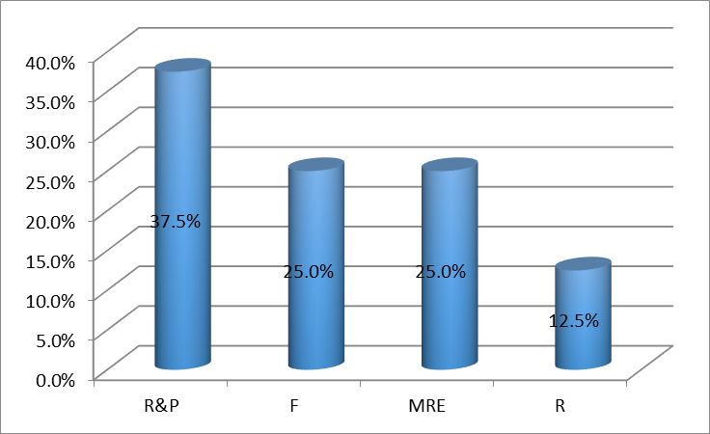

Source: Self-elaborated figure

|  |  |
| --- | --- |
| R&P  F  MRE  R | Regulations and Policies  Financing EE projects  Models on Emissions Reduction  Regulations |

3.3.7 Integration

The integration of the Project with the environmental and energy strategy of UNDP Colombia, with activities referred to in UNDAF-Colombia 2012-2014, and with GEF programs, has already been analyzed in subparagraphs (b) and (c) of Section 3.3.2 Relevance.

Other aspects of this Project funded by GEF, which reinforce the goals of UNDP in Colombia, are the following:

* Poverty reduction: Through the development of the RETEVIS proposal (regulation for EE in social interest housing), the comfort of that type of housing at the least energy cost is encouraged.
* Improving governance: The Project has created capabilities and institutional strengthening, particularly at UPME, and it is expected to be able to integrate staff into the future NEEA. In addition, it has contributed in the creation of several drafts of regulations referring to EE in Colombia.
* Prevention of natural disasters: The Project contributes to the mitigation of climate change, particularly through the creation of an enabling environment to promote energy efficiency.
* Gender Balance: The different activities of the Project were developed with a balance of gender participation (PMU, support staff from UPME, training sessions, recruitment of consultants, etc.). According to information contained in the 2013 PIR (page 26), women represented 36% of participants in the training events executed by the Project, and two-thirds of the consultancies financed with funds from the Project had at least a woman on the consultant team.

3.3.8 Impact

The Impact of the Project was analyzed based on the following question:

Impact: Are there any indications that the Project has contributed to reducing environmental stress or improving the ecological status or that it has allowed to progress toward these outcomes?

**Table 38: Impact**

|  |  |  |  |
| --- | --- | --- | --- |
| **Evaluation Criteria** | **Indicators** | **Sources** | **Methodology** |
| 1. Reduction of greenhouse gas emissions from the buildings sector in Colombia based on this project | * Tons of CO2 emissions avoided directly (projected) * Tons of CO2 emissions avoided indirectly (projected) | * Reports of the Project * Audit Reports on energy efficiency in public buildings | * Review of documents * Interviews |
| 1. Promotion of energy efficiency in buildings by eliminating the identified barriers (institutional, legal, regulatory, and on technical skills) | * Change in market transformation * Change in approval of policies * Energy saved (MWh) * Direct Investment (USD) * Number of lending institutions | * Reports of the Project * Audits * Market analysis | * Review of documents * Revision of market information * Interviews |
| 1. Standards developed on energy efficiency | * Number of training sessions * Number of materials for EE discussions and training sessions | * Reports of the Project * Published documents | * Review of documents * Interviews |
| 1. Technical strengthening on the replacement of chillers | * Technical assistance program for the replacement of chillers implemented * Guides/technical guidelines for the replacement of chillers published and distributed | * Reports of the Project * Published documents | * Review of documents * Interviews |

**a) Reduction of greenhouse gas emissions from the buildings sector in Colombia based on this Project:**

Outcome 4 of the Project, the replacement of 13 large, inefficient, CFC-based chillers, could not be implemented because of a series of reasons already analyzed. This Outcome had the following goals projected for the reduction of emissions:

* Direct emissions avoided: 62,000 Ton CO2
* Indirect emissions avoided due to replication of projects: 124,400 Ton CO2; and due to market transformation: 150.000 Ton CO2

Given that Outcome 4 was replaced by a campaign of 31 energy audits in large buildings, and in order to compare with this modified Outcome 4, the potential for reduced emissions steaming from the savings measures identified in the audits (if there are finally implemented) was calculated.

If the implementation of savings measures identified in the 31 energy audits (Outcome 4 modified) is carried out, the emissions for a total of 104,727 Tons CO2 would be prevented over the lifetime of the measures (20 years, which really means 13.4 effective years, considering a change of 33% in the Baseline).

**Table 39: GHG emissions that would be avoided if the savings measures identified in the audits (Outcome 4 modified) were executed**

|  |  |
| --- | --- |
| **Audit #** | **Ton CO2/year avoided** |
| **Total 11 audits** | **1,261.00** |
| **Average per audit** | **114.64** |
| **Total 31 audits** | **3,553.84** |
| **20-year potential** | **71,076.80** |
| **13.4-year potential** | **47,620.00** |
| **Marginal EF adjustment** | **104,727.00** |

**b) Promotion of energy efficiency in buildings by eliminating the identified barriers (institutional, legal, regulatory, and technical capacities):**

* Change in market transformation
* Change in approval of policies
* Energy saved (MWh)
* Direct Investment (USD)
* Number of lending institutions

The effect of the Project in the previous parameters was discussed in section 3.3.1. (Overall outcomes). The respective rating is shown in the table below.

**c) Standards developed on energy efficiency:**

The two criteria mentioned in the TOR to measure this variable do not relate to the variable "Standards developed on EE", but rather to the development of technical skills. Surely, confusion between Outcome 2 and Outcome 3 was present.

The progress made on standards and regulations was already analyzed in section 3.3.3. (Effectiveness and specific outcomes), considering the progress made in Outputs 2.1 and 2.2 of the Logical Framework. The rating of the Impact criterion is shown in the table below.

Regarding the number of training sessions, three events were organized under the Project, and the staff of the PMU participated as speakers in multiple activities organized by other institutions.

Regarding the number of materials for EE discussions and training sessions, the three main documents produced were: The guide on chillers replacement, the guide on financial mechanisms for EE projects, and the guide for the formulation of a NAMA for existing buildings. The rating of the Impact criterion is shown in the table below.

**d) Technical strengthening on the replacement of chillers:**

31 audits were done, and at least 9 of them were done in buildings that had chillers to be replaced or chillers already replaced. The initial goal was to do the audits in 13 chillers.

A guide was prepared for the replacement of chillers, which was distributed directly by the Project in four cities of the country and at a national level by ACAIRE.

**e) Table of Impact ratings:**

**Table 40: Impact Rating**

| **Indicator** | **Achieved** | **Impact Rating** |
| --- | --- | --- |
| **a) Reduction of greenhouse gas emissions from the buildings sector in Colombia based on this project:** | | Minimum (M) |
| Reduction of emissions (Ton CO2) | 0 (zero) Ton CO2 reduced. However, the potential for reductions, if all the savings measures identified in the energy audits were executed, would be of 104,727 Ton CO2 (vs. 60,000 Ton CO2 that would be accomplished from the replacement of 13 chillers). |
| **b)** **Promotion of energy efficiency in buildings by eliminating the identified barriers (institutional, legal, regulatory, and technical skills):** | | Minimum (M) |
| (1) Market transformation (scale 1 ...4) | (1) Market Transformation: 2.33 of a goal of 4 |
| (2) Approval of policies (scale 1 ...4) | (2) Approval of policies: 2 of a goal of 4 |
| (3) Energy saved: (MWh) | (3) Energy saved: 0 MWh of a goal of 88,600 MWh |
| (4) Investment (US$) | (4) Investment: US$ 0 of a goal of US$ 3.2M |
| (5) Number of lending institutions | Not Evaluated |
| **c) Standards developed on energy efficiency:** | | Minimum (M) |
| Development and implementation of specific regulations to promote EE in buildings, regarding: (i) provision of energy services for buildings; (ii) energy audits; iii) certification of professionals on energy; (iv) Energy companies (ESCOs) | Progress was made in only one of the goals (specific regulations for social interest housing, RETEVIS). It means **25% of compliance** with the goals of this Output. |
| Development of national standards for EE in buildings, including energy audits and energy management | * Considering that the Project contributed directly to the development of a national standard and partly or indirectly with the development of other two, that none of them has been agreed upon with the affected stakeholders and even less legally issued, that no protocol for the implementation of energy audits was generated, and that only one guide for energy efficiency management was developed, 33% is assigned in compliance with the goals of this Output. |
| Trainings Sessions (Workshops) | * Number of training sessions: 3 events * Number of material on EE discussions and training: 3 main documents |
| **d) Technical strengthening on the replacement of chillers:** | | Significant (S) |
| Technical assistance program for the chillers replacement implemented | 31 audits were done, and at least 9 were done in buildings that had chillers to be replaced or chillers already replaced. The initial goal was to do the audits in 13 chillers. |
| Guides/technical guidelines for the replacement of chillers published and distributed | A guide was prepared for the replacement of chillers, which was distributed directly by the Project in 4 cities of the country and at the national by ACAIRE. |
| **Impact Rating** | | **Minimum (M)** |

# 4. Conclusions, recommendations, and lessons learned

## 4.1. Overall Conclusions

Project Nº 70460 contributed towards institutional strengthening on issues regarding energy efficiency in buildings (especially at UPME), the development of new regulations (at least at the level of well-founded proposals), and the development of skills and knowledge on this topic among market stakeholders.

The Project was properly aligned with the corresponding national strategies and with the current strategies of UNDP and GEF.

At the national level, the Project responds to what is contemplated in Law 697/2001, October 3rd, 2001, called "Law for the Promotion of Energy Efficiency and Renewable Energy" and in the "Program for Rational and Efficient Use of Energy and Renewable Energies" (PROURE) .The overall goal of PROURE is "To Promote the Rational and Efficient Use of Energy and other Forms of Non-Conventional Energy, which contributes to ensuring the energy supply fully and timely, the competitiveness of the Colombian economy, consumer protection, and the promotion of the use of non-conventional energies in a sustainable manner with the environment and natural resources."   Project Nº 70467 especially contributed to the strategic subprograms SPE_1 (Institutional strengthening), SPE_2 (Education and skill-building), and SPE_3 (Financial strategy and market promotion) of PROURE.

The  Project contributes to the implementation of the Thematic Area "A: Overcoming poverty , Millennium development goals, and sustainable development" mentioned in the Project Document of the Colombia Program (2008-2012), DP/DCP/COL/ 1 and the "Direct Effect" of the 2012-2014 UNDAF Matrix called "2.4. National and territorial skills strengthened for mitigation and adaptation to climate change." In addition, the Project responds to the strategic goals of the GEF Focal Area of Climate Change and the goals of the Strategic Program CC-SP1: Promotion of Energy Efficiency in Residential and Commercial Buildings.

The main objective of the Project was to eliminate barriers and create enabling conditions, not so much to reduce direct emissions. Even though the execution of a pilot project that would combine the reduction of GHG and ODS (replacing large chillers) was planned, the change in the baseline of that goal prevented it from being achieved. This, however, was not a negative for the country because the replacement of many inefficient, CFC-based chillers actually was accomplished due to the initiative of the chiller owners themselves, without the intervention of the Project. However, documenting how the replacement took place was insufficient, even using a posteriori and approximate basis.

Despite the fact that many of the barriers identified at the beginning of the Project still persist, the contribution made by the Project to mitigate them is undeniable. The actions taken, which are still pending, have a clear strategy to continue, only if UPME assume them as theirs and achieve political support internally from MME and externally from other institutions, such as MVCT, MADS and ICONTEC.

Main achievements of the Project were the following: Research and definition of a proposal for the creation of the National Energy Efficiency Agency (NEEA), the preparation of a proposal for the RETEVIS (Technical Regulations for Energy Efficiency in Social Interest Housing), the study on the energy characteristics of construction materials, the guide for the replacement and selection of coolers (chillers), contributions to the definition of the Colombian Environmental Seal for Sustainable Buildings promoted by MADS and the Sustainable Construction Code promoted by MVCT, the formulation of financing schemes for EE and NCES projects and technical assistance to Bancoldex for the design of financial products targeting this market, the support of the activities under the Tripartite Agreement Mexico-Colombia-Germany, training sessions (events), and the campaign of energy audits in large buildings (especially public buildings).

If the implementation of the savings measures identified in the 31 energy audits was accomplished, a total of 154,500 MWh would be reduced and a total of 104,727 Tons CO2 emissions would be avoided over the lifetime of the measures (20 years, which really means 13.4 effective years considering a change of 33% in the Baseline) when using a marginal emission factor- EF (gas and coal), because of the effect of good practices, changes in technology, and architectural measures. If the average EF is used, the reduction of emissions would be 47,620 Tons CO2. The execution of this impact should be monitored and supported by UPME during the years following the conclusion of the Project.

The general Table of Ratings on the performance of the Project, based on all the justifications presented in Chapter 3. Outcomes and findings of the evaluation, appears below:

|  |  |  |  |
| --- | --- | --- | --- |
| **Ratings of Performance of the Project** | | | |
| **1. Monitoring and Evaluation** | **Rating** | **2. Implementation of the IA and the EA** | **Rating** |
| Design of entry M&E | Satisfactory  (S) | Quality of implementation of the implementing agency | Satisfactory  (S) |
| Implementation of the M&E plan | Satisfactory  (S) | Quality of execution of the executing agency | Satisfactory  (S) |
| **Overall quality of M&E** | Satisfactory  (S) | **Overall quality of implementation and execution** | Satisfactory  (S) |
| **3. Evaluation of outcomes** | **Rating** | **4. Sustainability** | **Rating** |
| Relevance | Relevant  (R) | Financial resources | Somewhat Likely  (SL) |
| Effectiveness | Somewhat  Likely  (SL) | Socio-political | Somewhat Likely  (SL) |
| Efficiency | Satisfactory  (S) | Institutional framework and governance | Somewhat Likely  (SL) |
| Impact | Minimum (M) | Environmental | Likely  (L) |
| **Overall rating of the outcomes** | Somewhat  Likely  (SL) | **Overall probability of sustainability** | Somewhat Likely  (SL) |

## 4.2. Corrective measures for the design, execution, monitoring, and evaluation of the Project

### 4.2.1. Corrective measures for the design of the Project:

In section 3.1.1 the design of the PRODOC and the Logical Framework of Outcomes was analyzed. Within the measures that may be recommended for similar projects in the future, starting from the weaknesses found in the original elaboration of the current project, are the following:

* Add intermediate milestones with deadlines to the Logical Framework; for example, for the outputs related to the creation of the NEEA and the ones related to the emission of regulations, it would be advisable to separate them into two phases: One for the previous studies and elaboration of proposals, and another one for discussions and execution of the proposals. It means to separate the goal in two phases: one for preparation and design, and another one for consultation and execution, with their corresponding deadlines.
* Add mitigation actions that would allow the Project to accomplish a similar desired outcome or a partial outcome in case that, for any reasons, the original action could not be executed at all. This could have been useful to fix the problem on the lack of political support for the creation of the NEEA or the change of baseline for Outcome 4 (replacement of chillers).
* To obtain tangible outcomes on the issue of reduction of GHG emissions (fundamental goal of projects financed by GEF), it is necessary to avoid the complete dependence of the Project on other institutions different from the executing agency (UPME vs OTU, replacement of chillers outcome). This in spite of the fact that the main goal of the Project was to eliminate barriers and create enabling conditions, not so much to reduce direct emissions.
* Avoid the establishment of goals based on outdated information (the inventory of chillers that was used to design Outcome 4 was almost five years old when the PRODOC was made).
* In designing proposals to stimulate the market, confirm that a balance between the development of rules and regulations, on one hand, and the introduction of economic and financial incentives on the other hand, really exists. Otherwise, there is a risk of loading regulations on the supply side agents (in this case, suppliers of EE goods and services) without actually stimulating the market.
* For projects like this, seeking to have influence on more general issues (adoption of energy efficiency measures in buildings), placing too much emphasis on a single technology (chillers) is not advisable. The opportunity to achieve progress in other technologies was missed out, such as in the bioclimatic design and improvement of the thermal envelope, and other air-conditioning technologies (e.g., mini splits for residential use), efficient lighting, etc. However, this was a defect in the design of the PRODOC, that the Administration of the Project then sought to correct during the Project execution. For example, the methodology of the RETEVIS uses bioclimatic and alternative materials criteria; the energy audits and the validation exercises done on the San Andres Islands and Soacha also contemplate these aspects.

### 4.2.2. Corrective measures for the implementation of the Project:

Within the improvements that could have been applied during the execution of the Project, they are the following:

* Faster situational analysis at the start of the Project, making it possible to identify changes in the baseline and assumptions of PRODOC, and then making alternative proposals and present them for approval by the PSC (the case of the chillers replacement project).
* The incorporation of a consultant or adviser on political issues and interministry affairs, and having him/her give support to UPME in the process of convincing the other ministries and public agencies (case in point is the establishment of the NEEA and the adoption of new standards and regulations). Even at the internal level within the MME (UPME belongs to it), the process of convincing on the strategy for the NEEA (the PPP) required several meetings of justifying and convincing the Vice-Minister and the Minister respectively.
* Even when the PRODOC did not establish milestones and intermediate deadlines, they could be placed in the Project work plan (AOPs), identifying those activities that required to be divided into two main phases, Formulation and Implementation, with balanced deadlines appropriate for the total term of the Project (as in the case of the replacement of chillers, the creation of the NEEA, and the adoption of new standards and regulations).
* The Mid-Term Evaluation report and the interviews done to the PMU officials pointed out that some Project activities were delayed more than expected due to the slowness of the process and paperwork required by the implementing agency. In the last year of operation, after the MTE, processes became more agile.

### 4.2.3. Corrective measures for monitoring and evaluation of the Project:

Within the improvements that could have been applied for the monitoring and evaluation of the Project, the following could be mentioned:

* Even when 50% of execution of the Project budget had not been reached, it was preferable that the Mid-Term Evaluation be executed sooner, precisely because the low execution level could be a signal of the need to make changes to the Project. According to information received by the evaluators, the process was delayed due to a lack of qualified candidates to perform this MTE.
* The mechanisms of knowledge management still need to be executed to collect the experience gained by staff members who were in charge of the Project, as input to improve the State's policies concerning EE in buildings, and the design of incentives for the market stakeholders.

## 4.3. Actions to follow-up or reinforce the initial benefits of the Project

Within the recommended measures to follow or reinforce the initial benefits of the Project, the following can be mentioned:

* Six years passed since the need was identified in the PIF, and the country still suffers from not having an institution especially devoted to EE matters. Therefore, it is necessary to ensure the appropriate institutional and financial support for the creation of a strong, general-oriented agency (NEEA); starting with the MOU between the MME and ANDI, but looking for the early induction of other public and private stakeholders, as anticipated in the design proposed for the PPP.
* Confirming the reduction of GHG emissions that would be accomplished if the energy-saving measures referred to in the energy audits were actually implemented. This implies a follow-up process, for which the UPME would be responsible of (as a result of the process of strengthening of the institution), to find out what building owners (almost all governmental) will carry out the measures, which of these measures are being implemented, and what was the impact on the reduction of energy consumption. The latter would allow estimating the reduction of emissions once the energy bills prior to the change are compared with the new ones.
* Ensuring the beginning of the process of discussion, consultation, and final approval of the RETEVIS as a mandatory regulation in Colombia, which needs to be a jointly effort between MVCT and UPME/MME.
* Submitting the final outcomes of the Project at a meeting of the CIURE (it is intended to revive it during 2014), and look for the support of that instance to follow up on the activities that were pending, such as the creation of the NEEA and the consultation and approval of the new regulations (especially, the RETEVIS).
* Seeking to recruit a consultant with experience in political issues and interministry affairs, and having him/her give support to the UPME in the process of convincing the other ministries and public agencies that must assume themselves, as their own, many of the goals that the project left pending (for example, the creation of the NEEA and the adoption of regulations).
* Seeking a closer connection with Bancoldex by taking advantage of the launch of the new line of US$50 million that the bank has contemplated for early 2014, to address the financing of EE projects in the hotel and hospital sectors, as well as support for ESCO-type companies.
* Follow up (UPME accompanying MVCT) of the activities of the Tripartite Agreement (Mexico-Colombia-Germany), especially for the creation of a mechanism of green mortgages for the residential sector, similar to what exists in Mexico, and for the designing of a new program for EE in buildings, which is part of the scope of the agreement.
* Through established international conventions, it is recommended that training programs and professional exchanges are sought to ensure not to repeat mistakes in the incorporation of a policy of energy efficiency in the country.
* If a new project on EE in buildings is executed, it is necessary to try to give the private sector greater participation, given that  Project N° 70467 focused mainly on the public and residential sector, and very little in the private, industrial, and commercial sector. For example, almost all of the energy audits were conducted in public buildings. This pilot project should have the following goals: To validate the guides, technical materials, and proposals for regulations that were produced by the Project, as well as confirm the feasibility of new ESCO-type financing mechanisms. It could be structured with Bancoldex, as part of the placement of their new credit line for hotels and hospitals. According to information provided by the Project Coordinator, UPME has already submitted a continuation proposal to the Focal Point of GEF in Colombia (MADS), under the framework of the "GEF 5" window, which considers some of these matters.
* It is important and essential in the incorporation of EE policies for buildings in Colombia, to establish cooperative agreements with the construction and design industries by showing them the important economic, commercial, and environmental benefits of implementing sustainable and bioclimatic strategies in their projects, which are derived from the outcomes of the Project.
* Conduct training workshops for companies and suppliers of materials to show the economic and commercial benefits of promoting eco-friendly materials lines.
* Continue with the idea of establishing a procedure for certification of professional EE specialists, but by coordinating it and being led by the respective professional associations.
* Making agreements with universities and the Ministry of Education to promote training sessions and engage concepts and energy efficiency topics in their study programs.
* The Project did not propose much to implement financial-economic incentives to stimulate the EE market in buildings, only the formulation of a document of possible incentives, as an input for UPME to define policies. It is now necessary that UPME continues defining what new policies for EE in buildings will pursue, particularly those for public buildings.
* The Project should define, among its goals, standards for the implementation of energy audits. In practice, what the Project defined were Reference Terms for the implementation of the energy audits campaign, which should be turned into a "Protocol for the implementation of energy audits in public buildings of Colombia".
* A restructuring of UPME is expected for late 2013 or early 2014. It is recommended that, as part of that process, a staff group is set to continue working on issues related to EE in buildings; it should incorporate the monitoring of the outcomes of Project N°70467 and the continuation of the pending activities in their work plans for 2014.

## 4.4. Proposals for future guidelines which emphasize the main goals

The Main Objective of Project N° 70467 was "To promote energy efficiency in buildings by eliminating institutional, legal, and regulatory barriers, as well as technical skills, which currently limit their large-scale adoption."

It is considered that, even though the Project meant significant progress towards those goals, barriers still exist and there is a lot pending to mitigate them. The recommended actions in the previous section present concrete proposals to further mitigate them.

## 

## 4.5. The best and worst practices to address issues related to relevance, performance, and success

Some of the good practices that were used in the Project include the following:

* The frequent and regular procedures of Monitoring and Evaluation
* Choosing the correct execution agency
* The alignment of the Project with the current national programs and the priorities of UNDP and GEF (relevance).

Some of the worst practices that were used in the Project include the following:

* Not placing intermediate milestones to achieve the goals, with deadlines defined within the total term of the Project
* Placing goals which depended primarily on other institutions, different from the executing agency. Those institutions should have participated in the PSC or through another form of commitment.
* Having waited too long before deciding to change an Outcome or Output that did not seem feasible to achieve or that had lost its relevance
* Lack of a better planning for activities requiring long time to be executed.

# Annexes

## Annex 1: Terms of Reference

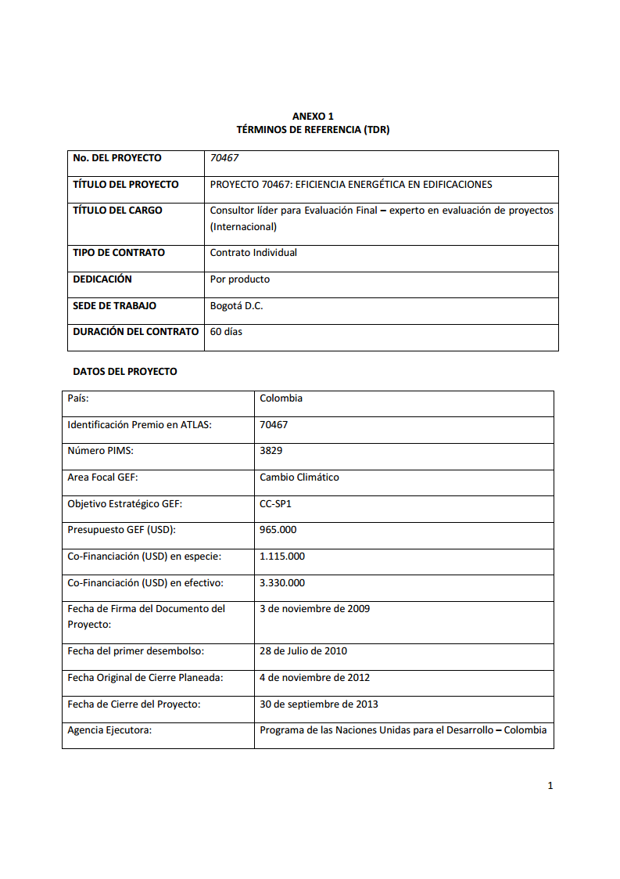

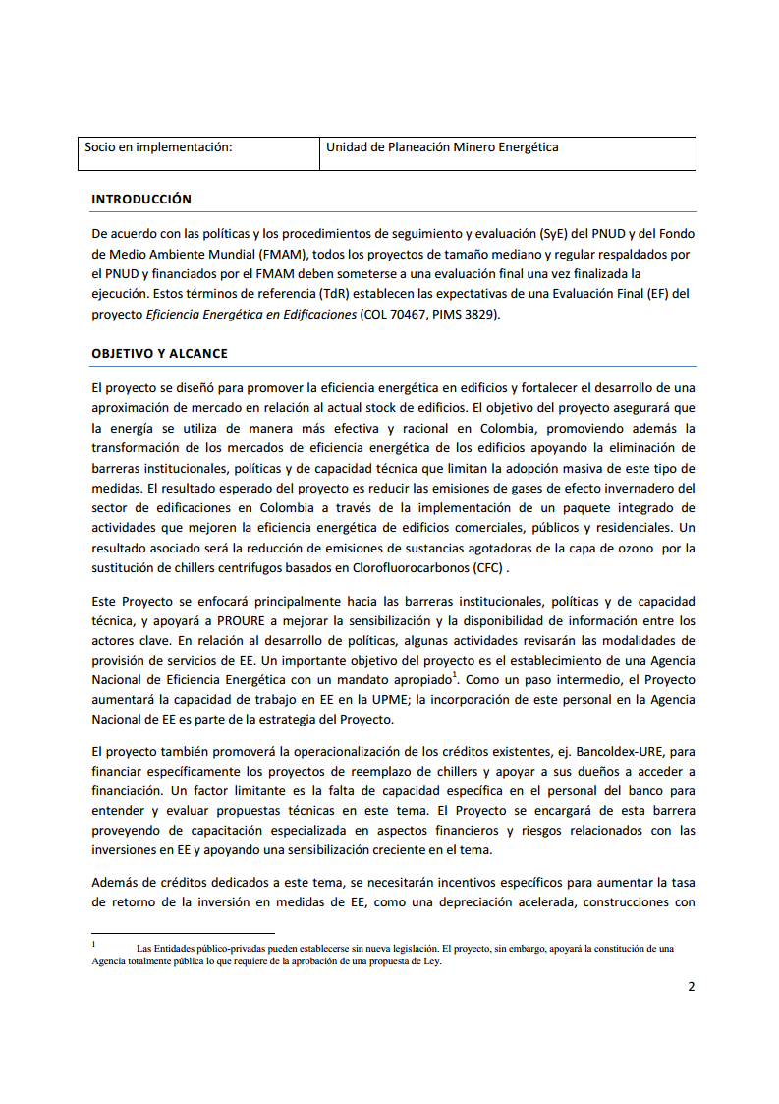

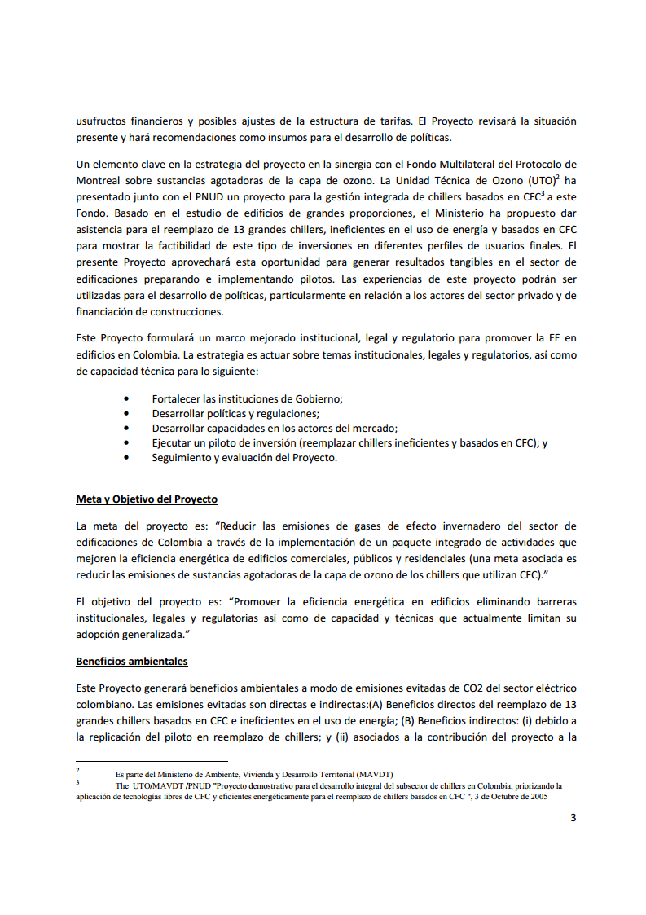

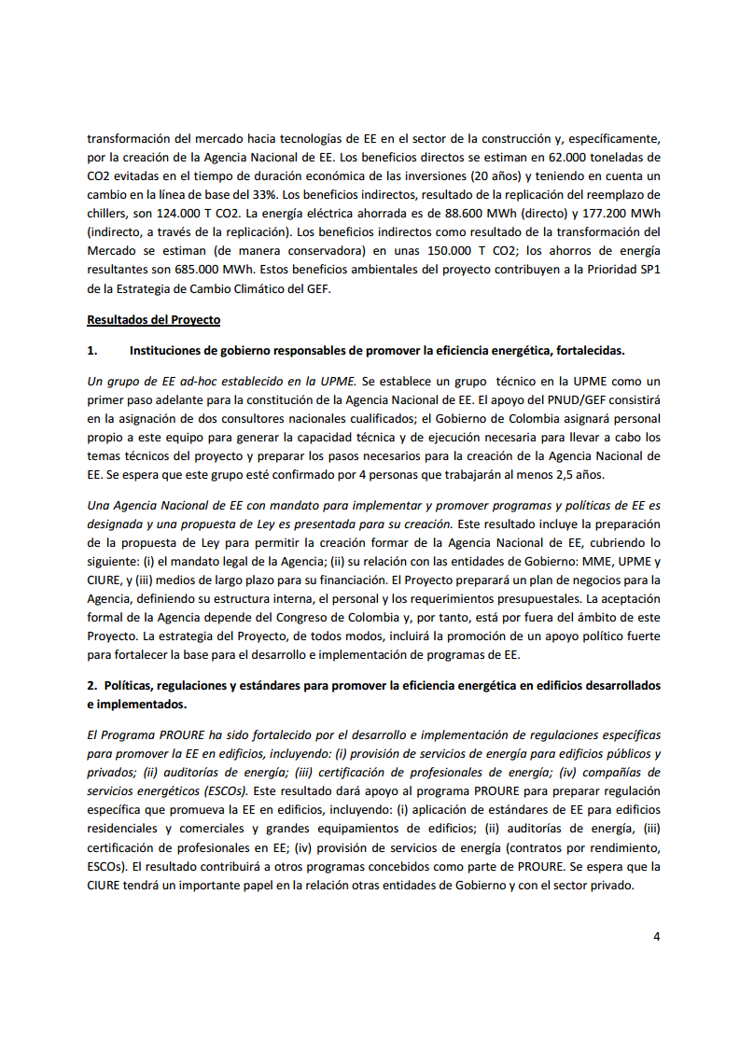

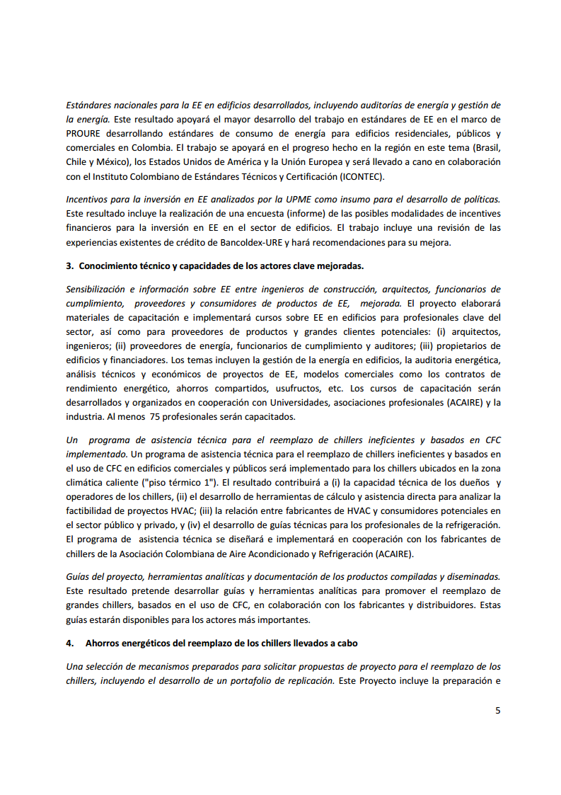

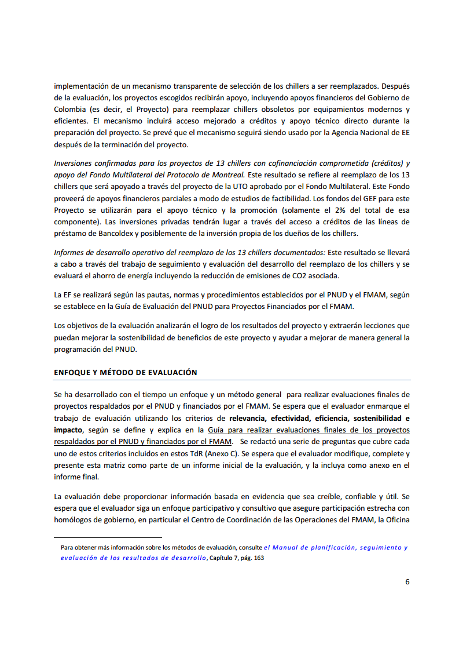

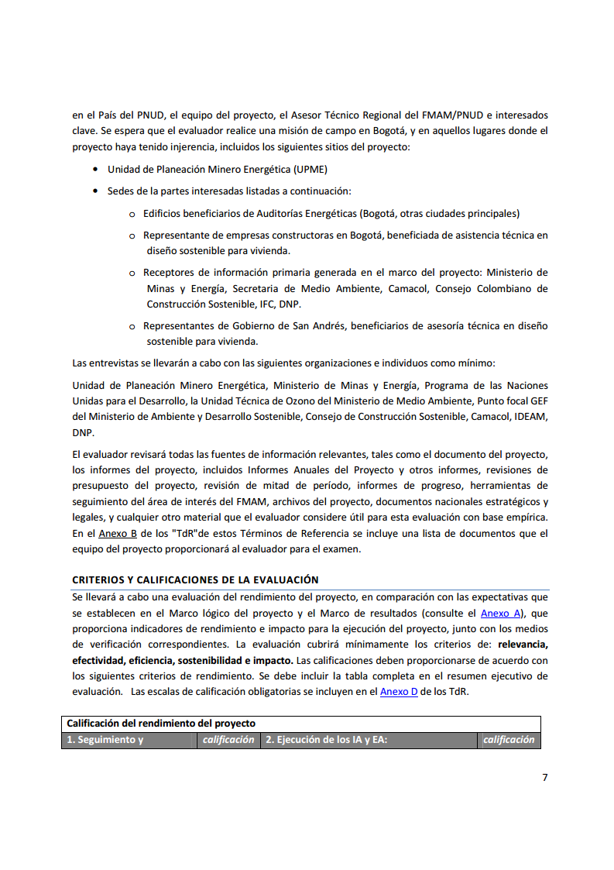

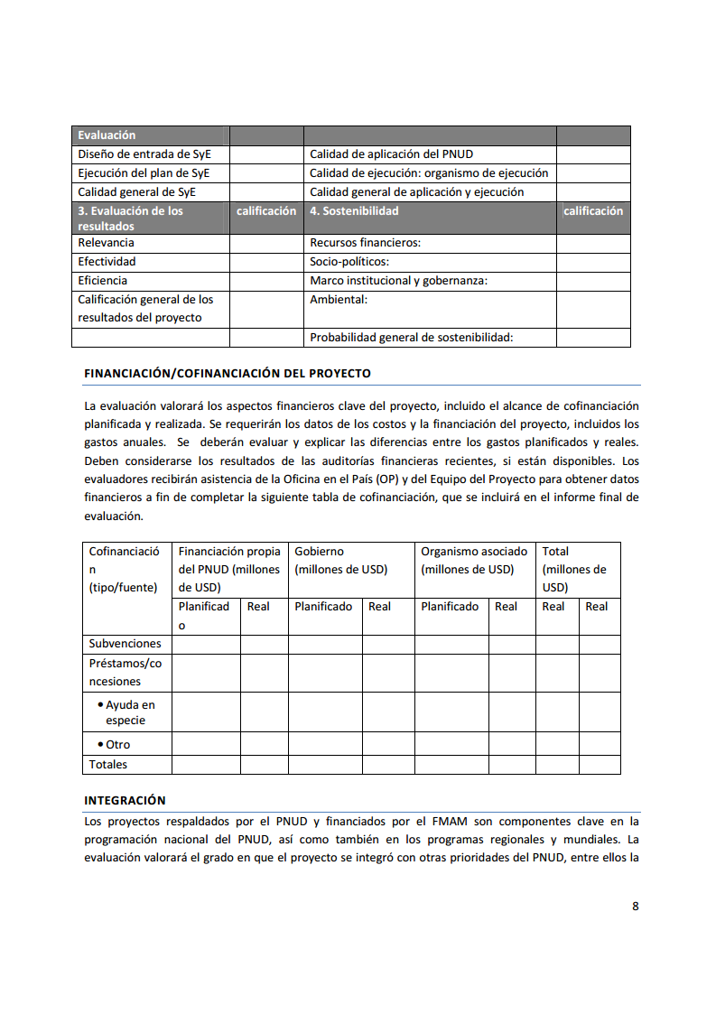

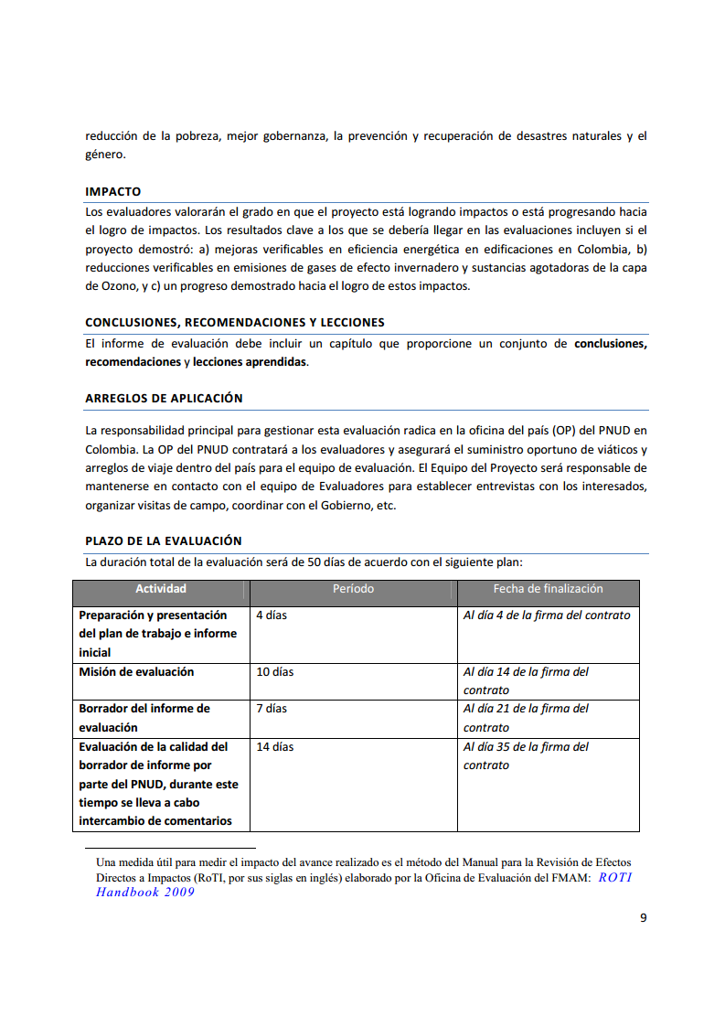

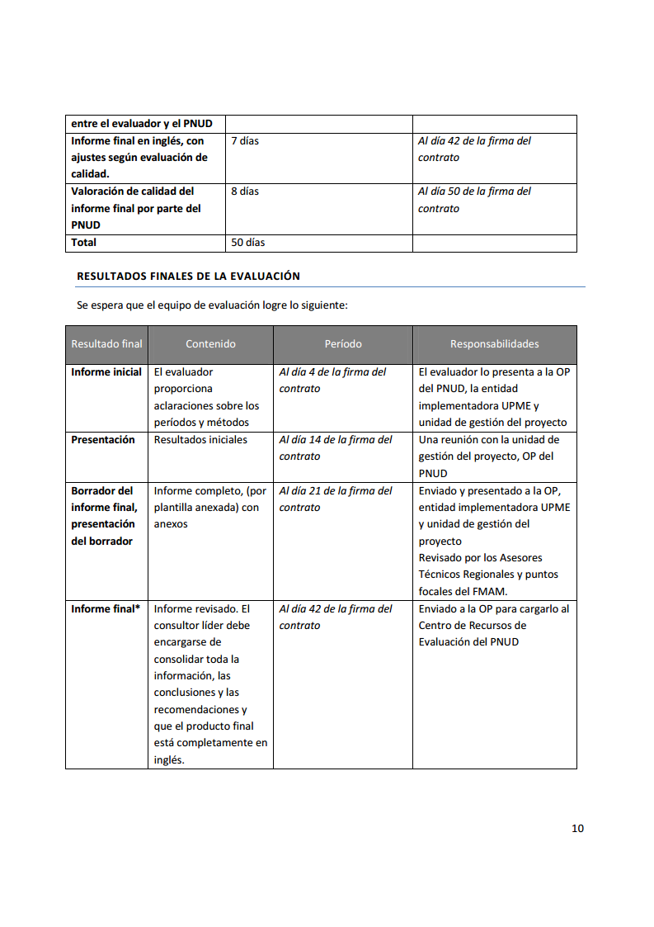

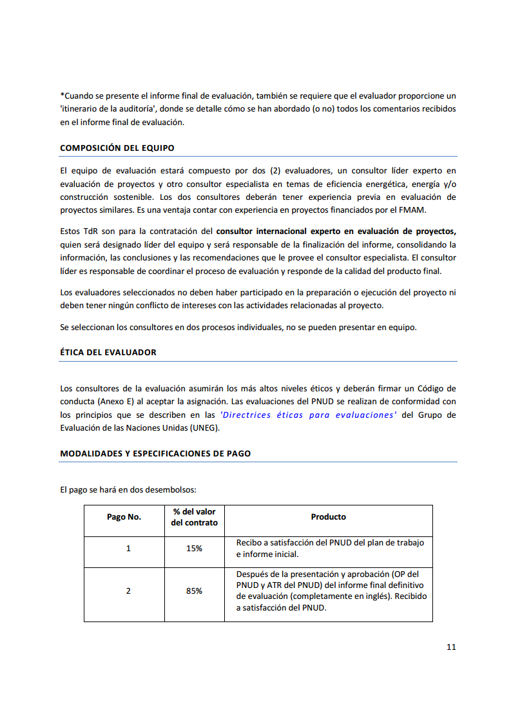

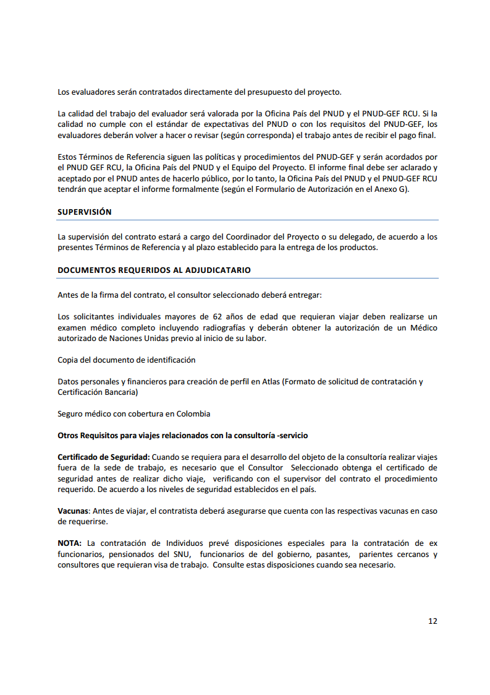

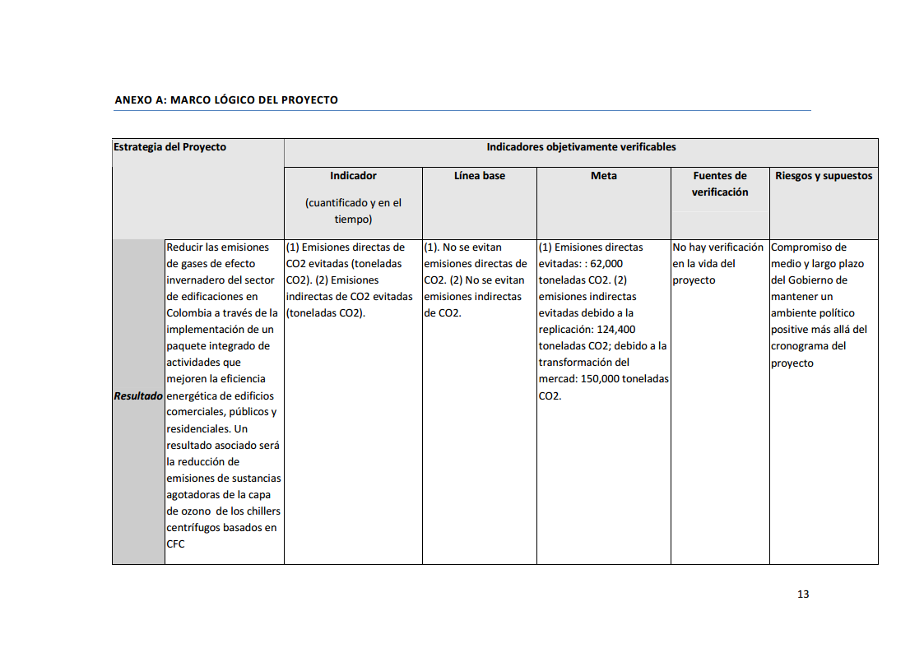

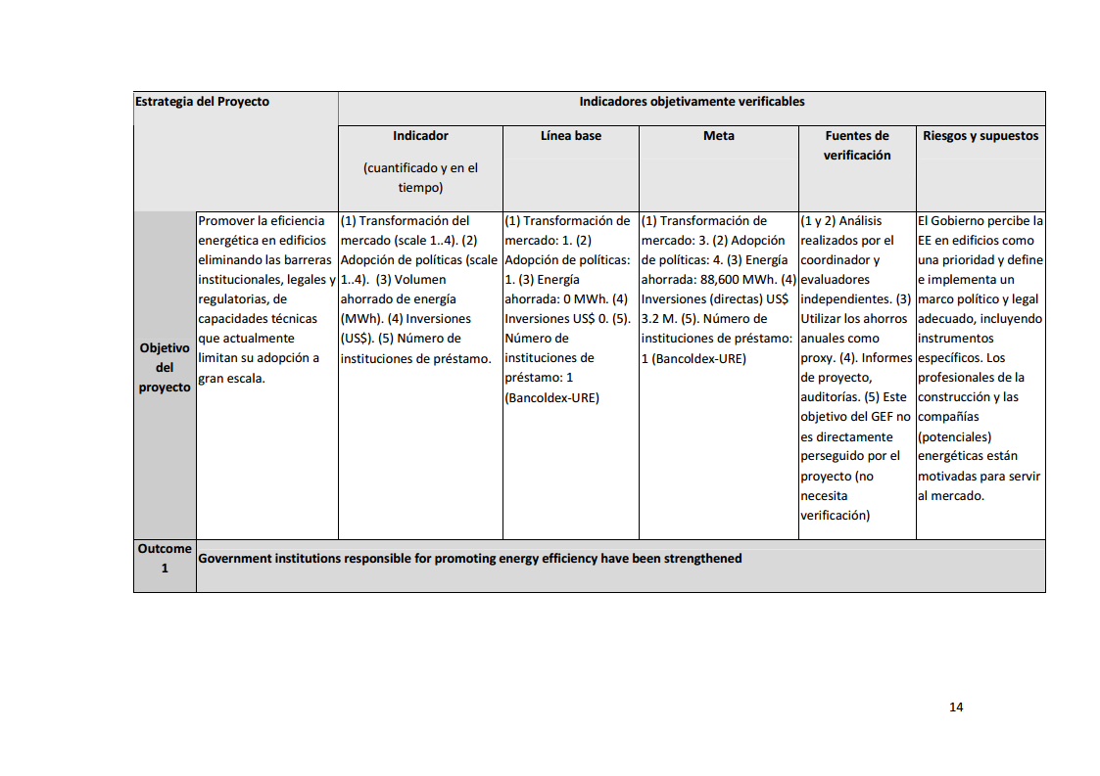

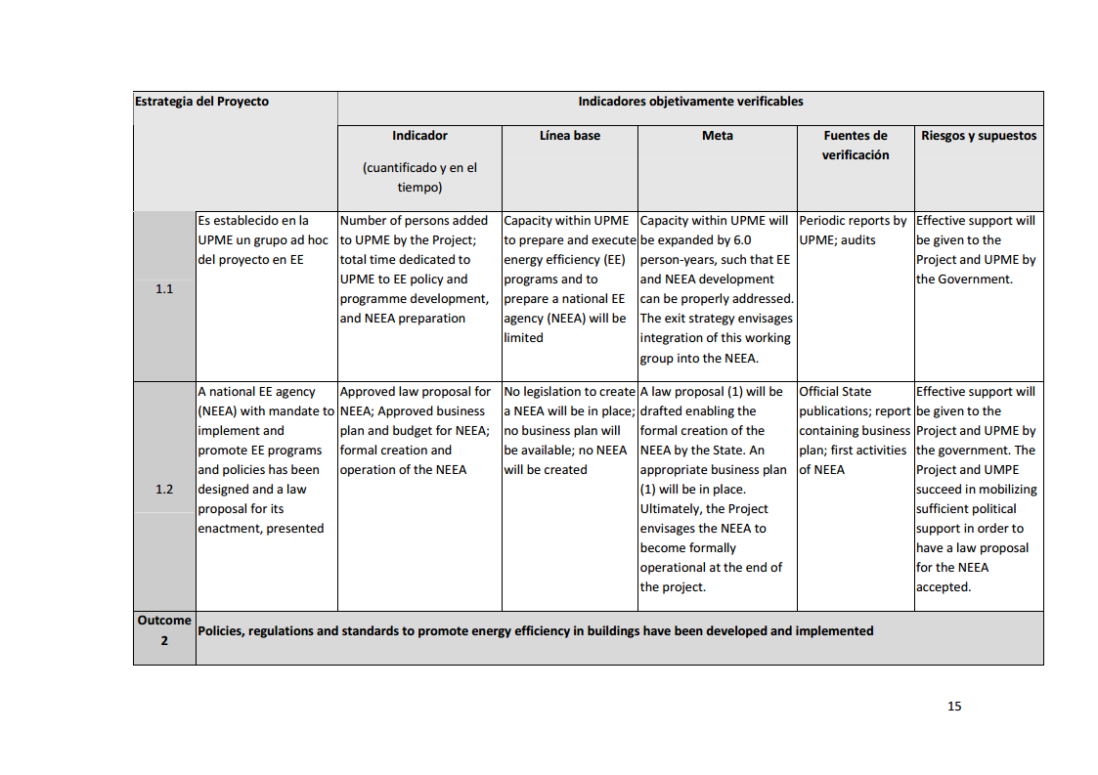

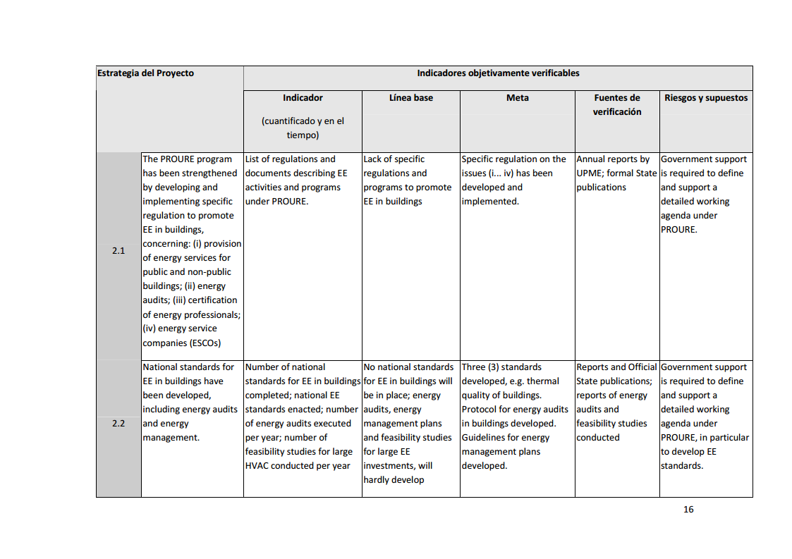

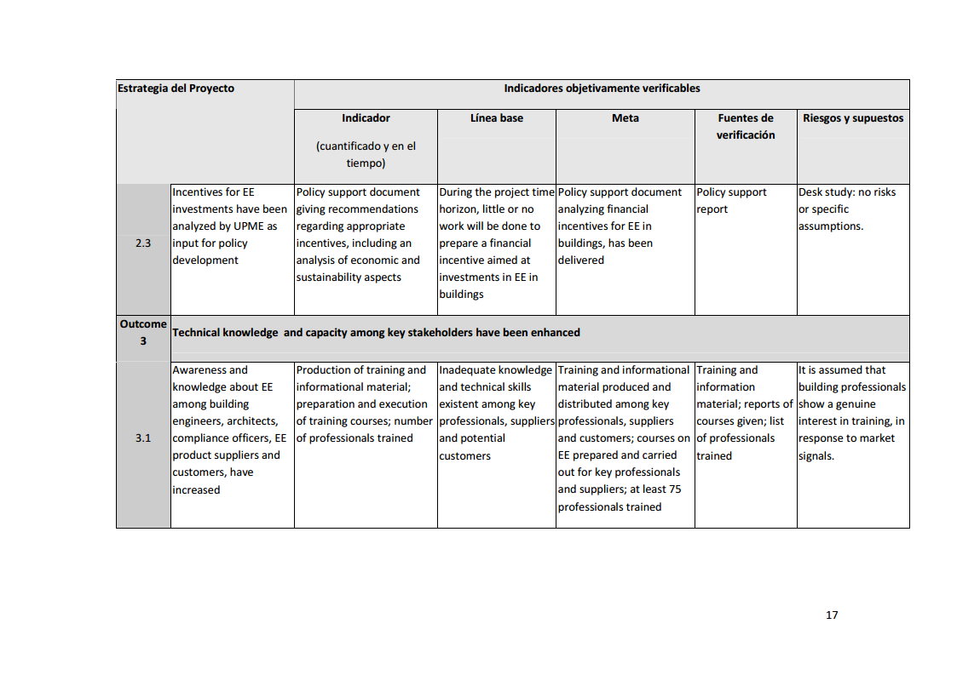

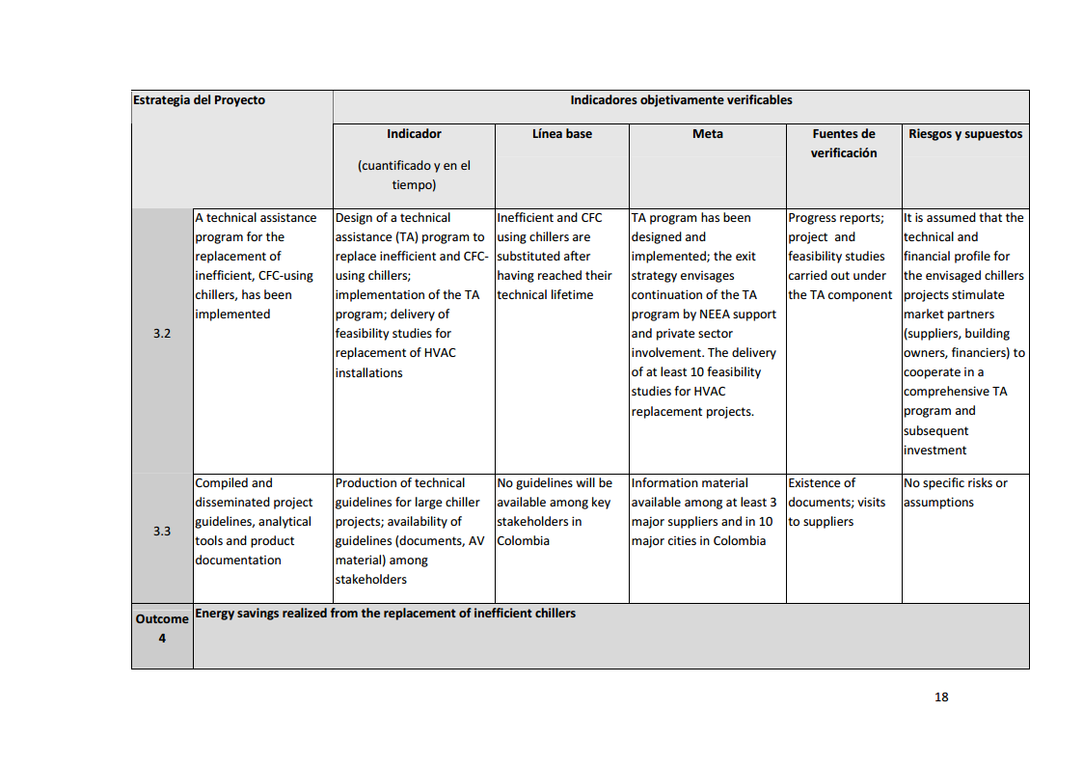

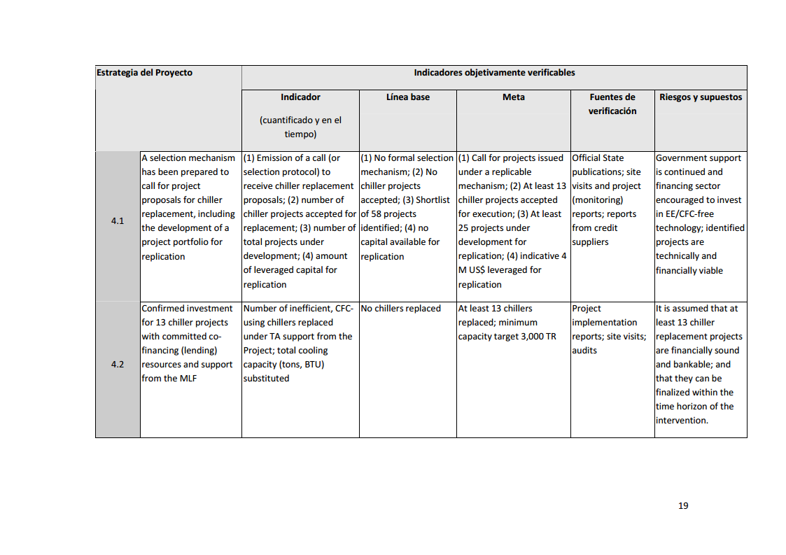

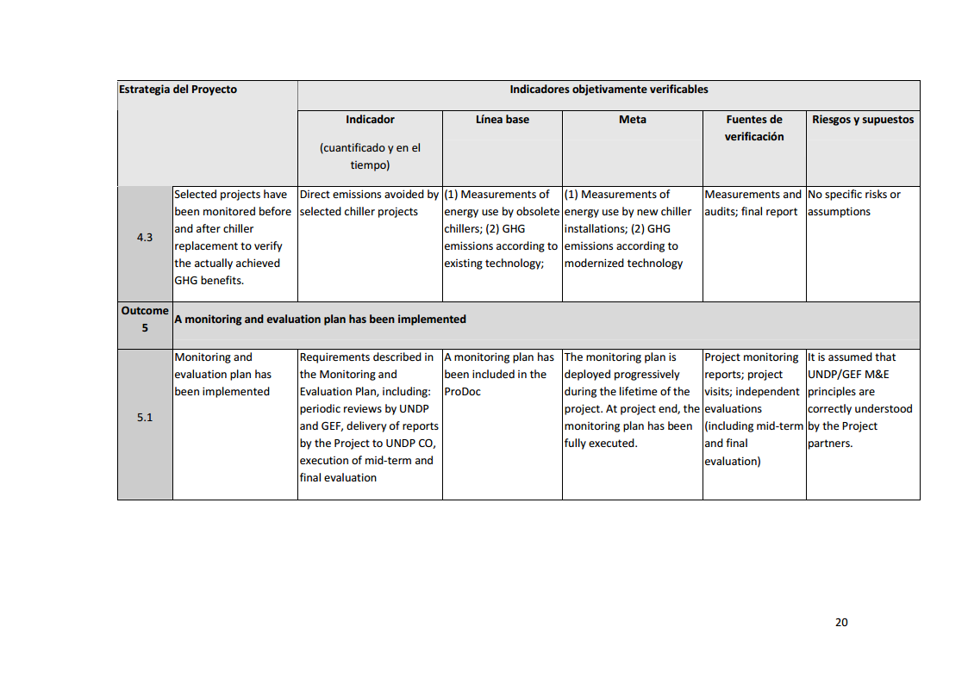

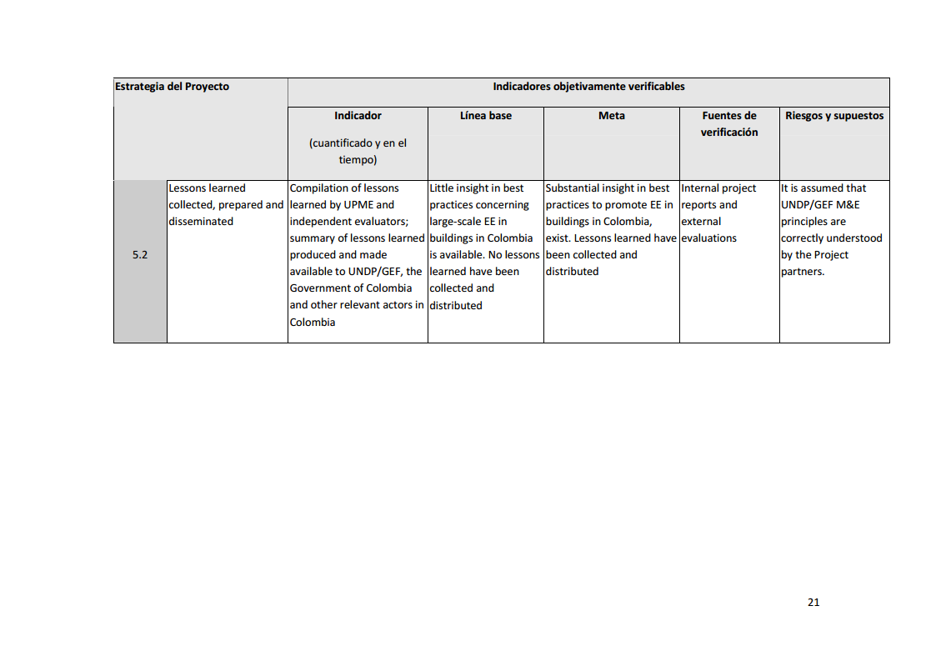

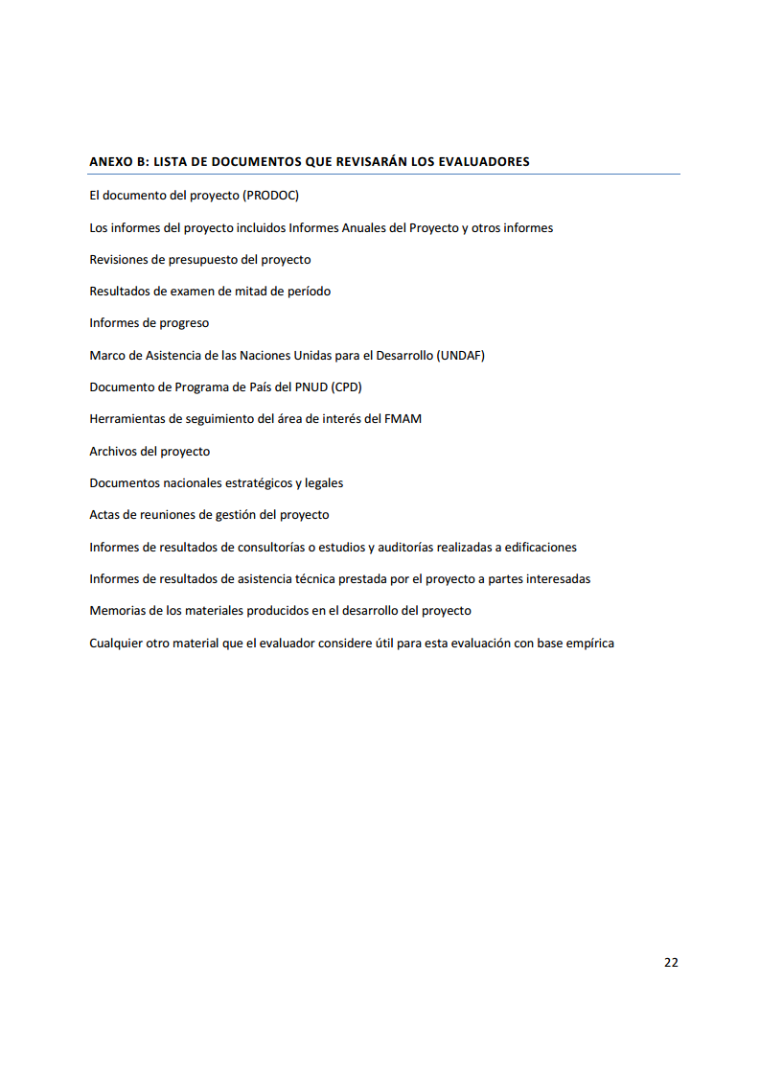

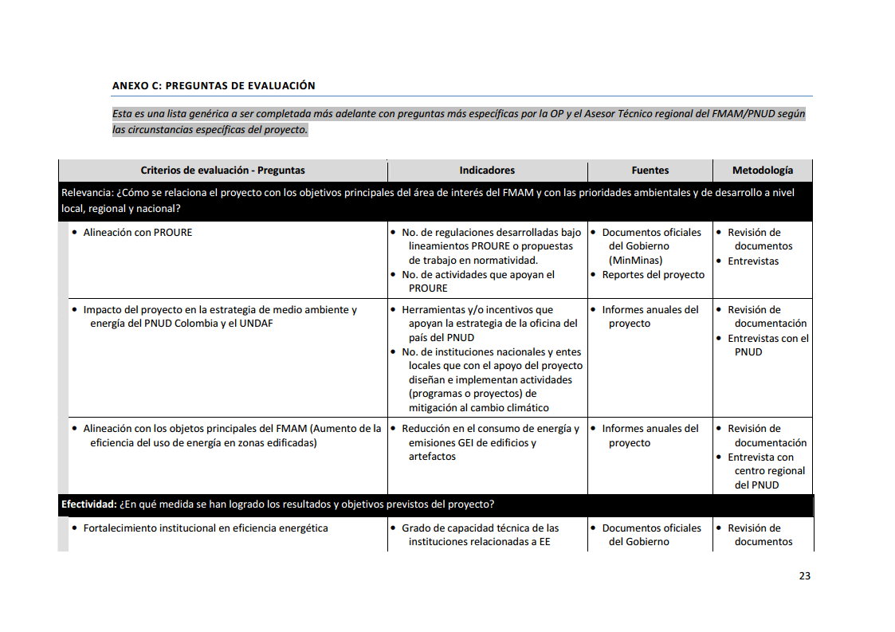

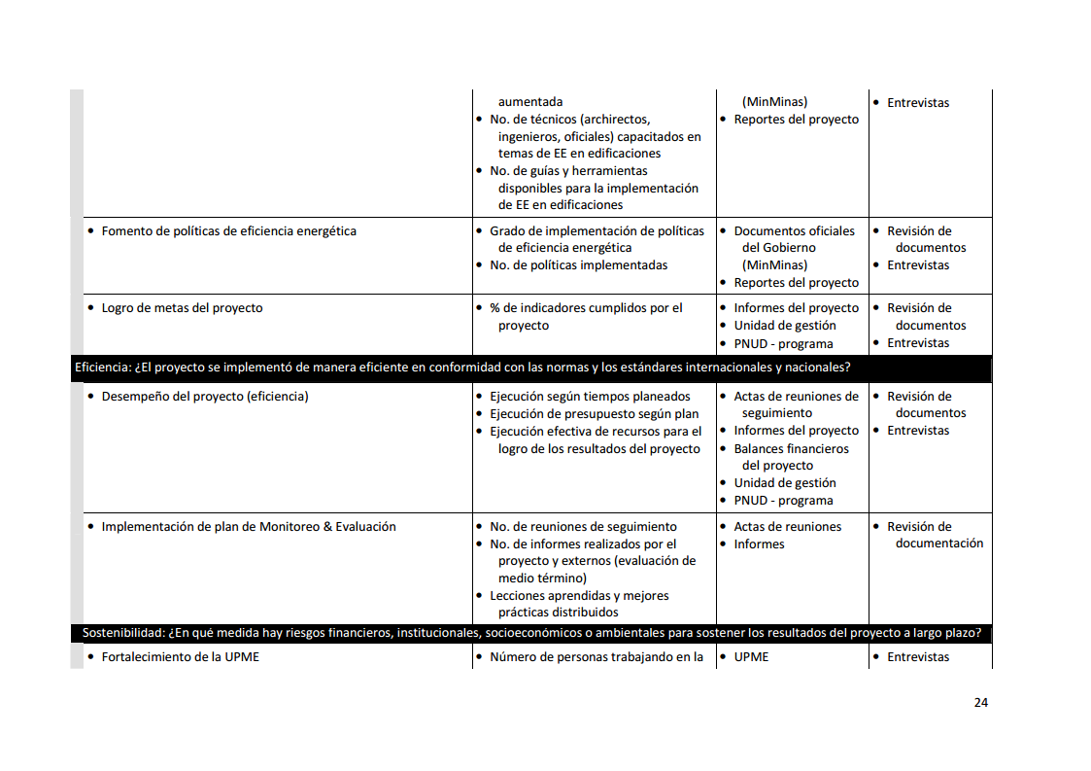

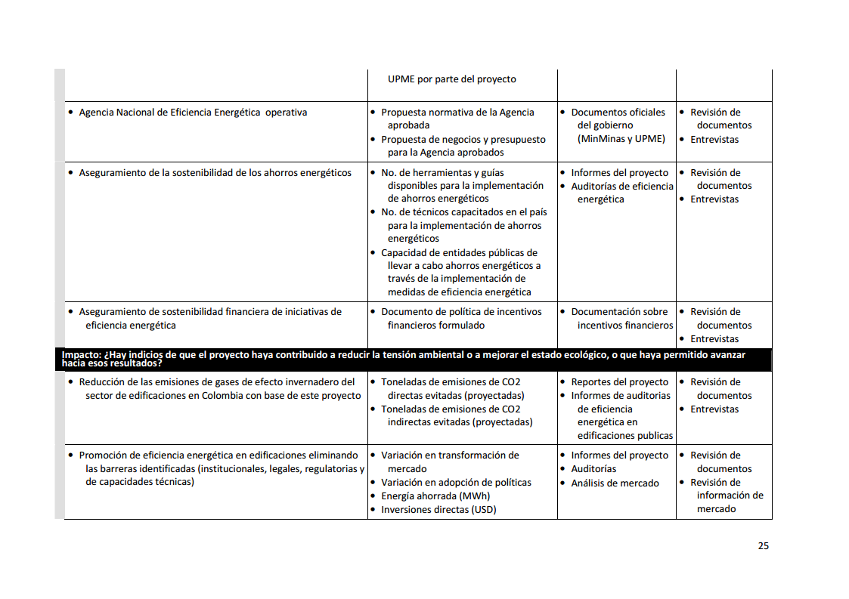

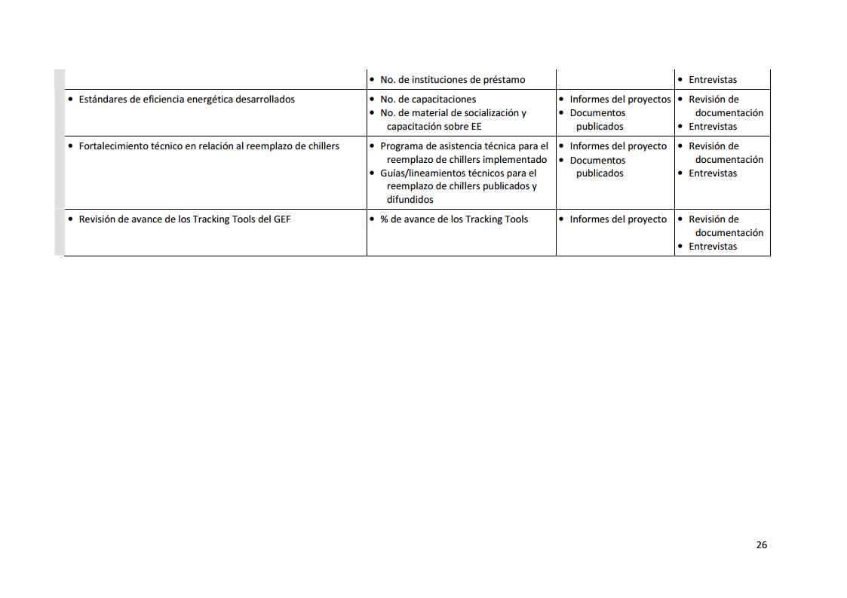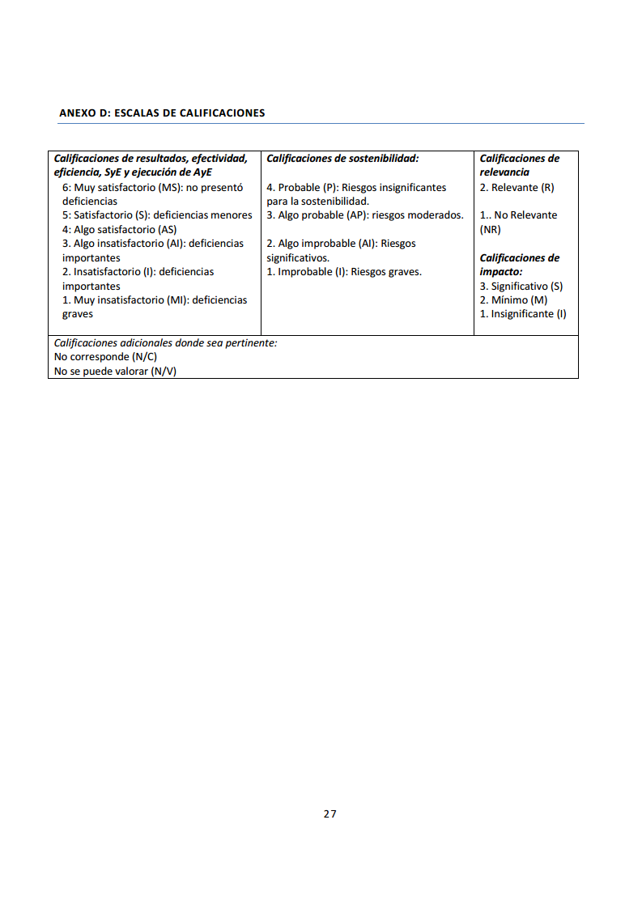

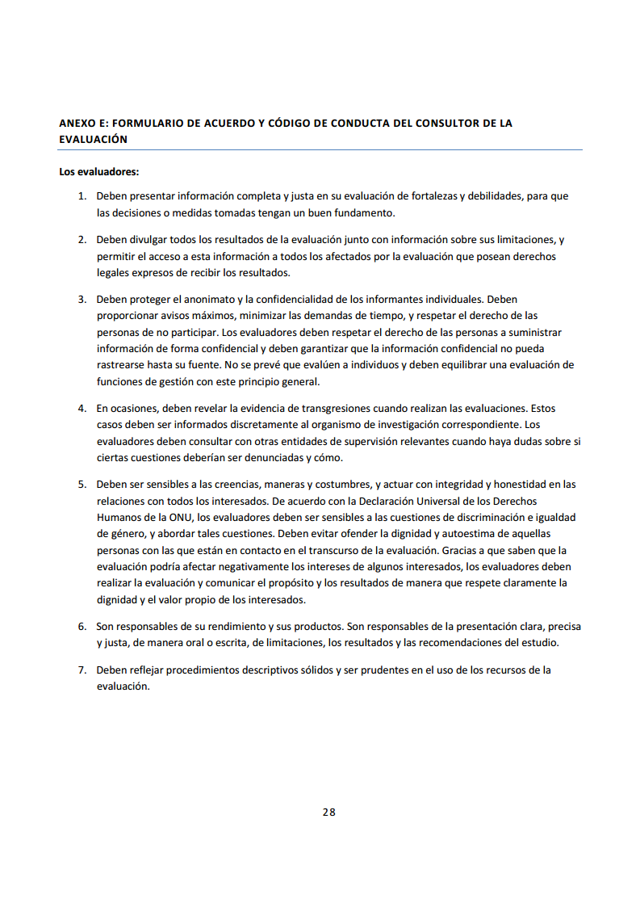

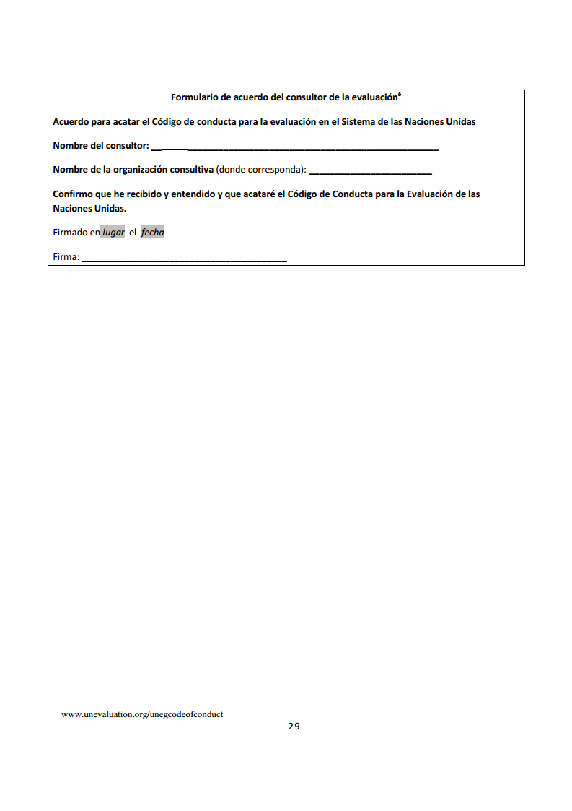

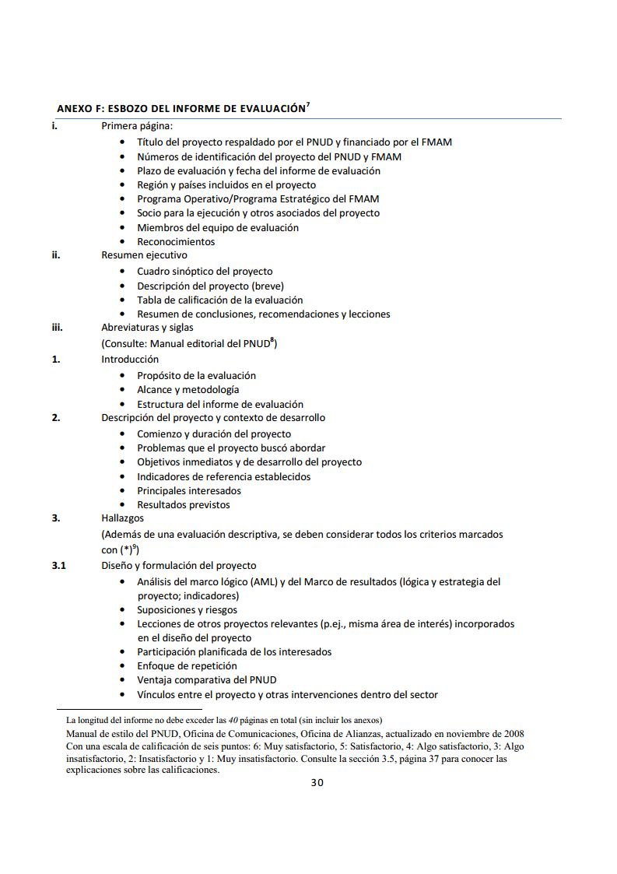

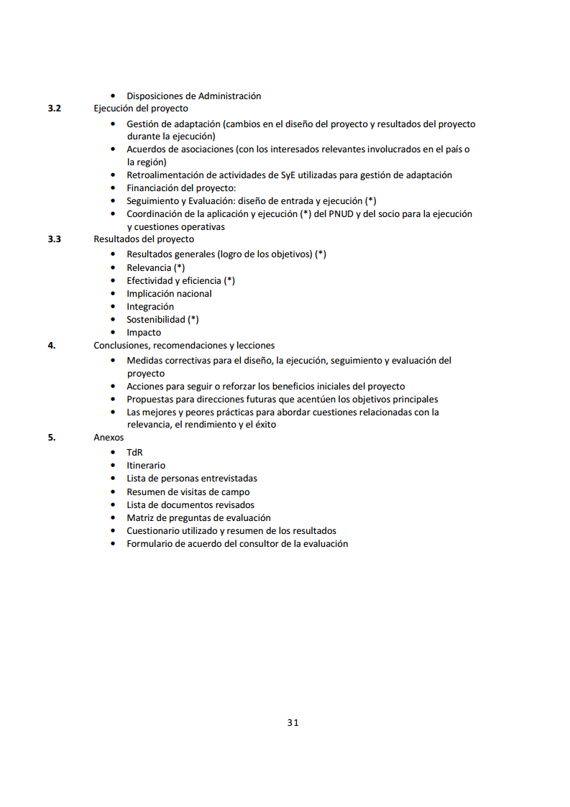



## Annex 2: Assessment Questions

* **Key actors.**

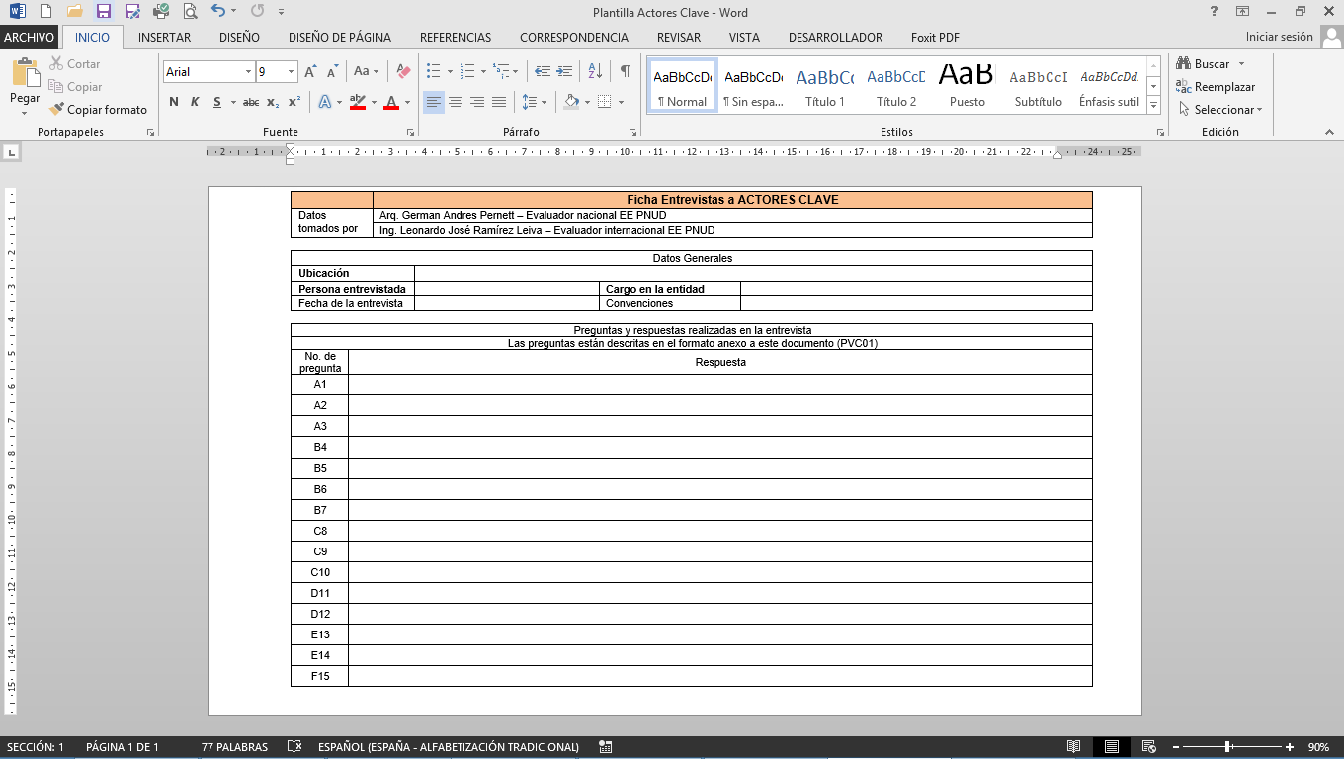

|  |
| --- |
| **Questions to entities (PVC01)** |
| **A. Relevance: How is the project related with the main objectives of the area of interest of the GEF and with the environmental priorities and development goals at local, regional and national level?**   1. Within the "Rational and Efficient Use of Energy" program, which have been the most notable achievements at the local, national and/or international levels (Standards, projects, training)? 2. What is the amount of energy consumption in buildings (figures or percentages) that you expect or want to reduce in the next 20 years? 3. What is the amount of CO2 emissions (figures or percentages) that you expect or want to reduce in the next 20 years?   (The PRODOC estimated a direct reduction of 62,000 tons of CO2 plus indirect reductions of 274,000 tons of CO2 in a period of 20 years)  **B. Effectiveness: To what extent have been achieved the results and objectives of the project?**   1. Number of Technicians (architects, engineers, official) that have been trained in topics of energy efficiency (EE) in buildings in the past 10 years and what projects you have in planning for this purpose. 2. How many people are working in EE under permanent dedication now? 3. How many people are working in EE part-time now? 4. Policies that are already running concerning strategies for EE.   **C. Efficiency: Was implemented the project in an efficient manner in accordance with international and national standards?**   1. Number of guides, publications, tools, and internal and external training developed and available to support the implementation of EE in buildings. 2. Did you have a budget allocated to programs, trainings and projects in EE? 3. Has the project complied with adequate strategies and timelines for implementation of projects in EE? |
|

|  |
| --- |
| **D. Sustainability: To what extent there are financial, institutional, socio-economic or environmental risks threatening the sustainability of project results in the long-term?**   1. In relation to the creation of the National Energy Efficiency Agency, do you find that its creation is a clear answer to the optimization of energy consumption at a national level, in the transportation, industrial, commercial and residential sectors? 2. The main barriers for the development of EE policies are of financial, technical or legal framework nature?.   **E. Impact: Are there any indications that the project has contributed to reducing environmental stress or to improve the ecological status, or that it has allowed to make progress toward these outcomes?**   1. What policy documents of financial incentives have been formulated and are in force? 2. What rules or regulation policies you consider to be more important to establish, for the benefit of EE of the country?   **F. Compliance of results: What opinion do you have with regards to the EEB project compliance?**   1. Do you believe that the implementation of "energy audits" is fundamental for the rational use of energy and reduction of "GHG" emissions in buildings? |
|

* **Energy audits.**

|  |  |  |  |  |  |  |  |  |  |  |
| --- | --- | --- | --- | --- | --- | --- | --- | --- | --- | --- |
| Matrix Analysis of energy audits in Colombia | | | | | | | | | | |
| General Objective | Identify measures for energy efficiency and savings recommended for the audited buildings, taking into account measures for technology change and energy management practices. | | | | | | | | | |
| **Relevance: How is the project related with the main objectives of the area of interest of the GEF and with the environmental priorities and development goals at local, regional and national level?** | | | | | | | | | | |
| Evaluation Criteria | | Indicators | | | | Sources | | | Methodology | |
| 1. Alignment with the main objectives of GEF (increase of energy efficiency in built-up areas) | | Figures for the reduction of greenhouse gas emissions "GHG" (CFCS,NOx,CH4, CO2) | | | | Energy audits | | | * Review of documents. | |
| 2. Alignment with PROURE | | Items with the highest incidence in the energy consumption of the building.[19] | | | | Energy audits | | | * Review of documents. | |
| Consumption in Kwh/month | | | |
| 3. Impact of the project in the environmental and energy strategy of UNDP Colombia and UNDAF | | Cost of the energy improvement solutions | | | | Energy audits | | | * Review of documents. | |
| Buildings analyzed | | Indicators | | | | | | | | |
| Items with the highest incidence in the energy consumption of the building. | | | | | | | | To reduce potential of emission of greenhouse gases "GHG" (CFCS,NOx,CH4, CO2) |
| Consumption before the energy audit | | | | | | | After the execution of the recommended improvements |
| Consumption in kWh/month Substation 1 | Consumption in kWh/month Substation 2 | Consumption in kWh/month Substation 3 | Consumption in kWh/month Lighting | Consumption in kWh/month office equipment | Consumption in kWh/month motors or pumps | Consumption in kWh/month Air Conditioning | % Savings |
| 1. Medellin: Alcaldia de Medellin (29,637 m).  Located at calle 44 N° 52 - 165 in the Administrative Center of the Alpujarra region in the city of Medellin | |  |  |  |  |  |  |  |  |  |
| Audit carried out by:  Deloitte | |
| 2. Medellín: Building of Area Metropolitana (6,591.77 )  Located at Calle 41 No. 53 -07, Medellin | |  | | |  |  |  |  |  |  |
| Audit carried out by:  Consultoría en Eficiencia Energética | |
| 3. Medellín: Corporación Autónoma Regional de Antioquia - Corantioquia  Located at carrera 65 NO. 44a -32   (5007 M2) | |  | | |  |  |  |  |  |  |
| Audit carried out by:  Consultoría en Eficiencia Energética | |
| 4. Medellín: The administrative building of Gobernación de Antioquia Street 42 number 52- 106 Medellin, Colombia   (54,000 M2) | |  | | |  |  |  |  |  |  |
| Audit carried out by:  Consorcio de Eficiencia Energética | |
| 5. Bogota: Ministry of environment and sustainable development, Bogotá between calles 37 and 38 and between carreras 13 and 8. (7415.15 M2) | |  | | |  |  |  |  |  |  |
| Audit carried out by:  Inessman: Ingeniería Especializada en Sistemas y Mantenimiento LTDA. | |
| 6. Bogota: Ministry of Mines and Energy, located at calle 43 Not 57 - 31 CAN in Bogota - Colombia  (9,960 M2) | |  | | |  |  |  |  |  |  |
| Audit carried out by:  Consorcio de Eficiencia Energética | |
| 7. Medellín: Building of the Palacio de Justicia en Medellin, located in carrera 52 NO 42 - 73 Administrative Center of the Alpujarra   (37.155 M2) | |  | | |  |  |  |  |  |  |
| Audit carried out by:  Consorcio de Eficiencia Energética | |
| 8. Santa Marta: Corporación Autónoma Regional de Magdalena, located at Avenida del Libertador No. 32-201, Taironas neighborhood - Santa Marta, Magdalena  (1.118 M2) | |  | | |  |  |  |  |  |  |
| Audit carried out by:  Applus Norcontrol | |
| 9. Barranquilla: Corporación Autónoma Regional del Atlántico - CRA, located at Calle 66 No. 54-43, Barranquilla, Atlantico.  (836 M2) | |  | | |  |  |  |  |  |  |
| Audit carried out by:  Applus Norcontrol | |
| 10. Gobernación del Atlático, located at Carrera 45 and Calle 40, Barranquilla, Atlantico.  (10268 M2) | |  | | |  |  |  |  |  |  |
| Audit carried out by:  Applus Norcontrol | |
| 11. Alcaldía de Barranquilla,  Paseo Bolivar Street 34 No. 43 - 31  (10,080 M2) | |  | | |  |  |  |  |  |  |
| Audit carried out by:  Applus Norcontrol | |
| 12. Quibdó: energy audit of the City Hall Municipalidad de Quibdó, located at carrera 2 No. 24a-32 (893.94 m2) | |  | | |  |  |  |  |  |  |
| Audit carried out by:  Deloitte | |
| 13. Cali: Corporación Autónoma del Valle del Cauca Carrera 56 # 11 - 36  (11,200 M2) | |  | | |  |  |  |  |  |  |
| Audit carried out by:  Creara International. | |
| 14. Valledupar: Alcaldía de Valledupar, Carrera 5 No. 15 - 69 (4235TH m2) | |  | | |  |  |  |  |  |  |
| Audit carried out by:  UT Serconanter | |

|  |  |  |  |  |  |  |  |  |  |
| --- | --- | --- | --- | --- | --- | --- | --- | --- | --- |
| **Effectiveness: To what extent have been achieved the results and objectives of the project?** | | | | | | | | | |
| Evaluation Criteria | Indicators | | | Sources | | | Methodology | | |
| 1. Achievement of project goals, indicators been met. | Rates of reduction of energy consumption expected from optimization measures, according to the Energy Audit (percentage) | | | Energy audits | | | * Review of documents | | |
| Areas with higher EE potential from interventions at the building, resulting from technological changes. | | | Energy audits | | | * Review of documents | | |
| 2. Institutional Strengthening in energy efficiency (EE) | No. of technical experts in EE in the building. | | | Energy audits | | | * Review of documents * Interviews | | |
| No. Internal policies that govern the energy consumption. | | | Energy audits | | | * Energy audits | | |
| Years of operation of the building | | | Energy audits | | | * Energy audits | | |
| Investment and EE improvements carried on before the energy audit | | | Energy audits | | | * Energy audits | | |
| Building analyzed | Indicators | | | | | | | | |
| Rates of reduction of energy consumption from optimization measures, according to the Energy Audit (percentage), compared to the total energy consumed by the building. | | | | | No. of technical experts in EE in the building. | No. Internal policies that govern the energy consumption. | Years of operation of the building | Investment and EE improvements to the building made before audit |
| Reduction Lighting ( %) | Reduction  HVAC ( %) | Reduction equipment and engines ( %) | | Total estimated Reduction ( %) |
| 1. Medellín: Alcaldía de Medellin |  |  | | |  |  |  |  |  |
| 2. Medellín: Metropolitan Area |  |  |  | |  |  |  |  |  |
| 3. Medellín: Gobernación de Antioquia (19,000 m2) Corporación Autónoma Regional de Antioquia - Corantioquia |  |  |  | |  |  |  |  |  |
| 4. Medellín: The administrative building of the Gobernación de Antioquia Street 42 number 52- 106 Medellin, Colombia |  |  |  | |  |  |  |  |  |
| 5. Bogota: Ministry of environment and sustainable development |  |  |  | |  |  |  |  |  |
| 6. Ministry of Mines and Energy, located at calle 43 Not 57 - 31 CAN, Bogota |  |  |  | |  |  |  |  |  |
| 7. Medellín: Building of the Palacio de Justicia in Medellin |  |  |  | |  |  |  |  |  |
| 8. Corporación Autónoma Regional de Magdalena |  |  |  | |  |  |  |  |  |
| 9. Barranquilla: Corporación Autónoma Regional del Atlántico |  |  |  | |  |  |  |  |  |
| 10. Gobernación del Atlático, located at Carrera 45 and Calle 40, Barranquilla, Atlantico. |  |  |  | |  |  |  |  |  |
| 11. Alcaldía de Barranquilla, Paseo Bolivar Street 34 No. 43 - 31 |  |  |  | |  |  |  |  |  |
| 12. Quibdó: energy audit of the City Hall Municipalidad de Quibdó |  |  |  | |  |  |  |  |  |
| 13. Cali: Corporación Autónoma Regional de Valle del Cauca |  |  |  | |  |  |  |  |  |
| 14. Valledupar: Alcaldía de Valledupar |  |  |  | |  |  |  |  |  |

|  |  |  |  |  |  |  |
| --- | --- | --- | --- | --- | --- | --- |
| **Efficiency: The project was implemented in an efficient manner in accordance with international and national standards?** | | | | | | |
| Evaluation Criteria | Indicators | | Sources | | | Methodology |
| 1. Project Performance (efficiency) | No. of technical solutions (reforms, measures of technology change and energy management) | | Energy audits | | | * Review of documents. |
| Estimated budget of the improvements | | Energy audits | | | * Review of documents. |
| Time of return of the measures, establishing the internal rate of return | | Energy audits | | | * Review of documents. |
| Building analyzed | Indicators | | | | | |
| No. of technical solutions (reforms, measures of technology change and energy management), | Emissions reduction potential of kg of CO2/year | | Capital Cost of the improvements | Time of return of the measures, establishing the internal rate of return | |
| 1. Medellín: Alcaldía de Medellin |  |  | |  |  | |
|  |  |  | |
|  |  |  | |
|  |  |  | |
| 2. Medellín: Area Metropolitana |  |  | |  |  | |
|  |  |  | |
|  |  |  | |
|  |  |  | |
| 3. Corporación Autónoma Regional de Antioquia - Corantioquia |  |  | |  |  | |
|  |  |  | |
|  |  |  | |
|  |  |  | |
| 4. Medellín: The administrative building of the Gobernación de Antioquia Street 42 number 52- 106 Medellin, Colombia |  |  | |  |  | |
|  |  |  | |
|  |  |  | |
|  |  |  | |
| 5. Bogota: Ministry of environment and sustainable development |  |  | |  |  | |
|  |  |  | |
|  |  |  | |
|  |  |  | |
| 6. Ministry of Mines and Energy, located at calle 43 Not 57 - 31 CAN, Bogota |  |  | |  |  | |
|  |  |  | |
|  |  |  | |
|  |  |  | |
| 7. Medellín: Building of the Palacio de Justicia in Medellin |  |  | |  |  | |
|  |  |  | |
|  |  |  | |
|  |  |  | |
| 8. Corporación Autónoma Regional de Magdalena |  |  | |  |  | |
|  |  |  | |
|  |  |  | |
|  |  |  | |
| 9. Barranquilla: Corporación Autónoma Regional del Atlántico |  |  | |  |  | |
|  |  |  | |
|  |  |  | |
|  |  |  | |
| 10. Corporación del Atlántico, located at Carrera 45 and Calle 40, Barranquilla, Atlántico. |  |  | |  |  | |
|  |  |  | |
|  |  |  | |
|  |  |  | |
| 11. Mayor of Barranquilla, Paseo Bolivar Street 34 No. 43 - 31 |  |  | |  |  | |
|  |  |  | |
|  |  |  | |
|  |  |  | |
| 12. Quibdó: energy audit of the City Hall Municipalidad de Quibdó |  |  | |  |  | |
|  |  |  | |
|  |  |  | |
|  |  |  | |
| 13. Cali: Corporación Autónoma Regional del Valle del Cauca |  |  | |  |  | |
|  |  |  | |
|  |  |  | |
|  |  |  | |
| 14. Valledupar: Alcaldía de Valledupar |  |  | |  |  | |
|  |  |  | |
|  |  |  | |
|  |  |  | |
|  |  |  | |

|  |  |  |  |  |  |
| --- | --- | --- | --- | --- | --- |
| **Sustainability: To what extent there are financial, institutional, socio-economic or environmental risks threatening the sustainability of project results in the long-term?** | | | | | |
| Evaluation Criteria | Indicators | | Sources | | Methodology |
| 1. Project Performance (efficiency) | Cost of energy of the building and type of tariff | | Energy audits | | * Review of documents. |
| Capital Cost of the EE improvements | | Energy audits | | * Review of documents. |
| Estimated execution times. | | Energy audits | | * Review of documents. |
| Building Analyzed | Indicators | | | | |
| Cost of energy of the building and type of tariff | Capital Cost of the EE improvements | | Maximum estimated execution time. | |
| 1. Medellín: Alcaldía de Medellin |  |  | |  | |
| 2. Medellín: Area Metropolitana |  |  | |  | |
| 3. Medellín: Corporación Autónoma Regional de Antioquia - Corantioquia |  |  | |  | |
| 4. Medellín: The administrative building of the Gobernación de Antioquia Street 42 number 52- 106 Medellin, Colombia |  |  | |  | |
| 5. Bogota: Ministry of environment and sustainable development |  |  | |  | |
| 6. Ministry of Mines and Energy, located in the calle 43 Not 57 - 31 CAN, Bogota |  |  | |  | |
| 7. Medellín: Building of the Palacio de Justicia in Medellin |  |  | |  | |
| 8. Corporación Autónoma Regional de Magdalena |  |  | |  | |
| 9. Barranquilla: Corporación Autónoma Regional del Atlántico |  |  | |  | |
| 10. Corporación del Atlántico, located at Carrera 45 and Calle 40, Barranquilla, Atlántico. |  |  | |  | |
| 11. Alcaldía de Barranquilla, Paseo Bolivar Street 34 No. 43 - 31 |  |  | |  | |
| 12. Quibdó: energy audit of the City Hall Municipalidad de Quibdó |  |  | |  | |
| 13. Cali: Corporación Autónoma Regional del Valle del Cauca |  |  | |  | |
| 14. Valledupar: Alcaldía de Valledupar |  |  | |  | |

## Annex 3: Itinerary



## Annex 4: Answers from Key Players

* Ing. Luis Fernando Lopez. Direction of Energy. Ministry of Mines and Energy.

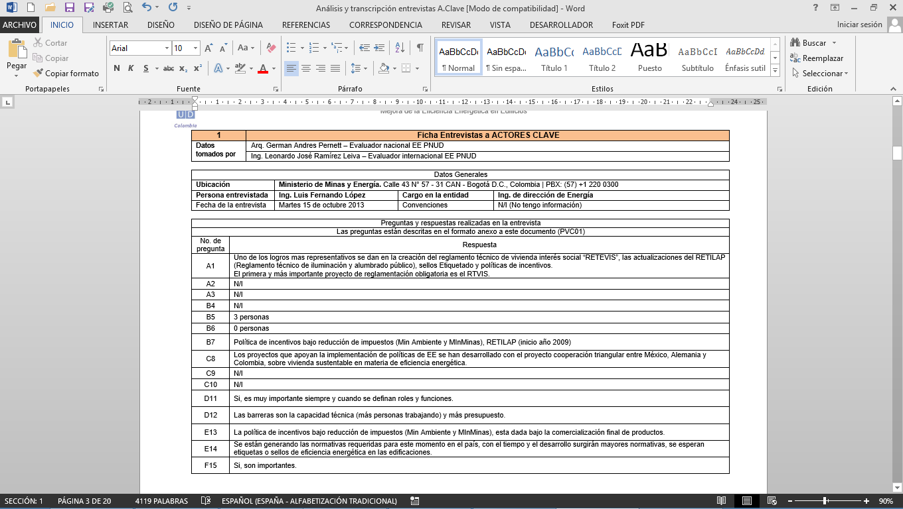

* Ing. Olga Victoria Gonzalez. URE Coordinator. Mines and Energy Planning Unit (UPME).

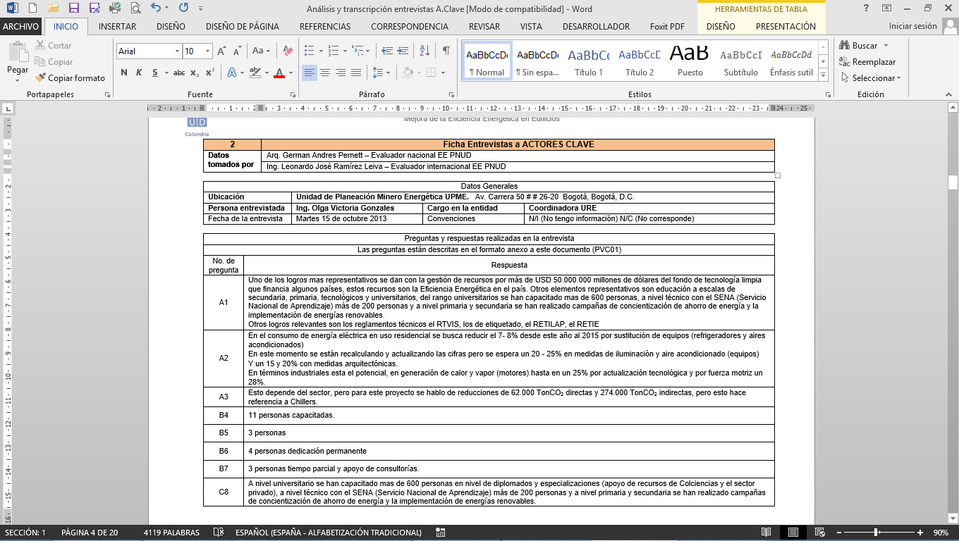

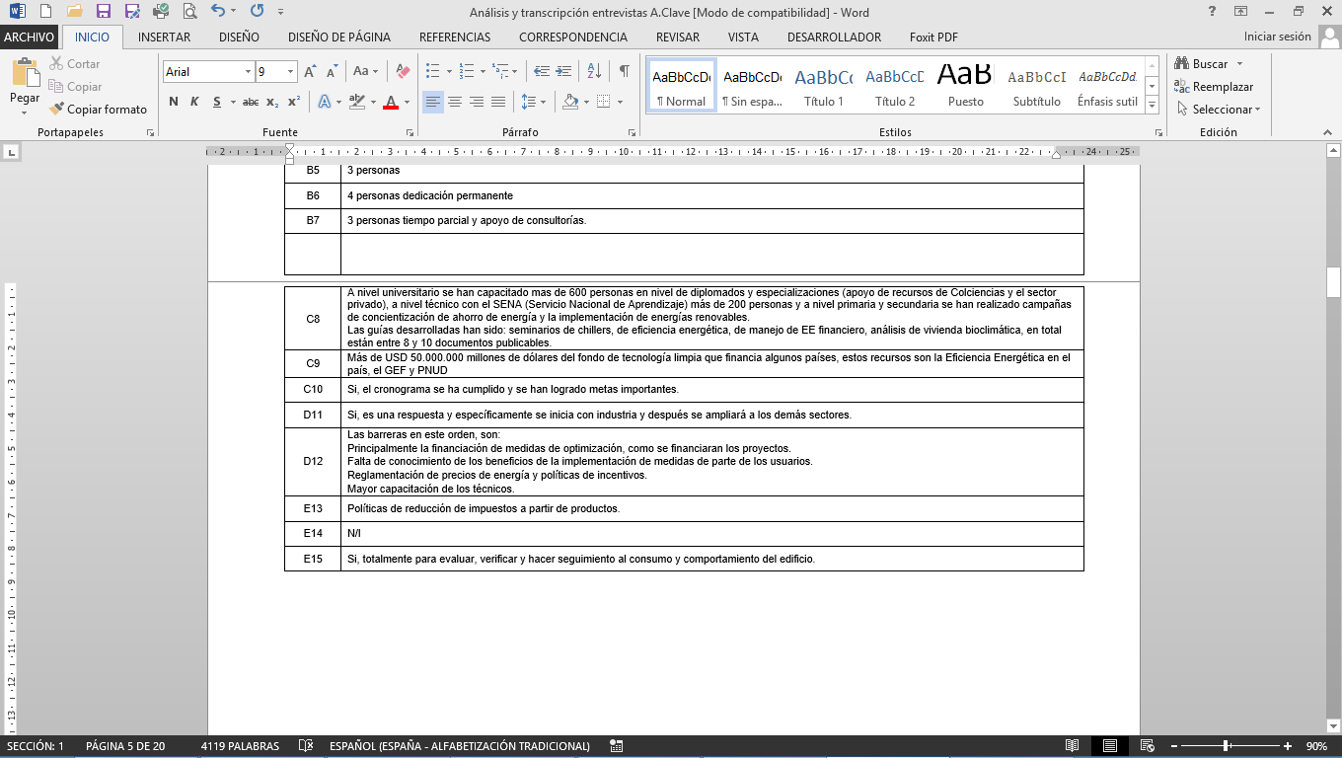

* Ing. Juan Carlos Alvarez. Climate Change Advisor. United Nations Development Program (UNDP).

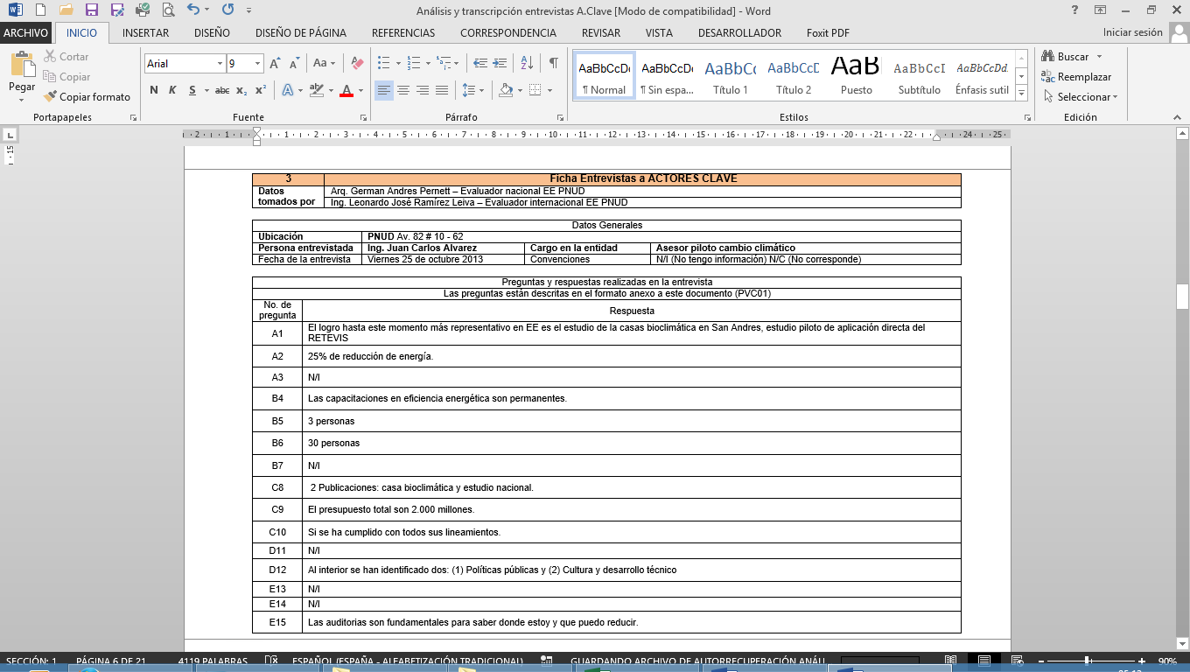

* Ing. Beatriz Chaparro e Ing. Nelson Anillo. Professionals at the Ministry of Environment and Sustainable Development. Environmental Affairs Projects. Mining and Energy Planning Unit (UPME).

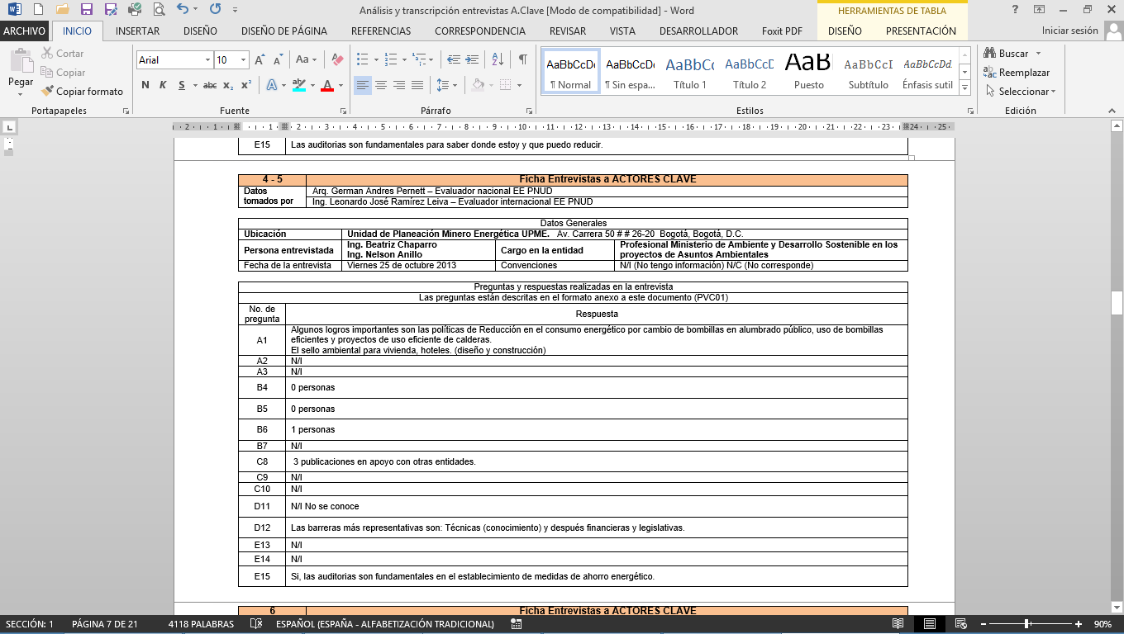

* Dr. Augusto Pinto. Coordination of Housing and Urban Development. Department of National Planning (DNP).

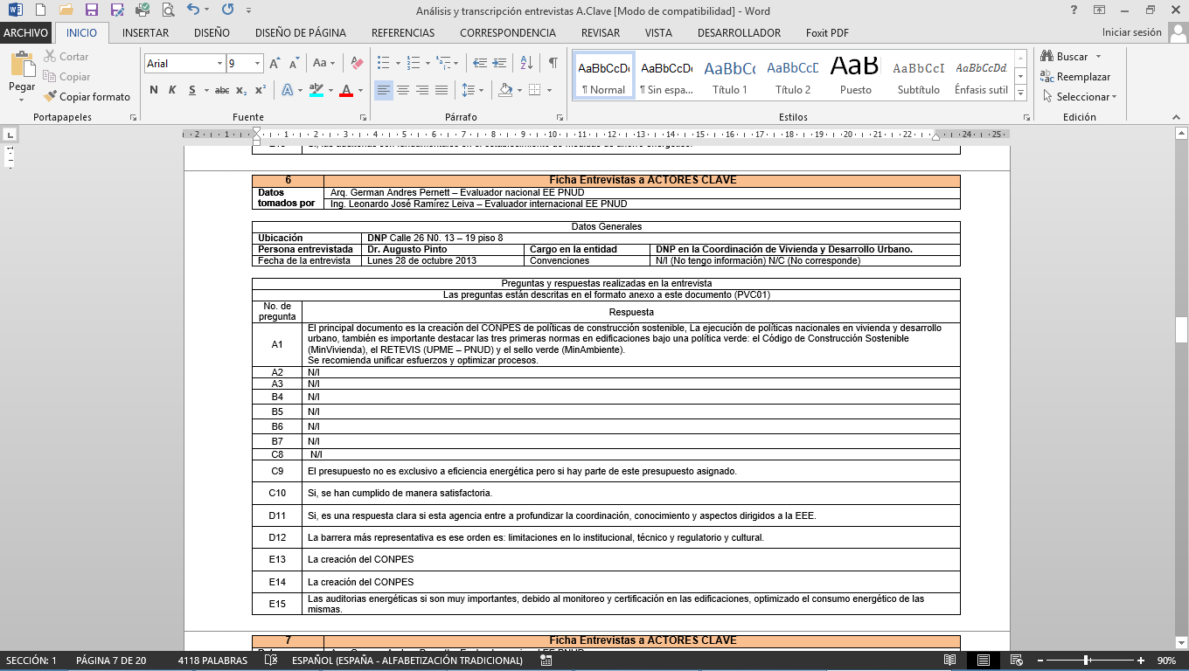

* Dr. Doris Arévalo. Director Department of Business. Bancoldex.

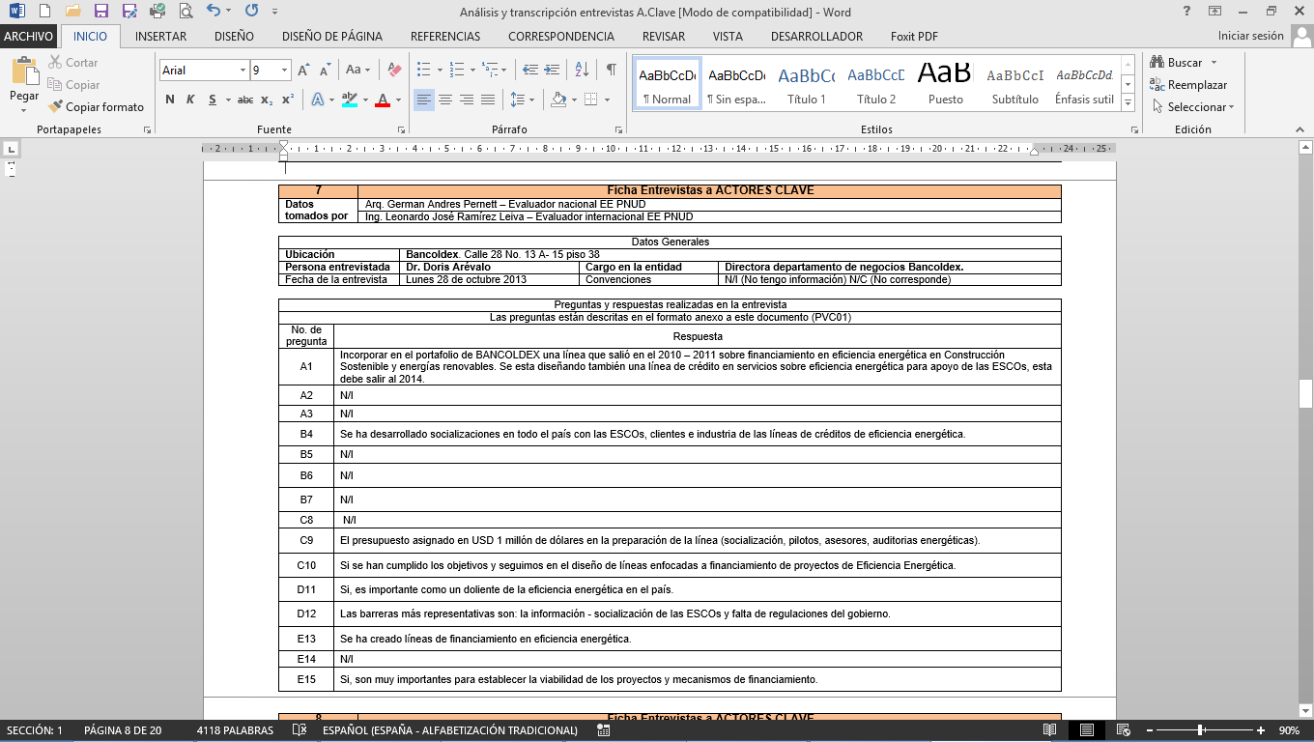

* Ing. Omar Baez. Professional in Energy Efficiency. Mines and Energy Planning Unit (UPME).

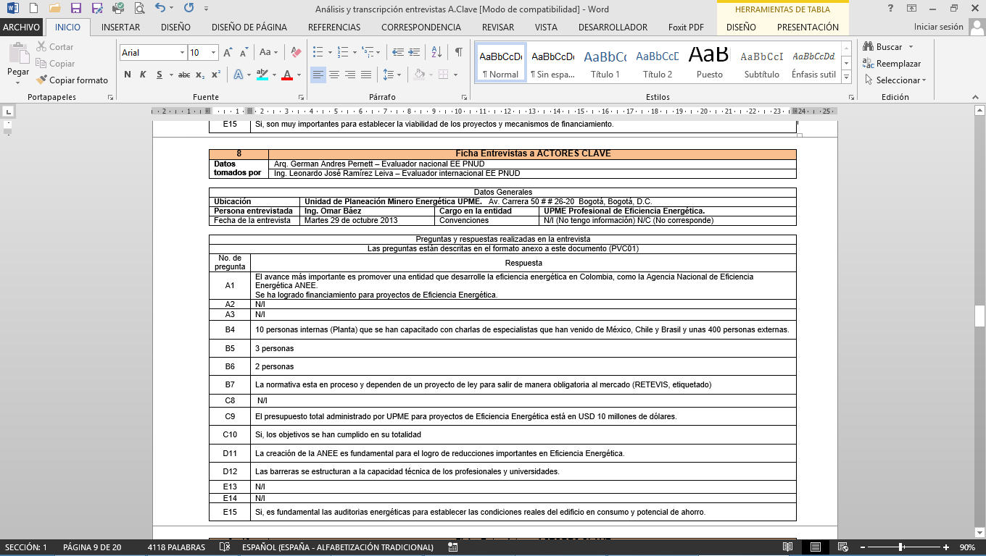

* Eng. Cristina Mariaca & Eng.  Leidi Suarez. Director. Ozone Technical Unit (UTO).

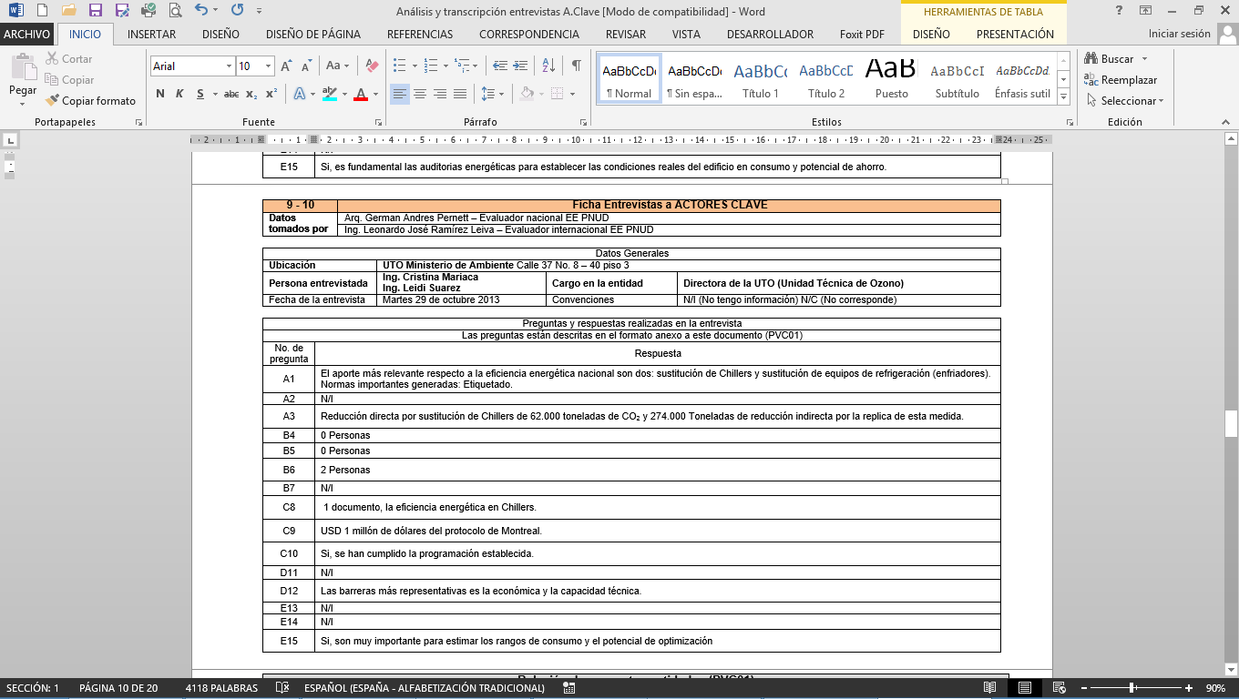

* Ms. Laura Maria Aranguren Niño. Climate Change Officer. Ministry of Environment and Sustainable Development (MADS).

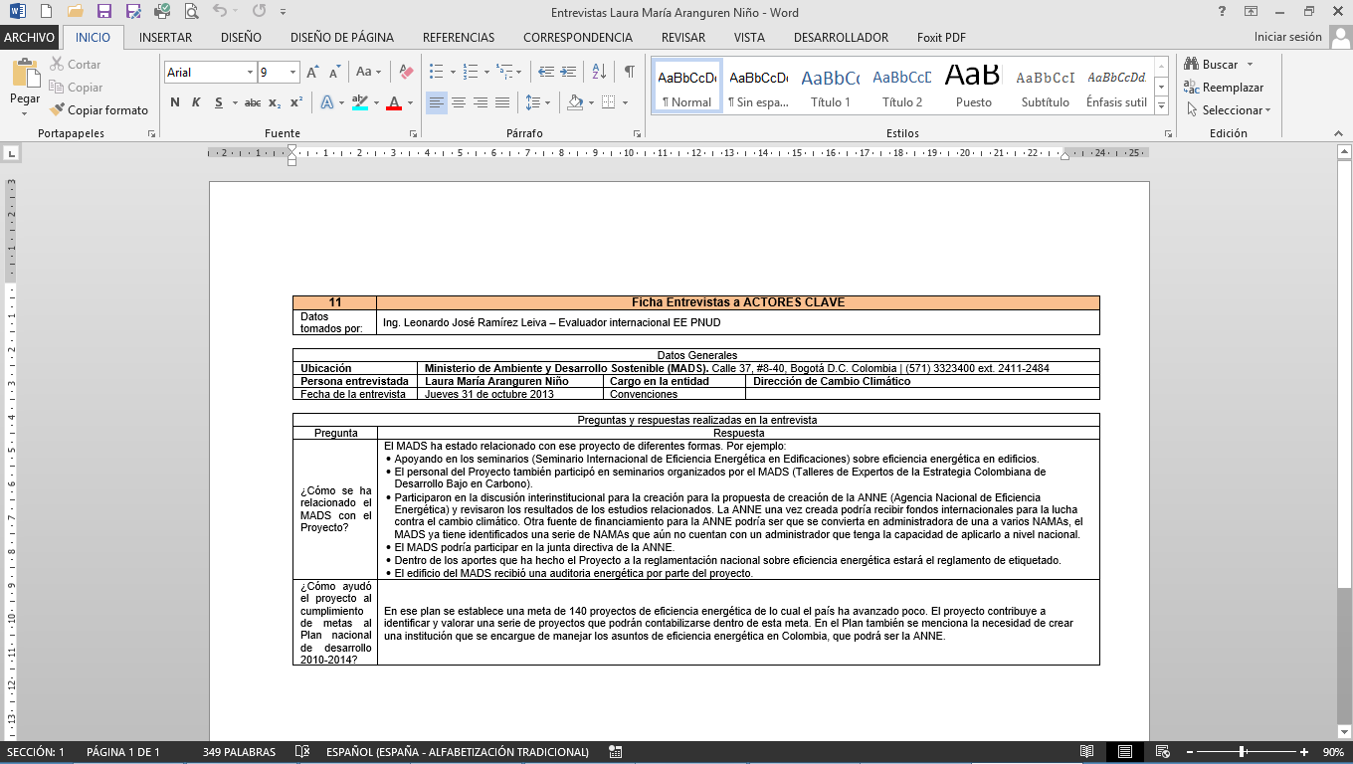

* **Summary of Results**

**Note:** The answers respond to a given position on the part of an officer of the institution visited, but do not represent the definite position of the corresponding institution with regard to the topics covered.

|  |
| --- |
| **1. Strengthening of institutions responsible for promoting energy efficiency in Colombia:**  This analysis is based on questions about the implementation of new models of management and control of energy consumption: |
| Question 1 of analysis.  Within the "Rational and Efficient Use of Energy" program, which have been the most notable achievements at the local, national and/or international levels (Standards, projects, training)? (1)  Question 2 of analysis.  How many people are working in EE under permanent dedication now? (5)  Question 3 of analysis.  How many people are working part-time now (6)  Aspects to be evaluated in the responses:  Evaluating the most significant aspects achieved during the time of development of project No. 70467 Energy Efficiency in Buildings. |





Source: own preparation chart. Source: own preparation chart.

Conclusions:

The most significant achievement of project 70467 in the area of energy efficiency (37.5 %) is given by the creation and development of regulations and policies. For instance, various aspects such as:

* The formulation and development of the National Energy Efficiency Agency as a public-private initiative.
* The interministry coordination and integration (MinMinas, MinVivienda, MinAmbiente) and the private sector (ANDI, Bancoldex)
* The creation of regulations such as the Technical Regulation of Social Housing (RETEVIS)
* The introduction to the country of new concepts of energy efficiency for emission reduction.
* The incorporation to key public agencies (UPME, MADS) of staff specialized in energy efficiency.

|  |
| --- |
| **2. Policies and regulations that promote energy efficiency in Colombia:**  This analysis is based on questions about the implementation of new models of management and control of energy consumption: |
| Question 1 of analysis.  Number of guides, publications, tools, and internal and external training developed and available to support the implementation of EE in buildings (8).  Question 2 of analysis.  Did you have a budget allocated to programs, trainings and projects in EE? (9)  Question 3 of analysis.  In relation to the creation of the National Energy Efficiency Agency, do you find that its creation is a clear answer to the optimization of energy consumption at a national level, in the transportation, industrial, commercial and residential sectors? (11)  Aspects to be evaluated in the responses:  Evaluating the most significant aspects achieved during the time of development of project No. 70467 Energy Efficiency in Buildings. |



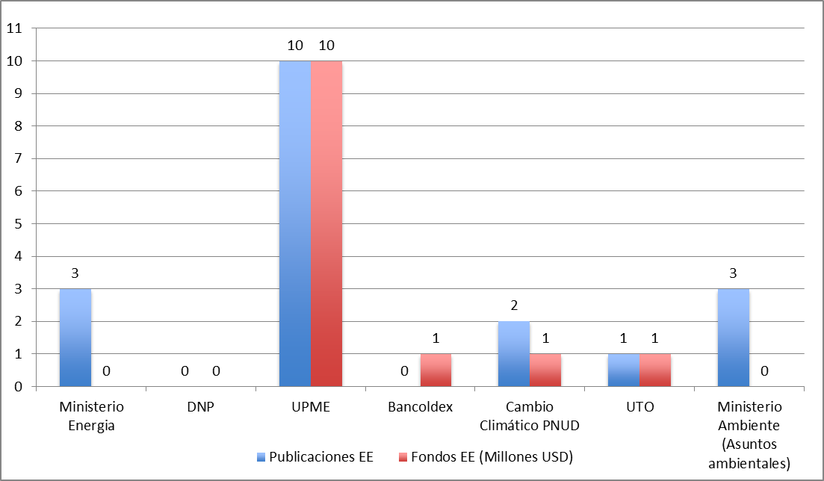

Source: own preparation chart.

Conclusions:

UPME (Mines and Energy Planning Unit) has led the processes of EE documentation and training in Colombia, resulting in 10 documents on Energy Efficiency in 3 years and trainings with national and international speakers and with the participation of more than 800 people in the country. In this effort both the Ministry of Mines and Energy and the Ministry of Environment and Sustainable Development have participated.

Although the effort was important, there is still a need of more regulations and training to increase EE penetration in the country, to fill a gap in the majority of professionals and managers operating in the domestic energy sector.

|  |
| --- |
| **3. Level of expertise in energy efficiency in Colombia:** |
| Question 1 of analysis.  Number of Technicians (architects, engineers, official) that have been trained in topics of energy efficiency (EE) in buildings in the past 10 years and what projects you have in planning for this purpose. (4). |



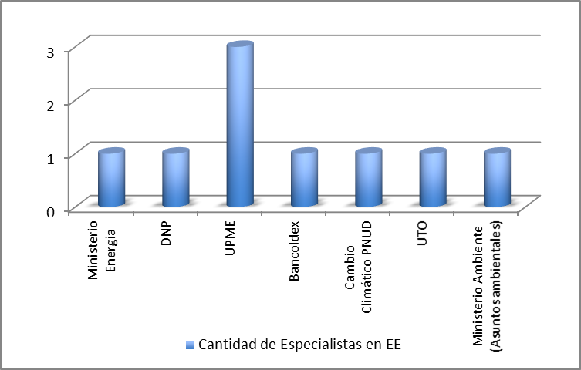

Source: own preparation.

Conclusions:

The Colombian industry, specifically the one led by the construction sector, has energy experts, but there is a lack of experts and specialists in energy efficiency. It is important to increase the efforts for training these professionals in EE matters.

## Annex 5: List of persons interviewed

|  |  |  |  |
| --- | --- | --- | --- |
| **Listing of interviews conducted in the framework of the**  **Final Evaluation of Project No. 70467 Energy Efficiency in Buildings.** | | | |
| **No.** | **Entity** | **Place of interview** | **Person interviewed** |
| **1** | Ministry of Mines and Energy | Calle 43 No. 57 - 31 CAN - Bogota D.C. , Colombia | PBX: (57) +1 220 0300 | Ing. Luis Fernando Lopez |
| **2** | Mines and Energy Planning Unit | Av. Carrera 50 # # 26-20Bogota, Bogotá, D. C. | Ing. Olga Victoria Gonzalez |
| **3** | United Nations Development Program | UNDP Av 82 # 10 - 62 | Ing. Juan Carlos Alvarez |
| **4 - 5** | Mines and Energy Planning Unit | Av. Carrera 50 # # 26-20Bogota, Bogotá, D. C. | Ing. Beatriz Chaparro  Ing. Nelson Anillo |
| **6** | Ministry of Housing, City and Territory | DNP 26 Calle No. 13 - 19 floor 8 | Dr. Augusto Pinto |
| **7** | Bancoldex | Calle 28 No. 13 A - 15 floor 38 | Dr. Doris Arévalo |
| **8** | Mines and Energy Planning Unit | Av. Carrera 50 # # 26-20Bogota, Bogotá, D. C. | Ing. Omar Baez |
| **9 - 10** | Ozone Technical Unit. Ministry of Environment | Calle 37 No. 8 - 40 floor 3 | Ing. Cristina Mariaca  Ing. Leidy Suarez |
| **11** | Ministry of Environment and Sustainable Development. Climate Change Initiative | Calle 37, # 8-40, Bogotá D.C. Colombia | Ing. Laura Maria Aranguren Niño |
| **12** | National University | Avenida Carrera 30 # 45, Bogotá, 111321 Cundinamarca, Colombia | Prof. Arq. Esperanza Caro |

## Annex 6: List of Revised Documents

**Project Documents**

* Project Document (PRODOC).
* Terms of Reference.
* Report of Kick-off Workshop.
* Report of Mid-Term Evaluation
* UNDP Evaluation Guidance for GEF-financed projects (March 17, 2011).
* Manual for Planning, Monitoring and Evaluation of Development Results (UNDP).
* Annual Project Review (APR) & Project Implementation Review (PIR) 2011.
* Annual Project Review (APR) & Project Implementation Review (PIR) 2012.
* Annual Project Review (APR) & Project Implementation Review (PIR) 2013.
* Annual Work Plan 2010.
* Annual Work Plan 2011.
* Annual Work Plan 2012.
* Annual Work Plan 2013.
* Combined Delivery Report 2010 and 2011.
* Combined Delivery Report 2012.
* Expense List 2013.
* Request for Information #1.
* Request for Information #2.
* Implementation of Government co-financing.
* Detail of GEF resources to be executed in 2013.
* Letter of counterpart- UNDP Colombia.
* Steering Committee Meetings:
* Act No. 1 "Kick-off Workshop" (June 28, 2010).
* Act No. 2 January 26, 2011.
* Act No. 3 December 09, 2011.
* Act No. 4 "Follow-up Meeting" (September 07, 2012).
* Act No. 5 January 09, 2013.
* Follow-up quarterly meetings:
* Report Follow-up meeting UNDP-UPME (September 17, 2010).
* Act No. 2 June 01, 2011.
* Act No. 3 October 14, 2011.
* Act No. 4 (Act No. 5) (April 18, 2012).
* Act No. 5 (Act No. 6) (July 06, 2012).
* Act No. 6 October 11, 2012.
* Act No. 7 (April 08, 2013).
* Act No. 8 (June 28, 2013).
* Act No. 9 October 30, 2013.
* Quarterly Plans:
* April - June 2011.
* October - December 2011.
* April – June 2012.
* July - September 2012.
* October - December 2012.
* April- June 2013.
* July - September 2013.
* October - December 2013.
* Quarterly Report:
* July- December 2010.
* January- March 2011
* April- June 2011.
* July- September 2011.
* January- April 2012.
* April- June 2012.
* July- September 2012.
* October- December 2012.
* January- March 2013.
* April- June 2013.
* July- September 2013.
* PROURE: Indicative Action Plan 2010-2015.
* Draft Document Program for Colombia (2008-2012).
* Framework of the United Nations Development Assistance 2008-2012.
* Matrix UNDAF 2012-2014.
* Financial Mechanisms and instruments for energy efficiency projects in Colombia.
* Characterization of the Residential Energy Sector- Urban and Rural Areas in Colombia - Final Report Volume I - Methodology and analysis.
* Characterization of the Residential Energy Sector- Urban and Rural Areas in Colombia - Final Report Volume II - Thermal characterization by floor.
* Characterization of the Residential Energy Sector- Urban and Rural Areas in Colombia - Final Report Volume III - Characterization by regions.

**Products of the Project - Activity 1**

* Final Report "Definition and development of a successful strategy to enable the launching of an institutional arrangement, on the basis of the findings and recommendations of the study conducted by GEF/UNDP Project/COL 70467 ".
* First deliverable of Contract No. 0000010656 2011 (NEEA).
* Second deliverable of Contract No. 0000010656 2011 (NEEA).
* Third deliverable of Contract No. 0000010656 2011 - Final Report (NEEA).
* Memorandum of Understanding for the creation of a model of partnership to design, develop, promote, and implement energy efficiency projects - Chapter Industry.
* Record of discussions between representatives from the Deutsche Gesellschaft Fϋr Internationale Zusammenarbeit (GIZ) GMBH (German Development Cooperation), Office representation in Mexico; the Mexican Agency of International Cooperation for Development; the Institute of the National Housing Fund for Workers and the Presidential Agency for International Cooperation of Colombia, relating to the Triangular Cooperation between Mexico, Germany and Colombia for the project "Sustainable Housing in the area of energy efficiency and environmental improvement".

**Products of the project - Activity 2**

* Market opportunities for Clean Energy and Energy Efficiency (OPEN).
* Definition and inclusion of criteria for energy efficiency for the design of the Adaptive Bioclimatic House in the Archipelago of San Andres.
* Consultancy for the design of financial and economic models that allows the management of financial resources for the National Program for Replacement of Domestic Refrigerators that still are working with CFCs, by non-ODS and energy efficient equipment in Colombia. Document 3 - Final Report.
* "Strategies for energy efficiency in buildings in Colombia that serve as input for the construction of a national policy" - Final Delivery (compilation of 3 deliveries).
* Methodology for the preparation of national appropriate mitigation actions (NAMAS) with criteria for energy efficiency in the rehabilitation of buildings in Colombia.
* Mitigation of emissions of greenhouse gases through the implementation of energy efficiency measures, in the sub-sectors: hotels and hospitals - Workshop "Financial Intermediaries".
* Project COL/70467 "Process No. 2013 - 043 Technical Assistance to optimize the energy performance and comfort conditions in social interest housing units, considering the technical design, architectural and urban development of a housing project" - Array of conclusions.
* Project COL/70467 "Process No. 2013 - 043 - Technical Assistance to optimize the energy performance and comfort conditions in social interest housing units, considering the technical design, architectural and urban development of a housing project" - Final Report.
* Project COL/70467 "Process No. 2013 - 043 - Technical Assistance to optimize the energy performance and comfort conditions in social interest housing units, considering the technical design, architectural and urban development of a housing project project" - Executive Summary of the Final Report.
* Summary table of opportunities and actions for energy management.
* URE-VIS Diagram.
* Determination of the Number URE-VIS
* Design and socialization of the Technical Proposal for a Regulation of Energy Efficiency for Social Interest Housing - approach and content of the proposal.
* Design and socialization of the Technical Proposal for a Regulation of Energy Efficiency for Social Interest Housing - Determination of the Diagram and Number URE-VIS.
* Design and socialization of the Technical Proposal for a Regulation of Energy Efficiency for Social Interest Housing - Use of simulation programs.
* Design and socialization of the Technical Proposal for a Regulation of Energy Efficiency for Social Interest Housing - Technical Support Document.
* "Determination of physical properties, and estimation of the energy consumption in the production of steel, concrete, glass, brick and other materials, including other alternative and non-traditional ones, used in the construction of Colombian buildings" and the "technical proposal for a regulation of energy efficiency for social interest housing" - Final Report.
* Software for computer calculation of energy consumption and parameters of comfort in the life cycle of social housing.

**Products of the project - Activity 3**

* Proposals for financial schemes applicable to energy efficiency projects and non-conventional sources of energy.
* List of seminars.
* Energy Audit - Area Metropolitana del Valle de Aburra - Report N°2.
* Energy Audit - Corporación Autónoma Regional de Antioquía-Corantioquia - Report N°2.
* Energy Audit - Gobernación de Antioquia - Final Report
* Energy Audit – Premises of the Ministerio de Ambiente y Desarrollo Sostenible.
* Energy Audit - Ministerio de Minas y Energía - Final Report
* Energy Audit - Corporación Regional Autónoma del Magdalena (CORPAMAG) - Final Report.
* Energy Audit - Corporación Regional Autónoma del Atlántico (CRA) - Final Report.
* Energy Audit - Gobernación del Atlántico - Final Report.
* Energy Audit - Alcaldía Distrital de Barranquilla - Final Report.
* Energy Audit - Alcaldía Municipal de Quibdó - Final Report.
* Energy Audit - Corporación Autónoma Regional del Valle del Cauca (CVC).
* Energy Audit - Alcaldía de Valledupar - Final Report.
* Energy Audit - Corporación Autónoma Regional del Cesar (Corpocesar) - Final Report.
* Energy Audit - Corporación Autónoma Regional de la Guajira (Corpoguajira) - Final Report.
* Energy Audit - Corporación Autónoma Regional de Norte de Santander (Corponor) - Final Report.
* Energy Audit - Corporación Autónoma Regional de los Valles del Sinú y San Jorge - Final Report.
* Energy Audit - Gobernación de Bolívar - Final Report.
* Energy Audit - Gobernación del Cesar - Final Report.
* Energy Audit - Gobernación de Sucre - Final Report.
* Energy Audit - Gobernación de Norte de Santander - Final Report.
* Energy Audit - Instalaciones de la Secretaría de Salud de Santiago de Cali. Final Report
* Energy Audit - Secretaría de Salud de Sucre - Final Report.

**Products of the project - Activity 4**

* Energy Audit - Alcaldía Municipal de la Ciudad de Medellín - Report N° 2.
* Energy Audit - Edificio José Félix de Restrepo (Palacio de Justicia de Medellín) - Report N°2.
* Energy Audit - Banco de la República Sede Barranquilla.
* Energy Audit - Ciudad Universitaria de Antioquía de Medellín - Final Report.
* Energy Audit - Centro de Convenciones de Cartagena de Indias- Final Report
* Energy Audit - DIAN de la Ciudad de Medellín – Report N°2.
* Auditoría Energética - Edificio Vicente Uribe Rendón de la Ciudad de Medellín - Report N°2.
* General Model for the financial structuring of projects and technological replacement with ODS-free and energy efficient air-conditioners in the Colombian market. Model for the financial structuring of outsourcing services for the air conditioning market in Colombia.
* Guide for energy efficient and environmental coolers based on water-Chillers.
* List of CFC-based chillers identified in Colombia in December 2010.
* Technical characterization of chillers, cold water pumps, water pump condensation, cooling towers and air handling units in Colombia.
* Characterization of the Chillers Sector in Colombia to be used in a Replacement Project in the framework of the Montreal Protocol.

## Appendix 7: Project Benchmark Indicators

| **Project Strategy** | | **Objectively verifiable indicators** | | |
| --- | --- | --- | --- | --- |
| **Indicator**  **(Quantified and in time)** | **Baseline** | **Goal** |
| **Result** | Reducing greenhouse gas emissions from the buildings sector in Colombia through the implementation of an integrated package of activities that improve the energy efficiency of commercial, residential and public buildings. An associated result will be the reduction in emissions of ozone-depleting substances from CFC-based centrifugal chillers. | (1) direct emissions of CO2 avoided. (2) indirect emissions of CO2 avoided (tons CO2). | (1) direct emissions of CO2 are not avoided. (2) indirect emissions of CO2 are not avoided (tons CO2). | (1) direct emissions avoided: 62.000 tons CO2. (2) indirect emissions avoided due to the replication: 124.400 tons CO2. Due to the transformation of the market: 150.000 tons CO2. |
| **Objective of the project** | Promoting energy efficiency in buildings by eliminating institutional, legal and regulatory, and technical capability barriers that currently restrict its large-scale adoption. | (1) market transformation (scale 1 ... 4). (2) Adoption of policies (scale 1 ... 4). (3) volume of savings of energy (MWh). (4) investment (US$). (5) Number of lending institutions. | (1) market transformation: 1. (2) Adoption of policies: 1. (3) Energy saved: 0 MWh. (4) Investments: US$ 0. (5). Number of lending institutions: 1 (Bancoldex-URE). | (1) market transformation: 3. (2) Adoption of policies: 4. (3) Energy saved: 88.600 MWh. (4) Investment (direct) US$ 3.2 M. (5). Number of lending institutions: 1 (Bancoldex-URE). |
| **Result 1** | **Government institutions responsible for promoting energy efficiency strengthened** | | | |
| 1.1 | An EE ad-hoc group established at UPME. | Number of professionals added to UPME by the project; total time devoted to UPME in developing EE policies and programs and to the preparation of the NEEA. | The capacity of UPME to prepare and execute programs for energy efficiency (EE) and to prepare a national agency for EE will be limited. | The capacity will be expanded at UPME by 6.0 person-year, so that the development of EE programs and NEEA can be done in an appropriate manner.  The exit strategy involves the integration of this group to the NEEA. |
| 1.2 | A national agency for EE with a mandate to implement and promote EE programs and policies is designated and a proposal of law is presented for its creation. | Approval of the law proposal for ANNE; approval of the business plan and budget for the ANNE; formal creation and operation of the Anne. | There is no current legislation for the creation of the ANNE; there is not a business plan, ANNE is not created. | A proposal of law (1) shall be drawn up allowing for the creation of the ANNE on the part of the State. An appropriate business plan (1) is available. Ultimately, a bill provides that the ANNE is put formally in operation at the end of the project. |
| **Result 2** | **Policies, regulations and standards to promote energy efficiency in buildings developed and implemented** | | | |
| 2.1 | The PROURE Program has been strengthened by the development and implementation of specific regulations to promote EE in buildings, including: (i) provision of energy services for public and private buildings; (ii) energy audits; (iii) certification of professionals of energy; (iv) energy services companies (ESCOs). | List of regulations and documents that describe activities and programs of EE under PROURE. | Lack of regulations and programs that promote specific EE in buildings. | It has been developed and implemented specific regulation in all cases (i…iv). |
| 2.2 | National Standards for EE in buildings developed, including energy audits and energy management. | Number of national standards for EE in buildings completed; decreed national standards for EE; the amount of energy audits carried out per year; number of feasibility studies for large HVAC conducted per year. | No national standard for EE in buildings in force. Energy audits, energy management plans and feasibility studies for large investments in EE in buildings hardly will be developed. | Three (3) standards developed, e.g. thermal quality of buildings. Developed protocol for energy audits in buildings. Developed guidelines for energy management plans. |
| 2.3 | Incentives for investment in EE analyzed by UPME as an input for the development of policies. | Support policies document providing recommendations on appropriate incentives, including an analysis of economic aspects of sustainability. | During the time horizon of the project, little or no work will be to prepare a financial incentive for investment in EE in buildings. | It has been handed a document in support of policies analyzing financial incentives for EE in buildings. |
| **Result 3** | **Technical Knowledge and capabilities of key players improved** | | | |
| 3.1 | Awareness and information on EE among construction engineers, architects, compliance officials, providers and consumers of products of EE, improved. | Production of training materials and information; preparation and implementation of training courses; number of skilled professionals. | Knowledge and technical skills inadequate among key professionals, suppliers and potential customers. | Training Material and information has been produced and distributed to key professionals, suppliers and customers; courses have been prepared and executed on EE matters for key professionals and suppliers; at least 75 professionals have been trained. |
| 3.2 | A program of technical assistance for the replacement of inefficient and CFC-based chillers implemented. | Design of a program of technical assistance (TA) to replace inefficient chillers that use CFCs; implementation of the TA program; delivery of feasibility studies for the replacement of HVAC installations, | Inefficient Chillers based on CFCs are replaced after having reached their useful life. | It has been designed and implemented a TA program. The exit strategy provides for the continuation of the TA program through the ANNE and the participation of the private sector.  Delivery of at least 10 feasibility studies for projects of replacement of HVAC. |
| 3.3 | Project Guides, analytical tools, and documentation of the products compiled and disseminated. | Development of technical guidelines for projects involving large chillers, availability of guidelines (documents, AV material) among key players. | There are no guidelines among the key actors in Colombia. | Material is available among at least 3 major suppliers and in 10 major cities in Colombia. |
| **Result 4** | **Energy savings through the replacement of chillers carried out** | | | |
| 4.1 | Selection of mechanisms for requesting project proposals for the replacement of chillers, including the development of a replication portfolio. | (1) Tender (or protocol) to receive proposals for replacement of chillers; (2) amount of projects accepted for replacement of chillers; (3) The total number of projects under development; (4) amount of capital committed for replication. | (1) there is no formal mechanism of selection; (2) projects for replacement of chillers are not accepted; (3) existing list of 58 identified chiller projects; (4) there is no capital for replication. | (1) Tender for projects issued under a replicable mechanism; (2) At least 13 projects of chillers replacement accepted for implementation; (3) At least 25 projects under development for replication; (4) Indicative US$ 4M committed for replication. |
| 4.2 | Investments confirmed for 13 projects of chillers with financing committed (credits) and support from the Multilateral Fund of the Montreal Protocol. | Amount of chillers which are inefficient and CFC-based replaced under the TA support Project; total capacity of cooling (tons, BTU) replaced. | Chillers were not replaced. | At least 13 chillers replaced, minimum capacity target 3,000 TR |
| 4.3 | Reports of operational performance of the replacement of 13 chillers documented. | Direct emissions avoided by the selected chillers projects. | (1) measurement of energy consumed by obsolete chillers; (2) Emissions (GHG) according to the existing technology. | (1) measurement of energy consumed by the new chillers; (2) Emissions (GHG) according to modernized technology. |
| **Result 5** | **Monitoring and evaluation plan implemented** | | | |
| 5.1 | Monitoring and evaluation plan implemented. | Requirements described in the Monitoring and Evaluation Plan, including: periodic reviews by UNDP and GEF, delivery of reports by the project to UNDP CO, implementation of a mid-term evaluation and a final evaluation. | A monitoring plan has been included in the PRODOC. | The monitoring plan is progressively deployed during the life of the project. At the end of the project, the monitoring plan has been implemented in its entirety. |
| 5.2 | Lessons learned collected, prepared and disseminated. | Compilation of lessons learned by UPME and independent evaluators; production of a summary of lessons learned and placed at the disposal of UNDP/GEF, the Government of Colombia and other relevant actors in Colombia. | There is little knowledge on best practices in relation to projects of EE in large-scale buildings in Colombia. Lessons learned have not been collected or distributed. | There is substantial knowledge on best practices to promote EE in buildings in Colombia.  Lessons learned have been collected and distributed. |

## Annex 8: Actions taken in relation to the recommendations of the MTE

| **Recommendations** | **Main actions**  **(Can be more than one)** | **Responsible** | **Deadline (may be undefined)** | **Status** | **Actions taken**  **(Current Situation)** |
| --- | --- | --- | --- | --- | --- |
| Extend the project beyond December 2012 | UPME formally request UNDP for the extension of the project until May 2013. A proposal should be submitted in the AWP for 2013 with the resources that should be phased out from 2012 to 2013 | UPME | October 2012 | Extension request made. The AWP 2013 was reviewed. | The project was extended until November 30, 2013. |
| Implementation of a back-up plan for the sustainability strategy taken. In particular to the creation of the NEEA. | As a result of the consulting which was carried out on the subject, the proposed solution was an institutional arrangement in the framework of a public-private partnership. It does not require the development of a draft law. The proposal will be discussed with the Ministry of Mines and Energy | UPME - MME | Undefined | Discussions were carried out of the topic with the direction of UPME | MOU between MME-ANDI ready for signature (APP for ANNE). |
| Strengthening the capabilities of the URE and Alternate Sources Group at UPME and the executor of the project | In the restructuring of UPME, the subject of EE will be transversely incorporated in the group of demand and the subject of non conventional energy sources in the generation group, in order to incorporate and analyze all relevant impacts. | UPME | Undefined | In the process of approval | The three officials who worked on the Project Management Unit (PMU) No. 70467 received multiple training sessions on topics of energy efficiency in buildings. All of them will continue providing services to UPME: Two of them as consultants on the Labeling Project and one as financial manager of UPME. |
| Develop and implement mechanisms of knowledge management | Define and document guidelines on actions and strategies taken for energy efficiency in buildings within the framework of PROURE and lessons learned through the development of the project | UPME | May 2013 | In the process of development | Lessons learned were compiled in the Mid-Term Report and in the Final Report. According to information received from the Project Coordinator, he must also submit a report of lessons learned to UNDP, which was pending as of the date of preparation of this report. |
| Validate the experiences carried out under the implementation of the project, through demonstration pilot projects for new participants. Added schemes of financial, technical and tax incentives for EE projects in buildings, management and a greater understanding and characterization of the market | Define actions for the execution of pilot projects for adaptive housing in the Archipelago of San Andres and technical assistance to a housing project of social interest. Documenting the lessons learned from the previous years | EEB Project | March 2013 | In process | The main exercises of validation were related to the implementation of the RETEVIS in the San Andres Adaptative Housing Project and in the Social Housing Project of Soacha (Bogota). The demonstration project for replacing 13 chillers failed to perform, but in its place there was a campaign of 31 energy audits, from which the energy savings can be validated (after implementing the saving measures). As well as the resulting emission reductions. The only financial incentives that the project brought as a result were the input and advice to Bancoldex so that this institution could launch a new green line of US$50 million. |
| Strengthen the cooperation agreements, through alliances with international entities in Brazil, Mexico, Spain and other countries, materializing synergies of work with the human talent of UPME and other projects | Development of the project for triangular cooperation Alemania-Mexico -Colombia signed in September 2012 for the development of sustainable housing in energy and environmental matters. | UPME -DNP | A year from September 2012 | Developing the plan of activities (Kick-off Workshop) | Already initiated activities. |
| Strengthen working together in the topic of the project to achieve greater synergies with state entities such as MVCT, FNA, MME, MADS, academia and guilds like CAMACOL, ACIEM, SCI, CCCS, Colombian society of Architects and the CCEE, among others | Working agreement with the FNA to develop training actions in EE aimed to key actors (promoters of social interest housing- SIH). Run technical assistance for a SIH project to CAMACOL and/or FNA. | EEB Project | October 2012 | Training will take place on October 17 and 18, 2013. For technical assistance, the project with CAMACOL is under definition- Bogota Region | The workshop " Energy Efficiency in Social Housing" was held in October 2012 with the participation of 65 persons. |
| Design and implementation of mechanisms for establishing networking, facilitating its articulation with public and private entities, strengthened through synergies and with greater knowledge and characterization of the different actors | Through events and forums in EEB that strengthen the articulation of the actors. | EEB Project | Undefined | In process of development | In addition to the workshop mentioned above, the Project Coordinator has been involved in several roundtable discussions such as the Interagency Technical Bureau, participation in the tripartite working group and the discussions with the Ministry of Housing and the Ministry of Environment around the topics of RETEVIS, efficient construction materials and EE labeling. |
| Appropriating the resources necessary to accelerate the pace of work in the time remaining, including the recommended term extension. In addition, procedures must be reviewed of the institutions involved in the execution of the project | A proposal will be submitted through the AWP for 2013, with the resources that should be phased out from 2012 to 2013. UPME will make a technical contribution of resources to advance technical activities that would strengthen the implementation of new energy audits in public buildings and allow the accompaniment and subsequent evaluation of the results of these are concluded | UPME | November 2012 | In revision with UNDP - Colombia | The extension of the deadline of the project was approved, and according to the Project Coordinator and the UNDP Program Officer, as of November 01, 2013 only remained a small balance of GEF funds to be executed, corresponding to some operating expenses and the cost of the final evaluation. In 2013, UPME approved and implemented fresh resources for the amount of US$231,532 for the project. |
| Continue actions of strengthening of PROURE management. Specific actions to facilitate the implementation of standards and incentives that encourage the development of programs and projects with PROURE regulations and incentives programs for EE. | UPME promotes projects in EE, strengthening the PROURE | UPME | Undefined | In the process of development | One of the main activities that are still pending is the socialization and final approval of the RETEVIS, a process that has seen little progress in the last two years of life of the project. |
| Place in the national agenda for discussions and issue the Technical Regulation of Social Housing with criteria for energy efficiency - RETEVIS | Strengthen the definition of RETEVIS. Support to MME and MVCT in the revision of the parameters that will consolidate the proposal for a regulation | UPME | May 2013 | In the process of development | Ditto. |
| Strengthen the process of dissemination of informational guides and primers, as the Technical Guide for replacement of chillers and other guides for technical and financial implementation of efficient technologies in buildings, like the "Green Mortgage" concept, along with the transfer of knowledge and technical assistance from international experts | Finishing the publication of a technical guide for cooling fluids, which contains the proposed criteria (energy and environmental) that the agent interested in air-conditioning equipment must take into account at the time of making an investment or replacement of equipment. Run energy audits in buildings needing the replacement of obsolete chillers and then document lessons learned. | UPME | February 2013 | The process for execution of energy audits, under development | The technical guidelines for the replacement of chillers were printed and distributed directly by the project in five major cities of Colombia and at a national level by means of ACAIRE. Energy audits were contracted out to various suppliers and as of the date of preparation of this report they were already largely concluded. |
| Continue with additional actions related with the chiller demonstration project that runs UTO-MADS and complementary actions with programs of replacement of household refrigerators and air conditioning equipment | Run energy audits in buildings with chillers and document lessons learned. | UPME | February 2013 | The process for execution of energy audits, under development. | Ditto. |

## Annex 9: Analysis of energy audits

**Analysis of consumption and emissions reductions, estimated from the savings measures recommended in the energy audits (Optimization of lighting, office equipment and HVAC, best practices and architectural measures).**

A sample of 11 energy audits (a third of the total of 31 executed) was used to make a series of statistical calculations, and to determine the average value of energy savings (kWh/year) and of avoided emissions (ton CO2/year), product of the implementation of improvements in energy efficiency proposals. The result was the following:

|  |  |  |  |  |
| --- | --- | --- | --- | --- |
| **Audit #** | **Energy Savings kWh/year** | **Ton CO2/year avoided** | **Emission Factor** | **Cost of the investment (US$)** |
| 1 | 722,511.24 | 209 | 0.2893 | 151,903 |
| 2 | 153,120.00 | 60 | 0.3918 | 71,197 |
| 3 | 64,915.20 | 44 | 0.6778 | 113,440 |
| 4 | 190,164.00 | 100 | 0.5259 | 203,558 |
| 5 | 262,742.76 | 65 | 0.2474 | 42,259 |
| 6 | 22,222.20 | 6 | 0.2700 | 10,601 |
| 7 | 121,709.28 | 32 | 0.2629 | 57,799 |
| 8 | 1,407,996.00 | 390 | 0.2770 | 1,347,791 |
| 9 | 908,660.04 | 300 | 0.3302 | 616,022 |
| 10 | 62,058.84 | 13 | 0.2095 | 45,547 |
| 11 | 175,138.08 | 42 | 0.2398 | 84,558 |
| **Total 11 audits** | **4,091,237.64** | **1,261.00** | **0.3082** | **2,744,675.52** |
| **Average per audit** | **371,930.69** | **114.64** |  | **249,515.96** |
| **Total 31 audits** | **11,529,851.39** | **3,553.84** |  |  |
| **Potential for 20 years** | **230,597,027.80** | **71,076.80** |  |  |
| **Potential for 13.4 years** | **154,500,008.60** | **47,620.00** |  |  |
| **Exchange rate: (COP/US$)** | 1,900.00 |  |  |  |

Source: own preparation chart.

**Ranges of reduction of energy consumption from optimization measures, issued by the energy audits.**

|  |  |
| --- | --- |
|  | Ranges of reduction of energy consumption |
| Lighting | 6.08 % |
| HVAC | 15.55 % |
| Computers and engines | 8.74 % |
| Other | 1.60 % |
| **Total estimated Reduction** | **32.00 %** |

Source: own preparation chart.

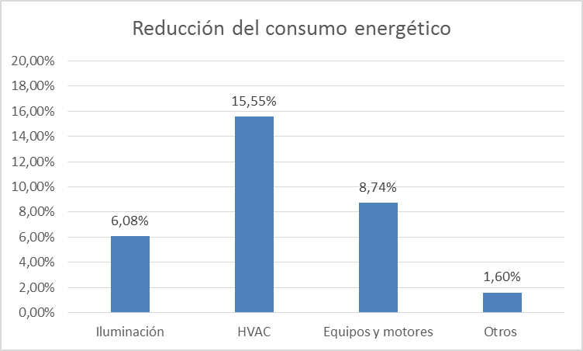

Source: own preparation chart.

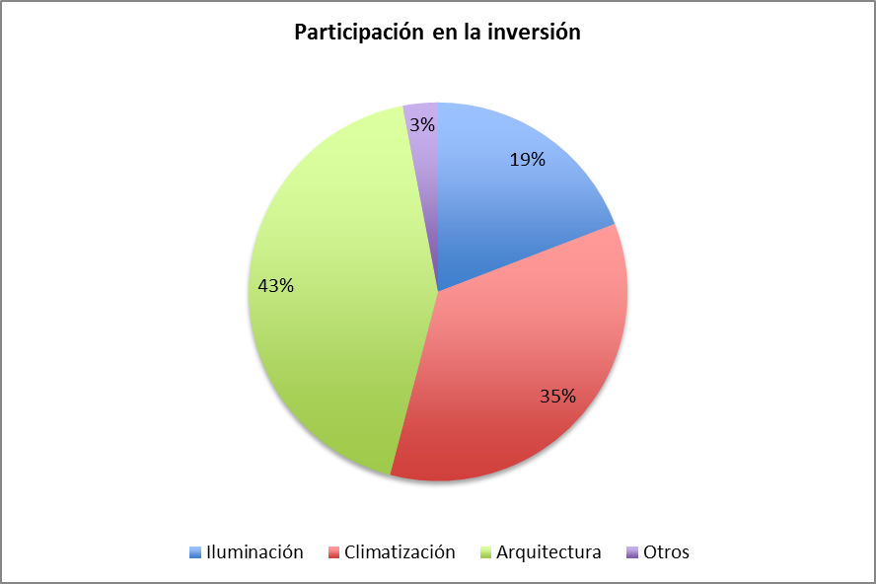

|  |  |
| --- | --- |
|  | Percentages of the total cost |
| Lighting | 19.00 % |
| Air Conditioning | 35.00 % |
| Architecture | 43.00 % |
| Other | 3.00 % |
| Total | 100.00 % |

Source: own preparation chart.

Source: own preparation chart.

## Annex 10: List of products generated by the Project

**Project Documents**

* Financial Mechanisms and instruments for energy efficiency projects in Colombia.
* Characterization of the Residential Energy Sector- Urban and Rural Areas in Colombia - Final Report Volume I - Methodology and analysis.
* Characterization of the Residential Energy Sector- Urban and Rural Areas in Colombia - Final Report Volume II - Thermal characterization by floor.
* Characterization of the Residential Energy Sector- Urban and Rural Areas in Colombia - Final Report Volume III - Characterization by regions.

**Products of the Project - Activity 1**

* Final Report "Definition and development of a successful strategy to enable the launching of an institutional arrangement, on the basis of the findings and recommendations of the study conducted by GEF/UNDP Project/COL 70467 ".
* First deliverable of Contract No. 0000010656 2011 (NEEA).
* Second deliverable of Contract No. 0000010656 2011 (NEEA).
* Third deliverable of Contract No. 0000010656 2011 - Final Report (NEEA).
* Memorandum of Understanding for the creation of a model of partnership to design, develop, promote, and implement energy efficiency projects - Chapter Industry.

**Products of the project - Activity 2**

* Definition and inclusion of criteria for energy efficiency for the design of the Adaptive Bioclimatic House in the Archipelago of San Andres.
* Consultancy for the design of financial and economic models that allows the management of financial resources for the National Program for Replacement of Domestic Refrigerators that still are working with CFCs, by non-ODS and energy efficient equipment in Colombia. Document 3 - Final Report.
* "Strategies for energy efficiency in buildings in Colombia that serve as input for the construction of a national policy" - Final Delivery (compilation of 3 deliveries).
* Methodology for the preparation of national appropriate mitigation actions (NAMAS) with criteria for energy efficiency in the rehabilitation of buildings in Colombia.
* Mitigation of emissions of greenhouse gases through the implementation of energy efficiency measures, in the sub-sectors: hotels and hospitals - Workshop "Financial Intermediaries".[20].
* Project COL/70467 "Process No. 2013 - 043 Technical Assistance to optimize the energy performance and comfort conditions in social interest housing units, considering the technical design, architectural and urban development of a housing project" - Matrix of conclusions.
* Project COL/70467 "Process No. 2013 - 043 - Technical Assistance to optimize the energy performance and comfort conditions in social interest housing units, considering the technical design, architectural and urban development of a housing project" - Final Report.
* Project COL/70467 "Process No. 2013 - 043 - Technical Assistance to optimize the energy performance and comfort conditions in social interest housing units, considering the technical design, architectural and urban development of a housing project project" - Executive Summary of the Final Report.
* Summary table of opportunities and actions for energy management.
* URE-VIS Diagram.
* Determination of the Number URE-VIS
* Design and socialization of the Technical Proposal for a Regulation of Energy Efficiency for Social Interest Housing - approach and content of the proposal.
* Design and socialization of the Technical Proposal for a Regulation of Energy Efficiency for Social Interest Housing - Determination of the Diagram and Number URE-VIS.
* Design and socialization of the Technical Proposal for a Regulation of Energy Efficiency for Social Interest Housing - Use of simulation programs.
* Design and socialization of the Technical Proposal for a Regulation of Energy Efficiency for Social Interest Housing - Technical Support Document.
* "Determination of physical properties, and estimation of the energy consumption in the production of steel, concrete, glass, brick and other materials, including other alternative and non-traditional ones, used in the construction of Colombian buildings" and the "technical proposal for a regulation of energy efficiency for social interest housing" - Final Report.
* Software for computer calculation of energy consumption and parameters of comfort in the life cycle of social housing.

**Products of the project - Activity 3**

* Proposals for financial schemes applicable to energy efficiency projects and non-conventional sources of energy.
* Energy Audit - Area Metropolitana del Valle de Aburra - Report N°2.
* Energy Audit - Corporación Autónoma Regional de Antioquía-Corantioquia - Report N°2.
* Energy Audit - Gobernación de Antioquia - Final Report
* Energy Audit – Premises of the Ministerio de Ambiente y Desarrollo Sostenible.
* Energy Audit - Ministerio de Minas y Energía - Final Report
* Energy Audit - Corporación Regional Autónoma del Magdalena (CORPAMAG) - Final Report.
* Energy Audit - Corporación Regional Autónoma del Atlántico (CRA) - Final Report.
* Energy Audit - Gobernación del Atlántico - Final Report.
* Energy Audit - Alcaldía Distrital de Barranquilla - Final Report.
* Energy Audit - Alcaldía Municipal de Quibdó - Final Report.
* Energy Audit - Corporación Autónoma Regional del Valle del Cauca (CVC).
* Energy Audit - Alcaldía de Valledupar - Final Report.
* Energy Audit - Corporación Autónoma Regional del Cesar (Corpocesar) - Final Report.
* Energy Audit - Corporación Autónoma Regional de la Guajira (Corpoguajira) - Final Report.
* Energy Audit - Corporación Autónoma Regional de Norte de Santander (Corponor) - Final Report.
* Energy Audit - Corporación Autónoma Regional de los Valles del Sinú y San Jorge - Final Report.
* Energy Audit - Gobernación de Bolívar - Final Report.
* Energy Audit - Gobernación del Cesar - Final Report.
* Energy Audit - Gobernación de Sucre - Final Report.
* Energy Audit - Gobernación de Norte de Santander - Final Report.
* Energy Audit - Instalaciones de la Secretaría de Salud de Santiago de Cali. Final Report
* Energy Audit - Secretaría de Salud de Sucre - Final Report.

**Products of the project - Activity 4**

* Energy Audit - Alcaldía Municipal de la Ciudad de Medellín - Report N° 2.
* Energy Audit - Edificio José Félix de Restrepo (Palacio de Justicia de Medellín) - Report N°2.
* Energy Audit - Banco de la República Sede Barranquilla.
* Energy Audit - Ciudad Universitaria de Antioquía de Medellín - Final Report.
* Energy Audit - Centro de Convenciones de Cartagena de Indias- Final Report
* Energy Audit - DIAN de la Ciudad de Medellín – Report N°2.
* Auditoría Energética - Edificio Vicente Uribe Rendón de la Ciudad de Medellín - Report N°2.
* General Model for the financial structuring of projects and technological replacement with ODS-free and energy efficient air-conditioners in the Colombian market. Model for the financial structuring of outsourcing services for the air conditioning market in Colombia.
* Guide for energy efficient and environmental coolers based on water-Chillers.
* Characterization of the Chillers Sector in Colombia to be used in a Replacement Project in the framework of the Montreal Protocol.

## Annex 11: List of seminars and workshops conducted by the Project

* International Seminar on Energy Efficiency in Buildings.

Date: November 2 and 3, 2011.

Location: Hotel Bogota Marriott (Bogota).

Participants: 179.

Content:

* Policy and instruments of Energy Efficiency - Architectural Design and alternative energies - materials for construction applications for efficient energy use in buildings - Equipment for Energy Efficiency in Buildings.
* Methodological proposal for the design of a technical regulation of Energy Efficiency for social interest housing in Colombia. Mines and Energy Planning Unit. UPME.
* Green Mortgage Program. Improvements in the quality of life with the use of efficient technologies. Infonavit. Case Mexico.
* Certification Program for Sustainable Buildings. National Agency for Standardization and Certification of Buildings and Construction. Case Mexico.
* New Headquarters of Rochester College. LEED Project sustainable construction.
* Hospital San Vicente de Paul. Incidence of architectural design and natural and mechanical ventilation, in the energy efficiency of the building.
* Building ISAGEN. The design and construction materials.
* Building 3M. Energy Efficiency in Buildings.
* The Living Building Challenge. Sustainable Construction and Energy Efficiency in Buildings. International Living Building Institute of Oregon, USA.
* Green covers as air-conditioning systems. Case Mexico.
* The future of the construction materials, a step toward the environmental and economic sustainability of the construction. Case in point: Colombia.
* The use of concrete as an element of energy efficiency. Holcim Mexico.
* Efficient Lighting and the myths and realities of LED lighting. Costa Rica.
* Sustainable Buildings and the use of air conditioning in the light of energy efficiency. Case in point: Colombia.
* National Code for Energy Conservation.  Global Services International Code Council (ICC) Washington. United States.
* Seminar Financial Mechanisms and instruments for energy efficiency projects in Colombia.

Date: May 12 and 13, 2011

Location: Hotel DannCarlton (Bogota)

Participants: 144.

Content:

* International Cooperation on Environment and Energy. Case Japan.
* Initiatives for the promotion of energy efficiency projects and reducing emissions of greenhouse gases.
* Financing Energy Efficiency: Experiences of International Corporation.
* Financial Mechanisms for Energy Efficiency in the international context. Case Mexico.
* Indicative Action Plan PROURE 2010-2015. Case in point: Colombia.
* Colombian Strategy Development on Low Carbon. Case in point: Colombia.
* Financing Options for a National Agency for Energy Efficiency. Case Chile.
* Proposals for financial schemes to enable energy efficiency projects and non-conventional sources of energy in Colombia.
* Performance contracts for projects of Rational and Efficient Use of Energy-URE.
* Financing Mechanisms for projects of rational and efficient use of energy. Case Bancoldex.
* Business Strategy and environmental mechanisms to support energy efficient. Bancolombia Case.
* Funding for energy efficiency projects. Case, Brazil.
* Carbon Markets and Opportunities for energy efficiency.
* Financial Mechanisms of the ESCOs for the implementation of energy management systems.
* Energy efficiency and sustainable construction. Case in point: Colombia.
* Solatube lighting technology. Productive Sector. Case in point: Colombia.
* Energy efficiency cogeneration projects. Case in point: Colombia.
* Energy Efficiency course on social housing.

Date: October 17 and 18, 2012

Location: Hotel Estelar La Feria (Bogota)

Attendees: 65.

Content:

* Introduction
* Estimation of the energy consumption of a typical SIH building.
* The various mechanical and electrical systems in buildings.
* Thermal Basics in SIH buildings
* Passive energy-saving measures in SIH buildings.
* Design, compactness and orientation.
* Insulation of doors and windows.
* Isolation of vertical and horizontal parameters.
* New Eco-materials for the construction of housing in Colombia.
* Active savings measures in SIH buildings
* Major initiatives of savings and efficiency in air conditioning.
* Major initiatives of savings and efficiency in lighting.
* Major initiatives of savings and efficiency in the production of hot water.
* Automation and Control
* Cost-benefit-analysis
* EE investments in SIH buildings.
* Return of investment in SIH buildings
* Preparation of projects in energy efficiency.
* Selection of measures.
* Presentation of savings estimates.
* Submission of return on investment.
* Maintenance costs.
* Practical examples.
* Two buildings of similar construction but distinct energy performances. Explanation.
* The impact of different energy efficiency measures in the annual energy consumption of a building.
* Financial analysis.

## Annex 12: Indicators, targets and results achieved by the Project

**Indicators, targets and results achieved by the Project**

**Results achieved as of October 31, 2013,   
Projected as of September 30, 2013 (closing date of the Project)**

|  | **Indicator** | **Baseline** | **Goal** | **Reached** | **% Advancement** |
| --- | --- | --- | --- | --- | --- |
| **1. Government institutions responsible for promoting EE, strengthened.** | | | | | |
| 1.1. An EE ad-hoc group established at UPME. | * Number of professionals added to UPME by the project; * Total time devoted to UPME in developing EE policies and programs and to the preparation of the NEEA. | * The capacity and time of UPME to develop those tasks is limited. | * The capacity will be expanded at UPME by 6.0 person-year. * The exit strategy involves the integration of this group to the NEEA. | * The capacity at UPME was increased by 3 person-year, and 2 more existing staff was assigned part-time. (a) * The 3 Project officials are going to continue working on projects related within UPME, although NEEA does not exist yet. | * Assuming the 3 persons of the project working full-time, plus the 2 persons from UPME working part-time (50 %), a total of equivalent 4 persons are working on EE. That is to say, a **67% compliance**. |
| 1.2 . A national agency (NEEA), with mandate to implement and promote programs and policies for EE, has been designed, and a proposal of law for its incorporation, has been submitted. | * Approved proposal for NEEA * Business Plan and budget approved NEEA * Formal creation and operation of the NEEA. | * None of those objectives are reached. | * There is a draft law proposal to create NEEA. * There is a business plan. * The ANNE is already operational at the date of completion of the project. | * There is a draft proposal for the creation of the ANNE through a public-private partnership. * There is a business plan and a budget. * The ANNE is not operational, nor does it appear that it will be in the short term. (b) | * Two of the three goals have been met. That is to say, a **67% compliance**. |
| **2. Policies, regulations and standards to promote EE in buildings have been developed and implemented.** | | | | | |
| 2.1 .The PROURE has been strengthened through the development and implementation of specific regulation to promote EE in buildings, in relation to: (i) provision of energy services for buildings; (ii) energy audits; iii) certification of professionals in energy; (iv) energy service companies (ESCOs) | * List of regulations and documents describing the activities and programs implemented under PROURE | * Absence of specific regulations and programs that promote the EE in buildings. | * Specific regulation for points i) …iv) has been developed and implemented | * The Project only developed directly a specific regulation, the RETEVIS, which is at the level of proposal. It has not been agreed upon by all the actors involved, and therefore has not been implemented. * There is not additional specific regulation for the provision of energy services for buildings, for the development of energy audits, for the certification of professionals either for the creation and promotion of ESCOs. | * Progress was made in only one of the objectives (specific regulation for social interest housing). That is to say, a **25% fulfillment of the goals** of this output. |
| 2.2 . Develop national standards for EE in buildings, including energy audits and energy management. | * No. of national standards completed for EE in buildings; * National standards officially promulgated; * No. of energy audits carried out; * No. of feasibility studies for large air conditioning systems (HVAC) incurred. | * No national standard for EE in buildings will be implemented; * Energy audits will hardly be conducted, power management plans and feasibility studies for large investments in EE. | * Three (3) standards developed. * A protocol for conducting energy audits in buildings, developed. * Guides for plans of efficient management of energy, developed. | * The project contributed definitively to the development of a proposal for a (1) national standard for EE in social interest housing, the RETEVIS. It has not been agreed upon or enacted. * The project contributed indirectly to the development of other two (2) standards, whose complete draft has not yet been completed (the environmental seal for buildings of the MADS, and the Code of Sustainable Construction of the MVCT) * It was not developed any protocol to carry out energy audits in buildings. * Developed one (1) guide for the replacement of chillers. | * If it is considered that the project helped directly with the development of a national standard, and part or indirectly with the development of two other, that none of them has been agreed upon with the stakeholders, and much less promulgated, that was not generated any protocol for the implementation of energy audits, and that was developed only a guide for the efficient management of energy. Therefore, it can be assigned a **33% compliance**in the goals of this output. |
| 2.3 . Incentives for investment in EE have been analyzed by UPME as an input for the development of policies. | * Document in support of EE policy, giving recommendations for the development of appropriate incentives, including an analysis of the economic aspects of sustainability. | * During the project period, very little work is going to be invested in preparing a financial incentive to promote EE investments in buildings. | * One (1) document in support of EE policy, analyzing financial incentives for EE in buildings, has been produced. | * Developed one (1) proposal for financial schemes applicable to energy efficiency projects and non-conventional sources of energy. This document has been used as an input by Bancoldex to design the products of a new green line for EE in hotels and hospitals. | * The document was prepared, and it is already being used by financial institutions. That is to say, a **100% compliance.** |
| **3. It has improved the knowledge and technical ability between the parties concerned.** | | | | | |
| 3.1 . There has been an increase in the knowledge of EE among engineers, architects, regulatory officials, vendors of EE products and end customers. | * Production of information and training material. * Preparation and implementation of training courses. * No. of trained professionals. | * Inadequate knowledge and lack of technical skills among key professionals, suppliers and end-customers. | * Information and training materials produced and distributed to key professionals, suppliers and customers. * Courses in EE prepared and implemented for key professionals and suppliers. * At least 75 trained professionals. | * Developed training materials for the replacement of chillers and for the development of financing schemes for EE. Also, a methodology was developed for the formulation of NAMAs. It has been distributed directly by the project and through ACAIRE. * There were three (3) events around the theme of EE in buildings, with national and international speakers. * Trained 388 professionals from different sectors. | * It is considered that it has achieved a **100% compliance.** |
| 3.2 . A program of technical assistance for the replacement of inefficient chillers, which also utilize CFCs refrigerants, has been implemented. | * Design of a technical assistance program to replace inefficient chillers that use CFCs. * Implementation of the program of technical assistance. * Production feasibility studies for the replacement of inefficient air conditioning systems HVAC. | * The inefficient equipments based on CFCs, are replaced until the end of their useful life. | * The technical assistance program has been designed and implemented. * The exit strategy incorporates the continuation of the technical assistance program through the ANNE and the participation of the private sector. * The production of at least 10 feasibility studies for the replacement of inefficient HVAC. | * The design of a program of 31 energy audits in large buildings, which was effectively implemented. Includes at least 7 buildings that still used chillers with CFCs refrigerants. * One of the lines of income generation planned for the ANNE involves the sale of technical services to the private sector. * As of the date of preparation of this study, there were 28 reports of energy audits completed. | * It is considered that it has achieved a **100% compliance.** |
| 3.3 . Guides compiled and disseminated, analytical tools, and documentation of the project. | * Production of technical guidelines for the replacement and installation of large chillers. * Availability of the guides among the various stakeholders. | * No guide of this type will be available among interested stakeholders in Colombia. | * Informational materials available between at least three (3) large suppliers. * Materials available in ten (10) largest cities of Colombia. | * Guide the replacement and installation of chillers was distributed through one of its promoters, ACAIRE, among all of its partners throughout the country. * The Project distributed directly the guide in the five (5) major cities of Colombia, Bogota, Medellin, Barranquilla, Cartagena, and Cali. | * It is considered that it has achieved a **100% compliance.** |
| **4. Energy savings obtained from replacing inefficient chillers.** | | | | | |
| 4.1 . A selection mechanism has been prepared to receive proposals for the replacement of inefficient chillers, including the development of a portfolio of replication. | * Elaboration of a selection protocol to receive proposals * No. of projects accepted for replacement of chillers * No. of projects under implementation. * Amount of leveraged finance for replication. | * Selection protocol is not developed. * No project for chiller replacement is accepted. * List of the 58 projects identified. * There is no financing available for replication. | * A protocol developed, considering a replication mechanism. * At least 13 projects for chiller replacement accepted for execution. * At least 25 projects in development for replication. * An indicative budget of US$ 4 million in funding for replication. | * Due to the change in the baseline of this result (disappearance of most of the original inventory of chillers), there was no selection protocol. * With funds from the Project, there were conducted comprehensive energy audits in two (2) buildings that still have five (5) large inefficient chillers. Audits were also made in other two (2) buildings that had already replaced their chillers, and one (1) in a building that wants to install an efficient chiller. * There is no replication project, although there was a total of 31 energy audits, which could eventually be implemented. * No replacement of inefficient chillers was executed with the support of funds from the project. However, many chillers (see table in the section of General Results) were replaced by the initiative of their owners, without the intervention of the project. | * It is considered that the project has achieved a **0% of compliance** against the original Output**.**(c) |
| 4.2 . Investments confirmed for 13 projects of replacement of inefficient chillers with funding from the MLF of the Montreal Protocol. | * No. of inefficient and CFC-based chillers that have been replaced and that are under the technical assistance program of the project. * Total cooling capacity (Tons of refrigeration or BTU) of equipment replaced. | * No chiller is replaced. | * At least 13 chillers are replaced. * At least 3,000 TR are replaced. | * No chiller was replaced by initiative of the project. However, it is considered that a large portion of the original inventory of chillers was replaced by the initiative of their owners. * The buildings in which energy audits are conducted with project funds represent a total of 2,933 TR, including chillers that must be replaced and that already were replaced. The equipment that is still to be replaced, that is receiving technical support from the project are: Gobernación de Antioquia (2x450 TR=900 TR); Alcaldía de Medellin (2x250+243 TR= 743 TR). Total=1,643 TR. | * It is considered that the project has achieved a **0% of compliance** of the original Output. (c) |
| 4.3 . The selected projects have been monitored before and after the replacement of the chillers, in order to verify the results of GHG emissions reduction achieved. | * Avoiding direct GHG emissions thanks to the replacement of the chillers selected. | * Measurements of energy consumption by the obsolete chillers. * GHG emissions in accordance with existing technologies (obsolete chillers). | * Measurements of energy consumption by the efficient chillers. * GHG emissions in accordance with the new technologies (efficient chillers). | * As part of the audits performed, measurements were made of the current consumption of the inefficient equipment. * As part of the audits conducted, estimations of the reduction of GHG emissions that would take place if the energy saving are implemented. | * Measurements have been executed on the energy consumption of nine (9) equipment (some replaced and other to be replaced), and estimates of emission reductions if the recommended savings measures are implemented. There are a few projects for which the PMU counts with electric billings ex ante and expost. It is considered that it has achieved a **50% compliance rate.** |
| **5. A monitoring and evaluation plan has been implemented.** | | | | | |
| 5.1 . A monitoring and evaluation plan has been implemented. | * Periodic reviews of UNDP and GEF. * Delivery of reports by the Project to UNDP-CO. * Implementation of the mid-term and final evaluations. | * A monitoring plan has been included in the PRODOC. | * The monitoring plan is implemented gradually over the course of the Project * At the end of the project, the monitoring plan has been fully implemented. | * It was verified that throughout the project, there have been 5 meetings of the Steering Committee (vs. 6 which had to be done), 9 quarterly follow-up meetings (vs. 12 required), 8 Quarterly Plans (vs. 12), 11 quarterly reports-QPR (vs. 12), 3 APR-PIR (vs. 3), 4 AWP-POAs (vs. 4), 3 reports of expenditures-CDR (vs. 4),   1 Kick-off Workshop (vs. 1), 1 Mid-term Evaluation (vs. 1), and the current Final Evaluation (vs. 1). | * It is considered that it has been achieved a **90% compliance**(including the last reports to be issued at the conclusion of the project) |
| 5.2 . Lessons learned collected, prepared and disseminated. | * Compilation of lessons learned by UPME and the independent evaluators. * Summary of lessons learned produced and made available to UNDP/GEF, the Government of Colombia and other relevant actors. | * Little information concerning best practices in EE in large buildings in Colombia is available. * No lesson learned is collected and distributed. | * Substantial information on best practices in EE in buildings in Colombia is available. * The lessons learned are collected and distributed. | * The project has generated substantial information on guidelines and methodologies for energy efficiency in social interest housing, for the replacement of chillers, on financial mechanisms for the implementation of projects for EE, and on the energy efficiency properties of construction materials (including all its life cycle). * Still need to gather the lessons learned from the Project Coordinator, and to disseminate those lessons learned and the ones that appear in the Final Report. | * It is considered that it has been achieved a **50% compliance** to the date, but still lack the dissemination of lessons learned. |

**Notes:**

(a) The original design (according to PRODOC, p. 49), mentioned 6 persons: a project coordinator, an administrative coordinator, a technical coordinator leader, and three specialists in EE. Instead, the project worked with three persons: a project coordinator, an administrative coordinator, a technical assistant, and two staff from UPME, who supported the project part time. In addition, the Project outsourced several professional specialists according to the particular needs of the project.

(b) On the part of the Evaluation Team, there are serious doubts about the feasibility of obtaining the financing for the amounts that appear in the proposed Business Plan. The only step that has been given for the creation of the ANNE, according to the legal model proposed (PPP) is the negotiation and agreement (unsigned) of a letter of intent (memorandum of understanding) between the MME and ANDI, but it is circumscribed to the industrial sector and does not mention financial responsibilities for any of the parties.

(c) It cannot be attributed any replacement of chillers to the project. However, it should be noted that since December of 2011 the Project adopted a change in this Outcome, and its replacement by a campaign of energy audits in buildings, some of which included chillers remnants of the original inventory that UTO identified.

## Annex 13: Agreement Form and Code of Conduct

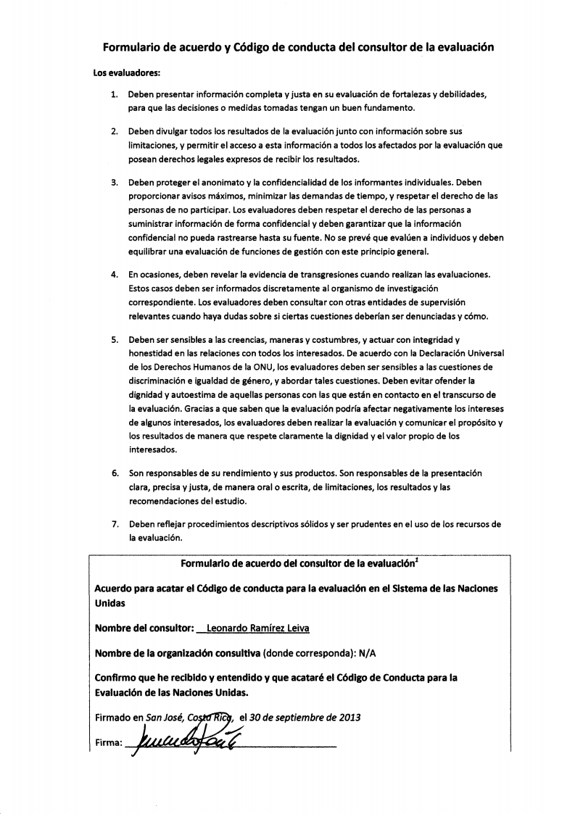

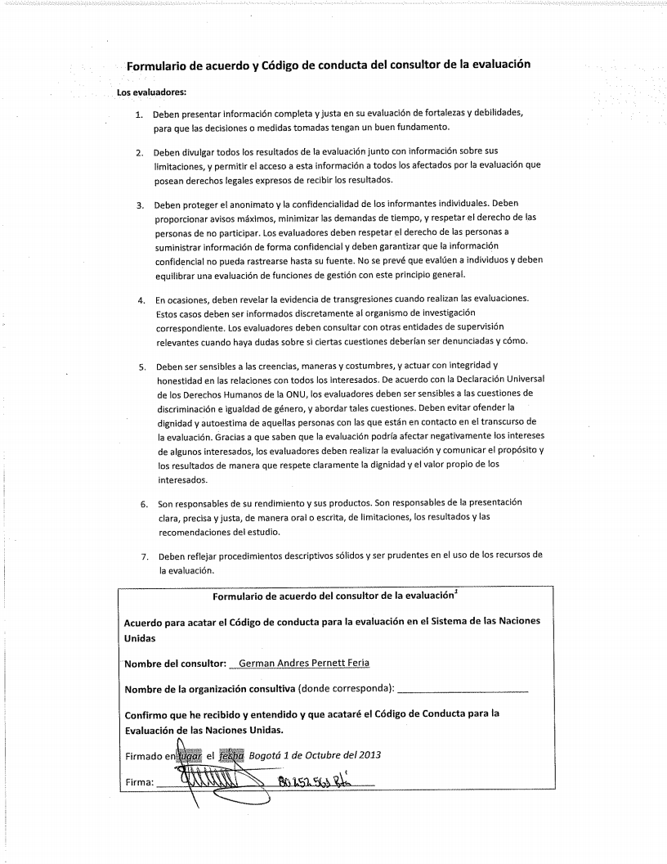

1. The evaluation team received a copy of a document containing the formal approval of the extension of the deadline until September 30th, 2013 on behalf of UNDP/GEF, and a letter from the UPME Director-General addressed to the UNDP Resident Representative, dated August 21st, 2013 requesting a new extension until November 30th, 2013.
2. El OTU/MAVDT/UNPD “Demonstration Project for the integral development of the chiilers subsector in Colombia, prioritizing the application of CFC-free and energy efficient technology for the replacement of CFC-based chillers”. October 3, 2005.
3. Project Document of the Colombian Program (2008-2012). Educational Board of the United Nations Program for the United Nations Development and Population Fund. July 16th, 2007.
4. Verbal information provided by OTU to the evaluators.
5. According to Decree 2501 of 2007, article 3 "Rational and efficient use of electrical energy in social interest housing", the emission of these regulations corresponds to the Ministry of Mines and Energy, and the Ministry of Environment, Housing and Territorial Development.
6. According to what was agreed upon on December 9th, 2011 by the Project Steering Committee. Record No. 03.
7. Data provided bu UNDP up until November 22nd, 2013.
8. According to the PNUD Colombia counterparty letter received on November 22nd, 2013.
9. According to a note on the Quaterly Report of the Project April – June 2012
10. Annex 1_Sintesis CFC chillers Colombia update 2010.xlsx. Information provided by the Project and prepared by OTU in December 2010.
11. According to a statement given by Eng. Cristina Mariaca of OTU, who works directly with UNDP Project #74760.
12. In total, the Project funded, with its own resources, energy audits in 19 buildings located in different cities.
13. Follow-up Meeting of the Project #70467, September 07, 2012. Act No. 04.
14. Follow-up Meeting of the Project #70467, September 07, 2012. Act No. 04.
15. According to comments made on January 26th, 2011 at the Steering Committee. Act Nº 2
16. Final Report.  Third deliverable of the contract No. 0000010656 2011. UPME-UNDP. Consulting and Management, Co Limited. May 2012
17. ODS: Ozone Depleting Substance
18. GHG: Greenhouse Gases
19. Factors that determine energy consumption: constructive aspects, lighting equipment, air-conditioning equipment and heating, and electrical devices and consumption habits.
20. Sponsored by Bancoldex with the colaboration of the PMU.