Terminal Evaluation

UNDP/ GEF project GEF 3138/PIMS 3657
Applying an ecosystem-based approach to fisheries management: focus on seamounts
of the southern Indian Ocean

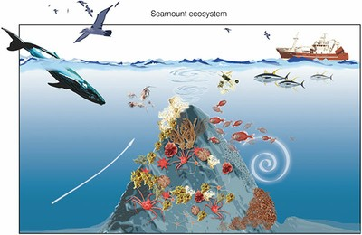

©Censeam

May 2013

Prepared for GEF/United Nations Development Program
by Dr Virginie Tilot

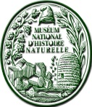 Académie des Sciences d’Outre-Mer 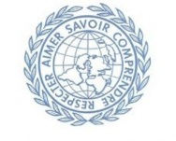
Museum National d’Histoire Naturelle
Time frame of the evaluation

According to the TORS of the terminal evaluation and to the content of the inception report, which has been accepted by UNDP, the total duration of the evaluation involved 24 days which would be performed between mid-March and end of May according to the following plan:

Activity | Timing | Completion Date
Preparation | 3 days | 26 March 2013
Evaluation Mission | 14 days | 3 weeks after signature  19 April 2013
Draft Evaluation Report | 4 days | 7 weeks after signature  16 May 2013
Final Report | 3 days | 9 weeks after signature  31 May 2013
Note: the last requested documentation for evaluation was received 21 May, a new version of Outcome 3 was provided, and its validity checked with UNDP officers indicated that it had not been validated. It therefore cannot be receivable. The evaluation has taken into account only the validated changes in the original logical framework matrix although comments on all changes in the Logframe are provided hereafter.

- Region of the evaluation: Southern Indian Ocean

- Countries of the evaluation intervention: Global

- GEF Operational Program/Strategic Program: OP 8
Waterbody-based Operational Program
GEF-4 Strategic program(S): SP1: restoring and sustaining coastal and marine fish stocks and associated biological diversity

- Implementing partner and other project partners :
UNDP GEF is the implementing agency
IUCN – International Union for the Conservation of the Nature is the executing agency

Other partners involved: the NORAD programme which funds the EAF-Nansen project and FAO, UK Government through the Natural Environment Research Council (NERC) executed by the Institute of Zoology of the Zoological Society of London (ZSL) then the Department of Zoology of the University of Oxford, the Fishing Industry (SIODFA), UNDP-GEF Agulhas and Somali Current Large Marine Ecosystem project (ASCLME), WCPA

- Name and organization of Evaluator : Dr Virginie Tilot, Muséum National d’Histoire Naturelle, Département d’Ecologie et Gestion de la biodiversité, UMR 7204 : CERSP, 55 rue Buffon, 75005 Paris, France

- Name of the organization commissioning the evaluation: UNDP/GEF, IUCN
Acknowledgements

The evaluator would like to acknowledge UNDP/GEF, in particular Andrew Hudson and Akiko Yamamoto and IUCN, in particular Aurélie Spadone and James Oliver, for their helpful coordinated support. All my gratitude to Alex Rogers, David Vousden and the pool of scientists that helped me gather information around the two oceanographic cruises, R/V Dr Fridtjof Nansen, as part of the NORAD/FAO Nansen programme in cooperation with the UNDP GEF ASCLME project and R/V James Cook led by the Department of Zoology, University of Oxford leading the NERC project throughout the Southern Indian Ocean Seamounts and banks. The SIODFA has been also very helpful providing valuable input all along the evaluation procedure. The evaluator wishes also to acknowledge the comments of stakeholders in the region and of those challenging the same issues in the world.

Table of Contents

Time frame of the evaluation
Acknowledgements
Table of contents
List of Acronyms and Abbreviations
Executive Summary
Project description
Project summary table
Summary of conclusions, recommendations and lessons learned
1 Introduction
1.1 Purpose of the evaluation
1.2 Evaluation scope and methodology
1.3 Structure of the Evaluation report
2 Project description and development context
2.1 Project start and duration
2.2 Problems that the project sought to address
2.3 Immediate and development objectives of the project
2.4 Baseline indicators established
2.5 Partners and stakeholders relevant to the project
2.6 Expected global and regional results
3 Findings
3.1 Project Design/Formulation
3.1.1 Analysis of LFA/Results Framework
3.1.2 Assumptions and Risks
3.1.3 Planned stakeholders participation
3.1.4 Lessons from other relevant projects incorporated into project design and replication of other initiatives
3.1.5 UNDP comparative advantage
3.1.6 Management arrangements
3.2 Project Implementation
3.2.1 Adaptive management
3.2.2 Partnership arrangements, regional participation and relation with regional/global instruments
3.2.3 Project finance/co-finance
3.2.4 Monitoring and evaluation design at entry and implementation
3.2.5 UNDP and Implementing Partner implementation/execution coordination and operational issues
3.3 Project Results
3.3.1 Overall results and ratings by outcome
3.3.2 Relevance
3.3.3 Effectiveness
3.3.4 Efficiency
3.3.5 Country/Region/Global ownership
3.3.6 Mainstreaming
3.3.7 Sustainability
3.3.8 Impact
4. Conclusions
5 Recommendations
6 Lessons learned
ANNEX 1 TORs of the Terminal Evaluation (Project Log Frame in Annex A)
ANNEX 2 Evaluation Question Matrix and questionnaire
ANNEX 3 List of Partners and stakeholders of the project
ANNEX 4 List of persons interviewed and site visit
ANNEX 5 List of supporting documents reviewed
ANNEX 6 Detailed evaluations of project outcomes (6.1; 6.2; 6.3; 6.4)
ANNEX 7 GEF Funding and matching funds to support the seamounts project
ANNEX 8 Short biography of the evaluator
ANNEX 9 Code of Conduct and Agreement Form signed by the evaluator

List of Acronyms and abbreviations

ACEP: African Coelacanth Ecosystem Programme
AFD: French Development Agency
APR: Annual Project Report
ASCLME: Agulhas and Somali Currents Large Marine Ecosystems
AWP: Annual Work Plan
B: Biodiversity
BPA: Benthic Protected Area
CBD: Convention on Biological Diversity
CenSeam: Census of Seamounts
CEO: Chief Executive Officer
CoML: Census of Marine Life
CPAP: UNDP Country Programme Action Plan
CPD: UNDP Country Programme Document
CSBT: Commission for the Conservation of Southern Bluefin Tuna
CO: UNDP Country Office
CoML: Census of Marine Life
CORDIO Coastal Oceans Research and Development in the Indian Ocean
DAFF: Department of Agriculture, Fisheries and Forestry, Australia
DLIST: Distance Learning and Information Sharing Tool
DOALAS: UN Division for Ocean Affairs and the Law of the Sea
DOQ: Deep Ocean Quest
EA: Executing Agency
EC: European Commission
EEZ: Exclusive Economic Zone
ERC: Evaluation Resource Centre
FAO: Food and Agriculture Organization of the United Nations
FIRMS Fishery Resources Monitoring System (FIRMS)
FFEM: French Global Environment Facility
GEF: Global Environment Facility
GEF EO: GEF Evaluation Office
IFREMER: Institut Français de Recherche pour l’Exploitation de la Mer
IOC: Indian Ocean Commission
IOGOOS: Indian Ocean Global Ocean Observing System
IOTC: Indian Ocean Tuna Commission
ISA: International Seabed Authority
IMO: International Maritime Organization
IOZ: Institute of Zoology
IA: Implementing Agency
IUCN: International Union for the Conservation of Nature
IR: Inception Report
IRD: Institute of Research for Development
IW: Inception Workshop
IW: International Waters
IW: LEARN International Waters: Learning Exchange and Resource Network
IWC: International Whaling Commission
LFA: LogFrame Analysis
LME: Large Marine Ecosystem
LOSC: Law of the Sea Convention
M&E: Monitoring and Evaluation
MCS: Monitoring, Control and Surveillance
MEP: Marine Environment Protection
MMA: Marine Managed Area
MOU: Memorandum Of Understanding
MPA: Marine Protected Area
MSP: Medium Size Project
MTE: MidTerm Evaluation
NC: Nairobi Convention
NGO: Non-Governmental Organization
NOAA: National Oceanic and Atmospheric Administration
NORAD: Norwegian Agency for Development Cooperation
ODINAfrica: Ocean Data & Information Network of Africa
OFP: GEF Operational Focal Point of GEF
OROSPAR: Commission for the Oslo and Paris Conventions (NE Atlantic)
PA: Protected Area
PC: Project Coordinator
PDF-A: Preparatory Development Form- Assistance block A
PIF: Project Identification Form
PIMS: UNDP GEF Project Information Management System
PIR: Project Implementation Review
POPP: UNDP Programme and Operations Policies and Procedures
ProDoc: Project Document
PSC: Project Steering Committee
PSSA: Particularly Sensitive Sea Areas under IMO
PT: Project Team
PTA: Principal Technical Advisor
RCU: UNDP/GEF Regional Coordinating Unit
ReCoMaP: Regional Programme for the Sustainable Management of the Coastal Zone of the Countries of the Indian Ocean
RFMO: Regional Fisheries Management Organization
ROAR: Results Oriented Annual Report
SADEC: Southern African Development Community
SAIAB: South African Institute of Aquatic Biodiversity
SAP: Strategic Action Programme
SC: Steering Committee
SIDA: Swedish International Development Cooperation Agency
SIDS: Small Island Developing States
SIO: Southern Indian Ocean
SIODFA: Southern Indian Ocean Deepsea Fishers Association
SIOFA: South Indian Ocean Fisheries Agreement
SSA: Sargasso Sea Alliance
SWIOFC: South West Indian Ocean Fisheries Commission
SWIR: South West Indian Ridge
TA: Technical Advisor
TE: Terminal Evaluation
ToR: Terms of Reference
TPR: Tripartite Review
UK: United Kingdom of Great Britain and Northern Ireland
UNCED: United Nations Conference on Environment and Development
UNCLOS: United Nations Convention on the Law of the Sea
UNDAF: UN Development Assistance Framework
UNDP: United Nations Development Programme
UNDP EO: UNDP Evaluation Office
UNEP: United Nations Environment Programme
UNESCO: United Nations Educational, Scientific and Cultural Organization
UNFSA: United Nations Fish Stocks Agreement
UNGA: United Nations General Assembly
UNICPOLOS: United Nations Informal Consultative Process on Oceans and the Law of the Sea
UNOPS: United Nations Office for Project Services
VME: Vulnerable Marine Ecosystem
WCPA: World Commission on Protected Area
WIO: Western Indian Ocean
WIO-C: Consortium for Conservation of Coastal and Marine Ecosystems in Western Indian Ocean
WIO-LaB: Western Indian Ocean Land Based Activities
WIOMSA: Western Indian Ocean Marine Science Association
WSSD: World Summit on Sustainable Development
WWF: World Wide Fund for Nature
ZSL: Zoological Society of London

Executive summary

Brief description
The overarching project objective is to help improve marine resources conservation and management in the high seas. In particular, it focuses on seamount ecosystems and addresses:
-The lack of knowledge on the functioning of the ecosystem and interactions with associated environmental and faunal assemblages;
-The lack of capacity for inventory, analysis, assessment and monitoring of deep sea biodiversity and of high seas fisheries;
-The lack of comprehensive governance framework for marine biodiversity in the SIO region;
-The challenge to manage high seas fish stocks, including monitoring, control and surveillance
-The lack of awareness of the general public, the fishing industry and the decision makers on these topics.

A biodiversity-rich area beyond national jurisdiction (ABNJ) centered on seamounts of the southern Indian Ocean (SIO) will serve as a demonstration case for developing robust conservation and management measures for marine biodiversity in areas beyond national jurisdiction.

Trending NE across approximately 10 degrees of latitude (~41-31 degrees S) in the SIO, the project area covers five seamount regions, two of which are inside proposed Benthic Protected Areas (BPAs), Atlantis Bank and Coral Seamount. Five states are nearest to the project area: France (via Crozet Island, La Réunion), Madagascar, Mauritius, Mozambique and South Africa.

The four main components of the project are:
1. Scientific understanding and capacity for monitoring, assessment and analysis of high seas biodiversity and fisheries improved in the SIO;
2. Governance framework for high seas resources conservation and management enhanced in the project area;
3. Options for conservation and management measures applicable to high seas in the SIO;
4. Learning, awareness raising and knowledge sharing.

By the completion of these joint ventures in science, policy and practice, the project aims at developing the necessary knowledge to develop effective management options for biodiversity conservation in the high seas based on the precautionary and ecosystem approaches and thus contribute to the implementation of UNGA Resolution 61/105.

Table 1: Project Summary Table

Project Title | “Applying an ecosystem-based approach to fisheries management: focus on seamounts in the southern Indian Ocean”
GEF Project ID: | 3138 |  | At endorsement Thousand US$ | At completion Thousand US$
UNDP Project ID: | 3657 | GEF financing: | 950 USD | 950 USD
Country: | Global | IA/EA own: | 150 USD | 150 USD
Region: | Southern Indian Ocean | Government
Focal Area: | International Waters | Other: | 5,490 USD
FA Objectives  (OP/SP) | SP1 Restoring and sustaining coastal and marine fish stocks and associated biological diversity | Total co-financing: | 5,640 USD | 5,974 USD
Executing Agency: | IUCN | Total Project Cost: | 6,590 USD
Other Partners involved: | FAO (Nansen Programme)  UK government through NERC  Fishing Industry (SIODFA) | ProDoc Signature (date project began): April 2009
 |  | (Operational) Closing Date | Proposed: April 2011  Extension 1 year | Actual: March 2013

The project is funded by the Global Environment Facility (GEF), implemented by the United Nations Development Programme (UNDP), and executed by the International Union for Conservation of Nature (IUCN).

Summary of conclusions, recommendations and lessons learned

Conclusions

The GEF UNDP/IUCN project “Applying an ecosystem-based approach to fisheries management: focus on seamounts in the southern Indian Ocean“ (referred to SIO-Fisheries & Seamounts in document) includes four main components, scientific research, monitoring and surveillance of deep sea biodiversity and fisheries, governance and communication, but the central point is the development in the high seas of a proposal for integrated marine spatial planning and management, with a special focus on fisheries, considered as the most important and potentially impacting activity.

Most of the countries of the region, with existing framework of cooperation, are progressing towards integrated coastal zone management, mainly focusing on land use planning and management with an extension to territorial waters, rarely to their exclusive economic zone. The high seas marine spatial planning and management is a concept until now far from the preoccupations of the region coastal states and they rely for this purpose on international instruments and their regional application.

The project on SIO-Fisheries & Seamounts was expected to propose to these countries the basic mechanisms for a joint management of the high seas issues, based on the transposition of international instruments such as UNCLOS (with a special attention to the International Maritime Organization – IMO - and to the International Seabed Authority – ISA -) and the CBD, on the strengths and complementarities of the regional instruments such as the Nairobi Convention (UNEP), the regional fisheries management organizations (RFMO-FAO) or regional fisheries arrangement (FAO), and the input of research institutions (international and regional) for a better understanding of the biodiversity, of the oceanographic conditions and of the functioning of high and deep seas ecosystems, allowing to propose management measures covering all activities such as marine protected areas.

The results of this 4 year project are not answering the expectations, even if the research has brought and will bring in the coming years sound results in peer reviewed journals, as it was orientated towards mainly pure science and not science for management. For the management of seamounts, no management plan has been designed as expected. On the governance aspects, the choice of introducing an informal and voluntary alliance, as proposed by another project, is not responding to the anticipations of the countries, of UNDP and overall of the GEF strategy for International Waters.

The reason for this gap between the original expectations and the present results is due to multiple factors:
- A lack of (continuous) vision of the ultimate objective, high seas spatial planning and management. This lack of vision and the difficulties to deliver according to the initial logical framework has conducted to proposals for the change of the name of the project (2012) and a major modification of outcome 3 (2011), based on discussions and comments during workshops.
- The lack of (continuous) leadership and the multiple changes in the leading team inside IUCN (2 project coordinators, 3 project managers).
- The use of short term independent consultants “of international quality on specific topics”, with a global vision and experience generally not focusing on the regional aspects.
- A focus on science for knowledge and not science for management.
- A focus on awareness at the global level and less or none at the regional or national level.
- A lack of anchoring and lobbying at the regional and national level (at ministerial level, e.g. fisheries, environment, maritime transport and also foreign affairs for the high seas), by both the implementing (regional network of UNDP offices) and the executing agencies (IUCN global, regional and national network of members, commissions and experts).

Overall scoring and ratings

Table 2 - Scoring and rating for Outcomes, Effectiveness, Efficiency, M&E, I&E Execution

 | 6= Highly Satisfactory  100 to 90% | 5= Satisfactory  89 to 75% | 4=Moderately Satisfactory  74 to 60% | 3=Moderately Unsatisfactory  59 to 50% | 2=Unsatisfactory  49 to 35% | 1=Highly Unsatisfactory  34 to 0%
Achievement of objectives & planned results |  |  | 4
Attainment of outputs and activities |  |  | 4
Cost effectiveness |  |  | 4
Impact |  |  |  | 3
Sustainability |  |  |  | 3
Stakeholders participation |  |  |  | 3
Country/region ownership |  |  |  | 3
Implementation approach |  |  |  | 3
Financial planning |  |  | 4
Replicability |  |  |  | 3
Monitoring and evaluation |  |  | 4

Comments on table 2

Against these general indicators of project performance the project has been assessed as being, “Moderately Unsatisfactory” in 6 indicators, and “Moderately Satisfactory” in 5 indicators.

Overall, the project can be assessed as being between moderately satisfactory and moderately unsatisfactory. Abbreviated argumentation in support of each score is presented hereafter and developed in each relevant section of the report (with the specific scoring of each outcome).

(1) Achievement of objectives & planned results
The project has achieved part of the objectives and planned results, as described before. The objective was to apply an ecosystem-based approach to fisheries management for biologically -globally significant and commercially important areas beyond national jurisdiction in the southern Indian Ocean, focusing on seamounts, with a long term aim to demonstrate innovative approaches to improve conservation and management of unique biodiversity and ecological resources in the high seas. A list of what has not been done includes: the fact that biologically-globally significant areas have not been defined, nor a methodology to identify them , nor a monitoring system developed; commercially important fishing areas in the high seas have not been defined and the importance of fisheries in the region has not been evaluated; data could have been extracted from FAO and SIODFA; management plans for two seamounts have not been prepared; innovative approaches to improve conservation and management of the high seas have not been produced, except for a recommendation for one option concerning a not legally binding and voluntary alliance, not really applicable for sustainable management of the high seas fisheries. The project was based on the results of two cruises, that have been successful in their realization, but the results would only be available two or three years after the end of the project.

(2) Attainment of outputs and activities
For the outputs and activities, the scientific understanding of seamounts ecosystems and their interactions with deep water and pelagic fisheries (Output 1.1) has slightly improved and will continue to improve in the coming years as the results, analysis and models are to be published (this being the responsibility of one partner, the NERC, financing the main part of the cruises). The same comment applies to Output 1.2, concerning the creation of a knowledge base for conservation and management options for seamounts. The capacity for monitoring and analysis of high seas and deep seas biodiversity and fisheries in the region (output 1.3) has been slightly increased with one training workshop (taxonomy) and participation to the cruises. For output 2.1, the legal and institutional options (according to existing instruments) have been described, but the gap analysis for the region has not been completed and there were some misinterpretations. Concerning the management and compliance options applying a precautionary and ecosystems approach (output 3.1), they have partly been identified, but the consulting process with various stakeholders has not been held. Finally, concerning output 4.1, the understanding of the high seas and deep seas and its importance has been raised mainly for the general public, but with a limited effort on policy makers of the region and the fishing industry, except SIODFA that was already aware.

(3) Cost effectiveness
In terms of cost effectiveness, the main comment on the use of funds is that the most important part has not been directed to activities, meetings and conference held in the region and that most of the experts, trainees and staff involved were not from the region (mostly students).

(4) Impact
In terms of global environmental benefit, the project has not presently brought any positive impact on the existing situation, the main commercial activities (high seas and deep seas fisheries) proceeding as usual. Some companies (SIODFA) are aware of the need for conservation, having declared voluntary Benthic Protected Areas which are not binding for other companies. In the future, with the results of the cruises and their translation in management recommendations in a legally binding system, the high seas fisheries could bring some income to developing countries of the region.

(5) Sustainability
As the actual impacts of the project are very limited and the system proposed for governance not in place and not really efficient, the sustainability is also very limited. Nevertheless, if changes occur in the coming year with the setup of proper regional and international instruments, some improvement could happen, but there is a strong need for stakeholder involvement from the countries.

(6) Stakeholders participation
The stakeholders participation and in particular form the countries of the region, has been very limited.

(7) Country(ies)/region ownership
With reference to the two previous points, it is evident that the ownership of the project by the region and the countries of the region is very limited.
(8) Implementation approach
The content of the logical framework was coherent with the objective of the project. The changes proposed by the first PSC were just minor adjustments. During the project, due to a misunderstanding of the objective (proposing a change in the title) or due to a limited commitment of the PMU (part time coordinator and consequent turn-over of staff), numerous changes were proposed, weakening in particular outcome 3, the central part of the project. The inception workshop was not held and the inception report was not produced, allowing a common understanding of the project. Such an innovative project could necessitate a midterm review but it has not been planned.

(9) Financial planning
The financial planning has been moderately satisfactory, as the co-funding was superior to the plan. However the initial funding for the team of experts could have been higher in order to cover all competences required by the project including a negotiator to liaise with all stakeholders of the region.

(10) Replicability
As written, the project concept is relevant. It could have brought an important change in the management of the high seas in the region. The lessons learned from this venture could be replicated to other regions in the world’s high seas.

(11) Monitoring and evaluation
As indicated in the previous section, a stronger monitoring could have allowed better results and a better impact. A stronger PSC with a better knowledge of the high seas management and instruments, the respect of all the monitoring and evaluation procedures, and a mid-term review were necessary.

Table 3 - Scoring and rating of project performance against GEF-IW program monitoring scale

 | Likely  75 to100% | Moderately Likely  50 to 74% | Moderately Unlikely 25 to 49% | Unlikely  0 to 24%
Relevance |  |  | M
Effectiveness |  |  | M
Efficiency |  |  | M
Results |  |  | M
Sustainability |  |  | M

Comments on table 3

For the Relevance, the project was fully relevant in its concept and responded to a regional and global need for high seas policy. This project was and is in line with the GEF Operational Programs or the strategic priorities under which the project was funded, but the implementation has not brought the expected results according to the Logframe.

For the Effectiveness, the initial objective has not been achieved and the outcomes and outputs are partly available, some concerning the scientific research being expected in the coming years, some have been deleted and others omitted.

For the Efficiency, as the resources allocated have been used and parts of the results have not been delivered, the cost effectiveness is considered as low.

For the Results, there are limited available results; the scientific research (2 cruises, 2009, 2011) has been successful but the main results are to be published approximately end of 2013, early 2014, the involvement of the regional stakeholders has been very weak, the documentation made available on governance remaining global and not region specific and the proposed management framework considering only a voluntary and not legally binding alliance was not the only possible option.

For the Sustainability, based on the previous comment, there is limited sustainability, the only aspect being that the results of the research will assist in the understanding of the highs seas and seamounts of the region.

For the Recommendations, there are:
- a need to apply innovative management tools and methodology to monitor deep seas ecosystems, a robust mechanism that would assess the health of the ecosystem and enable to react to activities affecting the marine environment by immediate management/conservation measures which could be taken on a participative process. This adaptive and evolving mechanism which would include multilayer rapid ecological assessments, threat indicators, management indexes, would serve as backbone to an effective marine spatial management and planning of the ABNJs.

- a present possibility to set up site specific management plans with the existing data on the project area of seamounts, in particular with SIODFA data and preliminary results of the 2 project cruises. It would reestablish a good collaboration with SIODFA, and the fishing Industry, and trigger the next phases which could be integrated in an overall scheme of establishing governance at the regional and global level.

-a need to achieve a comprehensive desk review of all available information on the SIO area, in particular a comprehensive analysis of the different activities occurring in high seas with a focus on fisheries in deep sea, which most countries are familiar with in respect to the characteristics of their coasts, proximate deep water and the use of offshore devices e.g., Fishing Aggregative Devices (FADs). And an analysis of publications of results of international oceanographic cruises in the SIO area in particular on the well explored SW Indian Ridge where are located the seamounts, including the numerous geophysical and multidisciplinary cruises. The scales of data collecting for imagery/mapping of the seabed are relevant to assess large areas for setting up reference areas for MPAs, including representative faunal assemblages and habitats.

- a need to achieve a comprehensive analysis of legal and institutional instruments and stakeholders in the region and assess their relevance to the project. It should be done in a participative mode with all stakeholders during one or a series of workshops with representatives of all governments and existing entities in the region. Would follow a list of options on how integrating the management of high seas issues into the existing framework in the region and globally, analyzing the complementarities between instruments for the purpose of the project and proposing one or more options for reaching the objectives, then selecting the recommended one(s). A follow up of territorial boundaries of the countries in the vicinity of the SIO project area and of the other activities than fisheries (mining, gas, petrol, traffic, pollution..) which could affect the SIO area.
- to focus on Marine spatial planning and management (MSM) and train all stakeholders (including Flagships of industrial fishing in high seas) and country representatives of the region in a participative approach on a multilayer management characteristic of MSM with a series of workshops in the region and pilot sites which could be in banks, deep sea areas in territorial waters of the region or in existing Marine Protected Areas networks including high seas of the region (e.g., Chagos, Saya de Malha Banks..). Experience from other networks could be stressed as with OSPAR, CCAMLR..).

- a need to develop more material for learning, awareness and public communication for the region, in particular in the 2 official languages (English, French) and if possible in Portuguese.

For the Lessons learned with the project, there should have been:
-more monitoring and more presence in the region, with an inception workshop and report, a mid-term evaluation which would have enabled to refocus the project when necessary. The PMU should have been posted in the region to develop close collaboration with regional instruments and stakeholders. PSC meetings should have been more regular and in the region (or tel/skype conferences).

-A multidisciplinary specialized team under a strong coordinator. As in addition to the deep seas/ high seas scientist of NERC, the project was in need of a full time, well experienced coordinating team on the cusp of science, policy and conservation/management and communication, and if possible with experience of the region and bilingual (English-French). The team would be adapted to liaise with each partner and communicate all results at the regional and global levels. The team should have been experienced in marine spatial management and planning, deep sea ecology and high seas governance. The team should have been composed of four persons, a project coordinator experienced in deep sea ecology/conservation/management, a high seas fisheries expert, an expert on international legislation, institution and negotiation, an expert in communication.

-more implication of main regional stakeholders such as SIODFA, the fishing Industry which have the knowledge, experience and practice in the SIO area. SIODFA also initiated the conservation/management process in the SIO area by setting up the BPAs and developing all management options and tools. They should be encouraged in their efforts. Private sector needs to be a key player in order to secure a higher probability for long-term sustainability of interventions. More collaboration as well with The Nairobi Convention, SIOFA, SWIOFC, WIOMSA, ORDINAFRICA.

1. Introduction
1. 1 Purpose of the evaluation

According to the guidance, rules and procedures established by UNDP and GEF (see list below), the main objectives of the evaluation are to establish the extent to which the project’s objectives have been met, to assess the project’s relevance, effectiveness, efficiency, to draw lessons that can improve the sustainability of results and the contribution to global environmental benefits and to provide recommendations to enhance the results of current and future UNDP projects funded through GEF.
- UNDP “Handbook on Planning, Monitoring and Evaluating for Development Results”, 220pp.
- UNDP Project-Level Evaluation. “Guidance for Conducting Terminal Evaluations of UNDP-supported GEF-financed Projects” UNDP 53pp.
- UNEG, “Norms for Evaluation in the UN System”, 2005. http://www.unevaluation.org/unegnorms
- UNEG, “Standards for Evaluation in the UN System” and “Ethical Standards for Evaluations” 2005. http.//www.unevaluation.org/unegstandards.
- OPS4-M2-ROtI Handbook | Global Environment Facility (theory of change (ROtl)
- Evaluating Humanitarian Action Using OECD/DAC Criteria, Beck T., 2006.

1.2. Evaluation scope and methodology

Evaluation scope - Evaluation criteria - Evaluation questions
The GEF Monitoring and Evaluation Unit developed an International Waters Program Monitoring Questionnaire as a means of rating project performance. The key elements of this are to assess the project against eleven functional categories of project performance. Each category is awarded a percentage success rate that is then transcribed into a quality of success identifier on a six-point scale.

The eleven functional categories are as follow
(1) Achievement of objectives & planned results (2) Attainment of outputs and activities (3) Cost effectiveness (4) Impact (5) Sustainability (6) Stakeholders participation (7) Country(ies)/region ownership (8) Implementation approach (9) Financial planning (10) Replicability and (11) Monitoring and evaluation.

For each functional category, a percentage of success (scoring) has been allocated to an indicator/source of verification for each outcome then an average was calculated for the outcome. The percentage categories were (6) 100-90, (5) 89-75, (4) 74-60, (3) 59-50, (2) 49-35, (1) 34-0.

Then the scoring was transformed in ranking according to the following categories of success: (6) Highly satisfactory, (5) Satisfactory, (4) Moderately Satisfactory, (3) Moderately Unsatisfactory, (2) Unsatisfactory and (1) Highly Unsatisfactory.

The project key elements (objective and outcomes) evaluation scoring and rating have been conducted according to this system, a short explanatory note is provided in the summary results and longer discussions on specific points are displayed in the annexes.

In addition, the project performance has been rated and scored against the GEF program monitoring scale.

The 5 indicators of performance (including indicators of sustainability, of relevance and of impacts) are: relevance, effectiveness, efficiency, results and sustainability using four percentages and categories as follows: Likely (100 to 75%), Moderately Likely (74 to 50%), Moderately Unlikely (49 to 25%) and Unlikely (24% to 0%) (See table 3 in the executing Summary).

1.3. Structure of the Evaluation report
The evaluation report includes the following sections: (2) Project description and development context, (3) Project findings, including (3.1) Project design, (3.2) Project implementation, (3.3) Project results, (4) Conclusions (5) Recommendations and (6) Lessons learned and Annexes.

2. Project description and development context

2.1. Project start and duration

The project was signed by IUCN on 27/04/2009 and by UNDP on 28/04/2009 for a duration of 3 years, with an implementation starting date of January 2009 and an expected implementation completion in June 2011. The project was extended to March 2013, due to delays in the second scientific cruise following a decision of the Project Steering Committee in its session of July 2010.

2.2. Problems that the project sought to address

During the past 20 years, global fisheries have increased their quota in the high seas which are subject to weak or no regulation or control. Specific sites such as seamounts are hotspots of biological diversity and production, but knowledge is scarce and research needs to be developed. In addition, governance bodies of the Southern Indian Ocean region with a potential mandate on the high seas and the conservation and management of deep sea ecosystems are not efficiently organized. The combination of these three elements justifies the development of a project for tackling these issues and the potential impacts of human activities in the commons of the ocean. This project could therefore serve as a pilot study for other regions with similar issues.

2.3. Immediate and development objectives of the project

The project objective is to apply an ecosystem approach to fisheries management for biologically-globally significant and commercially important areas beyond national jurisdiction in the Southern Indian Ocean, focusing on seamounts, with the long term aim to demonstrate innovative approaches to improve conservation and management of unique biodiversity and ecological resources in the high seas.

The four outcomes pursued are:
- Scientific understanding and capacity of monitoring, assessment and analysis of the high seas biodiversity and fisheries improved,
- Governance framework for high seas resources conservation and management enhanced,
- Options for conservation and management measures applicable to high seas areas in the southern Indian Ocean identified,
- Learning, awareness raising and knowledge sharing.

2.4. Baseline indicators established

The baseline, as developed in the log-frame, states that the proposed activities will fill the existing gaps in most of the fields, including scientific data for better understanding of seamounts and knowledge of deep sea biodiversity in this region, appreciation of impacts (mainly focusing on fisheries), management and conservation needs for seamounts, methodologies for identification of vulnerable sites and efficacy of existing voluntary protected sites (Benthic Protected Areas BPA), development of management plans for seamounts, raise or increase of capacity building for regional scientists, increase of awareness for policy makers, fishing industry and public, proposal of options for the improvement of the legal and institutional framework for the high seas and in particular seamounts in the region and improvement of the exchange of information.

2.5 Partners and stakeholders relevant to the project

Annex 3 displays the list of partners and stakeholders relevant to the project.
The partners involved in the project, are:
GEF: The Global Environment Facility (GEF), Funding Agency
UNDP: United Nations Development Programme (UNDP), Implementing Agency
IUCN: International Union for Conservation of Nature, Executing Agency
IOZ/ZSL/NERC, Institute of Zoology, Zoological Society of London, UK, then the Zoology Department of the University of Oxford (new position of Prof A. Rogers)
NERC: Natural Environment Research Council, UK
SAIAB: South African Institute for Aquatic Biodiversity
IMR: Institute of Marine Research
NORAD/EAF-Nansen Project/FAO-IMR- (SAIAB), Norway
GEF UNDP ASCLME Project
SIODFA: Southern Indian Ocean Deepsea Fishers Association (SIODFA)
ECOMAR: University of Reunion Marine Ecology Lab (ECOMAR), France
ACEP: African Coelacanth Ecosystem Programme

2.6. Expected Global Results

In addition to regional results, the project was expected to deliver global results, and in particular the following:
- The precautionary and ecosystem based management approach in high seas implemented, demonstrated and utilized to inform and refine regional and international processes dealing with the regulation of areas beyond national jurisdiction, consistent with UNCLOS;
- practical site based guidance developed for implementing the requirements of UNGA resolution 61/105 with respect to managing deep sea bottom fisheries on the high seas to prevent significant adverse impacts to vulnerable marine ecosystems;
- significant contribution to global knowledge of seamount, and their inter-relationships with benthic and pelagic fisheries;
- habitats critical to commercially important benthic and pelagic fisheries in the high seas identified and options for their sustainable management developed;
- capacity to manage fish stocks and other marine resources strengthened, with the participation of the private sector.

3. Findings
3.1. Project Design/Formulation

3.1.1. Analysis of LFA/Results Framework

The project, “Applying an ecosystem-based approach to fisheries management: focus on seamounts in the southern Indian Ocean“, was designed in 2008 and agreed in 2009. The agreement for implementation started on April 15, 2009 and ended October 15, 2011. The goal was to improve conservation and management of unique biodiversity and ecological resources in the high seas, and the objective was: to apply an ecosystem-based approach to fisheries management for biologically- globally significant and commercially-important areas beyond national jurisdiction in the southern Indian Ocean (SIO), focusing on seamounts, with a long-term aim to demonstrate innovative approaches to improve conservation and management of unique biodiversity and ecological resources in the high seas. The innovative approach was intended to serve as reference for other regions of the world oceans and to provide options for management of the high seas, using existing international instruments and setting mechanism of cooperation and coordination between them. The four outcomes were expected to support the proposed approach(es) or option(s) by providing (1) more scientific information on seamounts and their functioning, on monitoring processes and on high seas fisheries, based on literature review and two oceanographic cruises in the SIO, (2) a review of the international and regional instruments allowing the management of the high seas with a particular attention to seamounts and fisheries, (3) the development of model management/monitoring framework for the high seas of the region based on two pilot cases related to seamounts and fisheries and (4) an integrated communication, information and learning system for raising awareness among all regional stakeholders including policy makers, the scientific community, the fishing industry and the general public.

3.1.2. Assumptions and Risks

The main assumptions and risks identified were due to the lack of interest, lack of agreement on the proposed mechanism and/or ownership from the policy makers, the scientific community, NGOs or the fishing industry. Therefore an important part of the project was expected to focus on communication, diffusion of information, and lobbying in the countries of the region, using both a top-down and a bottom-up approach.

3.1.3. Planned stakeholders participation

As stated in 3.1.2., the project was expected to develop a strong regional participation in particular government relevant sectors, the scientific community and the private fishing industry in the high seas.

3.1.4. Lessons from other relevant projects incorporated into project design and replication of other initiatives

Other projects in the region respond better to the request of coastal countries for the management of their territorial and exclusive economic zone waters and in particular concerning fisheries. The Agulhas and Somali Current Large Marine Ecosystems project (ASCLME) (GEF-UNDP) is orientated to science for management. It is developing an initiative concerning a Western Indian Ocean Sustainable Ecosystem Alliance.

The South West Indian Ocean Fisheries Project (SWIOFP) (GEF-World Bank) ending in 2011 was specifically targeted at fisheries management, in the national waters of the region.
The SIO-seamounts fisheries project was the first project to consider high seas and could build upon the two previous quoted projects as the national institutions were aware of the links between coastal and offshore areas concerning fisheries.

Existing models of management including networks of MPAs in the deep sea could have been referred to in the project (CCAMLR, OSPAR Commission and Chagos BIOT no-take marine reserve). The MPA project of Saya de Malha Banks high seas could have been relevant, especially as it is associated to the GEF UNDP ASCLME project. The area involves the same process in hydrodynamics created by an elevated structure complex which fosters high productivity as in Chagos and as in seamount ecosystems (comments on outcome 1). These two latter cases located in the region would have completed the understanding of the functioning of an area including seamount ecosystems, one of the objectives of the project.

The approach of the UK government concerning the Marine Protected Areas of Chagos archipelago (55 islands and atolls), made up of a combination of atolls, islands and many submerged banks and seamounts covering about 640,000 km of shallow and deep waters is an interesting process in the EEZ that could bring most valuable information.

The voluntary declaration of 11 Benthic Protected Areas by the Southern Indian Ocean Deep Fisheries Association, regrouping private fishing companies is also of interest.

In another region, the OSPAR Convention, based on both the Commissions of Oslo and Paris, is developing a management system for the North Eastern Atlantic marine environment (including high seas) with 15 States and the European Union and including three regional fisheries management organizations, could serve as an example for the Southern Indian Ocean and in the future for the complete Indian Ocean.

3.1.5. UNDP comparative advantage

UNDP has an office for each country of the region except France (La Réunion) and an important experience in the development of these countries. UNDP is in relation with the high ranking officials of these governments for land use planning, integrated coastal zone management and social and economic development. The presence of UNDP in the project was one of its strength if it has been used for informing and lobbying the governments of the region.

UNDP was also responsible for another GEF project in the region connected to the sea (ASCLME). The GEF UNDP/IUCN project collaborated with three other GEF funded projects: ASCLME, SWIOFP and WIO-LaB in the South West Indian Ocean region.

Similarly, IUCN members are numerous in the region, from Ministries to national institutions and NGOs and this network was one of the strength of IUCN for developing this project but it has not been used during of the development of the project.

3.1.6. Management arrangements

The project was implemented by UNDP and executed by IUCN. A Project Management Unit was setup in Switzerland. The project was managed by a full time project coordinator (50% financed by the project), based in Switzerland. A project steering committee (PSC) was set up with a meeting planned yearly. All the PSC meetings were held in Paris. As none of the PSC meetings were held in the region and as the PMU was based in Switzerland, it is evident that the links with the region were limited, even if two technical workshops were realized in the region. No mid-term evaluation was planned; such a mechanism could have identified the main issues in delivery, proposed solutions or could have refocused the project.

3.2. Project Implementation

3.2.1. Adaptive management

The Project Steering Committee PSC

PSC was functional by July 2009 to make strategic decisions to steer the project in an adaptive manner based on the future outcomes of negotiations related to high seas governance”.
The initial composition included 4 members and two observers, but in the first meeting ASCLME was adopted as a full member, and WCPA/IUCN was approved as full member (even if not present, and never attending any meeting in the future). At the second meeting, SIODFA was approved as full member. The lack of participation of SIODFA in the PSC3 and PSC4 and of FAO in PSC4 shows a lack of interest in the project of these two important partners (See next table).

Table 4 - Membership and Participation to the Steering Committee Meetings

 | PSC1 2009 | PSC2 2010 | PSC3 2011 | PSC4 2012
UNDP | Y | Y | Y | Y
IUCN | Y | Y | Y | Y
FAO | Y | Y | Y | N
ZSL | Y | Y | N | Y
ASCLME * | Y | Y | Y | Y
SIODFA ** | Y | Y | N | N
WCPA/IUCN*** | APPROVED | N | N | N
*ASCLME Observer at PSC1, Adopted as full member during the meeting
**SIODFA agreed as observer, then agreed as full member at PSC2
***Not present during PSC1, but adopted as full member for the future

The Project Management Unit PMU

The PMU was based in Switzerland, at the headquarters of IUCN. The main expertise of IUCN is to influence policies, based on scientific evidence. The role of IUCN in international fora and projects is mainly to assist as “liaison with project partners and stakeholders, participation in and input into relevant intergovernmental fora and expert meetings, dissemination and communication of project results, office facilities, equipment, communication and secretarial support”, as was quoted in a letter dated November 2008 to GEF (see annex to Project Document, p54). For other activities, such as the preparation of policy papers, technical documents or scientific publication, IUCN is using experts of international quality, as those being part of its commissions (about 10,000 in the world).

Such a project necessitates at its head the permanent presence (not 50%) of a project coordinator with all the necessary expertise. The project coordinator was not properly selected, needing important background and experience on deep sea ecology, high seas fisheries, ecological conservation, international instruments for the high seas, Southern Indian Ocean regional instruments, and ability to discuss with high ranking officials in each country and with regional and international instruments of the region. In addition, he was unable to complete the full time of the project being replaced for the remaining part, with an interim period without coordinator. The same issue occurred with the project manager, three persons occupying this position. The lack of continuity has certainly created doubt and uncertainties for other partners.

In reality, this project was in need of a team of four persons, the project coordinator, one deep sea ecologist and fisheries expert, one expert on international legislation, institution and negotiation, one expert in communication who could be a good mediator, in addition to the deep seas/ high seas scientist provided by NERC for the cruises. The team would have developed links with existing components in the region, setting the focus on developing capacities in the region and would have promoted high seas marine spatial planning and management within the area, associating the private sector through the Southern Indian Ocean Deep-sea Fishery Association (SIODFA).

Adaptive management: the changes in the logical framework matrix

Along the GEF UNDP/IUCN project life, different changes were agreed during the different PSC meetings, the most important one being proposed during the PSC3 of June 2011. Details are provided hereafter.

Changes proposed during PSC3 by the executing agency:
- A proposal of change in the title of the project (not agreed upon) (PSC3 section 2).
- A proposal for a change in the title of the Outcome 3 for ‘recommended actions in management in the Southern Indian Ocean’ replacing the initial “Development of model management framework and monitoring framework”; the wording changed in this section from ‘ecosystem‐based management model’ to ‘management recommendations’. This appears to be a major change, as the term of ecosystem approach” disappears which was the primary objective of the project. The changes were adopted. (PSC3 section3 on management)
- A request from the present members of IUCN to prepare, according to the change of titles, a new version of the Outcome 3 to be circulated for approval. This document was quoted in the report of the PSC3 meeting but not provided with the documents to evaluate. After request from the evaluator, it was received. Apparently, this document did not circulate among all members of the PSC after the meeting and no TORs nor updated logframe were produced. Thus there is no confirmation that this modification, discussed during the 4th PSC, has been accepted officially by UNDP. Therefore, these changes have not been considered during the evaluation.

Table 5 presents the initial text of Outcome 3 and the changes during the project. It shows in bold the deletion of the section 3.1.4 (agreed by PSC 1), and in italics + underlined the new wording of the Outcome as agreed by PSC3 and in italics the changes to the TORs of Outcome 3 to be drafted by IUCN (and submitted to the members of the PSC but apparently not circulated and not approved in PSC4) and delivered at the request of the evaluator on 21 May 2013, close to the official end of the project.

Table 5 – Initial Outcome and changes during the project

Outcomes | Outputs | Indicators | Target | Source of verification
Outcome 3: Development of model management framework and monitoring framework as well as specific management plans based on identified options for conservation and management measures applicable to high seas areas in the Southern Indian Ocean  Outcome 3:  Recommended actions in management in the Southern Indian Ocean  for conservation and management measures  applicable to high seas areas in the southern Indian Ocean | 3.1. Management and compliance options applying a precautionary and ecosystems approach identified, in collaboration with fishing Industry  3.1 Management and compliance options applying a  precautionary and  ecosystems approach identified, in collaboration with  the fishing industry | 3.1.1 Conservation and management measures including model monitoring, control and surveillance framework, identified and assessed for feasibility through consultative process with various stakeholders including the fishing industry  3.1.1. Conservation and management measures, including monitoring, control and surveillance, identified and assessed for feasibility through consultative process with various stakeholders, including the fishing Industry | List of agreed options for conservation and management measures developed, including monitoring, control and surveillance (MCS) systems  Basket of options for management measures, monitoring, control and surveillance developed | Fisheries situation, analysis report, including options for conservation and management, and MCS systems, meeting reports, workshop proceedings  Meeting notes of stakeholder workshops, options analysis report
 |  | 3.1.2 Two specific management plans for two high seas are developed  3.1.2 Options and recommendations on the management framework for high seas biodiversity in the southern Indian  Ocean | Two pilot areas identified and respective management plans developed  Management recommendations for high seas biodiversity conservation in the southern Indian Ocean | Management plans for the two selected high seas areas  Road Map towards conservation of biodiversity and management  framework for the southern Indian Ocean document
 |  | 3.1.3 Comprehensive model management framework for high seas biodiversity in the southern Indian Ocean developed  3.1.3 Options and recommendations on the monitoring, control and enforcement framework for high seas biodiversity in the southern Indian Ocean | Comprehensive model management framework including two pilot areas management plans  Management recommendations on the monitoring, control and enforcement framework | Model management framework document  Monitoring, control and enforcement framework recommended actions developed in the Road Map document
 |  | 3.1.4 Model monitoring, control and enforcement framework for high seas biodiversity management in the southern Indian Ocean developed | Agreed model monitoring, control and enforcement framework for high seas biodiversity management in the southern Indian Ocean developed | Monitoring, control and enforcement framework document

A careful reading of the proposed changes shows that most of the sources of verification have been removed or changed: for (3.1.1) the fisheries situation analysis report including options for conservation and management and MCS systems has been removed; for (3.1.2) the management plans for the two selected high seas areas (seamounts) have been replaced by a “Road Map towards conservation of biodiversity and management framework for the southern Indian Ocean” and (3.1.3) the model management framework document has been removed as it has been considered to be part of the Road Map. Furthermore, the reading of the Road Map depicts a general approach to the issue of management of the high seas, it is not region specific nor concentrating on seamounts. It proposes only a not legally binding and voluntary alliance perhaps valid for a project on knowledge as the ASCLME, but not valid at all for a proper marine spatial planning and management of the high seas of the Southern Indian Ocean. At least a coordination between international instruments (UNCLOS, CBD and others) and regional instruments (at least Nairobi Convention under UNEP and RFMO or RFA under FAO) would have been needed.

Phasing, timing and deliverables issues

It is evident that the phasing of the different stages and components of the project has not been well planned, this underlying the fact that the whole vision of marine spatial planning (and management) has not been expressed. The processes of data collection, compilation and analysis on the seamount sites in view of delivering information for developing and achieving the management phases of the project could not have been done in time as planned in the project. Research in deep sea ecology generally requires a considerable amount of work of minimum 2 to 4 years after a cruise, especially with such a large span of data to analysis: photo, video footage, species, sediment samples, DNA identification, environmental parameters. Once analyzed, modelization can take place for a proper understanding of the ecosystem.
Furthermore the NERC project has been delayed by two years and urgent previous ongoing research matters were to be treated in priority after the cruises. Thus post cruise phases of analyzing data sampled during the cruises and compiling a database for the GEF UNDP/IUCN project have been delayed.

After analysis conducted rapidly during this evaluation, there is a bulk of scientific information, maps, literature existing on the high seas and in particular in the study area at SIODFA, FAO and with other institutions. Data and literature on fisheries (more than 30 years of data, imagery, etc.) and on the description of natural resources and environmental parameters of the area (Russian, English, French, German, Indian, Japanese scientific and technical literature) which could have been assembled in a proper comprehensive literature review.

Moreover, after evaluation of preliminary results of both cruises and research under progress with the scientific component of the project, there was enough baseline data to start management plans on the two proposed sites, as first planned in the project, even if the description of the sites and the impacts were not comprehensive. It could have been completed with preliminary results from the 2 cruises which for example served the purposes of drafting the description files for proposing these sites as EBSA’s (by NERC and accepted by the CBD).

Apart from this assessment on what is needed for a first management plan based on a precautionary principle, it is of course a prerequisite to pursue research on seamount ecosystem. The science efforts to better understand the functioning of the seamount ecosystem and the global functioning of the water column and associated faunal assemblages is a key priority for science, conservation and management of fisheries, a key human activity in high seas.

3.2.2. Partnership arrangements, regional participation and relation with regional/global instruments

Partnership

The coordination of the 9 partners, including the GEF and UNDP, was coherent at the beginning of the project. They were directly involved in the project. ASCLME and SIODFA became permanent members of the PSC, both organizations having signed a MoU with IUCN (see section 2.5).

For the other stakeholders of the project, as listed in Annex 3 it seems that coordination and cooperation was not properly developed, partly due to the location of the Project management Unit in Switzerland and the visit in the region reduced to the participation to the scientific cruises (no contact with regional entities) and the realization of thematic workshops, (limited contacts with the regional entities). This is an evident gap in the course of the project that tight contacts have not been developed with at least the Nairobi Convention (UNEP) or the regional RFMO or RFMA (FAO instruments) and the relevant officials of each country.

Regional participation to meetings, workshops and training sessions
One can comment on the lack of traceability concerning the participants at all the meetings, trainings and workshops of the project, with the absence of general attendance sheets or daily sheets when an event was conducted over several days or when it was a shared event (the case in the project).This should be a rule to have this recorded in all projects, as it is a major parameter for the evaluation.

Relation with global instruments
- Two briefing papers have been produced in 2006 and 2009 on “updates on progress relating to marine protected Areas Beyond National Jurisdictions (ABNJ)” by SAIS and IUCN. The 2009 update included SIODFA’s Benthic Protected Areas studied by the GEF UNDP/IUCN/NERC project. IUCN having a permanent observer mission to the United Nations, presented with SAIS this 2009 policy brief at UNGA Ad Hoc Open-ended Informal Working Group, NY on high seas related issues (1-5 February 2010).

- The project has also been presented at UN meetings on the regular process for the global reporting and assessment of the state of the marine environment, including socio-economic aspects.

- Information on the seamounts project was included in a letter to the Secretariat of the United Nations and was presented at the eleventh meeting of the United Nations Open-ended Informal Consultative Process on Oceans and the Law of the Sea (UNICPOLOS) in New York, 21-25 June 2010.

- The GEF UNDP/IUCN SIO project was presented as a case study in a policy brief by UNEP for State members of Regional Seas Conventions on global and regional developments relevant to cross-sectoral management of open ocean and deep-sea ecosystems, including ABNJs.

- The project has been presented in the CBD Regional Workshop on Ecologically and Biologically Significant Areas (EBSAs) of the Southern Indian Ocean, 31 July-4 Aug 2012 in Mauritius. A presentation given in plenary session informed participating country representatives about the main outcomes of the project, the major threats to high seas biodiversity, legal and institutional gaps, and the importance of seamount ecosystems for marine biodiversity in the region. Proposals for the three seamounts (Atlantis, Coral and Middle of What) have been submitted to the CBC Secretariat. Atlantis and Coral seamount have been accepted as candidate EBSAs.

3.2.3. Project finance/co-finance

The initial budget has been respected, even considering an extension of one year of the project
The quarterly financial reports have been provided according to the following schedule
- 2010 Q1, Q2, Q3 (07 and 08-09) and Q4 (10 and 11-12)
- 2011 Q1, Q2, Q3 and Q4
- 2012 Q1, Q2, Q3 and Q4 (10 and 11-12)
- 2013 Q1, without finance as for the wrap up of the project without expenses.
An audit has been provided at the date of 31-12-2011.

Considering the co-financing, it has been superior to the amount announced, even if some elements considered as co-financing were not relevant to the area, but to high seas work in general and could therefore be acceptable.

Table 6- SIO Seamounts project Budget table

 | PIF |  | PRO-DOC |  | END 2012
 | GEF | Co-funding | GEF | Co-funding | GEF | Co-funding
Outcome 1 | 400 | 5,530 | 422 |  | 454 | 5,974
Outcome 2 | 180 | 40 | 166 |  | 158 | 1,357
Outcome 3 | 175 | 50 | 214 |  | 191 | 125
Outcome 4 | 100 | 0 | 53 |  | 52 | 109
Management | 95 | 420 | 95 |  | 95 | 250
 | 950 | 6,590 | 950 |  | 950 | 7,815
Note: the total cost for GEF is 1,100,000 US Dollars (corresponding to 50,000 for project preparation, 950,000 for Project and 100,000 for Agency fee)

Annex 7 shows the cofinancing table presented in 2012 serving as reference to the project. Further analysis has not been possible as relevant documentation was not available (not evaluated).

3.2.4. Monitoring and evaluation design at entry and implementation (rating)

The monitoring and evaluation M&E plan includes the following elements, their status is indicated hereafter:
- The realization of a Project Inception Workshop but no information has been provided to the evaluator concerning this essential step.
- There was no inception report either in the provided documentation.
- The annual Project Steering Committees (4) were all realized in France, far from the implementation region.
- The Annual Project Reports APR and the corresponding Project Implementation Reviews PIR were realized.
- The quarterly reports were realized, covering a summary of the activities and the financial statement (see previous section 3.2.4).
- No terminal report of the project was provided and apparently the terminal Project Steering Committee was not held.
- A mid-term audit was conducted, but no final audit
- No mid-term evaluation was conducted, but it was not planned

Important documents announced are missing and are quoted in the analysis of the logical framework further below.

Rating: the M&E is evaluated as Moderately Satisfactory

3.2.5. UNDP and Implementing Partner implementation/execution coordination and operational issues

The coordination between the implementing and the executing agency was planned to be conducted smoothly at the start of the project as all the elements were properly defined in the project document. The initial phase, with the cancellation of the inception workshop and of the inception report could have, if realized, allowed all partners to agree on the real content of the project and not to let IUCN decide on the content they could provide step by step and even propose to change the name of the project and delete some of the products expected without justification. As UNDP was new in the field of High Seas management and conservation, they had to rely on IUCN and the other partners to be informed on the processes, the challenges and the needs to reach the objectives. On the other side, IUCN has defined in the Project document the activities that it would provide as: “liaison with project partners and stakeholders, participation in and input into relevant intergovernmental fora and expert meetings, dissemination and communication of project results, office facilities, equipment, communication and secretarial support”, as was quoted in a letter dated November 2008 to GEF (see annex to Project Document, p54). The limited participation of the partners in the two last steering committees could have been a warning. Also, a mid-term review for such a project could have allowed to evaluate the progress and to refocus the project if necessary.

Rating: the Implementation is evaluated as Moderately Satisfactory

3.3. Project Results

3.3.1. Overall results and ratings
This section considers one by one the different outcomes (attainment of objectives) of the project with the outputs, indicators and source of verification. Detailed information of the evaluation of all outputs of the 4 outcomes can be found in Annex 6.

Outcome 1: Improving scientific understanding and capacity for monitoring, assessment and analysis of high seas biodiversity and fisheries (see further details in Annex 6.1)

Output 1.1 Scientific understanding of seamounts ecosystems and their interactions with deep-water and pelagic fisheries improved

Indicator 1.1.1 Baseline of scientific data on selected benthic environments in the southern Indian Ocean created

The two scientific cruises of the project (12 November-19 December 2009 and 7 November-21 December 2011) have successfully achieved most of their sampling objectives, gathering data which will form a significant contribution to knowledge to science, when fully exploited and published. The publication of the bulk of scientific results is planned for end of 2013/2014 in a special issue of Deep Sea Research. The first taxonomy paper is submitted. The work is still in progress.

Furthermore the NERC project has been delayed by two years and urgent matters were to be treated in priority after the cruises. This created further delays for the post cruises analysis.

The cruises enabled to train regional scientists, 2 PhD and 1 masters students, perform public awareness and education and increase networking of regional scientists with the international research community (see also outputs in outcome 4.).

SIODFA, FAO and fishery organizations have a bulk of literature and data on seamounts of the area (more than 200) including literature on the region (grey literature and publications hard to access that one of their members collected over 3 decades) which has unfortunately not been made available to the project. Also literature exists on the description of natural resources and environmental parameters of the area (Russian, English, French, German, Indian, Japanese scientific and technical literature..) which could have been included by the project into the comprehensive literature review.

Indicator 1.1.2 Deepwater benthic and pelagic fish species associated with seamounts identified and documented

Scientifically verified inventory of pelagic and benthic fish species associated with seamounts is still under progress.

During the 10 day taxonomic workshop organized by ASCLME and EAF-Nansen projects at the South African Institute of Aquatic Biodiversity (SAIAB), 21 scientists from 7 countries (regional ones) identified more than 200 species of fish (including larval stages of approximately 30 fish species) and 74 species of squids among which some recorded for the first time in the region. In particular, a squid 70 cm long, belonging to the family of Cirroteuthidae was new to science, as are most species collected in deep seas.

Some of the 7000 lots of samples collected during cruise 1 (2009) have been identified during the cruise and the 2 taxonomic workshops (Grahamstown with participants of the region and Oxford with UK universities), most are still in the process of identification. Genetic samples were taken from more than 500 fish and cephalopods specimens. Fish samples collected during the second cruise complemented the inventory. Databases of species, acoustics and oceanographic data have been created and data are still in the process of compilation.

Indicator 1.1.3 Physical and biological factors influencing benthic biodiversity and pelagic-benthic interactions in the southern Indian Ocean identified and documented

An important set of oceanographic data has been compiled and databases created. Preliminary analysis took place during the cruises and is still in progress.

With the focus to substantiate pelagic-benthic interactions on seamounts, several hundreds of biological samples from fishes including stomach contents, otoliths, scales, muscle have been extracted during cruise 1 and net samples were collected supplemented by deep-scattering layer acoustic data during the second cruise.

All physical data, including cruise report and copy of the High resolution imagery, video data, high resolution swath mapping, database of oceanographic data are submitted to the UK British Oceanographic Data Center (BODC) at NERC. Subsequent datasets are to be submitted to BODC. Afterwards they would be available to all according to the usual procedure.

Output 1.2 Knowledge base for conservation and management options created

Indicator 1.2.1 Potential impact of current and future fishing activities on seamounts assessed

During the second cruise, human impact evidence were gathered on every of the five seamounts. Bottom-trawling marks on the seabed, fishing gear lost (e.g. nets, lobster pots), illegal fishing devices (IUU), debris (e.g. plastic glove, metallic piece of equipment). Micro-plastics were found on the sediments and in the stomach content of animals. The assessment of the amplitude of the impact of current and future fishing on seamounts (including pollution related to fishing activities in the area) is still in progress involving comprehensive analysis of the ROV high definition images (photographs and videos).

The NERC project plans to prepare a guide for fishers on VME taxa in the same way as has been done for CCAMLR. It will also report to the RFMO in the region on the benthic ecosystems including elements for coupling science to environment. The work is in progress.

SIODFA has several management options that have been experienced and developed in their fishing areas over seamounts as their primary goals were to maintain unsubsidized, profitable and environmentally sustainable fisheries and to set international best practice for responsible deep-sea fishery management. They developed, with the collaboration of IUCN, eleven deep-sea “Benthic Protected areas (BPAs)” of the southern Indian Ocean totaling over 300 000 km², one of the largest marine protected area enclosures. This unique development was the first instance of an industry group voluntarily agreeing to set aside areas in which they would not fish for conservation reasons. Any new potential members of SIODFA must agree to respect this programme which focuses on minimizing the impact of fishing activities on the marine environment and other species and on developing management tools and conservation measures adapted to the deep sea.

Unfortunately their experience and management options have not been integrated and developed in the project. Neither those of other models of large conservation schemes in high seas including seamounts (Chagos, CCAMLR, OSPAR..), neither literature on the topic in the region and globally which could help in the assessment and future developments (see evaluation 3.1.2.).

Indicator 1.2.2 Management/conservation needs of selected seamounts and efficacy of Benthic Protected Areas (BPAs) assessed

See 1.1.1., 1.2.1. for SIODFA’s input and experience. Two of the five seamounts, Atlantis and Coral Seamounts, visited during the second cruise are voluntary protected areas by the Southern Indian Ocean Deep-Sea Fishers Association (SIODFA). The targeted task of analysis of the ROV high definition images of these two sites in comparison with the non-BPA studied seamounts to assess the efficacy of BPAs as a management and conservation tool is still in progress.

The 2 BPA site areas of the project have been accepted as candidate EBSAs in 2012 within the framework of the CBD.

Indicator 1.2.3 Methodologies for impact assessment (IA) and detection for vulnerable high seas marine ecosystems improved

The aims of the second cruise were to ground-truth models of habitat suitability for deep-sea stony corals which are associated with Vulnerable Marine Ecosystems (VME) formation and to analyse the fauna and oceanography of five seamounts of the Southwest Indian Ocean Ridge.

The task of designing a refined methodology for Impact assessment has not been achieved by the project. Ground-truthing by coupling the analysis of imagery and samples taken at the different seamounts coupled with topographic and environmental conditions on the substrate (seabed classification using substratum grain/texture from acoustics) and in the water column would enable to detect Vulnerable High Seas marine ecosystems. It is in progress, being included in the comprehensive analysis of all data collected during both cruises. It will probably be published by end of 2013-2014 as the rest of the research.

The results that are to be published by the NERC project on basis of the comprehensive analysis of all data collected during the cruises will be breakthrough findings in the field of deep sea research.

The lack of effectiveness of the GEF UNDP/IUCN project to produce the management/conservation component is more due to a lack of vision on the strategy to adopt to fulfill what was expected in the project: concrete management schemes and tools to set up in close collaboration with the fisheries and other stakeholders in the region, two management plans for the seamounts sites proposed as BPAs and presently candidate EBSAs, an innovative experience to in a spatial marine management and planning scheme to replicate afterwards in the high seas.

Scientists specialized in the deep sea and conservation are pioneers as the domain is one of the planet’s last frontier and most species and habitats are new to science.

To understand trophic and functional relations in faunal assemblages, correlations with environmental parameters within specific habitats, an ecological and multidisciplinary approach is necessary, a present attitude with deep sea ecologists. Two approaches exist when assessing deep sea habitats: the ecological management orientated approach and the genomic/ zoogeographic approach, the latter relating more to fundamental science.

The sampling strategy oriented towards management/conservation is not the same as collecting samples on the benthos in the perspective of comprehensive research targeted towards exploring the structure and the functioning of a new ecosystem. The design of site exploration should have been at least partly oriented towards conservation/management, with an adapted sampling strategy involving rapid ecological assessments of deep sea habitats tailored for rapid response to managers. This rapid ecological assessment would be achieved by means of ROV transects according to a planned methodology in order to investigate main representative habitats and faunal assemblages, ecological niches, faunal functional groups and anthropogenic impacts. Indicators would be computed (ecological, biodiversity, management indexes, threat indicators..). Environmental parameters close to the substrate would be recorded in order to set up multi-parameter layering including natural and human impacts. This would enable a sound mapping of the seafloor and modeling of the ecosystem functioning, (coarsely at first and evolving with coming data from exploration and research). Globally, it would be an innovative strategy and methodology in marine spatial management in the high seas, as announced and expected in the project, which would enable stakeholders to be informed of the state of the ecosystem, understand the general functioning of the ecosystem and respond to predictive scenarios.

The second approach is based on taxonomic identification more for fundamental research purposes where environmental parameters, inventories (often genomic) on all faunistic compartments and interactions with associated assemblages (pelagos included here) are to be investigated, with a multidisciplinary approach, to properly understand the functioning of the ecosystem and the study of the evolution of species at different temporal and spatial scales. These encompass current environmental factors influencing genetic structure of populations, to historical events associated with past climate change that have shaped the current biota of the oceans. Research often takes several years before producing results according to the amount of data to analyze, a process that generates PhD and research programmes which is one of the objectives.

Thus both sampling strategies, for management/conservation or for fundamental science, are different as they respond to different expectations and often complete each other. A good example lies with the wide range of coral monitoring protocols or rapid ecological assessments performed on coastal and marine ecosystems in the world which enable to give rapid responses to managers and scientists over large spatial and temporal scales. These standardized methods are applied to similar habitats and enable to set up a common database, characteristics that enable proper monitoring and to compare different locations in the world over time and space. These assessments are not sufficient for fundamental research, they are tailored made for applied purposes. However they are a good preliminary to fundamental research, in the sense that they cover large areas over regular lapses of time and could detect any particularity to investigate more thoroughly.

In the UNDP GEF-IUCN project, the design of site exploration should have been at least partly oriented towards conservation/management ecology, with an adapted sampling strategy involving rapid ecological assessments by means of ROV transects according to a planned methodology to investigate the main representative habitats and faunal assemblages, ecological niches, faunal functional groups and anthropogenic impacts. Environmental parameters close to the substrate should have been registered in order to set up multi-parameter layering (ecological, biodiversity, management indexes, threat indicators..) which would enable the modeling of the ecosystem functioning (coarsely at first and evolving with coming data and progress in science); an innovative tool which would enable stakeholders to be informed of the state of the ecosystem and respond to predictive scenarios.

The management component could have produced most of the planned outcomes on basis of preliminary scientific results of the cruises, on the experience of SIODFA and FAO in situ, developing management options and on a comprehensive analysis of the scientific and fisheries literature on the area and on similar environments in the region and globally. It has been demonstrated that the analysis of preliminary results from the benthic cruise were sufficient for setting up the basis of a management orientated document presented by NERC project in 2012 at the CBD which had for result to have them accepted as candidate EBSAs. It could as well have been sufficient for setting up management plans for the BPA sites as first planned in the project.

One should have also investigated more comprehensively the existing data on seamount environment and faunal assemblages. Are as well relevant, scientific data, in particular video/photos footage from other oceanographic cruises on the SW Indian Ridge which are mostly for geological/physical purposes. The scales, that are used, are often what is needed to explore an area proposed as reference area or MPA, well representing faunal assemblages and substrate occurring in the area.

CCAMLR has developed several management options and tools on the topic, in particular with a risk management framework for avoiding significant adverse impacts of bottom fishing gear on Vulnerable Marine Ecosystems. This would have been most valuable to replicate the model in the project area.

Output 1.3 Capacity for monitoring and analysis of high and deep seas biodiversity and fisheries enhanced

Indicator 1.3.1 Scientists from developing countries in the region trained in deep-sea monitoring, assessment and analysis both onshore and on board

The Target has been only partly achieved, as the 7 scientists from the region, among which only two from developing countries, (only one fish specialist) have participated in the cruises and thus have been involved in the collect of data. They have not been trained in “deep sea monitoring and assessment,” as planned in the project, but have been participating in collecting data on deep sea and in the water column, in oceanography and taxonomy, during the first cruise and the workshop. However, as one knows, training in taxonomy on all genera would take more than this span of time to be achieved conversely as reported in the project implementation reports.

It would have been preferable to organize a training in marine spatial management (MSM) and planning in the high seas with several study cases in the deep sea, eventually focusing on the assessment and monitoring phases but including these in the whole scheme of MSM, and with more participants of the region, stakeholders and representatives of the different countries with a participative approach. The process is similar to coastal zone management for which the countries of the region were trained since several decades and still are.

Deep sea monitoring and assessment is a topic in deep sea ecology which has not yet been properly substantiated by research and application as in coastal waters where rapid environmental assessments and long term and large scale monitoring strategies have been designed to respond to different management issues. Therefore the concepts, methodologies and strategies are to be developed to the deep sea and the high seas in order to answer to management issues concerning threats and impacts of natural and anthropogenic origin on the seabed and the water column, e.g. climate change, mining, fishing, transport, pollution and research.

In this perspective, rapid ecological assessments performed by deep sea ecologists would evolve with progress in deep sea exploration and research (see 1.2.3). Even appearing as rough estimates, these methods would stress the main functional and trophic groups, environmental parameters, limiting factors defining a specific ecosystem and the natural and anthropic impacts which would affect it. In the case of seamounts, several layers of information could be superposed, on fisheries, environmental conditions, other activities. Management indexes, threat indicators, estimated tipping points could be produced. These rapid ecological assessments would lead to a process similar to a Transboundary Diagnosis Analysis (TDA) transposed in 3D, including the water column. The building of the TDA would be participatory, involving all stakeholders. Once a TDA established, the process of Strategic Action Plan (SAP) adapted to the High Seas could be initiated, as an adaptive marine spatial planning involving the participation of all stakeholders.

Table 7 - Scoring and rating for Outcome 1

 | 6= Highly Satisfactory  90 to 100% | 5= Satisfactory  75 to 89% | 4=Moderately Satisfactory  60 to 74% | 3=Moderately Unsatisfactory  50 to 59% | 2=Unsatisfactory  35 to 49% | 1=Highly Unsatisfactory  0 to 34%
Achievement of objectives & planned results |  | 5
Attainment of outputs and activities |  | 5
Cost effectiveness |  | 5
Impact |  |  | 4
Sustainability |  |  | 4
Stakeholders participation |  |  | 4
Country/region ownership |  |  | 4
Implementation approach |  |  | 4
Financial planning |  | 5
Replicability |  | 5
Monitoring and evaluation |  | 5

Summary of comments related to:
Outcome 1: Improving scientific understanding and capacity for monitoring, assessment and analysis of high seas biodiversity and fisheries

During the cruises, the collection of data and samples has been successful, but the results, analysis, and models are far from being completed, the normal process being that four or five years after a cruise, comprehensive reports and peer reviewed publications are made available to scientists and progressively to decision makers and other actors. It was one of the weak points of this part of the project to consider that the data would be available from the cruises during the project and not to consider correctly the management/conservation part of the sampling during the cruise which would have provided rapid ecological multilayer assessment with among other indicators, threat and health indicators, enabling to react to managers. The only reliable source at this stage was a compilation of existing data, reports and documents, an activity that was planned at least on fisheries but has not been provided.

Two of the Benthic Protected Areas (voluntarily declared by the deep sea fishing industry) have been surveyed but their management /conservation needs have not been identified neither their efficacy.

Methodology for impact assessment and detection of vulnerable high seas marine ecosystems has not been provided.

Capacity building for scientists for developing countries has been realized but only for a few persons, very specific topics such as taxonomy and oceanography at sea (all disciplines), in particular deep sea and high seas.

No specific network of scientists, policy makers and managers for the high seas conservation has been created, only links with another project (ASCLME) having for objective of providing science for management in marine waters under national jurisdiction.

The rating includes 6 Satisfactory and 5 Moderately Satisfactory.

Outcome 2: Enhancing governance frameworks for high seas resources conservation and management (see further details in Annex 6.2)
Output 2.1 Legal and institutional options consistent with the United Nations Convention on the Law of the Sea (UNCLOS) and the Straddling/Highly Migratory Stocks Agreement for managing biological resources in the high seas of the southern Indian Ocean assessed

Indicator 2.1.1 Institutional and legal gaps analyzed

The title of the first proposed document changed from “Comprehensive analysis of existing legal and institutional framework for managing biological resources in the high seas of the southern Indian Ocean to “Institutional and Legal Gap Analysis: an ecosystem approach to management of seamounts in the Southern Indian Ocean”, IUCN SIO report volume 3 published in 2012.

The main comment would be that the Institutional and legal gap analysis is not comprehensive but deceivingly short if one considers the chapter dealing on the topic, vol 3 p 46, with a text of half a page. It definitely should have been expanded as it enables the development of options for improvement of the legal and institutional framework (2.1.2 and outcome 3)

The analysis of the global instruments is comprehensive and well documented, however for the region it is not of the same quality. There are some errors and omissions concerning some instruments in particular concerning their relevance to the project and the interpretation of their mandate documented by all the regional and international projects they support. In particular, the ASCLME regional project, with no legal agreement or prescribed area of competence or application, is quoted in the list of instruments and fostered as the sole entity able to resolve the lack of competence in region-level capacity-building and to address regional issues in an ecosystem context...

The evaluation would have expected a comprehensive analysis of the different instruments (global and regional) existing in the region and their relevance to the project. This analysis should have been done in a participative mode with all stakeholders. This would have been performed during one or a series of workshops with all governments and existing entities in the region. Would follow a list of options (2.1.2) on how integrating the management of high seas issues into the existing framework in the region and globally, analyzing the complementarities between instruments for the purpose of the project and proposing one or more options for reaching the objectives, then selecting the recommended one(s).

The objectives of the project being to develop marine spatial planning in the high seas and to increase knowledge on high seas and deep seas habitats, in particular on seamounts and associated fisheries (benthic and pelagic), an analysis of the regional entities shows that a total of five global instruments, eight regional instruments, one project and one association of industrial fishing companies (directly involved in the study area) are relevant to the GEF UNDP/IUCN project.

The basic elements of each regional instrument have been provided, but the complementarity between some of them (duo, trio, or more) has not been explored, neither a series of best option(s) to develop for the future, only one option has been recommended with the development of the SIO Alliance (see evaluation of outcome 3).

It is not evident in any document that bilateral discussions have been held between each of these entities and the project’s executing team (IUCN), except through FAO, ASCLME project, SIODFA Association, involved in the Project Steering Committee. None of the other entities appear to have been involved and no information can be found in the different reports provided to the evaluator and in the interviews.

In addition IUCN’s constituency includes members of the region, as provided in the following table. Those with potential relevance to the project do not appear in the different activities nor have been quoted by IUCN as stakeholders (see list Annex 4).

It is important to bear in mind that the process of integrated marine spatial planning and management is familiar to the region as it has been involved in the process, named then “Integrated Coastal Zone Management”, since approximately 1996, with most entities e.g. EC, DANIDA, ReCoMAP, GEF, UNEP/WIO-LaB/EAF, COI, UNESCO/IOC, CORDIO...and is still in process. Numerous workshops, often with pilot sites have activated all stakeholders in different disciplines to participate and concretize the concepts of multilayer layer management in a participative approach. Moving the topic of marine spatial management to the high seas with all stakeholders in a participative approach focusing on fisheries management of a seamount pilot site would have been more suitable to fulfill the primary objective of the project than the theoretical “governance” workshop, as was the one organized by the project in Grahamstown. It would have a direct impact in anchoring the project to the region.

Fisheries management would have been a good topic for a workshop of the GEF UNDP/IUCN project. The field of fisheries management is familiar to the region for it is one of the main activities in the region that has been subject to capacity building, training, projects, equipment... Even if high seas are out of reach for several countries of the region because of lack of HI Tech equipment, and experience, they are aware of fishing techniques and gear at great depths. Indeed some islands, mainly volcanic, have steep slopes diving into great depths. Many workshops have trained to fish around Fishing Aggregative Devices (FADs) anchored at several hundred meters deep and training could be provided to participate in high seas fisheries (e.g. in manoeuvring as other developing countries present on fleets).

The governance and management workshops had for target to raise awareness, among others, policy makers. Support documents were provided to participants so that they could relay the information. However it would have been recommended to convene more policy makers, external to the 2 projects hosting the meetings, and representatives of all the countries of the West and South Indian Ocean.

Another issue in the region lies in the fact that the settling of extended continental shelf claims may nurture the number of unresolved sovereignty disputes in the western Indian Ocean region and furthermore with those that can claim a continental shelf beyond 200 nautical miles, up to 360 nautical miles according to specific criteria. Presently, the five states nearest the project area (+ Crozet archipelago) have each proclaimed, with no contest, a 200- nautical-mile Exclusive Economic Zone (EEZ) and each benefits from a 200-nautical-mile ‘legal’ continental shelf. Madagascar could extend its jurisdiction to 360-nautical miles because of its extended continental shelf, in particular the geomorphological structure south of the island on the Madagascar Ridge. It would be largely part of the project area. Other countries could ask an extension as well. Mining claims, oil, gaz, energy extraction and future plans for exploitation are thus to be considered.

Concerning the participation of UNDP in the project and their presence in the region, in particular in each of the countries except for France overseas territories, and their relation with high ranking officials and administrations, UNDP offices in the region, as a network representing the United Nations system, could have promoted the project and perhaps raised interest in some countries for taking the leadership for high seas management in the region. Such an option remains possible in the future and for other projects.

Indicator 2.1.2 Options for improvement of the legal and institutional framework in the southern Indian Ocean developed in cooperation with relevant stakeholders

This section has not been developed although announced in the Logframe (see 2.1.1).

According to the evaluation, several ongoing programmes and initiatives, among which some partners of the GEF UNDP/IUCN project, are active in common sectors and issues at national, regional and international levels. Recommendations for improving or extending their area of competence could have been made in particular for:

At the international/global level
- The International Seabed Authority (ISA) could be, as for OSPAR, the global legal framework to administer and enforce the management of the project area. The deep seabed of the project area is part of the “Area”, the seabed and ocean floor beyond the limits of national jurisdiction. Regulations and the Guidelines emitted by ISA for sulphide ore deposits and polymetallic nodules provide useful examples of EIA for activities that could affect benthic habitats. The present perspective of ISA is to manage impacts of seabed mining in the water column up to the surface and the air above. As a management/conservation tool, a network of tridimensional marine protected areas in the Clarion Clipperton Fracture Zone, where polymetallic nodules are the most interesting commercially, have been proposed. Recently, a mining permit for the exploitation of sulphide ore deposits in hydrothermal sites within the project site has been concluded with China Ocean Mineral resources Research and Development Association (COMRA). Tridimensional marine protected areas could be proposed within the project area.

At the regional level
- The Nairobi Convention offers a legal framework and coordinates the efforts of the countries of the region to plan and develop programmes that strengthen their capacity to protect, manage and develop their coastal and marine environment sustainably. It also provides a forum for inter-governmental discussions that lead to better understanding of regional environmental problems and the strategies needed to address them; develops and implements regional programmes and projects that address critical national and transboundary issues; and promotes sharing of information and experiences in the WIO region and with the rest of the world. The work Programme for the Nairobi Convention 2008-2012 promotes an ecosystem-based, multi-sector approach in policy and management, taking into consideration, whole systems rather than individual components and focusing on systems integrity. The two major ecosystems in the WIO region are the focus of 3 main GEF projects that operate with the support of the Contracting Parties to the Nairobi Convention and their development partners, the SWIOPF, ASCLME and WIO-LaB projects. The 10 members (Comoros, France, Kenya, Madagascar, Mauritius, Mozambique, Seychelles, Somalia, Tanzania, South Africa) of the Nairobi Convention include the five states nearest to the project area.

The mandate of the Nairobi Convention could be expanded, in particular to the high seas, with a new protocol. Its framework could then be strengthened as developed in the IDDRI paper at the management workshop organized by the project in 2012 in Rome. The Nairobi Convention and its protocols provide the most grounded platform for regional cooperation and possibly a home for the administrative body, although this ideally should be located in one of the five states nearest to the project area. Among the regional Seas Conventions in the world, several also apply to ABNJ and open seas including agreements for the Mediterranean and the Northeast Atlantic (OSPAR), two cases that could serve as models in the matter of governance (see evaluation comments in outcome 3).

- The Regional Fisheries Arrangement (RFA) named Southern Indian Ocean Fisheries Agreement (SIOFA) is in force since July 2012. It could be the perfect entry point in relation with fisheries. The SIOFA incorporates modern principles of environmental and fisheries management, including the duty of states to cooperate, implementation of an ecosystem approach to fisheries management, application of the precautionary approach, protection of biodiversity in the marine environment and a requirement that fishing practices should take due account of the need to minimize the harmful impact that fishing activities may have on the marine environment.

The Nairobi Convention and SIOFA are able to provide additional legal support tailored to specific needs of the project area.

- The South West Indian Ocean Fisheries Commission (SWIOFC-FAO) concerns presently mainly the territorial waters. An analysis of the option for extension within the framework of the previous instrument could have been explored, involving all the relevant countries.

- The Western Indian Ocean Marine Science Association (WIOMSA) promotes marine science research and leads on-going building programmes in Integrated Coastal Management (ICM) and Marine Protected Area (MPA). WIOMSA in collaboration with UNEP is hosting a regional Group of Experts on marine Protected Areas for the Eastern African Region (GEMPA). GEMPA has been established with the aim of building a constituency for marine protected areas in the region and to provide a forum for linkages and dialogue between MPA practitioners and experts and between government and non-government organizations. High Seas MPAs such as those set up in the project area could be added to the network and the experience shared with GEMPA.

- The Ocean Data and Information Network of Africa (ODINAFRICA), supported by the Intergovernmental Oceanographic Commission of UNESCO, brings together over 40 Marine Institutions in Africa, including all Small Island Developing States (SIDS) Programme countries. ODINAFRICA also maintains the African Marine Atlas based on its own databases and NOAA’s. Information from the high seas, in particular the seamounts project area, could be added.

For the Private sector
- SIODFA are the main users of the resources and their role at the present time is very important but not legally binding or enforceable This valuable industry contribution by SIODFA to science, management and conservation in ABNJ and in particular with the design of 11 benthic protected areas closed to fisheries should be recognized, encouraged and if possible reinforced with supportive legislation. The main issue for SIOFA is that non SIODFA members can fish in the area without controls.

The evaluation has analyzed in detail the functional mandates and focus areas of regional integration organizations, showing that these regional bodies have mandates and topic areas common to those of the GEF UNDP/IUCN project, in particular in integrated sustainable management of marine areas and natural resources, fisheries, science and technology, economical and technical cooperation and private sector development (fisheries in high seas is mainly relevant to this sector, but also maritime traffic and mining). (Annex 6.2)

Being generally attended by high level institutions (prime ministry, ministry of finance..), these organizations could play an important role in anchoring the project into the countries of the region. Possibly, one or several countries could have considered taking the leadership for the implementation of a proper management system in the high seas of the region.

Indicator 2.1.3 Potential threats from activities other than fisheries assessed

The volume 2 produced by IUCN on “Anthropogenic threats to seamount ecosystems and biodiversity” was meant to be an important background paper for the governance workshop in 2011. The final document has been printed quite late in the project, after the management workshop, in 2012.

This volume is a compilation of all threats as one can find in a comprehensive report on the high seas (even some elements are not relevant and only apply to shallow waters). It is not the reflect of 4 years of a project where the collect of data and a comprehensive literature review on the topic should bring out findings to better understand the functioning of the seamount ecosystem and its reactions to threats, thus baseline data enabling to demonstrate innovative approaches to improve conservation and management of seamounts in the southern Indian Ocean.

However the executive summary, p 33, is evaluated as excellent and underlines well the main focus of the project and the vision to bring forward to achieve all outcomes. It pinpoints that “the need is not for more hard science on seamounts and associated ecosystems but for a robust mechanism to improve the determination and quantification of uncertainty and risk attendant on activities in or affecting the marine environment, such that commercially and environmentally responsible actions to address the threats of these activities to marine biodiversity and ecosystems can be developed…This would permit a robust ecosystem-based management plan for seamounts… an objective comparator of the threats and effects that would improve the predictability of the tipping point trigger(s) or improve the quantification of the risks thereof for seamount ecosystems.”.. “Otherwise, the sheer multiplexity of the effects of anthropogenic activities on seamount ecosystems and biodiversity are unlikely to be manageable.”..“An open ocean seamount ecosystem would provide a promising initial framework within which to design and test such a mechanism”. Unfortunately this vision has not been realized, it would have brought the innovative and practical approach expected which could have been replicated in other vulnerable deep sea habitats in ABNJs as described in evaluation comments to section 1.2.3. and 1.3.1.

When quoting the possible impact of plastic among marine litter, one could have presented in this section some of the preliminary results of the benthic cruise where this type of litter has been observed strongly attached to the fixed fauna, as well as the presence of illegal fishing devices (IUU) discarded on the seabed, in reference to comments in section 1.2.3.

Bioprospecting is a valid threat in particular for vulnerable deep sea habitats and has been the reason of the creation of a code of conduct established by some deep sea companies, e.g. Nautilus, Deep sea coalition alliance, OSPAR..

The evaluation assesses that the characteristics of offshore fisheries in western Indian Ocean as announced in the title of output 2.1 dealing with Straddling and highly migratory stocks, could have been analyzed even summarily. It could be emphasized that the western Indian Ocean is the region with some of the most exploited, poorly understood and badly enforced and managed pelagic fisheries in the world. FAO reports that the overall catches continue to dramatically increase, landings of species especially vulnerable to population decline as a result of fisheries, and much of the region suffers from pervasive illegal fishing, severe anthropogenic impacts, and from a lack of coordination to regulate and monitor international fishing companies.

Table 8 –Scoring and rating for Outcome 2

 | 6= Highly Satisfactory  90 to 100% | 5= Satisfactory  75 to 89% | 4=Moderately Satisfactory  60 to 74% | 3=Moderately Unsatisfactory  50 to 59% | 2=Unsatisfactory  35 to 49% | 1=Highly Unsatisfactory  0 to 34%
Achievement of objectives & planned results |  |  | 4
Attainment of outputs and activities |  |  | 4
Cost effectiveness |  |  | 4
Impact |  |  |  | 3
Sustainability |  |  |  | 3
Stakeholders participation |  |  |  | 3
Country/region ownership |  |  |  | 3
Implementation approach |  |  | 4
Financial planning |  |  | 4
Replicability |  |  |  | 3
Monitoring and evaluation |  |  | 4

Summary of comments related to:
Outcome 2: Enhancing governance frameworks for high seas resources conservation and management

The legal and institutional instruments have been listed and analyzed, correctly at the global level, but insufficiently at the regional level, mixing instruments with project and fishing industry association. The gap analysis has not been sufficiently substantiated at the regional level, as well as options for improvement are not detailed, including the use concommitly of several instruments, global and regional.

The potential threats are listed, corresponding more to global threats and not directly related to the activities in the region and in association with seamounts. This document was expected to be supported by scientific documentation/evidences announced in outcome 1.

The rating includes 5 Moderately Unsatisfactory and 6 Moderately Satisfactory.

Outcome 3: Development of Model management framework and monitoring framework as well as specific management plans based on identified options for conservation and management measures applicable to high seas areas in the southern Indian Ocean (see further details in Annex 6.3)

This outcome, considered as the central piece of the project, has been progressively modified, during the lifetime of the project and proposed to be replaced at the end of the project by “A Road Map towards sustainable use and conservation of biodiversity in the Southern Indian Ocean” which is the title of IUCN SIO report Volume 4.

During the 3rd PSC meeting, just after the government workshop in Grahamstown (June 2011), it was agreed that the modifications proposed by IUCN were to be followed by the drafting of TORS and an updated project logframe (including the proposed modifications for Outcome 3) to be submitted to UNDP (see section 3.2.1). Apparently, the document did not circulate among all members of the PSC afterwards and no TORs and no updated logframe was produced. Thus there is no confirmation that this modification, discussed during the 4th PSC, has been accepted officially by UNDP. Therefore, it does not appear acceptable to the evaluator.

The initial outcome 3, still displayed on the 2012 PIM, was “Development of Model management framework and monitoring framework as well as specific management plans based on identified options for conservation and management measures applicable to high seas areas in the southern Indian Ocean”.

It is based on the following strategy and outputs (ref. Prodoc): (1) the results of the analysis of previous and ongoing research, (2) proposals of different models (options) of management framework and monitoring framework (administrative and technical) for the seamounts in the high seas of the region, (3) discussion of the management models (options) with the existing regional and global instruments (meetings at the regional level) and implementation of these models on two pilot sites (expert panel and presentation/review in regional forum), (4) Proposition of the findings to countries of the region, at the national level or in a regional forum.

The evaluation of the project comments that:
- The results of the previous and ongoing research in the region have not been collected and analyzed (thematic covered and gaps), and in particular the evaluation/analysis of fisheries situation. It is evident, as quoted in the PSC4, that the results of the research of the second cruise could not be made available in time, as well as the results of the first one, knowing that data collected during a research cruise of this importance can take at least 5 years to be completely. Generally masters students, PhD students, postdoctorates are recruited for this purpose.
A comprehensive review of existing research could have brought essential elements to build a baseline reference tailor-made for management and conservation measures which differ from core research focusing principally on DNA identification and zoogeographic distribution (see comments on outcome1).
- Proposals of different models (options) of management framework and monitoring framework (administrative and technical) for the high seas seamounts of the region should have been an open document, analyzing the legal and institutional options of the region, the strengths and weaknesses of the different existing instruments, alone and in conjunction with others and proposing some modification in the existing ones (such as for example, the development of a high seas protocol under the Nairobi Convention associated with the regional RFMO of the southern Indian Ocean) (see comments in outcome 2.1.2)
- The proposed management models (options) considered as the most appropriate could have been presented to and discussed with countries of the region or instruments of the region and applied to the pilot sites (theoretically) to identify the feasibility
- Proposition of the findings could have been presented to the countries of the region, at the national level or in a regional forum, perhaps in the form of a road map, centered on the region but with national, regional and international implications.

Output 3.1 Management and compliance options applying a precautionary and ecosystems approach identified, in collaboration with the fishing industry

Indicator 3.1.1 Conservation and management measures, including model monitoring, control and surveillance framework, identified and assessed for feasibility through consultative process with various stakeholders, including the fishing industry

There is an important difference between recommended actions (in proposed outcome 3) and management and compliance options (in proposed output 3.1.), supporting the changes proposed by IUCN to produce an informal and non-binding system of WIO Alliance, and reflecting the lack of involvement of national, regional and international stakeholders in the project process which expected participation at different levels.

The evaluation assesses that there is no added value to the activities of 3.1.1 as there was no consultation (one weakness of the project), no analysis report on the Fisheries situation in the project’s seamount area as announced and that the MCS systems workshop has not been realized.

Indicator 3.1.2 Two specific management plans for two high seas areas developed

For Indicator, Target and source of verification of 3.1.2 , the changes are:
- For the indicator, removal of “the two specific management plans for two high seas areas”, replaced by “management options and recommendations for high seas biodiversity”.
- For the target, same changes;
- For the Source of verification: same removal and a new item is announced, “the road map”.

The evaluation comments that the activities are totally different but there is no added value to ouput 3.1.1

IUCN announced at the governance workshop at Grahamstown on 23-24 June 2011 that “we have enough information to set up a management framework for seamounts”. We can only wonder for what reason this planned output has not been achieved and why it has been deleted from the Logical framework at the end of the project in reference to the proposal of a new outcome 3 made by IUCN at the last PSC in 2012.

The evaluation assesses that the GEF UNDP/IUCN project could have set up management plans, even preliminary, as first announced in the logframe for the 2 sites located in BPAs selected by SIODFA. It would have been even more useful as these sites have been accepted as candidate EBSAs. This would be in line with Article 6 of the UN Fish Stocks Agreement, providing that « the absence of adequate scientific information is not to be used as a reason for postponing or falling to take conservation and management measures”. As quoted in IUCN SIO report Volume 2, “Absence of certainty and lack of knowledge should not be confused.” The remaining provisions in Article 6 specify a range of measures to implement the precautionary approach.
The evaluation totally agrees with what has been written in volume 3, p 32: “In the context of contributing to the development of a robust ecosystem-based management plan for seamounts, it is suggested that more research on seamounts and their associated ecosystems and biodiversity per se is not, in this instance, the first priority…At present, and despite the growing use of the precautionary principle, the inability to characterize risk and uncertainty in the environmental context has hampered efforts to protect the environment. Obtaining more knowledge of seamount ecosystems and biodiversity will not remedy this situation. The priority knowledge gap in this context is the need for a robust mechanism to improve the determination and quantification of uncertainty and risk attendant on activities in or affecting the marine environment, such that commercially and environmentally responsible actions to address the threats of these activities to marine biodiversity and ecosystems can be developed. An open ocean seamount ecosystem would provide a promising initial framework within which to design and test such a mechanism.”

Unfortunately this vision has not been realized, it would have brought the innovative and practical approach expected which could have been replicated in other vulnerable deep sea habitats in ABNJs as highly recommended by the evaluation in comments to sections 1.2.3. and 1.3.1.

Furthermore, international policy commitments now aim to reduce the biodiversity loss, which results in species population declines and extinctions, habitat degradation and ecosystem changes, by supporting the development of threat indicators that can monitor environmental concerns related to fisheries. Overexploitation of Apex predators or deep sea species commercially targeted has dramatically influenced biological communities by triggering cascading effects down food webs, leading to decreases in diversity and/or productivity, loss of ecosystem services and, in some instances, ecosystem collapse.

Innovative tools and methodologies need to be developed in the deep sea to assess the health of vulnerable marine ecosystems targeted by fishers, miners and other exploiters. Protection of ecosystem integrity encompasses three components: ecosystem health, capacity and resilience. Inclusion of different measures would help ensure more comprehensive characterization of biodiversity in deep sea and broad scale conservation. Abyssal megafauna commonly encompasses many different phyla with a large number of species often distantly related. Ecosystem-based management reverses earlier single-species approaches by supporting ecological processes and recognizing the diverse ecological role of the different functional guilds in the dynamics of complex ecosystems at temporal and spatial scales. At the cusp of ecological and conservation sciences new tools would thus be adapted to the deep sea, they would include rapid ecological assessments, monitoring strategies, parametric measures, management indexes, threat indicators, predictive models... Thus they would enable to monitor environmental concerns with the participation of all stakeholders and to respond accordingly by immediate management/conservation measures. These new tools and methodologies would serve as backbone to an effective marine spatial management of the ABNJs. (comments to sections 1.2.3. and 1.3.1.).

SIODFA expected the GEF UNDP/IUCN project to realize its objectives, and add more to what they developed into a sound ethical and ecosystem-based management strategy in the framework of high seas governance. They are aware of the present institutional and legal gaps and would want to draw attention on innovative management options they are developing in deep sea, in particular a network of benthic protected areas managed by an innovative strategy and adaptive tools which could serve as model to be replicated in the high seas. This valuable experience in a pilot study could be integrated in guidelines at a global level for UNCLOS.

Unfortunately the evaluation found that SIODFA disengaged itself gradually from the project as no progress in producing the expected outputs had been achieved. Collaboration has been difficult afterwards, trust was lacking between fishing industry and research (NERC) as with IUCN and other partners. It is most unfortunate as all the elements were there for the project to be successful. It would have indeed refocused the project towards its first site specific objectives. However SIODFA is still willing to collaborate in better terms, if the original perspective of the project is restored.

The evaluation outlines some models of Marine Protected Areas (MPAs) management including areas in the deep seas which could have been referred to in the project: CCAMLR, OSPAR Commission and Chagos BIOT no-take marine reserve). The MPA project of Saya de Malha Banks high seas could have been cited, especially as it is associated to the GEF UNDP ASCLME project and that it involves the same hydrodynamism of an elevated structure within deep sea fostering productivity as in Chagos and as in seamount ecosystems (comments on outcome 1). These two latter cases located in the region would have completed the understanding of the functioning of an area including seamount ecosystems, one of the objectives of the project. (description of these Models of MPAs in Annex 6.3.)

The creation of networks of marine reserves, as fostered by the World Summit for Sustainable Development, is thus viewed as an essential component of marine management as it focuses on the protection of the ecosystem rather than managing specific threats or species in isolation. Guidelines have been developed for such networks to reduce or eliminate the previously assumed tradeoff between achieving conservation and fisheries goals. However, a long-term commitment to enforce a no-take MPA is required to achieve its full benefits as both size and age of the MPA are important in determining their effectiveness.

Indicator 3.1.3 Comprehensive model management framework for high seas biodiversity in the southern Indian Ocean developed

During the 3rd PSC 3 (12 July 2011), IUCN wrote that it was agreed that outcome 3 would be changed from “ecosystem-based management model to “recommended actions in management in the Southern Indian Ocean” and that a drafted TOR would circulate on the subject. This has not been confirmed by the different partners.
Comments of the evaluation on Volume 4 “A Road Map towards sustainable use and conservation of biodiversity in the Southern Indian Ocean”, announced as the main output of outcome 3.

The evaluation assesses that this road map, does not apply specifically to the region, but realizes a general vague approach, and proposes an informal, voluntary association (alliance, collaborative arrangement), institutionally benign and neutral and a non-legally binding instrument. The initiative and management targets are biodiversity. The list of relevant instruments does not quote the regional ones. The final aim is to implement a voluntary Management Plan in a not-too-distant future”. All appears vague, no specific actions and no formal results are announced. There are no funding mechanisms identified. It is difficult to find, in the different paragraphs, specific sections related to the region, most of the text presenting the SIO Initiative is general and applicable to the high seas. It does not reflect the specificities of the region and of the concerned countries and sectors of activities.

IUCN presents itself as the leader of the process with “the technical authority and legitimacy”, the SIO initiative serving as informal platform. IUCN, through the Alliance, also expects to lead other processes that contribute to the management Plan’s objectives, activities of member’s research programmes, specific activities of IOTC, CCAMLR, IOC/COI or in other areas as it already outlines the fact that these entities prefer to retain their separate identities (see vol 4, p13).

This alliance concept should include the initiation of joint programs, plans of action, and MOUs to promote cooperation amongst the coastal States of the South West Indian Ocean, the signatories and parties to SIOFA, and the secretariats or administrative units of all relevant public and private bodies (such as the IOTC, SWIOFC, the Nairobi Convention, the ASCLME and SWIOF projects, Indian Ocean Commission, ISA, FAO, the Port State Control MOU and SIODFA).

The initial composition of the alliance should not exclude consideration being given to including additional States and parties who are stakeholders in the sustainable development, management and use of the resources of the ABNJ in the Indian Ocean.

A principle of the Initiative may be difficult to respect, “Openness” e.g. the full access to information by all partners and full participation of developing countries. Indeed, commercial fisheries and research have different reasons not to inform all persons, for some time, of the data they collect on the area. Similarly, it may be difficult to implement one of the goals of the initiative, “to promote the capacity of neighboring developing coastal states to participate in such processes (data processing, research, management).

The SIO Alliance follows the model of the Madeira Process, such as OSPAR, NEAFC and the Sargasso Sea Alliance. However the Sargasso Sea Alliance is led by the Government of Bermuda, has an existing management regime and its study area is partly located in EEZ and in ABNJ.

For OSPAR the International Seabed Authority leads the collective arrangement of joint management plans of IWC, IMO, OSPAR and NEAFC.

The Madeira Process has joint principles:
-Ecosystem approach
-Obligation to protect and preserve the marine environment as in the LOSC (Art.192)
-Sustainable use of natural resources
-Use of best available scientific advice
-Application of EIA and SEA
-Polluter pays principle
-Public availability of information
-Application of BAT/BEP
-Precautionary Principle

The SIO Alliance did not include as principle: ecosystem approach although it is in the title of the GEF UNDP IUCN and its main perspective.

Concerning the activities to be managed (4.11 in Road Map), the surveillance and enforcement should utilize VMS, Electronic monitoring systems, AIS, LIT, satellite-based surveillance..

The evaluation wonders why does the SIO Alliance accept observers as the whole process is voluntary and informal?

The evaluation comments in particular:
- p. 2 of the document, the executive summary indicates that the management plan will describe (1) the management area (2) the biodiversity targets (3) the actual and potential economic activities impacting biodiversity and will define (4) objectives in this regard and identify (5) means and (6) financing resources. The different sections are not region specific but general, present very general recommendations and propose to develop each aspects when the Alliance is created, recommending as a preliminary step an inception meeting (page 12) with IUCN as an organizer and facilitator.

- ,p 7, the target audience is generally for IUCN members interested in governance of ocean biodiversity conservation. However no list is provided but it is expected that the relevant members of IUCN in the region have been informed. It is the first time that they are cited in the project documents. It would have been good to quote them and involve them from the beginning of the project.

- p 8 indicates: “The Rome workshop recognized that developing an operational management plan for SIO biodiversity was impossible within the time and institutional framework available”. The project started in 2009 and closed at the end of the first trimester in 2013. The workshop taking place in July 2012, at least some steps could have been achieved during the project.

- p 14 It appears delicate to impose another platform, the new SIO alliance, in the WIO region, where there is already the WIOSE Alliance of the GEF UNDP ASCLME project which encompasses ABNJs for the reason that ‘the IGOs, which include the Nairobi Convention parties and several fishery commissions and agreements and neighboring states are much more sensitive about the participation of non-mandated parties, many of which are outside the region”. A reason for which WIOSE Alliance refocused its targets on science and technique. (originally it included as well policy and management).

- p 20, the management plan will be a long term commitment. How, if no financial mechanism is identified?

- p 22-24, the description of natural resources and habitats of the area shows that there were enough information with the preliminary results of both cruises and in the literature to draw site specific management plans as requested.

- p 25, there are only management targets, no biodiversity targets and the threats from economic activities include fisheries, mining, navigation and tourism with a reference to discharge for vessel.

- p 25, 4.5.5, the planned area for the SWIR will include EEZs. Madagascar may extend the jurisdiction of its continental shelf to 360 nautical miles on the southern part of the island, on the Madagascar Ridge where is located Walter’s Shoal. Not only mining, oil, gas, energy extraction but also deep sea fishing for deep sea species that “rely on the seabed”, such as deep sea trawling are the activities concerned by its jurisdiction (The water column is not concerned in this case). Agreements will have to be reached as compatibility between measures concerning the management of biodiversity have to harmonize.

To conclude, the evaluation comments that the whole process could have been initiated at the beginning of the project, in 2009. It would have helped the project to anchor itself into the region, to keep a vision and produce more thoroughly the different outcomes planned in the GEF UNDP IUCN project.

Table 9 – Scoring and rating for Outcome 3

 | 6= Highly Satisfactory  90 to 100% | 5= Satisfactory  75 to 89% | 4=Moderately Satisfactory  60 to 74% | 3=Moderately Unsatisfactory  50 to 59% | 2=Unsatisfactory  35 to 49% | 1=Highly Unsatisfactory  0 to 34%
Achievement of objectives & planned results |  |  |  | 3
Attainment of outputs and activities |  |  |  | 3
Cost effectiveness |  |  | 4
Impact |  |  |  | 3
Sustainability |  |  |  | 3
Stakeholders participation |  |  |  |  | 2
Country/region ownership |  |  |  |  | 2
Implementation approach |  |  |  | 3
Financial planning |  |  | 4
Replicability |  |  |  | 3
Monitoring and evaluation |  |  | 4

Summary of comments related to:
Outcome 3: Development of Model management framework and monitoring framework as well as specific management plans based on identified options for conservation and management measures applicable to high seas areas in the southern Indian Ocean

The main comment is that only one option has been developed, between experts, not presented to or discussed with the regional or national stakeholders, but mainly with a regional project, GEF UNDP ASCLME. The proposed model management plan concerns only a voluntary and not legally binding alliance and the road map to move towards this alliance. There are in fact several partnership, platforms for collaboration that are anchored in the region with an institutional framework, e.g. WIOP, PMAESA..

Other expected documents such as a fisheries situation analysis report including options for conservation and management, MCS meetings reports, model management plans for two seamounts, have not been produced.

The rating includes 2 Unsatisfactory, 6 Moderately Unsatisfactory and 3 Moderately Satisfactory.

Outcome 4: Learning, awareness raising and knowledge sharing (see further details in Annex 6.4)

Output 4.1 Understanding of high and deep seas biodiversity and its importance raised within policy makers, the fishing industry, and the general public

Indicator 4.1.1 Policy makers sensitized about importance of deep and high seas biodiversity and related management aspects

The GEF UNDP /IUCN project, merging with NERC ASCLME projects, successfully raised awareness of policy makers around the world about deep sea biodiversity and the need to manage and protect the high seas with international communications, publications, websites and news of good quality.

The governance and management workshops had for target to raise awareness, among others, policy makers. Support documents were provided to participants so that they could relay the information. However it would have been recommended to convene more policy makers and representatives of all the countries of the West and South Indian Ocean.

Indeed, the majority of the audience was composed of scientists and fishery experts for the governance workshop in June 2011. Among the 3 persons from the regional countries (Madagascar, South Africa and Mauritius), 2 worked in fisheries and 1 on environment at WWF. They were not official representatives of the countries of the WIO region. Those that were at the management workshop in Rome were mostly originating from out of the Indian ocean region and mainly worked at FAO, others mainly IUCN consultants. The workshop was held at FAO headquarters concomitant to the thirthy-seventh session which made it convenient for participants.

The 2 cruises raised some awareness, among others, of policymakers with blog and press release (see 4.1.3.). For cruise 1 among the participants, they were 9 from the region on a total of 19, only 3 from developing countries, no policy makers, 2 working in fisheries, the other in environmental sciences. Cruise 2 did not have any person from the region, nor developing countries. Those from France and South Africa were mainly scientists.

Indicator 4.1.2 Awareness raised within the fishing industry on sound management and sustainable development of deep and high seas fishing activities

The Project was promoted at different events, conferences, workshops.

However the impact of the project has not been apparently a total success with FAO. As an indicator, FAO required its logo to be removed from IUCN reports Volume 3 and Volume 4 on the Legal and Institutional gap analysis and the Roadmap. According to IUCN, there were conflicts of interest with FAO.

SIODFA expected the GEF UNDP/IUCN project to realize its objectives, and add more to what they developed into a sound ethical and ecosystem-based management strategy in the framework of high seas governance. They are aware of the present institutional and legal gaps and would want to draw attention on management options they are developing in deep sea with new techniques and a network of benthic protected areas managed by a innovative strategy and adaptive tools which could serve as model to be replicated in the high seas; a valuable experience in a pilot study that could be integrated in guidelines at a global level for UNCLOS. SIODFA then disengaged itself gradually with the project as expected outputs of the project and in particular concerning the management/conservation on the pilot sites were not produced and communication with the PMU not based on a regular exchange (see 3.2.).

It is most unfortunate as all the elements were there for the project to be successful. The project has unfortunately not been analyzing the large bulk of data that SIODFA compiled and analyzed on the seamount area including literature on the region (grey literature and publications hard to access that one of their members collected over 3 decades). Experience from the environmental projects that SIODFA develops, with HI Tech instrumentation, has not been shared and especially the management options that they are setting up have not been referred to and explored thoroughly by the project. It would have indeed refocused the project towards its first site specific objectives. However SIODFA is still willing to collaborate in better terms, if the original perspective of the project is restored.

Several stakeholders (in particular from the region e.g. Nairobi Convention) have complained that they have not received documents, nor have been informed regularly of the progress of the project. For example, they state not knowing the existence of the reports produced by IUCN and in particular the fourth volume including the roadmap.

Indicator 4.1.3 International communications campaigns on project findings organized

A communication plan was developed by IUCN and approved by PSC in July 2009 then implemented during the project lifetime. The project website www.iucn.org/marine/seamounts has been created and updated on a regular basis. Several articles on the project in newsletter and newspapers/magazines are available on the website.
Increased public awareness about deep and high seas biodiversity and sustainable management has been raised through a promotional brochure, a project webpage, a cruise blog http://seamounts2009.blogspot.com/which have been updated regularly, media articles on Google Earth (possibility to follow the cruise in real time) and YouTube through Project lifetime.

The promotional brochure, which was updated during the project, was largely distributed (printed copies and pdf on IUCN website) to the different meetings (see 4.1.1.) such as: LME meeting in Paris (July 2009), WIOMSA symposium (August 2009), SIODFA meeting (September 09), IW Conference Cairns, (October 2009).

IW Learn contributions were very successful: http://iwlearn.net/news/iwlearn-news/joint-iucn-asclme-seamounts-cruise-featured-on-bbc-news.

Several communication products were developed jointly with ASCLME and other project partners. An article on Seamounts project’s last updates was included in 2011 Issue 8 of IUCN Marine Newsletter of the Global Marine and Polar Programme published in May 2011. An article in NOC Deep Sea Life, March 2013 presents the objectives of the project: “From exploring the bottom of the sea to better conserving biodiversity and addressing fisheries management in the high seas” written by IUCN.

There has been successful awareness projects to younger audiences with a reception day on the vessel organized at the beginning of cruise 1 with 4 classes from La Reunion, with a school in Switzerland and at Sommerville college.

BBC Nature weekly diary during the second cruise generated a large audience. The website BBC Nature published a total of five entries of ‘Seamounts and coral: A Conservation Diary from the deep’ on each Friday of the expedition (18 Nov, 25 Nov, 2 Dec, 9 Dec and 16 Dec). They advertised it on their homepage. The Total of Pageviews of the diary reached about 90,000 in 2009.

The first blog http://seamounts2009.blogspot.com/ was of much better quality than the second. It was entertaining, articles were reviewed or written by deep sea biologists or other scientists. All trades on the ship were presented.

A major asset was that articles were written in French and in English, which is very important for the western Indian Ocean as those are the two official languages. Portuguese could have been used as it is the third language spoken in the region.

Output 4.2 Science-Policy-Practice loop tightened

This Science-Policy-Practice loop has not been tightened although it was the main objective of the project.

Indicator 4.2.1 Project findings (results, publications, etc.) provided at relevant regional and global negotiation processes for better informed negotiations and decision-making

The objectives of the project and the expected main outcomes were presented at different meetings (see above). The major threats to high seas biodiversity, legal and institutional gaps, and the importance of seamount ecosystems for marine biodiversity have been addressed mostly globally. Therefore no concrete model of science-policy-practice loop has been tightened on the seamount area. No demonstration project with developed robust conservation and management measures for marine biodiversity has been designed and applied to the SIO seamounts area.

As the analysis of the scientific data is still in progress, the principal results have not been published. Some preliminary results on deep sea biodiversity, ecology of seamounts and associated faunal assemblages and the need to manage and protect the high seas have been announced on the blog, in general public documents, at local, regional and global fora scientific, management or policy orientated. (See evaluation of outputs in 4.1.1).

Indicator 4.2.2 Development of high seas management and conservation measures informed by best available scientific data

This output has not been achieved as the baseline data review for the seamount sites of SIO has not been totally analyzed. The work is in progress and a major publication of several articles is planned to be published in a special issue of Deep Sea Research by end of 2013-beginning 2014.

An article by IUCN in a research journal, NOC Deep Sea Life, March 2013 presents the objectives of the project: “From exploring the bottom of the sea to better conserving biodiversity and addressing fisheries management in the high seas. It would need to be reviewed as there are several errors and omissions (see 4.1.3).

Indicator 4.2.3 Outcomes of policy-making processes fed into the project implementation

These planned outcomes have not been achieved. Outcome 3 appears to have totally changed at the end of the project with apparently no official agreement. In reference to the minutes of the 4th PSC meeting on 4 July 2012, IUCN proposed to change outcome 3 from concrete management options and tools for the SIO seamount area to a global roadmap for the high seas of the project area (See 3.1.1.). The management workshop at FAO in Rome (16-17 July 2012) was targeted towards that direction.

In the evaluation interviews, there was little knowledge of the content of SIO report volume 4, the roadmap, among stakeholders, especially in the region. Once informed, very little were convinced that it would be the best option.

Output 4.3 Region-based knowledge management system strengthened and networks of scientists, policy-makers and managers concerned with high seas conservation and management expanded

Indicator 4.3.1 Regular exchange of project findings and mutual information update with relevant projects and governance institutions in the southern Indian Ocean region (e.g. ASCLME)
The project cooperated with the region through ASCLME activities within the 10 countries of the WIO region, in particular when the MOU was signed with IUCN, after the governance workshop held in Grahamstown on 23-24 June 2011. ASCLME was named full member of PSC in 2009. Since, their programmes merged and 21 days of ASCLME EAF-Nansen project cruise at sea has been funded by GEF UNDP. There has been a joint organization of the 3 workshops, merging activities. The concept of alliance proposed in vol. 4 (Outcome 3, SIO vol. 4) was presented jointly by ASCLME and IUCN in Rome July 2012.

The project website links to regional organizations: Birdlife South Africa, Nairobi Convention, ACEP, ECOMAR (la Reunion), IOC, IOTC, Ordinafrica, SWIOFP, WIOMSA

But according to interviews, exchange of communication was not done on a regular basis.

It is a pity that regular exchanges did not occur with SIODFA as it is the main stakeholder having initiated the whole process by voluntary closing areas to trawl fishing and setting up a network of Benthic Protected Areas in a region that it exploits commercially. It would have been also advisable to have the association nominated as full member of the PSC from the beginning instead of 2010. Collaboration would have worked much more smoothly.

Indicator 4.3.2 Regular exchange of project findings and mutual information update with relevant governance institutions and scientific organizations and NGOs etc. both regionally (and globally)

See 4.1.3 and 4.3.2. for project website links to relevant institutions and scientific organizations and NGOs in the region and globally.

If there would have been a regular exchange of findings and mutual information update with the relevant governance institutions in the region, the project would have been better perceived and anchored in the region, a proper institutional and legal gap analysis achieved and options of management developed in cooperation. Only a few national and regional institutions were participating in the project and the workshops, even fewer received information on the project via publications and websites.

As for the knowledge exchange between different scientific organizations, it has been done with the scientific teams of IOZ/ZSL/NERC and the NORAD/EAF-Nansen Project/FAO-IMR-SAIAB, in particular with their networks. Linkages have been set with the global Initiative Census of Seamounts (CenSeam), part of Census of Marine Life.

During the taxonomic workshop in November 2010, the institutions involved were: SAIAB, Port Elizabeth museum, University of Cape Town, National Institute of Fisheries Research of Mozambique, University of Western Cape, Albion Institute of Mauritius, Fisheries Department Falklands, Nelson Mandela Metropolitan University, Zoological Institute (Oxford), UK). However these are mainly English speaking institutions and other countries of the region could have been present, in particular more French speaking countries, thus representing the idioms of the region. Mozambique, the only Portuguese speaking country, could have participated as well. Its high involvement in fisheries of the southern Indian Ocean would have triggered its interest in the identification of deep sea fauna.

It would be highly recommended to expand the transfer of information, results, management options of the GEF UNDP/IUCN project to entities in the region which have for objectives to enhance regional cooperation, to adopt holistic and integrated approaches to achieve sustainable development, realize sound management of critical marine resources and foster education and capacity as targeted by the Mauritius Strategy (see comments on outcome 3).

In particular, it would be advised to transfer results of the project to ORDINAFRICA, an Ocean Data and Information Network of Africa supported by the Intergovernmental Oceanographic Commission of UNESCO, bringing together over 40 Marine Institutions in Africa, including all Small Island Developing States (SIDS) Programme countries. This information Network includes information from the Global Sea Level Observing System (GLOSS) and the SHOM system covering Madagascar, Mayotte and Reunion. ODINAFRICA also maintains the African Marine Atlas based on its own databases and NOAA’s.

Table 10- Scoring and rating for Outcome 4

 | 6= Highly Satisfactory  90 to 100% | 5= Satisfactory  75 to 89% | 4=Moderately Satisfactory  60 to 74% | 3=Moderately Unsatisfactory  50 to 59% | 2=Unsatisfactory  35 to 49% | 1=Highly Unsatisfactory  0 to 34%
Achievement of objectives & planned results |  |  |  | 3
Attainment of outputs and activities |  |  |  | 3
Cost effectiveness |  |  | 4
Impact |  |  |  | 3
Sustainability |  |  | 4
Stakeholders participation |  |  | 4
Country/region ownership |  |  |  | 3
Implementation approach |  |  |  | 3
Financial planning |  |  | 4
Replicability |  |  |  | 3
Monitoring and evaluation |  |  | 4

Summary comments related to
Outcome 4: Learning, awareness raising and knowledge sharing

Outcome 4 includes learning, education, communication, awareness, diffusion of information on the deep sea biodiversity and its importance to policy makers, the fishing industry and general public. For the general public, the efforts are consequent. For the fishing industry, SIODFA was accepted as a member of the PSC starting from PSC2 but was not attending PSC3 and PSC4 due to unconfidence in the delivery of the expected results. For the policy makers, the links with FAO, with regional fisheries management organizations and regional fisheries arrangement, the links were very weak. The same comment can be done for the links with the regional conventions and instruments, the countries of the region and the relevant institutions, administrations and officials. The documents produced have not been widely distributed, being published in 2012, too late to have an impact during the course of the project. Other expected documents have not been prepared, thus not distributed.
The rating of this outcome 3 includes 6 moderately unsatisfactory and 5 moderately satisfactory.
3.3.2. Relevance
The project “Applying an ecosystem-based approach to fisheries management: focus on seamounts in the southern Indian Ocean” is relevant as its main objective is to apply the principles and requirements of the UN system, and especially the UNCLOS and the CBD to a new domain for GEF IW, the high seas. The topic is in borderline of UNDP IW’s mandate, as it proposes to conserve biodiversity and manage human activities in an area encompassing a network of seamounts, considered as “Vulnerable Marine Ecosystems” located in the high seas for which the global community, as a whole, is responsible. The objective is to draw attention of UNCLOS and CBD, by proposing this project as a “pilot project” in which a model conservation and management plan for seamounts in the high seas would be set up, then replicated.

As the overall objective of the project is to improve conservation and management of biodiversity of seamounts, unique and vulnerable habitats in the high seas, it is in line with GEF 4 strategies and strategic programmes of the International Waters and the Biodiversity Focal areas.

Concerning the International Waters Focal Area, it addresses the two strategic objectives:
-“To foster international multi-state cooperation on priority transboundary water concerns”, in particular “to restore and sustain coastal and marine fish stocks and associated biological diversity” through more comprehensive, ecosystem-based approaches to management. The project aims at facilitating the development of a management and regulatory framework for marine resources in the high seas of the southern Indian Ocean, based on the internationally recognized ecosystem and precautionary approaches and on the findings of scientific research through site exploration of seamounts in the south Indian Ocean with 2 oceanographic cruises.
-“To catalyze transboundary action addressing water concerns” through involving the relevant stakeholders of the countries of South Indian Ocean to participate and benefit in the capacity building, technical assistance in initiating policy, legal and institutional reforms and develop management tools on a regional basis to meet the WSSD targets for sustainable fisheries and the UNGA 61/105 requirements. Learning, communication and outreach are major components of the project.

The project refers mainly to the Strategic Program 1 “restoring and sustaining coastal and marine fish stocks and associated biological diversity” with the target to increase the coverage of MPA and to enhance political commitments made to ecosystem-based joint action on sustainable fisheries.

Concerning the Biodiversity Focal Area, it addresses two strategic objectives: “to catalyze sustainability of protected area systems”, in particular to “increase representation of effectively managed marine PA areas in PA systems” and “to mainstream biodiversity in production landscapes/sea-spaces and sectors” in particular “strengthening the policy and regulatory framework for mainstreaming biodiversity”.

The relevance of the project also lies in the fact that globally the conservation and sustainable management of the high seas biodiversity has become a priority at international fora and for specific agencies such as the UN General Assembly, the CBD and FAO which stressed “the need for rapid action to address the serious threats to marine biodiversity in areas beyond national jurisdiction, with particular reference to seamounts, hydrothermal vents, cold-water corals and other vulnerable ecosystems and certain underwater features and in keeping with precautionary and ecosystem approaches”.

An important step towards implementation of UNGA 61/105 and its paragraph 80, a resolution on sustainable fisheries and on protection of vulnerable marine ecosystems adopted by the United Nations General Assembly in 2006, has been achieved by the SIODFA which in 2006 voluntarily set aside 11 Benthic Protected Areas of the southern Indian Ocean over 300 000 km², one of the largest marine protected area enclosures.

One of the main objectives of the GEF UNDP/IUCN project is to contribute, by its outcomes, to implement decisions taken by States at international meetings such as WSSD, FAO, UNGA, CBD, UNFSA or United Nations Informal Consultative Process on Oceans, Law of the Sea (UNICPOLOS) and regional relevant instruments (Regional convention; RFMOs and RFAs).

In reference to Table 3 Rating of project performance against GEF-IW program monitoring scale

The project was fully Relevant but the results are scored Moderately Likely

3.3.3. Effectiveness

As described in the section on implementation and results (3.2), the expected outcomes and objectives have not all been achieved as planned, even if the length of the project, with its extension, was sufficient to realize most of them. Several factors having contributed to this result, are described in the following paragraphs.

If the scientific component has not been achieved, the work is in progress and soon outstanding results will be published in peer-reviewed publications.

The lack of effectiveness of the management/conservation component is more due to a lack of vision on the time assessed to analyze data after a cruise and of the type of data and the sampling strategy needed for ecological site assessment tailored for rapid response to conservation/management which is not the same strategy as sample collecting on the benthos. Also it has been demonstrated that the analysis of preliminary results from the benthic cruise were sufficient for setting up the basis of a management orientated paper presented by the NERC project in 2012 at the CBD which had for result to have them accepted as EBSAs.

One should have also investigated more comprehensively the existing data on fisheries, seamount environment and faunal assemblages. As well scientific data in particular video/photos footage from other oceanographic cruises on the SW Indian Ridge which are mostly for geological/physical purposes are relevant. Often the exploration of the seabed is performed by different submersibles manned, towed or autonomous, by regular transects on a large scale generally for mapping and sampling purposes. The scales they use are often what is needed to explore an area proposed as reference area or MPA, well representing faunal assemblages and substrate occurring in the area.

Therefore the design of site exploration should have been at least partly orientated towards conservation/management ecology, with an adapted sampling strategy involving rapid ecological assessments by means of ROV transects according to a planned methodology to investigate the main representative habitats and faunal assemblages, ecological niches, faunal functional groups and anthropogenic impacts. Environmental parameters close to the substrate should have been registered in order to set up a multi-parameter layering (ecological, biodiversity, threat indicators..) which would enable the modeling, (coarsely at first and evolving with coming data), of the ecosystem functioning; An innovative tool which would permit stakeholders to be informed of the state of the ecosystem and respond to predictive scenarios.

The management component could have produced most of the planned outcomes on basis of preliminary scientific results of the cruises, on the experience on site of SIODFA and FAO developing management options on site and on a comprehensive analysis of the scientific and fisheries literature on the area and on similar environments in the region and globally.

A much higher involvement in the region, southern Indian and Western Indian Ocean would have developed fruitful discussions enabling to work on the legal and institutional gap analysis an setting up together the different options, thus anchoring better the project and making it sustainable as an initiative.

Collaboration with partners such as FAO and the fishing industry, SIODFA were also key elements for achieving the desired results on the loop sciences/ fisheries/management while taking into account socio-economic needs. As this collaboration has not been quite effective, neither with other entities of the region, the project did not, as planned, achieve the strengthening of the framework for building conservation/management schemes in the high seas.

However the project has definitively had much benefits (described in detail in the evaluation of outputs) by collaborating with the other GEF-funded projects in the region (ASCLME, SWIOFP, WIO-LaB), especially with ASCLME.

In reference to Table 3 Rating of project performance against GEF-IW program monitoring scale

The Effectiveness of the project is scored as Moderately Unlikely

3.3.4. Efficiency

At the beginning of the project, all the mechanisms for a proper implementation were in place and well defined in the project document. Nevertheless, progressively different steps have not been respected, such as the realization of an inception workshop and the preparation of an inception report.

The concept of the project assumed that the existing data would be compiled in an analytic review and that the data collected during the cruises would be rapidly available and tailor-made for conservation/management, and that has not been the case.

There has been a lack of vision from the beginning as it is well known that if the objective of the cruises was basic research, “outcome 1-Improve scientific understanding and capacity monitoring, assessment and analysis of high seas biodiversity and fishes), the interpretation of the outcome has been focusing only on the first part, improving science, which was in fact the objective of NERC’s project. This interpretation will necessarily originate comprehensive inventories and the collect of a large span of environmental parameters as it is the case for oceanographic research cruises. In general, automatic equipment collects thousands of samples and imagery in a relatively limited time span, on the other hand, analysis takes in general several years (if ever) to be completed.

The second part of outcome 1: “capacity monitoring, assessment and analysis of high seas biodiversity and fishes” is the management/conservation component where should have been developed a specific strategy of multilayer rapid assessment such as developed in the comments of the evaluation of outcome 1 and summarized in one point of the recommendations. These innovative tools and methodology would have enabled to monitor environmental concerns and respond accordingly by immediate management/conservation measures.

In line with the concept of rough mechanism assessing the health and threats to a deep sea habitat, it has been demonstrated that the analysis of preliminary results from the benthic cruise were sufficient for setting up the basis of a management orientated document presented by NERC project in 2012 at the CBD which had for result to have them accepted as candidate EBSAs. The existing information on the site (SIODFA, FAO) and the preliminary results would have been sufficient for setting up management plans for the BPA sites as first planned in the project. An adapted sampling strategy would have considerably completed the database necessary for elaborating this methodology.

The lack of anchoring of the project in the region was certainly one of the reasons for limiting an efficient and continuous partnership between all.

As all the results were not provided, and as the funds allocated were spent, the financial efficiency is rated as very low.

In reference to Table 3 Rating of project performance against GEF-IW program monitoring scale

The Efficiency of the project is scored as Moderately Unlikely

3.3.5. Country/Region/Global ownership

The senior officials of the five countries of the region have not been really informed and involved in the project. The region, through its regional instruments, in particular the Nairobi Convention, has not been involved in the process. For the regional fisheries management organization or regional fisheries arrangement of the FAO, their implication in the project has been limited, even inexistent at the end of the project with no participation of FAO in the Project Steering Committees.

Communication campaigns at the global level and for the general public were effective, but some targets as the fishing industry, the scientific world and the NGOs have been forgotten.

3.3.6. Mainstreaming

It is difficult to evaluate if the project concerning high seas and deep sea fisheries is mainstreaming as defined by UNDP standards. On the long term, if high seas fisheries are regulated in the project area and conservation/management measures implemented in a sustainable manner and had positive effects on the countries of the region, the project would be mainstreaming. It would be indeed if part of the income would be shared with the region, in respect of gender issues, or generating jobs, improving natural resources management, improving policy frameworks for resource allocation or distribution.

The points of convergence between UNDP environment-related and other development programming and the project lie in the principles “to improve conservation and management of unique biodiversity and ecological resources in an ecosystem-based approach”.

3.3.7. Sustainability

In terms of sustainability, according to the divergence between the original objectives, outcomes and expected outputs and the final products results, the conditions are not in place for even short term sustainability except for the scientific component of the project which will produce a bulk of peer reviewed publications with outstanding results.

Prepared at the end of the project (2012), the road map for an alliance remaining voluntary and not-legally binding has not been proposed and discussed with the regional instruments and the representatives of the countries.

The Project design was clearly including “options for improvement of the legal and institutional framework in the southern Indian Ocean developed in cooperation with relevant stakeholders” (and not mainly with another project) or “Comprehensive model management framework for high seas biodiversity in the southern Indian Ocean developed” or “Policy makers sensitized about importance of deep and high seas and related management aspects”. There is little reference of contacts and meetings with relevant stakeholders and policy makers involved in the region, except for the members of the steering Committee.

For the scientific aspect, and the data collected during the cruise, their availability will occur after the project and have not been used for the preparation of the management options, except for assembling site information for proposing to CBD, two of the studies sites, the 2 Benthic Protected Areas, as EBSAs and have been successful.

Financial sustainability
There is no extension of the activities of the project planned in the future and therefore no budget has been identified. The development of the proposed alliance could have been supported by searching additional funding.

Institutional and governance sustainability
There are no current Institutions, Commissions or Instruments, or even countries of the region, ready to take over the proposals made during the project and to assume a leadership in its implementation. The proposed alliance is just a concept, as proposed not legally binding. However the region and the activities in the high seas need to have a more formal approach, using several of the existing instruments, as done in other regions.
Replicability
A detailed analysis of international legal and institutional instruments has been produced at the global level and could be useful to other projects in high seas such as the review of all threats other than fisheries. For the regional approach, additional information is needed and a new project focusing on lobbying for a joint activity between different international and regional instruments could be proposed. In this matter, a joint effort from UNDP, UNEP, FAO and the World Bank in the region could be important as catalytic for the high seas management and conservation, using the CBD and the LOSC and their specific regional instruments and lobbying opportunities.

In reference to Table 3 Rating of project performance against GEF-IW program monitoring scale

The Sustainability of the project is scored as Moderately Unlikely

3.3.8. Impact

The project has not achieved the planned impacts. No coordination or cooperation mechanism allowing improvement of the management of the high seas of the region has been developed, due to the limited contacts with these instruments.

However, its scientific component has progressed towards the achievement of a better knowledge and in the future understanding of the functioning of the seamounts ecosystems. The NERC, based on data collected before and during the project, has been able to propose two of the seamounts classified as benthic protected areas by SIODFA as ABNJ vulnerable sites that have been accepted by the CBD.

There are no verifiable reductions in stress on ecological systems as planned as outcome in the Project Document Logical framework, nor demonstrated progress towards these impact achievements.

However one must comment that there is an impact in the SIO region, and globally as the information circulates in the specialized press, of the continuing efforts of SIODFA to develop conservation and management schemes for a best practice in sustainable development, on basis of closing to deep sea trawling 11 Benthic Protected Areas, covering over 300 000 km² of the seafloor, one of the largest marine protected area enclosures. This unique development was the first instance of an industry group voluntarily agreeing to set aside areas in which they would not fish for conservation reasons

Rating: The Impact of the project is scored as Moderately Unlikely

4. Conclusions

The GEF UNDP/IUCN project “Applying an ecosystem-based approach to fisheries management: focus on seamounts in the southern Indian Ocean“ (referred to SIO-Fisheries & Seamounts in document) includes four main components, scientific research, monitoring and surveillance of deep sea biodiversity and fisheries, governance and communication, but the central point is the development for the region of high seas of a proposal for integrated marine spatial planning and management, with a special focus on fisheries, considered as the most important and potentially impacting activity.

Most of the countries of the region, with existing framework of cooperation, are progressing towards integrated coastal zone management, mainly focusing on land use planning and management with an extension to territorial waters, rarely to their exclusive economic zone. The high seas marine spatial planning and management is a concept until now far from the preoccupations of the region coastal states and they rely for this purpose on international instruments and their regional application.

The project on SIO-Fisheries & Seamounts was expected to propose to these countries the basic mechanisms for a joint management of the high seas issues, based on transposition of the international instrument such as UNCLOS (with a special attention to the International Maritime Organization – IMO - and to the International Seabed Authority – ISA -) and the CBD, on the strengths and complementarities of the regional instruments such as the Nairobi Convention (UNEP), the regional fisheries management organizations (RFMO-FAO) or regional fisheries arrangement (FAO), and the input of research institutions (international and regional) for a better understanding of the biodiversity, of the oceanographic conditions and of the functioning of high and deep seas ecosystems, allowing to propose management measures, including marine protected areas.

The results of this 4 year project are not answering to the expectations, even if the research has brought and will bring in the coming years sound results in peer reviewed journals, as it was orientated towards mainly pure science and not science for management. For the management of seamounts, no management plan has been designed as expected. On the governance aspects, the choice of introducing an informal and voluntary alliance, as proposed by another project, is not responding to the expectations of the countries, of UNDP and overall of the GEF strategy for International Waters.

The reason for this gap between the original expectations and the present results is due to multiple factors:
- A lack of (continuous) vision of the ultimate objective, high seas spatial planning and management. This lack of vision and the difficulties to deliver according to the initial logical framework has conducted to proposals for the change of the name of the project (2012) and a major modification of outcome 3 (2011), based on discussions and comments during workshops.
- The lack of (continuous) leadership and the multiple changes in the leading team inside IUCN (2 project coordinators, 3 project managers).
- The use of short term independent consultants of international quality, but with a global vision and not a regional one.
- A focus on science for knowledge and not science for management.
- A focus on awareness at the global level and less or none at the regional or national level.
- A lack of anchoring and lobbying at the regional and national level (at ministerial level, e.g. fisheries, environment, maritime transport and also foreign affairs for the high seas), by both the implementing (regional network of UNDP offices) and the executing agencies (IUCN global, regional and national network of members, commissions and experts).

The following activities and products have been realized:
- Two cruises, mainly supported through co-financing, for which the results will be produced within the coming years (planned end of 2013-2014) and scientific papers published accordingly. As the cruises were not uniquely considering scientific data collection for management but more for basic knowledge, it could be considered as a the first baseline on some of the seamounts of the region.

- Two of the Benthic Protected Areas (voluntarily declared by the deep sea fishing industry) have been surveyed but their management /conservation needs have not been identified and their efficacy not verified.

- 2 training workshops (Grahamstown and Oxford) on systematics with the participation of some regional representatives (only at Grahamstown, no complete attendance list)

- Four documents
Volume 1 (2012, 18 pages), presenting an overview of seamounts ecosystems and biodiversity mainly globally in the high seas including a short knowledge gap analysis.

Volume 2 (2012, 63 pages), on the anthropogenic threats to seamounts ecosystems and biodiversity, presents a global review of the non-fisheries threats in the oceans and no specific analysis of the southern Indian Ocean and the seamounts. This document was expected to be supported by scientific documentation/evidences withdrawn from outcome 1.

Volume 3 (2012, 58 pages) is a legal and institutional gap analysis presenting a review of all the international instruments and of some of the region, including in the list two stakeholders, the ASCLME project and SIODFA, an association of industrial fishing companies. The recommendation of this document is to change the focus of the present project from fisheries to a broader scale management of the region, proposing an alliance including the most relevant instruments, but no formal contacts have been taken with these instruments. The gap analysis is not realized, nor is a substantiated list of options for improvement of the governance at the region level, including the concomitant use of several instruments, global and regional.

Volume 4 (2013, 32 pages) is announced as the result of the Management workshop presented before end of 2012 and proposes directly a road map towards an alliance, not legally binding and voluntary. This alliance is a replicate of the one that ASCLME project wants to develop for providing science for governance in coastal areas, both similar to the Sargasso Sea Alliance, which in turn is led by the government of Bermuda and located partly in the high seas and in EEZ. This was not the objective of the project, expecting to explore the potential development of a governance system
between existing instruments at the global and regional levels in order to manage the high seas and deep seas of the region. This option was not presented to or discussed with the regional or national stakeholders, but with a regional project ASCLME. The proposed model management plan concerns only a voluntary and not legally binding alliance and the road map to move towards this alliance.

Some of the expected products have not been delivered, in particular
- Management plans for two seamounts.

- Methodology for impact assessment and detection of vulnerable high seas marine ecosystems has not been provided.

- No specific network of scientist, policy makers and managers for the high seas conservation has been created, only links with another project with an objective of providing science for management in marine waters under national jurisdiction.

- The fisheries situation analysis report (output 3.1.1) including options for conservation and management, MCS meetings reports, model management plans for two seamounts, have not been produced.

5. Recommendations

Innovative management tools and methodology to monitor deep seas ecosystems
A main recommendation would be, as quoted in volume 3 of the project, to develop an innovative tool as was first announced in the project “a robust mechanism to improve the determination and quantification of uncertainty and risk attendant on activities in or affecting the marine environment, such that commercially and environmentally responsible actions to address the threats of these activities to marine biodiversity and ecosystems can be developed. An open ocean seamount ecosystem would provide a promising initial framework within which to design and test such a mechanism.” Innovative tools and methodologies would enable to monitor environmental concerns with the participation of all stakeholders and to respond accordingly by immediate management/conservation measures. These new tools and methodologies would serve as backbone to an effective marine spatial management of the ABNJs.

Is needed a new tool which could assess and monitor the health and specific parameters of a seamount ecosystem. In this perspective, multilayer rapid ecological assessments performed by deep sea ecologists with ROVs or other underwater devices would be most relevant to projects addressing conservation and management issues in the deep sea and high seas. These assessments would outline the main functional groups and limiting factors defining a specific ecosystem, in this case seamounts. Several layers of information could be superposed, on fisheries, environmental conditions, other activities.. Management indexes, threat indicators could be produced. Rapid assessments could lead to a process similar to a Transboundary Diagnosis Analysis (TDA) transposed in 3D, including the water column. The building of the TDA would be participatory, involving all stakeholders. Once a TDA established, the process of Strategic Action Programme (SAP) adapted to the High Seas could be initiated, an adaptive marine spatial planning involving the participation of all stakeholders.

Present possibility to set up site specific management plans
It is totally feasible presently with the experience on site of SIODFA and FAO, the scientific and fisheries literature in the area and in the region apart from the project and the preliminary results of the 2 cruises, to set up these management plans for the 2 BPAs-EBSAs selected sites as first planned in the project.

This would be in line with Article 6 of the UN Fish Stocks Agreement, providing that “the absence of adequate scientific information (which is not the case, as there are preliminary results and experience in the area) is not to be used as a reason for postponing or falling to take conservation and management measures”. Otherwise there would be no more organisms and ecosystems in an impacted area to analyze if it were to wait for a complete understanding of the functioning of an ecosystem.

Setting up management plans for 2 BPAs would reestablish a good collaboration with SIODFA, and the fishing Industry, and would trigger the next phases which could be integrated in an overall scheme of establishing governance at the regional and global level.

Once the scientific component of the project completed, with the publication of all results and applications, databases set public, shared information on maps, photographs as expected in the project, the system would evolve progressively and enable further research and management options. Thus while science develops, the concept of precautionary principal in conservation/management enables to establish the framework for conservation and sustainable development of a natural resource that is exploited without any regulation

Comprehensive desk review of all available information on the SIO area
A comprehensive analysis of the fisheries, management issues and options in the SIO region would be necessary as a baseline to further elaborate a framework of management and governance as expected in the project. As well scientific data, in particular video/photos footage from other oceanographic cruises on the SW Indian Ridge which are mostly for geological/physical purposes are relevant. The scales of data collecting for imagery/mapping of the seabed are relevant to assess large areas for setting up reference areas for MPAs, including representative faunal assemblages and habitats.

Comprehensive analysis of legal and institutional instruments and stakeholders in the region
It would be necessary to achieve a comprehensive analysis of the different instruments (global and regional) existing in the region and assess their relevance to the project. It should be done in a participative mode with all stakeholders during one or a series of workshops with representatives of all governments and existing entities in the region. A detailed analysis of the functional mandates and focus areas of regional integration organizations would be compulsory, showing that these regional bodies have mandates and topic areas common to those of the GEF UNDP/IUCN project, in particular in integrated sustainable management of marine areas and natural resources, fisheries, science and technology, economical and technical cooperation and private sector development (fisheries in high seas is mainly relevant to this sector, but also maritime traffic and mining). The complementarity between some of the mandates (duo, trio, or more) has not been explored, neither the best option(s) for the future governance of high seas in the region.

It would be recommended to follow up the potential changes of territorial boundaries and jurisdiction of the countries in the vicinity of the SIO project area, in particular Madagascar which could extend to 360 nautical miles southwards (including Walter Shoals) because of the submerged geomorphological structure in prolongation of the island. It would also be recommended to follow the mining, petrol and gas exploration and future activities that could be developed in the area. All these factors would affect seriously the state of the environment, the conservation of the biodiversity, the management of the resources and of the overall governance of the SIO area.

Marine spatial planning and management
A series of workshops on marine spatial management and planning and fisheries management in the high seas should have been set in the SIO and WIO region with the relevant governance institutions. A regular exchange of findings and mutual information update should have been fostered. The project would have been better perceived and anchored in the region, a proper institutional and legal gap analysis achieved and options of management developed in cooperation. Being generally attended by high level institutions (prime ministry, ministry of finance, others), these organizations could play an important role in anchoring the project into the countries of the region. Possibly, one or several countries could have considered taking the leadership for the implementation of a proper management system in the high seas of the region.

It would be recommended to organize a training in marine spatial management (MSM) and planning in the high seas with several study cases in the deep sea, eventually focusing on the assessment and monitoring phases but including these in the whole scheme of MSM, and with more participants of the region, stakeholders and representatives of the different countries with a participative approach. Moreover the process of MSM is familiar to the region as it has been involved in the process, named then “Integrated Coastal Zone Management”, since approximately 1996, with most entities e.g. EC, DANIDA, ReCoMAP, GEF, UNEP/WIO-LaB/EAF, COI, UNESCO/IOC, CORDIO...and is still in process. Numerous workshops, often with pilot sites have activated all stakeholders in different disciplines to participate and concretize the concepts of multilayer layer management in a participative approach. Moving the topic of marine spatial management to the high seas with all stakeholders in a participative approach focusing on fisheries management of a seamount pilot site would have been more suitable to fulfill the primary objective of the project and would have enabled it better to be anchored in to the region. There is a need to draw a comprehensive analysis of the different activities in the high seas.

A workshop on fisheries management and the management of other activities threatening or impacting high seas and the deep sea (navigation, mining..) would be a good topic for a workshop on the same issues as the project. The field of fisheries management is familiar to the region as it is one of its main activities and has produced capacity building, training, projects, equipment... Even if high seas are out of reach for several countries of the region because of lack of High Tech equipment, and experience, fishers are aware of some fishing techniques (long-lines) and gear at great depths along their coasts and neighboring banks and have learned to fish around Fishing Aggregative Devices (FADs) anchored at several hundred meters and would be glad to train on the field.

It would be important to have countries of flagships participating in these regional workshops.
These workshops could be organized in a location more central to the region, for several purposes including better integration, in Mauritius for example where IOC, EAF, UNDP, EU, IOTC and others are based. Mauritius is one of the countries concerned by SIO area and has a semi-industrial fishery.

It would be advised to restore good discussions and collaborations with the main stakeholders of the project area, in particular with the fishing industry, to encourage SIODFA in its outstanding initiatives in science, practice and management and help to set up management plans of the benthic areas proposed as BPAs and further promoted as EBSAs.

The Alliance concept proposed by the project should include the initiation of joint programs, plans of action, and MOUs to promote cooperation amongst the coastal States of the South West Indian Ocean, the signatories and parties to SIOFA, and the secretariats or administrative units of all relevant public and private bodies (such as the IOTC, SWIOFC, the Nairobi Convention, the ASCLME and SWIOF projects, Indian Ocean Commission, ISA, FAO, the Port State Control MOU and SIODFA). The initial composition of the alliance should not exclude consideration being given to including additional States and parties who are stakeholders in the sustainable development, management and use of the resources of the ABNJ in the Indian Ocean.

It would be relevant to expand the transfer of information, results and management options of the GEF UNDP/IUCN project to entities in the region which have for objectives to enhance regional cooperation, to adopt holistic and integrated approaches to achieve sustainable development, realize sound management of critical marine resources and foster education and capacity as targeted by the Mauritius Strategy

In particular, it would be advised to transfer results of the project to ORDINAFRICA, an Ocean Data and Information Network of Africa supported by the Intergovernmental Oceanographic Commission of UNESCO, bringing together over 40 Marine Institutions in Africa, including all Small Island Developing States (SIDS) Programme countries.

Marine Protected Areas Network in high seas
We recommend to use as models of management the existing networks of MPAs in the deep sea could have been referred to in the project (CCAMLR, OSPAR Commission and Chagos BIOT no-take marine reserve). The MPA project of Saya de Malha Banks high seas could have been cited, especially as it is associated to the GEF UNDP ASCLME project and that it involves the same hydrodynamic processes triggered by an elevated structure in open seas fostering high productivity as in Chagos and in seamount ecosystems. These two latter cases located in the region would have completed the understanding of the functioning of an area including seamount ecosystems, one of the objectives of the project. It is advisable as well to integrate the experience of deep sea MPAs in the world (USA, Canada, Australia, NZ.) aiming at protecting seamounts and deep cold water coral ecosystems.

The evaluation recommends to investigate the management strategy and tools that CCAMLR has developed, in particular a risk management framework for avoiding significant adverse impacts of bottom fishing gear on Vulnerable Marine Ecosystems.

Communication and awareness
Documents, blogs and other material produced for learning, awareness raising and knowledge sharing should be done in English, French and Portuguese as these are the languages spoken in the region. The two first are those official. The first blog produced during the first part of the project has articles in both languages which was highly appreciated by the WIO region.

6. Lessons learned

More monitoring of the project and more presence in the region
Such a complex and innovative project should have been more strictly monitored. At the beginning, an inception workshop (and report) should have clarified numerous points and a mid-term evaluation should have allowed a refocus if necessary. The Project Management Unit should have been posted in the region, in order to develop closer relations and network with the regional instruments and stakeholders. The PSC meetings should have been more regular and in the region (or tel/skype conferences).

A multidisciplinary specialized team under a strong coordinator
In addition to the deep seas/ high seas scientist of NERC, the project was in need of a full time, well experienced coordinating team on the cusp of science, policy and conservation/management and communication, and if possible with experience of the region and bilingual (English-French). The team would be adapted to liaise with each partner and communicate all results at the regional and global levels. The team should have been experienced in marine spatial management and planning, deep sea ecology and high seas governance. The team should have been composed of four persons, a project coordinator experienced in deep sea ecology/conservation/management, a high seas fisheries expert, an expert on international legislation, institution and negotiation, an expert in communication. The team would have developed links with existing components in the region, setting the focus on developing capacities in the region and promoting high seas marine spatial planning and management within the area, associating the private sector through the Southern Indian Ocean Deep-sea Fishery Association (SIODFA).

There was a need for a project coordinator that would be a good mediator and be able to liaise smoothly between all partners and stakeholders. A person that would always keep in mind the vision to follow and lead the process of marine spatial planning and management in order to keep the momentum which was present at the beginning of the project. This person would have merged the different backgrounds in a non-regulated environment, often perceived as “the high seas freedoms”:
- policy makers in the region (representing countries or regional instruments),
- the private sector (represented mainly by the high tech fishing industry from flag states),
- deep sea scientists in specialized fields
-other actors (mining, maritime traffic, international and national NGOs)

Implication of the main regional stakeholders
SIODFA and the fishing industry should have had a more prominent role as they have the knowledge, experience and practice in the SIO area. SIODFA also initiated the conservation/management process in the SIO area by setting up the BPAs and developing all management options and tools. They should be encouraged in their efforts. The private sector needs to be a key player in order to secure a higher probability for long-term sustainability of interventions. More collaboration is needed as well with the Nairobi Convention, SIOFA, SWIOFA, WIOMSA, ORDINAFRICA.

ANNEXES
ANNEX 1 Terms of Reference (Project Log Frame in Annex A)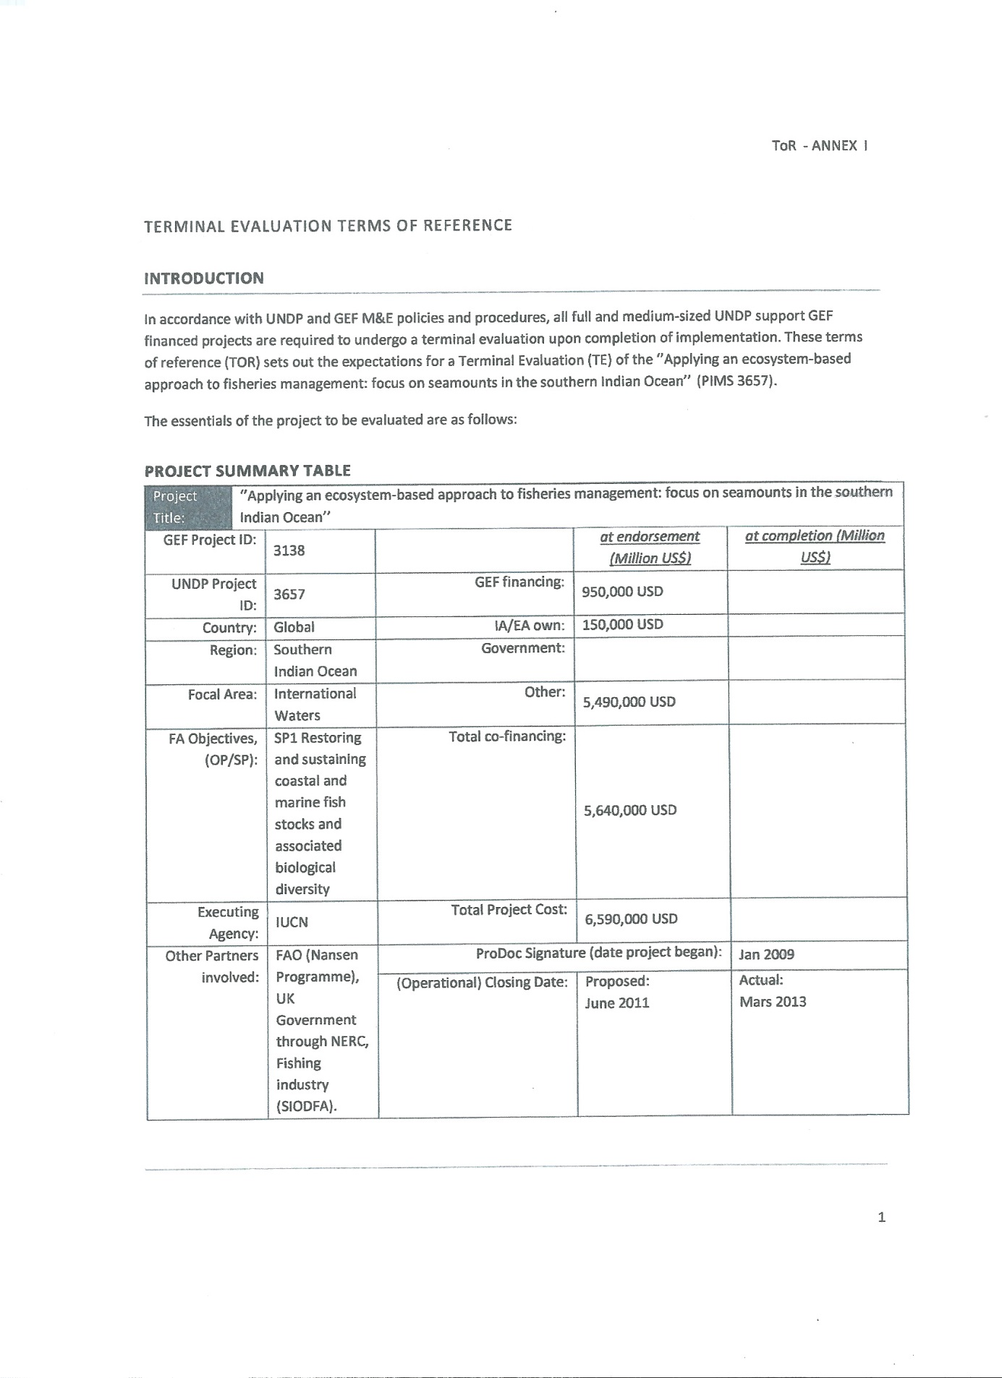
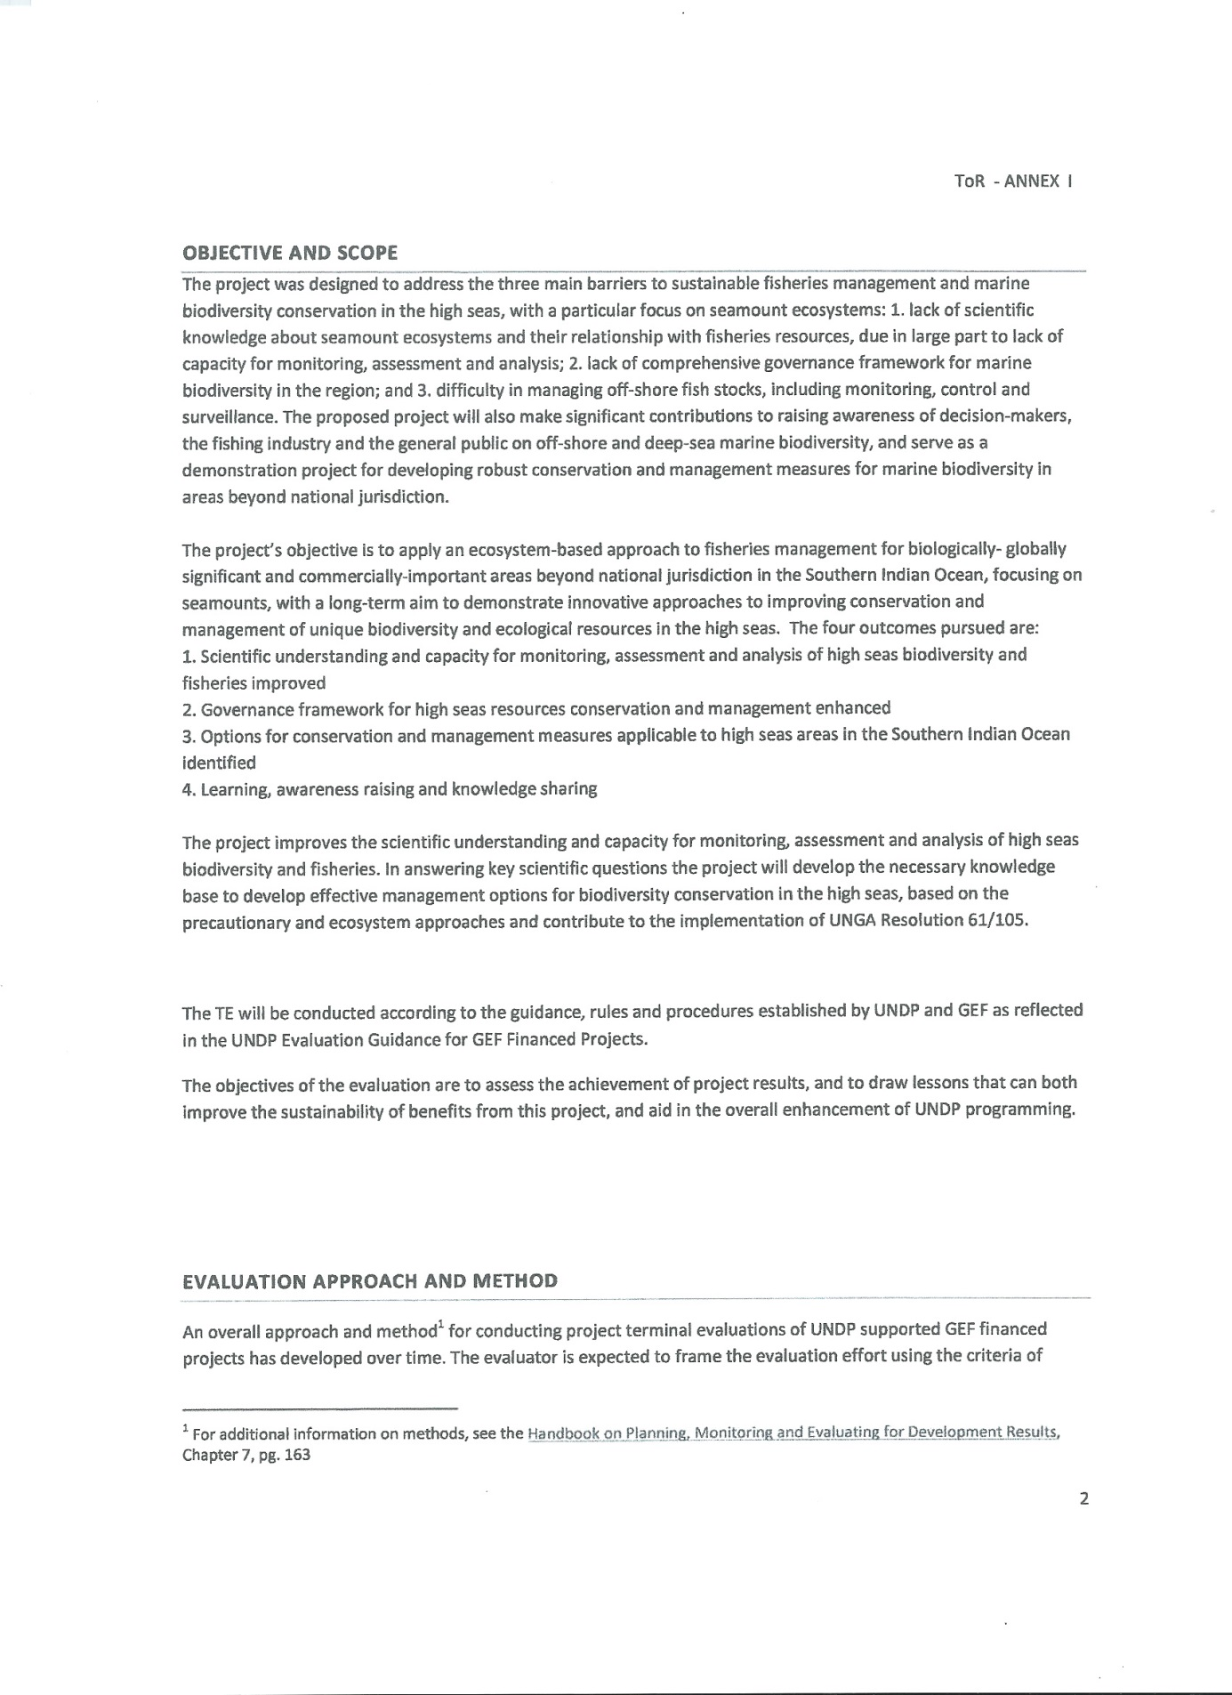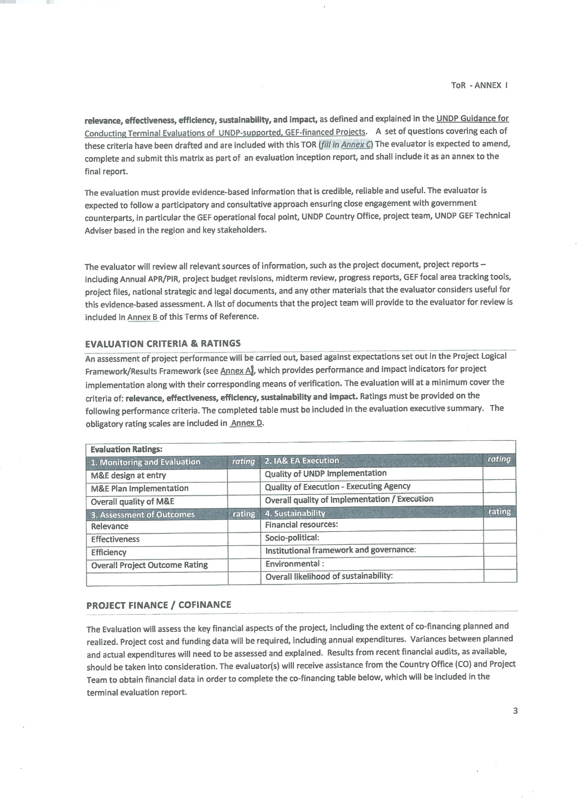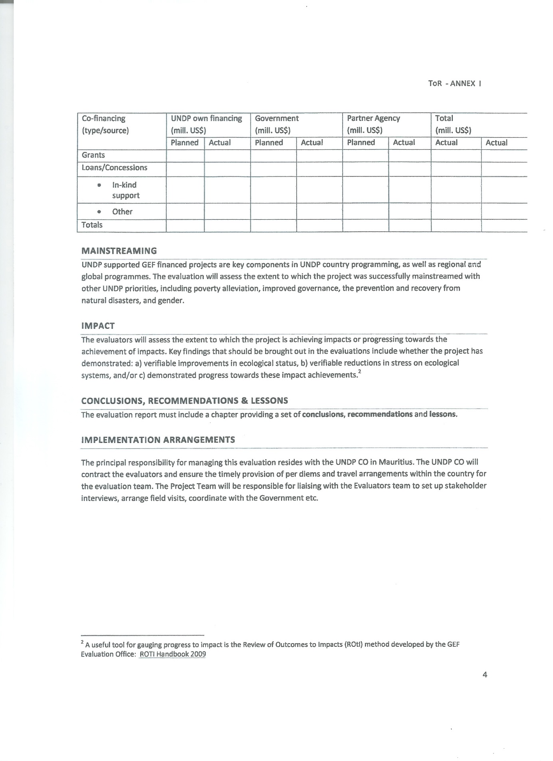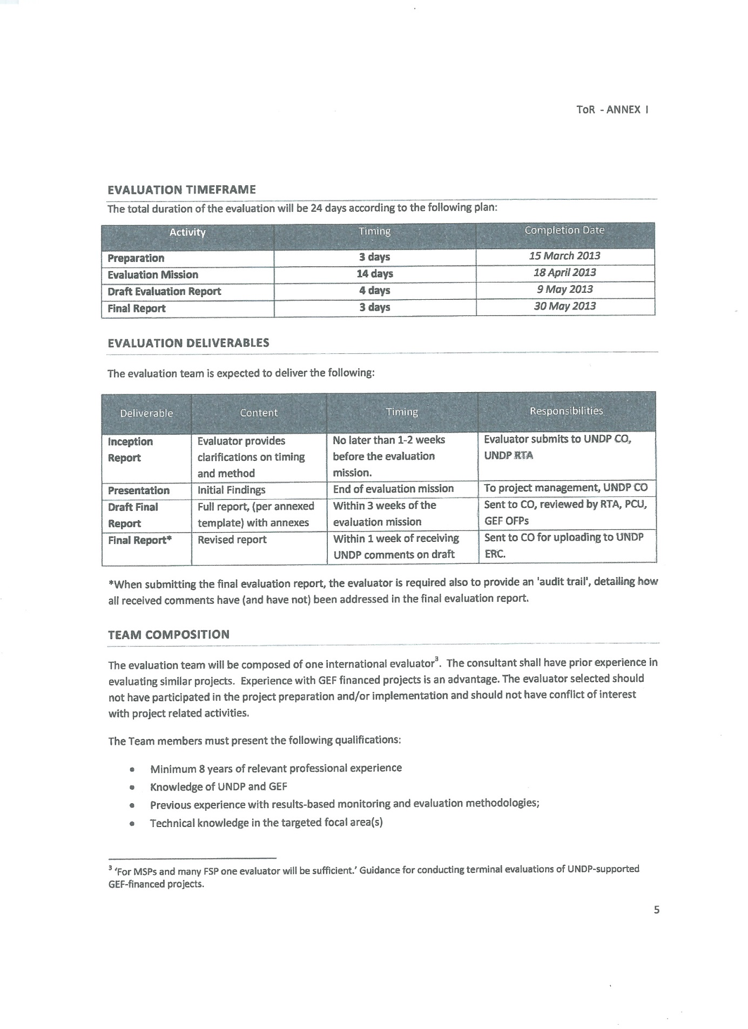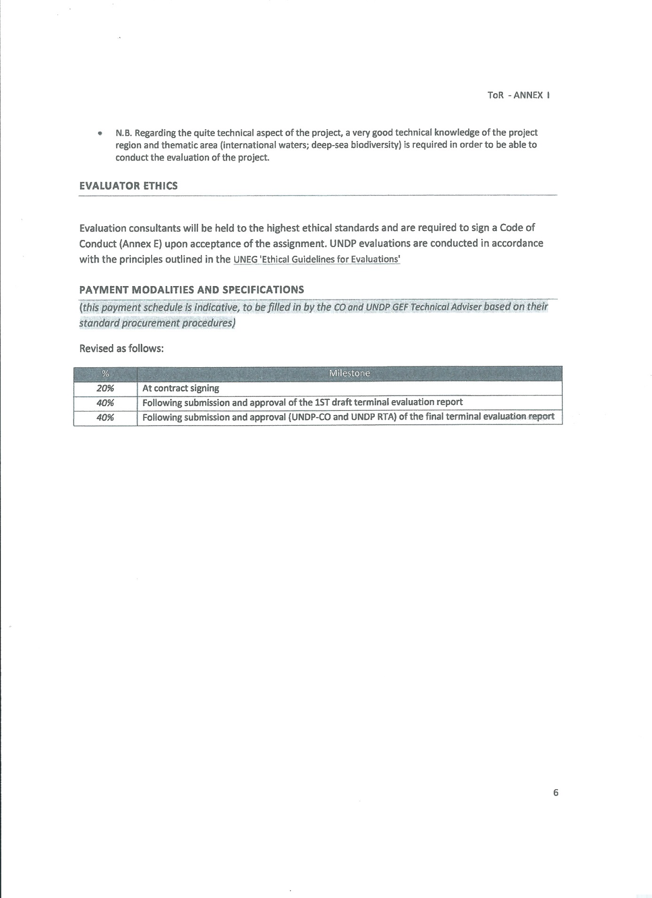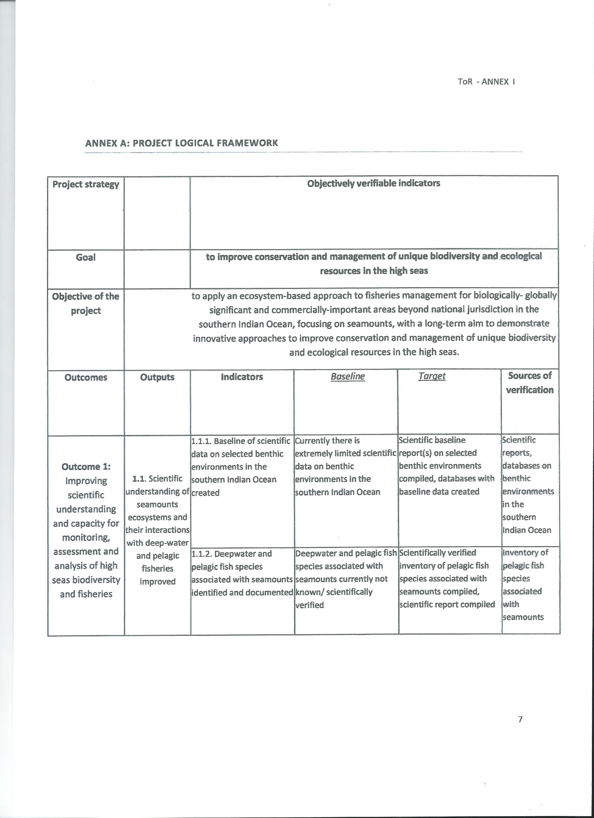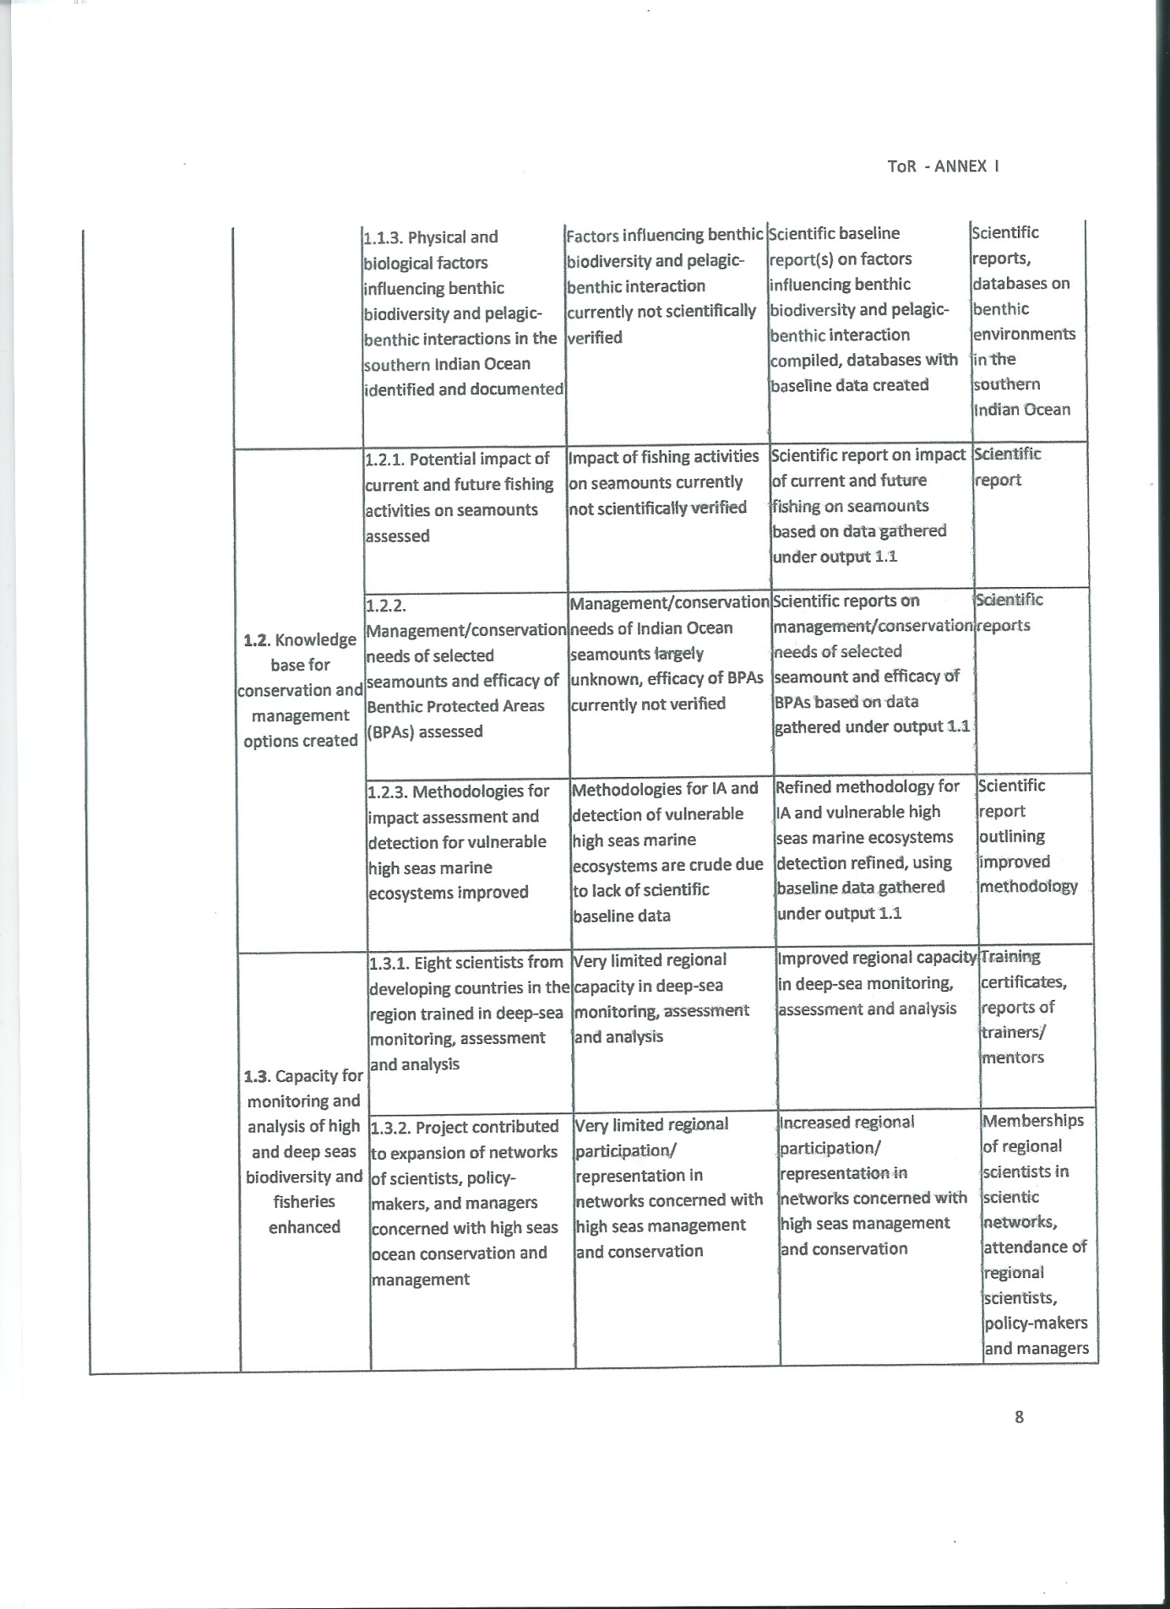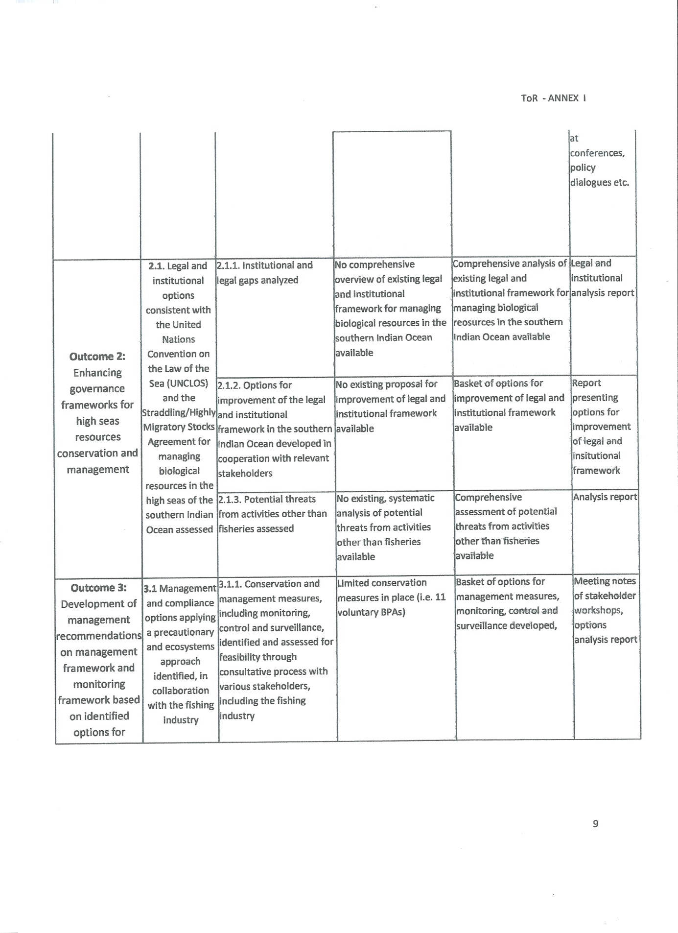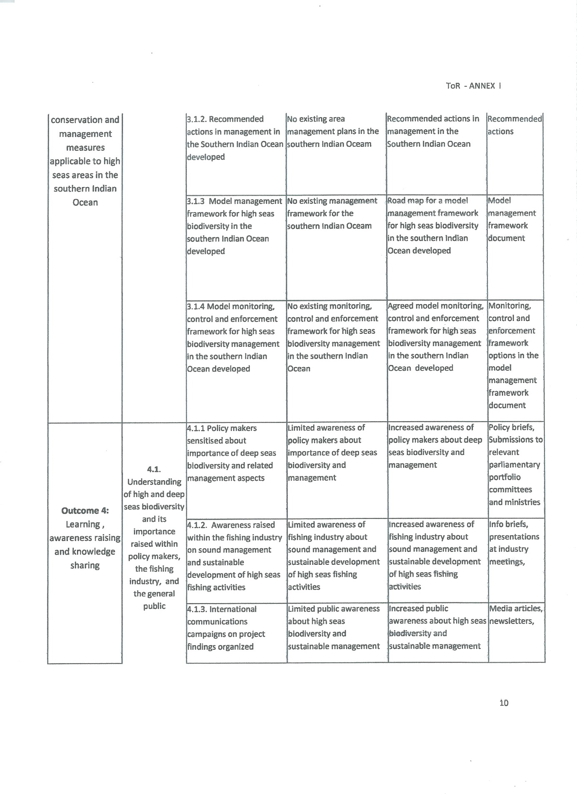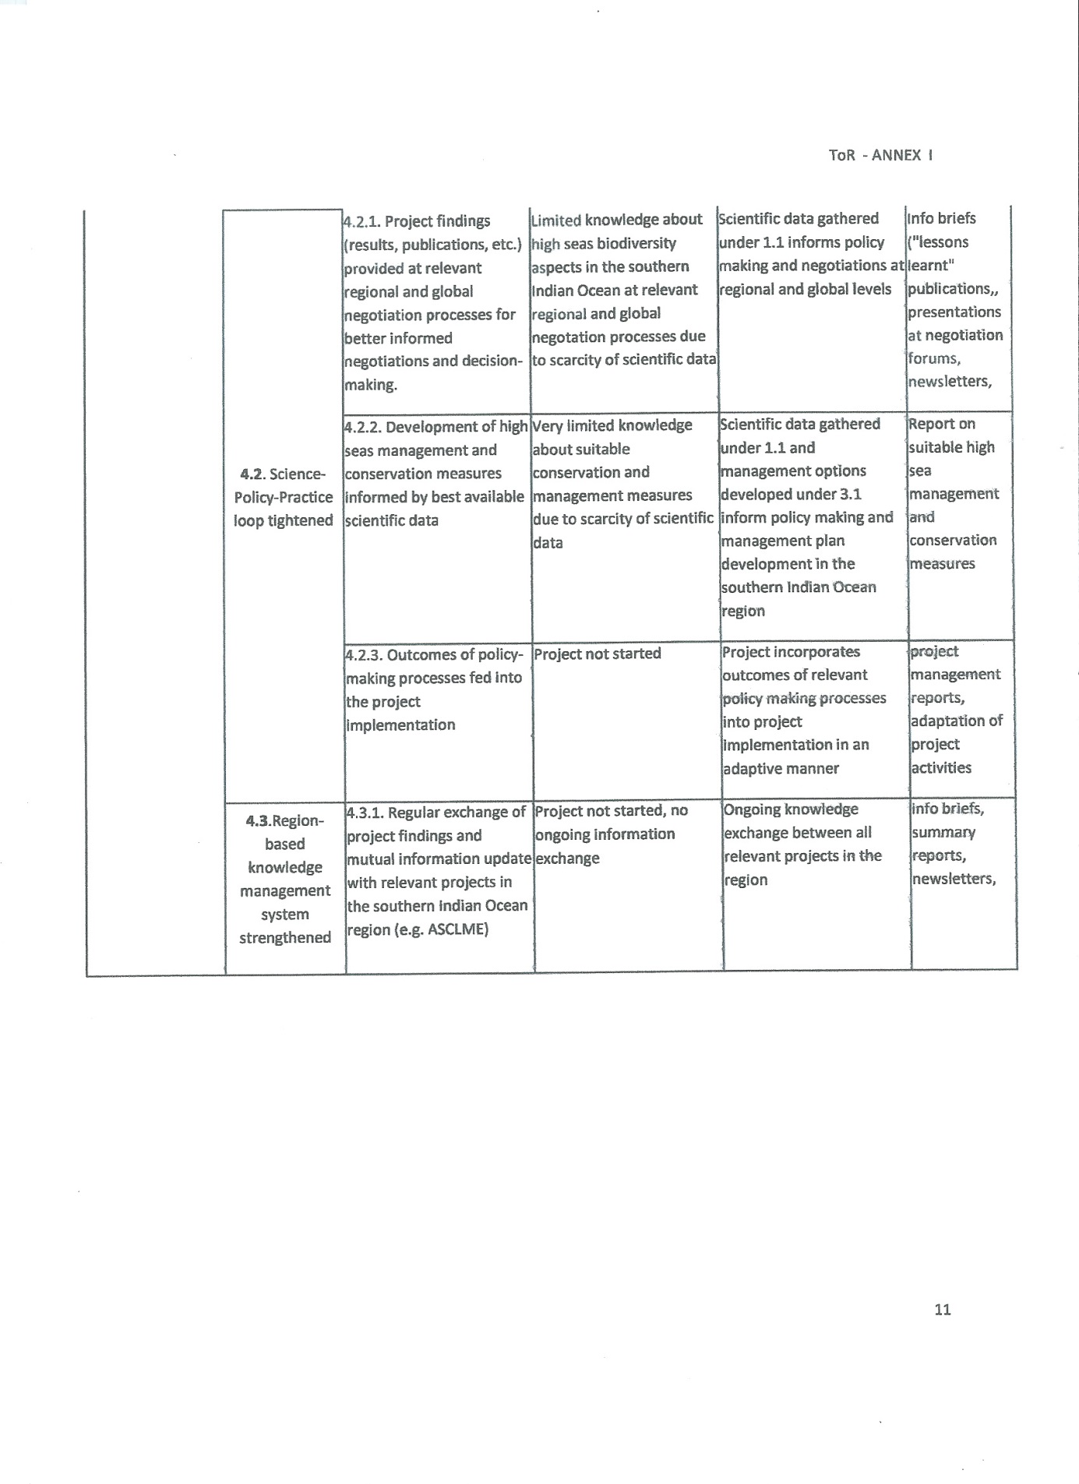
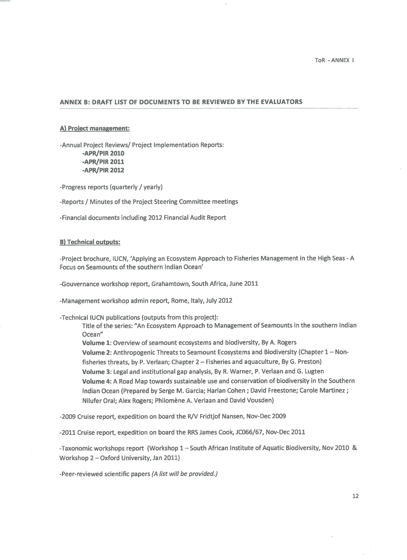
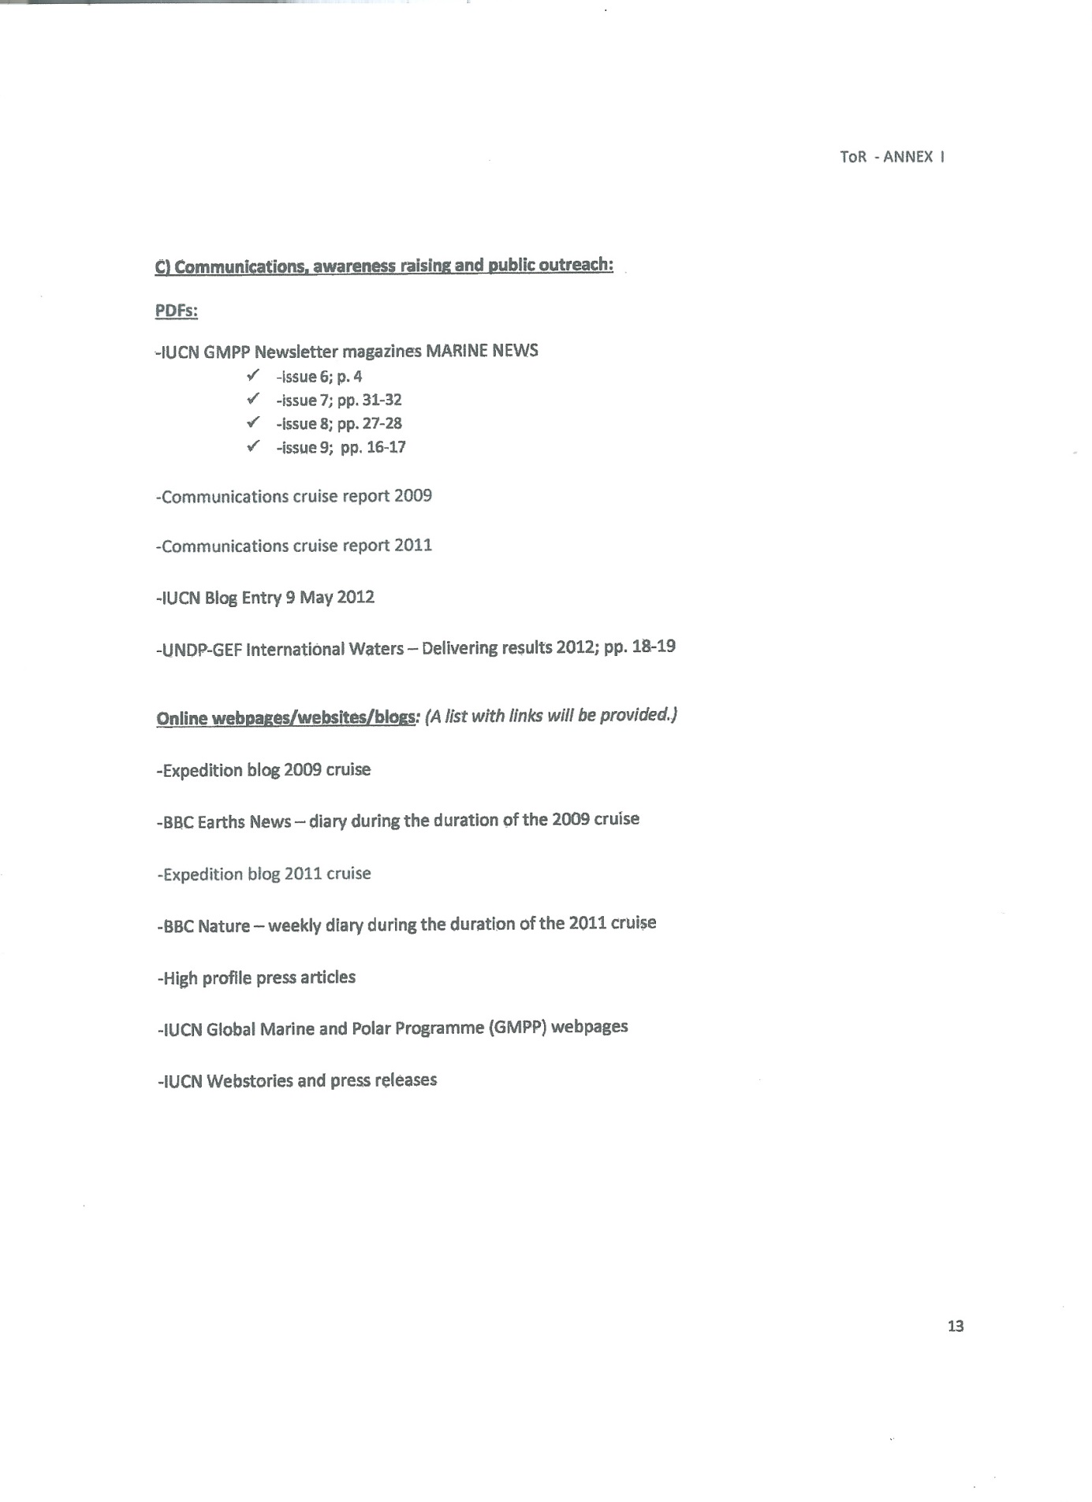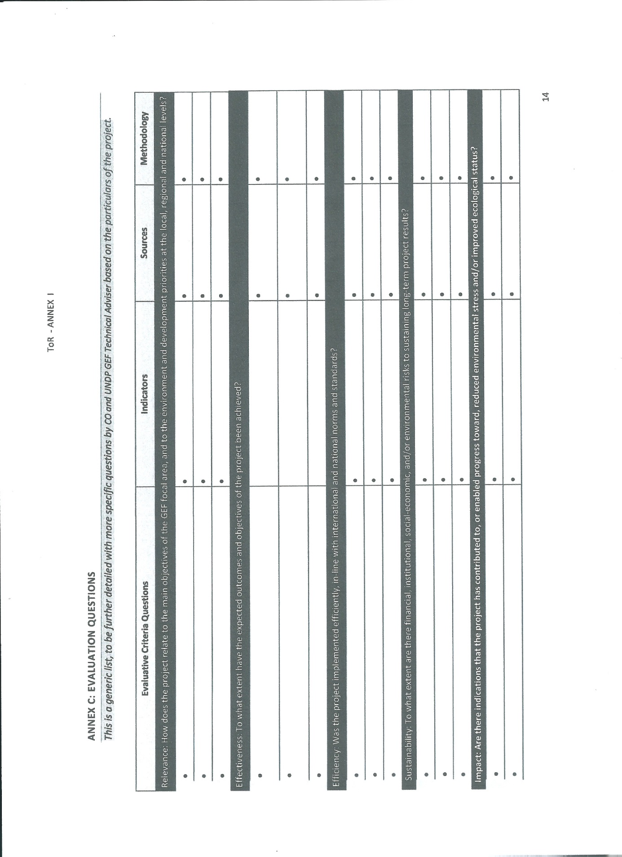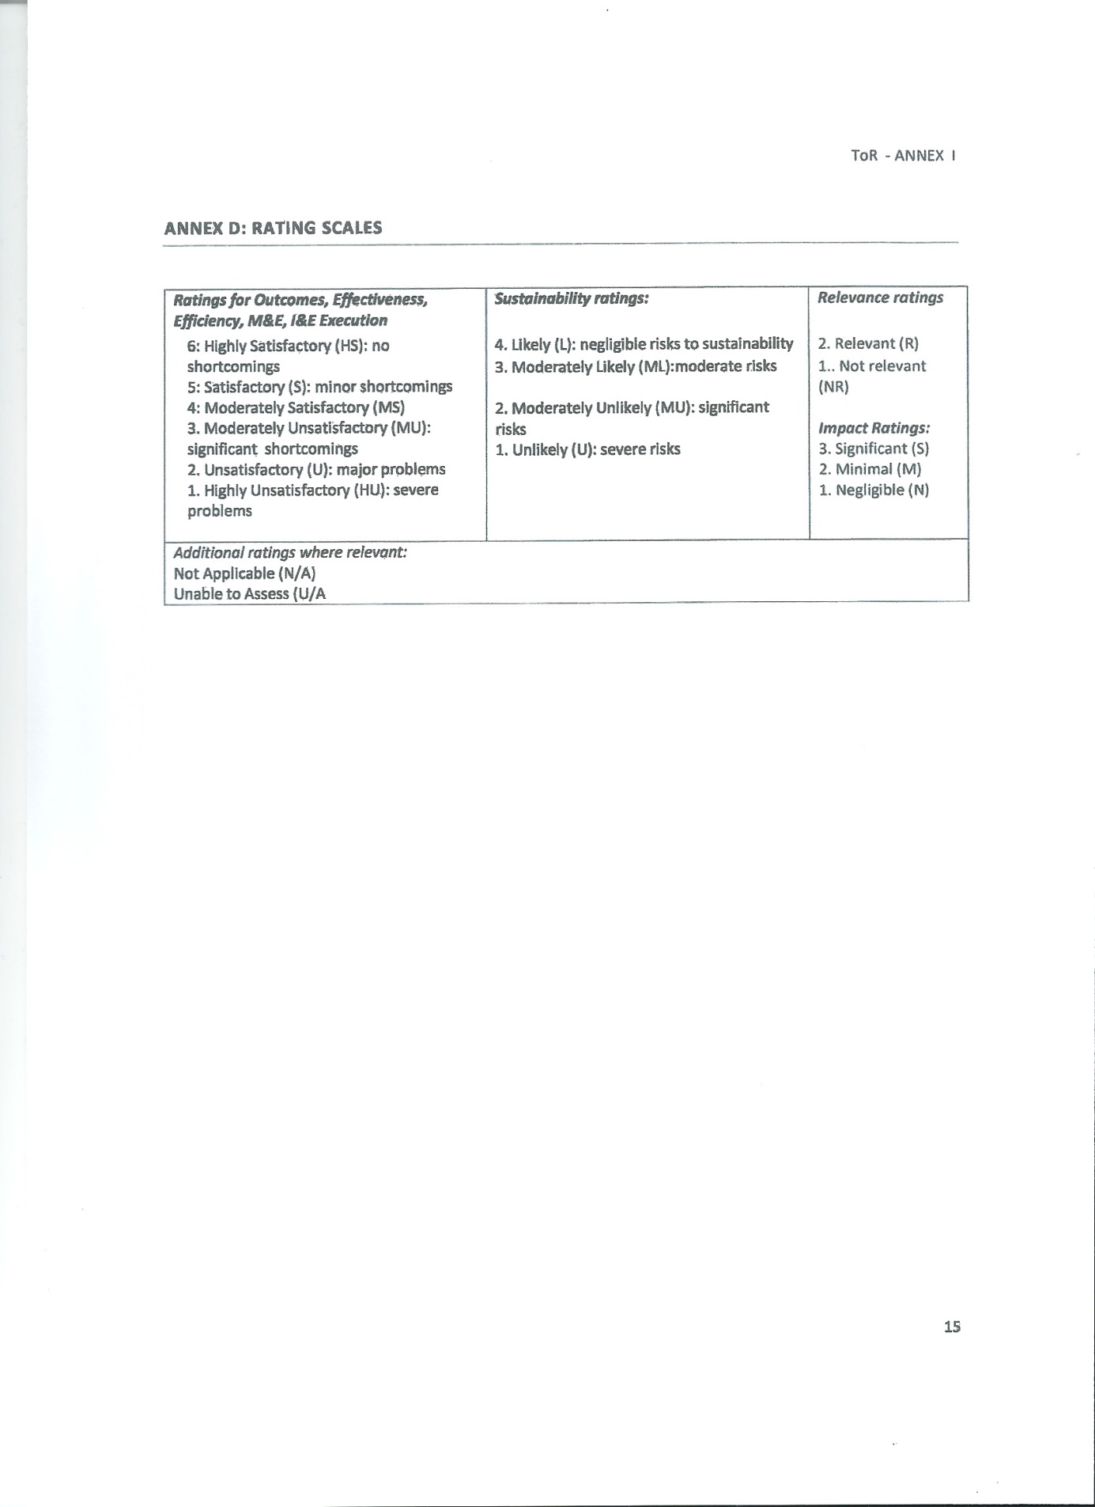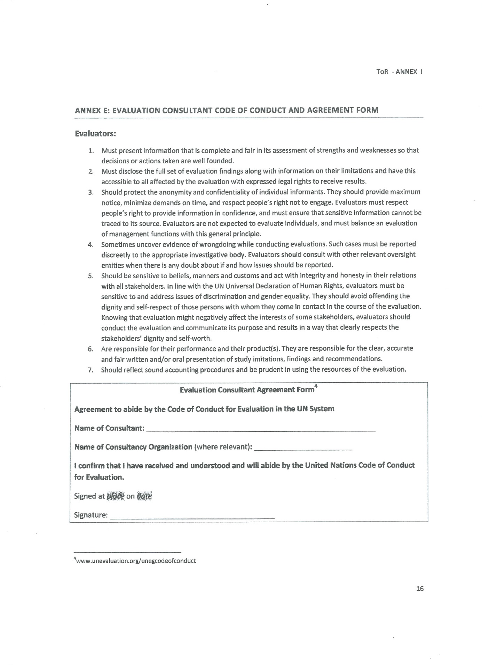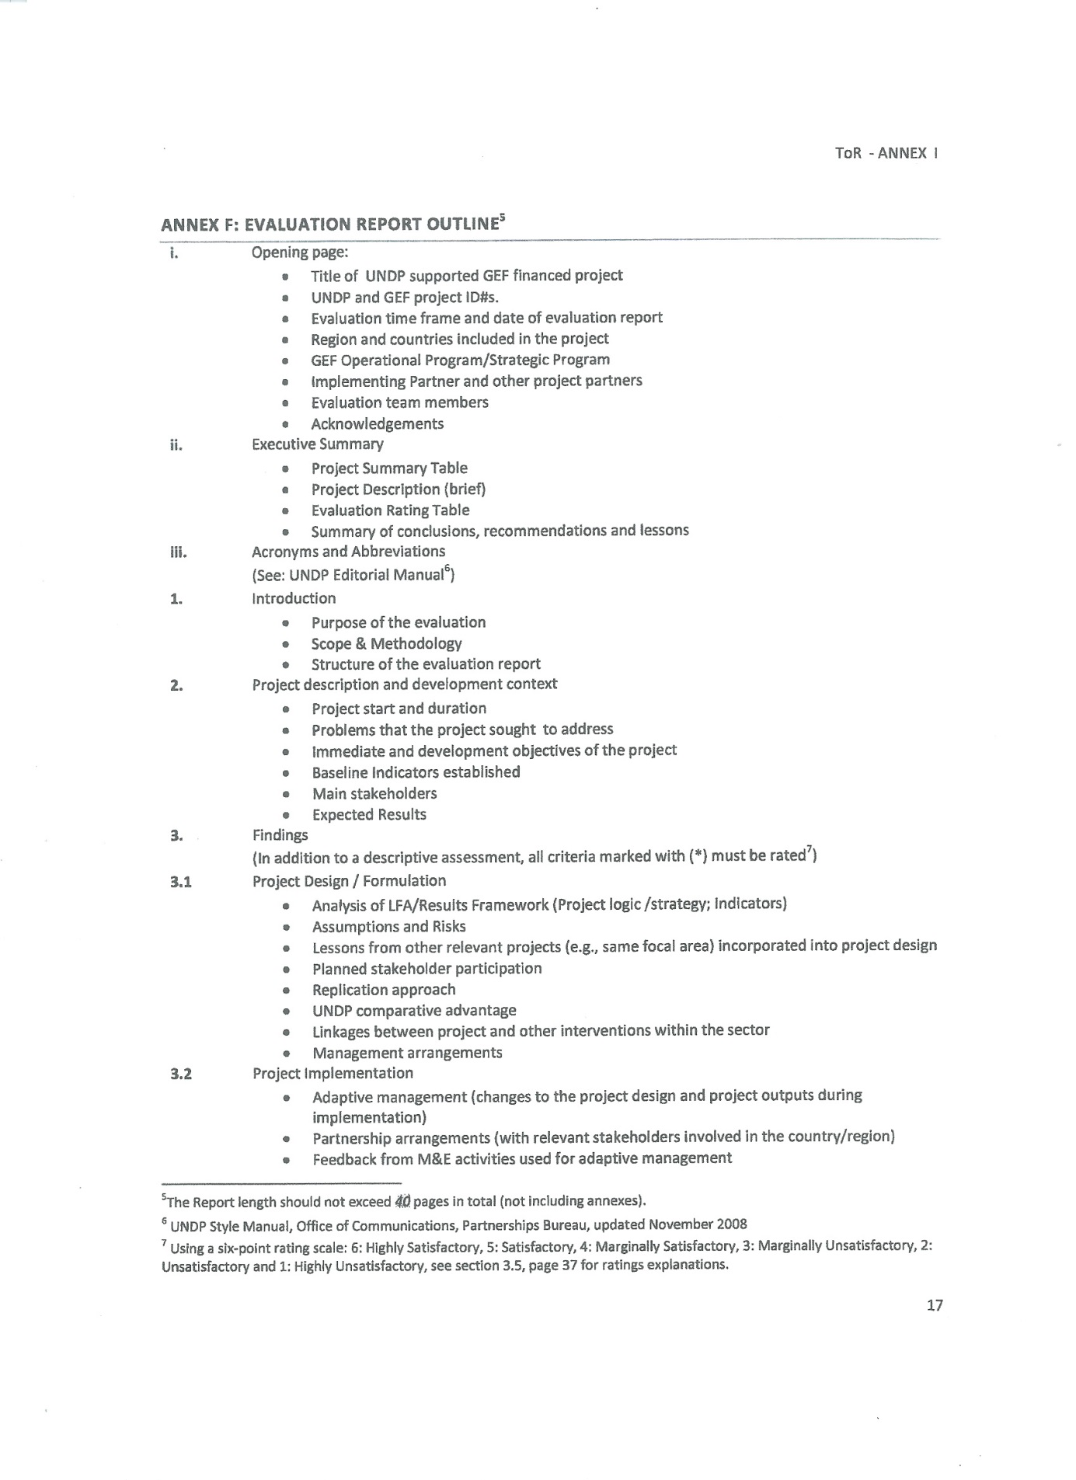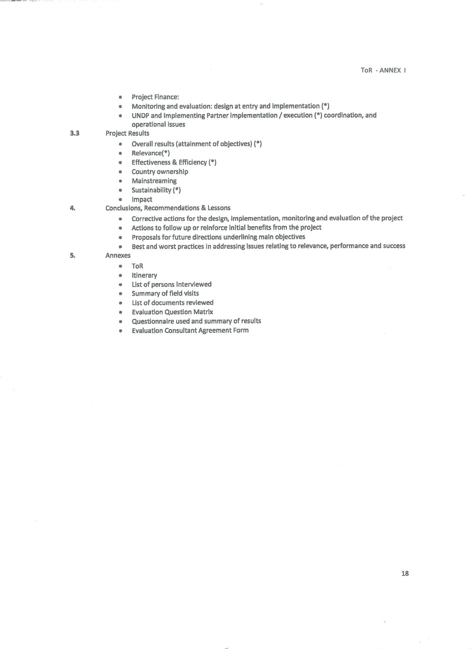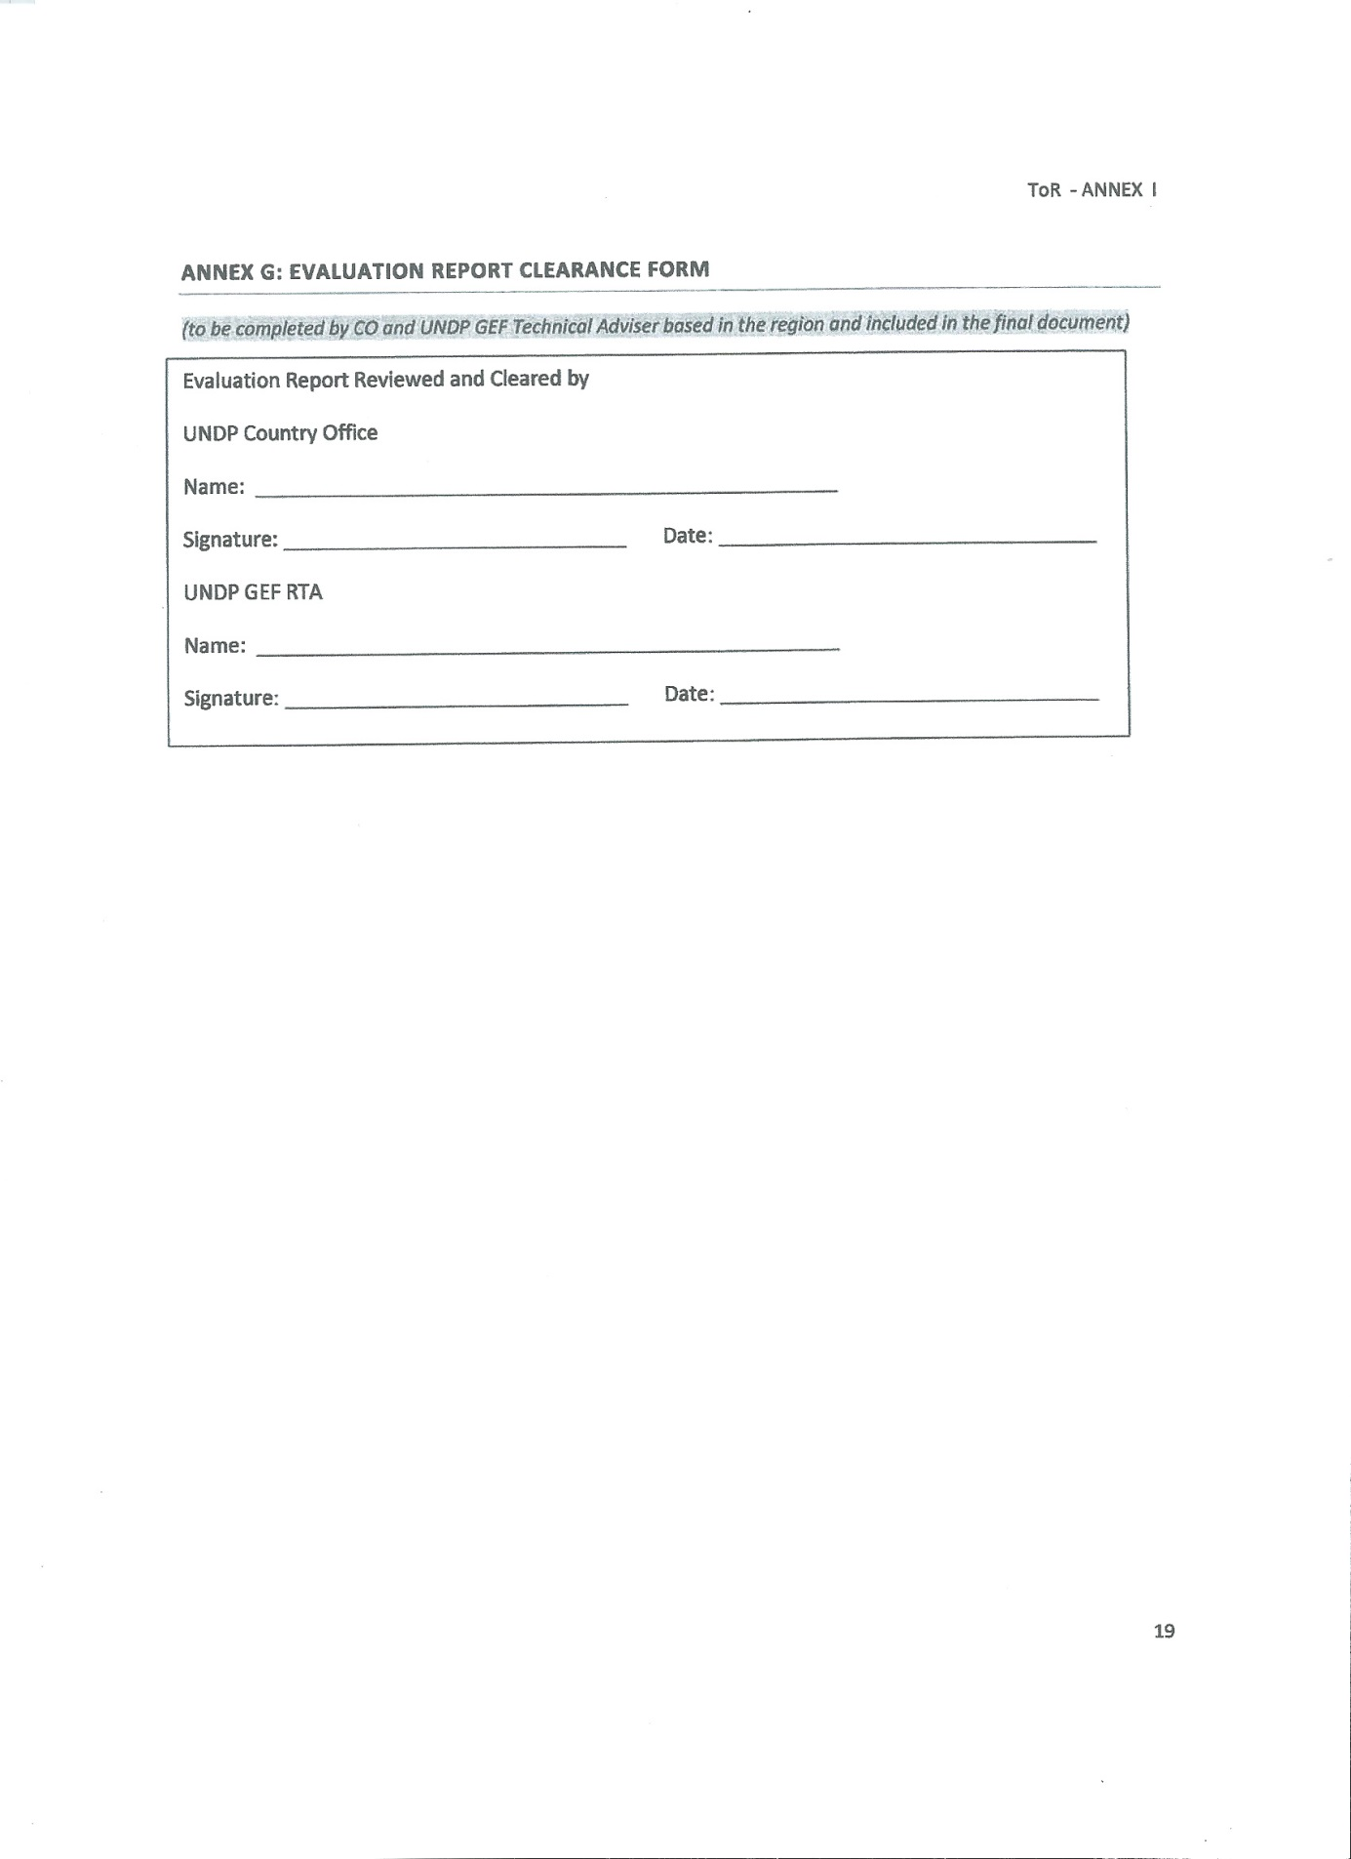

ANNEX 2 Evaluation Question Matrix and Questionnaire
- Evaluation Question Matrix

Evaluative Criteria Questions |  | Indicators | Sources | Methodology
Relevance: How does the project relate to the main objectives of the GEF focal area, and to the environment and development priorities at the local, regional and national levels?
 | . To what the extent the project is in line with the GEF International Waters priorities and to the strategic program on restoring and sustaining coastal and marine fish stocks and associated biological diversity? | . GEF International Waters priorities. | - Project Document, reports and outputs.  - GEF IW priorities | - Analysis of sources.  - Interviews.
 | . Is the project relevant to UNCBD and other international convention objectives? | . UNCBD priorities and areas of work incorporated in project design.  . Level of implementation of UNCBD in the western Indian Ocean region and contribution of the project.  . Priorities and areas of work of other conventions incorporated in project design.  . Extent to which the project is actually implemented in line with incremental cost argument | . Project Document, reports and outputs.  . National policies and strategies to implement the UNCBD, other International conventions, or related to environment more generally.  . UNCBD and other international convention web sites. | - Analysis of sources.  - Interviews
 | . Is the project relevant to the GEF biodiversity focal area? How does the project support the GEF biodiversity focal area and strategic priorities? | . Existence of a clear relationship between the project objectives and GEF biodiversity focal area. | . Project documents  . GEF focal areas strategies and documents | - Document analyses  - GEF website  - Interviews with UNDP and project team and chief scientist and his team
 | . Is the project addressing UNDP initiatives concerning the issues of social and gender inclusion, equality and empowerment? | - The project is mainstreaming UNDP’s gender perspective in the process of assessing the implications for women and men of legislation, policies or programmes in all political, economic and societal spheres. | - UNDP’s initiatives  - Project documents and outputs  - Key project stakeholders. | - Document analysis  - Interviews with relevant stakeholders
 | . Did the project contribute to strengthening the application of these principles to various development efforts in a given region and incorporated the UNDP commitment to rights-based approaches and gender mainstreaming in the initiative design? | . The respect of the principles of equality and inclusive development, such as advocated by UNDP, has been applied in the project.  . The project addressed the needs of the disadvantaged and vulnerable populations in the region. | - Project Document, reports and outputs.  - Key project stakeholders | - Document analysis  - Interviews with relevant stakeholders
 | . Is the project addressing the needs and priorities of target beneficiaries at the regional levels? How does the project support the needs of relevant stakeholders? Has the implementation of the project been inclusive of all relevant stakeholders? Were local beneficiaries and stakeholders adequately involved in project design and implementation? | . Strength of the link between expected results from the project and  the needs of relevant stakeholders.  . Degree of involvement and inclusiveness of stakeholders in project design and implementation | - Project Document, reports and outputs.  - Key project stakeholders | - Analysis of sources  - Interviews
 | . Is the project internally coherent in its design? Are there logical linkages between expected results of the project (log frame) and the project design (in terms of project components, choice of partners, structure, delivery mechanism, scope, budget, use of resources…)?Is the length of the project sufficient to achieve project outcomes? | . Level of coherence between project expected results and project design internal logic.  . Level of coherence between project design and project implementation  approach. | - Project Document, reports and outputs.  - Key project stakeholders. | - Analysis of sources  - Interviews
 | . How is the project relevant with respect to other donor-supported activities? Does the GEF funding support activities and objectives not addressed by other donors? How to GEF-funds help to fill gaps that are necessary but are not covered by other donors? Is there coordination and complementarity between donors? | . Degree to which the project was coherent and complementary to other donor programming nationally and regionally | - Documents from other donor supported activities.  - Other donor representatives.  - Project documents. | - Document analyses.  - Interviews with project partners and relevant stakeholders.
 | . Does the project provide relevant lessons and experiences for other similar projects in the future? | - Relevant lessons from the project. | - Project Document, reports and outputs. | - Analysis of sources  - Interviews
Effectiveness: To what extent have the expected outcomes and objectives of the project been achieved?
 | . Has the scientific understanding of seamount ecosystems and their interactions with deep-water and pelagic fisheries been improved and to what extent? | . Collection and analysis of scientific data on selected benthic environments of seamounts in the southern Indian Ocean.  . Identification and analysis of environmental and biological factors influencing benthic biodiversity on seamounts.  . Understanding the functioning of Seamount ecosystem.  . Identification of deep water and pelagic fish species targeted by fisheries and understanding the correlations with seamount ecosystems.  . Identification and analysis of pelagic and benthic faunal communities interactions in the seamounts of southern Indian Ocean. | - Cruise reports, IUCN reports vol 1, 2, taxonomic workshop report and peered-reviewed scientific literature published by the project after field studies achieved during oceanographic cruises | - Analysis of the sources and Evaluation of enhancement of knowledge according to state of knowledge in peer-reviewed literature prior to the two oceanographic cruises  - Interviews with project team
 | . Has knowledge baseline information been acquired to enable to draw conservation and management options for fisheries associated to seamounts? | . State of environment and Vulnerability of seamount ecosystem assessed.  . Impact of current and potential fisheries and other human and natural impacts on seamount biodiversity and habitat assessed.  . Management/conservation needs of selected seamounts and efficacy of Benthic Protected Areas (BPAs) assessed.  . Methodologies for impact assessment and ecological assessment/spatial and temporal monitoring for vulnerable/human targeted high seas marine ecosystems adapted to seamount ecosystems. | - Cruise reports, IUCN reports vol 1, 2, taxonomic workshop report and peered-reviewed scientific publications published after field studies achieved during oceanographic cruises | - Analysis of the sources and Evaluation of enhancement of knowledge according to state of knowledge in peer-reviewed literature prior to the two oceanographic cruises  - Interviews with project team
 | . Is the capacity for monitoring and analysis of high and deep seas biodiversity and fisheries enhanced, in particular in the in the Western Indian Ocean region? | . Eight scientists from developing countries in the region trained in sampling, inventoring, analyzing modeling data, assessing and monitoring deep sea and pelagic faunal communities and habitats, in particular in seamount areas of the southern Indian ocean.  . Networks of scientists, policy-makers, and managers concerned with high seas ocean conservation and management expanded, in particular in the Western Indian Ocean region. | - Cruise reports 1, 2 IUCN reports, taxonomic workshop report and peered-reviewed scientific publications published after field studies achieved during oceanographic cruises | - Evaluation of enhancement of knowledge according to state of knowledge in peer-reviewed literature prior to the two oceanographic cruises  - Interviews with project team and other partners
 | . Has the governance framework for high seas biodiversity conservation and resources management been concretely enhanced in the southern Indian Ocean region? | . Comprehensive analysis of existing legal and institutional framework and gap assessment for managing biological resources in the high seas of southern Indian Ocean.  . Legal and institutional options consistent with the United Nations Convention on the Law of the Sea (UNCLOS) and the Straddling/Highly Migratory Stocks Agreement for managing biological resources in the high seas of the southern Indian Ocean assessed.  . Options for improvement of the legal and institutional framework in the southern Indian Ocean developed in cooperation with relevant stakeholders of the region.  . Potential threats from other activities than fisheries and from natural impacts assessed. | - IUCN report 3,4 Governance and Management workshops administrative report and “A road map towards sustainable use and conservation of biodiversity in the Southern Indian Ocean”, IUCN report produced after the management workshop  - Technical papers on legal and institutional framework | - Evaluation of improvements made according to the governance framework and the legal and institutional context in the region before the project  - Interviews with project team and other partners
 | . Have options for conservation and management measures been applicable to high seas areas in the southern Indian Ocean been identified? | . Management and compliance options applying a precautionary and ecosystem approach been identified, in collaboration with the fishing industry.  . Conservation and management measures, including monitoring, control and surveillance, identified and assessed for feasibility through consultative process with various stakeholders, including the fishing industry.  . Instead of 2 management plans on specific seamounts (first agreed outcomes of project), Recommended actions for the management of high seas of the southern Indian Ocean.  . Management recommendations for high seas biodiversity in the southern Indian Ocean developed. | - IUCN report 3, Governance and Management workshops administrative report and IUCN report 4, “A road map towards sustainable use and conservation of biodiversity in the Southern Indian Ocean”, IUCN report produced after the management workshop , IUCN report on the governance workshop | - Evaluation of enhancement of knowledge on management and conservation of biodiversity of high seas in the western Indian ocean before the project  - Interviews with project team and other partners
 | . Is there an increased understanding of high seas and deep seas biodiversity and its importance raised within policy makers, the fishing industry and the general public, in particular in the region of Western Indian Ocean | . Project findings (results, publications..) provided at relevant regional and global processes for better informed negotiations and decision-making.  . Awareness raised within the fishing industry on sound management and sustainable development of high seas fishing activities  . International communications campaigns on project findings organized | - IUCN reports 1, 2 3, Governance and Management workshops administrative report and “A road map towards sustainable use and conservation of biodiversity in the Southern Indian Ocean”, IUCN report produced after the management workshop , IUCN report on the governance workshop | - Evaluation of enhancement of knowledge on management and conservation of biodiversity of high seas in the western indian ocean before the project  - Interviews with project team and other partners
 | . Is the Science-Policy Practice loop tightened? | . Development of high seas management and conservation measures informed by scientific data from the literature and the two scientific expeditions  . Outcomes of policy-making processes fed into the project implementation | - IUCN reports 1,2, 3; Governance and Management workshops administrative report and “A road map towards sustainable use and conservation of biodiversity in the Southern Indian Ocean”, IUCN report produced after the management workshop , IUCN report on the governance workshop | - Evaluation of enhancement of knowledge on management and conservation of biodiversity of high seas in the western Indian ocean before the project  - Interviews with project team and other partners
 | . Is the region-based knowledge management system strengthened ? | . Synergies with relevant initiatives in the region created and maintained | - IUCN report 3, Governance and Management workshops administrative report and “A road map towards sustainable use and conservation of biodiversity in the Southern Indian Ocean”, IUCN report produced after the management workshop , IUCN report on the governance workshop | - Evaluation of enhancement of knowledge on management and conservation of biodiversity of high seas in the western indian ocean before the project  - Interviews with project team and other partners
 | . What lessons have been learned from the project regarding achievement of outcomes?  . What lessons can be drawn regarding effectiveness for other similar projects in the future?  . What changes could have been made (if any) to the design of the project in order to improve the achievement of the project’s expected results? | . Conclusions and recommendations post cruises  . Lessons learned from the project in the region | Data collected throughout  Evaluation | - Data analysis
Efficiency: Was the project implemented efficiently, in-line with international and national norms and standards?
 | . What lessons can be learnt from the project regarding efficiency? | . Availability and quality of financial and progress reports  . Level of discrepancy  between planned and utilized financial  expenditures  . Adequacy of project choices in view of existing context, infrastructure  and cost | - Data collected throughout evaluation  - UNDP, IUCN Project team | - Data analysis  - Key interviews
 | . Was adaptive management used or needed to ensure efficient resource use? | . Availability and quality of financial and progress reports  . Level of discrepancy between planned and utilized financial  Expenditures | - Data collected throughout evaluation,  - UNDP,IUCN Project team | - Data analysis  - Key interviews
 | . Did the project logical framework and work plans and any changes made to them use as management tools during  implementation? | . Adequacy of project choices in view of existing context, infrastructure and cost | - Data collected throughout evaluation,  - UNDP, IUCN Project team | - Data analysis  - Key interviews
 | . To what extent results have been delivered with the least costly resources possible? Could financial resources have been used more efficiently? | . Availability and quality of financial and progress reports  . Level of discrepancy between planned and utilized financial  expenditures  . Adequacy of project choices in view of existing context, infrastructure  and cost | - Data collected throughout evaluation  - UNDP, IUCN Project team | - Data analysis  - Key interviews
 | . Were the accounting and financial systems in place  adequate for project management and producing accurate and timely financial information? | . Availability and quality of financial and progress reports  . Level of discrepancy between planned and utilized financial expenditures | . Data collected throughout evaluation  UNDP,  . IUCN Project team | . Data analysis  . Key interviews
 | . Were progress reports produced accurately, timely and responded to reporting requirements including adaptive management changes? | . Timeliness and adequacy of reporting provided | - Project team  - UNDP  - Project documents | - Document analysis  - Key interviews
 | . Was project support provided in an efficient way? | . Adequacy of project choices in view of existing context, infrastructure and cost | - Project documents  - UNDP  - Project team | - Document analysis  - Key interviews
 | . How efficient are partnership arrangements for the project?  . To what extent partnerships/linkages between institutions/organizations were encouraged and supported?  . Which partnerships can be considered sustainable? | . Specific activities conducted to support the development of cooperative arrangements between partners  . Evidence that particular partnerships/linkages will be sustained | - Project documents and evaluations. Project partners and relevant stakeholders | - Document analysis, interviews
 | . Was an appropriate balance struck between utilization of international expertise as well as local capacity? | . Proportion of expertise utilized from international experts compared to national experts. | - Project documents and evaluations UNDP, Beneficiaries | - Document analysis , Interviews
 | . Did the leveraging of funds (co-financing) happen as planned? | . Planned vs. actual funds leveraged | - Project documents | - Document analysis  - Interviews
 | . How was results-based management used during  project implementation? | . Adequacy of project choices in view of existing context, infrastructure  and cost  . Quality of results-based management reporting (progress reporting, monitoring and evaluation) | - Data collected throughout evaluation | - Data analysis  - Interviews
 | . What changes could have been made to the project in order to improve its efficiency? | . Adequacy of project choices in view of existing context, infrastructure and cost | - Data collected throughout evaluation | - Data analysis
 | . Was the project implemented efficiently, in-line with international and national norms and standards? | . Adequacy of efficiency of implementation according to national and international standards | - Data collected throughout evaluation | - Data analysis
 | . What lessons can be drawn regarding efficiency for other similar projects in the future? | . Cost in view of results achieved compared to costs of similar projects  from other organizations | - Data collected throughout evaluation | - Data analysis
Sustainability: To what extent are there financial, institutional, social-economic, and/or environmental risks to sustaining long-term project results?
 | . Are there financial risks that may jeopardize the sustainability of project outcomes? | . Establishment of financial and economic instruments and mechanisms to ensure the ongoing flow of benefits once the GEF assistance ends  . Development and implementation of a sustainability strategy. | - Project reports  - Data collected throughout evaluation | - Data analysis  - Interviews
 | . Are there socio-economic and political risks that may jeopardize the sustainability of project outcomes? Is there sufficient public/stakeholder awareness in support of the project’s long-term objectives? | . Establishment of financial and economic instruments and mechanisms to ensure the ongoing flow of benefits once the GEF assistance ends  . Development and implementation of a sustainability strategy. | - Project reports  - Interviews  - Data collected throughout evaluation | - Interviews  - Data analysis
 | . Are there institutional (legal framework, policies)framework and governance risks that may jeopardize the sustainability of project outcomes? | . Development of policy and regulatory frameworks that further the project objectives.  . Development of appropriate institutional capacity (systems, structures, staff, expertise...).  . Achieving stakeholders’ consensus regarding courses of action on project activities.  . Development and implementation of a sustainability strategy. | - Project reports  - Interviews  - Data collected throughout evaluation | - Interviews  - Data analysis
 | . Are there environmental risks that may jeopardize the sustainability of project outcomes? Are there on going activities that may threathen the sustainability of project benefits? | . Incorporation of environmental and ecological factors affecting future flow of benefits.  . Development and implementation of a sustainability strategy. | - Project reports  - Data collected throughout evaluation | - Interviews  - Data analysis
Impact: Are there indications that the project has contributed to, or enabled progress toward, reduced environmental stress and/or improved ecological status?
 | . Has the project demonstrated verifiable improvements on ecological status?at what scales?long lasting?Global environmental benefits? | . Verifiable improvements in ecological status or verifiable process indicators suggesting that impacts should occur in the future as a result of project achievements | - Project reports  - Data collected throughout evaluation | - Interviews  - Data analysis
 | . Has the project demonstrated verifiable improvements on socio-economic status?at what scales?long lasting? | . Verifiable improvements in socio-economic status or verifiable process indicators suggesting that impacts should occur in the future as a result of project achievements | - Project reports  - Data collected throughout evaluation | - Interviews  - Data analysis
 | . Has the project demonstrated verifiable reductions in stress on ecological systems? at what scales? long lasting? | . Verifiable improvements in stress reduction on ecological systems or verifiable process indicators suggesting that impacts should occur in the future as a result of project achievements | - Project reports  - Data collected throughout evaluation | - Interviews  - Data analysis
 | . Has the project incited regulatory and policy changes at regional, national and/or local levels? | . Verifiable improvements in regulatory and policy changes or verifiable process indicators suggesting that impacts should occur in the future as a result of project achievements | - Project reports  - Data collected throughout evaluation | - Interviews  - Data analysis
 | . Are there environmental risks that may jeopardize the sustainability of project outcomes? | . Verifiable improvements in stress reduction or verifiable process indicators suggesting that impacts should occur in the future as a result of project achievements | - Project reports  - Data collected throughout evaluation | - Interviews  - Data analysis
 | . If verifiable impacts are not evident are intended impacts on an impact pathway in reference to the theory of change (ROtl, OPS4-M2-ROtI Handbook | Global Environment Facility)? | . Verifiable process indicators suggesting that impacts should occur in the future as a result of project achievements. Identification of intermediate states, assumptions and impact drivers to define intended impacts by using the R0tl methodology | - Project reports  - Data collected throughout evaluation | - Interviews  - Data analysis

- Questionnaire

The criteria and questions that the evaluation will use to assess performance and rationale are the following:

1. Relevance: How does the project relate to the main objectives of the GEF focal area, and to the environment and development priorities at the local, regional and national levels?

2. Effectiveness: To what extent have the expected outcomes and objectives of the project been achieved?

3. Efficiency: Was the project implemented efficiently, in-line with international and national norms and standards?

4. Sustainability: Was the project implemented efficiently, in-line with international and national norms and standards?

5. Impact: Are there indications that the project has contributed to, or enabled progress toward, reduced environmental stress and/or improved ecological status?

Specifically the Terminal Evaluation will address the following points:

1.Relevance: How does the project relate to the main objectives of the GEF focal area, and to the environment and development priorities at the local, regional and national levels?

- 1.1 To what the extent the project is in line with the GEF International Waters priorities and the strategic program on restoring and sustaining coastal and marine fish stocks and associated biological diversity?

-1.2 Is the project relevant to UNCBD and other international convention objectives?

-1.3 Is the project relevant to the GEF biodiversity focal area?

-1.4 How does the project support the GEF biodiversity focal area and strategic priorities?

-1.5 Is the project addressing UNDP initiatives concerning the issues of social and gender inclusion, equality and empowerment?

-1.6 Did the project contribute to strengthening the application of these principles (1-5) to various development efforts in a given region and incorporated the UNDP commitment to rights-based approaches and gender mainstreaming in the initiative design?

-1.7 Is the project addressing the needs and priorities of target beneficiaries at the regional levels?

-1.8 Is the project internally coherent in its design?

-1.9 Are there logical linkages between expected results of the project (log frame) and the project design (in terms of project components, choice of partners, structure, delivery mechanism, scope, budget, use of resources…)?

-1.10 Was the length of the project sufficient to achieve project outcomes?

-1.11 How is the project relevant with respect to other donor-supported activities?

-1.12 Does the GEF funding support activities and objectives non addressed by other donors?

-1.13 How GEF-funds help to fill gaps that are necessary but are not covered by other donors?

-1.14 Is there coordination and complementarity between donors?

-1.15 Does the project provide relevant lessons and experiences for other similar projects in the future?

2.Effectiveness: To what extent have the expected outcomes and objectives of the project been achieved?

-2.1 Has the scientific understanding of seamount ecosystems and their interactions with deep-water and pelagic fisheries been improved and to what extent?

-2.2 Has knowledge baseline information been acquired to enable to draw conservation and management options for fisheries associated to seamounts?

-2.3 Is the capacity for monitoring and analysis of high and deep seas biodiversity and fisheries enhanced, in particular in South Western Indian Ocean region?

-2.4 Has the governance framework for high seas biodiversity conservation and resources management been concretely enhanced Southern Western Indian Ocean region?

-2.5 Have options for conservation and management measures applicable to high seas areas in South Western Indian Ocean been identified?

-2.6 Is there an increased understanding of high seas and deep seas biodiversity and its importance raised within policy makers, the fishing industry and the general public, in particular in the South Western Indian Ocean region?

-2.7 Is the Science-Policy Practice loop tightened?

-2.8 Is the region-based knowledge management system strengthened?

-2.9 What lessons have been learned from the project regarding achievement of outcomes?

-2.10 What lessons can be drawn regarding effectiveness for other similar projects in the future?

-2.11 What changes could have been made (if any) to the design of the project in order to improve the achievement of the project’s expected results?

3.Efficiency: Was the project implemented efficiently, in-line with international and national norms and standards?

-3.1 What lessons can be learnt from the project regarding efficiency?

-3.2 Was adaptive management used or needed to ensure efficient resource use?

-3.3 Did the project logical framework and work plans and any changes made to them use as management tools during implementation?

-3.4 To what extent results have been delivered with the least costly resources possible?

-3.5 Could financial resources have been used more efficiently?

-3.6 Were the accounting and financial systems in place adequate for project management and producing accurate and timely financial information?

-3.7 Were progress reports produced accurately, timely and responded to reporting requirements including adaptive management changes?

-3.7 Was project support provided in an efficient way?

-3.8 How efficient are partnership arrangements for the project?

-3.9 To what extent partnerships/linkages between institutions/organizations were encouraged and supported?

-3.10 Which partnerships can be considered sustainable?

-3.11 Was an appropriate balance struck between utilization of international expertise as well as regional/national capacity?

-3.12 Did the leveraging of funds (co-financing) happen as planned?

-3.13 How was results-based management used during project implementation?

-3.14 What changes could have been made to the project in order to improve its efficiency?

-3.15 Was the project implemented efficiently, in-line with international and national norms and standards?

-3.16 What lessons can be drawn regarding efficiency for other similar projects in the future?

4.Sustainability: To what extent are there financial, institutional, social-economic, and/or environmental risks to sustaining long-term project results?

-4.1 Are there financial risks that may jeopardize the sustainability of project outcomes?

-4.2 Are there socio-economic and political risks that may jeopardize the sustainability of project outcomes?

-4.3 Is there sufficient public/stakeholder awareness in support of the project’s long-term objectives?

-4.4 Are there institutional and legal framework risks and governance risks that may jeopardize the sustainability of project outcomes?

-4.5 Are there environmental risks that may jeopardize the sustainability of project outcomes?

-4.6 Are there on going activities that may threaten the sustainability of project benefits?

5 Impact: Are there indications that the project has contributed to, or enabled progress toward, reduced environmental stress and/or improved ecological status?
-5.1 Has the project demonstrated verifiable improvements on ecological status? At what scales? Long lasting? Global environmental benefits?

-5.2 Has the project demonstrated verifiable improvements on socio-economic status? At what scales? Long lasting?

-5.3 Has the project demonstrated verifiable reductions in stress on ecological systems? At what scales? Long lasting?

-5.4 Has the project incited regulatory and policy changes at international, regional, national and/or local (site) levels?

-5.5 Are there environmental risks that may jeopardize the sustainability of project outcomes?

-5.6 If verifiable impacts are not evident, are intended impacts on an impact pathway in reference to the theory of change (ROtl, OPS4-M2-ROtI Handbook | Global Environment Facility)?

ANNEX 3 List of Partners and stakeholders of the project
DIRECT PARTNERS

GEF: The Global Environment Facility (GEF) is a global partnership among 178 countries, international institutions, non-governmental organizations (NGOs), and the private sector to address global environmental issues while supporting national sustainable development initiatives. It provides grants for projects related to six focal areas: biodiversity, climate change, international waters, land degradation, the ozone layer, and persistent organic pollutants. Today the GEF is the largest funder of projects to improve the global environment. Since 1991, GEF has achieved a strong track record with developing countries and countries with economies in transition, providing $8.6 billion in grants and leveraging $36.1 billion in co-financing for over 2,400 projects in more than 165 countries.

UNDP: United Nations Development Programme (UNDP) is the United Nation's global development network, an organization advocating for change and connecting countries to knowledge, experience and resources to help people build a better life. UNDP is on the ground in 166 countries, working with them on their own solutions to global and national development challenges. UNDP supports improved governance of freshwater, marine and coastal resources at local, national, regional and global levels through its Water Governance Programme. UNDP’s GEF International Waters portfolio focuses on strengthening the joint management of rivers, lakes, aquifers and oceans by helping government and other stakeholders set priorities, building consensus on governance reforms and investments, nurturing and strengthening institutions, and supporting the implementation of action programs.

IUCN: The International Union for Conservation of Nature is the world’s oldest and largest global environmental organization. Conserving biodiversity is central to the mission of IUCN. To deliver conservation and sustainability at both the global and local level, IUCN builds on its strengths in the following areas: Science – 11,000 experts setting global standards in their fields; Action – hundreds of conservation projects all over the world from the local level to those involving several countries, all aimed at the sustainable management of biodiversity and natural resources; and, Influence – through the collective strength of more than 1,200 government and non-governmental Member organizations, IUCN influences international environmental conventions, policies and laws. IUCN-WCPA, the World Commission on Protected Areas and the Global Ocean Biodiversity Initiative (GOBI) is an international partnership advancing the scientific basis for conserving biological diversity in the deep seas and open oceans.

ASSOCIATE PARTNERS

IOZ/ZSL/NERC Institute of Zoology, Zoological Society of London then the Zoology Department of the University of Oxford (according to the new position of Prof Rogers): The Institute of Zoology is the research division of the Zoological Society of London. The project here is funded by NERC. IOZ is a government-funded higher education and research establishment specializing in scientific issues relevant to the conservation of animal species and their habitats. IOZ research focuses on five thematic areas: evolutionary biology, genetics, ecology, reproductive biology and wildlife epidemiology.

NERC: Natural Environment Research Council (NERC) is the UK's main agency for funding and managing research, training and knowledge exchange in the environmental sciences. Its vision is to advance knowledge and understanding of the Earth and its environments to help secure a sustainable future for the planet and its people.

NORAD/EAF-Nansen Project/FAO-IMR-SAIAB: The EAF-Nansen Project is executed by FAO in close collaboration with the Institute of Marine Research (IMR), Norway, and funded by the Norwegian Agency for Development Cooperation (NORAD). The principal aim of the EAF-Nansen project is to strengthen the knowledge base for and implementing an ecosystem-approach to marine fisheries in developing countries, with a current emphasis on sub-Saharan Africa. IMR is the Institute of Marine Science in Norway and SAIAB is the South African Institute for Aquatic Biodiversity based in Grahamstown in South Africa.

GEF UNDP ASCLME Project: The goal of the five-year Agulhas and Somali Current Large Marine Ecosystems Project is to ensure the long-term sustainability of the living resources of the ASCLME region by introducing an ecosystem-based approach to management. The Project is funded by the Global Environment Facility (GEF) and implemented by the United Nations Development Programme (UNDP).

ECOMAR: University of Reunion Marine Ecology Lab (ECOMAR) focuses its research on the study of the structure and the functioning of marine ecosystems in order to sustainably manage marine biodiversity and better understand anthropogenic and climate change impacts on the marine environment.

SIODFA: Southern Indian Ocean Deepsea Fishers Association (SIODFA) is an Association of fishing companies established in 2006, whose primary goals are to maintain unsubsidized, profitable and environmentally sustainable fisheries and to set international best practice for responsible deep-sea fishery management. It is open to companies that have deepwater fishing operations in the high seas of the Indian Ocean and share the objectives of the Association. SIODFA is comprised of Austral Fisheries PTY Ltd (Perth, Australia), B and S International Ltd (Vodskov, Denmark), Sealord Group (Nelson, New Zealand) and TransNamibia Fishing Pty Ltd (Walvis Bay, Namibia), and represents the majority of the deepwater fleet in the southern Indian Ocean..

OTHER STAKEHOLDERS CONTACTED OR POTENTIAL

Global level

UN-The International Seabed Authority (ISA)
UN-Food and Agriculture Organization of the United Nations (FAO)
UN-The International Maritime Organization (IMO)
Unesco/ Intergovernmental Oceanographic Commission (IOC)
The Convention on the Conservation of Migratory Species of wild animals (CCMS/AEWA, ACAP, IOSEA)
The Convention on International Trade of Endangered Species (CITES)
The International Whaling Commission (IWC)
UNEP Global International Waters Assessment (GIWA)
UN Small Island States (SIDS)
InterRidge (International Cooperation in Ridge-Crest studies)
International Marine Minerals Society (IMMS)
Census of Marine Life on Seamounts (CenSeam)
EC-Hotspot Ecosystem Research and Man’s Impact on European Seas (Hermione) seamounts
The Deep Sea Conservation Coalition
High Seas Alliance
The World Ocean Council

REGIONAL LEVAL

The UNEP Eastern African Regional Seas Programme is governed by the legally binding Convention for the Protection, Management and Development of the Marine and Coastal Environment of the Eastern African Region (the Nairobi Convention) and two Protocols (on Protected Areas and Wild Fauna and Flora, and on Co-operation in Combating Marine Pollution in Cases of Emergency), which provide an important platform for dialogue between Governments and the civil society at the regional and national level.
UNEP Nairobi Convention Clearinghouse Mechanism (CHM),
UNEP GIWA
UNEP (DEPI) EAF

The Indian Ocean Commission (IOC/COI) is an intergovernmental organization set up in 1984 between Comoros, Madagascar, Mauritius, France (La Réunion) and the Seychelles to serve as a platform of solidarity for the entire population of the Indian oceanic region.

The Western Indian Ocean Marine Science Association (WIOMSA) is a regional professional, non-governmental, non-profit, membership organization, registered in Zanzibar, Tanzania. The organization is dedicated to promoting the educational, scientific and technological development of all aspects of marine sciences throughout the region of Western Indian Ocean.

WIO-C Consortium for Conservation of Coastal and Marine Ecosystems in Western Indian Ocean

CORDIO, Coastal Oceans Research and Development in the Indian Ocean

CPSOOI Commission des pêches pour le sud-ouest de l’océan Indien

The treaty of the East African Community (EAC)
The Common Market for Eastern and Southern Africa (COMESA)
The Southern Africa Development Community (SADC)
The Indian Ocean Rim-Association for Regional Cooperation (IOR-ARC)

The Asia-Pacific Fishery Commission (APFIC)

The FAO Indian Ocean Tuna Commission (IOTC) has for purpose to conserve and manage tuna and tuna-like species that migrate into or out of the Indian Ocean, including the project area, and to encourage sustainable development of fisheries based on such stocks.
The FAO Southern Indian Ocean Fisheries Agreement (SIOFA).
FAO/SWIOFC South West Indian Ocean Fisheries Commission
FAO/SWIOP the South West Indian Ocean Fisheries Project
FAO–Distant Water Fishing Nations (DWFN), Countries that flag ships for industrial fishing in the SW Indian Ocean, see with FAO, from the EU and the East Asian states of South Korea and Taiwan, Australia, New Zealand, Russia.. For semi-industrial fishing (Mauritius, Seychelles, Mozambique).
FAO Marine and Inland Fisheries Service (FIRF)
FAO - Sub-Regional Office for Southern Africa (SFS)

EU/IOC European Commission/Indian Ocean Commission
EU EEAS Indian Ocean
EU/FED European Development Fund
EC TRANSMAP Transboundary Networks of Marine Protected Areas for integrated conservation and sustainable development : biophysical, socio-economic and governance assessment in East Africa http://transmap.fc.ul.pt

Western Indian Ocean region in co-operation with Sweden through SIDA (SAREC)
Norwegian Agency for Development Cooperation (NORAD)

Global Ocean Observing System (GOOS) Africa
Indian Ocean Observing System (IndOOS)

UNESCO/IOC/WIO Cetacean Conservation and Research
UNESCO/IOC, FUST Ocean Data and Information Network for Africa-ODINAFRICA
ORDINAFRICA : Ocean Data and Information Network of Africa supported by the Intergovernmental Oceanographic Commission of UNESCO
UNESCO/IOC, the Capacity Development Programme in the Western Indian Ocean region
UNESCO/IOC ICSU WMO Climate variability and Predictability (CLIVAR)

WIOFISH WB/ORI West Indian Fish Database

ACEP: The African Coelacanth Ecosystem Programme (ACEP) is nested within the South African Institute for Aquatic Biodiversity (SAIAB). Its main goals are to generate new ecological knowledge about the marine environment of southern Africa, provide recommendations for conservation and management strategies, build capacity and promote public awareness.

JICA Indian Ocean Japanese International Cooperation Agency

IOS Indian Ocean Whale Sanctuary

WWF/COI Marine protected areas network of the Indian Ocean Commission

COUNTRIES OF THE WESTERN INDIAN OCEAN

FIR Comoros,
Direction General de l’Environnement (DGE),
Ministère des Pêches, du Développement rural, de l’Artisanat et de l’Environnement (MPDAE)
Association d’Intervention pour le Développement et l’Environnement (AIDE)
Centre national de Données Océanographiques des Comores (CNDOC)
Centre National de Documentation et de Recherche (CNDRS)
Institut National de Recherche pour l’Agriculture, la Pêche et l’Environnement (INRAPE)
Université des Comores
Direction Nationale des Ressources Halieutiques (Comores)
APG Association for the Preservation of Gombessa ( the Coelacanth)
UNDP, Comores

Mauritius,
Albion Fisheries Research Center (AFRC)
Ministry of Environment and Sustainable Development
Ministry of Fisheries
Mauritius Oceanography Institute (MOI)
University of Mauritius
Institute of Marine Research, Marine Sciences Department
Mauritius Marine Conservation Society
UNDP, Mauritius&Seychelles

Seychelles,
Seychelles Fishing Authority (SFA)
Institut National de Recherche pour l’Agriculture, la Pêche et l’Environnement (INRAPE)
Marine Research Center (MRC)
Seychelles Maritime Administration (SMA)
Ministry of Environment, Natural resources and Transport, department of Environment
Ministry of Agriculture and Marine resources
University of Seychelles
IOTC Indian Ocean Tuna Commission
Marine Conservation Society MCS-Seychelles

Madagascar,
Centre National de Recherche sur l’Environnement (CNRE)
Office National pour l’Environnement (ONE)
Institut Halieutique et des Sciences Marines (IHSM)
Centre National de Recherche Océanographique (CNRO)
Agence Malgache pour la Pêche et l’Aquaculture (AMPA)
Agence Nationale d’Appui à l’Environnement (ANAE)
Agence Nationale de Gestion des Aires Protégées (ANGAP)
Direction de la Pêche et des Ressources Halieutiques (DPRH)
Ministère de l’Agriculture, de l’Elevage et des Pêches (MAEP)
Ministère de l’Environnement, des Eaux et Forêts (MEEF)
Université d’Antananarivo (Madagascar)
IRD, Madagascar
WWF,Madagascar and Western Indian Ocean Programme Office
UNDP, Madagascar

Mayotte (France)
Direction de l’environnement, de l’aménagement et du logement (DEAL)
Mayotte Nature Environnement (MNE)
Chambre d’Agriculture de la Pêche et de l’Aquaculture de Mayotte (CAPAM)
Fédération de Mayotte des Associations Environnementales (FMAE)
Mayotte (Fr), Direction de l’Environnement et du Développement Durable
Association Megaptera (France)

La Reunion, (France)
Université de la Réunion (ECOMAR)
Agence pour la Recherche et la Valorisation marine (ARVAM)
IRD la réunion

France
Direction de l’Environnement et du Développement Durable (DEDD),France
Direction de l’Environnement et du Développement Durable Mayotte (DEDD) France
Ministère de l’Ecologie, du Développement durable et de l’Energie
Ministère des Outre-Mer
Ministère de l’Agriculture, de l’Agroalimentaire et de la Forêt
Agence des Aires Marines Protégées
Ministère de la Marine, Marine nationale
Ministère des Affaires Etrangères)
Institut français de recherche pour l’exploitation de la mer (IFREMER)
Secrétariat général de la mer
Conseil Maritime Ultramarin du Bassin Sud Océan Indien (CMUBSOI)
Muséum National d’Histoire Naturelle (MNHN)
Agence Française de Développement
Institut de Recherche pour le Développement
Université Pierre Marie Curie (UMPMC)
Université de Brest
Institut Physique du Globe
Bureau de Recherches Géologiques et Minières (BRGM)

Terres australes et antarctiques françaises (TAAF) (Crozet, Amsterdam, Saint Paul and Kerguelen islands)
Syndicat des Armements Réunionnais de Palangriers Congélateurs (SARPC)
Syndicat des armateurs français et australiens
Muséum national d’Histoire Naturelle
Australian Antarctic Division AAD
Antarctic Climate et Ecosystems ACER, Région Bretagne
Institut Polaire français IPEV
Agence des Aires Marines Protégées
Ministère de la Marine, Marine nationale
Ministère des Affaires Etrangères

Mozambique
Ministery of Fisheries
Ministery of Science and Technology
Ministry for Environmental Co-ordination (Unit for Coastal Zone Management)
National Institute for Fisheries Research Institute (IIP)
Instituto Nacional de Desenvolvimento de Pesca de Pequena Escala (IDPPE)
Center for Marine Sciences and Oceanography
University (Marine Biological Station of Inhaca),
Institute for Hydrography and Navigation
Fisheries Training Center of Matola
Marine Safety Authority
National Directorate of Fisheries Economics
National Directorate of Fisheries Administration (DNAP)
Delegation of the European Commission in Mozambique
AQUAPESCA
Icelandic International Development Agency (ICEIDA), Mozambique
UNDP, Mozambique

South Africa
Oceanographic Research Institute (ORI)
Marine and Coastal Management (MCM)
University of Cape Town (UCT)
Department of Agriculture, Forestry and Fisheries (DAFF)
UCT Marine Research Institute
Institute of Marine Research
WWF South Africa-South African Fisheries
National Fishery Sector Overview (NFSO)
Ministry of Water and environmental Affairs
UNDP, South Africa

The Commission for the Conservation of Antarctic Marine Living Resources (CCAMLR)
Antarctic and Southern Ocean Coalition (ASOC)
Australian Antarctic Division (AAD)
Antarctic Environmental Protection
Antarctic Climate and Ecosystems( CRC)
Southern Ocean Vessel Safety
Antarctic Oceans Alliance

OTHERS

OSPAR Convention
Sargasso Sea Alliance, Bermuda
Oxford University
National Oceanographic Center (NOC), Southampton, Uk
University of Wollongong, Australia
Commonwealth Scientific and Industrial Research Organisation (CSIRO), Australia
CSIRO Indian Ocean Climate Initiative
LOCO Long-Term Ocean Climate Observations (LOCO)
ISSF International Seafood Sustainability Foundation
Fund for the promotion for Fisheries (FPF)
Blue Ocean
The Nature Conservancy (TNC)
World Wildlife Fund (WWF)
Greenpeace, Africa
Marine Conservation Institute
Flag States fishing in the project area and in the high seas in the vicinity

ANNEX 4 List of persons interviewed and site visit
List of persons interviewed (questionnaire and skype/tel, field visits)

IUCN

Harlan Cohen | Participated in workshops, adviser, co-author Vol 4 | harlan.cohen@iucn.org
Tom Laughlin | Former project director | tlaughlin3@gmail.com
Sarah Gotheil | Former project manager | sarah.gotheil@bluewin.ch
Aurélie Spadone | Project manager | aurelie.spadone@iucn.org
James Oliver | Alternate project manager | james.oliver@iucn.org  skype iucn_oliver.james
François Simard | Project director | francois.simard@iucn.org,  skype iucn_francois.simard
Carl Gustaf Lundin | Director of IUCN Global Marine and Polar Programme | carl.lundin@iucn.org,  skype iucn_carl.lundin
Ang Sherpa | Project financial manager | ang.sherpa@iucn.org
Carlos Mendez | Financial officer | carlos.mendez@iucn.org
Carole Martinez | participated in Rome workshop, , co-author Vol 4 | carole.martinez@iucn.org,  skype carole-martinez
Kristina Gjerde | Reviewed legal gaps papers, participated in Rome workshop, adviser | kristina.gjerde@eip.com.pl,  skype kristinagjerde

UNDP / GEF

Akiko Yamamoto | Region-based Technical Adviser | akiko.yamamoto@undp.org,  skype akiko.yamamoto120
Andrew Hudson | Principal Technical Adviser | andrew.hudson@undp.org
Florence Njiriri | Programme Associate (works with Akiko Yamamoto) | florence.njiriri@undp.org
Roland Alcindor | UNDP Country office for Mauritius & Seychelles, Programme manager | roland.alcindor@undp.org,  skype roland220867
Satyajeet Ramchurn s | UNDP Country office for Mauritius & Seychelles, Environment programme officer | satyajeet.ramchurn@undp.org

Other participants of the project

David Vousden | Director ASCLME project, South Africa, member of the Project Steering Committee, participated in workshops, co-organisation of the Grahamstown governance workshop, MoU, co-author Vol 4 | david.vousden@asclme.org,  +27 79 038 6802 (mobile)
Graham Patchell | Southern Indian Ocean Fisheries Association (SIODFA) | gjp@sealord.co.nz  actively participated
Ross Shotton | SIODFA | r_shotton@hotmail.com
Robin Warner | University of Wollongong, Australia, Participated in workshops, author of Vol 3, adviser | robin_warner@uow.edu.au
Nilufer Oral | Co-chair with David VdZ of CEL, oceans group, participantin the management workshop in Rome, co-author Vol 4 | niluferoral@hotmail.com
Philomène Verlaan | Participated in workshops, author of Vol 2 and Vol 3, adviser, co-author Vol 4 | tcipav@yahoo.com
Merete Tandstad | FAO Fisheries and Aquaculture department, member of the Project Steering Committee | merete.tandstad@fao.org
Prof Alex Rogers | Chief scientist of the two scientific expeditions, Oxford University, author Vol 1, co-author Vol 4 | alex.rogers@zoo.ox.ac.uk,  skype alex.david.rogers
Michelle Taylor | Oxford University, participated in cruises | michelle.taylor@zoo.ox.ac.uk
Philipp Boersch-Supan | Oxford University, participated in Grahamstown gouvernance workshop and both cruises | philipp.boersch-supan@zoo.ox.ac.uk
Jane Read | NOC Southampton, participated in both cruises | jfr@noc.ac.uk
Vladimir Laptikhovsky | Lead taxonomist (2009 cruise samples) | VLaptikhovsky@fisheries.gov.fk
David Freestone | Sargasso Sea Alliance, Participated in workshops, adviser, co-author Vol 4 | davidacfreestone@gmail.com
Gail Lugten | Co-author Vol 3 | gail.lugten@utas.edu.au
Garry Preston | Co-author Vol 2 | preston.garry@gmail.com
Tore Stromme | EAF-Nansen, IMR detached at FAO, coordinates EAF-Nansen Project & cruises | tore.stroemme@imr.no
Rainer Von Brandis | Co-organised the taxonomic workshop in Grahamstown, SA. | rainer@darros.com
Warwick Sauer | ASCLME | W.Sauer@ru.ac.za
Lucy Scott | ASCLME, participant and co-organizer of the Grahamstown workshop | lucy.scott@asclme.org
Kirsty Kemp | Participant in the 2009 cruise, Alex Rogers team, author of the taxonomic workshops report | Kirsty.Kemp@ioz.ac.uk
Vijay Mangar | Participant in the 2009 cruise, from Mauritius. Was paid by FAO | vmangar@mail.gov.mu
Tom Bornman | Works for SAIAB, and as cruise coordinator for ASCLME (and the seamounts cruise 2009) | t.bornman@saiab.ac.za
Serge Garcia | FEG, CEM, author Vol 4, chair Management workshop | garcia.sergemichel@gmail.com
Magnus Ngoile | Governance and policy adviser, ASCLME | magnus.ngoile@asclme.org,  makngoile818@gmail.com
Doris H. Benivary | Participant in the cruise (Madagascar) | benivary@yahoo.fr
Etienne Bemanaja | Participant in the cruise (Madagascar) | bemanaja@yahoo.fr
David Vanderzwaag | Co-Chair of CEL, oceans group, together with Nilufer Oral | david.vanderzwaag@dal.ca
Alveim Oddgeir | IMR, senior taxonomist | oddgeir.alvheim@imr.no
Claire Attwood | Communications consultant in 2009 | claire@fishmedia.co.za
David Obura | Coastal Oceans Research and Development in the Indian Ocean (CORDIO), participant (Grahamstown workshop) | dobura@cordioea.net

Site visit
University of Oxford, Department of Zoology, Tinbergen Building, South Parks Road, Oxford OX1 3PS, UK
Alex Rogers and his team
Discussion with Dr Michèle Taylor, Postdoctoral Researcher from UK and her research on Research on cryptic fauna in corals

Anni Djurhuus, from Feroé Islands and her research on Bacteria (Cyanobacteria and Prochlotococcus) and analysis of POC over coral seamounts

Philipp.Boersch-Supan, from the Pelagic Ecology research Group, Scottish Oceans Institute, University of St Andrews and presently in Alex Rodgers’ team in the Department of Zoology, Oxford University. He presented his research on “Trophic interactions between seamount fish and pelagic micronekton”. Major results: Food web modeling indicates that the aggregations of resident fish associated to seamounts rely on a net import of prey such as zooplankton and small fish, squid and crustaceans (micronekton) from the open ocean. The mechanisms providing these trophic subsidies are under research.

Presentation and discussions on outputs in regard to the SIO project
by Prof Alex Rogers and his team Department of Zoology, University of Oxford, UK, in particular the following:
- participation in the preparation of a TED Studies: Marine Biology course on the Deep Ocean that is now accessible on the web (Instructor materials created by Ted Wiley). It includes some photographs from the UNDP GEF/ IUCN/NERC Seamounts project. It will be translated into several languages including Chinese. http://eu.wiley.com/WileyCDA/Section/id-816336.html
- “Trophic interactions between seamount fish and pelagic micronekton”, Philipp Boersch-Supan, (communication at congress)
- “The Diet of Seamount Fishes: Trophic Interactions in the Twilight Zone” J. Freer, Poster
- “Elephant seal foraging dives track prey distribution, not temperature: Comment on McIntyre et al., 2011”, Boersch-Supan, Boehme, Read, Rogers, Brierley, 2012. Marine Ecology Progress Series, in preparation.
- “Predicting global habitat suitability for stony corals on seamounts” Tittensor,Baco,Brewin, Clark, Consalvey, Hall-Spencer, Rowden, Schacher, Stockes, Rodgers, 2009 has been used for the exploration of seamounts in SIO project.
- The biogeography of the yeti crabs (Kiwaidae) with notes on the phylogeny of the Chirostyloidea (Decapoda: Anomura) C.N. Roterman, J.T. Copley, K.T. Linse, P.A. Tyler, A.D. Rogers, submitted to Proc Royal Soc B.
- Description of the scal-foot gastropod”: a new genus and species of hydrothermal vent endemic gastropod (neomphalina:peltospiridae) from the Indian Ocean. CHONG CHEN^{*1} KATRIN LINSE², JONATHAN T. COPLEY³, ALEX D. ROGERS¹, in preparation.

Alex Rogers gave the perspectives of future publications, in particular to publish results of the UNDP GEF IUCN SIO project in a special issue of DeepSea Research II, with the following contents:
Rogers AD Alvheim O, Bemanaja E, Benivary D, Boersch‐Supan PH, Bornman T, Cedras R, DuPlessis N, Gotheil S, Hoines A, Kemp K, Kristiansen J, Letessier T, Mangar V, Mazungula N, Mørk T, Pinet P, Pollard R, Read J, Sonnekus T Pelagic communities of the South West Indian Ocean seamounts: R/V Fridtjof Nansen Cruise 2009‐410. Deep‐Sea Research II In Submission

Letessier TB, De Grave S, Boersch‐Supan PH, Kemp K, Brierley AS, Rogers AD The biogeography of pelagic shrimps (Decapoda) and gnathophausiids (Lophogastridea) on seamounts of the South‐West Indian Ocean Ridge. Deep‐Sea Research II In Submission.

Lapitovsky V Kemp K, Letessier TB, Boersch‐Supan PH, Rogers AD Cephalopods of the Southwest Indian Ocean Ridge: a hotspot of extreme biological diversity and absence of endemism. Deep‐Sea Research II In Submission

Read J, Pollard R, et al An introduction to the physical oceanography of six seamounts in the
Southwest Indian Ocean. Deep‐Sea Research II In Submission.

Read J, Pollard R, et al Circulation, stratification and seamounts in the South West Indian Ocean. Deep‐Sea Research II In Submission

And more specifically, future work to be published on the following topics:
.- Analysis of ROV video data combined with geological mapping, mapping of other physical parameters and also benthic terrain mapping
-Benthic communities (plastics)
- Fish communities
- Further analyses of geology data
- Examination of mass wasting on seamounts, also mantle Bouger anomalies
- Proposal in for follow-on project on Bouvet Is. to Dragon vent sites
-Backscatter data will enable us to examine the relationship between biological communities and acoustics (Atlantis Bank)

ANNEX 5 List of supporting documents reviewed

A Project management

Seamounts MSP 2010 WorkPlan

Seamounts MSP 2011 WorkPlan

Seamounts MSP 2012 WorkPlan

Annual Project Review (APR) Project Implementation Report (PIR) 2010

APR PIR 2011

APR PIR 2012

Progress reports

Quarterly Progress report 2009 (Q2, Q3, Q4), 2010 (Q1, Q2, Q3, Q4), 2011 (Q1, Q2, Q3, Q4), 2012 (Q1, Q2, Q3, Q4), 2013 Q1,

Summary Progress Report July 2010-June 2011

Co-financing table 22 7 2010

IUCN-UNDP Financial Audit 2011

Agenda and Minutes 1rst Project Steering Committee (PSC) meeting 2009

Agenda and Minutes 2nd PSC meeting 2010

Agenda and Minutes 3rd PSC meeting July 2011

Project Development Facility Request for PDF Block A for MSP signed F. Pinto, 9 3 2006

Request for CEO endorsement/approval MS Project ID:3657 Dec 2008

Project Identification Form (PIF) Project ID:3657 with Framework submitted 28 8 2008 signed Y Glemarec

B Technical Outputs

IUCN SIO reports

-Admin Report Management workshop Rome 2012 16-17 July

-An Ecosystem Approach to Management of Seamounts in the Southern Indian Ocean. Seamounts Vol 1 Overview of Seamount Ecosystems and Biodiversity (A. Rogers)

-An Ecosystem Approach Seamounts Vol 2 Anthropogenic Threats to seamount Ecosystems and Biodiversity (F. Simard and A. Spadone)

-An Ecosystem Approach Seamounts Vol 3 legal and Institutional Gap Analysis (P. Verlaan, G. Lugten)

-An Ecosystem Approach Seamounts Vol 4 final draft. A road map towards sustainable use and conservation of biodiversity in the Southern Indian Ocean (S. Garcia, H. Cohen, D. Freestone, C. Martinez, N. Oral, A. Rogers, P. Verlaan, D. Vousden)

- Governance workshop IUCN report 2011+recommendations

-SIO Seamounts Project brochure IUCN Oct 2011

- 2009 first Cruise Report 20th December 2009: Rogers AD, Alvheim O, Bemanaja E, Benivary D, Boersch‐Supan PH, Bornman T, Cedras R, Du Plessis N, Gotheil S, Hoines A, Kemp K, Kristiansen J, Letessier T, Mangar V, Mazungula N, Mørk T, Pinet P, Read J, Sonnekus T (2009) Cruise Report ”Dr. Fritjof Nansen” Southern Indian Ocean Seamounts (IUCN/ UNDP/ ASCLME/ NERC /EAF Nansen Project 2009 Cruise 410) 12th November – 19th December, 2009. International Union for the Conservation of Nature, Gland, Switzerland, 188pp.

- 2011 second Cruise Report JC66: Rogers AD, Taylor ML (2012) Benthic biodiversity of seamounts in the southwest Indian Ocean Cruise report – R/V James Cook 066 Southwest Indian Ocean Seamounts expedition – November 7th – December 21st, 2011. 235pp.

- Taxonomic Workshops Report Final Jan 2011

-Maps: SIODFA fishing areas

Bathy study area 2009 GEBCO

- List of peer reviewed scientific papers under submission (Alex Rogers):
-Komai T. A new species of the hippolytid genus Paralebbeus Bruce & Chace, 1986 (Crustacea: Decapoda: Caridea) from the Coral Seamount, southwestern Indian Ocean (Crustacea: Decapoda: Caridea), 2013. under submission.
-Laphitovsky, V. Cephalopods of the Southwest Indian Ocean Ridge: a hotspot of extreme biological diversity and absence of endemism.

Preparation of a Special Issue in Deep Sea Research II which would include the following papers:

-Rogers AD Alvheim O, Bemanaja E, Benivary D, Boersch‐Supan PH, Bornman T, Cedras R, DuPlessis N, Gotheil S, Hoines A, Kemp K, Kristiansen J, Letessier T, Mangar V, Mazungula N, Mørk T, Pinet P, Pollard R, Read J, Sonnekus T Pelagic communities of the South West Indian Ocean seamounts: R/V Fridtjof Nansen Cruise 2009‐410.Deep‐Sea Research II In Preparation.

-Letessier TB, De Grave S, Boersch‐Supan PH, Kemp K, Brierley AS, Rogers AD

The biogeography of pelagic shrimps (Decapoda) and gnathophausiids (Lophogastridea) on seamounts of the South‐West Indian Ocean Ridge. Deep‐Sea Research II In Preparation.

-Lapitovsky V Kemp K, Letessier TB, Boersch‐Supan PH, Rogers AD Cephalopods of the Southwest Indian Ocean Ridge: a hotspot of extreme biological diversity and absence of endemism. Deep‐Sea Research II In Preparation.

- Read J, Pollard R, et al An introduction to the physical oceanography of six seamounts in the Southwest Indian Ocean. Deep‐Sea Research II In Submission.

- Read J, Pollard R, et al Circulation, stratification and seamounts in the South West

Indian Ocean. Deep‐Sea Research II In Preparation.

- Boersch‐Supan PH, Boehme L, Read JF, Rogers AD, Brierley AS (2012) Elephant seal foraging dives track prey distribution, not temperature: Comment on McIntyre et al. (2011). Marine Ecology Progress Series 461: 293‐298.

C Communication Outputs
▪ Expedition Blog 2011 (by Aurélie Spadone)
-http://seamountsexpedition.blogspot.com/
▪ Links BBC Nature weekly diary :

18 Nov 2011
-http://www.bbc.co.uk/nature/15772693
25 Nov 2011
-http://www.bbc.co.uk/nature/15872414
2 Dec 2011
-http://www.bbc.co.uk/nature/15991999
9 Dec 2011
-http://www.bbc.co.uk/nature/16076387
16 Dec 2011
-http://www.bbc.co.uk/nature/16197761
▪ Expedition blog de 2009 (by Sarah Gotheil)
-http://seamounts2009.blogspot.com/
▪ Link BBC Earth News diary :
-http://news.bbc.co.uk/earth/hi/earth_news/newsid_8363000/8363108.stm
▪ IUCN Global Marine and Polar website – Seamounts project webpages
http://www.iucn.org/about/work/programmes/marine/marine_our_work/marine_governance/seamounts/
▪ IUCN Blog entry 9 May 2012 – On general international website (www.iucn.org)

-http://portals.iucn.org/blog/2012/05/09/from-exploring-the-bottom-of-the-sea-to-better-high-seas-fisheries-management/

-Cruise reports comm (2009 cruise report comm, 2011 cruise report comm)

-IUCN Marine news (issues 6, 7, 8, 9)

- IUCN Global Marine and Polar website – Seamounts project webpages http://www.iucn.org/about/work/programmes/marine/marine_our_work/marine_governance/seamounts/ Applying an ecosystem approach to fisheries management in the high seas : a focus on seamounts in the southern Indian Ocean

-NOC DeepSeaLife news final bookmarks small UNDP International Waters-Delivering Results 2012

Outputs in regard to the SIO project by Prof Alex Rogers and his team Department of Zoology, University of Oxford, UK are the following:
- participation in the preparation of a TED Studies: Marine Biology course on the Deep Ocean that is now accessible on the web (Instructor materials created by Ted Wiley). It includes some photographs from the IUCN/NERC Seamounts project. It will be translated into several languages including Chinese. http://eu.wiley.com/WileyCDA/Section/id-816336.html
- “Trophic interactions between seamount fish and pelagic micronekton”, Philipp Boersch-Supan, (communication at congress)
- “The Diet of Seamount Fishes: Trophic Interactions in the Twilight Zone” J. Freer, Poster
- “Elephant seal foraging dives track prey distribution, not temperature: Comment on McIntyre et al., 2011”, Boersch-Supan, Boehme, Read, Rogers, Brierley, 2012. Marine Ecology Progress Series, in preparation.
- “Predicting global habitat suitability for stony corals on seamounts” Tittensor,Baco,Brewin, Clark, Consalvey, Hall-Spencer, Rowden, Schacher, Stockes, Rodgers, 2009 has been used for the exploration of seamounts in SIO project.
- The biogeography of the yeti crabs (Kiwaidae) with notes on the phylogeny of the Chirostyloidea (Decapoda: Anomura) C.N. Roterman, J.T. Copley, K.T. Linse, P.A. Tyler, A.D. Rogers, submitted to Proc Royal Soc B.
- Description of the scal-foot gastropod”: a new genus and species of hydrothermal vent endemic gastropod (neomphalina:peltospiridae) from the Indian Ocean. CHONG CHEN^{*1} KATRIN LINSE², JONATHAN T. COPLEY³, ALEX D. ROGERS¹, in preparation.
Future work :
Rogers AD Alvheim O, Bemanaja E, Benivary D, Boersch‐Supan PH, Bornman T, Cedras R, DuPlessis N, Gotheil S, Hoines A, Kemp K, Kristiansen J, Letessier T, Mangar V, Mazungula N, Mørk T, Pinet P, Pollard R, Read J, Sonnekus T Pelagic communities of the South West Indian Ocean seamounts: R/V Fridtjof Nansen Cruise 2009‐410. Deep‐Sea Research II In Submission

Letessier TB, De Grave S, Boersch‐Supan PH, Kemp K, Brierley AS, Rogers AD The biogeography of pelagic shrimps (Decapoda) and gnathophausiids (Lophogastridea) on seamounts of the South‐West Indian Ocean Ridge. Deep‐Sea Research II In Submission.

Lapitovsky V Kemp K, Letessier TB, Boersch‐Supan PH, Rogers AD Cephalopods of the Southwest Indian Ocean Ridge: a hotspot of extreme biological diversity and absence of endemism. Deep‐Sea Research II In Submission

Read J, Pollard R, et al An introduction to the physical oceanography of six seamounts in the
Southwest Indian Ocean. Deep‐Sea Research II In Submission.

Read J, Pollard R, et al Circulation, stratification and seamounts in the South West Indian Ocean. Deep‐Sea Research II In Submission.- Analysis of ROV video data combined with geological mapping, mapping of other physical parameters and also benthic terrain mapping
And publication of results on the following topics:
-Benthic communities (plastics)
- Fish communities
- Further analyses of geology data
- Examination of mass wasting on seamounts, also mantle Bouger anomalies
- Backscatter data will enable us to examine the relationship between biological communities and acoustics (Atlantis Bank)
-Proposal in for follow-on project on Bouvet Is. to Dragon vent sites

ANNEX 6 Detailed evaluation of project outcomes

ANNEX 6.1 Outcome 1

Outcome 1: Improving scientific understanding and capacity for monitoring, assessment and analysis of high seas biodiversity and fisheries

  - Scientific understanding of seamounts ecosystems and their interactions with deep-water and pelagic fisheries improved
    - Baseline of scientific data on selected benthic environments in the southern Indian Ocean created

The first cruise of the project (12 November-19 December 2009) has successfully achieved most of its objectives, gathering data and samples which will form a significant contribution to knowledge in oceanography, biogeochemistry and zoology :
-hydrographic structure of the Sub-Tropical Convergence zone,
- patterns of chlorophyll concentration, nutrient chemistry and phytoplankton diversity from the oligotrophic Sub-Tropical Anticyclonic Gyre system through the Sub-Tropical Front to Sub-Antarctic waters
- Small scale current topography interactions around seamounts with differing summit heights, including evidence of tidally driven concentration and / or mixing of water and phytoplankton and influence on the distribution of zooplankton
-Trapping of multiple deep-scattering layers of zooplankton and predation by resident seamount predators
-evidence supporting proposed biogeographic zones within the southern Indian Ocean
-evidence of the significance of both water masses and the presence of elevated topography on seabird distributions,
-evidence on the connectivity of populations of pelagic organisms across the South West Indian Ocean Ridge..

The second cruise (7 November- 21 December 2011) on board the RRS James Cook, a research vessel from the Natural Environment Research Council (U.K.) operated by the National Oceanographic Center – Southampton, was successfully conducted. The cruise visited five seamounts of the South West Indian Ocean Ridge (SWIOR): Atlantis, Sapmer, Middle of What, Melville Bank and Coral Seamounts. Oceanographic data were collected: microturbulence, velocity profiles, temperature and salinity profiles. Multi-beam swath surveys of the five seamounts were conducted to obtain an accurate topography and geological information. Towed benthic gear, cores, grabs and the ROV (Remotely Operated Vehicle - robot) Kiel 6000 were deployed to explore the five seamounts and collect sediments, benthic fauna samples (fauna from the bottom of the sea) and imagery. All samples collected were pre-identified, labeled and packed on board for further analysis on land. Hard corals, octocorals, and sponges were the most frequent benthic organisms observed and a wide diversity of species were sampled and preserved. Video surveys were undertaken to examine the association of fauna with specific geomorphological features and environmental conditions. The few sediment cores procured information on species diversity of meiofauna and macrofauna associated to seamounts.

All physical data, including cruise report and copy of the High resolution imagery, video data, high resolution swath mapping, database of oceanographic data were submitted to the UK British Oceanographic Data Center (BODC) at NERC. Subsequent datasets are to be submitted to BODC. Afterwards they would be available to all according to the usual procedure.

The specimens collected were all deposited at the South African Institute of Aquatic Biodiversity (SAIAB). A few exceptions went to the Natural History Museum of London as there were specialists taxonomists there for these groups.

In summary, both cruises have successfully achieved most of their sampling objectives, gathering data which will form a significant contribution to knowledge to science, when fully exploited and published. The publication of the bulk of scientific results is planned for end of 2013/2014 in a special issue of Deep Sea Research. The first taxonomy paper is submitted. The work is still in progress.

Furthermore the NERC project has been delayed by two years and urgent matters were to be treated in priority after the cruises. This created further delays to the post cruises analysis.

The NERC project plans to prepare a guide for fishers on VME taxa in the same way as it has been done for CCAMLR. It plans also to report to the RFMO in the region on the benthic ecosystems including elements for coupling science to environment.

The NERC project plans to produce a scientific paper on seabed classification using substratum grain/texture from acoustics as methodology to detect vulnerable High seas marine ecosystems that could be coupled to habitat suitability modeling from space.

Cruise 1 enabled to train regional scientists, 2 PhD students and one master student from South Africa, one PhD student from La Reunion, one person from the Fisheries Department in Mauritius, one bird observer from Madagascar. In cruise 2, there were too many technicians on board, especially for the ROV, to have any other scientists.

All participants have contributed to the general paper as it is the rule on a scientific cruise. Three of the invited scientists are planned to participate in papers other than the general paper.

The cruises also permitted to perform public awareness and education and increase networking of regional scientists with the international research community (see also outputs in outcome 4.).

SIODFA, FAO and fishery organizations have a bulk of literature and data on seamounts of the area (more than 200) and on the region (grey literature and publications hard to access that one of their members collected over 3 decades) which has unfortunately not been made available to the project. Also literature exists on the description of natural resources and environmental parameters of the area (Russian, English, French, German, Indian, Japanese scientific and technical literature..) which could have been included by the project into the comprehensive literature review.

    - Deepwater benthic and pelagic fish species associated with seamounts identified and documented

Scientifically verified inventory of pelagic fish species (June 2010, after cruise 1) and benthic fish species (June 2012, after cruise 2) associated with seamounts is still under progress. Some of the 7000 lots of samples collected during cruise 1 (2009) have been identified during the cruise and the taxonomic workshop, Most are still in the process of identification. Databases of species, acoustics and oceanographic data have been created and data are still in the process of compilation. A catalogue of more than 300 photographs of marine species has been assembled and is evolving with the process of imagery and sample identification.

During the 10 day taxonomic workshop organized by ASCLME and EAF-Nansen projects at the South African Institute of Aquatic Biodiversity (SAIAB), 21 scientists from 7 countries (regional ones) identified more than 200 species of fish (including larval stages of approximately 30 fish species) and 74 species of squids among which some recorded for the first time in the region. In particular, a squid 70 cm long, belonging to the family of Cirroteuthidae was new to science as are most species collected in deep seas. Genetic samples were taken from more than 500 fish and cephalopods specimens. Fish samples collected during the second cruise complemented the inventory.

Another post cruise taxonomic workshop was organized in Oxford on January 17-29, 2011 and focused entirely on the crustacean catch. The 3 participants were from Oxford University, and University of St Andrews. Specimens documented were prepared for accession to the Oxford University Museum of Natural History.

    - Physical and biological factors influencing benthic biodiversity and pelagic-benthic interactions in the southern Indian Ocean identified and documented

An important set of oceanographic data has been compiled and databases created. Preliminary analysis took place during the cruises and is still in progress.

With the focus to substantiate pelagic-benthic interactions on seamounts, several hundreds of biological samples from fishes including stomach contents, otoliths, scales, muscle tissue have been extracted during cruise 1 and net samples were collected supplemented by deep-scattering layer acoustic data during the second cruise.

All physical data, including cruise report and copy of the High resolution imagery, video data, high resolution swath mapping, database of oceanographic data are submitted to the UK British Oceanographic Data Center (BODC) at NERC. Subsequent datasets will be submitted to BODC. Afterwards they would be available to all according to the usual procedure.

1.2. Knowledge base for conservation and management options created
1.2.1. Potential impact of current and future fishing activities on seamounts assessed

During the second cruise, human impact evidence were gathered on every of the five seamounts. Bottom-trawling marks on the seabed, fishing gear lost (e.g. nets, lobster pots), illegal fishing devices (IUU), debris (e.g. plastic glove, metallic piece of equipment). Micro-plastics were found on the sediments and in the stomach content of animals. The assessment of the amplitude of the impact of current and future fishing on seamounts (including pollution related to fishing activities in the area) is still in progress involving comprehensive analysis of the ROV high definition images (photographs and videos).

The NERC project plans to :
-assess the fisheries situation on the seamount sites, in particular the distribution of lost gear on all seamounts.
-assess the threats other than fisheries on the seamount sites. Video and samples are in the process of being analyzed for trash and plastics.
-prepare a guide for fishers on VME taxa in the same way as has been done for CCAMLR.
- report to the RFMO in the region on the benthic ecosystems including elements for coupling science to environment (see 1.1.1).
- produce a scientific paper on seabed classification using substratum grain/texture from acoustics as methodology to detect vulnerable High seas marine ecosystems that could be coupled to habitat suitability modeling from space.

SIODFA has several management options that have been experienced and developed in their fishing areas over seamounts as their primary goals were to maintain unsubsidized, profitable and environmentally sustainable fisheries and to set international best practice for responsible deep-sea fishery management. They developed, with the collaboration of IUCN, eleven deep-sea “Benthic Protected areas (BPAs)” of the southern Indian Ocean totaling over 300 000 km², one of the largest marine protected area enclosures. This unique development was the first instance of an industry group voluntarily agreeing to set aside areas in which they would not fish for conservation reasons. Any new potential members of SIODFA must agree to respect this programme which focuses on minimizing the impact of fishing activities on the marine environment and other species and on developing management tools and conservation measures adapted to the deep sea.

Unfortunately their experience and management options have not been integrated and developed in the project. Neither those of other models of large conservation schemes in high seas including seamounts (Chagos, CCAMLR, OSPAR..), neither literature on the topic in the region and globally which could help in the assessment and future developments (see evaluation 3.1.2.).

1.2.2. Management/conservation needs of selected seamounts and efficacy of Benthic Protected Areas (BPAs) assessed

See 1.1.1., 1.2.1. for SIODFA’s input and experience. Two of the five seamounts, Atlantis and Coral Seamounts, visited during the second cruise are voluntary Benthic Protected Areas set up by the Southern Indian Ocean Deep-Sea Fishers Association (SIODFA). The targeted task of analysis of the ROV high definition images of these two sites in comparison with the non-BPA studied seamounts to assess the efficacy of BPAs as a management and conservation tool is still in progress.

The 2 BPA site areas of the project have been accepted as candidate EBSAs in 2012 within the framework of the CBD.

1.2.3. Methodologies for Impact Assessment (IA) and detection for vulnerable high seas marine ecosystems improved

The aims of the second cruise were to ground-truth models of habitat suitability for deep-sea stony corals which are associated with Vulnerable Marine Ecosystems (VME) formation and to analyse the fauna and oceanography of five seamounts of the Southwest Indian Ocean Ridge.

The NERC project plans to produce a scientific paper on seabed classification using substratum grain/texture from acoustics as methodology to detect vulnerable High seas marine ecosystems that could be coupled to habitat suitability modeling from space.

The task of designing a refined methodology for Impact Assessment has not been achieved. The NERC project planned ground-truthing by coupling the analysis of imagery and samples taken at the different seamounts with topographic and environmental conditions on the substrate (seabed classification using substratum grain/texture from acoustics) and in the water column. This would enable to detect Vulnerable High Seas marine ecosystems. It is under progress, being included in the comprehensive analysis of all data collected during both cruises. It will probably be published by end of 2013-2014 as the rest of the research.

The results that are to be published by the NERC project on basis of the comprehensive analysis of all data collected during the cruises will be breakthrough findings in the field of deep sea research.

The lack of effectiveness of the GEF UNDP/IUCN project to produce the management/conservation component is more due to a lack of vision on the strategy to adopt to fulfill what was expected in the project: concrete management schemes and tools to set up in close collaboration with the fisheries and other stakeholders in the region, two management plans for the seamounts sites proposed as BPAs and presently EBSAs, an innovative experience to in a spatial marine management and planning scheme to replicate afterwards in the high seas.

One must recall here the scientific context of research and management in open seas and deep sea. Scientists specialized in the deep sea and conservation are pioneers as the domain is the planet’s last frontier and most species and habitats are new to science.

To understand trophic and functional relations in faunal assemblages, correlations with environmental parameters within specific habitats, an ecological and multidisciplinary approach is necessary, a present attitude with deep sea ecologists. Two approaches exist when assessing deep sea habitats: the ecological management orientated approach and the genomic/ zoogeographic approach, the latter relating more to fundamental science.

The sampling strategy oriented towards management/conservation is not the same as collecting samples on the benthos in the perspective of comprehensive research targeted towards exploring the structure and the functioning of a new ecosystem. The design of site exploration should have been at least partly oriented towards conservation/management, with an adapted sampling strategy involving rapid ecological assessments of deep sea habitats tailored for rapid response to managers. This rapid ecological assessment would be achieved by means of ROV transects according to a planned methodology in order to investigate main representative habitats and faunal assemblages, ecological niches, faunal functional groups and anthropogenic impacts. Indicators would be computed (ecological, biodiversity, management indexes, threat indicators..). Environmental parameters close to the substrate would be recorded in order to set up multi-parameter layering including natural and human impacts. This would enable a sound mapping of the seafloor and modeling of the ecosystem functioning, (coarsely at first and evolving with coming data from exploration and research). Globally, it would be an innovative strategy and methodology in marine spatial management in the high seas, as announced and expected in the project, which would enable stakeholders to be informed of the state of the ecosystem, understand the general functioning of the ecosystem and respond to predictive scenarios.

The second approach is based on taxonomic identification more for fundamental research purposes where environmental parameters, inventories (often genomic) on all faunistic compartments and interactions with associated assemblages (pelagos included here) are to be investigated, with a multidisciplinary approach, to properly understand the functioning of the ecosystem and the study of the evolution of species at different temporal and spatial scales. These encompass current environmental factors influencing genetic structure of populations, to historical events associated with past climate change that have shaped the current biota of the oceans. Research often takes several years before producing results according to the amount of data to analyze, a process that generates PhD and research programmes which is one of the objectives.

Thus both sampling strategies, for management/conservation or for fundamental science, are different as they respond to different expectations and often complete each other. One can benefit from the other but sampling strategies on site are not the same. A good example lies with the panel of coral monitoring protocols or the rapid ecological assessments performed on coastal and marine ecosystems in the world which enable to give rapid responses to managers and scientists over large spatial and temporal scales, standardize methods for similar habitats and set a common database for comparison purposes. These assessments are not sufficient for fundamental research, they are tailored made for applied purposes, they would be a good preliminary to research, in the sense that they cover large areas over regular lapses of time and could detect any particularity to investigate more thoroughly with fundamental research.

Indeed the sampling strategy is not the same as sample collecting on the benthos in the perspective of comprehensive research exploring the functioning of a new ecosystem. The design of site exploration should have been at least partly orientated towards conservation/management ecology, with an adapted sampling strategy involving rapid ecological assessments by means of ROV transects according to a planned methodology to investigate the main representative habitats and faunal assemblages, ecological niches, faunal functional groups and anthropogenic impacts. Environmental parameters close to the substrate should have been registered in order to set up multi-parameter layering (ecological, biodiversity, management indexes, threat indicators..) which would enable the modeling, (coarsely at first and evolving with coming data), of the ecosystem functioning; An innovative tool which would enable stakeholders to be informed of the state of the ecosystem and respond to predictive scenarios.

The management component could have produced most of the planned outcomes on basis of preliminary scientific results of the cruises, on the experience on site of SIODFA and FAO developing management options on site and on a comprehensive analysis of the scientific and fisheries literature on the area and on similar environments in the region and globally. It has been demonstrated that the analysis of preliminary results from the benthic cruise were sufficient for setting up the basis of a management orientated document presented by NERC project in 2012 at the CBD which had for result to have them accepted as candidate EBSAs. It could as well have been sufficient for setting up management plans for the BPA sites as first planned in the project.

One should have also investigated more comprehensively the existing data on fisheries, seamount environment and faunal assemblages. As well scientific data, in particular video/photos footage from other oceanographic cruises on the SW Indian Ridge which are mostly for geological/physical purposes are relevant. Often the exploration of the seabed is performed by different submersibles manned, towed or autonomous, by regular transects on a large scale generally for mapping purposes. These devices also perform more detailed studies when site specific, for sampling rock, fluids and other material, fluids.. and for investigating particular areas such as hydrothermal sites, cobalt rich crusts on seamounts... The scales they use are often what is needed to explore an area proposed as reference area or MPA, well representing faunal assemblages and substrate occurring in the area.

CCAMLR has developed several management options and tools on the topic, in particular with a risk management framework for avoiding significant adverse impacts of bottom fishing gear on Vulnerable Marine Ecosystems. This would have been most valuable to replicate the model on the project area.

1.3. Capacity for monitoring and analysis of high and deep seas biodiversity and fisheries enhanced
1.3.1. Scientists from developing countries in the region trained in deep-sea monitoring, assessment and analysis both onshore and on board

The Target has been only partly achieved, as the 7 scientists from the region, among which only two from developing countries, (only one fish specialist) have participated in the cruises and thus have been involved in the collect of data. They have not been trained in “deep sea monitoring and assessment,” as planned in the project, but have been participating in collecting data on deep sea and in the water column, in oceanography and taxonomy, during the first cruise and the workshop. However, as one knows, training in taxonomy on all genera would take more than this span of time to be achieved as it is reported in the project implementation reports.

It would have been preferable to organize a training in marine spatial management (MSM) and planning in the high seas with several study cases in the deep sea, eventually focusing on the assessment and monitoring phases but including these in the whole scheme of MSM, and with more participants of the region, stakeholders and representatives of the different countries with a participative approach. The process is similar to coastal zone management for which the countries of the region were trained since several decades and still are.

Deep sea monitoring and assessment is a topic in deep sea ecology which has not yet been properly substantiated by research and application as in coastal waters where rapid environmental assessments and long term and large scale monitoring strategies have been designed to respond to different management issues. Therefore the concepts, methodologies and strategies are to be developed to the deep sea and the high seas in order to answer to management issues concerning threats and impacts of natural and anthropogenic origin on the seabed and the water column, e.g. climate change, mining, fishing, transport, pollution and research.
The development of conservation strategies (MPAs..) and management tools (IA, monitoring protocols) adapted to the different habitats of the deep sea and high seas is one of the prerequisites addressed to the scientific world and all stakeholders dealing with deep sea matters, by the Law of the Sea and other UN agencies, such as the International Seabed Authority to face the urgency of the present and future exploitation of deep sea resources. The domain of high seas is the last frontier to be exploited whilst no guidelines have been developed and no governance set up for implementation.

There is therefore an urgent need to develop guidelines for minimizing impacts from deep sea mining, deep fishing, and other exploitations, with the designation of marine protected areas representative of areas hardly explored still hosting species mostly new to science. Innovative management/conservation tools to be developed in a ecosystemic and sustainable perspective. are rapid ecological assessments, monitoring and impact assessment protocols for specific Vulnerable Marine Ecosystems. These tools should be adaptive as they, evolve with time.

Scientists specialized in the deep sea and conservation are rare as the topic is quite new, deep sea biologists were first taxonomists as all species were new to science and the first approach was to start inventories, coupled now with DNA analysis, biogeography and the study of the evolution of marine organisms at different temporal and spatial scales. These encompass current environmental factors influencing genetic structure of populations, to historical events associated with past climate change that have shaped the current biota of the oceans.

To understand trophic and functional relations in faunal assemblages, correlations with environmental parameters within specific habitats, an ecological and multidisciplinary approach is necessary, the present perspective adopted by deep sea ecologists conservation/management oriented. Their sampling strategy based mainly on video and photo imagery of the seabed along transects over a large scale performed by underwater submersibles with, ROVs AUVs and the collect of environmental parameters is not the same as for sampling organisms on the benthos.
In this perspective, rapid ecological assessments performed by deep sea ecologists would evolve with progress in deep sea exploration and research (see 1.2.3). Even appearing as rough estimates, these methods would stress the main functional and trophic groups, environmental parameters, limiting factors defining a specific ecosystem and the natural and anthropic impacts which would affect it. In the case of seamounts, several layers of information could be superposed, on fisheries, environmental conditions, other activities. Management indexes, threat indicators, estimated tipping points could be produced. These rapid ecological assessments would lead to a process similar to a Transboundary Diagnosis Analysis (TDA) transposed in 3D, including the water column. The building of the TDA would be participatory, involving all stakeholders. Once a TDA established, the process of Strategic Action Plan (SAP) adapted to the High Seas could be initiated, as an adaptive marine spatial planning involving the participation of all stakeholders.

SIODFA, a main stakeholder and partner of the project, has several management options that have been experienced and developed in their fishing areas over seamounts as their primary goals were to maintain unsubsidized, profitable and environmentally sustainable fisheries and to set international best practice for responsible deep-sea fishery management. Furthermore, they have a considerable amount of baseline information on the fishery industry and the seamount area of the southern Indian ocean and in high seas of the region (more than 200 seamounts). Unfortunately their experience has not been integrated and developed in the project.
ANNEX 6.2 Outcome 2

Outcome 2: Enhancing governance frameworks for high seas resources conservation and management

2.1. Legal and institutional options consistent with the United Nations Convention on the Law of the Sea (UNCLOS) and the Straddling/Highly Migratory Stocks Agreement for managing biological resources in the high seas of the southern Indian Ocean assessed

2.1.1. Institutional and legal gaps analyzed

The title of the first proposed document changed from “Comprehensive analysis of existing legal and institutional framework for managing biological resources in the high seas of the southern Indian Ocean to “Institutional and Legal Gap Analysis: an ecosystem approach to management of seamounts in the Southern Indian Ocean”, IUCN SIO report volume 3 published in 2012. A first draft served as background document for the governance workshop in Grahamstown, end of June 2011, in addition to the 2 first volumes of SIO reports. The final version of volume 3, integrating comments raised during the workshop, has been published in 2012.

The main comment would be that the Institutional and legal gap analysis is not comprehensive but deceivingly short if one considers the chapter dealing on the topic, vol 3 p 46, with a text of half a page. It definitely should have been expanded as it enables the development of options for improvement of the legal and institutional framework (2.1.2 and outcome 3).

The analysis of the global instruments is comprehensive and well documented, however for the region it is not of the same quality. There are some errors and omissions concerning some instruments in particular concerning their relevance to the project and the interpretation of their mandate documented by all the regional and international projects they support. In particular, the ASCLME regional project, with no legal agreement or prescribed area of competence or application, is quoted in the list of instruments and fostered as the sole entity able to resolve the lack of competence in region-level capacity-building and to address regional issues in an ecosystem context...

The analysis appears to be biased and quotes statements made in the GEF UNDP ASCLME project document, such as: “regional initiatives are in place, nested in a regional policy framework…heavily focused on coastal zones of participating countries… Given the transboundary nature of many threats, their root causes and effects cannot effectively be contained through national and sectoral initiatives alone, a holistic multisectoral regional ecosystem management approach is needed... There is a lack of competence to exercise jurisdiction in the high seas…No organization is currently responsible for region-level capacity-building on behalf of the participating countries, as the current array of regional organizations either lack full regional membership or have an insufficient mandate to address regional issues in an ecosystem context” should be reviewed.

Surprisingly the GEF UNDP ASCLME project, which is only a project “with no legal agreement or prescribed area of competence or application” (as quoted in the text), is in the listing of regional instruments dealing with marine conservation and management presented in Volume 3. It is fostered as the sole entity able to resolve the lack of competence in region-level capacity-building and to address regional issues in an ecosystem context. It is also proposed as model with its concept of WIOSEA and in Volume 3, it is encouraged to use its approach leading to the concept of an Alliance to demonstrate effective management and governance mechanisms. A concept that the evaluation shall comment in the section attributed to outcome 3. In addition, It is inferred, in some documents from ASCLME and SWIOFP, that WIOSEA includes high seas as it is defined as “an effective coordination mechanism to guide both regional and national monitoring and management activities and policies (which, in the case of LMEs include the high seas or ABNJs), cf. “A briefing note on the western Indian Ocean sustainable ecosystem alliance (WIOSEA) concept” by ASCLME PCU and SWIOFP RMU(http://www.swiofp.net).

It is relevant to the evaluation to quote ASCLME’s reducing vision of the existing regional framework, cf volume 4, p 14: “In the Western Indian Ocean region, the intergovernmental organisations (which include the Nairobi Convention parties, several fishery commissions and agreements and neighboring coastal states) are much more sensitive about the participation of non-mandated parties (many of which are outside of the region) in policy decisions, even though they see the value of such an Alliance..”

To conclude, one expected, as announced in the Logframe, a comprehensive analysis of the different instruments existing in the region and their relevance to the project. This analysis should have been done in a participative mode with all stakeholders during one or a series of workshops with all governments and existing entities in the region. Would follow a list of options on how integrating the management of high seas issues into the existing framework in the region and globally, analyzing the complementarities between instruments for the purpose of the project and proposing one or more options for reaching the objectives, then selecting the recommended one(s).

A comprehensive gap analysis would have to review the following entities relevant to project, to investigate the relevance to the GEF UNDP/IUCN project of the programmes, projects and other activities they support in the region and discuss with each representative and partners and key stakeholders options to consider to establish long lasting avenues of collaboration.

The global legal framework and regional mechanisms relevant to the project are:
-The LOSC has 162 States Parties. The LOSC sets out principles and requirements for oceans governance to regulate activities conducted on the seas within a set of maritime zones. The LOSC imposes a strong duty to cooperate on a regional and sub-regional basis with respect to protection and preservation of the marine environment, the conservation of high seas living resources, and the prevention of pollution.

-The LOSC complemented by the CBD, provides the legal basis for and can be built upon to develop a comprehensive regional approach to the management of the marine environment and biodiversity in the project area.

- The 1995 Agreement for the Implementation of the Provisions of the 1982 UN Convention on the Law of the Sea Relating to the Conservation and Management of Straddling Fish Stocks and Highly Migratory Fish Stocks (UN Fish Stocks Agreement) is designed to reinforce the efficacy of its conservation and management measures in ABNJ, thus including the project area, in its further development of the fisheries enforcement powers contained in the LOSC. The Agreement provides model provisions for a cooperative system of monitoring, compliance and enforcement on the high seas which involves parties to the Agreement, RFMOs and port States. The development and implementation of vessel monitoring systems, including satellite transmitter systems, are included in the range of measures prescribed.

-The FAO High Seas Compliance Agreement reinforces the responsibilities of flag States for fishing vessels to comply to relevant rules of international law and exercise effective flag State control over nationals and flag vessels by taking “such measures as may be necessary for the conservation of living resources of the high seas”. The FAO Compliance Agreement and the UN Fish Stocks Agreement have been supplemented by the Code of Conduct for Responsible Fisheries, which is a voluntary instrument adopted by the FAO Conference in Resolution 4 of 1995.

- The UN General Assembly and the FAO have noted the detrimental impact that deep sea fishing can have on the seabed environment, including seamounts, and deep sea fisheries are now under review by the UNGA and the FAO Committee on Fisheries (COFI); Flag State and RFMO regulations are to be guided by the UNGA Resolutions and the FAO International Guidelines on the Management of Deep Sea Fisheries in the High Seas.

-The International Seabed Authority (ISA) could be, as for OSPAR, the global legal framework to administer and enforce the management of the project area. Under Article 145 of the LOSC, the ISA must adopt appropriate rules, regulations and procedures for:
“(a) the prevention, reduction and control of pollution and other hazards to the marine environment, including the coastline, and of interference with the ecological balance of the marine environment, particular attention being paid to the need for protection from harmful effects of such activities as drilling, excavation, disposal of waste, construction and operation or maintenance of installations, pipelines and other devices related to such activities;
(b) the protection and conservation of the natural resources of the Area and the prevention of damage to the flora and fauna of the marine environment”.
The deep seabed of the project area is part of the “Area”, the seabed and ocean floor beyond the limits of national jurisdiction. Regulations and the Guidelines emitted by ISA for sulphide ore deposits and polymetallic nodules provide useful examples of EIA for activities that could affect benthic habitats.

- The International Maritime Organization (IMO) and its Convention of the Prevention of Pollution from Ships (MARPOL 73/78), the Convention on the Prevention of Marine Pollution by Dumping of Wastes and other Matter (London Convention) and 1996 London protocol, the International Convention on Oil Pollution, Preparedness, Response and Cooperation (OPRC), International Convention for the Control and Management of Ships’ Ballast Water and Sediments (BWMC)

- The Convention on the Conservation of Migratory Species of wild animals (CCMS/AEWA, ACAP, IOSEA) and the Convention on International Trade of Endangered Species (CITES) are relevant in the project area.

- The International Convention for the Regulation of Whaling (ICRWC) includes provision for fixing open and closed waters including sanctuary areas under Article V(1)c. The International Whaling Commission (IWC) established the Indian Ocean Sanctuary which includes the project area. The Indian Ocean Sanctuary was an initiative by the Seychelles in its first year as a member of the IWC in 1979. It prohibits whaling throughout the Indian Ocean extending north from 55 degrees south. It was adopted initially in order to protect breeding and calving grounds in the Indian Ocean. It was reviewed and retained in 1992 and is reviewed every ten years since.

The regional mechanisms relevant to the project are:
-The UNEP Eastern African Regional Seas Programme is governed by the legally binding Convention for the Protection, Management and Development of the Marine and Coastal Environment of the Eastern African Region (Nairobi Convention) and two Protocols (on Protected Areas and Wild Fauna and Flora, and on Co-operation in Combating Marine Pollution in Cases of Emergency), which provide an important platform for dialogue between Governments and the civil society at the regional and national level. Partnerships between the Nairobi Convention and regional non-governmental organizations such as The World Conservation Union (IUCN) and Western Indian Ocean Marine Science Association (WIOMSA) have encouraged government focal points to work together with NGOs to share expertise and experience with an aim of stemming the multitude of problems associated with poor regulatory regimes and capacity to manage sustainably natural resources.

- The Indian Ocean Commission (IOC/COI) is an intergovernmental organization set up in 1984 between Comoros, Madagascar, Mauritius, France (La Réunion) and the Seychelles to serve as a platform of solidarity for the entire population of the Indian oceanic region. IOC’s mission includes development, through projects related to sustainability for the region, aimed at protecting the region, improving living conditions of the populations and preserving the very natural resources that the countries depend on. It also encourages diplomatic, economic and commercial cooperation between member States that stand together by tradition. French and English are the COI’s official language. Mozambique and South Africa are not members. The objectives of the COI include cooperation in marine fisheries, conservation of resources and ecosystems, integrated coastal zone management, marine protected areas, marine pollution, education and awareness, cetacean, coral reefs..The main funders are EU (principally), France (through its Ministeries, l’Agence Française de Développement, (AFD),FFEM) African Development Bank (BAD), UN agencies.

- The FAO Indian Ocean Tuna Commission (IOTC) has for purpose to conserve and manage tuna and tuna-like species that migrate into or out of the Indian Ocean, including the project area, and to encourage sustainable development of fisheries based on such stocks. Except for Mozambique, all states immediately adjacent to the project area are members. The lack of an ecosystem approach to fisheries management (focusing more on bycatch), the absence of the precautionary approach, and no application of area-based management tools were deficiencies noted in a 2008 performance review and have been addressed since.

-The FAO Southern Indian Ocean Fisheries Agreement (SIOFA), ratified by four of the states (South Africa is not a signatory) nearest the project area, entered in force on 21 June 2012. The EU is a party in its own right, but France is not. Its objective is to ensure the long-term conservation and sustainable use of the fishery resources in the SIOFA area through cooperation among the Contracting Parties. It covers the project area and excludes all waters under national jurisdiction. Although the waters of SIOFA and the IOTC overlap, the two agreements are responsible for different species of fish. IOTC covers tuna and tuna-like highly migratory fish and the SIOFA is mostly concerned with demersal species, such as orange roughy, which have attracted substantial fishing effort. The SIOFA incorporates modern principles of environmental and fisheries management, including the duty of states to cooperate, implementation of an ecosystem approach to fisheries management, application of the precautionary approach, protection of biodiversity in the marine environment and a requirement that fishing practices shall take due account of the need to minimize the harmful impact that fishing activities may have on the marine environment.

- The Southern Indian Ocean Deepsea Fishers’ Association (SIODFA), a private industrial fisheries grouping, which unites the fishing companies that conduct most of the deepwater fishing in the southern Indian Ocean. Its primary goals are to set self-imposed restrictions to maintain unsubsidized, profitable and environmentally sustainable fisheries and to set international best practice for responsible deep-sea fishery management. SIODFA voluntarily closed more than 300 000 square kilometers to trawling by creating 11Benthic Protected Areas (BPAs) which include part of the project area. SIODFA supported the IOZ/ZSL project for NERC funding. This project has for objective to explore the biodiversity of seamounts. SIODFA has a considerable amount of baseline information on the fishery industry and the seamount area of the southern Indian ocean and in high seas of the region (more than 200 seamounts) and is developing concrete actions and innovative management strategies and tools (based on recent evaluation of their documents).

- The South West Indian Ocean Fisheries Commission (SWIOFC) was established as an Article VI FAO Regional Fishery Body. Its area of application applies only to the waters of the South West Indian Ocean within the national jurisdiction of coastal States, not ABNJs. The SWIOFC’s management mandate is to promote the sustainable utilization of the living marine resources by complying with the FAO Code of Conduct on Responsible Fisheries, including the precautionary approach and the ecosystem approach to fisheries management. The South West Indian Ocean Fisheries Programme (SWIOFP) is implemented by the World Bank to address industrial fisheries in the SWIO-Region

-The Asia-Pacific Fishery Commission (APFIC) entered in force on 9 November 1948. Its geographic scope covers the Asia Pacific, including ABNJ, and its broad fisheries mandate applies to both marine and inland aquatic resources there. As an Article XIV body, APFIC has the ability to consider fisheries management matters, and to make management decisions. It can encourage its members to agree to abide by general environmental and fisheries management norms and international agreements. In the project region, only France is an APFIC member. The UN Fish Stocks Agreement Review declared that APFIC was still at a preliminary stage in attaining the best practice guidelines recommended by the UN Fish Stocks Agreement for long-term conservation and sustainable use of highly migratory and straddling fish stocks specifically and high seas fisheries in general.

- ODINAFRICA: Ocean Data and Information Network of Africa supported by the Intergovernmental Oceanographic Commission of UNESCO, brings together over 40 Marine Institutions in Africa, including all Small Island Developing States (SIDS) Programme countries. This information Network includes information from the Global Sea Level Observing System (GLOSS) and the SHOM system covering Madagascar, Mayotte and Reunion. ODINAFRICA also maintains the African Marine Atlas based on its own databases and NOAA’s.

-WIOMSA: the Western Indian Ocean Marine Science Association is a regional professional, non-governmental, non-profit, membership organization, registered in Zanzibar, Tanzania. The organization is dedicated to promoting the educational, scientific and technological development of all aspects of marine sciences throughout the region of Western Indian Ocean (Somalia, Kenya, Tanzania, Mozambique, South Africa, Comoros, Madagascar, Seychelles, Mauritius, Reunion (France)), with a view towards sustaining the use and conservation of its marine resources. The organization's inter-disciplinary membership consists of marine scientists, coastal practitioners, and institutions involved in the advancement of marine science research and development. The Association: (1) provides a forum for communication and exchange of information amongst its members that promotes and fosters inter-institutional linkages within and beyond the region; (2) supports marine research by offering research grants; (3) implements programs to build the capacity of marine scientists and coastal management practitioners; and (4) works to promote policy dialogue on key topics by organizing meetings and seminars on the findings and policy implications of science. WIOMSA signed a Memorandum of Understanding with UNEP as the secretariat to the Nairobi Convention, whereby WIOMSA will be responsible for providing research, technical, managerial and advisory support to UNEP as requested.

A special entity is the CCAMLR Convention which entered into force on 7 April 1982. It is an international treaty that was adopted at the Conference on the Conservation of Antarctic Marine Living Resources which met at Canberra, Australia, 7–20 May 1980. The Commission for the Conservation of Antarctic Marine Living Resources (CCAMLR), established in 1982 by an international Convention has for objective of conserving Antarctic marine life by practicing an ecosystem approach. Based on the best available scientific information, CCAMLR agrees a set of conservation measures that determine the use of marine living resources in the Southern Ocean. It has established a comprehensive system of MPAs among which including seamounts, declared Vulnerable Seafloor Ecosystems. It also has implemented several management tools such as marking of fishing vessels and gear, schemes promoting compliance with CCAMLR conservation measures, prevention, deterrence and elimination of IUU fishing, automated satellite-linked Vessel Monitoring Systems (VMS)..

The GEF UNDP Agulhas and Somali Current Large Marine Ecosystem Project (ASCLME), is not an instrument and does not include a legal agreement or a prescribed area of competence or application. It is a project which worked closely with the GEF UNDP/IUCN project. It has for objective to be a regional mechanism whose objectives are to gather information on all aspects of the LME, to document environmental threats facing the LME, to develop an action plan for dealing with transboundary threats, and to introduce an ecosystem approach to managing the marine resources of the western Indian Ocean. In addition, It is inferred, in some documents from ASCLME and SWIOFP, that WIOSEA includes high seas as it is defined as “an effective coordination mechanism to guide both regional and national monitoring and management activities and policies (cf. http://www.swiofp.net). ASCLME has for target to work as platform for regional cooperation. The five States nearest the project area are participants. The project has just been extended for 5 years.

The following table summarizes the topics, the countries of the project area concerned and the relevance to GEF UNDP/IUCN project of the global and regional instruments. The countries directly concerned by the project are France (La Reunion), Madagascar, Mauritius, Mozambique and South Africa. A ranking of their relevance to the project is proposed by the evaluation, from 1 (most relevant) to 3 (less relevant). All the organizations, international, regional, project and associations ranked 1 are the most relevant to the UNDP GEF project on seamounts.

Global instruments | Topics | Project countries | Relevance to project
United Nations Convention on the Law of the Sea (LOSC) | Territorial waters, EEZ, Continental shelf extension, pollution and dumping, maritime traffic, fisheries, link with other instruments | All | 1
Convention on Biological Diversity (CBD) | Conservation of biodiversity, sustainable use of biodiversity components and fair and equitable share of benefits arising from genetic resources | All | 1
Agreement on the implementation of UNCLOS relating to the conservation and management of straddling Fish Stocks and Highly migratory fish stocks (UN Fish Stocks Agreement) | Fisheries | All | 1
Part of LOSC, the International Seabed Authority (ISA) | Exploration and exploitation of surface and underground mineral resources | All | 1
FAO High Seas compliance Agreement | Fisheries and flag state-port state jurisdiction | All | 1
IMO International convention for the prevention of pollution from Ships (MARPOL 73/78) | Shipping and pollution | All | 3
IMO Convention on the prevention of marine pollution by dumping of wastes and other matters and protocol (London Convention) | Dumping, pollution | All | 3
IMO International convention on oil pollution , preparedness, response and cooperation (OPRC) | Oil pollution | All | 3
IMO International convention for the control and management of ships ballast waters and sediments (BWMC) | Pollution from ballasts | All | 3
International Convention for the Regulation of Whaling (ICRWC), the Indian Ocean Sanctuary | Whaling | All | 3
Convention on the Conservation of Migratory Species of wild animals (CCMS) and subsequent agreements on migratory waterbirds (AEWA), albatrosses and petrels (ACAP) and marine turtles (IOSEA) | Migratory species, wild fauna, Birds, marine turtles conservation | All | 2
Convention on International Trade of Endangered Species (CITES) | Endangered species | All | 2
UNESCO Convention on underwater cultural heritage | Shipwrecks and other archaeological artefacts | All | 3
Regional instruments
UNEP Regional Sea programme for Eastern Africa, Nairobi convention and protocols | Biodiversity and Marine Pollution, Integrated Coastal Zone Management (ICZM), mainly coastal | All | 1
Indian Ocean Commission (IOC/COI) | Fisheries, marine conservation, sustainable management of marine resources, ICZM | France (Reunion), Comoros, Madagascar, Mauritius and Seychelles | 1
FAO Indian Ocean Tuna Commission (IOTC) | Fisheries | For Western, all except Mozambique | 1
FAO Southern Indian Ocean Fisheries Agreement (SIOFA) not in force | Fisheries | Mauritius and Seychelles are Parties with EU | 1
South West Indian Ocean Fisheries Agreement (SWIOFC-FAO) | Fisheries in territorial waters, not ABNJ | South Africa, Mozambique, Tanzania, Kenya, Somalia, Madagascar, Comoros, Seychelles, France (Reunion, Mayotte, Crozet) | 1
Asia Pacific Fishery Commissions (APFIC) | Fisheries |  | 3
WIOMSA | Marine science (ICZM, MPA) | All | 1
UNESCO/ORDINAFRICA | Ocean data | All | 1
CCAMLR | Marine conservation, management natural resources, MPAS including seamounts in high sea, shared ecosystem functioning |  | 1
Association
Southern Indian Ocean Deep sea Fisher’ Association (SIODFA) | Science, Benthic Protected Areas, economic | Private companies, economic interest | 1
Project/Programme
Agulhas and Somali Current Large Marine Ecosystem (ASCLME) | Transboundary environmental issues, Science, marine conservation | Somalia, Kenya, Mozambique, South Africa, Comoros, Seychelles, Madagascar, Mauritius, France (Reunion, Mayotte) | 1

The table shows that the objectives of the project being to develop marine spatial planning in the high seas and to increase knowledge on high seas and deep seas habitats, in particular on seamounts and associated fisheries (benthic and pelagic), an analysis of the regional entities shows that a total of five global instruments, eight regional instruments, one project and one association of industrial fishing companies (directly involved in the study area) are relevant to the GEF UNDP/IUCN project.

The basic elements of each of regional instrument have been provided, but the complementarity between some of them (duo, trio, or more) has not been explored, neither the best option(s) for the future, only one option has been recommended with the development of the SIO Alliance (see evaluation of outcome 3).

It is not evident in any document that bilateral discussions have been held between each of these entities and the project’s executing team (IUCN), except through FAO, ASCLME project, SIODFA Association, involved in the Project Steering Committee. None of the other entities appear to have been involved and no information can be found in the different reports provided to the evaluator and in the interviews.

In addition IUCN’s constituency includes members of the region, as provided in the following table. Those with potential relevance to the project do not appear in the different activities nor have been quoted by IUCN as stakeholders (see list Annex 3).

Table including countries and IUCN members in the SouthWestern Indian Ocean
Member name | Acronym |  | Geographic location |  |  | Category
Department of Environmental Affairs - Web | DEA |  | South Africa |  |  | State
Free State Department of Economic Development, Tourism and Environmental Affairs |  |  | South Africa |  |  | Affiliate
South African Association for Marine Biological Research - Web | SAAMBR |  | South Africa |  |  | National non-governmental organization
South African National Parks - Web | SANParks |  | South Africa |  |  | Government agency
Island Conservation Society - Web | ICS |  | Seychelles |  |  | National non-governmental organization
Ministry of Home Affairs, Environment, Transport & Energy - Web |  |  | Seychelles |  |  | State
Nature Protection Trust of Seychelles - Web | NPTS |  | Seychelles |  |  | National non-governmental organization
Nature Seychelles - Web |  |  | Seychelles |  |  | National non-governmental organization
Forum Natureza em Perigo - Web | FNP |  | Mozambique |  |  | National non-governmental organization
Fundo Do Ambiente - Web | FUNAB |  | Mozambique |  |  | Government agency
Ministerio da Agricultura e Desenvolvimento Rural - Web | MADR |  | Mozambique |  |  | Government agency
Ministère de l`Environnement, des Forêts et du Tourisme |  |  |  |  | Madagascar | State
Agence des aires marines protégées - Web |  | AAMP |  | France |  | Government agency
Centre de Découverte du Monde Marin - Web |  | CDMM |  | France |  | National non-governmental organization
Centre international de droit comparé de l`environnement - Web |  | CIDCE |  | France |  | International non-governmental organization
Conservatoire du littoral - Web |  | CELRL |  | France |  | Affiliate
Groupe Local d'Observation et d`Identification des cétacés de la Réunion - Web |  | GLOBICE Réunion |  | France |  | National non-governmental organization
Ministère des Affaires Etrangères et Européennes - Web |  | MAEE |  | France |  | State
Muséum National d'Histoire Naturelle - Web |  | MNHN |  | France |  | National non-governmental organization
NAUSICAA, Centre National de la Mer - Web |  | NAUSICAA |  | France |  | Affiliate
Oiseaux Migrateurs du Palearctique Occidental - Web |  | OMPO |  | France |  | International non-governmental organization
Scientific Committee on Problems of the Environment - Web |  | SCOPE |  | France |  | International non-governmental organization
Société Française pour le Droit de l'Environnement - Web |  | SFDE |  | France |  | National non-governmental organization
Société Réunionnaise pour l'Etude et la Protection de l'Environnement Ile de la Réunion - Web |  |  |  | France |  | National non-governmental organization
The Cousteau Society - Web |  | TCS |  | France |  | International non-governmental organization
Ministry of Agro Industry and Fisheries |  |  |  | Mauritius |  | State

Another issue in the region lies in the fact that the settling of extended continental shelf claims may nurture the number of unresolved sovereignty disputes in the western Indian Ocean region and furthermore with those that can claim a continental shelf beyond 200 nautical miles, up to 360 nautical miles according to specific criteria. Presently, the five states nearest the project area (+ Crozet archipelago) have each proclaimed, with no contest, a 200- nautical-mile Exclusive Economic Zone (EEZ) and each benefits from a 200-nautical-mile ‘legal’ continental shelf. Madagascar could extend its jurisdiction to 360-nautical miles because of its extended continental shelf, in particular the geomorphological structure south of the island on the Madagascar Ridge. It would be largely part of the project area. Other countries could ask an extension as well. Mining claims, oil, gaz, energy extraction and future plans for exploitation are thus to be considered.

It is important to bear in mind that the process of integrated marine spatial planning and management is familiar to the region as it has been involved in the process, named then “Integrated Coastal Zone Management”, since approximately 1996, with most entities e.g. EC, DANIDA, ReCoMAP, GEF, UNEP/WIO-LaB/EAF, COI, UNESCO/IOC, CORDIO...and is still in process. Numerous workshops, often with pilot sites have activated all stakeholders in different disciplines to participate and concretize the concepts of multilayer layer management in a participative approach. Moving the topic of marine spatial management to the high seas with all stakeholders in a participative approach focusing on fisheries management of a seamount pilot site would have been more suitable to fulfill the primary objective of the project than the theoretical “governance” workshop, as was the one organized by the project in Grahamstown. It would have a direct impact in anchoring the project to the region.

Fisheries management would have been a good topic for a workshop of the GEF UNDP/IUCN project. The field of fisheries management is familiar to the region for it is one of the main activities in the region that has been subject to capacity building, training, projects, equipment... Even if high seas are out of reach for several countries of the region because of lack of HI Tech equipment, and experience, they are aware of fishing techniques and gear at great depths. Indeed some islands, mainly volcanic, have steep slopes diving into great depths. Many workshops have trained to fish around Fishing Aggregative Devices (FADs) anchored at several hundred meters deep and training could be provided to participate in high seas fisheries (as other developing countries present on fleet).

The governance and management workshops had for target to raise awareness, among others, policy makers. Support documents were provided to participants so that they could relay the information. However it would have been recommended to convene more policy makers, external to the 2 projects hosting the meetings, and representatives of all the countries of the West and south Indian Ocean. Indeed, the majority of the audience was composed of scientists and fishery experts for the governance workshop in June 2011. Among the 3 persons from the regional countries (Madagascar, South Africa and Mauritius), 2 worked in fisheries and 1 on environment at WWF. They were not official representatives of the countries of the WIO region (see 4.1).

Concerning the participation of UNDP in the project and their presence in the region, in particular in each of the countries except for France overseas territories, and their relation with high ranking officials and administrations, UNDP offices in the region, as a network representing the United Nations system, could have promoted the project and perhaps raised interest in some countries for taking the leadership for high seas management in the region. Such an option remains possible in the future and for other projects.

Specific comments of the evaluation:
- on the governance workshop report:
- p7. IUCN expressed its intention to make major changes to the project:
- to change the scope of the project from “ecosystem approach to fisheries” to “marine resources management” and renamed the four main components of the project as follows:
-1.improve scientific understanding of seamounts in the SIO (deleting “improving capacity for monitoring, assessment and analysis of high seas biodiversity and fisheries)
-2.improve the governance framework in the region (instead of Enhance governance frameworks for high seas resources conservation and management)
-3.develop a model ecosystem-based management framework for the area (deleting “ as well as specific management plans based on identified options for conservation and management measures applicable to high seas areas in the southern Indian Ocean)
-4.communication and outreach (deleting Learning,awareness raising and knowledge sharing).
- p 10. IUCN claims “We have enough information to set up a management framework for seamounts”. One can only wonder why this first planned output has then been deleted from the project by IUCN.
- p 12, ASCLME has already a mandate for ABNJ. Does it really? High seas have been described as borderline to its scope.
- p 11, It is stated that ASCLME project and SIODFA are listed among regional instruments, which is not the case.

- on IUCN SIO report volume 3:
-Annex 2 The overview of soft law instruments in the region “Non legally binding instruments applicable to the project area” is announced in the text but does not exist; it is replaced by an overview of six MARPOL annexes. As for the “Voluntary guidelines on biodiversity-inclusive impact assessment of the CBD, also announced in Annex 2 and not present in the final draft of the document.
-The Indian Ocean Commission (IOC) or Commission de l’Océan Indien (COI) is a bilingual entity as described by its secretary general and not only francophone as quoted in Volume 3. This organism reflects the 2 languages spoken in the region and includes English speaking Seychelles as one of its members.
-CCAMLR should have been described in Volume 3 as it is referred to, in Volume 4, as one of the legal framework relevant to the GEF UNDP/IUCN project.

2.1.2. Options for improvement of the legal and institutional framework in the southern Indian Ocean developed in cooperation with relevant stakeholders

This section has not been developed although announced in the Logframe (see 2.1.1).

According to the evaluation, several ongoing programmes and initiatives, among which some partners of the GEF UNDP/IUCN project, are active in common sectors and issues at national, regional and international levels. Recommendations for improving or extending their area of competence could have been made, in particular for:

At the international/global level
- The International Seabed Authority (ISA) could be, as for OSPAR, the global legal framework to administer and enforce the management of the project area. The deep seabed of the project area is part of the “Area”, the seabed and ocean floor beyond the limits of national jurisdiction. Regulations and the Guidelines emitted by ISA for sulphide ore deposits and polymetallic nodules provide useful examples of EIA for activities that could affect benthic habitats. The present perspective of ISA is to manage impacts of seabed mining in the water column up to the surface and the air above. As a management/conservation tool, a network of tridimensional marine protected areas in the Clarion Clipperton Fracture Zone, where polymetallic nodules are the most interesting commercially, have been proposed. Recently, a mining permit for the exploitation of sulphide ore deposits in hydrothermal sites within the project site has been concluded with China Ocean Mineral resources Research and Development Association (COMRA). Tridimensional marine protected areas could be proposed within the project area.

At the regional level
- The Nairobi Convention offers a legal framework and coordinates the efforts of the countries of the region to plan and develop programmes that strengthen their capacity to protect, manage and develop their coastal and marine environment sustainably. It also provides a forum for inter-governmental discussions that lead to better understanding of regional environmental problems and the strategies needed to address them; develops and implements regional programmes and projects that address critical national and transboundary issues; and promotes sharing of information and experiences in the WIO region and with the rest of the world. The work Programme for the Nairobi Convention 2008-2012 promotes an ecosystem-based, multi-sector approach in policy and management, taking into consideration, whole systems rather than individual components and focusing on systems integrity. The two major ecosystems in the WIO region are the focus of 3 main GEF projects that operate with the support of the Contracting Parties to the Nairobi Convention and their development partners, the SWIOPF, ASCLME and WIO-LaB projects. The 10 members (Comoros, France, Kenya, Madagascar, Mauritius, Mozambique, Seychelles, Somalia, Tanzania, South Africa) of the Nairobi Convention include the five states nearest to the project area.

The mandate of the Nairobi Convention could be expanded, in particular to the high seas, with a new protocol. Its framework could then be strengthened as developed in the IDDRI paper at the management workshop organized by the project in 2012 in Rome. The Nairobi Convention and its protocols provide the most grounded platform for regional cooperation and possibly a home for the administrative body, although this ideally should be located in one of the five states nearest to the project area. Among the regional Seas Conventions in the world, several also apply to ABNJ and open seas including agreements for the Mediterranean and the Northeast Atlantic (OSPAR), two cases that could serve as models in the matter of governance (see evaluation comments in outcome 3).

- The Regional Fisheries Arrangement (RFA) named Southern Indian Ocean Fisheries Agreement (SIOFA) is in force since July 2012. It could be the perfect entry point in relation with fisheries. The SIOFA incorporates modern principles of environmental and fisheries management, including the duty of states to cooperate, implementation of an ecosystem approach to fisheries management, application of the precautionary approach, protection of biodiversity in the marine environment and a requirement that fishing practices should take due account of the need to minimize the harmful impact that fishing activities may have on the marine environment.

The Nairobi Convention and SIOFA are able to provide additional legal support tailored to specific needs of the project area.

- The South West Indian Ocean Fisheries Commission (SWIOFC-FAO) concerns presently mainly the territorial waters. An analysis of the option for extension within the framework of the previous instrument could have been explored, involving all the relevant countries.
- The Western Indian Ocean Marine Science Association (WIOMSA) promotes marine science research and leads on-going building programmes in Integrated Coastal Management (ICM) and Marine Protected Area (MPA). WIOMSA in collaboration with UNEP is hosting a regional Group of Experts on marine Protected Areas for the Eastern African Region (GEMPA). GEMPA has been established with the aim of building a constituency for marine protected areas in the region and to provide a forum for linkages and dialogue between MPA practitioners and experts and between government and non-government organizations. High Seas MPAs such as those set up in the project area could be added to the network and the experience shared with GEMPA.

- The Ocean Data and Information Network of Africa (ODINAFRICA), supported by the Intergovernmental Oceanographic Commission of UNESCO, brings together over 40 Marine Institutions in Africa, including all Small Island Developing States (SIDS) Programme countries. ODINAFRICA also maintains the African Marine Atlas based on its own databases and NOAA’s. Information from the high seas, in particular the seamounts project area, could be added.

For the Private sector
- SIODFA are the main users of the resources and their role at the present time is very important but not legally binding or enforceable This valuable industry contribution by SIODFA to science, management and conservation in ABNJ and in particular with the design of 11 benthic protected areas closed to fisheries should be recognized, encouraged and if possible reinforced with supportive legislation. The main issue for SIOFA is that non SIODFA members can fish in the area without controls.

Comments of the evaluation, in particular:
- In reference to previous comments, page 47, 1.of IUCN SIO report volume 3 proposing options and recommendations: “Change the focus of the project from the existing sectoral orientation (fisheries) to a broader ecosystem management approach for the region, noting that fisheries are an important component”. It is indeed widely recognized that the ecosystem approach applied to one sector will only provide part of the solution. The consideration of all sectors of activities and potential impacts, including climate change is the case in the Mediterranean Regional Sea (UNEP, Mediterranean Action Plan, Barcelona Convention). In this sense, this new perspective has oriented accordingly the analysis of relevant instruments and organizations to the project, considering through UNCLOS other marine activities, such as maritime traffic, mining and pollution. Other organizations could have been considered as partners in the region, in particular those concerned by the social and economic development and in particular those concerned by regional integration. The private sector development as it may be interested to cooperate with SIODFA, the main private stakeholder in the project area.

- In reference to p 47, 2: “The primary aim of the project should be to enhance cooperation between existing bodies and organizations rather than creating a new body”. This could have been supported by indicating which organizations or instruments were considered as appropriate for this purpose, which was the topic of 2.1.2.

The following box provides some details on functional mandates and focus areas of regional integration organizations, showing that these regional bodies have mandates and topic areas common to those of the project, in particular in integrated sustainable management of marine areas and natural resources, fisheries, science and technology, economical and technical cooperation and private sector development (fisheries in high seas is mainly relevant to this sector, but also maritime traffic and mining).

Being generally attended by high level institutions (prime ministry, ministry of finance, environment, fisheries...), these organizations could play an important role in anchoring the project into the countries of the region. Possibly, one or several countries could have considered taking the leadership for the implementation of a proper management system in the high seas of the region.

Box on regional integration organizations

The Indian Ocean Commission (IOC) is to strengthen the relationship and solidarity of the islands towards their sustainable development objective through enhanced regional cooperation. The IOC works on four pillars which have been adopted in 2005 by the Summit of Heads of States: Political and diplomatic cooperation, Economic and commercial cooperation, Sustainable development in a globalization context, Strengthening of the regional cultural identity. IOC has a particular focus on the sustainable management of marine and coastal resources, metrology, higher education, tourism development and IT development (Source: EU RSP-RIP -9th EDF; Victoria Agreement).

The treaty of the East African Community (EAC) was signed on 30 November 1999 and entered into force on 7 July 2000. EAC mission is to widen and deepen Economic, Political, Social and Culture integration in order to improve the quality of life of the people of East Africa through increased competitiveness, value added production, trade and investments. Its focus areas are: Agriculture and Food Security; Infrastructure; Development of Human Resources; Science and Technology; Labour; Tourism and Wildlife Management; Health; Social & Cultural Activities; Political Affairs; Regional Peace, Security & Defense (Source: EU RSP-RIP 9th EDF; www.eac.int.html).

The Inter-Governmental Authority on Development (IGAD) mandate concerns Trade Related Policies: Customs Procedures, Private Sector Development, Investment Policies, Movement of Persons, Fiscal & Monetary Harmonization and Industry. The Functional Policies and Focus Areas are: Agriculture, Infrastructure, Management of Natural Resources, Tourism, Health, Peace and Security (Source: EU-RSP-RIP 9th EDF).

The Common Market for Eastern and Southern Africa (COMESA) functional Policies and focus areas are: Agriculture and Food Security, Infrastructure, Conflict Prevention, Transport, Energy, Fisheries, Knowledge for Development, Applied Research (Source: EU-RSP-RIP 9th EDF).

The Southern Africa Development Community (SADC) Functional Policies and Focus Areas: Food, Agriculture and Natural Resources; Infrastructure and Social Sector; Tourism and Mining. Source: EU-RSP-RIP 9th EDF)

The Indian Ocean Rim-Association for Regional Cooperation (IOR-ARC) seeks to build and expand understanding and mutually beneficial co-operation through a consensus based, evolutionary and non-intrusive approach. There are no laws and binding contracts. Compliance with consensus based decision remains without any rigid institutional structure to specify any rules and regulations. Co-operation is based on principles of sovereignty, equality, territorial integrity, political independence, and non-interference in internal affairs, peaceful coexistence, and mutual benefit. Membership is open to all sovereign states of the Indian Ocean Rim willing to subscribe to the principles and objectives of the Charter. IOR-ARC has 4 components: Trade Liberalization, Trade and investment Facilitation; Economic and technical cooperation and Trade and Investment Dialogue (Source: www.dfa.gov.za/foreign/Multilateral/inter/iorarc.htm)

In addition, the Objectives of the 10th European Development Fund (EDF) for Eastern and Southern Africa and Indian Ocean (ESA-IO) has prepared a Regional Strategy Paper (RSP), in which the develop the intention to contribute to the eradication of poverty in the region’s countries and assist them in attaining the Millennium Development Goals (MDGs), and in particular (1) to contribute to an increased level of social, economic and environmental development and deeper regional integration in the (ESA-IO) region through the sustainable development of natural resources in the high seas; and, (2) to accelerate the implementation of the “Mauritius strategy” in the ESA-IO region through a regional programme.

The 23-paragraph Mauritius Declaration reaffirms the continued validity of the Barbados Programme of Action as the “blueprint providing the fundamental framework for the sustainable development of Small Island Developing States” (SIDS). Reiterating that the acknowledged vulnerability of such States will grow unless urgent steps are taken, it reaffirms the international community’s commitment to support the efforts of SIDS for their sustainable development through the further full and effective implementation of the Barbados Programme of Action.
The Mauritius Declaration recognizes that particular attention should be given to building resilience in SIDS, including through technology transfer and development, capacity-building and human resource development. It further recognizes that international trade is important for building resilience and sustainable development and, therefore, calls upon international financial institutions to pay appropriate attention to the structural disadvantages and vulnerabilities of SIDS. The Declaration also underscores that attention should be focused on the specific trade- and development-related needs and concerns of SIDS to enable them to integrate fully into the multilateral trading system in accordance with the Doha mandate on small economies. The text goes on to address women and youth, conservation of island and marine biodiversity, the importance of cultural identity, HIV/AIDS, and commits to timely implementation of the Mauritius Strategy.

Thus the Mauritius Strategy (MS) touches all sectors of government and has a clear regional dimension. The calls for: The adoption of holistic and integrated approaches at all levels as fundamental to achieving sustainable development objectives; reducing Island vulnerabilities and building resilience; enhancing Regional cooperation through common sustainable development objectives and related activities; national and regional action to enhance national and regional preparedness to the effects of climate change and natural disasters; protection and sound management of critical coastal and marine resources; development of the Tourism Sector and protection of critical assets on which tourism is based. The MS also touches on sustainable land management; education, water resources, the private sector and others.
Another comment concerns the participation of UNDP in the project. Considering the presence of UNDP in each of the countries except for France overseas territories, and their relation with high ranking officials and administrations, UNDP offices in the region, as a network representing the United Nations system, could have promoted the project and perhaps raised interest in some countries for taking the leadership for high seas management in the region. Such an option remains possible in the future and for other projects.

2.1.3. Potential threats from activities other than fisheries assessed

The volume 2 produced by IUCN on “Anthropogenic threats to seamount ecosystems and biodiversity” was meant to be an important background paper for the governance workshop in 2011. The final document has been printed quite late in the project, after the management workshop, in 2012.

This volume is a compilation of all threats as one can find in a general report on the high seas (even some elements are not relevant and only apply to shallow waters). The evaluator expected to see an assessment of potential threats on seamounts and more specifically on those of the project area in southern Indian Ocean as announced in outputs 2.1., 2.1.1 and 2.1.2 that focus on the southern Indian ocean, but it is not the case.

It is not the reflect of 4 years of a project where the collect of data and a comprehensive literature review on the topic should bring out findings to better understand the functioning of the seamount ecosystem and its reactions to threats, thus baseline data enabling to demonstrate innovative approaches to improve conservation and management of seamounts in the southern Indian Ocean.

However the executive summary, p 33, is evaluated as excellent and underlines well the main focus of the project and the vision to bring forward to achieve all outcomes. It pinpoints that “the need is not for more hard science on seamounts and associated ecosystems but for a robust mechanism to improve the determination and quantification of uncertainty and risk attendant on activities in or affecting the marine environment, such that commercially and environmentally responsible actions to address the threats of these activities to marine biodiversity and ecosystems can be developed…This would permit a robust ecosystem-based management plan for seamounts… an objective comparator of the threats and effects that would improve the predictability of the tipping point trigger(s) or improve the quantification of the risks thereof for seamount ecosystems.”.. “Otherwise, the sheer multiplexity of the effects of anthropogenic activities on seamount ecosystems and biodiversity are unlikely to be manageable.”..“An open ocean seamount ecosystem would provide a promising initial framework within which to design and test such a mechanism”. Unfortunately this vision has not been realized, it would have brought the innovative and practical approach expected which could have been replicated in other vulnerable deep sea habitats in ABNJs as described in evaluation comments to section 1.2.3. and 1.3.1.

When quoting the possible impact of plastic among marine litter, one could have presented in this section some of the preliminary results of the benthic cruise where this type of litter has been observed strongly attached to the fixed fauna, as well as the presence of illegal fishing devices (IUU) discarded on the seabed (displayed during interviews), in reference to comments in section 1.2.3.

Bioprospecting is a valid threat in particular for vulnerable deep sea habitats and has been the reason of the creation of a code of conduct established by some deep sea companies, e.g. Nautilus, Deep sea coalition alliance, OSPAR..

The first part of the section on Fisheries deals with seamount ecosystem fisheries out of Indian Ocean. It starts with a good summary of the primary mechanisms ruling the functioning of this specific ecosystem on basis of recent results and updated scientific literature and referring to IUCN SIO report Volume 1 “Overview of Seamount Ecosystems and Biodiversity”.

The review of the main types of fishing operations on seamounts is well presented and developed, however data on the project site would have been possible with the bulk of scientific and management data that SIODFA produces on its area and FAO and other entities produce for the western Indian Ocean region. Although three paragraphs in page 3 of the first cruise report present information on the fisheries for deep-sea species in the SW Indian Ocean.

The evaluation assesses that the characteristics of offshore fisheries in western Indian Ocean as announced in the title of output 2.1 dealing with Straddling and highly migratory stocks, could have been analyzed even summarily. It could be emphasized that the western Indian Ocean is the region with some of the most exploited, poorly understood and badly enforced and managed pelagic fisheries in the world. FAO reports that the overall catches continue to dramatically increase, among which especially vulnerable species., Reports exist on how much the region suffers from pervasive illegal fishing, severe anthropogenic impacts, and from a lack of coordination to regulate and monitor international fishing companies.

Offshore fisheries operating in the western Indian Ocean are large-scale industrial fisheries, with a high level of technology and investment. Distant water fishing fleets mostly from Asia and Europe target a wide range of migratory fish, such as tuna, kingfish, bonito and mackerel, most of which are sold in the export market. The longline fishery is one of the dominant, commercial pelagic fishery methods globally. In Indian Ocean, it is mainly under Taiwanese and Japanese flagged vessels targeting large pelagic species, including yellowfin (Thunnus albacares) and bigeye tuna (Thunnus obesus), swordfish (Xiphias gladius), striped marlin (Tetrapturus audax), Indo-Pacific sailfish (Istiophorus platypterus). Purse-seine fisheries are also global in nature, operating in coastal and open waters for aggregated pelagic species, particularly tuna and sardines.

As with all commercial pelagic fisheries, by catch and discards are the greatest potential threat to non-target species and management and mitigation of by catch is one of the most pressing issues facing the commercial fishing industry. According to Romanov (2001), in western Indian Ocean fisheries, the total pelagic shark catch by all fisheries is assessed as considerable but underestimated resulting in a reduction in their abundance to critical levels and diminishing the biodiversity of the pelagic ecosystem.

The section on Open Ocean Aquaculture (OOA) and ocean fertilization seems hardly relevant to the project area located far from the coasts and in the “ roaring forties..”

Comments of the evaluation, in particular:
- p IV “By conducting some of the very first assessments of seamount ecosystems, the project”…this study is not the first, when referring to the scientific literature, in research and in fisheries.. Seamounts were called guyots, banks, reefed mountain, coral atoll according to the submarine feature it designed. They have been explored, some thoroughly, by geologists, geographers, biologists, oceanographers, fishers and different actors at sea. Professor Rodgers, among others, a seamount specialist, initiated his research in 1994 on the biology of seamounts. On the project site, SIODFA has very accurate information on approximately 200 seamounts of the project area (SIODFA, pers.comm.).
- Some threats are none relevant to the project and to ABNJ, such as :
- p 13: anchoring (impossible at several hundred meters on seamounts) and grounding (possible only in shallow waters)
- p 1-15: Invasive alien species (impossible to detect as it is in open waters with a substrate at several hundred meters).”these non-indigenous plants and animals can adversely affect habitats they invade”. There are no plants on the deep sea substrate as there is no light at that depth.
- p 17: There is no shading and lighting an substrates at great depth; ship wakes at 5-30m are not relevant.
- p 26: recreational activities and surface and subsurface marine tourism are hard to imagine in such a remote area several and great depth except by submersible which would be costly.
- p 31: overflight and noise from low-attitude flights may seem hard to be a threat to seamounts lying at several hundred meters below the surface.
- p 48: all data and literature are from outside of the Indian Ocean as quoted, which is most unfortunate for the project as literature and projects on the topic exist in the region.

ANNEX 6.3 Outcome 3

Outcome 3: Development of Model management framework and monitoring framework as well as specific management plans based on identified options for conservation and management measures applicable to high seas areas in the southern Indian Ocean

This outcome, considered as the central piece of the project, has been progressively modified, during the lifetime of the project and proposed to be replaced at the end of the project by “A Road Map towards sustainable use and conservation of biodiversity in the Southern Indian Ocean” which is the title of IUCN SIO report Volume 4.

During the 3rdPSC meeting, just after the government workshop in Grahamstown (June 2011), it was agreed that the modifications proposed by IUCN were to be followed by the drafting of TORS and an updated project logframe (including the proposed modifications for Outcome 3) to be submitted to UNDP. Apparently, the document did not circulate among all members of the PSC afterwards and no TORs and no updated logframe was produced. Thus there is no confirmation that this modification, discussed during the 4th PSC, has been accepted officially by UNDP. Therefore, it do not appear acceptable to the evaluator.

The following table presents the changes (agreed, proposed or realized) during the project for Outcome 3 and shows in bold the deleted section 3.1.4., and in italics the new wording of each section requested by the PSC3 to IUCN.

Outcomes | Outputs | Indicators | Target | Source of verification
Outcome 3: Development of model management framework and monitoring framework as well as specific management plans based on identified options for conservation and management measures applicable to high seas areas in the Southern Indian Ocean  Outcome 3:  Recommended actions in management in the Southern Indian Ocean  for conservation and management measures  applicable to high seas areas in the southern Indian Ocean | 3.1. Management and compliance options applying a precautionary and ecosystems approach identified, in collaboration with fishing Industry  3.1 Management and compliance options applying a  precautionary and  ecosystems approach identified, in collaboration with  the fishing industry | 3.1.1 Conservation and management measures including model monitoring, control and surveillance framework, identified and assessed for feasibility through consultative process with various stakeholders including the fishing industry  3.1.1. Conservation and management measures, including monitoring, control and surveillance, identified and assessed for feasibility through consultative process with various stakeholders, including the fishing Industry | List of agreed options for conservation and management measures developed, including monitoring, control and surveillance (MCS) systems  Basket of options for management measures, monitoring, control and surveillance developed | Fisheries situation, analysis report, including options for conservation and management, and MCS systems, meeting reports, workshop proceedings  Meeting notes of stakeholder workshops, options analysis report
 |  | 3.1.2 Two specific management plans for two high seas are developed  3.1.2 Options and recommendations on the management framework for high seas biodiversity in the southern Indian  Ocean | Two pilot areas identified and respective management plans developed  Management recommendations for high seas biodiversity conservation in the southern Indian Ocean | Management plans for the two selected high seas areas  Road Map towards conservation of biodiversity and management  framework for the southern Indian Ocean document
 |  | 3.1.3 Comprehensive model management framework for high seas biodiversity in the southern Indian Ocean developed  3.1.3 Options and recommendations on the monitoring, control and enforcement framework for high seas biodiversity in the southern Indian Ocean | Comprehensive model management framework including two pilot area management plans  Management recommendations on the monitoring, control and enforcement framework | Model management framework document  Monitoring, control and enforcement framework recommended actions developed in the Road Map document
 |  | 3.1.4 Model monitoring, control and enforcement framework for high seas biodiversity management in the southern Indian Ocean developed | Agreed model monitoring, control and enforcement framework for high seas biodiversity management in the southern Indian Ocean developed | Monitoring, control and enforcement framework document

The initial outcome 3, still displayed on the 2012 PIM, was “Development of Model management framework and monitoring framework as well as specific management plans based on identified options for conservation and management measures applicable to high seas areas in the southern Indian Ocean”.

It is based on the following strategy and outputs (ref.Prodoc):
-(1) the results of the analysis of previous and ongoing research,
-(2) proposals of different models (options) of management framework and monitoring framework (administrative and technical) for the seamounts in the high seas of the region,
-(3) discussion of the management models (options) with the existing regional and global instruments (meetings at the regional level) and implementation of these models on two pilot sites (expert panel and presentation/review in regional forum),
-(4) Proposition of the findings to countries of the region, at the national level or in a regional forum.

The evaluation of the project outlines the following facts:
1. The results of the previous and ongoing research in the region have not been collected and analyzed (thematic covered and gaps), and in particular the evaluation/analysis of fisheries situation. It is evident, as quoted in the PSC4, that the results of the research of the second cruise could not be made available in time, as well as the results of the first one, knowing that data collected during a research cruise of this importance can take at least 5 years to be completely. Generally masters students, PhD students, postdoctorates are recruited for this purpose.
A comprehensive review of existing research could have brought essential elements to build a baseline reference tailor-made for management and conservation measures which differ from core research focusing principally on DNA identification and zoogeographic distribution (see comments on outcome1).

2. Proposals of different models (options) of management framework and monitoring framework (administrative and technical) for the high seas seamounts of the region should have been an open document, analyzing the legal and institutional options of the region, the strengths and weaknesses of the different existing instruments, alone and in conjunction with others, and proposing some modification in the existing ones (such as for example, the development of a high seas protocol under the Nairobi Convention associated with the regional RFMO of the southern Indian Ocean) (see comments in outcome 2.1.2).

3. The proposed management models (options) considered as the most appropriate could have been presented to, and discussed with, countries of the region or instruments of the region and applied to the pilot sites (theoretically) to identify the feasibility.

4. Proposition of the findings could have been presented to the countries of the region, at the national level or in a regional forum, perhaps in the form of a road map, centered on the region but with national, regional and international implications.

3.1 Management and compliance options applying a precautionary and ecosystems approach identified, in collaboration with the fishing industry

3.1.1. Conservation and management measures, including model monitoring, control and surveillance framework, identified and assessed for feasibility through consultative process with various stakeholders, including the fishing industry

There is an important difference between recommended actions (in proposed outcome 3) and management and compliance options (in proposed output 3.1.), supporting the changes proposed by IUCN to produce an informal and non-binding system of WIO Alliance, and reflecting the lack of involvement of national, regional and international stakeholders in the project process which expected participation at different levels.

The evaluation comments that there is no added value to the activities of 3.1.1 as there was no consultation (one weakness of the project), no analysis report on the Fisheries situation in the project’s seamount area as announced and that the MCS systems workshop has not been realized.

3.1.2.Two specific management plans for two high seas areas developed

For Indicator, Target and source of verification of 3.1.2 , the changes are:
-For the indicator, removal of “the two specific management plans for two high seas areas”, replaced by “management options and recommendations for high seas biodiversity”.
-For the target, same changes;
-For the Source of verification: same removal and a new item is announced, “the road map”.
The evaluation comments that the activities are totally different but there is no added value to ouput 3.1.1

IUCN announced at the governance workshop at Grahamstown on 23-24 June 2011 that “we have enough information to set up a management framework for seamounts”. We can only wonder for what reason this planned output has not been achieved and why it has been deleted from the Logical framework at the end of the project in reference to the proposal of a new outcome 3 made by IUCN at the last PSC in 2012.

The evaluation assesses that the GEF UNDP/IUCN project could have set up management plans, even preliminary, as first announced in the logframe for the 2 sites located in BPAs selected by SIODFA. It would have been even more useful as these sites have been accepted as candidate EBSAs. This would be in line with Article 6 of the UN Fish Stocks Agreement, providing that « the absence of adequate scientific information is not to be used as a reason for postponing or falling to take conservation and management measures”. As quoted in IUCN SIO report Volume 2, “Absence of certainty and lack of knowledge should not be confused.” The remaining provisions in Article 6 specify a range of measures to implement the precautionary approach. This is even more relevant as there is an urgency to implement a precautionary approach to achieve sustainability in marine fisheries in the context of the extreme overexploitation of fish stocks in the western Indian Ocean.
The evaluation totally agrees with what has been written in volume 3, p 32: “In the context of contributing to the development of a robust ecosystem-based management plan for seamounts, it is suggested that more research on seamounts and their associated ecosystems and biodiversity per se is not, in this instance, the first priority…At present, and despite the growing use of the precautionary principle, the inability to characterize risk and uncertainty in the environmental context has hampered efforts to protect the environment. Obtaining more knowledge of seamount ecosystems and biodiversity will not remedy this situation. The priority knowledge gap in this context is the need for a robust mechanism to improve the determination and quantification of uncertainty and risk attendant on activities in or affecting the marine environment, such that commercially and environmentally responsible actions to address the threats of these activities to marine biodiversity and ecosystems can be developed. An open ocean seamount ecosystem would provide a promising initial framework within which to design and test such a mechanism.”

Unfortunately this vision has not been realized, it would have brought the innovative and practical approach expected which could have been replicated in other vulnerable deep sea habitats in ABNJs as highly recommended by the evaluation in comments to sections 1.2.3. and 1.3.1.

Furthermore, international policy commitments now aim to reduce the biodiversity loss, which results in species population declines and extinctions, habitat degradation and ecosystem changes, by supporting the development of threat indicators that can monitor environmental concerns related to fisheries. Overexploitation of Apex predators or deep sea species commercially targeted has dramatically influenced biological communities by triggering cascading effects down food webs, leading to decreases in diversity and/or productivity, loss of ecosystem services and, in some instances, ecosystem collapse.

Innovative tools and methodologies need to be developed in the deep sea to assess the health of vulnerable marine ecosystems targeted by fishers, miners and other exploiters. Protection of ecosystem integrity encompasses three components: ecosystem health, capacity and resilience. Inclusion of different measures would help ensure more comprehensive characterization of biodiversity in deep sea and broad scale conservation. Abyssal megafauna commonly encompasses many different phyla with a large number of species often distantly related. Ecosystem-based management reverses earlier single-species approaches by supporting ecological processes and recognizing the diverse ecological role of the different functional guilds in the dynamics of complex ecosystems at temporal and spatial scales. At the cusp of ecological and conservation sciences new tools would thus be adapted to the deep sea, they would include rapid ecological assessments, monitoring strategies, parametric measures, management indexes, threat indicators, predictive models... Thus they would enable to monitor environmental concerns with the participation of all stakeholders and to respond accordingly by immediate management/conservation measures. These new tools and methodologies would serve as backbone to an effective marine spatial management of the ABNJs. (comments to sections 1.2.3. and 1.3.1.).

SIODFA expected the GEF UNDP/IUCN project to realize its objectives, and add more to what they developed into a sound ethical and ecosystem-based management strategy in the framework of high seas governance. They are aware of the present institutional and legal gaps and would want to draw attention on innovative management options they are developing in deep sea, in particular a network of benthic protected areas managed by an innovative strategy and adaptive tools which could serve as model to be replicated in the high seas. This valuable experience in a pilot study could be integrated in guidelines at a global level for UNCLOS.

Unfortunately the evaluation found that SIODFA disengaged itself gradually from the project as no progress in producing the expected outputs had been achieved. Collaboration has been difficult afterwards, trust was lacking between fishing industry and research (NERC) as with IUCN and other partners. It is most unfortunate as all the elements were there for the project to be successful. It would have indeed refocused the project towards its first site specific objectives. However SIODFA is still willing to collaborate in better terms, if the original perspective of the project is restored.

In Volume 4 (Roadmap), SIODFA is emphasized as “a major stakeholder in the region as its participation is crucial for effective management of sustainable fisheries and biodiversity conservation. The establishment of SIODFA and its unilateral designation of Benthic Protected Areas in that ocean are tangible sign of awareness of these concerns and willingness to act”.

Concerning the first planned outcome, the evaluation outlines some models of Marine Protected Areas (MPAs) management including areas in the deep seas which could have been referred to in the project:
- The OSPAR MPA network, a vast network of unique and ecologically sensitive areas of high seas, over more than 433 000km2, in the wider Atlantic where protection is implemented in an innovative approach by OSPAR Commission. In particular, OSPAR Ministers have established six marine protected areas covering a total area of 285 000 km² protecting a series of seamounts and sections of the Mid-Atlantic Ridge and hosting a range of vulnerable deep-sea habitats and species. OSPAR has also given consideration to key human activities, such as offshore drilling activities, and agreed a new Strategy for the North-East Atlantic Environment. The leading example of OSPAR on ocean governance sets a precedent for other regions in working towards the World Summit on Sustainable Development and the Convention on Biological Diversity (CBD). The political commitment to a coherent and well-managed MPA network concerns 15 states and EC over 5 regions. A Joint Assessment and Monitoring Programme (JAMP) including Initial Assessment MSFD, habitat mapping and biomonitoring and sustainable development is implemented. Ospar works in synergy with FAO (NEAFC), CBD, IWC, IMO..The International Seabed Authority (ISA) covers this collective arrangement of joint management plans concerning marine spatial planning, socio-economics and EBSAS.
- The Chagos/British Indian Ocean Territory (BIOT) no-take marine reserve declared by the British Government in April 2010, the world’s largest MPA, which offers opportunities to act as a fisheries management tool for the western Indian Ocean, considering its size of 210.000 square miles and location in the Indian Ocean. It includes a no-take zone from the coast out to the extended 200-mile EEZ including an exceptional diversity of undersea geological features among which seamounts, mid-ocean ridges, trenches deeper than 6000 m, and a broad abyssal plain with polymetallic nodules (http://www.fco.gov.uk/en/news/latest-news/?view=News&id=22014096).

- The Saya de Malha Banks high seas MPA project is located on part of the Mascarene Plateau, an underwater ridge connecting the Seychelles and Mauritius in the Western Indian Ocean. The site includes a huge submerged atoll (3times big Chagos); it has been identified as an ecologically and biologically significant area of global outstanding interest by scientific experts and the Marine Conservation Institute. The Saya de Malha have a high productivity fuelled by deep nutrients forced to the surface by an upwelling system bringing deep, cold and nutrient rich waters. The Banks represent one the largest shallow tropical marine ecosystems and contain the most extensive seagrass area in the world covering 40,000 km², which provides feeding habitat for the green turtle. The Saya de Malha Banks deep surrounding water provides also breeding grounds for blue whales. The high secondary production of the Saya de Malha Banks has led to the diversity of fish communities which are subject to an intensive commercial hook and line fishery. Furthermore, the area may also play a role in the maintenance of the straddling fish stocks that supply much of the catch in neighbouring waters of Seychelles and Mauritius. The Saya de Malha Banks are a candidate for EBSA and have been integrated in a Pilot Management Project on Seamounts and Shallow Banks in the Western Indian Ocean with the GEF UNDP ASCLME programme.

- CCAMLR is a model with its first high seas MPAS in the South Orkneys including 2 pelagic bioregions, productive areas of the shelf edge and seamount ridges. Fishing and discharge from fishing vessels are banned, protecting the area’s rich biodiversity, facilitating maintenance of critical ecosystem processes and allowing scientists to better monitor the effects of climate change on the Southern Ocean.

The positive measurable benefits of these high seas MPAs, for the pelagic populations, migratory species and dwelling species, could have been used for the purpose of the GEF UNDP/IUCN project.

The creation of networks of marine reserves, as fostered by the World Summit for Sustainable Development, is thus viewed as an essential component of marine management as it focuses on the protection of the ecosystem rather than managing specific threats or species in isolation. Guidelines have been developed for such networks to reduce or eliminate the previously assumed tradeoff between achieving conservation and fisheries goals. However, a long-term commitment to enforce a no-take MPA is required to achieve its full benefits as both size and age of the MPA are important in determining their effectiveness.

The pelagic system is characterized by the following parameters: (1) the potentially highly migratory nature of many of the species, (2) the ephemeral nature of the physical processes that drive pelagic biological distributions, (3) habitat heterogeneity, in particular around oceanic islands or seamounts, with the mass effect resulting in localized increases in oceanic productivity and (4) the effects of fishers’ behavior.

There are various theories as to why islands and seamounts are hotspots of pelagic biodiversity, particularly for Apex predators such as bigeye, yellowfin and skipjack tunas. The presence of skipjack tuna shoals is often highly predictable due to their association with convergence zones and upwellings. Shoaling behaviour is also common for other ocean predators such as pelagic sharks.

Management tools for conservation of the biodiversity in the high seas

Assemblages of these pelagic species have been observed at seamounts and offshore islands in the eastern tropical Pacific. This natural heterogeneity in distribution is also exploited by the use of man-made fish aggregation devices (FADs) which apply further pressure on populations by extracting immature individuals. A conservation measure that showed results in enhancing preservation of migratory species relies on strategically located pelagic marine reserves (close to seamounts and offshore islands).

The design of innovative tools for the planet’s last frontier of conservation/management of biodiversity should be adapted to networks of tridimensional marine protected areas in the deep sea and the pelagic realm. These will rapidly become a reality although their implementation may be challenging and costly. These networks of high seas MPAs (which could include multiple use managed areas within a proper marine spatial management scheme) would play the role of stepping-stones for many faunal assemblages in the western Indian Ocean; thus would help fish populations on a broad geographic scale by preserving key areas for larval supply and recruitment.

No-take protecmarine protected areas that encompasses seamounts, convergence and upwelling zones are therefore likely to be an effective conservation tool for migratory, pelagic and site attached faunal assemblages. A coordinated approach for protection may be preferable with areas of limited fishing effort. Optimisation models have suggested that pelagic fisheries could even gain some economic efficiencies by closing large areas, provided overall effort is reduced and shifted into other high value activities in adjacent areas. Moreover, theoretical analyses of predator–prey models suggest that migratory pelagic species require large protected reserves to exhibit increases in population size.

Conservation measures in seamounts
Fisheries protection measures are often approached from the perspective of a few economically important species. However, poor stock estimation, improved gear technology and ‘cheating’ by fishers often means that these management plans are intrinsically flawed. Moreover, species that are not managed would still suffer the effects of totally unmanaged fishing and be vulnerable to bycatch. Thus well enforced no-take MPAs would prevent such activities from reducing both the complexity of the habitat and associated biodiversity. Reserves aimed at conserving and restoring whole assemblages and ecological processes should be established as permanent no-take zones.

The few economically important species targeted by industrial fisheries are the deep sea fish associated to seamounts, such as: orange roughy Hoplostethus atlanticus, alfonsinos Beryx splendens, B. decadactylus, pelagic armourhead Pseudopentaceros wheeleri, P. richardson, rockfish Sebastes spp., Helicolenus spp., oreos Oreosomatidae, cardinal fish Epigonus spp., roundnose grenadier Coryphaenoides rupestris, Patagonian toothfish Dissostichus eleginoides. These fish have also been recorded on continental and island slopes. But it is only with an ecosystem approach that conservation and management would be effective.

3.1.3. Comprehensive model management framework for high seas biodiversity in the southern Indian Ocean developed

For the Target and source of verification of 3.1.3 the changes are:
-For the indicator, change from “a comprehensive model management framework” to “options and recommendations for MCS”;
-For the target, same changes;
-For the Source of verification: same changes.

During the 3rd PSC 3 (12 July 2011), IUCN wrote that it was agreed that outcome 3 would be changed from “ecosystem-based management model to “recommended actions in management in the Southern Indian Ocean” and that a drafted TOR would circulate on the subject. This has not been confirmed by the different partners.

“Comprehensive” has been deleted from the title following decisions taken at the 4the PSC meeting (4 July 2012). One of many changes, especially for outcome 3.

Comments of the evaluation on Volume 4 “A Road Map towards sustainable use and conservation of biodiversity in the Southern Indian Ocean”, announced as the main output of outcome 3.

The evaluation assesses that this road map, does not apply specifically to the region, but realizes a general vague approach, and proposes an informal, voluntary association (alliance, collaborative arrangement), institutionally benign and neutral and a non-legally binding instrument. The initiative and management targets are biodiversity. The list of relevant instruments do not quote the regional ones. The final aim is to implement a voluntary Management Plan in a not-too-distant future”. All appears vague, no specific actions and no formal results are announced. There are no funding mechanisms identified. It is difficult to find, in the different paragraphs, specific sections related to the region, most of the text presenting the SIO Initiative is general and applicable to the high seas. It does not reflect the specificities of the region and of the concerned countries and sectors of activities.

IUCN presents itself as the leader of the process with “the technical authority and legitimacy”, the SIO initiative serving as informal platform. It also expects to lead other processes that contribute to the management Plan’s objectives, activities of member’s research programmes, specific activities of IOTC, CCAMLR, IOC/COI or in other areas as it already outlines the fact that these entities prefer to retain their separate identities (see vol 4, p13).

This alliance concept should include the initiation of joint programs, plans of action, and MOUs to promote cooperation amongst the coastal States of the South West Indian Ocean, the signatories and parties to SIOFA, and the secretariats or administrative units of all relevant public and private bodies (such as the IOTC, SWIOFC, the Nairobi Convention, the ASCLME and SWIOF projects, Indian Ocean Commission, ISA, FAO, the Port State Control MOU and SIODFA).
The initial composition of the alliance should not exclude consideration being given to including additional States and parties who are stakeholders in the sustainable development, management and use of the resources of the ABNJ in the Indian Ocean.
A principle of the Initiative may be difficult to respect, “Openness” e.g. the full access to information by all partners and full participation of developing countries. Indeed, commercial fisheries and research have different reasons not to inform all persons, for some time, of the data they collect on the area. Similarly with one of the goals of the initiative, “to promote the capacity of neighbouring developing coastal states to participate in such processes (data processing, research, management).

The SIO Alliance follows the model of the Madeira Process, such as OSPAR, NEAFC and the Sargasso sea Alliance. However the Sargasso Sea Alliance is led by the Government of Bermuda, has an existing management regime and its study area is partly located in EEZ and in ABNJ.
The Madeira Process has joint principles:
-Ecosystem approach
-Obligation to protect and preserve the marine environment as in the LOSC (Art.192)
-Sustainable use of natural resources
-Use of best available scientific advice
-Application of EIA and SEA
-Polluter pays principle
-Public availability of information
-Application of BAT/BEP
-Precautionary Principle

The SIO Alliance did not include as principle: ecosystem approach although it is in the title of the GEF UNDP IUCN and its main perspective.

The arrangement serves to:
- inform each other of any updated scientific information and environmental assessment and monitoring data,
-notify and consult each other of existing or proposed new human use
-cooperate on EIAs, SEAs or equivalent instruments,
-meet annually to review their respective objectives for the (selected) areas/status/appropriateness of management measures and proposals for improvement
-cooperate to obtain knowledge of the areas concerned through, where appropriate, developing exchange of data, sharing of databases and collecting data in standardized formats.

Concerning the activities to be managed (4.11 in Road Map), the surveillance and enforcement should utilize VMS, Electronic monitoring systems, AIS, LIT, satellite-based surveillance..

The evaluation wonders why does the Sargasso alliance accept observers as the whole process is voluntary and informal?

The evaluation comments in particular:
- p. 2 of the document, the executive summary indicates that the management plan will describe (1) the management area (2) the biodiversity targets (3) the actual and potential economic activities impacting biodiversity and will define (4) objectives in this regard and identify (5) means and (6) financing resources. The different sections are not region specific but general, present very general recommendations and propose to develop each aspects when the Alliance is created, recommending as a preliminary step an inception meeting (page 12) with IUCN as an organizer and facilitator.

- ,p 7, the target audience is generally for IUCN members interested in governance of ocean biodiversity conservation. However no list is provided but it is expected that the relevant members of IUCN in the region have been informed. It is the first time that they are cited in the project documents. It would have been good to quote them and involve them from the beginning of the project.

- p 8 indicates: “The Rome workshop recognized that developing an operational management plan for SIO biodiversity was impossible within the time and institutional framework available”. The project started in 2009 and closed at the end of the first trimester in 2013. The workshop taking place in July 2012, at least some steps could have been achieved during the project.

-p14 It appears delicate to impose another platform, the new SIO alliance, in the WIO region, where there is already the WIOSE Alliance of the GEF UNDP ASCLME project which encompasses ABNJs for the reason that ‘the IGOs, which include the Nairobi Convention parties and several fishery commissions and agreements and neighboring states are much more sensitive about the participation of non-mandated parties, many of which are outside the region”. A reason for which WIOSE Alliance refocused its targets on science and technique. (originally it included as well policy and management).

-p18 In Box 2, the 8th § should be deleted, it relates to the Sargasso Sea Alliance

-p 20, For OSPAR, the International Seabed Authority (ISA) leads the collective arrangement of joint management plans of IWC, IMO, OSPAR and NEAFC.

-p20, the management plan will be a long term commitment. How will it achieve this, if no financial mechanism is identified?

-p 22-24, the description of natural resources and habitats of the area shows that there were enough information with the preliminary results of both cruises and in the literature to draw site specific management plans as requested.

-p 25, there are only management targets, no biodiversity targets and the threats from economic activities include fisheries, mining, navigation and tourism with a reference to discharge for vessel.

-p 25, 4.5.5, The planned area for the SWIR will include EEZs. Madagascar may extend its continental shelf to 360 miles, southward on the Madagascar Ridge where is located Walter’s Shoal. Agreements will have to be reached as compatibility between measures concerning the management of biodiversity have to harmonize.

-p 26 2nd§, it would protect some important geomorphological features in agreement with ISA (if there were other mining claims).

To conclude, the whole process could have been initiated at the beginning of the project, in 2009. It would have helped the project to anchor itself into the region, to keep a vision and produce more thoroughly the outcomes planned in the GEF UNDP IUCN project.
ANNEX 6.4 Outcome 4

Outcome 4: Learning, awareness raising and knowledge sharing

4.1. Understanding of high and deep seas biodiversity and its importance raised within policy makers, the fishing industry, and the general public

4.1.1 Policy makers sensitized about importance of deep and high seas biodiversity and related management aspects

The GEF UNDP /IUCN project, merging with NERC ASCLME projects, successfully raised awareness of policy makers around the world about deep sea biodiversity and the need to manage and protect the high seas with these following international communications, publications, websites and news of good quality:

- The project has been presented and discussed at FAO Committee on Fisheries meeting (UNFSA-9th round of informal consultation of states parties) in Rome, 2-6 March 2009.

- The project was present at LME Experts meeting in Paris (9-10 July 2009) which linked with the 1rst PSC meeting and inception workshop.

- GEF 5th Biennial IW Conference in Cairns, Australia (26th October - 29th October 2009) where a booth was shared between IUCN, ASCLME, SWIOFP and WIO-Lab, shared on IW-Learn activities.

- A Policy brief “Weighing Governance Options to Improve the Conservation and Management of Biodiversity beyond National Jurisdiction” (available on project website) has been developed by John Hopkins University’s Paul H. Nitze School of Advanced International Studies (SAIS) for IUCN on international (global and regional) developments relating to high seas marine protected areas. It is a general analysis for improving the global ocean governance framework. The document has been presented at an IUCN panel on Ocean Governance at the 5th Global Oceans Conference on Oceans, Coast and Islands at Unesco, Paris, in May 2010. A Powerpoint presentation by SAIS is on IUCN website.

- Contributions to GEF International Waters Learning Exchange and Resource Network. An example of IW Learn contribution is: http://iwlearn.net/news/iwlearn-news/joint-iucn-asclme-seamounts-cruise-featured-on-bbc-news.

- An article “Ecosystem-based approach to fisheries management-seamounts in the Southern Indian Ocean” in GEF UNDP International waters- Delivering results. It in fact presented the activities achieved and the general recommendations produced after the governance workshop.

- Two briefing papers have been produced in 2006 and 2009 on “updates on progress relating to marine protected Areas Beyond National Jurisdictions (ABNJ)” by SAIS and IUCN. The 2009 update included SIODFA’s Benthic Protected Areas studied by the GEF UNDP/IUCN/NERC project. IUCN having a permanent observer mission to the United Nations, presented with SAIS this 2009 policy brief at UNGA Ad Hoc Open-ended Informal Working Goup, NY on high seas related issues (1-5 February 2010).
- The project has also has been presented at UN meetings on the regular process for the global reporting and assessment of the state of the marine environment, including socio-economic aspects.

- Information on the seamounts project was included in a letter to the Secretariat of the United Nations and was presented at the eleventh meeting of the United Nations Open-ended Informal Consultative Process on Oceans and the Law of the Sea (UNICPOLOS) in New York, 21-25 June 2010.

- The GEF UNDP/IUCN SIO project was presented as a case study in a policy brief by UNEP for State members of Regional Seas Conventions on global and regional developments relevant to cross-sectoral management of open ocean and deep-sea ecosystems, including ABNJs.

-The project has been presented at the CBD Regional Workshop on Ecologically and Biologically Significant Areas (EBSAs) of the Southern Indian Ocean, 31 July-4 Aug 2012 in Mauritius. A presentation given in plenary session informed participating country representatives about the main outcomes of the project, the major threats to high seas biodiversity, legal and institutional gaps and the importance of seamount ecosystems for marine biodiversity in the region. Proposals for the three seamounts (Atlantis, Coral and Middle of What) have been submitted to the CBC Secretariat. Atlantis and coral seamount have been accepted as candidate EBSAs.

- The project has been represented at the World Conservation Congress of IUCN in Jeju, Korea, in September 2012.

The governance and management workshops had for target to raise awareness, among others, policy makers. Support documents were provided to participants so that they could relay the information. However it would have been recommended to convene more policy makers and representatives of all the countries of the West and South Indian Ocean.

Indeed, the majority of the audience was composed of scientists and fishery experts for the governance workshop in June 2011. Among the 3 persons from the regional countries (Madagascar, South Africa and Mauritius), 2 worked in fisheries and 1 on environment at WWF. They were not official representatives of the countries of the WIO region. Those that were at the management workshop in Rome were all originating from out of the Indian ocean region and mainly worked at FAO, others mainly IUCN consultants. The workshop was held at FAO headquarters concomitant to the thirty-seventh session.

The 2 cruises raised some awareness, among others, of policymakers with blog and press release (see 4.1.3.). For cruise 1 among the participants, they were 9 from the region on a total of 19, only 3 from developing countries, no policy makers, 2 working in fisheries the other in environmental sciences. Cruise 2 did not have any person from the region, nor developing countries. Those from France and South Africa were mainly scientists.

4.1.2. Awareness raised within the fishing industry on sound management and sustainable development of deep and high seas fishing activities

The Project was promoted at the first World Summit on Fisheries Sustainability, at Vigo, Spain, the 15 September 2009 in a presentation “International Governance, responsibility and Management of the High Seas”.

The governance and management workshops had for target to raise awareness, among others, with the fishing industry and the management of protected areas and to develop an ethical perspective as well as ecosystem-based.

Concerning the governance workshop in June 2011 in Grahamstown, the majority of the audience was composed of scientists and fishery specialists. People from the countries of the region (Madagascar, South Africa and Mauritius) worked in fisheries (2) and 1 at WWF. The workshop raised awareness in high seas fisheries issues.

The 2 cruises raised some awareness, among others, of the fishing industry with blog and press release (see 4.1.3.). For cruise 1 among the participants, they were 9 from the region on a total of 19, only 3 from developing countries, non-policy makers, 2 working in fisheries the other in environmental sciences.

The management workshop being based at FAO headquarters was well located for dealing with this topic.

However the impact of the project has not been apparently a total success with FAO. As an indicator, FAO required its logo to be removed from IUCN reports Volume 3 and Volume 4 on the Legal and Institutional gap analysis and the Roadmap. According to IUCN, there were conflicts of interest with FAO.

SIODFA expected the GEF UNDP/IUCN project to realize its objectives, and add more to what they developed into a sound ethical and ecosystem-based management strategy in the framework of high seas governance. They are aware of the present institutional and legal gaps and would want to draw attention on innovative management options that they are developing in deep sea with new techniques and a network of benthic protected areas managed by a innovative strategy and adaptive tools which could serve as model to be replicated in the high seas; a valuable experience in a pilot study that could be integrated in guidelines at a global level for UNCLOS. SIODFA then disengaged itself gradually with the project as expected outputs of the project and in particular concerning the management/conservation on the pilot sites were not produced and communication with the PMU not based on a regular exchange (see 3.2).

The project has unfortunately not been analyzing the large bulk of data that SIODFA compiled and analyzed on the seamount area including literature on the region (including grey literature and publications hard to access that one of their members collected over 3 decades). Experience from the environmental projects that SIODFA develops, with HI Tech instrumentation, has not been shared and especially the management options that they are setting up have not been referred to and explored thoroughly by the project. It would have indeed refocused the project towards its first site specific objectives. However SIODFA is still willing to collaborate in better terms, if the original perspective of the project is restored.

Several stakeholders (in particular from the region e.g. Nairobi Convention) have complained that they have not received documents, nor have been informed regularly of the progress of the project. For example, they sate not knowing the existence of the reports produced by IUCN and in particular the fourth volume including the roadmap.

4.1.3. International communications campaigns on project findings organized

A communication plan was developed by IUCN and approved by PSC in July 2009 then implemented during the project lifetime. The project website www.iucn.org/marine/seamounts has been created and updated on a regular basis. Several articles on the project in newsletter and newspapers/magazines are available on the website.

Increased public awareness about deep and high seas biodiversity and sustainable management has been raised through a promotional brochure, a project webpage, a cruise blog http://seamounts2009.blogspot.com/which have been updated regularly, media articles on Google Earth (possibility to follow the cruise in real time) and YouTube through Project lifetime.

The promotional brochure, which was updated during the project, was largely distributed (printed copies and pdf on IUCN website) to the different meetings (see 4.1.1.) such as: LME meeting in Paris (July 2009), WIOMSA symposium (August 2009), SIODFA meeting (September 09), IW Conference Cairns, (October 2009) ..

Powerpoint presentations were adapted to each audience and meeting and displayed on the IUCN website.

IW Learn contributions were very successful: http://iwlearn.net/news/iwlearn-news/joint-iucn-asclme-seamounts-cruise-featured-on-bbc-news.

Several communication products were developed jointly with ASCLME and other project partners.

The Portrait and interview of Chief scientist of the NERC project, Professor Rodgers, was published on the main IUCN website and via “Wild Talk” audio series.

An article on Seamounts project’s last updates was included in 2011 Issue 8 of IUCN Marine Newsletter of the Global Marine and Polar Programme published in May 2011.

An article in NOC Deep Sea Life, March 2013 presents the objectives of the project: “From exploring the bottom of the sea to better conserving biodiversity and addressing fisheries management in the high seas” written by IUCN.

For the first cruise, a “media advisory” sent out to international media, produced high qualitative outcomes as it enabled to publish a weekly seamount diary on BBC Earth News website, articles in “Die Burger Newspaper” and access to the website of “Scuba news”. The cruise blog, set up in September 2009, was used as the main communications tool to report on the life and work on the vessel, as well as to introduce the cruise participants. Posts were published on a daily basis since the first day of work on Reunion island (November 8 2009).

Links on IUCN website concerning the project include:
- ACEP: The African Coelacanth Ecosystem Programme (ACEP)
- GEF UNDP ASCLME Project
- BirdLife South Africa
- Global Census of Marine Life on Seamounts (CenSeam), part of Census of Marine Life (CoML)
- EAF-Nansen project/FAO
- ECOMAR (University of Reunion Marine Ecology Lab)
- GEF (Global Environment Facility)
-IMR (Institute of Marine Research), Norway
-IOC-COI : Indian Ocean Commission-Commission de l’Ocean Indien
-IOTC : Indian Ocean Tuna Commission
-IW:Learn: GEF International Waters Learning Exchange and Resource Network
-Nairobi Convention
-NC clearinghouse and information sharing system
- National Geographic Atlas
-National Geographic Global Action Atlas
- NERC : Natural Environment Research Council
- Norad : Norwegian Agency for Development Cooperation
- Odinafrica: ocean data and information in Africa
- PPO : Protect Planet Ocean
- Seamounts Online
- SWIOFP: South West Indian Ocean Fisheries Project
- UNDP : United Nations Development Programme
- UNDP GEF International Waters Portfolio of projects
- WIOMSA: Western Indian Ocean Marine Science Association

The evaluation comments that IOZ/ZSL, NERC, and SIODFA are missing and ought to be added.
The Press articles on IUCN website are of good quality and addressed to a large audience:
- WIOMSA magazine
- WIOMSAnewsbrief
- SANCOR the newsletter
- Journal de l’ile de la Reunion
- Fox news
- The Herald
-Die Burger
- WE argus, SA
- Terra gente Brazilian
- ASCLME newsletter
- Quest magazine, Academy of Sciences, South Africa

A Cruise diary on BBC Earth News was updated on a weekly basis (1 000 000 unique visitors); the Cruise was featured on expedition layer of Google Earth and Cruise updates on Protect Planet Ocean website. Project features were on Global Actions Atlas, National Geographic.

Several links to other websites, including IUCN Global Marine Programme, ASCLME and the EAF-Nansen project were set up. A statistics tool was introduced on November 26 to analyze the success of the blog (using www.statcounter.com).

The second cruise generated high profile press coverage through a press release of IUCN at the launch of the expedition (BBC News - Science & Environment more than 113,000 pageviews in july 2012, Huffington post, Al Jazeera, Times of Malta, Washington times, the Press Association and numerous newspapers). On the internet, the expedition was promoted on different websites (IPSO, IUCN, Invisible Dust, Sommerville College, SAMS, Museum Victoria (Australia)).

The taxonomic workshop and the discovery of new species, in particular photographs of the new squid, generated high profile press coverage by BBC and National Geographic among others international outlets. It caught the interest from press worldwide about deep sea biodiversity and the need to manage and protect the high seas.

Outreach to younger audiences, successful projects:
-At the beginning of cruise 1, a reception day was organized in November 2012 for 4 classes of St-Denis, La Reunion and the local media and authorities visited the vessel and met with the scientists. The special “media advisory” in French has been successful with 2 of the 3 local newspapers and the television. The articles (in French) and comments on the school’s journal are available on the cruise blog and the seamounts project website. The school kids have appreciated their tour on the Nansen, and wrote about their experience in the December edition of the school journal (available on the blog). 56 promotional t-shirts were designed, with a seabird in the front and the 9 logos of the organisations associated with the cruise in the back. They were distributed to all cruise participants to be worn during the reception day. A cruise launch web story went up on November 12, the day of departure, on the homepages of IUCN, the Global Marine Programme and the GEF UNDP/IUCN seamounts project.

-A class of the 14-15 year old school pupils have been following the expedition via the blog. The visit made to the Collège des Mousquetaires La Tour-de-Peilz, Switzerland in January 2012 was successful. It enabled to gather their comments, answer their questions, raise their awareness on deep-sea biodiversity, threats on marine environment…

-In the U.K., a communication at Sommerville college was equally successful..

BBC Nature weekly diary during the second cruise generated a large audience. The website BBC Nature published a total of five entries of ‘Seamounts and coral: A Conservation Diary from the deep’ on each Friday of the expedition (18 Nov, 25 Nov, 2 Dec, 9 Dec and 16 Dec). They advertised it on their homepage. The Total of Pageviews of the diary reached about 90,000 in 2009.

The Links to the diary entries are:
http://www.bbc.co.uk/nature/15772693 (18 Nov)
http://www.bbc.co.uk/nature/15872414 (25 Nov)
http://www.bbc.co.uk/nature/159919999 (2 Dec)
http://www.bbc.co.uk/nature/160763877 (9 Dec)
http://www.bbc.co.uk/nature/16197761 (16 Dec)
Other links : IUCN webpage - Seamounts project, Previous expedition (2009 cruise): the blog, NERC - Natural Environment Research Council, IPSO - International Programme on the State of the Ocean. It was a good decision to include the International Programme on the State of the Ocean (IPSO) that was established by scientists with the aim of saving the Earth and all life on it. IPSO's unique consortium of scientists and other Ocean experts — including those from the legal, communications and political arenas — identify the current problems, project the future outcomes of these problems and develop workable solutions to alter the trajectory of degradation.

For the following communication products, the evaluation comments:

- The first blog http://seamounts2009.blogspot.com/ was of much better quality than the second. It was entertaining, articles were reviewed or written by deep sea biologists or other scientists. All trades on the ship were presented. A major asset was that articles were written in French and in English, which is very important for the western Indian ocean as those are the two official languages. The second blog was only in English and not as complete. It would need editing on the content.

- An article in NOC Deep Sea Life, March 2013 presents the objectives of the project: “From exploring the bottom of the sea to better conserving biodiversity and addressing fisheries management in the high seas. IUCN is put forward as Coordinator of the project. It does not refer to UNDP, GEF, SIODFA, ASCLME, FAO and other partners. It is an error to say that it is “some of the first assessments of the seamounts ecosystem”, there have been many other research cruises on the South West Indian Ocean Ridge for different purposes and other exploratory cruises by highly technological fishing vessels which have collected a large bulk of data. Again same wrong message about “fisheries being a threat to seamounts”, it is more the mismanagement which is a threat more than the activity itself otherwise fishing would be banned from all seas. Some of these type of misunderstandings of the main topic, being marine spatial planning, on the interpretation of the science/conservation/policy loop are present as well in the second blog. The texts from this author should be reviewed thoroughly by scientists specialized in the field.

- BBC: http://www.bbc.co.uk/nature 2011 Seamounts and coral: a conservation diary from the deep. With the following comments from the evaluation:
- Some legends of photographs of the deep sea fauna are wrong or missing, the text should have been reviewed by a scientist, a deep sea biologist.
- In particular,
-“I think we have a responsibility to protect this improbable life” Why is improbable?(anthropomorphic reaction)
- “I hope that the evidence of human impact on the seabed that we have gathered will help to ensure that measures are taken to manage the way we exploit seamounts, especially in view of the imminent threat of deep-sea mining”. On seamounts? No, probably on the vents or polymetallic nodule seabed in abyssal plains” there are no cobalt rich crusts commercially interesting on the seamounts of the area.
- “I will study life thousands of metres below the surface.” No, seamounts are not that deep in the study area.
- “Orange roughy, a solitary fish..” No, it is not “solitary”, it lives in stocks. And this aggregating behaviour makes orange roughy highly susceptible to overfishing, trawl catches of >20 tons within several minutes of bottom contact being common…see article: Boyer, Kirchner, McAllister, 2001. The orange roughy fishery of Namibia: lessons to be learned about managing a developing fishery. Boyer, Kirchner, McAllister, 2001, Journal of the Marine Biological Association of the UK / Volume 82 / Issue 02 / April 2002, pp 321-331.

4.2. Science-Policy-Practice loop tightened

This Science-Policy-Practice loop has not been tightened although it was the main objective of the project.

4.2.1. Project findings (results, publications, etc.) provided at relevant regional and global negotiation processes for better informed negotiations and decision-making

The objectives of the project and the expected main outcomes were presented at different meetings (see above). The major threats to high seas biodiversity, legal and institutional gaps, and the importance of seamount ecosystems for marine biodiversity have been addressed mostly globally. Therefore no concrete model of science-policy-practice loop has been tightened on the seamount area. No demonstration project with developed robust conservation and management measures for marine biodiversity has been designed and applied to the SIO seamounts area.

As the analysis of the scientific data is still in progress, the principal results have not been published. Some preliminary results on deep sea biodiversity, ecology of seamounts and associated faunal assemblages and the need to manage and protect the high seas have been announced on the blog, in general public documents, at local, regional and global fora scientific, management or policy orientated. (See evaluation of outputs in 4.1.1).

4.2.2. Development of high seas management and conservation measures informed by best available scientific data

This output has not been achieved as the baseline data review for the seamount sites of SIO has not been totally analyzed. The work is in progress and a major publication of several articles is planned to be published in a special issue of Deep Sea Research by end of 2013-beginning 2014.

An article by IUCN in a research journal, NOC Deep Sea Life, March 2013 presents the objectives of the project: “From exploring the bottom of the sea to better conserving biodiversity and addressing fisheries management in the high seas. It would need to be reviewed as there are several errors and omissions (see 4.1.3).

4.2.3. Outcomes of policy-making processes fed into the project implementation

These planned outcomes have not been achieved. Outcome 3 appears to have totally changed at the end of the project with apparently no official agreement. In reference to the minutes of the 4th PSC meeting on 4 July 2012, IUCN proposed to change outcome 3 from concrete management options and tools for the SIO seamount area to a global roadmap for the high seas of the project area (See 3.1.1.). The management workshop at FAO in Rome (16-17 July 2012) was targeted towards that direction.

In the evaluation interviews, there was little knowledge of the content of SIO report volume 4, the roadmap, among stakeholders, especially in the region. Once informed, very little were convinced that it would be the best option.

4.3. Region-based knowledge management system strengthened and networks of scientists, policy-makers and managers concerned with high seas conservation and management expanded

4.3.1. Regular exchange of project findings and mutual information update with relevant projects and governance institutions in the southern Indian Ocean region (e.g. ASCLME)

The project cooperated with the region through ASCLME activities within the 10 countries of the WIO region, in particular when the MOU was signed with IUCN, after the governance workshop held in Grahamstown on 23-24 June 2011. ASCLME was named full member of PSC in 2009 (not SIODFA, only observer). Since, their programmes merged and 21 days of ASCLME EAF-Nansen project cruise at sea has been funded by GEF UNDP. There has been joint organization of the 3 workshops. The concept of alliance proposed in vol 4 (Outcome 3, SIO vol 4) was presented jointly by ASCLME and IUCN in Rome july 2012.

It is a pity that regular exchanges did not occur with SIODFA as it is the main stakeholder having initiated the whole process by voluntary closing areas to trawl fishing and setting up a network of Benthic Protected Areas in a region that it exploits commercially. It would have been also advisable to have the association nominated as full member of the PSC from the beginning instead of 2010. Collaboration would have worked much more smoothly.

The project website links to regional organizations: Birdlife South Africa, Nairobi Convention, ACEP, ECOMAR (la Reunion), IOC, IOTC, Ordinafrica, SWIOFP, WIOMSA

But according to interviews, exchange of communication was not done on a regular basis if ever.

The GEF UNDP/IUCN SIO project was presented at the following events in the region:
-As a case study in a policy brief by UNEP for State members of Regional Seas Conventions on global and regional developments relevant to cross-sectoral management of open ocean and deep-sea ecosystems, including ABNJs.
- in the CBD Regional Workshop on Ecologically and Biologically Significant Areas (EBSAs) of the Southern Indian Ocean, 31 July-4 Aug 2012 in Mauritius. Proposals for the three seamounts (Atlantis, Coral and Middle of What) have been submitted to the CBC Secretariat. Atlantis and coral seamount have been accepted as EBSAs.

During the 10 day taxonomic workshop organized by ASCLME and EAF-Nansen projects at the South African Institute of Aquatic Biodiversity (SAIAB), 21 scientists from 7 countries identified more than 200 species of fish and 74 species of squids among which some recorded for the first time in the region. Genetic samples were taken from 500+fish and cephalopods specimens. Fish samples collected during the second cruise complemented the inventory.

The project’s governance workshop was held with ASCLME “science to governance” workshop 23-24 June 2011. The joint objectives were to develop a regional mechanism for linking science to governance for a more effective long-term ecosystem management in the western Indian Ocean. This enabled participants of one workshop to attend the other.

4.3.2 Regular exchange of project findings and mutual information update with relevant governance institutions and scientific organizations and NGOs etc. both regionally (and globally)

See 4.1.3 and 4.3.2. for project website links to relevant institutions and scientific organizations and NGOs in the region and globally.

If there would have been a regular exchange of findings and mutual information update with the relevant governance institutions in the region, the project would have been better perceived and anchored in the region, a proper institutional and legal gap analysis achieved and options of management developed in cooperation. Only a few national and regional institutions were participating in the project and the workshops, even fewer received information on the project via publications and websites.

As for the knowledge exchange between different scientific organizations, it has been done with the scientific teams of IOZ/ZSL/NERC and the NORAD/EAF-Nansen Project/FAO-IMR-SAIAB,in particular with their networks.

During the taxonomic workshop in November 2010, the institutions involved were: SAIAB, Port Elizabeth museum, University of Cape Town, National Institute of Fisheries Research of Mozambique, University of Western Cape, Albion Institute of Mauritius, Fisheries Department Falklands, Nelson Mandela Metropolitan University, Zoological Institute (Oxford), UK). However they are mainly English speaking institutions and other countries of the region could have been present, in particular more French speaking countries, thus representing the idioms of the region. Mozambique, the only Portuguese speaking country, could have participated as well. Its high involvement in fisheries of the southern Indian ocean would have triggered its interest in the identification of deep sea fauna.

Knowledge exchange with governance institutions and NGOs happened at the governance workshop hosted at Rhodes University in Grahamstown, SA, 23-24 June, 2011. This workshop was organized jointly with ASCLME developing a regional mechanism for linking Science and Governance for more effective long-term ecosystem management in the western Indian Ocean. Participants would thus join in both workshops.

Collaboration and knowledge exchanges occurred with the French agency for Marine Protected Areas, the fisheries Expert Group (Commission on Ecosystem management of IUCN) and the European Bureau for Conservation and Development, Institute for sustainable Development and International Relations (IDDRI (France), FAO, WWF, Madagascar, Government of Mauritius, IOTC, Nairobi Convention and the United Nations International Seabed Authority (ISA).

Linkages have been set with the global Initiative Census of Seamounts (CenSeam), part of Census of Marine Life.

Preliminary cruise results have been presented at:
-GEF 5th Biennial IW Conference in Cairns, Australia (26th October - 29th October 2009)
where a booth was shared between IUCN, ASCLME, SWIOFP and WIO-Lab, shared on IW-Learn activities.
-Institute of Zoology, Zoological Society of London, ‘Marine protected areas and high seas, November 2010
-University of Exeter, 2010
-Census of Seamounts, terminal phase, 2010
-12th Deepsea Biology Symposium, Reykiavik, Iceland, 2010
- WIOMSA symposium in 2011
-IUCN World Conservation Congress, 2012 at JEJU, Korea

Articles on the project’s objectives and findings have been published in WIOMSA newsletter and magazine.

Exchange of scientific information has been produced with : SAIAB (South African Institute for Aquatic Biodiversity), Rhodes University, Oxford University, Natural History Museum, Scottish Association for Marine Science, Museum Victoria – Australia, National Oceanography Centre – Southampton, University of St-Andrews, University of Southampton, University of St-Andrews, ECOMAR (University of la Réunion Marine Ecology Lab), African Coelacanth Ecosystem Programme, IMR (Institute of Marine Research), ZSL (Zoological Society of London), ASCLME’s project, CenSeam (Global Census of Marine Life on Seamounts).

It would be highly recommended to expand the transfer of information, results, management options of the GEF UNDP/IUCN project to entities in the region which have for objectives to enhance regional cooperation, to adopt holistic and integrated approaches to achieve sustainable development, realize sound management of critical marine resources and foster education and capacity as targeted by the Mauritius Strategy (see comments on outcome 3).

In particular, it would be advised to transfer results of the project to ORDINAFRICA, an Ocean Data and Information Network of Africa supported by the Intergovernmental Oceanographic Commission of UNESCO, bringing together over 40 Marine Institutions in Africa, including all Small Island Developing States (SIDS) Programme countries. This information Network includes information from the Global Sea Level Observing System (GLOSS) and the SHOM system covering Madagascar, Mayotte and Reunion. ODINAFRICA also maintains the African Marine Atlas based on its own databases and NOAA’s.

ANNEX 7 GEF Funding and matching funds to support the seamounts project
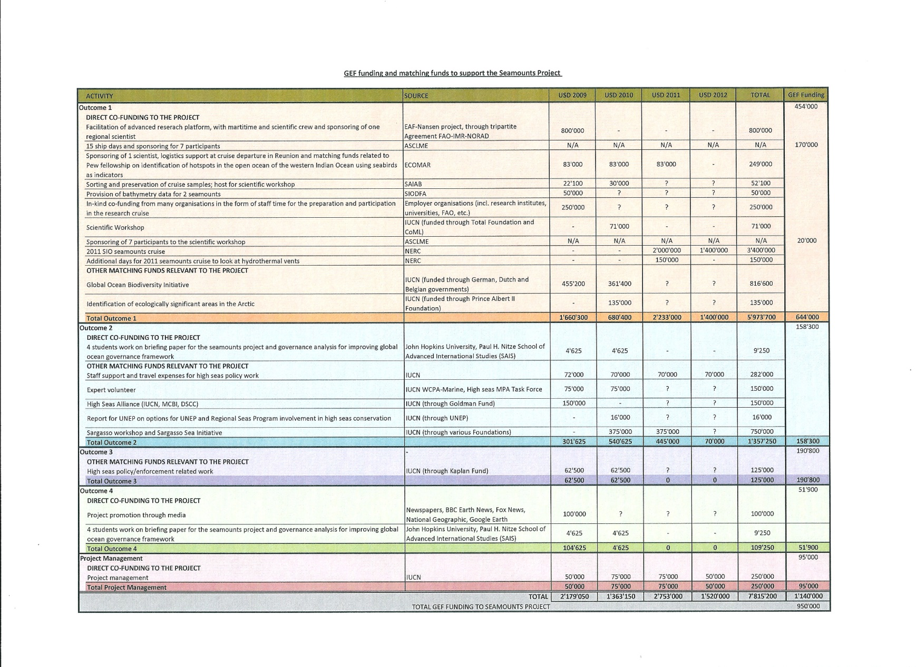
ANNEX 8 Short biography of the evaluator

Dr VIRGINIE M.C. TILOT
MARINE ENVIRONMENT/SUSTAINABLE DEVELOPMENT AND CONSERVATION EXPERT

Titles
Membre correspondant de l’Académie des Sciences d’Outre-Mer, France
Attaché honoraire du Muséum National d’Histoire Naturelle,
Département d’Ecologie et Gestion de la Biodiversité, UMR 7204 : CERSP
International Expert consultant on short, medium and long term contracts for diverse national and international organizations and institutions

Technical Background
Dr. V.Tilot has close to 30 years of experience in the areas of applied natural sciences, marine (high seas/coastal/island) ecology, coastal/ocean management and planning, marine protected areas (creation, implementation) in particular the « high seas », environmental impact studies, national and regional conservation policy, biodiversity assessment, global change assessment, Large Marine Ecosystems, coral reef ecology, fisheries, aquaculture, Integrated Coastal and Marine Area Management, oceanographic/diving surveys, Global Environmental Fund (GEF), evaluation of environmental programmes at local, national and regional scales.

Appointed by several international organisms among which different agencies of the United Nations (UNEP, UNDP, FAO, Unesco/IOC...) the European Commission, non governmental organisms (IUCN, WWF..), governmental organisms, private companies and universities, she has been working in collaboration with international (multilingual and multidisciplinary) teams in advanced scientific and technological matters and in joint projects, in particular with developing countries from small scale, site-specific projects to regional scale projects. She also was involved in more specific topics of research, teaching and training. She designed cross-sectoral strategies and integrated national and regional development strategies and prepared natural resources management and marine and coastal eco-regional planning. She achieved several analysis/evaluation/drafting of projects and large international programmes. She participated and organized several meetings and international workshops.

Her experience covers different marine areas, including the High Seas, of the Atlantic, Pacific, Indian Ocean, Red Sea, Mediterranean Sea and coastal and terrestrial areas of more than 50 countries. She produced a total of 91 publications, among which 74 at an international level, relate to the different fields of experience.

Annex 9 Code of Conduct and Agreement Form signed by the evaluator

Evaluators:
- Must present information that is complete and fair in its assessment of strengths and weaknesses so that decisions or actions taken are well founded.
- Must disclose the full set of evaluation findings along with information on their limitations and have this accessible to all affected by the evaluation with expressed legal rights to receive results.
- Should protect the anonymity and confidentiality of individual informants. They should provide maximum notice, minimize demands on time, and respect people’s right not to engage. Evaluators must respect people’s right to provide information in confidence, and must ensure that sensitive information cannot be traced to its source. Evaluators are not expected to evaluate individuals, and must balance an evaluation of management functions with this general principle.
- Sometimes uncover evidence of wrongdoing while conducting evaluations. Such cases must be reported discreetly to the appropriate investigative body. Evaluators should consult with other relevant oversight entities when there is any doubt about if and how issues should be reported.
- Should be sensitive to beliefs, manners and customs and act with integrity and honesty in their relations with all stakeholders. In line with the UN Universal Declaration of Human Rights, evaluators must be sensitive to and address issues of discrimination and gender equality. They should avoid offending the dignity and self-respect of those persons with whom they come in contact in the course of the evaluation. Knowing that evaluation might negatively affect the interests of some stakeholders, evaluators should conduct the evaluation and communicate its purpose and results in a way that clearly respects the stakeholders’ dignity and self-worth.
- Are responsible for their performance and their product(s). They are responsible for the clear, accurate and fair written and/or oral presentation of study imitations, findings and recommendations.
- Should reflect sound accounting procedures and be prudent in using the resources of the evaluation.
Evaluation Consultant Agreement Form
Agreement to abide by the Code of Conduct for Evaluation in the UN System
Name of Consultant: __ ________________________________Dr Virginie Tilot_________________
Name of Consultancy Organization (where relevant): _________Museum national d’histoire naturelle, Paris_______________
I confirm that I have received and understood and will abide by the United Nations Code of Conduct for Evaluation.
Signed at place on date
Signature: __ Malaga 14/3/2013___________________________________

www.unevaluation.org/unegcodeofconduct

