Terminal Evaluation Report:

Programme for the Mobilization of Surface Water and Sustainable Land Management (PROMES-GDT) in Djibouti

GEF # 3529 UNDP # 3216

Dr. Trinto Mugangu, Head of the Terminal Evaluation Mission
with technical support from Abdoulkader Ibrahim Egueh and Youssouf Adbara Ali

Djibouti, May and June 2014

Executive Summary
The Programme for the Mobilization of Surface Water and Sustainable Land Management (PROMES-GDT GEF # 3529) in Djibouti is a Medium-Size Project implemented by the Government of Djibouti and the United Nations Development Programme (UNDP) with financing from the Global Environment Facility (GEF). Co-financing is provided by several partners, including UNDP, the International Fund for Agricultural Development (IFAD), the French Global Environment Facility (FFEM) through the French Development Agency (AFD), the World Food Programme (WFP), the Government of Djibouti through the Ministry of Agriculture, Water, Fisheries, Animal and Maritime Resources (MAEPE-RH) and the Ministry of Finance, and in-kind contributions from local beneficiaries. The PROMES-GDT seeks to provide a comprehensive, integrated response to the challenges posed by the degradation of natural resources, the water shortage, drought, and poverty within the country’s pastoral communities. It seeks to enhance the capacity of local communities to plan their own development, while providing local institutions and the government with the appropriate tools to achieve a sustainable reduction in poverty. It combines physical measures to restore or build surface water and runoff harvesting systems and restore and manage grazing lands and pastures. The PROMES-GDT strategy is based on surface rainwater harvesting and sustainable land management through construction of water infrastructure, sustainable land management, improvement of animal production, and the protection and safeguarding of threatened forest areas in the Day Forest. Three priority intervention areas were defined: 1) the Day Forest and the surrounding area; 2) areas close to the Petit Bara and the Grand Bara; and 3) the Gobaad region. The PROMES-GDT is intended to reach approximately 6,000 households, with an average of six people per household, for a total of approximately 36,000 people.

In accordance with the monitoring and evaluation policies and procedures of the UNDP and the GEF, all medium and large projects supported by the UNDP and financed by the GEF must receive a terminal evaluation when implementation ends. The purpose of the terminal evaluation is to assess the extent to which the project objectives were achieved and learn lessons that may improve the sustainability of the benefits and promote overall improvements in UNDP programmes in Djibouti. Those include good governance, improving the living conditions of poor or nomadic populations, conserving and regenerating mountain forests, improving access to water for the poor in arid environments, easing women’s workload through community participation and self-determination, and achieving climate resilience among the Afar and Issa nomadic populations and their livestock along the transhumance corridors.

An independent international consultant was hired for the period 1 May 2014 - 30 June 2014 to conduct this terminal evaluation. The consultant was in Djibouti from 13 - 23 May 2014 and visited three project sites from 15 - 18 May 2014. The methodology used included primarily the following components: using the project monitoring system, analysing how the project team followed the performance and impact indicators and the degree to which those indicators were met; (b) reviewing existing project reports and documents; (c) conducting field observations, with photographs if necessary; (d) interviewing individuals or groups to analyse the opinions of the project’s stakeholders and partners on the project’s performance; and, (d) reviewing gender sensitivity as reflected in the project’s activities. At the conclusion of these visits, observations, and interviews in the field and with the project’s administrators and partners, the terminal evaluation focused on the key issues of project relevance, effectiveness, efficiency, sustainability and likely impact.

The overall project objective was to strengthen the livelihood of pastoral communities by promoting sustainable management of natural resources. The evaluation mission concluded that the project was MODERATELY SATISFACTORY in achieving this overall objective, with a rating of 4 points out of 6. Of the 13 impact monitoring and progress indicators, only two reached an achievement level of 100% or higher (quantity of water mobilized and the number of families with access to water). Two others reached 88% (creation of local steering committees and preparation of water and pastoral development plans), and three achieved 50% (number of junipers planted in Day, dissemination of practices and hiring of regional coordinators replaced by organizers). Achievement of one indicator was only initiated, with a local code drafted, rather than a development plan as planned for the Day region. The project team did not monitor the remaining indicators, often because members lacked the capacity to do so.

The PROMES-GDT terminal evaluation mission issued 24 conclusions and recommendations, organized into four points: (a) corrective measures related to the project’s design, implementation, monitoring and evaluation; (b) measures to ensure the continuity or strengthening of the project’s initial benefits; (c) proposals related to future directions supporting the main objectives; and (d) best and worst practices during the issue analysis (related to relevance, performance and success).
- Corrective measures related to the project’s design, implementation, monitoring and evaluation
- Four, rather than three, sites should have been chosen during the project design phase, including three high-altitude sites and one in the Day Mountains, which constitute a separate ecosystem. Its water cycle in arid and high-elevation areas near oceans differs from the water cycle in low-elevation arid areas.
- The UNDP-GEF should consider extending this project by introducing the fog-water harvesting system in Day, using nets to water the young juniper and boxwood plants and provide water to livestock and the transhumant communities. These harvesting systems have been developed in Eritrea.
- With regard to monitoring, the project did not monitor some of the indicators in the logical framework because team members lacked expertise, specifically in measuring tropical livestock carrying capacity (TLU), or because they lacked knowledge in complex process of calculating the capacity building units; the designer included this in the project but did not provide adequate training for project monitoring/evaluation team members.

- Measures to ensure the continuity or strengthening of the project’s initial benefits
- Organizational and regulatory measures to empower and ensure the continued existence of the local steering committees (LSCs) should be developed and legally instituted.
- Creating local steering committees (LSCs) did enhance local capacity, but the committees did not develop sufficient expertise in the workings of the soil and water conservation (SWC) management system so that they could continue on their own. Local communities should thus receive training so that they can become expert in the productive system that produces valuable benefits for them.
- Communities should receive training on maintaining the facilities to improve their lifespan and output, which benefits the local communities or their associations.
- Residents of Airolaf village in the Day region learned carpentry skills via training in Turkey. Professional carpenters supervised the trainees, thus enhancing their skills. However, this effort should be redesigned and given legal status, thus allowing members of local communities in the Day region to become skilled in and gain ownership of wood processing techniques and wood working trades.
- A system for determining and sharing revenue should also be developed. Considerable potential exists for conflict over sustainable management of the Day Forest, given the presence of both private and tribal interests in Airolaf.

(c) Proposals related to future directions supporting the main objectives
- The project team should immediately write a manual of national norms and procedures for harvesting and storing rainwater by building and managing ponds and underground tanks. This will provide the country with standards that can serve as a benchmark for such facilities.
- A regulatory or political framework should be established to encourage and make it safe for villagers to work together in community-based organizations and encourage them to operate autonomously to maintain the project’s achievements. The project should support the creation of CBOs during its last six months, which should obtain legal recognition from the State by acquiring appropriate status.
- A system should be established to develop and sustain the three nurseries that the PROMES-GDT created in Day, Randa and Otoy by turning them over to local ownership. Initiatives that involve tree-planting must be able to obtain young plants at an affordable price (specifically including PRODERMO, the African Water Facility (AWF) or the Islamic Bank).
- A workshop should be held on harvesting and storing rain water in Djibouti to draw out the lessons learned from the actions of many partners and their coordination within the PROMES-GDT, around the Ministry of Agriculture and the Environment (GEF focal point).
- PROMES-GDT actors and managers should be invited, as soon as possible, to discuss and implement the corrective measures to ensure that the project’s achievements are sustained before it ends. Management of the carpentry workshop, the ecotourism system and the bee-keeping in Day and the nurseries in Day, Randa and Otoy should be revised so that by the end of the project, they are managed profitably by the villagers’ CBOs, with an equitable income-sharing system, including a conflict management mechanism.
- A situation analysis workshop should be held to determine the root causes of the degradation and drying of the Day Forest to provide appropriate responses and actions to better manage this unique mountain forest in Djibouti, support its recovery and ensure its sustainability.
- The recommendations of this workshop on the root causes of the degradation and drying of the forests in the Day Mountains, including the water cycle in this mountain ecosystem close to the ocean, based on Eritrea’s experiences in harvesting water from mountain fog through junipers, boxwoods or nets, should be used to design a new project phase focusing on the conservation of this arid mountain ecosystem in its two parts, including one in a protected area and the other outside the protected area, but subject to pressure from livestock, as in the village of Airolaf (Day Forest).

(d) Best practices during the analysis of issues related to relevance, performance and success

In terms of relevance, the PROMES-GDT worked towards four of the GEF objectives to combat land degradation and conserve arid forests at the local level and at three sites with transhumance corridors:
        - Pursued improvements to the ecosystem services to ensure the livelihood of local and transhumant populations:
        - Maintain a forest ecosystem in Day in an arid mountain area;
        - Reduce, through management, the pressure imposed by livestock on natural resources (water and forage) and the transhumance corridors; and,
        - Strengthen local communities’ sustainable land management capacity.

- In terms of performance, the project did an exemplary job of mobilizing surface water by building ponds after rains and by channelling runoff into underground reservoirs to supply water to the transhumant pastoralists’ villages, along their transhumance corridors and for their livestock.

In terms of success, the PROMES-GDT was also an example in this area because at least six other initiatives (including PRODERMO) are already replicating its strategy elsewhere in the country where these services are not yet provided.

- With regard to the issue of water in an arid country and the PROMES-GDT proposal for Djibouti, many bilateral and multi-lateral partners learned to work together on and successfully carry out the project.

- Additional protective efforts, such as the use of piled rocks and wire mesh, should be encouraged. However, deadwood fencing, as seen in Day, has not proven effective or useful.

- Creative revenue-generating alternatives for the settled transhumant populations must be rethought and implemented. This is the case for carpentry, ecotourism (including camping and visits), and bee-keeping in Day and the profitability and ownership, through the CBDos, of the three nurseries established by the PROMES-GDT.

- The PROMES-GDT team became expert in monitoring satellite images using Google Earth and was thus able to monitor the forest ecosystem in Day over time by using successive scenes. This technique is a potential tool that the government could use to monitor and guide management of the Day Forest, as well as the country’s other water harvesting and storage facilities.

Table of Contents
Page
Executive Summary 1
Abbreviations 9
1. Introduction 11
1.1. Purpose of the evaluation 11
1.2. Scope of application and methodology 12
1.2.1 Terms of Reference 12
1.2.2. Methodology 12
Table 1. The four rating scales based on the evaluation components 13
1.3. Structure of the evaluation report 14
2. Project description and development context 14
2.1 Project launch and duration 14
2.2 Problems the project sought to address 15
2.3 Immediate and development objectives of the project 16
2.4 Basic indicators established 17
2.5 Main stakeholders 17
2.6 Expected outcomes 18
3. Findings and Conclusions of the Evaluation Mission 19
3.1 Project design/formulation 19
3.1.1 Logical framework analysis of the outcomes (project logic/strategy; indicators) 19
3.1.2 Hypotheses and risks 20
3.1.3 Lessons learned from other relevant projects incorporated in the design 20
3.1.4 Planned stakeholder participation 21
3.1.5 Replication approach 21
3.1.6 The UNDP’s comparative advantage 21
3.1.7 Links between the project and other interventions in the sector 22
Map of water interventions in Djibouti 23
3.1.8 Management methods 23
3.2 Project implementation 23
3.2.1 Adaptive management 23
3.2.2 Partnership agreements 24
3.2.3 Comments from the monitoring and evaluation activities used in connection with adaptive management 24
3.2.4 Project financing 24
Table 2. Project financing and level of disbursements at 30 April 2014 25
3.2.5 Monitoring and evaluation design at the outset and implementation (*) 25
3.2.6 Coordination for implementation and execution 25
3.3 Project outcomes 26
3.3.1 Overall outcomes (attainment of the objectives) (*) 26
Table 3. Trainings outside the country for project staff and stakeholders 27
3.3.2 Relevance (*) 27
3.3.3 Effectiveness and efficiency (*) 27
3.3.4 Country ownership 28
3.3.5 Integration 28
3.3.6 Sustainability (*) 28
3.3.7 Implementation impact (*) and operational issues 29
3.4 Conclusions, recommendations and lessons 30
Table 4. Summary of rating scores 30
3.4.1 Corrective measures for project design, implementation, monitoring and evaluation 30
3.4.2 Measures to ensure the continuity or strengthening of the initial benefits 31
3.4.3 Proposals related to future directions supporting the main objectives 31
3.4.4 Best and worst practices during the analysis of issues related to relevance, performance and success 32
4. Appendices 34
Annexe 1 : Itinéraire de la Mission & personnes rencontrées 35
Annexe 3a. Liste alphabétique des personnes rencontrées par la mission FEM d’évaluation finale 38
Annexe 3b : Personnes rencontrées – Contacts et Photos 40
Annexe 4A. Réalisation des résultats suivant les indicateurs du cadre logique du projet 45
Annexe 4b: Gestion Adaptative-Performances Physiques 48
Annexe 4c : Réalisations du Projet par Composante suivant l’auto-évaluation du personnel du projet au 30 Avril 2014 51
Annexe 4e. Infrastructures & ouvrages prévus et réalisés par CPL, situation de mise en repos & pépinières 53
Annexe 5a-Budget FEM 2012-2013 54
Annexe 5b: Financement et Decaissement au 30 Avril 2014 PROMES-GDT. Montage Financier et Performance financière par source de financement. 57

Abbreviations
ADB | African Development Bank
AFD | French Development Agency
AWF | African Water Facility
CBO | Community-Based Organisation
CERD | Centre d’Etudes & de Recherches en Développement de Djibouti
FFEM | French Global Environment Facility
GEF | Global Environment Facility
GIS | Geographic Information Systems
IFAD | International Fund for Agricultural Development
LFA | Logical Framework Analysis
LSC | Local Steering Committee
MAEPE-RH | Ministry of Agriculture, Water, Fisheries, Livestock and Water Resources
NEX | National Execution
NGO | Non-Governmental Organization
NSC | National Steering Committee
CGEP | Water and Pasturelands Management Committee
PAC | Project Approval Committee
PMU | Project Management Unit
PRODERMO | Rural Community Development and Water Mobilization Project / Projet Développement communautaire Rural et Mobilisation des eaux
PRODOC | Project Document
PROMES-GDT | Programme for the Mobilization of Surface Water and Sustainable Land Management
RC | Regional Coordinators
SAHP | Hydraulic and Pastoral Planning Scheme
SLM | Sustainable Land Management
SWC | Soil and Water Conservation
TLU | Tropical Livestock Unit
TOR | Terms of Reference
UNDP | United Nations Development Programme
UNV | United Nations Volunteer
WB | World Bank
WFP | World Food Programme

      - Introduction
In accordance with the monitoring and evaluation policies and procedures of the UNDP and the GEF, all medium and large projects supported by the UNDP and financed by the GEF must receive a terminal evaluation when implementation is complete. The Mobilization of Surface Water and Sustainable Land Management Programme (PROMES-GDT, GEF # 3529) in Djibouti is a medium-size project of the United Nations Development Programme (UNDP) with funding from the Global Environment Facility and co-funding from several partners.

The PROMES-GDT is intended to provide a comprehensive, integrated response to the challenges posed by the degradation of natural resources, water shortage, drought, and poverty within the country’s pastoral communities. It seeks to enhance the capacity of local communities to plan their own development, while providing local institutions and the government with the appropriate tools to achieve a sustainable poverty reduction.
The PROMES-GDT involves a wide range of local and international partners. It combines physical measures to restore or create surface water and runoff harvesting systems and to restore and manage grazing lands and pasture. Thus, the interventions seek to enhance the capacity of the actors involved in local development, monitoring and technical capacity.

The PROMES-GDT has three components:
- Surface water harvesting and sustainable land management through the construction of water infrastructure, sustainable land management, improved animal production and the protection and safeguarding of threatened forest areas in the Day Forest region;
- Building national capacity by training professional staff and increasing their awareness and strengthening local communities’ ability to take on responsibility; and,
- Coordinating and managing the Programme through the daily management of the project and its human resources, coordinating the activities of the partners and stakeholders, and providing institutional support for the project management unit (PMU).

Three priority intervention areas were defined: the Day Forest and the surrounding area; 2) areas close to the Petit Bara and the Grand Bara; and 3) the Gobaad region. The PROMES-GDT is intended to reach approximately 6,000 households, with an average of six people per household, for a total of approximately 36,000 people.

  - Purpose of the evaluation

The purpose of the terminal evaluation is to assess the extent to which the project’s objectives were achieved and to learn lessons that can improve the sustainability of benefits and encourage overall improvements in UNDP programmes, including governance, community participation and self-determination, climate resilience and access to water.

1.2. Scope of application and methodology

1.2.1 Terms of Reference
The scope of application is found in the terms of reference (ToR) of the evaluation mission, summarized below. “The international evaluator - the director of the team - will have overall responsibility for the terminal evaluation and for producing the expected outcomes. He/she will report, technically and administratively, to the UNDP office in Djibouti. He/she will be responsible for the following tasks:

- Guiding and managing the evaluation, including the field mission, in coordination with the UNDP country office and the project team;
- Ensuring that the evaluation meets UNDP-GEF terminal evaluation standards in all aspects;
- Defining the methodology for data collection, evaluation and analysis;
- Defining the division of work within the evaluation team;
- Directing interviews and relevant analyses on the strategy, outcomes achieved and partnerships;
- Preparing a presentation on the provisional outcomes during the field mission;
- Preparing the draft evaluation report; and,
- Revising and completing the evaluation report.”

1.2.2. Methodology
The methodology used may be presented in five points: (a) based on the project monitoring system, analysing how the project team monitored the performance and impact indicators and the degree to which those indicators were achieved; (b) reviewing existing project reports and documents; (c) conducting field observations, with photographs if necessary; (d) holding individual or group interviews to obtain and analyse the opinions of project stakeholders and partners on the project’s performance; and, (d) reviewing gender sensitivity as reflected in the project’s activities.

To do that, the specific and measurable indicators in the project logical framework (documented by the project team using its system for monitoring and evaluating the project objectives and expected outcomes) were documented through the project’s reports and documents. The project team became expert in monitoring satellite images using Google Earth, and was thus able to monitor changes in the Day Forest ecosystem using successive scenes over time. Individual and group interviews were also held with the project team, members of the steering committee, Ministry of Agriculture (MAEPE-RH) officials, the Director of the CERD, the GEF focal point, Ministry of the Environment officials, and representatives of the project’s partners, including IFAD, WFP, AFD and UNDP.

Visits were held in the project’s three priority areas from 15 – 18 May. Interviews were conducted with members of local steering committees (LSC), project beneficiaries, project actors and agents, including carpenters, nursery workers, security guards, and representatives of local and traditional authorities. One night was spent with a nomadic family that belongs to the Afar tribe, in El-Eyissa, in the northern part of the country. Following that visit, meetings and visits were held at the facilities, nurseries, enclosures designed to protect vegetation from grazing animals, water storage facilities and open excavations for water ponds. Last, interviews were conducted with women and men regarding the project’s treatment of gender concerns.

At the conclusion of these visits and interviews in the field and with the project’s administration and partners, the terminal evaluation addressed key issues focusing on the project’s relevance, effectiveness, efficiency, sustainability and likely impact.
- In terms of relevance, how did the project relate to the main objectives of the GEF focal area and to local, regional and national environmental and development priorities?
- In terms of effectiveness, to what extent were the project’s objectives and expected outcomes achieved?
- In terms of efficiency, was the project implemented efficiently, in accordance with national and international norms and standards?
- In terms of sustainability, do financial, institutional, socio-economic or environmental risks exist and how do they affect the long-term sustainability of the project’s outcomes?
- In terms of the project’s likely impacts, is there evidence to suggest that the project has contributed to (or enabled) reduced pressure on the environment or improvements in the living conditions of project beneficiaries?

These questions were evaluated based on the following four rating scales (Table 1). The scores were also expressed as weighted percentages (Table 4).

Table 1. The four rating scales based on the evaluation components
Ratings of outcomes, effectiveness, efficiency, monitoring/evaluation and investigations | Sustainability ratings | Relevance ratings
6 Highly Satisfactory (HS): no shortcomings  5 Satisfactory (S): minor shortcomings  4 Moderately satisfactory (MS)  3 Moderately unsatisfactory (MU): major shortcomings  2 Unsatisfactory (U): major problems  1 Highly unsatisfactory (HU): serious problems | 4 Likely (L): negligible risks for sustainability | 2 Relevant (R)
 | 3 Moderately likely (ML): moderate risks | 1 Not relevant (NR)
 | 2 Moderately unlikely (MU): major risks  1 Unlikely (U): serious risks | Impact ratings  3 Satisfactory (S)  2 Minimal (M)  1 Negligible (N)
Additional ratings as necessary:
Not applicable (N/A)
Evaluation impossible (EI)

1.3. Structure of the evaluation report
This report is organized into four chapters: introduction; project description and context; findings and recommendations of the evaluation mission; and, conclusions and recommendations. In addition, appendices provide an underpinning for the report.

The introduction first summarizes the issue and the organization of the project. Next, it presents the shortened terms of reference and the methodology that the evaluation mission used.

The second chapter describes the project and the context in which it was developed. It presents the start of the project, a list of the partners involved, the problems the project sought to address, the project objectives, the monitoring/evaluation indicators, the main stakeholders, and the expected outcomes.

The third chapter presents the findings, conclusions and recommendations of the evaluation mission. It is subdivided into three sub-chapters: the project’s design/formulation; its implementation; and, the project outcomes. In terms of the project design, the report presents the following: an evaluation of the logical framework, including the project strategy and indicators; hypotheses and risks; lessons learned from other projects; participation of the beneficiary stakeholders; replication approach; comparative advantage of the UNDP; connection between this project and other interventions of the sector; and, management methods. In terms of the project implementation, the report analyses the implementation prospects, including: adaptive management; partnership agreements; project financing; monitoring and evaluation; and, UNDP coordination and execution and operational issues. In terms of project outcomes, the reports discusses the extent to which the objectives were achieved and the evaluation criteria (relevance, effectiveness, efficiency, country ownership, incorporation, sustainability and impact).

Last, the fourth chapter on conclusions and recommendations addresses: corrective measures for the project’s design, implementation, monitoring and evaluation; how to ensure that the project’s initial benefits are sustained and strengthened; future directions to promote the main objectives; and, best practices for the project’s relevance, performance and success.

2. Project description and development context

2.1 Project launch and duration
The UNDP-GEF component of the PROMES-GDT was launched in the field in 2012, after the June 2011 meeting of the Project Approval Committee, followed by the signing of the Project Document (PRODOC) by the Djibouti government and the UNDP country office. However, the PROMES-GDT began in 2008 with contributions from IFAD, the WFP, the government and in-kind contributions from the stakeholders. Starting on 16 December 2008, the contract for the FFEM contribution established the UNDP country office as the implementation agency. This arrangement allowed the UNDP to have a presence in the project through its own contribution via technical assistance focused on improving sustainable land management, building capacity at all programme sites and conserving and regenerating the Day Forest.

The GEF project was approved after a delay of two years. Given that context, projects financed by other partners changed over time. It was thus not possible to adhere completely to the initial financing plan, which was validated in 2011. Some of the activities that were to have been funded by the GEF were thus funded by the FFEM and, in certain cases, IFAD. The delay also resulted in a loss of confidence at a time when the government team had set up all the financing of the programme.
The UNDP-GEF portion of the programme continued until December 2014, but the IFAD and other components continued until June 2015.

2.2 Problems the project sought to address
The Republic of Djibouti has a land area of 23,000 km² and is characterized by an arid climate. The country experiences recurring natural catastrophes, such as droughts and floods. The population totals approximately 650,000. More than 70% of the population lives in the capital.

The rural population is estimated at 150,000 (20% of the total). More than 80% of this population is nomadic and practices extensive herding over approximately 1.7 million hectares of collective corridors, in the north and south of the country. The herd is estimated at approximately 600,000 goats, 400,000 sheep, 50,000 cattle and 40,000 camels, raised partially along the corridors and partially under sedentary conditions in peri-urban areas.

The PROMES-GDT was designed to address the thirst problem that the pastoral populations face during the dry seasons. The lack of water represents a constraint on the mobility of animals and optimal use of the corridors.

The pastoral communities (Afar and Issa) have developed pastoral systems historically allowing them to use highly arid ecosystems and relatively rare forage resources on a sustainable basis. Under this system, based on the practice of transhumance, they use grazing areas within the country’s different ecosystems seasonally. Despite its great flexibility, which provides a buffer against drought, this system is now threatened by the gradual degradation of natural resources and the increasingly sedentary nature of the pastoral communities.

Herders are a dispersed and relatively unorganized population. Each Afar and Issa tribe uses a clearly-defined land area where grazing is practiced freely, sometimes ignoring rangeland management rules because of imbalances between resources and livestock. Following the 1983-84 and 1987-88 droughts, the increasing number of water points in rural areas (specifically, drilled holes) and the construction of roadways and villages, most of the nomadic population has settled around water points and villages. The excess burden on the corridors – estimated at 63% above their carrying capacity – caused by this expanding herd has led to the deterioration of the vegetation cover, which can no longer regenerate under current use conditions.

Thus, a specific ecosystem - the Day Mountain forest in the north-central part of the country - is attracting herders who have settled in the Day village of Airolaf, where the climate is less arid than elsewhere in the country. Many of the country’s urban residents have chosen to live there during the hottest period of the year, from July to September. A hotel and tourist accommodations have even been built there. Excess grazing by camels, cows and goats has led to the destruction of the Day Mountain forest. The programme thus also sought to address the conservation, protection and regeneration of part of this mountain forest in areas surrounding the village that is now home to settled nomads and hosts tourists.

2.3 Immediate and development objectives of the project
The goal of the project was to strengthen the livelihoods of pastoral communities by promoting the sustainable management of natural resources.

Its specific objectives were to:
            - implement measures for harvesting surface water to meet the drinking water needs of the community and its herd and to increase accessibility and sustainable management of grazing lands; and,
- enhance technical and human capacity at the central and local levels.

The project’s three components were:
- Mobilization of surface water and sustainable land management. This component included four main sub-components: i) water management, by repairing and building tanks and earth reservoirs for drinking water for human populations and troughs for livestock and by building small dams on an experimental basis; ii) sustainable land management, involving soil and water conservation to protect water structures, regenerate the vegetation cover in the surrounding areas, and develop the corridors by setting them aside and reforesting them; iii) improvement of animal production by taking a livestock census, training herders; and, (iv) protection and conservation of degraded forest lands, particularly in the Day Forest and surrounding areas. The immediate outcomes of this component include mobilizing
234,000 m³ of surface water, thus meeting the water needs of 6,000 households (20% of the country’s rural population) during the dry season. Thanks to work on grazing land and soil and conservation efforts, forage biomass is expected to increase by over 1 million forage units, thereby improving animal performance, specifically milk production for consumption and possible sale. The socio-economic situation of women should be taken into account and the PROMES-GDT should increase their role in natural resource management by involving them in decisions-making regarding programme implementation.

- National capacity building. The objective of this component was to develop local communities’ natural resource management capacities by establishing committees. The members of these committees should be trained in analysing, planning, managing and monitoring the development of collective natural resources. In addition, the technical staff of the Ministry of Agriculture (in particular, from the Directorates for Water, Agriculture and Forests and Animal Resources and the Ministry’s decentralized units at the regional level) should be trained in the integrated and participatory management of natural resources. The immediate outcome of this component is improved capacity, within the MAEPE-RH, to execute the strategy to mobilize surface water, carry out the physical development projects, taking environmental aspects into account, and combat thirst more effectively in rural areas.

- Project management and coordination. A programme management unit (PMU) was established within the Ministry of Agriculture. Given the multidisciplinary and integrated nature of the programme, this unit was assigned full-time staff through the secondment of qualified staff from the Directorates of Water, Agriculture, Forests, and Animal Resources. The sub-regional directorates for rural development handled needs in the field and within the communities.

2.4 Basic indicators established
Thirteen basic indicators were established for project monitoring/evaluation. Six of those address the overall objective, three address specific objective 1 and four address specific objective 2. The basic impact and performance indicators for the overall objective were to:
- Achieve a 30% increase in vegetation cover in the grazing areas by the end of the project;
- Increase the targeted rate of animal production on grazing lands from 1 TLU/hectare at the start of the project to 5 TLU/hectare at the end;
- Increase surface water quantity from 300,000 m³ at the start of the project to 500,000 m³at the end;
- In the long term, plant 1,000 trees/year over a 10-year period starting in 2011 (Juniperus procera in the Day Forest, land area of 1,800 hectares);
- Increase the measurement of the needs assessment for capacity building from 19 in 2011 to 37 in 2014; and,
- Publish at least two lessons learned on good practices in the area of water and sylvo-pastoral management the end of the project.

The objective 1 indicators were to:
- Increase access to water sources during the dry seasons for 6,000 families (36,000 people) (from 50% in 2011 to 75% in 2014);
- Reduce pressure on grazing lands by the end of the project (from 63% in 2011 to 30%); and,
- Achieve the adoption, by local actors, of a development plan for the Day Forest (economically and culturally sustainable model for protecting the forest to be developed by the end of the project).

The objective 2 indicators were to:
- Establish the Local Steering Committee as a local natural resource management institution (local committees to be in operation by the end of the project);
- Establish Hydraulic and Pastoral Development Schemes (SAHP) in eight priority areas;
- Achieve the use, by decision-makers, of a GIS system by the end of the project; and,
- Achieve the adoption of the role of Regional Coordinator (RC) to promote participatory development at the central and regional levels.

2.5 Main stakeholders
The main stakeholders include:
- The country’s nomadic and transhumant populations;
- Women and children, who gather water and other natural resources for domestic needs;
- MAEPE-RH officials;
- Directorate for Water, Agriculture, Livestock and Rural Water Supply;
- Development partners (IFAD, WFP, AWF, FFEM, GEF, UNDP, AFD, Djibouti government);
- National agencies such as the CERD, Ministry of the Environment and the Ministry of Finances;
- Decentralized (regional administrations) or devolved (local elected officials) agencies; and,
- Local NGOs and CBOs.

The following populations and villages of the three corridors were chosen as project sites:
- Day Forest and surrounding areas (Randa, Otoy, Kalou, Dora, El-Eyissa and Madgoul);
- Petit Bara and Grand Bara; and,
- Gobaad.

2.6 Expected outcomes

Activity area 1: Hydraulic works to increase the quantity and quality of water available for human and animal use
To increase the availability and quality of water for human and animal use and, consequently, to combat the effects of drought, the restoration of existing water structures and the construction of new structures are planned for the project area. A range of options will be reviewed and implemented, including the installation of small dams to harvest surface water and the protection of existing water points. These options include the following:
      - Feasibility studies for small dams at 10 sites;
      - Selection of two sites for building small/medium-size dams; and,
      - Restoration and/or construction of water facilities (95 for human use and 60 for animal use).

Activity area 2: Implementation of sustainable land management for grazing land, corridors and forests
Sustainable land management is intended to improve the communities’ food and socio-economic security. Improved corridor management, combined with an increase in usable areas, will ease the pressure on an already fragile environment. Together with the construction of new water points for livestock and improved veterinary health services, these measures should enable the population to increase pastoral and agriculture productivity, specifically through:
      - Temporary protection for particularly degraded areas;
      - Reforestation or seeding of forage species;
      - Training and support for herders in animal health;
      - Livestock census;
      - Preparation of development plans;
      - Training;
      - Strengthening community groups and associations;
      - Minor corridor restoration work; and,
      - Works to protect the forested areas of the Day Forest.

Activity area 3: Technical support and training
The goal of this activity was to strengthen the capacity of State and community actors to plan and implement a sustainable and participatory natural resource management method. It includes measures to improve expertise using the GIS to develop a system to monitor and evaluate the quality of the corridors and the impacts of the physical measures implemented, including:
      - Conducting basic studies and participatory diagnoses;
      - Developing and implementing local development plans;
      - Training national and decentralized agents;
      - Setting up local steering committees;
      - Acquiring the necessary technology and infrastructure for the GIS;
      - Training and study trips;
      - Developing GIS products that are relevant for planning; and,
      - Using GIS inputs in project management, monitoring and evaluation.

3. Findings and Conclusions of the Evaluation Mission

3.1 Project design/formulation

3.1.1 Logical framework analysis of the outcomes (project logic/strategy; indicators)
The logical framework analysis (LFA) was good. The project strategy focused on rainwater and rainwater management over time by storing water in open-air ponds or underground tanks. In most cases, this was done properly and functioned effectively. The project logic adopted for low-altitude lands is thus sound, making it possible to control the water and, thus, implement sustainable management of the transhumance corridors covered.

However, the Day Mountain forest has a different water cycle. The water there is largely in the form of fog. It is captured by mountain vegetation adapted to the environment, such as juniper and boxwood. Strong grazing pressure from camels, cows and goats and, perhaps, the aging of the trees have led to the rapid degradation of the ecosystem near the villages of the transhumant populations.

Under these conditions, a strategy focused on rainwater or runoff harvesting will not help to regenerate the vegetation in the Day Mountains, which is increasingly dying off. Rather than choose three sites during the project design phase, four should have been chosen, including three high-altitude sites and one in the Day Mountains, which constitute a separate ecosystem. Its water cycle in arid and high-elevation areas near oceans is different than the water cycle in low-elevation arid areas.

The logical framework also provides for relying on non-governmental organizations (NGO) or community-based organizations (CBO) to help the State enlist the rural and transhumant populations in implementing this project. However, very few NGOs and CBOs exist and they could not be mobilized.

Last, the project strategy called for the in-kind participation of the project’s beneficiary communities, anticipating contributions in the form of opening of access routes so that the project’s local planning and ownership activities could be deployed with confidence. This was successful overall, but in one of the eight locations (Petit Bara), implementation was only initiated, so the project activities were not ultimately deployed.

The logical framework indicators are generally sound. However, the project team did not monitor some of them because of lack of expertise (specifically, in measuring tropical livestock carrying capacity) or lack of knowledge of the complex calculation of the capacity building units that the designer introduced, without providing adequate training for the monitoring/evaluation team responsible for documenting performance through the project indicators.

3.1.2 Hypotheses and risks
Four hypotheses and risks were formulated when the project was designed. Two of them – specifically, monetary fluctuations and weak relationships among project components – did not materialize. However, rain (the third risk) is still erratic, but harvesting and storage of runoff in underground tanks was an effective project strategy and helped to minimize its impact. The fourth risk was the possibility that the participatory approach might not function for lack of community involvement or beneficiaries’ lack of understanding about the project strategy. This risk did materialize to a significant extent, as the grassroots communities took only half-hearted ownership of the project. There is no effective strategy in place to ensure that the project’s benefits will be sustained after it ends. Since the project wraps up in December 2014, the project actors and managers must be encouraged to consider these issues and implement appropriate measures to ensure that the project’s benefits continue after it ends.

3.1.3 Lessons learned from other relevant projects incorporated in the design
The PROMES-GDT is an innovative project that addresses the thirst problem in a very arid environment by harvesting and storing rainwater. The project has thus learned lessons from other projects by building underground tanks as water reserves in the villages served, but also by initially using pond water for human populations and livestock. Using stacked rock walls and metal enclosures to protect the corridors also proved successful. The replanting of young trees, starting in nurseries, transplanting them to reforestation areas and irrigating them there, while digging holes to harvest water near the trees, was also relevant and enriching. This was drawn from the Ethiopian experience.

However, lessons drawn from other projects, such as the sedentarization of the transhumant populations in the Sahel, were not always incorporated in the project design because the State’s strategy for educating nomadic children is to settle them by creating wells in the villages. In the Sahel, this kind of standardization led to overgrazing, as in Djibouti, particularly in the Day Forest.

In addition, fog water was shown to be a potential source of water in mountains in arid regions near oceans. This is the case for Day, where juniper and boxwoods adapted to this fog-water capture grow. For now, water capture techniques using nets placed more than four meters high are being tested in mountain ecosystems in certain arid countries near oceans, specifically in Eritrea.

The PROMES-GDT design thus failed to incorporate certain lessons from other projects in arid countries regarding the settling of nomadic and transhumant populations and the differences in water harvesting and storage in low and high altitudes.

3.1.4 Planned stakeholder participation
The intended stakeholders include: the country’s nomadic and transhumant populations; women and children; MAEPE-RH officials; the directorates of water, agriculture, livestock and rural water supply; development partners (IFAD, WFP, AWF, FFEM, GEF, UNDP, AFD and the Djibouti government); national agencies such as CERD, the Ministry of the Environment, the Ministry of Agriculture and the Ministry of Finances; the decentralized (regional administrations) and devolved (local elected officials) agencies; and, local NGOs and the populations of the villages throughout the three corridors chosen as project sites.

Most of the stakeholders were involved in the project. However, a national agency such as CERD, which is supposed to enhance capacity in the area of geographic information systems, was not contacted or contracted to do so. Fortunately, the project was able to train some of its field staff to use Google Earth as a decision-making, land management and works monitoring tool. In addition, the population of one of the eight planned sites – the Petit Bara – could not be involved in the project because certain factors worked against their participation. They were unable to demonstrate their interest in participating in the project’s activities by opening access routes to their area, which the project team had established as a prerequisite for continuing its support. Last, almost no local NGOs were mobilized in connection with the project.

3.1.5 Replication approach
The PROMES-GDT is replicable because it was implemented at three sites (in the north, centre and southwest of the country). The World Bank is also replicating it, via its PRODERMO project, at three additional sites in Djibouti, based on the PROMES-GDT experience. The Djibouti government has asked IFAD to finance an extension of the PROMES-GDT beyond May 2015 to cover other sites.

3.1.6 The UNDP’s comparative advantage
The UNDP has a dual comparative advantage in terms of the PROMES-GDT. First, the UNDP assists populations in taking responsibility for and combatting poverty and natural disasters in arid regions where water is a limiting factor for the survival of human beings and their livestock. The second comparative advantage is that the mandates of both the UNDP and the GEF encourage sustainable land and forest resource management to ensure environmental resilience and improve the living conditions of poor populations.

The project has been a relevant example of putting the UNDP’s comparative advantages to effective use. UNDP support has enabled the populations to obtain access to water to combat the thirst problem during arid periods when rain is rare. Women and children can obtain water more quickly and closer to where they live, which eases their daily burden. In addition, the project showed that in the Day Mountains, the forest can be replanted and regenerated by setting up a nursery to reconstitute a forest damaged by over-grazing and drought .

3.1.7 Links between the project and other interventions in the sector
The Djibouti government had raised a critical problem facing its populations: access to water for as long as possible throughout the year to combat thirst among humans and their livestock in an arid environment. The PROMES-GDT was a positive and innovative response to a problem that made life difficult for the transhumant herders by ensuring the availability of water in rainwater and runoff harvesting infrastructure (underground tanks and ponds). The population itself manages those supplies very carefully to meet its water needs long after the limited rain has stopped.

The PROMES-GDT has become an attractive model for many projects, which are being incorporated into the initiative in order to serve more villages along the transhumance routes. They include, specifically, the World Bank’s PRODERMO project, which has replicated the PROMES-GDT at three new sites, and the UNDP’s climate resilience project, which will harvest rainwater to meet the population’s needs. The African Water Facility of the African Development Bank and the efforts of the Islamic Bank will also replicate the lessons learned by the PROMES-GDT (see the MAEPE-RH water initiatives map).

In addition, the PROMES-GDT was a successful example of mobilizing multiple partners – IFAD, UNDP, GEF, AFD, FFEM, WFP and AWF – to work with the Djibouti government to address the thirst problem and enhance the stakeholders’ ability to take responsibility.

Last, the PROMES-GDT was designed based and implemented based on the experiences of projects in Ethiopia and Turkey, where the actors were sent for training and to learn, respectively, techniques for mobilizing surface water and managing a carpentry workshop.

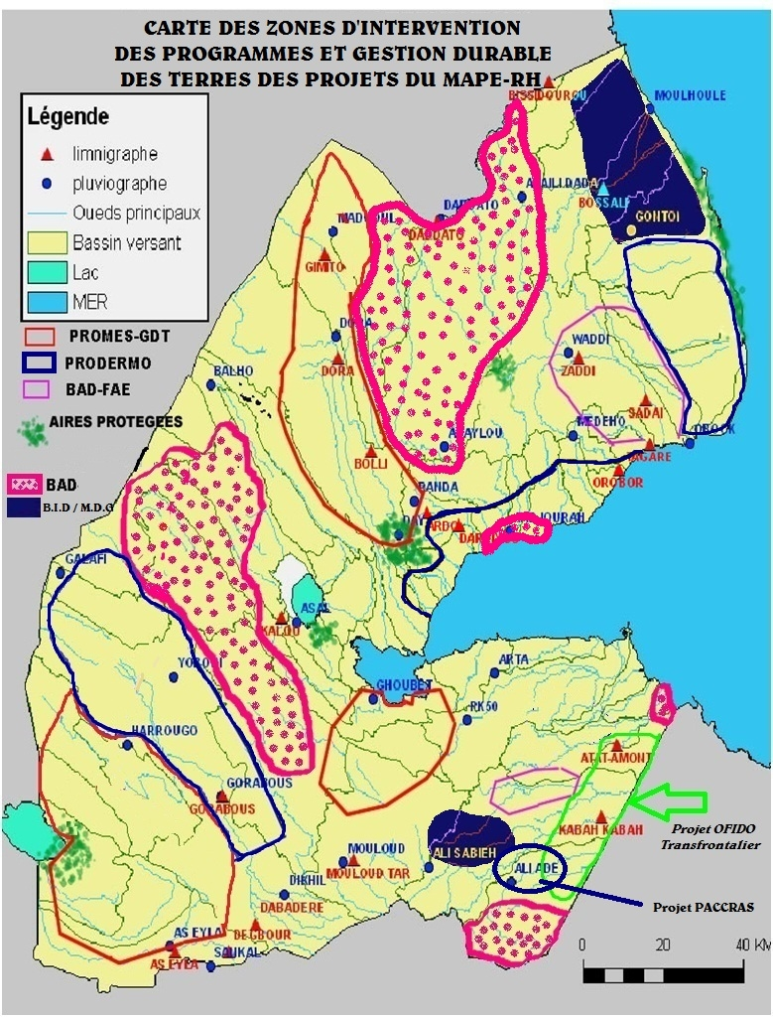

Map of water interventions in Djibouti

3.1.8 Management methods
The management method is referred to as national execution (NEX). The project management unit, which is based at the MAEPE-RH, handles management. Payments are made by check, signed by a MAEPE-RH manager and counter-signed by a Ministry of Finances staff member. Resources are thus disbursed for project activities at the level of the PMU and in the field. The UNDP receives the consolidated supporting documentation on disbursements and use of funds on a quarterly basis. This was a requirement to obtain funds for the next quarter.

3.2 Project implementation

3.2.1 Adaptive management
Adaptive management involved primarily making adjustments to the financing allocated to the activities following the previous years’ performance at the level of disbursement by budget line or to finance activities not planned initially but that became necessary after the beneficiaries’ training. This involved a new budget line, added as of 2013, for water recharge trenches and holes, dug near young trees to provide them a small water supply, after a training in Ethiopia.

Employment contracts with companies were also sometimes broken down into several sub-contracts to satisfy the greatest number of stakeholders concerned, based on their ethnic origin. This was the case involving the construction work in Day, where several ethnic groups co-exist. Each group insisted that the construction companies owned by their members be chosen equitably under the contract procurement process.

3.2.2 Partnership agreements
Partnership agreements were established between the project management unit (PMU) and several MAEPE-RH directorates (including water supply, livestock, major works and agriculture) for the project activities corresponding to the directorate with the expertise and technology required to carry them out.

Invitations to tender for construction work or by private experts were also approved by agreements with the PMU.

For services outside of the scope of the Ministry of Agriculture, the partnership agreement was to be entered into with the PMU and the partner, countersigned by the MAEPE-RH. Such an agreement was to be entered into with the CERD, but was not with regard to the GIS activities.

3.2.3 Comments from the monitoring and evaluation activities used in connection with adaptive management
Thanks to adaptive management, recharge holes were dug in 2013 near the young plants in order to harvest rainwater and thus keep moisture in the soil for a longer period. This followed the training that the project beneficiaries received in Ethiopia.

3.2.4 Project financing
This project received financing from multiple funders. The GEF provided US $1,056,800 and the UNDP provided US $67,700. Co-financing was provided, respectively, by IFAD (US $6,074.7 million), FFEM (US $1,185.8 million), WFP (US $1,935.5 million in-kind), the Djibouti government (US $2,626.2 million in-kind) and the beneficiaries (USD $172,200 in labour). Financing totalled US $13,121,800 (see Table 2).

At 30 April 2014, GEF budget disbursements stood at 87%. The remaining 13% should cover, as a priority, until 31 December 2014, the activities intended to ensure the sustainability of the project’s benefits and impacts.

Table 2. Project financing and level of disbursements at 30 April 2014
Financing source | Financing (‘000 USD) | Disbursements at 30/04/14 (‘000 USD) | Disbursements  (%) at 30/04/14
GEF | 1,056.8 | 925.0 | 87%
UNDP | 67.7 | 67.7 | 100%
FFEM | 1,185.8 | 1,185.8 | 100%
IFAD | 6,074.7 | 4,659.9 | 77%
WFP | 1,935.2 | 1,935.2 | 100%
Government | 2,626.2 | 908.3 | 35%
Beneficiaries | 172.2 | 160.5 | 93%
Total | 13,121.8 | 9,842.4

3.2.5 Monitoring and evaluation design at the outset and implementation (*)
Monitoring and evaluation were well-developed beginning with the project design phase. However, some indicators could not be followed (for example, capacity enhancement units and TLU) because the project staff members were not trained to perform the complex calculations required. At least three members of the project were responsible for monitoring and evaluation, but not systematically for all the indicators. During the evaluation mission, a single member of the monitoring/evaluation team was still working with the project. The contracts for the U.N. volunteer (UNV) and the project’s deputy coordinator had already ended. Those two had already left Djibouti at the time of the May 2014 terminal evaluation mission. Only the Day Forestry Expert remained and accompanied the evaluation mission throughout its visit.

In summary, the terminal evaluation mission assigned a rating of SATISFACTORY to the project’s monitoring and evaluation design. This rating would have been higher if training on monitoring all the indicators had been scheduled. Implementation of monitoring and evaluation received a rating of MODERATELY SATISFACTORY, as the project team did not monitor all the indicators.

3.2.6 Coordination for implementation and execution
The Ministry of Agriculture (MAEPE-RH) was the implementation agency. The Ministry of Energy assumed that role for a three-month period (April – July 2011) following a government reorganization. However, there were no changes to the project team during the change of ministerial oversight. Under the national execution method (NEX), the MAEPE-RH was responsible for coordination, with support from and control by the Ministry of Finance as execution partner for making disbursements and providing the government’s matching contribution. The project was complex, with several development partners and funders. The project team did an excellent job of coordinating the contributions of the development partners in the field. The terminal evaluation mission assigned this aspect a SATISFACTORY rating. The project team was very active. It was able to mobilize other partners, such as the World Bank (WB), and launched a similar project (PRODERMO), which already operates at three other sites in Djibouti where combating thirst and poverty is also an issue.

3.3 Project outcomes

3.3.1 Overall outcomes (attainment of the objectives) (*)
The overall project objective was to strengthen the livelihoods of the pastoral communities by promoting the sustainable management of natural resources. This overall objective received a rating of MODERATELY SATISFACTORY (4 points out of 6). Of the 13 impact monitoring and progress indicators (Table 3), only two were achieved at 100% or higher (quantity of water mobilized and the number of families with access to water). Two others reached 88% (creation of local steering committees and preparation of hydraulic and pastoral development plans), and three achieved 50% (number of junipers planted in Day, dissemination of practices and hiring of regional coordinators replaced by organizers). For one indicator, implementation involved only drafting a local code. A development plan was not prepared, as planned for the Day region. The project team did not monitor the remaining indicators, often because of a lack of capacity.

The first part of specific objective 1 (establishing surface water management measures to meet the water needs of the community and its herd) received a SATISFACTORY rating. Indeed, water is available to all the target households and the project achieved a bonus of 150%. Many water storage facilities (ponds) and underground tanks were built with a dedicated system for storing rainwater, with gabion walls or dams.

The completion of the second part of specific objective 1, related to promoting sustainable use of grazing areas by increasing the availability, accessibility and sustainable management of grazing areas, received a PARTIALLY SATISFACTORY rating. The stacked rock walls in the areas near El-Eyssa provided effective protection. However, metal trellis enclosures were installed around three parcels, totalling five hectares in the Day Forest near the project office. The deadwood enclosures were not so effective, although guards were assigned there to chase away wandering livestock.

However, the area east of the project office, which is furthest from the village of Airolaf in the Day region, with nearly 2,500 permanent residents and livestock, appears to be recovering its greenery gradually, as seen in a 2014 Google Earth image, compared to images from 2005 and 2013.

Achievement of specific objective 2 - enhancing institutional, technical and human capacity at the central and local levels - received a SATISFACTORY rating. The four related indicators each achieved scores between 50% and 88% and trainings were also conducted outside the country for project staff and stakeholders (Table 3).

In addition, office facilities were built in Day and Dora and solar panels were installed. Solid metal frameworks were also built in Day, Randa and Otoy in the northern site (Day and surrounding areas) to support the tarps covering the nurseries. A water filter with solar panels was also installed in Otoy to provide the drinking water to the population.

Table 3. Trainings outside the country for project staff and stakeholders
Title of Training | Country | Participants
Woodcutting and production of artisanal objects | Turkey | Five people, including two women, for one month
Accounting and procurement system | Italy | Three people (accountant, assistant accountant, procurement manager) for two weeks
Exchange of experiences | Ethiopia | 11 local steering committees (LSC) members for two weeks
Monitoring and evaluation | Senegal | Two people for one month
Building hydraulic structures | Niger | One hydraulic engineer for one month
Water and soil conservation activities (CES) study trip | Tunisia | Four people for two weeks

3.3.2 Relevance (*)
In terms of relevance, the evaluation mission was to determine how the project related to the main objectives of the GEF focal area and to local, regional and national environmental and development priorities. The GEF focal area concerned is land degradation and efforts to combat desertification. The strategy is to help stop and reverse the current trend of land degradation.

The PROMES-GDT was rated RELEVANT (2 points out of 2) and VERY SATISFACTORY because it addressed and worked towards the four objectives below for this GEF focal area at the local area and in three transhumance corridor sites:
  - Improve the ecosystem services to guarantee the livelihood of the local and transhumant populations;
  - Maintain a forest ecosystem in the Day region in an arid mountain area;
  - Reduce, through management, the pressure imposed by livestock on natural resource (water and forage) and the transhumance corridors; and,
  - Enhance local communities’ capacity in the area of sustainable land management.

3.3.3 Effectiveness and efficiency (*)
Effectiveness was determined by evaluating the extent of achievement of expected outcomes and objectives. Following the discussion in section 3.3.1, the expected outcomes and objectives were rated as MODERATELY SATISFACTORY (4 points out of 6).

Efficiency was determined by evaluating whether the project was implemented efficiently, in accordance with national and international norms and standards. The project received a rating of SATISFACTORY in terms of following international norms and standards for project implementation. Indeed, this project will now serve as the standard in surface water management in Djibouti. We recommend that the project team immediately prepare a manual of national norms and procedures based on its experience in harvesting and storing rainwater by building and managing ponds and underground tanks. This manual will provide the country with norms and standards that can serve as a benchmark for such projects.

3.3.4 Country ownership
The Djibouti government took effective ownership of the PROMES-GDT, which was designed in response to its urgent request in the area of thirst and natural resource management. Certain communities in regions such as Tadjourah and Dikhil also took ownership of the project’s benefits. The population – particularly the villages served – took ownership of all the water harvesting projects. Ownership is not yet complete with regard to natural resource management, particularly the forest and grazing areas, because these resources are subject to the tragedy of the commons. That is, everyone wants to claim the resources for themselves to the extent possible, without considering the needs of others and future generations. The system in place does not help the beneficiaries to understand that the project’s impacts - regenerating the Day Forest and protecting certain grazing areas - are intended to ensure their survival and well-being and those of their livestock. This will require an additional effort addressing stakeholder ownership of the benefits of sustainable land management and its impacts for grassroots communities.

3.3.5 Integration
The PROMES-GDT is an integrated and integrating project, combining multiple solutions to the problems of survival of the population and its ecosystem. It is simultaneously a rural, agricultural and hydraulic development project, as well as an environmental project in terms of natural ecosystem management. It is well integrated as a pilot project within the government’s activities. It is a source of pride for Djibouti’s population in general, the authorities in particular, and many development partners, who have found a way to work together, favouring integration, to resolve the country’s fundamental problem of thirst.

From the UNDP perspective, this is also an integrative project because it helps to alleviate poverty, improve governance, prevent natural catastrophes and encourage recovery in their wake. The project also focused on gender equity. The PROMES-GDT helps combat poverty in the rural environment, particularly among nomadic and transhumant populations, who are disadvantaged in the society, and improves their access to basic social services such as water, hygiene and sanitation. It enables governance by integrating environmental planning and efforts to combat land degradation by the populations themselves through their participation in local steering committees and water, soil and natural resource management activities. The PROMES-GDT constitutes a response that can help to avert natural disasters, such as drought and thirst among humans and livestock. It helps to create resilience among the populations in the face of natural hazards. Forest management and conservation contribute to minimizing the impacts of climate change and tree regeneration and planting contribute to improving natural ecosystem services and provide forage for livestock. This project is thus a successful initiative for harvesting and preserving surface and rainwater, easing the workload for women and children who must search for water for domestic needs and livestock.

3.3.6 Sustainability (*)
Sustainability must simultaneously address capacity, financing and institutional issues, as well as stakeholder ownership of project impacts and benefits and their continuation after external assistance ends. Four criteria were used to evaluate sustainability: was stakeholders’ capacity enhanced and were their local institutions strengthened to encourage ownership and ensure sustainability?; was a financial and economic mechanism established to ensure continuity?; were organizational measures created, appropriate to the stakeholders, so that they could continue to take responsibility?; and, were regulatory or policy frameworks established to ensure that the project impacts will continue?

In terms of the first criterion, local capacity was created by setting up local steering committees, but the committees did not develop the expertise in the operation of the water and soil conservation (WSC) management system required to carry on themselves. Residents of Airolaf village in the Day region learned carpentry skills through a training in Turkey and through the use of professional carpenters to supervise the trainees.

In terms of the second criterion, the project did not establish appropriate financial or economic mechanisms to ensure that the benefits continue, particularly given that local NGOs were not identified and involved in the project. The project managers respond that income-generating activities have been developed in the Day region; specifically, honey production, ecotourism and carpentry. Unfortunately, no hives were observed in the Day region. In terms of carpentry, it uses expensive, cutting-edge tools that villagers cannot purchase, under current conditions, if the equipment malfunctions and if project support ends. Take, for example, the example of a circular saw that has already been damaged, which the project will have to order from Turkey.

In terms of the third criterion, organizational and regulatory measures to empower and ensure the continued existence of the local steering committees (LSCs) were not established. Once the project’s external financing ends, the LSCs will no longer be able to meet or operate.

Last, in terms of the fourth criterion, no regulatory or policy framework was created to ensure that village-based organizations will continue. The drafting of the standards and the procedure manual may make some progress. In short, the impacts of the PROMES-GDT are MODERATELY UNLIKELY to continue (2 points out of 4) unless the project continues, addresses this issue, and implements an ownership strategy and a strategy to maintain the benefits, in consideration of these four criteria.

3.3.7 Implementation impact (*) and operational issues
Impact measures the changes in the populations’ and beneficiary stakeholders’ well-being, directly or indirectly, planned or not, resulting from the development project’s activities. As the PROMES-GDT is just now winding up, it is difficult to assess the impacts because they often emerge only after a longer period of time. However, access to water increased sharply for the populations and their livestock. This will continue as long as rains continue to fill the ponds and underground tanks in the transhumant’ villages and constitutes is a direct, positive change that the project sought. It came at the right time to combat thirst.

Other potential impacts will come with time, specifically:
- Regeneration of the forest by the tree nurseries and the protection of the grazing areas; this will lead to changes that may be felt in time if they are successful or continue to exist; and,
- The local committees’ capacity to organize to manage water and forest resources constitutes an asset that may lead to beneficial changes, but the committees need continued support to ensure the impact of this project.

3.4 Conclusions, recommendations and lessons

Table 4. Summary of rating scores
Items rated (see Table 1) | Rating in words | Rating in figures | Score and  Percentage
Outcomes, effectiveness, efficiency, monitoring/evaluation, investigations | Moderately satisfactory | 4/6 | 66.67%
Sustainability | Moderately unlikely | 2/4 | 50.00%
Relevance | Relevant | 2/2 | 100.00%
Impact | Minimal | 2/3 | 66.67%
Total |  |  | 71%

Based on the calculation performed in Table 4, the final evaluation mission assigned a score of 71% to the GEF component of the PROMES-GDT.

3.4.1 Corrective measures for project design, implementation, monitoring and evaluation
The PROMES-GDT is a comprehensive, integrated response to the challenges posed by the degradation of natural resources (specifically, the drying out of the Day Forest), water shortage, thirst, and poverty within the country’s pastoral communities.

However, the project’s design revealed capacity gaps in terms of setting up the monitoring/evaluation system. First, the beneficiaries (settled transhumant communities) did not strengthen their ownership of the project’s achievements (via capacity-based, institutional, legal, leadership and other means). Second, other possible approaches such as fog-water harvesting (based on ecological knowledge of the juniper and its ability to capture fog-water in the Day Mountains, not far from the sea) were not considered.

The following recommendations were formulated in response:
- Rather than choose three sites during the project design phase, four should have been chosen, including three high-altitude sites and one in the Day Mountains, which constitute a separate ecosystem. The water cycle in arid and high-elevation areas near oceans is different than the water cycle in low-elevation arid areas.
- The UNDP-GEF should consider extending this project by introducing the fog-water harvesting system using nets in Day to water the young juniper and boxwood plants and provide water to livestock and the transhumant communities. These harvesting systems have been developed in Eritrea.
- With regard to monitoring, the project did not monitor certain indicators in the logical framework because of lack of expertise, specifically in terms of measuring the tropical livestock carrying capacity (TLU), or because of lack of knowledge of the complex calculation of the capacity building units introduced into the project by its designer, without adequate training for the monitoring/evaluation team.

3.4.2 Measures to ensure the continuity or strengthening of the initial benefits
- Organizational and regulatory measures to empower and ensure the continued existence of the local steering committees (LSC) and take obtain legal status for them should be drafted.
- Local capacity was created through the organization of local steering committees, but they did not develop expertise in the workings of the water and soil conservation management system so that they could continue on their own. The local communities should thus be trained so that they can take control of the productive system that produces valuable benefits for them.
- Training should be provided to communities on maintaining the facilities to improve their longevity and returns, benefiting the local communities or their associations.
- Residents of Airolaf village in the Day region learned carpentry skills through a training in Turkey and the use of professional carpenters to supervise the trainees. However, this effort should be redesigned so that it obtains legal status. The members of local communities in the Day region should develop competence in and ownership of wood processing techniques and wood working trades.
- A system for determining and sharing revenue should also be developed because there is considerable potential for conflict over sustainable management of the Day Forest, given the presence of both private and tribal interests in Airolaf.

3.4.3 Proposals related to future directions supporting the main objectives
- The project team should immediately write a manual of national standards and procedures for harvesting and storing rainwater by building and managing ponds and underground tanks to provide the country with standards that can serve as a benchmark for such facilities.
- A regulatory or policy framework should be created to ensure that the village-based organizations can function independently and carry on. This should be done by creating community-based organizations with legal recognition from the State by granting them appropriate status.
- A system should be created to develop and sustain the three nurseries that the PROMES-GDT project created in Day, Randa and Otoy by turning them over to local ownership. The initiatives that involve planting trees should be able to obtain young plants at an affordable price (specifically including PRODERMO, the African Water Facility (AWF) or the Islamic Bank).
- A workshop should be held on harvesting and storing rain water in Djibouti to draw out the lessons learned through the actions of many partners and their coordination in PROMES-GDT, around the Ministry of Agriculture and the Environment (GEF focal point).
- The PROMES-GDT project actors and managers should meet, as soon as possible, to discuss and implement the corrective measures necessary to ensure that the project’s achievements are sustained before it ends (specifically, review the system for managing the carpentry workshop, ecotourism and beekeeping in Day) .
- A situation analysis workshop should be held to determine the root causes of the degradation and drying of the Day Forest in order to provide appropriate responses and take appropriate action to better manage this unique mountain forest in Djibouti, help it recover and ensure its sustainability.
- The recommendations of this workshop on the root causes of the degradation and drying of the forests in the Day Mountains, including the water cycle in this mountain ecosystem close to the ocean, based on Eritrea’s experiences in harvesting water from mountain fog through junipers, boxwoods or nets, should be used to design a new project phase focusing on the conservation of this arid mountain ecosystem in its two parts: one set up in a protected area and the other outside the protected area, but subject to pressure from livestock, as in the village of Airolaf (Day Forest).

3.4.4 Best and worst practices during the analysis of issues related to relevance, performance and success

Regarding relevance, the PROMES-GDT project achieved four of the GEF objectives in the focal area of combating land degradation and conserving arid forests at the local level and in three sites with transhumance corridors:

Improve ecosystem services to ensure the livelihoods of the local and transhumant populations by:

- Working to maintain a forest ecosystem in Day in an arid mountain area;
17) Working to reduce, through management, the pressure imposed by livestock on natural resource (water and forage) and the transhumance corridors; and,
18) Enhancing local communities’ sustainable land management capacity.

- In terms of performance, the project was exemplary in mobilizing surface water by building ponds after rains and channelling run-off into underground reservoirs to supply water to the transhumant pastoralists’ villages, along their transhumance corridors and for their livestock.

- The PROMES-GDT was also an example of success because at least six other initiatives are replicating its strategy elsewhere in the country in places that do not yet receive these services.

- With regard to the issue of water in an arid country and the response that the PROMES-GDT offers Djibouti, many bilateral and multilateral projects learned to work together and carry out the project successfully.

- Additional protective efforts, such as the use of piled rocks and wire mesh, should be encouraged.

23) Creative revenue-generating alternatives for the settled transhumant populations must be rethought and implemented, with regard to carpentry, ecotourism (including camping and visits), and beekeeping in Day and the commercialization and ownership of the three nurseries set up by the PROMES-GDT.

24) The PROMES-GDT teams became expert in monitoring satellite images using Google Earth and were thus able to monitor the forest ecosystem in Day over time using successive scenes. This technique is a potential tool that the government could use to monitor and focus the management of the Day Forest, as well as the country’s other water harvesting and storage facilities.

4. Appendices

Annexe 1 : Itinéraire de la Mission & personnes rencontrées

Date, Personnes rencontrées
Mardi, 13/05/2014 | Arrivée à Djibouti  MAEPE-PH-UGP Courtoisie-Baragoita  PNUD/ Courtoisie-Hassan-Ali
Mercredi, 14/05/2014  M. Baragoïta Saïd Mohamed | Coordinateur de l'UGP--Briefing  Tél 77 81 04 88 mail/ maepe.baragoita@gmail.com
 | Equipe du Projet
M. Abdoulkader Ibrahim Egueh | Responsable Forestier  Tél/ 77 83 99 18 mail/ abd_kader77@hotmail.com
M. Hamadou Mohamed Aramis | Responsable de la brigade mécanisée nord  Tél 77 81 53 46 mail/ aramista2@yahoo.fr
M. Abdoulkader Hamadou Hamid | Animateur Sud basé a Dikhil  Tél 77 87 34 63 mail/ abdoulkaderhamadou_hamid@hotmail.com
M. Youssouf Adbara Ali | Biologiste/pépiniériste  Tél 77 85 88 15 mail/ yaa1989@hotmail.fr
M. Mohamed Abdallah | Animateur de Dorra  Tel
Jeudi, 15/05/2014  M. Dini Abdallah | Point focal du FEM /Comité de Pilotage National (CPN)
Jeudi, 15/05/2014  M. René Guiraud  M. Harbi Omar Chirdon | PNUD  Représentant résident - Briefing  Chargé du Programme  Tél/ 77 83 30 53
Jeudi, 15/05/2014 | Voyage de Djibouti vers Day
 | Terrain/ Personnes rencontrées
Jeudi,15/05/2014 19:50 | Parcours Day
M. Mohamed Ahmed Moussa  M. Dabaleh Said  M. Ahmed Mohamed Ali  M. Mohamed Ali Aleo | (rencontre avec les comités CGF, CPL et chef d’atelier)  Adjoint CPL  Membres du CPL  Président du CGF  Membres du CGF
Nuit | Visite du bureau du projet à Day  Nuit au bureau du projet à Day
Vendredi, 16/05/2014  M. Abdo Aléo  M. Abdo Cheiko  M. Mohamed Ibrahim  M. Saleh Ali Kamil  M. Hamadou Ali Aleo  M. Ali Mohamed Ali  M. Kamil Ibrahim Haissama | Visite d’Atelier Artisanal bois mort du Day (7 personnes)  Chef de l’atelier  Chef technique de l’atelier  Ouvrier de l’atelier  ouvrier de l’atelier  ouvrier de l’atelier  ouvrier de l’atelier  ouvrier de l’atelier  lat.11°47’11’’ et long.42°38’23’’
Vendredi, 16/05/2014 | visite de travaux de CES, le périmètre protégé (et la pépinière de la forêt du Day (lat.11°46’23’’ et long 42°39’13’’)  1 hectare clôturé par treillis métallique avec 430 genévriers comptés par la mission d’évaluation finale
Vendredi, 16/05/2014 | Visite et repas a Tadjourah
Après-midi | Visite de la pépinière de Randa et rencontre avec la comité CGF (Comité de gestion de la forêt)
M.Mohamed Ali Issa  M.Mohamed Douba  Mme.Nasro Mohamed Ali | Président de CGF de Randa  Membres de CGF  Membres de CGF  Lat.11°51’08’’ et long 42°39’41’’
Soir | Visite d’une citerne enterrée à Illaysa  Nuit avec une famille nomade à Illaysa
Samedi, 17/05/2014 | Réunion avec comité de CGEP et CPL D’Illayssa
M.Ali Mohamed Adbara  M.Djilani Hamana Adbara  M.Mohamed Ali Mohamed  M.Mohamed Hamadou  M.Kamil Mohamed Youssouf  M.Hamadou Aramis | Chef Coutumier d’Illayssa  Chef de CGEP Illayssa  Chef de CGEP Ahli Damoum  Membres de CGEP  Membres de CGEP Illayssa  Membres de CGEP Illayssa
M. Youssouf Ali  M. Hassan Soumbourou | Visite de la retenue d’Assaya (après Illayssa) et le site d’un seuil de gabion pour la régénération assistée  Chef CGEP « retenue Assaya » & gardiennage « mise en repos de Warhim »
Visite de Mise en repos de Warhim (800 hectares)
Lat.11°50’10’’ et Long.42°35’34’’
M. Mohamed Ali  M. Mohamed Houmed Hamadou  M. Mohamed Hamadou Adala  M. Mohamed Hamadou Moussa | Parcours Dorra-Otoy  (visite de retenues As Maro (lat.12°06’39’’et long.42°22’56’’, d’Otoy1 lat.12°05’02’’et long.42°22’28’’, Otoy2 lat.12°04’54’et long.42°22’34 et une nouvelle citerne d’Otoy)  Président du CGEP
Visite Forêt de Kalou à Dorra
(régénération assistée d’un périmètre de 5 hectares)
Réunion avec le CPL de Dorra/Otoy au Bureau du Projet à Dorra
Président du CPL d’Otoy
Président du CPL d’Asal/Doda
Président du CPL de Mounkour
Nuit au bureau du Projet à Dorra
Dimanche, 18/05/2014 | Visite du Barrage de Kalou et Pépinière de Dorra
Midi 18/05/2014  Après-midi Visite du Goba’ad | Parcours Grand Barra /Petit Barra  (visite de la Retenue de Kilakillé)
Visite Seuil de recharge d’Ibirleh (lat.11°04’53’’ et long.42°12’55’’)

Réunion avec comité de Pépinière d’As Eyla (lat.10°59’50’’et long.42°07’25’’) et visite Citerne enterrée de Hawadala (lat.11°01’10’’ et long.42°06’31’’)
Membre de CGF
Membre de CGF

Mme Fatouma Kadija, Pepinieriste As Eyla
Soiree | Retour à Djibouti
Lundi, 19/05/2014 | Repos - Arrangements des Notes – Préparation Powerpoint
Mardi, 20/05/2014  9h00 à 9h35min  M. Djama Mahamoud Daher  M. Aouled Djama Ahmed  M. Abdoulkader Ibrahim Egueh  10h15min  M.Ahmed Bourhan Ahmed  M.Mohamed Doudou | Point focal de FIDA/CPN  Conseiller du Ministre de l’Agriculture  Direction des Grands Travaux (DGT)/CPN  Directeur grands travaux MAEPE-RH  Tél 77 81 74 03 – mail/ aouled.djama@gmail.com  Point focal de DAF  Tél/ 77 83 99 18 mail/ abd_kader77@hotmail.com  Conseiller régional de Tadjourah  Tel/77 87 44 24 mail/ ahmedbourhan2@gmail.com  Responsable Informatique  Tel/77 60 20 45 mail/ med_doudou@hotmail.com
Mercredi, 21/05/2014  10h20min  M. Ignace Monkam Daverat  M. Daher Osman Karieh  14H00min  M. Houmed Gaba  15h00  Directeur du CERD  17H50min  M. Ali Dabaleh | Agence Française de Développement (AFD)  Directeur de l’Agence AFD à Djibouti  Tél/ 21 35 22 97// 77 88 21 21-mail/ monkam-daverati@afd.fr  Chargé de Projets de l’AFD  Tél/ 21 35 22 97 // 77 67 22 10 –mail/osmankarieh@afd.fr  PAM/Chargé du programme/Membre du CPN  tél 21 35 34 05 // 77 86 02 22 – mail houmed-gaba.mohamed@wfp.org  CERD  Président du CPL du Day
Jeudi, 22/05/2014  Fin de la mission à Djibouti | Débriefing au PNUD  Equipe du Projet  Point Focal FEM  Point Focal AFD

Annexe 3a. Liste alphabétique des personnes rencontrées par la mission FEM d’évaluation finale

N° | Nom du personnel rencontrés | Fonction | Institution | Mobile | Email
1 | M. Abdo Aléo | Chef de l’atelier | Atelier de Day
2 | M. Abdo Cheiko | Chef technique de l’atelier | Atelier de Day | 77 87 19 74
3 | M. Abdoulkader Hamadou Hamid | Animateur Sud basé a Dikhil | PROMES/GDT | 77 87 34 63 | abdoulkaderhamadou_hamid@hotmail.com
4 | M. Abdoulkader Ibrahim Egueh | Responsable forestier | PROMES/GDT | 77 83 99 18 | abd_kader77@hotmail.com
5 | M.Ahmed Bourhan Ahmed | Conseiller régional de Tadjourah | PROMES/GDT | 77 87 44 24 | ahmedbourhan2@gmail.com
6 | M. Ahmed Mohamed Ali | Président du CGF de Day | DAY
7 | M. Ali Dabaleh | Président du CPL du Day | Day
8 | M.Ali Mohamed Adbara | Chef Coutumier d’Illayssa | Alentour du Day
9 | M.Ali Mohamed Ali | Ouvrier de l’atelier du Day | Atelier de Day
10 | M.Aouled Djama Ahmed | Directeur grands travaux MAEPE-RH | MAEPE-RH | 77 81 74 03 | aouled.djama@gmail.com
11 | M. Baragoïta Saïd Mohamed | Coordinateur de l'UGP | MAEPE-/PROMES-GDT | 77 81 04 88 | maepe.baragoita@gmail.com
12 | M. Dabaleh Said | Membres du CPL | Day
13 | M.Daher Osman Karieh | Chargé de Projets | AFD | 77 67 22 10 | osmankarieh@afd.fr
14 | M.Dini Abdallah | Point focal du FEM | Ministère de L’environnement
15 | M.Djama Mahamoud Daher | Point focal de FIDA | MAEPE-RH
16 | M.Djilani Hamana Adbara | Chef de CGEP Illayssa | Randa
17 | Mme.Fatouma Dabaleh | Membre de CGF de DAY | Day
18 | Mme.Fatouma | Membre CGF d’AS eyla | Goba ad
19 | M.Hamadou Ali Aleo | ouvrier d’atelier du Day | Atelier Day
20 | M.Hamadou Aramis | Membre de CGEP Illayssa | Randa
21 | M. Hamadou Mohamed Aramis | Responsable de la brigade mécanisé nord | PROMES-GDT | 77 81 53 46 | aramista2@yahoo.fr
22 | M.Harbi Omar Chirdon | Chargée du Programme | PNUD
23 | M. Hassan Ali | Spécialiste Programme | PNUD | 77 81 07 83 | hassan.ali@undp.org
24 | M.hassan Soumbourou | Membre de CGEP | Randa
25 | M. Houmed Gaba | Chargé du programme | PAM | 77 86 02 22 | houmed-gaba.mohamed@wfp.org
26 | M. Ignace Monkam Daverat | Directeur de l’Agence | AFD | 77 88 21 21 | monkam-daverati@afd.fr
27 | Mme.Kadiga | Membre de CGF As Eyla | Goba ad
28 | M.Kamil Ibrahim Haissama | Ouvrier d’atelier du Day | Atelier de Day
29 | M.Kamil Mohamed Youssouf | Membres de CGEP Illayssa | Randa
30 | M. Mohamed Abdallah | Animateur Dorra | PROMES-GDT
31 | M. Mohamed Ahmed Moussa | Adjoint CPL | Day
32 | M. Mohamed Ali Aleo | Membres du CGF | Day
33 | M. Mohamed Ali | Président du CGEP d’Otoy | Dorra
34 | M.Mohamed Ali Issa | Président de CGF de Randa | Randa
35 | M.Mohamed Ali Mohamed | Chef de CGEP Ahli Damoum | Randa
36 | M.Mohamed Douba | Membre de CGF de Randa | Randa
37 | M.Mohamed Doudou | Responsable Informatique | PROMES-GDT | 77 60 20 45 | med_doudou@hotmail.com
38 | M.Mohamed Hamadou | Membres de CGEP Illayssa | Randa
39 | M. Mohamed Hamadou Adala | Président du CPL d’Asal/Doda | Dorra
40 | M. Mohamed Hamadou Moussa | Président du CPL de Mounkour | Dorra
41 | M. Mohamed Houmed Hamadou | Président du CPL d’Otoy | Dorra
42 | M. Mohamed Ibrahim | Ouvrier d’atelier du Day | Atelier de Day
43 | Mme.Nasro Mohamed Ali | Membre de CGF de Randa | Randa
44 | M. René Guiraud | Représentant résident | PNUD
45 | M. Saleh Ali Kamil | Ouvrier d’atelier du Day | Day
46 | M. Youssouf Adbara Ali | Biologiste/pépiniériste | PROMES-GDT | 77 85 88 15 | Yaa1989@hotmail.fr
47 | M. Youssouf Ali | Chef CGEP « retenue Assaya » & gardiennage « mise en repos de Warhim » | Randa

Annexe 3b : Personnes rencontrées – Contacts et Photos

Date, Heure & Noms | Organisations, Email, Téléphone (+235-tel #) Noms des Personnes Rencontrées et Photos
13/05/2014  M. Hassan Ali | PNUD/  Spécialiste Programme/Comité de pilotage National (CPN)  Mob : 77 81 07 83 – mail/ hassan.ali@undp.org
14/05/2014  M. René Guiraud  M. Harbi Omar Chirdon  M. Dini Abdallah | PNUD  Représentant résident  Chargée du Programme  Tél/ 77 83 30 53  Point focal du FEM /CPN  Tél/
20/05/2014 de 9h00 à 9h35min  M. Djama Mahamoud Daher  M. Aouled Djama Ahmed  M. Abdoulkader Ibrahim Egueh  10h15min  M.Ahmed Bourhan Ahmed  M.Mohamed Doudou | Point focal de FIDA/CPN  Conseiller du Ministre de l’Agriculture  Direction des Grands Travaux (DGT)/CPN  Directeur grands travaux MAEPE-RH  Tél 77 81 74 03 – mail/ aouled.djama@gmail.com  Point focal de DAF  Tél/ 77 83 99 18 mail/ abd_kader77@hotmail.com  Conseiller régional de Tadjourah  Tel/77 87 44 24 mail/ ahmedbourhan2@gmail.com  Responsable Informatique  Tel/77 60 20 45 mail/ med_doudou@hotmail.com
21/05/2014  10h20min  M. Ignace Monkam Daverat  M.Daher Osman Karieh  14H00min  M. Houmed Gaba  17H50min  M. Ali Dabaleh | Agence Française de Développement (AFD)  Directeur de l’Agence AFD à Djibouti  Tél/ 21 35 22 97// 77 88 21 21-mail/ monkam-daverati@afd.fr  Chargé de Projets de l’AFD  Tél/ 21 35 22 97 // 77 67 22 10 –mail/osmankarieh@afd.fr  PAM/Chargé du programme/Membre du CPN  tél 21 35 34 05 // 77 86 02 22 – mail houmed-gaba.mohamed@wfp.org  Président du CPL du Day
 | Membres du Personnel de l’UGP
14/05/2014  M. Baragoïta Saïd Mohamed | Coordinateur de l'UGP  Tél 77 81 04 88 mail/ maepe.baragoita@gmail.com
M. Abdoulkader Ibrahim Egueh | Responsable forestier  Tél/ 77 83 99 18 mail/ abd_kader77@hotmail.com
M. Hamadou Mohamed Aramis | Responsable de la brigade mécanisée nord  Tél 77 81 53 46 mail/ aramista2@yahoo.fr
M. Abdoulkader Hamadou Hamid | Animateur Sud basé a Dikhil  Tél 77 87 34 63 mail/ abdoulkaderhamadou_hamid@hotmail.com
M. Youssouf Adbara Ali | Biologiste/pépiniériste  Tél 77 85 88 15 mail/ yaa1989@hotmail.fr
M. Mohamed Abdallah | Animateur du Dorra  Tel
 | Terrain/ Personnes rencontrées
15/05/2014 | Parcours Day
M. Mohamed Ahmed Moussa  M. Dabaleh Said  M. Ahmed Mohamed Ali  M. Mohamed Ali Aleo | (rencontre avec les comités CGF, CPL et chef d’atelier)  Adjoint CPL  Membres du CPL  Président du CGF  Membres du CGF
16/05/2014 | visite de travaux de CES, le périmètre protégé (et la pépinière de la forêt du Day (lat.11°46’23’’ et long 42°39’13’’)  1 hectare clôturé par treillis métallique avec 430 genévriers comptés par la mission d’évaluation finale  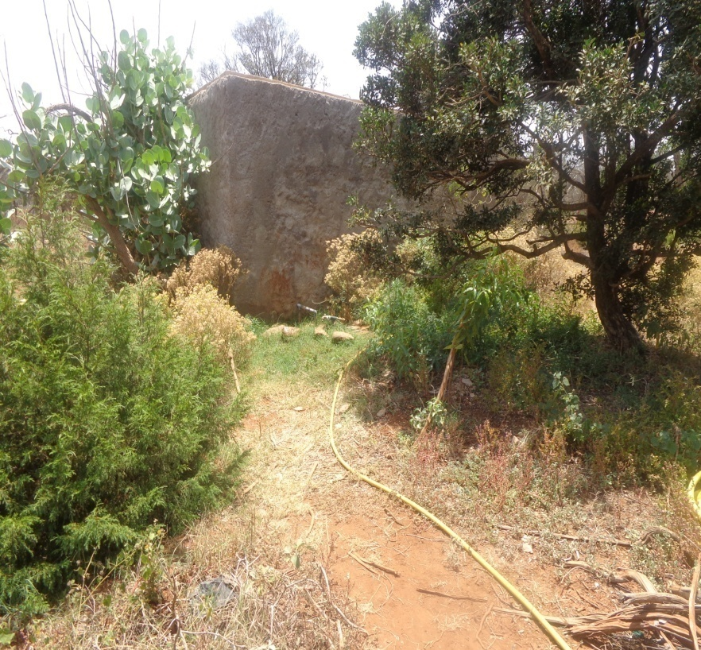
M. Abdo Aléo  M. Abdo Cheiko  M. Mohamed Ibrahim  M. Saleh Ali Kamil  M. Hamadou Ali Aleo  M. Ali Mohamed Ali  M. Kamil Ibrahim Haissama | Visite d’Atelier Artisanal bois mort du Day (7 personnes)  Chef de l’atelier  Chef technique de l’atelier  Ouvrier de l’atelier  ouvrier de l’atelier  ouvrier de l’atelier  ouvrier de l’atelier  ouvrier de l’atelier  lat.11°47’11’’ et long.42°38’23’’  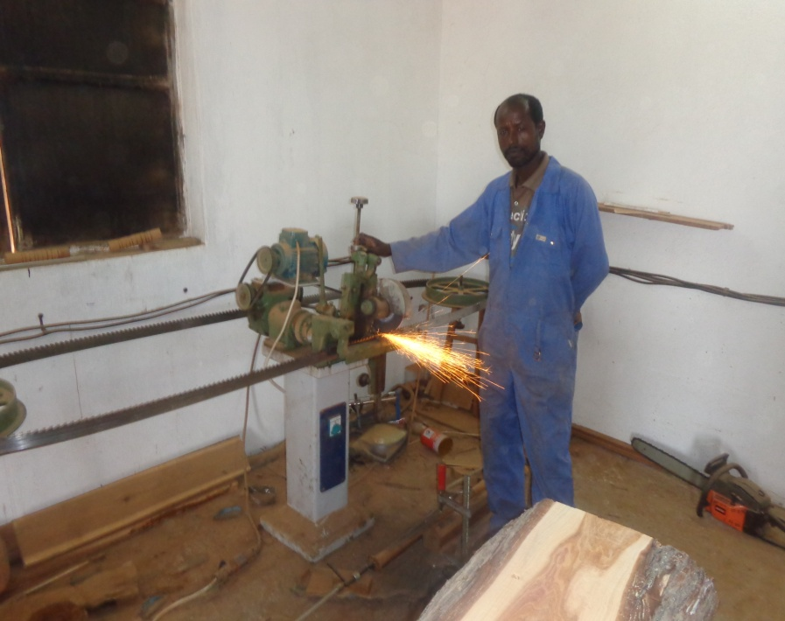
Apres-midi | Visite de la pépinière de Randa et rencontre avec la comité CGF (Comité de gestion de la forêt)
M.Mohamed Ali Issa  M.Mohamed Douba  Mme.Nasro Mohamed Ali | Président de CGF de Randa  Membres de CGF  Membres de CGF  Lat.11°51’08’’ et long 42°39’41’’
17/05/2014 | Réunion avec comité de CGEP et CPL D’Illayssa
M.Ali Mohamed Adbara  M.Djilani Hamana Adbara  M.Mohamed Ali Mohamed  M.Mohamed Hamadou  M.Kamil Mohamed Youssouf  M.Hamadou Aramis | Chef Coutumier d’Illayssa  Chef de CGEP Illayssa  Chef de CGEP Ahli Damoum  Membres de CGEP  Membres de CGEP Illayssa  Membres de CGEP Illayssa
M. Youssouf Ali  M. Hassan Soumbourou | Visite de la retenue d’Assaya (après Illayssa) et le site d’un seuil de gabion pour la régénération assistée  Chef CGEP « retenue Assaya » & gardiennage « mise en repos de Warhim »  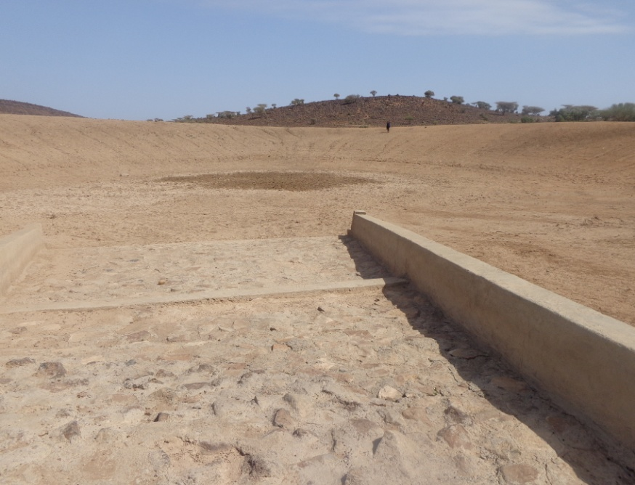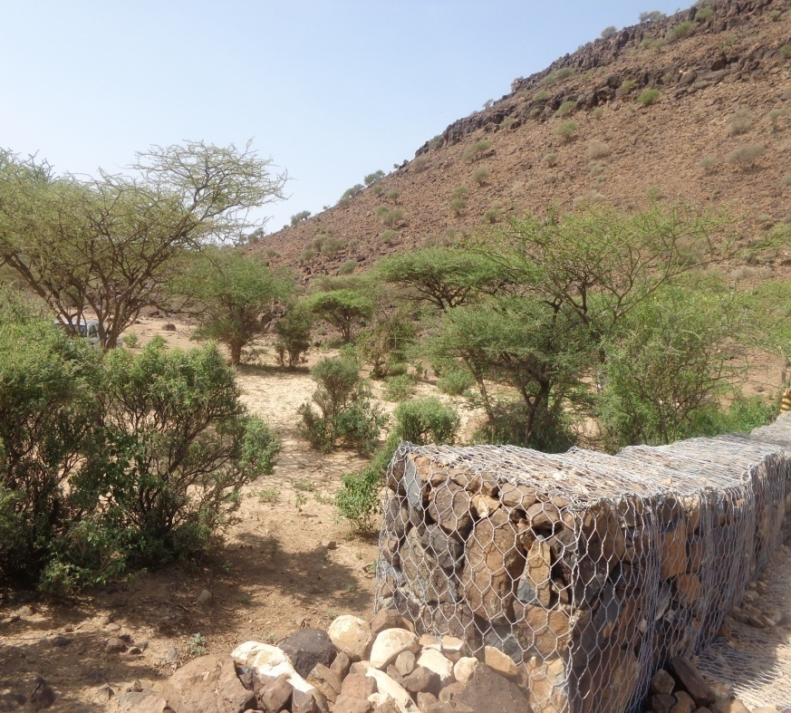
Visite de Mise en repos de Warhim (800 hectares)
Lat.11°50’10’’ et Long.42°35’34’’
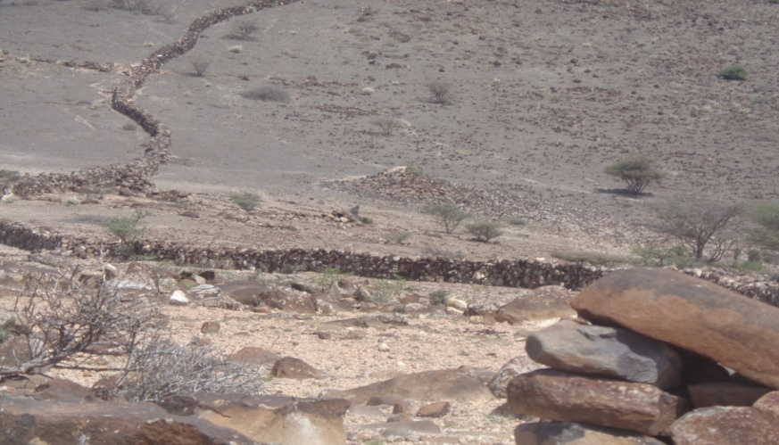
M. Mohamed Ali  M. Mohamed Houmed Hamadou  M. Mohamed Hamadou Adala  M. Mohamed Hamadou Moussa | Parcours Dorra-Otoy  (visite de retenues As Maro (lat.12°06’39’’et long.42°22’56’’, d’Otoy1 lat.12°05’02’’et long.42°22’28’’, Otoy2 lat.12°04’54’et long.42°22’34 et une nouvelle citerne d’Otoy)  Président du CGEP
Visite Forêt de Dorra
(régénération assistée d’un périmètre de 5 hectares)
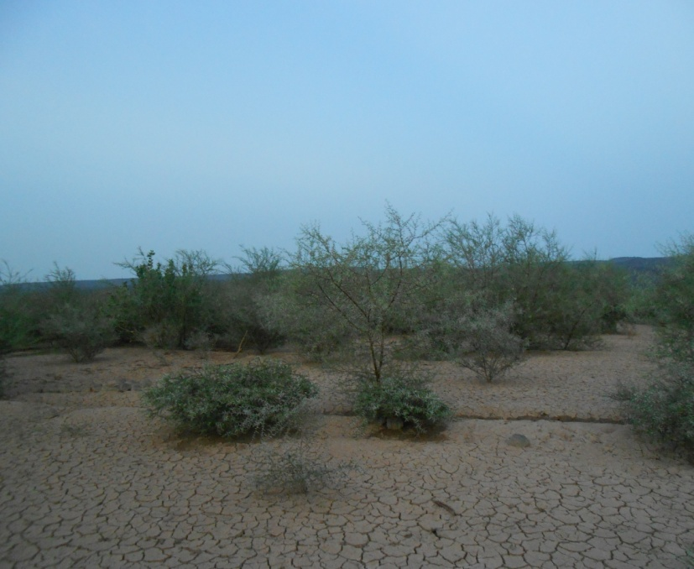
Réunion avec le CPL de Dorra/Otoy
Président du CPL d’Otoy
Président du CPL d’Asal/Doda
Président du CPL de Mounkour
18/05/2014 | Visite du Barrage de Kalou et Pépinière de Dorra  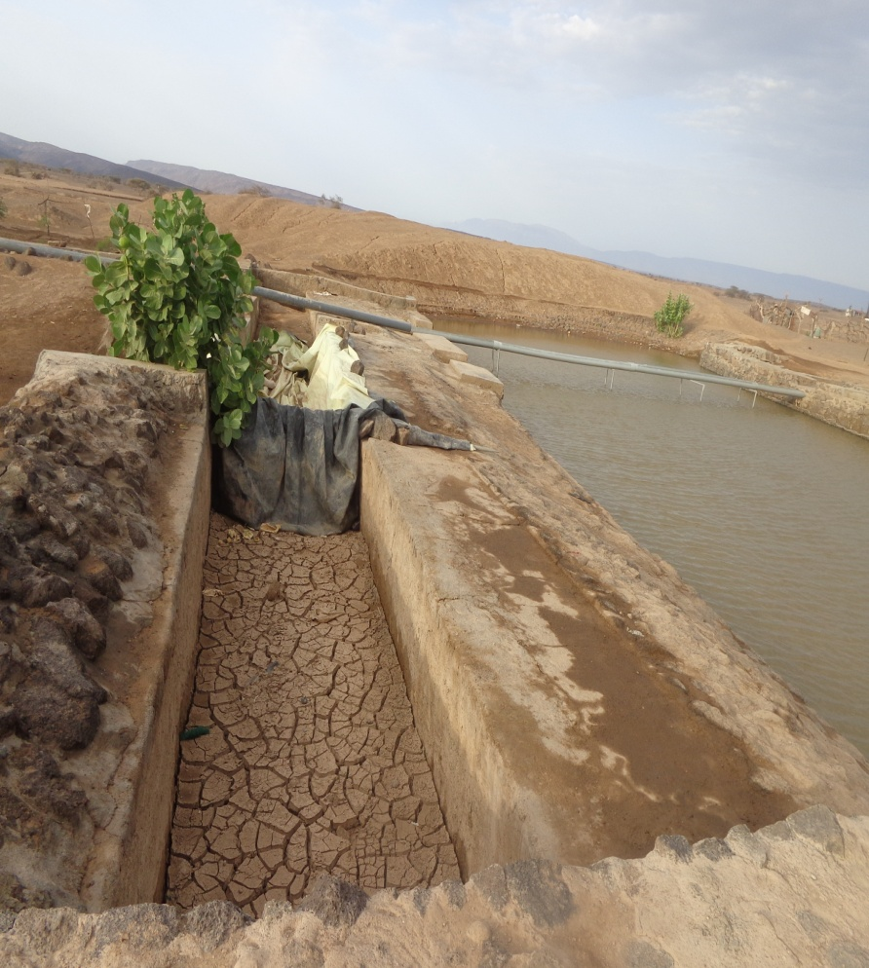
Midi 18/05/2014  Après-midi | Parcours Grand Barra /Petit Barra  (visite de la Retenue de Kilakillé)  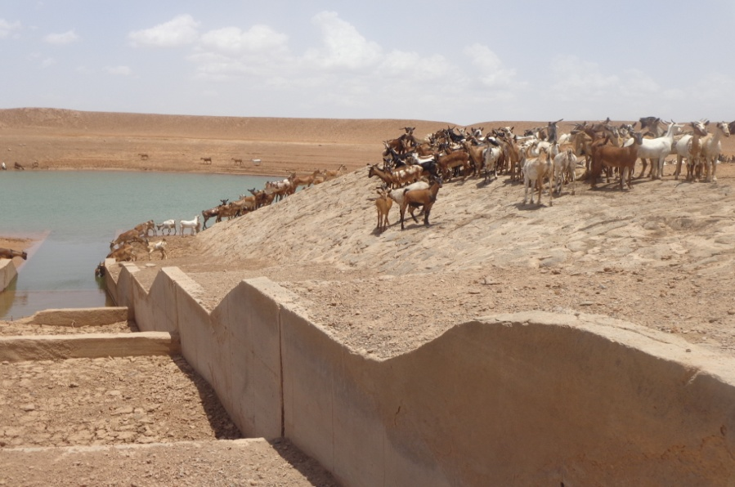
Visite Seuil de recharge d’Ibirleh (lat.11°04’53’’ et long.42°12’55’’)

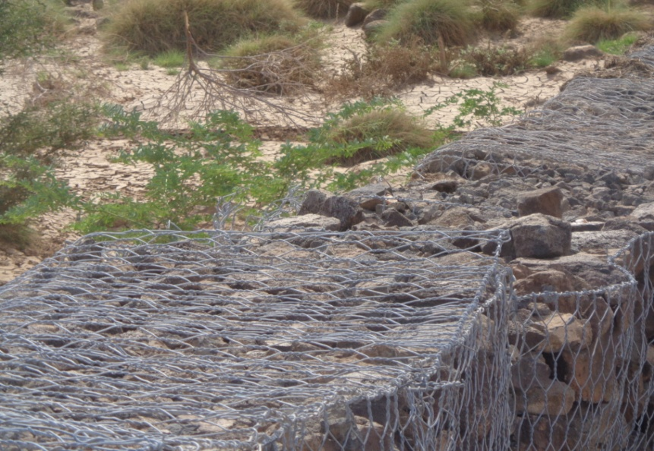
Réunion avec comité de Pépinière d’As Eyla (lat.10°59’50’’et long.42°07’25’’) et visite Citerne enterrée de Hawadala (lat.11°01’10’’ et long.42°06’31’’)
Membre de CGF
Membre de CGF
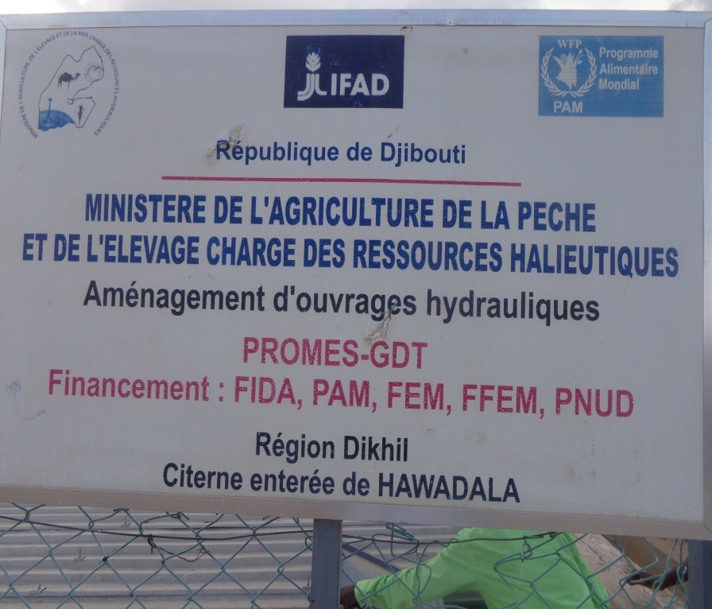
Mme Fatouma Kadija, Pepinieriste 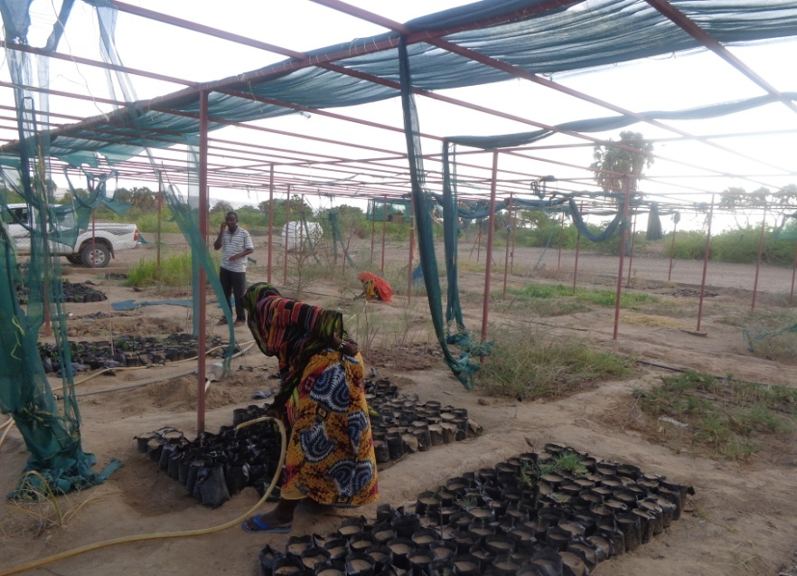

Annexe 4A. Réalisation des résultats suivant les indicateurs du cadre logique du projet

Niveau Projet | Indicateurs d’impact | Lignes de bases | Cibles | Moyens de vérification | Réalisés | Taux de réalisation | Observations de l’évaluateur
Objectif Global  Renforcer les moyens de subsistance des communautés pastorales en favorisant la gestion durable des ressources naturelles | Couverture végétal sérieusement dégradée dans les zones de pâturage en augmentation | Couverture végétale actuelle dégradée est de 8.3% dans les zones de pâturages | Couverture végétale dans les zones de pâturages augmentée au moins jusqu’à 30% à la fin du projet | FGEF évaluation ligne de base lors du démarrage  Enquête Socio-économique IFAD (RIMS)  Rapport et Enquête Programme Alimentaire Mondiale  Evaluation mi-parcours et évaluation finale  Statistiques macro-économiques  Rapport Annuel d’activités | 4 800 ha. mis en repos à Day mais l’étude sur la couverture végétale n’est pas encore réalisée. | Inconnu | Les images satellites de Google Earth en 2014 montrent un peu plus de verdure qu’en 2013 à Day
 | Production des pâturages dans le 10,000 ha du projet augmentée | Taux actuel de production est 1 UBT/ha  (UBT= Unité de Bétail Tropical) | Taux ciblé de production est de 5 UBT/ha à la fin du projet |  | L’étude sur le taux ciblé de production UBT n’est pas encore réalisé | Le calcul de ce taux est inconnu au personnel du projet | L’équipe du projet devra être formé pour effectuer le calcul UBT
 | Disponibilité des eaux de surface dans la zone du projet augmentée | Niveau actuel des eaux de surface mobilisées autour de 300,000m³ | Quantité des eaux de surface augmentée à 500,000m³ à la fin du projet |  | Le programme a augmentée la quantité des eaux mobilisées autour de 500,000m³ | 100%
 | Menacés Juniperus procera dans la foret du Day (superficie de la zone 1,800ha) régénérée | Actuellement 600 arbres sont encore envie dans la zone centrale de 675 ha et en voie disparition complète dans les zones restantes | A long terme le programme plantera 1,000 arbres /an sur une période 10 ans en commençant en 2011 |  | 6 000 plantes sur 12 000 prévues à cause de la sécheresse | 50%
 | La mesure de l’évaluation des besoins en renforcement des capacités améliorées | Valeur de base de la mesure de l’évaluation des besoins en renforcement des capacités est 19 en 2011 | La mesure de l’évaluation des besoins en renforcement des capacités augmente à 37 en 2014 |  |  | Inconnu
 | Information et dissémination de pratique de gestion en eau et en sylvo-pastoralisme démontré | Absence de documentation et d’échange | Au niveau deux leçons apprises sont publiés à la fin du projet |  | Pas de publication sur les leçons apprises sur les pratiques de gestion en eau et en sylvo-pastoralisme | La dissémination a toutefois était faite par l’exemple qui est répliquée par les nouveaux projets, mais pas de publication formelle (50%) | Confectionner dans les six prochains six mois un manuel de normes et les leçons apprises
Objectif 1:  Mettre en place des mesures de gestion de eaux de surface pour satisfaire les besoins de consommation de la communauté et de son cheptel et promouvoir une utilisation durable des zones de pâturage en augmentant la disponibilité et l’accès aux pâturages | Accès aux sources d’eau dans les saisons sèches pour 6000 familles (36,000 habitants) amélioré | Plus de 50% de familles n’ont pas accès à l’eau en saison sèche | Réduction du taux de famille n’ayant pas accès à l’eau en saison sèche réduit de la moitie à 25% à la fin du projet | Registre des communautés (Suivi des contributions financières des usagers des citernes.  Rapport Annuel des activités du Programme  Evaluation a mi-parcours et évaluation finale  Evaluation rurale  Etude d’impact environnementale | 9.000 familles ont accès à l’eau. | 150%
 | Capacité de la charge animale sur le pâturage augmentée | Capacité actuelle de la charge du pâturage dépasse les 63% | Pression sur les pâturages est réduite de 30% à la fin du projet |  | La pression sur les pâturages a été réduite mais on ne connaît pas le taux de la réduction. | Quelques pâturages ont été mis en défens par des clôtures en pierre (8000ha près d’Ileyssa ou en grillage métallique 5ha à Day) | L’équipe du projet devra être formé en calcul de capacité de charge animale de pâturages
 | Un plan d’aménagement pour la forêt du Day est adopté par les acteurs locaux | Seulement la zone centrale de 675ha est protégée mais pas d’une manière durable | Un modèle économiquement et culturellement durable pour la protection de  la foret est établi à la fin du projet |  | Pas de plan d’aménagement pour la Forêt du Day, mais un code local est établi | 25% | Un plan d’aménagement du Day devra se faire en considérant d’autres alternatives de capture des eaux de brouillard
Objectif 2:  Renforcer les capacités institutionnelles, techniques et humaines aux niveaux central et local | Le “Comité de Pilotage Local” est établi en tant qu’institution local pour la gestion de ressources naturelles | Participation local limitée dans la gestion des ressources naturelles | Structures et différents et comités locaux sont fonctionnels à la fin du projet | Suivi par le département décentralisé  Plan de développement communautaire  Rapports de formation  Rapports des évaluations | 8 CPL ont été créés mais 7 fonctionnels (Grand et Petit Bara-non fonctionnels) | 87,5%
 | Les « Schéma d’Aménagement Hydraulique et Pastorale (SAHP”) établi dans 7 zones prioritaires | Actuellement, il n’y a pas de plans au niveau des organisations communautaire | Les SAHP adopté dans les 7 zones prioritaires |  | 7 SAHP élaborés | 87,5%
 | Technologie GIS adopté comme outil de base pour la gestion intégrée des ressources naturelles | Absence d’outils pour la gestion d’information permettant la prise de décision | Un system de GIS est utilisé par les décideurs à la fin du projet |  | Le PROMES-GDT utilise Google Earth pour le suivi de la gestion des ressources naturelles. Le contrat avec CERD n’a pas été signé. | 50% (équipe du projet mais doit pouvoir le partager avec les décideurs pour la prise de décision)
 | Fonction de Coordinateurs Régionaux adopté pour promouvoir la participation dans le développement participatif aux niveaux central et régional | Il n’excite pas de fonctions institutionnelles pour la gestion des ressources naturelles au niveau local | Les coordinateurs régionaux sont intégrés dans la fonction publique à la fin du projet |  | Le PROMES-GDT a recruté des animateurs qui ne seront pas intégrés dans la fonction publique à la fin du projet. | Le projet n’a pas pu recruter ou former les coordinateurs régionaux seulement 4 animateurs (50%)

Annexe 4b: Gestion Adaptative-Performances Physiques

Désignation | Unité | Prévision |  |  | réalisation |  |  | Analyse |  | Remarques
 |  | Total Projet |  | PTBA 2013 | Cumulés | PTBA 2013 | Total | % réaliser 2013 | Tot réalisé / Tot projet (%)
 |  | Initial | Ajusté |  | 2013
Résultats
Eau de surface mobilisée | M³ | 200,000 | 500,000 | 121,000 | 375,520 | 75,000 | 450,520 | 62% | 90%
Protection antiérosive des ouvrages assurée | KML | 420 | 330 | 100 | 100 | 50 | 150 | 50% | 45%
Mise en repos | ha | 10,000 |  | 2,400 | 3,000 | 1,800 | 4,800 | 75% | 48%
Espaces forestiers réaménagés (a) | ha | 500 | 300 | 100 | 150 | 100 | 250 | 100% | 83%
Activités
Aménagement des ouvrages hydrauliques
Construction de citernes enterrées
Construction de citernes 100 m3 | Citerne | 50 | 50 | 10 | 20 | 0 | 20 | 0% | 40%
Réhabilitation de citernes existantes
Réhabilitation de citernes existantes | Citerne | 15 | 16 | 0 | 22 | 1 | 23 |  | 144%
Réhabilitation de citernes familial | Citerne | 0 | 10 | 10 | 0 | 10 | 10 | 100% | 100%
Réalisation de nouvelles retenues
Nouvelles retenues | Retenue | 8 | 11 | 3 | 5 | 3 | 8 | 100% | 73%
Nouvelles mares (2000-3000 m³) | Mare | 0 | 0 |  |  | 2 | 2
Réhabilitation de retenues existantes
• Réhabilitation de retenues | Retenue | 8 | 14 | 3 | 9 | 2 | 11 | 67% | 79%
B.Réhabilitations des plaines d'innondations temporaire fortement erodés/Amenagement de petits ouvrages de retentions,avec seuil en gabions et terrassements ,traitement par TX de CES en amont
Etude Topo | Etude |  | 11 | 2 | 6 | 2 | 8 | 100% | 73%
Travaux de réalisation des petits ouvrages de retentions | Site |  | 11 | 2 | 6 | 2 | 8 | 100% | 73%
Gestion durable des terres
Développement et gestion
• Mises en repos | ha | 10,000 | 6,000 | 2,400 | 3,000 | 1,800 | 4,800 | 75% | 80%
• Surface traité par CES | ha | 1,000 | 600 | 240 | 160 | 100 | 260 | 42% | 43%
• Cordons pierreux | km | 200 | 100 | 50 | 25 | 25 | 50 | 50% | 50%
Amélioration de la production animale
Convention avec la Direction de l'Elevage concernant les besoins identifiées dans l'enquête de base | Unité | 1 |  | 0 | 1 | 0 | 1 | 0% | 100%
Enquêtes de base couvrent: Analyse des règles d’utilisation des ressources naturelles, Recensement du cheptel des zones retenues, Enquêtes zootechniques | Unité | 1 |  | 0 | 1 | 0 | 1 | 0% | 100%
Formation des éleveurs en santé animale et en gestion du bétail | session | 5 |  | 1 | 3 | 1 | 4 | 100% | 80%
Réhabilitation et équipement d’un local vétérinaire | Unité | --- | 1 | 0 | 1 | 0 | 1 | 0% | 100%
Appui à la conservation et régénération de la forêt du Day
Régénération assistée du genévrier et d’espèces de son habitat (surface) | Ha
Plants et regarnis | Nbs | 14,500 | 12,000 | 3,000 | 5,700 | 1,500 | 7,200 | 50% | 60%
Unité à réaliser (Ha) | Unité | 50 | 30 | 10 | 10 | 0 | 10 | 0% | 33%
Enherbement et plantations d’arbres fourragers sur cordons pierreux
Surface traitée (ha) | Ha | 500 | 300 | 100 | 50 | 100 | 150 | 100% | 50% | réalisé
Cordons pierreux | Km | 150 | 100 | 30 | 40 | 5 | 45 | 17% | 45%
Tranché ou trous des recherges | m³ | 0 | 0 | 0 | 0 | 600 | 600 |  |  | C'est activité n'était pas prévue dans le prgramme, mais c'est les aquis
Végétalisation
-Arbres plantés et regarnis | Nbre | 46,000 | 11,000 | 3,000 | 1500 | 500 | 2000 | 17% | 18%
-Surface semée en herbe | Ha | 30 | 17 | 5 | 3 | 0 | 3 | 0% | 18%
Exploitation des bois morts de genévrier
Formation d'ouvriers
Bucheronnage | Pers | 6 |  | 6 |  | 9 | 9 | 150% | 150%
Inventaire de la forêt du Day | Unité | 1 |  | 0 | 1 | 0 | 1 | 0% | 100%
Correction et Végétalisation des petites ravines
Ravines
Nombre ravines | Nbre | 250 |  | 50 | 130 | 20 | 150 | 40% | 60%
Gabionnage | m | 500 | 300 | 100 | 120 | 0 | 120 | 0% | 40%
Nombre Arbustes, boutures, arbrisseaux et plantes succulentes mis en terre. | Nbre | 29,000 | 5,000 | 1000 | 30 | 0 | 30 | 0% | 1%
Mises en défens expérimentales | Ha
Clôturage 3 parcelles de 100x200m | Unité | 3 |  | 1 | 2 | 0 | 2 | 0% | 67%
Postes météo ('$ US) | Unité | 3 | 3 | 3 | 1 | 0 | 1 | 0% | 33%
Actions d'accompagnement
a. Mise en place d'une unité d'artisanat du bois
Formation | Pers | 6 | 10 | 10 | 0 | 10 | 10 | 100% | 100%
Expertise nationale | P-Mois | 2 |  | 1 | 0 | 0 | 0 | 0% | 0%
Equipements de l'unité et consommables | Lot | 1 |  | 1 | 0 | 1 | 1 | 100% | 100%
Aménagement des locaux | Unité | 1 |  | 0 | 1 | 0 | 1 | 0% | 100%
b. Développement de l'apiculture
Expertise international (P-mois) | P-Mois | 0.5 |  | 0.5 | 0 | 0 | 0 | 0% | 0%
Expertise nationale (P-mois) | P-Mois | 4 |  | 1 | 1 | 0 | 1 | 0% | 25%
Equipements de l'unité et consommables (Lot) | Lot | 1 |  | 1 | 0 | 0 | 0 | 0% | 0%
Aménagement des locaux (Unité) | Unité | 1 |  | 1 | 0 | 0 | 0 | 0% | 0%
Les interventions en périphérie de la forêt
Plantations de protection en une zone tampon à la forêt
Surface traitée | Ha | 700 | 300 | 100 | 100 | 0 | 100 | 0% | 33%
Cordons pierreux | Km | 70 | 30 | 10 | 10.5 | 5 | 15.5 | 50% | 52%
Ravines traitées | Nbre | 250 | 150 | 50 | 40 | 10 | 50 | 20% | 33%
dont gabionnage | M³ | 100 |  | 100 | 0 | 0 | 0 | 0% | 0%
Plantation d’arbres | Nbs | 182,000 | 3,000 | 1,000 | 1,000 | 1,000 | 2,000 | 100% | 67%
Micro-plantations d’arbres à usages multiples campements et des citernes
Plantation autour de citernes à Randa et à Mak’arassou | Plantes | 5,000 | 2,000 | 1,000 | 700 | 500 | 1,200 | 50% | 60%
Campements du Day | Plantes | 5,000 |  | 1,000 | 2,500 | 1,000 | 3,500 | 100% | 70%
Plantations de brise-vent et zones d’abri autour des mares artificielles
Plantation autour de retenues d’eau à Dorra | Plantes | 8,000 |  | 500 | 5,000 | 1,000 | 6,000 | 200% | 75%
Résultats
Comités de gestion d’eau et parcours fonctionnels | Nbre |  | 110 | 23 | 52 | 11 | 63 | 48% | 57%
Femmes représentées dans les comités de gestion de l’eau et des parcours | %
2. Activités
Renforcement des capacités communautaires
Élaboration des schémas d'aménagements pastoraux | Nbre |  | 34 | 8 | 18 | 8 | 26 | 100% | 76%
CLP établis | Nbre |  | 8 | - | 8 | 0 | 8 | 0% | 100%
Nombre de formations, désagrégé par sexe | Nbre | 18 |  | 8 | 6 | 8 | 14 | 100% | 78%

Annexe 4c : Réalisations du Projet par Composante suivant l’auto-évaluation du personnel du projet au 30 Avril 2014
Résultat 1 : Une meilleure capacité de mobilisation des eaux de surface | Indicateur | Degré de réalisation au 30 Avril 2014 | Observations par la Mission d’Evaluation Finale du FEM (Mai 2014)
 | - 8 100 m³ capacité totale des citernes  - 275 000 m³ capacité totale des retenues  - 195 000 m³ capacité des gabions d’épandage et des barrages  - Efficacité des ouvrages (SYGRI, niveau 2)  - Durabilité des ouvrages hydrauliques créés/réhabilités(SYGRI)  - Nombre d’animaux desservis (par type d’aménagement)  - Nombre de ménages desservis (par type d’aménagement) | - 5 320 m³, soit 66% des capacités de mobilisation  - 290 000 m³. 105%d’Objectif  - 200 000 m³ 100%d’Objectif  - Minimum 20 000 m³ par retenue, 100 m³ par citerne et 50 000 - 300 000 m³ par seuils d’épandage  - 10 ans, pour durabilité limite de service et 10 ans en plus pour la durabilité limite ultime avec les entretiens  - 10 900 d'animaux par retenue de 20 000m³  - 30 ménages par citerne, 340 ménages par retenue et 50 ménages par seuil.
Produit 1.1: Augmentation des citernes à usage domestique | - 50 citernes communautaires construites  - 16 citernes communautaires réhabilitées  - 10 citernes familiales réhabilitées  - Nombre de ménages desservis | - 26 citernes, soit 52%  - 23 citernes, soit environ 144%  - 10 citernes (100%)  - 1 290 ménages
Produit 1.2: Création des retenues pour le bétail | - 11 retenues construites  - 13 retenues réhabilités  - 11 plaines réhabilitées  - 2 petits barrages en gabions | - 10 retenues construites, soit 90%  - 11 retenues réhabilitées, soit 85%  - 8 plaines réhabilitées, soit 73%.  - Le programme n'est pas réalisé.

Résultat 2 : Une gestion plus durable des terres pastorales | Indicateur | Degré de réalisation au 30 Avril 2014 | Observations par la Mission d’Evaluation Finale du FEM (Mai 2014)
 | - Augmentation de l’offre fourragère de 1 million d’UF  - Productivité des pâturages augmentée de 0,05UBT/ha à 0,1 UBT/ha | - Ces indicateurs n’ont pas encore été pris en compte du fait que des mesures de biomasses et de capacité de charge n’ont pas été effectuées in situ. Leur prise en compte sera effective d’ici la fin du projet à travers la mobilisation d’un expert en pastoralisme.
Produit 2.1 : Mise en œuvre des travaux CES | - 6 000 ha de parcours mis en repos  - 600 ha de travaux CES (10%)  - 100 km de cordons pierreux  - Nombre de personnes formées en CES | - 4800 ha (80%)  - 320 ha (50% des objectifs visés)  - 50 cordons pierreux (50%)  - 200 personnes.
Résultat 3 : Amélioration de la production animale | - 1 000 d’éleveurs faisant état d’une amélioration sanitaire de leur cheptel | - 828 éleveurs
Produit 3.1 : | - Nombre d’éleveurs formés  - Nombre d’animateurs formés  - Recensement du cheptel organisé. | - 158 éleveurs formés  - 40 animateurs auxiliaires  - 1 Recensement organisé
Résultat 4 : Conservation et régénération de la forêt du Day | - Couverture végétale augmentée de 30%  - 30 ha régénérés (250 arbres/ha)  - Plan de gestion de la forêt adopté  - Efficacité des programmes de gestion des ressources naturelles (SYGRI) | - Eléments de référence non disponibles pour pouvoir apprécier les augmentations  - 10 hectares régénérés (33%)  - Aucun plan de gestion participatif. Par contre, un code local de gestion participative de la forêt est adopté.  - Bonne appropriation de techniques de restauration des écosystèmes (CES, pépinière et plantations, planification de la gestion de la forêt).
Produit 4.1 : Espaces forestiers aménagés d’une façon durable | - 12500 arbres produits et plantés  - 300 ha mise en repos  - 300 ha de travaux CES  - 90 km de travaux CES | - 6 000 jeunes plantes mis en terre (50%)  - 200 ha mis en repos (66%)  - 200 ha de travaux de CES (66%)  - 50 km de cordons pierreux (55%)

Annexe 4e. Infrastructures & ouvrages prévus et réalisés par CPL, situation de mise en repos & pépinières
Description | Unité | Zone Goba’ad |  |  |  | Zone Grand et Petit Bara |  |  |  | Zone Day et sa Périphérie
 |  | CPL Goba’ad |  | CPL Dakka |  | CPL Bara |  | CPL Karta |  | CPL Day |  | CPL Randa |  | CPL Dorra |  | CPL Andabba-Madgoul |  | Total ouvrages
 |  | Prévus | Réalisés | Prév | Réal | Prév | Réal | Prév | Réal | Prév | Réal | Prév | Réal | Prév | Réal | Prév | Réal | Prévus | Réalisés
Citernes réhabilitées | Nbre | 1 | 2 | - | - | - | - | - | - | 5 | 5 | 10 | 10 | - | 4 | - | 2 | 16 | 23
Nouvelles Citernes | Nbre | 5 | 3 | 5 | 2 | 5 | - | 5 | 2 | 10 | 3 | 10 | 5 | 5 | 3 | 5 | 2 | 50 | 20
Retenues réhabilitée | Nbre | - | - | - | - | 3 | 2 | - | - | - | - | 3 | 3 | 4 | 2 | 4 | 4 | 14 | 11
Nouvelles Retenues | Nbre | - | - | 1 | - | - | - | 2 | 2 | 1 | 1 | 1 | 1 | 4 | 4 | 2 | 2 | 11 | 10
Seuils d’épandage & de dérivation | Nbre | 1 | 1 | 2 | 1 | - | - | - | - | 2 | 1 | 2 | 2 | 2 | 2 | 2 | 1 | 11 | 8
Mis en repos | Nbre d'ha | 800 | 400 | 400 | 400 | - | - | - | - | 800 | 600 | 2000 | 1800 | 800 | 400 | 1200 | 1200 | 6000 | 4800
Pépinières | Nbre | 1 | 1 | - | - | - | - | - | - | 1 | 1 | 1 | 1 | - | - | - | - | 3 | 3

Annexe 5a-Budget FEM 2012-2013

Budget du FEM en 2012
Chapitres et composantes | Unité | Quantité | Cout Unit | Total USD
Composante 1/
Atlas Activity 1: Mobilisation des eaux de Surface et Gestion Durable de Terres
Nouvelles techniques de gabionnage |  | 600 | 56 | 33 600
Sous-total Composante 1 |  |  |  | 33 600
Composante 2/
Atlas Activity 2: Renforcement Institutionnel et Développement Participatif
Expert en pastoralisme et approche participative |  | 6 | 12 000 | 72 000
Spécialiste en administration publique |  | 1 | 12 000 | 12 000
Spécialiste genre |  | 1 | 12 000 | 12 000
Expert SIG |  | 1 | 12 000 | 12 000
Expert en communication |  | 1 | 12 000 | 12 000
Expert en génie civile |  | 4 | 12 000 | 48 000
Formations, ateliers et actions de développement local |  |  |  | 20 000
Equipement informatique et de téléphonie |  |  |  | 35 000
Fonctionnement des équipes |  |  |  | 15 000
Sous-total Composante 2 |  |  |  | 238 000

Budget du FEM en 2013
Chapitres et composantes | Unité | Quantité | Cout Unit | Total USD
Composante 1/
Atlas Activité 1: Mobilisation des eaux de Surface et Gestion Durable de Terres
1.1 Correction et végétalisation des petites ravines, Transfert de technologies et de pratiques nouvelles de CES (Gabionnage, tranchées, etc.) :
Achat outils et petits matériels | lot | 1 | 5 000 | 5 000
Achat des gabions | m³ | 200 | 56 | 11 200
1.2 ETUDES
Etude d’impact des ouvrages et des techniques de restauration et sauvegardes des écosystèmes sylvo-pastoraux | Etude | 1 | 20 000 | 20 000
1.3 FONCTIONNEMENT
Fonctionnement des équipes | Forfait | 1 | 5 000 | 5 000
Sous-total Composante 1 |  |  |  | 41 200
Composante 2/
Atlas Activité 2: Renforcement Institutionnel et Développement Participatif
2.1. Assistance technique
Reliquat contrat technicien international. Unité artisanat-bois (50%). |  |  | 4 500 | 4 500
Nouveau contrat de formation et d’assistance en technologie et utilisation du bois. | mois | 1 | 9 000 | 9 000
Edification des barrages, conseils et conduite des travaux. (Interventions en zone périphérique du Day) | mois | 2,5 | 12 000 | 30 000
Expert national en Apiculture | mois | 1 | 4 500 | 4 500
Système d’information géographique (SIG). | mois | 1 | 12 000 | 12 000
2.2 Voyages d’étude
2.2.1 Ethiopie (10 PERSONNES) (900 $ /Per) | Semaine | 2 | 9 000 | 9 000
2.2.2 Maroc (4 PERSONNES)(5000 $/Per.) | Semaine | 2 | 20 000 | 20 000
2.2.3 France (2 PERSONNES)(6000 $/Per.) | Semaine | 2 | 12 000 | 12 000
Sous-total Composante 2 |  |  |  | 101 000

Annexe 5b: Financement et Decaissement au 30 Avril 2014 PROMES-GDT. Montage Financier et Performance financière par source de financement.

Source de financement | Approuvé (US$ ‘000) | Actuel  (US$ '000) | Décaissements (USD ‘000) | Décaissements en pourcentage
Don FIDA | 6,074.7 | 6,074.7 | 5,095.8 | 84%
FFEM | 1,185.8 | 1,185.8 | 1,185.8 | 100%
FEM | 1,056.8 | 1,060.0 | 1,000.0 | 94%
PAM | 1,120.5 | 1,935.2 | 1,935.2 | 100%
PNUD | 67.7 | 67.7 | 67.7 | 100%
Gouvernement | 2,626.2 | 2,626.2 | 2,000.0 | 76%
Beneficiaires | 172.2 | 172.2 | 160.5 | 93%
Total | 12,303.9 | 13,121.8 | 11,445.0 | 87%

Participation communautaire est estimé 7% du cout de l'ouvrage,
Donc categorie de travaux d'amenagement
les travaux consistent a la fouille/travaux CES/ Cordon pieureux/ seuil en pierre

The totalling of the rating scores assumes equal weighting across the rating items, in spite of different denominators (or different scales) by item evaluated, based on Table 1.

