UNDP Regional Programme 2014-2107

for Latin America and the Caribbean

Midterm External Review

Final Report

Presented by:

Javier Jahnsen

February 2016

Table of cONTENTS

i. Acronyms 3

ii. Acknowledgments 4

iii. Disclaimer 4

iv. Executive Summary 5

1. Introduction 8

1.1 Methodology of the MTR 11

**1.1.1 Review criteria and questions** 11

**1.1.2 Data collection methods** 12

**1.1.3 Limitations of the MTR Methodology** 14

2.1 A Changing Regional Landscape 15

**2.1.1 Growth has decelerated in the region** 15

**2.1.3 The environment continues to degrade and impacts regional well-being** 16

**2.1.4 Declining levels of development assistance** 16

**2.1.5 The shift from MDGs to SDGs** 17

**2.1.6 Gender inequality gaps remain in the region.** 17

**2.1.7 Vulnerability to risks related to insecurity and conflicts** 17

**2.1.8 Migration dynamics are complex in the Central American North Triangle** 18

3.1 Findings by review criteria 18

**3.1.1 Financial overview** 18

**3.1.2 Context** 20

**3.1.3 Assessment of results** 25

**3.1.4 Quality standards**  28

4. Programme effectiveness findings by RP outcome 29

**4.1 Outcome 1** 29

**4.2 Outcome 2** 32

**4.3 Outcome 3** 34

**4.4 Outcome 4** 36

5. Conclusions 38

6. Lessons Learnt 39

7. Recommendations: 40

**Featured recommendation: The need for a robust RP M&E Framework** 41

8. Annexes 42

8.1 Data collection tools and instruments 42

**8.1.1 Individual/Group Interview questionnaire for project stakeholders** 42

Interviewer 42

**8.1.2 Online Interview questionnaire for project stakeholders** 45

8.2 MTR Matrix 51

9. Bibliography 65

# Acronyms

HIV Human immunodeficiency virus

IRRF Integrated Results and Resources Framework

JCCCP Japan-Caribbean Climate Change Partnership Project

LAC Latin America and the Caribbean

MTR Midterm Review

RBLAC UNDP Bureau for Latin America and the Caribbean

RDT Regional Directors’ Team

ROAR Results-Oriented Annual Report

RPD Regional Programme Division

RSC Regional Hub

ToC Theory of Change

ToR Terms of Reference

UNDP United Nations Development Program

# Acknowledgments

The reviewer is thankful to all stakeholders that participated in the interviews and those who shared technical documentation. Worthy of note is the contribution of UNDP’s Regional Hub and New York Office as well as the participation of Country Office Representatives.

# Disclaimer

The conclusions included in the present document are the sole responsibility of the reviewer and do not necessarily reflect the position of UNDP.

# Executive Summary

UNDP has commissioned this mid-term review (MTR) of the 2014-2017 Regional Programme for Latin America and the Caribbean. On the one hand, the MTR seeks to feed into UNDP’s wider process of reviewing all regional and global programmes and, on the other, it constitutes a timely effort that aims to provide inputs as per the commitment made with UNDP’s Executive Board, as well as analyzing progress in achieving RP results, the relevance of the objectives of the RP and their contribution to UNDP’s Strategic Plan. This MTR was conducted by consultant Javier Jahnsen between the last quarter of 2015 and the first quarter of 2016. It is important to note that this is a review of the RP and not of the Regional Hub, of which the RP is a service.

**The Regional Challenges for the implementation of the SDG agenda**

Challenges have emerged for Agenda 2030 and the Sustainable Development Goals (SDGs). First, after a decade of economic growth, LAC has experienced a deceleration which limits the fiscal space. Secondly, citizens require stronger, more responsive and more inclusive democratic governance systems that incorporate the voices of important and traditionally-marginalized groups like women and youth. Third, the environment continues to degrade and impacts regional well-being -LAC currently has one of the worst deforestation rates in the world-. Fourth, declining levels of development assistance pose a risk and an opportunity for the SDG agenda as the scarcity of funding for development assistance requires that the RP –as an important service of UNDP’s Regional Hub- seeks alternative sources of funding and technical cooperation if it is to be sustainable. Fifth, the shift from MDGs to SDG has created a very positive environment for UNDP to continue being the most prepared partner for implementing the SDG agenda. Six, gender inequalities remain in the region due to factors such as wage differentials in spite of higher education, unpaid labor in the household and the prevalence of violence against women. Migration dynamics and vulnerability to risks related to insecurity persist as an issue of concern in the region.

**Relevance**

The RP is sensitive to changes in the regional context and is in line with the SP outcomes. In spite of the above-mentioned persisting challenges, stakeholders have recognized the relevance of the role of UNDP, and that of the RP, in particular, within the new regional development context brought about by the SDG. Interviewed CO stakeholders reached consensus on stating that the support they receive from the RP has made considerable technical expertise available. The RP has evolved from emphasizing work on Latin America to enhancing its capacity to look and respond to the needs of the Caribbean, which are clearly linked to challenges put forward in the SDG and other documents addressing development issues of island states such as the SAMOA Pathway.

**Achievement of results**

The RP has embraced the Regionality Principle in achieving its results. It has generated regional public goods in the area of citizen security and also in the realm of the SDGs by developing a broader regional proposal for promotion of the SDGs and sustainable development solutions. In addition, the RP has contributed to the advancement of awareness of emerging development issues via work on state building and learning from successful experiences in extra-regional countries. The RP has also promoted innovation on a regional level with initiatives such as the Gender Equality Seal and by fostering an integrated view to promote the SDG agenda, in particular the linkages between poverty reduction and environmental action.

Finally, the RP has generated development knowledge through the “Superando obstáculos para la transversalidad de género en América Latina y el Caribe” project, an initiative linked to output 3 of the RP, which has produced regional knowledge products such as a virtual platform for sharing information on the cross-cutting nature of gender in the LAC region.

After some delays during its inception stage, the RP still needs to make certain adjustments to be on track for achieving its results. Such adjustments include the development of clearly specified administrative procedures and an enhanced communication strategy to give its SP-linked results more visibility. Furthermore, the situation and strategies to address the needs of vulnerable and excluded groups need to be re-emphasized.

**RP Efficiency**

As of December of 2015, 36%[1] of total resources allocated have been implemented. This percentage of execution is due to the fact that two of the largest new projects approved have started implementation during the quarter 3 of 2015 (JCCCP, Prejuve). The composition of funding has changed, with a decreasing trend in the share of CORE[2] (from 1.1% to 0%[3] from a budget perspective and from 26.1% to 10.2% from an expenditure perspective).

**Recommendations**

1. The RP should use the unique added value of the work on the gender outcome with initiatives that no other region has.
2. The potential of the Regional Human Development Report as an evidence-based policy-informing tool should be maximized. This report should be reflected upon using methods that go beyond presentations with regional and country stakeholders.
3. In order to continue incorporating and enhancing the application of the regionality principle of the RP, there is a need for an experience-sharing forum focusing on South-South Cooperation.
4. Given that SDGs are now at the top of the international agenda , the RP should take advantage of this opportunity, especially given that countries have the option to align their national priorities to SDGs. Accordingly, the RP should assist them to define areas that impact countries the most (e.g. water and sanitation, governance).
5. UNDP has great social and technical capital in the form of regional knowledge and information, better access to regional networks and a robust outlook on regional needs. This capital can neither be overlooked nor lost, but instead it should be continuously used as an element to continue joint programming and joint resource mobilization with donors and governments within the context of SDG implementation.
6. For improving quality, UNDP needs to organize the management structure of the projects to comply with the new quality standard (e.g. documentation, flows of processes, decision making chains).
7. Aside from the M&E function per se, there are other areas in which the RP and the projects it supports should make improvements, such as setting quarterly targets to monitor and assess their achievement and standardizing reports to allow for a progress quantification that goes beyond financial execution to better support decision making.
8. The team in charge of regional M&E should receive additional training to continue strengthening a Results Based M&E oriented function within the organization.

# 1. Introduction

The structure and objectives of UNDP’s Regional Programme for Latin America and the Caribbean 2014-2017 (RP) are included in the Regional Programme document for Latin America and the Caribbean, 2014-2017, which puts forward the following overarching goal: “**Reduction of persistent income and non-income poverty and exclusion, and lower levels of vulnerability and conflict, are gained through sustainable development practices and strengthened governance within regionally-agreed development goals in the post MDG era** “ [4]**.**

The RP for Latin America and Caribbean was formulated in 2013 taking into account the corporate priorities presented in the new UNDP Strategic Plan (SP), the alignment exercise to the new SP, and the findings and recommendation of the evaluation of the RPD 2008-2013.

The main objective of the RP is to tackle multiple, enduring and pervasive inequalities via results geared towards reducing persistent income and non-income poverty and exclusion, lowering levels of vulnerability and conflict, building sustainable development practices, and strengthening democratic governance while acknowledging the diversity of the region. The RP prioritized four UNDP strategic plan outcomes related to the three areas of work, namely, sustainable development, inclusive and effective democratic governance, and resilience building[5]. These outcomes are:

* Outcome 1 (Strategic plan outcome 1). Growth and development are inclusive and sustainable, incorporating productive capacities that create employment and livelihoods for the poor and excluded.
* Outcome 2 (Strategic plan outcome 2). Citizens’ expectations for voice, effective development, the rule of law and accountability are met by stronger systems of democratic governance.
* Outcome 3 (Strategic plan outcome 4). Faster progress is achieved in reducing gender inequality and promoting women’s empowerment.
* Outcome 4 (Strategic plan outcome 5). Countries are able to reduce the likelihood of conflict and lower the risk of natural disasters, including those resulting from climate change.

The RP is by nature diverse as it reacts to specific topics according to different donor perspectives and available funding. It is to be achieved via de aforementioned outcomes, which, as shown in the following figure, are closely linked to the 17 Sustainable Development Goals (SDG).

Figure 1 Link between the RP outcomes and the SDGs.

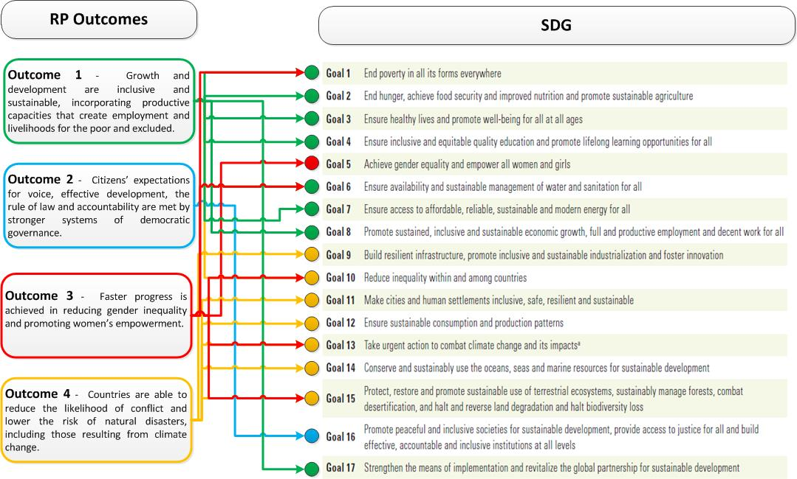

Source: Based on the RP outcomes and the list of SDGs included in the 2015 Human Development Report

In September 2015, the UN General Assembly (UNGA) ratified the 2030 Agenda and its 17 Sustainable Development Goals (SDGs). The SDGs are multi-dimensional and underpin the Agenda 2030. This is consistent with the aim of the latest Human Development Report for Latin America, which states the region needs to aspire to progress that is multidimensional, progress that goes beyond the economic dimension into the realm of freedom, citizen security, environmental safety, Human Rights and access to opportunities. The SDG agenda will generate many changes with respect to how development is addressed in the region. First, according to UNDP 2016 Regional Human Development Report, one of the significant shifts between MDGs and SDGs is the scope and ambition of the new agenda as evidenced by the move from an 8-goal/21 target policy agenda to a 17-goal/169 target framework. While the MDGs provided a reference for governments to develop policies, they were too narrow. In addition, the eight MDGs failed to consider the root causes of poverty and overlooked gender inequalities as well as the holistic nature of development[6], all of which are now relevant elements of the SDGs.

Secondly, each Latin American and Caribbean country is at liberty of adapting their policies and implementation strategies, harmonizing international commitments put forward by SDGs with country-specific needs and priorities.

Third, the fact that SDGs were the result of the largest consultation effort in UN history, have granted them a considerable strategic advantage in Latin America and the Caribbean: They have been selected not only by people in an office, but by members of grass-root organizations, who are very knowledgeable of the main challenges facing communities.

Fourth, considering that achieving the above-mentioned targets would not be easy from a financial perspective[7] as the region faces a reduction in available funds for development assistance, the implementation of the SDG agenda calls for operational effectiveness and efficiency of regional and national projects.

On the basis of the above-mentioned context, UNDP commissioned this External Midterm Review (MTR) of the UNDP’s Regional Programme 2014-2017 for Latin America and the Caribbean. On the one hand, the MTR seeks to feed into UNDP’s wider process of reviewing all regional and global programmes and, on the other, it constitutes a timely effort that aims to analyze progress in achieving RP results, the relevance of the objectives of the RP and their contribution to UNDP’s Strategic Plan. In addition, the review seeks to analyze how changes observed in the regional development and organizational contexts have influenced RP performance. Based on these analyses, the MTR will highlight changes that should be implemented within the RP to improve its effectiveness and efficiency, while identifying relevant lessons learnt.

The specific objectives of the MTR include the following:

* Review the quantitative and qualitative results achieved through the implementation of the Regional Programme in partnership with the key development actors in the region, highlighting progress, the key drivers of success, and main gaps identified.
* Review how the Regional Programme has contributed to potentiate existing Country Office (CO) portfolios in the achievement of planned development results;
* Presenting key findings, and making recommendations about the necessary adjustments to the programme which will be useful to increase performance and programme effectiveness, and;
* Propose a monitoring plan with output indicators to allow for an effective monitoring and future evaluation of the contributions of the programme to the Strategic Plan and to Country Office (CO) results, as well as including indicators to assess programme performance.

The TOR for this MTR, which was carried out by Javier Jahnsen –a Bolivian independent consultant- are in Annex 1. It is important to note that this is a review of the RP and not of the Regional Hub, of which the RP is a service. To achieve these objectives, this report includes a summary of the methodology that was applied to conduct the MTR, the main findings linked to thematic areas of the MTR, conclusions, lessons learnt and recommendations. Finally, the document includes annexes containing the additional information used during the MTR.

## 1.1 Methodology of the MTR

A key aim of the MTR has been to obtain an updated perspective of how the RP is progressing. Using the SP as a guideline, the RP document articulates what UNDP sees as the development priorities and persisting challenges in the region. The review criteria for the MTR consists of four thematic elements, namely, context, assessment of results, institutional effectiveness and quality standards. These four elements facilitated the classification of stakeholders’ responses and the generation of a list of lessons learnt and recommendations.

Three different data collection methods were used to conduct the review, namely, a desk review, an individual/group interview questionnaire and an online survey questionnaire. The desk review focused on documentation provided by the technical counterpart, which included project documents, guidelines, plans and frameworks. The individual interviews were aimed at stakeholders from UNDP’s Regional Hub, who were interviewed during a visit to Panama and those based in the New York office –via teleconference-. Finally, the survey questionnaire was used to obtain information from CO Representatives from the LAC region

The external review covers the period from the inception of the RP -in January of 2014- to date and focuses on the above mentioned objectives, while embodying a strong results-based orientation. The geographic scope of the MTR corresponds to CO in Latin America and the Caribbean.

This review analyses the evolving development scenario and challenges in the region since the preparation of the RPD and accordingly provide a forward-looking view about the future priorities and positioning of the RPD. An important goal for the MTR is to show how UNDP in the Latin America and Caribbean Region is currently positioned and can best respond to supporting the countries with the Sustainable Development Goals (SDGs).

### **1.1.1 Review criteria and questions**

The criteria for the MTR consists of four thematic elements, namely, context, assessment of results, institutional effectiveness and quality standards. These four elements allowed the reviewer to construct a strategic list of lessons learnt and recommendations. The following specific review questions were included within these criteria.

Table 2. Review criteria and questions.

|  |  |
| --- | --- |
| **Criteria** | **Questions** |
| **Context** | -How has UNDP’s operating environment shifted in the region since the adoption of the SP (2014-2017) and the RPD?  -What specific changes in the regional development context have had an influence on the regional programme? Are there changes that need to be made to the RPD in response to those changes?  -What strategic opportunities and risks are emerging as a result?  -Do the initial assumptions of the ToCs continue to hold true or do they need to be adjusted? |
| **Assessment of results** | - Is the RP on track to make its contribution to the SP (achieve development results) and support COs in the region (achieve development effectiveness)?  -What are the contributions of the RP on top and above to what COs have achieved?  - What are the gaps left to achieve UNDP's targets in the region and is the pace good enough to do so?  - What are the underlying causes of underperformance and key drivers of success? |
| **Institutional effectiveness** | - What are the initial results from the structural change in the RP/RSC?  - How is the resource situation evolving and what are the implications for the RP?  - Has the RP been able to adapt and respond to changes in the regional context?  -Are there strategies/areas of work/actions that still need to be adapted? If so, which ones?  - Are there developments with regard to UNDP’s role in the UN RDT and engagement with regional bodies? |
| **Quality standards** | - Where does the Regional Program currently stands vis a vis the corporate quality standards? (Refer to the CPDs standards and the Project QA policy as reference).  -  - What improvements could be made for improving Regional Program formulation in the future? |

The information gathered in response to these questions will allow the reviewer to identify lessons learnt and recommendations in accordance with the following considerations:

Table 3 Questions linked to lessons learnt and recommendations.

|  |  |
| --- | --- |
| **Thematic area** | **Aspect to be considered** |
| **Lessons learnt** | - What are the key thematic, operational and institutional lessons to be drawn?  - How well is the Regional Programme positioned vis a vis the SDGs?  -Are there changes to be made to the RPD to better address the SDGs? |
| **Recommendations** | - What are the main recommendations linked to programme organization and intervention delivery methods for 2016-17 and perhaps beyond?  -What are the main recommendations for enhancing the sustainability of RPD interventions beyond 2017? |

The matrix Included in Annex 2 provides information on the links between elements of the analytical approach, namely, criteria, evaluation questions, data sources and data collection methods.

### **1.1.2 Data collection methods**

Three different data collection methods were used to conduct the review, namely, a desk review, an individual/group interview questionnaire and a survey questionnaire.

**Desk review:**

This process included the review of documents made available during the MTR inception stage. These documents included, but were not limited to:

* Regional Programme 2014-2017 with the Result Framework
* UNDP Strategic Plan and IRRF -Regional and Global Programme proposal for a common approach for monitoring results (October 2015)
* Draft of Theories of Change for the four outputs of the Regional Programme
* Country Programme Document and project Quality Assurance standards
* Financial progress documents like Regional Programme Delivery reports
* Programmatic progress documents
* Evaluation reports
* RP Outcome Indicator Reports
* RP Output details
* The Evaluation Plan of the LAC Regional Programme
* Results frameworks
* The organizational structure of the RP
* Project work plans
* Annual project reports
* Other technical documents provided by the client

**Individual/group interviews/online surveys**

This process included interviews with key stakeholders using different interviews and survey methods, which are described in the following table:

Table 4 List of stakeholders interviewed.

|  |
| --- |
| **Context** |
| − RBLAC Director/Deputy Director **(Face to Face)**  − Senior Strategic Advisors RBLAC and Caribbean **(Face to Face)**  − RH Director **(Face to Face)**  − Cluster Leaders **(Face to Face)**  − Chief CORE Support Team **(Face to Face)**  -At least 3 RRs in the region (Online)  -Director for IDEA International (Online)  -Staff from SICA, CARICOM and UNASUR (Online) |
| **Quantitative and Qualitative Assessment of Results** |
| − /Deputy Director **(Face to Face)**  − RH Director **(Face to Face)**  − Regional Programme Coordinator **(Face to Face)**  − Project Managers and Technical Teams **(Online)**  − Country Advisors **(Face to Face)**  − RBLAC Strategic Planner **Online)**  -COs participating in key regional projects **(Online)** |
| **Institutional Effectiveness** |
| − RBLAC Director/Deputy Director **(Face to Face)**  − RH Director/Chief of RH BSO **(Face to Face)**  − Cluster Leaders **(Face to Face)**  − Chief CORE Support Team **(Face to Face)**  − Other relevant staff in HQs **(Face to Face)**  -UNDG LAC Specialist (Face to Face)  − RBLAC Operations Advisor **(-Online)**  − Resource Mobilization & Partnership Specialist **(Online)** |
| **Quality Standards** |
| -Deputy Director (Face to face)  − RH Director (Face to face)  − Regional Programme Coordinator (Face to face)  -Chief CORE Team (Face to face)  -Cluster Leaders (Face to face)  -RBLAC Strategic Planner (Online)  Other relevant staff in HQ (Face to face) |
| **Lessons Learned and Recommendations** |
| − RH Director/Chief of RH BSO **(Face to Face)**  − Cluster Leaders **(Face to Face)**  − Chief CORE Support Team **(Face to Face)**  − RBLAC Strategic Planner **(online)**  − Regional Programme Coordinator **(Face to Face)** |

Online interviews were conducted using questionnaires designed in SurveyMonkey.com. Two groups of stakeholders were formed to participate in online interviews. The first group was comprised by staff from the Regional Hub and the New York Office such as the RBLAC Strategic Planner, the Resource Mobilization & Partnership Specialist and the RBLAC Operations Advisor. The second group included Country Office Staff and External Partners. The online questionnaires applied to each of these two groups are described in the annex section.

### **1.1.3 Limitations of the MTR Methodology**

* Some interviewed stakeholders were not able to provide answers that clearly differentiate between implications of changes in the regional and organizational development context for the RP and for those for the RSC.
* At the time of the review, the M&E function of the RP had not been fully deployed, which created limitations in accessing standardized performance indicator data.
* The reviewed project reports have different presentations formats that mixed narrative and quantitative information.

2. Description of the development context

## 2.1 A Changing Regional Landscape

### **2.1.1 Growth has decelerated in the region**

Considerable weaknesses in the biggest economies of Latin America had a negative impact on the region during the last year. Brazil’s GDP, for example, was estimated to fall by almost 3% in 2015 and is forecast to decrease by an additional 0.7% in 2016. Argentina faces high levels of inflation, continuously decreasing foreign exchange reserves and an unresolved conflict with a group of foreign creditors. While Venezuela is dealing with major macroeconomic problems, it is not clear how this will be handled in 2016, especially considering the recent changes in the balance of power within the national congress[8].

According to UNDP projections, nearly 1.5 million Latin Americans were at risk of falling back into poverty by the end of 2015, a group that was added to the 1.7 million Latin Americans already living with less than US$4.00 a day in 2015[9].

Recent data from the Economic Commission for Latin America and the Caribbean (ECLAC) shows that growth in the region is slowing. During the first quarter of 2015, the region’s annual growth rate was projected to be significantly lower than the 1.1% posted in 2014. Growth patterns differed greatly between nations and sub-regions. For example, while the region’s weighted-average growth rate was expected to be 0.5%, South America is set to contract by 0.4%, but Central America and Mexico are likely to expand by 2.7% and the Caribbean will grow by 1.7%. Developed countries are projected to see average growth of 2.2%, while emerging economies will continue their slowdown, with expected growth of 4.4%[10].

The 2015 Human Development Report highlights considerable challenges that remain in the region, from enduring income and non-income inequalities, plateauing urbanization and a smaller window of opportunity to take advantage of the demographic dividend to entrenched patterns of environmental extractivism and low levels of productivity. These challenges are amplified by contrasting realities in access to health, education and other social services.

**2.1.2 Citizens require stronger, more responsive and more inclusive democratic governance systems**

The data from Latinobarómetro (2013) indicates that citizens prefer democratic forms of government. However, a not-so-positive perspective is offered when they are questioned about their satisfaction with the performance of elected governments and with their trust in public institutions and officials. Evidently, this scenario calls for more participation –mainly from women and youth, population groups that comprises nearly one fifth and half of the region’s population, respectively -. Other governance-related areas are still in need of enhancement, such as the efforts to prevent discrimination of people on the basis of their race, their ethnicity, their sexual orientation, and gender identity or health status. The Caribbean region shares these concerns, with a strong demand for inclusive, sustainable public policies, as well as participation by women and youth, and citizen security. Political representation of the most marginalized populations continues to be limited and systems to protect the rights of these groups are weak, including limited access to justice.

### **2.1.3 The environment continues to degrade and impacts regional well-being**

While the productive model followed by the region during the last decades –focused on natural resource extraction- has generated resources to enhance the well-being of the population, it has also created a negative impact for the environment. The loss of bio-diversity, the uncontrolled change in the agricultural frontier, deforestation (64% of the loss of forests worldwide took place in LAC[11] during the first five years of this century, the worst deforestation rate in the world), pollution and the absence of environmental considerations –such as prevention, preparation and risk mitigation plans- as cross-cutting elements of public policies have created a not-so-promising scenario.

Despite considerable efforts by governments in the region, the people of Latin America and the Caribbean are heavily dependent on natural resources for their well-being. Although some countries have incorporated elements included in the Rio Declaration within their public policies, sustainable growth is negatively affected by energy intensive patterns of production and consumption.

Climate change and geographical characteristics make the region particularly vulnerable to natural disasters, particularly in the Caribbean Small Island Developing States, the Central American isthmus and the Andean region. The degradation of Latin American and Caribbean ecosystems, driven by climate change and shifts in the use of land, have made the region even more vulnerable.

The first ever universal, legally binding global climate agreement put forward in the 2015 Paris Climate Conference (COP21), established a blueprint for the way forward to avoid dangerous climate change, which included reducing green-house effect emissions, transparency and global stock take, strengthening the ways in which societies adapt to the impacts of climate change, averting and addressing loss and damage associated with the adverse effects of climate change and supporting climate actions to build resilience to climate change impacts.

The aforementioned ever-changing context has created a challenge for UNDP Regional Programme for Latin America and the Caribbean and has raised an important question that remains relevant and linked to the recent agreements of COP21: How can the region achieve well-being that goes beyond an increase in income in an ever-degrading environment?

### **2.1.4 Declining levels of development assistance**

The region faces a new context of declining and concentrated development assistance (in 2011, 41 per cent of total official development assistance was allocated to four countries). The region is also characterized by limited fiscal space and by predominantly neutral or regressive national tax and benefits systems. Fiscal reform will be on the regional agenda over the next half-decade.

### **2.1.5 The shift from MDGs to SDGs**

The transition to the post-2015/ Sustainable development goals agenda entails broadening the instruments and objectives of development in the region to close the gaps that could not be closed as part of the implementation of the MDGs, particularly in the case of maternal and child health and the environment. The ‘Rio+20’ agenda provides a solid framework for this purpose and has made sustainability a key feature of all of UNDP’s development endeavors.

### **2.1.6 Gender inequality gaps remain in the region.**

The region is facing considerable challenges brought about by gender disparities. Such inequality has been increased by growing family diversity and the modification of gender roles within households –with more women assuming the role of household heads-, something that is associated with the incorporation of women into the labor market. According to the International Labor Organization[12], 100 million women –more than half of women of working age- comprise the current Latin American labor force, a group that studies more than men but earns considerably less. The incorporation of women into the labor force has also increased their overall level of responsibility as they have to continue playing multiple roles within the household –as primary caregivers and individuals in charge of family health- as outside of it –as producers of well-being and wealth-.

The most important factors that maintain the gender gaps and disparities are:

* Women have higher levels of education and yet they remain in the lowest paid, more vulnerable and more insecure jobs
* Women undertake about 70% of unpaid care work, which represent one of the key factors to prevent their development
* LAC is one of the most violent places for women in the world. Rates of femicide and violence against women are amongst the highest in the world, particularly in the Caribbean and the Northern Triangle.
* Some of the most conservative legal frameworks regarding women’s reproductive rights are still in force in LAC.

A sign of progress is evidenced by 2012 data from the Inter-Parliamentary Union, which showed that the percentage of women in Latin American parliaments has risen to 22%.

### **2.1.7 Vulnerability to risks related to insecurity and conflicts**

The levels of citizen insecurity, social conflict and exposure to natural disasters have made Latin America and the Caribbean one of the most vulnerable regions of the world. As stated in the Regional Programme Document, more than one million people have died in the region as a result of criminal violence during the last 10 years. In some areas such as the Southern Mexican border more specifically in the Countries belonging to the northern triangle, citizen insecurity and violence have replaced employment as the primary concern in the region, which is experiencing alarming levels of general violence caused by organized crime (e.g. Maras and drug cartels), corruption of law enforcement authorities, and social fragmentation.

### **2.1.8 Migration dynamics are complex in the Central American North Triangle**

During the spring of 2014[13], nearly 10,000 migrant children started arriving every month at the Mexico-US border. Such dramatic influx of migrants triggered an examination of factors compelling children to take such a dangerous journey. Nearly two thirds of these children came from Central America’s North Triangle. Among the causes motivating their migration were the desire to reunite with their parents –already in the US-, fleeing a region with some of the world’s highest homicide rates, rampant extortion, communities controlled by youth gangs, domestic violence, impunity for most crimes, as well as economic despair and lack of opportunities. The particular case of migrant children added visibility to a situation that affects people of all ages, that is, the need to migrate to seek for a better future that would not be possible in their home country.

3. Main findings of the review and field work stages

## 3.1 Findings by review criteria

### **3.1.1 Financial overview**

The project document of the RP states that the total amount of financial resources needed to implement the programme was estimated at $45.8 million. Of that amount, core resources were expected to be $14.515 million over the 2014-2017 period. However, in the event that UNDP voluntary contributions did not reach the planned levels outlined in DP/2013/41 (US$1.75 million and US$1.85 million in 2016-2017), core resources allocations to the regional programme would have to be reduced. Non-core resources, on the other hand, estimated at $ 31.287 million, were expected to be mobilized from bilateral and multilateral institutions, trust funds, the private sector and foundations.

According to a presentation delivered in February 2016 to the RBLAC Hub Board, a total of $56,895,291 were planned to be allocated by the Regional Programme for the 2014-2017 period, US$11 million more than what was originally estimated (Table 5). 42.4% of this allocation corresponds to Outcome 1: Growth is inclusive and sustainable, incorporating productive capacities that create employment and livelihoods for the poor and excluded. Only 1.3% corresponds to Outcome 3.

Table 4 RP Financial Overview.



As shown in the following graph, the composition of funding has changed, with a decreasing trend in the share of CORE (from 26.1% to 10.2% in 2015), TTF and Spanish Trust Fund resources, and an increased percentage of bi-lateral cost sharing contributions (e.g. Spain, US, Japan, EU).

Figure 2 RPD 2014-2017 Expenditure/Budget per fund

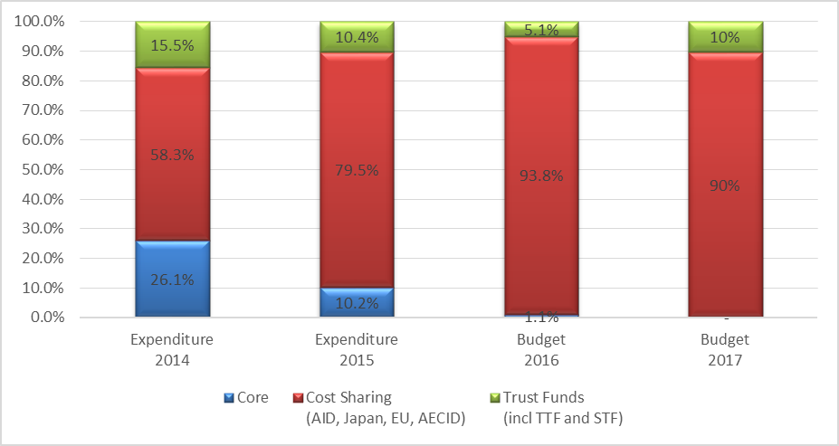

Source: RP financial overview. Adapted from RBLAC presentation delivered on February, 2016

Note: Core Figures do not fully reflect TRAC allocations for 2016-2017.

As of December of 2015, 36%[14] of total resources allocated have been implemented. This percentage of execution is due to the fact that two of the largest new projects approved have initiated implementation during the quarter 3 of 2015 (JCCCP, Prejuve).

At the outcome level (see Table 5), the funds mobilized for outcome 3 were 17% of the target programmed for the cycle, whereas for the others the planned amount is on track or has already been surpassed. RPD resources allocated for Outcomes 1, 2, and 4 were driven by the allocations pledged for JCCCP, SIGOB, Infosegura and Youth Violence[15], respectively[16].

At the output level, outputs 1.2 (social Protection), 1.5 (Energy), 2.2 (Anti-corruption), 2.4 (Extractive Industries), 3.1 (women´s economic empowerment) and 3.3 (women’s participation) are financially under-represented, the most critical cases being that of output 3.1, with no funds allocated. The outputs with the highest allocations, on the other hand, included 4.2 (Citizen Security), 1.4 (Climate Change Adaptation & Mitigation) and 2.1 (Inclusive public policies) with 33%, 30% and 17% of total funds programmed, respectively.

### **3.1.2 Context**

**The shift in UNDP’s operating environment in the region since the adoption of the Strategic Plan (2014-2017) and the RPD**

Stakeholders interviewed during the MTR share a common perception that UNDP’s operating environment in the region has changed considerably in recent years and will continue to do so in the coming years. Between 2014 and 2015, as reported by interviewed stakeholders, UNDP witnessed certain changes like economic cuts in international cooperation and political changes brought about by legislative and national election results, all of which call for UNDP to reposition itself in the region by fostering dialogue and taking the lead role in SDG implementation while maintaining the capacity to analyze the context in order to manage opportunities and avoid tensions.

The role and thematic content of the RP continues to be relevant within this shifting environment, with the Human Development Report being one of the main tools to maintain the UNDP’s regional positioning and with the SDGs and the SP being the guiding framework for a multi-dimensional approach to regional development.

**The impact of regional changes on the RP’s programmatic implementation**

From a programmatic perspective, there has been a shift in the list of topics/intervention areas being prioritized at the regional level and Country Offices (COs) now play a key role in making these changes a reality. According to interviewed stakeholders and conclusion 4 of the evaluation of the past RP[17], before the RP was implemented, UNDP faced the risk of being alienated from contributing to development results in the Caribbean Sub-region, a situation that is now changing as a result of efforts like the Third Conference on Small Island States (which addresses fiscal challenges, non-communicable diseases, climate change, poverty eradication,  changing unsustainable and promoting sustainable patterns of consumption and protecting and managing the natural resource base[18]), the Addis Agenda for Action, and the Caribbean Disaster Reduction Agenda. If one looks at the original PRODOC of the Regional Programme, it highlights some priority areas that overlap with the areas put forward in the above-mentioned documents. As a result of the recommendations of the prior regional programme, the current RP has started strengthening its interventions in the Caribbean.

UNDP’s SP for 2014-2017 allowed the bureau to focus on strategic interventions. Furthermore, the alignment process allowed country offices to analyze how their objectives could be harmonized with those of the Strategic Plan. This was seen as an advantage by CO as it provided a roadmap for UNDP’s regional office to provide support to the countries without duplicating efforts.

**Impact of UNDP’s restructuring process on the RP**

Although relevant in most of its aspects, UNDP’s slow restructuring process brought about some difficult changes for the Regional Hub. In the area of Human Resources, it is relevant to mention that the number of staff increased after the restructuring process –from 75 to 79[19] [20], based in criteria that included priority areas identified in the region, the orientation of the policy advise function guided by the Policy Bureau- and their link to the Results Framework of UNDP’s Strategic Plan-, but not all offered posts were filled because 15 were ‘frozen’ as a result of shortages in resources. These frozen posts included development planning specialists, livelihood, employment and social protection specialists, climate change and energy specialists, development impact specialists, monitoring and planning support, and gender specialists, among others, which would have worked out of the Regional Hub. The fact that these posts were not filled created a potential bottleneck in being able to provide sufficient services to respond to technical assistance demand from countries. For example, only 50% of the positions for gender were filled and, proportionally, the allocation of staff to gender was considerably lower than other areas of work.

According to interviewed stakeholders, while UNDP’s operational environment is becoming more efficient and effective, there has been a slow adjustment period that many COs are still going through. While some stakeholders commented that the restructuring process affected the way in which COs deliver on their programs at the country level, others stated that, from an operational perspective, UNDP has decentralized its support and has brought it closer and made it more readily available to country offices.

**Emerging strategic opportunities and risks for UNDP’s RP as a result of the shifts in the operating environment**

Changes in the operating environment have generated more opportunities than risks for the Regional Programme. While most of the identified opportunities call for alignment of the RP activities and objectives with those of regional integration mechanisms such as UNASUR and SICA, government programmes and donors (e.g., DFID, the Caribbean Development Bank and the WB), the foreseen risks, which should not be overlooked, are mostly linked to the lack of financial resources for programme implementation in a scenario that demands quality services for country offices and nations.

***Opportunities for the RP***

* The unique added value of the work of the RP on gender with initiatives that no other region has, has created an opportunity to promote extra-regional South-South cooperation by consolidating the work on gender as best practices. These initiatives include women’s political participation through the ATENEA project, work on gender and social protection -which make UNDP the only agency working on social protection with a strong gender perspective- and the Gender Equality Seal[21] for Public and Private Enterprises that is now being globalized by UNDP.
* The possibility of alignment with regional economic integration mechanisms such as UNASUR, CARICOM and SICA and enhanced integration of regional UNDP work with the work conducted by COs could allow the RP to enhance the support of the SDG agenda in the region. An example of this opportunity would be the public endorsement of the 17 targets by the above-mentioned entities.
* The need for governments to fully grasp the relevance of gender equality as a key issue for achieving the SDGs and the need to integrate this topic as a cross-cutting issue in interventions linked to health, education and social protection could create an opportunity for UNDP to strengthen its positioning as the main think tank in the area of gender with initiatives like América Latina Genera.
* UNDP has a lot of experience in multi-dimensional and inter-sectoral work in the region. This is a comparative advantage that should be seized by the RP within the context of the SDG agenda as the achievement of the 17 targets cannot be the result of the isolated effort of a single government agency.
* More governments are becoming aware of the need to address commodities supply chains, which is relevant for health related supplies and access to more affordable medicines to reach universal health coverage.
* There is a possibility to work more effectively with other partners such as DFID, the Inter-American development Bank, the Caribbean Development Bank and the WB, a favorable situation to enhance multi-source fund raising processes.
* There are opportunities for UNDP in the region to explore the development dimensions of drug policy, as the Drug policy under the current approach on the War on Drugs has brought more violence and less opportunities for communities that are dependent on crop cultivation. Changes in drug routes in the region have shifted the problem from the Caribbean to Central America.

***Risks for the RP***

* Managing multi-dimensional interventions with national ministries that have traditionally worked in isolation and resist change could present a problem for the RP as well as UNDP country offices.
* The impact of challenges such as El Niño and emerging epidemic, the drop in oil prices, democratic vulnerability and the financial crisis are risks that cannot be overlooked while mobilizing resources and implementing activities for the RP, given that there is a reduced fiscal space.
* In LAC mobilizing money is not easy, especially if one considers the level of development of Latin American and Caribbean countries –some of them graduating from international cooperation-, and the humanitarian emergencies growing in other regions of the world.
* As described in the background section, the causes of migration in the North Triangle of Central America are multidimensional. UNDP has a comparative advantage on these topics but it is still in the process of consolidating its positioning. Accordingly, there is a risk that UNDP loses relevance in topics such as migration due to the lack of a mechanism to provide an integrated response. If this occurs, it would also create a risk for the RP as it would face difficulties in implementing activities linked to Outcome 1 –Outputs 1.1 ad 1.2 on planning tools to promote human development and the implementation of an agenda of social protection, respectively- and Outcome 4 –Output 4.2 Communities empowered and security sector institutions enabled for increased citizen safety and reduced levels of armed violence.

**Necessary changes to be made to the RP in response to shifting dynamics in the regional development context**

The political, social and economic context is quickly changing in the region and, when the RP was formulated, UNDP could not anticipate all changes the regional context was going through. Currently, some countries of Latin America continue to grow while others have decelerated their progress. In addition, some nations graduated from international cooperation and inequalities continue to be reduced. Needless to say, the political scenarios –the new US-Cuba relations, the corruption-related legal processes and social mobilization in Guatemala, Colombia’s peace process, the elections in Argentina and the upcoming electoral process in Nicaragua- are being modified.

After two years of implementation, opinions as to whether the RP requires adjustments are varied. While some stakeholders stated that the RP is comprehensive and that no change in the regional context justifies its adjustment, others commented that in a context marked by a continuous reduction of resources from donors, the RP needs to be flexible and adjusted to be able to respond to the shifting operational environment. Some of the proposed adjustments include a renovated focus on justice, security and Human Rights. This last topic requires that UNDP’s vision on Human Rights, which aims at expanding choices and protecting rights and freedoms in more than 100 countries, be continuously followed and strengthened in the region to i) guarantee that the work of national human institutions and accountability mechanisms continue to be strengthened, ii) to continue to support member states in the region to collaborate with the Human Rights machinery and iii) to continue to streamline Human Rights within UNDP’s regional programming.

Other suggested adjustments include enhancing joint work with regional mechanisms such as UNASUR, SICA and CARICOM, ensuring follow-up of international commitments like the SDG from a regional and country-specific perspective, re-engineering the RP to eliminate all interventions that are not linked to SDGs, the need to continue or strengthen work on gender mainstreaming as an added value for a development agency, re-thinking a strategy for UNDP to reposition itself in middle-income countries, obtaining country-specific inputs from COs in order to tailor regional interventions, and highlighting the importance of South to South cooperation, especially considering that UNDP has been working for decades on this approach (e.g. the gender programme and its regional value added) but it is until now that it has developed a proper South to South corporate strategy.

An area for adjustment of the RP in line with the changing development context and solicited as part of this MtR, is the need to establish a robust Monitoring and Evaluation Framework. This framework should include a clear M&E plan for the rest of the RP implementation period with clear links to the RP results framework and its indicators at all levels of the results chain, specification on the Regional Hub structures in charge of the M&E function, a detailed M&E budget, and well-defined data collection instruments and data flows explaining the process from information production to collection, analysis and dissemination. This major adjustment would constitute a considerable quality leap in order to guarantee that activities and interventions are followed-up on in a proactive and standardized fashion.

**RP positioning within the context of SDGs**

Interviewed stakeholders stated that governments and donors consider UNDP is a key partner in the implementation of the SDGs in the region, given its experience with the Millennium Development Goals, among other topics. Nonetheless, in order to make this a reality, the RP must conduct activities to establish an enabling environment based on i) increased capacities of regional technical assistance providers who should contribute to the shift from the island-type view of the MDGs to the multi-dimensional view of development put forward by the SDG; ii) a participative and collaborative approach between technical teams to harmonize national priorities to the SDGs and RP outcomes –accepting the idea that the SDGs cannot be seen as a recipe but as a framework that needs to be strategic and conscious of regional and national problems-.

UNDP has consolidated political and technical recognition, which has granted it a privileged position that can be used to have more opportunities to support national and local governments to achieve the SDGs and to promote joint programming and implementation with other agencies and donors given its advantage as a regional center with a restructured organization that has a multidimensional and skilled team that can effectively support the COs. Interviewed stakeholders reported that, as part of the RP, the Regional Human Development Report -which serves as a guideline for the actions that will be recommended for 2016 and beyond- and gender sensitive projects focusing on citizen security, governance, environment and natural resource management, climate change, disaster preparedness and risk mitigation and women’s empowerment are the vehicles that will be used to position the SDG agenda in the LAC region .

UNDP is well positioned in the Caribbean given its presence in some of the countries of this sub-region, the solid experience and good-will developed by COs, a strong trust-based relationship with national governments, and the country programs that are currently in place, which are consistent with the elements put forward in the SDG agenda. A Multi-country Sustainable Development Framework is being developed to serve as tool that, within the context of SDGs, will better position UNDP in the Caribbean sub-region by linking SDG targets with local priorities such as the 4 pillars identified in the aforementioned framework.

Although interviewed stakeholders agreed on the comparative advantage of the RP within the SDG agenda, consensus also exists on the need to cope with more flexible strategies that include obtaining financial resources and working with the private sector to implement activities - such as is the case with the Green Commodities Programme and the Equality Seal- and highlighting the fact that the SDGs are not only about the environment but about approaching regional development from a multi-dimensional standpoint, an action that could be strengthened within the context of UNDP’s new organizational structure and the RP.

### **3.1.3 Assessment of results**

**Compliance of the RP with the regionality principle**

A common approach for monitoring results and contributions at global and regional levels has been proposed by UNDP. This approach includes two typologies, one focusing on Regional Development Results and another one aimed at providing regional support to country results development effectiveness. The development results are influenced by the regionality principle, which focuses on the promotion of regional public goods, promoting innovation on a regional level, the development of regional indicators and generating and sharing development knowledge. There was a consensus among interviewed stakeholders that such principle is being complied with via specific outputs of the Regional Programme.

The following section analyzes some examples of compliance.

1. *Promotion of regional public goods*. According to interviewed stakeholders, work is being conducted in the area of citizen security in conjunction with SICA in Central America via the Comprehensive Security and Prevention of Violence Affecting Children Adolescents and Youth in SICA Countries regional project (PREJUVE)). A concrete example of compliance with this principle is the development of 8 national work plans and institutional capacities for improving the prevention of violence, which is output number 2 of the PREJUVE project and corresponds to Output 4.2 of the RP “Communities empowered and security sector institutions enabled for increased citizen safety and reduced levels of armed violence”. Another regional public good is the work undertaken in the Amazon. Under the RP, 8 stocktaking reports on the SDGs have been undertaken in the 8 countries sharing the Amazon basin, aiming at developing a broader regional proposal for promotion of the SDGs and sustainable development solutions. This work has included the establishment of a data base containing figures on SDGs in the Amazon for 5 countries. Another example is the Programme on the Gender Equality Seal for Public and Private Enterprises working in 12 countries with over 55 tools that are used in all countries. Finally, the implementation of the ATENEA project on political participation of women must be highlighted with regard to the creation of public goods. The project is implemented in 5 countries with a common methodology (adapted to each context) and a parity index that allows for sub-regional and regional comparability.
2. *Advancement of awareness of emerging development issues that could benefit from multi-country experiences and lessons*. The Comprehensive Strengthening of Institutional Management in Latin America and the Caribbean Project, linked to Outcome 2 of the RP has had a focus on emerging topics like state building and ensuring that issues of inclusion, responsiveness and capability are being addressed. This has been achieved by supporting the functional and operational capacity development of public institutions, so that these institutions can better achieve their mandate and serve citizens. Another example is the work conducted by the SIGOB project, which has been enriched by learning from successful experiences in extra-regional countries.
3. *Promoting innovation on a regional level (e.g. development of regional guidelines and studies in LAC) when obstacles to implement a single initiative are unsurmountable for an individual country*. Important results linked to this aspect of the regionality principle were obtained as part of the innovations proposed by the SIGOB Project, which are linked to Output 2.1 of the RP (Institutional capacities and mechanism for formulating and implementing inclusive public policies enhanced in executive and legislative bodies –at national and sub-national level- for improved participation, representations and accountability. These results included an increase in the number of countries and institutions with SIGOB systems. Furthermore, it is important to highlight the RP efforts to foster an integrated view to promote the SDG agenda, in particular the linkages between poverty reduction and environmental action, such as through the study on impact on livelihoods in the environmental portfolio, which will be used for improving future programming in the region, and has also developed a specific manual and indicators framework to be applied in programming.
4. *The development of regional indicators*: The RP has a results framework that includes regional outcome indicators on poverty, coverage of social protection systems, coverage of cost-effective sustainable energy, satisfaction with democratic governments, confidence in the Judiciary, employment rates, participation of women in public offices, gender equality in public and private enterprises, violence and disaster and climate risk management.
5. *The generation and sharing of development knowledge via mechanisms such as South-to-South and triangular cooperation*. Progress has been achieved through the “Superando obstáculos para la transversalidad de género en América Latina y el Caribe”, a project linked to output 3 of the RP, which has produced regional knowledge products such as a virtual platform (América Latina Genera) for sharing information on the cross-cutting nature of gender in the LAC region. Another example of compliance with this aspect of the regionality principle is the progress on achieving output 3 of the PREJUVE project through the exchange of a successful South-South experience from Medellin on the prevention of violence and the activities implemented by the CRMI project, which strengthens documentation of best practices for improved south-south cooperation in the fields of Disaster Risk Management and Climate Change Adaptation. An example of the later is the replication of the Cuban experience on the Centers for Management and Reduction of Risks and Studies on Risk and Vulnerability in 5 Caribbean countries.

**Is the RP on track to make its contribution to the SP (achieve development results) and support COs in the region (achieve development effectiveness)?**After some delays during its inception stage, and according to interviewed stakeholders, the RP still needs to make certain adjustments to be on track for achieving its results. Such adjustments include the development of an enhanced communication strategy to give its SP-linked results more visibility. Furthermore, the RP needs to develop a robust M&E framework –a proposal of which is included in the present document as per the TORs of this MtR- that includes a plan and the resources to support results-based management. The opinions related to the RP’s support to the COs, which were obtained from the online survey and the interviews, are heterogeneous. While some stakeholders stated that the RP needs to scale-up its contribution to COs as currently there is no regional strategy along this line, others commented that the RP is a key instance underpinning the work of COs, especially in the areas of security, gender, environment, energy, and risk management. Given that development effectiveness reflects the extent to which an intervention has brought about targeted change in a country or the life of the individual beneficiary, that development effectiveness is influenced by various factors, beginning with the quality of programme design and ending with the relevance and sustainability of desired results, and that in order to assess the effectiveness of a given intervention one needs to answer two questions in tandem -whether the immediate goals of assistance are been achieved and if those goals have enhanced the development process-, at this point in RP implementation, considering this broader holistic perspective, there is no sufficient evidence to answer the question of whether development effectiveness has been enhanced in the region.

**Contributions of the RP to potentiate existing Country Office (CO) portfolios in the achievement of planned development results**

According to some stakeholders, the slow and cumbersome implementation of the internal restructuring process UNDP created some initial difficulties for the RP and its relations with COs. There was a trade-off between the restructuring process and the ability to be more efficient in providing technical assistance to COs, a situation that is common to any major organizational change.

With the restructuring now well underway, UNDP has slowly shifted its strategy to provide continuous support to COs, and according to interviewed stakeholders, the RP needs to strengthen its link to the goals and priorities identified by these offices while considering that each output of the RP had a different team responsible for implementing it and the strategy for linking activities to CO outputs and priorities changed dramatically between teams. For example, the Gender Team had an annual mapping of activities which was then validated against the Gender Output and the RP. Additional examples of support provided to COs to potentiate their portfolios are presented below.

* Underpinning CO actions in the area of gender (through the support of experts from the Regional Hub) and sharing good practices in the area of risk management and HIV prevention
* The alignment of the regional programme with national priorities
* The RP is an important tool to orient the CO and turn the different initiatives into concrete projects and programmes.
* Providing a solid basis for joint programming within the UN System
* Training provided to staff on gender-results-based management; support for the implementation of the UNDP’s internal Gender Seal; provision of inputs to feed policy processes -for example, policy advice on gender-sensitive social protection floors or policy development on the care economy.
* Through InfoSegura, the RP supported the inception of a new strategy for UNDP in Guatemala to promote the consolidation of management information systems for evidence-based policies in the security and justice sector
* Supporting the Colombian national government in the peace process.

**What are the contributions of the RP on top and above to what COs have achieved?**

As reported by the stakeholders who participated in the online survey, in spite of a difficult initial stage, the RP has achieved several results during the first phase of its implementation cycle.

* Participative developments of the Regional Human Development Report, a tool that will help UNDP position the SDG agenda and the willingness to align the portfolio to the SP.
* The RP positioned the concept of resilience within the policy agendas of Central America.
* Development of tools for public policies in citizen security and knowledge management mechanisms such as the Regional Human Development Report.
* Policy support on Citizen Security and South - South cooperation.
* Strengthening the gender agenda via work with the private sector (the EQUIPARES Seal) and the Gender Equality Seal of UNDP COs.
* CRMI project assistance to Caribbean countries in the implementation of those sections of the Mauritius Declaration that call for establishing or strengthening national and regional climate-change coordination mechanisms; improving national disaster mitigation, preparedness and early-warning capacity.

**What are the gaps left to achieve UNDP's targets in the region and is the pace good enough to do so?**

The main gaps left to achieve UNDP’s targets in the region are related to the slow implementation of UNDP’s restructuring process, the perceived centralization of decisions, the lack of a proper communication strategy between the regional office and the COs so that the former can communicate the actions of the RP and that the latter can have a clear understanding of their contributions to the objectives of the RP, and the reduction of available financial resources. In addition, interviewed stakeholders stated that external factors, such as the shifting political dynamics in the LAC region have highlighted the need for adjustments within the RP so as to be more flexible and adaptable to the decreasing financial resource scenario and the topics it prioritizes so that it can maintain its regional validity while incorporating the specificity of sub-regions like Central America, where the topic of security, for example, cannot be addressed in the same way for all countries of the isthmus.

### **3.1.4 Quality standards** [22]

UNDP’s Regional Center applied quality assurance standards on a voluntary basis to 4 projects during 2015. This was a pilot process aimed at 2 projects being implemented and 2 projects in their closing stages. The objective of this process was to provide feedback on the effectiveness of the quality assurance standards so that these can be adjusted to regional requirements. UNDP plans to establish this mechanism as a requirement for all projects being approved, those under implementation and those in their closing stages starting on January 2016. For these reasons, during the fieldwork stage of the present MTR, interviewed stakeholders did not have sufficient information on whether quality standards had been appropriately met.

**Improvements to be made to improve the quality of the RP in the future**

Among other elements, UNDP’s Quality Standards –which are being piloted- aim at guaranteeing that all data necessary (social and environmental standards, the Human Based Approach, gender equality, etc.…) is included and analyzed within reports produced by country and regional offices. To assess quality, however, UNDP needs to collect information on a periodic basis and streamline quality assessments within monitoring and evaluation processes, as this will allow the organization to draw conclusions on whether the aforementioned standards have been complied with. The rationale behind assessing the quality of processes is not simply the identification of problems or lack of compliance with standards, but the generation of a reflective debate on what needs to be improved.

## 4. Programme effectiveness findings by RP outcome

This section presents findings on program effectiveness in contributing to specific RP outputs with each of the 4 RP outcomes. Outputs for which progress could not be assessed during the development of this review include: Output 1.2, Output 2.2 and 2.4, and Output 3.1.

### **4.1 Outcome 1**

While outcome 1 includes a very wide spectrum of outputs and activities in several topics, which sometimes could create challenges in assessing progress, the projects linked to this outcome have generated considerable contributions toward its achievement in LAC. But this has not been an easy task, as some interventions, like the ones related to achieving equitable growth and strengthening the sustainability of social protection systems will require additional efforts and additional time to fully create the desired changes. In spite of these challenges, the projects linked to this outcome have taken important steps like:

* The creation of statistical evidence for policy-making –as part of the Human Development Report-,
* The creation of awareness on the importance of managing risks and the relevance of addressing and supporting the implementation of climate change initiatives via the creation of an enabling policy and environmental strategy,
* The development of a HDR on Multidimensional Progress in LAC,
* SDGs have been embraced in the region as the framework to align National Development Plans,
* Strong support to negotiations linked to climate change,
* Development of a UNDP/IADB joint study on “Access to energy and socioeconomic impact”.
* Initiating the implementation of the Japan-Caribbean Climate Change Programme

*Output 1.1 Regional, sub-regional and national policies have the necessary analytical perspective and strategic planning tools to promote Human Development with special emphasis on the structural factors of inequality*

The RP has achieved progress in promoting Human Development with special emphasis on the structural elements of inequality. At the same time it has generated regional evidence to incorporate new dimensions to measure human development, poverty and inequality, including time poverty and subjective wellbeing. This has been done via the projects supported by the “Fondo Fiduciario España-PNUD Para América Latina y El Caribe” through the completion of the Regional Human Development Report, its communication strategy and sub-regional development reports for the Caribbean and Central America, a robust reference needed not only for evidence-based policy making that takes into consideration the multi-dimensional nature of development, but also for strengthening the support of the Regional Hub and the interventions of the RP so that UNDP is better positioned to lead the implementation of the SDG agenda in the region.

At the strategic and policy level, contributions have been made to the development of inclusive fiscal spaces as part of the “Compromiso por la equidad fiscal en América Latina” Project, through which detailed analyses of the social and fiscal systems of Costa Rica, Mexico, Peru, the Dominican Republic, Ecuador and Honduras have been produced to inform national reforms in the fiscal sector.

In addition, the Gender Team supported COs by providing inputs into policy processes (these are always linked to a specific outcome/output of the UNDP Strategic Plan, which in turn is linked to the RP) like policy advice on gender-sensitive social protection floors or policy development on the care economy. Finally, the Gender Team also provides support to COs using tools and approaches that have been developed in a more generic way for a region or sub-region.

*Output 1.3 . Solutions developed at national and sub-national levels for sustainable management of natural resources, biodiversity and ecosystem services*

The interrelation of natural resources management policies and the generation of sustainable livelihood in LAC have been supported by the activities of Strategic Ecosystems and Biodiversity protected through the implementation of economic valuation methodologies, payment of environmental services and adoption of new technologies project, which has assisted countries in the region to build their capacities to understand and address the linkages between ecosystem services and their importance for income generation and strengthening of livelihoods. This project has supported 18 countries of the region to analyze and plan for the financial sustainability of their protected area systems as key components of natural capital essential to economic growth, livelihoods, climate change adaptation and mitigation. Furthermore, this project has worked on targeted scenario approaches, which are being used for sector analyses and country level programming; analysis of Protected Area budgeting systems, stocktaking reports of SDGs in 8 Amazon countries and studies on impact on livelihoods of the environmental portfolio, including development of manual and indicators to guide country level programming.

Another important project that has made contributions to this output is the Green Commodities Project –an initiative with a portfolio of 14 projects covering 10 countries and 7 commodities- by sharing lessons and tools on sustainable commodities such as the Monitoring Land Use Change Tied to Tenancy tool developed by Costa Rica, which is in being studied for replication in several countries and a landmark agreement between the Dominican Government, the National Cocoa Commission and UNDP. By addressing the often long-standing root causes that are limiting the sustainability of key agricultural commodity sectors and by working with leading companies (e.g. Mondelez and IKEA), government representatives, farmers and civil society organization, the project brings different stakeholders together, often for the first time, to devise clear public policies; legal frameworks; clarity around land-use planning; effective ways of enforcing laws; finance; and support that allows farmers to improve their production techniques.

*Output 1.4 Scaled up action on climate change adaptation and mitigation across sectors which is funded and implemented*

With financing from the Spanish Government, the RP supported governments to make well informed investment choices towards Low Emission and Climate Resilient Development Strategies (LECRDS). Countries have scaled up their actions on assessing, developing and implementing Regionally and Nationally Appropriated Mitigation Actions (NAMAs) and establishing regional exchanges of experiences on climate change technology solutions, processes for the elaboration of Low Emission Development Strategies (LEDS) and climate finance. NAMAs on efficient stoves and thermic re-conditioning of households have been completed in El Salvador and Chile, respectively.

Furthermore, the new version of the Guide for the Iberoamerican Climate Change Negotiator -an important knowledge product in the area of climate change- was published, disseminated and presented to negotiators by different means and media. Under this output, the project has also supported the implementation of the Low Emission Capacity Building Programme in LAC (Argentina, Chile, Colombia, Costa Rica, Ecuador, Mexico, Peru and Trinidad and Tobago) which aims at building capacities to design and implement Low Emission Development Strategies and national mitigation actions in the public and/or industrial sectors.

The Climate Change Programme has been relevant in terms of its areas of work. First, it has been a great platform to attract other programs and donors through UNDP`s global network of offices and contacts, which is one of the major added values of UNDP at the regional level. Secondly, the impact of the Climate Change Programme on the development of public policies and climate planning frameworks, constitutes a key contribution. Third, the specialized technical assistance in the transfer of instruments and methodologies for adaptation at the local level, has promoted innovation. Fourth, there are positive changes in the processes of institutionalization and governance of climate systems in Latin America. There is evidence to affirm that the contribution of UNDP in this area has been of greater value than that of other international and/or multilateral institutions.

Under the JCCCP, on the other hand, consultations to advance the national processes for the National Adaptation Plans (NAPs) and Nationally Appropriate Mitigation Actions (NAMAs) are continuing in Belize, Dominica, Grenada, and Jamaica.

*Output 1.5 Inclusive and sustainable solutions adopted to achieve increased energy efficiency and universal modern energy access (especially off-grid sources of renewable energy)*

The RP has been instrumental for enhancing the partnership with the IADB in the area of energy. This partnership has focused on the SE4All in LAC, how this can be forwarded in selected countries, and includes a study on socioeconomic benefits on energy access, to be published in 2016.

The above-mentioned consultation process conducted as part of the JCCCP project for the development of NAPs and NAMAS resulted in generation of a partnership agreement between UNDP and the Caribbean Community Climate Change Centre (CCCCC) for the preparation of a detailed scientific study for a NAMA in the Belize waste-to-energy sector. This process aims to facilitate the analysis of producible and usable renewable energy in the form of electricity and heat from biogas, biomass and organic waste.

### **4.2 Outcome 2**

Outcome 2 is a really ambitious one because of the varied range of issues it wishes to address, from improving citizens’ participation and representation and promoting inclusive and participative governance reforms to contributing to citizens empowerment to ensure rights for all (irrespective of political, religious or any affiliation as well as ethnic origin, sexual orientation, gender identity or age) and promoting responsive, transparent and accountable government at national and subnational levels. In spite of progress, one cannot conclude that the RP has been totally successful in achieving this outcome, especially because many of the objectives it includes –such as the rule of law and accountability- cannot be achieved in the short run, but require considerable transformations in the existing national governance systems. What can be said is that the RP has moved forward in the area of capacity building and generation of knowledge products, as evidenced, for example, by the results of the GAIN project to promote transparency and reduce corruption and those of the Support to Citizen’s Participation and Inclusion for Stronger Systems of Democratic Governance in LAC project, an initiative that has supported dialogues on youth inclusion as well as inter-generational policy dialogues and has launched the Iberoamerican Youth Programme. UNDP’s involvement in the drafting of HIV and gender identity laws and supporting the participation of civil society organizations and Parliamentarians on fora to discuss sexual diversity and gender identity have resulted in important progress in improving laws and policies to protect LGBT groups. Nonetheless, additional efforts remain in linking project results in the areas of accountability, equality, non-discrimination and transparency. The RP has also made efforts to advance the dialogue on Extractive Industries in the region.

*Output 2.1 Enhancing institutional capacities and mechanisms for formulating and implementing inclusive public policies enhanced in executive and legislative bodies for improved participation, representations and accountability*

Particular progress is noted with the availability of electronic platforms for tracking progress of Human Rights Programmes as well as decrees and law projects, capacity building in the area of the Rights of Indigenous People, virtual trainings on Electronic Government in Colombia, a development map for the Haitian Ministry of Justice, the enhancement of technical capacities of executive and legislative bodies and the implementation of South-South activities like experience exchange with Extra-LAC countries via the activities of the SIGOB project –which has completed nearly 100% of it proposed outputs- and the Comprehensive Strengthening of Institutional Management in Latin America and the Caribbean Project.

The RP has supported the improvement of electoral transparency in the region with the help of the SIDS and Post-2015 Agenda (SaPA) project, as UNDP, in partnership with the UN Department of Political Affairs, helped CARICOM to identify the solutions needed for more effective support to member states in the area of elections observation. This resulted in the development of an ICT platform to better share knowledge on effective practices among member states and, skills strengthening of CARICOM and election management bodies to ensure that a cadre of skilled facilitators is available to the region to facilitate continuous skills enhancement when needed.

*Output 2.2.* *Institutions and systems enabled to address awareness, prevention and enforcement of anti-corruption measures across sectors and stakeholders (SP Output 2.2)*

The UNDP Global Anti-Corruption Initiative (GAIN) has made considerable contributions to this output by the activities it has carried out under its output 1.2, which focuses on the development of a sectorial approach to fighting corruption. An example of this is the elaboration of an action plan to strengthen transparency and to prevent corruption in public hospitals in Chile. In addition, with gain support, UNDP advanced a project in Costa Rica, which successfully implemented a series of trainings and technical assistance programmes designed to increase transparency and accountability among Associations of Rural Aqueducts. Under GAIN output 2.1, the project conducted work on citizen engagement and prevention of corruption through improving transparency, accountability and access to information.

*Output 2.3. National institutions, systems, laws and policies strengthened for equitable, accountable and effective delivery of HIV and related services*

The regional efforts and National Dialogues on HIV and the Law, supported by UNDP, contributed to opening dialogue and discussion on topics of high sensitivity. In addition, after 2013, these efforts helped in promoting advocacy initiatives to change and/or review laws and policies, especially punitive or outdated laws or policy frameworks that may affect an effective response to HIV. But beyond the proposed policy changes recommended, a review of the results of the National Dialogues on HIV and the Law –conducted between 2014 and 2015- indicated that country stakeholders doubted that the changes proposed could be implemented without national counterparts taking over the process initiated by UNDP. Furthermore, the review of the National Dialogues also revealed that in spite of highlighting the persisting stigma and discrimination facing key populations, including men who have sex with men, sex workers and transgender persons, little or no progress had been achieved in actually reducing discrimination toward them in LAC. It became evident that it was not sufficient to simply include key populations within national HIV strategies and policies, which could be seen as a mere “tick-the-box” exercise to say that a law or policy has been strengthened. What is needed is that national law enforcement and health authorities –the realms in which discrimination and abuse of key populations usually occur- act in accordance with content of these instruments. UNDP’s contributions on reducing discrimination include:

* Gender identity laws drafted in 5 countries and Parliamentarian discussions took place in Bolivia, Nicaragua and El Salvador
* Anti-discrimination law approved in the Dominican Republic
* Advocacy actions to reform the Sexual Offence Act in Jamaica
* Support for greater participation of LGBT groups in the OAS General Assembly, including the adoption of the Convention against All Forms of Discrimination and Intolerance and the ongoing advocacy to increase the number of countries ratifying it.

In 2015, UNDP in partnership with UNAIDS led the Zero discrimination targets consultations and supported the finalization of proposed set of indicators that governments will report on at a follow-up meeting in 2016. These actions are aimed at reducing prejudice, violence, stigma, and discrimination associated with HIV or against people living with HIV and key populations.

*Output* *2.4 Legal and regulatory frameworks, policies and institutional capacities enabled to combat multiple discriminations (gender and other inequalities) and address emerging issues (such as extractive industries and others)*

*The Support to Citizen Participation and Inclusion for Stronger Systems of Democratic Governance in LAC Project* has contributed significantly to the achievement of this output by cooperating with LAC countries by assisting public institutions to respond to citizens expectations, while bringing together UNDP’s ability to advocate, advise, promote dialogue, achieve consensus and build institutional and stakeholders’ capacities, to expand citizens’ participation, paying special attention to the inclusion of marginalized groups.

### **4.3 Outcome 3**

Aside from being a separate RP outcome, issues linked to gender equality are a cross cutting aspect of UNDP’s strategic plan and gender mainstreaming is fully integrated into the activities of the work associated with implementation of the RP Outcome. The RP attained considerable progress with initiatives like the Gender Equality Seal and EQUIPARES, in spite of output 3.1[23] being financially underrepresented. The success linked to gender has been achieved mainly through América Latina Genera and ATENEA, projects that are, in fact, the concrete expression of the operationalization of outputs included in Outcome 3. The Gender Equality Seal for Public and Private Enterprises, for example, has contributed to the development of capacities of governments, private companies, as well as of technical advisers and auditors to support governments in the Seal certification process. An outstanding achievement of this initiative is the positioning of the gender agenda in non-traditional realms such as sustainable energy, DRR, climate adaptation and social protection and business. In the area of women’s political participation, on the other hand, the RP piloted ATENEA in 3 countries, signed a Joint Project with UNWOMEN and IDEA to scale up ATENEA to 19 countries –a major regional endeavor- and produced a milestone study on women’s political participation in the Caribbean.

*Output 3.1 Country led measures accelerated to advance women’s economic empowerment*

The project América Latina Genera has made contributions to this output through the work on the Gender Equality Seal for public and private enterprises that included developing projects in 5 countries between 2014 and 2015, certifying over 50 companies in the evaluation period. In addition, the completion of a regional platform INDICA IGUALDAD, and the organization of a Regional Forum “Empresas por la Igualdad” as well as the signing of an MoU by 12 governments to promote South-South cooperation including 3 exchanges in the evaluation period.

Any country-led measure that wishes to advance women’s empowerment is useless without i) the proper capacity to put it into practice and ii) the proper dissemination process. America Latina Genera has contributed to satisfy these conditions by developing a partnership with ECLAC, UN Women, ILO, AECID and the Government of Uruguay to mainstream gender into the SDGs via a series of experts webinars involving the preparation of an expert meeting to take place in 2016. In addition, the project manages the LAGenera platform, with a monthly bulletin that reaches 7,000 people and a large audience through social media.

*Output 3.2 Evidence-informed national strategies and partnerships to advance gender equality and women’s empowerment*

Progress has been achieved by the “Superando obstáculos para la transversalidad de género en América Latina y el Caribe” Project as it has shared and disseminated the most recent debates of the feminist movement as well as the feminist academic production and has conducted webinars and systematized experiences on the cross-cutting nature of gender within public policies in Latin America and the Caribbean to promote dialogue and exchange among public officials and civil society leaders. This project has also led efforts in streamlining gender within other realms of national and sub national realities, as evidenced in existing successful experiences like the institutionalization of gender within the national HIV response in Cuba, the gender sensitization of security and police forces in Argentina and the introduction of cross-cutting gender elements within the universal social protection system in Uruguay.

Gender mainstreaming has been enhanced via work in areas that had never been seen from a gender perspective, such as disaster risk reduction, climate change adaptation and environment. This includes support to mainstreaming in projects in several countries, direct support to COs in policy development and capacity development of government officials (e.g. Partnerships with SEPREDENAC). Furthermore, in collaboration with Emakunde, the Gender Mainstreaming Programme developed an expert network that facilitated over 25 virtual meetings in 2015 with over 300 participants.

The work conducted on Violence Against Women includes activities on policy assessment and support to policy development on this topic. UNDP worked with other agencies in promoting a strategy for the implementation of the UNiTE campaign at regional and country level.

*Output 3.3. Measures in place to increase women’s participation in decision-making*

The ATENEA Project, which is implemented in 19 countries to enhance women’s political participation, has made considerable contributions to this output by generating regional knowledge and strategic alliances to accelerate progress toward political parity in LAC through the creation of a national and regional political parity index.

### **4.4 Outcome 4**

Relevant progress was observed for this outcome as the projects linked to it were able to contribute to reducing the likelihood of conflict and lower the risk of natural disasters. On the one hand, the activities carried out in 2015 have created opportunities for democratic dialogue and peace building and the establishment of institutional spaces for conflict resolution. Moreover, community and institutional strengthening has been achieved via regional knowledge goods in the area of security in Central America and the development of plans to enhance secondary and tertiary prevention of violence. Aside from this progress, the area of security remains a challenge for the RP, particularly in Central America and the Caribbean as problems such as Maras, Narco-activity and other forms of organized crime still pose a threat to peaceful living. Institutional, legislative and policy frameworks are in place to enhance the execution of disaster and climate risk management measures. The regional projects continued providing technical assistance to COs to develop and implement disaster risk reduction, recovery and climate risk management projects at the national, regional and global levels.

*Output 4.1. Policy frameworks and institutional mechanisms enabled at the national and sub-national levels for the peaceful management of emerging and recurring conflicts and tensions*

The Support to Strengthen CPR Capacities of UNDP CO LAC Project enhanced the capacities of Colombian ministries in the area of conflict analysis and democratic dialogue. With the help of the Regional Project on Democratic Dialogue, public officials trained in social dialogue and peace building in Colombia and the capacities of civil society members and UN System Agencies were strengthened as part of territorial support for the Alianzas para la Paz Project. Furthermore, technical support was provided to the Council for Citizen Security of El Salvador. Considerable progress was achieved in the establishment of institutional mechanisms for peaceful management of conflicts as an analysis for the implementation of an Early-Response System for conflict prevention was conducted in in Costa Rica. Moreover, a guide on the design of training courses on conflict-sensitive planning, collective rights, mediation and prevention of conflicts was developed to help strengthen the implementation of the conflict prevention policy framework in LAC.

As part of the Urban Health and Justice Initiative, UNDP continued to support the work at municipal level in 4 countries (Guyana, Guatemala, Brazil and the Dominican Republic) to address the needs of key populations (men who have sex with men, sex workers and transgender people). In Dominican Republic, UNDP is supporting an NGO that is providing free- of -charge legal services for key population in Boca Chica and Santo Domingo, through an innovative approach that includes private-sector collaboration. The program continues to build the capacity of law enforcement authorities and local health staff to address stigma and discrimination against sex workers and persons of diverse sexual orientations and gender identities. A Fast Track City Initiative is currently being developed by UNAIDS and the selection of cities in this region was informed by existing work conducted by UNPD, to ensure continuity in the efforts. UNDP is involved in the preparations in Kingston, Jamaica and in Porto Alegre, Brazil.

*Output 4.2. Empowered communities and strengthened security sector institutions to achieve an improved level of security and reduce levels of armed violence.*

Several activities implemented by regional projects have contributed to this output during the last year. First, in compliance with the first objective of the regionality principle under which the RP is to be implemented (i.e. development of regional public goods), 7 knowledge products were developed to enhance community and institutional strengthening in the area of security in Central America as part of the “Gestión de Información Basada en Evidencia para la Seguridad Ciudadana en América Central”- Infosegura project. Also, work with civil society networks in Guatemala (Mesa de Análisis Especializado) and in Honduras (Alianza por la Paz y la Justicia), as well as the support provided to the Salvadoran National Council on Citizen Security have contributed to raising awareness in the area of security and conflict resolution.

The “Seguridad Integral y Prevención de la Violencia que afecta a Niñas, Niños, Adolescentes y Jóvenes en los países del SICA” - Prejuve Project has also provided considerable contributions to empowering security sector institutions via the formulation of strategic plans to address violence affecting youth and the development of plans including a selection of interventions linked to secondary and tertiary prevention of violence.

*Output 4.3. Effective institutional, legislative and policy frameworks in place to enhance the implementation of disaster and climate risk management measures at national and sub-national levels*

The Caribbean Risk Management Initiative Project has achieved progress in developing regional capacity to formulate policies aimed to mainstream disaster risk reduction and adaptation to climate change. In 2015, for example, the activities of this project were focused on training 840 participants (from local governments, local units, and community members) in risk management and risk reduction. Furthermore, given that South-South cooperation and learning exchanges are an integral part of the RP, stakeholders from government institutions of Caribbean countries were trained in transferring the Cuban model of the RRMC, a clear example of activities in line with the RP’s regionality principle. The recent evaluation of the CRMI project highlighted its good results, which are linked to output 4.3. These results included:

The fact that the project addressed important national and local development priorities and needs in countries and communities with different disaster vulnerability profiles and political, economic and governance contexts.

Its effectiveness due to Regional Hub management and leadership; the role of UNDP Cuba in transferring the RRMC model; the role of UNDP COs; commitment and involvement of the stakeholders.

The project demonstrated the importance of a regional approach to multi-country cross-disciplinary interventions and confirmed the comparative advantage of RH management in close collaboration with the Country Offices.

In line with the RP’s aim at developing knowledge products and tools to raise awareness in governments on the need to invest in risk reduction for resilience, the “Institucionalización de Procesos y Herramientas de RRD en Centroamérica” Project has fostered the involvement of public institutions in data collection to populate an inventory on available tools for the integrated management of risk in Guatemala. Moreover, the project supported there-activation of the Foro Permanente para la Reducción de la Vulnerabilidad (FPRV) in El Salvador and generated ownership of the project by the Comisión Permanente de Contingencias (COPECO) in Honduras and by SINAPRED in Nicaragua.

# 5. Conclusions

1. As shown in the section on Programme Effectiveness, the RP has achieved successful results in its outcomes. The achievements linked to the gender, for example, must be highlighted, as these included milestones that have not been achieved in other regions of the world, such as the impact and outreach of the Gender Seal, information sharing and the creation of virtual platforms on gender issues, as well as the ground-breaking work developed in the areas of disaster risk reduction, climate change adaptation and environment from a gender perspective. It is important to note, however, that in spite of the lack of clarity of the interface between América Latina Genera and the RP, the work of the former was the vehicle by which UNDP’s gender team implemented the latter.
2. The results of Outcomes 1, 2 and 4 were also considerable, specifically in areas that have to do with the multi-dimensional nature of development, the fight against corruption and the promotion of transparency in the realms of health and public offices, disaster preparedness, environmental protection and risk reduction.
3. There are clear positive results of the implementation of RP interventions that include the generation of the Regional Human Development Report as a key tool for positioning UNDP and for informing the policies to be produced in the post-2015 development agenda and the positioning of the concept of resilience –adaptive evolution in the face of constant change- in Central America.
4. As evidenced in the findings section, the current interventions of the RP have incorporated the elements of the regionality principle. The countries of the LAC region, for example, are the ones conducting most of the South to South cooperation efforts with the help of UNDP and there is work being conducted with SICA for the generation of regional public goods in the area of security and with SEPREDENAC on gender and disaster risk prevention and management. Also South-South cooperation has been valuable in the area of disaster risk reduction both in the Caribbean and Central America. Another example of successful South-South cooperation are the Climate Public Expenditure Review processes, which involve six countries in the region and the exchanges between government and private sector on gender equality in the work-place between Mexico, Colombia, Guatemala and El Salvador.
5. As mentioned in the findings section on required adjustments to be made to the RP, the real added-value of the programme will only be assessed in a periodic non-reactive manner if a clear link is established between regional outputs and outcomes and the contribution that country offices provide, something that can only be achieved via a robust M&E framework that describes not only the indicators that will allow the RP to track progress at all levels of the results chain, but also the structures in charge of the M&E function, data sources and information management processes that will rely on the Atlas M&E window.
6. The sustainability scenario of the RP beyond 2016 is not clear. The reduction of financial resources for technical cooperation is a major risk, a situation that demands that the RP be on the frontline of a regional strategic dialogue and a regional and innovative resource mobilization effort. If the current financial situation of UNDP and its effect on human resources in the different country offices is taken into account, the RP would not be in a good position to continue its planned implementation beyond 2017. Along these lines, it is important to highlight that core funding of the RP was considerably diminished in 2015 and is non-existent as of 2016, leaving the RP objectives and expected outputs to be accomplished through earmarked funding and individual projects. The RP has thus become more of a generic guiding framework with particular outputs to be achieved depending on available funding.
7. Aside from the need for an M&E framework, other adjustments identified in the review call for the adaptation of RP interventions to sub-regional and national realities such as is the case of activities in the area of security in Central America. In addition, as evidenced in previous sections, the compliance with quality standards in RP interventions can no longer be an option but a mandatory aspect of regional projects to guarantee that assessments like this mid-term review are able to identify deviations from the norm.

# 6. Lessons Learnt

1. Communication across technical teams and learning from experiences of successful projects within and without the region is critical for the success of the RP in the next two years.
2. Establishing quality standards -as put forward on the quality assurance document- will allow UNDP for better control of its processes and aid the RP in assessing its level of success or failure. The analysis of bottlenecks in terms of quality should be made available to all UNDP staff implementing RP intervention to improve processes based on experiences from others.
3. Within the context of the RP, as well as in other areas, South-South cooperation between continents is highly valuable. But this does not mean that recipes should be imported, but adapted. An example of this is the Climate Public Expenditure Review process, supported by the Regional CC programme, in which experiences from Asia and Africa were brought to the region, discussed with stakeholders and adapted according to LAC realities. While recent developments have taken the form of increased volumes of South-South trade and flows of foreign direct investments, the RP most significant capacities that should continue to be strengthened include regional integration, technology transfers and sharing of solutions, experiences and experts.
4. The implementers of the RP learned that the link between democratic governance, sustainable development and resilience, provide the opportunity for UNDP to connect with a range of sectorial institutions and achieve better development results.
5. Enhanced involvement of COs in regional project design can provide the specificity that some regional initiatives are currently lacking.
6. Regional assistance and improved strategic communications during CO’s projects’ life cycles can help strengthen the relationship between regional and national processes.
7. If the aim of UNDP is to assess the effectiveness of programmes –not projects-, financial execution should not be the only evaluative criterion. There is a need for monitoring not only financial execution but also impacts on development results. The latter is not sufficiently done and there is still a considerable difficulty for staff to shift their reporting activity to a results-based mind-set.

# 7. Recommendations:

1. The RP should use the unique added value of the work on the gender outcome with initiatives that no other region has. This opportunity could be concreted via extra-regional South-South cooperation focusing on women’s political participation, social protection from a gender perspective and the promotion of gender equality in the world of work.
2. The potential of the Regional Human Development Report as an evidence-based policy-informing tool should be maximized. This report should be reflected upon using methods that go beyond presentations with regional and country stakeholders. These methods could include multi-dimensional policy-making workshops using the statistical base of the HDR and the RP’s expertise in policy formulation to create capacities in the completion of a cycle that goes from the identification of a problem to the implementation of a public policy to address it from a multi-dimensional, evidence-based perspective.
3. For improving quality, UNDP needs to organize the management structure of the projects to comply with the new quality standard (e.g. documentation, flows of processes, decision making chains). This should not be an optional process, but a mandatory component of every regional and national intervention that should be linked with the M&E framework that is being proposed to guarantee that assessments like this MTR are able to clearly identify deviations from the norm. Quality should be a cross-cutting evaluation criterion measured as part of the assessments conducted on the effectiveness and efficiency of projects.
4. In order to continue incorporating and enhancing the application of the regionality principle of the RP, there is a need for an experience-sharing forum focusing on South-South Cooperation. This forum would constitute the perfect opportunity to share experiences gained on citizen security in LAC and other regions, and would also provide space to learn about extractive industries in Africa and the work being conducted in the area of urbanization in Asia. In addition, there is a need to strengthen the link with UNDP’s corporate strategy on South South Cooperation.
5. The SP and the RP are valid for the SDG agenda as they were born in the midst of the negotiations for the Agenda 2030, and were considerably influenced by it. Given that SDGs are now at the top of the international agenda , the RP should take advantage of this opportunity, especially given that countries have the option to align their national priorities to SDGs. Accordingly, the RP should assist them to define areas that impact countries the most. There should be a regional vision on the shifting environment, a vision that focuses on the multi-dimensionality of SDGs. UNDP must position itself as an entity with a regional strategy, so that that even if the strategy is tailored to the specific context of countries, it still contributes to regional goals.
6. UNDP has great social and technical capital in the form of regional knowledge and information, access to regional networks and a robust outlook on regional needs. This capital can neither be overlooked nor lost, but instead it should be continuously used as an element to continue joint programming and joint resource mobilization with donors and governments within the context of SDG implementation. This is a situation of the most urgent nature as there is a risk of losing the comparative advantage that UNDP –via de RP and the RSC- has in the region, particularly in the areas of gender and security.
7. Aside from the M&E function per se, there are other areas in which the RP and the projects it supports should make improvements. First, project update reports should be standardized to allow for a progress quantification that goes beyond financial execution and includes an assessment of programmatic execution (in terms of percentages and variation analyses of what was planned and what was actually executed) as this will provide a more complete picture of performance. To provide an example, is not the same to say that several partnerships have been established if one does not know what number of partnerships were required in the first place. Secondly, given that many interventions of the RP and the regional projects it supports have strong training components, there is a need for measuring the quality of training efforts to evolve from the traditional output indicator “Number of persons trained” to the more complete type of output indicators of the kind “Number of persons trained who demonstrated their knowledge of the subject that was the focus of the training” or “Number of trainings conducted in accordance with RP training quality standards”. This re-orientation of quality measurements should not only affect the output level of the results chain, but also the outcome level.
8. The team in charge of regional M&E should receive additional training to continue strengthening the M&E function within the organization. This function needs to be scaled-up within the organization, to evolve from an ex-post exercise to a more proactive and frequent practice of data collection, analysis and evidence-based decision making, all critical aspects linked to results-based management.

|  |
| --- |
| **Featured recommendation: The need for a robust RP M&E Framework** |
| The RP should have a robust M&E Framework including not only a plan but a clear definition of financial, human and technical resources to guarantee a proactive approach. This framework should base its measurements on two specific topologies, namely, 1) Development Results (at regional level) and 2) Development Effectiveness (support to COs). The elements that should be incorporated to this monitoring framework should be the elements of development effectiveness that are currently financed by TRAC, which basically sum up to actions performed through the Country Advisors. To measure these development effectiveness activities, the following indicators are proposed:   * + % of country offices, which receive regional RBM support, with ROARs that meet/exceed QA;   + % of new CPDs supported by the hub meeting organizational QA standards;   + % of country offices that have achieved 80% or more of the IWPs targets.   Given that development effectiveness is not part of the RP, there is an agreement to amend the existing RP to incorporate this element, especially considering that approximately US$ 746,000 of TRAC will be allocated to development effectiveness activities per year, amounting to US$2,238,000 in the programme cycle. Although this figure would represent only 4.4% of the total allocated resources to the RP, is would represent 40% of the TRAC resources for which the RP is accountable to the Executive Board. Nonetheless, it is important to note that this allocation is not reflected in the actual RP nor is it backed by a regional project. Such allocation was done following corporate recommendations.  The main instrument of the RP M&E Framework will be an M&E plan that will contain, at least, the following sections, taking two categories into account, namely, overall RP monitoring and monitoring of projects that comprise the RP.   1. Role of the different stakeholders and entities in charge of the monitoring function 2. Indicator definition and measurement 3. Routine data collection    1. Data sources    2. Reporting levels and information flows    3. Data dissemination plan 4. Data management    1. Data collection instruments    2. Data storage 5. Programme review and evaluation 6. Data quality assurance 7. Method to link the contribution of regional interventions to the SP and results at country office level. 8. M&E Costed Workplan 9. Annexes    1. Indicator technical details    2. Results framework and its link to the common framework for monitoring the regional program |

# 8. Annexes

## 8.1 Data collection tools and instruments

The main data collection methods to be used for the MTR include questionnaires for individual and group interviews to be done either face-to-face or online. The following sections contain the afore-mentioned instruments, all of which are open for improvement after being discussed with the technical counterpart.

### **8.1.1 Individual/Group Interview questionnaire for project stakeholders**

The following section contains the generic face-to-face interview guide to be used for the external review. Given that not all stakeholders will be asked the same questions, the reviewer will include only those questions that are relevant for the respondent being interviewed.

**UNDP Regional Programme Midterm Review |Face-to-Face individual/group Interview Guide**

Interview date | time [Date | time] | Interview location [Location]

|  |  |  |  |  |  |  |  |  |  |  |
| --- | --- | --- | --- | --- | --- | --- | --- | --- | --- | --- |
| |  |  | | --- | --- | | Interviewer | [Name] | |  | [Purpose] | |  |  | |  |  | | |  | | --- | | Interviewee/s  Interviewee/s | |

Introduction

Thank you for agreeing to participate in the interview. My name is Javier Jahnsen and I am conducting this interview on behalf of <specify name > as part of the MTR of UNDP Regional Programme. The purpose of this interview is to help us better understand the results obtained from the implementation of the programme, the elements that have worked and those that have not. The interview will last approximately 1.5 hours.

Context

How has UNDP’s operating environment shifted in the region since the adoption of the SP (2014-2017)and the RPD?

What strategic opportunities and risks are emerging as a result?

What specific changes in the regional development context have had an influence on the regional programme? Are there changes that need to be made to the RPD in response to those changes?

-Do the initial assumptions of the ToCs continue to hold true or do they need to be adjusted?

Assessment of results

Is the RP on track to make its contribution to the SP (achieve development results) and support COs in the region (achieve development effectiveness)?

How has the Regional Programme contributed to potentiate existing Country Office (CO) portfolios in the achievement of planned development results?

What are the gaps left to achieve UNDP's targets in the region and is the pace good enough to do so?

What are the underlying causes of underperformance and key drivers of success?

Quality Standards

Where does the Regional Program currently stands vis a vis the corporate quality standards? (Refer to the CPDs standards and the Project QA policy as reference).

What improvements could be made for improving Regional Program formulation in the future?

Institutional effectiveness

What are the initial results from the structural change in the RP/RSC?

How is the resource situation evolving and what are the implications for the RP?

Are there developments with regard to UNDP’s role in the UN RDT and engagement with regional

bodies?

Has the RP been able to adapt and respond to changes in the regional context?

Are there strategies/areas of work/actions that still need to be adapted? If so, which ones?

Lessons learnt

What are the key thematic, operational and institutional lessons to be drawn?

How well is the Regional Programme positioned vis a vis the SDGs?

-Are there changes to be made to the RPD to better address the SDGs?

Recommendations

- What are the main recommendations linked to programme organization and intervention delivery methods for 2016-17 and perhaps beyond?

-What are the main recommendations for enhancing the sustainability of RPD interventions beyond 2017?

### **8.1.2 Online Interview questionnaire for project stakeholders**

This survey questionnaire will be made available via surveymonkey.com, a well-known survey-development platform. The following is the introductory section of the survey. The list of questions will be accessed via an Internet Link as specific questions will only apply to a specific set of stakeholders.

Two groups will be formed to participate in online interviews. The first group will be comprised by staff from the Regional Hub and the New York Office such as the RBLAC Strategic Planner, the Resource Mobilization & Partnership Specialist and the RBLAC Operations Advisor. The second group will be formed by Country Office Staff and External Partners.

**Purpose of MTR**

Principio del formulario

UNDP has commissioned this mid-term review of its Regional Programme for Latin America and the Caribbean. The evaluation is being conducted by an independent consultant. The purpose of the evaluation is to:

* Review the quantitative and qualitative results achieved through the implementation of the Regional Programme in partnership with the key development actors in the region, highlighting progress, the key drivers of success, and main gaps identified.
* Review how the Regional Programme has contributed to potentiate existing Country Office (CO) portfolios in the achievement of planned development results;
* Based on the review done, present key findings, draw lessons learnt, and make recommendations about the necessary adjustments to the programme which will be useful to increase performance and programme effectiveness, and;
* Propose a monitoring plan for the Regional Program Resource and Results Framework, with output indicators to allow for an effective monitoring and future evaluation of the contributions of the programme to the Strategic Plan and to CO results. Also, include indicators to assess programme performance. This monitoring framework should build on the common framework for monitoring regional programmes which is being agreed comparatively[24].
* Prepare two in-depth results of two regional flag ship projects as selective case studies to strengthen and make more credible the evidence base to showcase RPD results, its effectiveness and added value.

This questionnaire will take between 30 minutes and 1 hour to complete. You have the right to decline to answer any questions if you decide to do so.

The information we collect from this survey will be used by the consultant, along with other data sources, in the development of key findings and conclusions. If you agree to participate, please begin the survey by clicking on the button below.

Final del formulario

UNDP Regional Programme Midterm Review |Online Interview Guide for Regional Hub and New York Office Staff

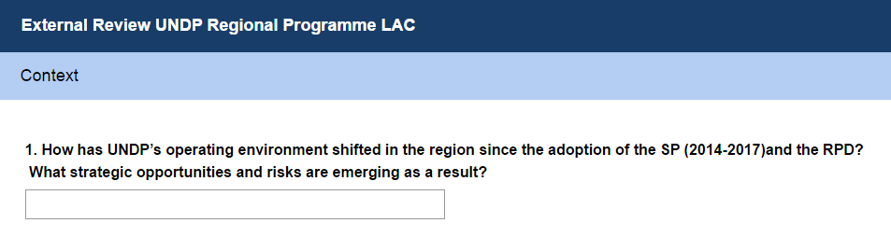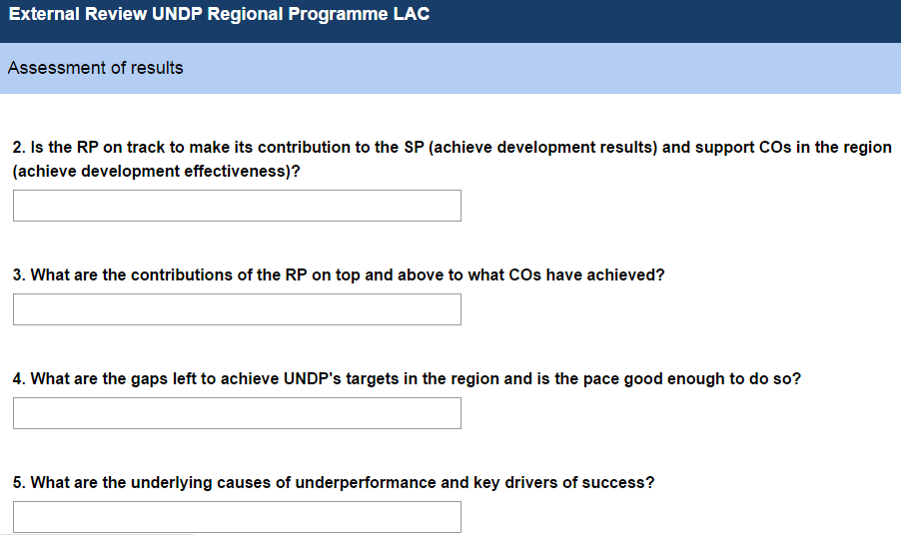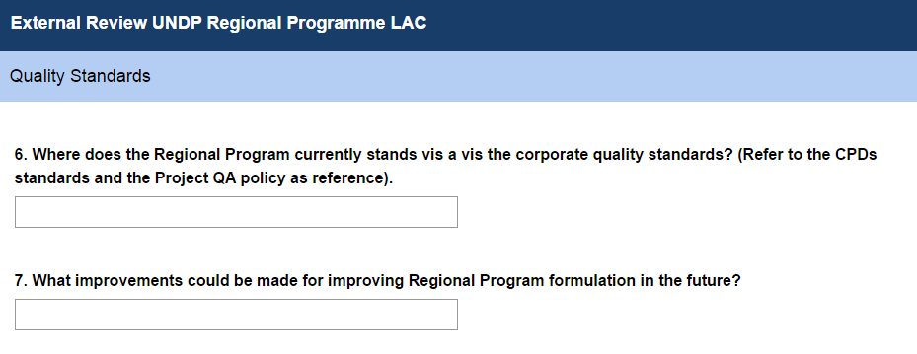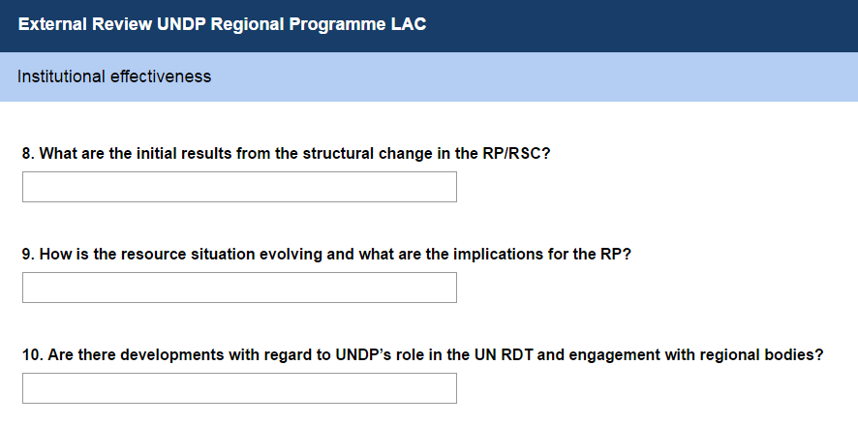

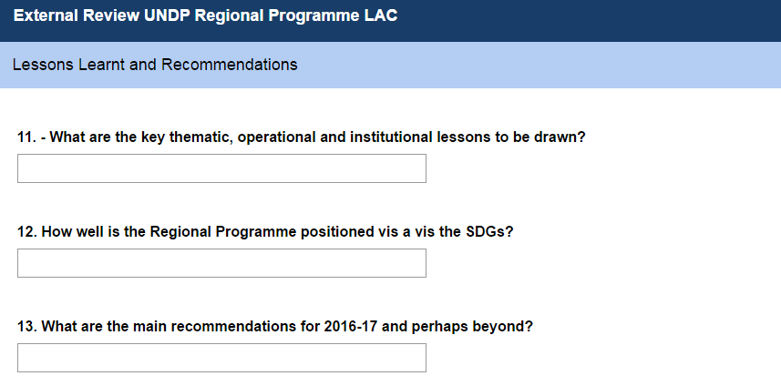

UNDP Regional Programme Midterm Review |Online Interview Guide for Country Offices and External Partners

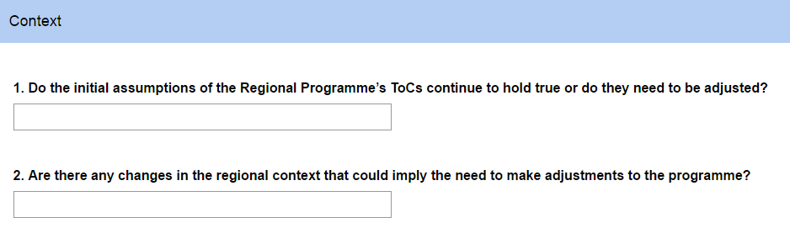

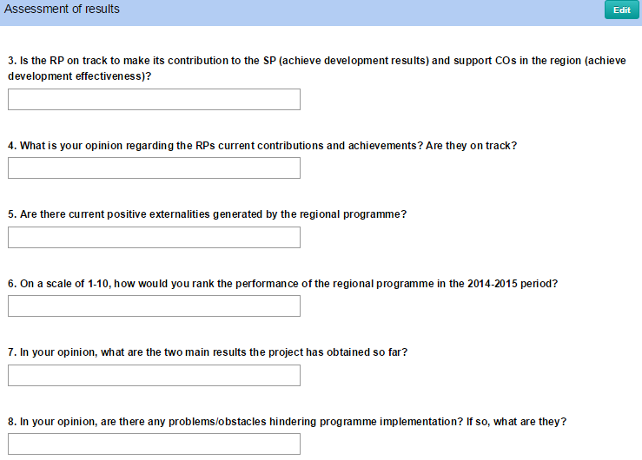

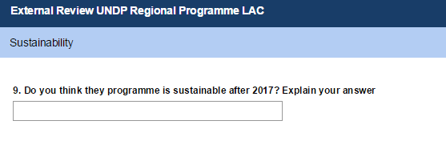

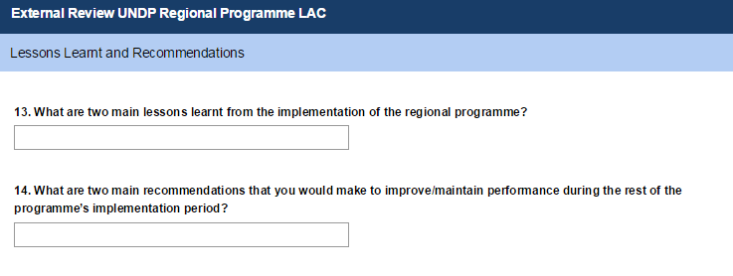

## 8.2 MTR Matrix

| **MTR Matrix**  Liinks between elements of the analytical approach: criteria, evaluation questions, data sources and data collection methods | | | | |
| --- | --- | --- | --- | --- |
| **Criteria/Sub-criteria** | **Questions to be addressed** | **What to look for** | **Data sources** | **Data collection methods** |
| **Context** | *How has UNDP’s operating environment shifted in the region since the adoption of the SP (2014-2017) and the RPD?* | * Evidence of political, social and economic change in the operating environment between the moment of programme start and the current moment. | Stakeholders:  − RBLAC Director/Deputy Director  − Senior Strategic Advisors RBLAC and Caribbean  − RH Director  − Cluster Leaders  − Chief CORE Support Team  − ECLAC/UNDESA experts and/or other external partners  At least 3 RRs in the region  -Director for IDEA International  -Staff from SICA, CARICOM and UNASUR | Face to face and online interviews |
| *What strategic opportunities and risks are emerging as a result?* | * Areas in which activities within the Regional Programme should be strengthened or scaled up. * Areas that would enhance the positive results of the implementation of the Regional Programme | − RBLAC Director/Deputy Director  − Senior Strategic Advisors RBLAC and Caribbean  − RH Director  − Cluster Leaders  − Chief CORE Support Team | Face to face and online interviews |
| *Do the initial assumptions of the Regional Programme’s ToCs continue to hold true or do they need to be adjusted?* | * Effect of regional changes on ToC | -− RBLAC Director/Deputy Director  − Senior Strategic Advisors  -CO  -External Partners |
| **Assessment of results** | *Is the RP on track to make its contribution to the SP and support COs in the region?* | * Quantitative and qualitative evidence/indicator values that facilitate the comparison of expected vs. actual results. * **Evidence of success in the first three levels of the results chain –input, process, output-** * Expectations that COs had at the beginning of the programme * Opinions from COs regarding the RPs current contributions * Current positive externalities generated by the programme | Stakeholders:  − RBLAC Director/Deputy Director  − RH Director  −Chief CORE Team  Regional Programme Coordinator  − Project Managers and Technical Teams  − Country Advisors  − RBLAC Strategic Planner  − Online survey to COs participating in key regional projects.  Documentation:  − Regional Programme RRF and Monitoring Framework (under construction)  − Regional Programme financial update  − Regional Project´s Progress Reports 2014-15  − Regional Project´s RRF & Monitoring Plan updates  − Reports of Evaluations performed to Regional Projects during 2014, 2015  − ROAR 2014  − ABP/RBLAC IWP 2014 & 2015  − Quick web survey to collect information regarding support to COs in the region. | Face to face and online interviews  Analysis of documentation |
| *What are the gaps left to achieve UNDP's targets in the region and is the pace good enough to do so?* | * Evidence of less-than-adequate indicator values with respect to agreed-upon targets * Country/beneficiary complaints | − RBLAC Director/Deputy Director  − RH Director  Chief CORE Team  Project managers  − Regional Programme Coordinator | Face to Face – Online Interviews |
| *What are the underlying causes of underperformance and key drivers of success* | * External causes of underperformance * Internal causes of underperformance * Key catalyzers for success (enabling political and social environment, ownership and buy-in) | − RBLAC Director/Deputy Director  − RH Director  Chief CORE Team Project Managers  − Regional Programme Coordinator | Face to Face – Online Interviews |
| **Institutional effectiveness** | *What are the initial results from the structural change in the RP/RSC?* | * Concrete evidence of structural change in organograms, organizational arrangements | − RBLAC Director/Deputy Director  − RH Director/Chief of RH BSO  − Cluster Leaders  − Chief CORE Support Team  − Other relevant staff in HQs | Face to Face – Online Interviews |
| *How is the resource situation evolving?* | * Budget trends disaggregated by source | Stakeholders:  − RBLAC Deputy Director  − RH Director/Chief of RH BSO  − RBLAC Operations Advisor  − Resource Mobilization & Partnership Specialist  − Other relevant staff in HQs  Documentation:  − RP Financial Updates  − Hard and Soft Pipeline | Face to face and online interviews  Analysis of documentation |
| *Are there developments with regard to UNDP’s role in the UN RDT and engagement with regional bodies?* | * Signed agreements with regional bodies * Evidence of joint efforts | − RBLAC Director/Deputy Director  UNDG LAC Specialist  − RH Director  − Chief CORE Support Team | Face to face and online interviews |
| **Quality Standards** | *Where does the Regional Program currently stands vis a vis the corporate quality standards?* | * *Deviations or consistency with CPDs standards and the Project QA policy* | − /Deputy Director  − RH Director  − Regional Programme Coordinator  RBLAC Strategic Planner | Face to Face – Online Interviews |
| *What improvements could be made for improving Regional Program formulation in the future?* | * Addition of the consideration of new national and regional strategies/policies. * Possibility of indicator review | − RBLAC Director/Deputy Director  − RH Director  Chief CORE Team  Cluster Leaders  − Regional Programme Coordinator  RBLAC Strategic Planner  Other relevant staff in HQ | Face to Face – Online Interviews |
| **Lessons learnt and recommendations** | *What are the key thematic, operational and institutional lessons to be drawn?* | * What has worked, what has not worked. * Details of successful lessons learnt to be replicated during the remainder of the programme implementation period * How does the current programme address the SDGs? Are there changes to be made to the RPD to better address these? | Stakeholders:  − RH Director/Chief of RH BSO  − Cluster Leaders  − Chief CORE Support Team  − RBLAC Strategic Planner  − Regional Programme Coordinator  Documentation:  − Regional Programme RRF and Monitoring Framework (under construction)  − Regional Project´s Progress Reports 2014-15  − Regional Project´s RRF & Monitoring Plan updates  − Reports of Evaluations performed to Regional Projects in 2014, 2015 | Face to Face – Online Interviews |
| *What are the main recommendations for 2016-17 and perhaps beyond?* | * Specific and timed courses of action to improve programme performance per outcome. | − RBLAC Director/Deputy Director  − RH Director  Cluster Leaders  − Regional Programme Coordinator | Face to Face – Online Interviews |

8.2 Terms of reference of the MTR

**Terms of Reference**

**UNDP Regional Programme for Latin America and the Caribbean**

**Midterm Review**

**Background and context**

The Regional Programme for Latin America and Caribbean was formulated in 2013 taking into account the corporate priorities presented in the new UNDP Strategic Plan (SP), the alignment exercise to the new SP, and the findings and recommendation of the evaluation of the RPD 2008-2013. The formulation process encompassed participative workshops with the thematic areas which help build the theories of change behind the results proposed for the new programme. The programme also benefited from an extensive consultative process involving COs, and key partners.

The main objective of the Regional Programme is to tackle multiple, enduring and pervasive inequalities that cannot be addressed through isolated actions. Hence, its planned results are geared towards reducing persistent income and non-income poverty and exclusion, lowering levels of vulnerability and conflict, building sustainable development practices, and strengthening democratic governance while acknowledging the diversity of the region (middle-income countries, Small Island developing States and least developed countries).

The programme addresses structural issues that are strategic for the region. These are better addressed regionally as they require bringing together multi-sector expertise to provide policy guidance and accumulated knowledge to respond to complex trans-boundary political, economic, social and environmental issues that are frequently sensitive in nature. The general approach for the preparation of the programme has been to try to intervene as closely as possible to the root cause of the problems identified, which should be tackled from a regional level and with a multidimensional perspective.

The regional programme prioritized four UNDP strategic plan outcomes related to the three areas of work, namely, sustainable development, inclusive and effective democratic governance, and resilience

building[25]. This outcomes are:

**Outcome 1** (Strategic plan outcome 1). Growth and development are inclusive and sustainable, incorporating productive capacities that create employment and livelihoods for the poor and excluded.

**Outcome 2** (Strategic plan outcome 2). Citizens’ expectations for voice, effective development, the rule of law and accountability are met by stronger systems of democratic governance.

**Outcome 3** (Strategic plan outcome 4). Faster progress is achieved in reducing gender inequality and promoting women’s empowerment.

**Outcome 4** (Strategic plan outcome 5). Countries are able to reduce the likelihood of conflict and lower the risk of natural disasters, including those resulting from climate change.

The programme also seeks to increase the development effectiveness of programme interventions in the priority areas identified. Into each stage of regional interventions (design, implementation and evaluation), it will integrate (a) capacity development, knowledge management, and innovation as programming frameworks; and (b) South-South cooperation as the mechanism for effective collaboration across countries both within and outside the region.

In accordance with the independent evaluation recommendations, special attention has been given to the Caribbean sub region from a programmatic point of view. In that regard, the regional programme prioritized the UNDG thematic priority areas identified for the Caribbean in October 2012 – climate change and the environment, institutional strengthening and human security – as well as fiscal burden, women’s political participation, citizen security, disaster risk reduction, and resurgent HIV epidemics among marginalized groups and women.

The programme counts with an RRF which contains the indicative resources as well as a mix of SP and regionally owned indicators, targets and baselines at the outcome level. The Centre is currently developing a monitoring plan, which includes defining output and performance indicators aimed at measuring programme progress and contributions to the SP. The RBLAC IWP found in the corporate planning system shows the regional programme linking to the new SP at the outcome and output levels.

Since the formulation and approval of the Regional Programme in January of 2014, the RBLAC Regional Hub embarked in the UNDP structural change process, an exercise that formed part of a larger commitment to the Executive Board through which UNDP will improve its institutional effectiveness to meet the Strategic Plan's objectives

The goals of UNDP´s Structural Change was to promote better integration, both functionally and geographically through: a) Strengthening UNDP's regional presence by moving the advisory and support services to regional hubs, to help Country Offices to deliver better, faster and cheaper; b) Consolidating the policy functions by improving programme quality, research and development, and benefiting from better knowledge and business intelligence, while operating more efficiently; c) Rationalizing management support by allowing bureau to concentrate on programme implementation and on their core competencies. This aimed to reduce duplication and allow for economies of scale in performing operational transactions; and d) Improving management -staff ratios by shifting the grade profile of our workforce to achieve a more effective management-to-staff ratio, promoting more collaboration, accountability and a more dynamic career mobility[26].

As a result of this process, the RBLAC Regional Hub underwent an organizational restructuring which entailed assuming new functions, revisiting others, and adjusting its operation and amount of staff. This process that lasted over a year aimed at “Strengthening UNDP's Regional Presence” by transforming the regional centers into Regional Hubs with the expectation of providing comprehensive Country Offices support services covering programme oversight, programme advisory/support, resource mobilization, South-South cooperation and operations. As a result of this transformation, Country Offices are expected to benefit from a more integrated support from Regional Hubs that are fully enabled to connect and deliver superior service delivery capabilities[27].

Whereas the establishment of these Regional Hubs is almost complete, they are not yet functioning in accordance with the expectations of entities/“Think Tanks” seamlessly delivering services from HQ, through Regional Hubs, to Country Offices. However with improvements in technology, processes and the manner in which people adjust and implement new work habits, it is expected that the working environments can be optimized[28].

With the Structural Change implementation, UNDP's Regional Hubs are uniquely designed not as sub-units of a particular bureau, but as spaces where Central Bureau – such as BPPS and BoM -- can collaborate in a consistent way with Regional Bureau and Regional Hubs, delivering collaborative services to Country Offices.

**Rationale and Purpose of the Review**

This review responds to the need to provide inputs about the progress of the Regional Programme for the Mid-term Review (MTR) of the Strategic Plan 2014-17 (SP) as per the commitment made with Executive Board in para 45 of the Plan. The MTR of the SP aims to address shifts in UNDP operating environment and their implications, assess progress towards development results and institutional effectiveness, including qualitative shifts, and set out options for the remaining years of the Plan and into the next SP. A key focus of the MTR of the SP will be the performance of the Global and Regional Programmes.

In order to respond to this need, the Bureau requested to carry out a MTR of the current regional programme to inform about its progress and contributions to SP. It must be noted that the current Evaluation Plan of the Regional Programme considered four outcome evaluations instead of a MTR. Nonetheless, and in order to ensure a common approach across Bureaus, this review is been commissioned in preparation for the MTR of the SP and to assess progress of the RP considering that start-up and performance of all programmes have been affected by UNDP internal changes, brought about by the structural review, and by financial issues. This exercise will also constitute an important input for the RP end-term independent evaluation which will be conducted by the IEO in 2016.

The MTR will seek to assess progress against the programme's results, extract lessons learned, and propose corrective actions. These corrective actions will directly inform RBx IWPs as well as RP activities and budgets during 2016-17 to accelerate progress wherever needed. In addition, this review will help assess and propose adjustments in the original Results and Resource Framework (RRF) taking into account the changes in the resource environment, and the opportunities for resource mobilization to support the planned results.

This review should take into account the evolving development scenario and challenges in the region since the preparation of the RPD and accordingly provide a forward-looking view about the future priorities and positioning of the RPD. An important goal for the MTR will be to show how UNDP in the Latin America and Caribbean Region is currently positioned and can best respond to supporting the countries with the SDGs.

**Objectives**

The main objectives of the Mid Term Review are:

1- Review the quantitative and qualitative regional development results achieved through the implementation of the Regional Programme in partnership with the key development actors in the region, highlighting progress, the key drivers of success, and main gaps identified. The assessment should have a focus on the regionality principles[29] of the Regional Programme.

2- Review how the Regional Programme has contributed to potentiate existing Country Office portfolios in the achievement of planned development results. In particular, assess the development effectiveness achievements and challenges related to advisory services to Country Offices.

3- Based on the review done, present key findings, draw lessons learnt, and make recommendations about the necessary adjustments to the programme - including adjustments and/or refinements to the original theories of changes drafted for the Programme and to the Results Framework - which will be useful to increase performance and programme effectiveness.

4- Propose a monitoring plan for the Regional Program Resource and Results Framework, with output indicators to allow for an effective monitoring and future evaluation of the contributions of the programme to the Strategic Plan and to CO results. Also, include indicators to assess programme performance. This monitoring framework should build on the common framework for monitoring regional programmes which is being agreed comparatively[30].

5- Prepare two in-depth results of two regional flag ship projects as selective case studies to strengthen and make more credible the evidence base to showcase RPD results, its effectiveness and added value.

**Scope of the Review**

The review covers the period from the inception of the Regional Programme in January of 2014 to date, and focuses on the above mentioned objectives. It is to provide clear and backed conclusions and recommendations on how to improve performance during the remaining Regional Programme period and future programming.

The key Mid-term Review questions include:

**Context**

- *How has UNDP’s operating environment shifted in the region since the adoption of the SP (2014-2017) and the RPD? What strategic opportunities and risks are emerging as a result?*

**Quantitative and Qualitative Assessment of Results**

- *Is the RP on track to make its contribution to the SP (achieve development results) and support COs in the region (achieve development effectiveness)?*

- *What are the contributions of the RP on top and above to what COs have achieved?*

- *What are the gaps left to achieve UNDP's targets in the region and is the pace good enough to do so?*

- *What are the underlying causes of underperformance and key drivers of success?*

**Institutional Effectiveness**

- *What are the initial results from the structural change in the RP/RSC?*

- *How is the resource situation evolving and what are the implications for the RP?*

- *Are there developments with regard to UNDP’s role in the UN RDT and engagement with regional bodies?*

**Lessons Learned and Recommendations**

- *What are the key thematic, operational and institutional lessons to be drawn?*

- How well is the Regional Programme positioned vis a vis the SDGs?

- *What are the main recommendations for 2016-17 and perhaps beyond?*

**Quality Standards**

- Where does the Regional Program currently stands vis a vis the corporate quality standards? (Refer to the CPDs standards and the Project QA policy as reference).

- What improvements could be made for improving Regional Program formulation in the future?

The Mid-term Review should also revise and propose refinements to the Theories of Changes drafted to design the programme, and offer a methodologically consistent monitoring plan to track meaningfully regional interventions, and their contribution to the SP and to results at country office level. This plan should build on the common framework for monitoring regional programme which is being agreed comparatively.

**Methodology**

The consultant will design the exact methodology for the review based on the guidance provided through this TORs and the indicative guide included in Annex I. This review should rely primarily on information available through internal systems and tools to assess and understand the performance of the Regional Programme and identify what needs to change moving forward in 2016-17. The review should include an in-depth desk review of the key documentation listed in guide of Annex I, which should be complemented with interviews to key internal and external stakeholders proposed, including Regional Programme teams, Thematic Advisors involved in project implementation, RBLAC Directorate, and the County Offices in the region that participate in the regional projects. Quick web surveys to COs will also be necessary in other to gather information about the Regional Programme performance with regards to the development effectiveness results.

The review should prepare two selective case studies from at least two flagship regional projects to show case strategic/instructive results which could provide stronger evidence of the RPD contributions and added value. The particular cases will be selected in consultation with the Regional Hub. This case studies will be featured as annex of the main MTR report. The projects will be selected as part of the review process in discussion with the Regional Hub.

Even though this is a review, the conclusion and recommendations should be based on strong and credible evidence. Thus, the type of information and methods selected must produce evidence. This implicates justification of findings with the reference data in the narrative text, as well as a presentation of the results matrix of the Programme, updated with the new indicator status, but delimited by the restrictions identified during the review. It should mention the central focus on the contribution to outcomes, without excluding other levels of results (outputs) accumulated during the two year period of implementation.

**Expected Products**

The products of this review should include, at minimum, the followings:

1- **Inception report.** The consultant will conduct a preliminary scoping exercise and design an inception report (containing a review matrix, the protocols to collect information from the different stakeholders, and a description of the methodology to be applied) which should be discussed with the Regional Hub, before the review is conducted.

This represents a general planning document of the review, which includes a calendar of the main stages and activities planned and deliverables. This report shall detail the understanding of the consultant on what will be reviewed and why, showing how each question shall be answered and by which means: the proposed methodology, the proposed information sources, and the data recollection procedures. This information shall be reflected in a review matrix, for example:

|  |  |  |  |  |
| --- | --- | --- | --- | --- |
| **SAMPLE Midterm REVIEW MATRIX** | | | | |
| **Criteria/Sub-criteria** | **(Examples of) questions to be addressed** | **What to look for** | **Data sources** | **Data collection methods** |

**2- Draft review report.** This first draft will be reviewed by the Regional Hub to ensure that the review meets the expectations and quality criteria, to then request the necessary adjustments in order to produce the final version. This report should have 8,500 words maximum for the main text of the analytical report (excluding annexes).

**3- Final review report.** The final report should have 8,500 words maximum for the main text of the analytical report (excluding annexes) with key findings, good practices and clear recommendations. The report should be presented in English with executive summaries in English and Spanish.

4- **Monitoring Plan** of the Regional Programme with output indicators to track the contributions of the regional interventions to the SP and to CO results. Also, indicators to track programme performance.

**Payment**

|  |  |  |
| --- | --- | --- |
| **Deliverables** | **Target due Date** | **Payment Percentage** |
| Product 1 | November 17th | 20% |
| Product 2 | November 30th - Dec 16th | 25% |
| Product 3 | December 28th | 25% |
| Product 4 | January 31st | 30% |

**Annexes**

-Indicative list of interviews and list of key documentation to be reviewed

-Preliminary list of projects

-Regional Programme 2014-2017 with the Result Framework

-UNDP Strategic Plan and IRRF -Regional and Global Programme proposal for a common approach for monitoring results (October 2015)

-Draft of Theories of Change for the four outputs of the Regional Programme

-Country Programme Document and project Quality Assurance standards

|  |  |  |  |
| --- | --- | --- | --- |
| **Annex I. List of indicative interviews and background documentation** Interviews | | Documents to review | |
| **Context** | | | |
| 1. *How has UNDP’s operating environment shifted in the region since the adoption of the SP (2014-2017) and the RPD? What strategic opportunities and risks are emerging as a result?* | | − RBLAC Director/Deputy Director  − Senior Strategic Advisors RBLAC and Caribbean  − RH Director  − Cluster Leaders  − Chief CORE Support Team  − ECLAC/UNDESA experts and/or other external partners | |
| **Quantitative and Qualitative Assessment of Results** | | | |
| 2. *Is the RP on track to make its contribution to the SP and support COs in the region?* | − RBLAC Director/Deputy Director  − RH Director  − Regional Programme Coordinator  − Project Managers and Technical Teams  − Country Advisors  − RBLAC Strategic Planner  − For Q2, consider online survey to COs participating in key regional projects. | | − Regional Programme RRF and Monitoring Framework (under construction)  − Regional Programme financial update  − Regional Project´s Progress Reports 2014-15  − Regional Project´s RRF & Monitoring Plan updates  − Reports of Evaluations performed to Regional Projects during 2014, 2015  − ROAR 2014  − ABP/RBLAC IWP 2014 & 2015  − Quick web survey to collect information regarding support to COs in the region. |
| 3. *What are the gaps left to achieve UNDP's targets in the region and is the pace good enough to do so?* | | | |
| 4. *What are the underlying causes of underperformance and key drivers of success* | | | |
| **Institutional Effectiveness** | | | |
| 5. *What are the initial results from the structural change in the RP/RSC?* | | − RBLAC Director/Deputy Director  − RH Director/Chief of RH BSO  − Cluster Leaders  − Chief CORE Support Team  − Other relevant staff in HQs | |
| 6. *How is the resource situation evolving?* | − RBLAC Deputy Director  − RH Director/Chief of RH BSO  − RBLAC Operations Advisor  − Resource Mobilization & Partnership Specialist  − Other relevant staff in HQs | | − RP Financial Updates  − Hard and Soft Pipeline |
| 7. *Are there developments with regard to UNDP’s role in the UN RDT and engagement with regional bodies?* | | − RBLAC Director/Deputy Director  − RH Director  − Chief CORE Support Team | |
| Lessons Learned and Recommendations | | | |
| 8. *What are the key thematic, operational and institutional lessons to be drawn?* | − RH Director/Chief of RH BSO  − Cluster Leaders  − Chief CORE Support Team  − RBLAC Strategic Planner  − Regional Programme Coordinator | | − Regional Programme RRF and Monitoring Framework (under construction)  − Regional Project´s Progress Reports 2014-15  − Regional Project´s RRF & Monitoring Plan updates  − Reports of Evaluations performed to Regional Projects in 2014, 2015 |
| 9. *What are the main recommendations for 2016-17 and perhaps beyond?* | | | |

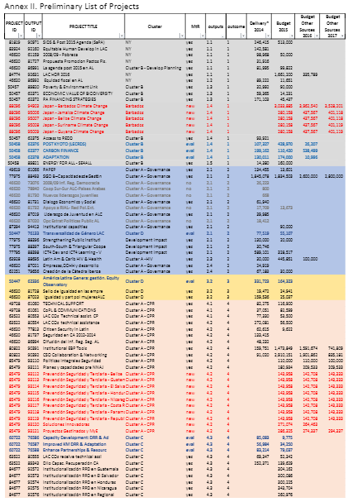

# 9. Bibliography

UNDP. 2015. Annual progress report. Seguridad Integral y Prevención de la Violencia que afecta a Niñas, Niños, Adolescentes y Jóvenes en los países del SICA.

UNDP. 2015. Annual progress report. Gestión de Información Basada en Evidencia para la Seguridad Ciudadana en América Central

UNDP. 2015. Annual progress report. Fondo Fiduciario España-PNUD para América Latina y el Caribe.

UNDP. 2015. Annual progress report. Institucionalización de Procesos y Herramientas de RRD en Centroamérica.

UNDP. 2015. Annual progress report. Strengthening Crisis Prevention and Recovery Capacities in Latin America and the Caribbean

UNDP. 2015. Annual progress report. Japan-Caribbean Climate Change Partnership.

UNDP. 2015. Annual progress report. SIGOB –Fortalecimiento de las capacidades de gestión

para la gobernabilidad democrática

UNDP. 2015. Regional Plan Results framework.

UNDP. 2015. Annual progress report. Superando obstáculos para la transversalidad de género en América Latina y el Caribe.

UNDP. 2015. Annual progress report. Comprehensive Strengthening of Institutional Management in Latin America and the Caribbean

UNDP. 2015. Annual progress report. Green Commodities Programme.

UNDP. 2015. Annual progress report. Promoción de Adaptación al Cambio Climático, Energía

y Medio Ambiente

UNDP. 2015. Annual progress report. SIDS and Post-2015 Agenda (SaPA)

UNDP. 2014. Evaluation Plan of LAC Regional Programme 2014-2017.

UNDP. 2015. RPD Financial Overview. [Power Point Presentation].

UNDP. 2015. Annual progress report. RPD Outcome Indicators BMT. [Excel File]

CEPAL. 2015. Economic Survey of Latin America and the Caribbean

UNDP. 2015. UNDP Annual Business Plan (ABP) 2016

<http://www.latinamerica.undp.org/content/rblac/es/home/idh-regional/hdr-2015-2016.html>, consulted on December 28th, 2015.

UNDP. Regional Office for Latin America and the Caribbean. 2015. Regional Human Development Report.

<http://www.ilo.org/global/about-the-ilo/newsroom/comment-analysis/WCMS_237488/lang--en/index.htm>, consulted on December 28th, 2015.

UNDP. 2015. Achievement by Design. Strategic Planning for a Higher Performing UNDP. Strengthening Project Quality Assurance

UNDP. 2015. Post Structural Review

1. N=US$56,895,591 as reported in the 2016 RBLAC Hub Board presentation.
2. At the time the external review took place the information on the 2016 allocation of funds was not yet available
3. This percentage does not reflect the allocation of TRAC for 2016 which at the time of this report had not been disbursed.
4. RBLAC Regional Hub Board Presentation. February 2016.
5. Terms of Reference of the MTR Consultancy
6. http://www.theguardian.com/global-development/2015/jan/19/sustainable-development-goals-united-nations
7. Rough calculations from the intergovernmental committee of experts on sustainable development financing have put the cost of providing a social safety net to eradicate extreme poverty at about $66bn a year.
8. Adapted from UNDP. 2015. UNDP Annual Business Plan (ABP) 2016.
9. Adapted from <http://www.latinamerica.undp.org/content/rblac/es/home/idh-regional/hdr-2015-2016.html>, consulted on December 28th, 2015.
10. CEPAL. 2015. Economic Survey of Latin America and the Caribbean
11. UNDP. Regional Office for Latin America and the Caribbean. 2015. Regional Human Development Report.
12. Adapted from http://www.ilo.org/global/about-the-ilo/newsroom/comment-analysis/WCMS_237488/lang--en/index.htm
13. The Wilson Center. Crime and Violence in Central Americas’ North Triangle. Available at https://www.wilsoncenter.org/sites/default/files/FINAL%20PDF_CARSI%20REPORT_0.pdf
14. N=US$56,895,591 as reported in the 2016 RBLAC Hub Board presentation.
15. The largest projects were recently initiated. Infosegura, DIPECHO and IDH by the end of 2014 and JCCCP and PREJUVE by mid-2015.
16. UNDP. 2015. RPD Financial Overview
17. Conclusion 4. The regional programme does not have a strategy suited to assisting national partners to address the needs and vulnerabilities of the Caribbean. Together with insufficient support to country offices, the risk exists of further alienating UNDP from contributing strategically to development results in the sub-region. The Caribbean – the Small Island Developing States, in particular – lacks a distinct orientation from the regional bureau. Biodiversity, climate change, energy and disaster risk reduction are key priorities for the Caribbean, and these areas provide the best option for Caribbean country offices to mobilize resources. The UNDP approach to the Caribbean as a geographic entity or language-distinct area is not appropriate. Limited funding and interest from donors have amplified the difficulties in the greater Caribbean, and have hampered UNDP support in the sub-region. Other aspects, such as lack of linguistic abilities, local understanding and demand have also interfered.
18. Adapted from The SAMOA Pathway, available at <http://www.sids2014.org/index.php?menu=1537>, consulted in March 2016.
19. The figure after the restructuring review does not include the 15 frozen positions.
20. Currently there are 3 vacant positions with no incumbent.
21. The Equality Seal works with over 1400 private companies and is the only UNDP programme with such an outreach to the private sector.
22. UNDP’s 2014-2017 SP aims at achieving higher quality projects through enhanced planning, design, monitoring and evaluation, underpinned by a stronger focus on results based management. The Project Quality Assurance (QA) system is the primary corporate monitoring element to deliver on this SP commitment. The objective of this system is to support continuous improvement and results based management; strengthen accountabilities for effective project and programme management; strengthen organizational learning and knowledge sharing; and develop a more rigorous project assessment base from which to report on programme quality to stakeholders2015. Achievement by Design. Strategic Planning for a Higher Performing UNDP. Strengthening Project Quality Assurance
23. As reported in the RP’s financial overview.
24. For the preparation of the Plan, the consultant will take into consideration the common monitoring framework that will results from the current discussions between HQ and Regional Hubs. This monitoring framework should articulate indicators to measure regional development results and indicators to measure development effectiveness achievements. For reference, the current proposal under discussion is included as part of these ToRs.
25. The prioritization of SP outcomes and outputs was based on initial regional theories of change prepared during the initial formulation stages of the Regional Programme
26. 2 Structural Change Website. <https://intranet.undp.org/unit/office/exo/sp2014/SP201417/Structural.Change/default.aspx>
27. “Regional Hub Optimization – Structural Change (2015). Draft PID.
28. “Regional Hub Optimization – Structural Change (2015). Draft PID.
29. The regional work of UNDP is based on five mutually reinforcing ‘regionality’ principles which define the particular value added of regional or subregional approaches to addressing development challenges. These are: (i) Promotion of regional public goods based on strengthened regional cooperation and integration; (ii) Management of cross-border externalities 5 and spillovers that are best addressed collaboratively on an intercountry basis; (iii) Advancement of awareness, dialogue and action concerning sensitive or emerging development issues that will benefit from multi-country experiences and perspectives; (iv) Promotion of experimentation and innovation to overcome institutional, financial and informational barriers that may be too high for an individual country to surmount; and (v) Generation and sharing of development knowledge, experience and expertise – for instance, through South-South and triangular cooperation – so that countries can connect to, and benefit from, relevant experiences from across the region and beyond.
30. For the preparation of the Plan, the consultant will take into consideration the common monitoring framework that will results from the current discussions between HQ and Regional Hubs. This monitoring framework should articulate indicators to measure regional development results and indicators to measure development effectiveness achievements. For reference, the current proposal under discussion is included as part of these ToRs.