**Logo PNUD**

**REPUBLIC OF DJIBOUTI**

**Ministry of Habitat, Urbanism, Environment and Territory Planning**

**-------------------------------------------------**

**Environment and Territory Planning Agency**

**-----------------------------------------------------------**

**TEMINAL EVALUATION OF MARINES PROTECTED AREAS PROGRAMME OF DJIBOUTI**

**FINAL REPORT**

**Consultant :**

* **Gondo GBANYANGBE, International Consultant,**

**Project Management /Evaluation Specialist**

**February 2016**

## Executive summary

## Introduction page

**Title of the project**: ‘‘Establishing Effectively Managed Marine Protected Areas in Djibouti‘’

**Project ID**: GEF: 3216 (PMIS#) ----- UNDP: 00071584 (Atlas#) and 4049 (PIMS#)

**Calendar of the evaluation and date of evaluation report**: 14th to 28th February 2016 / 28 Feb 2016

**Country and Region included in the project**: Republic of Djibouti; RBAS

**GEF Strategic/Operational Programme**: Biodiversity

**Implementing Partners**: Environment and Territory Planning Agency (DATE), and United Nations Development Programme (UNDP)

**Evaluation Team**: Gondo GBANYANGBE, International Consultant, Head of the mission with support from DATE and UNDP

## Acknowledgment

This current terminal evaluation was commissioned by the government of Djibouti through the Ministry of Habitat, Urbanism, Environment and Territory Planning (MHUEAT), more specifically the Agency in charge of Environment and Territory Planning (DATE). This solicitation is a response to one of the GEF procedural obligations for all projects funded by GEF and supported by UNDP. Therefore, we would like to express our sincere thankfulness to the Government of Djibouti for its confidence to us for the implementation of this terminal evaluation.

Also, we address our recognition to UNDP in particular the United Nations Resident Coordinator and Resident Representative of the United Nations Development Programme (UNDP), who accepted despite her very busy calendar to receive our team and exchanged with us on the field activities of this mission. We thank UNDP for all the financial, material and technical supports to the mission, without that the mission could not be successfully achieved.

To the Environment & Territory Planning Agency (DATE) and all the staff member of the project management unit (UGP) we are very acknowledgeable for their availability and assistances during every step of the mission to get a solely character and we thank particularly them for that.

During the field visits, we were warmly receive by the locals communities of the 03 MPA in Arta, Obock and Khor Anghar whose accepted to with us keys information’s they got and we would like to say thanks to them for that. To all the regional and locales authorities, we say thank for their supports to our mission and for their support for the conservation of the Marines Protected Areas (MPA) in their respective areas.

We also say thank you to the project steering comity members and those private agencies that’s accepted to collaborate with us during this mission. Finally, we express our sincere thankfulness to the Director of the Environment & Territory Planning (DATE) and the Environment & Energy Programme Specialist at UNDP for all their availability, support and advices for the success of this mission.

## Summary

### Table 1 : Project summary

|  |  |  |  |  |  |  |
| --- | --- | --- | --- | --- | --- | --- |
| Project title : |  | | | | | |
| Project ID GEF : | | 3216 (PMIS#) |  | | *At approval*  *(USD)* | *At End*  *(USD)* |
| ID de projet du PNUD : | | 00071584 (Atlas#)  4049 (PIMS#) | GEF Financing  : | | 980.000 | 980.000 |
| Pays : | | Djibouti | Implementing agency financing/UNDP Financing  : | | 200.000 | 200.000 |
| Region : | | RBAS | Government | | 400.000 | 200.000 |
| Focal area : | | Biodiversity | Other :  (PERSGA, CERD & ADDS) | | 420.000 | 420.000 |
| Objectives FA, (OP/SP) : | | Biodiversity | Total co-financing : | | 1.020.000 | 820.000 |
| Implementing agent : | | MUHE | Project total cost : | | 2.00.0000 | 1.800.000 |
| Other partners participating to project : | | PERSGA, CERD et ADDS | Signature of DP (project start date) : | | | 09/02/2010 |
| Ending date (operational) : | Proposed :  31/12/2015 | | Real :  31/12/2015 |

### Description of project (brief)

During these last ten years, the Republic of Djibouti has make the protection of environment it much important priority with a political volunteer expressed through the establishment the terrestrial & marines protected areas (MPA) and the ratification of many internationals agreement. Despite this willingness, the country is facing number of constraints linked to insufficient qualified human resources & materials, coordination mechanism and stakeholder’s mobilisation to response efficiently to these national and international engagements.

This is why the government of Djibouti with UNDP support requested and obtained a funding from the Global Environmental Facility (GEF) to establish an effectively managed system of marines protected areas (MPA) in the country which first phase has end last December 2015.

The MPA project aims to establish effectively managed marine protected areas in Djibouti and focus on 04 components inter-linked. The planed duration of the project is 05 years and will use the expertise and technical & financial contributions of many national & international partners’ supports and their expertise with particular attention to the establishment of replication mechanism of result in a national level.

This 05 years project strategic aims was to facilitate the consideration of the energetic & environmental planning dimension for better integration in the country development process. Thus, the project targeted on four components as follow:

### Component 1: *Policy and regulatory framework for the management of MPAs*

This component aimed to allow the concerned institutions in MPAs management in Djibouti to establish functioning mechanisms to ensure coordination of development activities, specifically those which pose a major threat on the marine biodiversity and MPAs, such as construction projects, tourism development and marine traffic. The demarcation of the MPAs’ boundaries, support to environmental impact assessment (EIA) of activities within the MPA areas, illegal fishing and marines traffic are an important aspect of this component.

### Component 2: *Efficient and financially sustainable management structures of the MPAs at central and site*

This output will allow the DATE to establish the essential management structures at the central and local level allowing the efficient management and financial sustainability of the 3 MPAs declared under the protected areas law. The establishment of operational monitoring team in central & local level, the formulation of management plan and the priorities actions for the conservation of biodiversity are the main aspects under consideration in this component.

### Component 3: *Financing for MPAs*

This component was about support to the development of a financing strategy to fund the expanded protected areas network (PAN) and aim at diversifying revenue streams to meet expenditures for effective MPA management. It will seek the active involvement of local communities in a participatory system that provides direct access and ownership of resources. Empowerment of local communities to identify and implement income generating activities based on sustainable use of the MPAs resources will increase income in the MPAs areas and provide incentives for local community members to respect resource use limitations and participate in the effective management of the MPAs.

### Component 4: *Programme coordination and Management*

The project was implemented by the Ministry of Habitat, Urbanism, Environment and Territory Administration (MHUEAT) more specifically its Direction de l’Aménagement de Territoire et de l’Environnement (DATE). Close coordination will be sought with line ministries involved in the MPAs such as Tourism, Agriculture and the National Marine Forces. Coordination with participating donors will also be secured at technical and financial levels, mainly UNDP, PERSGA, AFD/FFEM, ADDS and CERD, each supporting a portion of the project according to their comparative advantage and programming frameworks.

The project will be managed by a Project Coordination Unit (PCU) which will be responsible with overall coordination, logistical and administrative aspects of the project, including Monitoring and Evaluation. The MPAs management teams will be responsible for interventions which will be implemented at the level of the MPAs, under the responsibility of MPAs managers. Technical assistance for technical components of the project will be facilitated and programmed through the PCU.

### Tableau 2 : Echelles des notations de l’évaluation

|  |  |  |
| --- | --- | --- |
| ***Notation for the efficiency, the results,* the follow-up and the evaluation, the global mark of the realisation of the project, and agency of implementation / agency of realisation** | ***Notation of sustainability*** | ***Notation of the pertinence*** |
| 6 – Highly Satisfactory (**HS**) : no shortcomings  5 - Satisfactory (**S**) : minor shortcomings  4 - Moderately Satisfactory (**MS**) : moderated shortcomings  3 - Moderately Unsatisfactory (**MU**) : important shortcomings  2 - Unsatisfactory (**U**) : major problems  1 - Highly Unsatisfactory (**HU**) : huge problems | 4 - Likely (**L**) : Unimportant risks for the durability  3 - Averagely likely (**MP**) : moderate risks  2 – Moderately not very probable (**MP**) : important risks  1 – Not probable (**P**) : grave risks | 2 - Pertinent (**P**)  1 - Not pertinent (**PP**) |
| *Notations supplémentaires le cas échéant :*  Sans objet (**S.O.**) Évaluation impossible (**E.I.**) | | |

### Summary of conclusions, recommendations and lesson learn

After examination of different data from documents given to us and analysis of data from different field’s field visits, the terminal evaluation mission of the project on the marines protected areas (MPA) of Djibouti has come to the following conclusions and recommendations:

1. **Corrective measures for the design, the implementation, the monitoring and evaluation of the project :**
2. At its design, the project planned only for 03 MPA but it should be important to consider all the other 03 MPAs sites (Ghoubet gulf, Sagallou et Raissali/white sand) with regard to the current situation and the importance of aquatic species as well as increasing threats to the biodiversity of these other three high interest for conservation in the country ;
3. UNDP/GEF should consider the possibility of extending this project in order to capitalise the results for sustainability and extend the project to the other 03 news MPAs indicated previously where the marine biodiversity is threatened as well as terrestrial biodiversity as possible ;
4. The establishment of a monitoring/evaluation will be a major importance to ensure regular monitoring of indicators in the logical framework to make sure that the project could realise its expected results ;
5. In line with the same idea, plan a IEC unit (information-Education-Communication) remains very important to ensure a better visibility of UNDP/GEF actions and ensure a good communication between the various stakeholders ;
6. UNDP should become actively involved in the implementation of projects through :

* The recruitment and establishment under UNDP responsibility of project technical staff (National Coordinator, Finance Manager, National Experts, etc. ) with clear term of reference and obligation of results ;
* The recruitment of an International Technical Advisor to organise, co-ordinate and ensure better monitoring of all project activities ;

1. Establish a real capacity building programme for the Environmental Agency (evaluate the needs in terms of human resources, equipment’s, training modules, place and mode of training per category of staff member, plan new organisational chart, etc.) ;

1. Support the institutional governance, ensure better synergy between stakeholders and make sure that the political will expressed by the Government during the design of this project is realised through more mobilisation of financial resources specifically at national level for the protection of marines protected areas (MPAs) as well as all others sites with high biodiversity conservation value ;
2. Undertake all necessary measures to ensure the payment of the $US 200 000 planned by the Government as its co-funding in cash.
3. **Measures to ensure the sustainability or strengthen the initial advantages of the project :**
4. Organisational and regulatory measures in order to make autonomous and sustainable all the monitoring and wise men committees that was establish in the surrounding communities of the MPAs. These established committees need a clarified term of reference and technical support to become really operational ;
5. In all MPAs, the Eco-guards has been established without any status nether mandate legally recognised, despite efforts they made. Therefore, it should be important to work actively with the Government in order to set up a particular status for these Eco-Guards (per example : paramilitary status and integrated them to the public labour work within the Ministry of Environment ;
6. Provide support to indigenous populations living around the MPAs through setting up and development of livelihoods or income generating activities in the local communities ;
7. Facilitate training of local community leaders on the importance of MPAs and species with high conservation value ;
8. Establish a governance framework where all stakeholders should meet and discuss issues related to institutional and resources mobilisation questions for long term period, specifically for the sectors of tourism, fishing, marine, costal guards, environment and others private partners ;
9. **Measures concerning future orientation in favour of the main objectives :**
10. Set up a real institutional, technical and financial capacity building programme for the environmental agency (DATE) to become able to answer efficiently to its mission ;
11. The validation and the operationalization of the new code of conduct that was elaborated by the MPA’s project on the sharks and marines turtles remains necessary to use the document as basic for all operators specifically in the tourism and fishing sector to reduce threats on these two species ;
12. The new fishing code should also be approved and validated by the concerned authority in order to ensure rational and sustainable management of resources in this sector ;
13. Le nouvel code de la pêche devra aussi être validé et approuvé par l’autorité compétente en vue d’assurer une gestion rationnelle et durable des ressources du secteur ;
14. It will be important at any case tout establish a regulatory framework to facilitate the creation of community associations (community based organisations – CBO) and make them working in an autonomous manner and ensure sustainability of gains of this project. The project should support these CBO in obtaining their status, internal rules and regulations and agreement with the concerned authority at the state level ;
15. Organise a national workshop on the MPAs inviting all stakeholders and arouse interest in establishing special funds dedicated to the conservation of MPAs ;
16. Organise as soon as possible a meeting with all stakeholders and the MPAs managers in order to establish measures in favour of project gains for MPAs and reflexion on modalities of conflict resolutions around different interests (tourism-fishing-environment)
17. **Best and worse practices during processing of questions concerning the relevance, the performance, the efficiency, the effectiveness, the sustainability and the impact :**

Concerning the relevance, the MPA project correspond perfectly to locales and national priorities in conformity to social development initiatives settled up in 2007 by the Government which are also defined in the country development plan through the « **Vision Djibouti 2035** ». the operationalization of this vision being made by successive five years plans, the project is also line with the first five years plans which is the SCAPE (2015-2019), adopted in August 2015.

Also United Nations (UN) agencies working in Djibouti made a commitment to implement this plan and support the governmental effort in the implementation of its national priorities through strategic plan developed by UNDP and approved during the mid-term review of the country programme. The project is in sync with the second component of the UNDP’s actions plan in the country programme signed with the Government of Djibouti in 2013 with the framework of the Djibouti vision 2035.

This programme, which aims to provide integrated and sustainable responses to the challenges of poverty and environment, fits perfectly within the framework of INDS objectives. This programme is also on the UNDAF and the Action Plan of the Country Programme which retained environment as transversal domain.

Concerning the conformity with the **GEF operational programme or with the strategic priorities** in which it was funded, the project focus on the GEF global environmental which aims the conservation of marine biodiversity in the territorial sea of Djibouti, in order to strengthen the system of marine protected areas.

For this purpose, the project focuses on the global environmental profits through several urgent and strategic measures which relieve the pressures that threaten the MPA in Djibouti. The most important contributions of the project to the level of global environmental profits are indicated below:

1. Reduce the pressure of threats on biodiversity in the MPAs
2. Improve the status of biodiversity in the MPAs
3. Strengthen the national capacities for the management of pressures on the biodiversity.

Concerning the **effectiveness**, it remains to note that despite the delay accused in starting the implementation of activities due to the lack of provision of resources from the national counterparty, the project was able to realise nevertheless in so little time some activities in order to achieve the project goals.

For the **efficiency** we can say, due to the fact that the financial contributions of the Government was not received at indicated time, the project implementation unit has necessary to review the budget for the available resources (UNDP and GEF contributions) in order to effectively start the planned activities.

Regarding the **sustainability**, the project has enormously contributed to arouse a total awareness both at the national and community level in favour of biodiversity protection in the MPAs.

Despite the limited financial resources, the local communities and authorities committed themselves to make sustainable the undertaken actions and the **impacts** will be really positive and visible in a long term period.

Therefore, with a clear stated political will and support the MPAs will become a sustainable source of income for the state (country) and will effectively contribute to supply a global profit for the whole humanity.

# Acronyms and abbreviations

APR Annual Project Report

CEO Chief Executive Officer

CPAP UNDP country programme action plan

CPD UNDP country programme document

CO UNDP country office

EA Executing agency

ERC Evaluation Resource Centre

ET Evaluation team

GEF Global Environment Facility

GEF EO GEF Evaluation Office

GIS Geographical Information System

FSP Full size project

IA Implementing agency

LFA Log frame analysis

M&E Monitoring and evaluation

MOU Memorandum of understanding

MSP Medium size project

MTE Midterm evaluation

NGO Non-governmental organization

OFP GEF operational focal point

PDF-A Preparatory development assistance block A

PIF Project identification form

PIMS UNDP GEF project information management system

PIR Project implementation report

PMU Project Management Unit

POPP UNDP Programme and Operations Policies and Procedures

ProDoc Project document

PSC Project steering committee

PT Project team

PTA Principal technical advisor

RCU UNDP/GEF regional coordinating unit

ROAR Results oriented annual report

TE Terminal evaluation

TER Terminal evaluation review

TOR Terms of reference

UNDAF UN development assistance framework

UNDP United Nations Development Programme

UNDP EO UNDP Evaluation Office

UNEP United Nations Environment Programme

UNV United Nations Volunteer

# Table of content

I. Executive summary 2

i. Introduction page 2

ii. Acknowledgment 2

iii. Summary 3

1. Table 1 : Project summary 3

2. Description of project (brief) 3

➢ Component 1: Policy and regulatory framework for the management of MPAs 4

➢ Component 2: Efficient and financially sustainable management structures of the MPAs at central and site 4

➢ Component 3: Financing for MPAs 4

➢ Component 4: Programme coordination and Management 4

3. Tableau 2 : Echelles des notations de l’évaluation 5

4. Summary of conclusions, recommendations and lesson learn 6

II. Acronyms and abbreviations 10

III. Table of content 11

1. Introduction 13

a. Objective of the evaluation 13

b. Scope and methodology 13

In every case, the objectively verifiable indicators of the logical framework were minutely examined according to the means of verification to make sure about the quality of each of the obtained results. 15

All these questions were estimated on 4 scales of notation (table 2) which score were also balanced in percentage (table 5). 15

Difficulties meet and limits of the evaluation: 15

c. Structure of the evaluation report 15

2. Description and context of the project development 16

a. Démarrage et durée du projet 17

b. Problems that the project aimed to remediate 17

c. Objectifs immédiats et de développement du projet 19

d. Basic indicators established 19

e. Main stakeholders 20

f. Expected outcomes 20

3. Conclusions 21

3.1 Design/Formulation of the project 21

a. Analysis of LFA/the results (Logic/strategy of the project; indicators) 21

b. Hypotheses and risks 22

c. Lessons learned from other relevant project (par example, in the same domain, same focal area) incorporated in the project design 22

d. Participation of planned stakeholders 23

e. Approach de replication 23

f. Comparative advantage for UNDP 23

g. Links between the project and others interventions within the sector 23

h. Management modalities 24

3.2 implementation of the project 24

a. Adaptive management (modifications to the project design and result during the implementation) 24

b. Accords de partenariat (avec les parties prenantes pertinentes impliquées dans le pays/la région) 24

c. Commentaires provenant des activités de suivi et d’évaluation utilisés dans le cadre de la gestion adaptative 24

d. Financing of the project 24

e. Monitoring and evaluation: Design at entry (*), Implementation (*), and global evaluation (*) 26

f. Coordination of the implementation and execution with UNDP (*) and the implementing partner (*) and operational questions. 26

3.3 Results of the project 26

a. Global results (realisation of objectives) (*) 26

b. Relevance (*) 27

c. Effectiveness and efficiency (*) 27

d. Efficiency (*) 28

e. Ownership by the country 28

f. Integration 28

g. Sustainability: financial resources (*), socio-politic (*), governance and institutional frame (*), environment (*), and global probability of sustainability (*) 28

h. Impact 28

4. Conclusion, recommendations and learned lessons 29

4.1 Mesures correctives pour la conception, la mise en œuvre, le suivi et l’évaluation du projet 29

4.2 Measures to ensure the sustainability or strengthen the initial advantages of the project 30

5. Annexes 33

1. Termes de Références de l’évaluation finale du projet AMP 33

2. Itinerary of the evaluation mission 41

3. List persons interviewed by alphabetical order 44

4. List of documents examined 46

5. Table of evaluation questionnaire 47

6. Formulaire d’acceptation du consultant en évaluation 50

7. Lettre du PNUD adressée au Gouvernement par rapport au Cofinancement 51

8. Lettre de rappel du PNUD adressée au Gouvernement pour la libération des cofinancements de l’Etat en 2013 51

9. Review of the METT and the Terminal GEF Biodiversity Tracking tools (separated file) 51

# Introduction

All projects whether medium or large size, as long as they are supported by UNDP and funded by GEF has to be subject of terminal evaluation at the end of their implementation according to the UNDP and GEF policies and procedure of monitoring and evaluation.

For this terminal evaluation, an independent international consultant was recruited during the period from 13th to 28th February 2016 and visited Djibouti between 14th to 27th February with a visit to all the 03 MPAs in the field from 18 to 21st February 2016.

This field visit which started by the Arta region was pursued up the seven brothers islands in the Khor Anghar sub-region toward the Yemen border in the north from Obock, the regional chief down.

## Objective of the evaluation

This mission aims to evaluate the whole performance of the project according to its objectives achieved and results obtained as well as the perception that have the participants and beneficiaries of project activities and the incidences on a long term period. It will consist to a collection and the systematic analysis of information on the real efficiency of the project. This work will consist to making a diagnostic and analysis of the relevance, the progress, the successes and the efficiencies of the project taking into consideration the planned outcomes and the really achieved outcomes.

For that purpose, the terminal evaluation allows to provide an appreciation on the results achieved by using indicators, as well as degree of realisation of the objectives of the project in order to learn lessons that should facilited improvement of advantages sustainability and facilitate improvement of the UNDP’s whole programme in Djibouti, including good governance, improvement of life condidtion for poor or nomads populations, the conservation of marine biodiversity and the reduction of work for women through community empowerment and participations and the adaptation to the climate change.

## Scope and methodology

#### Scope

The evaluation concerns all the duration of the project implementation (from February 2011 to December 2015) and all activities realised by the project or with support of the project whatever the financing organism.

The scope is indicated in the terms of reference (ToR) of the mission of the terminal evaluation and is summarised as below: «the international evaluator – team leader – will have the general responsibility for the terminal evaluation and for the production of expected outcomes. He will technically and administratively report to the UNDP office in Djibouti. He will be responsible for the following tasks:

* Guide manage the evaluation including field trip, in coordination with the UNDP country office and the project team ;
* Ensure that the evaluation satisfy the standard for terminal evaluations of UNDP/GEF in all dimensions ;
* Define the methodology of the evaluation – collect and et analyse the data’s ;
* Define the division of work in the evaluation team ;
* Lead the interviews and relevant analysis, the strategy, achieved results and the partnerships ;
* Prepare a presentation on draft results from the field trip ;
* Prepare the draft of the evaluation report ;
* Review and finalise the evaluation report. »

#### Methodology

The methodology used for this terminal evaluation follow mainly these five points below:

* Examine existing reports and documents of the project ;
* Control indicators because of the absence of a monitoring system for the project and see how are the impacts and performance indicators of the project and their level of realisation ;
* Observations from field with photography’s taken if necessary ;
* Conduct interviews for individuals or groups for studying stakeholders and partners opinions on the project’s performance ; and
* Consideration of the sensibility of gender (Man and Women) in the project activities.

At the end of the field visit, observations, interviews and the administration of the project partners, the final evaluation focused on keys issues concerning the **relevance**, the **effectiveness**, the **efficiency**, the **sustainability** and the **likely impact** of the project, such as defined in the directives of the UNDP for the realisation of terminal evaluation of project supported by UNDP and financed by GEF.

* The relevance allows evaluating if the activity is adapted to local and national development priorities, organisational politics including change over time. It also allows to verify the conformity with the GEF operational programme or with strategic priorities for which the project was financed
* The effectiveness allows estimation of measures in which an objective was reached or may be reached
* The efficiency allows as for him to verify if the project results were achieved with the least expensive possible resources, also called “efficiency with regard to the cost” or “efficiency”
* The sustainability concern the probable capacity of the project to continue to offer advantages during long term period after its end and allows to verify if the project has been environment-friendly, as well as financially and socially sustainable ;
* The impact allows evaluating in qualitative and quantitative manner the positives and negatives effects of the project and its ownerships by the beneficiaries as well as related factors. Its help measuring the return of the programme in medium and long term time within a large vision ;

In order to have better structural approach of reflections in a participatory manner, analysis tools by the SFPO method was used to allow the stakeholders of this programme to express their experiences, disappointments, hopes and concerns with regards to one or several activities of this programme. This allowed making a link between retrospective view (on the past) and prospective view (on the future).

The use of this tool was made through a series of questions of which among others:

**Success:**

* What were the successes in qualitative and quantitative term and what is their perception?
* What objectives were achieved and what are the key points?

**Failures:**

* What were the weak points, difficulties, and faintness and reached limits?
* Did you arrived at dead ends or were there unwanted collateral effects, drift?

**Potentialities:**

* What are the chances, opportunities, and new project ideas offered to you?
* Can the previous failures be transformed into successes?
* Are there unexploited capacities or resources or new challenges can be envisaged with probability of success?

**Obstacles:**

* What are the handicaps, resistances and oppositions which slow you down?
* What drift do you see appearing on the horizon in a near future?
* Did you reach certain unbridgeable limits or what are the unfavourable conditions in the current context?

In every case, the objectively verifiable indicators of the logical framework were minutely examined according to the means of verification to make sure about the quality of each of the obtained results.

All these questions were estimated on 4 scales of notation (table 2) which score were also balanced in percentage (table 5).

### Difficulties meet and limits of the evaluation:

Overall, the mission did not meet great difficulties that can seriously impact on it progress, nevertheless, the mission was confronted in:

* Low availability of staff from certain technical partner organisations, of the public sector as well as private and some member of associations that benefit from trainings organised by the project. These difficulties limited the sample of people investigated individually ;
* The slowness of certain actors to provide the information ;
* The inadequacies of the project database, especially at the monitoring/evaluation level ;
* Etc.;

## Structure of the evaluation report

This current terminal evaluation report of the marines protected areas includes four parts. It begins at first with an introduction in the first parts follow-up directly by the description and the context of the development of this project. The third part of the report is concentrated on the conclusions of the mission about the design of the project, its implementation and the results achieved with keys corresponding recommendations. The fourth part of the report concerns overall the conclusion, recommendations and lessons learned on the project achievement. Finally several appendices are joined to the current terminal evaluation report and provide detailed information’s on certain aspects in conformity with UNDP/GEF procedures for terminal evaluation.

The introduction which is the first chapter provides a brief description of the evaluation procedure and remind about the objective of the mission. It introduces secondly briefly the term of reference (TOR) and explains the methodology applied and the scope of the mission.

The second chapter of the report present a description of the project and its context of development. This chapter includes successively the starting up of the project, the problems that the project aimed to remediate (or solve), the immediate objectives of the project, the established basic indicators, the list of stakeholders as well as the expected results.

The third chapter of this current report provide an indication on the findings concerning the design of the project, the implementation and results achieved.

From the point of view of the design, the mission presents an evaluation of the logical framework, the hypotheses and the risks, lessons learned from other projects, the participation of beneficiary stakeholders, the approach of replication, the comparative advantages for UNDP, the link between this project and other interventions of the same sector and at the end the management modalities.

Concerning the implementation, the report presents an analysis of implementation perspectives including respectively adaptive management, partnership agreement, project funding, monitoring and evaluation, implementation coordination, implementation by UNDP and some operational questions.

As regards of the achievements, the reports presents the level of achievement of objectives and criteria’s of evaluation which are respectively the relevance, the effectiveness, the efficiency, the ownership of the country, the integration, the sustainability and the impact.

The 4th chapter also present the mains conclusion and recommendations of the terminal evaluation mission resting on the following points:

1. Correctives measures for the design, implementation, monitoring and evaluation of the project ;
2. Measures to ensure the sustainability and strengthen the initial advantages of the project ;
3. Future orientations in favour of the main objectives ; and
4. Best practices for the relevance, the performance and the success of the project.

# Description and context of the project development

As indicated previously, this chapter begin by a description of the project and the context of the development of the project from the start that is subject to the first point below:

## Démarrage et durée du projet

Planned for duration of five (05) years, the starting up of the project knew a severe delay and was able to begin only from 2012 according to the Project Implementation Review (PIR). The project document (PRODOC) was signed in March 2010 but the effective starting up of the project took time with over year of delay made by the project team before organising the launching workshop of the project in 2012. The duration of the project being of 05 years, it was necessary to take into account the effective date of beginning in November 2011 to reconsider the effective closing date of the project which was now fixed to 31st December 2015. But it remains to notice that this delay cannot affect at all the viability or the relevance of the project which is moreover a part of the TOP priorities of the Government. This explains why the closing of the project was effective in December 2015 and the organisation of this terminal evaluation in February 2016 in the planned deadline with regards to the UNDP/GEF procedures.

## Problems that the project aimed to remediate

The Republic of Djibouti has a very rich marine biodiversity which includes species with high value for conservation such as marine turtles with five different species in the Djibouti’s waters as well as humpack whale (Megaptera novaeangliae) and the blue whale (Balaenoptera musculus). The Hawksbill turtles and Green turtles occur in the area. Rare and highly charismatic megafauna and marine mammals including whale sharks (*Rhincodon typus*) and manta rays (*Manta birostris*) in addition to humphead wrasse (*Cheilinus undulates*), sharks (*Carcharhinidae*), dolphins (*Delphinidae*), and many other marines species with special interest such as the Dugong (Dugong dugon). The country has also coraf reefs and mangroves with global importance for biodiversity. Therefore, the project aimed to remediates to important threats identified at marine biodiversity level in Djibouti which are among others:

* The degradation of the coastal zone due to the intensive constructions, solid waste and liquid discharges which threaten the coral reef, mangrove and the marine ecosystem equilibrium ;
* The intensive et illegal fishing practices by foreign boats (Yemenites and Somalian fishermen) who threaten the population of sharks, holothurie, sea turtles the biodiversity in general;
* The marine degradation due to commercial marine traffics and to the pleasure boats which threaten the coral reef, the mangrove swamps and the marine ecosystem equilibrium ;
* The blocking with sand of the dunes which can drive to the disappearance of the mangrove ;
* 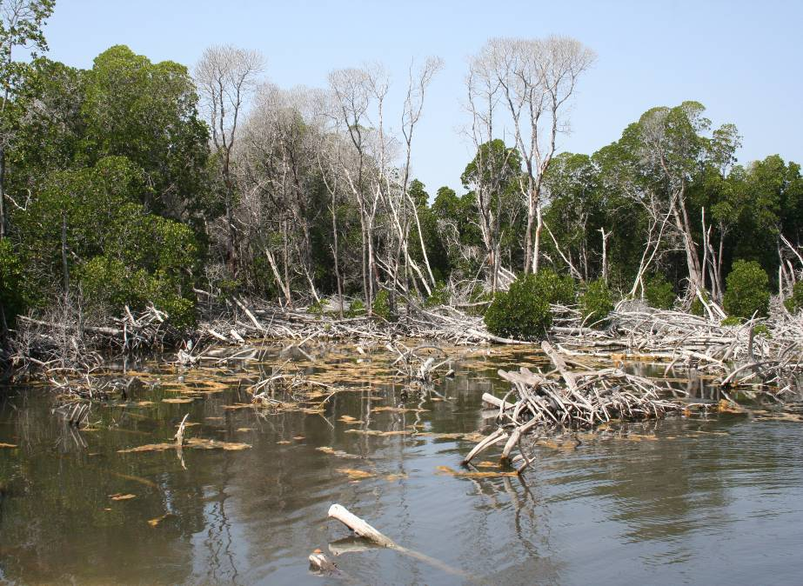The presence of invasive species weakening the fragile marine ecosystem.

**Figure 1 :** Degraded mangroves in Moucha and Maskhali (Photo from Nabil, 2009)

In the interest of better protection of this biodiversity, the ‘’ Direction de l’Aménagement du Territoire et de l’Environnement (DATE)’’ within the Ministry of ‘’ Habitat, de l’Urbanisme, de l’Environnement et de l’Aménagement du Territoire (MHUEAT)’’ developped legal basic for the establishment of the marines protected areas (MPAs) in Djibouti. The legal Act N°45/AN/04/5, promulgated in March 2004 declared the below zones as terrestrial and marines protected areas in Djibouti:

* The ‘‘Seven brothers Islands’’ as well as Ras Siyan, Khor Angar and the Godoria Forest, in the north of the Obock prefecture, which cover 20.000 ha of terrestrial area and 4,000 ha in the marine area ;
* The Moucha and Maskali Islands, in the region of Djibouti, which cover 500 ha ;
* The Haramous Islands, as well as the coast of Douda-Loyada, in the region of Djibouti, with a surface of 12,000 ha and the one of Haramous-Douda which cover 3.000 ha

Therefore, the law on the MPAs will help to protect a surface of 27,500 ha, which will contribute to the conservation the marine biodiversity in Djibouti in a very important way.

The position of the 03 MPAs as indicated on the below map can confirm the regional distribution and the representation of the MPA network in the national biodiversity resources.

**Figure 2 : Geographical location of the 3 MPAs of Djibouti**

**Sept Frères**

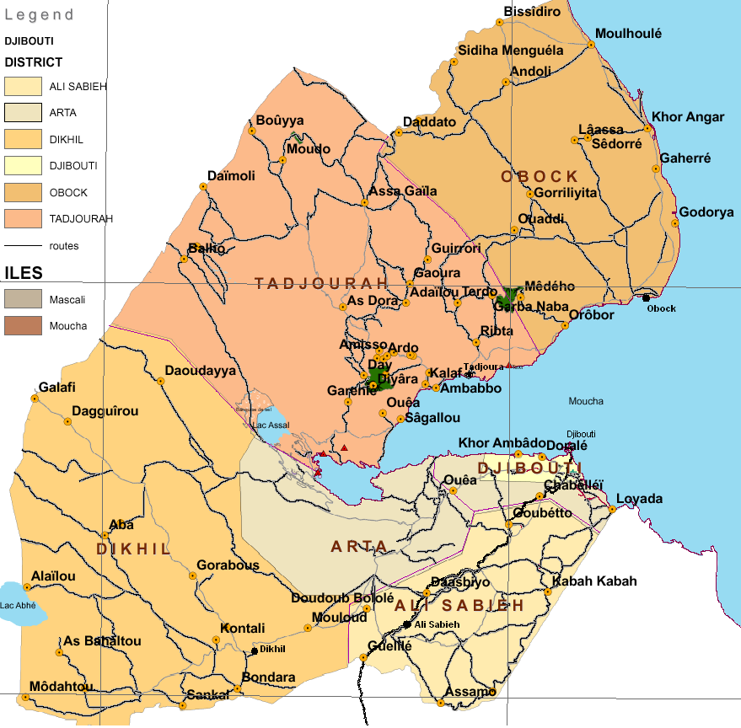

**Sept Frères**

**Sept Frères**

By establishing the MPAs, the Republic of Djibouti has established necessary basic to install a MPA’s system which should lead to a setting up of new MPA once an effective management system is in place.

## Objectifs immédiats et de développement du projet

**Aims and Objectives**

The aims of the Marines Protected Areas (MPA) project were to establish an effective management of the MPA in the Djibouti through four (04) main components inter-related.

The project should adopt a long term strategy to help Djibouti to establish its system of a MPA to protect the important the important threatened marine biodiversity and serve as precursor to establish an understandable system of management of protected areas in Djibouti as a whole. For that purpose, the objective of the project was to catalyse the institutional and financial sustainability of the marine protected areas system in Djibouti. The project also aimed to mobilise the commitment of local populations and the private sector in the management and the conservation of MPAs in Djibouti. It also considered to put into contribution expertise and technical and financial support of several national and international partners, with a particular attention on setting up mechanism of future replication of the results on national level.

## Basic indicators established

From a general point of view, a total of 18 basic indicators were established in the logical framework of the project document with four (04) linked directly to the global objective of the project. But it remains necessary to indicate that there are some errors existing between both versions French and English of the same project document (PRODOC). Firstly, the logical framework in the French version of the PRODOC contains only 11 indicators out of the 18 that exist in the English version with a gap of 07 indicators. However, the English version does not possess the component 04 of the logical framework of the French version. Therefore, the mission proceeded to a comparison and consideration of all indicators from both version of the project document (PRODOC). This has help to obtain a total of 18 indicators as indicated below per category:

**Objective of the Project: Establishing Effectively Managed Marine Protected Areas in Djibouti**

1. Surface area of 27,500 ha of MPAs effectively managed
2. Reef check surveys
3. Number of families with improved income through sustainable use of MPAs resources (English)
4. Degree of uptake of standards and code of practice by tour operators (English)

**Component 1: Policy and regulatory framework for the management of MPAs**

1. MPAs management is addressed at regular meetings of the CTE
2. Capacity development scorecard for implementation of policies increase from 6% to 50%
3. Legal delimitation and demarcation of MPAs
4. Issuance of decree of EIAs Guidelines for development activities in MPAs

***Component 2: Efficient and financially sustainable management structures of the MPAs at central and site level***

1. METT increase to average global rates of at least 40%
2. Financial sustainability scorecard increase to 50%
3. Budget appropriation and user fee system is underwritten for MPAs management
4. Issuance of decree for MPAs Fund

***Component 3: Financing for MPAs***

1. Revenues increase from sustainable use of MPAs through income generating activities
2. Number of new economic initiatives in MPAs
3. Norms and standards for nature tourism adopted by tour operators

**Component 4: Project Coordination and Management**

1. Establishment of the project management unit
2. Establishment of the monitoring/evaluation system
3. Project implementation level on the basic of annual budget and work plan

## Main stakeholders

The mains stakeholders in the current project on the MPAs are the follows:

* Environment and Territorial Planning Agency (DATE)
* National Office of site protection, environment and Tourism of Djibouti
* Studies and Research Centre of Djibouti (CERD)
* National agency for grazing and fishing
* Agriculture and forestry services
* National agency of Habitat and Urbanism
* National agency of Marines Affaires
* National agency of industrial development
* National agency of Coastal Guards of Djibouti
* Concerned decentralised regions (regional administration and local leaders)
* Development partners (GEF / UNDP, FFEM, Government of Djibouti)
* Local ONGs and CBOs
* Privates’ agencies (GOUBET, DECAN, ATTA, etc.)
* Ministry of Finances
* Local communities around the 03 MPAs.

## Expected outcomes

Les activités ci-après ont été réalisées dans le cadre du présent projet par composante :

**Component 1: Policy and regulatory framework for the management of MPAs**

* Organisation of the launching workshop of the project
* Organisation of 05 steering committee meetings
* Recruitment of a UNV for the project
* Local communities awareness meetings in 2013
* Elaboration of code of good conduct on the marines turtles and the Whale sharks
* Demarcation and installation of 05 buoys to materialise the boundaries for the MPAs
* Installation of 20 signs panels and bulwarks at MPA entrance points
* Realisation of EIA for project activities in the MPAs
* Elaboration of maps for the 03 MPAs with GIS data’s
* Proposal of new decree on the MPA validated by the steering committee (outstanding for signature in the Presidency of the Republic)

**Component 2: Efficient and financially sustainable management structures of the MPAs at central and site level**

* Acquisition of necessary equipment’s for the effective starting up of the project in the field (table 3)
* Establishment of 04 Monitoring Committee
* Establishment of 04 Wise men Committee
* Establishment of 01 regional committee at Obock for the MPAs
* Cleaning of beaches, nesting areas for the marines turtles
* Organisation of 19 training workshops with 15 in 2014 for different committees, locale populations and the eco-guards and the 03 MPA managers
* Field visit by the UNDP Representative in the 07 brothers Islands in 2014
* Training of over 85 persons on the communication strategy within the 03 MPAs
* Training of 130 persons on the good conduct code on the marines turtles and the whale sharks
* Training and awareness programme for fishermen on the sustainable use of marine resources (50 persons)
* Training on the coral reef, anchorage, use of PVC and the reports writing, piloting, navigation and first aid at sea side, mechanic for managers and eco-guards
* Organisation of regional forum on the MPA
* Elaboration of partnership document between main stakeholders

***Component 3: Financing for MPAs***

* Organisation of meetings between partners specifically the sector of tourism and fishing
* Meeting to discuss with the government on the resources mobilisation for the state counterpart

**Component 4: Project Coordination and Management**

* Recruitment of National Coordinator
* Recruitment of 03 site managers for the MPA
* Recruitment of 15 eco-guards for the MPA
* Recruitment of Driver
* Organisation of over 10 coordination meetings

# Conclusions

## 3.1 Design/Formulation of the project

### Analysis of LFA/the results (Logic/strategy of the project; indicators)

The analysis of the project logical framework was overall good. The project strategy focus on the effectiveness of the marines protected areas management and the basic systems of protected areas in the country. For many cases, the indicators work correctly, but it has to be noticed the only fact that the logic of intervention does not specify the activities to be implemented in detail per component in order to determine specifics results linked to each activity. This could help to measure the percentage of activities achieved and results obtained in each of the four specifics objectives of the MPA project.

The logical framework only provides indicators for the mains specifics objectives in general. Even relevant, but make it difficult when it comes to measure inside one specific objective the implementation rate of activities to know the results achieved.

The logic should be as follow: Main objective – specific objectives (04) – Expected results (for each specific objective) – The activities to be realised linked to each result and finally the indicators of the realisation of each activity. This is what could help to measure that a number of activities realised lead to an achievement for a specific result and correspond to one clear specific objective. However, none indication was made for the neither expected results, nor activities to be realised in the logical framework. Nevertheless, it is important to indicate that the literature of the English version of the project document provide indication of results expected per component while the French version is indicating the sub-component, which is likely to be a miss interpretation or translation of the original version.

It is important to note that the chronogram of the activities was completely omitted in the PRODOC which could not facilitate the work for the project management team

### Hypotheses and risks

In the design of the project, six hypotheses and risks were formulated around the four specific objectives of the project. Amongst these hypothesis, only three has been materialised, which are:

1. Stability is maintained in the country and MPAs
2. Council of Ministers approves the request to concede public land for MPAs (similarly to the case of the DECAN Animal Refuge land of 30 ha)
3. Central and local authorities continue to cooperate on MPAs management

The other four hypotheses remaining did not occur and it explains a bit the overall situation of the project with regard to achievement:

1. Government approves allocation of user fees for MPAs management
2. An MPAs Fund is negotiated similarly to the “Fond d’Entretien Routier”
3. Private sector is committed to corporate environmental responsibilities
4. Continue monitoring and evaluation

Up to the closing date of the project, the Decree on the MPAs’ was not signed; the fund for MPA uninitiated, the private sector still hesitating on its commitment and the monitoring/evaluation is insufficient. Despite of the will of the project team and the local community with regards to the project achievement, no strategy or measure is taken to ensure the profit of the project is sustainable after the end of the project, unless a second phase of the project is set up. Some measures should be taken to ensure the transition phase between the end of the project and the beginning of the second phase.

### Lessons learned from other relevant project (par example, in the same domain, same focal area) incorporated in the project design

The project document indicates clearly that the results will be disseminated beyond the project area of intervention through forums and existing information sharing network. The area of environment being still embryonic in Djibouti, the project will have to participate various network of UNDP/GEF, in particular its senior staff for sharing experiences with other project in the same focal domains. Identify, analyse and share lessons learned remains beneficial for the design and implementation of other project in the future. A support from UNDP/GEF is necessary to document learned lesson per category.

### Participation of planned stakeholders

The keys stakeholders planned to participate to current project include: DATE, PERSGA, CERD, ADDS, UNDP/GEF, tourism services, fishing and aquaculture, industrial development, le government, Ministry of Finance, the marines affaires agency, decentralised administration, local NGOs and the local communities around the 03 MPAs. The majority of these stakeholders were involved in the implementation of the project and some of them were even member of the steering committee. This is the case for the GOUBET Agency and DECAN Agency both private operators.

However, certain key stakeholders were not very active such as we expected from them. This is the case with PERSGA, ADDS, CERD and specifically the National agency of fishing who observed some distance from the project certainly due to insufficient communication with the department of environment. All the local communities participated to the project activities even if the communication with prefectures and decentralise authorities were insufficient.

### Approach de replication

The MPA project can be replicated with a possibility of extending its activities to other important marine areas in the country. This appear to be possible in a way that the locale communities and authorities expressed even the establishment of new marines protected areas in the area of Sagallou, Gulf of Ghoubbet and white sand at Raissali. This should facilitate the replication of the MPA project for a better conservation of aquatic resources of the country. Therefore, it is important to remind here that the Government should concretise its political will expressed at the signature of the PRODOC by making available its contribution in cash as well as news financial resources for the protection of new MPAs of the country.

### Comparative advantage for UNDP

The project has double comparative advantage linked to this project. Firstly, UNDP support populations to take their responsibilities to fight the poverty and degradation of the mangrove and unsustainable use of aquatic resources in a country the human development indices remains one of the lowest in the world. The project is a relevant example to making the population to face their responsibilities which is to take care of their own future and use rationally resources that they have in a very sustainable manner for the well-being of all generation. Therefore, a particular accent should be made for incomes generation activities in futures project.

### Links between the project and others interventions within the sector

The Republic of Djibouti through the establishment of the MPAs has raised critical problems which the population are facing but also many actors whose intervene in the sector. The crossed interests of the actors of tourism with those of fishery and those who are concerned by the sea traffic had become a real headache for the country and the population living under extreme poverty. The project on the MPA was very positive despite of some obstacles on its course, but allowed an awakening of the consciousness’s at the level of all the stakeholders. Better regulations remain crucial for all the parties, to reduce the risks of harmful disasters to all. The MPA project has therefore become a model despite the slowness in the realisation of the various commitments. Despite some difficulties the MPA project becomes an example in the mobilisation of several stakeholders and partners in its transversal rules from the top to the bottom.

### Management modalities

The management of the project is ensured by the Ministry of habitat, urbanism, environment and the territorial planning (MHUEAT), more specifically by the environment and territorial planning agency (DATE) and by national execution (NEX) method. The project is directly managed by a co-ordinator who is responsible for the coordination of aspects of logistic, administration of the project including monitoring and the evaluation. In the field; the MPA project team is responsible for activities at MPA level under the responsibility of the site manager.

## 3.2 implementation of the project

### Adaptive management (modifications to the project design and result during the implementation)

From an overall point of point of view, there was no major modification to the project document design as well as to the expected results during the implementation. Despite the delay before the launching of the project, it has no incidence on the strategic orientation of the project likely to bring a modification

However, it is important to notice that the unavailability of the government’s financial resources has created a necessity for a slightly modification of the budget in order to implement the activities, specifically the acquisition of equipment’s and materials that was planned.

### Accords de partenariat (avec les parties prenantes pertinentes impliquées dans le pays/la région)

A document of partnership agreement was established between different main stakeholders, in particular between the DATE, CERD and the tourism and fishery technical services. But the level of effective implementation of this partnership agreement is very low with regards to limited number of meeting organised and decisions taken together. There are even difference of opinion between the national agency responsible for the fishing sector and the one responsible for the environmental protection due to insufficient or deficit of communication.

### Commentaires provenant des activités de suivi et d’évaluation utilisés dans le cadre de la gestion adaptative

As indicated in the previous section, there was no major change or modification that could necessity a particular monitoring and evaluation with the adaptive management framework.

### Financing of the project

Conformément au financement prévu pendant la conception du projet, le tableau ci-dessous donne une indication des différents financements mobilisés par donateur.

**Tableau 3: Funding really obtained**

|  |  |  |  |  |  |  |  |  |  |  |
| --- | --- | --- | --- | --- | --- | --- | --- | --- | --- | --- |
| Co-financing  (type / source) | GEF (USD) | | PNUD (USD) | | Government | | Others | | Total (USD) | |
| Planed | Real | Planed | Real | Planed | Real |  |  | Planed | Real |
| Grants | 980 000 | 980 000 | 200 000 | 200 000 | 200 000 | 0 | 120 000 | 120 000 | 1 500 000 | 1 300 000 |
| Loan |  |  |  |  |  |  |  |  |  | 0 |
| Support in king |  |  |  |  | 200 000 | 200 000 | 300 000 | 300 000 | 500 000 | 500 000 |
| Other |  |  |  |  |  |  |  |  |  |  |
| **Total** | **980 000** | **980 000** | **200 000** | **200 000** | **400 000** | **200 000** | **420 000** | **300 000** | **2 000 000** | **1 800 000** |

**N.B**. It emerges from this table that the (**USD 200 000**) of financial contribution expected from the government was not mobilised which created a concentration of effort on the external donor funding. As so, the implementation of the budget is presented in the table below with an indication of the rate expressed in percentage component by component.

**Table 4 : Budgetary implementation rate (percentage of disbursements) per component**

|  |  |  |  |
| --- | --- | --- | --- |
| **Component** | **Budget (initial)** | **Expenses** | **%** |
| Political and legal frame | 138 000 | 174 564 | 126 % |
| Management structures | 480 500 | 653 783 | 136 % |
| Financing for the MPAs | 396 500 | 7 923 | 02 % |
| Management and coordination of the project | 165 000 | 126 626 | 77 % |
| **Total** | **1 180 000** | **962 896** | **85 %** |

**N.B:** This table does not take into consideration nether the contribution of $US 120 000 from PERSGA, nor contribution in king. Here is only the financing from UNDP and GEF.

### Monitoring and evaluation: Design at entry (*), Implementation (*), and global evaluation (*)

During the design of the project document, it has been indicated (page 5 of the English version) that the programmes of meetings for reviewing will be developed by the project management unit in consultation with implementing partners et representatives of stakeholders and included in the project launching report. The document should have to include (i) the chronogram of the steering committee meeting and (ii) the project monitoring and evaluation activities. The daily monitoring of the project should be under the responsibility of manager based on annual work plan (PTA) and the indicators. However, the implementation presented really a very different view which began with deadly delay in an effective launching the project which happen only a year later due to lack of financial resources not available, with no monitoring plan for the indicators. With regards to this situation and in the absence of monitoring and evaluation specialist in the project team but also insufficient clear information programme for monitoring and evaluation, it was difficult for the project coordinator to ensure a better monitoring of the project activities. Nevertheless, the project implementation review indicated a satisfactory progress in the implementation of activities in his report during the 4th years in 2014. But, after the departure of the UNV in the beginning of the 2015, last year of the project, the activities remained static. On the other hand, the mid-term evaluation and the final evaluation are clearly designed in the PRODOC.

Summary, the mission of the project evaluation has granted the mark of MODERATELY SATISFACTORY to the design of the monitoring and evaluation of the project. The mark would have been higher to this if the project team has presented a plan and monitor to each of the indicator.

### Coordination of the implementation and execution with UNDP (*) and the implementing partner (*) and operational questions.

The Ministère de l’habitat, de l’urbanisme, de l’environnement et de l’aménagement du territoire (MHUEAT) was the implementing agency of the project. Under national execution (NEX) the ministry through the DATE was responsible for the coordination on the implementation and execution of the project. The coordination with other national partners has face difficulties with regards to lack of resources mobilisation on one hand and on the other hand to a deficit of communication

The recruitment of the UNV helped to boost the implementation of the project in an operational way with some key important progress. But unfortunately, at the end of the contract for the UNV because of lack of financial resources not mobilised the operations of the project remained static.

The terminal evaluation has granted the mark of MODERATELY SATISFACTORY to this section.

## 3.3 Results of the project

### Global results (realisation of objectives) (*)

The main objective of the project was to establish effectively managed marine protected areas in Djibouti. This objective is granted with a mark of MODERATELY SATISFACTORY.

The main indicator which the Decree on the MPAs, despite its approval by the steering committee, is still not approved by the government and remains not signed as well as the application (implementation) of the new code of conduct neither on the marine’s turtles nor on the whale sharks. But the mission granted a mark of SATISFACTORY the demarcation and materialisation of the MPAs’ boundaries as well as the many training organised for the stakeholders and the project team.

Therefore the first specific objective (component 1) was granted with a mark of MODERATELY SATISFACTORY for all the efforts maded and indicated in the previous paragraph.

The second specific objective (component 2) has receive a mark of MODERATELY SATISFACTORY because of the efforts made by the project team, the decree on the MPA haven’t been signed and with any available source of sustainable resources for the MPA haven’t been explored or established it is not possible to say that financing of MPA could be guarantee for long term.

The 3rd specific objective (component 3) receive the same mark of MODERATELY SATISFACTORY as well as the first two previously. Because the insufficient collaboration with local and central authorities and the private sector still remaining undecided with regard to its commitment and responsibilities. In addition, no income generating activities was developed for the local communities even not initiated at indicated in the PRODOC.

Le 4th specific objective (component 4) is the only one that receives the mark of SATISFACTORY because of effort made by the project team as well as the partners involved in the implementation of the project. Despite the delay in launching the project, the staffs was recruited, the project management unit established with effort to monitor in the field which has led to the project implementation review by UNDP. For this raison, it is important that UNDP increase the number of its field visit for monitoring project in the field.

### Relevance (*)

In term of relevance, the terminal evaluation mission verified the measure in which the project is in phase with the main objective of the operational/strategic programme of GEF and the local, national and regional environmental priorities. The operational programme of the concerned GEF is the conservation of biodiversity.

The strategy is to support an effectively managed system of marines protected areas and the consideration the environmental and energetic dimensions in the process of the country development.

Therefore, the project is truly RELEVANT

### Effectiveness and efficiency (*)

The effectiveness as indicated previously was determined by assessing the measures in which the results and the objectives were achieved. Therefore, according to discussions, the mark MODERATELY SATISFACTORY of was granted to this part.

### Efficiency (*)

For the efficiency, after evaluation as indicated above was also granted the mark of MODERATELY SATISFACTORY with regards to important efforts made by the project team during a very short term of time to achieved certain keys expected outcomes despite the delay encountered and the insufficient financial resources, as well as monitoring of international standard in the project implementation.

### Ownership by the country

Despite some efforts made, the ownership of the country is not still really effective and need some time and support through the establishment of communication strategy towards all stakeholders to facilitate this process in a local and national level. This will begin firstly by the signature of the decree on the MPA to start with real acknowledgment by the State and make legal all new provisions for the MPA in the law.

### Integration

The project corresponds perfectly with the UNDP programme as agree and signed with the government of Djibouti and is a well-integrated project involving on one hand the problems of fighting against the extreme poverty of the populations and the conservation of the biodiversity. This integrate also itself with the governance, prevention of natural disasters and the aspect gender (equity man-woman)

### Sustainability: financial resources (*), socio-politic (*), governance and institutional frame (*), environment (*), and global probability of sustainability (*)

The sustainability should simultaneously study questions of capacities, financing and institutional as well as the ownership of the gains and impacts by the project stakeholders. Four criteria was used to evaluate the sustainability: capacities of stakeholders, economic and financial mechanism in place to ensure the continuation, establishment or existence of elements of organizational measure to continue to take their responsibilities and the legal framework to ensure that the impacts of the project can continue.

Therefore, it is indicated that at local level, the monitoring committees, the wise men and regional committees was set up but does not have sufficient capacities to become and work autonomously. The private sector organisation does not have concrete commitment to face the situation and the legal framework is not totally established.

### Impact

Concerning the impact, some factors has annoyed the impact of the project to be more tangible and more visible in a short term time:

* Ownership of the project by all national stakeholders still not effective,
* Important document elaborated by the MPA project (Decree) not approved by the government

Nevertheless, with the willingness of all stakeholders, the benefices are enormous and the impacts in long term time will be more visible. Through the GEF financing, the MPA system in Djibouti will be strengthened with effective management and sustainable financially in a MPA network level which cover up to 27,500 ha. This will be followed by political measures necessary for urgent and proprietary decisions making linked to problems that threats the MPAs. In addition the project will directly contribute to ensure the global environmental benefices through many urgent and strategic measures that can remediate to the pressures threatening the MPAs in Djibouti.

The much important contributions of the project to the global environmental benefices are the follow:

1. Reduce the pressure of threats on the biodiversity within the MPAs.
2. Improve the status of biodiversity in the MPAs
3. Strengthen the national management capacities of pressures on biodiversity.

# Conclusion, recommendations and learned lessons

**Table 5:** General marking of the evaluation

|  |  |  |  |
| --- | --- | --- | --- |
| **Marks of the evaluation :** | | | |
| **1 Monitoring & evaluation** | ***Mark*** | **2 Implementing agency*/agency of realisation*** | ***Mark*** |
| Design of monitoring and evaluation at entry | **MS** | Quality of implementation by UNDP : realisation agency | **MS** |
| Implementation of the monitoring and evaluation plan | **MS** | Quality of the implementation : implementing agency | **MS** |
| General quality of the monitoring and evaluation | **MS** | General quality of the implementation and realisation | **MS** |
| **3 Evaluation des results** | ***Notation*** | **4 Sustainability** | ***Notation*** |
| Relevance | **P** | Financial resources | **MS** |
| Effectiveness | **MS** | Socio-politic | **MS** |
| Efficiency | **MS** | Governance and institutional framework | **MS** |
| General mark of the project realisation | **MS** | Environmental | **MS** |
|  |  | General probability of sustainability | **MP** |

After analyses of the various collected data, the mission has made general conclusions and the following recommendations:

## Mesures correctives pour la conception, la mise en œuvre, le suivi et l’évaluation du projet

1. At its design, the project planned only for 03 MPA but it should be important to consider all the other 03 MPAs sites (Ghoubet gulf, Sagallou et Raissali/white sand) with regard to the current situation and the importance of aquatic species as well as increasing threats to the biodiversity of these other three high interest for conservation in the country ;
2. UNDP/GEF should consider the possibility of extending this project in order to capitalise the results for sustainability and extend the project to the other 03 news MPAs indicated previously where the marine biodiversity is threatened as well as terrestrial biodiversity as possible ;
3. The establishment of a monitoring/evaluation will be a major importance to ensure regular monitoring of indicators in the logical framework to make sure that the project could realise its expected results ;
4. In line with the same idea, plan a IEC unit (information-Education-Communication) remains very important to ensure a better visibility of UNDP/GEF actions and ensure a good communication between the various stakeholders ;
5. UNDP should become actively involved in the implementation of projects through :
   1. The recruitment and establishment under UNDP responsibility of project technical staff (National Coordinator, Finance Manager, National Experts, etc. ) with clear term of reference and obligation of results ;
   2. The recruitment of an International Technical Advisor to organise, co-ordinate and ensure better monitoring of all project activities ;
6. Establish a real capacity building programme for the Environmental Agency (evaluate the needs in terms of human resources, equipment’s, training modules, place and mode of training per category of staff member, plan new organisational chart, etc.) ;
7. Support the institutional governance, ensure better synergy between stakeholders and make sure that the political will expressed by the Government during the design of this project is realised through more mobilisation of financial resources specifically at national level for the protection of marines protected areas (MPAs) as well as all others sites with high biodiversity conservation value ;
8. Undertake all necessary measures to ensure the payment of the $US 200 000 planned by the Government as its co-financing in cash.

## Measures to ensure the sustainability or strengthen the initial advantages of the project

1. Organisational and regulatory measures in order to make autonomous and sustainable all the monitoring and wise men committees that was establish in the surrounding communities of the MPAs. These established committees need a clarified term of reference and technical support to become really operational ;
2. In all MPAs, the Eco-guards has been established without any status nether mandate legally recognised, despite efforts they made. Therefore, it should be important to work actively with the Government in order to set up a particular status for these Eco-Guards (per example : paramilitary status and integrated them to the public labour work within the Ministry of Environment ;
3. Provide support to indigenous populations living around the MPAs through setting up and development of livelihoods or income generating activities in the local communities ;
4. Facilitate training of local community leaders on the importance of MPAs and species with high conservation value ;
5. Establish a governance framework where all stakeholders should meet and discuss issues related to institutional and resources mobilisation questions for long term period, specifically for the sectors of tourism, fishing, marine, costal guards, environment and others private partners ;
   1. **Measures concerning future orientation in favour of the main objectives :**
6. Set up a real institutional, technical and financial capacity building programme for the environmental agency (DATE) to become able to answer efficiently to its mission ;
7. The validation and the operationalization of the new code of conduct that was elaborated by the MPA’s project on the sharks and marines turtles remains necessary to use the document as basic for all operators specifically in the tourism and fishing sector to reduce threats on these two species ;
8. The new fishing code should also be approved and validated by the concerned authority in order to ensure rational and sustainable management of resources in this sector ;
9. It will be important at any case tout establish a regulatory framework to facilitate the creation of community associations (community based organisations – CBO) and make them working in an autonomous manner and ensure sustainability of gains of this project. The project should support these CBO in obtaining their status, internal rules and regulations and agreement with the concerned authority at the state level ;
10. Organise a national workshop on the MPAs inviting all stakeholders and arouse interest in establishing special funds dedicated to the conservation of MPAs ;
11. Organise as soon as possible a meeting with all stakeholders and the MPAs managers in order to establish measures in favour of project gains for MPAs and reflexion on modalities of conflict resolutions around different interests (tourism-fishing-environment)
    1. **Best and worse practices during processing of questions concerning the relevance, the performance, the efficiency, the effectiveness, the sustainability and the impact :**

Concerning the relevance, the MPA project correspond perfectly to locales and national priorities in conformity to social development initiatives settled up in 2007 by the Government which are also defined in the country development plan through the « **Vision Djibouti 2035** ». the operationalization of this vision being made by successive five years plans, the project is also line with the first five years plans which is the SCAPE (2015-2019), adopted in August 2015.

Also United Nations (UN) agencies working in Djibouti made a commitment to implement this plan and support the governmental effort in the implementation of its national priorities through strategic plan developed by UNDP and approved during the mid-term review of the country programme. The project is in sync with the second component of the UNDP’s actions plan in the country programme signed with the Government of Djibouti in 2013 with the framework of the Djibouti vision 2035.

This programme, which aims to provide integrated and sustainable responses to the challenges of poverty and environment, fits perfectly within the framework of INDS objectives. This programme is also on the UNDAF and the Action Plan of the Country Programme which retained environment as transversal domain.

Concerning the conformity with the **GEF operational programme or with the strategic priorities** in which it was funded, the project focus on the GEF global environmental which aims the conservation of marine biodiversity in the territorial sea of Djibouti, in order to strengthen the system of marine protected areas.

# Annexes

## Termes de Références de l’évaluation finale du projet AMP

INTRODUCTION

Conformément aux politiques et procédures de suivi et d’évaluation du PNUD et du FEM, tous les projets de moyenne ou grande taille soutenus par le PNUD et financés par le FEM doivent faire l’objet d’une évaluation finale à la fin de la mise en œuvre. Ces termes de référence (TOR) énoncent les attentes d'une évaluation finale (TE) du Projet d’Aires Marines Protégés (AMP).

Tableau de résumé du projet

|  |  |  |  |  |  |  |
| --- | --- | --- | --- | --- | --- | --- |
| Titre du projet : |  | | | | | |
| ID de projet du FEM : | | 3216 (PMIS#) |  | | *à l’approbation*  *(USD)* | *à l’achèvement (USD)* |
| ID de projet du PNUD : | | 00071584 (Atlas#)  4049 (PIMS#) | Financement du FEM : | | 980.000 | 980.000 |
| Pays : | | Djibouti | Financement de l’agence d’exécution/agence de réalisation : | | 200.000 | 200.000 |
| Région : | | RBAS | Gouvernement : | | 400.000 | 200.000 |
| Domaine focal : | | Biodiversité | Autre : | | 420.000 | 420.000 |
| Objectifs FA, (OP/SP) : | | Biodiversité | Cofinancement total : | | 1.020.000 | 820.0000 |
| Agent d’exécution : | | MUHE | Coût total du projet : | | 2.00.0000 | 1.800.000 |
| Autres partenaires participant au projet : | |  | Signature du DP (Date de début du projet) : | | | 09/02/2010 |
| Date de clôture (opérationnelle) : | Proposé :  31/12/2015 | | Réel :  31/12/2015 |

Objectif et portée

Djibouti a fait de la préservation de l’environnement une priorité soutenue par des engagements à l’échelle nationale et internationale qui, se sont traduits, ces dernières années, par l’adoption de texte de lois et d’outils institutionnels ainsi que la ratification de plusieurs Conventions Internationales. Toutefois, l’application effective de cet arsenal juridico institutionnel souffrirait de certaines contraintes dont entre autres : l’insuffisance des ressources humaines et matérielles, la faiblesse du mécanisme de coordination et de mobilisation des parties prenantes.

La biodiversité marine a Djibouti  est très riche, Djibouti  abrite cinq espèces de tortues marines, la baleine à bosse (Megaptera novaeangliae) et la Baleine bleue (Balaenoptera musculus) se trouvent également dans les eaux du Djibouti, ainsi que les requins baleines (rhincodon typus) d’autres espèces marines d'intérêt spécial tel que le Dugong (Dugong dugon). Le pays possède aussi des récifs coralliens ainsi qu’une mangrove d’importance globale pour la biodiversité.

Des menaces importantes sont identifiées au niveau de la biodiversité marine à Djibouti et incluent :

* dégradation de la zone côtière due à la construction intensive, aux déchets solides et aux rejets liquides menacent le récif corallien, les mangroves et l’équilibre de l’écosystème marin
* pêche intensive et illégal pratiquée (bateaux étrangers, pêcheurs Yéménites et Somaliens) menacent la population de requins, la population d’holothurie, la population de tortue de mer et la biodiversité marine
* dégradation marine due au trafique marin commercial et aux bateaux de plaisance menacent le récif corallien, les mangroves et l’équilibre de l’écosystème marin
* ensablement des dunes menant a la disparition de la mangrove
* espèces envahissantes (rats, prosopice, étoiles de mer, chiens) fragilisent l’écosystème marin

Le projet Aires Marines Protégées (AMP) vise à établir une gestion efficace des Aires Marines Protégées (AMP) à Djibouti s’articulera sur 4 composantes inter-reliées. La durée prévue du projet est de 5 ans, et mettra à contribution l’expertise et le soutien technique et financier de plusieurs partenaires nationaux et internationaux, avec une attention particulière à la création de mécanismes de réplication future des résultats à l’échelle nationale.

**Composante 1: Cadre légal et politique des Aires Marines Protégées (AMP)**

Cette composante permettra aux institutions concernées par la gestion des AMP à Djibouti d’établir des mécanismes institutionnels et la coordination intersectorielle DES activités de développement, notamment celles qui pourraient menacer la biodiversité marine et les AMP, telles que les projets de construction, de développement de tourisme et de trafic marin. La Délimitation et démarcation des AMP, l’appui technique aux études d’évaluation de l'impact sur l'environnement des activités dans les AMP, la pêche illégale et le trafic maritime constituent un volet important de cette composante

**Composante 2: Structures de gestion efficace et financièrement durable des AMP au niveau central et local**

Cette composante permettra à la DATE d’établir les structures de gestion nécessaires aux deux niveaux central et local, assurant la gestion efficace et la durabilité financière des 3 AMP. La mise en place des équipe des opérationnelles de suivi au niveau central et local, la formulation des plans de gestion, et les mesures prioritaires pour la conservation de la biodiversité ont partie de cette composante.

**Composante 3: Financement pour les AMP**

Ce volet apportera appui à l’implication active des communautés locales dans un système participatif permettant un accès direct et l’appropriation des ressources. L’autonomisation des communautés locales pour leur permettre d’identifier et mettre en œuvre les actions génératrices de revenu en se basant sur l’utilisation durable des ressources des AMP. Des mécanismes de partenariat entre les deux secteurs privé et public sont également privés.

**Composante 4: Coordination et gestion du projet**

Le Projet est mis en œuvre par le Ministère de l'Habitat, de l'Urbanisme, de l'Environnement et de l'Aménagement du Territoire (MHUEAT), notamment sa Direction de l’Aménagement du Territoire et de l’Environnement (DATE). Une coordination étroite avec les ministères impliqués dans les AMP, tels que les Ministères de Tourisme, Agriculture et les Force Maritime Nationale, sera implorée. Le programme sera géré par une Unité de Gestion du Projet qui sera responsable de la coordination, et les aspects logistiques et administratifs du Projet, dont la surveillance et l’évaluation.

L’évaluation finale sera menée conformément aux directives, règles et procédures établies par le PNUD et le FEM comme l’indique les directives d’évaluation du PNUD pour les projets financés par le FEM. Elle portera sur le volet les aires marines protégées. Les objectifs de l’évaluation consistent à apprécier la réalisation des objectifs du projet et à tirer des enseignements qui peuvent améliorer la durabilité des avantages de ce projet et favoriser l’amélioration globale des programmes du PNUD.

Approche et méthode d'évaluation

Une approche et une méthode globales[1] pour la réalisation des évaluations finales de projets soutenus par le PNUD et financés par le FEM se sont développées au fil du temps. L’évaluateur doit articuler les efforts d’évaluation autour des critères de **pertinence, d’efficacité, d’efficience, de durabilité et d’impact**, comme défini et expliqué dans les [directives du PNUD pour la réalisation des évaluations finales des projets soutenus par le PNUD et financés par le FEM](http://web.undp.org/evaluation/documents/guidance/GEF/GEF-TE-Guide_FRE.pdf). L'évaluateur doit développer une série de questions spécifiques couvrant chacun de ces critères en déclinant la liste générique dans l'Annexe C de ces termes de référence, suite à des consultations avec le bureau d pays du PNUD et le Conseiller Technique Régional PNUD-FEM , et soumettre le tableau dans le cadre de la méthodologie proposé ainsi que dans le rapport initial d'évaluation et le rapport final en annexe

* L’évaluation doit fournir des informations factuelles qui sont crédibles, fiables et utiles. L’évaluateur doit adopter une approche participative et consultative garantissant une collaboration étroite avec les homologues du gouvernement, en particulier avec le point focal opérationnel du FEM, le bureau de pays du PNUD, l’équipe chargée du projet, le conseiller technique du PNUD-FEM et les principales parties prenantes. L'évaluateur devrait effectuer une mission sur le terrain à Djibouti y compris aux différentes sites du projet et zones protégées*.* Les entretiens auront lieu au minimum avec les organisations et les particuliers suivants :
* PNUD : Représentant Résident, DRR, l'Unité Environnement et le Conseiller Technique Régional du FEM
* L’agence d’exécution : directeur, experts, unités concernées
* L’équipe du projet, le chef de projet, l'équipe technique et administrative.
* Les ministères/départements clés  du gouvernement (Agriculture, Transport, Tourisme etc…)
* Le comité de pilotage
* Le point focal opérationnel du FEM
* Les ONG et les communautés engagées dans le projet :
* Le CERD
* Les opérateurs dans le secteur du tourisme

L’évaluateur passera en revue toutes les sources pertinentes d’information, telles que le descriptif de projet, les rapports de projet, notamment le RAP/RMP et les autres rapports, les révisions budgétaires du projet, l’examen à mi-parcours, les rapports sur l’état d’avancement, les outils de suivi du domaine focal du FEM, les dossiers du projet, les documents stratégiques et juridiques nationaux et tous les autres documents que l’évaluateur jugera utiles pour cette évaluation fondée sur les faits. Une liste des documents que l’équipe chargée du projet fournira à l’évaluateur aux fins d’examen est jointe à l’annexe B des présents termes de référence.

Critères d'évaluation et notations

Une évaluation de la performance du projet, basée sur les attentes énoncées dans le cadre logique/cadre de résultats du projet (Annexe A) qui offre des indicateurs de performance et d’impact dans le cadre de la mise en œuvre du projet ainsi que les moyens de vérification correspondants, sera réalisée. L’évaluation portera au moins sur les critères de **pertinence, efficacité, efficience et durabilité.** Des notations doivent être fournies par rapport aux critères de performance suivants. Le tableau rempli doit être joint au résumé d’évaluation. Les échelles de notation obligatoires sont inclus dans l'annexe D.

|  |  |  |  |
| --- | --- | --- | --- |
| **Notes d'évaluation :** | | | |
| **1 Suivi et évaluation** | ***Notation*** | **2 A*gence d’exécution/agence de réalisation*** | ***Notation*** |
| Conception du suivi et de l’évaluation à l’entrée |  | Qualité de la mise en œuvre par le PNUD : agence de réalisation |  |
| Mise en œuvre du plan de suivi et d’évaluation |  | Qualité de l’exécution : agence d’exécution |  |
| Qualité globale du suivi et de l’évaluation |  | Qualité globale de la mise en œuvre et de l’exécution |  |
| **3 Evaluation des résultats** | ***Notation*** | **4 Durabilité** | ***Notation*** |
| Pertinence |  | Ressources financières |  |
| Efficacité |  | Sociopolitique |  |
| Efficience |  | Cadre institutionnel et gouvernance |  |
| Note globale de la réalisation du projet |  | Environmental |  |
|  |  | Probabilité globale de la durabilité |  |

Financement/cofinancement du projet

L’évaluation portera sur les principaux aspects financiers du projet, notamment la part de cofinancement prévue et réalisée. Les données sur les coûts et le financement du projet seront nécessaires, y compris les dépenses annuelles. Les écarts entre les dépenses prévues et réelles devront être évalués et expliqués. Les résultats des audits financiers récents disponibles doivent être pris en compte. Les évaluateurs bénéficieront de l’intervention du bureau de pays (BP) et de l’équipe de projet dans leur quête de données financières pour compléter le tableau de cofinancement ci-dessous, qui sera inclus dans le rapport d’évaluation finale.

|  |  |  |  |  |  |  |  |  |
| --- | --- | --- | --- | --- | --- | --- | --- | --- |
| Cofinancement  (type/source) | Propre financement du PNUD (en millions USD) | | Gouvernement  (en millions USD) | | Organisme partenaire  (en millions USD) | | Total  (en millions USD) | |
| Prévu | Réel | Prévu | Réel | Prévu | Réel | Prévu | Réel |
| Subventions |  |  |  |  |  |  |  |  |
| Prêts/concessions |  |  |  |  |  |  |  |  |
| * Soutien en nature |  |  |  |  |  |  |  |  |
| * Autre |  |  |  |  |  |  |  |  |
| Totaux |  |  |  |  |  |  |  |  |

Intégration

Les projets financés par le PNUD et soutenus par le PNUD sont des éléments clés du programme de pays du PNUD, ainsi que des programmes régionaux et mondiaux. L’évaluation portera sur la mesure dans laquelle le projet a été intégré avec succès dans les priorités du PNUD, y compris l’alignement sur le Plan Stratégique, l’atténuation de la pauvreté, l’amélioration de la gouvernance, la prévention des catastrophes naturelles et le relèvement après celles-ci et la problématique hommes-femmes.

Impact

Les évaluateurs apprécieront dans quelle mesure le projet atteint des impacts ou progresse vers la réalisation de ceux-ci. Parmi les principales conclusions des évaluations doit figurer ce qui suit : le projet a-t-il démontré: a) des progrès vérifiables dans l'état écologique, b) des réductions vérifiables de stress sur les systèmes écologiques, ou c) des progrès notables vers ces réductions d'impact. [2]

Conclusions, recommandations et enseignements

Le rapport d’évaluation doit inclure un chapitre proposant un ensemble de conclusions, de recommandations et d’enseignements.

Modalités de mise en oeuvre

La responsabilité principale de la gestion de cette évaluation revient au bureau de pays du PNUD à Djibouti et au gouvernement. Le bureau de pays du PNUD ou le gouvernement contactera les évaluateurs en vue de garantir le versement en temps opportun des indemnités journalières à l’équipe d’évaluation et de finaliser les modalités de voyage de celle-ci dans le pays. L’équipe de projet sera chargée d’assurer la liaison avec l’équipe d’évaluateurs afin d’organiser des entretiens avec les parties prenantes et des visites sur le terrain, ainsi que la coordination avec le gouvernement, etc.

Calendrier d’évaluation

L’évaluation durera au total 14 jours ouvrables selon le plan suivant :

|  |  |  |
| --- | --- | --- |
| **Activité** | Durée | Date d’achèvement |
| **Préparation** | 03 jours | *Fevrier 2016* |
| **Mission d’évaluation** | 7 jours | *fevrier 2016* |
| **Projet de rapport d’évaluation** | 02 jours | *fevrier 2016* |
| **Rapport final** | 2 jours | *Fevrier 2016* |

Produits livrables en vertu de l'évaluation

Les éléments suivants sont attendus de l’équipe d’évaluation :

|  |  |  |  |
| --- | --- | --- | --- |
| Produits livrables | Table des matières | Durée | Responsabilités |
| **Rapport initial** | L’évaluateur apporte des précisions sur le calendrier et la méthode | Au plus tard deux semaines avant la mission d’évaluation. | L’évaluateur envoie au BP du PNUD |
| **Présentation** | Conclusions initiales | Fin de la mission d’évaluation | À la direction du projet, BP du PNUD |
| **Projet de rapport final** | Rapport complet, (selon le modèle joint) avec les annexes | Dans un délai de trois semaines suivant la mission d’évaluation | Envoyé au BP, examiné par le CTR, le service de coordination du programme et les PFO du FEM |
| **Rapport final\*** | Rapport révisé | Dans un délai d’une semaine suivant la réception des commentaires du PNUD sur le projet | Envoyé au BP aux fins de téléchargement sur le site du CGELE du PNUD. |

*Lors de la présentation du rapport final d’évaluation, l’évaluateur est également tenu de fournir une « piste d’audit », expliquant en détail la façon dont les commentaires reçus ont (et n’ont pas) été traités dans ledit rapport.

Composition de l'équipe

L'équipe d'évaluation sera composée d'un évaluateur international qui possède une expérience antérieure. Le consultant sélectionné ne doit pas avoir participé à la préparation ou à la mise en œuvre du projet et ne doit pas avoir de conflit d’intérêts avec les activités liées au projet.

L’évaluateur international  aura la responsabilité générale pour l’évaluation finale et pour la production des résultats attendus. Il/elle rapportera techniquement et administrativement au bureau du PNUD à Djibouti.

* Sera responsable des taches suivantes :
  + guider et gérer l’évaluation y compris la mission de terrain, en coordination avec le bureau pays du PNUD et l’équipe de projet ;
  + assurer que l’évaluation satisfait les standards pour les évaluations finales du PNUD-FEM dans toutes les dimensions ;
  + définir la méthodologie de l'évaluation (collecte et analyse de données, etc.) ;
  + préparer le projet de rapport début
  + définir la division du travail dans l'équipe d'évaluation ;
  + diriger les entretiens et les analyses pertinentes (sur la stratégie, les résultats atteints, partenariats, etc.) ;
  + préparer la présentation des résultats provisoires lors de la mission de terrain ;
  + préparer le projet de rapport d'évaluation ;
  + réviser et finaliser le rapport d'évaluation.
* Devra posséder :
  + formation universitaire dans un domaine pertinent (gestion environnementale, biologie / écologie, sciences naturelles, sciences sociales ou économiques)
  + 7ans minimum d'expérience professionnelle internationale pertinente, y compris des connaissances techniques solides dans les domaines des aires marines protégées, notamment la conservation de la biodiversité et/ou la gestion des ressources naturelles ;
  + une expérience antérieure avec les méthodologies de suivi et d’évaluation axées sur les résultats ;
  + une connaissance et/ou expérience du PNUD et du FEM, y compris des stratégies et des politiques d’évaluation et de suivi pertinentes ;
  + une compétence dans la gestion adaptative appliquée dans l’évaluation des projets internationaux de gestion des ressources naturelles ;
  + des compétences analytiques démontrées ;
  + une bonne maîtrise et capacité de communication du français, de l'anglais et si possible de l’arabe.

Le consultant sera recruté par le Gouvernement et le PNUD participera à l'identification et à la sélection.

Code de déontologie de l'évaluateur

Les consultants en évaluation sont tenus de respecter les normes éthiques les plus élevées et doivent signer un code de conduite (voir Annexe E) à l’acceptation de la mission. Les évaluations du PNUD sont menées en conformité avec les principes énoncés dans les [« Directives éthiques de l'UNEG pour les évaluations »](http://www.unevaluation.org/ethicalguidelines)

Modalités de paiement et spécifications

*(le présent échéancier de paiements est donné à titre indicatif et doit être complété par le BP et le conseiller technique du PNUD-FEM selon leurs procédures habituelles de passation de marchés)*

|  |  |
| --- | --- |
| % | Étape |
| *10 %* | Suite à la presentation et l’approbation de rapport initial |
| *40 %* | Suite à la présentation et l’approbation du 1ER projet de rapport d’évaluation finale |
| *50 %* | Suite à la présentation et l’approbation (par le BP et le CTR du PNUD) du rapport d’évaluation finale définitif |

Processus de candidature

Les candidats pour le Consultant International et le Consultant National sont invités à envoyer un dossier de candidature en version électronique au bureau du projet, à l’attention de l'Unité de Gestion du Projet [housseinrirach@yahoo.fr](mailto:housseinrirach@yahoo.fr)

Le dossier de candidature devra être envoyé au plus tard le 30 juillet 2014 , et devra contenir:

* Une lettre de motivation
* Un curriculum vitae complet et à jour, en français, avec contacts e-mail et téléphone.
* Une offre technique / méthodologique, de 5-10 pages maximum.
* Une offre financière, indiquant le coût total de la mission (y compris les frais/indemnités quotidiennes et les frais de déplacement) qui seront détaillées conformément au [modèle joint à la Lettre de manifestations d’intérêt](http://procurement-notices.undp.org/view_file.cfm?doc_id=29916).
* Un profil de la compagnie en cas d’appartenance à des entreprises.

## Itinerary of the evaluation mission

According to programme pre-established in the initial report of the terminal evaluation, the route of the mission is subdivided into 5 the main steps:

**1st step**: from Sunday 14th to Wednesday 17th February 2016

* Arrival in Djibouti, Sunday 14th February 2016.
* Monday, 15 February 2016, visit at the Environmental agency (DATE) and meeting with respectively the Managing Director of the DATE, after the introduction of the UNDP programme specialist.
* Tuesday 16th and Wednesday 17th February 2016: meeting with many stakeholders in Djibouti town amongst others the project staff, the sites managers, eco-guards of the Djibouti town area, the programme specialist at UNDP, the Managing Director of Horn Fish, etc.

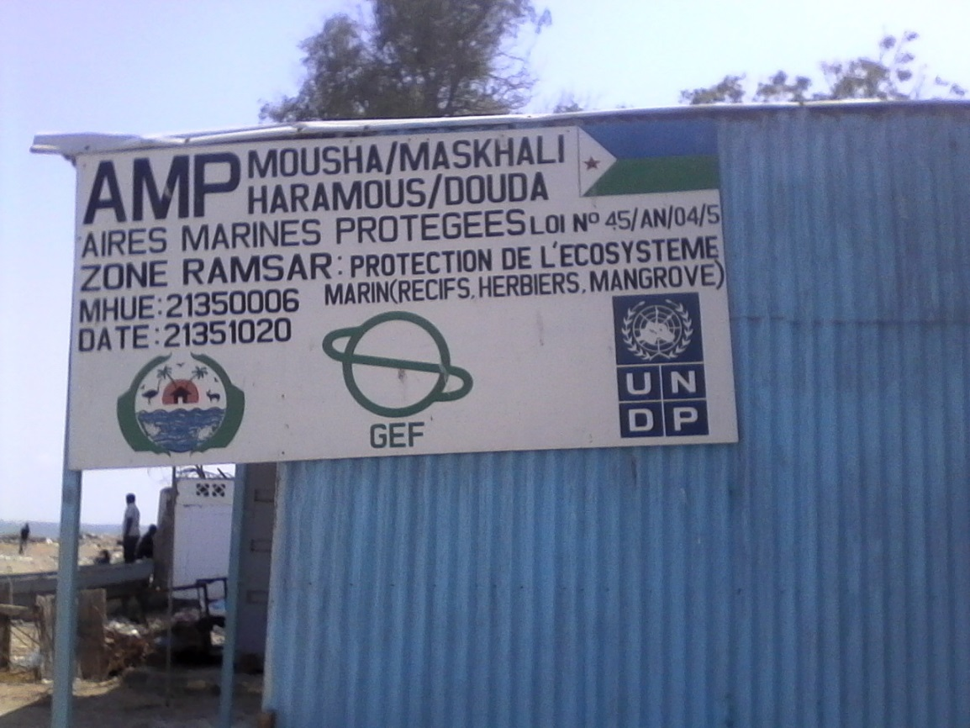

**Figure 3**: Beginning of the Djibouti town MPA area

**The second step** of the mission concern the field visit which begun by the Arta region, where the mission organised meeting successively with the Prefect of the region, the members of the project team, the monitoring committee and the committee of elders, etc.

**The 3rd step** of the mission concern the visit made in the different islands: Haramous, Masha, Maskali in order to verify the various demarcation installed by the MPA project on the seaside.

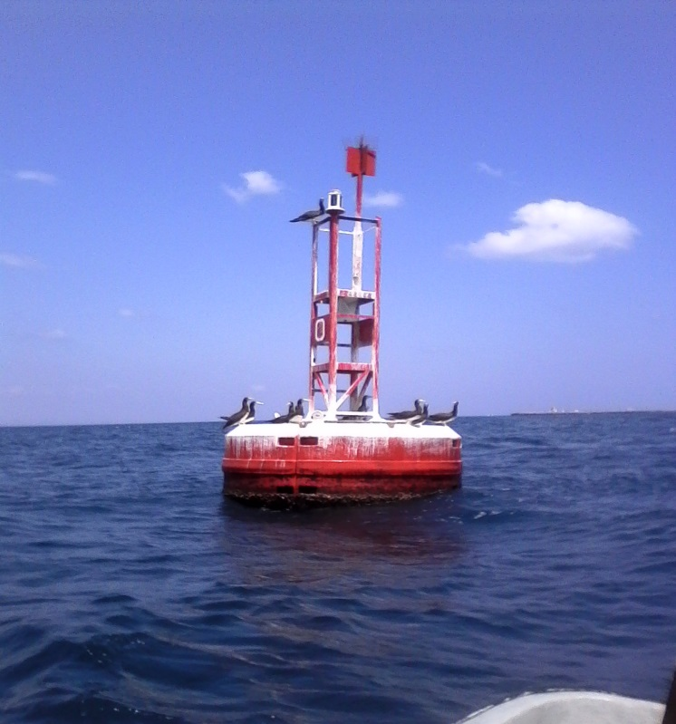

Figure 4: Demarcation (Boue) installed on the sea at Maskali Island (around Djibouti town)

The 4th step was at Obock, the regional chief-down in the north where the mission was receive by the prefectural authorities, the eco-guards, the sites managers before continuing for the **5th step** of the mission at the Khor Anghar sub-prefecture up to the ‘’07 brothers islands’’ and the MPA of Godoria before the return of the mission in Djibouti town, to continue the meeting and interviews.

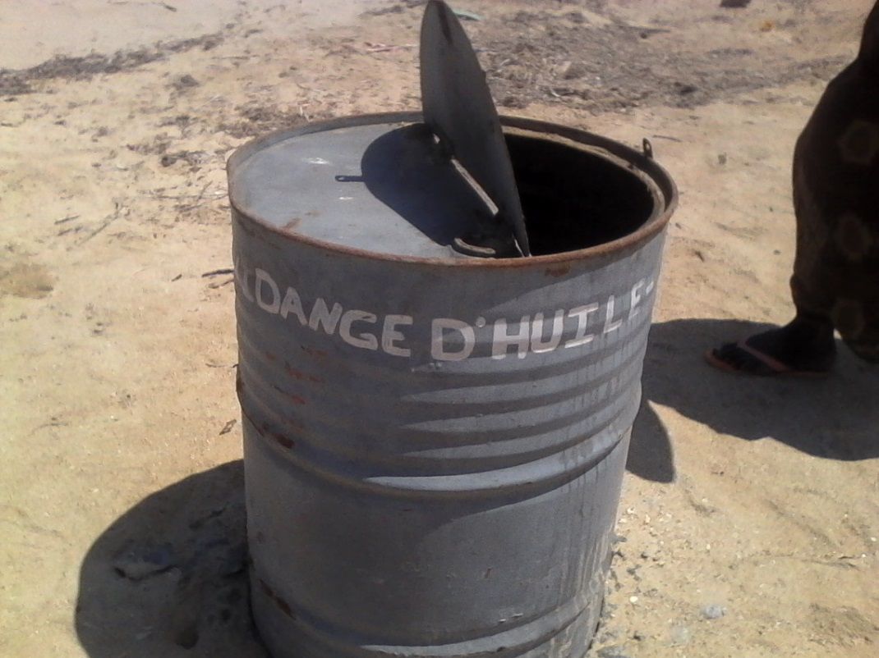

**Figure 5**: Barrel for draining of motor oil for the boats at the Khor Anghar beach

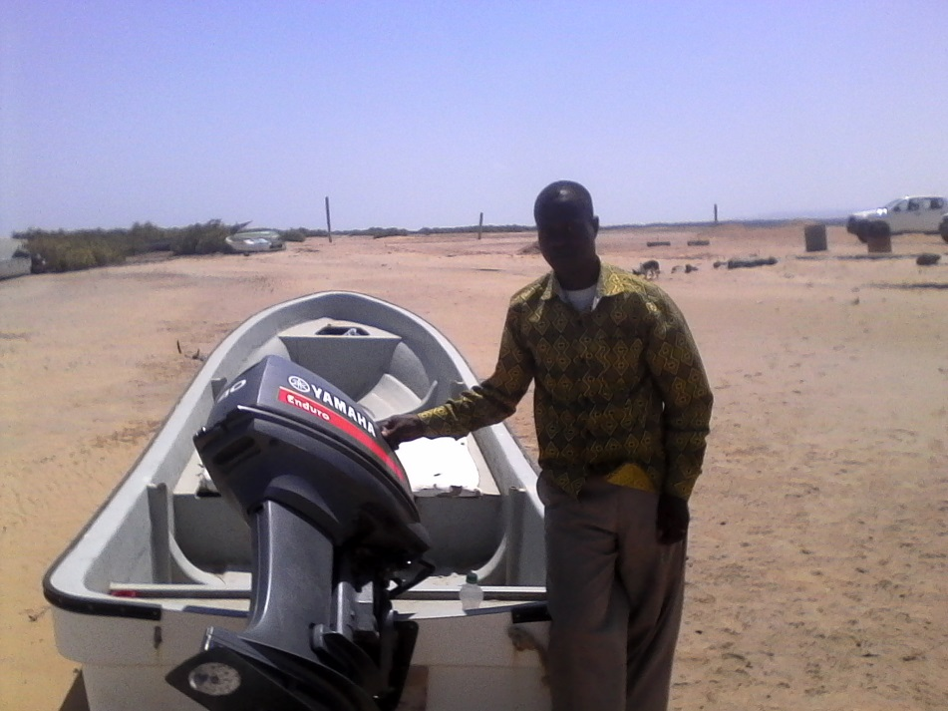

**Figure 6** : Boat of the project at Khor Anghar beach

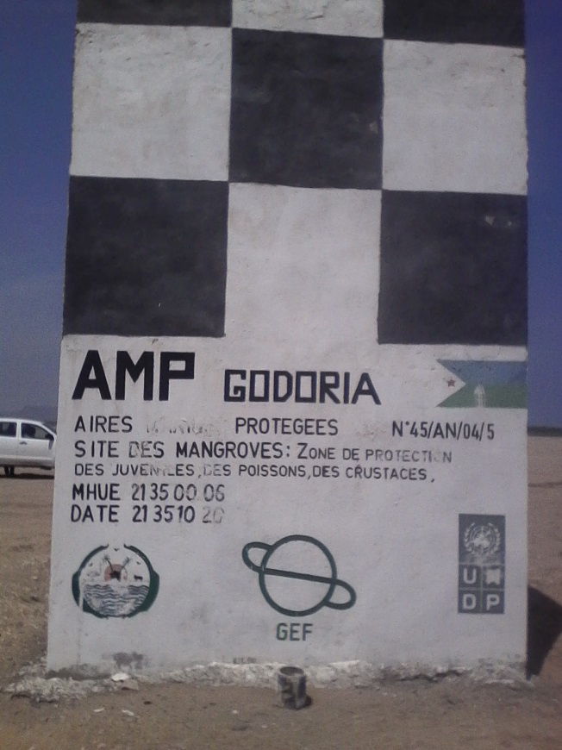

**Figure 7** : Muraille marquant le début de l’AMP de GODORIA (Khor Anghar)

The last days of the mission were mainly dedicated to meetings with the UNDP Resident Representative and Coordinator of the UN System in Djibouti as well as the private agencies specifically the GOUBET and The DECAN.

## List persons interviewed by alphabetical order

|  |  |  |  |  |
| --- | --- | --- | --- | --- |
| **N° Ordre** | **Prénoms et Nom** | **Fonction** | **Organisation** | **Contact** |
| 1 | Abdallah Ali Mohamed | Gardien | Khor Anghar |  |
| 2 | Abdillali Darar Okié | Préfet | Région D’ARTA | [(+253) 77 01 72 71 ; Darda19@hotmail.com](mailto:Darda19@hotmail.com) |
| 3 | Abdoulahi Ahmed Aden | Eco-Garde | Region d'Arta | (+252) 77 87 73 96 |
| 4 | Abdourahman Brahim Waberi | Pilote bateaux/Eco-gardes | Région d'Arta | (+252) 77 11 34 18 |
| 5 | Aden Naissa Ali | Eco-Garde | AMP/DATE | +253 77 76 75 65 |
| 6 | Ahmed Abdallah Bourham | Comité de Veille | AMP/ Khor Anghar |  |
| 7 | Ahmed Ali Hamadou | Eco-Garde | AMP/ Khor Anghar |  |
| 8 | Ahmed Ibrahim Hero | Pêcheur | Khor Anghar |  |
| 9 | Ahmed Mohamed Ali | Sous-Préfet | Khor Anghar |  |
| 10 | Ali Kassim Mohamed | Infirmier/Centre de Santé | Khor Anghar |  |
| 11 | Ali Mohamed Ahmed | Comité de Veille | AMP/ Khor Anghar |  |
| 12 | Ali Mohamed Ahmed Dini | Comité de Veille | AMP/ Khor Anghar |  |
| 13 | Dr Abdourahman Daher | Directeur | Institut des Sces de la Vie / CERD | [(+253) 77 82 14 84 ; daher@yahoo.fr](mailto:daher@yahoo.fr) |
| 14 | Elmi Abdi Okieh | Eco-Garde | Région d'Arta |  |
| 15 | Hahata Idriss | Pêcheur | Khor Anghar |  |
| 16 | Hassan Ali | Spécialiste Programme | PNUD | [(+253) 77 81 07 83 Hassan.ali@undp.org](mailto:Hassan.ali@undp.org) |
| 17 | Hassan Houmed Hassan | Eco-Garde | AMP/DATE | +253 77 85 67 48 |
| 18 | Houmed Ibrahim Omar | Comité de Veille | AMP/ Khor Anghar |  |
| 19 | Houmed Yoseif Houmed | Gestionnaire de site | AMP/DATE | +253 77 61 97 94 |
| 20 | Houssein Ibrahim Ali | Eco-Garde | AMP/ Khor Anghar |  |
| 21 | Houssein Mohamed Mohamed | Eco-Garde | AMP/ Khor Anghar |  |
| 22 | Houssein Rirarche | Directeur Général | DATE |  |
| 23 | Ibrahim Ahmed Mohamed | Agent de Santé | Obock |  |
| 24 | Kassim Ibrahim Mohamed | Pêcheur | Khor Anghar |  |
| 25 | Mahad | Directeur Ecole Elémentaire | Khor Anghar |  |
| 26 | Mahmoud Ibrahima Grobleh | Directeur Général | Horn Fish | (+253) 77 72 03 75 |
| 27 | Mary Sidya Moro | Ex-Coordonnateur | VNU |  |
| 28 | Mohamed Ali Omar | Eco-Garde | AMP/ Khor Anghar |  |
| 29 | Mohamed Ali Wihara | Pêcheur | AMP/ Khor Anghar |  |
| 30 | Mohamed Djibril | Coordonnateur par intérim) | AMP/DATE |  |
| 31 | Mohamed Ebo Aden | Eco-Garde | AMP/DATE | +253 77 68 43 83 |
| 32 | Mohamed Hamadou Mohamed | Comité de Sage | AMP/ Khor Anghar |  |
| 33 | Mohamed Hero | Pêcheur | Obock |  |
| 34 | Mohamed Ibrahim Mohamed | Pêcheur | Obock |  |
| 35 | Mohamed Moussa Mohamed | Gestionnaire de site | AMP/DATE | [(+253) 77 64 77 11 ; Moussabax3@hotmail.com](mailto:Moussabax3@hotmail.com) |
| 36 | Mohamed Omar Med | Comité de Sage | Khor Anghar |  |
| 37 | Mohamed Youssouf Mohamed | Pêcheur | Khor Anghar |  |
| 38 | Moumin Kalil Harred | Président du Comité | Région d'Arta | (+252) 77 71 73 91 |
| 39 | Moussa Mohamed Houssein | Eco-Garde | Région d'Arta | (+252) 77 71 41 63 |
| 40 | Mr De La France | Directeur Général | DECAN Refuge Animalier | [(+253) 77 81 09 07 ; b.lafrance@intnet.dj](mailto:b.lafrance@intnet.dj) |
| 41 | Ms Valerie Cliff | Coordonnatrice Résidente du Système des Nations Unis et Représentante Résidente | PNUD | [(+253) 21 35 33 71 ; Valerie.cliff@undp.org](mailto:Valerie.cliff@undp.org) |
| 42 | Salim Hassan Abdallah | Pêcheur | Khor Anghar |  |
| 43 | Valérie Chaouche | Directrice du Département Tourisme | Agence de Voyage LE GOUBET | [(+253) 77 02 95 33 ; valerie@riesgroup.dj](mailto:valerie@riesgroup.dj) |
| 44 | Youssouf Mohamed Ali | Gardien | Khor Anghar |  |

## List of documents examined

1. Document du Programme d’Aires Marines Protégées de Djibouti ;
2. Rapport d’EIES ;
3. Rapport de l’étude de caractérisation des quatre AMP ;
4. Rapport de proposition de délimitation des AMP à travers des points GPS et UTM ;
5. Etude de réalisation des cartes des AMP ;
6. Rapports des ateliers de formation ;
7. Les rapports de KAI MARINE SERVICES ;
8. Rapports annuels 2013 ; 2014
9. Rapport du forum régional sur la concertation et la dégradation de la mangrove au niveau de l’AMP de Sept Frères.
10. Les rapports d’activités sur l’état d'avancement du projet, rapports et comptes rendus de missions au niveau des zones concernées par le projet (2012, 2013, 2014 et 2015) ;
11. Rapport du Plan de suivi des recommandations de l'audit 2013 et 2014 ;
12. PIIR APR 2013, 2014 ;
13. Lettre du PNUD adressée au Gouvernement par rapport au Cofinancement
14. Lettre de Rappel du Gouvernement pour la libération des cofinancements de l’Etat
15. Review of the METT and the Terminal GEF Biodiversity Tracking tools (separated file)

## Table of evaluation questionnaire

|  |  |
| --- | --- |
|  |  |

Cette matrice d'évaluation présente un aperçu de l’ensemble des question qui ont permis de couvrir l’ensemble des aspects par le consultant tel que inclus dans le rapport initial et annexé e au présent rapport d’évaluation finale.

| **Critères des questions d'évaluation** | | **Indicateurs** | **Sources** | **Méthodologie** |
| --- | --- | --- | --- | --- |
| Pertinence : Comment le projet se rapporte-t-il aux principaux objectifs du domaine focal du FEM et aux priorités en matière d’environnement et de développement au niveau local, régional et national ? | | | | |
|  | * Les objectifs et les éléments du projet étaient-ils clairs, possibles et réalisables dans le délai alloué et conformes aux plan d’action du programme – pays ? | * Gestion efficace des AMP | * Document de projet | * Examen du document de projet |
|  | * Le concept du projet était-il conforme aux priorités et aux plans de développement du pays ? | * Appropriation par l’Etat | * Plan d’action pays programme PNUD | * Examen du document de projet |
|  | * La problématique homme-femme a t – il été prise en compte dans le document de projet ? | * Taux d’implication | * Rapports du projet | * Examen du document de projet |
| Efficacité : Dans quelle mesure les résultats escomptés et les objectifs du projet ont-ils été atteints ? | | | | | |
|  | * Les capacités des institutions chargées de l’exécution et de ses homologues ont-elles été correctement prises en compte lors de la conception du projet ? | * Capacité renforcée des structures nationales | * Rapports | * Examen du document de projet * Réunions | |
|  | * Les accords de partenariat ont-ils été correctement identifiés et les rôles et les responsabilités négociés avant l’approbation du projet ? | * Gestion efficace des AMP | * Document d’accord signé | * Examen du document de projet et réunions | |
|  | * Les leçons tirées d’autres projets pertinents ont-elles été correctement incorporées dans la conception du projet ? | * Gestion efficace des AMP | * Rapports | * Examen des documents de projet et réunions | |
| Efficience : Le projet a-t-il été mis en œuvre de façon efficiente, conformément aux normes et standards nationaux et internationaux ? | | | | | |
|  | * Le projet n’a t – il pas dépassé les niveaux de coûts prévus ? | * Taux d’exécution budgétaire | * Rapports Financier Final et Budget prévu | * Examen du budget prévisionnel et du coût final | |
|  | * Les résultats attendus du projet respectent – ils le modèle SMART (Spécifique-Mesurable-Réalisable-Pertinent-Temps) ? | * Qualité des résultats atteints | * Rapport techniques final | * Rapport et visite de terrain | |
|  | * Les résultats (ou les résultats potentiels) du projet ont-ils été intégrés dans les plans nationaux, sectoriels et de développement ? | * Approbation par le Gouvernement | * Plan d’action et politique d’orientation du gouvernement | * Rapports, réunions et plan national d’actions | |
| Durabilité : Dans quelle mesure existe-t-il des risques financiers, institutionnels, socio-économiques ou environnementaux au maintien des résultats du projet à long terme ? | | | | | |
|  | * Le concept du projet était-il conforme aux priorités et aux plans de développement du pays et les bénéficiaires se sont-ils appropriés du projet | * Approbation par le Gouvernement | * Plan d’action et politique d’orientation du gouvernement | * Rapport et réunions | |
|  | * Les co-financements ont-ils été mobilisé ou ressources supplémentaires pour la poursuite des actions après le projet ? | * Disponibilité de ressources pour les AMP | * Budget national et Fonds pour les AMP mise en place | * Rapport, Décret et conventions | |
|  | Existe-t-il des risques financiers, environnementaux, législatifs ou politiques qui pourraient compromettre la durabilité des résultats du projet ? | * Perception des bénéficiaires | * Plan d’action et politique d’orientation du gouvernement | * Examen des rapports, les réunions et visite de terrain | |
| Impact : Existe-t-il des indications à l’effet que le projet a contribué au (ou a permis le) progrès en matière de réduction de la tension sur l’environnement, ou à l’amélioration de l’état écologique ? | | | | | |
|  | * Les hypothèses et les risques liés au projet ont-ils été clairement identifiés dans le document de projet ? | * Gestion efficace des AMP | * Document de projet | * Examen des rapports, les réunions et visite de terrain | |
|  | * Le projet a-t-il des améliorations vérifiables et une réduction au niveau de la tension écologique (long terme) ? | * Système de suivi évaluation mise en place | * Rapports de terrain | * Examen des rapports, les réunions et visite de terrain | |

## Formulaire d’acceptation du consultant en évaluation

**Formulaire d’acceptation du consultant en évaluation[3]**

**Engagement à respecter le Code de conduite des évaluateurs du système des Nations Unies**

**Nom du consultant :** __ Gondo GBANYANGBE ______________________________________

**Nom de l’organisation de consultation** (le cas échéant) :________________________

**Je confirme avoir reçu et compris le Code de conduite des évaluateurs des Nations Unies et je m’engage à le respecter.**

Signé à *Conakry* le *19/01/2016*

Signature : _______________________________________

## Lettre du PNUD adressée au Gouvernement par rapport au Cofinancement

## Lettre de rappel du PNUD adressée au Gouvernement pour la libération des cofinancements de l’Etat en 2013

## Review of the METT and the Terminal GEF Biodiversity Tracking tools (separated file)

1. Pour de plus amples informations sur les méthodes, lire le chapitre 7 du [Guide de la planification, du suivi et de l’évaluation axés sur les résultats de développement](http://www.undp.org/evaluation/handbook), à la page 163
2. Un outil utile pour mesurer les progrès par rapport aux impacts est la méthode ROtI (Review of Outcomes to Impacts) mise au point par le Bureau de l'évaluation du FEM :  [ROTI Handbook 2009](http://www.thegef.org/gef/sites/thegef.org/files/documents/M2_ROtI%20Handbook.pdf)
3.