Terminal Evaluation Terms of Reference

INTRODUCTION

In accordance with UNDP and GEF M&E policies and procedures, all full and medium-sized UNDP support GEF financed projects are required to undergo a terminal evaluation upon completion of implementation. These terms of reference (TOR) sets out the expectations for a Terminal Evaluation (TE) of the ***Grid-connected Rooftop Photovoltaic Systems project*** (PIMS 4331)

The essentials of the project to be evaluated are as follows:

Project Summary Table

|  |  |  |  |  |  |  |
| --- | --- | --- | --- | --- | --- | --- |
| Project Title: |  | | | | | |
| GEF Project ID: | | 4052 (GEF PMIS #) |  | *at endorsement (Million US$)* | | *As at 31.3.16 (Million US$)* |
| UNDP Project ID: | | 4331 (UNDP PIMS#)  81971 (UNDP Atlas #) | GEF financing: | 1,160,000 | | 1,079,256 |
| Country: | | Seychelles | IA/EA own: | Same as Government | |  |
| Region: | | Africa | Government: | 1,224,697 | | 740,741 |
| Focal Area: | | CCM | Other: | 4,902,441 | | 2,737,073 |
| FA Objectives, (OP/SP): | | SP-3Grid-connected | Total co-financing: | 6,127,138 | | 3,479,814 |
| Executing Agency: | | Ministry of Environment, Energy and Climate Change | Total Project Cost: | 7,287,138 | | 4,559,070 |
| Other Partners involved: | | Seychelles Energy Commission | ProDoc Signature (date project began): | | | 01 September 2012 |
| (Operational) Closing Date: | | Proposed: | Actual:  31 December 2016 |

Objective and Scope

The project was designed to transform the energy sector of Seychelles that today is almost 100% dependent on imported fossil fuel (diesel) into one where solar PV and other renewable energies provide a significant percentage of national electricity generation. The project objective was to increase the use of grid-connected photovoltaic (PV) systems as a sustainable means of generating electricity on main islands and smaller islands of the Seychelles, with a focus on small-scale producers who are already connected to the national electricity grid. On the main islands, where the Public Utilities Corporation (PUC) is the supplier of almost all electricity, there is a well-established grid system that can support the feed-in of PV-generated electricity into the grid. Most importantly, the PUC was willing, for the first time, to support the sale of power back to the grid (due to new national policies that prioritize renewable energy, and to the country’s desire for WTO accession, which requires it to "open up" its energy market).

Component 1 of the project addresses policy, institutional, legal/regulatory and financial frameworks and covers Renewable Energy Technologies (RETs) in general. The project has undertaken targeted activities to revise the legal and policy frameworks to authorize grid-connected solar PV systems and to prioritize the development of RETs in the country, and to establish an independent regulator and clarify other institutional responsibilities for oversight and technical support of RETs.

Component 2 addresses technology support and delivery systems to address RETs but emphasize Solar PV systems. Significant capacity building was undertaken to enable the first demonstrations of grid-connected PV systems, as well as their adoption on a wider scale, has been wide-ranging in its scope, ranging from technical issues related to the electricity grid and RETs, to enabling key players to understand the economic rationale for renewable energy, to developing and implementing financial mechanisms and market structures, to training government and private financial institutions on assessing and making loans to various RET projects. Partners such as the Seychelles Institute of Technology (SIT) and the University of Seychelles (UniSey) have been supported to build their expertise on renewable energy technologies

Component 3 addresses demonstration systems for energy production, and focused specifically on Solar PV systems. Of key importance has been the close coordination of the implementation of demonstration grid-connected PV systems installed with funding from a financing scheme for PV systems that combines the resources of the GEF and the Ministry of Finance, such that potential adopters of PV technology are motivated and ready to make investments in PV

Activities under Components 1 and 2 concentrated in the initial stages of the project, as they set the stage for the establishment of PV demonstration systems under Component 3 during the latter stages of the project. Together, these actions were designed to play a critical role in “jump-starting” the adoption of solar PV technology in the Seychelles, and in setting the stage for broad-scale replication by reducing the costs of PV technology through a market-based approach that established a financial incentive mechanisms for PV systems and reduce transaction costs (by creating a reliable supply chain and establishing local capacity for installation and maintenance).

Responsibility for implementing the project is ceded by the Executing Agency (MEECC) to the GOS-UNDP-GEF Programme Coordination Unit (PCU) under the overall management of a Programme Coordinator and providing technical oversight, financial and administrative services to the project. MEECC has appointed a National Project Director (NPD) to oversee implementation; the NPD also chairs the project Steering Committee which is comprised of key project stakeholders. The project is managed day-to-day by a Project Manager based at the PCU. The UNDP Seychelles Country Office is responsible for quality assurance.

The TE will be conducted according to the guidance, rules and procedures established by UNDP and GEF as reflected in the UNDP Evaluation Guidance for GEF Financed Projects.

The objectives of the evaluation are to assess the achievement of project results, and to draw lessons that can both improve the sustainability of benefits from this project, and aid in the overall enhancement of UNDP programming.

Evaluation approach and method

An overall approach and method[1] for conducting project terminal evaluations of UNDP supported GEF financed projects has developed over time. The evaluation should include a mixed methodology of document review, interviews, and observations from project site visits, at minimum, and the evaluators should make an effort to triangulate information. The evaluator is expected to frame the evaluation effort using the criteria of **relevance, effectiveness, efficiency, sustainability, and impact,** as defined and explained in the [UNDP Guidance for Conducting Terminal Evaluations of UNDP-supported, GEF-financed Projects.](http://web.undp.org/evaluation/documents/guidance/GEF/UNDP-GEF-TE-Guide.pdf)  A set of questions covering each of these criteria have been drafted and are included with this TOR (*Annex C*). The evaluator is expected to amend, complete and submit this matrix as part of an evaluation inception report, and shall include it as an annex to the final report.

The evaluation must provide evidence‐based information that is credible, reliable and useful. The evaluator is expected to follow a participatory and consultative approach ensuring close engagement with government counterparts, in particular the GEF operational focal point, UNDP Country Office, project team, UNDP GEF Technical Adviser based in the region and key stakeholders. The evaluator is expected to conduct a field mission to Seychelles, including installation sites on Mahe and possibly Praslin and La Digue islands. Interviews will be held with the following organizations and individuals at a minimum: Seychelles Energy Commission, Public Utilities Corporation, Seychelles Institute of Technology, service providers/installers and clients.

The evaluator will review all relevant sources of information, such as the project document, project reports – including Annual APR/PIR, project budget revisions, midterm review, progress reports, GEF focal area tracking tools, project files, national strategic and legal documents, and any other materials that the evaluator considers useful for this evidence-based assessment. A list of documents that the project team will provide to the evaluator for review is included in Annex B of this Terms of Reference.

Evaluation Criteria & Ratings

An assessment of project performance will be carried out, based against expectations set out in the Project Logical Framework/Results Framework (Annex A), which provides performance and impact indicators for project implementation along with their corresponding means of verification. The evaluation will at a minimum cover the criteria of: **relevance, effectiveness, efficiency, sustainability and impact.** Ratings must be provided on the following performance criteria. The completed table must be included in the evaluation executive summary. The obligatory rating scales are included in  Annex D.

|  |  |  |  |
| --- | --- | --- | --- |
| **Evaluation Ratings:** | | | |
| **1. Monitoring and Evaluation** | ***rating*** | **2. IA& EA Execution** | ***rating*** |
| M&E design at entry |  | Quality of UNDP Implementation – Implementing Agency |  |
| M&E Plan Implementation |  | Quality of Execution - Executing Agency |  |
| Overall quality of M&E |  | Overall quality of Implementation / Execution |  |
| **3. Assessment of Outcomes** | **rating** | **4. Sustainability** | **rating** |
| Relevance |  | Financial resources: |  |
| Effectiveness |  | Socio-political: |  |
| Efficiency |  | Institutional framework and governance: |  |
| Overall Project Outcome Rating |  | Environmental : |  |
|  |  | Overall likelihood of sustainability: |  |

Project finance / cofinance

The Evaluation will assess the key financial aspects of the project, including the extent of co-financing planned and realized. Project cost and funding data will be required, including annual expenditures. Variances between planned and actual expenditures will need to be assessed and explained. Results from recent financial audits, as available, should be taken into consideration. The evaluator(s) will receive assistance from the Country Office (CO) and Project Team to obtain financial data in order to complete the co-financing table below, which will be included in the terminal evaluation report.

|  |  |  |  |  |  |  |  |  |
| --- | --- | --- | --- | --- | --- | --- | --- | --- |
| Co-financing  (type/source) | UNDP own financing (mill. US$) | | Government  (mill. US$) | | Partner Agency  (mill. US$) | | Total  (mill. US$) | |
| Planned | Actual | Planned | Actual | Planned | Actual | Planned | Actual |
| Grants | 60,000 |  | 424,697 |  | 4,842,441 |  | 6,127,138 |  |
| Loans/Concessions | 0 |  | 0 |  | 0 |  | 0 |  |
| * In-kind support | 0 |  | 0 |  | 0 |  | 0 |  |
| * Other | 0 |  | 800,000 rebate scheme |  | 0 |  | 0 |  |
| Totals | 60,000 |  | 1,224,697 |  | 4,842,441 |  | 6,127,138 |  |

Mainstreaming

UNDP supported GEF financed projects are key components in UNDP country programming, as well as regional and global programmes. The evaluation will assess the extent to which the project successfully mainstreamed with other UNDP priorities, including poverty alleviation, improved governance, the prevention and recovery from natural disasters, and gender. The evaluation will examine this project’s contribution to the United Nations Development Assistance Framework (UNDAF) or equivalent.

Impact

The evaluators will assess the extent to which the project is achieving impacts or progressing towards the achievement of impacts. Key findings that should be brought out in the evaluations include whether the project has demonstrated: a) verifiable improvements in the enabling environment for CCM, b) verifiable reductions in carbon emissions, and/or c) demonstrated progress towards these impact achievements.[2]

Conclusions, recommendations & lessons

The evaluation report must include a chapter providing a set of **conclusions**, **recommendations** and **lessons**. Conclusions should build on findings and be based in evidence. Recommendations should be prioritized, specific, relevant, and targeted, with suggested implementers of the recommendations. Lessons should have wider applicability to other initiatives across the region, the area of intervention, and for the future.

Implementation arrangements

The principal responsibility for managing this evaluation resides with the UNDP CO in *Seychelles*. The UNDP CO will contract the evaluator and ensure the timely provision of per diems and travel arrangements within the country for the evaluator. The Project Team will be responsible for liaising with the evaluator to set up stakeholder interviews, arrange field visits, coordinate with the Government, etc.

Evaluation timeframe

The total duration of the evaluation will be *17* working days over a period of 11 weeks according to the following plan:

|  |  |  |
| --- | --- | --- |
| **Activity** | Timing | Completion Date |
| **Preparation** | *3* days | *26th August* |
| **Evaluation Mission** | *7* days | *11-17th September* |
| **Draft Evaluation Report** | *5* days | *7th October* |
| **Final Report** | *2* day | *31st October* |

Evaluation deliverables

The evaluation team is expected to deliver the following:

|  |  |  |  |
| --- | --- | --- | --- |
| Deliverable | Content | Timing | Responsibilities |
| **Inception Report** | Evaluator provides clarifications on timing and method | No later than 2 weeks before the evaluation mission. | Evaluator submits to UNDP CO |
| **Presentation** | Initial Findings | End of evaluation mission | To project management, UNDP CO, Project Steering Committee, key stakeholders |
| **Draft Final Report** | Full ort, (per annexed template) with annexes | Within 3 weeks of the evaluation mission | Sent to CO, reviewed by RTA, PCU, GEF OFPs |
| **Final Report\*** | Revised report | Within 1 week of receiving UNDP comments on draft | Sent to CO for uploading to UNDP ERC. |

*When submitting the final evaluation report, the evaluator is required also to provide an 'audit trail', detailing how all received comments have (and have not) been addressed in the final evaluation report.

Team Composition

The evaluation team will be composed of 1 international evaluator. The consultant shall have prior experience in evaluating similar projects. Experience with GEF financed projects is an advantage. The evaluator selected should not have participated in the project preparation and/or implementation and should not have conflict of interest with project related activities. . The international evaluator will serve as the Team Leader and will be responsible for the final deliverable of the TE inception report, draft report, and final report.

The evaluator must present the following qualifications:

Education:

* An advanced degree (Masters level or higher) in climate change mitigation, renewable energy, or a related subject

Experience:

* Minimum *10* years of relevant professional experience in climate change mitigation and energy
* Knowledge of and/or experience with UNDP and/or GEF
* Previous experience with results‐based monitoring and evaluation methodologies;
* Technical knowledge in the targeted focal area (Climate Change Mitigation CCM)
* Competence in adaptive management, as applied to renewable energy and CCM projects
* Experience working in Small Island Developing States
* Demonstrated understanding of issues related to gender and renewable energy; experience in gender sensitive evaluation and analysis
* Excellent communication skills; demonstrable analytical skills
* Fluency in English

Evaluator Ethics

Evaluation consultants will be held to the highest ethical standards and are required to sign a Code of Conduct (Annex E) upon acceptance of the assignment. UNDP evaluations are conducted in accordance with the principles outlined in the [UNEG 'Ethical Guidelines for Evaluations'](http://www.unevaluation.org/ethicalguidelines)

Payment modalities and specifications

|  |  |
| --- | --- |
| % | Milestone |
| *10%* | Following submission and approval of TE Inception Report |
| *30%* | Following submission and approval of the 1st draft terminal evaluation report |
| *60%* | Following submission and approval (UNDP-CO and UNDP RTA) of the final terminal evaluation report |

Application process

Applicants are requested to apply online http://jobs.undp.org by (date). Individual consultants are invited to submit applications together with their CV. The application should contain a current and complete C.V. in English with indication of the e‐mail and phone contact. Shortlisted candidates will be requested to submit a price offer indicating the total cost of the assignment (including daily fee, per diem and travel costs).

UNDP applies a fair and transparent selection process that will take into account the competencies/skills of the applicants as well as their financial proposals. Qualified women and members of social minorities are encouraged to apply.

Annex A: Project Logical Framework

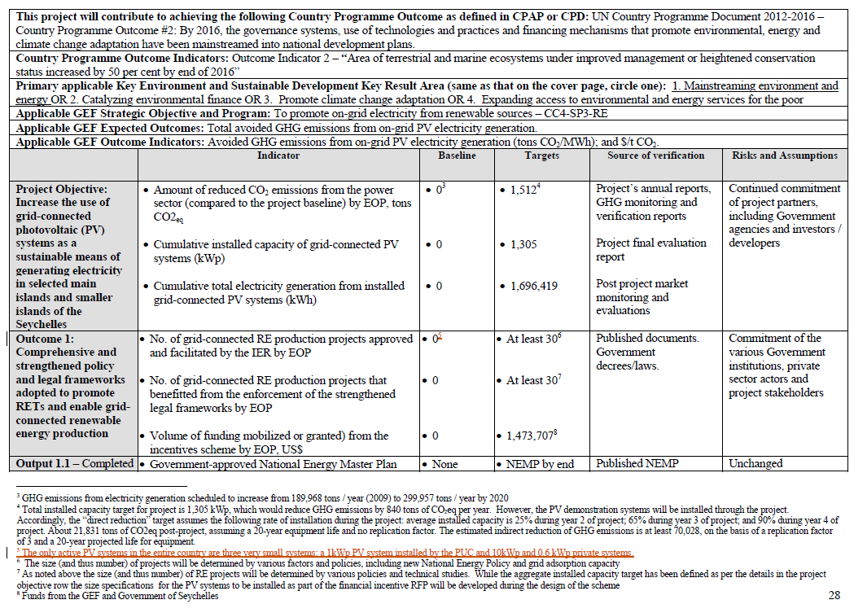

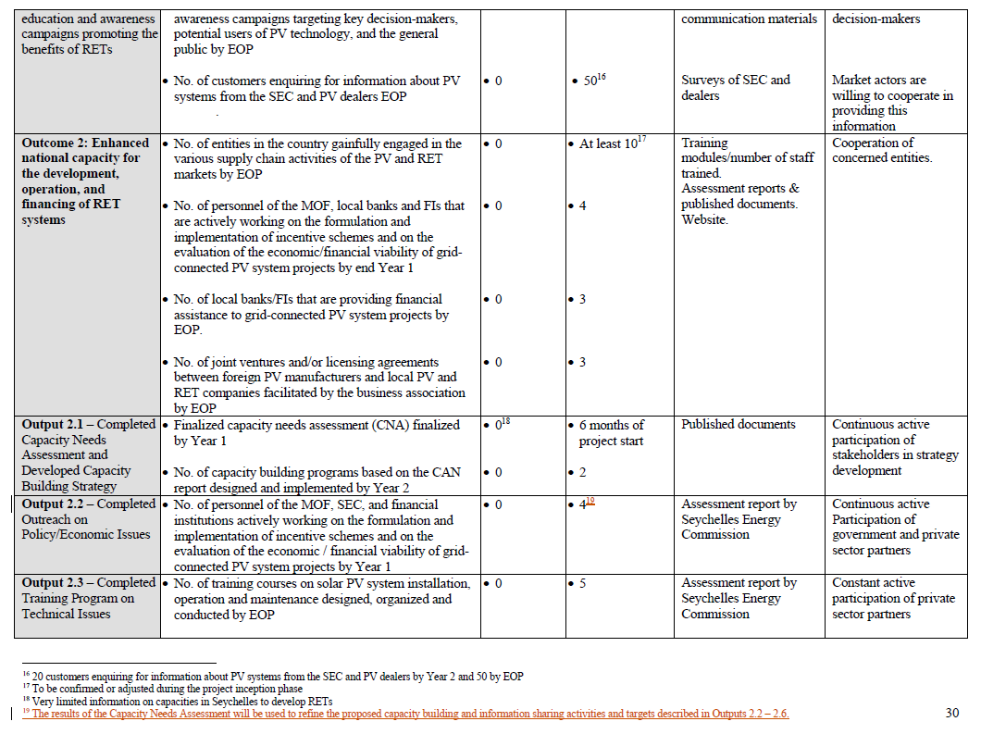

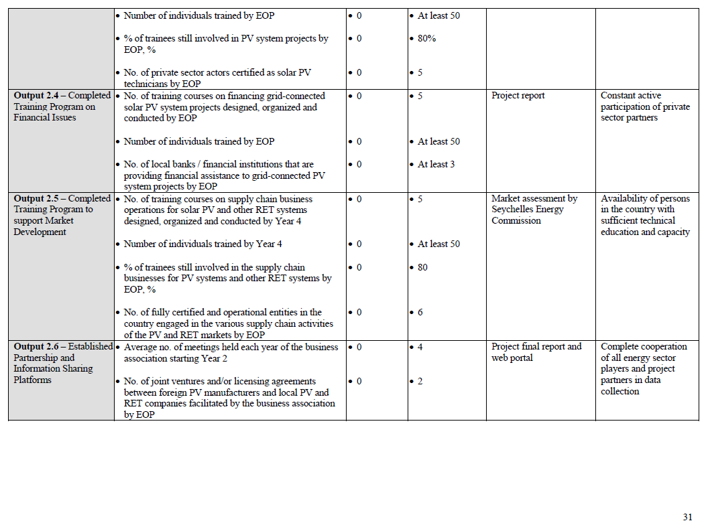

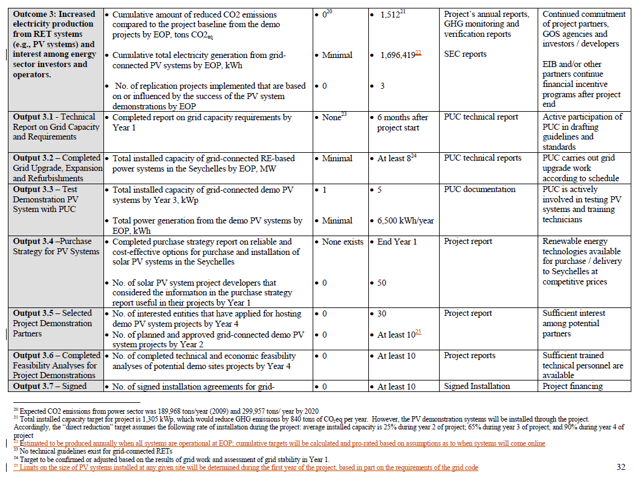

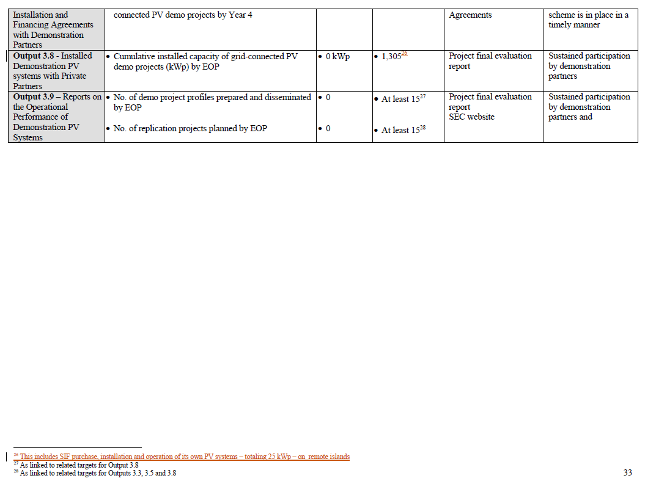

Annex B: List of Documents to be reviewed by the evaluators

1. GEF Project Information Form (PIF)
2. UNDP Project Document
3. Project Logframe Analysis (LFA)
4. Project Implementation Plan
5. Implementing/ Executing partner arrangements
6. List and contact details for project staff, key project stakeholders, including Project Board, and other partners to be consulted
7. UNDP Environmental and Social Screening results
8. Project Inception Report
9. All Project Implementation Reports (PIR’s)
10. Project MTR Report
11. Project MTR Management Response
12. Quarterly progress reports and work plans of the various implementation task teams
13. Project budgets and financial data
14. Audit reports
15. Oversight mission reports
16. All monitoring reports prepared by the project
17. Financial and Administration guidelines used by Project Team
18. Project Board Meeting minutes
19. Project Tracking Tool, at baseline, at mid-term, and at terminal points
20. UNDP Development Assistance Framework (UNDAF)
21. UNDP Country Programme Document (CPD)
22. UNDP Country Programme Action Plan (CPAP)
23. GEF focal area strategic program objectives

The following documents will also be available:

1. Project operational guidelines, manuals and systems
2. UNDP country/countries programme document(s)
3. Minutes of the PV project Board Meetings and other meetings (i.e. Project Appraisal Committee meetings)
4. Guidance for conducting terminal evaluations of UNDP-supported, GEF-financed projects

Project and partner technical reports may also be reviewed. Reports are uploaded on [www.pcusey.sc](http://www.pcusey.sc)

Annex C: Evaluation Questions

| **Evaluative Criteria Questions** | | **Indicators** | **Sources** | **Methodology** |
| --- | --- | --- | --- | --- |
| Relevance: How does the project relate to the main objectives of the GEF focal area, and to the environment and development priorities at the local, regional and national levels? | | | | |
|  | * How well does the project align with evolving GEF focal area priorities through GEF 4 5 and 6? | * Extent to which UNFCCC and related GEF priorities and areas of work incorporated | * Project documents * National policies and strategies to implement the UNFCCC, or related to energy more generally. * Project partners * Project beneficiaries |  |
|  | * How well does the project support the National Climate Change Strategy? Are there linkages with other strategic documents, such as National Development Strategy, INDCs? | * Degree to which the project supports national environmental objectives |
|  | * Is the project aligned with other donor and Government programmes and projects? Is the project country driven? | * Degree of coherence between the project and nationals priorities, policies and strategies |
|  | * Does the project adequately take into account the national realities, both in terms of institutional and policy frameworks in its design and implementation? | * Adequacy of project design and implementation to national realities and existing capacities |
|  | * Have implementation strategies been appropriate (is the logframe logical and complete)? | * Degree to which the project supports objectives of Government energy strategies |
|  | * Was the project responsive to threats and opportunities that emerged during the course of the project? | * Level of adaptive management related to emerging trends |
|  | * Did the project address the needs of target beneficiaries and other stakeholders? Was it inclusive? Were beneficiaries and other stakeholders effectively engaged in implementation? | * Degree to which the project supports local aspirations * Degree to which the project meets stakeholder expectations |
|  | * Has the experience of the project provided relevant lessons for other future projects targeted at similar objectives? | * Extent to which of lessons learned relating to all facets of the project are documented |
| Effectiveness: To what extent have the expected outcomes and objectives of the project been achieved? | | | | | |
|  | * How well has the project performed against its indicators and targets? | * Extent to which milestones and targets are achieved as laid out in the logframe and monitoring plan | * Project reports * Minutes of Project and ITCP Steering Committee Meetings * Minutes of District Technical Planning Committee meetings * Local partners and beneficiaries * Project risks log |  | |
|  | * Which have been the key factors leading to project achievements? | * Achievement of milestones and targets as laid out in the logframe and monitoring plan |
|  | * To what extent can observed results be attributed to the project or not (enabling environment for PV, level of uptake of PV, etc.)? In this respect have there been notable changes in the enabling environment for the project? | * Extent of change to the enabling environment |
|  | * Has the project failed in any respect? What changes could have been made (if any) to the design or implementation of the project in order to improve the achievement of the expected results? | * Evidence of adaptive management and/or early application of lessons learned |
|  | * How has the project contributed to raising capacity of local stakeholders to address aims of the project or of Government? | * Extent of support from local stakeholders |
|  | * What are the views of stakeholders on the implementation and activities of the project? Are there activities missing from the implementation? | * Extent to which stakeholders are actively participating in the project or * Extent to which beneficiaries were engaged in implementation and monitoring of the project |
|  | * How well were risks, assumptions and impact drivers managed? What was the quality of risk mitigation strategies developed? Were these sufficient? Are there clear strategies for risk mitigation related to long-term sustainability of the project? | * Extent to which project has responded to identified and emerging risks (particularly risks of low participation due to perceived needs for immediate action rather than planning) * Level of attention paid to up-dating risks log |
| Efficiency: Was the project implemented efficiently, in-line with international and national norms and standards? | | | | | |
|  | * Financial efficiency: * Were the accounting and financial systems in place adequate for project management and producing accurate and timely financial information? * Have funds been available and transferred efficiently (from donor to project to contractors) to address the project purpose, outputs and planned activities? * Were funds used correctly – explain any over- or under-expenditures? * Were financial resources utilized efficiently (converted into outcomes)? Could financial resources have been used more efficiently? * Were issues raised in audit reports and how efficiently were they addressed? * Was project implementation as cost effective as originally proposed (planned vs. actual) * Did the leveraging of funds (co-financing) happen as planned? | * Extent to which funds have been converted into outcomes as per the expectations of the ProDoc * Level of transparency in the use of funds * Level of satisfaction of partners and beneficiaries in the use of funds * Timely delivery of funds, mitigation of bottlenecks. * Coordination and synergies of project funds and co-financing | * Project financial records * Project audit reports * Project work plans and reports |  | |
|  | * Implementation efficiency (including monitoring): * Was the project implemented as planned, including the proportion of activities in work plans implemented? * Has monitoring data been collected as planned, analyzed and used to inform project planning? * Has project implementation been responsive to issues arising (e.g. from monitoring or from interactions with stakeholders)? * What learning processes have been put in place and who has benefitted (e.g. training, exchanges with related projects, overseas study visits) and how has this influenced project outcomes? * Were progress reports produced accurately and timely, and did they respond to reporting requirements including adaptive management changes? * Did the project experience any capacity gaps (e.g. staffing gaps)? * Has internal and external communication been effective and efficient? * How efficiently have resources and back-up been provided by donors, including quality assurance by UNDP? | * Extent to which project activities were conducted on time * Extent to which project delivery matched the expectation of the ProDoc and the expectations of partners * Level of satisfaction expressed by partners in the responsiveness (adaptive management) of the project * Level of satisfaction expressed by MEECC and PCU in regard to UNDP back-stopping | * Project work plans and reports * Local partners |  | |
|  | * Efficiency of partnership arrangements for the project * To what extent were partnerships/linkages between institutions/ organizations/private sector encouraged and supported? * Which partnerships/linkages were facilitated? Which ones can be considered sustainable? * What was the level of efficiency of cooperation and collaboration arrangements? * Which methods were successful or not and why? | * Extent to which project partners committed time and resources to the project * Extent of commitment of partners to take over project activities | * Project work plans and reports * Local partners |  | |
| Sustainability: To what extent are there financial, institutional, social-economic, and/or environmental risks to sustaining long-term project results? | | | | | |
|  | * Is the social, legal and political environment conducive to sustainability? | * Extent of supportive policies | * Steering Committee minutes * Local partners and beneficiaries |  | |
|  | * Are there early signs of activities being taken up by project partners, and plans being developed to sustain them? | * Extent to which partners are considering post-project actions |
|  | * Have partners and stakeholders successfully enhanced their capacities and do they have the required resources to make use of these capacities? | * Extent to which partners and stakeholders are applying new ideas outside of the immediate project context |
|  | * Does the project have a clear exit strategy or transformational strategy? | * Intent to follow-up on the project (on the part of Government and stakeholders) * To what extent has the exit strategy been implemented |
| **Impact: Are there indications that the project has contributed to, or enabled progress toward, reduced environmental stress and/or improved ecological status?** | | | | | |
|  | * What impact has the project had on policy, legal and institutional frameworks relating to uptake of renewable energy? | * Evidence of uptake of new technologies * Extent to which national strategic planning supports project interventions | * Project reports * Minutes of Steering Committee meetings * Local partners and beneficiaries |  | |
|  | * What impacts has the project had or is it likely to have on people in the project area in terms of cost-savings, income generating opportunities, etc.? | * Level of satisfaction of project interventions expressed by beneficiaries |
|  | * Has the project had any impact on gender equality and economic empowerment for women and other marginalized groups? Was it intended to? | * Evidence of gender equity in project interventions such as trainings, installed PV systems and rebates. |
|  | * What lessons can be learnt from the project regarding efficiency? Could the project have more efficiently carried out implementation (in terms of management structures and procedures, partnerships arrangements etc.)? | * Level of satisfaction in project implementation arrangements * Suggestions put forward by partners for possible improvement |

Annex D: Rating Scales

|  |  |  |
| --- | --- | --- |
| ***Ratings for Effectiveness, Efficiency, Overall Project Outcome Rating, M&E, IA & EA Execution*** | ***Sustainability ratings:*** | ***Relevance ratings*** |
| 6: Highly Satisfactory (HS): no shortcomings  5: Satisfactory (S): minor shortcomings  4: Moderately Satisfactory (MS): moderate shortcomings  3. Moderately Unsatisfactory (MU): significant shortcomings  2. Unsatisfactory (U): major problems  1. Highly Unsatisfactory (HU): severe problems | 4. Likely (L): negligible risks to sustainability | 2. Relevant (R) |
| 3. Moderately Likely (ML):moderate risks | 1.. Not relevant (NR) |
| 2. Moderately Unlikely (MU): significant risks  1. Unlikely (U): severe risks |  |
| *Additional ratings where relevant:*  Not Applicable (N/A)  Unable to Assess (U/A | | |

Annex E: Evaluation Consultant Code of Conduct and Agreement Form

**Evaluators:**

1. Must present information that is complete and fair in its assessment of strengths and weaknesses so that decisions or actions taken are well founded.
2. Must disclose the full set of evaluation findings along with information on their limitations and have this accessible to all affected by the evaluation with expressed legal rights to receive results.
3. Should protect the anonymity and confidentiality of individual informants. They should provide maximum notice, minimize demands on time, and respect people’s right not to engage. Evaluators must respect people’s right to provide information in confidence, and must ensure that sensitive information cannot be traced to its source. Evaluators are not expected to evaluate individuals, and must balance an evaluation of management functions with this general principle.
4. Sometimes uncover evidence of wrongdoing while conducting evaluations. Such cases must be reported discreetly to the appropriate investigative body. Evaluators should consult with other relevant oversight entities when there is any doubt about if and how issues should be reported.
5. Should be sensitive to beliefs, manners and customs and act with integrity and honesty in their relations with all stakeholders. In line with the UN Universal Declaration of Human Rights, evaluators must be sensitive to and address issues of discrimination and gender equality. They should avoid offending the dignity and self-respect of those persons with whom they come in contact in the course of the evaluation. Knowing that evaluation might negatively affect the interests of some stakeholders, evaluators should conduct the evaluation and communicate its purpose and results in a way that clearly respects the stakeholders’ dignity and self-worth.
6. Are responsible for their performance and their product(s). They are responsible for the clear, accurate and fair written and/or oral presentation of study imitations, findings and recommendations.
7. Should reflect sound accounting procedures and be prudent in using the resources of the evaluation.

**Evaluation Consultant Agreement Form[3]**

**Agreement to abide by the Code of Conduct for Evaluation in the UN System**

**Name of Consultant:** __     _________________________________________________

**Name of Consultancy Organization** (where relevant)**:** ________________________

**I confirm that I have received and understood and will abide by the United Nations Code of Conduct for Evaluation.**

Signed at *place* on *date*

Signature: ________________________________________

Annex F: Evaluation Report Outline[4]

|  |  |
| --- | --- |
| **i.** | Opening page:   * Title of UNDP supported GEF financed project * UNDP and GEF project ID#s. * Evaluation time frame and date of evaluation report * Region and countries included in the project * GEF Operational Program/Strategic Program * Implementing Partner and other project partners * Evaluation team members * Acknowledgements |
| **ii.** | Executive Summary   * Project Summary Table * Project Description (brief) * Evaluation Rating Table * Summary of conclusions, recommendations and lessons |
| **iii.** | Acronyms and Abbreviations  (See: UNDP Editorial Manual[5]) |
| **1.** | Introduction   * Purpose of the evaluation * Scope & Methodology * Structure of the evaluation report |
| **2.** | Project description and development context   * Project start and duration * Problems that the project sought to address * Immediate and development objectives of the project * Baseline Indicators established * Main stakeholders * Expected Results |
| **3.** | Findings  (In addition to a descriptive assessment, all criteria marked with (*) must be rated[6]) |
| **3.1** | Project Design / Formulation   * Analysis of LFA/Results Framework (Project logic /strategy; Indicators) * Assumptions and Risks * Lessons from other relevant projects (e.g., same focal area) incorporated into project design * Planned stakeholder participation * Replication approach * UNDP comparative advantage * Linkages between project and other interventions within the sector * Management arrangements |
| **3.2** | Project Implementation   * Adaptive management (changes to the project design and project outputs during implementation) * Partnership arrangements (with relevant stakeholders involved in the country/region) * Feedback from M&E activities used for adaptive management * Project Finance: * Monitoring and evaluation: design at entry (*), implementation (*), and overall assessment (*) * Implementing Agency (UNDP) execution (*) and Executing Agency execution (*), overall project implementation/ execution (*), coordination, and operational issues |
| **3.3** | Project Results   * Overall results (attainment of objectives) (*) * Relevance (*) * Effectiveness (*) * Efficiency (*) * Country ownership * Mainstreaming * Sustainability: financial resources (*), socio-economic (*), institutional framework and governance (*), environmental (*), and overall likelihood (*) * Impact |
| **4.** | Conclusions, Recommendations & Lessons   * Corrective actions for the design, implementation, monitoring and evaluation of the project * Actions to follow up or reinforce initial benefits from the project * Proposals for future directions underlining main objectives * Best and worst practices in addressing issues relating to relevance, performance and success |
| **5.** | Annexes   * ToR * Itinerary * List of persons interviewed * Summary of field visits * List of documents reviewed * Evaluation Question Matrix * Questionnaire used and summary of results * Evaluation Consultant Agreement Form * Annexed in a separate document: Audit trail * Annexed in a separate document: GEF Focal Area terminal Tracking Tool |

Annex G: Evaluation Report Clearance Form

*(to be completed by CO and UNDP GEF Technical Adviser based in the region and included in the final document)*

Evaluation Report Reviewed and Cleared by

UNDP Country Office

Name: ___________________________________________________

Signature: ______________________________ Date: _________________________________

UNDP GEF RTA

Name: ___________________________________________________

Signature: ______________________________ Date: _________________________________

Annex H: TE Report audit trail

The following is a template for the evaluator to show how the received comments on the draft TE report have (or have not) been incorporated into the final TE report. This audit trail should be included as an annex in the final TE report.

**To the comments received on (*date*) from the Terminal Evaluation of (*project name*) (UNDP *PIMS #)***

*The following comments were provided to the draft Terminal Evaluation report during (time period); they are referenced by institution (“Author” column) and comment number (“#” column):*

|  |  |  |  |  |
| --- | --- | --- | --- | --- |
| **Author** | **#** | **Para No./ comment location** | **Comment/Feedback on the draft TE report** | **TE team response and actions taken** |
|  |  |  |  |  |
|  |  |  |  |  |
|  |  |  |  |  |
|  |  |  |  |  |
|  |  |  |  |  |
|  |  |  |  |  |
|  |  |  |  |  |
|  |  |  |  |  |
|  |  |  |  |  |
|  |  |  |  |  |

1. For additional information on methods, see the [Handbook on Planning, Monitoring and Evaluating for Development Results](http://www.undp.org/evaluation/handbook), Chapter 7, pg. 163
2. A useful tool for gauging progress to impact is the Review of Outcomes to Impacts (ROtI) method developed by the GEF Evaluation Office:  [ROTI Handbook 2009](http://www.thegef.org/gef/sites/thegef.org/files/documents/M2_ROtI%20Handbook.pdf)
3. www.unevaluation.org/unegcodeofconduct
4. The Report length should not exceed *40* pages in total (not including annexes).
5. UNDP Style Manual, Office of Communications, Partnerships Bureau, updated November 2008
6. See ToR Annex D for rating scales. See TE Guidance section 3.5, page 37 for ratings explanations.