Increased synergy between implementing partners: ERRY joint programme is implemented by UNDP, ILO, FAO and WFP through a comprehensive, integrated approach to address a broad range of interconnected issues, taking into account the multi-sectoral demand of vulnerability. The interventions draw on the comparative advantage of each Partnering UN Organization (PUNO) and the key lessons learnt from implementing the ongoing ERRY programme, as articulated by the MTR, to maximize the impacts of the programme. The joint-delivery demonstrated that the programme’s results can be achieved within a short span of time, maximizing impact and creating synergies between different activities by working in the same targeted locations. Key lessons from the MTR to enhance the synergies among PUNOs are summarized as below:

Integration and convergence of action: The four UN agencies are targeting the same districts and communities in order to maximize impact in the same community with the diverse and integrated interventions from all PUNOs; increase synergies within the technical components such as the solar component which provided services to dairy product processing groups of FAO’s agriculture, UNDP and WFP’s livelihoods components; ILO skills and entrepreneurship training provided to all ERRY livelihoods interventions; provide post cash for work support by UNDP and ILO for the beneficiaries of cash for work to create sustainable livelihoods opportunities.
Coordination and collaboration among PUNOs through JCU-strengthening synergies between the different components of ERRY requires close coordination and collaboration among PUNOs; joint planning, assessments and monitoring visits to governorates and districts, which is one of the key lessons learned from the present project for the exchange of information, sharing of progress and joint learning. Community resilience planning and strengthening VCCs are the key to achieve community resilience through strengthening VCCs capacities to prepare resilience plans, mobilize resources and implement self-help initiatives. All PUNOs interventions are being implemented through VCC for better synergies; they contribute to the implementation of the community resilience plans and self-help initiatives. PUNOs are using and sharing the same offices in the field to enhance integration of the team, efficiency, collaboration and delivery as one joint programme. The following chart shows synergies through two components.

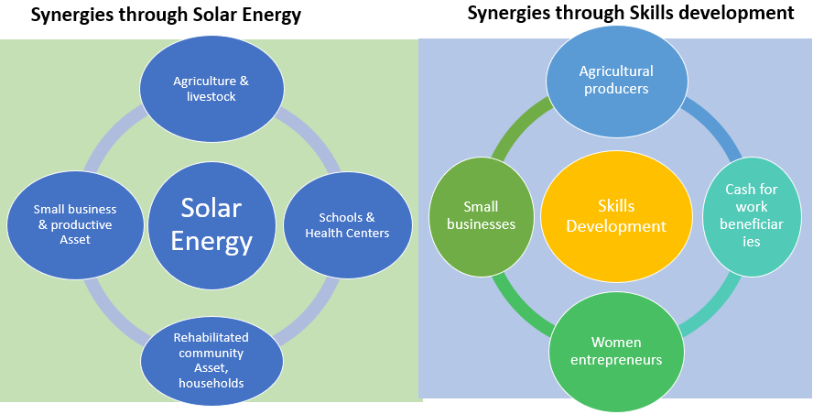

Livelihood stabilization and community assets rehabilitation for resilience building: Livelihoods are the means by which households obtain and maintain access to the resources necessary to ensure their immediate and long-term survival. Households use these assets to increase their ability to withstand shocks and to manage risks that threaten their well-being. Lessons learnt from the ongoing ERRY programme show that the conflict has an enormously destructive impact on individuals and communities’ livelihoods. People do not wait for help of relief food but adopt various positive or negative livelihood strategies to survive. It is very important to find ways of supporting these strategies before households become deplete of their assets and destitute. Stabilization of livelihoods is a prerequisite to resilience-building to guarantee immediate cash and income-generation opportunities for crisis affected households and contribute to assets rehabilitation and building at the community level. It is essential to protect or enhance household & community assets and aid that supports household livelihood coping strategies in conflict environments. This was confirmed by the ERRY MTR which showed that the programme’s livelihoods and economic empowerment activities, especially those focused on rehabilitating communal assets, had the most notable impacts on household’s and communities’ capacity to manage the ongoing shock.
Strengthening the capacity of Local and Community Institutions: Presence of strong and functioning community and local institutions is the foundation for the resilience building processes in the community. The community coping and self-help mechanisms and social networks need to be strengthened to effectively respond and address shocks and risks. Communities and institutions need to be supported to be able to effectively identify the priority areas of support best suited to their needs and in the planning for the related responses leveraging the available local resources and identifying gaps. The review of the ERRY programme’s implementation and outcomes half-way into its delivery showed, indeed, that VCCs and their capacity-building constitute a power tool to leverage synergies, to effectively reach vulnerable groups and to optimize impacts.

Increased Women Participation and Economic Empowerment: One of the key lessons learned from the ongoing EERY programme is that women participation in social cohesion and conflict resolution as insider mediators have contributed significantly in addressing resource-based conflicts. In addition, skills development, dairy product processing and small business support provided to women groups have led to considerable improvements in food security and income for households. Overall, economic empowerment of vulnerable women and women-headed households enable women to have a constructive role in building the community and household resilience. Economically-empowered women are also less vulnerable to risks of violence, abuse and exploitation. The positive change in the gender roles will facilitate engagement of women in the establishment and management of micro-businesses in relevant business lines which were previously perceived as male-dominated.

