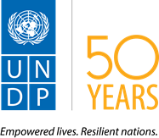

RESOURCE MOBILIZATION IMPLEMENTATION STRATEGY
CONTENTS
1. INTRODUCTION 2
2. CONTEXT: Zimbabwe Development Aid Environment 4
ODA Assistance to Zimbabwe 5
3. UNDP’s Partnerships in Zimbabwe 6
4. RESOURCE REQUIREMENTS 7
5. RM STRATEGY 10
5.1 Overall strategy 10
5.2 Assumptions 10
5.3 Partners Perception 13
5.4 Value Proposition 14
6. RM ACTION PLAN 15
7. PROMOTING DONOR VISIBILITY, ADVOCACY & STRATEGIC COMMUNICATIONS 19
8. List of Annexes 21
1. Zimbabwe Donor Profiles 21

1. INTRODUCTION
The United Nations Development Programme (UNDP) in support of the Government of Zimbabwe has embarked on the implementation of a new, five-year Country Programme Document (CPD) 2016-2020. Drawing from the priorities identified within the 2016-2020 ZUNDAF, this Country Programme aspires to deliver results in support of 3 broad national priorities aligned to the Government’s national development strategy for the period 2013-2018, the Zimbabwe Agenda for Sustainable Socio-Economic Transformation (ZIMASSET): Inclusive Growth and Sustainable Livelihoods; Democratic Governance and Climate Change and Resilience Building.

The CPD’s indicative resource requirement of USD 172 Million (excluding Global Fund Grants) is in line with the level of programme priorities which places emphasis on a balance between policy level support and downstream engagement for poverty reduction and inclusive growth. With the adoption of the 2030 Agenda for Sustainable Development and the changing development landscape both globally and in Zimbabwe, however, business as usual in terms of resource mobilization is no longer an option for UNDP and the UN System as a whole. The UNDP would thus need to collectively strategize on how to leverage resources through effective partnerships to achieve the sustainable development results as envisaged in its Country Programme.

This Partnerships and Resource Mobilization Strategy seeks to facilitate a coordinated approach to mobilizing and diversifying resources for high quality performance and results. Its implementation will position UNDP at the heart of the development landscape in Zimbabwe to meaningfully contribute towards the attainment of national aspirations articulated in the CPD. This strategy is an outcome of multiple and broad consultations with national counterparts, development partners in Zimbabwe, the UNCT and UNDP staff.

A graphic illustration of the theory of change underpinning the 2016-2020 CPD is provided in the diagram below.
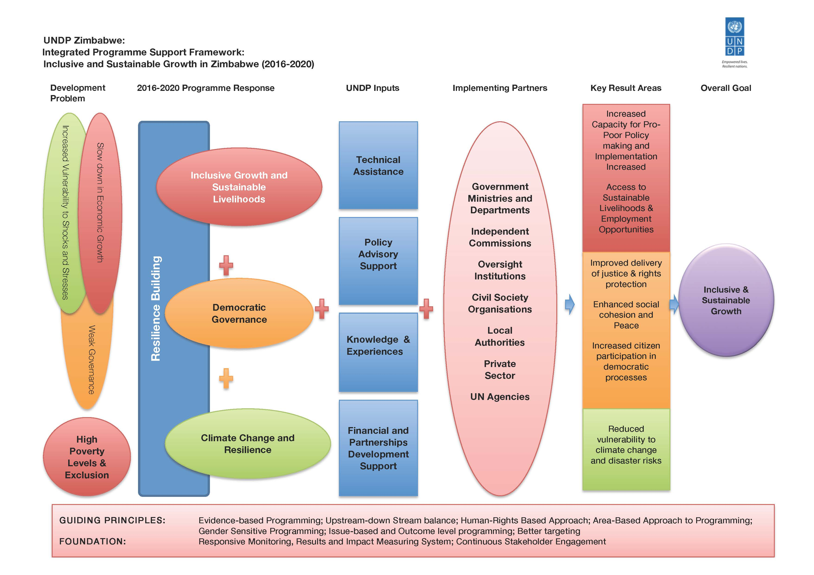

OVERARCHING GOAL
The 2016-2020 Resource Mobilization Implementation Strategy and Action Plan seeks a more coordinated approach to mobilize and diversify resources, enhance partnerships, and progressively explore new funding mechanisms centred on quality performance and results.

2. CONTEXT: Zimbabwe Development Aid Environment
According to the 2015 Human Development Report, Zimbabwe’s Human Development Index (HDI) value in 2014 is 0.509, placing the country in the low human development category. The HDI value has consistently been increasing since 2005, with life expectancy and education component indices improving during this period, while GNI per capita has largely been on a downward trend. Indeed, despite improvements in social sectors, key macroeconomic indicators have declined over the past years, and unemployment and poverty are rising, partly caused by the slowdown in economic growth, which declined from 11.9% in 2011 to 3.1 % in 2014. (UNRCO, 2016)

The 2016 national budget is set at USD 3.85 billion out of which USD 3.19 billion – or 80% - is expected to go to employment costs, USD 384 million (10%) to operations and USD 315 million (8%) to capital expenditure, leaving a deficit of USD 40 million.

The Government is implementing a strategy for reforms and intensifying its engagement with international creditors. Completion of key milestones under the International Monetary Fund (IMF) Staff-Monitored Programme, which reported that the country has shown strong commitment to structural reforms, and the development of a roadmap to seek debt rescheduling are critical steps towards IFI re-engagement and mobilizing development partners’ support. If the arrears are repaid as per the roadmap, it would pave the way for Zimbabwe to access fresh lines of credit to revive its economy.

In addition, the drought situation caused by the El Nino effect has affected 2.8 million people (or 30% of the rural populations in the country), leading the Government to declare a State of Disaster on 3 February 2016. The drought situation coupled with persistent liquidity challenges in 2016 will impact negatively on growth, as well as the achievement of national priorities, including the Sustainable Development Goals (SDGs).

ODA Assistance to Zimbabwe
Zimbabwe is highly dependent on foreign assistance. During the period 2003 – 2012, Zimbabwe received $5.6 billion in official development assistance (28th largest globally), according to the Assessment of Development Results (ADR, 2015) report. The proportion of humanitarian assistance within this amount averaged 37%. In 2012, ODA accounted for 11% of gross national income (GNI). Zimbabwe has consistently stayed in the top 20 of humanitarian assistance receivers, with a high of $420 million in 2009. Humanitarian assistance has focused especially on food security, due to periodic episodes of sustained drought.

The Global Fund to Fight Aids, Tuberculosis and Malaria managed by UNDP continues to be a significant provider of funds to Zimbabwe which is the fund’s largest recipient in the world. Since 2009, UNDP has managed 9 approved grants as a Principal Recipient (PR) with a total value of about $1billion of which about $850 million has been disbursed to the country. The approved budget of the New Funding Model HIV/AIDS grant managed by UNDP as PR (2014-2016) is $468, 272,909. UNDP has submitted a costed extension for the grant for 2017 with a budget of about $180 million. A 2017 allocation of $144 Million has been confirmed.

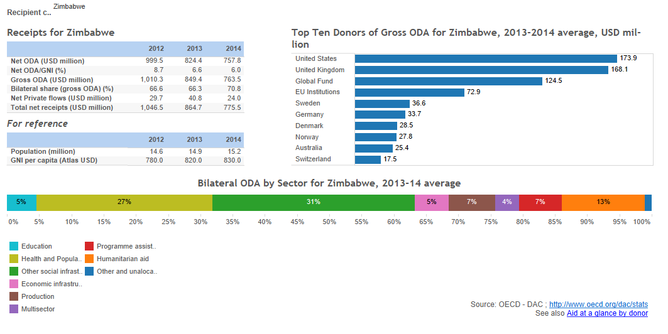

ODA flow to Zimbabwe
However, the number of donors that provide ODA through UN is decreasing; European Union (EU), UK Department for International Cooperation (DFID) and the Swedish International Development Cooperation Agency (SIDA) remain the main providers for resources. Denmark and Norway which have in the past channelled their resources to UN will be closing their operations by the end of 2016.

Despite the limited ODA context, there are new emerging partnership opportunities for UN/UNDP in facilitating South–South cooperation, for instance China in the area of climate change. Furthermore, a resilience approach to addressing community vulnerabilities to shocks and stresses is gaining momentum in attracting resources through the establishment of Zimbabwe Resilience Building Fund (ZRBF), managed by UNDP.

3. UNDP’s Partnerships in Zimbabwe
With the Government of Zimbabwe being our key development partner in the country, UNDP works closely with the Executive, line ministries, and other arms of Government, most notably the Parliament, throughout the programme implementation cycle.
At the same time, UNDP manages and primarily finances the Resident Coordinator system, which encourages collaboration by the UN Country Team in Zimbabwe, enhancing coherence efficiency and effectiveness in the UN’s collective development assistance to Zimbabwe. This support is channelled through the Zimbabwe UN Development Assistance Framework (ZUNDAF).
Our partnership network includes non-governmental organizations, and community-based organizations, academia as well as communities and citizens acting individually and collectively to provide services and advocacy in the areas of democratic governance, human rights and justice, health, environment and climate change, resilience building, gender equality and micro-credit provision, among others.
In addition, UNDP Zimbabwe has been exploring partnership opportunities with the private sector, mainly in the areas of innovation, ICT for development and promotion of market linkages.
Key national Partners include Ministry of Health and Child Care; Office of the President and Cabinet (OPC); Organ for National Healing Reconciliation and Integration (and subsequent National Peace and Reconciliation Commission); Ministry of Constitutional and Parliamentary Affairs; Zimbabwe Electoral Commission, Zimbabwe Human Rights Commission; Ministry of Local Government, Public Works and Housing, (Department of Civil Protection); Ministry of Justice, Legal and Parliamentary Affairs; Ministry of Small and Medium Enterprises and Cooperative Development; and Parliament; National Association of Non-Governmental organisations (NANGO); Ministry of Finance and Economic Planning; Ministry of Water, Environment and Climate; Ministry of Women Affairs; Gender and Community Development; and the Ministry of Agriculture, Mechanization and Irrigation Development.
Among the key UNDP donors are The Global Fund to Fight AIDS Tuberculosis and Malaria (Global Fund); DFID/UK; SIDA/Government of Sweden; European Union; Norwegian Agency for International Development; Denmark; Canadian International Development; JICA; and USAID.

4. RESOURCE REQUIREMENTS
Based on these CPD outcomes, the UNDP Resource requirements for the 2016-2020 CPD are estimated at about USD$ 172 million (excluding the Global Fund Grants). Of this amount, about 50 percent (nearly 86 million) has been secured already, with the outstanding balance expected to be mobilised by UNDP within the current programming cycle (see table below).

In line with the ZUNDAF 2016-2020, key CPD outcomes are as follows.

- Key Institutions are better able to formulate and implement poverty reduction strategies and programmes for improved livelihoods and reduced poverty of communities
- Increased citizen participation in democratic processes in line with the provisions of the Constitution and relevant international norms and standards
- Vulnerable communities are equipped to cope with climate change and build resilience for household food and nutrition security
- Key public sector institutions have improved capacity to mobilize, manage and account for resources effectively for quality service delivery
Table1: UNDP Resource Requirements
CPD Outcome | TOTAL (CPD) | CPD TRAC (5 years) | Cost-Sharing & EU Agreement - Source |  | Hard Pipeline - Source |  | Soft Pipeline - Source |  | Funding Gap (based on CPD) – Commitments)
Outcome 1. Key Institutions are better able to formulate and implement poverty reduction strategies and programmes for improved livelihoods and reduced poverty of communities | $36.5m | $6.7m | 0.00 $ |  |  |  |  |  | $29.8m
Outcome 2. Increased citizen participation in democratic processes in line with the provisions of the Constitution and relevant international norms and standards | $62.7m | $9.4m | $11.7m | Parliamentary Support Programme ($4,7M) from EU & Government of Sweden)  Support to the Ministry of Land ($7M from EU) | $20m | Support to Elections | $10m | Governance Strategy | $21.6m | If Hard Pipeline materialized, Soft Pipeline not included
Outcome 3. Vulnerable communities are equipped to cope with climate change and build resilience for household food and nutrition security | $68.8m | $2.7m | $38.4m | Zimbabwe Resilience Building Fund ($5,3 M from DFID, $18,2M from EU)  Environment ($11M from GEF)  Scaling Up Adaptation ($3,9M from GEF) | $0.00 |  | $20m | Green Climate Fund | $27.7m | Soft Pipeline not included
Outcome 4. Key public sector institutions have improved capacity to mobilize, manage and account for resources effectively for quality service delivery | $3.5m | $0.7m | $0.00 |  | $0.00 |  | $2.8m | On-going discussions | $2.8m | Soft Pipeline not included
TOTAL | $171.5m | $19.5m | $50.1m |  | $20m |  | $30m |  | $81.9m

5. RM STRATEGY

5.1 Overall strategy
- Leverage on existing partnerships: in particular, with the EU, DFID & Government of Sweden
- Cultivating new partnerships: including the following
- Private Sector and Corporates (Microsoft, Google, Econet Wireless, Barclays Zimbabwe, Coca-Cola, Zimbabwe)
- Technical Cooperation Partnerships (including among others, Philanthropic Institutions and foundations, ACBF, National and Continental Research Think Tanks)
- International partnerships and vertical funds such as the Green Climate Fund (GCF), Global Environment Facility (GEF)
- UN Pooled Funding Mechanisms such as the Central Emergency Response Fund (CERF), United Nations Peacebuilding Fund, Delivering As One Funds, Joint UN Programming, SDG FUND, etc
- Private Foundations like the Bill & Melinda Gates Foundation
- South-South and Triangular Cooperation including with the National Development and Reform Committee of P.R. China (NDRC). See table below
- BRICS
- Establish mechanisms to deliver and demonstrate results: through a robust Integrated Results and Resources Framework (IRRF), quality reporting as well monitoring & evaluation systems at the impact, outcome and output levels. This should include a theory of change for each of the four outcomes
- Strategic communications will be integrated into the resource mobilization training strategy and training on effective communications provided to staff, including specific support for non-core resource mobilization mechanisms
- More Donor recognition, engagement and visibility

5.2 Assumptions
- Continuing political stability: the strategy is premised on an atmosphere of continuing political stability and sustainable peace. However, with general elections planned for 2018, political rhetoric and temperatures are rising across the country, making the coming months—and years—increasingly uncertain.
- Sustained economic recovery: steady economic recovery would have ramifications in other areas of the economy, including the private sector, culminating in a climate of potentially successful domestic resource mobilization. In the UNDP Annual Review, Zimbabwe’s economic performance remained subdued in 2015, and the first part of 2016. The downward trend was maintained over the year with a growth rate of 1.4% against an annual forecast of 3.2%, and a ZimAsset target of 7%. The Annual Review states that the issues affecting the economy have largely remained unchanged over the past few years, but have, in some instances, worsened. Low levels of investment; high national debt; company closures; increasing unemployment; structural and infrastructural bottlenecks (aged infra-structure, power outages; and water shortages) have persistently featured in the country, thus eroding the base required for economic recovery
- Successful re-engagement with donors and the international community: With UNDP support, the Government has embarked on a debt arrears clearance strategy that was formally adopted in Lima, Peru in 2014. The UN Resident Coordinator and the UNDP Resident Representative has also been instrumental in facilitating dialogue with key national stakeholders on development issues facing the country. These efforts should pave way for productive talks with the donors and international financial institutions, leading to more development assistance to the country. However, this is work-in progress.
- Productive engagement with the private sector: with support from the UNDP Innovation Facility, the CO has been facilitating dialogues with the private sector on issues such as ICT for development. However, the private sector in Zimbabwe remains weak and the prevailing economic situation is likely to undermine their prospects—at least in the short-term
- Effective coordination with the UN System: The strategy is aligned to the UNCT’s Joint UN Partnership & Resource Leveraging Strategy 2016-2020. It hopes to ride on the momentum created by the recent commitment by the UNCT to formalize Delivering as One in Zimbabwe, and calls from the Government and development partners for One UN. However any weaknesses in coordination and delivery mechanisms could potentially undermine this goal leading to poor delivery and accountability for results
- Improved capacity of implementing partners: with the bulk of UNDP—and the UN’s—initiatives implemented in collaboration with a motley blend of NGOs and civil society partners, any real or perceived capacity constraints are likely to impact on programme implementation and delivery, and ultimately, accountability to donors.
- Global economic recovery: It’s anticipated that the shocks in the global markets that have affected key providers of ODA are temporary. But as witnessed in the controversial BREXIT vote, the international development landscape remains very fragile with the rise of right-wing populism in Europe and North America likely to influence foreign policy—and international development assistance—in the short and long term

5.3 Partners Perception
Strengths | Weaknesses
According to a 2016 UNDP Zimbabwe donors’ survey, UNDP Zimbabwe has a strong convening power which is appreciated by the Country’s development partners. Other highlights of the survey include  - UNDP is able to represent international community concerns in a manner which is more credible than if a Country Partner attempts such dialogues with the Government on its own bilaterally.  - This is due to the store of credibility that UNDP has as an impartial development actor working in partnership with the authorities of that country, as demonstrated by the work on the new Constitution  - Similarly, UNDP has access to parts of Zimbabwe authorities that other donors find much more difficult or with whom the Country Partners have a much more strained relationship than UNDP CO.  - UNDP has the institutional memory and long-term presence that allows it to position itself as the long-term partner dealing on development issues which will take many years to tackle, especially as most of the staff are local staff and will not just be rotated round every several years  - UNDP has the ability to draw upon expertise and best practices from similar regional contexts that are of particular use for Zimbabwe  - Other positive attributes include up-to-date intellectual outlook, ability to influence policy and build capacity; long-standing role as a trusted partner working across sectors and with multiple stakeholders | However, donors identified a number of challenges with UNDP such as the reluctance and failure to use this convening power more consistently and systematically. Others are  - UNDP CO could reach out more to the Country Partners and exchange information more regularly  - Need to communicate impacts and challenges more effectively  - UNDP programming is considered weak  - To this, we could add rising costs and diminished speed of action.

5.4 Value Proposition
At the global level, UNDP is one of the few multilateral development agencies working holistically sectors and across the world, operating at the heart of the UN Development system as manager of the Resident Coordinator System and Chair of the United Nations Development Group (UNDG). We are recognized as neutral, impartial and trusted, and acknowledged as a partner who can advise on the “big” issues of economic and social transformation, environmental sustainability and democratic governance, as well as develop the plans and capacities to deliver on them.

6. RM ACTION PLAN
Resource mobilisation implementation plan (2016-2020)
Programme Area | Projects | Resource Requirements | Available Resources | Resource Gap | Proposed Action | Time-Line | Status/progress tracking
Democratic Governance | Access to Justice and Protection of Fundamental Rights |  |  |  | 1. Explore opportunities for technical cooperation and partnerships for delivery of key project results (preferably with EU) | September
 |  | $6.1m |  |  | 2. Explore Government Funding and Contribution | Ongoing
 |  |  |  |  | 3. Sustain resource mobilisation efforts especially around Legal Aid and UPR from Traditional and Non-Traditional Sources | Ongoing
 | Support to the Zimbabwe Electoral Commission | $36.9m | $ 1m UNDP TRAC  $ 100,000 UN Women $ 17.2m Govt Contribution | $18.6m | Tentative indication of EU funding from EDF amounting Euros 7 million | Jul-16
 |  |  |  |  | SIDA is also interested and once EU approves EDF funding then follow up will be done | Aug-16
 |  |  |  |  | Japanese Government has shown interest and have requested for formal submission including a signed project document | Sep-16
 |  |  |  |  | For voter education activities some donors are directly supporting CSOs (IFES & EISA) and through coordination some project activites can be picked up from this source | Aug-16
 | Capacity Building for the Zimbabwe Human Rights Commission | $4.5m |  |  | 1. Explore technical level collaboration and support in the delivery of key results through partnerships with other National Human Rights Institutions or Non-Resident UN Agencies e.g. OHCHR. | Ongoing
 |  |  |  |  | 2. Sustain one-on-one engagement with private sector institutions and foundations keen to support Human Rights Work | Ongoing
 | Deepening Foundations for Peace and Social Cohesion | $4.75m |  | $3.55m | 1. Explore programmatic or Output level collaboration with like-minded partners for example the EU (who will soon initiate the design of a Peacebuilding Programme within the framework of the 11th EDF | September, 2016
 |  |  |  |  | 2. Develop a strategy for engaging philanthropic institutions / foundations for example: Humanity United; Mo Ibrahim Foundation to support PB Work) | October, 2016
 |  |  |  |  | 3. Explore opportunities for Technical Cooperation and transfer of knowledge in the delivery of key project results (e.g. Institute of Security Studies, the Swedish Embassy, Swiss Peace, Institute of Justice and Reconciliation) | Ongoing
 |  |  |  |  | 4. Explore opportunities for collaboration with Global Faith-Based Organisations for example: the World Church Council; AFSC; EED; CAFOD; ACT Alliance | October, 2016
 | Capacity Building for Local Government Sector | $5m |  | $3,8m | Support the Ministry of Local Government to convene a partnerships and resource mobilisation session with selected partners | October, 2016
 |  |  |  |  | Bilateral engagement session with Government of Sweden on the finalised Support to Local Government Project (Programme Document was already shared and there is scope for follow up | September, 2016
 |  |  |  |  | Exploring Technical Cooperation Partnerships with the Common Wealth Local Government Forum | Ongoing
 | Multi-Donor Support Programme for Parliament | $4.75m |  | 0 | Fully Funded
 | Gender Equality and Women Empowerment | TBA |  |  | Collaborative resource mobilisation Strategy within the framework of the UN Joint Gender Project (Targeted to Government of Sweden new support strategy for Zimbabwe)
Inclusive Growth and Sustainable Development | Sustainable Livelihoods | $ 5m | $3.7m | $1, 3m | Draft proposals targeting private sector, Foundations | Q3-Q4
 | Access to Land for Productive Livelihoods | $7.2m | $7.2m | 0.00
 | SDG implementation | $7.8m | $2.7m | $5.1m | Target UN Pooled Funds like SDG Fund, South-South & technical cooperation | Q3
 | Global Fund (GFATM) | $ 144m |  | 0.00
 | Support to the Zimbabwe National Statistical Agency | $ 1m | $200,000 | $800,000 | DFID a potential donor. Negotiations underway | Q3
Climate Change and Resilience | Zimbabwe Resilience Fund | $50m | $16m | $34m | Approach SIDA, among others for additional funding
 | Climate Action for Low Carbon and Climate Resilience | $33.6m | $15.7m | $17.5m | Partnership will be explored with the National Development and Reform Committee of P.R. China (NDRC) for potential USD 3m funding through their initiative on Alliance of Climate-Friendly Communities; and draft a funding proposal to SIDA  through the Enhanced Climate Action for Low Carbon and Climate Development Pathway 2016-2020 project of UNDP; SIDA also expressed interest in supporting the  Sustainable Energy for All (SE4ALL) regional programme | September, 2016
 | GEF Small Grants Programme | $1.4m | $1.4m | $0

7. PROMOTING DONOR VISIBILITY, ADVOCACY & STRATEGIC COMMUNICATIONS
In line with the 2016 UNDP Zimbabwe’s Communications Strategy as well as the Communications Strategy for the UN Communications Group (UNCG) in Zimbabwe, the CO will undertake a number of initiatives to enhance donor visibility, advocacy and strategic communications. These are reflected in the diagram below.

Objective | Key activities | Time-frame | Focal points | Progress tracking
Explore opportunities for partner visibility and communications for resource mobilization | Facilitate a round-table discussion with key donor representatives—a fishmonger’s indaba | Q3 | Management, Communications, Programme
 | Organize a donors’ visit to a UNDP-funded initiative | Q4 | Programme, Communications
 | Produce UNDP Zimbabwe 2016 Annual Report focused on the four outcomes | Q1-2017 | Communications, Programme
 | Develop communications products such as Fact sheets, videos, brochures | Q2-4 | Communications, Programme | Ongoing
 | Joint branding & outreach involving EU, DFID, SIDA | ongoing | Communications | Ongoing
 | Improve digital outreach for donor visibility and communications | Q2-4 | Communications | Ongoing
 | Liaise with communications officers working with key partners for joint communication initiatives | Q2-4 | Communications | Ongoing
Effective media relations through engagement with strategic media | Revise the media list to include key editors and journalists conversant with development issues | Q2-Q4 | Communications, Programme | Ongoing
 | Organize media trips to UNDP-supported projects | Q4 | Communications, Programme
 | Explore speaking interviews with UNDP RC or CD, pitching articles and offering quotes and off-the-record briefings | Q-2-Q4 | Management, Communications, Programme | TBC
Position UNDP as a thought leader | Leverage UNDP’s 50th Anniversary to strengthen our position as a sustainable development leader | September 2016 | Communications, Programme | Preparations on track
 | Organize the national launch of the 2015 Human Development Report; and the 2015 MDG Report; communicate key messages in various platforms including social media | Q3 | Economic Advisor, National Economist, Communications | On track
 | Support national commemoration of corporate-inspired events such as the World, Social Good Summit #Social Good Summit #2030Now; # Giving Tuesday #UNV Day #Human Rights Day | Q2-Q4 | Communications, UNV, UNCG Programme

8. List of Annexes

1. Zimbabwe Donor Profiles
Donor | European Union
Available financial envelope for Zimbabwe | €234 million, 2014-20
Planning cycle | Reflected in the National Indicative Programme for the period 2014-2020  The NIP focuses on 3 main areas:  - Health;  - Agriculture-based economic development;  - Governance and institution building.  EU Support is then set out in an annual plans called ‘National Action Plan’
Priority sectors | The 2015 Action Plan focuses on 5 action areas:  - Improving Health Outcomes for the Population of Zimbabwe  - Public Finance Management Enhancement Programme for Zimbabwe  - Promoting migration governance in Zimbabwe  - Support to National Authorising Office (NAO) and Technical Cooperation Facility (TCF) for Zimbabwe  - Resilience Building and Food and Nutrition Security Programme in Zimbabwe
Sectors that correspond to UNDP priority areas | In 2016, aside from Resilience Building, the Action Plan is not particularly aligned to UNDP priorities. However, within the NIP there are clearly areas of support that correspond very much to UNDP CPD priority areas:  Under Sector 2, one finds Agriculture based economic development. Within that there is a Result Area which is “Improved policy framework to enable sustainable agricultural growth and natural resources management”.  In the second Result Area for Agriculture, one finds “Enhanced competitiveness of the agricultural sector through improved value chains (inputs, production, processing, marketing and trade) and an improved business/marketing environment taking advantage of opportunities arising from the i-EPA implementation”. These measures are reflected in the current draft UNDP Concept Note for Inclusive growth and improved livelihoods. Finally there is a Result Area targeting resilience and food security for which UNDP might have a more minor role alongside other UN Agencies such as WFP and FAO  Under Sector 3: Governance and institution building, the amount of Result Areas that correspond to the UNDP CPD and the current draft concept note Supporting the new Constitution with increased Participatory and Accountable Governance are many and the opportunities for partnership have high prospects. In this sector, the EU refers to such issues as “Increased judicial competence, integrity and professionalism”; Enhanced capacity for all people, particularly women and vulnerable people, to exercise their rights to access to justice; Enhanced efficiency, transparency and accountability in the justice delivery systems”.  The EU also foresees parliamentary strengthening to reinforce its law-making processes and its oversight effectiveness; it also intends to support national peace and reconciliation processes; support electoral processes; and, support the role of independent Constitutional Commissions.
Suggested next steps | The Governance division of UNDP is already in discussions with the EU on supporting peace and reconciliation initiatives at the national and sub-national level for which a draft concept note has been developed. This aside, the EU is already included in discussions following the EAD/DPA report on the desirability of supporting Zimbabwe with elections and it is likely that the EU will be one of the donors that might eventually contribute to an electoral basket fund, as has been done in many other countries.
Characteristics of the donor | The EU is an increasingly vital partner to the UN system in general but it is also a high maintenance donor. It is often put under pressure by the European Parliament to show what is being done with European tax payers’ money and this pressure is then shifted on to the EU’s implementing partners.  As a result of this pressure, there are often clashes arising out of insufficient visibility, inadequate and/or late reporting, insufficient information flows, etc as perceived by the EU. Often, there are many grounds for such frustrations; sometimes it is a case of the EU having unrealistic demands.
UNDP global relationship with the donor | The EU and UNDP have a strong partnership worldwide. However although UNDP is one of the biggest recipients of EU funds alongside the World Bank and WFP (around between 350-500 million USD per annum), this multiplication of EU-UNDP partnerships has its challenges which are usually addressed on a case-by-case basis.

Donor | Department for International Development (DfID), UK
Available financial envelope for Zimbabwe | £120 million, 2015-16
Planning cycle | Reflected in the Operational Plan 2011-2016  (new Operational Plan 2016-2021) currently being worked on)
Priority sectors | The Operational Plan focuses on 3 action areas:  - Providing infrastructure, assets, finance, skills and access to markets needed for people to earn enough money to meet their basic needs;  - Improving access to health, water and sanitation, and education; and  - Helping to strengthen democracy and improve the way the economy and public finances are managed by the Government of Zimbabwe (GoZ) to support both economic development and poverty reduction.
Sectors that correspond to UNDP priority areas | There are some sectors in the Operational Plan which correspond to UNDP’s CPD, although the majority are outside. Due to DfID’s difficult relationship with Government it does not particularly venture into areas of democratic governance. Instead, it focuses on Health, Education, Water and Sanitation. However, it is interested in participating to ‘Wealth Creation’, to Resilience measures. There is also a modest funding for Governance and Security for discussions are currently underway for supporting a National Reconciliation and Dialogue initiative.
Suggested next steps | DFID is currently providing significant funding to the Zimbabwe Resilience Building Fund. Discussions are also ongoing for other potential areas of support.
Characteristics of the donor | Keen on robust M &E frameworks as well as IRRF.
UNDP global relationship with the donor | DfID has always been a strong partner to UNDP and they have collaborated closely and globally in such areas as Private Sector Development and electoral assistance. It has also been active in supporting the organization adapt more results-based oriented programming and programme implementation systems. It has carried out various evaluations on UNDP in terms of its effectiveness as a partner with the aim of improving it and is thus seen as a major stakeholder of the organization itself.

Donor | Swedish International Development Assistance (SIDA)
Available financial envelope for Zimbabwe | 200 million Swedish Krona per annum
Planning cycle | The current Swedish development cooperation in Zimbabwe operates in two main broad areas; (i) basic social services and (ii) democratic governance, human rights and gender. While SIDA piloted projects in the area of private sector development and employment creation, these projects were not a core sector in SIDA’s previous country strategy. With the on-going poor macro-economic environment that has led to massive deindustrialization and limited FDI in Zimbabwe, broadening SIDA’s programme areas to private sector development and employment creation has the potential to unlock economic growth based on green jobs and environmental integrity while contributing to poverty reduction and human wellbeing.
Priority sectors | (i) basic social services and (ii) democratic governance, human rights and gender
Sectors that correspond to UNDP priority areas | Climate Change and Energy; Resilience; Gender; Parliamentary Support Programme.
Suggested next steps | SIDA should be engaged as soon as possible on the Governance framework programme of UNDP, within the context of the 2016-2020 CPD.  SIDA is currently funding UNDP’s work on the Parliament and it is important that UNDP delivers to expectations for the sake of future partnership building.
Characteristics of the donor | SIDA is a donor that enjoys information exchanges and substantive discussions on key issues and as such UNDP CO should take the opportunity to engage on issues of mutual interest as much as possible.
UNDP global relationship with the donor | SIDA is a very strong supporter of multilateralism globally and its work in Zimbabwe is no exception. In recent years SIDA has worked closely with UNDP on Governance work, with UNICEF on education and health and with UNFPA on HIV/Aids and with the World Bank and the Africa Development Bank.

