**United Nations Development Programme** 

Programme of Assistance to the Palestinian People

**برنامج الأمم المتحدة الإنمائي/ برنامج مساعدة الشعب الفلسطيني**

**United Nations Development Programme**

**Programme of Assistance to the Palestinian People**

**Right to Education in the Gaza Strip Programme**

***Annex of E-Work (WBS 1700)***

***“Economic Empowerment through E-work Opportunity for Gaza Youth***”

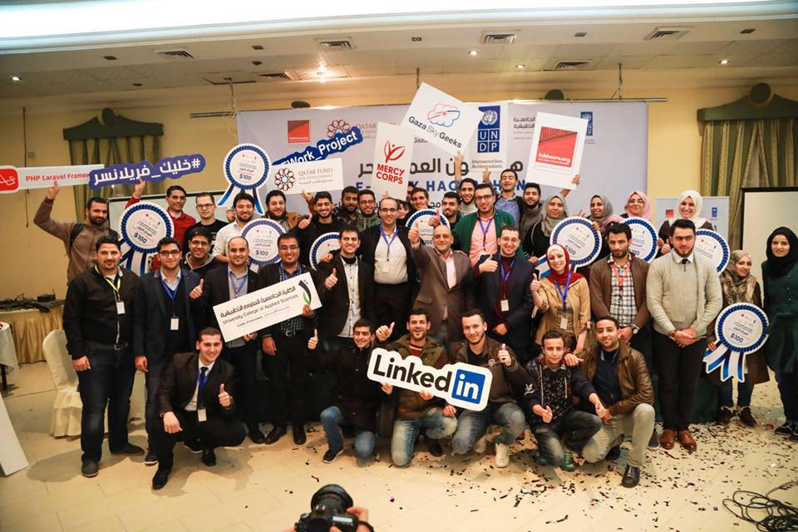

**Country: State of Palestine – Gaza Strip**

**Donor: Qatar Fund for Development through Al Fakhoora, a Programme of Education Above All Foundation – Qatar**

**September 2018**

**TABLE OF CONTENTS**

|  |  |
| --- | --- |
| List of Acronyms | 3 |
| Project Summary | 4 |
| Executive Summary | 5 |
| Youth Situation in Gaza Strip | 6 |
| E-work Project Results Chain | 7 |
| Progress in Project Outputs | 11 |
| Progress against KPIs | 26 |
| Sustainability | 31 |
| Challenges & Lessons Learned | 32 |
| Annex I: | 32 |

1. **List of Acronyms**

|  |  |
| --- | --- |
| **AF** | Al Fakhoora |
| **GSG** | Gaza Sky Geeks |
| **MC** | Mercy Corps |
| **M&E** | Monitoring and Evaluation |
| **NGOs** | Non-Governmental Organisations |
| **PwDs** | Persons with Disabilities |
| **UCAS** | University College of Applied Science |
| **UNDP/PAPP** | United Nations Development Programme/Programme of Assistance to the Palestinian People |
| **WBS** | Work Breakdown Structure |

1. **Project Summary**

|  |  |
| --- | --- |
| **Programme** | Right to Education in the Gaza Strip Programme (PAL10-00094739) |
| **Project** | Economic Empowerment Through E-work Opportunity for Gaza Youth (WBS 1700) |
| **Donor:** | Qatar Fund for Development through Al Fakhoora, a Program of Education Above All Foundation - Qatar. |
| **Executing Agency:** | United Nations Development Programme of Assistance to the Palestinian People (UNDP/PAPP) |
| **Project Budget:** | USD 290,000 |
| **Project Start Date:** | 1 September 2017 |
| **Project End Date** | 30 June 2018 |
| **Implementing Partners** | * Mercy Corps/ Gaza Sky Geeks (MC/GSG) * University College of Applied Science (UCAS) |

1. **Executive Summary:**

With a generous fund from Qatar Fund for Development through Al Fakhoora, a Programme of Education Above All Foundation – Qatar, UNDP has implemented the E-work component of the Right to Education in the Gaza Strip Programme. The E-Work project aims to increase access of Palestinian Youth in Gaza Strip to employment opportunities abroad through e-work and international freelancing platforms within a culture supporting freelancing as an approach to create opportunities in light of difficult context of Gaza.

Upon obtaining the approval of the Al Fakhoora, UNDP launched the E-Work project in partnership with the University College of Applied Sciences (UCAS) and Mercy Corps (MC). As part of phase I, 208 youth (104 M, 104 F) including 4 persons with Disabilities (PwDs) were selected out of 2784 applications received over a one-week advertising campaign. The selected trainees received advanced technical training on 10 different ICT fields related to web, design, game development, and mobile development. Result of pre- and post-assessment showed significant improvement of the trainees’ technical skills. The technical training courses were concluded by a Hackathon with the participation of 250 youth and mentors. During the hackathon, the participants had a challenge of completing products or project relevant to the subject of their training during a five-hour period under the supervision of trainers and mentors, where 10 participants won a USD 100 cash prize per each and were qualified to the second phase of the project.

The second phase of coaching and mentorship targeted the best 92 youth (38 males and 54 females) who were selected based on strict criteria. The trainees were equipped with the necessary soft and practical skills including English language and introduction to freelancing to effectively compete on the online freelancing platforms. Each of the 92 youth received at least 140 hours of one-to-one and group coaching and mentoring sessions by experienced mentors in the freelancing field. Youth were granted access to co-working spaces in two of the most vibrant co-working spaces in Gaza Strip which are supported with high-speed internet and continuous power supply. Each of the targeted youth opened at least three accounts at the different online freelancing platforms including Freelancer, UpWork, Fiverr, People Per Hour, Mosaql, Khamsat, etc. During the coaching and mentorship, the 92 youth managed to achieve 834 jobs through the different online freelancing platforms with a total income of USD 99,369 gained by the fresh freelancers are in the 10 fields.

In order to create a culture adopting online freelancing as a medium for creating opportunities for Gaza youth, several seminars, awareness raising workshops were carried out and reached 897 university students and academics (390 M. and 507 F.). An opening workshop about “Reality of Freelancing in the Gaza Strip: Opportunity and Challenge” was organized with the participation of 150 individuals (75 M. and 75 F.) form relevant stakeholders including freelancers, private sector representatives, academics and NGOs’ representatives who convened to explore and analyze the reality of freelancing ecosystem, challenges and opportunities in the Gaza context. Stakeholders recommended promoting the culture of freelancing in the academic curricula of universities in order to enhance the youth awareness and preparedness for the virtual economy. Also, they highlighted the potential sectors of freelancing including mobile development, digital marketing and artificial intelligence.

This report highlights the main achievements, results and challenges of the different project outputs.

1. **Youth Situation in the Gaza Strip**

Blockades, war, and poor governance have strangled Gaza's economy and the unemployment rate is now the highest in the world at 43 percent.[1] Even more alarming is the situation of youth unemployment which soared to more than 60 percent by the end of 2014 (the unemployment rate for young men was 36.9 percent in 2013, while for young women it was much higher at 64.7 percent). Nearly 80 percent of Gaza’s population receives some kind of social assistance, and nearly 40 percent of them still fall below the poverty line.

It is assumed that unemployment is further on the rise as a result of the 2014 summer hostilities. However, facing the compounded effects of the continuing blockade and the closure of the tunnels with Egypt, the Gaza economy was already collapsing before the conflict. The unemployment rate surged to 44.5 per cent in the second quarter of 2014, up from 27.9 per cent in the same quarter of 2013, and the refugee unemployment rate reached 45.5 per cent, the highest level ever reported in UNRWA’s Palestinian Central Bureau of Statistics (PCBS)-based records. More than half of the unemployed are between the ages of 15 to 24 years old. It should also be noted that PCBS’s unemployment statistics do not capture rates for under-employment in Gaza. For example, a person working one hour per week is considered employed in accordance with PCBS’s data.

Youth in Gaza are among the most affected social groups who face many challenges and especially in terms of the personal and professional development of those enrolled in tertiary education or have recently graduated due to the Israeli occupation policies of exclusion, closure, blockade, etc. A large number of them are highly educated. The State of Palestine has a 95 percent adult literacy rate, well above the regional average of 77 percent.**[2]** Education is highly valued by families in Gaza with 80 percent of schools operating on a double shift before the conflict.

Despite their educational status, youth are limited to finding employment opportunities in the Strip, due to the eight-year long Israeli blockade, which severely restricts the movement of people and goods. The blockade has crushed the Strip’s once dynamic and trade-oriented economy and its capacity to create jobs, and pushed the majority of the population into aid-dependency. Furthermore, another factor limiting students’ employment prospects is the inability of the educational system to adapt to the rapidly changing needs of the labour market and the excess of graduates with the same specializations. Thus, as a result, one of the glaring factors impacting their lives is the increasing poverty levels due to worsening conditions.

Gaza’s unemployment and poverty figures are very troubling and the economic outlook is worrying. The current market in Gaza is not able to offer jobs leaving a large population in despair, particularly the youth. The ongoing blockade and the 2014 hostilities have taken a toll on Gaza’s economy and people's livelihoods. Gaza’s exports virtually disappeared and the manufacturing sector has shrunk by as much as 60 percent. The economy cannot survive without being connected to the outside world.[3]

1. **E-work Project Results Chain[4]**

***Expected Results***

The project mainly aims to *achieve excellence in the utilization of ICT as a medium to generate employment for Gaza youth*: By providing the youth with the needed technical and soft skills, working space, mentoring and linking them to the e-work jobs opportunities, this will be the optimal utilization of cutting-edge knowledge for reducing poverty and engaging educated youth in productive employment.

To achieve the results, the following methodology is used:

***Overall Programme Goal (“Right to Education”):***

**Programme Outcome (Ultimate Outcome):** Increased resilience and improved wellbeing of Palestinian children and youth in Gaza through having a better access to quality education, diversified livelihood opportunities, and leadership and advocacy skills, while integrating building back better principles and mental health support interventions.

**UNDAF/CPD Outcome (3):** By 2016, Palestinian children and youth in the Occupied Palestinian Territory (oPt) have more equitable access to and completion of quality education in an inclusive child-friendly learning environment.

**Outcome/Intermediate Outcome (WBS 1700):** Increased access of Palestinian Youth in Gaza Strip to employment opportunities abroad through e-work and international freelancing platforms within a culture supporting freelancing as an approach to create opportunities in light of difficult context of Gaza, which will ultimately contribute to decreasing unemployment rate among Gaza youth.

**Outputs (Immediate Outcomes)*:***

**Output 1: Strengthened Capacities of 200 Palestinian Youth through Advanced Technical Training Programme in ICT Related Specializations**

**Activity 1.1 Preparation of Training Programme for 200 Palestinian Youth**

**1.1.1** Prepare and advertise ToRs for Implementing partners

**1.1.2** Selection of Implementing Partners

**1.1.3** Introductory workshop with relevant e-work stakeholders to coordinate and organize efforts.

In the beginning of the project, a launching workshop will be organized to announce the new E-Work project and to discuss the E-Work issues with partner organizations and current donors in this field. The workshop will address the importance of e-work as an alternative source of generating incomes for Gaza youth from external markets with participation of main stakeholders, academics and beneficiaries.

**1.1.4** Implementation of advertising and promotional campaign

Starting with an awareness campaign for E-Work possibilities and the project objectives. The campaign may include the following:

- Social Media Ads

- Google AdWords Ads

- Radio Ads

- Workshops in major Gaza universities and youth organizations (10 workshops)

- Other types of Ads (printed materials, Billboard, ..)

**1.1.5** Selection of trainees through selection criteria and interviews

UNDP has coordinated with PICTA to discuss possible cooperation in the selection of target groups, noting that PICTA as a syndicate of the ICT graduates has finalized assessment and screening of the ICT graduates for similar e-work projects with TAQAT in 2016. PICTA has an updated and classified database of 750 graduates. PICTA has agreed to nominate the potential candidates for this project. Nevertheless, UNDP will undertake the selection process based on pre-defined criteria. In case PICTA's nomination does not satisfy UNDP standards, UNDP will use the originally planned selection process which is as follows:

After the advertising campaign, selection committees will start the following procedures to select the best candidates for the training programs. The criteria of selection are:

* Should be graduate
* Not employed full time and able to commit to the training programme
* Has at least medium level in the required technical skill and can provide work samples
* Has no or limited previous record and jobs in freelancing platforms
* Good English language
* Pass assessment exam

Selection criteria will consider also the gender balance of males/females in the training. The assessment exam will be conducted for 40 candidates of each training fields to select 20 trainees. The exam measures both technical abilities for each candidate as well as the freelancing mind-set for her/him.

The training is designed to be conducted in three stages to ensure the highest success rates of employment through e-work platforms. Starting with the basis of freelancers’ success: technical improvement. Then we give them two parallel training sessions in the soft skills (including English language) and E-Work platforms to enable them to work online after the end of the program.

**Activity 1.2: Successful Participation of 200 Palestinian Youth in an Advanced Technical Training Program**

**1.2.1** Ten Technical Training courses (60 hours each) for 200 trainees

The main trigger to the success of the future freelancer is his/her technical abilities. The first step of the training will be intensive (60 hours) courses on specific technical fields that will enable young graduates to upskill their technical abilities. This training will also focus on self-learning and how to develop and acquire new technical skills through online courses. Each selected participant will have the opportunity to join only one technical course for a duration of one month. At the end of the training, 8 out of 20 participants will be selected for the next phase of training in the project.

Training groups are:

1. **Mobile development**: 2 training courses (iOS development and Android development)
2. **Design:** 3 training courses (Motion Graphics, Graphic Design, Infographics)
3. **Game development:** 1 training course (Unity)
4. **Web:** 4 training courses (PHP frameworks, ASP.NET MVC, Web Design, and CMS & WordPress)

These topics were selected based on the high demand of them on freelancing portals. Throughout the training, each trainee is assessed by:

* Pre-exam and post-exam to measure acquired knowledge and skills
* Achieving real life jobs as training projects
* Success in the Freelancing Hackathon

**1.2.2** Cash incentive of USD 100 per trainee

During the technical training period (month), each participant will receive a financial incentive of USD 100 to cover transportations and other expenses. The cash incentive will be linked to the commitment of the trainees and their performance during the training sessions.

**1.2.3** Freelancers Hackathon competition between trainees.

Full day competition for the trainees to compete together in order to achieve working products. This competition will put the trainees in the stress of completing working products in their technical fields. The results of the hackathon will be used as part of the trainees' assessment for the next phase of the project.

**1.2.4** Documenting and Publishing Training videos of technical training to online platforms for future online trainees.

**Output2: Increase Employability of Trained Palestinian Youth in the Online Freelancing Platforms**

**Activity 2.1: Improved Soft Skills and Enhanced Access of Palestinian Youth to E-Work Platforms**

**2.1.1** Four Soft Skills, Four E-Work Trainings (30 hours each) & four English language courses for 80 trainees

Soft skills program is a 30 hours training course to equip successful graduates from the technical training with relevant skills to freelancing such as: Negotiation Skills, technical writing, time management, entrepreneurship, teamwork and marketing. Each participant will have a score at the end of the training to assist his/her abilities in those skills. Other four training courses in English language will also be given to the trainees, tailored to enhance the participants' communication skills for English based e-work platforms.

Parallel groups will take E-Work platforms training: 30 hours training program to allow the young graduates to be familiar with popular E-Work platforms such as Upwork, Fiverr and Freelancer. The training will also cover payment methods, contracting, how to prepare competitive profile and how to apply for and win jobs in those platforms. Each participant will be evaluated based on their progress of creating good profiles and applying for jobs.

**2.1.2** Provide cash incentives of USD 250 to trainees based on their progress & performance

During training and mentoring, each of the 80 participants will receive 250$ per month during the three months of both soft skills training (1 month) and mentoring & coaching phase (2 months). Also they will receive paid rent for co-working space (80 trainees for 3 months).

These incentives will be paid based on the progress, commitment and accomplishment of tasks.

**2.1.3** Documenting and Publishing Training videos of Soft Skills and E-Work Skills to online platforms for future online trainees.

**2.1.4** Four Educational Seminars Offered to Students in Gaza Universities.

Each workshop will be targeting a university in Gaza with the aim of spreading the awareness about the freelancing culture among students and graduates.

**2.1.5** E-Work ToT workshop with Professional Trainers and Academic Lecturers.

This workshop targets 30 academics and trainers who can include freelancing topics in their courses.

**Activity 2.2: Trained Palestinian Youth Have Guidance to Their First Steps in Freelancing Career**

**2.2.1** Prepare Coaching & Mentoring action plan for each technical field

The trainees need both coaching and mentoring to be able to apply their newly acquired skills to get their first freelancing jobs. **Coaching** is used in the first month where the coach will work closely with the trained freelancers to improve their skills, behaviours and performance mind-set to help with the immediate results. In the first month; Goals will be defined and split to sub-tasks, each group of trainees will have a different set of goals based on their specialization.

For example, Mobile developers can have a goal of getting one medium job during the first month which may equal (in costs) to 3 jobs for a designer.

**Mentoring** will allow freelancers to have more control on their progress while maintaining the supervision. Mentors are guides for the trained freelancers and have regular meetings with them to help them make necessary decision during their freelancing career.

**2.2.2** Provide 140 hours of coaching and mentoring for two months for each technical field (each 140 hours will be organized between 20 trainees in both individual and group sessions).

Each of the trainees will be assigned to working space where he/she has access to high-speed internet and office requirements in co-working spaces.

Trainees will have a total of 140 hours of coaching and mentoring for a duration of two months. These 140 hours are dedicated to each field of the ten fields. During the first month, coaching will be focused on assisting trainees to apply for the first jobs. After that, they will have mentoring for another month to follow up their progress.

**Activity 2.3: Provide Trained Palestinian Youth with Facilities and Online Jobs**

**2.3.1** Provide Hosting Co-Working Spaces for Each Trained Freelancer

These co-working spaces will give the trained freelancers a place to work without the fear of electricity issues in Gaza. Working spaces are also great opportunity for them to meet with senior freelancers already working there and can exchange experience with them.

Working spaces have the following conditions:

* Can accommodate at least 10 trained freelancers
* Working hours extended to 8:00 PM or 10 hours / day
* Provide adequate office, chair and hosting services
* High speed internet and
* Continuous electrical supply during the working hours

**2.3.2** Advertise and contract Jobs for Trainees & Provide them with subscriptions

Part of the incentives given to trainees will be real online jobs. The project will work with partners to secure jobs on the online platforms (such as Upwork and Freelancer) to allow trainees to compete and get first jobs and evaluation. These jobs will be awarded based on competitive offers by the trainees. This task will be part of the work with the implementing partners (IPs) of the project. The project will also cover necessary paid memberships and subscriptions for the trainees in the freelancing platforms and other relevant services. These subscriptions and memberships will increase the possibility of success for the new freelancers in their early days of their career.

**2.3.3** Final Ceremony of the project

1. **Progress in Project Outputs:**

**Output 1: Strengthened Capacities of 200 Palestinian Youth through Advanced Technical Training Programme in ICT Related Specializations**

The core of the E-work project success is to choose the right partner and the suitable trainees. At the beginning, ICT stakeholders mapping was done to determine the most relevant partner/s who can carry out the technical training of the project beneficiaries in the best way. Mercy Corps / Gaza Sky Geeks and University College of Applied Science were chosen after a systematic process of technical and programmatic capacity assessment. After that, an advertising and promotional campaign had been done during the project including different platforms and tools such as; Facebook, Jobs.ps, Fora9, sponsored ad, UCAS website, GSG Facebook page and UNDP Facebook page. The links below show the website and the announcement of the project;

Facebook Ad:

<https://facebook.com/ucasGaza/photos/a.246094415513733.55091.244757768980731/1370685609721269/?type=3>

Jobs.ps: <http://www.jobs.ps/index.php?post_id=30080>

For9a website: <http://www.forus4u.com/2017/10/blog-post_34.html>

UCAS Website: <http://www.ucas.edu.ps/AdvDetail.html?ShowID=6844>

**Selection of Beneficiaries:**

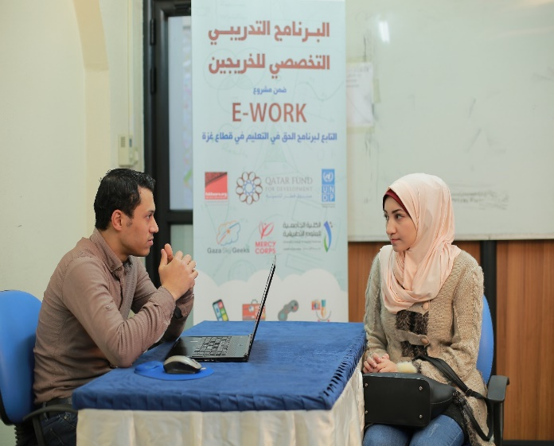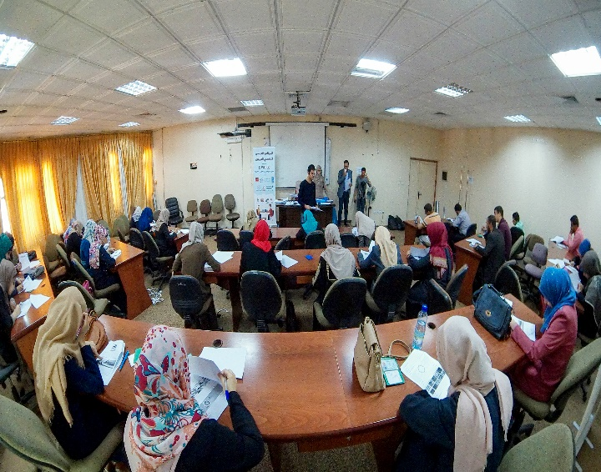Total number of 2784 applications (1388 M; 1396 F) were received for this project within only one week announcement. Careful selection process was administered to ensure selection of the most potential candidates through inclusion/exclusion criteria, ranking, written test and interviews which resulted in the selection of 200 candidates with other 20 candidates on the waiting list. (Annex I provides more details on the selection process).

Written Test of the Candidates as part of the Selection Process

Interview of the Candidates as part of the Selection Process

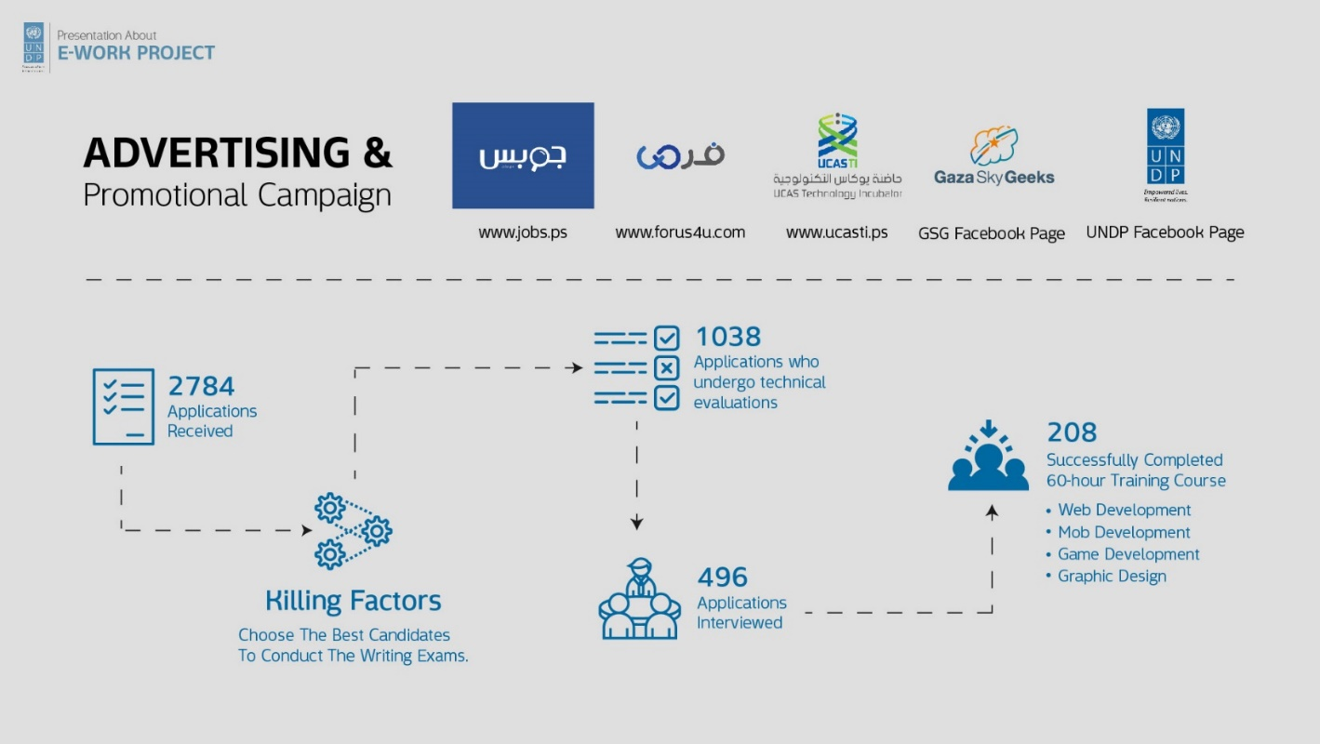

A total number of 208 trainees (104 M, 104 F) including 4 PwDs who successfully completed 60-hour technical training of more than 80% attendance. Trainees engaged in 10 different training course on specific technical fields, as follows:

1. **Mobile development**: 2 training courses (iOS development and Android development)
2. **Design:** 3 training courses (Motion Graphics, Graphic Design, Infographics)
3. **Game development:** 1 training course (Unity)
4. **Web:** 4 training courses (PHP frameworks, ASP.NET MVC, Web Design, and CMS & WordPress)

In the second phase, the best 9 candidates from each course were selected out of 20 participants in the technical training based on the evaluations of their technical capacities from their phase-I and according to the agreed upon selection criteria. Furthermore, freelance mentors assessed candidates technical and soft skills, including English, through interviews. All scores were combined and the best nine from each of the ten technical courses were selected to join the second phase of the program.

* 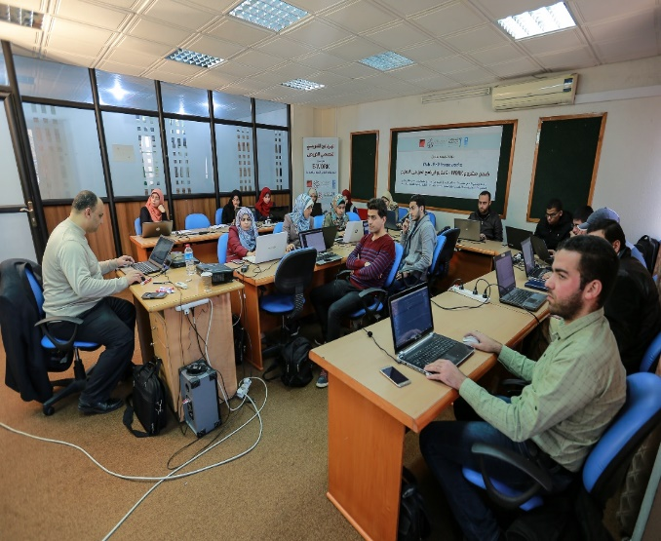**Technical training:**

Ten Intensive 60-hour training courses on ten specific technical fields were carried out by the two partners of the E-work project. A total number of participants who completed at least 80% of the technical training were 208 youth (104 M; 104F). MC/GSG was responsible of Mobile development (iOS development and Android development) and Design (Motion Graphics, Graphic Design, and Infographics) which targeted 105 trainees (51 M; 54 F). Meanwhile, UCAS took the responsibilities of other courses which are Game development (Unity) and Web (PHP frameworks, ASP.NET MVC, Web Design, and CMS & WordPress) which targeted 103 youth (53M, 50 F).

The training doesn’t only focus on upgrading technical skills of the trainees in different sectors but also focused on self-learning and how to develop and acquire new technical skills through online courses.

On the other hand, Pre & Post Assessment Questionnaires were disseminated to the trainees at the beginning and the end of the training to evaluate the impact of the training on the trainees’ level of knowledge and skills.

The training advanced the trainees’ technical skills in addition to enhance self-learning skills. A pre- and post-assessment was carried out to measure the impact of the technical training on improving the trainees’ knowledge and technical skills in the different subjects of training they were engaged in. The result of assessment showed improvement of the trainees’ technical skills from a baseline of 51.7% to 76.9%. Comparing the improvement level with the baseline shows an overall improvement rate of 48.7% among the whole targeted trainees. Trainees’ overall satisfaction of the technical trainings was 83%.

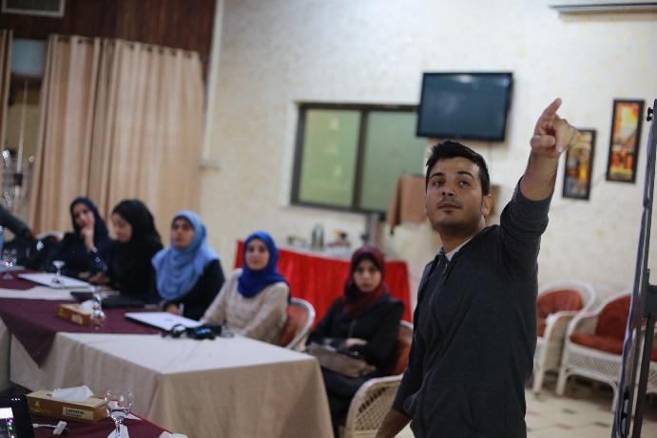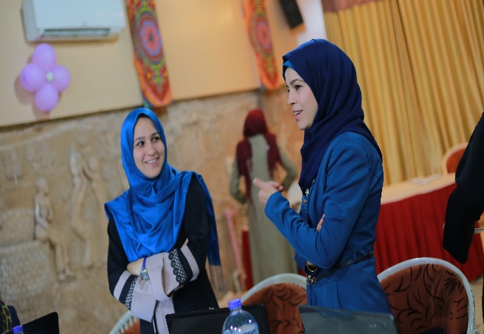

**Results of the training:**

For UCAS five courses, the overall percentage mean of the pre-assessment for the trainees was 44.5%, with the overall percentage mean of the post-assessment for the trainees reached 74.8% contributing to an overall improvement rate of 68% in the trainees’ level of knowledge. The chart below indicates the improvement rate for each training course:

In parallel, for MC/GSG five courses, the overall percentage mean of the pre-assessment for the trainees was 59%, with the overall percentage mean of the post-assessment for the trainees reached 79% contributing to an overall improvement rate of 33.8% in the trainees’ level of knowledge. The chart below indicates the improvement rate for each training course:

**Output2: Increase Employability of Trained Palestinian Youth in the Online Freelancing Platforms**

**Activity 2.1: Improved Soft Skills and Enhanced Access of Palestinian Youth to E-Work Platforms**

In Phase II, the top 92 trainees (38 males and 54 females) - including 12 candidates on the waiting - were qualified to be enrolled in three months extensive mentoring and freelancing programme. The 92 trainees received supplementary training on soft skills (four courses), E-work trainings and English language (four courses). The training included introduction to freelancing, how to sign-up to freelance marketplaces such as Freelancer.com, Upwork, People Per Hour and other platforms. During the training, the participants completed their freelancing profiles which include: Overview, portfolio, tests, etc. Furthermore, they started applying for freelance jobs and the majority of them got their first job during the first month. In parallel, the English language training equipped the participants with needed English skills for online freelancing such as: negotiation skills, proposal writing and communication skills in English.

*“I have learned a lot from “The intensive training we received improved our skills in a very short time period. I become competitive in the market and started to received excellent job offers from the local market and on the freelancing platforms..”*

***Sarah Jamal* - *Infographic trainee*.**

At the end of the training courses, a post-test was conducted to measure the trainees’ progress and to determine the improvement in skills. The results showed that the trainees’ clearly made progress in gaining knowledge on the addressed subjects. The pre-test average was 41% in freelancing and 64% in English while post-test average was 79% in freelancing and 92% in English resulting in 29% average improvement in English and 38% in freelancing.

**Activity 2.2: Trained Palestinian Youth Have Guidance to Their First Steps in Freelancing Career**

**Activity 2.3: Provide Trained Palestinian Youth with Facilities and Online Jobs**

In the second phase of coaching and mentorship, each of the 92 trainees (38 males and 54 females) received at least 140 hours of one-to-one and group coaching and mentoring sessions by experienced mentors in the freelancing field. Youth were granted access to co-working spaces in two of the most vibrant co-working spaces in Gaza Strip which are supported with high-speed internet and continuous power supply. Each of the targeted youth opened at least three accounts at the different online freelancing platforms including Freelancer, UpWork, Fiverr, People Per Hour, Mosaql, Khamsat, etc. During the coaching and mentorship, the 92 youth managed to achieve 834 jobs through the different online freelancing platforms with a total income of USD 99,369 gained by the fresh freelancers are in the 10 fields.

## Illustrations of the results

The *accumulated* earnings for each technical field based on the received reports are the following:

|  |  |  |  |  |
| --- | --- | --- | --- | --- |
| # | Technical Field | Month1 | Month2 | Month3 |
| 1 | iOS | $9,427.00 | $22,402.00 | $27,022.00 |
| 2 | Android | $3,010.00 | $6,720.00 | $8,515.00 |
| 3 | Graphic / Infographic | $6,374.00 | $11,058.00 | $16,228.00 |
| 4 | Motion Graphic | $1,430.00 | $6,991.00 | $9,021.00 |
| 5 | PHP | $3,107.00 | $6,850.00 | $9,957.00 |
| 6 | WordPress | $1,915.00 | $6,551.00 | $8,466.00 |
| 7 | ASP.NET | $3,200.00 | $6,496.00 | $9,696.00 |
| 8 | Web Design | $2,040.00 | $2,953.00 | $4,993.00 |
| 9 | Unity | $2,389.00 | $3,082.00 | $5,471.00 |

The following figure illustrates the achievements in earnings as a comparison chart:

These percentages are illustrated in the following figure:

When comparing the accumulated number of jobs received by trainees, we find the following:

|  |  |  |  |  |
| --- | --- | --- | --- | --- |
| # | Technical Field | Month1 | Month2 | Month3 |
| 1 | iOS | 21 | 44 | 56 |
| 2 | Android | 13 | 39 | 53 |
| 3 | Graphic / Infographic | 70 | 159 | 233 |
| 4 | Motion Graphic | 18 | 96 | 138 |
| 5 | PHP | 16 | 31 | 40 |
| 6 | WordPress | 31 | 42 | 58 |
| 7 | ASP.NET | 18 | 21 | 63 |
| 8 | Web Design | 27 | 35 | 52 |
| 9 | Unity | 28 | 47 | 141 |

The following graph illustrate these numbers:

Another interesting point is how long did it take for the trainees to get their online jobs. The following table is the accumulated percentage of those who received jobs during the three months:

|  |  |  |  |  |
| --- | --- | --- | --- | --- |
| # | Technical Field | Month1 | Month2 | Month3 |
| 1 | iOS | 44.44% | 100.00% | 100.00% |
| 2 | Android | 100.00% | 100.00% | 100.00% |
| 3 | Graphic / Infographic | 77.78% | 100.00% | 100.00% |
| 4 | Motion Graphic | 77.78% | 100.00% | 100.00% |
| 5 | PHP | 55.56% | 88.89% | 100.00% |
| 6 | WordPress | 80.00% | 900.00% | 100.00% |
| 7 | ASP.NET | 55.56% | 66.67% | 100.00% |
| 8 | Web Design | 88.89% | 100.00% | 100.00% |
| 9 | Unity | 80.00% | 100.00% | 100.00% |

The following chart illustrate the three months progress for each technical field:

* **Workshops:**

Many workshops and seminars were carried out during the project as follows:

1. ***Stakeholders Workshop:***

An introductory workshop entitled: “The Reality of Freelancing in the Gaza Strip: Opportunities and Challenges” was held on November 29, 2017. It started with 2-hour Focus Group Discussions (FGD) and included 30 stakeholders divided into three groups(10 persons in each group): Reality group, Challenges group and Opportunities group. Each group consisted of freelancers, private sector representatives, academics and NGOs representatives.

The reality group discussed the current reality of the freelancing ecosystem in the Gaza Strip and they agreed that there is a lack of awareness among students and graduates about freelancing, highlighting that only some IT and design students are aware of freelancing while there is less awareness among graduates in other fields such as accounting and law. The group emphasized the importance of including materials about the freelancing in the academic curriculum of universities in order to enhance the students’ awareness about this domain.

At the same time, the challenges group discussed the impediments that are preventing additional Palestinian youth from taking advantage of online work opportunities. They indicated that weak technical, soft and English skills are main reasons that should be addressed.

Meanwhile, the Opportunities group shared ideas and thoughts about the unexploited windows of opportunities and the future trends in the freelancing markets. They recommended improving graduates’ skills, particularly in the trendy topics such as mobile development, digital marketing and artificial intelligence (AI). They also talked about the importance of enhancing linkages between universities, NGOs and the private sector.

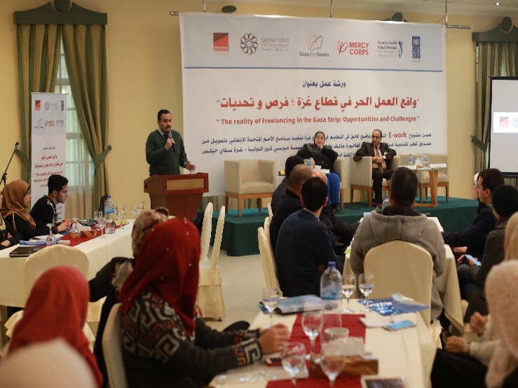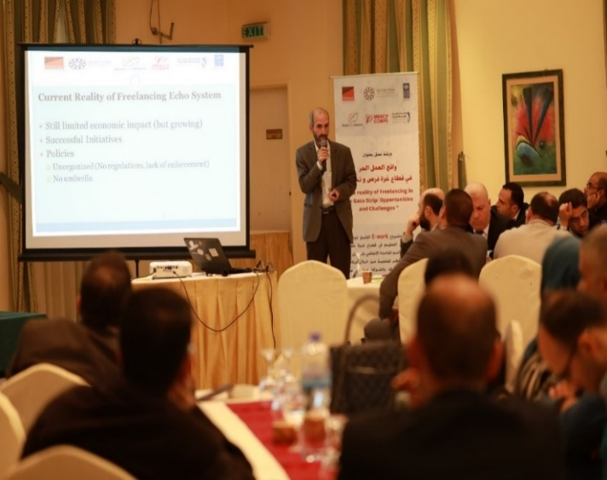The FGDs were followed by the big workshop that was attended by 106 participants including 30 participants of the FGDs. It started with the opening speeches of project partners. After that, the participants of the FGDs delivered three presentations summarizing their findings and recommendations. Then, there were interesting discussions and fruitful exchanges of knowledge. All of them agreed on the importance of freelancing as a solution for talented Gazan youth to work and find jobs.

1. ***Awareness Workshops:***

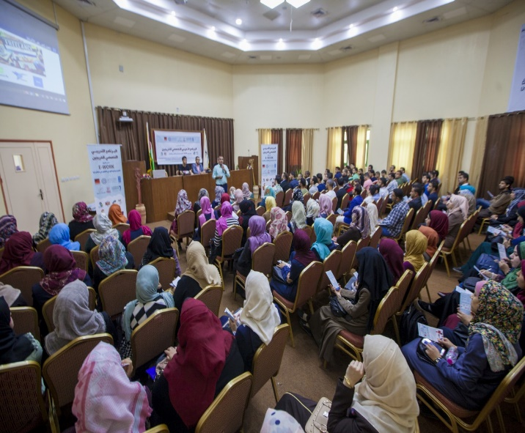During phase I, ten awareness workshops were conducted by UCAS in close cooperation with UNDP team. These workshops aimed at increasing the awareness of the freelancing cultures among youth.

Many universities, colleges and youth organization were targeted through these workshops. A total of 600 youth (359 F, 241 M) benefited from these workshops. PwDs engaged in these workshops as well; there was a special workshop for PwDs to raise their awareness about freelancing with a total number of 13 participants.

The below links shows the new published on two of these workshops;

* <http://ucas.edu.ps/NewsDetail.html?ShowID=6852>
* <http://alumni.iugaza.edu.ps/%D8%B4%D8%A6%D9%88%D9%86-%D8%A7%D9%84%D8%AE%D8%B1%D9%8A%D8%AC%D9%8A%D9%86/>

1. ***Educational Seminars for University Students:***

During phase II, four educational seminars were organized by UCAS targeting students at universities and training centres, including Al Azhar University, Islamic University, UCAS and Khan Younis Training Centre. 147 students and graduates (74 males and 73 females) benefited from the seminars which aimed at promoting a culture conductive to freelancing and e-work. 89.7%. of participant students who show satisfaction from educational seminars

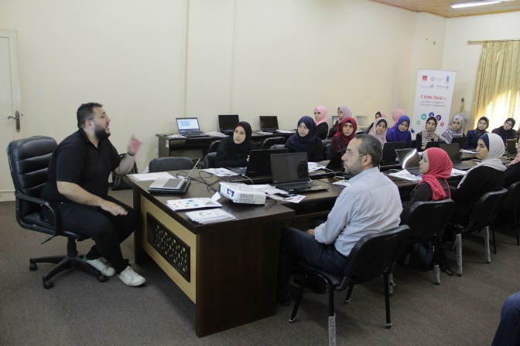 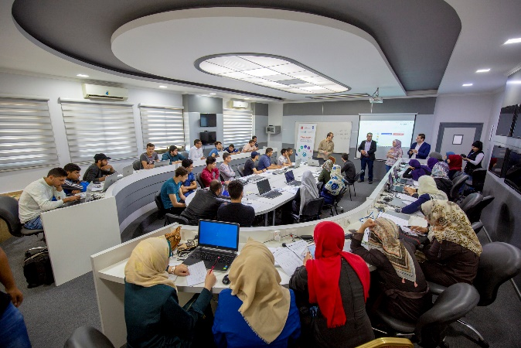

1. ***ToT Workshop with Professional Trainers and Academic Lecturers***

A one-day ToT workshop was conducted in partnership with Mercy Corps on May 10, 2018. The workshop consisted of three sessions: the first one was about freelancing opportunities & platforms, the second focused on strong profile development, and the third discussed effective proposal writing. One of the interesting topics that was introduced to the participants was online freelancing value chain and research opportunities available on online freelancing platforms. It started with opening speeches of projects partners. Then the 33 academics were introduced to the Value Chain of freelancing that was developed by Mercy Corps in one of its previous studies on Online Freelancing. Then they were introduced to the online platforms such as Upwork, Freelancer, Mostaql, etc. The second session discussed building strong profiles on platforms, and how to write an outstanding overview and adding the previous work experiences and qualifications on the profile. The third session was about proposal writing, the first part of the session was theoretical while the second part was bidding on real online projects. After this practical day, academics were expected to transfer the freelancing culture to their students in order to encourage them to immerse themselves in this wide world of opportunities. As a part of a separate ongoing TOT for the academics program, MC/GSG will continue following up with this group of academics and ensure adding them to our current academics network who will be supported with accessing MC/GSG freelancing curriculum that is in its final development stages.

* **Financial Stipends for Trainees:**

In order to enhance youth commitment and success in the online freelancing journey, they were provided with financial incentives to cover the necessary expenses necessary for their participation in the training programme. The implementing partners signed a commitment letter with trainees in order to inform them of their expected duties, responsibilities, co-working space usage policies, procedures and the expected financial support related to their participation in the E-Work program. In phase I of the technical training, each participant received a financial incentive of USD 100 to cover transportations expenses. In phase II of coaching and mentorship, the 80 main trainees who attended monthly more than 70% of trainings were granted financial stipend of $250 a month for a period of three months.

* **Tools & Equipment**

Many of the targeted youth had outdated IT equipment and therefore, the project attempted to support them through purchansing or upgragding their laptops to be able to work effectively and meet ther clients demands. Therefore, the implementing partners’ have completed assessment of the ICT equipment for all participating trainees. The assessment results indicated needs for different types of items such as laptop batteries and chargers, SSD hard drives, RAM sticks, new Laptops, etc. therefore, prioritized needs were determined and purchased under allocated budget

* **Recording of Training Video Sessions**

A plan for the video recordings has been developed by E-Work team to organize recording processes and provide trainers with all needed instructions to use the same methodology to ensure that all videos are recorded in a consistent manner. Trainers recorded sample videos, which were reviewed by the project team. The project team provided feedback to trainers to enhance the quality of the recorded videos. Then trainers proceeded in recording of training videos.

At the same time, video editors were working synchronously to complete the editing of the videos by reviewing and cutting all parts that needed to be revised in order to finalize the editing process in a professional way. Furthermore, they produced intros/outros for each video in addition to a promotion for all training courses.

The recorded videos covered all the training aspects including all theoretical and practical skills in different ways of presentation. The total number of recorded and edited videos is 79 for the five training courses, which cover all needed skills and knowledge that were addressed during the training courses. Five introductions for five training courses and one promotional video were also completed for all of the trainings. After completion of editing process all video were uploaded online.

The training Tutorials were published online and can be accessible by learners for self-learning and development

1- Android: <https://goo.gl/CwNsMq>  
2- iOS: <https://goo.gl/zAGpXX>  
3- Motion Graphics: <https://goo.gl/tmWbCM>  
4- Graphic Design : [https://goo.gl/dUVqxB](https://l.facebook.com/l.php?u=https%3A%2F%2Fgoo.gl%2FdUVqxB&h=ATMn4I-pACa5FXVHxu5Ih6ZTIvA6o0W_70hoHaWiysm8f_shBbhbsBOOzypNVQ4JUqpFOglmQQB2Jtffg4gq3DzHfNyV2K5yd2e4HesVW0Uz9BhqfHgb7kL7pDnLaKpF4WBia4U)  
5- Infographic: [https://goo.gl/68PuFs](https://l.facebook.com/l.php?u=https%3A%2F%2Fgoo.gl%2F68PuFs&h=ATPbwNnFmr7Ov5SBrQFu9wxfJ7u-XW2ZwRwYEz-AZsR-pg8giK5DwFuCj5d-fpi2St8yhcP-z68UtZ7D4glwkH8QaiJlhHbdFa0hVJpLhkvE0pTnoQ4G0lr_L8i2V1IURx-Ppwc)

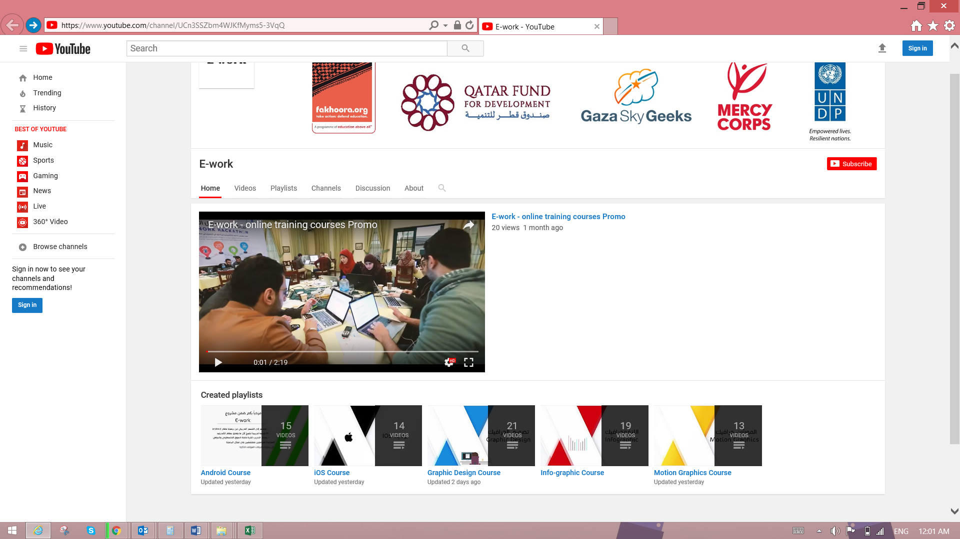

In addition, video promos were produced by the partner organizations, Mercy Corps and UCAS, which can be reached at the following links:

<https://drive.google.com/file/d/1pnS_tgAVOstSN6Pj7hJCqCRBItw-Z-An/view>

<https://www.youtube.com/watch?time_continue=1&v=nmI5fL8Kf-A>

* **Hackathon:**

A full day competition started with a brief speech for E-Work partners to motivate the trainees about utilizing the skills and experience they received during training in the competition. An orientation session followed the speech to inform them about the rules, challenges, and duration of the competition.

Approximately 200 trainees separated into 10 training courses with each group containing 20 trainees. All of the groups had a challenge to complete working products related to their technical field, while the mentors and trainers were following up with the trainees and providing them with advice and instructions to improve their products/projects. The atmosphere was exciting and the spirit of competition was clear among the trainees.

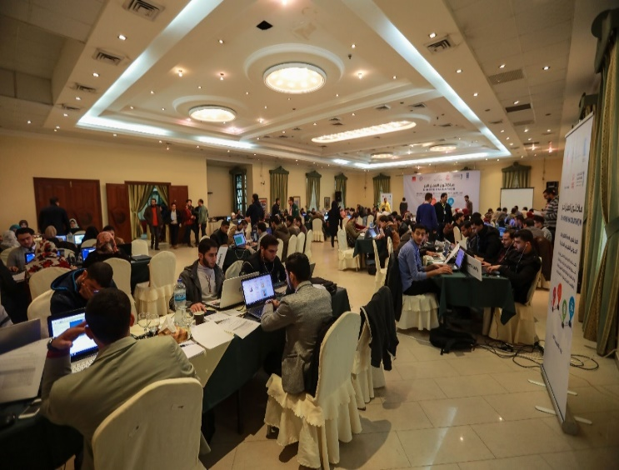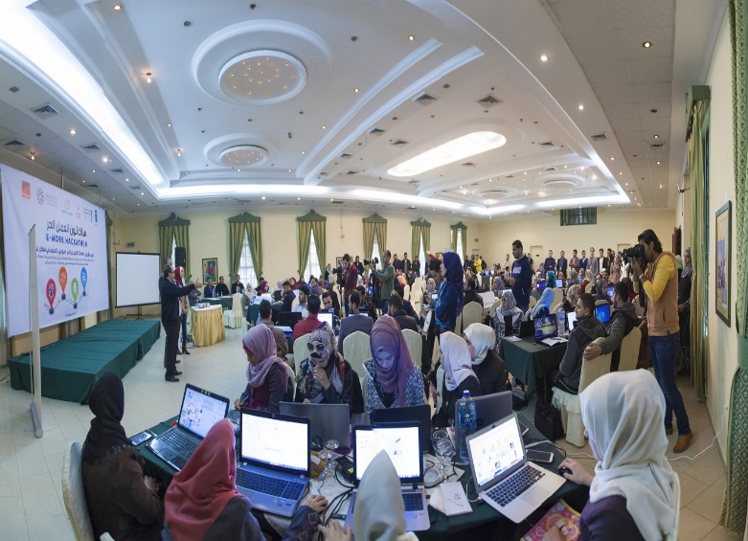Subsequently, the best three from each group, based on the rank of technical mentors and the trainers, presented their achievement in front of a judging panel. The panel consisted of five experts in different technical fields who were asked to select one winner from each group. At the end, ten winners were named and each received a prize of $100. In addition, they directly qualified for the next phase of the project.

* **Trainees Quotes:**
* *Mohammed Al Shawwa: “*Game Development training has a great role in improving my abilities and skills and allowed me to participate in a competition Nazzef and I nominated for the first stage in the competition and now I am working on developing a prototype game to move for next stage”.
* *Solayman Salah: “*Now, I can develop and improve websites with confident with a new language I learnt.”
* *Asma Eltlbani*: “This course change my life and open new doors for me as I became more professional in web issues. At the end of this course, I got an offer to design and develop a website for an international company online”.
* *Ghadeer Kehail*: “Before enrolling in this course, I was working with international clients as administrator for their social media pages. Now, I told my clients that I am a web developer now in WordPress and I can add new features for their company’s website. Without this course, I wouldn’t reach this so far.”
* *Sarah Jamal - Infographic trainee;* “I have learned a lot from the training. My morale rose-up after I was desperate regarding the situation in Gaza. I am more motivated to develop my skills.”
* *Riman Al-Tilbani, an Android trainee*, posted on Facebook saying: “First income from Android Programming! Although it is a small amount of money, however it is nice. Thanks for all who helped me.” and she shared the following photo:-

#### Access to Payment Channels: Opening Bank Accounts and Accessing Payoneer and MasterCard

One of the major obstacles Gazan online freelancers face is online payment processing. After working tirelessly to win business in the global marketplace, they then must pay steep fees for wire transfers or to foreign banks to receive payment from clients, pay their partners, or process online transactions from customers. Services like Western Union and MoneyGram are reliable, but expensive and not amenable to most clients. Services like PayPal are not fully integrated with West Bank/Gaza local bank accounts. Furthermore, due to Palestinian banking policies, many sole-proprietor freelancers with non-merchant accounts are restricted from receiving or sending SWIFT/IBAN wire transfers, GSG leveraged its existing relationship with Bank of Palestine to advocate for friendlier policies for freelancers. Having a Bank of Palestine checking account that can process SWIFT/IBAN wires is not possible unless there is formal employment with a salaried income deposited into the account, making it difficult for freelancers in Gaza to get paid. UCAS and MC/GSG successfully advocated for a breakthrough in this policy and supported the E-Work freelancers’ participants to have access to open bank accounts at Palestine Bank.

MC/GSG has leveraged its current relationship and brokered a partnership with Payoneer, a financial services company that facilitates online money transfers and digital payment services. With this partnership in place, we provided prepaid cards to the E-Work freelancers with the $30 annual fee waived until December 2019. Payoneer will also dedicate a relationship manager who will help MC/GSG with any issues regarding payments, cards, technical issues, and any other issues between our freelancers and Payoneer. Percentage of the participants having Payoneer account noticeably increased from 20% to 82% because of GSG support.

**Final Ceremony:**

Final ceremony of the e-work project activities was organized with the participation of the relevant stakeholders including trainers, trainees, academics and private sector. The ceremony marked the completion of the e-work project activities, speeches of project partners, donor speech, presentation of activities and success stories and handing over certificates for the trainees, trainers, stakeholders who exerted high efforts and the arts sections.

Promo: <https://www.facebook.com/ucasti.org/videos/1778751025550463/>

UCAS Speech: <https://www.facebook.com/ucasti.org/videos/1773838049375094/>

MC/GSG Speech: <https://www.facebook.com/ucasti.org/videos/1777443762347856/>

Al Fakhoora Speech: <https://www.facebook.com/ucasti.org/videos/1775048752587357/>

UNDP/PAPP Speech: <https://www.facebook.com/ucasti.org/videos/1774946902597542/>

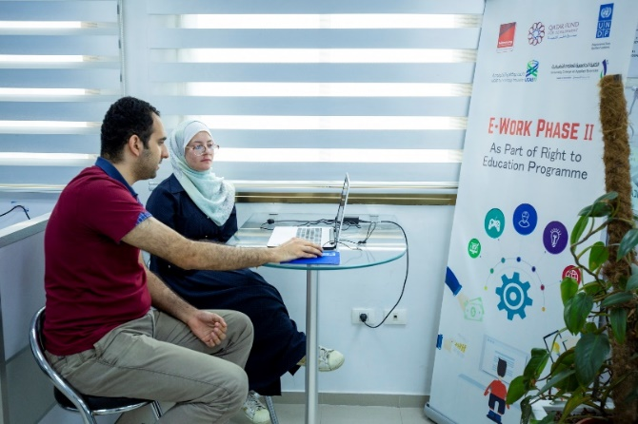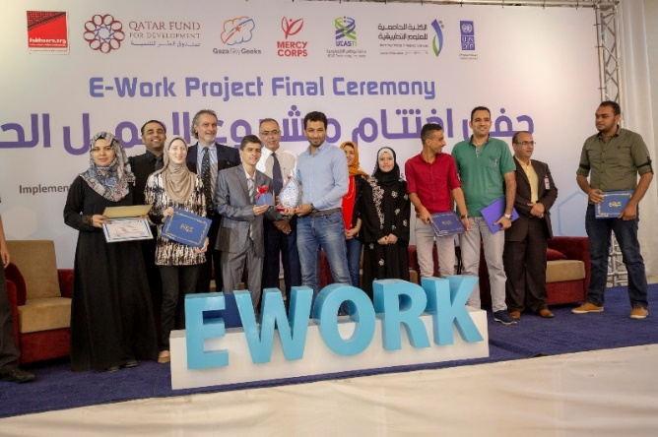

1. **Progress against KPIs:**

|  |  |  |  |
| --- | --- | --- | --- |
| **Output 4.2 (Immediate Outcome (WBS 1700)[5]** Increased access of Palestinian Youth in Gaza Strip to employment opportunities abroad through e-work and international freelancing platforms within a culture supporting freelancing as an approach to create opportunities in light of difficult context of Gaza, which will ultimately contribute to decreasing unemployment rate among Gaza youth. | | | |
| ***Indicator 1: Unemployment rate among Gaza Youth decreased*** | | | |
| **Baseline** | **Target** | **Actual** | **Description (60 words maximum)** |
| 65% unemployment in Gaza | Contribution to decreased unemployment rate among youth. | Completed  The e-work project has contributed to decreasing the unemployment rate among youth through linking 92 youth targeted with external markets. | Upon the completion of the E-Work activities, 92 youth have effectively engaged in online freelancing platforms and obtained independent source of income with total of around USD 100,000 via the online platforms. This has good contribution in decreasing unemployment among the Gaza youth, especially ICT graduates. |
| ***Indicator 2: No. of Youth who actively engaged in the freelancing skilling, mentorship activities, and then started freelancing path.*** | | | |
| **Baseline** | **Target** | **Actual** | **Description (60 words maximum)** |
| 0 | 200 youth received technical training of whom 80 will be engaged in soft skills, e-work mentoring and coaching and got online jobs. | Completed  208 youth (104 M; 104 F) completed the technical training on ten different ICT sectors, while 92 youth (38 males and 54 females). | Out of 2784 applications received (1388 M; 1396 F), 208 youth (104 M, 104 F) including 4 persons with Disabilities (PwDs) were systematically selected to take part in advanced technical training on mobile development, design, game development, and Web as part of phase I of E-Work component. Based on strict selection process, 92 youth (38 males and 54 females) were qualified for phase II of coaching and mentorship. |
| **Output1: Strengthened Capacities Of 200 Palestinian Youth Through Advanced Technical Training Programme in ICT Related Specializations** | | | |
| ***Indicator 1: No. of Palestinian youth chosen and completed the technical training.*** | | | |
| **Baseline** | **Target** | **Actual** | **Description (60 words maximum)** |
| 0 | 200 youth (50% males & 50% females). | Completed  208 trainees (104 M; 104 F) were chosen out of 2784 applications. The selected trainees were divided into 10 groups, where each group completed 60 hours of technical training on different ICT sectors. | A total number of 208 trainees (104 M, 104 F) including 4 persons with disabilities (PwDs) received ten 60-hour training courses on specific technical fields as follows;   1. Mobile development: 2 training courses (iOS development and Android development) 2. Design: 3 training courses (Motion Graphics, Graphic Design, Infographics) 3. Game development: 1 training course (Unity) 4. Web: 4 training courses (PHP frameworks, ASP.NET MVC, Web Design, and CMS & WordPress). |
| ***Indicator 2: Level of technical knowledge and skills acquired by the targeted youth.*** | | | |
| **Baseline** | **Target** | **Actual** | **Description (60 words maximum)** |
| 51.7% according to pre-assessment. | increase by 50%. | Completed  Through pre and post assessments, the overall improvement rate was 48.7% in the trainees’ level of knowledge and technical skills in the different courses. | A pre- and post-assessment was carried out to measure the impact of the technical training on improving the trainees’ knowledge and technical skills in different subjects of training they were engaged in. The result of assessment showed improvement of the trainees’ technical skills from a baseline of 51.7% to 76.9%. Comparing the improvement level with the baseline shows an overall improvement rate of 48.7% among the whole targeted trainees. Trainees’ overall satisfaction of the technical trainings was 83%. |
| ***Indicator 3: Organization of a successful hackathon event/competition attended by 100 pre-selected youth.*** | | | |
| **Baseline** | **Target** | **Actual** | **Description (60 words maximum)** |
| 0 | One hackathon successfully organized | Completed  One hackathon was successfully organized with the participation of 208 youth. | 208 Youth had the chance to participate in the challenge by completing working products relevant to the subject of their training during a five-hour period and using skills learned during technical training stage, while the mentors and trainers were following up with the trainees and providing them with advice and instructions to improve their products/ projects. Subsequently, the best three trainees from each group, based on the rank of technical mentors and the trainers, presented their achievements in front of a selection panel and the entire participants. The panel consisted of five experts in different technical fields who were asked to select one winner from each group. By the end of the hackathon, 10 participants won a USD 100 cash prize and were qualified to the second phase of the project. |
| **Output2: Increase Employability of Trained Palestinian Youth in the Online Freelancing Platforms** | | | |
| ***Indicator 1: No of Palestinian youth completed the Soft Skills & E-Work Training*** | | | |
| **Baseline** | **Target** | **Actual** | **Description (60 words maximum)** |
| 0 | 80 youth | Completed  92 Youth (38 males and 54 females) were selected from the trainees of the technical training. | Selection of 92 youth to take part in phase II of the e-work activities including soft skills and e-work training. Selection was based on interviews and assessment of trainees’ technical and soft skills, including English.  The youth received 40 hours training in English language & soft skills and 30 hours training in freelancing. Having introduced to freelancing platforms such as Freelancer.com, Upwork, People Per Hour and other platforms, targeted youth set up their own accounts. The pre-test average was 41% in freelancing and 64% in English while post-test average was 79% in freelancing and 92% in English resulting in 29% average improvement in English and 38% in freelancing. |
| ***Indicator 2: No. of Palestinian youth received coaching & mentoring sessions for two months at co-working spaces supplied with continuous source of electricity, high-speed internet with 10 hours a day.*** | | | |
| **Baseline** | **Target** | **Actual** | **Description (60 words maximum)** |
| 0 | 80 youth | Completed  92 Youth (38 males and 54 females) received coaching & mentoring sessions by experienced mentors in the freelancing field at adequately supported with high-speed internet and continuous power supply co-working spaces | Each of the 92 youth received at least 140 hours of one-to-one and group coaching and mentoring sessions by experienced mentors in the freelancing field. Coaching and mentoring sessions were provided to trainees in freelancing and technical topics, which allowed mentors to provide the mentees with the needed individual support in order to boost their freelancing performance.  Youth were granted access to co-working spaces in two of the most vibrant co-working spaces in Gaza Strip which are supported with high-speed internet and continuous power supply during working hours (9am to 7pm) six days a week. |
| ***Indicator 3: % of youth applied the training in real life through opening at least two accounts on freelancing portals and applying for at least 15 jobs*** | | | |
| **Baseline** | **Target** | **Actual** | **Description (60 words maximum)** |
| 0 | 80 % | Completed  100% of the targeted youth opened at least three accounts each and all of them applied for the jobs. | Each of the targeted youth opened at least three accounts at the different online freelancing platforms including Freelancer, UpWork, Fiverr, People Per Hour, Mosaql, Khamsat, etc. and started competing for jobs, where the total number of online job applications amounted to more than 7,138 bidding. |
| ***Indicator 4: No. of online jobs and income value obtained by the project benefited freelancers through the freelancing platforms during mentorship and coaching.*** | | | |
| **Baseline** | **Target** | **Actual** | **Description (60 words maximum)** |
| 0 | 240 jobs (income value varies) | Completed  A total of 834 jobs were obtained by the project benefited freelancers with total income of USD 99,369. | The 92 youth managed to achieve 834 jobs through the different online freelancing platforms with a total income of USD 99,369 gained by the fresh freelancers are in the 10 fields.  Highest income was recorded by the IOS freelancers, who earned USD 27,022 through 56 jobs. Meanwhile, ASP.NET, PHP, WordPress motion graphics, Android, graphic design and infographics average income was around USD 9,000 to 9,500 per group. In contrast, Web Design and Game Development recorded the lowest income of around USD 5,250 per group. |
| ***Indicator 5: Percentage of students show satisfaction from educational seminars.*** | | | |
| **Baseline** | **Target** | **Actual** | **Description (60 words maximum)** |
| 0 | 60% | Completed  Average satisfaction rate among students benefited from education seminars was 89.74%. | Aimed to increase awareness of freelancing culture, 4 educational seminars were held at main Gaza universities which benefited 147 students (74 males and 73 females). The majority of participants of the education seminars in the four universities and colleges were satisfied with the sessions with the rate of 89.74% |
| ***Indicator 6:*** *No. of targeted academics and trainers successfully complete TOT workshop.* | | | |
| **Baseline** | **Target** | **Actual** | **Description (60 words maximum)** |
| 0 | * 30 Academics and Trainers. | Completed  33 academics were introduced to  Online Freelancing and online platforms such as Upwork, Freelancer, Mostaql, etc. | Academics received a one-day ToT workshop about freelancing opportunities and platforms, profile development, and effective proposal writing. The workshop was practice-oriented as it included bidding on real online projects. After this practical day, academics were expected to transfer the freelancing culture to their students in order to encourage them to immerse themselves in this wide world of opportunities. |

1. **Sustainability:**

Sustainability was at the core of the whole programming cycle of e-work project including design, implementation, monitoring and evaluation. The following are mains aspects that enhance the sustainability of the project impact:

* The training materials were recorded and uploaded on Youtube for other future freelancers to learn from them. The training materials were disseminated to future graduates through the online portals.
* Many awareness workshops were conducted in different universities, colleges and youth institutions to create a culture of freelancing and e-work among youth and academics.
* Media campaign including billboard and social media ads was designed and posted in public domains including the universities compound and social media domains to enhance the culture of freelancing.
* Trained youth started to launch initiatives to train their peers at local universities to adopt freelancing as an alternative approach of employment and income generation.

1. **Challenges & Lessons Learned:**

### Technical Training Design

The implementation timeline for the technical training was very tight (about four weeks). It is recommend that technical trainings are longer to enable implementing partners to build a stronger technical competency for the selected trainees.

To mitigate this limitation, the project team continued follow-up with trainees after the end of Phase I activities. The project team engaged experienced freelancers and mentors to provide trainees with advice and guidance about how to further develop their technical and English skills through engagement on Facebook Groups. That helped make a smoother transition into Phase II of project by further enhancing trainees’ skills.

* iOS trainees Access to Mac Devices

The limited hours of access to Mac devices caused slow technical growth of the iOS students, therefore trainees’ should be supported with permanent access to Mac devices to be able to continue work on their tasks and further develop their technical skills.

1. **Annex I:**

**Selection of Beneficiaries:**

**Phase I:**

The selection of the E-work project trainees was a main milestone for the success of the project. A total number of 2784 applications (1388 M; 1396 F) were received for this project. Due to the importance of this section, UNDP in close cooperation with both MC/GAG and UCAS developed a clear system of selection. First, killing factors were determined in which each candidate who didn’t have the minimum requirements will be excluded directly; the table below indicates the killing factors;

|  |  |
| --- | --- |
| **#** | **Killing factors for selection process for trainees application** |
| 1 | Still student |
| 2 | Age is above 35 |
| 3 | Full time employed |
| 4 | Can’t Commit in attending the training |
| 5 | Can’t bring his laptop |
| 6 | Answering the question in Arabic |
| 7 | Well known people who participated in GSG or UCAS previous similar training. |
| 8 | Has no basic experience in the three options |
| 9 | Inconsistence information |

After that, scoring criteria were developed and used to evaluate the applications that passed the first stage of the selection. The table below shows the Ranking for scoring criteria for trainee’s application in E-Work Project:

|  |  |  |  |  |
| --- | --- | --- | --- | --- |
| **Ranking for Scoring criteria for trainees application in E-Work Project** | | | | |
| **General Scoring Criteria** | **Scoring Mechanism** | | | **Score**  **percent** |
| (GPA) Grade Point Average : | less than 70% | | 2% | max8% |
| 70% - 79% | | 4% |
| 80% - 89% | | 6% |
| 90% and above | | 8% |
| English Skills | Reading | Basic | 1% | max12% |
| Intermediate | 2% |
| Advance | 3% |
| Professional | 4% |
| Writing | Basic | 1% |
| Intermediate | 2% |
| Advance | 3% |
| Professional | 4% |
| Speaking | Basic | 1% |
| Intermediate | 2% |
| Advance | 3% |
| Professional | 4% |
| Ranking for first option  experience | Basic experience | | 15% | max20% |
| Medium experience | | 20% |
| No experience at all is Killing  Factor | High experience | | 10% |
| Employment Status | Yes | Part time | 10% | max30% |
| Freelancer | 20% |
| No | Free | 30% |
| Full time employment is Killing factor. |
| Motivation | High | | 30% | max30% |
| Medium | | 20% |
| Low | | 10% |
| **Total:** | | | | **100%** |
| **After this ranking: For iOS training (15) mark will be added for those who have MAC device.** | | | | |

Then, applicants who passed both first and second stage of the selection process were called for an exam related to their first option. At the end of this process interviews were conducted to the applicants who get the highest marks on the exams to choose the best 200 candidates.

**Phase II:**

In order to select best candidates for E-work Phase II, the following process was implemented in close coordination with the implementing partners:

* Before interviews, selection criteria were developed by UNDP team.
* All the 208 trainees of Phase-I were invited to attend interviews in order to select best 80 candidates to join the second phase. Interviewers were experienced trainers and freelance mentors.
* Candidates were ranked in each technical field according to their marks set by interviewers.
* Best 8 candidates of each course were selected for the second phase for each technical field.
* One or two backup candidates were selected in each training courses.

Note: As per a joint agreement with the implementing partners, the best candidate in each technical training who won the competition during the hackathon conducted at the end of Phase-I and passed interviews were selected for second phase-II.

1. http://www.worldbank.org/en/news/press-release/2015/05/21/gaza-economy-on-the-verge-of-collapse
2. http://www.unicefusa.org/stories/8-things-you-need-know-about-gaza/18886
3. Gaza’s real GDP is only a couple of percentage points higher now than it was 20 years ago in 1994, while the population growth is estimated to have increased by about 230 percent over the same period. Consequently, real per capita income in Gaza is 31 percent lower now than in 1994. The 2014 war has reduced Gaza’s GDP by about US$460 million. Construction, agriculture, manufacturing, and electricity sectors were hit the most with output reductions of 83 percent in the construction sector in the second half of 2014 and roughly 50 percent in these other sectors.
4. As per the approved project proposal of E-work component.
5. Original Project Outcome (WBS 1700): Mental health wellbeing enhanced for students and their parents through better mental health care and better prospects for a brighter future.