- Recording of Training Video Sessions
A plan for the video recordings has been developed by E-Work team to organize recording processes and provide trainers with all needed instructions to use the same methodology to ensure that all videos are recorded in a consistent manner. Trainers recorded sample videos, which were reviewed by the project team. The project team provided feedback to trainers to enhance the quality of the recorded videos. Then trainers proceeded in recording of training videos.
At the same time, video editors were working synchronously to complete the editing of the videos by reviewing and cutting all parts that needed to be revised in order to finalize the editing process in a professional way. Furthermore, they produced intros/outros for each video in addition to a promotion for all training courses.
The recorded videos covered all the training aspects including all theoretical and practical skills in different ways of presentation. The total number of recorded and edited videos is 79 for the five training courses, which cover all needed skills and knowledge that were addressed during the training courses. Five introductions for five training courses and one promotional video were also completed for all of the trainings. After completion of editing process all video were uploaded online.
The training Tutorials were published online and can be accessible by learners for self-learning and development
1- Android: https://goo.gl/CwNsMq
2- iOS: https://goo.gl/zAGpXX
3- Motion Graphics: https://goo.gl/tmWbCM
4- Graphic Design : https://goo.gl/dUVqxB
5- Infographic: https://goo.gl/68PuFs
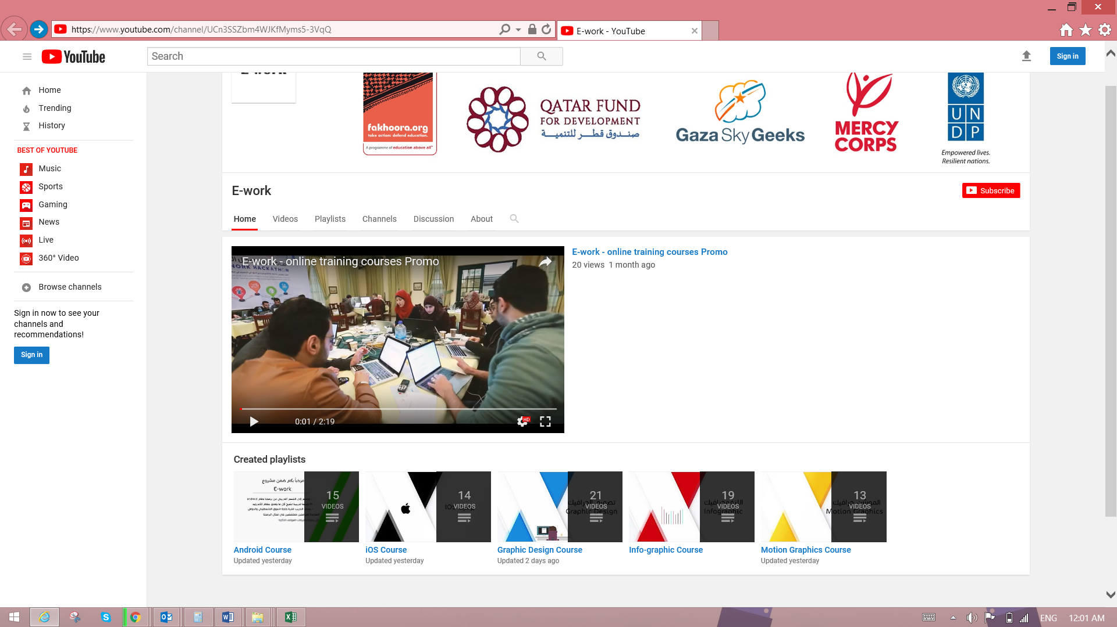
In addition, video promos were produced by the partner organizations, Mercy Corps and UCAS, which can be reached at the following links:
https://drive.google.com/file/d/1pnS_tgAVOstSN6Pj7hJCqCRBItw-Z-An/view
https://www.youtube.com/watch?time_continue=1&v=nmI5fL8Kf-A

