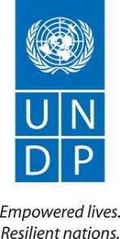

UNDP Sierra Leone
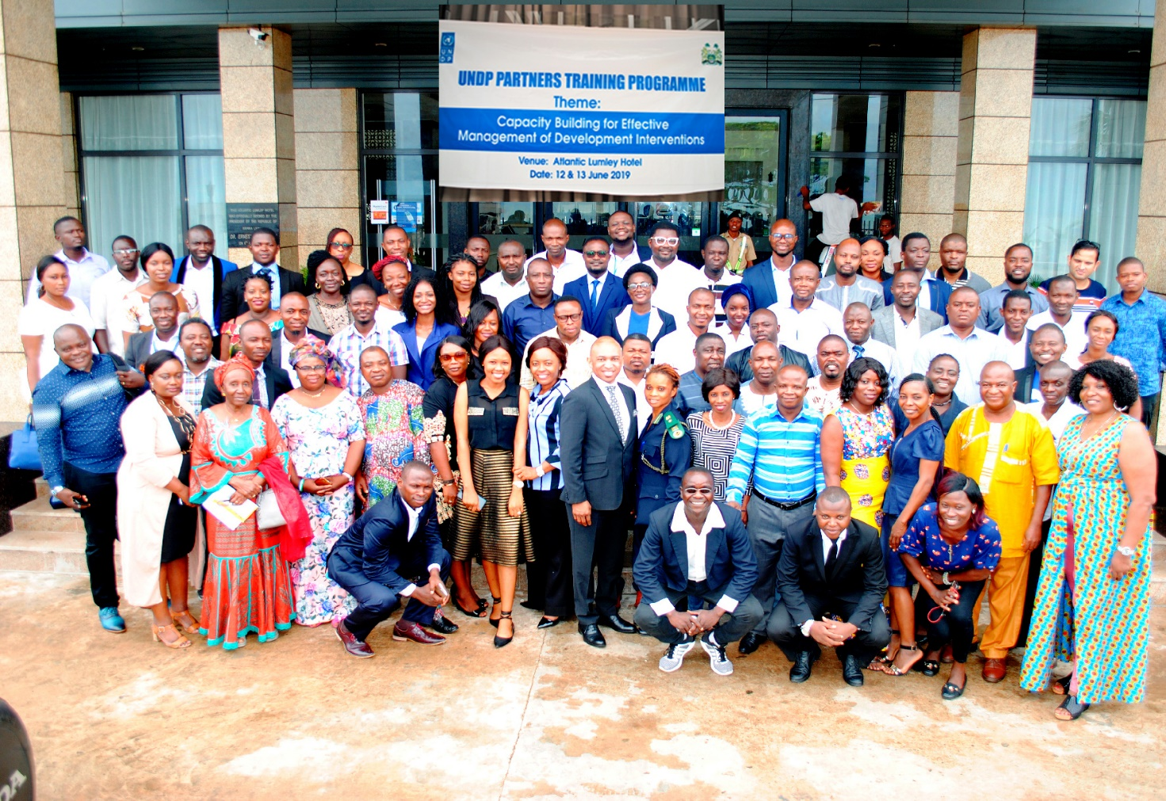

Implementing Partners Training Report
“Capacity Building for Effective Management of Development Interventions”
12-13, June 2019

Acronyms and Abbreviations

CSO - Civil Society Organization
GOSL - Government of Sierra Leone
HACT - Harmonized Approach to Cash Transfer
IP - Implementing Partner
M&E - Monitoring and Evaluation
NDP - National Development Plan
PSU - Planning and Support Unit
RBM - Results Based Management
RBR - Results Based Reporting
ROL - Rule of Law
RR - Resident Representative
SDG - Sustainable Development Programme
SLED - Sustainability and Local Economic Development
UNDP - United Nations Development Programme

Contents

1. Background …………………………………………………………………. 4

2. Opening and closing of the training …………………………………. 4

3. Purpose of the training …………………………………………………. 4

4. Participant Expectations ……………………………………………….... 4

5. Ground Rules ………………………………………………………………. 5

6. Training summary …………………………………………………………. 5

7. Facilitators …………………………………………………………………. 6

8. Questions/Issues raised in the training …………………………………… 6

9. Findings from the Pre and Post assessments ………………………....... 7

10. Recommendations …………………………………………………………. 7

Annex A
Photo Gallery…………………………………………………………………………. 8
- Background
Over the years, UNDP’s attempts towards increased use of national institutions and systems has been challenged by inherent capacity issues given its high standards and expectations on programme delivery, reporting and accountability. The findings from Joint monitoring events, field visits, spot checks, use of data and evidence, assessments, Audits, and Evaluations reveal the capacity gaps within participating institutions.

It is in this context that the partners capacity development training was proposed to increase the capacity of the partners for their overall programmatic, operational, financial and quality assurance related functions. This training was designed to respond to specific capacity issues; key areas where partners’ capacity required strengthening.

- Opening and closing of the Training
The training was opened by the Samuel Doe (RR) who emphasized to the participants that UNDPs work involved tackling poverty in all its forms. It involved working with the GOSL and the development partners in strengthening up-stream and down-stream mechanisms and systems to ensure that people are at the centre of development and benefit from initiatives. In the absence of the RR, the training was closed by Walter Neba (ROL Project Manager), who thanked the participants for the time dedicated to the training and encouraged them to implement what they had learnt. He also reiterated the need for them to implement their projects in line with UNDP regulations and procedures and GOSL procedures, where they were applicable.

- Purpose of the training
The training aimed at equipping organizations with the requisite skills and knowledge required to effectively manage a project cycle (results-based planning, management, accountability, monitoring, evaluation and reporting). It is envisaged that the required skills would be used by the participants to improve quality, standards, procedures, policies and the quality of project implementation in their respective organizations.

- Participant Expectations (Summary)
- To know more about UNDPs processes, procedures, programme and projects and how they align with the National Development Plan (NDP) and SDGs
- To know more about UNDP in the implementation of its projects
- To know more about project cycle management and UNDPs expectations of the IPs
- To get more knowledge on procurement activities
- To get more knowledge on project and financial management
- Acquire more skills in Results Based Narrative Reporting (RBR) and Financial Reporting
- Required documentation and type of evidence
- Deeper understanding of RBM and M&E
- How to build resilience in vulnerable communities

- Ground Rules
The following in-house rules were instituted by the participants to create order in the training room:
- Phones in silent or off
- Speak through the facilitator
- Respect others’ views
- Time management
- Limited movement

- Training Summary
The training was held at Atlantic Lumley Hotel on the 12th and 13th of June 2019 and was officially opened by the UNDP Resident Representative. It targeted partners that were directly involved in programme and operation functions. These included project managers, project officers, administrative and finance staff, procurement staff and programme staff from UNDP. A total of 87 participants (F27; M60) attended the training, representing government institutions, University, CSOs and UNDP Programme staff.

The training was interactive and engaging and also involved the following training methods: power points presentations, group work, small buzz group discussions and case studies.

The training topics covered the following:
- UNDP Programme, Processes and Procedures
- UNDP Finance Processes and Procedures
- An Overview: Inclusive Growth and Sustainable Environment, Governance and Strategic Advisory Unit
- Introduction to Harmonized Approach to Cash Transfer (HACT)
- Introduction to Rights-Based Management (RBM)
- Results-Based Reporting (RBR), Visibility and Communication in projects
- Planning and Conducting Results Monitoring,
- Commissioning and Managing Results Evaluation
- Project Data Collection and Evidence Documentation
- Results-Based work planning and Budgeting
- Indicators and Results Tracking
- Gender and Gender Mainstreaming
- Risks Management
- Lessons Learning and documentation of Success Stories
- Introduction to Resource Mobilization
- Financial Accountability and Reporting
- Basics of UNDP Procurement Processes
- Internal Control Systems & Preparing for Audits

The training was interactive and engaged the participants. It also involved the following training methods: power points presentations, group work, small buzz group discussions and case studies. At the end of the training, each of the participants was given a flash drive that contained all the presentations and a Certificate of Attendance.

- Facilitators
The 11 facilitators were drawn from both programmes and operations staff in UNDP Sierra Leone, as follows:

- Daisy Foday – Programme Specialist, Head - PSU
- Irene Ntanda – Planning and Coordination Specialist, PSU
- Madhab Regmi – Monitoring and Evaluation Specialist, PSU
- Musu Bangura – Gender Specialist, PSU
- Lamin Bangura – Programme Finance Analyst, PSU
- Samuel Palmer – Programme Specialist, SLED Cluster
- David Jarrett – Procurement Analyst, Operations
- Mahmoud Conteh - Programme Associate, Governance Cluster
- Patrick Mamie – Finance Associate, Operations
- Thomas Williams – Finance Analyst, Operations
- Joseah Mutai – M&E Officer, Governance Cluster

- Questions/Issues raised in the training
- How the projects are linked to GoSL’s National Development Plan
- How to deal new activities that are important for the project but were not originally factored into the AWP.
- How to go beyond just the numbers in gender reporting
- The time allotted for the training was short and in future trainings, specific dates and topics should be allocated according to staff skill sets and job functions.
- Regularly conduct bi-annual and one-on-one refresher training for the IPs
- How can visibility of various partners, who contribute to the same project, be highlighted in reports.
- Government systems do not function the same way as UNDP, so some processes and procedures may take longer to materialize.

- Findings from Pre and Post training Assessments
A pre-assessment questionnaire was administered before the training and it revealed that 32 participants (36.8%) had a slightly moderate understanding of the training topics while 55 participants (63.2%). The post-assessment results revealed that 10 participants (11.5%) still had a moderate understanding of the topics while 77 participants (88.5%) had greatly improved their understanding of the topics. The moderate rates in understanding can be attributed to the different skill sets, qualifications and job functions that the different participants possessed or were engaged in. Learning new topics out of their regular responsibilities/domains was a challenge to some.

10. Recommendations
- Conduct regular custom-designed refresher trainings for IPs.
- Ensure ample time is scheduled for the training and sessions to allow for more practical exercises and questions.
- Needs assessments to be conducted among the IPs to determine the specific type of training required.
- Decentralized training events would ensure the participation of more partners and increased knowledge transfer.

Annex A: Photo Gallery
