Downscaling Coarse Resolution Climate Projections for Djibouti

Technical Report

By
Dr. Hussen Seid Endris

July, 2018

Contents
Downscaling Coarse Resolution Climate Projections for Djibouti 0
Chapter 1 1
1.0 Introduction 1
Chapter 2 3
2.0 Data 3
2.1 Model data 3
2.2 Observed data 3
2.3 Methods 4
Chapter 3 5
3.0 Results 5
3.1 Validation of Downscaled Results 5
3.2 Projected changes in rainfall and temperature 6
Chapter 4 18
4.0 Conclusion 18
References 19

Chapter 1

1.0 Introduction
Global Climate Models (GCMs) simulate the atmospheric, ocean and land processes and interactions between them, and are the fundamental tools for projecting climate change. They are designed to evaluate the behavior of the global climate system and are effective at simulating global and continental characteristics of the climate like global/continental temperature and precipitation patterns. The spatial resolution of the most updated GCMs used in the Fifth Assessment Report of the Intergovernmental Panel on Climate Change (IPCC AR5) from the phase 5 Coupled Model Inter-comparison Project (CMIP5) ranges from 100 to 300 km. Although GCMs at this resolution have the potential to capture the global climate characteristics and broad circulations patterns, they are not capable of capturing the detailed processes associated with regional–local climate variability and changes that are required for accurate regional and national climate change assessments. The lack of high spatial resolution makes it especially difficult to represent orographic impacts, even for large watersheds. Moreover, the coarse resolution limits their ability to reproduce realistic extreme events that are critical to many users of climate information.
In order to obtain regional and local climate information, different methods to downscale climate data from coarse-scale GCM output have been developed. These downscaling methodologies categorized into two broad classes: statistical and dynamical. Statistical downscaling is based on first developing a statistical model, which relates some large-scale climate variables or predictors (e.g., sea level pressure, geopotential height, wind fields, relative humidity) and regional/local variables or predictors (such as rainfall or temperature) ) [Hewitson and Crane, 1996; Wilby et al., 2004]. The large-scale variable from a GCM output is then fed into the statistical model to calculate the corresponding local/regional climate feature. Dynamical downscaling, on the other hand, is based on mathematical representations of the physical processes that create the climate system, similar to GCMs, but applied over a limited area at a higher spatial resolution than the GCMs (Giorgi and Mearns, 1999). Dynamical downscaling is done with a Regional Climate Model (RCM). In case of dynamical downscaling, driving data from reanalysis or GCM is used to force the boundaries of an RCM over a limited area. The basic sets of boundary conditions are temperature, moisture, and circulation (winds), as well as sea-surface temperature and sea ice.
Each downscaling technique has its own advantages and disadvantages. Some of the advantages of statistical downscaling over dynamical downscaling are that statistical downscaling is comparatively cheap, computationally efficient, and provides simple ways for generating scenario ensembles. It is also able to directly incorporate observations. Disadvantages of this approach are that it requires long and reliable observed historical data series for calibration, depends on the chosen predictors, does not include feedbacks in the climate system, assumes stationarity in relationship between predictor and predictand, and is affected by biases in the underlying GCM. The strength of the dynamical approach is that it produces responses based on physically consistent processes and produces finer resolution information from GCM-scale output that can resolve atmospheric processes on a smaller scale. However, it is computationally intensive, which limits the number of scenarios that can be downscaled and is strongly dependent on the GCM boundary forcing. Moreover, compared with actual landscape characteristics at a RCMs resolution (~50 x 50 km at best), many important details are still lacking because of the complex and highly variable topography. Impact models often have to deal with processes at a finer scale and therefore require data of higher spatial resolution than the RCMs normally can provide. A post-processing of RCM outputs is therefore necessary to obtain plausible time series at an appropriate scale for use in local impact studies.

An empirical quantile mapping method (EQM), which is most commonly used statistical downscaling approach, has been used to bias-correct and downscale precipitation and temperature RCM projections for Djibouti to provide appropriate input data (5km spatial resolution) for an assessment of climate change effects on hydrology. As noted above, statistical downscaling is less computationally demanding than dynamical downscaling, which makes it advantageous for exploring the range of uncertainty due to different models and emissions scenarios.

Chapter 2

2.0 Data

2.1 Model data
Climate impact studies rely on climate input data, and more specifically, precipitation and temperature, which are the two most important driving variables for hydrological modelling. An ensemble of 3 GCMs downscaled through Rossby Centre Regional Atmospheric Model (RCA4) regional climate model from CORDEX Africa simulations for variables precipitation and mean temperatures were collected. The 3-member ensemble RCM simulations, each representing two alternative emission pathways (RCP4.5 and RCP8.5), were statistically downscaled and bias-corrected over Djibouti. The three GCMs are HadGEM-ES, MPI-ESM-LR and GFDL-ESM2M. The choice of the three models for this analysis was based mainly on their skill in reproducing the historical rainfall patterns over Eastern Africa. Study by Endris et al. (2016) has shown that HadGEM-ES, MPI-ESM-LR and GFDL-ESM2M able to capture the large-scale teleconnections over Eastern Africa better than other GCMs. Secondly, dynamically downscaled outputs from the 3 GCMs are available for three different scenarios (RCP2.6, RCP4.5 and 8.5), as the other model runs were available for only one or two out of the three scenarios. The models have been run for historical period covering the period from 1951 until 2005 and future projection 2006 up to 2100 at 50km spatial resoltion. The historical simulations are forced by observed natural and anthropogenic atmospheric composition, whereas the projections are forced by the Representative Concentration Pathways (RCPs). The RCPs represent approximate total radiative forcing values in W m⁻² for the year 2100 relative to 1750 in the range of 2.6 – 8.5 W/m² (Moss et al. 2010). For this analysis, two scenarios (RCP4.5 and 8.5) are used. RCP4.5 represents a medium emission scenario in which the greenhouse gases will slowly increase until approximately 2040 and then a reduction will occur later on. This scenario assumes climate policy intervention to transform associated reference scenarios. RCP8.5 refers to the most severe scenario, giving a future with continuously increasing greenhouse gases.

2.2 Observed data
The Climate Hazards Group Infra-Red Precipitation with Stations (CHIRPS) gridded rainfall data (Funk et al., 2015), at 5km resolution was used for the period 1981-2010. CHIRPS data is a blended satellite-station data presented in grid format and provides better estimates of precipitation over areas that have sparse ground station coverage. For temperature, gridded daily dataset was obtained from ERA-Interim reanalysis at the European Centre for Medium-Range Weather Forecasts (ECMWF). ERA-Interim is a global atmospheric reanalysis from 1979, continuously updated in real time. These datasets of precipitation and temperature represent the best available observational data for the whole of Djibouti at the time this work was undertaken.
The method of triangulation and 2D ordinary kriging are applied to spatially interpolate precipitation and temperature observations, respectively, to obtain values at the desired 5 km resolution. These datasets were therefore used as the observational data required adjusting the climate model biases.

2.3 Methods
This section provides the approach used to produce to downscale the coarse resolution climate data to the desired resolution (5km). The original GCM/RCM outputs were first interpolated/re-gridded to a 5 x 5 km grid using a simple nearest neighbor method. The reason interpolating the GCM/RCM data to 5km is to match the simulated data to the gridded observed data over the domain. The observed precipitation and temperature datasets were then used for bias correction and bias adjustment procedures. The precipitation projections were bias-corrected separately and independently from temperature projections.
In this study, an empirical quantile mapping method (EQM) has been used to bias-correct and spatially downscale the simulated precipitation and temperature projections (Gudmundsson et
al., 2012) for Djibouti to provide appropriate input data (5km spatial resolution) for an assessment of climate change effects on hydrology. This method has a computational advantage relative to theoretical distribution based mapping methods since it does not assume a theoretical distribution, such as a Gamma distribution for precipitation. Fitting a theoretical distribution to a dataset can be very time-consuming. The EQM method instead utilizes the empirical cumulative distribution functions (ECDFs) for both observed and modelled variables. A transfer function matching the modelled ECDF in the control period with the observed ECDF was applied to adjust values from the climate projection quantile by quantile so that they yielded
a better match with the observed. The R package ‘qmap’ version 1.0-2 (Gudmundsson, 2014) was applied to bias-correct and bias-adjust all the datasets.

Chapter 3

3.0 Results

3.1 Validation of Downscaled Results

3.1.1 Precipitation
The validations of the statistical downscaling outputs were done by assessing the distributions from the reference data (CHIRPS), the raw model outputs and statistical downscaling outputs. The result for the validation of precipitation, Figure 1, shows that statistical downscaling (SD) results substantially improve the precipitation results from the raw model outputs. The raw model outputs are more biased in simulating the dry days as indicated by the low density of zero values. The raw model outputs also not able to reproduce the high precipitation values (i.e., the raw simulations show too high precipitation values, whereas the observation shows relatively lower values). However, the high precipitation values are well improved by the SD method.
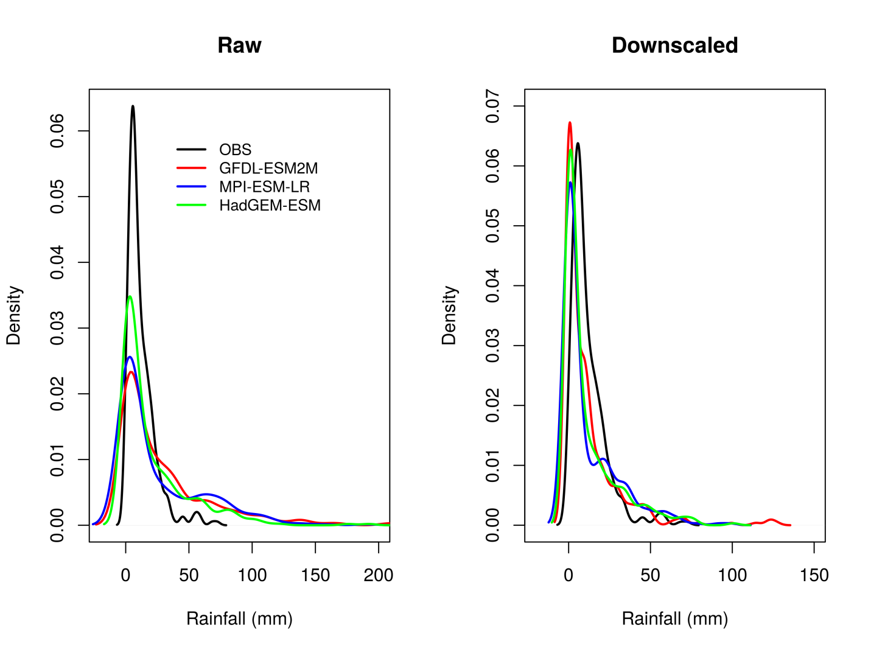
Figure 1: Rainfall distribution curves from the observation (CHIRPS), Statistical Downscaling (SD) and raw simulations area averaged over Djibouti from 1981 - 2010.

3.1.2 Temperature
Validation results for average temperature show similarity with those from the precipitation results. The biases from the raw simulations are substantially improved by statistical downscaling. The raw simulations tend to simulate lower temperature relative to the observation. The SD outputs are able to capture the observed distribution, Figure 2.
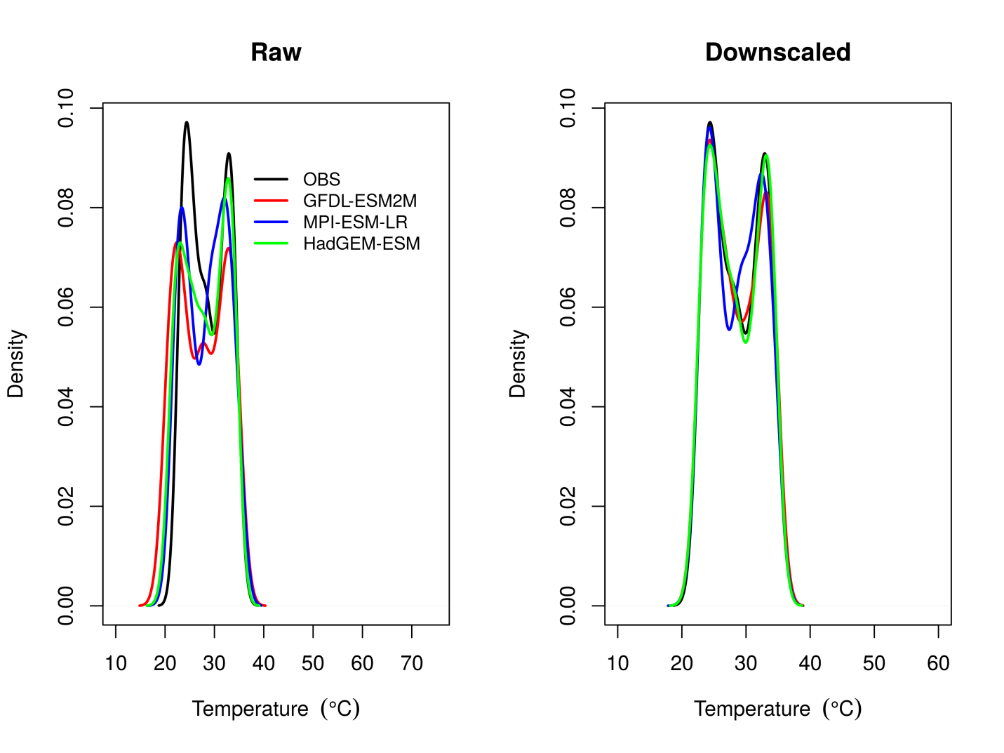
Figure 2: Temperature distribution curves from the observation, raw simulations and Statistical Downscaling (SD) area averaged over Djibouti from 1981-2010.

3.2 Projected changes in rainfall and temperature
The projected changes in rainfall and temperature based on the RCP4.5 and RCP8.5 scenarios have been analysed for two future periods (near future 2031-2060 and far future 2071-2100) to provide information on the expected magnitude of the climate response over each time periods. The period 1981-2010 is considered as a baseline or reference for the present climate. The projected climates change signals for near future (2031-2060) and far future (2071-2100) are calculated as the difference between the future time periods (averages calculated over 30 years) and the reference period. For example, the rainfall change in near future is computed based on the difference in average rainfall between 2031-2060 and reference (1981-2010) period.

3.2.1 Rainfall

3.2.1.1 Near Future (2031 - 2060)
Figure 3 and 4 show the projected changes in the annual and seasonal rainfall components over Djibouti from 3 different models under RCP4.5 and RCP8.5 scenarios, respectively, for near future (2031-2060) compared to the reference period (1981–2010). It can be seen that the sign and intensity of projected changes in rainfall over Djibouti depend very much on the season. During RCP4.5 scenario (Figure 3), the majority of the models project increase rainfall during October-November-December (OND) and decrease rainfall during March-April-May (MAM). The annual rainfall doesn’t show a noticeable rainfall change over Djibouti. The average of the three models (Figure 3, bottom panel) indicates increase rainfall during OND season and a decline during MAM season. It is important to note that MAM is a dry season over Djibouti. Rainfall results for RCP8.5 scenario are almost similar to RCP4.5 scenario in near future (Figure 4) with the exception of GFDL-ESM2M model. GFDL-ESM2M projects increase OND rainfall under RCP4.5 scenario, but decrease OND rainfall under RCP8.5 scenario. The rainfall during MAM season is projected to decrease over most parts of Djibouti in all the models during RCP8.5 scenario. The June-July-August-September (JJAS) rainfall is projected to increase over the Eastern part of Djibouti in near future (Figure 4). The projected annual rainfall shows a tendency to increase over northern part of Djibouti under RCP8.5 scenario.

3.2.1.2 Far Future (2071 - 2100)

The projected changes in rainfall in far future (2071-2100) relative to the reference period (1981-2010) for RCP4.5 and RCP8.5 scenarios are presented in Fig. 5 and Fig. 6, respectively. There is a general similarity in rainfall pattern under the two scenarios although the projected changes under RCP8.5 scenario are stronger compared to RCP4.5 scenario. During JJAS and OND seasons, the majority of the models project positive rainfall anomalies over most parts of Djibouti. By contrast, the majority models project negative rainfall anomalies during MAM season. Similarly, the average of the three models shows a wet anomaly during JJAS and OND seasons and a dry anomaly during MAM season under both RCP4.5 and RCP8.5 scenarios. The annual rains are projected to increase 10 - 50% under RCP4.5 and 25 - 75% under RCP8.5 over most parts of Djibouti.

w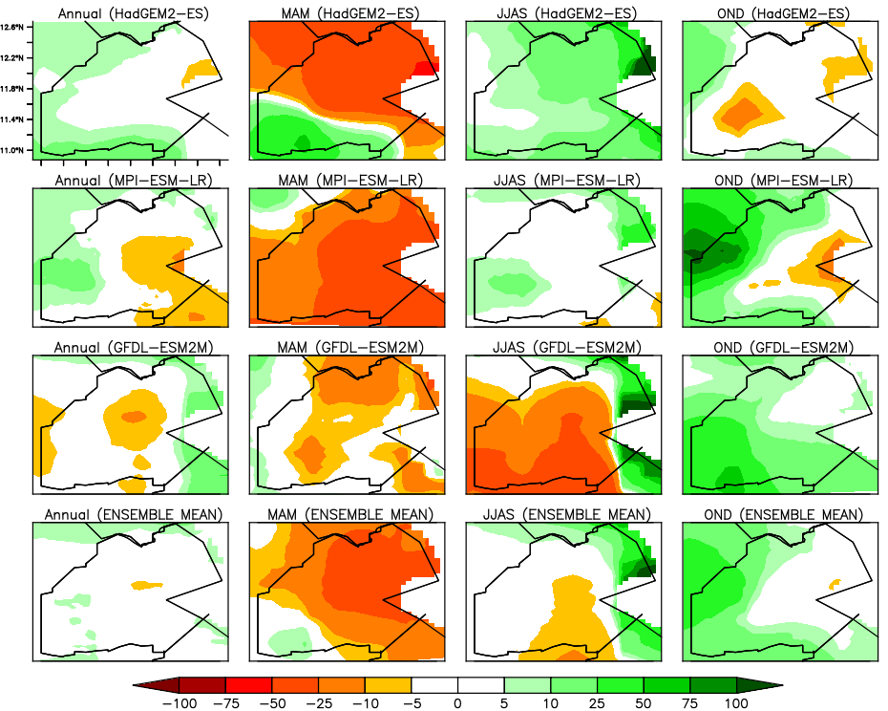
Figure 3: Projected rainfall changes (%) over Djibouti in near future (2031-2060) from 3 different models and their ensemble mean for 4 different seasons during RCP4.5 scenario. The rows represent the different models (HadGEM2-ES, MPI-ESM-LR, GFDL-ESM2M and the ensemble mean) and the columns represent the different seasons (Annual, MAM, JJAS and OND).

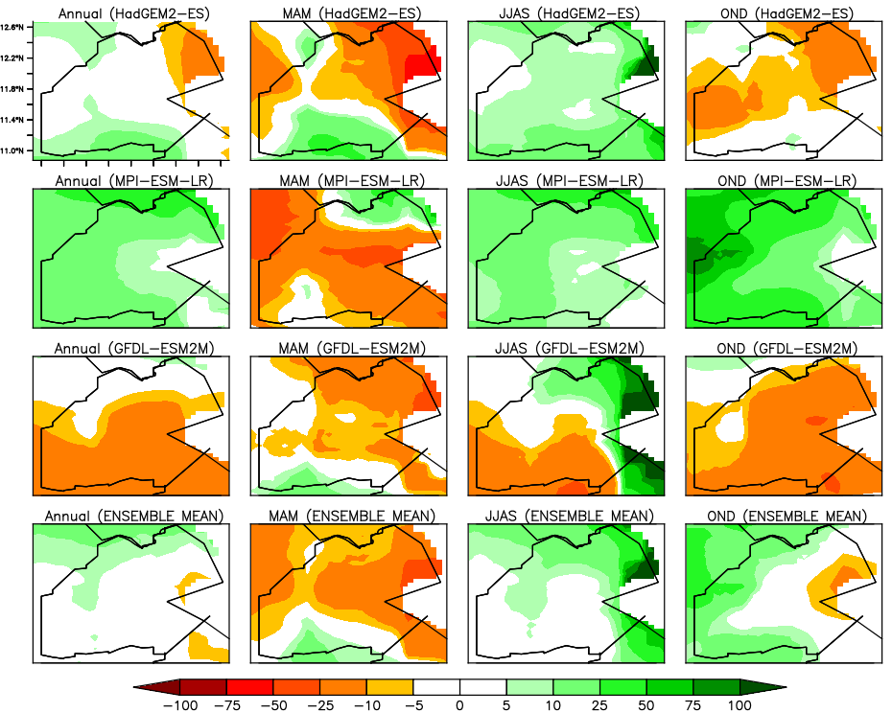
Figure 4: Projected rainfall changes (%) over Djibouti in near future (2031-2060) from 3 different models and their ensemble mean for 4 different seasons during RCP8.5 scenario. The rows represent the different models (HadGEM2-ES, MPI-ESM-LR, GFDL-ESM2M and the ensemble mean) and the columns represent the different seasons (Annual, MAM, JJAS and OND).

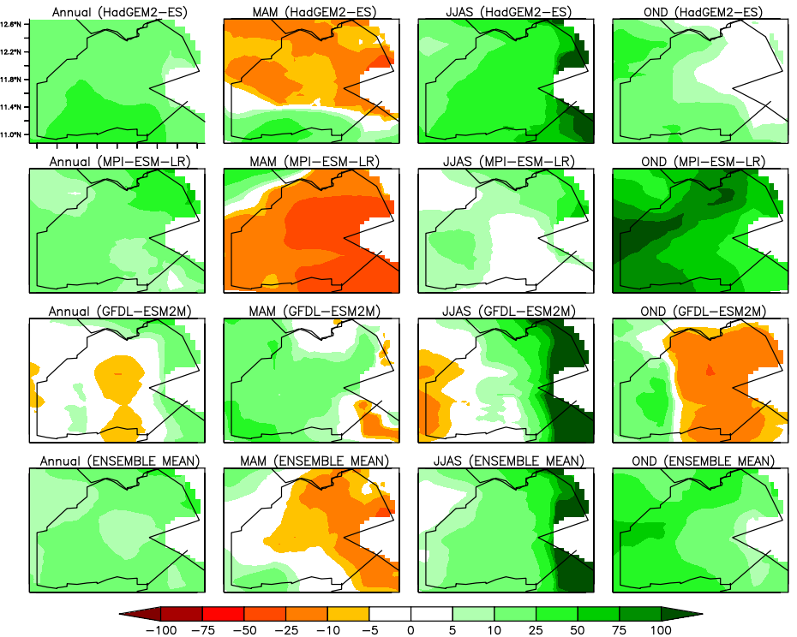
Figure 5: Projected rainfall changes over Djibouti in far future (2071-2100) from 3 different models for 4 different seasons during RCP4.5 scenario. The rows represent the different models (HadGEM2-ES, MPI-ESM-LR, GFDL-ESM2M and the ensemble mean) and the columns represent the different seasons (Annual, MAM, JJAS and OND).

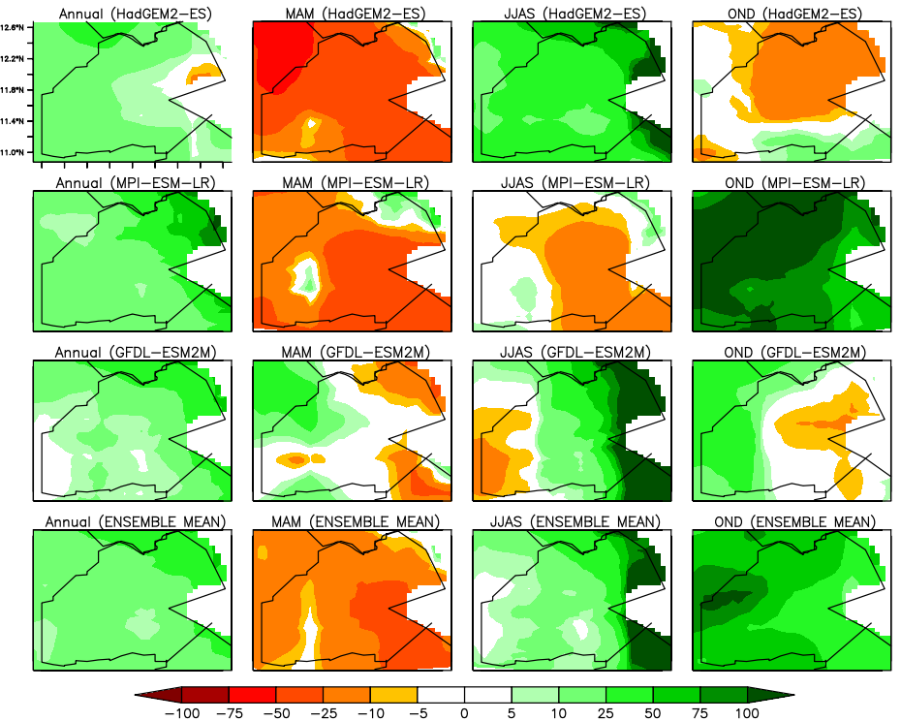
Figure 6: Projected rainfall changes (%) over Djibouti in far future (2071-2100) from different models for different seasons during RCP8.5 scenario. The rows represent the different models (HadGEM2-ES, MPI-ESM-LR, GFDL-ESM2M and the ensemble mean) and the columns represent the different seasons (Annual, MAM, JJAS and OND).

3.2.2 Temperature

3.2.2.1 Near Future (2031 - 2060)
The projected changes in mean surface temperature fort near and far future periods relative to the reference period have been analysed for the different seasons and scenarios. Figure 7 and Figure 8 show the near future (2031-2060 period) projected changes in mean surface temperature from different models for RCP4.5 and RCP8.5 scenarios, respectively. Unlike for rainfall, the sign of projected temperature changes are not dependent on particular season. The results show that almost all parts of Djibouti will get warmer in future. The rate of warming is relatively higher during JJAS and MAM compared to OND season. Annual surface temperatures are anticipated to be 1.0 to 2.0 °C higher under RCP4.5 scenario but 1.5 to 2.5°C higher under the RCP8.5 scenario over most parts of the country.
3.2.1.2 Far Future (2071 - 2100)
The projected changes in mean temperature over Djibouti in far future (2071-2100) from different models for different seasons (Annual, MAM, JJAS and OND) during RCP4.5 and RCP8.5 scenario are presented in Figure 9 and Figure 10, respectively. Similar to those for near future results, the expected warming extent is highest during MAM and JJAS and least during OND. Moreover, the temperature changes during RCP8.5 (business as usual) scenario are significantly higher than RCP4.5 scenario. This is due to the reduction in radiative forcing expected toward the end of the century due to policy measures under the RCP 4.5 scenario. During JJAS, the temperature changes are expected to be 2.0 to 3.5°C higher under the RCP4.5 and 3.0 to 5°C higher under the RCP8.5 scenarios over most parts DJIBOUTI, with greatest warming expected in coastal areas. The projected annual temperatures are expected to be 1.5 to 2.5°C higher under RCP4.5 scenario, and 3.0 to 4.0°C higher under the RCP8.5 scenario over most parts of Djibouti, which is notably smaller than the changes anticipated during the warmest (JJAS) season.
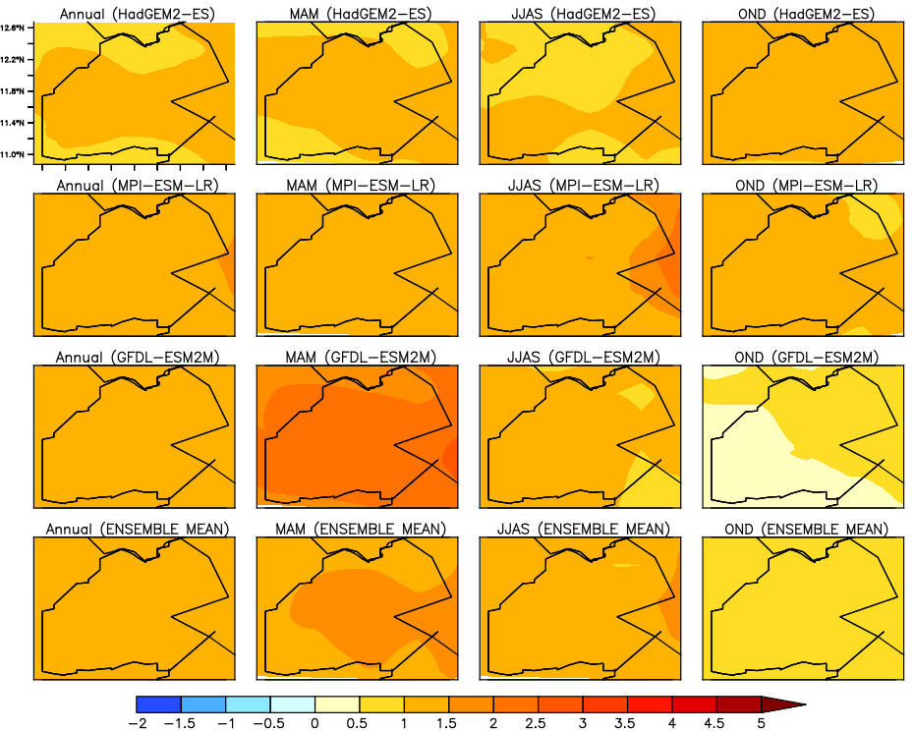
Figure 7: Projected changes in mean temperature over Djibouti in near future (2031-2060) from different model in different seasons (Annual, MAM, JJAS and OND) during RCP4.5 scenario.

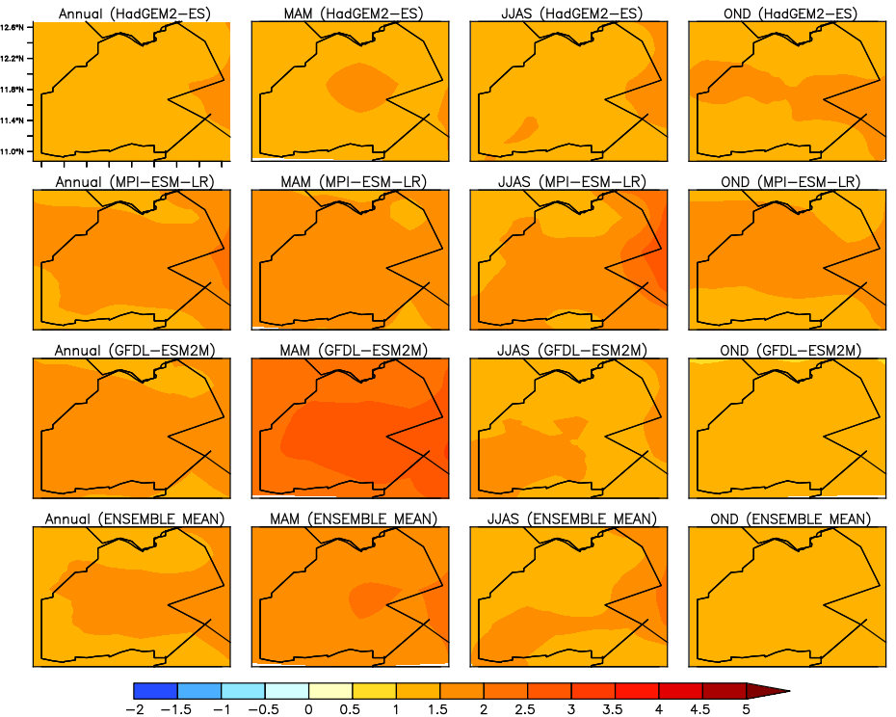

Figure 8: Projected changes in mean temperature over Djibouti in near future (2031-2060) from different model in different seasons (Annual, MAM, JJAS and OND) during RCP8.5 scenario.

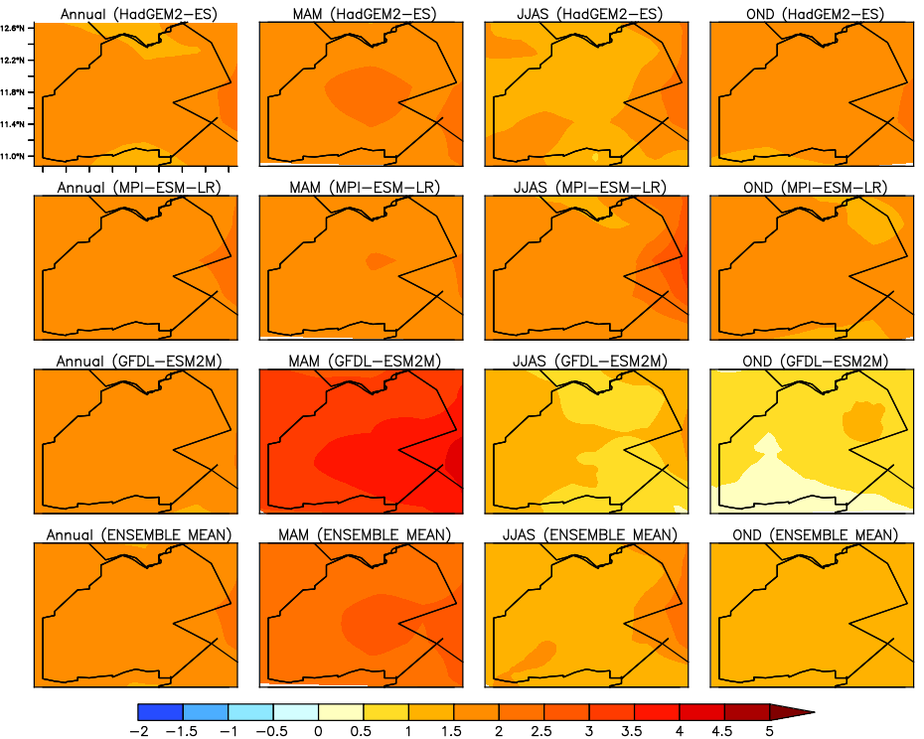

Figure 9: Projected changes in mean temperature over Djibouti in far future (2071-2100) from different model in different seasons (Annual, MAM, JJAS and OND) during RCP4.5 scenario.

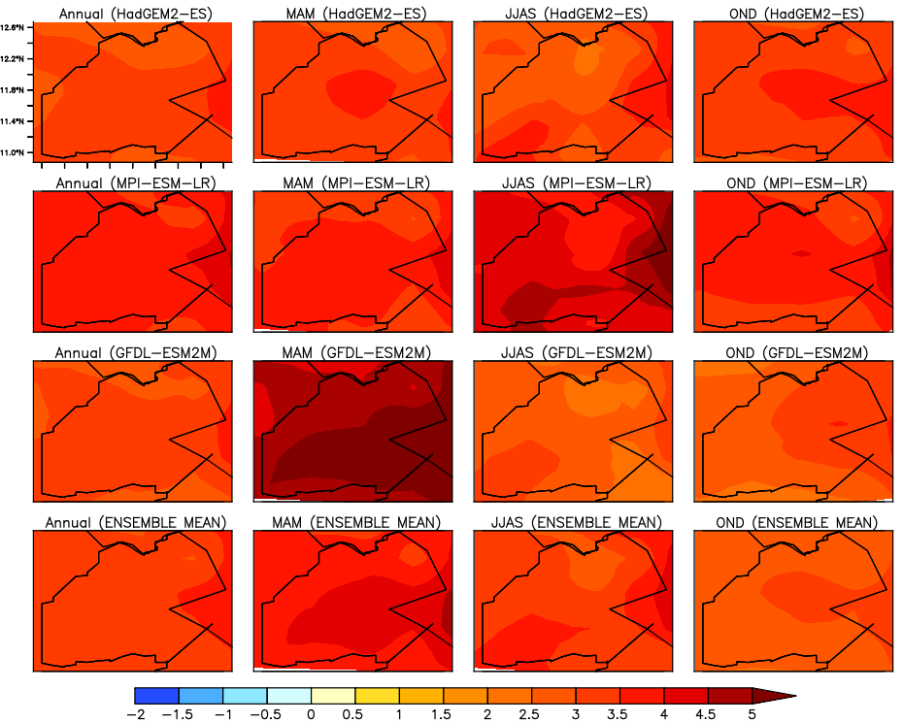
Figure 10: Projected changes in mean temperature over Djibouti in far future (2071-2100) from different model in different seasons (Annual, MAM, JJAS and OND) during RCP8.5 scenario.

3.2.3 Time Series of Temperature
Time series of annual mean temperature averaged over Djibouti from different models is presented for two different scenarios. Figure 11 shows the time series of annual surface temperature over Djibouti for the 20th century simulations and the 21st century projections under RCP4.5 and RCP8.5 scenarios. The results show that the projected time series of annual temperatures have similar variation tendencies as the emission pathway. For RCP4.5, the temperature continues to rise until 2070 and is then effectively stabilized from 2070 to 2100. For RCP8.5, the temperature continues to rise with the ongoing increase of radiative forcing. By the end of the century, the projected increase in the annual surface temperature will likely be between 4 and 5 °C higher over Djibouti under the RCP8.5 scenario relative to the reference period.
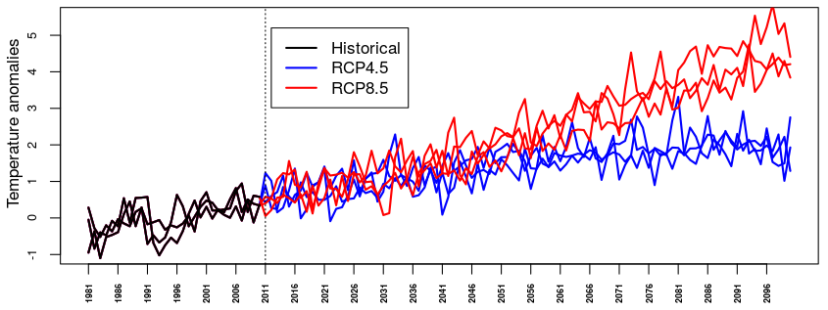
Figure 11: Time series of annual mean surface temperature anomalies (units: °C) over Djibouti from 1981 to 2100 relative to the temperature averaged from reference period (1981–2010).

Chapter 4

4.0 Conclusion
The study used statistical method to downscale and bias-correct the coarse resolution climate model outputs to high resolution over Djibouti. The result from validation showed that the raw simulations had low skill in simulating climate variables over Djibouti. The statistical downscaling methods used substantially improved the coarse resolution model output for both precipitation and temperature in addition to increasing the spatial resolution to 5 Km. The downscaled datasets are useful in impact studies at local scales.
Future seasonal rainfall will likely to increase during JJAS and OND, but decrease during MAM. Future changes in temperature suggest a warmer future in all parts of Djibouti. In near future, annual surface temperature are projected to increase between 1.0 °C and 2.0 °C under RCP4.5 scenario but will likely be greater in the RCP8.5 scenario which is expected to be between 1.5 °C and 2.5 °C. By the end of the century, annual surface temperature are expected to be 2.5 to 3.5°C higher under the RCP4.5, and 3.5 to 5.0°C higher under the RCP8.5 scenario over most parts of Djibouti.

References
Endris, H. S., Lennard, C., Hewitson, B., Dosio, A., Nikulin, G., &Panitz, H. J. (2016).Teleconnection responses in multi-GCM driven CORDEX RCMs over Eastern Africa.Climate Dynamics, 1-26.
Funk, C., Peterson, P., Landsfeld, M., Pedreros, D., Verdin, J., Shukla, S., Husak, G., Rowland, J., Harrison, L., Hoell, A. and Michaelsen, J., (2015). The climate hazards infrared precipitation with stations-a new environmental record for monitoring extremes. Scientific data, 2, p.150066.
Giorgi, F., and L. O. Mearns, 1999: Introduction to special section: Regional climate modeling revisited. J. Geophys. Res., 104, 6335–6352, doi:10.1029/98JD02072.
Gudmundsson, L., Bremnes, J. B., Haugen, J. E., &Engen-Skaugen, T. (2012).Downscaling RCM precipitation to the station scale using statistical transformations–a comparison of methods.Hydrology and Earth System Sciences,16(9), 3383-3390.
Hewitson, B. and Crane, R. (1996).Climate downscaling techniques and application. climate research, 7:85–95.
Moss, R. H., Edmonds, J. A., Hibbard, K. A., Manning, M. R., Rose, S. K., Van Vuuren, D. P., &Wilbanks, T. J. (2010). The next generation of scenarios for climate change research and assessment. Nature, 463(7282), 747-756.
Wilby, R. L., Charles, S. P., Zorita, E., Timbal, B., Whetton, P., &Mearns, L. O. (2004). Guidelines for use of climate scenarios developed from statistical downscaling methods. Supporting material of the Intergovernmental Panel on Climate Change, available from the DDC of IPCC TGCIA, 27.

