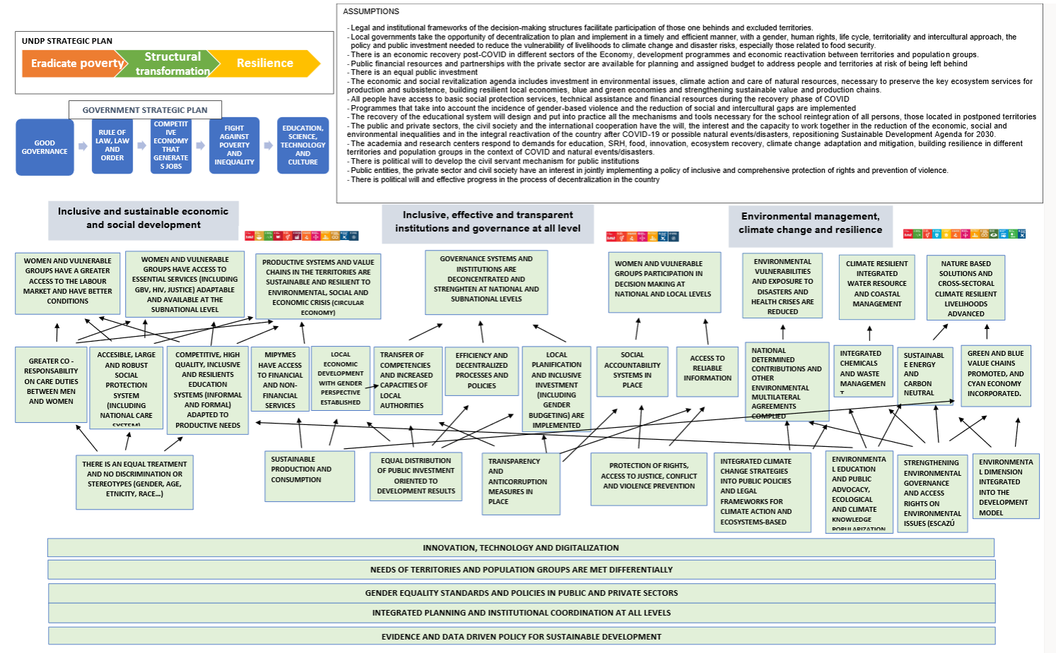
RISKS | ASSUMPTIONS
- Lack of political will to design and put in place development programmes and equal economic reactivation oriented to women, indigenous, afrodescendants, migrants, family farmers, MIPYMES.  - Lack of political will to advance the country's decentralization process.  - Priority of public investment changes due to the economic crisis and the fiscal deficit.  - Redistribution of public expenditure is not prioritized, post COVID, according to gender, territories, ethnicity, race and poor conditions criteria.  - The prioritization of public spending can lead to a lack of budget for improving access to services.  - Lack of support and interest of the private sector to stablished partnerships and co-invest in population sectors and territories in risk of being behind.  - Collapse of essential services in the face of COVID-19, so that the usual needs cannot be met.  - New or persistent health, food, environmental and economic crises increase the level of vulnerability of people and territories, reducing their capacity for resilience  - The programmes do not integrate specific measures to reduce the exacerbation of gender violence and social inequality based on the situation of COVID-19 during and after the pandemic. | - Legal and institutional frameworks of the decision-making structures facilitate participation of those one behinds and excluded territories.  - There is political will to develop the civil servant mechanism for public institutions.  - There is political will and effective progress in the process of decentralization in the country.  - Local governments take the opportunity of decentralization to plan and implement in a timely and efficient manner, with a gender, human rights, life cycle, territoriality and intercultural approach, the policy and public investment needed to reduce the vulnerability of livelihoods to climate change and disaster risks, especially those related to food security.  - There is an equal public investment and political will to assign adequate budgets to develop the new development model.  - The economic and social revitalization agenda includes investment in environmental issues, climate action and care of natural resources, necessary to preserve the key ecosystem services for production and subsistence, building resilient local economies, blue and green economies and strengthening sustainable value and production chains.  - Public financial resources and partnerships with the private sector are available for planning and assigned budget to address people and territories at risk of being left behind  - There is an economic recovery post-COVID in different sectors of the Economy, development programmes and economic reactivation between territories and population groups.  - All people have access to basic social protection services, technical assistance and financial resources during the recovery phase of COVID  - Programmes that take into account the incidence of gender-based violence and the reduction of social and intercultural gaps are implemented  - The recovery of the educational system will design and put into practice all the mechanisms and tools necessary for the school reintegration of all persons, those located in postponed territories.  - The academia and research centers respond to demands for education, SRH, food, innovation, ecosystem recovery, climate change adaptation and mitigation, building resilience in different territories and population groups in the context of COVID and natural events/disasters.  - Public entities, the private sector and civil society have an interest in jointly implementing a policy of inclusive and comprehensive protection of rights and prevention of violence.  - Civil society is willing to counteract initiatives that are contrary to human rights and to accompany the implementation of the new model of governance, institutional modernization and the justice system.  - Effective implementation and participation of people living with HIV through social contracting.  - The economic and social recession caused by COVID19 favours the construction of resilient local economies, the application of the concept of a circular economy, the promotion of local production circuits and short marketing chains, as well as the strengthening of value and production chains.  - The public and private sectors, the civil society and the international cooperation have the will, the interest and the capacity to work together in the reduction of the economic, social and environmental inequalities and in the integral reactivation of the country after COVID-19 or possible natural events/disasters, repositioning Sustainable Development Agenda for 2030.

UNDP´S ROLE | TARGET GROUPS | PARTNERS
- Ability to view development challenges in an articulated manner and not just by sector that is truly unique to the UNCT  - Development Dialogues and Strategic Planning  - Design, monitoring and impact evaluation of public policies  - Technical assistance in planning and inclusive budgeting  - Multi-level articulation and inter-institutional coordination  - Strengthening institutional capacities for human development.  - Intersectional approach to inequalities (gender, age, ethnic/race, urban/rural)  - Tools and methodologies to reach those ones behind (Gender Seal, IPM, SDG Invest, supply chain development)  - Knowledge management, innovation, lessons learned and good practices  - Global network of experts and UNDP Regional Office expert network established in Panama  - Sharing of experiences  - Principal Recipient of funds  - Capacity development for public management  - Purchases and contract management  - Agreements with the IDB and the WB at the global level | - Policy makers  - Public Institutions that provide basic services  - Local government  - Women  - Indigenous  - Afrodescendants  - Peasants  - Youth  - Micro and small producers  - Private sector  - Academia  - Professional organizations  - Community-based organizations | - Ministry of the Presidency  - Ministry of Foreign Affairs  - Ministry of Economy and Finance  - Ministry of Education  - Ministry of Trade and Industry  - Ministerio de Gobierno  - Ministry of Labor  - Ministry of Environment  - Ministry of Health  - Minis¿¿  - Panama Canal Authority  - Local governments  - SENACYT, Tribunal Electoral, INAMU, Colon Free Zone, AMPYME, INADEH,  - Public Prosecutor´s Office  - Civil Society  - National Women´s Institute  - Global Fund  - Vertical Environment Funds  - IDAB, GB, CAF, BCIE  - UNICEF, UNFPA, UNEP, FAO, UN Women, UNOPS, OIT, UNESCO

