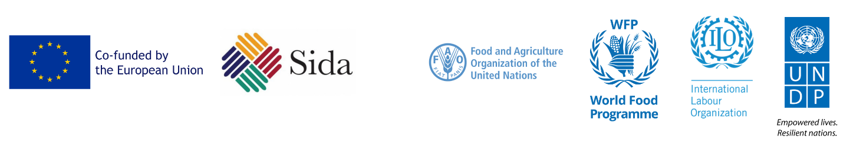
Supporting Resilient Livelihoods and Food Security in Yemen (ERRY II) Joint Programme
Resilience Definition and the Programme’s Contribution:
ERRY Joint Programme defines resilience as the ability of individuals, communities, and institutions to better cope with crises, shocks, or stressors. Given the diversification of the joint programme interventions, the programme contributes to enhancing the target households’ and communities’ level of resilience from two dimensions: 1) the five capital assets (human, financial, social, natural, and physical) and 2) the three capacities of resilience (adaptive, absorptive, and transformative). Combining capital assets with resilience qualities and characteristics, and tracking both aspects provides a more accurate picture of resilience.
The Joint Programme applies a coordinated resilience approach to reduce vulnerabilities and contribute to improved levels of community livelihood stability and self-reliance in targeted areas, improved local governance and reduced competition over scarce resources, as well as provision of renewable energy. It also applies the livelihoods and resilience frameworks to address vulnerability issues through joint programming and in strategic partnerships between humanitarian and development partners.
As stabilization of livelihoods is a prerequisite to resilience-building, the emergency employment component of the joint programme implements labor-intensive emergency employment/CFW activities that rehabilitate community assets. Under this activity, food insecure households have increased access to food and cash through the CfW initiative, which improves their food security levels and helps them transition towards resilience and recovery. At the same time, households are engaged in productive activities designed to create or restore productive community assets which enhances communities’ resilience in the face of shocks. Moreover, the agricultural value chain component of ERRY II works mainly on supporting rural farmers and women-headed households through the provision of improved inputs, equipment, training sessions, and technologies to improve household food security, income, and livelihood opportunities. In addition, the joint programme works on creating sustainable livelihood opportunities in the post-cash for work phase to support self-employment through entrepreneurship development for vulnerable households and individuals. Intensive training workshops on life skills and business development are conducted in addition to providing financial grants to owners of identified viable businesses, helping them to start their own businesses, thus contributing to improved resilience and self-reliance. Besides, the solar component of the joint programme helps vulnerable communities benefit from solar energy to create sustainable livelihood opportunities through supporting micro-grid businesses, as well as enhance social service delivery by providing solar energy to basic services facilities, productive assets, small businesses and farmers for agricultural production. Finally, the local governance and social cohesion component of the joint programme contributes to strengthening the capacity of local and community institutions since the presence of strong and functioning community and local institutions is the foundation for resilience-building in a community. The programme enhances the capacity of communities and local authorities to respond to conflict and gender-sensitive priorities, service delivery, and peaceful resolution of local conflicts to promote social cohesion. Additionally, key to achieving community resilience is strengthening the capacity of VCCs to prepare resilience plans, mobilize resources and implement self-help and compact initiatives.

