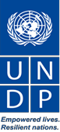

UNDP Lesotho

Partnerships and Communications Strategy and Action Plan (PCAP)

December 2019

Introduction and Background
UNDP’s Strategic Plan 2018-2021 recognizes that to achieve the Agenda 2030 and the SDGs, new models of partnership and collaboration are required. In a new global partnerships landscape that is moving from funding to financing for development, and in the context of ongoing UNDS reform, UNDP’s work to cultivate strategic partners, galvanize political and financial support, and position itself at the centre of development policy and innovation at country and global levels, has never been more critical nor more challenging.

In the context of these trends and developments, UNDP Lesotho has developed the Partnerships and Communications Strategy and Action Plan (PCAP) to position itself strategically in terms of partnerships building and resource mobilization in Lesotho. The PCAP is guided by and complements the following documents: i) UNDP’s Country Programme Document (CPD) 2019 – 2023, and ii) the UNCT’s joint Resource Mobilization and Partnership Strategy.

The CPD is informed by the 2030 Agenda for Sustainable Development, anchored on Lesotho’s National Strategic Development Plan (NSDP) II and the United Nations Development Assistance Framework (UNDAF) 2019–2023, and guided by the UNDP Strategic Plan, 2018–2021. The UNDP programme is structured around three pillars: (a) governance, accountability, social cohesion and stability; (b) sustainable and inclusive economic growth; and (c) environmental sustainability, climate change and resilience. The CPD has an overall budget of US $25.4 million (RR: US $4.5 million; OR: US $20.9 million).

The joint United Nations Resource Mobilization and Partnership Strategy (UNRMPS), which is currently still in draft, will provided practical guidance and tools to fundraise and leverage the resources required to achieve the results of the Lesotho United Nations Development Assistance Framework (UNDAF) 2019 – 2023. Its aim is to complement individual UN agency’s partnerships and resource mobilization (P/RM) efforts in Lesotho in order to secure adequate funding for programmes and to facilitate more transparent and effective interagency coordination.

In Q1 of 2020, a mission from UNDP’s Finance Sector Hub (FSH) is planned to explore innovative financing opportunities and set the stage to conduct a Development Finance Assessment (DFA). Any resulting partnerships recommendations from the mission or coming out of the DFA process will be integrated into the PCAP.

As a framework and actionable tool, the PCAP will be updated on a regular basis during the quarterly program review meetings and will remain flexible for requisite modifications to accommodate emerging development issues and/or changes in the country context and partnership landscape.

PART I. Outlook

Financial Flows and Funding to Lesotho
Official Development Assistance (ODA): After having received peak ODA contributions of USD 320 Mio. in 2013, ODA contributions to Lesotho dropped sharply in 2014 and 2015. With a total of USD 146.79 Mio. net ODA received in 2017, Lesotho currently accounts for 0.4% of the ODA regional share of sub-Saharan Africa.
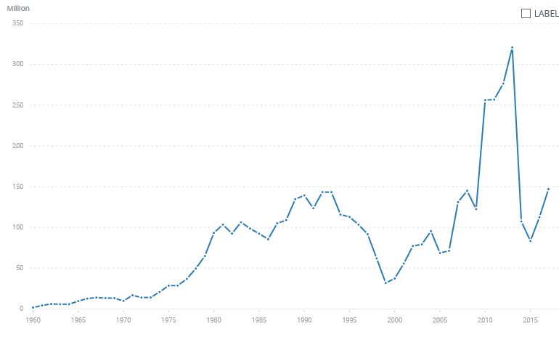
Source: World Bank
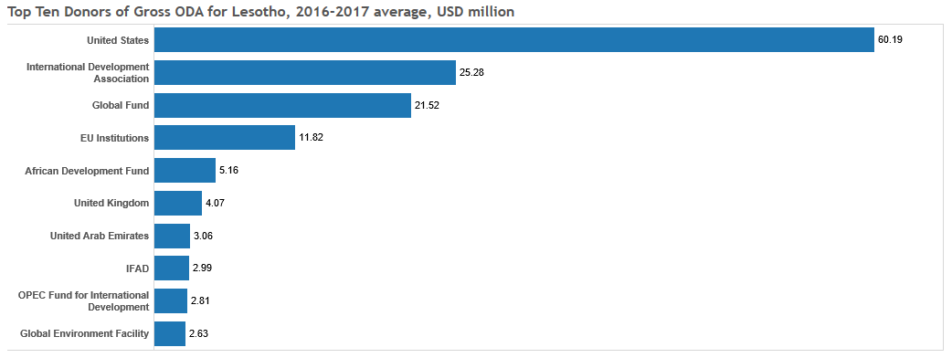
Sources of ODA in Lesotho consist of concessional loans and grants from bilateral donors and multilateral institutions, with the major funders consisting of the US government, IDA, Global Fund, and the EU. Health and Population (78%) is by a large margin the sector that received most ODA, followed by Humanitarian Aid (9%) and Programme Assistance (4%).

In addition to the ODA recorded by OECD DAC, the government of Lesotho has also listed development assistance from the following stakeholders:
Funding Type/Source | Disbursed Amount in US$ Million
 | FY 2015/16 | FY 2016/17 | FY 2017/18
Arab Development Fund | 11.98 | 2.60 | 3.48
Foundations | 0.00 | 1.10 | 8.13
International NGO | 0.00 |  | 1.26
Multilateral | 89.29 | 87.74 | 208.08
SSC providers | 3.66 | 4.41 | 21.89
Private Sector | 0.00 | 0.00 | 6.36
Total | 104.93 | 95.85 | 249.2

Source: MDP Aid Coordination, Government of Lesotho
The Arab Development Fund financed the Metolong Dam and the Ministry of Public Works recently signed a new contract with the Kuwait Fund for the renovation of the international airport in Maseru.
Lesotho has a very small community of donors and development partners resident in country. Currently, only 5 countries (China, Libya, South Africa, the UK, and the US) and the EU operate resident missions, delegations or consulates in Lesotho. Other countries cover Lesotho through their missions in South Africa and Zimbabwe. This has constrained resources mobilization efforts, funding opportunities and technical support.
Germany is mainly present in Lesotho through GIZ which has supported international cooperation between Germany and the Kingdom of Lesotho since 1976. On behalf of the EU, GIZ is supporting Lesotho’s efforts to implement the National Strategic Development Plan in sectors that include: Decentralization and local development, citizen participation and political education, transboundary water resources management, social welfare systems, and energy efficiency and renewable energies.
The UK just recently re-opened their embassy in Lesotho after several years of closure and limited engagement in the country. Most projects came to an end in 2010 and as of now only the Chevening Scholarships project and a humanitarian response project under the leadership of the UNRCO are operational. It is expected that the re-opening of the UK mission will lead to an increase of UK aid to Lesotho
International Financial Institutions: In April 2019, the European Investment Bank (EIB) signed a EUR 82 million (slightly over 1.3 billion Lesotho Maloti) loan for the second phase of a water infrastructure project that aims to improve access to clean water in the Lesotho Lowlands.
The World Bank portfolio composition of Lesotho is made up of a total of 10 projects, with a total commitment of $306.90 million, of which about $85.28 million is disbursed, and focusing on private sector development, education, health, agriculture, and water infrastructure.
Since 1995, IFAD has supported nine programmes in the country for a total of US$78.9 million, benefiting more than 179,000 poor rural households. IFAD loans support the efforts of smallholder farmers to ensure food security for their families, raise their incomes and improve overall nutrition.
In 2018, the African Development Bank (AfDB) approved a study on renewable energy integration. The Bank also is supporting programmes towards SMME and private sector development, digitization and e-government infrastructure and road networks.
Vertical Funds, Climate Finance: The Global Fund mainly finances health, nutrition and HIV and AIDS programmes. GEF has provided US$11.8 million to Lesotho in the past 5 years, and almost 90% of this is hosted by UNDP on behalf of the Government of Lesotho. GEF focuses on environmental interventions mostly aimed at supporting countries to meet the objectives of the international environmental conventions and agreements.
Foreign Direct Investment (FDI): has been declining, from 5% of GDP in 2015, to 1.4% in 2018. This has also affected the revenue from the South African Customs Union (SACU), which forms the bulk of government’s budgetary resources; this is projected to decline further by 15% to about 39% in 2019/20 compared to 44% in 2014/15.
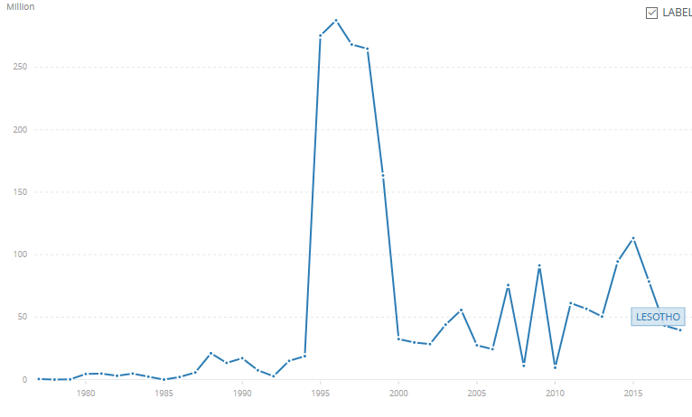

Source: World Bank
Lesotho relies heavily on South Africa for food, jobs and trade. The country imports more than 90% of the goods consumed from South Africa. The government revenue is derived from domestic taxes, customs revenue (mainly from the Southern African Customs Union (SACU), the nascent diamond mining industry and royalties from transfer of water to South Africa.
Lesotho is among highest exporters of textiles and clothing to the United States of America under the AGOA agreement, signed in 2000. The textile and clothing industry are run as CMT (cut, make and trim) mostly by Chinese and Taiwanese investors, with little to no linkages to domestic manufacturing companies. The sector employs more than 40,000 Basotho women and men, and exports estimated US$ 300 million worth of clothing annually. The AGOA Agreement will expire in 2025. Although Lesotho has preferential market access to SADC countries and the EU, trade activities in these areas is negligible.
Mining and quarrying also is a significant component to economic activities in the Lesotho, with an estimated average contribution of 7% to GDP per annum. This is expected to improve due to increased activities in the diamond mining. Diamonds are mainly sold to Belgium and neighboring South Africa.
Lesotho transfers water to South Africa through the Lesotho Highlands Water Project and receives water royalties in return. The Phase I of the project was constructed between 1988 – 2006 and resulted in higher current account balances due to construction activities in the project areas. A Phase II of the project is expected to start in Polihali, Mokhotlong district in 2020, and it is anticipated to increase local economic activities and a spike to economic growth.
Private Sector: The private sector in Lesotho consists mostly of SMMEs, with operations focusing on retail and wholesaling (30%) and agriculture (22%), with little to no value addition across the sectors. Further, due to deteriorating rainfalls, agricultural production has declined, and most food products are imported from South Africa. Large companies are mostly either foreign owned or with little government shareholding, or government parastatals. These large companies are predominantly found in the retail sector, such as , Shoprite, and Pick and Pay, Woolworths, Ackerman’s, Pep Stores; financial sector – Standard Lesotho Bank, First National Bank, NedBank, Metropolitan Lesotho; telecommunications – Vodacom, Econet, engineering, mining and civil works – Matekane Group of Companies, Nthane Brothers, Letseng Diamonds; and hospitality sectors – Maseru and Lesotho Avani. The private sector is largely uncoordinated, and there are currently two rival private sector networks, the Private Sector Foundation of Lesotho and the Lesotho Chamber of Commerce and Industry operational in Lesotho, and several youth-led social entrepreneurship networks.
Remittances: Lesotho is a net recipient of remittance flows, and these is estimated at 15% to GDP (2018). South Africa is the highest destination of Lesotho skilled and unskilled labour, with minework as the main profession. Despite challenges in recording remittances and declining rate of remittances (figure below), Lesotho is ranked among the top 10 sub-Saharan countries with highest share of remittances to GDP.
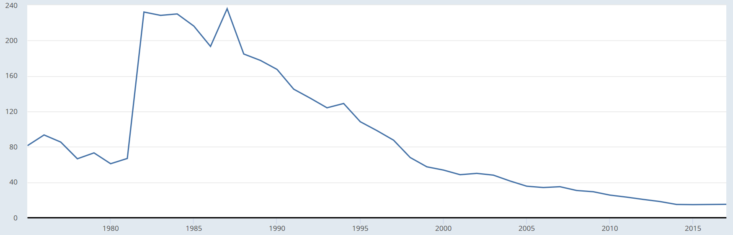
Source: World Bank
Foundations, Civil Society and NGOs: Lesotho has a large but very weak presence of civil society organizations and non-governmental organizations. Most of these are mainly focused in advocacy and governance activities with a few organizations, especially international NGOs, focusing on service delivery. There is also a high emergence of social enterprises especially in support to youth development and entrepreneurship. Foundations that are currently present in Lesotho are the Clinton Foundation (health sector and HIV/AIDS support services), EGPAF (pediatric AIDS foundation), Sentebale – Prince Harry foundation (HIV support services for youth), W.K. Kellogg Foundation (health, education), and the Vodacom Lesotho Foundation (entrepreneurship and economic development, education, and health).
Funding to the UNDP Country Office
The level of total contributions to the CO have been low but relatively stable and somewhat diversified. In 2017 however, the CO experienced a deficit of about $3.5k, due to internal adjustments and a lack of funding from the main financial partners. The figure below shows the donor contributions between 2014 and 2020.
Activities in the country office have been financed through a combination of core and non-core funding. External funding has been very volatile, owing to the small donor presence and country’s economic status. The total programme expenditure in 2019 amounted to USD2.9 million, with almost 70% external funding. The CO has received contributions from the European Union, Global Environmental Facility, UN Peacebuilding Fund, DFID and regional resources from external funders, such as SIDA and Government of Italy. Although UNDP has co-financed in other UN agency activities, it has not received any funding from other UN agencies in the recent past.
Figure 1: Contributions by top donors 2014 - 2020

UNDP’s Comparative Advantage
UNDP has been present in Lesotho since 1967 making it the UN agency with the longest continuous residency status in the country. UNDP is also considered a neutral body. Combined with the decades of partnership, this has entrenched a high level of trust between UNDP and Lesotho in all areas of development and, according to the 2017 Partnership Survey, more than 80% of government partners regarded UNDP as a trusted partner of choice for programme management, international development agenda and capacity building.
This partnership has been particularly robust in the thematic areas of inclusive growth, energy, environmental management and democratic governance. In the area of democratic governance, UNDP provided technical support and leadership in sensitive areas such as elections, political dialogue, and key governance institutions including parliament, the judiciary, anti-corruption agency, and the ombudsman have contributed to stability, human rights, democratic governance and overall development in Lesotho. UNDP support to governance has helped to forge a similar relationship of trust and collaboration with the regional body, SADC and it has further contributed to UNDP’s strong brand and pervasive visibility – often overshadowing other UN agencies - throughout the country
In its capacity as the integrator and convener working with Government Ministries, other UN agencies, Embassies and a wide variety of development partners, UNDP has been the main promoter of the Agenda 2030 and the localization of SDGs in Lesotho.
UNDP’s flexible implementation modalities (DIM, NIM) and strong operational capacities (e.g. finance and procurement) make UNDP an efficient and effective provider of services and implementer of large-scale development projects. For example, UNDP provides procurement and HR services to non/resident agencies and Government Ministries.
Vis-à-vis other UN agencies, UNDP has a unique relationship with academia in Lesotho as it collaborates with the most varied range of partners and in a diverse range of sectors.
Finally, UNDP’s global network of offices and technical experts enable UNDP Lesotho to tap into vast internal resources.
Key Trends and Developments
The Government of Lesotho has recently adopted the National Strategic Development Plan (NSDP II) and in turn, most partners to Lesotho are developing the country programme support strategies. While the Strategy clearly delineates development priorities, this presents an opportunity to also influence and identify open areas of collaboration and partnership among development partners. The main risk in this is traditional duplication of efforts in the support to the Government of Lesotho, which UNDP could to mitigate through coordination with development partners in the country.

More importantly, the Government will operationalize the National Reforms’ Authority in the next six months to manage, coordinate, and lead the national reforms process. The national reforms are currently only funded by UNDP and the EU leaving room for UNDP to advocate for additional funding from other partners and non-resident missions (e.g. the US, SADC). If implemented successfully, the national reforms are envisioned to bring about greater stability, curb illicit financial flows, and consequently attract more investors both from the private and public sectors to Lesotho, which could open-up new partnership opportunities for UNDP Lesotho.

Following a decade of closure, the British High Commission has reopened its mission in Lesotho. This presents an opportunity to position Lesotho as a priority country for DFID, Commonwealth Secretariat and the Commonwealth Parliamentary Association through technical support and strengthening of Lesotho’s Parliamentary Women Caucus. The High Commission has shown great interest in the reforms and the Parliamentary Women Caucus and has already initiated dialogue with UNDP.

With an end of the Cotonou Agreement in February 2020, there is some uncertainty on the immediacy of availability and conditions to the support envelope of the European Union to Lesotho. This is both a risk and an opportunity for UNDP; as the key development partner in the country and to UNDP, especially for implementation of key programmes such as the reforms project. On the other hand, UNDP may utilize this period to strengthen its engagement with the European Union to position itself as a partner in this next era.

Due to challenges in economic governance, the IMF has suspended its budget support to the country, exposing it to further economic shocks and vulnerabilities. This would put more constraint on available resources and would require increased efforts for external resources mobilization. Since it has limited strategic importance for other countries, Lesotho relies on and is strongly affected by the relationship with South Africa. Addressing food insecurity which has been increasing over the past years and unsustainable management of resources as well as the ability to harness the demographic dividend are of crucial importance.

In the context of ongoing UN reforms and the broader UN country team resource mobilization strategy, UNDP will need to adopt a more proactive approach to engaging partners and communicating/packaging its strategic focus and position within the UN system to expand chances of partnership.

Part II. Strategic Objectives
UNDP Lesotho’s strategy on partnerships development is to strengthen its position as a partner of choice for government and development partners in programme and resources management to enable it to mobilise adequate funding to fulfil its development commitments to the Government of Lesotho, as detailed in the CPD 2019 – 2023. In this case, UNDP Lesotho aims to:
- Build on its technical expertise in democratic governance, inclusive growth, energy, and environmental management to strengthen UNDP’s engagement with existing donors (EU) and establish new partnerships with and mobilize additional resources from at least two new traditional or emerging donors (UK, Ireland, Switzerland, South Africa, Germany and GIZ, China, Japan, Italy, etc.) to diversify UNDP’s funding base;
- Leverage UNDP’s increased engagement with the WB and AfDB at corporate level as well as UNDP’s strong operational presence in Lesotho to explore with the Government the possibility of supporting the delivery of under-performing loans from international financial institutions (e.g. WB, AfDB) and of mobilizing other domestic resources;
- In collaboration with the FSH and drawing on UNDP’s corporate knowledge of financing for development, to explore innovative financing mechanisms and establish one mechanism (e.g. diaspora bond, impact investment) if feasible;
- Drawing on UNDP’s worldwide partnerships network (e.g. Regional Hubs in Bangkok and Istanbul), establish and broaden partnerships with the regional/international private sector, foundations, high-net individuals, and academia in order to position UNDP as thought leader and diversify its partnership base in Lesotho.
Resource Mobilization (RM) Target

The RM target is based on UNDP’s commitments outlined in the CPD 2019 – 2023 which amounts to a total of US $25,399,000 (including RR and OR) and an average fundraising target of US $5,079,800 annually. As of now, a total of USD 1,932,132 (RR: USD 1,112,652, OR: 819,479) has been raised. It is anticipated that the CO will receive additional total RR of USD 3,436,348 (USD 859,087 per year) for 2020 - 2023. The remaining OR to be fundraised until December 2023 amount to a total of USD 20,030,521.

Overall RM target: USD 20,030,521

Annual targets: 2020 USD 5,201,912
2021 USD 8,008,444
2022 USD 3,580,445
2023 USD 3,239,720

Communication Objectives

The main communication objective is to enhance the overall visibility of UNDP Lesotho and support its positioning efforts as the strategic partner of choice in the development landscape of Lesotho. Specifically, communication aims to:

- Support strategic partnership building with donors and partners (traditional and emerging donors, private sector, IFIs, etc.) and resource mobilization efforts by creating awareness on the services provided by UNDP;

- Position UNDP as the major player and thought leader in inclusive and sustainable development as well as the Agenda 2030 and the SDGs in Lesotho;

- Intensify advocacy with GoL and promote services provided by UNDP;

- Establish working relations with the local media and identify effective way of disseminating UNDP knowledge products to the public

Target Audiences
Target audiences include UNDP Lesotho’s current and targeted main donors and partners (traditional and emerging donors, vertical funds and climate finance), IFIs, GoL, the private sector, beneficiaries and implementing partners, the general public, local media and Basotho opinion shapers/influential figures as well as other UN agencies. Target audiences are listed in the table in Part III.

Key Messages

The top three messages of UNDP Lesotho, which are aligned with the Country Programme and the partnership objectives, are:

- Message for donors/development partners: Partner with UNDP, a leading player in democratic governance, inclusive growth, energy and environmental management impacting on sustainable development in Lesotho.

- Message for the Government and IPs: UNDP works closely and responsively with GoL to achieve its development priorities and the SDGs in addressing poverty and building stronger institutions and systems.

- Message for opinion shapers: UNDP provides independent and strategic thought leadership, technical and policy guidance and advisory services in governance, environment, energy and inclusive growth.
Part III. Actions
The table below outlines concrete partnerships and communications activities for each partner inclusive of timelines, required resources, status of implementation, and responsible CO unit/person. The table will be reviewed – and if need be revised – during the quarterly program review meetings.
Target partner/Audience (Name) | Purpose (i.e. Positioning, partner building, RM, programming)  (if RM, state target amount) | Targeted area(s) of cooperation*  Linked to new Strategic Plan)  (*Can also name the titles of associated projects) | Concrete Activities (for Partnerships, Resource Mobilization and  Communication) | Timing | Resource Requirements | Responsible CO Unit/Person  (And supporting unit/persons if any) | Status
Vertical Funds, Climate Finance
GEF (non-resident) | Partner building, RM | Environment, natural resources, tourism | - Set up follow-up meeting w/ World Tourism Organization  - Develop visibility material to communicate success stories and past experiences with Ministry of Tourism, Environment and Culture  - Finalize two proposals | Q1 2020  Q4 2019 | Cost of visibility material  Cost of meetings | E&E  Comms intern
GCF (non-resident) | Partner building, positioning | Energy, environment | - Exploratory meeting w/ National University of Lesotho and Dept. of Meteorology | Q4 2019 | N/A | E &E
Traditional and Emerging Donors
The Delegation of the European Union (resident) | Partner building, RM $ 3,000,000 (calendar October to October) | Lesotho National Dialogue and Stabilization Project (closing 31 March 2020); Lesotho National Reforms Implementation Support Programme; democratic governance | - Awaiting the approval from EU HQ to begin negotiations on contribution agreement  - Finalize agreement with SADC and EU on support to foreign judges  - Continue our engagement in UN development partners technical advisory group  - Produce documentary about EU funded dialogue process  - Produce knowledge pieces (academic articles in journals; Reuters, BBC, etc.)  - TEDx event | Q1 and Q2 2020 | Cost of documentary,  Cost of visibility material | GPU/Project Manager
United Kingdom (resident) | Positioning, partner building |  | - Set up follow-up meeting w/ Embassy  - Continue engagement in informal security reform group of foreign missions  - Prepare visibility material and share w/ Embassy  - Invite Embassy to key events in 2020 | Q1 2020 | N/A | RR, DRR
DFID (non-resident) | $1,000,000 (June to June)  $50,000 | 1. Lesotho National Dialogue and Stabilization Project  2. Lesotho National Reforms Implementation Support Programme  Technical Support and Strengthening of Civil Society Entities, Citizens, and Youth develop Enhanced capacities for advocacy, public participation, oversight and social accountability | - UNDP Resident Representative to send formal introduction to the DFID Regional Office.  - Planned UNDP resource mobilization mission to regional offices in Johannesburg.  - Concept Note development stage | Q1 and Q2 2020 | Cost of mission | RR, DRR, GPU/Project Manager  RR, DRR, GPU/PDA
The Commonwealth Secretariat (non-resident) | RM (technical support to parliament) | - Lesotho National Dialogue and Stabilization Project;  - Lesotho National Reforms Implementation Support Programme | - Follow-up regarding financial agreement from the Good Offices | Q1 2020 | N/A | GPU/Project Manager
The High Commission of South Africa (resident) | RM (technical support) | - Lesotho National Dialogue and Stabilization Project;  - Lesotho National Reforms Implementation Support Programme | - Follow-up regarding technical support to security reform  - Continue in UN/Development Partners Technical Advisory Group  - Prepare visibility material and share w/ Embassy  - Invite Embassy to key events in 2020  - Set-up quarterly bilateral update meetings | Q1 and Q2 2020 | Cost for event | GPU/Project Manager
OSISA (non-resident) | RM ($250, 000) | Institutional, capacity development, and Gender Mainstreaming of political parties | - Concept Note development stage  - Set up follow-up meeting during mission to Johannesburg and in Maseru | Q1 2020 | Cost of mission | RR, DRR, GPU/PDA
Switzerland, SDC (non-resident) | RM (USD 15 Mio.), partner building |  | - Follow-up regarding new strategy | Q1 2020 | N/A | RR, DRR
Ireland (non-resident) | Positioning, partner building |  | - Include in RM mission | Q1 and Q2 2020 | Cost of mission | RR, DRR
Japan, JICA (non-resident) | Positioning, partner building |  | - Include in RM mission | Q1 and Q2 2020 | Cost of mission | RR, DRR
Embassy of Federal Republic of Germany (non-resident) | $1000000 (October to October) | - Lesotho National Dialogue and Stabilization Project  2. Lesotho National Reforms Implementation Support Programme | - UNDP Resident Representative to send formal introduction to the Embassy.  - Planned UNDP resource mobilization mission to regional offices in Johannesburg.  - Embassy expressed interest to be involved with the participation of the Ambassador at the Multi Stakeholder National Dialogue Plenary II | Q1 and Q2 2020 | Cost of mission | RR, DRR, GPU/Project Manager
GIZ (resident) | Positioning, partner building | Reforms agenda  Women and youth empowerment | - Continue engagement through technical advisory groups on reforms  - Invite to key events  - Engage for collaboration in strategic areas | Continuously | N/A | GPU
China (resident) | Positioning, partner building |  | - Explore SSC and Triangular Cooperation opportunities  - Set up quarterly meetings with Ambassador to update him on UNDP’s work  - Invite Embassy to key events | Q1 2020 | N/A  Cost of events | RR, DRR
USA (resident) | Positioning, partner building |  | - Set up quarterly meetings with Ambassador to update him on UNDP’s work  - Invite Embassy to key events | Continuously | N/A  Cost of events | RR, DRR
Canada (non-resident) | Positioning, partner building |  | - Include in RM mission | Q1 and Q2 2020 | Cost of mission | RR, DRR, etc.
International Financial Institutions
World Bank (resident) | Positioning, partner building, long-term: RM | Data  Financial Inclusion  SMME and Private sector development | - Continue engagement by inviting the Bank representation to strategic meetings, including economic growth, data and SDGs  - Invite the bank to provide technical input on relevant areas including financial inclusion, data and statistics and poverty  - Facilitate joint actions in support to the Ministry of Development Planning and Ministry of Finance  - Provide technical input and participate, as necessary and possible on the Bank’s missions and initiatives | Q4  TBC  Continuously | N/A  Cost of mission  Cost of field visit  N/A | RR, DRR, SPU
IFC (non-resident) | Financial inclusion |  | - Establish areas and countries of engagement in the Southern Africa  - Follow up with meetings (engaging with Vodacom Lesotho)  - Include in RM mission | Q1 and Q2 2020 | Cost of mission | SPU, RR, DRR
African Development Bank (non-resident) | RM ($500,000 and in-kind technical support) | 1. Lesotho National Dialogue and Stabilization Project  2. Lesotho National Reforms Implementation Support Programme | - Follow-up regarding financial contributions for reform process and civil society  - Include in RM mission | Q1 2020 | N/A  Cost of mission | RR, DRR, GPU/Project Manager
Government
Ministry of Trade and Industry | Programming, RM | Africa Continent Free Trade Area
Ministry of Communications and Technology | Programming, RM | 4th Industrial Revolution | - Explore and engage with the ministry on “Connect a village” to accelerate delivery of internet and voice services in hard to reach rural areas  - Finalize the planned support for capacity building for ICT sector including policy development | Q3 – Q4, 2021 | Cost of missions and meetings  Cost of visibility, eg. Photography, digital graphics and video clips | SPU, Accelerator Lab
Ministry of Gender and Youth, Sports and Recreation | Programming, RM | Youth Empowerment  Gender equality | - Finalise and support implementation of the Ýouth Connekt project for youth empowerment  - Explore possibilities for rolling out the Gender Seal for private sector with the MGSR | Q2, Q3, Q4, 2020 – 2021 | Cost of mission  Digital graphics, video clips  Technical support | Youth Development Officer, SPU, GPU, S&E  Communications
Ministry of Development Planning | Programming, RM | SDGs, Statistics, M&E | - Support roll-out of use of administrative data and other innovative data collection mechanism for data collection  - Technical assistance to strengthen coordination and policy engagement  - Identify opportunities to support the Economic Labs project | Q1 – Q4 2020 | Cost of missions,  Technical assistance,  Cost of meetings | SPU
National University of Lesotho | Partner building, positioning | Research, innovations, technology | - Strengthen the partnership with the university as the administrative level, to mainstream support and capacity building  - Continue advocacy for the university as the technical lead for innovations and technology for development project  - Engage the university for short-term capacity building programmes/seminars on development issues including HDR, SDGs, 4IR, AfCFTA  - Engage the university for development of the NHDR 2021 and other policy development areas for the GOL | Q1 – Q4, 2020, 2021 | Cost of mission, technical assistance, cost of meetings | SPU
Limkokwing University of Creative Technology | Partnership  Positioning | Innovations, technology | - Explore potential areas for strategic engagement and partnership with the university | 2020 | Cost of meetings | SPU, Accelerator Lab
UN
UN Peace Building Fund | RM ($3,000,000 (January to December)) | - Lesotho National Dialogue and Stabilization Project;  - Lesotho National Reforms Implementation Support Programme | - develop CN  - draft justification for eligibility | Q1 2020 | N/A | GPU/Project Manager
DPPA XP and UNDP – DPPA Joint Programme | $275,000 (2020) | Supporting Conflict Prevention, Party Democracy and Consensus Building in Lesotho | - ca. USD 170,000 already approved  - add component to current proposal for additional funding (USD 90,000) | Q4 2019 and Q1 2020 | N/A | GPU/PDA
UNICEF | Programming  Positioning | Public Finance Management  Data  Financial inclusion | - Continued engagement on strategic areas  - Identify opportunities for partnership | Regularly Every quarter
IOM | Programming  Positioning | Migration  Diaspora engagement  Financial inclusion | - Continued engagement on strategic areas  - Identify opportunities for engagement
Private Sector, Foundations
Econet (resident) | Positioning, partner building | Operational support (apps, etc.) | - Follow-up w/ Econet regarding partnership  - Develop CN to map out partnership | Q4 2019 |  | Accelerator Lab
Vodacom Lesotho Foundation (resident) | Positioning, partner building | TBD | - Set up introductory meeting  - Research status quo of UNDP’s corporate level engagement with Vodacom | Q1 2020 | N/A | SPU
Bill and Melinda Gates Foundation (non-resident) | Positioning, partner building |  | - Conduct research on funding modality and areas of potential partnership  - Include in RM mission | Q1 and Q2 2020 | Cost of mission | RR, DRR
Standard Lesotho Bank | Programming | Local value chains development  Financial inclusion  Youth and women empowerment | - Continue to engage and invite to strategic meetings  - Finalize ongoing dialogue for local value chain development | Q1 – Q4 | Cost of meetings | SPU, Accelerator Lab
Other financial institutions |  | Youth and women empowerment  Financial inclusion | - Identify strategic areas to strengthen individual engagement  - Facilitate to engage and invite to strategic meetings | Continuous | Cost of meetings | SPU, Accelerator Lab
GSMA | Positioning | Financial inclusion, innovations | - Explore engagement on financial inclusion through mobile money platforms | Q3 | Cost of meetings and missions | SPU
General Public
Beneficiaries | Programming | All areas | - establish a comprehensive database of all projects’ beneficiaries, both (direct and indirect)  - | Continuous | Cost for mission | Unit leaders/Comms Officer
Media | Positioning, partner building | All areas | - Engaging media through press briefings, press releases, invitation to projects and programs’ activities  - knowledge dissemination to media personnel on UNDP mandate and its work in Lesotho | Continuous | Cost for meetings/mission | Comms Officer
Internal actions
Update PCAP regularly | All areas | All areas | - Integrate P/RM as a permanent agenda item of the quarterly program review meetings and discuss action table of PCAP  - Update PCAP after program review meetings as necessary | Quarterly  Quarterly | N/A  N/A | RR, DRR
Explore feasibility of innovative finance mechanism w/ FSH |  |  | - Set up mission w/ FSH (Orria, Tomas Sales; Impact@Africa)  - Connect w/ HQ, BRH to explore possibilities regarding funding from foundations, private sector and high-net individuals | Quarterly |  | RR/DRR/SPU
Strengthen capacity to implement and deliver |  |  | - Roll out the PPM training to strengthen programme management capacities  - Share tools and templates for important project management processes  - Strengthen strategies for programmes/project management  - Facilitate middle management engagement for cross unit collaborative | Q1, Q2, Q3, Q4 | RR, DRR, DPU, GPU, E&E, PMSU, COMER
Map development partners operating in Lesotho | All areas | All areas | - Using the UNCT partner database, map development partners who are relevant to UNDP  - Using UNCT information as a starting point, establish and maintain an updated database for development partners plus a reporting system for Country Office |  |  | RR, DRR
Strengthen the capacity of UNDP CO to undertake resource mobilization and communications/advocacy | All areas | All areas | - Conduct CO capacity assessment regarding resource mobilization/communication  - Develop and implement training plan  - Request HQ, RSCA for support |  | N/A  Cost of training  Cost of training, missions
Explore JPO/UNV modality | RM |  | - Potential partners w/ a large JPO programme are Germany, Japan, and the Nordic countries |  | N/A | RR, DRR
UNCT RM harmonization | RM, Programming |  | Joint RM mission and engagement with partners | Bi Annual | Cost of missions | RR/DRR

Part IV. Risks and Evaluating Success
UNDP Lesotho has identified the following most significant and likely risks as well as mitigating measures to address them:
Risk Category | Risk Description | Mitigation Measure
Political/ regulatory | Political instability | Close monitoring of political developments, and mediation efforts across all levels
 | Delay in implementation of the reform agenda
Strategic | Inability to mobilize adequate resources for the CPD 2019 – 2023 | Implementation and regular monitoring of the PCAP; through the mutually reinforcing actions of managing and increasing the quality and number of partnerships and through communicating clearly on results, the mobilization of resources can be a continuous effort to support and position UNDP Lesotho
Operational | Programme implementation delays | Continuous monitoring of implementation and burn rate meetings and continuation of bilateral and donor roundtables

Success will be evaluated as follows:
Result level | Result statement | Key Performance indicator | Target/ Baseline | Measure tools
Output | Expanded public out-reach on  promotions of UNDP projects | - Number of downloads in a time period  - Number of followers or subscribers (e.g. social media)  - Number of media features |  | Collecting newspaper clippings  Website analytics, pages viewed
 | Enhanced quality of knowledge products | - Number of staff trained in development of targeted knowledge products  - Number of downloads/requests of KPs in a time period  - Number of requests to reproduce or cite information from KPs |  | Activity reports
 | Strengthened engagement with the donors and development partners | - Number of meetings with donors and development partners as outlined in the action table  - Number of proposals submitted  - Number of concept notes developed and submitted |  | Activity reports  Email  SMT note to files
 | Enhanced outreach engagement with the government | - Number or percentage of IPs who expressing satisfaction with UNDP collaborations/ initiatives  - Rating on the Partner’s survey |  | Survey
 | Enhanced outreach engagement with CSOs and opinion shapers | - Number of knowledge sharing meetings with CSOs and OS’  - Number of new CSO partners engaged, disaggregated by sector/focus area, gender and age group |  | Checklist
Outcome | Increased visibility | - Number of people reached through UNDP publicity resources  - Perception on role of UNDP |  | Survey  Observation  Key informant interviews
 | Increased programme resource | - Number of donor commitments in the programme period  - Number of donors reached  - % increase in funding |  | Desktop review
 | Improved partnership with the government and donors | - Perception of key government officials on UNDP contributions |  | Questionnaire/ Survey  KI Interviews  Document analysis

Source: OECD DAC Aid Data
Data for 2020 is preliminary.
Source: Resource Mobilization Analytics Tool

