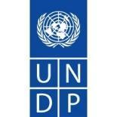

National Protected Areas Finance and Investment
Plan for Papua New Guinea
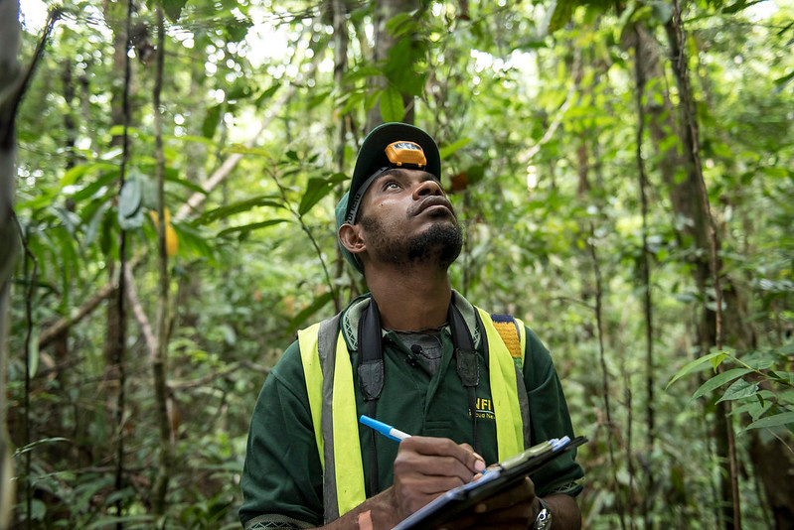
Final draft

This report was developed by Natural Strategies.

Authors:

Alexander Koch, CEO, Natural Strategies
Ludwig Liagre, Senior Associate Consultant, Natural Strategies
Bruno Paino, Global Lead, Nature-based Solutions Finance
Anouska Kinahan, Senior Associate Consultant, Natural Strategies
Catalina Becerra, Regional Lead, Nature-based Solutions Latin America
Andy Philip, Associate Consultant, Natural Strategies

The authors would like to thank the following for their strategic guidance and valuable contributions in developing this document:
- Ms. Kay Kumaras Kalim: Director, Sustainable Environment Department, Conservation and Environment Protection Authority
- Dr. Andrew Rylance, UNDP Chief Technical Advisor – Sustainable Financing of Papua New Guinea’s Protected Area Network
- Mr. Ted Mamu, Project Manager – Sustainable Financing of Papua New Guinea’s Protected Area Network
- Ms. Patricia Kila, Stakeholder Engagement Specialist - Sustainable Financing of Papua New Guinea’s Protected Area Network

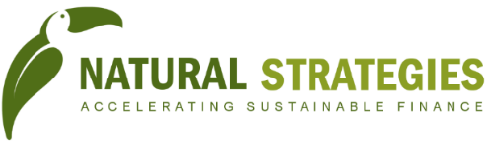

Natural Strategies S.L.
CIF: B67403808
Sant Pau Art Nouveau Site
Sant Antoni Maria Claret 167
08025, Barcelona, SPAIN
www.naturalstrategies.com
Table of content

Executive Summary 9
1.Context, objectives and methodology 14
2.Cost and financial gaps assessment for PAs in PNG 15
2.1. Introduction 15
Background and context 15
The National Protected Area Finance and Investment Plan 16
2.2. Aims and scope 17
2.3. Cost-modelling approach and methodology 19
A stepwise approach 19
Challenges and limitations 20
Building on existing data 21
The UNDP-Biodiversity Consultancy Study (2019) : approach and main results 21
The UNDP-TBC Study : PAs assessed 22
Other key data sources 23
2.4. Step 1: Categorization of PAs 23
Proposed differentiating factors 23
2.5. Step 2: Selection of PAs for each category 24
Selection rationale 24
Selected PAs for each category 24
2.6. Step 3: Developing ‘future-proof’ scenarios 25
Rationale of defining scenarios 25
Main scenarios features 25
Scenario proposals 27
2.7. Step 4: Defining cost structure and items for each PA category 29
2.8. Step 5: Collecting costs data, including. for scenario 30
Data collection methodology 30
Questionnaire 30
Targeted interviews 30
Building on PAs included in the UNDP-TBC study 30
Additional PAs considered 31
2.9. Step 6: Calculating estimations for the PA system cost, with scenario 31
Cost estimation for individual PAs : baseline situation 31
Cost scenarios for individual PAs : assessing future-proof costs 32
2.10. Step 7: Estimating funding gaps: financial needs assessment 34
Financial flows to individual PAs 34
Financial gaps for individual PAs – baseline situation, and with future scenarios 36
Summary of costs and funding gaps 40
Extrapolation to the whole PA system in PNG – with “future-proof” scenarios 42
2.11. Concluding remarks and perspectives on the cost assessment 48
3.Prioritizing financial options: an attempt based on CBA 49
Main lessons learned and results of applying the CBA framework to the prioritization of finance solutions are summarized below. 49
4. Pre-feasibility studies of top three financial options 51
4.1. Earmarking of revenues from taxes, fees and quotas in the tourism and extractive industries for local conservation purposes 51
Introduction 51
Context / baseline 52
Scope of the financial solution 54
Technical feasibility: 59
Environmental and social impacts 59
Stakeholder support 60
Financial forecasting 61
Management & legal and institutional framework 63
Implementation plan 65
Overall conclusion on pre-feasibility 66
4.2. Pre-feasibility study for Commodities promotion through Project Based REDD+ on selected PAs in PNG 68
Introduction 68
Context / baseline 71
Scope of the financial solution 75
Technical feasibility 80
Environmental and social impacts 86
Stakeholder support 87
Importance of Involving Local Communities in the Design of REDD+ Projects 88
Financial forecasting 89
Management 93
Legal and regulatory framework 94
Implementation plan 95
Overall conclusion on pre-feasibility 96
4.3. Biodiversity offsets 98
Introduction on biodiversity offsets 98
Context / baseline 98
Scope of the financial solution 100
Technical feasibility 102
Environmental and social impacts 103
Stakeholder support 103
Financial forecasting 105
Management 108
Legal and regulatory framework 109
Implementation plan 109
Overall conclusion on pre-feasibility 110
5.Analysing relevance of additional financial options 110
5.1. Debt-for Nature Swap 110
Introduction on debt-for-nature swap 110
Case studies 112
Potential for PNG and key steps for implementation 114
5.2. Payments for Ecosystem Services 116
Introduction on Payments for Ecosystem Services 116
Case studies 117
Potential for PNG and key steps for implementation 121
5.3. Third party management of PAs 122
Introduction on Third party management of PAs 122
Case studies 123
Potential for PNG and key steps for implementation 123
5.4. Tax exemption on donations 124
Introduction on Tax exemption on donations 124
Case studies 124
Potential for PNG 125
6.Towards implementation of the National PAs Finance and Investment Plan 125
6.1. Prioritization of financial options 125
6.2. Importance of a Conservation Trust Fund 128
6.3. First steps in the implementation of a PA finance plan 129
6.4. Towards an implementation roadmap 130
ANNEXES 146

List of figures
Figure 1: Simplified methodological overview 18
Figure 2: 7 steps-approach 20
Figure 3: PA cost formula from the TBC study 22
Figure 4: Costs estimates with future scenarios - comparison between YUS and PTMRCA 40
Figure 5: Costs/Ha estimates with future scenarios - comparison between YUS and PTMRCA 40
Figure 6: Costs per individual PAs with future scenarios 41
Figure 7: Costs/Ha per individual PAs with future scenarios (in USD) 42
Figure 8: Extrapolation approach : a simplified overview 43
Figure 9: Financing gaps & cost coverage, per scenarios 47
Figure 10: Royalty rates for 21 Sub-Saharan countries 57
Figure 11: A comparison of the potential revenue by both sector and mechanism using the most likely scenario 63
Figure 12: Total forest replacement by analyzed commodities 69
Figure 13: Distribution of staple food crops in PNG - Tok Pisin Encyclopedia 76
Figure 14: Commodities investments through project-based REDD+ 78
Figure 15: BAU vs target tree cover loss in selected PAs 92
Figure 16: Proposed financial architecture – REDD+/commodities 94
Figure 17: Biodiversity offsets – simply explained 98
Figure 18: Key steps for biodiversity offsets 98
Figure 19: Possible biodiversity-offset scheme through the BCCTF in PNG 109
Figure 20: Information on key PNG creditors 115
Figure 21: Payments for Ecosystem Services: a possible scheme 117
Figure 22: Example of a private PES scheme 117
Figure 23: FONAFIFO PES scheme in brief 118
Figure 24: Examples of PES modalities, FONAFIFO – non-exhaustive and illustrative 119
Figure 25: Financing scheme of the PES under the VNFF 120
Figure 26: Prioritization of financial options - financial impact & technical difficulty 126
Figure 27: Relative importance of analyzed financing options – simplified view 127
Figure 28: Matching financing objectives with analyzed financing options 127
Figure 29: Possible sequence of financial options design 129
Figure 30: Governance of the PA finance plan implementation – a simplified view. 130

List of tables
Table 1: PAs with costs tables, from the TBC study (2019) 22
Table 2: Differentiating factors' definition (by CEPA) 23
Table 3: Differentiating factors matrix for PA categorization 24
Table 4: Categorization matrix with selected PAs 25
Table 5: Considerations on scenarios features 27
Table 6: Key scenarios definitions for 3 proposed scenarios at the PA system level – theoretical proposals 28
Table 7: Main costs categories and items (non-exhaustive) 29
Table 8: Additional costs items per PA categories 30
Table 9: Baseline costs of individual PAs, in Million USD (based on conducted interviews) 31
Table 10: scenarios definition for PTMRCA 32
Table 11: scenarios definition for YUS 32
Table 12: scenarios definition for New Ireland LMMA 33
Table 13: scenarios definition for Hogave 33
Table 14: Annual current revenues of individual PAs (Million USD) 35
Table 15: Cost markers (USD) 41
Table 16: Cost data available for the extrapolation effort 46
Table 17: Extrapolated costs for the PA system (in Million USD) – figures for discussion 46
Table 18: A comparison of royalty rates across selected countries 57
Table 19: 2018 Baseline data 61
Table 20: Projected royalty revenue potential from the mining and oil and gas industry 62
Table 21: Projected revenue from the introduction of an environment levy 62
Table 22: Capacities required for implementing the option commodities / REDD+ 80
Table 23: Estimated Carbon Value for a 10-year period 92
Table 24: Pros and cons of voluntary versus compulsory offset schemes 105
Table 25: Revenues from an offset transaction – order of magnitude 106
Table 26: Pros and cons of debt-for-nature swap 112
Table 27: Cross-comparison of the two PES case studies (Costa Rica, Vietnam) 118
Table 28: PES revenues in Costa Rica in 2019 119
Table 29: Revenue sources of the VNFF in Vietnam 120
Table 30: PES-like approaches in the FONAFIFO and VNFF more in detail 121
Table 31: Financial options analyzed through their financial potential, and time for implementation 126
Table 32: Financial options and CTF role 128
Table 33: Implementation roadmap - Earmarking revenues from the extractive sector 131
Table 34: Implementation roadmap - Commodities promotion through Project Based REDD+ 133
Table 35: Implementation roadmap – biodiversity offsets 140

Abbreviations
BCCTF | Biodiversity and Climate Change Trust Fund
BO | Biodiversity offsets
CBD | Convention on Biological Diversity
CEPA | Conservation and Environment Protection Authority
DNS | Debt-for-Nature Swap
DPE | Department of Petroleum and Energy
EMPNG | ExxonMobil PNG
ES | Ecosystem Services
FLR | Forest and Landscape Restoration
FONAFIFO | National Forest Financing Fund (Costa Rica)
GDP | Gross Domestic Product
GEF | Global Environment Facility
Ha | Hectare
LMMA | Locally Managed Marine Area
LNG | Liquefied Natural Gas
M&E | Monitoring & Evaluation
METT | Management Effectiveness Tracking Tool
M-NFF | Moroccan National Forest Fund
MoA | Memorandum of Agreement
MRA | Mineral Resources Authority
NG | Net Gain
NNL | No Net Loss
O&G | Oil and Gas
PA | PAs
PAN | PAs Network
PDL | Petroleum Development Licenses
PES | Payments for Ecosystem Services
PFES | Payments for Forest Ecosystem Services
PNG | Papua New Guinea
PPP | Polluters Pays Principle
RBP | Result-based payment
REDD+ | Reducing Emissions from Deforestation and Forest Degradation, and the role of conservation, sustainable management of forests, and enhancement of forest carbon stocks in developing countries
Sc | Scenario
TBC | The Biodiversity Consultancy
TEV | Total economic value
UBSA | Umbrella Benefits Sharing Agreement
UCC | Costa Rican Carbon Units
UNDP | United Nations Development Programme
UPP | User Pays Principle
USD | US Dollars
VNFF | Vietnamese National Forest Protection and Development Fund
WMA | Wildlife Management Area
WTA | Willingness to accept
WTP | Willingness to pay

Executive Summary

Process
This analysis was created through a consultative process involving various stakeholders from diversified sectors and institutions within Papua New Guinea (PNG). In addition to maintaining a working relationship with CEPA and UNDP and providing periodic briefings, the team conducted several multi-stakeholder workshops, in particular:
- Induction workshop, 10 June 2020
- Capacity-building workshops on Cost-Benefit Analyses for Protected Areas, 16-18 November 2020
- Final presentation workshop, 26 March 2021
In addition, direct bilateral interviews were organized with 50+ representatives from public and private organizations and institutions. These interviews were critical to collect and verify data for the costs assessment of the Protected Areas (PA) system, as well as to prioritize key financial options and to identify key considerations and refine recommendations for financing instruments.
The full list of partners mobilized can be found in Annex 3.
Key messages:
- Less than 15% of the existing 62 PAs currently receive any financial support.
- Government sources provide very limited financial support to PAs.
- Total financing currently available for the current PA system is estimated at USD $3.3M from all funding sources.
- To meet the funding requirements for the current PA system, an additional USD $9M is required annually (Scenario 1)
- However, for PNG to achieve 50% of their commitments under Aichi target 11 (17% terrestrial ecosystems conservation, 10% marine ecosystems conservation), an additional USD $35M is required annually (Scenario 2)
- To achieve 100% of the target, an additional USD $75M is required annually (Scenario 3).
- For Scenarios 2 and 3, the relative per hectare costs of USD $2.8 and USD $2.9, respectively, are well within international cost ranges.
- Therefore, two key conclusions are drawn from the analysis:
  - No single finance solution will be sufficient to satisfy the funding gap - a portfolio or range of solutions are required.
  - Large, national-level solutions are required. The current approach to site-based financing is not sufficient to satisfy the funding gap.
- The figure below outlines the funding requirements under the three scenarios and the impact of different financial solutions to satisfy these funding gaps.
- The funding solutions are prioritized based on their financial impact and technical feasibility.
- Based on our analysis, we propose that it is possible achieve Scenario 1, and possibly Scenario 2, within the next 10 years.

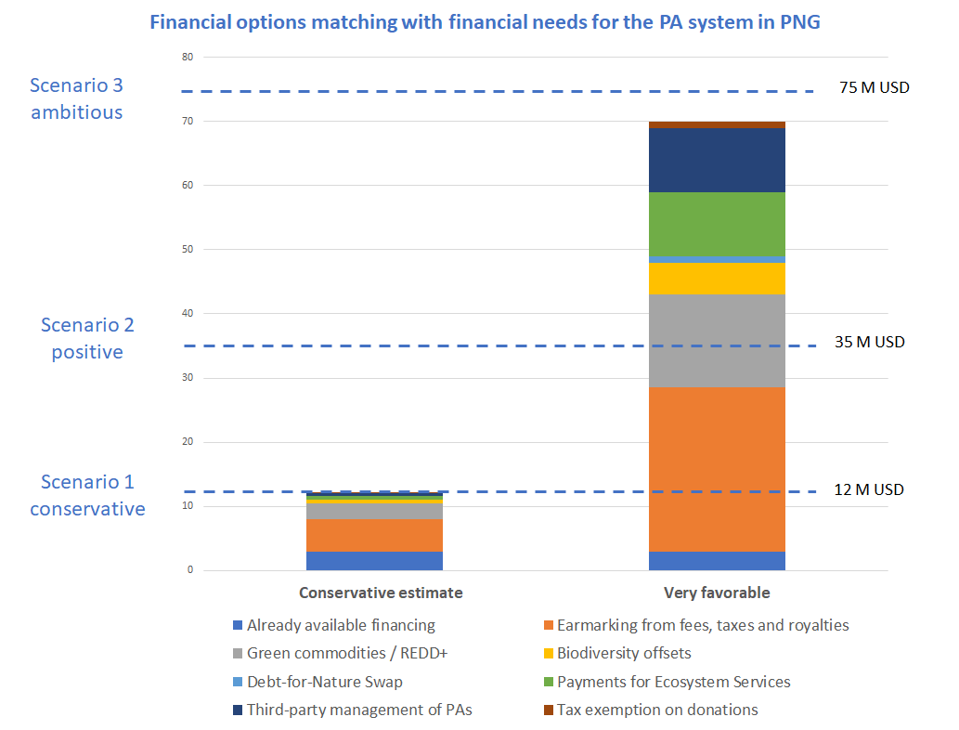

The results of the analysis demonstrate that a single financial option will not suffice, but a smart combination of options will help bridge the gap in a sustainable manner. A Conservation Trust Fund is currently being designed in PNG and our analysis refers to how this CTF could be meaningful for coordinating a multi-faceted PA finance plan. Nevertheless, the relations between the analyzed financial options and the CTF will have to be further specified in the framework of the CTF development and operationalization.
Bilateral interviews and a survey were conducted to prioritize financial options to be considered for prefeasibility assessments in the context of this study (the prioritization process is specified in greater detail in Section 3). The financial options that were identified and prioritized based on their financial impact and technical feasibility are:
- Earmarking revenues from taxes, fees and royalties in the PNG extractive industries
- Commodities promotion through Project Based REDD+
- Biodiversity-offsets
- Debt-for-Nature Swap
- Payments for Ecosystem Services
- Third-party management of PAs
- Tax-exemption on donations
The first three options were analyzed in more detail in pre-feasibility assessments presented in Section 4. The other four options were assessed in less detail, but the analysis provides key findings on their respective potential (as specified in Section 5).
Each option has financial potential that requires consideration. To operationalize these options in the PNG context, it must be ensured that i) there is political will for increasing resources for biodiversity conservation and ii) national stakeholders are aligned on a common vision for PA financing.
Cost assessment
The analysis aimed at identifying a way to estimate and anticipate the costs and financial needs of the PA system in PNG. Less than 15% of the existing 62 PAs currently receive any financial support. Therefore, the study built on the limited primary data available. As a consequence, substantial economic modelling was required in order to establish the estimation of costs to manage the PA system. The modeling results highlight orders of magnitude of costs and financing needs, which can be used with confidence to build realistic financing strategies. In a context where the PA system in PNG is meant to expand, it is important to account for this future growth, and to identify financial options to achieve this growth.
The cost analysis demonstrates to effectively manage the existing PA system requires USD $9M in annual spending in addition to already available resources, bringing the annual total to USD $12M USD. This corresponds to about USD $4.2/Ha/year, and an average amount of USD $192,000/PA/year. To overcome this funding hurtle, this paper will identify and prioritize several financing options.
Beyond this current state funding target, the analysis also highlights more ambitious scenarios towards achieving the Aichi target 11 (17% terrestrial ecosystems conservation, 10% marine ecosystems conservation). To achieve 50% of the Aichi target 11, about USD $35M/year (i.e., USD $2.8 Ha/year) would have to be mobilized, and to achieve the full target, approximately USD $75M (i.e., USD $2.9 Ha/year) would be needed. While these amounts may not be achievable in the next three years, it provides clarity on what is required to achieve these targets. Moreover, these figures align with the amounts spent by other countries in support of biodiversity.
The study has been built on a logical stepwise approach, which is described in detail so-as to facilitate its application and refinement by decision-makers in PNG. Beyond efforts to produce additional data, this report thus has a pedagogical approach to facilitate future work on costs and financing needs estimation for the PA system in PNG. For example, the application of PA categories will help identify costs and financing needs for specific PA types. Also, by defining scenarios with different levels of ambitions, the analysis highlights ways to draw a possible future for the PA system, while considering foreseeable costs based on extrapolation approaches.
Pre-feasibility studies on financial options
Earmarking revenues from taxes, fees and royalties in the PNG extractive industries
Currently, there are no mandatory financing schemes from the extractive sector earmarked specifically for the environment, and it would appear that any voluntary payments towards the environment seem less than adequate. While mandatory environmental fees are common practice for mining operations across the globe, as specified in this paper’s benchmark efforts, voluntary payments negotiated on an individual basis consistently lead to lower revenues.

It is clear therefore, that there remains significant untapped revenue potential, and that in principle would be relatively easy to implement, would be aligned with other countries in the region and across the world, would not affect investment attractiveness for the sector, and would have immense positive social and environmental impacts that could set the stage for enabling other environment-related levies to be collected across other sectors.

In keeping with globally competitive rates, applying an additional 0.5% to existing royalty rates and ear-marking this for PA financing has the potential to generate an estimated USD $23M per annum for PA management costs. Alternatively, PNG could apply an environmental levy to the extractive sector as is common practice in other countries such as Australia and Zimbabwe. As an example, a 1% levy has the potential to generate approximately USD $27M per annum for PAs. Recognizing that such mechanisms would be possible only for the duration of a project’s lifespan, and that many negative impacts of the extractive sector can be permanent, this mechanism also proposes an additional one-off fee to be negotiated under project agreements that would be paid into an environmental trust fund, which help provide PA financing in perpetuity. Providing finances to environmental funds by the extractive sector is common practice around the globe, in particular across South America and Africa.

Commodities promotion through Project Based REDD+
To achieve significant emissions reductions in PNG, a substantial transition is required for the rural economy and the methods by which timber and agricultural production is undertaken. When implemented with appropriate emphasis on protection, production and inclusion aspects, a REDD+ co-management model between local communities, civil society and the public sector has the potential to meet the needs of a diverse group of stakeholders and harness the capital necessary to promote and scale sustainable agriculture and forest protection. Such an arrangement would support 1) state actors to achieve climate commitments, develop programs at the territory level, and receive associated result-based payments; 2) private sector actors to invest in sustainably-produced commodities and secure a sustainable supply of products for their operations; 3) producers to access markets, technical assistance, and financial resources to increase yields and improve livelihoods; and 4) NGOs, civil society organizations, donors and other sponsors to achieve their respective goals and to efficiently integrate their efforts.
This development model will look to position a selection of PAs as the core of a sustainable land-use strategy that develops and promotes high-quality sustainable products and commodities across all areas (e.g., carbon, timber, coffee, cocoa, biodiversity) with strong co-benefits. The country's high-forest cover and impressive biodiversity, land tenure regimes that favor local communities and relatively low deforestation rates are conducive for such a model, which will also help reduce forest degradation by providing local communities with alternative viable economic activities. In determining which PAs might be best suited for this model, community-specific factors such as PA area scale, local stakeholder support, and geographic proximity to transportation routes must be considered.

PNG has the potential to market a high number of environmental and social benefits linked to sustainable and certified agricultural production. Several organizations are already undertaking this work, but opportunities exist to further strengthen and scale this action. The application of this approach requires a coordinated package of positive incentives spanning regulatory, technical assistance and financial mechanisms, balanced with realistic assumptions on the potential for effective land-use (e.g., productivity rates). The implementation of REDD+ projects in a selection of PAs could be used strategically to draw-in further investments into sustainable land use activities by consolidating a public-private – community partnership model for the country. This model would also provide the possibility of including ecosystem restoration alongside sustainable management and conservation of non-degraded areas within a landscape, or even focus completely on ecosystem restoration (e.g., within nullified Special Agricultural Business Lease areas).

From the revenue assessment conducted, the revenues from this option could range from USD $2.7M to USD $15.5M (depending on the future market rate for carbon).

Biodiversity offsets
Despite its technical challenges, the Biodiversity Offset (BO) option seems like a feasible means to drive PA funding in PNG. While this option may not yield the scale of revenues that other options (such as earmarking of fees, taxes and royalties) could deliver, it is another financial lever that could be used to target sectors such as oil and gas, mining, and palm oil. Based on the analysis, the conservative funding potential of BOs is between USD $0.5M and USD $5M per year. The lower end of this range takes into account the technical challenges linked with establishing such a mechanism, including negotiations with the targeted sectors.
Ideally, the BOs would be operationalized through a CTF such as the proposed Biodiversity and Climate Change Trust Fund (BCCTF) and would be mandatory to maximize resource mobilization from this option (versus a voluntary scheme, which is less likely to provide sufficient resource mobilization).
It seems there is a good potential that BOs could be complementary to other financial options, such as i) earmarking of fees, taxes and royalties (as highlighted in Section 4.1 with the proposal for a “dual” system) and ii) Payments for Ecosystem Services (PES). Indeed, PES can be better achieved by multiple sectors, building on the “user-pay” principle, and could easily aggregate contributions from damaging sectors, using the “polluter-pay” principle.
While several stakeholders would have a role to play to ensure implementation of this scheme (including the offset operator, the BCCTF, and auditors), CEPA’s role in a biodiversity-offset mechanism should be well framed so it can concentrate on short-term achievable tasks such as the definition of policy options to enable the environment for the development of compulsory biodiversity offsets and the identification of potential areas for this mechanism. The independent offset operator could be a selected local NGO, or an international NGO building a consortium with a local NGO.
Additional finance solutions (e.g., Debt-for-Nature Swaps) are also assessed in Sections 5 but not presented here as the financial impact is considered less than the prioritized three above.

1.Context, objectives and methodology

The development of Papua New Guinea’s first national PAs Finance and Investment plan is supported by the United Nations Development Programme (UNDP) and the Conservation and Environment Protected Authority (CEPA)-implemented project on the Sustainable Finance of Papua New Guinea’s Protected Area Network (referred to hereafter as ‘the project’). Funded through the Global Environment Facility (GEF), the project will aim to extend the government of PNG’s ability to fulfil its PA mandate and implement the PA Policy (2014):
- secure stable and long-term financial resources for the management of PAs across the country;
- ensure that these financial resources are allocated to contribute to improving effectiveness of the management of the PAs across the country; and
- ensure that they are managed cost-effectively and efficiently with respect to their conservation and other complementary development objectives.
In recognition of this need, the project will assist with the development of a diversified mix of conventional and innovative funding sources and consolidate revenues to finance the ongoing costs of establishing and managing PAs. In addition, the project will assist the PNG government to establish a Biodiversity Fund that will be built on a secure, accountable and transparent financial mechanism for receiving, administering and disbursing funds. The project will, therefore, result in a system that will provide catalytic and long-term financial support that will lead to stable ecosystems (both within and outside of PAs), coupled with the social transformations to make that happen (including transforming institutions to become supporters/facilitators of that process, and the establishment of long-term partnerships).
In this context, the main objectives of this PA finance and investment plan include:
- Estimating costs for establishing and managing the PNG PA system, and assessing financing gaps;
- Identifying viable financial options and analyzing their potential to match the estimated gaps; and,
- Developing a relevant finance and investment plan for the PNG PA system.
In the context of this mission, capacity development on Cost-Benefit Analysis (CBA) has also been provided, and a technical guidance document on CBA was produced (as a separate deliverable).
In order to develop the points mentioned above, and for each component of the work, the consultant team has adopted a systematic approach, based on following steps:
- Literature review;
- Methodological proposal, discussed with CEPA and UNDP;
- Stakeholder consultation, including bilateral meetings and multi-stakeholder workshops;
- Benchmarking of results via-à-vis other contexts.
It is to be noted that due to the covid-19 crisis, the assignment has been conducted in-part on-site with the support of a local expert ensuring organization and facilitation of interviews with local stakeholders, and in-part remotely with a team of international experts.

2.Cost and financial gaps assessment for PAs in PNG

2.1. Introduction
The following document seeks to provide a model to estimate and anticipate the costs and financial needs of the PA system in Papua New Guinea. Natural Strategies conducted this exercise as part of an assignment called ‘National Protected Area Finance and Investment Plan to Support the Sustainable Financing of Papua New Guinea’s Protected Area Network’, in support of the United Nations Development Programme (UNDP) and the Conservation & Environment Protection Authority (CEPA) of Papua New Guinea (PNG).

Background and context
The present assignment is part of a larger project named ‘Sustainable Finance of Papua New Guinea’s Protected Area Network’ implemented by the United Nations Development Programme (UNDP) with financial support from the Global Environment Facility (GEF). The project seeks to extend the Government of PNG’s ability to fulfil its PA mandate and implement the PAs Policy 2014, in particular to:

- secure stable and long-term financial resources for the management of PAs across the country;
- ensure that these financial resources are allocated to contribute to improving effectiveness of the management of the PAs across the country; and
- ensure that they are managed cost-effectively and efficiently with respect to their conservation and other complementary development objectives.

In recognition of this need, the project aims to assist with the development of a diversified mix of conventional and innovative funding sources and consolidate revenues to finance the ongoing costs of establishing and managing PAs. The project seeks, therefore, to result in a system that will provide catalytic and long-term financial support that will lead to stable ecosystems (both within and outside of PAs), coupled with the social transformations to make that happen (including transforming institutions to become supporters/facilitators of that process, and the establishment of long-term partnerships).

As emphasized in the main project document, lack of funding for PAs in PNG is critical, thus the need to conduct a large-scale costing and financial needs assessment in order to develop a relevant financing strategy and action plan. Information on costing for PAs in PNG is limited because so few are actually financed. Thanks to the analysis and relatively simple model proposal made in this work, PNG is in a much stronger position to make informed decisions on financing and managing the PA as a system. This also allows the government to develop estimates for establishing new PAs or expanding existing ones.

The National Protected Area Finance and Investment Plan
In this context, UNDP has contracted Natural Strategies to (i) develop a national level PA finance and investment plan for the country and (ii) plan and implement a national level training for public and private stakeholders on environmental cost-benefit analysis.

The finance and investment plan will be complemented by a corresponding ten-year action plan. It will build on the achievements of the current Community-based Forest and Coastal Conservation project and the Management Effectiveness of the PA System project.

In doing so, Natural Strategies conducted a detailed analysis of viable revenue-generating options for PAs, focusing on both conventional and innovative sources. Initial findings were discussed with PNG stakeholders in a consultation workshop. This was combined with a Cost-Benefit-Analysis (CBA) training for national stakeholders with the objective to build knowledge about the CBA methodology and how it can be applied for PAs and nature conservation more broadly.

2.2. Aims and scope
The PAs Costing & Financial Needs Assessment in PNG presented in this document has several objectives, which, in turn, define its scope:
- it seeks to provide an analytic basis to identify viable revenue-generating options for PAs. By comparing current PA costs with available financing, it aims to provide PNG stakeholders with an approximate picture regarding the extent to which current financial mechanisms cover the financial needs of PAs in the country. In doing so, the assessment also provides insights on the magnitude of additional finance that could be required for the long-term sustainable management of the network.
In addition, it seeks to enable a better understanding of which elements in establishing and managing PAs tend to be most commonly under-funded. This information can help PNG mobilize new financing streams in a more targeted way: different financial mechanisms can be tailored to cover specific types of costs; and individual donors and investors can be approached that best match the magnitude and type of specific funding needs.
- the assessment seeks to inform a discussion at the national level on the expected evolution of PA costs over the next ten years. It takes into account that the PA system’s scale and ambition, and with it the related costs, may evolve over time. In light of this, to ‘future-proof’ the assessment, it includes scenarios estimating the impact on costs if the PA surface area will gradually increase; if management of PAs will become more effective over time; and if PA stakeholders will increase key on-site activities such as ecosystem restoration.
Ultimately, including these scenarios into the scope of the assessment seeks to facilitate an exchange in PNG by comparing the relative estimated costs and benefits of different potential pathways of the PA system in the future. It thereby seeks to inform a national policy decision on the desirable and realistic level of ambition for the evolvement of the PA system in the next ten years.
- As such, the financial needs assessment can also inform the design of the planned Biodiversity Fund. By gaining a better understanding of the type and scale of PA funding that need to be mobilized in the near – to mid-term, the Fund can be tailored accordingly: E.g., many bi-lateral and multilateral financing mechanisms that the Fund could tap into differ in terms of eligible/fundable conservation activities and type & amount of available funding, and some (such as the Green Climate Fund) require corresponding accreditation.
- Finally, this is a quick-scan assessment based on limited data and therefore can only claim to be an approximation of the exact costs of the PA system. Therefore, we developed the assessment in a way that CEPA and other stakeholders can continuously refine and update it as and when richer and more precise data will become available. It therefore also aims to serve as guidance to identify current data gaps and as a tool for PNG stakeholders to continuously enhance and refine their understanding of PA costs and financial needs as an important element of budget planning for the PA system.
Main tasks of the assessment include:
- Reviewing the analysis of costs to establish and implement PAs in the country, taking into consideration the specific local context, management diversity, and relationship with nature.
- Modelling the costs of the current PAs system and the potential costs of an expanded system (or with a revised management approach) over the next 10 years.
- In order to make sure that the resulting Financial Needs Assessment is ‘future-proof’, cost scenarios are developed based on different assumed scales or levels of management of the PA system in the future.

In the context of challenges in accessing data for the whole PA system in PNG, the present report will seek to highlight in an illustrative way some of the key steps and methodological approaches which could help improve the accuracy of the costing exercise in the future. This deliverable could thus also be used as a methodological guidance.
Figure 1: Simplified methodological overview
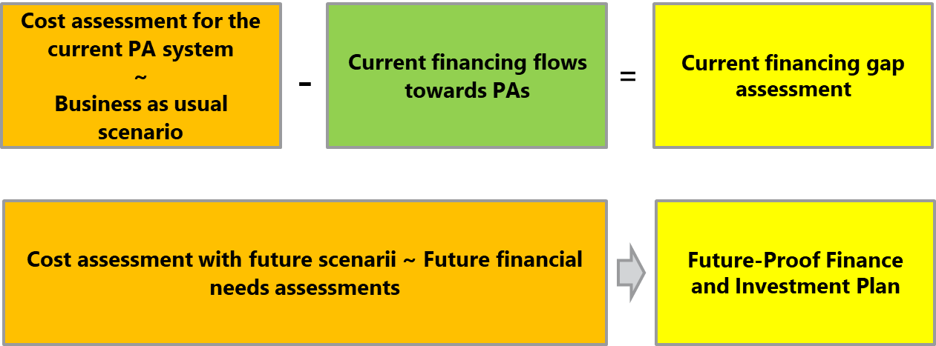
As explained in Figure 1, the estimation of the current costs structure in the present situation (business as usual scenario) and the estimation of the current financing flows will enable to assess the current financing gap. Efforts to estimate future costs (based on future scenarios) will be key to design a future-proof Finance and Investment Plan.

2.3. Cost-modelling approach and methodology
In order to develop a coherent methodology to implement a relevant PAs costs assessment, we propose the below described steps, enabling to integrate a certain level of complexity in the proposed model.

A stepwise approach
The illustrated 7 steps (Figure 2) are considered critical to deliver a high-quality costing exercise. In summary:
Step 1 aims at categorizing PAs in order to identify homogeneous groups of PAs with similar characteristics.
Step 2 enables, with the leadership of CEPA, to identify relevant PAs examples for each category.
Step 3 seeks to define ‘future-proof’ scenarios, which will serve to assess realistic future financial needs for PAs in PNG.
Step 4 looks into more details in the cost structure of each PA category, highlighting the main differences between categories.
Step 5 corresponds to the data collection and treatment phase, which is critical to assess current and future costs of PAs (in particular for the cost assessment of future scenarios). This will enable estimation of costs for each PA category.
Step 6 aims to assess costs for a number selected individual PAs from the different categories (in the baseline situation and with future proof scenarios), which would enable to extrapolate the findings of the study to the full PA system in PNG. This step will seek to propose a simple approach enabling an understanding of orders of magnitudes, broken down by main scenarios (when feasible).
Step 7 aims to estimate the financial needs (funding gaps) for individual PAs (for the baseline situation and for future proof scenarios) which could be further extrapolated into the funding gap of the whole PA system in PNG (in the baseline situation and with future proof scenarios).
The following sections provide a more detailed description for each step.

Figure 2: 7 steps-approach
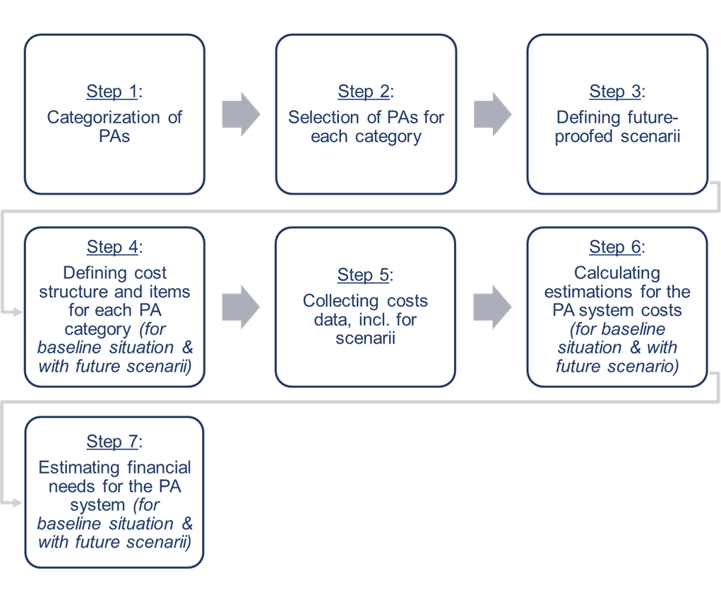

Challenges and limitations
The main challenges and limitations in conducting the analysis were related to difficulties in accessing data:
- Large parts of the PA system of PNG are characterized by their remoteness, limited infrastructure and highly decentralized management through local villages – and clan structures. In practice, many PAs are administered relatively informally and only a fraction of them are based on comprehensive documentation of costs & expenditures and detailed yearly budgets (about 10% of PAs).
- In those cases where management costs are consistently documented, the data is typically not publicly accessible and, in some cases, confidential (e.g., salaries). Exchanging with local PA managers and supporters to access the data required considerable time and effort due to limited internet use and connectivity in remote areas and the COVID-19 pandemic. Still, with efforts in conducting interviews, it was possible to access most of the available data.
- To address data limitations and ensure comparability across different PAs, the consultants sought to partly base their estimates of current cost on data collected through the UNDP-Biodiversity Consultancy study, 2019. However, it appeared that in most cases, the data collected through that study already included certain elements of potential future costs, thereby limiting their utility to estimate the costs of the status quo in the PA system (nonetheless this data was useful for the conservative scenario estimates, as described further in this analysis)
- CEPA is currently leading a process to revise the PA categorization across PNG. As Step 1 of the consultants’ 7 step process, the PA categorization constituted a precondition to advance with subsequent steps of the overall product, so the timeline and approach of this assignment had to be aligned with the ongoing CEPA categorization process.
- When assessing costs for specific PAs, there is a need to tailor the future scenarios to the local contexts and social dynamic, thus the scenarios have to be tailored to every single PA situation. This effort nonetheless helps in getting more precise approximations of the potential costs to be covered in the future. It is to be pointed out that such a tailor-made approach could be done only with a limited number of PAs in the framework of this assignment.
- Extrapolating the calculated data to the whole PA system is also a challenge. The present analysis proposes an approach that could be improved with additional data and more PAs included in the assessment. Authors thus wish this study can be seen as one of the stones on the way towards a complete and precise costing process for the whole PA system in PNG.

Building on existing data
Beyond own estimations and calculations made, the current analysis has built on existing data produced previously. The following sections provide more information about such useful sources.

The UNDP-Biodiversity Consultancy Study (2019) : approach and main results
The Study “Costs of establishing and implementing PAs establishment and ongoing management in PNG” (2019) (currently a Draft Report to CEPA and UNDP, and hereafter called “the UNDP-TBC study”) provides a lot of costs information on specific PAs in PNG.
In particular, the UNDP-TBC study :
- Focuses on terrestrial PAs
- Considers “lowest reasonable costs”, on the below costs categories
- Baseline surveys of ecosystems, species and threats to the persistence of these;
- Infrastructure development and maintenance;
- External technical support;
- Supporting sustainable local livelihoods (this was set at a level believed to be adequate to balance the opportunity-costs of conservation with tangible short-term and long-term benefits); and
- Direct support (where direct payments, e.g. for school teachers, are considered more effective than developing local livelihood opportunities).
- Develops a formula : “considered to be relatively robust for a medium-large Protected Area” (100.000 – 200.000 Ha)

Figure 3: PA cost formula from the TBC study
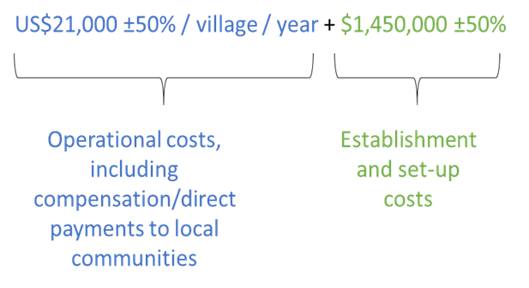
It should be noted that, as mentioned in Section 3, in reviewing the UNDP-TBC study costs data, it appeared that in most cases the information collected is already including some future costs elements. Therefore, the data should be regarded in most cases as part of a future scenario. Thus, the baseline costs have to be estimated appropriately. The consultants concluded that they will often be lower than the costs estimated in the UNDP-TBC study.

The UNDP-TBC Study : PAs assessed
From the UNDP-TBC study there are six PAs with cost data, and available cost tables – see list in table below.
Table 1: PAs with costs tables, from the TBC study (2019)
PAs | Organization in charge
Proposed Hogave Conservation Area | PNG Institute of Biological Research
Managalas Conservation Area | Partners with Melanesians
Proposed Torricelli Mountain Range Conservation Area (PTMRCA) | Torricelli Conservation Alliance: Torricelli Conservation Area; Tenkile Conservation Alliance (TCA)
YUS Conservation Area | Tree Kangaroo Conservation Programme: YUS Protected Area;
Great Manus Forest community conservation areas | Wildlife Conservation Society: Great Manus Forest community conservation areas; and
New Ireland locally managed marine areas. | Wildlife Conservation Society: New Ireland locally managed marine areas.

The current analysis builds on this data to assess the baseline situation of these PAs and further to add a layer of cost estimates in relation to future proof scenarios.

Other key data sources
Other important analyses and studies were used as a source of data, such as the
- METT study “A method for assessing effectiveness in Papua new guinea’s PAs (2017)”
- GEF Prodoc for the project “Sustainable Finance of Papua New Guinea’s Protected Area Network”

2.4. Step 1: Categorization of PAs
Step 1 aims at categorizing PAs in order to identify homogeneous groups of PAs with similar characteristics.

Proposed differentiating factors
Following differentiating factors were proposed to CEPA for this analysis:
- National vs subnational
- Terrestrial vs Marine
- Remote vs Not remote
After an internal categorization effort, CEPA proposed to consider the 3 differentiating factors as proposed above, and specified their definition (Table 2)
Table 2: Differentiating factors' definition (by CEPA)
Differentiating factors | Definitions
National vs subnational | National PAs are considered the ones under CEPA management. Subnational PAs are managed by sub-national governments and other organizations such as NGOs.
Terrestrial vs Marine | Any PA on an Island having more than 50% then classify as majority
Remote vs Not remote | Anything beyond 50km from the prov. Town/center is considered as remote

Even though these factors may be completed in the future, incorporating more complexity, it was nonetheless recognized it is already a good basis for the categorization, and further the costing exercise.

PA categorization by CEPA
Once endorsed by CEPA, a differentiating factors matrix could be established to further position specific PAs within the identified categories. Table 3 provides a simplified view of such a matrix that could be populated by at least two PAs for each category.
Table 3: Differentiating factors matrix for PA categorization
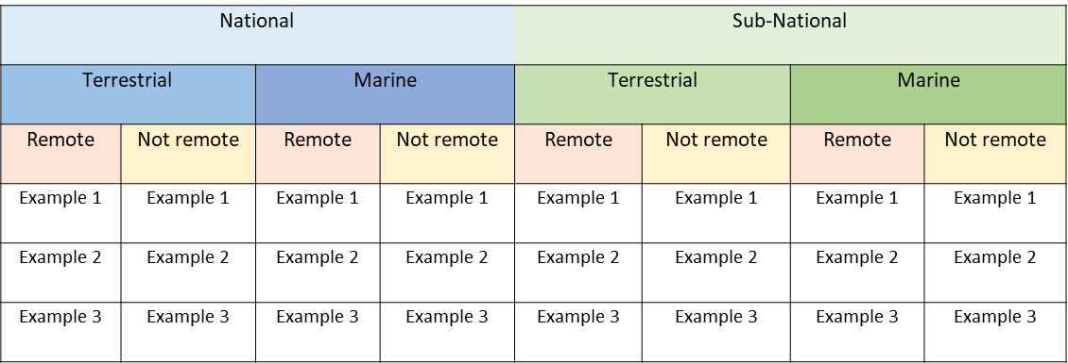

2.5. Step 2: Selection of PAs for each category
Step 2 enables, with the leadership of CEPA, identification of relevant PA examples for each category.

Selection rationale
Selection of PAs to populate the matrix is based primary on the following criteria:
- Data availability: Is data on costs and funding sources easily available? For example, already partly available through the UNDP-TBC study and/or easily available through interviews with identified organizations (CEPA or other PAs’ managers and advisors)

- Representativity: Is the PA selected representative from the targeted category? Is there a possibility to extrapolate data from the selected PAs to other PAs from the same category?
To make the selection, CEPA officers have been mobilized and final selection has been endorsed by CEPA.

Selected PAs for each category

Table 4: Categorization matrix with selected PAs
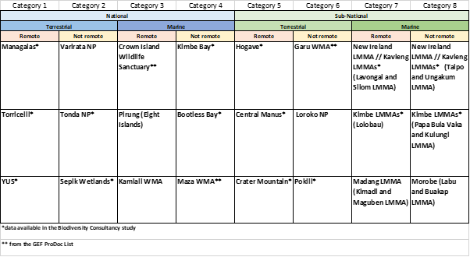

2.6. Step 3: Developing ‘future-proof’ scenarios
Step 3 seeks to define ‘future-proof’ scenarios, which will serve to assess realistic future financial needs for PAs in PNG.

Rationale of defining scenarios
Defining future-proof scenarios is essential to estimate potential future costs for the PNG PA system in a realistic way. These scenarios would have different drivers (so-called features hereafter) which would help in differentiating them. Also, they may have different levels of ambitions, matching with more or less positive projections. Impacts of any processes are linked to many factors and the actual situation in the future is difficult to assess. With different scenarios, integrating future-proof parameters, the likelihood to identify relevant pathways matching with reality is increased.

Main scenarios features
Potential scenarios features include:

- Increase in number of PAs (or) PA Surface increase
It is planned that more PAs will be officially established in the future, and that the overall surface of the PA system will increase, in accordance with international agreements. While the Aichi targets, of which the PNG Government has committed, currently calls for 10% marine and coastal areas under protection, and 17% terrestrial areas under conservation (Aichi target 11), a more ambitious target of 30% overall conservation (for both marine & coastal and terrestrial) is currently being discussed in international negotiations (under the Post-2020 global biodiversity framework).
N.B.: For the scope of this assignment, the Aichi target 11 has been considered as already very ambitious and will correspond to the hereafter called “ambitious” scenario.

- Management type, effectiveness and efficiency
Management types of PAs in PNG are very diverse, ranging from management supervised by CEPA, management in the hands of an external organization (e.g., NGO) or management by local communities in autonomy. And each management type does not involve exactly the same types of costs structures.
- Efforts on ecosystem restoration
While ecosystem restoration is not considered a priority in PNG to focus on the conservation of what is still there, we can foresee that it may come at the forefront of the agenda while the world is entering the UN Decade on Ecosystem restoration 2021-2030. It may thus be relevant to consider carefully the potential for ecosystem restoration in the PA system in PNG.
Table 5 provides more considerations on each potential scenario.
N.B. While these features are quite general, at the PA level they will have to be specified to adapt to the local context and specific PAs needs. Thus, not all features may fit with a given PA, and only sub-categories of these features may be retained for specific PAs.

Table 5: Considerations on scenarios features
Increase in number of PAs (or) PA Surface increase | Management type, effectiveness and efficiency | Efforts on ecosystem restoration
- N.B. the register on PAs indicates that PNG has 10% terrestrial PAs and 1% marine PAs  - PNG vision by 2050 : Increase in PA surface to meet the CBD target (10% marine & coastal PAs, and 17% terrestrial PAs)  - How will international rules further influence PA surface increase? The increase in PA numbers? (up to 30% protection discussed under the CBD), and how much would it cost to achieve such a target?  - What increase (% or absolute data) in PA numbers or in PAs surface, for each PA category, is realistic in the next 10 years? (is the 30 % target realistic and the 2050 vision not underestimated?) | - Management effectiveness (cost increase towards effective management)  - Increase in the management efficiency (based on METT data) : determining a % efficiency increase/year?  - Management types : National PAs (by CEPA), Subnational Protected Area (by Provinces and Local Level Governments), Privately-owned PAs | - N.B. ecological priority in PNG is to preserve old growth ecosystems from further loss before restoring ecosystems.  - Restoration can be locally important, especially for ecosystem services with benefits to local communities.  - If additional restoration such as large-scale reforestation is planned, this would significantly add to the PA costs.

Scenario proposals

It is proposed to analyze scenarios over a 10-year period, where scenarios would always consider a baseline situation (so-called business-as-usual scenario). Three main scenarios are proposed :

- Scenario 1: a conservative scenario.

Meaning a scenario which has high probability of taking place with a slightly improved situation and limited risks.

- Scenario 2: a positive scenario.

A scenario which has a fair probability of taking place with a significantly improved situation and a medium level of risks.

- Scenario 3: an ambitious scenario.

A scenario which has a low probability of taking place and supposes a highly improved situation and a high level of risks.

These scenarios derived for the whole PA system in PNG may lead to types of scenarios as described in table 6, building on the key features described in the previous section.

N.B. There also while these scenarios proposals are quite general and theoretical, at the PA level they will have to be specified to adapt to the local context and specific PA’s realities. Thus, the scenarios definitions will have to be tailor-made, even though we could keep the terminologies (conservative, positive and ambitious) for all PAs.

Table 6: Key scenarios definitions for 3 proposed scenarios at the PA system level – theoretical proposals
Scenario 1: Conservative scenario | Scenario 2 : Optimistic scenario | Scenario 3 : Ambitious scenario
- Towards CBD target (+2%) : 3% marine & coastal PAs, and 12% terrestrial PAs (what does it mean in increase in PA numbers for each category?)  - Slightly improved management (10% increase in PA budget?)  - Limited effort for ecosystem restoration (10% of ecosystem restoration financing needs covered) | - Towards CBD target (+5%) : 6% marine & coastal PAs, and 15% terrestrial PAs (what does it mean in increase in PA numbers for each category?)  - Improved management (25% increase in PA budget?)  - Significant efforts in ecosystem restoration (25% of ecosystem restoration financing needs covered) | - CBD target met : 10% marine & coastal PAs, and 17% terrestrial PAs (what does it mean in increase in PA numbers for each category?)  - Optimal management (% increase in PA budget or full PAs financing needs covered?)  - Strong efforts in ecosystem restoration (50% of ecosystem restoration financing needs covered)

2.7. Step 4: Defining cost structure and items for each PA category
Step 4 looks into more details in the cost structure of each PA category, highlighting the main differences between categories.
Below costs items in Table 7 are the ones used in the UNDP-TBC study to characterize the cost structure of a PA.
Table 7: Main costs categories and items (non-exhaustive)
Cost categories | Cost items
Establishment costs | - Baseline surveys of ecosystems, species and threats  - Socio-economic feasibility survey  - Social impact assessment including opportunity costs  - FPIC consultation with affected landowners  - Consultation with any leaseholders  - Wider consultation including government  - Developing and costing a Management Plan
Start-up costs | - Project manager  - Infrastructure development  - Recruitment and training of staff  - External support
Implementation costs | Overheads and management  - Infrastructure maintenance  - Staff development  - Financial accounting  - External technical support  - Management  - Research Officers  - Rangers  Reduction of deforestation and over-exploitation  - Awareness and education  - Demarcation of boundaries  - Supporting sustainable local livelihoods  - Direct support  Restoration of degraded forest  - Nurseries & enrichment planting of key species  - Maintenance and consultancy support  - Invasive species management
Monitoring & Evaluation costs | Monitoring and evaluation of offset results  - Participatory monitoring  - Technical monitoring  - Reporting back

In the present assessment additional costs items had to be considered, in particular when envisioning future proof-scenarios. They are collected per PA categories in the Table 8.
Table 8: Additional costs items per PA categories
PA categories | Specific (additional) costs
Terrestrial | - Forest and landscape restoration
Marine | - Equipment such as boats  - Underwater monitoring  - Reef & mangrove restoration,
Remote | - Travel costs, incl. Vehicles, fuel, etc
Not remote | - Additional rangers, patrolling costs  - Enforcement capacities
National | - Monitoring & evaluation  - Oversight and control capacities
Subnational | - Community benefits  - Livelihoods projects  - Community leaders’ empowerment

N.B. Ideally costs items specifically for the national/sub-national levels, and more specificities on cost items for future-proof scenarios would have to be identified. This could help for a costing assessment integrating more disaggregation per costs categories. In the present analysis nonetheless step 4 was only approached to a very limited extent.

2.8. Step 5: Collecting costs data, including. for scenario
Step 5 corresponds to the data collection and treatment phase, which is critical to assess current and future costs of PAs (in particular for the cost assessment of future scenarios).

Data collection methodology

Questionnaire
A questionnaire has been set up with the objective to gather data on costs and financing flows for specific PAs. The full questionnaire can be found in Annex 1.

Targeted interviews
Based on the questionnaire, a number of targeted interviews were conducted, with at least one contact person for each selected PAs. The full list of interviewees can be found in Annex 2.

Building on PAs included in the UNDP-TBC study
As previously mentioned, the analysis built on interviews and data collection through most of the PAs considered in the UNDP-TBC study. Following PAs in particular were considered :
- Proposed Hogave Conservation Area
- Managalas Conservation Area
- Proposed Torricelli Conservation Area
- YUS Conservation Area
- Great Manus Forest community conservation areas
- New Ireland locally managed marine areas.

Additional PAs considered
Additional PAs considered (not formerly included in the UNDP-TBC analysis) included, for example:
- Varirata National Park
- Kimbe LMMA
- Tonda National Park
- Crater Mountain WMA
- Pokili

2.9. Step 6: Calculating estimations for the PA system cost, with scenario
Step 6 aims to assess costs for a number selected individual PAs from the different categories (in the baseline situation and with future proof scenarios), which would enable to extrapolate the findings of the study to the full PA system in PNG. This step will seek to propose a simple approach enabling an understanding of orders of magnitudes, broken down by main scenarios (when feasible).

Cost estimation for individual PAs : baseline situation
Table 9: Baseline costs of individual PAs, in Million USD (based on conducted interviews)
PA | PTMRCA | YUS | Hogave | New Ireland
One-time costs (establishment & setting-up) | 1.8 | 2.25 | 0 | 0.872
Recurring costs | 1.8 | 1.1 | 0 | 0.5

We can also mention existing data on costs developed by the UNDP-TBC study for several PAs, which we understand already tend towards the conservative scenario (Sc1) – please see below.

Cost scenarios for individual PAs : assessing future-proof costs
Proposed Torricelli Mountain Range Conservation Area (PTMRCA)
Table 10: scenarios definition for PTMRCA
Conservative | Optimistic | Ambitious
See UNDP-TBC data  Costs : USD $1.8 M /year | -No surface extension  -Ecosystem restoration on 20% of current surface (3,600 Ha/year)  -Climate action activities | -Surface increase (+50 villages) – total surface ab. 300,000 Ha  -Ecosystem restoration on 20% of total surface (60,000 Ha/year)  -Climate action activities

Hypotheses:
- Operational costs increase linearly with unit costs considered as groups of 50 villages;
- The surface extension involves additional establishment and setting-up costs, also a linear function of the number of villages, with unit cost corresponding to groups of 50 villages;
- Ecosystem restoration costs are assessed at a conservative US $400 Ha/year (taking into account other restoration costs already covered by other cost items such as nurseries, maintenance, etc.)
- Climate action activities are considered recurring costs estimated at a conservative USD $100,000 year/50 villages.

YUS Conservation Area
Table 11: scenarios definition for YUS
Conservative | Optimistic | Ambitious
See UNDP-TBC data  Costs : USD$ 1.1 M/year | Staffing  +6 conservation officers (12 in total)  +6 rangers (24 in total)  Community incentives (leaders’ mobilization)  USD $5,000 /ward/year  Community livelihoods (value chains investments)  USD $5,000 /ward/year  Marine area management  USD $100,000/year | Staffing  +12 conservation officers (18 in total), i.e., 1 conservation officer per ward  +12 rangers (30 in total)  Community incentives (leaders’ mobilization)  USD $10,000 /ward/year  Community livelihoods (value chains investments)  USD $10,000 /ward/year  Marine area management  USD $200,000 /year
Hypotheses:
- A conservation officer cost per year is ab. USD $15,000 /year;
- A ranger cost per year is ab. USD $10,000 /year

New Ireland LMMA

Table 12: scenarios definition for New Ireland LMMA
Conservative | Optimistic | Ambitious
-Additional staff (+25%) | - Additional staff (+50%)  - One additional boat  -Additional Biological and socioeconomic monitoring (+98000 USD)  -No surface increase foreseen | -Twice initial staff (+100% increase)  -2 additional boats  -Mangrove and reef restoration (Mangrove and reef restoration) (0.5% = 1250 Ha)  -Enforcement and surveillance costs (USD +$67,000)  -additional Biological and socioeconomic monitoring (USD +$98,000)  -No surface increase foreseen
Hypotheses:
- Mangrove and reef restoration : USD $400 /Ha/year (very conservative) ;
- Initial staff costs (to be checked) : annual revenue minus other annual costs provided = ab. USD $200,000
- Price per boat = USD $31,000

Hogave Conservation Area
Table 13: scenarios definition for Hogave
Conservative | Optimistic | Ambitious
-All feasibility assessments conducted  -PA registered  -1 project manager only  (establishment + setting up costs of the TBC table) | -Beyond establishing and setting-up the PA  -A small management team in place (up to 3 staff, see hypothesis below)  (establishment + setting up + management costs of the TBC table) | - Beyond establishing and setting-up the PA  -A small management team in place (up to 5 staff, see hypothesis below)  -M&E (TBC data)  -efforts in ecosystem restoration (see TBC data)
Hypotheses
- Staffing structure (optimistic scenario) : 1 project manager, 2 rangers
- Staffing structure (ambitious scenario) : 1 project manager, 1 conservation officer, 3 rangers
- A conservation officer cost per year is ab. USD $15,000 /year;
- A ranger cost per year is ab. USD $10,000 /year

2.10. Step 7: Estimating funding gaps: financial needs assessment

Step 7 aims to estimate the financial needs (funding gaps) for individual PAs (for the baseline situation and for future proof scenarios) which could be further extrapolated into the funding gap of the whole PA system in PNG (in the baseline situation and with future proof scenarios).

Financial flows to individual PAs
Information on financial flows to individual PAs was collected during the interviews with PA managers and advisors.

Table 14: Annual current revenues of individual PAs (Million USD)
PA | TMRCA | YUS | Hogave | New Ireland | Varirata
Current approximate revenue/year | 0.5 | 0.6 | 0 | 0.5 | 0.15

Proposed Torricelli Mountain Range Conservation Area (PTMRCA)
Current revenues amount approximately USD $500,000 /year (mostly through donors’ grants).
YUS Conservation Area
Current revenues amount approximately USD $600,000 /year (endowment fund contributes to about 20% and donors’ grants about 80% in the current situation).
New Ireland LMMA
Current revenues amount approximately USD $500,000 /year (mostly based on donors’ grants and internal WCS MPA Fund).
Hogave Conservation Area
Hogave Conservation Area has currently no resources available.

Financial gaps for individual PAs – baseline situation, and with future scenarios
Proposed Torricelli Mountain Range Conservation Area (TMRCA)
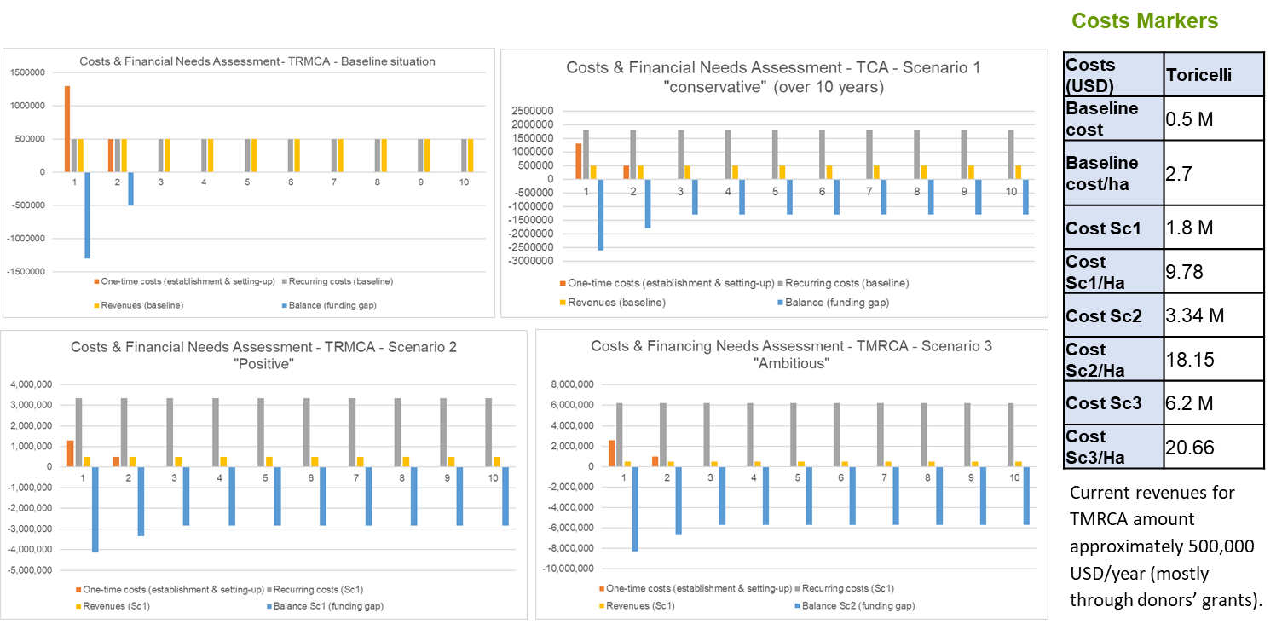

YUS Conservation Area
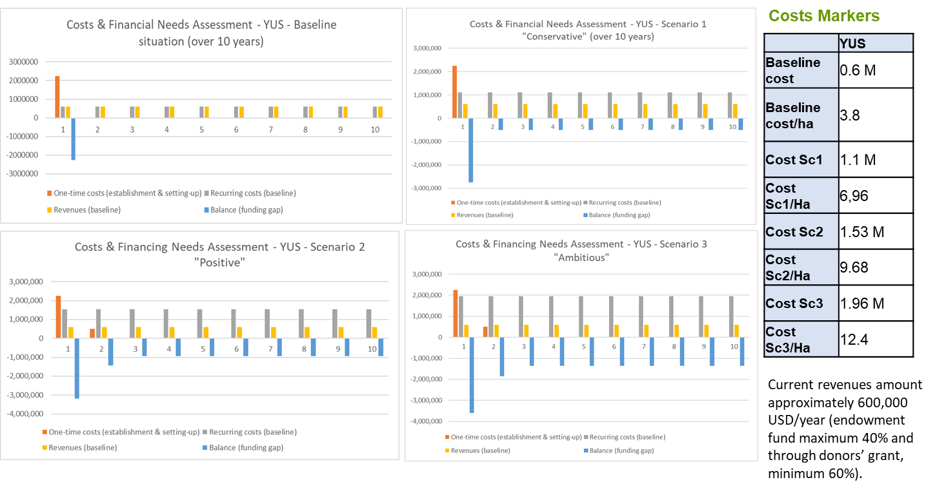

New Ireland
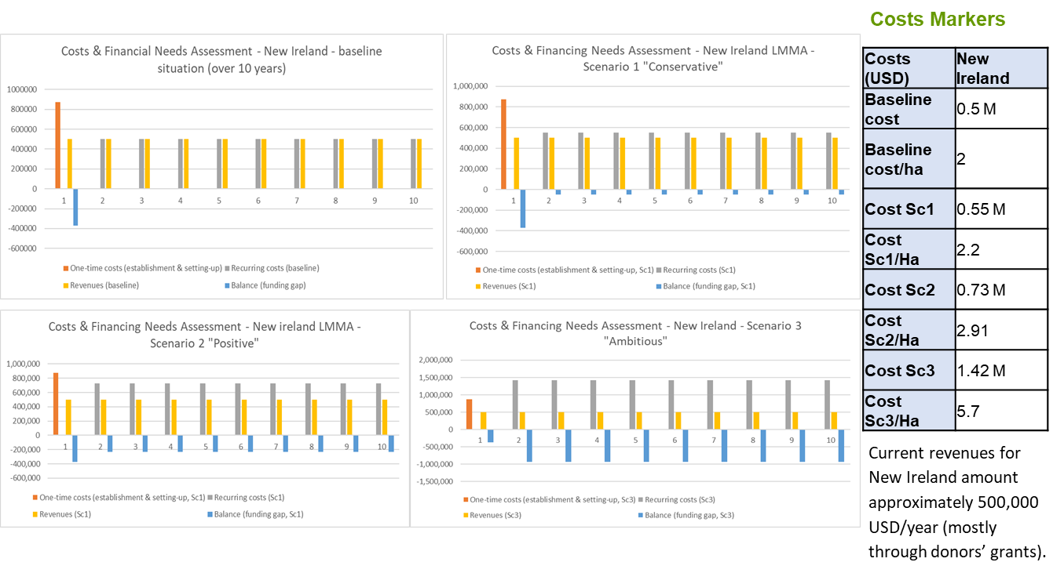

Hogave
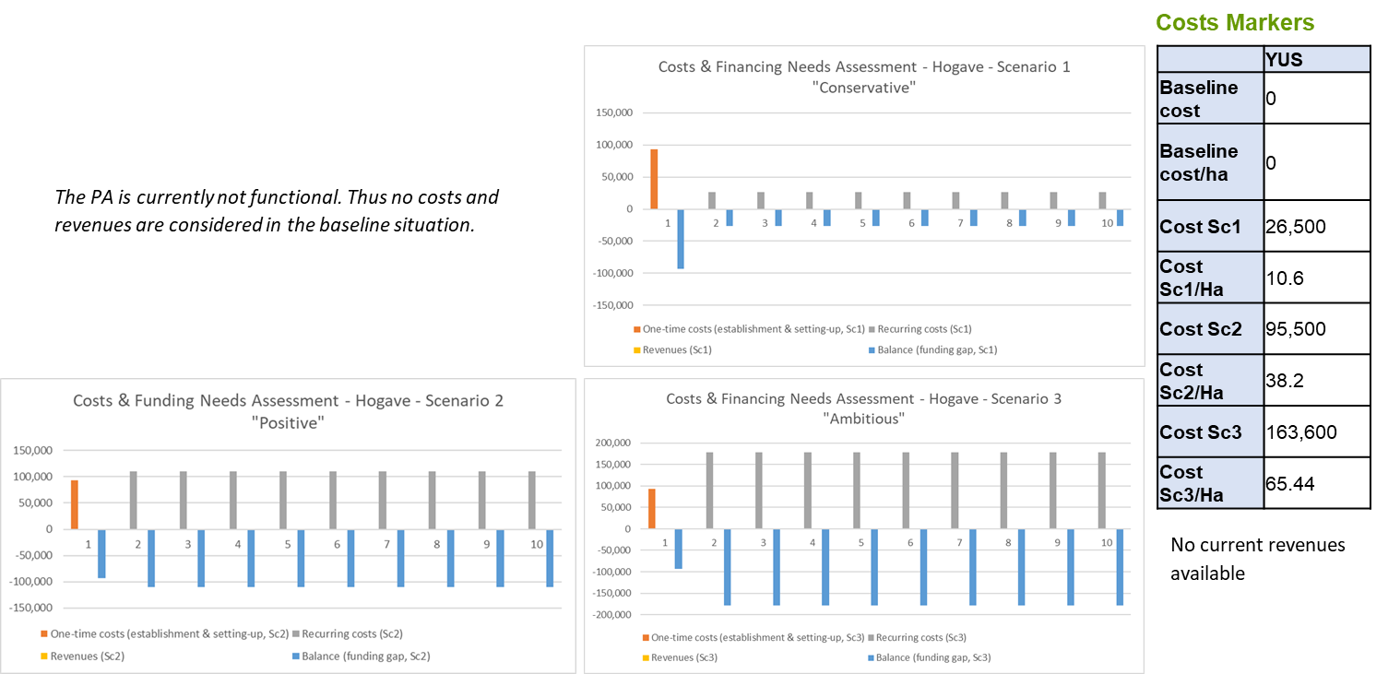

Summary of costs and funding gaps

Costs for PAs of the same category : an example for category 1
The costing effort can help in getting useful information for a specific PA category. For example, for category 1 “National-Terrestrial-Remote”, one can compare data between YUS and TMRCA.
Figure 4: Costs estimates with future scenarios - comparison between YUS and PTMRCA

The cost difference between both PAs over time is explained by the surface extension of the TMRCA in the future scenario, while YUS would most probably not have a similar potential for surface increase. Besides this, a significant amount of ecosystem restoration is planned in the case of PTMRCA. Given the cost intensity of ecosystem restoration it is not surprising that costs for PTMRCA are in general higher for all scenarios.
Figure 5: Costs/Ha estimates with future scenarios - comparison between YUS and PTMRCA

Summary for all PAs with data available
N.B. The below graphs and tables will be complemented with the collection and processing of additional data.
Based on the previous assessments it is possible to define costs markers in absolute terms and per Ha. The table below summarizes these costs markers for individual PAs. Such costs markers can help in conducting value transfers methodologies.
Figures 6 and 7 help visualize the costs and costs/Ha scenario with future scenarios.
Table 15: Cost markers (USD)
PA | TCA | YUS | Hogave | New Ireland
Baseline cost | 0.5 M | 0.6 M | 0 | 0.5 M
Baseline cost/ha | 2.7 | 3.8 | 0 | 2
Cost Sc1 | 1.8 M | 1.1 M | 26,500 | 0.55 M
Cost Sc1/Ha | 9.78 | 6,96 | 10.6 | 2.2
Cost Sc2 | 3.34 M | 1.53 M | 95,500 | 0.729 M
Cost Sc2/Ha | 18.15 | 9.68 | 38.2 | 2.91
Cost Sc3 | 6.2 M | 1.96 M | 163,600 | 1.427 M
Cost Sc3/Ha | 20.66 | 12.4 | 65.44 | 5.7

Figure 6: Costs per individual PAs with future scenarios

While comparing PAs with data available it is interesting to observe again how a PA with a significant surface increase trend such as PTMRCA stands above the other PAs (Figure 6). In the case of PTMRCA foreseen efforts on ecosystem restoration in the future also drove the costs up.
Costs per Ha shows that for a small PA (Hogave surface is comparatively small vis-à-vis the three other PAs), costs/Ha can rise significantly with the optimistic and ambitious scenarios. In fact, small PAs in size still have similar infrastructure requirements as large PAs which explain the high cost/Ha figures for Hogave.

Figure 7: Costs/Ha per individual PAs with future scenarios (in USD)
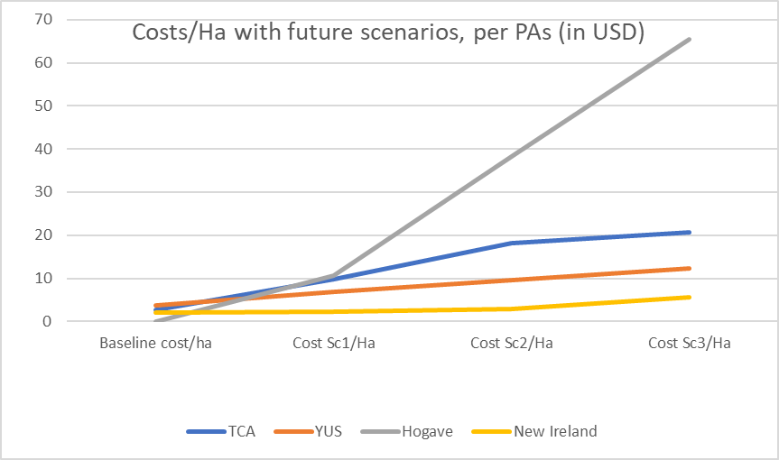

Extrapolation to the whole PA system in PNG – with “future-proof” scenarios

Proposed approach
Extrapolation of costs data assessed for individual PAs to the whole PA system can build on a series of steps. Ideally following activities would be conducted to be able to extrapolate to the whole system:
- Continuing effort in data collection for more PAs
- Computing costs data with more PAs (up to 12 in total)
- Further defining costs markers for individual PAs
- Conducting a comparative analysis between PAs of the same categories
- Extrapolating for PA categories (aggregation per PA categories)
- Extrapolation to the whole PA system based on surface of PAs (baseline and future surface, based on scenarios)
Figure 8 provides a simplified view of how the extrapolation can be conducted with a bottom-up approach, from individual PAs to PA categories, to the whole PA system.

Figure 8: Extrapolation approach : a simplified overview
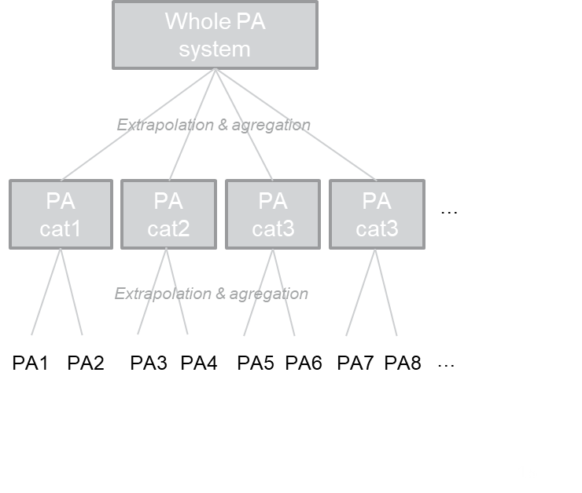

Example with Protected Area category 1, conservative scenario
For a given PA category, the extrapolation exercise could follow several approaches. Two of them are suggested below:
- Extrapolating based on the surface of each PA category
- Extrapolating based on PAs with data available

i) Extrapolating based on the surface of each PA category
PA | Torricelli | YUS | Managalas
Implementation cost (annual) | 1,800,000 | 1,100,000 | 299,172
Cost / Ha (USD) | 9.78 | 6.96 | 0.83
Average cost/Ha (USD) | 5.85

In the situation where surface increase of a specific PA category would be known, it is possible to multiply the average cost/Ha of a specific category by the surface in question, including the planned extension in a given scenario.
Extrapolation formula : Average cost/Ha X planned surface (incl. extension) in the next 10 years

ii) Extrapolating based on PAs with data available
Extrapolation formula : Sum of PAs annual implementation costs (in a given scenario)
With this approach for PA category 1 for example (terrestrial, national, remote), the conservative extrapolated cost for the category (in scenario 1) would be :
Torricelli Annual Implementation Costs (Sc1) + YUS Annual Implementation Costs (Sc1) + Managalas Annual Implementation Costs (Sc1) = approx. 3.2 M USD (per year)
To get close to the whole category cost in question one could multiply the figure estimated above by Number of PAs in the category 1 divided by the number of PAs with data available.
The total cost for PA category 1 (in the scenario 1 for example) could be estimated as follows :
Total costs PA category 1 = [Torricelli Annual Implementation Costs (Sc1) + YUS Annual Implementation Costs (Sc1) + Managalas Annual Implementation Costs (Sc1) ] X Total Number of PAs in category 1 / 3

Extrapolation effort to the whole PA system with currently available data
Given the gaps in data collection, it is proposed to conduct a very conservative extrapolation exercise. The approach consists in aggregating the costs data in the so-called conservative scenario (Sc1) for the PAs with available data (as compiled in the table below), as well as for Scenarios 2 and 3. Results are compiled in Table 16.

A number of assumptions were made to conduct the calculation:
- Scenarios 2 and 3 will follow a surface increase as described in the Annex 3.
- When not calculated individually, a conservative assumption will report the Sc1 costs to the Sc2 and Sc3.
- Given the passive management characteristics of many PAs, especially for the remote ones, assumption is made that 20% of the PA surface can be considered at full costs, while 80% need to be discounted at 25% of full costs (with application of a 0.25 discount factor). These parameters are variables in the model.
- The Conservative scenario does not include surface extension (with baseline as reference)
- Positive scenario 2 leads to achieve 50% of the Aichi target 11 (corresponding surface extension is specified in Annex 3)
- Ambitious scenario 3 leads to achieve the Aichi target 11 (corresponding surface extension is specified in Annex 3)
- For marine PA’s surface extension, a conservative cost/Ha of 4 USD/Ha (before discount). Is chosen based on the Balmford & al. 2004 study. The figure, defined as a variable in the model, is considered for surface extension in Scenarios 2 and 3.
- For terrestrial PAs surface extension, a conservative cost/Ha of 10 USD/Ha (before discount) is chosen based on own calculations for the conservative scenario. The figure, defined as a variable in the model, is considered for surface extension in Scenarios 2 and 3.
- Having done the calculation with 10 PAs (with available data), one could make the assumption that with the current number of 62 established PAs, one could multiply the above number by 6.2.
- For the calculation of the baseline current costs/revenues, we apply a discount factor (of 0.5, defined as a variable in the model), as we know from the METT study that most PAs do not have a proper budget, and we thus avoid overestimating baseline revenues/current costs in the PA system.

Data used come from
- Own calculation for Torricelli, New Ireland, Hogave, and YUS
- UNDP-TBC data (scenario 1): Managalas, Varirata, Tonda, Crater Mountain, Pokili, Kimbe LMMA

Table 16: Cost data available for the extrapolation effort
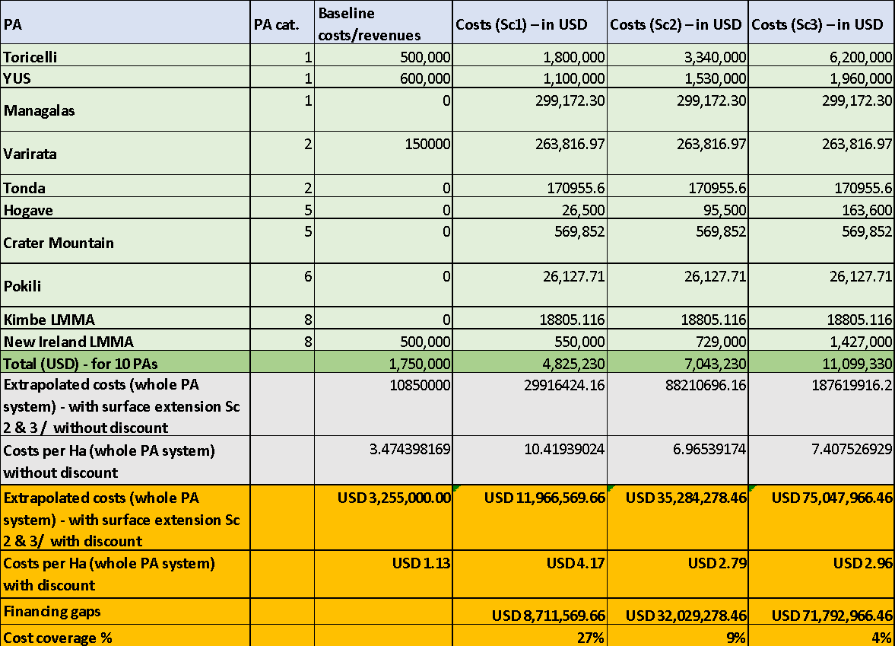
Table 17: Extrapolated costs for the PA system (in Million USD) – figures for discussion
Extrapolated costs of the PA system | Baseline costs | Costs (Sc1) | Costs (Sc2) | Costs (Sc3) – in USD
Total (M USD) | 3.2 | 11.9 | 35.2 | 75
Costs / Ha | 1.13 | 4.17 | 2.79 | 2.96

Figure 9: Financing gaps & cost coverage, per scenarios
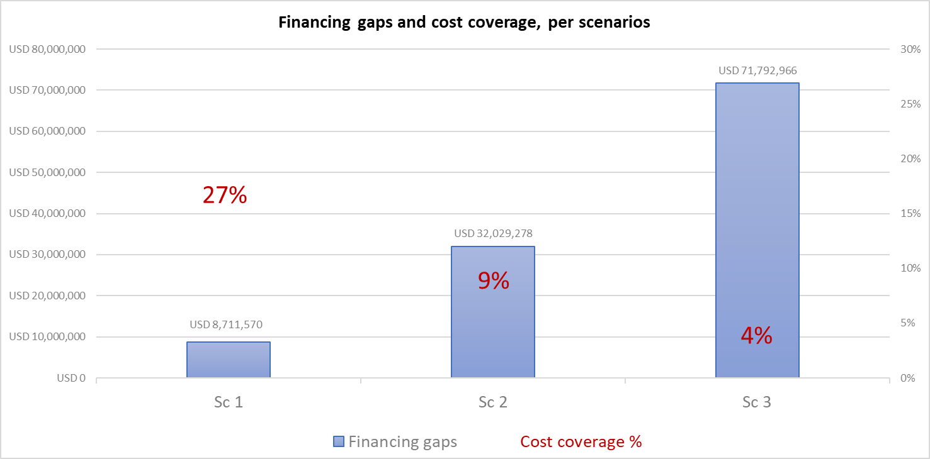

The extrapolated PA system costs per year (annual recurring costs) leads to figures ranging from USD $3.2M (baseline engaged costs/revenues) to USD $75M USD in the most ambitious scenario.
Costs for Scenarios 2 and 3 are quite high but not inconsistent with the benchmark of costs of PAs systems in other countries (TNC-UNDP, 2010). For example, countries like Peru, Cuba and Panama have respective financing needs (per year) of USD $41.8M (Peru), USD $36.8M (Cuba) and USD $33.8M (Panama).
Despite this, we do not consider it realistic to achieve Scenarios 2 and 3. Indeed, this would represent an increase in resources mobilization that does not seem achievable on the short-medium term. It seems that a realistic and achievable target for the next 10 years is to concentrate on the conservative scenario, towards mobilizing about USD $12M USD/year. This would mean increasing financing per year of USD $8.7M (cost coverage for the conservative scenario is 27%).
As for costs/Ha figures, they range from USD $1.1 /Ha (baseline costs) up to about USD $4.2 /Ha in the conservative scenario. The positive and ambitious scenarios have respective costs/Ha of USD $2.8 and USD $2.9 /Ha. Scenarios 2 and 3 build on a significant surface extension of the PA system, hence the decrease in costs/Ha. Considering an international benchmark of costs/Ha for PA systems per year, these figures seem conservative. For example, the Middle East region invests in PAs an average of USD $5.40/Ha/year, Eastern Europe USD $11.20/Ha/year, and the European Union USD $43.00/Ha/year (TNC-UNDP, 2010). Similarly, Balmford & al (2004) highlight that the median cost/Ha of marine PAs globally is about USD $7.5 /Ha.
It is important to note that part of the costs/financing needs figures are calling for different financing instruments such grants and loans. In particular livelihoods projects and value chains investments could be covered by loans. In a revised version of this analysis, with additional data, efforts could be conducted to split financing needs figures between the required financing instruments.

2.11. Concluding remarks and perspectives on the cost assessment
The analysis demonstrates realistic figures for resources mobilization for the PA system in PNG. Building on a conservative approach, the financing gaps have been identified for different scenarios. Recognizing that some scenarios have an illustrative purpose only as their level of ambition towards achieving the Aichi target 11 is probably too high, they still provide an order of magnitude that is not fully unrealistic, considering the budget engagement that some countries already make to their PA system (TNC-UNDP, 2010). Thus, aiming at covering the financing gap for an effective PA management would mean mobilizing close to 9 M USD per year in comparison to what is currently available. This can be achieved through diverse financing options that will be further described as part of the current assignment.
Despite data access limitations, this assessment can facilitate the exchange of the status and potential pathways for PA management in PNG. To pave the way towards a strengthened PA system in the country, the consultants suggest a number of additional steps that would complement this work:
- It will be important that PNG stakeholders continuously update and refine the financial needs assessment as and when richer and more precise data will become available. Doing so can gradually elevate the current approximation to a key tool for budget planning and policy making in the PA system of PNG.
- To facilitate the availability of comprehensive and comparable data, we recommend building standardized databases of PAs costs and available financial resources to maintain an accurate overview on corresponding funding gaps. Ideally, PA managers and supporters should be trained in populating such databases to ensure high quality of data entry. E.g., in entering data, it will be important to clearly distinguish between what constitutes de facto current PA management costs at a given point in time from the potential costs of a ‘wish-list’ of additional staffing or activities.
- The scope of this assignment was limited to the costs and financial needs of a range of different PA scenarios. It could be useful to complement this with estimations on the specific benefits that each of these scenarios could generate, e.g., by linking it to Cost-Benefit-Analysis. This could further help in taking informed decisions on PA policies in PNG: By comparing costs and benefits, organizations working on PAs could more transparently convey the value of environmental protection to stakeholders working in other sectors; PA managers could more easily identify the best use of limited resources and what to prioritize among various potential activities; and public and private sector could compare and calibrate more effective business models for long-term PA management.

3.Prioritizing financial options: an attempt based on CBA

Beginning in the initial stages of the assignment, Natural Strategies led bilateral interviews with various stakeholders in order to assess the relevance of a wide variety of options. Moreover, the team conducted a survey to capture input from key stakeholders.
This effort has been complemented by a consultation process in the framework of a workshop on cost-benefit analysis (CBA). The 3rd day of the workshop was dedicated to using the CBA framework to prioritize financial options.

Main lessons learned and results of applying the CBA framework to the prioritization of finance solutions are summarized below.

Key points
- The CBA framework can be applied to compare and prioritize different potential financial solutions to mobilize additional funding for the PA system in PNG.
- This kind of comparison can be further facilitated through Multi-criteria analysis (MCA), which is an economic assessment method building on CBA and fostering stakeholders’ participation and decision-making ownership.
- A range of financial instruments that are available for PAs were introduced to participants. These included both public sector and private sector related instruments, including: Payments for Ecosystem Services; Carbon markets; Biodiversity offsets; Private sector impact investments; Debt swaps for nature; and Earmarking and retention of biodiversity revenues (from fees on fisheries, forestry, tourism).
Exercise and key results
Working groups applied CBA criteria to the abovementioned financial instruments to compare and score their relevance and viability to strengthen PA funding in the specific context of PNG.
Guiding questions included:
- Will this financial instrument generate a significant amount of resources that are significantly higher than any investment needed to set up / operationalize the instrument?
- Will this option generate significant positive environmental and social impacts?
- Are any environmental or social risks linked to this financial instrument likely to be minimal?
- Would the set-up costs for implementing this alternative be relatively small?
- Is there a governance structure in place that could facilitate implementation of the alternative?
- Will this option likely receive the required interest and support from all private & public institutions (including local or international investors where relevant) that need to be involved in its implementation?
Participants provided a qualitative and quantitative assessment in response to these questions. Groups presented the key results and conclusions.

Key messages
Several key messages emerged to help design the financial options, including:
- Some of the considered financial instruments (e.g., biodiversity offsets) should not be used to justify negative impacts by extractive industries on PAs.
- For some instruments (e.g., jurisdictional REDD+) the full guidelines still need to be finalized, including the nesting of voluntary market projects into the national level system, which can be a challenge. But there is potential to generate revenues from this mechanism. The issues of transparency and equity in REDD+ benefit-sharing and local stakeholder participation are critical.
- It will be key to identify how to channel financial benefits from the considered instruments to local communities in and around the PAs.
- It could be more viable to design one integrated system in PNG that would channel different types of funds to PAs, rather than trying to design separate mechanisms in parallel that might not reach economies of scale on their own (following, for example, a conservation trust fund model).
- The earmarking and retention of biodiversity revenues from fees on fisheries, forestry, tourism could also have a high potential but requires agreement of the central government to channel a portion of these revenues to local areas. There are some examples from (e.g., tourism and mining) that could potentially be built upon.

This approach was combined with a series of bilateral interviews that sought to prioritize financial options. From the very long list of potential options (including 68 in the BIOFIN list of financial options), a first qualitative screening was conducted by the team to identify ~10 options with high potential in the PNG context. Options that were filtered out included opportunities such as green bank cards and lotteries. The design of a Conservation Trust Fund was not considered in this study as it is part of another ongoing analysis.
The list below was thus proposed to key stakeholders:
- Debt-for-Nature Swap
- Payments for Ecosystem Services
- Third-party management of PAs
- Green bonds
- EIA performance bonds and Conservation Impact Bonds
- Tax exemption on donations
- Earmarking of fees, taxes and royalties on the extractive industry and the tourism sector
- Carbon markets
- Impact finance
- Biodiversity-offsets
Bilateral interviews included a survey on proposed options with questions related to the i. existence of supportive legal frameworks, ii. political viability, ii. technical feasibility, iii. available examples in place.
Based on this prioritization effort, a proposal was made (and validated by CEPA) to prioritize the assessment of three financial options:
- Earmarking of fees, taxes and royalties on the extractive industry
- Commodities promotion through Project Based REDD+
- Biodiversity-offsets
Further, it was proposed to conduct a higher-level assessment of four additional options:
- Debt-for-Nature Swap
- Payments for Ecosystem Services
- Third-party management of PAs
- Tax exemption on donations

4. Pre-feasibility studies of top three financial options

4.1. Earmarking of revenues from taxes, fees and quotas in the tourism and extractive industries for local conservation purposes

Introduction

This assessment examines the feasibility of two commonly applied principles in environmental financing to generate funds for PNG’s protected area network (PAN): the Polluters Pay Principle (PPP), and the User-Pays Principle (UPP). The PPP is well established and is commonly applied as a means to increase funding for environment related activities. This Polluters Pay Principle centers around the idea that "the polluter should bear the cost of the measures needed to ensure that the ecosystem is and remains in an acceptable state". This prefeasibility assessment provides a background of potential revenues sources from these two Principles, and a brief overview of the institutional and legal frameworks required. This chapter therefore aims to provide detail to inform subsequent discussions regarding the implementation of these proposed mechanisms.

There are a number of potential areas where PNG could apply this principle for its PAs. Firstly, the extractive industry. While there are many benefits of this industry to a country, the negative impacts of the mining, oil and gas sectors on the environment are well documented,. The extractive industry can cause significant environmental damage from total habitat destruction, degradation and disturbance, to pollution and contamination, all of which severely impact biodiversity and ecosystem services. This in turn can have a negative impact on the health and livelihoods of people who depend on natural resources. The PPP stipulates that as a result of the polluter’s negative impacts on the environment there is an obligation for the polluter to bear the costs of environmental preservation and recovery proportional to the damage caused. This principle could also be applied to other sectors such as large commercial agriculture, where expanses of forests are removed to make way for cash crops, and fertilizers and pollutants enter the environment affecting both biodiversity and humans alike.

The UPP on the other hand, while linked to the PPP, stipulates “all resource users should pay for the full long-term marginal social cost of the use of a resource and related services including any associated treatment cost"¹. In other words, you use it, you pay for it. This principle is particularly relevant for PAs since their function is to conserve natural resources that are often used for recreation, enjoyment or science, and their sustainable consumptive (e.g., hunting, forestry) and non-consumptive (e.g., tourism) use. In PNG PAs are used for recreation, livelihoods (such as hunting and fishing), and for commercial purposes (e.g., forestry or tourism services provision). Other uses not widely applicable for PNG currently are research, filming and photography. In this assessment we examine the feasibility of generating funds to help finance the PAN of PNG considering both these principles.

The agriculture sector has been significantly impacted due to COVID 19, and production forecasts for this industry remain relatively lower than pre-COVID. Further, in 2020 additional levies and green fees were established for the agriculture sector. As a new initiative and given the impact of COVID on the industry, it is not surprising that there is some resistance to these new fees. Although also impacted by COVID, the extractive sectors (oil and gas and mining) are expected to show a strong rebound in 2021⁴. For these reasons this feasibility assessment examines the application of the PPP principle in detail for the oil, gas and mining sectors only, however the model presented here could be applied to other sectors in the future.

Similar to agriculture, the forestry sector’s post-COVID forecasted recovery is also expected to be challenging⁴. As such, with regard to UPP, given the 1) higher revenue potential for tourism-related environmental levies compared to other user fees and 2) that these would largely be applicable to foreign nationals as opposed to citizens, this assessment explores the UPP for the tourism sector only.

This option would be relevant for both terrestrial and marine PAs and conservation efforts. For example, marine PA contributions could be quite strong when considering offshore oil exploration projects, for example. Moreover, systematic contributions from fishing activities could be explored.

Context / baseline
The value of the extractive industry to PNG is evident. It is a significant contributor to PNG’s GDP (29%), is the biggest contributor to PNG’s export revenues (89%) and generated 10.1% of the PNG Government's revenue in 2018. Further, the extractive industry is a prominent feature for PNG’s Development Strategic Plan 2010-2030, where the aim is to double the amount of mineral exports. All subsoil assets in PNG belong to the State and the State has the right to acquire shares in all gas, petroleum and mining projects, as well as to grant free equity to landowners from the areas where a project is located.

Mining
The Mining Act 1992 and its 2020 amendment, administered by the Mineral Resources Authority (MRA), is the principal legislation that governs mining activities in PNG. The Mineral Resources Authority was established through the enactment of the Mineral Resources Authority Act 2005, which came into effect in 2006. The MRA is mandated to act as an agent for the state to negotiate mining development contracts under the Mining Act 1992 and to receive and collect for itself and on behalf of the state any fees, royalties, levies and other revenues payable under the Mining Act.

Gold, copper and silver are the main mineral resources in PNG - the country ranks 11th in the world for gold reserves and 14th for production. PNG is also a major producer of nickel and cobalt. PNG ranks very high (32 out of 183 countries) on an index that measures an economy’s dependence on the mining sector. Currently there are seven large mining projects in the country with a further four planned in the coming years. Of these, only one mine, OK TEDI, is state-owned while the others are operated by multinational companies mainly from Australia, Canada and South Africa. In addition to the formal mining sector, up to 80,000 small-scale alluvial miners are also operational in key mining regions in PNG.

Oil and Gas
The Oil and Gas Act 1998 and its 2015, 2017, 2019 and 2020 amendments are the overarching legislation for the oil and gas industry. The Department of Petroleum and Energy (DPE) is the institution mandated to oversee and collect all relevant fees, royalties, levies and other revenues payable under the O&G Act.

PNG ranks lower in production than most other oil and gas producing countries (99/103). However, in 2014 with the first exports from the Papua New Guinea Liquefied Natural Gas Project (PNG LNG), the PNG oil and gas industry has continued to grow. Exports from the PNG LNG project grew from approximately 7 million tons annually in 2015 to just over 9 million tons annually in 2018, making it the single biggest contributor to the PNGs extractive industry export revenue. There are approximately six major operators in the oil and gas industry in PNG and in 2016 all active petroleum development licenses (PDLs) were owned by companies associated with the PNG LNG project.

Approximately 55% of protected areas in PNG have experienced some level of threat from energy production and mining occurring within and around PAs, and several communities living around protected areas have reported impacts from the mining sector largely around the habitat destruction, pollution, contamination of natural resources, and illegal settlements.

Tourism Industry
The tourism industry uses environmental resources (consumptive e.g., water and non-consumptive e.g., birdwatching, hiking) and can also threaten biodiversity and ecosystems through physical damage of the marine environment by cruise ships or increased litter and waste, for example. Thus, both the PPP and the UPP could be appropriately applied to this industry.

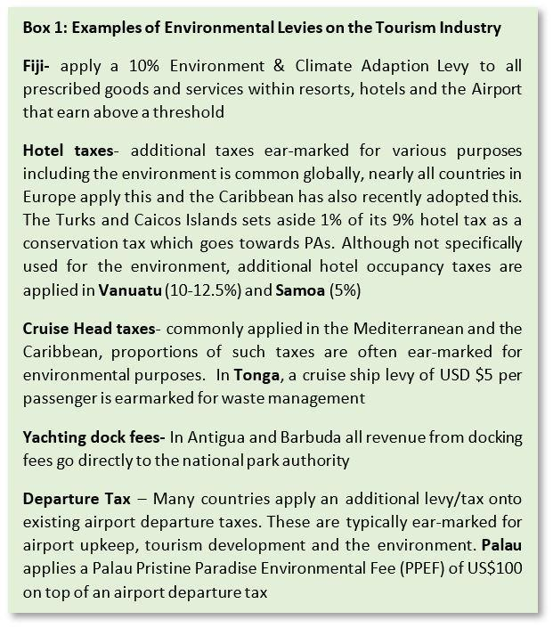
Several opportunities exist within the tourism sector for earmarking revenues for the environmental sector and specifically PAs, through the application of environmental levies to this industry. Box 1 provides some examples of the type of environmental levies that have been applied in other countries. Tourism numbers in PNG currently are relatively low, and there is a need for significant revision of the country’s tourism legislation to allow the collection of additional levies across this sector. As a result, such revenue mechanisms were not considered a feasible option for PNG at this time and were therefore not assessed in this paper. It is recommended however, that the application of such levies is considered in the future as PNG continues to develop its tourism product. It is also worth noting, that the legal requirements and revenue flow mechanisms for such activities could follow the proposed avenues as described here for the extractive sector.

Scope of the financial solution

Extractive Industry

There are a number of different revenue streams from the extractive industry to various beneficiaries (Government and non-government) across PNG. The extractive industry’s taxes, fees and levies range from corporate and other income taxes, environmental permitting fees, closure bonds, dividends, share of sales, rent, fees, royalties and levies. In addition to the varied revenue streams, revenue flows are also vast and complex, with different payments being paid directly and indirectly to beneficiaries from the companies through different mechanisms. Between 2013-2017 the extractive industry contributed almost PGK11 billion (~US$3 billion) to the national government and almost PGK6 billion (~US$1 billion) to subnational entities. Currently, with the exception of mine closure bonds, there are no mandatory revenues from this sector which are apportioned to environmental protection, despite the significant impact this sector has on PNG’s natural resources. Although, some companies do report some environmental contributions, these are generally under the discretionary social payments. And, although reported, it is very difficult to actually place an amount that was specifically provided for environmental contributions as these are often jointly reported with social contributions, or by simply stating specific activities that were supported. What is clear, however, is that since these tend to be discretionary payments, few companies appear to contribute to environmental related activities, and when they do it appears that the value of these contributions is relatively insignificant given the size and duration of operations.

Examining all the existing revenue streams for both sectors, it is apparent that royalties, levies and contributions under project agreements would be the most feasible avenues to generate additional financing for the environment. Appendix 1 provides an overview of the current revenue streams and flows of these current payments by the industry. Based on these avenues for generating additional funds, there are four potential ways in which additional revenue could be generated:

- Redistribution of existing revenues – instead of increasing fees, a proportion of existing revenues would be redistributed towards PA financing
- Increasing the percentages of existing royalties – this additional increase would be earmarked for PA financing
- Add a completely new environment levy to be applied to this sector – this would be in addition to the development levy/productions levy currently applied in this sector
- Lump sum contribution to a Trust Fund/trust account – to be built into project agreements

Following stakeholder discussions, it was felt that significant resistance would be met by beneficiaries if existing revenues were redistributed, as this would ultimately reduce their revenue otherwise obtained. However, increasing existing fees/levies or adding new ones, were considered feasible and timely options, since discussions to this effect have already commenced between the Government of PNG and these sectors.

Mandatory and/or voluntary social payments and infrastructure grants are typically negotiated by DPE under Umbrella Benefits Sharing Agreements (UBSAs) for oil and gas projects, or by MRA under Memorandum of Agreements (MoAs) for mining projects, prior to project commencement. There is scope to retrospectively approach existing projects and request voluntary payments for the environment, however, in addition to systematic collection of revenues, lump sum environmental contributions should be mandatory under all new project agreements for the oil, gas and mining sectors.

Globally, the extractive industry contributes to environmental finances through a wide variety of different mechanisms, some examples are-;
- a mining rehabilitation levy, the amount of which is highly variable depending on size and production of the mine (Australia and Botswana)
- a 1% environmental levy (Northern Territory, Australia and Zimbabwe)
- biodiversity offsets (Australia and Madagascar)
- variable pollution and environmental taxes (Ukraine and Kyrgyzstan)
- carbon taxes (Namibia and Norway)
- aggregates taxes earmarked for environmental purposes as in the UK
- proportioning and percentage of royalties, for example as in Poland, where up to 60% of royalties go into a Trust Fund for the environment¹⁴.

It is clear however, although contributions to the environment by the extractive sector are the norm rather than the exception, there are no set criteria or benchmarks for setting up financing mechanisms. As highlighted, the means are highly variable across the sector and tend to be established on a case-by-case basis by the individual countries.

This assessment explores the feasibility of three potential mechanisms which consider the existing revenue generation and flow mechanisms from the extractive sectors in the PNG context. The three potential revenue streams examined are: increasing existing royalties and earmarking these additional funds for PA financing, adding a new mandatory environmental levy and, environmental contributions under Umbrella Benefits Sharing Agreements (UBSAs) and Memorandum of Agreements (MoAs) which would be mandatory for new projects or voluntary for existing projects.

Royalties
Currently both the oil and gas, and the mining industry apply a mandatory 2% royalty on all projects that are paid directly by the projects to landowners and local and provincial governments. Between 2013-2017, landowners and local/provincial governments received approximately PGK111 (USD $31M) and PGK107million (USD $30M) per year respectively.

Globally, royalties across the mining sector are highly variable ranging from 0%-20%, and unlike PNG many countries place different royalty values depending on the mineral. A key consideration with any increases in existing levies and fees is to balance financial needs without jeopardizing investment attractiveness. Currently PNG has an average ranking in investment attractiveness for the mining sector compared to other countries (41/83), with Western Australia repeatedly ranking in the top three over the years and Canadian and American states also dominating the higher ranks. Table 18 provides a comparison of PNG’s royalties with other selected countries, and Figure 10 provides an overview of royalty rates across 21 countries in Sub-Saharan Africa. Given that royalty rates and investment attractiveness are higher across some of the countries in the table compared to PNG, it appears that royalties alone are not likely to be a deterrent for investing in mining projects for PNG. There is scope therefore for increasing royalties slightly, and potentially earmarking this increase for PA financing while having a negligible effect on the country’s investment attractiveness for this sector. With regard to increasing royalty rates and earmarking additional revenue for PAs from the mining industry, the projected revenue considered conservative, most-likely and optimum scenarios using a 0.25%, 0.5% and 1% increase on existing royalties respectively. These small percentage increases resulted in royalty rates between 2.25% and 3%, which are still competitive by global and regional standards, and are therefore unlikely to impact PNG’s overall investment attractiveness. Similarly, across the globe the average rate of royalties from the energy sectors is 8%, which is significantly higher than currently imposed by PNG, implying that there is scope to increase royalty rates in the oil and gas sector as well. As for the mining sector, here we consider conservative, most likely and optimum scenarios of 0.25%, 0.5% and 1% increases on existing royalties in the oil and gas sector.

Table 18: A comparison of royalty rates across selected countries

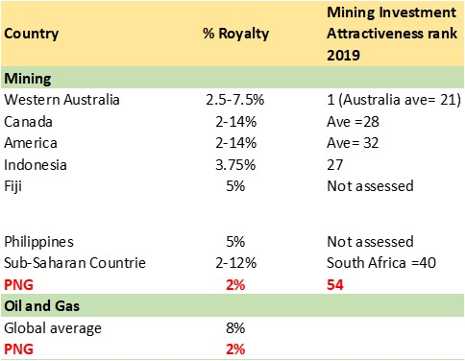

Figure 10: Royalty rates for 21 Sub-Saharan countries
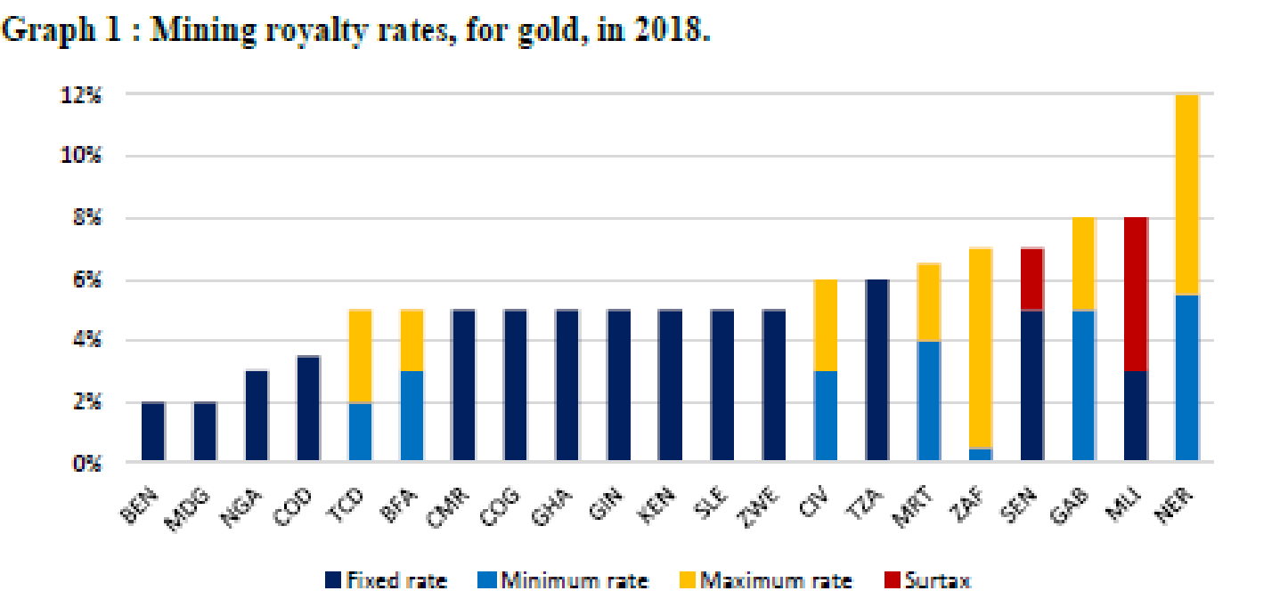

Levies
A 2% development levy of the wellhead of petroleum product value is applied to the oil and gas industry. This levy is paid to the DPE which is then transferred to the Department of Finance who then disburses these revenues to local and provincial governments. In 2018 the sector reported approximately PGK 72 million (USD $20M) paid in development levies. For the mining industry ,a 0.5% production levy provided to the MRA is applied. In 2018 this generated approximately PGK28 million (USD $7M) in revenue. Considering these existing levy rates and environmental levies in other countries (see above), this assessment explores the feasibility of adding an environmental levy using conservative, most-likely and optimum revenue scenarios at 0.5%, 1% and 2% respectively.

Environmental contributions under UMBAs/MoAs
The potential amounts of such contributions under these agreements are not fixed and are determined under negotiations of contracts by DPE and MRA. Therefore, such contributions could be determined using biodiversity offsets, with the size of the operation and other factors to be determined. Ultimately, there is scope to generate earmarked environmental funds under these agreements and revenue potential is unlimited. It is difficult therefore to project any sort of realistic revenue potential from this option. However, four new mining projects are in the process of commencing in PNG in the immediate future.

At least the equivalent of one year of levy fees could be used as a guidance for a lump sum contribution, for mining this would amount to US$19 million. Such an amount is further supported by the fact that US$20M would likely generate a return of almost US$1 million available for an endowment fund. An endowment fund would be the most ideal mechanism for handling such large lump sums (this is discussed further in section 6). Such contributions should take into account a phasing-in period, whereby these contributions would be provided after a minimum time from project commencement e.g., 3 years. Since no trust fund is established in PNG currently, but a proposal for a biodiversity Trust Fund is being developed, the timing for implementing this mechanism appears to be ideal.

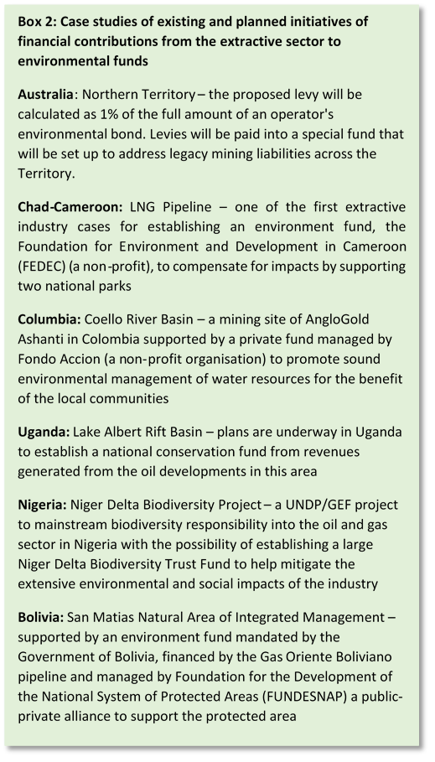
Considering the four new projects, this could have the potential to generate USD $80M in capital for PA financing. Box 2 provides examples of other countries that apply earmarked environmental contributions from the extractive sector which are paid into a trust fund. It can be seen that while not yet fully exploited in the Oceania region, earmarked contributions flowing into Trust Funds are common across Africa and South America where the extractive industry is also a highly important sector. Hence, while such mechanisms may be new for PNG and the region, it is highly likely that the multinational companies operating in PNG are familiar with such mechanisms. This represents an opportunity for PNG to become a role model for such initiatives in the region.

Technical feasibility:
The technical capacity required for implementing the proposed revenue streams could be relatively low. PNG has been collecting various royalties and levies from this sector for many years and revenue flow mechanisms are already in place. There is a need however, to ensure that industry reported revenue is monitored and continuously reconciled with beneficiaries reported revenue, which has not always been the case, in particular for local and provincial government and landowners and community- based beneficiaries. Further capacity would be required, however, to manage any new financing mechanisms. The Extractive Industries Transparency Initiative (EITI) is a global standard for the good governance of oil, gas and mineral resources. It seeks to address the key governance issues in the extractive sectors largely around transparent reporting of revenues. The EITI Standard is implemented in 55 countries around the world, including PNG. Each of these countries is required to publish an annual EITI Report to disclose information on contracts and licenses, production, revenue collection, revenue allocation, and social and economic spending. These reports are validated at least every three years. PNG’s membership to EITI therefore presents an opportunity for the necessary external oversight into the extractive sectors revenue flow.

It is also worth noting that many international financing institutions have, or are developing, environmental safeguard policies that require offsets where projects result in significant, unavoidable residual impacts on biodiversity and ecosystem services. For example, the IFC’s Performance Standard 6 (PS6), the 79 Equator Principle banks and the 32 Organisation for Economic Cooperation and Development (OECD) export credit agencies. PS6 requires a ‘net gain’ for ‘Critical Habitats’ and ‘no net loss’ for ‘Natural Habitats’. In addition, the Africa, Asia and Inter-American Development Banks, the European Bank for Reconstruction and Development (EBRD), and the World Bank Group (International Bank for Reconstruction and Development, International Finance Corporation and the Multilateral Investment Guarantee Agency) all have environmental and social safeguards/frameworks mandating offsets.

Environmental and social impacts
The permanent, long-term and far-reaching impacts of the extractive sector are well documented in scientific literature. For example, effects of mining are recorded in the marine sediments as far as 500km away from the source in Indrija in Slovenia, and mine waste dam collapses have shown to have negative environmental impacts as far as 1,000 km away from the source (Spain, Romania, Brazil). The international council on mines and minerals (ICMM), is an international organization dedicated to a safe, fair and sustainable mining and metals industry. The ICCM has developed mining principles that members commit to, of which mitigation is one. Under their mitigation hierarchy biodiversity offsets are a key activity. They explicitly state that biodiversity offsets should support “conservation outcomes applied to areas not impacted by a project to compensate for significant and adverse impacts of a mining project that cannot be avoided or restored.” Further they also recognize that whatever the type of mining, “…mining will change the landscape permanently to some degree”

Chemicals, heavy metals and other pollutants from extractive industry activities go into the water system, which affects all rivers and streams in a watershed not just at the site of pollution. Such pollution can alter the hydrological features of a water body which in turn will significantly alter the aquatic biodiversity at all levels even beyond the project site. Fish are mobile and there are many examples of high levels of heavy metal poisoning occurring in fish eaten by communities significantly downstream, and even in cases upstream, from mining operations. In fact, communities are already seeing heavy metal poisoning in their youth in PNG that will continue long after mining operations have ceased. Studies also show that water flowing from mines can carry sediment loads up to 1,000 times greater than flows from unmined areas.

When an area has been destroyed it will permanently negatively impact biodiversity and ecosystem functioning locally. Habitat restoration or conservation efforts purely based on proximity to the site will never be able to recreate or replace the ecosystem functioning and biodiversity that was previously present. Therefore, the remaining populations and ecological processes MUST be protected elsewhere. Protected areas are cornerstones for biodiversity protection for any country, including PNG, therefore the best place to ensure national populations are not permanently affected is in PAs.

The application of increasing revenues from the mining and oil and gas sectors and earmarking them for PAs, is unlikely to have any negative impacts on the communities, in fact it is likely to produce significant positive impacts. Communities surrounding PAs have already cited numerous negative impacts of this sector to their well-being and the benefits to communities from PAs are well-documented. Increasing revenues for PA management will help conserve the natural resources on which people depend, protect ecosystems and ecosystem services which are essential for climate change mitigation and adaptation, and are a source of livelihoods by creating employment opportunities as well as business opportunities as the PAs are developed further to increase tourism to the areas. Currently 62 protected areas and, as a result an estimated 624,569 individuals could benefit from such financing. Hence, financing PAs benefits not only biodiversity, but local communities and the entire country.

While generating revenues from the extractive sector can be considered low hanging fruit for environmental financing, environmental taxes have not been without their own controversy. There is a risk that the Polluters Pay Principle may encourage this sector to be less compliant or not seek out alternative more sustainable practices because they feel their environmental financial contribution mitigates the need. However, it is absolutely essential that irrespective of contributing finances, the extractive sector should remain compliant and continue to seek out more environmentally friendly practices where possible. It is critical therefore, that environmental compliance of these industries is routinely monitored, and the application of this proposed financing mechanism is not seen as an alternative to good practices, but in addition to.

Stakeholder support
It appears the potential for commencing this proposed mechanism is timely as there are several complimentary ongoing initiatives. There is already a desire to increase levies and fees in the extractive sector, and talks have already happened between the government and the industry. In addition, the feasibility of establishing a Biodiversity and Climate Change Trust Fund is currently being explored. The treasury is highly supportive of CEPA becoming financially independent and would support the establishment of a trust account for CEPA and earmarking of revenues for PAs.

Financial forecasting

Justification for the selected percentages proposed has been discussed in Section 2. It is recognized that revenue from royalties and levies will be highly variable and will depend on many factors such as market price, the number of projects operating and so on. However, in order to determine the potential feasibility of this proposed mechanism, revenue reported for levies and royalties were taken from 2018and used as a baseline, since these figures have been reconciled by EITI. Royalties from both sectors, as well as the development levy (oil and gas) and production levy (mining industry) were used for this analysis. By taking these figures, representing 2% of royalties, 2% development levy and 0.5% production levy, enabled the total value of funds from which the increased royalty and proposed environmental levy would be sourced to be determined (Table 19). Further, based on the 2021 PNG budget and medium outlooks for these sectors, we used their projected growth rates i.e., 1.1% for O&G in 2021 and 2022, with zero growth from 2023-2025, and 9.5% growth for the mining sector in 2021, 13.5% in 2022 and also with zero growth between 2023-2025. Hence, our year 1 projections (2021) apply a 1.1% increase on the 2018 baseline revenue for oil and gas, increasing by 1.1% again in 2022 and remaining at zero growth for the remaining 8 years, and a 9.5% increase from the baseline in year 1 for the mining industry, followed by 13.5% in year 2, and zero growth for the remaining 8 years. By applying a zero % growth rate over 8 years, makes these figures highly conservative, which is more preferable perhaps given the high level of unpredictability in such a sector. Tables 20 and 21, present 10-year financial projections for conservative, most-likely and optimum scenarios from increased royalties as well as for an additional environmental levy.

The tables show that indeed revenue potential under this proposed mechanism is highly significant and could even exceed the total annual costs required for the entire PA network. Figure 11 shows that if royalties are increased by 0.5% (most-likely scenario) or a 1% (most-likely scenario) environmental levy is applied across the sector, the greatest potential for revenue generation would come from establishing a levy and the mining sector would be the biggest contributor in either mechanism.

For comparison, in 2018 the mining sector reported approximately USD $28M and USD $1M in mandatory and discretionary social payments, respectively. The Oil and Gas industry reported USD $14M and USD $73M in mandatory and discretionary social payments, respectively. It should be noted however that these figures were not reconciled in the PNG EITI 2018 report, meaning that these amounts could not be verified with the beneficiaries.

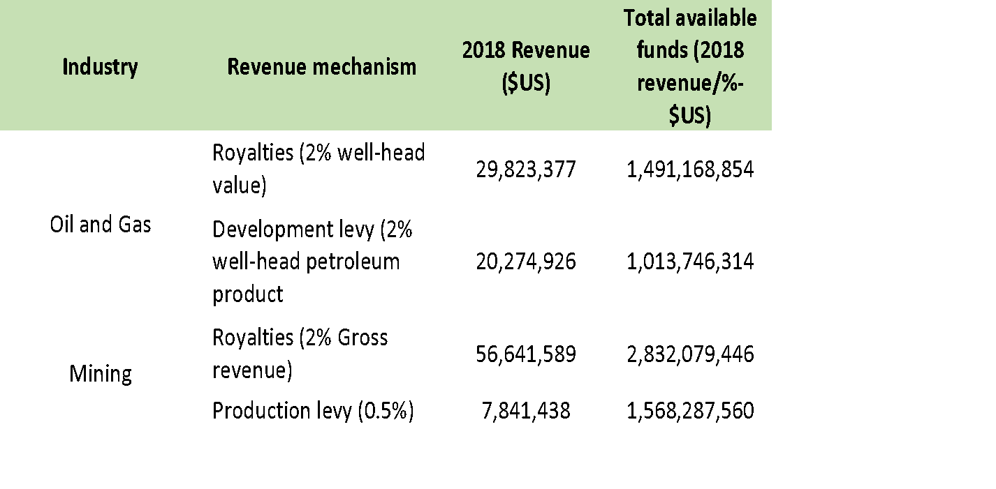
Table 19: 2018 Baseline data
Table 20: Projected royalty revenue potential from the mining and oil and gas industry
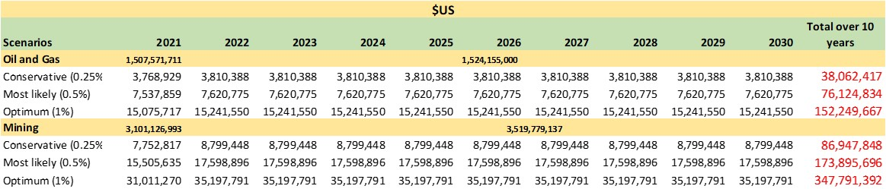

Table 21: Projected revenue from the introduction of an environment levy
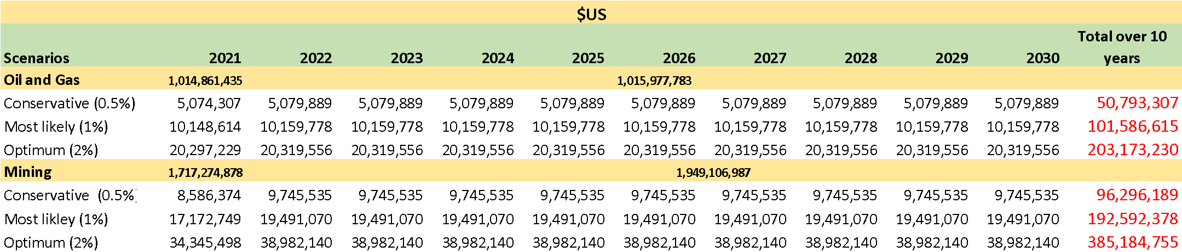

Figure 11: A comparison of the potential revenue by both sector and mechanism using the most likely scenario

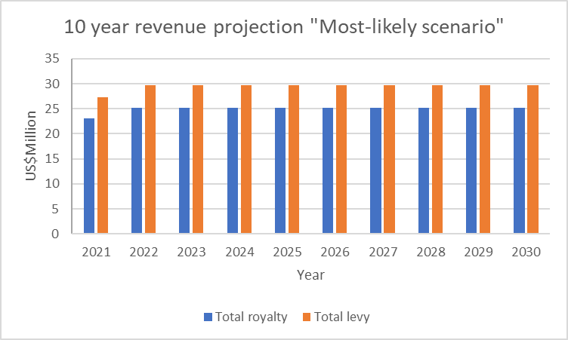

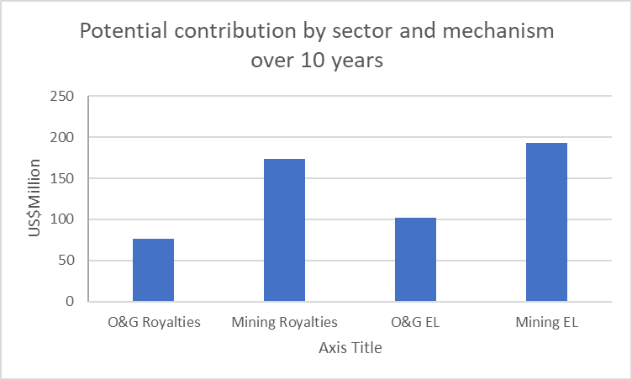

Management & legal and institutional framework
Necessary legislation for the collection and distribution of royalties by MRA and DPE exists for PNG. To increase the rate of royalties would require consultation with the sector (which have already commenced) and to formally announce the increase of royalties under the national gazette or through an amendment to existing legislation. An environmental levy on the other hand would be more complex to implement, as it would require totally new legislation most likely through revising the existing Environment and CEPA Acts, and since there is no precedent for environmental levies under any sector in the country, it will likely receive greater resistance than a small increase in an existing mechanism.

That said, there are two potential options to capture revenue from royalties, levies or mandatory contributions for PAs from the extractive sector, these are presented below-:

Option 1: A CEPA trust account

Under this option, there is a need for CEPA to open a trust account which enables them to receive, retain and disburse revenue for PAN management. The MRA, under its Act, has been mandated to collect revenues on behalf of the State and its beneficiaries, some of which are retained for MRA’s operations e.g., development levies. The Act also provides for the establishment of a trust account which is administered by the MRA. In order for CEPA to be able to also receive, retain and disburse revenue through a trust account, there is a need for legislation to be revised. CEPA would need to revise existing legislation, using the MRA Act as a model, that would provide for the establishment and administration of a trust account as well as for the introduction of environmental levies. Such legislation, led by CEPA would have to be developed together with the National Treasury (who have already expressed support for such legislation revision) and the Department of Justice.

Key considerations for this mechanism would be to ensure transparent accounting procedures, increase the financial management capacity of CEPA and very importantly, to ensure safeguards are in place so that revenue earmarked for PAs does not get subsumed into other core areas under CEPAs jurisdiction and/or CEPA administrative operations. Revenue earmarked for PAs would be directly used for management purposes for those PAs under CEPAs remit, but a mechanism should be in place whereby delegated management and locally managed PAs can apply either under a grant or annual plan and budget to CEPA for financial support for PAs under their management.

With regard to royalties, as is the current situation, revenue would be distributed directly to this account in the case of mining, and to DPE for O&G, of which the percentage earmarked would then be transferred into CEPA’s trust account, as is currently done for local and provincial government and landowners. Levies and payments under UBSAs and MOAs could also be paid directly by companies into this account.

Option 2: Biodiversity and Climate Change Trust Fund (BCCTF)

As the country moves towards the establishment of a BCCTF, with it comes a significant opportunity for open and transparent management of earmarked revenues for PAs. Although still being developed, it appears there could be opportunities for thematic windows to be established under the fund, for example a PA thematic window. For royalties, the current revenue flow mechanisms of MRA and DPE as intermediates could still apply, with both transferring the percentage royalty equivalent directly to the fund. Since royalties and levies are monthly contributions, it would make sense for this to be collected under a revolving fund under the thematic window. However, environmental contributions under UBSAs and MoAs, whether based on biodiversity offsets or some other deciding factor, would be potentially large amounts, these would be better to go into the fund’s endowment fund, where a percentage of annual interest of the fund relative to the percentage of fund made up of PA revenue, would be then allocated to the revolving fund under the PA thematic window. Funds from these would then be disbursed to CEPA and other PA management authorities through grants or annual disbursements based on submitted budgets.

An important advantage of using a TF as opposed to a trust account is that as an independent funding institution with robust governance, there is likely to be significant safeguards for transparency and administration, removing the risk of earmarked funds being used for purposes other than those intended. Such a mechanism would also remove significant burden on CEPA having to manage and administer these large amounts of revenue in addition to having to take the lead on the legislation required to establish revenue flow mechanisms.

Although a potential third option is to provide this revenue to the national treasury for disbursement to CEPA, it may be complicated to keep track of the earmarked funds and would make funds less accessible to PAs not currently managed by government entities. For this reason, this potential option is not considered feasible at the time.

It is worth noting both options provided would also be suitable mechanisms to receive and disburse any funds that are to be earmarked for PAs, including any environmental levies potentially applied to the tourism or other sectors, or revenue generated from PA user fees, such as entrance fees. And, while new or revised legislation is required for both options, the legislation for establishing a BCCTF would not fall on the shoulders of CEPA alone and given its wider application beyond only PAs, may receive a greater political support and hence be a timelier option.

Implementation plan
Potential revenue is likely to be slightly higher with the introduction of an environmental levy compared to royalties, however, due to the advanced legislation and well-established existing revenue flows, increasing royalties seems like the most feasible option to implement in the immediate to short-term. However, it is recommended in the meantime to also seek out opportunities for creating enabling conditions for the application of environmental levies across a number of sectors.

While there is a need for legislation to be enacted to enable either of the options above, increasing and earmarking royalties, could be more or less, assuming full support by key stakeholders, namely treasury, CEPA, MRA and DPE, implemented in the very near future. This could be implemented parallel to the process of establishing legislation, as both the MRA and DPE could still receive the money and hold it until such financial mechanisms are in place. This would allow CEPA and other PAs to identify funding needs for their protected areas and to establish appropriate systems and processes for receiving and spending PA budgets. In the meantime, CEPA could access these funds directly from MRA, DPE or Department of Finance to cover existing costs for PAs (which currently are anticipated to be far less than the potential annual revenue generated by this mechanism and the projected PAN costs), leaving significant funds to be transferred in due course to the BCCTF, both endowment and revolving funds.

As discussed previously, it is proposed that a dual financing mechanism occurs, whereby in addition to the regular earmarking of royalties throughout the project’s lifetime, a one-off lump sum is also paid by any new projects to be negotiated under MoAs and UBSAs. Biodiversity offsets could be the mechanism to determine the value to be contributed by the mining companies under project agreements or some other mechanism. Since the negative impacts of extractive sector can be permanent and therefore exist even beyond the lifetime of a project, the dual mechanism will provide funds (ideally to be placed in an endowment fund) where benefits of the contribution continue in perpetuity, whereas royalties will only be for the duration of the operation. To examine the potential combined revenue from royalties and contributions under project agreements, and how the BCCTF may look under the proposed PA window by Year 5, the following revenue flows are considered.

- Considering the above implementation plan, and assume that in Year 2 increased royalties are being implemented, this would mean that by the end of Year 2, the funds available for PAs would sit at approximately USD $25.5M but would be held by MRA/DPE. Assuming the BCCTF is in operation in Year 3, means that this USD $25.5M could be transferred to the BCCTF. As these particular funds are retrospective, it is suggested that the majority i.e., USD $20M would be placed into an endowment fund and the remaining into the revolving fund.
- In order to ensure financial sustainability, it is proposed that annually, a proportion of the royalty revenue generated flowing through the revolving fund, is provided to the endowment fund to increase the fund’s capital. It is recommended that funds greater than the predicted required costs for the PA network i.e., > USD $12M are transferred into the endowment fund. Hence, based on the annual projection (table 1XYZ), this would amount to a capital top up of USD $13M per annum.
- Assuming also, that as predicted, four new mining operations have commenced during this time, and environmental contributions negotiated under project agreements (as described in Section 2) would be received within this five-year period. This would add a further potential USD $80M in capital for the endowment fund.

Thus, by the end of Year five, the endowment fund could potentially have funds of USD $139M (USD $80M -project agreements, 3 years X USD $13M royalties, 1 year X USD $20M royalties), with a cumulative amount of approximately USD $41M (+endowment interest) flowing through the revolving fund. Appendix 5 provides a diagram showing how funds from royalties and UBSAs and MoAs could potentially flow in and out of the BCCTF.

Overall conclusion on pre-feasibility
There is no question that despite the numerous benefits to society from the extractive sector, with it comes equally numerous negative environmental impacts which affect not only biodiversity but directly and indirectly, communities and the country as a whole. Currently, there are no mandatory financing schemes from the extractive sector earmarked specifically for the environment and it would appear that any voluntary payments towards the environment seem less than adequate. It is clear therefore, that there remains untapped significant revenue potential, that in principle would be relatively easy to implement, would be aligned with other countries in the region and across the world, would not affect investment attractiveness for the sector, and would have immense positive social and environmental impacts that could set stage for enabling other environment related levies to be collected across other sectors.

Recognizing that legislative reform can be a lengthy process and taking into account the current PNG context, it is recommended to initiate the process though the existing royalty scheme and adding a small percentage increase that would be earmarked for PAs. Ideally, and further down the line, so that environmental levies can be capitalized upon in the future, it is recommended to at least start the process described that would be necessary to allow for the implementation of environmental levies across a number of other sectors deemed relevant.

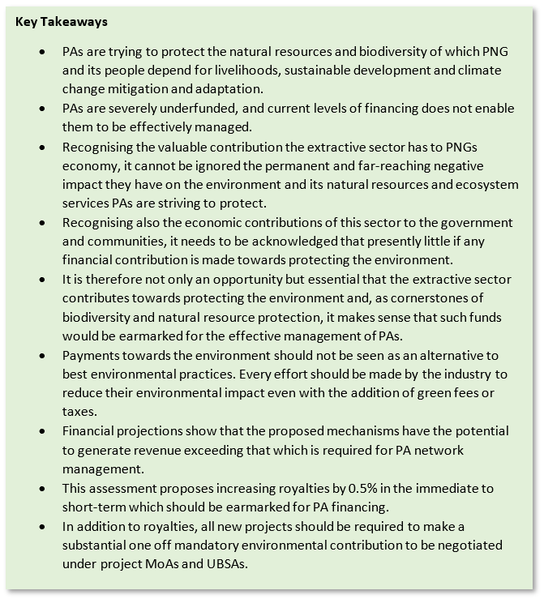

4.2. Pre-feasibility study for Commodities promotion through Project Based REDD+ on selected PAs in PNG

Introduction
Policies implemented by countries and the Nationally Determined Contributions made under the United Nations Framework Convention on Climate Change (UNFCCC) are still far below what is needed to limit global temperature to 1.5°C or less by 2100. As noted in the Emissions Gap Report (UNEP, 2019), full implementation of conditional and unconditional NDCs by 2030 would reduce global emissions by about 6 GtCO2eq and 4 GtCO2eq respectively compared to the current policy scenario. This leaves us well short of what is needed, with a gap in emissions reductions between 15 GtCO2eq and 32 GtCO2eq.
At the same time, global food systems are having an enormous impact on the planet's environment. It is responsible for 60% of biodiversity loss, 70% of water use and 23% of land degradation. Agriculture was accountable for 80% of tropical deforestation (2000-2010) and 51% during 2014 – 2018. Only in 2018, 6 million out of the 12 million ha of tree cover lost were due to agriculture, which is the equivalent to 15 football pitches of tropical forests lost every minute. Recent WRI analysis confirms that only 7 commodities are responsible for 57% of tree cover loss from agriculture during 2001 – 2015, with cattle, oil palm and soy being the most important ones and followed by cocoa, plantation rubber, coffee and plantation wood fiber. It is estimated that our global food system is responsible for as much as 26% of global GHG emissions, equivalent to the annual emissions of the USA and EU combined.
Figure 12: Total forest replacement by analyzed commodities
Estimates show that by 2050, we would need a 70% increase in food availability in order to feed our growing population. More than 75% of the world's agricultural land is operated by smallholding family farms (Lowder et al., 2016), and globalization along with rising global trade in commercial crops such as palm oil has connected an increasing number of smallholders to global commodity crop value chains (Rigg et al., 2016). A revolution in the global agriculture and food systems is required to feed 9 billion people by 2050 without adding pressure into the planet’s ecosystems and providing adequate livelihoods to small farmers. At the same time, an increase in GHG reduction ambitions is urgently required at all levels (sub-national, national, regional) and from all sectors (private, public, civil society).
Voluntary offsetting initiatives are increasingly perceived as a key element of business sustainability practices and are seen as a way to drive climate action from the private sector. An overwhelming 85% of respondents of a IETA study (2019) expect voluntary offsetting by businesses to increase in the next 5-10 years, in contrast to the 5% of respondents who do not expect an increase. The voluntary market has become a strategic part of businesses’ response to climate change, which, by its very nature, is a long-term management process. While there are still few long-term climate commitments in the private sector, major European oil companies and firms in other sectors have reaffirmed their intentions to drive a transition to zero net emissions. Many major companies have ratified their commitments and new announcements have been made despite the Covid-19 crisis.
The recognition of nature's important role in ensuring our survival has led the UN to declare 2021-2030 the decade of ecosystem restoration. This reinforces the fact that Natural Climate Solutions (NCS) are extremely important for achieving the transition to a low-carbon economy, especially over the next 10 years, during which time the planet's GHG emissions should be gradually reduced. Results of various studies, including Griscom et al. (2017), indicate that NCS should be equivalent to 37% of the emission reductions needed to achieve the Paris Agreement objectives. It will not be possible to achieve these objectives without making significant progress in protecting or restoring natural sinks (forests, grasslands, wetlands, peatlands, agricultural land and coastal ecosystems). The most immediate and cost-effective option is to reduce the conversion or destruction of tropical forests, which also generates significant benefits for communities and ecosystems.
Despite the importance of NCS and the growing interest of the private sector, only a fraction of climate change public funding (2-3%) is allocated to these activities and there are still obstacles to investing in NCS on a large scale. Some of the most important multi-stakeholder initiatives, such as Nature for Climate and the Natural Climate Solutions Alliance, are committed to solving the challenges and facilitating the channeling of private sector resources towards natural climate solutions.
Natural Climate Solutions, and in particular tropical forests, are now perceived, and rightly so, as a fundamental part of the fight against climate change and have thus become a key asset at a global level. In this context, PNG is presented with a historic opportunity to value its vast forest heritage and make it the engine for an inclusive and low emission development pathway. To take advantage of this opportunity, this document presents a green commodity production strategy that has PAs (PAs) and local communities at the center of a new sustainable rural development model that could increase agriculture output and reduce poverty while limiting impact on ecosystems and reducing GHG emissions. Given the existing national framework developed as part of the REDD+ readiness process in the country and the growing interest of the private sector on impact investment and Natural Climate Solutions, there is a great opportunity to consolidate PAs as the core of community-based conservation initiatives that combine revenue streams from voluntary carbon markets and sustainable commodity production. This document focuses its analysis on the role of REDD+ as a financial catalyst for this model.
PNG has so far taken a national approach to REDD+ through policies and measures that are being implemented through national and subnational government systems and there are at least four early REDD+ project initiatives targeting the voluntary carbon market. These projects have significant challenges and different levels of success, with some facing serious reputational issues especially in relation to the distribution of economic benefits. Nevertheless, these initiatives also offer relevant lessons that could help the design of a new and improved version of REDD+ projects in the country that could build trust among participants and foster joint action between the public sector, private actors and civil society over the coming years. This could enable the development of natural climate solutions at scale, with the potential to generate several co-benefits, limiting ecosystem degradation and associated biodiversity loss and improving the livelihoods of local populations.
It is important to highlight that the end of 2020 marks a fundamental change in the global governance of greenhouse gas emissions with the shift from the Kyoto Protocol era to that of the Paris Agreement. This also has implications for the future role and the feasible models of the voluntary carbon market. A critical focus is whether and how 'double counting' of emission reductions – using the same emission reduction for voluntary offsetting and to achieve a country's target under the Paris Agreement – is avoided. The solution under Article 6, would be to require a corresponding adjustment - CA, to ensure that only one party counts the reduction or removal to achieve its NDC. A CA would help to ensure that the carbon credit project provides emissions mitigation benefits that go beyond the level of ambition of the host country’s NDC that otherwise would not have been achieved. While this model can resolve a number of potentially negative effects on climate ambition, there are also concerns about its practicability and its impact on safeguarding and viability of projects, therefore disincentivizing further private sector investment in climate change mitigation initiatives. Since, the Paris Rulebook negotiations, encompassing the issue of CAs, remains ongoing, it would not be practical to immediately require these as few, if any, host-countries would be able to provide them. Hence, a transition period that should define the conditions under which it would be appropriate to require CAs for off-setting would be required.
During any transition period, consideration may need to be given to whether credits issued are suitable for off-setting or fall into the Financing Emissions Reductions Model - FERM. The transition period could be used to develop further market insight and understanding of the difference between these models and hence clear delineation in registries may be better held until the conditions for robust and fair transition are met. Due to the uncertain nature of UNFCCC negotiations on Article 6 and lack of clear insight from host countries, it is not feasible to set a specific timeline for transition. Instead, a number of options could be applied, for example reviewing during the first reporting period of the Paris Agreement or staggering the roll out of new requirements based on country capacity and the ongoing viability of projects.
It is therefore clear that the Voluntary Carbon Market is here to stay, as it is key to further channel resources from the private sector to emission reduction activities beyond companies’ operations. The next years will see an evolution of the voluntary carbon market so that it adapts to the requirements put in place by the future global GHG mitigation regime.

Context / baseline
Papua New Guinea (PNG) has been at the forefront of REDD+ negotiations globally since 2005 when it was introduced to the UNFCCC, together with Costa Rica, the concept of reduced emissions from deforestation. Since then, the Government of PNG has built internal capacities and tested REDD+ approaches with strong support from a variety of development partners as part of the Readiness Phase of REDD+. Key components for the development of REDD+ at the national level are already in place and a number of additional complementary studies have been conducted or are under development, including:
- National REDD+ Strategy (2017)
- Safeguards Information System (SIS) (under development)
- National Forest Monitoring System (NFMS) (under development)
- Forest Reference Level (FRL) (2017)
- National Forest Inventory (year)
- First Biennial Update Report (2019) including a Technical Annex for GCF Results Based Payments from 2014 – 2015 based on Reducing Emissions from Deforestation, Forest Degradation and Enhancement of Forest Carbon Stock
- REDD+ Finance and Investment Plan (year)
- Benefit Sharing (under development)
- Nesting (under development)
- Financial Mechanism (under development)
PNG’s approach to REDD+, as laid out in the National REDD+ Strategy, notes the need to allow development to continue, but in an economically and environmentally sustainable manner. PNG’s forests are central to the country’s formal and informal economy and the diverse cultures of its people. Over 85% of the nation’s 7.3 million population are based in rural areas and rely primarily on subsistence agriculture for survival and have limited access to health centers, education or broader development opportunities. The ecosystem services forests provide help to maintain access to water and suitable agricultural land for PNG’s predominantly rural population, and protect key infrastructure, people and crops from flash flooding and landslides. Forests also play a direct role in supporting the livelihoods of rural communities, with more than 500 species of wild-growing plants used for food and the value of annual bushmeat consumption estimated to be equivalent to USD $26M if alternative meats had to be sourced.
Agriculture, forestry and fishing combined represent 19% of GDP and are the largest sources of employment, providing jobs to around 20% of the working population. The forest sector in particular is estimated to contribute over USD $200M to government and land-owning communities on an annual basis through royalties, levies and taxes. It is therefore clear that there is a need for the natural wealth of the country to be placed at the center of the economic policy in order to achieve the low-emission, green-growth trajectory and climate compatible development that was introduced through the Climate Compatible Development Policy (2014).
Forests are a key piece of the country's National Determined Contributions and the role of nature is also central to reach the objectives of a number of other national policies and plans, particularly the country’s Protected Area Policy (2014); the National Strategy for Responsible and Sustainable Development (StaRS 2014) the Medium-term Development Plan; Vision 2050 (2009); the Climate Change Management Act (2015); and the Conservation and Environment Protection Authority Act (2014), UN Paris Agreement (Implementation) Act (2016), among others.
The National REDD+ Strategy has identified three key areas of intervention and their corresponding strategic actions, clearly showcasing the expected role of the land-use sector to foster economic development. The first strengths land-use and development planning within the different government levels and increases coordination among them. The second strengthens environmental management, protection, and enforcement, including actions to strengthen forest and environmental management and enforcement practices as well as the protection of ecosystems. The third enhances economic productivity and sustainable livelihoods by focusing its efforts on developing a sustainable commercial agriculture sector and increasing family agriculture productivity.
PNG’s vision for REDD+: “To catalyze transformational change within the forest and land-use sector towards a new responsible economy with lower GHG emissions, stronger long term economic growth and community livelihoods and the effective conservation of biodiversity and ecosystem services while ensuring that Papua New Guinea’s forest resources are used in a sustainable and equitable manner for the benefit of current and future generations.”
According to an initial analysis from UNDP (2019), approximately USD $200-300M of core financing (an equivalent increase of 50% on existing government budgets) is required to help meet the targets for avoided deforestation and emissions under the National REDD+ Strategy. Additionally, recent estimates for implementing the National REDD+ Strategy calculated that nearly USD $100M per annum is required to deliver the strategy over the next 10 years. PNG’s REDD+ Finance and Investment Prospectus (RFIP) sets out the potential opportunities that scaling up actions in-line with PNG’s National REDD Strategy (NRS) could deliver. These include emissions reductions of more than 60 million tons of CO2e over the coming decade, while also delivering significant economic, social and environmental co-benefits.
It is therefore clear that PNG will not be able to achieve its REDD+ goals, and more broadly establish financially and environmentally sustainable agriculture and forestry industries of the future by relying only on grants from multilateral and bilateral climate finance sources. Private impact investment will be needed, but in the short term, PNG will need to rely on upfront grant funding from sources that have an appetite for high levels of risk (e.g., World Bank, GCF, GFE) to put in place the building blocks that will mitigate investment risk and encourage FDI in projects in the land-use sector, including REDD+. Another aspect that should be prioritized to achieve the country's national REDD+ strategy should be building trust among project participants to avoid creating false expectations concerning the distribution of economic benefits from the sale of carbon credits.
To do so, when designing benefit-sharing plans communities need to be aware of certain specific circumstances that will define the type of benefits and the frequency of their distribution keeping in mind that carbon credits are conceived as being incentives rather than full-monetary solutions that can alone stop deforestation and reduce poverty. To avoid generating false expectations, communities should consider the following information:
- Project cycle: projects need to undergo several steps before they can be ready to receive economic payments from the sale of carbon credits. The usual logic sequence includes the development of project documentation, third-party validation, and verification, certification, and issuance. Overall, completing these steps might take at least 18 months. Therefore, REDD+ participants should be aware that revenues will not come right after deciding to be part of a REDD+ scheme but they will need to successfully complete the project cycle before a benefit-sharing plan can be operational.

- Economic benefits from REDD+ are only perceived if the deforestation rate inside the project area is reduced compared to a reference level. If deforestation increases, then no carbon credits can be issued, and no benefits can be claimed.

- Payments in REDD+ are not permanent in time and the amount of the rewards depends on the efficiency of the project in reducing deforestation. REDD+ aims at rewarding projects that successfully reduce deforestation and degradation. Rewards are proportional to the amount of area where deforestation/degradation was avoided. If the targets proposed for reducing GHG emissions are achieved then at some point during the crediting period, the threat of deforestation will be controlled, and no deforestation will continue to occur. Once the project achieves its zero-deforestation target then no additional rewards will be granted.

- Benefit-sharing plans can be adjusted over time by for example reducing the participation of investors and external parties and increasing the rewards to the local communities. When plans are adjusted accordingly, communities are given the opportunity to manage their project initiatives without having to rely on intermediaries during the complete length of the crediting period.

- Direct monetary benefits are rare in REDD+, however, Conditional Cash Transfers (CCT) can be implemented under certain social and political circumstances. CCT require defining input-base conditionally indicators (i.e., number of trees planted, number of people trained, etc.) or long-term-based outcome indicators (forest cover maintained, number of ERs issued, etc.) that should be monitored over time in order to distribute efficiently the economic benefits. While in some cases these cash-incentives can help poor communities overcome some of their basic needs, they can also create distrust among communities as the distribution can be perceived as unfair, and monitoring CCTs is usually expensive.

Other forms of direct cash distribution are those that don't depend on performance. For example, REDD+ revenues can be used to fund start-up costs and cover upfront labor fees. Positive experiences of this approach have been evidenced in several locations including the Bosques Amazónicos REDD+ project in Peru where money was allocated to support microloans to nut farmers to reduce the costs imposed by intermediaries.

- It is usually recognized as the best practice to use the economic benefits from REDD+ in financing the implementation of the project activities agreed by participants rather than distributing cash to ensure participants continue investing in reducing deforestation.

- Identifying who should receive benefits is crucial when designing benefit-sharing plans. The following list shows the most widely recognized beneficiaries of REDD+ revenues. These groups are not mutually exclusive and depend on the specific design of each project:
- Those with the legal right to claim ownership over the ERs.
- Those who reduce emissions.
- Forest stewards
- Those incurring costs
- Effective facilitators of REDD+ implementation
- The poor
Based on the country’s mid and long-term objectives, regulatory regime, and strategic approach, we believe that PAs could be key to increasing private sector investment into sustainable land use activities through an innovative public-private – community partnership model.

Scope of the financial solution
PNG has a significant area of tropical forest covering 77.8% of the country's land, approximately 35.89 million hectares. Together with the forest of West Papua (Island of New Guinea), they represent one of the largest areas of intact tropical forest in the world. PNG’s forests are also highly diverse, including 12 distinct forest types. Wetlands and grasslands represent each around 5% of total land mass while cropland covers approximately 5.07 million hectares (11%).
More than three quarters (28 million hectares) of PNG’s carbon rich and biodiverse forests remain undisturbed – a proportionately high level compared to world standards, representing a strategic resource in a world increasingly concerned about environmental degradation, global warming and the mass extinction episode brought by the Anthropocene. While some of this land will be required to achieve economic growth through the expansion of forestry and agriculture, unsustainable land use policies and lack of enforcement will put at risk the “natural capital” advantage of the country. Governmental decisions on policies, programs, and planning regimes to expand these industries will impact the country’s future prosperity for decades to come.
A well-managed Protected Area Network could have a strategic role for the future sustainable development pathway of the country. As a signatory to the United Nations Convention on Biodiversity (CBD), PNG committed to establishing by 2020 a “comprehensive, effectively managed and ecologically-representative national system of PAs”. In line with Aichi Target 11, the government stated in pillar 5 of Vision 2050 their aim at creating up to 20 new PAs to reach at least 17% of terrestrial environments protected. Nevertheless, PAs cover so far only 4% of the country’s land surface, approximately 1.9 million hectares.
As identified in the NRS, effective land use planning at different levels, stronger coordination between different sectors and government levels and better enforcement of regulations are fundamental requirements to create a model where agricultural production, timber and non-timber forest products extraction and forest conservation are at the center of the country's rural development strategy.
Commercial agriculture, dominated by oil palm, covers an area of approximately 350,000 ha in 2013. Secondary cash crops, including cocoa, palm oil, coffee, and coconuts collectively cover an equivalent area of land. Subsistence agriculture covers an area of 3.2 million ha in PNG, with production closely linked to domestic consumption. With population increasing rapidly (circa 3.1% per annum), and per capita consumption also rising, deforestation due to family agriculture is also likely to increase. Ambitious plans for agricultural expansion, targeting a five-fold increase in agricultural production by 2030, might also have an important impact on forest resources.

Figure 13: Distribution of staple food crops in PNG - Tok Pisin Encyclopedia
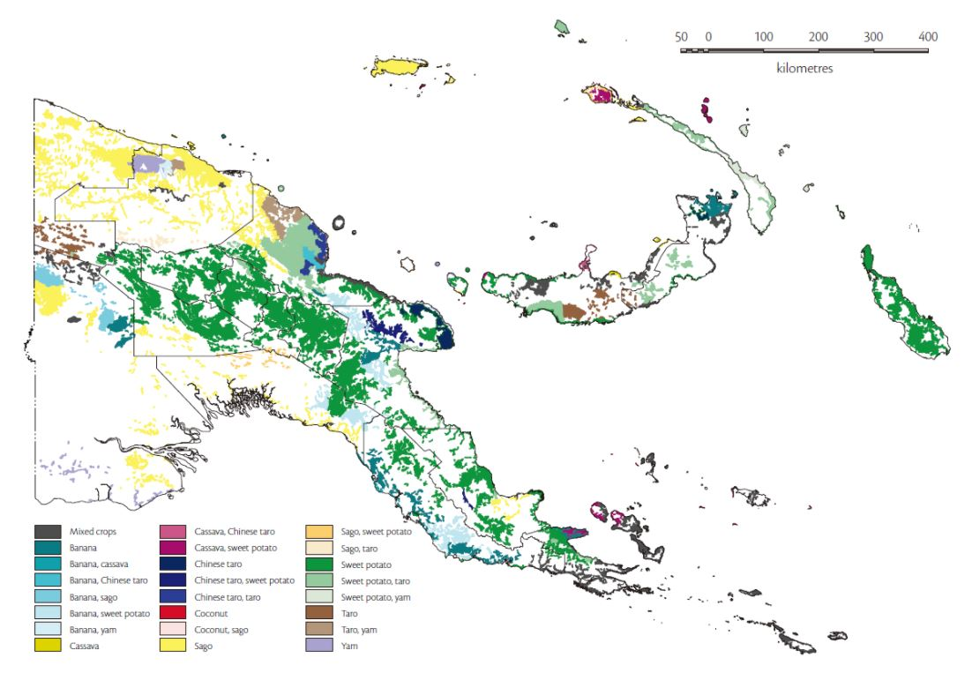
Over 8.6 million hectares of forest are currently under concession, with most timber permits not due to expire until 2050. Another 8.4 million ha have been identified for potential future development, which means that approximately 50% of forests in the country could be categorized as forest concessions. Additionally, the Government of PNG has designated 4 million ha of Special Agriculture Business License (SABL); the clearance of all this area would result in emissions of 1.2 GtCO2e, equivalent to around 30 years of emissions at current levels.
In order to sustainably use different ecosystems and balance the importance of forestry and agriculture for the country's economy, both formal and informal and particularly in rural areas, adequate incentives for forest conservation need to be in place and targeted towards local actors. The strategic implementation of REDD+ projects in a selection of PAs could be used as a catalyst to transform the way landscapes operate. We propose a model where the Government of PNG has a key role in facilitating and articulating a co-management model that establishes collaborative alliances between the private sector, civil society, communities and the State for the conservation of internationally significant forest ecosystems. REDD+ within PAs and their buffer zones might be a key piece to guarantee the financial sustainability of the Protected Area Network in the next 10 years, while also promoting commodities production, improving local livelihoods and accelerating rural development.
We suggest that the model should be designed with a strong multi-stakeholder process so that the perceptions, interests and expectations of the different actors can be identified and properly addressed. This process should be articulated and ideally embedded into ongoing national efforts. To distribute the benefits generated by this model, a benefit sharing scheme should have at least 3 main considerations:
- Most of the benefits should reach the local communities, ideally through a process to guarantee equitability and avoid leakage to graft. This could be done by financing activities and projects previously prioritized by local beneficiaries and usually related to sustainable economic activities, health and education and should be linked to specific conservation agreements and results based on key performance indicators.

- A fraction of the revenues generated by specific high potential PA’s could be earmarked and channeled to cover costs related to the Protected Area Network and help finance PAs with less potential to implement income generating activities. This would act as a cross subsidy that would operate within the network.

- A percentage of resources generated by the REDD+ projects should be used to cover implementation costs as well as those from other national institutions responsible for the national REDD+ architecture, which all REDD+ projects will benefit from. This means paying for a number of services required for the system to operate adequately and transparently, including some components mentioned in the next chapter, including a national GHG registry, forest monitoring system, and fund management.

A basic requirement of this model is the need for an investment promotion institution / fund to identify and promote a portfolio of commodities impact investing opportunities associated with relevant value chains in different REDD+ projects. Funds would be managed professionally and transparently according to the highest ESG standards and would be mostly used to reduce pressure on forests based on a protection - production – inclusion approach. REDD+ projects would implement this approach aiming at increasing productivity and profitability in areas already in use and valuing the ecosystem services provided by PAs. For all this to be sustainable in a context dominated by traditional land structures and family agriculture, it must be done by duly incorporating local communities in inclusive business models.
Actors should maintain the focus on lowering deforestation: if the focus shifts to focusing primarily on increasing productivity for smallholder producers without sufficiently linking these activities to forest protection, activities could have an adverse effect on forests by providing smallholders the technical and financial means to not only improve production in already-degraded areas, but also to seek to implement the improved practices by expanding their farms into standing forests.
Ideally, a product or jurisdictional certification could be used to look for differentiation opportunities in the market. Alternatively, a rigorous impact monitoring and traceability system could provide the same level of market recognition with even higher transparency and confidence. This will help attract traders and companies looking for sustainably-produced commodities into the specific project’s landscapes.

Figure 14: Commodities investments through project-based REDD+
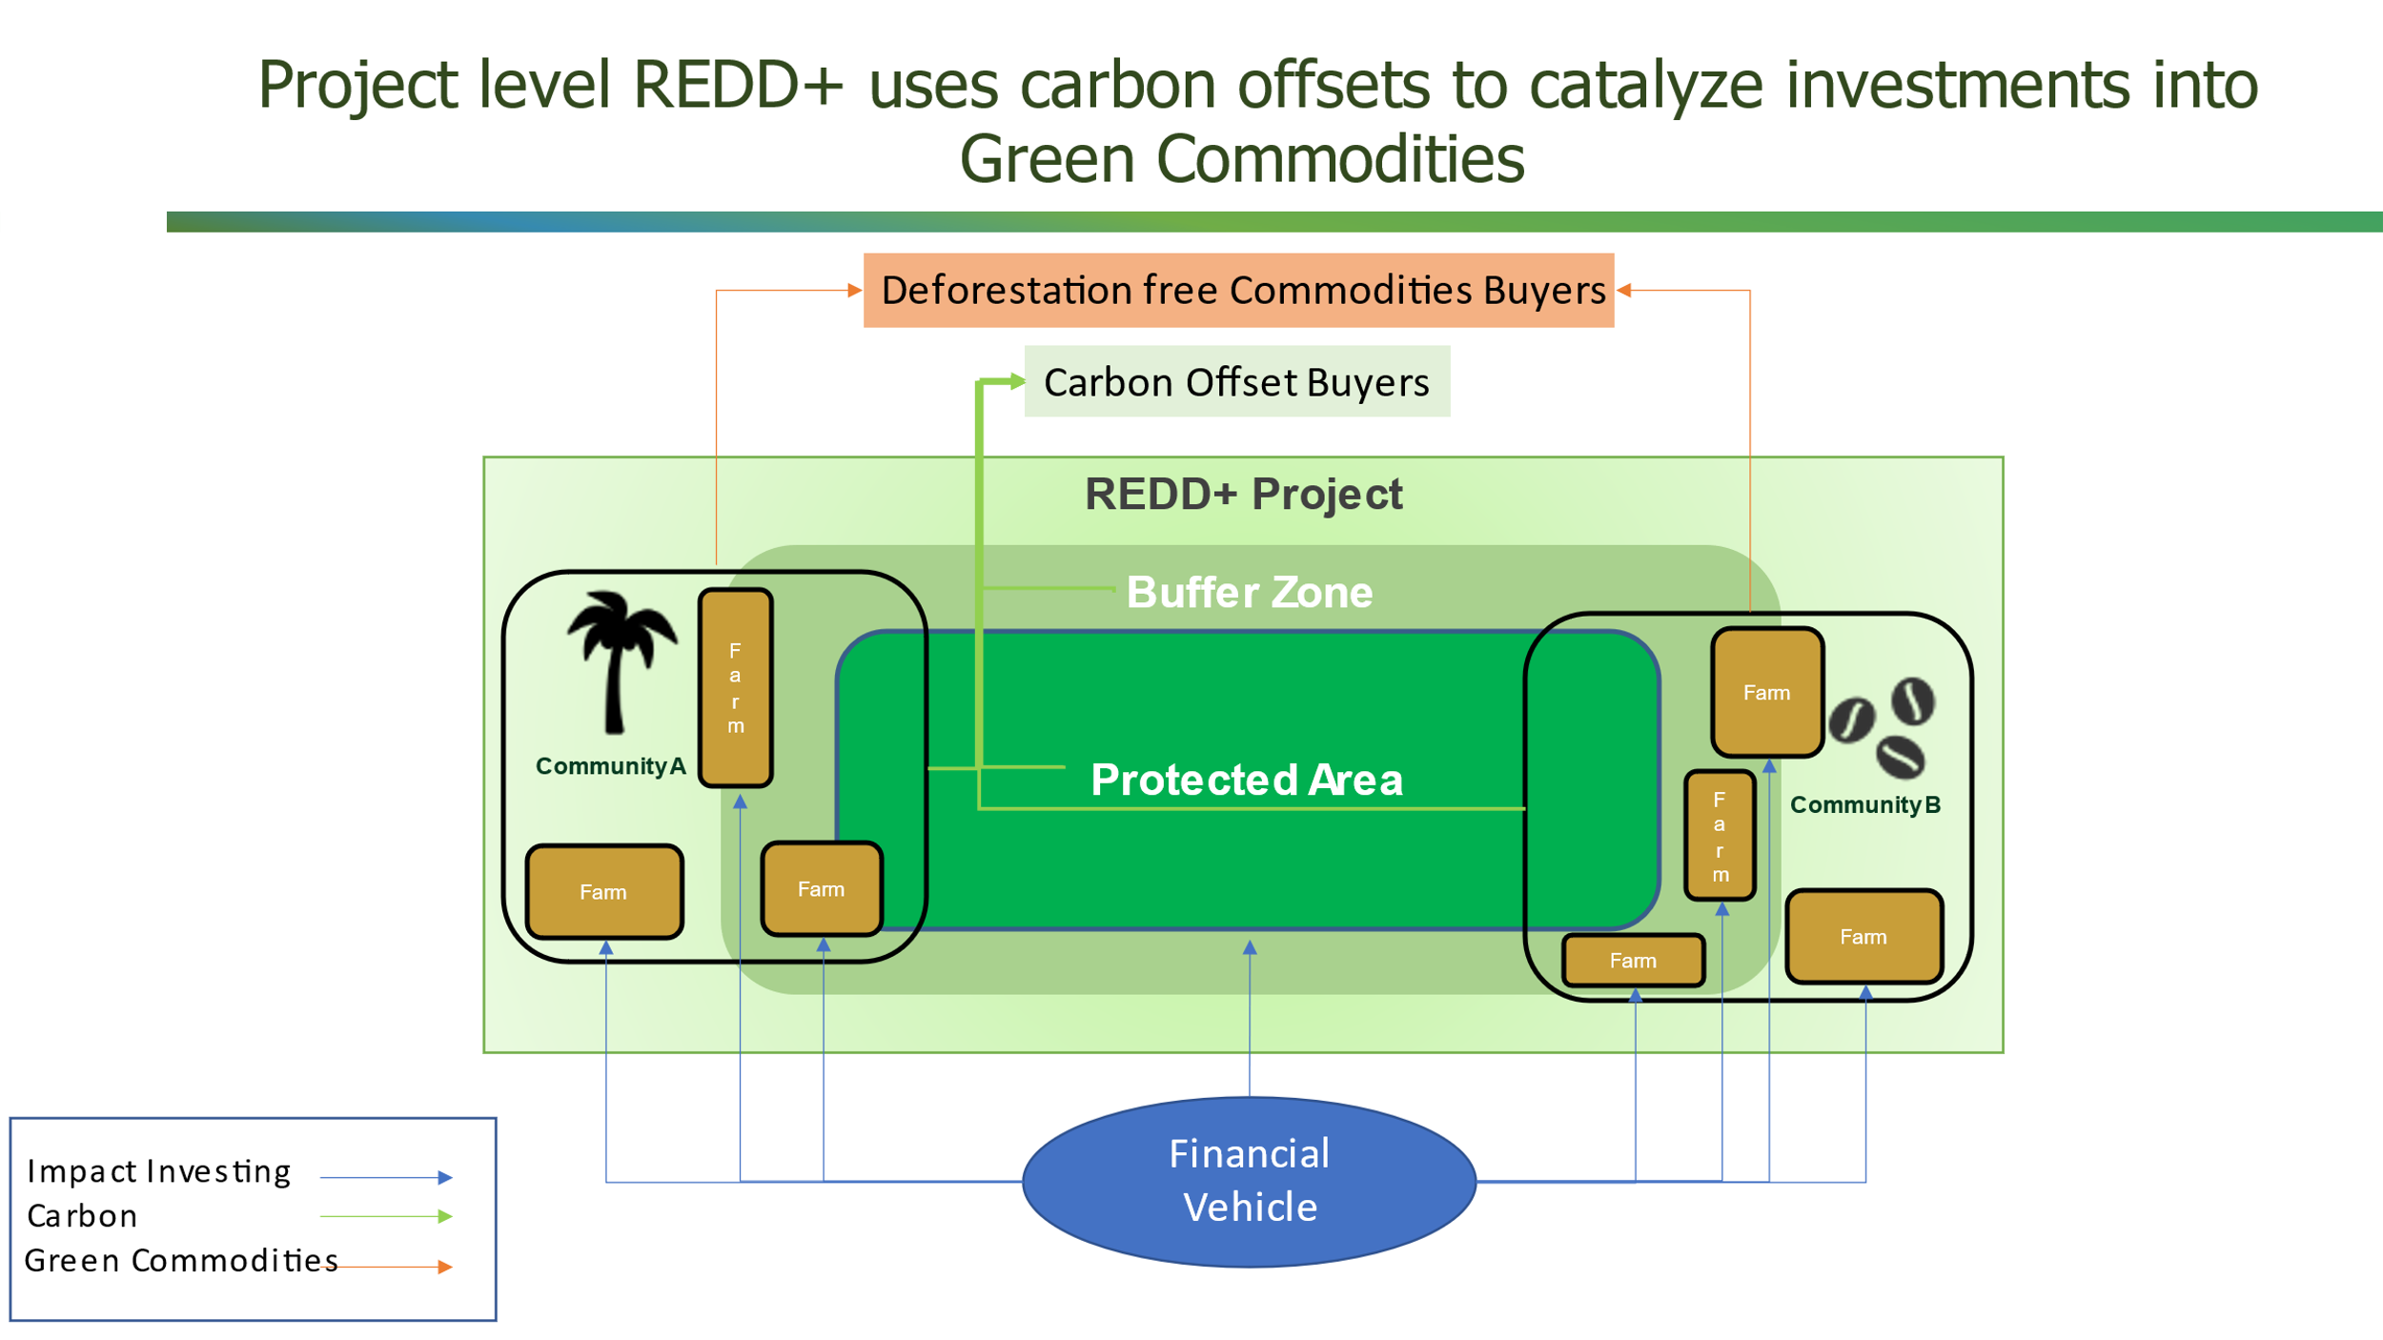

Blue Carbon
The coastal ecosystems of mangroves, tidal marshes, and seagrass meadows provide numerous benefits and services that are essential for climate change adaptation along coasts globally, including protection from storms and sea level rise, prevention of shoreline erosion, regulation of coastal water quality, provision of habitat for commercially important fisheries and endangered marine species, and food security for many coastal communities. Additionally, these ecosystems sequester and store significant amounts of coastal blue carbon from the atmosphere and ocean and hence are now recognized for their role in mitigating climate change.
It is estimated that the average annual carbon sequestration rate for mangroves averages between 6 to 8 Mg CO₂e/ha (tons of CO₂ equivalent per hectare). These rates are about two to four times greater than global rates observed in mature tropical forests. It is estimated that 35% of global mangroves have been lost in the last 2 decades. Countries with the highest areas of mangroves include Indonesia, Australia, Mexico, Brazil, Nigeria, Malaysia, Myanmar, Papua New Guinea, Cuba, India, Bangladesh, and Mozambique.
Papua New Guinea (PNG) has mangrove areas of global significance. Mangrove swamps occupy 51.6 million hectares (about 2% of the forest estate). A recent study demonstrated that the extent of mangroves in the Gulf of Papua has remained relatively stable for nearly 40 years, with expansion in some areas balanced by regression in other areas. There are 33 species of mangrove trees known, representing the highest mangrove diversity in the world. Several studies have shown mangroves of this coastline to be among the most productive in the world.
Moreover, PNG is located inside the “Coral Triangle”, an area covered by highly diverse coastal ecosystems in the Pacific Ocean more than 120 million people depend on for fishing and tourism. In PNG, mangroves can store up to 534 Mg C/ha, however, annual deforestation of these areas has been estimated to be nearly 57,000 hectares. This translates into 30 million tons of carbon dioxide emitted to the atmosphere annually due to deforestation and uncontrolled use of mangroves and marine ecosystems. Given this, there is strong potential for receiving rewards from the trade of carbon credits if deforestation of mangroves is reduced. For example, if annual mangrove deforestation is reduced by 10%, there is a potential to generate over 3 million of carbon emission reductions that can be traded in international markets at competitive prices.
However, until today, there are no on-going blue carbon projects in PNG as the country still continues to engage in preparatory activities and workshops to better understand the potential of mobilizing resources from blue carbon initiatives. These activities include the participation in the Blue Carbon Capacity Project led by the Coral Triangle Center launched in 2018, and government assessments into the feasibility of including blue carbon and wetlands as part of their NDC. These assessments are undertaken with the support of the Australian Government through the International Partnership for Blue Carbon, an initiative that is helping PNG in developing a tier II inventory and case studies to identify the potential for revenue generation of blue carbon in PNG.
Therefore, it is possible that during the subsequent submission of the country’s NDC, it will include a chapter dedicated to mangrove and wetlands, opening the window for the implementation of voluntary blue carbon initiatives in the country.
Mangrove restoration and greenbelt protection project in Indonesia
This project, created in 2014, seeks to 1) increase the environmental carrying capacity of mangrove ecosystems in the east coast of Northern Sumatra for carbon sequestration, 2) reduce the risk of natural disasters due to destruction of natural barriers against storms and 3) improve local livelihoods. Through the rehabilitation of 5,000 hectares of degraded mangroves over a period of 20 years, the project aims to reduce 2.5 million of tCO2 emissions. Of these, 397,000 tCO2 of Verified Carbon Units (VCUs) have already been issued and traded in international markets, generating an estimated income of approximately USD $1.2M (assuming an average price of USD $4/per VCU).
The project has been developed with the collaboration of a local NGO named YAGASU and the French food and beverage company Danone. In 2011, Danone joined forces with Credit Agricole, Schneider Electric and CDC Climat to launch a carbon investment fund named the Livelihoods Fund. This Fund provides investors access to biodiversity-friendly carbon credits in exchange for investments on large-scale social impact projects located in poor areas.
This project occurs on private and government owned areas along 497 kilometers of coast in 11 districts. The planting areas are distributed among 2,623 restoration sites that have an average size ranging between 1.8 and 5.7 hectares and that have been carefully georeferenced to facilitate monitoring over time. Before the implementation of the project activities, the main causes of deforestation and degradation were the conversion of mangroves into shrimp ponds, housing, estate plantation, and paddy fields, in addition to uncontrolled fishing, sedimentation and lack of financial resources and technical capacity to protect these ecosystems.

Technical feasibility
The implementation of a portfolio of REDD+ projects in PAs as a core element of a commodities promotion model might require a strong coordination and supervising effort from the government and particularly from CEPA.
The government at different levels would have to design, ideally together with key stakeholders, a co-management model capable of fostering collaboration between government at different levels, communities, civil society organizations as well as companies and private investors.
The co-management model can be designed in various ways, depending on the decisions made in the designing process, and the roles and responsibilities of the different leading and supporting entities will vary. The following three case studies show unique models for REDD+ projects within PAs.
During the interviews conducted as part of this consultancy, it was mentioned that international expertise is available in the country and that training local population and graduates from relevant careers like forestry, biology, economics, agriculture and anthropology, business, among others could and should be one of the ways to breach the existing knowledge gap.
Among the set of capacities that would be required for this model to be successful we can highlight:
Table 22: Capacities required for implementing the option commodities / REDD+
Capacity | Description
Leadership | To allow a set of diverse actors to join efforts behind a common objective.
Facilitation | To promote active participation of different stakeholders, especially minorities and those with less power and access to the decision-makers and create a common objective.
Communication | Interviews highlight the need to have special considerations for generating awareness as well as developing training and transfer of skills to the surrounding local population so that effective participation can be achieved. Creating a sense of ownership by the community allows for the sustainability of the PAs.
Coordination | Needed at different levels to facilitate landscape specific collaboration between communities, local governments, public institutions, private investors and civil society organizations
Land Use Planning and monitoring | To understand priority conservation areas as well as those with agricultural and forestry potential. Also, to monitor the developments in these areas.
Law enforcement | Reliable government institutions, clear regulations that provide legal security for those operating projects is key for REDD+ in particular and for private investment in general
Financial management | To adequately raise funds and manage the corresponding disbursements in a transparent way.
Business literacy | To identify business opportunities specific to the different PA’s and promote impact investment alternatives on sustainable commodities and beyond.

Additionally, there are a number of components that will have to be in place in order to generate an environment that is conducive to a co-management model that promotes the implementation of REDD+ projects in PAs (and other existing or new REDD+ projects). This will require the design of a nesting scheme, so that the emission reductions generated at different levels can be accounted for at the National level. This is a critical aspect since systems developed purely for the purposes of meeting UNFCCC requirements will likely be unable to support nesting (or other reporting requirements) efficiently and could lead to inconsistencies. Countries looking to nest projects, be they legacy or future projects, need to consider this fact in the initial design of a national system. Where it is not considered, there are likely to be more challenging problems with alignment and double counting. The design of a nested system should consider first and foremost how best to catalyze actions and actors needed to reduce emissions (or enhance removals)— that is, how to provide the most effective incentives to a variety of actors across a landscape.
The Tambopata REDD+ Project in Peru
In 2014, Althelia Ecosphere, an environmental asset manager, partnered with Peru’s National Service for Natural PAs - SERNANP and a Peruvian NGO – Asociación para la Investigación y Desarrollo Integral (AIDER), to structure an innovative project in Madre de Dios, the ‘Tambopata REDD+ Project’.
The Tambopata REDD+ Project protects 570,000 hectares of natural forest within the Madre de Dios portions of two PAs: Tambopata National Reserve and Bahuaja-Sonene National Park. It is a successful example of a public-private-people partnership. It aggregates funding from international public and private investors, a guarantee from a development institution and co-financing from the Peruvian government to address deforestation and social development in an at-risk area of the Peruvian Amazon.
The primary financing for the Tambopata REDD+ Project takes the form of a six-year EUR5.6 million loan from Althelia to Aider. AIDER signed in 2008 a partial administration contract with SERNANP, under which AIDER is responsible for conducting biological monitoring, research, control & surveillance and promoting sustainable livelihoods with local populations in the buffer zone of the PA to improve their quality of life and stabilize land use, building a symbiotic relationship between the people and the PA’s.
This financial structure and soft loan facility have been possible thanks to a 2014 partnership between Althelia and the United States Agency for International Development (USAID), whereby the USAID Development Credit Authority (USAID DCA) would guarantee private investors in Althelia Climate Fund up to 50% of the fund’s performance on a portfolio basis. The USAID DCA guarantee, for an amount of EUR100m, is intended to support Althelia’s global strategy to attract more private investors and has proven successful. It also allows Althelia to take more risks at a project level. For example, Althelia has been able to invest in projects such as the Tambopata REDD+ Project, where repayments are directly and indirectly dependent on smallholder farmers activities (reduction of deforestation and agroforestry), a category of borrower that is seen as risky by the traditional financial sector.
AIDER benefits from a low interest rate and has a three-year grace period in respect of capital and interest repayments. These repayments are earmarked from diversified revenue sources including the commercialization of environmentally certified agroforestry products and certified environmental services such as carbon credits. These concessional terms give AIDER operational and financial flexibility, while the interest rate is significantly lower than the average market rate from commercial banks.
With the financing of Althelia, Aider is provisioning technical assistance to smallholder farmers for the establishment of 1,250 hectares of fine & flavorful cocoa under agroforestry systems using degraded lands and pastures in the buffer zone of the PA. AIDER has also helped to establish a small producer cooperative, Cooperativa De Servicios Múltiples Tambopata Candamo (COOPASER), to help meet production targets, aggregate production, and operationalize the route to market of the agroforestry products. AIDER is also investing in COOPASER and building a US$200,000 facility to centralize production and improve post-harvesting handling and fermentation. This processing facility will enable cocoa to meet high quality standards and improve traceability, thereby ensuring that it can be sold in national and international specialty markets.
Guatecarbon Project in Guatemala
The Maya Biosphere Reserve (MBR) is an area rich in biodiversity and cultural history. Established by the Guatemalan government in 1990, the reserve spans nearly 2.1 million hectares. During the late 1990s and early 2000s, the Guatemalan government granted forest user rights, through concessions, to 12 community-based organizations and two private companies within the reserve’s Multiple-Use Zone, an area where the sustainable harvesting of forest resources is permitted. These concessionaires—whose operations have been certified to the sustainability standards of the Forest Stewardship Council® - FSC®, have proven themselves to be exceptional forest managers. FSC-certified forest concessions had nearly zero forest loss over the past 14 years, as compared to a deforestation rate of 1.2 percent in the MBR as a whole, with some areas of the reserve’s buffer zone reaching 5.5 percent per year.
GuateCarbon is a REDD+ project built on 721,006 hectares of which 660,820 is forest. Approximately 477,000 hectares are being sustainably managed by 11 forest concessions (nine that are run by communities and two by industry). The project has the technical assistance of the Rainforest Alliance and The Wildlife Conservation Society and supports activities related to sustainable forest management; sustainable production of timber and non-timber forest products; social development projects; support for greater institutional presence in the forest and territorial patrols; social and biodiversity monitoring.
As they have for generations, the reserve’s residents benefit from a host of non-timber forest resources, such as xate (a type of palm frond) and chicle. The sale of non-timber forest products generates an important revenue stream for women in particular. GuateCarbon provides communities with training to increase the competitiveness of these products and facilitate access to new markets. In addition to reducing a yearly average of over one million tons of carbon dioxide emissions per year, the project will also provide financial support to Guatemala’s National Council of PAs (CONAP).
The governance scheme of the project is located within the structure of Guatemala's National Council of PAs (CONAP), with the participation of the forest concessionaires of the MBR as co-proposers of the project. The governance council is a mixed structure that includes representatives from the government and the concessionaires; 4 of them represent CONAP, and the concessionaires are represented by 3 leaders from the different localities, an industrial concessionaire and a representative from the Association of Forest Communities of Petén (ACOFOP). The project’s direction, operation, processes, scopes and products will be regulated and reflected in corresponding manuals, which will be proposed by the governance council.
A Special Purpose Vehicle (SPV) oversees the financial administration of the project. The highest authority within the SPV is the governance council and its function is the management, transfer and execution of funds for the project. Through the SPV, funds from REDD+ negotiations in the carbon markets will be captured and directed to activities to reduce deforestation and forest degradation. Through the SPV, CONAP and the project's co-proponents through the governance council, will give their opinion on the commercial technical proposals received for the emission reduction certificates.
The Carbon Emissions Reduction project in the corridor Ankeniheny-Zahamena (CAZ) protected area in Madagascar

The CAZ REDD+ project covers 370,032 hectares of humid rainforest in Madagascar and aims at reducing unplanned deforestation of primary Malagasy forest caused mostly by slash and burn agriculture by creating a new PA that includes the remaining native forests of the Zahamena National Park, the Manongarivo special reserve, the Mantadia national park and the forests collectively known as “Ankeniheny'' in central-eastern Madagascar. This forest provides ecosystem services of great importance especially those related to water provision as several communities including those inhabiting the capital city Antananarivo who depend on their conservation for securing access to water for human consumption.

The project was initially proposed by the government of Madagascar through the Ministry of Environment and Forests in association with Conservation International (CI) and then became eligible for receiving technical support from the World Bank BioCarbon Fund which has also committed to purchase the initial verified carbon units generated by the project through an Emission Reduction Purchase Agreement (ERPA).

The overall functions of the project are distributed between CI who oversees the coordination of the project, provides technical and financial support for the implementation of the project activities, and is responsible for monitoring carbon stock changes and the village level associations and federations that co-manage these PAs.

The main form considered for distributing economic benefits is through the signature of conservation agreements and small-grants provided by CI that have been commonly used to fund tree nurseries, built agroforestry systems and fruit gardens, and enforce capacity building through training around sustainable farming.

Conservation agreements are a form of Payment for Ecosystem Services tool through which the project secures conservation action from local communities. Signatory communities have in place forest management plans and their implementation is constantly monitored by surveillance patrols. These agreements aim at operationalizing monitoring of PAs and biological corridors but also allow communities to develop small infrastructure projects such as irrigation dams, rehabilitation of schools, construction of community pharmacies, purchase of agricultural tools and machinery, and improvement of the rural electric grid.

On the other hand, the enormous impact of small-grants has been achieved thanks to the partnership established with different NGOs in charge of receiving proposals from the communities, issuing grants, and monitoring the proposed activities. This mechanism increases NGOs ’ grant management skills as well as builds their expertise in supporting conservation.

A nested approach to REDD+ benefit sharing has already been recommended for PNG. Since the majority of land is ruled under customary law, the formation of ILGs or a similar conglomerate body (e.g., community-based cooperatives) will be necessary for tenure and carbon rights issues to be overcome and for benefit distribution to occur (Babon 2013; Crane 2015). In the specific case of PAs, the promotion of community-based conservation initiatives should be formalized through the creation of National or Regional PAs, depending on the case.
Key pieces required for the implementation of Nesting include:
Harmonizing data and methodologies used at National Vs Project level: If a country’s nested approach allows stand-alone projects, a higher level of accuracy and precision, and a more granular stratification (of areas and estimates of carbon stock for forest/land classes) may be needed at the national level. In some instances, it is simply not possible for a project to use national-level data—for example, there may be insufficient accuracy of the spatial data required for the standard that the project wishes to use.
Setting projects baseline: Once a national or jurisdictional reference level is set, in most cases, it is not possible to simply “apply the jurisdictional baseline to projects” (as is suggested in the Verified Carbon Standard Jurisdictional and Nested REDD+, or VCS JNR, framework). Projects within a jurisdiction are based in areas with different dynamics and deforestation (or forest degradation) pressures, such that it is not possible to simply “divide up” the baseline based on, for example, a ratio of area coverage, unless the jurisdiction experiences a near-perfect mosaic of deforestation or degradation.
A robust GHG inventory and a national registry system to track Emissions Reductions: Double counting (or double claiming) is a term used to describe the use of a single emission reduction unit more than once. If countries design nested systems that are based on allocating finance or ERs generated at the higher scale, there is no risk of double counting because the allocations are designed to fit within the envelope of jurisdictional performance. However, where jurisdictions and projects or subunits with the jurisdictional area are accounting simultaneously, there needs to be a mechanism to avoid double counting. In addition, because often it is not possible to perfectly nest projects within a jurisdiction, there will be a need to “true up” the accounting and manage liabilities for the expected quantitative correction that may occur. This requires clarity on which party or parties are responsible both for managing the mismatches and for the liabilities for any “overshoot” that occurs. Alternately, systems (for example, buffers) may be developed to share the burden upfront of such overshoots.
PNG has initiated work on the development of a registry to clearly track and account for how any emission reduction units produced are utilized. A phased development process for this has been identified with capacity of the system being increased as PNG becomes increasingly engaged in international action to reduce emissions through both voluntary mechanisms and agreements under Article 6 of the Paris Agreement. PNG, through its role in the Coalition for Rainforest Nations, is also collaborating in the development of integrated approaches to registry development.
A clear benefit sharing structure and a financial vehicle: REDD+ funding can be channeled through both a national REDD+ fund and direct project-based finance when a nested approach is taken (Lindhjem 2011). That is, funding for projects can come from the national government or international funding bodies in conjunction with direct finance from the voluntary carbon market via direct purchases of emission reduction credits (Lindhjem 2011; Lee 2018).
Governments (National, Provincial, District and Local), in collaboration with relevant stakeholders (e.g., NGOs and customary landowners) should develop transparent processes to establish Conservation and Benefit Sharing Agreements to enable the establishment of PAs on customary lands. These agreements will take into account the biodiversity and the diversity of social and cultural practices. They will identify the roles and responsibilities of the customary landowners in the establishment, implementation and monitoring of the PA.
Under a nested system it is recommended that funding from investors be placed into a national fund with benefits being distributed down the vertical scale (e.g., national to provincial and provincial to ILGs) (Babon 2013). From there it can be distributed across the horizontal scale within government to cover operational costs or be re-invested in in-kind benefits and capacity building while distributing a share of funding down the scale to the next vertical level as appropriate. It is important that the benefit sharing system facilitates horizontal benefit sharing; if local actors perceive they are not receiving benefits of a reasonable quality or quantity their participation in, and the reputation of, REDD+ is likely to be compromised (Pascoe 2015).
In terms of national legislation in place in PNG for a proper benefit sharing scheme, the literature highlights that there are discrepancies between the Climate Change Management Act 2015, the Public Money Management Regularization Act 2017 and the Public Financial Management Act 1995 that need to be resolved prior to the creation of a benefit sharing system for PNG (Department of National Planning and Monitoring 2018).
Identify and development of a pipeline of bankable projects: It has been clearly identified by UNDP that one of the key challenges facing climate and impact investment finance deployment for REDD+ in the Pacific, including PNG, is identifying and assessing both pilot and large-scale projects that can generate a financial return. While there are some exceptions, and the evidence base continues to grow for linking sustainable agriculture with improved land productivity, the fact that REDD+ is generally not a profit-making enterprise should not be overlooked. Nevertheless, REDD+ projects can be seen as a catalyst to draw-in further sustainable land use investment in determined areas.
Currently, there is no publicly available pipeline of bankable and non-bankable REDD+ and sustainable agriculture and forestry projects for PNG. Developing a strong pipeline of bankable and socially inclusive and environmentally sustainable land management projects to attract climate finance and impact investment into a co-management model for PAs would be necessary. The PNG Government should work with its multilateral partners to assist in building this pipeline of projects based on this new model so the country could position and promote itself with an aggressive strategy to be a global leader within the growing sustainable commodities agenda and by offering insetting solutions for multinational companies. This would help the country more easily attract increasing amounts of climate finance, and progressively, tap into the private-sector impact investment market.

Environmental and social impacts
One of the drivers of the growing interest in natural climate solutions and emission reduction projects from the forestry sector, particularly REDD+, is the important number of co-benefits they generate. Well-structured and managed REDD+ projects include positive impacts like biodiversity and habitat conservation, sustained water supply, increased agricultural productivity and livelihood opportunities, among others. These reasons, combined with the availability of relatively mature quantification methodologies, the increasing application of technology for monitoring deforestation and carbon emissions in the forestry sector and the potential of some forestry projects to be very large and profitable, have made NCS projects popular with both project developers and certificate buyers. In addition, approximately 70% of the natural climate solutions needed are low impact, i.e., they can be generated by strengthening the protection of existing natural ecosystems or by improving practices associated with forest and cropland management.
In the specific case of PNG, forests play a central role in the social, cultural and economic livelihoods of PNG’s 8 million people whose diversity match that of the country’s ecology, with over 850 languages spoken. Over 90% of PNG’s land is under customary ownership and with over 80% of the population living in rural areas, the connections between land, culture and economy are critical. Rural communities rely on clean river systems for drinking water, over 500 species of wild plants are used for food and the value of annual bushmeat consumption is estimated to be equivalent to USD $26M. These services are essential to the current resilience of communities to environmental shocks as well as the impacts of climate change. Habitat loss is the primary threat to the over 470 threatened species identified in PNG. Loss of forest is also resulting in land degradation, pollution of waterways, sedimentation of coral reefs and impacts on the culture and livelihoods of forest-dependent communities. Many of these resources are central to the livelihood security of communities and the resilience of the country to shocks, which will be inevitable in the future since PNG is ranked as one of the 20 most vulnerable countries to climate and global change.
Interviewees remark that not many places will necessarily qualify for REDD+. Customary land ownership is perceived as a major challenge and to address it, strong agreements with landowners are needed. Social impacts, therefore, will depend on how a benefit sharing scheme is designed, how REDD+ projects are implemented and managed and the local potential for sustainable economic opportunities and commodities production. As interviewees mentioned, landowners must be in control of the forests and receive benefits on a regular basis against their compliance. The rules need to be set so that they support biodiversity conservation, not only carbon stocks. Otherwise, protecting forests in private communal land through REDD+ might not reduce deforestation and degradation.
As one interviewee mentions “It is not clear yet how benefits can be channeled to local communities. A negative example from the first REDD+ project in PNG resulted in the departure of a disillusioned international carbon investor. There is a need to have a good check-list mechanism in place to do appropriate due diligence. Social Benefits very much depend on how you set it up. The issue of benefit sharing and participation is very critical. So if you have a small group capturing most benefits you alienate everybody else. Equity in benefit distribution at the local level is key.”

Stakeholder support
There is a history of badly managed REDD+ projects in the country, with limited implementation and shady benefit sharing schemes. Gaining trust from local communities will require addressing the existing reputational issues faced by former REDD+ projects in the country.
As one interviewee puts it: “Since April-Salumei trading of its carbon stock, we have not seen any tangible benefits because all benefits are lost between the middleman, developer and few people who are instrumental in the initial deal. This project should be disbanded and the forest returned to the owners and not the developer. Hence, the Government of PNG must now fast-track the compliance mechanism and begin developing some pilot projects.”
These transparency, accountability and potential corruption issues caused the media to label the April Salumei project a scam, and according to some, has somewhat destroyed the credibility of REDD in PNG (Lang 2016). It can be argued that this sentiment is still felt by many investors and therefore any REDD+ benefit sharing system created for PNG must have clear accounting and reporting guidelines in place.
As the same interviewee describes: “Who owns the carbon is a sensitive issue in PNG because the local people own land but who owns the carbon is the question. Hence, proper benefits-sharing agreement and user rights or dealings must prevail. Benefits must also include sustainable livelihood and services to communities protecting the forest. A major challenge is aligning government, business and communities in a transparent and accountable manner.”
As different authors agree, benefit sharing systems are needed to create transparency relating to receiving, storing, distributing and using funds by the various stakeholders involved to avoid corruption and misuse/inefficient use of REDD+ funds and to hold parties accountable when misuse occurs (Arwida 2015; Office of Climate Change and Development 2010).
In general, stakeholders interviewed as part of this study suggest there is appetite for REDD+, but that it needs to be managed properly. It requires a good understanding of local power structures and authorities, so that benefit sharing schemes are in place in a consistent way. Interviewees consider that, if designed as a long-term alternative, REDD+ would gain significant support from stakeholders. There is also a feeling that, based on current and expected future emission reduction prices, REDD+ could support local livelihoods and much more.
Based on our understanding of the context of PNG and the interviews conducted, we believe it is possible to gain support and build momentum for the implementation of a portfolio of REDD+ projects in PAs based on a co-management model. Nevertheless, for this to happen there are a number of challenges that need to be addressed. These challenges are related to the design of an adequate fund management and benefit sharing scheme for this model as well as the implementation of a communication strategy to generate trust among the different stakeholders and explain the potential positive impacts on local livelihoods of the protection - production – inclusion approach. This will be key to overcome the bad reputation from previous REDD+ projects in the country as well as the perception of lack of capacities, inefficiencies and corruption from public sector institutions.
As one interviewee puts it: “Ultimately it comes down to communicating the benefits, explaining them. If communities understand the benefits, then they might accept the challenges. Irrespective of which kind of funding instrument to use, we may want to design them in a way that they are in line with local management systems, this is what local communities are very much looking for and it would increase the acceptance by locals.”

Importance of Involving Local Communities in the Design of REDD+ Projects
Rural communities have long been enduring the devastating changes of their territories and livelihoods as a result of the impacts of climate change, along with having to deal with the lack of tangible commitment from the institutions responsible for generating effective and contemporary public policies that should aim at increasing resilience and promoting adaptation measures to overcome these impacts.
The majority of vulnerable rural communities that rely on the forest for survival are more prone to face landownership insecurity, weak governance systems, lack of access to information, low income, along with the complete lack and forceful participation in decision-making scenarios that determine the mitigation and adaptation measures to be applied in their native territories (IUCN, 2010).
This lack of participation has proven to be one of the major causes of failures of natural-based initiatives including REDD+, as communities argue that they are not consulted during the design and selection of the interventions that are proposed to address deforestation and degradation in their territories even when is them the ones usually acting as agents of deforestation, and consequently sometimes such interventions fail to achieve their targets. Moreover, every key actor involved in the processes of deforestation and degradation has not only a degree of responsibility and influence but also a geographic expression that must be characterized within the community dynamics. Therefore, it is essential to define the interests and motivations that determine the decisions and relationships of stakeholdersto shape the design of project activities and ensure that communities are not excluded from decision making but also not prevented from accessing forest and profiting from it for their survival.
Communities offer valuable long-term observations and experience based on their traditional knowledge, innovations, and practices that should be linked to project activities to guarantee that stakeholders have the necessary tools and motivation to implement interventions in their territories and sustain them over time. Some of these valuable experiences include methods for fire and water management, agroecological techniques, coastal protection, sustainable use of biodiversity, use of non-timber forest products, among others. On the other hand, because the vulnerability of rural communities to the effects of climate change is largely determined by the degree to which their rights over their territories are recognized and guaranteed, a rights-based approach to mitigation and adaptation initiatives can help increase their resilience.
Likewise, the voice of the community during the consultation process and its decision-making power validates and legitimizes the design and implementation of REDD+ projects and in return, communities generate social, technical, and economic empowerment. Therefore, the voice of all relevant stakeholders must be not only heard but also considered to ensure equitable development and socio-environmental legitimacy of projects.
In 2010 The United Nations Climate Change Conference (COP 16), implemented the REDD+ safeguards programwhich subsequently evolved in the definition of the Cancun safeguards. Today most REDD+ projects and programs need to have in place provisions to monitor and ensure compliance with these safeguards from the design stage and throughout the crediting period. This safeguards approach should contribute to generating positive impacts on communities as with this, their rights are prioritized for every decision taken concerning the management of forest resources.
The international access to funding, technical resources, and technology is another important factor to design REDD+ projects together with communities as each participant involved may have access to resources from different entities worldwide that might help to strengthen community processes for the implementation of project activities but also to enable a governance environment that links institutional and local cooperation to design effective REDD+ and land-use policies and strategies.
Finally, the importance of involving communities in the design of REDD+ projects has long been recognized by the most used certification standards such as the Verified Carbon Standard (VCS) and the Climate, Communities, and Biodiversity Standard (CCB) . According to these standards, project proponents shall engage with local stakeholders to design and implement the project activities, document consultations, and indicate how the project design has been affected by the inputs of stakeholders. Projects that manage to involve the CCB Program rules and requirements in terms of inclusion, respect, and monitoring of impacts on local communities are more likely to attract preferential investors and offsetting buyers interested in supporting best-practice projects.

Financial forecasting
This chapter analyses the revenue generating potential of the REDD+ model proposed based only on income from the sale of carbon offsets. Revenue generation potential from commodities investments have not been considered because those belong to the farmers and communities implementing sustainable agricultural activities and not to the PA System. We envision a model where commodities investments, properly managed and monitored, generate positive impacts in the PA and its area of influence. Investment opportunities into sustainable commodities are a way to reduce pressure on PAs and valuable ecosystems by providing local communities with the tools, technical capacities, market linkages and financial resources to increase yields and income on existing farms while reducing their need to expand the agricultural frontier. Additionally, properly structured and promoted, these opportunities have the capacity to attract further financial resources into these areas through impact investment. Therefore, we focus our efforts on analyzing potential REDD+ revenues as a catalyst for further investments into commodities, but we do not assess the revenue potential of these additional investment opportunities.
Achieving net zero by 2050 requires filling 1) the emissions gap (the estimated number of emissions that the current NDCs are deviating from what climate science requires), 2) the finance gap (the amount of financial capital required to meet and exceed the current NDCs), and 3) the time gap that prioritizes climate action taken sooner versus later. Voluntary actions, in part delivered through carbon markets, could play a role in bridging the above-mentioned gaps. Voluntary Carbon Markets can be deployed to finance actions beyond organizational boundaries that lead to a reduction in the concentration of greenhouse gases in the atmosphere in a way that is real, additional, verifiable, and permanent.
The market for voluntary emission reductions is still relatively small, approximately USD $600M (2019), compared to the regulated market (emission allowances) of approximately USD $44B (2018). The market could see accelerated growth as countries reach their decarbonization limits, which means they will have to rely on offset projects to achieve national and corporate climate goals. Without offsetting, it is impossible to achieve long-term net zero emission commitments. The Taskforce on Scaling Voluntary Carbon Markets (TSVCM), a private sector-led initiative aiming at scaling transparent, verifiable and robust voluntary carbon markets to help meet the goals of the Paris Agreement, estimates that demand for carbon credits could increase by a factor of 15 or more by 2030 and by a factor of up to 100 by 2050. Overall, the market for carbon credits could be worth upward of USD $50B in 2030. The very long term (2050) market size is estimated to be substantially larger, at approximately USD $200B.
In 2020 a number of task forces were launched to discuss how to better organize this unregulated marketplace and to increase the transparency, quality and integrity of offsets. The leading initiative – the TSVCM), led by Bill Winters, chief executive of Standard Chartered, and Mark Carney, former governor of the Bank of England has recently presented their blueprint for creating large-scale carbon credit trading markets that ensure carbon credits are high quality.
The International Emissions Trading Association (IETA) launched its Markets for NCS initiative during COP 25 as a response to the evident increase in the private sector's appetite for emission reductions from activities related to nature conservation and regeneration. The objective is to create a global market for carbon credits generated by NCS projects in forests, soils and wetlands, enabling private sector investment at scale to support the transition to a low carbon economy and promote greater climate ambition. IETA is working in collaboration with its members and other stakeholders to establish an effective policy roadmap and market strategy.
Clearly, to encourage voluntary action by the private sector, companies must be able to demonstrate and communicate their commitment and impact to customers, investors and employees. This is done through carbon neutral claims and other tools that allow them to prepare for a future where carbon standards and regulations will reach all sectors of the economy. In that sense, there is a need to encourage voluntary activity to finance mitigation efforts that otherwise would not occur. This is particularly important in a context where the establishment of the necessary country specific regulations aimed at advancing the objectives of the Paris Agreement will take time to materialize.
At an online event organized by UN REDD in May 2020 (Charting our Carbon Future Series), the issue of pricing of emission reductions, with a special emphasis on those from REDD+ initiatives, was discussed. A survey of the participating experts shows that 61% consider that the price of emission reduction certificates should be higher than $10, while about a third of the participants mentioned that the price should be higher than $20. This is in-line with the results from IETA’s sentiment report (2019), which shows that 37% of respondents think that the global price of carbon should be 50 euros/tCO2eq in 2030 to meet the long-term objectives of the Paris Agreement (i.e., to reach the 2°C target). This represents a marked increase from the perception in previous years and could be due to a growing sense of urgency to stay below the 2°C target.
It is also expected that the growing recognition of co-benefits linked to NCS, which are not yet reflected in the prices paid for carbon, will create pressure for these types of projects to receive a larger premium over the market price. The science clearly points to the close links between biodiversity, climate change and local community livelihoods and over the next few years, pressure from consumers, investors and civil society in general will lead to companies having to pay a fair price for carbon that contains associated social and environmental components.
Over the next 2 - 3 years, specialists expect sales prices for REDD+ emission reductions to move between $10 and $20 per ton of CO2eq. This is due to the inclusion of REDD+ in different carbon pricing schemes (such as CORSIA, the California Cap and Trade system, Article 6, etc.), in addition to the increase in voluntary climate action by the private sector, which is expected to continue in the coming years.
The following analysis is based on data provided by 1) the Climate Change Development Authority and Forest Authority of PNG via the PNG REDD+ and Forest Monitoring Portal, 2) Global Forest Watch, an online platform that provides data and tools for monitoring forests, and 3) past UNDP reports on PNG’s PAs. From these sources, we were able to obtain key data relevant for REDD+, including tree cover loss, primary forest loss, CO2 emissions data, transportation routes, and logging concessions. Where possible, we captured this data for each proposed or existing PA. Where only Province-level data was available, we estimated the PAs’ respective measurements based on their size. Next, we created a scoring system for each metric, which we used to arrive at a total score for each PA to measure their potential for REDD+ activities. From this analysis, we identified 11 PAs that are strong candidates for REDD+, summing up a total of 2.7M ha among them. For these 11, we used provincial level tree cover loss and associated CO2 emissions during the 2010 – 2019 period to estimate average annual tree cover loss and emissions within each PA for the next 10 years. Based on these figures and assuming a constant tree cover loss rate for the next 10 years, the business as usual (BAU) scenario shows a total tree cover loss in the selected PA’s of 3,980 ha a year, equivalent to a 0.16% annual rate. The annual tree cover loss within the selected PAs represents approximately 12% of average annual deforestation rate reported by PNG in their First Biennial Report the UNFCCC (2019), which amounts to 30,667 ha between 2011 and 2015. The total forest area covered by the 11 PAs selected represent ~7% of total forest cover of 35.89 million hectares.
It should be noted that there are several protected areas that encompass mangroves, the most relevant of which is Tonda as it is included in our Top 11 and has significant mangrove coverage. Per Global Forest Watch, much of the mangroves in Tonda are in fact included as “forest cover”, and therefore are incorporated in our analysis. However, the country’s most abundant mangroves, in the Gulf region, are not within a PA and therefore are not included in this analysis.
For the target scenario, we assume a 10% annual reduction in tree cover loss until we reach our target, 0.05% annual tree cover loss rate, on Year 10, completing therefore a 2/3 reduction on annual tree cover loss. We then calculated average per hectare provincial level CO2 emissions related to tree cover loss and primary tree loss to arrive at a high-low spectrum of emission estimates. Finally, we applied a range of carbon prices per ton of $5 – $15 to arrive at a monetary value for the carbon emissions that could be realistically avoided over a ten-year period if conservation activities were implemented successfully.
Based on the average case for CO2 emissions avoided and a 30% buffer for potential leakage and permanence issues, Figure 15 shows initial results from the model as well as the contribution of each of the 11 prioritized PAs. The implementation of REDD+ in these high potential areas could avoid the loss of 15K hectares of tree cover and more than 8 million tons of CO2 emissions. Using a conservative price of $5 per ton of CO2e, our estimates show a potential revenue generation of USD $39M in a 10-year period. Among the selected PAs, Tonda WMA, Aramba WMA, Managalas CA, the Proposed Torricelli Mt. Range CA and Crater Mountain WMA show the greatest feasibility, representing together more than 80% of the total emission reduction potential in our analysis.

Figure 15: BAU vs target tree cover loss in selected PAs
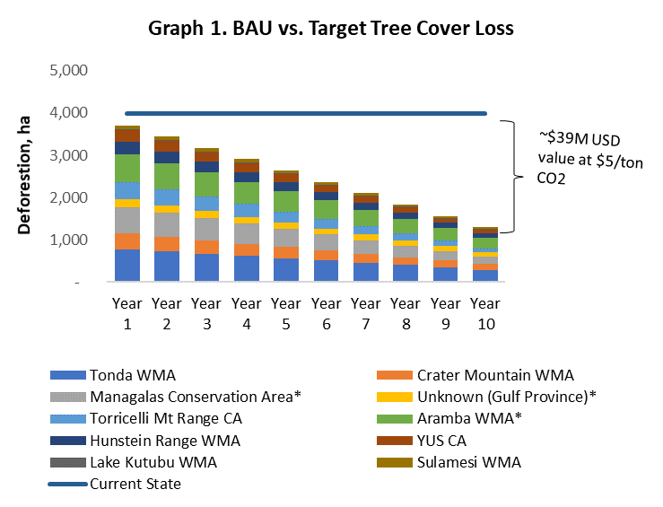
Using low and high figures for per hectare CO2 emissions in each province and based on our understanding of the carbon market and future carbon price dynamics previously explained in this chapter, a sensitivity analysis was conducted to explore the impact of expected higher carbon prices. Table 1 collects estimated carbon values at $5, $10 and $15 per CO2 ton over a 10-year period. The most likely results, using a USD $5 price per CO2 ton, range from USD $27M for low levels of per hectare CO2 emissions to USD $52M for high per hectare CO2 emission levels. This gives a per year potential revenue of USD $2.7M to USD $5.2M for the 11 PA’s selected. It is important to mention that per year revenues will likely not be identical each year and rather increase gradually in line with success towards reducing deforestation.
Table 23: Estimated Carbon Value for a 10-year period
 | CO2 Emissions Avoided | $5 | $10 | $15
High Estimate | 10 Mil Tons | $52 M | $103 M | $155 M
Average | 8 Mil Tons | $39 M | $78 M | $117 M
Low Estimate | 5 Mil Tons | $27 M | $53 M | $80 M

Based on average figures from the industry, we estimate project design, validation, registration and verification costs to be around USD $200,000 – 300,000 for each project. Nevertheless, these costs are expected to be reduced significantly during the next few years as information technology and digital solutions are deployed in the forest carbon sector at scale. We consider that these costs, at least partially, could be covered by Civil Society Organizations and carbon developers involved in each of the projects. Alternatively, impact investors could be attracted by the model. Additionally, futures contracts could be established for the sale of a portion of expected carbon offsets, so that upfront finance for development and initial implementation can be secured. We have not estimated additional REDD+ implementation costs in the analysis, since we assume that conservation and sustainable land management efforts are aligned with those included on the Costing & Financial Needs Assessment for PAs in PNG, recently developed by Natural Strategies.
Estimates from the assessment mentioned above show that, in a conservative scenario (Sc1), the total annual financial needs of the actual Protected Area Network in PNG are around USD $12M. In the case of the optimistic scenario (Sc2), the total annual financial needs reach USD $35M. Based on this figure and considering the estimated carbon value in the average case shown in Table 1, we conclude that, over a 10-year period and at USD $5 per CO2 per ton, REDD+ could generate the equivalent of 30% of the costs needed by the Protected Area Network. In the case of the optimistic scenario and with similar carbon prices, the contribution of REDD+ to the financial needs of the Protected Area Network in PNG over the next 10 years would be closer to 11%.
It should be noted that these estimates rely on a stable CO2 price per ton of USD $5, which is higher than has been observed for some private sector carbon efforts in the past. However, this result, together with other figures presented in this chapter, are promising. They highlight the revenue generating capacity of REDD+ projects in PAs and their potential to financially support the PA network.

Management
Based on our assessment, we propose a model where each PA creates a management unit, usually involving a CSO (though this could also be a private company) and local communities. The management unit designs and proposes a REDD+ project that seeks to reduce deforestation, preserve carbon stocks and promote sustainable economic activities in the area of influence of that particular PA, creating further impact investment opportunities.
The National Government would be responsible for promoting the model and ensuring that the management agreements are implemented adequately and respecting benefit sharing schemes. It would also collect a fee from each project and provide services to them based on the National REDD+ infrastructure being developed.
Each of these projects is independent from each other, but a common financial vehicle could be used to guarantee proper management of funds, market carbon offsets and even raise funds from multilateral organizations and other institutions. The financial vehicle could then use a blended finance approach to promote and de-risk commodities impact investment opportunities in the same landscapes.

Figure 16: Proposed financial architecture – REDD+/commodities
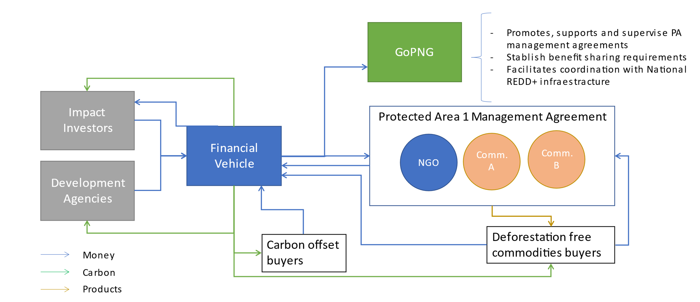

Legal and regulatory framework
The most important legal and regulatory aspects related to the implementation of the co-management model proposed have to do with four aspects already mentioned in the previous chapters: 1) legal rights over land and environmental services provided by those lands, 2) the institutionalization of an appropriate benefit sharing scheme, 3) a transparent and solid financial vehicle and 4) a nesting solution.
Reports from the Department of Lands & Physical Planning and from the Forest Authority retreats highlight some of the challenges to mobilize land and empower land owning communities to make decisions. Questions remain on whether the legislation is sufficient and whether processes are appropriate to facilitate these processes. In general, the need for improvements in land use planning and systems of land management was noted. Significant challenges linked to a lack of broader land use planning to help decision making of forest and forest clearance operations were identified. Additionally, it was suggested that it is important to address how to engage with landowning communities and ensure that agreements are both legitimate and able to last over the time frames needed for these projects.
The reports also mentions that the level of political will is low and the awareness of land-owning communities and other key stakeholders of the potential value of land use planning along with limited resources and the absence of an up-to-date policy and legislative framework was seen as a major barrier to undertake key actions.
A recent PNG GCF proposal highlights significant remaining challenges in the decision-making processes regarding how the allocation of different concession types and processes for land use transitions occur. These include: 1) A lack of coordinated planning on how forest lands can be cleared and utilized; 2) A lack of detailed legislation to conserve and sustainably manage forest resources; 3) A failure to fully implement existing legislation; and 4) The absence of effective support to rural development, leaving land-owning communities seeking private investment as the only way to access the basic services and development opportunities they need. These issues are also extremely relevant for a co-management model for PAs that promotes sustainable land management practices on their buffer zones. Additionally, it is important to mention that working on buffer zones and the potential expansion of PA could eventually see over position of land rights and priorities with Special Agriculture Business License (SABL) and Forest Concessions.
On this topic, interviewees recall that the ILG, a structure developed to enter a deal with forestry or palm oil operators, is already an example of how communities could commit their land towards conservation and benefit from it, assuming that the appropriate local community and government stakeholders were engaged for consent.
Another interviewee commented that “The negotiation and approval of REDD+ deals need to be put on the local level of landowners, with the oversight of the government so that they are not taken advantage of by fraudulent projects. In the past PNG Government claimed the exclusive right to REDD+ projects and revenue, disempowering the landowners – that is not a viable strategy.” Again, a clear benefit sharing scheme and transparent financial resource management should be at the center of its design.
Issues related to a benefit sharing scheme and the need for a specific financial vehicle have already been discussed in chapter 3 in some detail, but responses from the interviews show some of the concerns. One interviewee mentions that “It is still not clear how the money could flow from the centralized government to specific areas. Local governments have not been very active on this, so jurisdictional approaches might not work. A lot of focus has been put lately on the National approach.” It has been highlighted that there is still a lot to do to move the discussion back to the project / jurisdictional level and create the necessary structure for money to transparently and safely move to the local / project level so that initiatives at this level can take off.
In terms of the need to develop a nesting approach, it would be important to consider aspects that relate to the international architecture for REDD+ under article 6 of the Paris agreement and issues around the corresponding adjustments to avoid double counting. This topic is related to the creation of a robust GHG inventory and a national registry system to track emissions reductions mentioned in Chapter 3.

Implementation plan
Phase 1: Pre-feasibility (6 months / by the end of Year 1)
- Study on possibilities and implications of a Co-management model for PA
  - Governance
  - Beneficiaries, benefit and distribution model identification
  - Fund management design
  - Dispute settlement options
- Addressing requirements to use the National Forest Monitoring System for specific PAs.
- Pre-feasibility Study to pre-identified PAs based on national Forest Reference Level
- Nesting design for PNG
Phase 2: Program Design (by the end of Year 2)
- Defining the above-mentioned issues
- Identifying deforestation and degradation drivers and agents in each PA
- Social and land mapping for each selected PA and buffer zone
- PIN development for selected PAs
- Stakeholder engagement and communication Plan for each PA
- Identification of impact investment opportunities and investors
  - REDD+
  - Forestry, Agriculture, Tourism
Phase 3: Fund raising (by the end of Year 2)
- Promotion of impact investment opportunities and due diligence of investors
- Promotion among development finance banks
- Deal structuring
Phase 4: Program Implementation (by the end of Year 3)
- Implementation of Stakeholder engagement and communication Plan for each PA
- Partnership Agreements with local stakeholders for each PA
- Development and submission of Project Design Document for each PA
- Implementation of on the ground activities.
- PDD validation, verification and registry of each PA project.
- Marketing of Certified Emission Reductions

It is important to clarify that Phases 2 and 3 can occur simultaneously. Moreover, income generation from the sale of carbon credits can occur at the end of Year 3 or at the beginning of Year 4 if the implementation schedule is strictly followed. However, circumstances such as extended review cycles during validation and verification, and external events such as COVID-19, political instability, access to internet connection, etc. can affect the schedule proposed for the issuance of carbon credits.

Overall conclusion on pre-feasibility
The achievement of significant emissions reductions in PNG will require a transition in the rural economy and the way that timber and agricultural production is undertaken. When implemented with appropriate emphasis on protection, production and inclusion aspects, a REDD+ co-management model between local communities, civil society and the public sector has the potential to meet the needs of a diverse group of stakeholders and harness the capital necessary to promote and scale sustainable agriculture and forest protection. Such an arrangement would support state actors to achieve climate commitments, develop programs at the territory level, and receive associated result based payments; private sector actors to invest in sustainable commodities and secure a sustainable supply of products for their operations; producers to access markets, technical assistance, and financial resources to increase yields and improve livelihoods; and NGOs, civil society organizations, donors and other sponsors to achieve their respective goals and to efficiently integrate their efforts.
This development model will look to position a selection of PAs as the core of a sustainable land use strategy that develops and promotes high-quality sustainable products and services across all areas (carbon sequestration and storage, timber, coffee, coconut, cocoa, biodiversity conservation) with strong co-benefits. The country's high-forest cover and impressive biodiversity, land tenure regimes that favor local communities and relatively low deforestation rates are conducive for such a model, which will also help reduce forest degradation by providing local communities with alternative viable economic activities.
We consider that this model is a great alternative to generate significant resources for a selection of PA’s in PNG and, to a lesser extent, for the PA network. The implementation of a protection - production – inclusion approach, using carbon revenues strategically to promote investments into commodities and to attract further resources from impact investors into selected value chains seems highly relevant. With an adequate set of regulations and governance structure, this model should lead to a reduction in deforestation pressure, maintaining or even recovering forest cover and the provision of its ecosystem services. For all this to be sustainable in a context dominated by traditional land structures and family agriculture, it must be done by duly incorporating producer families through inclusive business models, within the traditional multi-clan community settings, avoiding incorporated Land Group registration land land-lease arrangements, purchases and displacement, which would generate new deforestation, and ensuring the proper provision of services for production and public services in general.

PNG has the potential to market a high number of environmental and social benefits linked to sustainable and certified agricultural production. Several organizations are already undertaking this work, but opportunities exist to further strengthen and scale up this action. The application of this approach requires a coordinated package of positive incentives spanning regulatory, technical assistance and financial mechanisms. The implementation of REDD+ projects in a selection of PAs could be used strategically to draw in further investments into sustainable land use activities by consolidating a public-private – community partnership model for the country. This model would also provide the possibility of including ecosystem restoration alongside sustainable management and conservation of non-degraded areas within a landscape, or even focus completely on ecosystem restoration, e.g., within nullified Special Agricultural Business Lease areas.

4.3. Biodiversity offsets

Introduction on biodiversity offsets
The below box and following figures communicate the key concepts underlying biodiversity-offset mechanisms.
Figure 17: Biodiversity offsets – simply explained
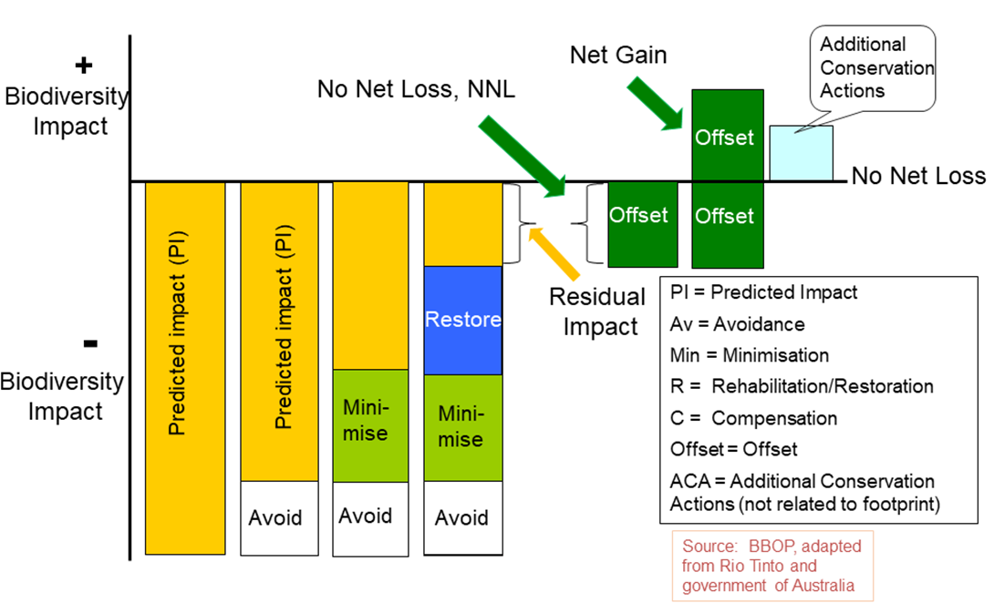
Figure 18: Key steps for biodiversity offsets
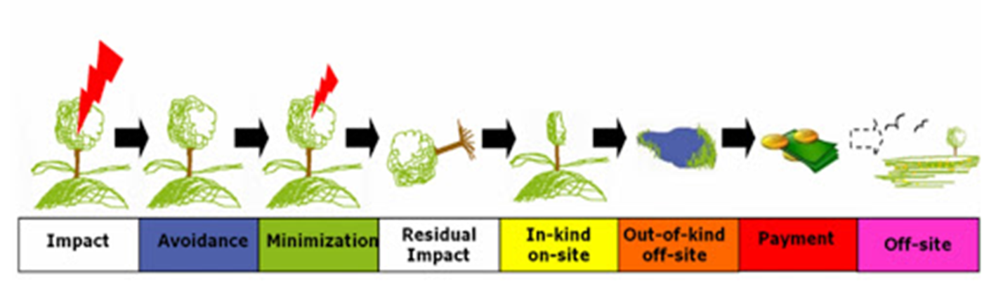

Context / baseline
Even though no biodiversity offset regulation exist in PNG, the PAs Bill (as of the March 2019 draft) defines biodiversity offsets (hereafter ‘Offsets’) “to compensate for any significant residual adverse biodiversity impact arising from an existing or proposed project of industrial development within Papua New Guinea and (a) shall address the residual impact of a project; and (b) have a target that in all the circumstances achieves (i) no net loss [NNL] of biodiversity; or (ii) a gain of biodiversity, in the specific context of the development of a project, or part of a project”.
UNDP has been supporting CEPA to define a relevant framework and policy to implement biodiversity-offsets. The Framework defined in UNDP-TBC (2019) offers the principles and details for a Policy and/or Regulation that will give legal effect to the Environment Act 2014 Amendment “requiring persons carrying out activities which cause environmental harm which cannot be adequately reduced or remedied through avoidance or mitigation to pay an environment offset".
Despite the fact that PNG currently has no specific legal framework on biodiversity-offsets, several key processes and initiatives have emerged, notably:
- The development of a Policy Framework (hereafter ‘Framework’) for biodiversity offsets, developed with UNDP support. The fundamental objectives of the Framework are to: a) incentivize avoidance and minimize the impacts of development projects on biodiversity through levying a realistic liability cost, and b) to deliver positive conservation outcomes to balance residual adverse impacts of development projects by mobilizing Offset payments which will be invested into PNG’s PA system. The framework also specifies key elements for an Offset calculator and a related GIS tool.

- Voluntary private-sector led initiatives for biodiversity offset projects, e.g., ExxonMobil LNG project.
Concerning voluntary private-sector led biodiversity-offsets initiatives, a case study of the ExxonMobil company in the context of the Liquefied Natural Gas (LNG) project in PNG is particularly interesting in terms of proposed process and analysis of the potential for revenue generation. The box below presents the guiding principles of the offset program developed by ExxonMobil, which is particularly relevant as it has a significant focus on how to appropriately gear the offset resources towards the PA system.
Guiding principles of the ExxonMobil offset program – LNG project
The offset program is based on the following guiding principles, which were developed in
consultation with stakeholders:
1. EMPNG’s offset program uses an area-based conservation strategy to offset
potential significant biodiversity-related residual impacts and losses that may
eventuate as a result of PNG LNG. This will be achieved through strengthening
existing PAs and/or establishing new PAs, supplemented by
other targeted projects where appropriate.
2. Priority will be given to strengthening and enhancing existing PAs over
the establishment of new PAs. Opportunities for the establishment of
new PAs will be evaluated primarily on their intrinsic conservation value
and the potential for successful and sustainable outcomes.
3. The offset program will be consistent with conservation priorities in Papua New
Guinea, which are focused on the development of a functioning and representative
PA system and the retention of large-scale forest cover and habitat
integrity.
4. Most land in Papua New Guinea is under customary tenure. Therefore,
conservation initiatives must be community-owned and managed through consent
and the active participation of landowners.
5. EMPNG intends for the PAs strengthened and/or established as part of
the offset program to be of a size that is to be determined case-by-case, based on
their ecological, social and economic viability.
6. EMPNG's offset program must be practical in the context of Papua New Guinea
and geared to prioritize successful and sustainable ecological, social and economic
conservation outcomes.
7. The types of habitat protected as part of EMPNG’s offset program should be
generally similar to the habitat types affected.
8. The offset program should be representative of the biodiversity values affected by
PNG LNG, including potential significant residual impacts to critical habitats,
identified focal habitats and species of conservation value.
9. PAs to be strengthened and/or established as part of the offset program
will be located within the Upstream area where possible.

Without a legal framework in place and operationalized, even after allowing for isolated voluntary initiatives, the biodiversity-offset approach would not represent an important driver for resource mobilization.
It is important to note that biodiversity-offsets can be relevant for both marine and terrestrial ecosystems, and it is important that the BO policy framework encompass both in the future. Indeed, offshore exploration activities, as well as unsustainable fishing practices could be eligible for BO schemes, justifying revenue collection for marine ecosystems and PAs as well.

Scope of the financial solution
Biodiversity-offsetting touches multiple sectors, in particular sectors having a negative impact on ecosystems and natural resources. A list of categories concerned below provides an overview of the diversity of sectors that can be addressed by biodiversity-offsets.
Sectoral categories potentially addressed by biodiversity-offsets, as described in the draft policy framework
Category A
Sub-Category 1: Petroleum Exploration
1.1. Drilling of oil and gas wells – liable if the cumulative area of drill sites, including non-drill site
disturbance such as roads and exploration, is >10 ha.
Sub-Category 2: Mineral Exploration and Mining
2.1 Any drilling program with aggregate depths ≥2,500 meters – as 1.1 (above).
2.2 Mechanized mining on mining lease…chemical processing no greater than 50,000 tons/annum
– liable.
2.3 Gravel extraction ≤10,000 tons/annum – exempt (unless part of existing Project).
2.4 Quarrying ≤100,000 tons/annum – exempt (unless part of existing Project).
Sub-Category 3: Minor Forest Activities – to be reviewed.
Sub-Category 4: Manufacturing and chemical processes – exempt.
Sub-Category 5: Activities involving petroleum or chemicals
5.1 Manufacturing of chemical processes – exempt.
5.2 Pipeline transport and storage using facilities with holding capacities >0.5 mil liters – liable (but
usually part of a larger Project).
Sub-Category 6: Forestry and production of timber products
6.1 Activities associated with a logging operation – to be reviewed.
6.2 Stationary sawmills and treatment facilities – exempt.
19 Currently set at 10 quality-hectares but could be revised based on further stakeholder input. 18 www.thebiodiversityconsultancy.com
6.3 Chemical; treatment of timber using copper-chrome-arsenate – exempt.
6.4 Wood processing to veneer, plywood, etc. – exempt.
6.5 Wood processing to wood products, wastepaper, etc. – exempt.
Sub-Category 7: Mining and extraction – liable.
Sub-Category 8: Aquaculture and agriculture – liable if occurring in natural habitats.
Sub-Category 9: Food processing and plant product processing – exempt.
Sub-Category 10: Energy production
10.1 Hydro-electric plants capacity >2 megawatts – liable.
10.2 Operation of fuel power stations capacity >5 MW – exempt.
10.3 Operation of fuel burning appliances, i.e., furnaces, boilers, etc. – exempt.
Sub-Category 11: Waste treatment
11.1 Sewage treatment in plants serving > an equivalent 5,000 people – exempt.
11.2-11.7 Sub-Category 11: Waste management – exempt.
Sub-Category 12: Infrastructure
12.1 Operation of maritime construction, etc. designed to handle vessels mass >50 tons – liable (on
a case-by-case basis).
12.2 Construction of marinas and boating facilities – liable (on a case-by-case basis).
12.3 Operation of portable water treatment plants capacity >1 million per day – exempt.
12.4 Construction of aerodromes or airfields except unpaved airstrips >10 km from an urban area –
liable (on a case-by-case basis).
12.5 Construction of new national roads – liable (on a case-by-case basis).
12.6 Construction of electricity transmission lines or pipelines >10 km long – liable (on a case-by-case
basis).
12.7 Construction of housing estates with an area of >5 ha – exempt.
Sub-Category 13: Other activities
13.1 Damming or diversion or rivers or streams – liable (on a case-by-case basis).
13.2 Discharge of waste into water or onto land – exempt.
13.3 Abstraction or use of water for commercial purposes – liable (on a case-by-case basis).
13.4 Import or export of ozone depleting substances or pesticides – exempt.

As indicated by the length of this list, many sectors and projects (planned and ongoing) could be relevant for inclusion in a biodiversity-offset scheme in PNG.
In particular, several activities have high potential:
- Petroleum exploration,
- Mineral exploration and mining,
- Mining and extraction
- Forestry and production of timber products,
- Aquaculture and agriculture
- Energy production
- Infrastructures (roads, electricity transmission lines, pipelines, etc.)

In the framework of this assessment, two sectors/sub-sectors are highlighted for further assessment, for which some available data enables initial conclusions on the potential of biodiversity offsets, namely:
- Petroleum/mineral exploration and mining
- Agriculture, in particular the palm oil sector

Considering also that biodiversity-offsets mechanisms are often implemented in a stepwise approach, the two proposed sectors/subsectors may serve as just the first round of the mechanism implementation.

Technical feasibility
Biodiversity-offset (BO) approaches are technically challenging. One main issue is to ensure that offset gains are equivalent to impact-related losses (so-called “Ecological equivalence”). Ecological equivalence is determined through the use of ecological equivalence assessment methods (EAMs) taking into account a range of key considerations such as ecological, spatial, temporal and uncertainty parameters. From the practice, many EAMs have been developed worldwide but none is considered a global standard (Bezombes & al. 2018).
Another critical issue is to put in place a monitoring & evaluation and control mechanism, and to ensure a relevant transaction mechanism is functional. In the context of PNG, the latter may be articulated through the Biodiversity and Climate Change Trust Fund (BCCTF) with a dedicated window to manage biodiversity offsets.
Technical capacities for monitoring and evaluation (M&E) and for the enforcement of the mechanism are key, but require trained staff equipped with the relevant tools (e.g., offset calculators, GIS tools). The level of complexity that an offset mechanism requires should not be underestimated.
In this context, CEPA’s role could be to manage and/or supervise the M&E and control activities of the offset mechanism, unless this role is outsourced to an external independent entity with built-in capacities on biodiversity offsets, for example a local or international NGO (or a consortium of both).
Indeed, in the situation of limited capacities within government agencies, it may be more realistic that CEPA’s role concentrate on:
- Defining and improving the guidelines of the offset mechanism
- Supervising the entity selected for the monitoring and evaluation of the mechanism
- Keeping the registry of offset projects up-to-date

Once the BCCTF is operational, one could also imagine that such a function could be internalized within the BCCTF, thus providing two of the key functions of an offset scheme: a) M&E and control, and b) transparent and reliable transaction mechanism.
In any case, training programs and technical assistance with expertise and knowledge transfers from international experts having implemented such schemes in other contexts will be required.

Environmental and social impacts
Biodiversity-offsets bear in them an environmental liability justifying the offset activity. Environmental impacts are thus at the core of the offset approach. While biodiversity-offsets may be seen by some as a “permit” to pollute and degrade the environment, environmental risks from BO mechanisms can be managed if the biodiversity-offsets conditions are met, in particular by strictly applying the mitigation hierarchy, and gearing offset resources towards ecological equivalence.
Social impacts also represent significant risk factors. Indeed, according to ExxonMobil’s PNG biodiversity strategic plan, “Most land in Papua New Guinea is under customary tenure, involving individuals, families, clans and groups with complex land rights. Boundaries vary from being well agreed and marked to being vague, unmarked, untested and often disputed. Any attempt to control the use of land for conservation purposes requires the consent and active participation of landowners. Conservation initiatives as part of the offset program must therefore be community-owned and managed in order to be viable in the long-term.”
Lessons learned from a the Ambatovy mining case in Madagascar tell us that “local development activities should be implemented before conservation restrictions; special effort needs to be made to target those most negatively affected (who are often hard to reach); engagement with researchers and civil groups can improve targeting of development activities”.

Stakeholder support
Potential support from state agencies
State agencies may have different behaviors vis-à-vis such a mechanism. It is expected that sectors having to engage in restoration may see biodiversity offsets as barriers to the sectoral development. On the contrary, environment-related sectors and those benefiting from natural capital (e.g., tourism) are more likely to strongly support such a mechanism.
Given the different perceptions from one sector to another, it is important that decision-making be conducted or at least overseen by central government departments that can serve as a focal point for the population of stakeholders and carry political clout.
Potential support from private companies
From the point of view of private companies/sectors having to compensate for their impacts, there may be a difference in the willingness to support the mechanism whether it is designed as a voluntary or a compulsory mechanism.
Private sector companies having to offset their negative impacts may not all be willing to enter into such a mechanism if designed as compulsory. Indeed, in some countries, companies prefer compensating their impacts themselves, through their own dedicated team for conservation, thereby avoiding having to pay into a centralized offset mechanism. This has been observed for example with the voluntary scheme developed by ExxonMobil in PNG.
However ,there are cases where biodiversity offsets are compulsory. In Colombia, for example, private companies are required to find an area equivalent to the one negatively affected by the development of infrastructure to compensate the loss of habitats and biodiversity. If compulsory biodiversity offsets are expected to occur, then normally they cannot be combined with other voluntary schemes such as REDD+ in the same project area as this might involve issues related with the demonstration of additionality and double counting. However, Colombia is pioneering this type of combination as the national legislation allows the generation of both biodiversity offsets and GHG removals or reduction inside the same accounting area as long as the areas are not overlapping (i.e., the same square meter cannot generate both biodiversity offsets and VCUs).
The Alicante River Canyon project in Colombia
This project located in the Nordeste and Magdalena Medio regions of Antioquia in Colombia is part of a landscape strategy of northern Antioquia led by the regional government in collaboration with South Pole, a private company well positioned in the trading of payments for environmental services.
The project involves approximately 95,000 hectares of primary and secondary forest and other ecosystems from which 45,000 are dedicated to REDD+ and biodiversity offsets (separately) and the remaining 45,000 are designed for the generation of biodiversity offsets in combination with reforestation activities in separate areas. This nature-based solution involves 300 landowners interested in generating additional income from the protection and sustainable use of their territories. The potential for the generation of carbon credits from the REDD+ initiative is of about 50,000 tCO2e/year, while the potential for the generation of carbon removals is of about 200,000 tCO2e/yr.
The project aims to protect critically endangered species by developing productive restoration activities focused on the recovery of forests and water sources while improving ecosystem services and biodiversity. The project area is home to more than 350 bird, 40 mammal, 40 reptile and amphibian, and 400 flora species. The biodiversity credits generated by the project will allow companies to offset their environmental impacts and invest in the preservation of natural capital, supporting the development of rural communities and protecting biodiversity.
As shown in this case study, voluntary biodiversity offsets combined with REDD+ or voluntary ARR schemes can generate both VCUs and biodiversity offsets in the same area as these schemes concentrate in separate ecosystem services and no specific regulations apply to them. In these cases, biodiversity offsets are usually denominated biodiversity net gains.
Biodiversity offset provisions can indeed be voluntary and include the environmental safeguards policies of private companies and institutional investors. A number of well-recognized international financial institutions include biodiversity offset requirements in their safeguard policies. The Equator Principles contain a recommendation on biodiversity offsets modelled on the Performance Standard/Requirement 6 of the IFC on biodiversity conservation. The financial institutions that adopted these principles are responsible for about 70% of project finance in developing countries. Moreover, an increasing number of companies make commitments for “no net loss” and “net positive” impacts on biodiversity.
Though voluntary offset schemes are quite low cost for national governments, they are not acceptable in a context where no other system is in place. Indeed, a voluntary scheme may result in a situation where few companies choose to offset their projects.
In an approach where there is already another system in place, such as earmarking of fees, royalties and taxes for the mining industry, offsetting impacts may be more viable as there is already a construct to which offset fees could be added.
Table 24: Pros and cons of voluntary versus compulsory offset schemes
 | Voluntary | Compulsory
Pros | -Low cost for public expenditures  -Testing of different approaches by voluntary companies | -High number of companies engaged, hence a higher revenue generation potential  -National mechanism set up (for example through a trust fund), which helps mainstreaming good practices and standards
Cons | -Limited number of companies engaging in offsetting, hence a limited potential for fund raising  -Risks for weak financial architecture, and potentially no national mechanism in place (as offset can be managed directly by companies themselves independently from the state)  -Risks for weak and not transparent M&E | -More expensive scheme to set up

Financial forecasting
The financial potential of biodiversity-offset mechanisms is highly dependent on the value of biodiversity assets in the affected region and on regulatory provisions. For example, in the context of PNG, if the values/Ha used are in the range of the results from the costing exercise, it is likely that biodiversity offsets will not provide sufficient returns. It may thus be critical to define a price/Ha for the offset program that includes the values of the ecosystem services provided by natural ecosystems in PNG. It can also be meaningful to define costs/Ha depending on the localization of ecosystems (like in the USA, as shown in the box below).
Set-up costs
For compulsory schemes, investment by the public sector is limited to the completion of the legislative process (drafting and approval of legislation) and to the creation or delegation of an entity/agency/CTF responsible for overseeing the biodiversity offset market. The cost of drafting new legislation and stakeholder consultations can be in the range of USD $50,000 to USD $200,000. In the case of voluntary offsetting, the costs to the public sector are minimal.

Compensation revenues
The costs incurred by financial institutions and private companies to prevent biodiversity loss depend on the size and value of the development project, related biodiversity loss and the success of other mitigation measures.
Application of the mitigation hierarchy, in particular for avoiding and reducing damages, could be done at reduced costs, such as by adapting the design of the development project. But residual impacts need to be properly compensated. For this, a very conservative assumption of the compensation cost can be extrapolated from the cost assessment for managing PAs (Section 2). However, this value will not lead to sufficient revenue mobilization.
Estimating revenues from selected sectors
It is suggested below to assess revenues from selected sectors, in particular: i) the extractive sectors of Mining / Oil & Gas and ii) Palm oil. These will serve as an illustration, being considered to be sectors with potential for a possible biodiversity offset mechanism in PNG.

- Extractive industry : Mining / Oil & Gas
The calculation is based on an extrapolation of the ExxonMobil engagement for biodiversity offsets for the PNG LNG project. In the case of this project, while the surface affected is 2,373 Ha, the offset target is defined at 13,108 Ha (to account for potential leakages) and a more ambitious offset framework is defined at 50,000 Ha, which enables to supposedly ensure ecosystem conservation and restoration on a wide scale while offsetting negative impacts.
Table 25: Revenues from an offset transaction – order of magnitude
 | LNG project | EMPNG’s offset target | Offset framework
Hectares | 2,373 | 13,108 | 50,000
Revenues (cost Sc1)/year | 9,895 | 54,660 | 208,500
Revenues (cost/Ha: 40 USD) | 94,920 | 524,320 | 2,000,000
Revenues (cost Sc1) – cumulated 10 years | 98,954 | 546,603 | 2,085,000
Revenues (cost/Ha : 40 USD) – cumulated 10 years | 989,540 | 5,466,030 | 20,085,000

Considering the cost/Ha for PA management defined in Section 2, the amount mobilized for the whole offset framework would be about USD $208,500/year. If we consider a higher cost/Ha (USD $40 /Ha) in the range of what EU countries spend for PAs for example, revenues could increase, up to USD $2M /year (with an ambitious offset framework approach). Nonetheless this high figure seems quite unrealistic, and the most ambitious scenario may rather be closer to the revenue from the ‘offset target’ scenario with about USD $520,000 /year.
In an attempt to extrapolate to the full Oil & Gas & Mining sectors in PNG, considering a conservative figure of 10 large mine projects entering a biodiversity offset agreement in the next few years, one may count on biodiversity offset revenues ranging from USD $100K to USD $5.5M /year. Given the efforts to be required to develop an operational biodiversity-offset mechanism, a realistic estimate might be in the range of USD $2-3 M /year mobilized through an offset mechanism from the extractive industry.
These figures are far less than what could be expected from the financial option on the earmarking of levies and royalties from the extractive industry, thus it seems relevant to favor the option described in Section 4.1.

- Palm oil sector
The palm oil sector may have an interesting potential for biodiversity-offsets in the context of PNG. Indeed, palm oil is “the largest produced agricultural commodity in the country. In 2017, palm oil production contributed to $344 million of the country’s total export earnings, providing employment to upwards of 200,000 Papua New Guineans. Being widely recognized for the fact that 95% of the country’s palm oil is rated as sustainable (with RSPO label or in process to become RSPO certified), Papua New Guinea is a global leader in premium palm oil produce, but the recent introduction of the palm oil and logging industries have begun to put a serious strain on the once evergreen landscapes of the country.” To face such challenges, the Papua New Guinea Palm Oil Platform (PNG POP) was launched in 2018 with strong commitment from the national government, leadership by the Papuan Department of Agriculture and Livestock, and funding from the UN REDD+ project.
Another major player in this space is the PNG Oil Palm Industry Corporation (OPIC), a levy-funded agency of the PNG Government responsible for a range of industry support activities including providing advice, disseminating information and educating small-holders regarding oil palm production methods. Palm oil plantations in PNG cover a land area of 58,000 hectares (estate 33.000 ha and smallholder 25,000 ha, involving about 7,000 families). The estates produce 65% of the output and 35% from the smallholders.
While it is difficult to access any precise data on the future development of the Palm Oil industry, many new projects are in the pipeline, representing hundreds of thousands of Ha.
Assessing the potential for the palm oil contribution to biodiversity-offsets through the RSPO principles would include :
-assessing which of the palm oil operators with RSPO certification did not conduct a proper HCV assessment after 2005
-from those who conducted a proposer HCV assessment, determining which have indeed led to a liability calculation and compensation
-calculating the gaps and the need for additional liability compensation
-assessing the future potential for RSPO-based remediation and compensation, based on future planned palm oil projects.

Figures on the conservation liability cannot be found from the RSPO Remediation and Compensation scheme and data base. However, to provide an example, we can consider Papua and West Papua (Indonesia), where figures are available.
Eight active companies in Papua and nine in West Papua have developed plantations in Papua since 2007 that could potentially be liable for deforestation offsets. Clearing during that period could reach over 70K Hectares. Considering a conservative estimate that 25% would fall under RSPO liability scheme, then the maximum amount that could be paid for compensation would approximately reach: 70K ha x 0.25 x USD $2,500 (fine) = ~USD $43M as a one-time payment.
Even if the assessment of the potential for biodiversity-offsets from the palm oil sector following the RSPO procedure would require a study in itself, it seems that the potential is significant.

Management
Given the technical challenges of the biodiversity-offset mechanism, it could be envisioned that the daily management of such a scheme could led by an organization disposing of the necessary expertise and capacities (which may be an international NGO in consortium with a national partner, as suggested previously), serving as an “independent offset operator”.
CEPA’s role in such a scheme could include:
- Defining and improving the guidelines of the offset mechanism
- Supervising the entity selected for the monitoring and evaluation of the mechanism
- Keeping the registry of offset projects up-to-date

In a compulsory scheme, an audit function will also be critical, to ensure compliance of the offset activities and transactions with the planned rules and procedures.
A critical aspect of such a scheme is the possibility that a CTF (the BCCTF could play this role) would ensure the collection and transfer of the offset transactions. With the BCCTF ensuring this function, the offset scheme could take a nation-wide approach, while enabling other sectors to contribute. The figure below highlights a possible mechanism based on the BCCTF in which biodiversity offsets are managed alongside other schemes such as the earmarking of fees, taxes and royalties which has a big potential in PNG.
Figure 19: Possible biodiversity-offset scheme through the BCCTF in PNG
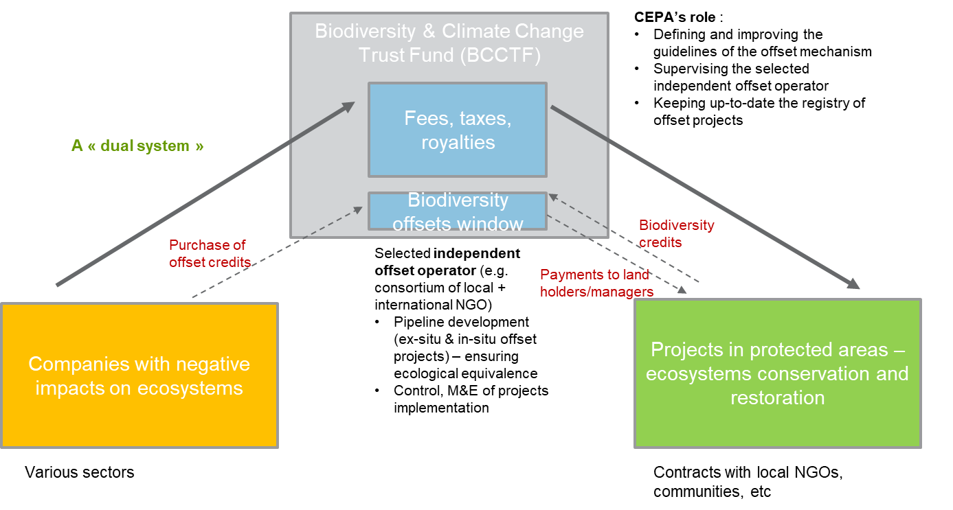

The role of local level governments could also be promoted to ensure proper actions are implemented and monitored on the ground, and that the necessary oversight mechanisms are put in place at the local level.

Legal and regulatory framework
A legal framework specifying the rules and procedures of a biodiversity offset mechanism is critical for the deployment of this option. It is thus necessary that the policy framework be defined as well as the tools developed for the effort to become operational. Ideally the legal framework would (among other elements):
- Emphasize the importance of the mitigation hierarchy
- Define the payment modalities and rates of the offset transactions
- Specify the use of revenues for PAs

If many countries have developed such a framework, adaptation to the PNG context may still require significant time in stakeholder’s consultation and in technical analyses which should not be underestimated.
Meanwhile BO can continue being implemented on a voluntary basis, still keeping this option at a rather limited potential.

Implementation plan
Implementing a BO mechanism in PNG would require following steps :
- Finalizing and enacting a policy framework on biodiversity-offsets
- Engaging awareness raising and negotiations with 2-3 pilot sectors (e.g., oil & gas, mining, palm oil) in order to define offsets rules and procedures (e.g., on ecological equivalence), including transactions modalities and payments rates
- Defining what the financial vehicle will be, ideally in connection to the planned BCCTF
- Selecting the team in charge of the daily management of the BO mechanism (an independent offset operator)
- Piloting the BO approach with the selected pilot sectors in selected regions, engaging the local level governments

Overall conclusion on pre-feasibility
Despite its technical challenges, the BO are a feasible option in PNG, with significant financial potential. While it may not yield the types of revenues that other options could deliver, it can be considered as a viable option. For sectors such as oil & gas, mining and palm oil, the potential has been highlighted in this section.
Ideally BO operationalization would be done through a CTF such as the proposed BCCTF, and it would take a compulsory form (versus a voluntary orientation which does not ensure sufficient resource mobilization). Indeed, if no other instrument would address sectors damaging the environment, biodiversity-offsets would make sense only if they are mandatory.
There is high potential that BO could be complementary to other financial options, such as i) earmarking of fees, taxes and royalties (as highlighted in section 4.1 with the proposal for a “dual” system) and ii) payments for ecosystem services. Indeed, PES can be better perceived by multiple sectors, building on the “user-pay” principle, and could easily aggregate contributions from damaging sectors, using the “polluter-pay” principle.
While several stakeholders would have a role to play to ensure implementation of this scheme (including the offset operator, the BCCTF, auditors, etc.), CEPA’s role in a biodiversity-offset mechanism should be well framed so it can concentrate on achievable tasks.
More information on the possible implementation plan of the BO option can be found in Section 6.

5.Analysing relevance of additional financial options

5.1. Debt-for Nature Swap

Introduction on debt-for-nature swap
Debt-for-nature swaps (DNS) are financial instruments that aim at helping indebted developing countries to protect their nature by reducing their debt burden in exchange for debt forgiveness or readjustment. For this arrangement to work, the accrued savings in local currency of debtor countries should be used to finance conservation and/or climate-related initiatives. Hence, while debtor countries increase their fiscal space and protect their natural resources, creditor countries, organizations and/or private companies benefit from improving their environmental credentials, but also from increasing the value of the remaining debt and even from exiting from negotiations with problematic debtor countries, among others.
Several types of debt relief agreements can be applied from creditors depending on the specific circumstances of debtor countries and on the wiliness of creditors to absolve partially or totally the debt or to sell the debt to a third party at a lower price in exchange for committing to direct investments in conservation initiatives. The money allocated to conservation initiatives is usually managed through a trust fund in charge of disbursing grants or funds used for example for the management of PAs.
The type of agreement will depend on the owner of the debt. Debts owed by governments can lead to public/bilateral swaps, while debts owned by either national or international private entities can lead to private or commercial swaps. Bilateral swaps are usually conceived by members of the Paris Club (a club of 19 creditor governments that often are interested in swap conversions to increase their official development assistance to developing countries). Bilateral swaps can require the participation of NGOs willing to participate in the agreement and allocate resources if they are addressed towards conservation. On the other hand, commercial swaps usually involve donors interested in acquiring part of the debt obligation at a reduced cost.
In the case of PNG, it will be critical that a DNS approach can ultimately support both marine and terrestrial PAs. The example of the DNS approach in the Seychelles (see box below) used for marine conservation could be adapted to the PNG context as well, in particular through the BCCTF.
There is no unique formula for designing a DNS mechanism as they depend on the specific country circumstances. Among the factors to be considered are included :
- political will,
- identification of projects,
- identification of neutral third-party organizations willing to collaborate (usually NGOs),
- designing a monitoring and implementation plan,
- clarifying governance structures to ensure transparency and reduce bureaucracy as these processes are already considered lengthy,
- involve local communities in all process and improve their capacities,
- encourage participation from the private sector and for entities willing to provide additional incentives to foster conservation,
- define a financial vehicle that is secure and provides guarantees to all participants such as a conservation trust fund.

The following are the pros, cons and risk of debtor countries willing to enter into a DNS agreement:
Table 26: Pros and cons of debt-for-nature swap
PROS | CONS
- Reduction of debt obligations  - Decrease of payments in foreign and more expensive currencies  - Increase of fiscal space for environmental spending  - Reduce debt distress  - Leverage funds for conservation and attract further investors  - Promote the participation of civil society and NGOs  - Improves debtor country’s credit standing, allowing for greater access to credit markets  - Stimulates the creation of environmental trust funds to dispense DFN proceeds | - Usually, the amount of the debt relief is small  - High transaction costs  - Time consuming negotiations (up to 3 years)  - Lengthy negotiations that increase operational costs  - Currency exchange risks  - Increase of future payments due to inflation  - DNS might exclude other forms of potential negotiation  - Lack of willingness to respect the agreement due to economic crises  - ODA substitution  - Deficient management of the CTF  - Loss of sovereignty about the spending of public resources  - Trade impositions from creditors  - Lack of political will  - Lack of good governance and enabling environments of debtor government.  - lack of transparency or accountability of project activities.  - Change of political leadership of debtor government causing discontinuity in the agreement.  - Lack of involvement of civil society, NGOs and private sector

Case studies

Below cases are concrete examples of the use of DNS approaches for conservation objectives.
The Seychelles Debt Restructuring for Marine Conservation and Climate Adaptation Program

Context
In 2018, the Republic of Seychelles agreed to protect three-quarters of its marine and coastal area in exchange for a reduction of its external debt. After about four years of negotiation, the Seychelles debt swap financing agreement was made possible with the support of private investors (China Global Conservation Fund of The Nature Conservancy, The Jeremy and Hannelore Grantham Environmental Trust, Leonardo DiCaprio Foundation) and bilateral and multilateral creditors including the governments of Belgium, France, Italy, the United Nations Development Program, the Global Environment Facility, and the World Association of Islands.

The debt conversion designed by the Seychelles government and The Nature Conservancy (TNC) is the first oceanic debt conversion worldwide and resulted in the swap of USD $21.6M of Seychelles' external debt upon commitment of the country to invest in long-term ocean conservation, and in the implementation of a marine spatial plan. The Seychelles Conservation and Climate Adaptation Trust (SeyCCAT) supports the financing of a Marine Spatial Plan for the Seychelles Exclusive Economic Zone, and the implementation of conservation activities for marine protection. The main project executed as part of this swap is related with the work developed by the Green Islands Foundation, which helps fishing communities identifying and developing sustainable alternatives to recover vulnerable fish population.

Scope
The Seychelles agreement aimed to increase the marine conservation area from 1% to about 30% by 2020. The main objective was to protect more than 40 million hectares while promoting sustainable development and adaptation to climate change. NatureVest, a unit of the Nature Conservancy, helped facilitate the swap in collaboration with the government to purchase and restructure Seychelles debt of USD $21.6M with members of the Paris Club. The money used to buy the debt was raised from impact loans (USD $15.2M) and from grants of philanthropic organizations focused on marine conservation (USD $5M). The estimated debt relief of this transaction was about US $1.4M. The funds obtained by NatureVest are financially managed by the Seychelles Conservation and Climate Adaptation Trust (Seychelles Conservation and Climate Adaptation Trust - SeyCCAT). The total amount of funds created from this transaction for the conservation of Seychelles marine resources is equivalent to UDS $5.6M (USD $280K/year).

Key Results
The zoning of the conservation area according to the allowed productive activities:
- Zone 1: areas of Greater Protection of Biodiversity (islands of the Aldabra Group), where human activities are prohibited in approximately 90% of the area, except for the execution of non-extractive activities such as tourism.
- Zone 2: Biodiversity Protection and Sustainable Use Zone (Amirantes Group and the Mahé Plateau), a zone where economic activities, such as fishing, sustainable tourism, and renewable energy production are allowed

JAMAICA DNS

Context
As a measure aimed at conserving and recovering the country's tropical forest resources, Jamaica signed a debt-for-nature swap agreement with the United States amounting to some USD $16M.
In 2000, the Forest Conservation Act of 1998 was funded to allow developing countries to reduce their debts to the United States and, at the same time, generate funds to conserve their forests. Jamaica is one of eight countries that have benefited from the Act so far, the others being Bangladesh, Belize, Colombia, El Salvador, Panama, the Philippines, and Peru. Together, these agreements will generate more than USD $95M to protect tropical forests over the next 10-25 years.

Scope
The main purpose of this DNS is to assist Jamaica in its struggle to safeguard the valuable forests and rich biodiversity for several areas. These include areas such as the Blue and John Crow Mountains National Park/Forest Reserve, home to the island's highest peak, the endangered giant fork-tailed butterfly, and several endemic orchids. It also includes the Portland Bight PA, the only place on the island where the Jamaican iguana, once thought to be extinct, is found in the wild.
The United States and Jamaica, together with The Nature Conservancy, concluded agreements to reduce Jamaica's debt to the United States by nearly USD $16M. In return, Jamaica has committed to providing the accrued resources to fund conservation and restoration projects for important tropical forest resources in the nation.
The two most important benefits to the island are the replacement of the US dollar obligation with a local currency and the restoration of forest land in priority areas.

Key Results
The funds were used to support local forest conservation activities over the next 20 years through the creation of the Tropical Forest Conservation Fund.

Potential for PNG and key steps for implementation
With the planned development of a Conservation Trust Fund (BCCTF in PNG), the financial mechanism underlying the DNS may be operational in the medium term. The time horizon for the development of the BCCTF may fit quite well with the necessary time required for DNS negotiations between PNG and its creditors potentially engaging in a DNS approach.
Opportunities of DNS for PNG can be identified through a first quick screening of PNG’s creditors as identified by the IMF in the figure below.
- Interestingly, one can see that the level of projected debt increase vis-à-vis the Paris Club and Multilateral creditors is quite high.
- The level of commercial debt is also significant (for example, one of the former key creditors was the international bank Credit Suisse)
- While China is an important bilateral creditor, one can question if China would be ready to enter a bilateral negotiation (though a Chinese institution did play a role in the DNS model of Seychelles).
- Australia (from the Paris Club) seems to be a significant creditor as well.
Figure 20: Information on key PNG creditors

The “building back better” (from Covid) agenda tied to the development cooperation plans for creditor countries may also be an entry point for DNS. “As part of pandemic economic rescue packages, governments have an opportunity to address simultaneously the crises of debt, climate and biodiversity destruction,” researchers from the London-based International Institute for Environment and Development (IIED) wrote in a report. The same report highlights a ranking of countries that would benefit most from such “debt swaps” based on their vulnerability to climate change, richness of biodiversity, indebtedness and creditworthiness. At the top of the list are Cape Verde - an island nation off the coast of West Africa - Vietnam, Honduras, Kenya, Nicaragua and Papua New Guinea.
An important consideration on DNS potential in PNG is that it may only be relevant for the BCCTF capitalization, considering that a swap of USD $30M, placed in an endowment fund at 3% net return (considering returns assumptions from CFA, 2020) may help mobilize about USD $1M USD per year for the PA system. Such revenues are perpetual, and possibly very favorable if interest rates were to increase in the future. Besides the possible importance of such a scheme for biodiversity financing, it also enables the Treasury to improve the situation of national indebtedness by establishing a more beneficial debt repayment schedule.
The typical steps for implementation involve:
- Awareness: determine the level of interest and political will
- Advocacy: pre-assessment of the debt to be swapped and financial vehicles
- Feasibility: review of foreign debt profile, creditors interest in negotiating, financial design
- Negotiation: At a minimum the following terms should be clarified and agreed between creditors and PNG:
  - Amount and type of debt to be negotiated
  - Share of debt that can be swapped (conversion rate)
  - Redemption price
  - Form of the proceeds
  - Exchange rate
  - Schedule and procedures
  - Terms for the use of revenues
  - Procedure for monitoring compliance
- Signature
- Transfer of funds
- Monitoring of funds
- Replication and scale-up

5.2. Payments for Ecosystem Services

Introduction on Payments for Ecosystem Services
The best- known PES definition (Wunder, 2005) – later in the publication, referred to as the Wunder PES definition – defines PES as: “ a voluntary transaction (1) where a well-defined ES (or a land-use likely to secure that service) (2) is being ‘bought’ by a (minimum one) ES buyer (3) from a (minimum one) ES provider (4) if and only if the ES provider secures ES provision (conditionality) (5).
In general, impactful PES are in reality so-called quasi-PES as they are not voluntary. Such schemes often rely on a legal basis and are articulated through a national fund.
Some PES are voluntary and developed by the private sector, as the case of the Vittel company in France as shown in the figure below.
It appears thus clearly that PES schemes have a potential for biodiversity conservation. Case studies in this section provide more elements on how such mechanisms could work.

Figure 21: Payments for Ecosystem Services: a possible scheme
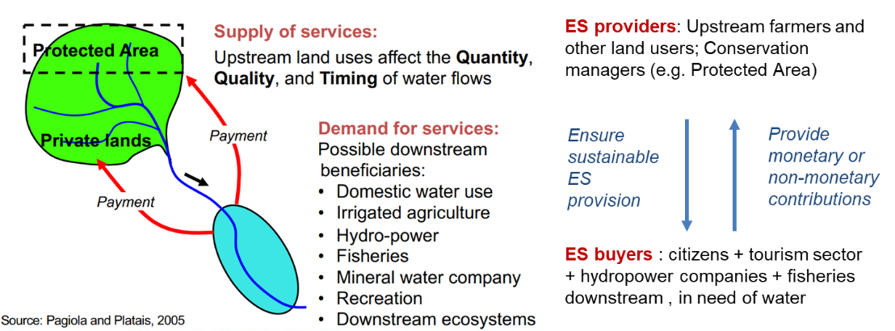

Figure 22: Example of a private PES scheme
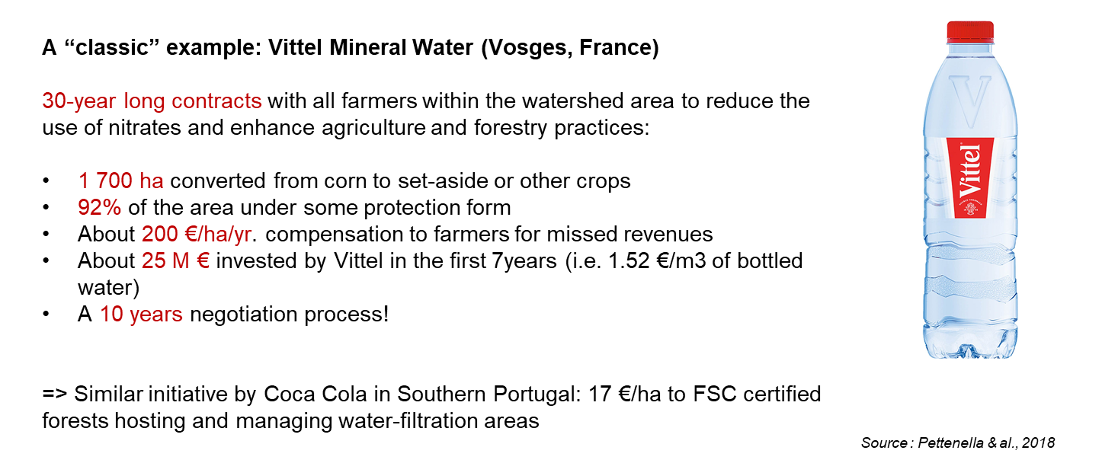
PES approaches can also be tailor-made to marine PAs and ecosystems. For example, financing agreements with fishermen, marine tourism operators and upstream stakeholders impacting estuaries and coastal ecosystems can be formalized in order to incentivize adoption of good practices for marine conservation.

Case studies
Several case studies can serve as meaningful sources of inspiration, such as those in Costa Rica, and Vietnam. Indeed, these two countries established operational national PES schemes articulated by a domestic fund, namely the National Forest Financing Fund (FONAFIFO) in Costa Rica, and the Vietnamese National Forest Protection and Development Fund (VNFF) in Vietnam. Table 27 describes the key elements of the two cases.

Table 27: Cross-comparison of the two PES case studies (Costa Rica, Vietnam)
Country | Costa Rica | Vietnam
Name | National Forest Financing Fund (FONAFIFO) | Vietnamese National Forest Protection and Development Fund (VNFF)
Legal form | Public entity (agency) | Public entity (agency)
Fund type | Revolving | Revolving
Operational since | 1996 | 2008 (VNFF establishment);  2010 (PFES)
Governance | Open (to multiple sectors) | Open (to multiple sectors)
Decentralization | Yes, with regional offices | Yes, with provincial funds
Utilization | Economic incentives | Economic incentives
Capitalization | Taxes (oil, water), CSR contributions, bilateral and multilateral funding | PES contributions from economic sectors (hydropower, water distribution, industry, ecotourism, etc.)
Capitalization/year | ~25 M USD | ~100 M USD
Oversight/M&E | Independent and external audit | Independent and external audit

Figure 23: FONAFIFO PES scheme in brief
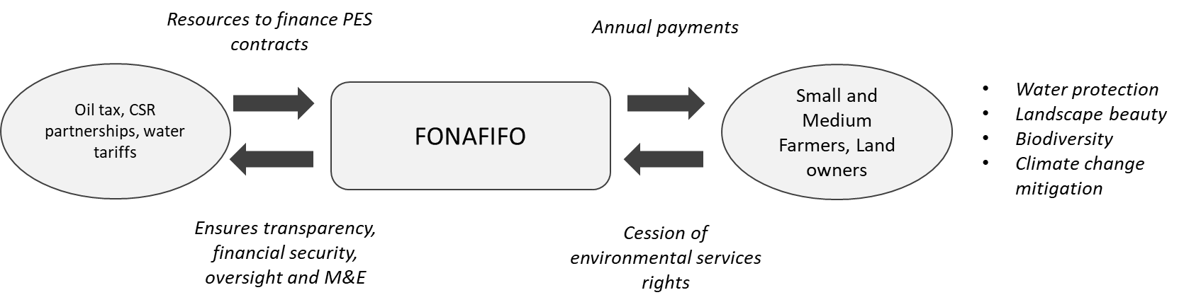

Figure 24: Examples of PES modalities, FONAFIFO – non-exhaustive and illustrative
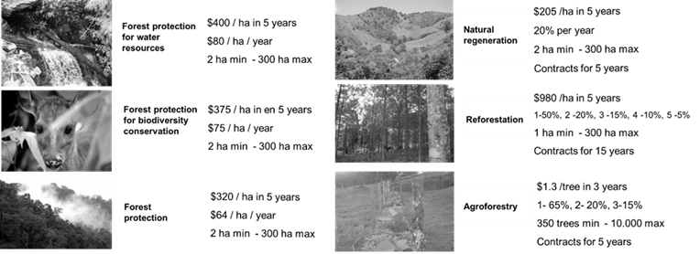

While these models are different, they all have a legal base, operate as revolving funds, and provide economic incentives for the provision of ecosystem services (FONAFIFO and VNFF).
FONAFIFO presents several remarkable characteristics. Firstly, ecosystem services to be paid for (i.e., biodiversity, water, carbon, landscape beauty) and the PES system are integrated within the forestry law and related regulations. Secondly, direct individual payments are granted to households/farmers and differentiated financial incentives are provided, depending on ecosystem types or land-use patterns (see figures above). One of the success factors of this approach is the land ownership (land-rights securitization) which covers the totality of the Costa Rican territory. Local associations and groups representing vulnerable people (such as those in indigenous territories) are also eligible to perceive payments, following FONAFIFO conditions. Moreover, FONAFIFO is capitalized through diverse sources including an oil tax, water tariffs, and partnerships with the private sector (Table 27). Finally, decentralized offices for local management and technical assistance (regional FONAFIFO offices) enable close support for the PES beneficiaries. Close coordination at national and decentralized levels is ensured with other state organizations such as the National System for Conservation Areas (SINAC).
Table 28: PES revenues in Costa Rica in 2019
Revenue/PES spending | USD | %
Oil tax | 17,919.144 | 72.5%
Water tariff | 2,294,680 | 9.3%
CSR partnerships | 39.712 | 0.2%
Remaining from previous year | 4,468.068 | 18.1%
Total | 24,721,064 | 100%

The case of the VNFF in Vietnam is characterized by an important level of decentralization, with the existence of provincial funds connected to the VNFF. Starting from just four provincial funds in 2009, 46 provincial funds were established in 2019. The capitalization is based on diverse sources of financing, including hydropower companies, water suppliers and tourism sector contributions, among others. This ensures a solid revenue stream. Table 28 highlights the different financing sources of the Vietnamese Payment for Forest Ecosystem Services (PFES) mechanism, currently mobilized and in development. For example, PFES contributions from the aquaculture and industrial sectors have been tested in the last years (iPFES, 2017). Capitalization efforts in recent years have enabled a major increase of the VNFF revenues, from close to USD $60M in 2016 to more than USD $130M in 2018. It is notable that a REDD+ trust fund is operating under the umbrella of the VNFF in order to ensure synergies with other forest financing sources. The optimization of financing flows towards final beneficiaries - only 0.5% are mobilized for administrative costs at the national level, and about 15% at the level of provincial funds where the administrative management is more demanding. Thus, between 75% and 85% of initial funds effectively reach local final beneficiaries. Tests are ongoing for a wide use of GIS monitoring technologies, as well as e-payment systems to increase efficiency in PES delivery.
Table 29: Revenue sources of the VNFF in Vietnam
Revenue/PES spending | Amount (USD) | %
Hydropower (indirect) | 0,0015 USD/kwh | 96.7%
Clean water suppliers (indirect) | 0,0022 VDN/m³ | 2.9%
Industry facilities (indirect) | 0,0021 VDN/m³ | 0.01%
Eco-tourism agents (direct) | Min. 1% revenue | 0.3%
Aquaculture producer (direct) | Min. 1% revenue | 0.001%
Large CO2 emitter (piloted) | 0,0002 USD/kwh; 0,0912 USD/ton clinker | -

Figure 25: Financing scheme of the PES under the VNFF
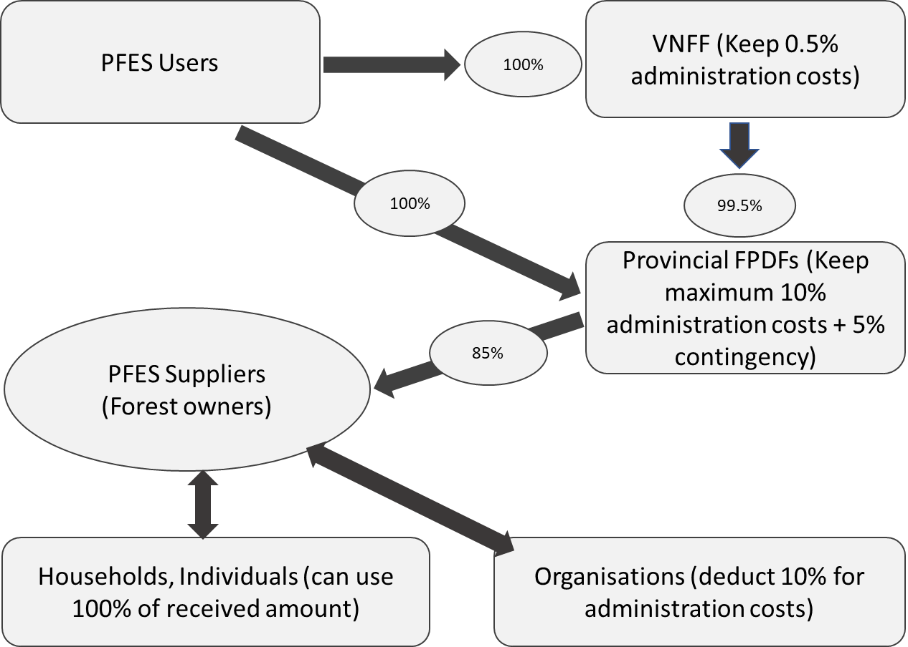

With more details, the PES rational for both case studies is as follows:
Table 30: PES-like approaches in the FONAFIFO and VNFF more in detail
 | FONAFIFO | VNFF
PES rationale in the capitalization (“Demand-side PES”) (i) | Indirectly (Non-forest related taxes) | PES contributions from economic sectors and companies  “polluter-pay principle” (towards ecological compensation)  +” beneficiary-pay principle”
Beneficiaries (ii) | Payments to smallholders/individual farmers | Payments to cooperatives/associations, and to individual farmers
Clearly defined ES (with ES prioritization)  (“Supply-side PES”) (iii) | Yes (prioritization of ES and differentiated payment) | Indirectly through targeted ES with contributing economic sectors and operators
Definition of PES amounts (iv) | TEV and/or a negotiation with beneficiaries on the WTA | A mix of cost of degradation,  TEV, and a  negotiation on the WTP/WTA
Valuation of ecosystem services on markets (v) | Yes, with UCC (ecosystem services rights on carbon are retroceded to the FONAFIFO) | Indirectly through REDD+ financing
REDD+ valuation (vi) | FONAFIFO plays a key role in the REDD+ implementation | A REDD+ trust fund has been created under the VNFF umbrella

Potential for PNG and key steps for implementation

In contrast to biodiversity-offsets, PES insist on the “user-pay principle”, thus the economic sectors and companies contributing have a real incentive to pay in the system that will in turn provide them with direct benefits.
Such a system can also be coupled with sectors and companies with the polluter-pay principle, here applying the offset approach. This way it appears clearly that offsets and PES are two complementary approaches, with a significant advantage on the PES side as it also mobilizes multiple sectors and stakeholders requiring nature in good conditions. PES thus represent a more positive and attractive solution to mobilize multiple sectors in contributing to nature conservation. Also, it is critical to think of an allocation of the earmarked fees and royalties (Section 4.1), which can play a key role for capitalizing a PES scheme.
In the case of PNG one challenge may be the definition of land tenure rights, but there are ways to overcome this difficulty. Indeed, in quasi-PES models like in the case of the Moroccan National Forest Fund (supporting a payment for ecosystem services type of approach), traditional communities can benefit from PES payments. So local traditional groups create local associations which help them structure and decide on the use of PES resources. Payments are directly transferred into the association account.
Key steps include for the implementation of a PES scheme :
- Anchoring the concept of Ecosystem Services in the national legislation, as well as the concept of PES;
- Assessing willingness to pay (WTP) / willingness to accept (WTA) for all parties involved;
- Defining the level of payments per type of land use supported by the PES fund (payments modalities);
- Specifying beneficiaries (smallholders, communities, wards, villages, others?);
- Developing the financing mechanism (possibly directly in connection with the BCCTF in the case of PNG.
- Putting in place the payments schedules from multiple companies and economic sectors (in general it is easier to start with one or two sectors only); using both the “user-pay” principle and the “polluter-pay” principle.
- Developing social safeguards around FPIC and MAT concepts
- Testing the PES mechanism in selected landscape(s) / PA(s) both in terrestrial and marine PAs

5.3. Third party management of PAs

Introduction on Third party management of PAs
Two main forms of third-party management will be addressed in this section:
Concession contracts, for example for tourism activities
A concession is the right to undertake a commercial or management operation within a PA, granted by a government, community, or other controlling or management body (the concessioning authority) to another party (the concessionaire), usually in exchange of a fee or a share of the revenues generated. (CFA, 2020). This solution addresses the lack of capacities of national and local governments to operate management operations and/or eco-friendly successfully. Concessions can be powerful tools to mobilize the private sector, thus contributing with its own resources and often able to mobilize investments for commercially viable activities, while generating social and environmental benefits. In order to contribute properly to biodiversity conservation, the specifications and rules of concessions must be well defined (with exclusions of harmful activities).
Wyman & al (2011) highlighted some of the good practices in tourism concessions (box below).

PA Management contract
Management contracts are instruments through which the government entrusts a third party, typically non-profit organizations, individually or in association, the total or partial execution of the operations on a PA’s master plan.
By means of the administration contract, the executor of the contract is empowered to manage and administer a PA, while the National PAs Authority is responsible for control and supervision. In addition, the executor of the contract administers the economic resources allocated or obtained for the benefit of the area and promotes the active participation of the local communities in the management of the area.

Case studies
In Peru for example, third party management contracts can only be used on a few categories of PAs. During the last 10 years, REDD+ projects designed and implemented by NGOs, including Conservation International, have been using this legal structure to successfully manage 4 PAs in the country.
In Indonesia, the Ecosystem Restoration Concessions (ERC) are another interesting model. The Indonesian Ministry of Environment and Forestry issued 60-year licenses to companies in order to develop sustainable forms of businesses that cover the costs of restoration and protection of local forests. While the land is being restored, income streams are expected to be based on Non-Timber Forest Products (NTFP) like honey, dragon blood fruit, rubber etc. and Payments for Ecosystem Services (PES including carbon credits). Once restoration is completed, companies can start logging again in a responsible manner, while carrying on with forest protection. Development banks such as KfW started to invest in such schemes.
In some countries like South Africa the revenues from tourism concessions represent almost all of the operating costs of PAs. When investments are required in PAs, concessionaires may also have the opportunity to mobilize impact funds (CFA, 2020).

Potential for PNG and key steps for implementation
No existing study assesses the financial potential of concessions for PA financing in PNG. Nonetheless results from other parts of the world provide interesting insights. For example, a 2010 survey of PA financing in the LAC region found out that the concessions were the second most important source of site-based revenues for PAs. The study also showed that most LAC countries were not using the concession modalities, hence letting a potential uncaptured (CFA, 2020).
The main challenge in PNG for the concession mechanism may have to do with the tourism development perspectives. If beyond the covid-19 crisis ecotourism development would increase, there is a certain potential to seize by using the concessions/third-party management modalities, in particular for the tourism sector. Both for remote and non-remote PAs, tourism operators could be granted the possibility to operate sustainable tourism business models, thus being able to pay a fee, rental contribution to the PA authority. Surely commercial-viability would have to be analyzed before entering a concession agreement and depending on the PA type and remoteness not the same business models would apply.
Steps for implementation may include :
- Listing the priority PAs where a concession model could be successful
- Defining criteria for the selection of “concessionaires”, including E&S safeguards
- Building the capacities of the national institutions in charge to supervise the concessions model (e.g., CEPA, TPA, etc.)
- Opening a tender process to potential concessionaires, and selecting the best candidates
- Negotiating the revenues models, to ensure a relevant flow back of resources for the management of PAs (potentially, envisioning a part of concession revenues to feed in the BCCTF)
- Facilitating a good relationship between concessionaires and local communities, ensuring FPIC and MAT conditions are respected
- Helping concessionaires access additional financing if needed, for example through impact finance

5.4. Tax exemption on donations

Introduction on Tax exemption on donations
Tax exemptions on donations can be a significant driver for any public goods-oriented organization. In general, occurring when the organization is recognized as a special status of serving public interest, this particularity can play a catalytic role for increasing financing flows, in particular grants.
Beyond tax exemptions on donations, there may be also another interesting focus of tax exemptions applied to investments in public infrastructure. This mechanism allows private companies to coordinate with the government the execution of high priority public infrastructure projects in exchange for income tax deductible certificates. It is therefore an opportunity for the public and private sector to work hand in hand to reduce the infrastructure gap in a country. Such a mechanism can be applied for green infrastructures which can be relevant for nature conservation. Private companies advance the payment of their income tax to finance and execute directly, quickly and efficiently, public investment projects prioritized by subnational governments and national governments. Once the execution or progress of the project is completed, the Public Treasury returns the amount invested to the Private Company through Certificates that may be used as Income tax payment. In some cases, public entities might return to the Public Treasury the amount financed for the execution of their projects.

Case studies
Interesting case studies include existing CTFs that enable donations with tax exemptions (CFA, 2008, 2020). This turns out to be a solid mechanism, that is also used by international platforms for conservation finance. Examples include the WeForest initiative, the Global Nature Fund, among many others.
FONAFIFO in Costa Rica is an interesting model of a national fund articulating a national PES scheme. While most of its resources come from taxes and levies, donations from individuals and corporates represent up to 5% of the fund capitalization. Despite a small share, it is symbolically interesting to engage citizens and corporate stakeholders in biodiversity conservation.
A good example of the tax exemption on investments schemes can be found in Peru. Since the legislation creating this mechanism in Peru was approved in 2009, more than 370 projects have been executed in the country for a total of USD 1.5 billion dollars. Some of these directly contributed to the implementation of REDD+ projects in the context of PAs.

Potential for PNG
Financial potential with such an approach may not be very high in the context of PNG, similarly as in other countries. Still this option could be considered as part of the financing mix. The example of Costa Rica, mobilizing up to 5% of the national PES scheme resources through direct donations from private companies in the context of CSR engagement is quite informative.
The main window of opportunity in PNG seems to be the BCCTF. If it receives a status of organization serving the general public interest (a charitable status), it may offer tax deductions to individuals and private companies. In a conservative assessment, one could foresee that the financial potential for such an option ranges between 0.1 and 1 M USD/year. In a favorable situation, for example where CSR donations would be combined with other mandatory schemes (e.g., extractive levies), financial potential of these options may increase.
Collection of revenues could be optimized as it is the case with crowdfunding platforms for example. As a point of caution though, such a scheme should not be seen as a replacement from other contributions by the private sector.
Besides tax exemptions for investments in green infrastructure projects may be a viable option to finance conservation or regeneration of areas that supply key local ecosystem services. This could be particularly interesting for PAs near cities (non-remote PAs) or those that provide particular services to specific industries (i.e., water for bottling companies)

6.Towards implementation of the National PAs Finance and Investment Plan

Prioritization of financial options
It is not an easy task to prioritize financial options. Indeed, there are several parameters, including stakeholders’ preferences and political leadership for specific options which would have to be clarified.
Nonetheless, based on simple criteria, such as the i) financial potential and ii) the time period to implement, first elements of prioritization emerge (Table 31).

Table 31: Financial options analyzed through their financial potential, and time for implementation
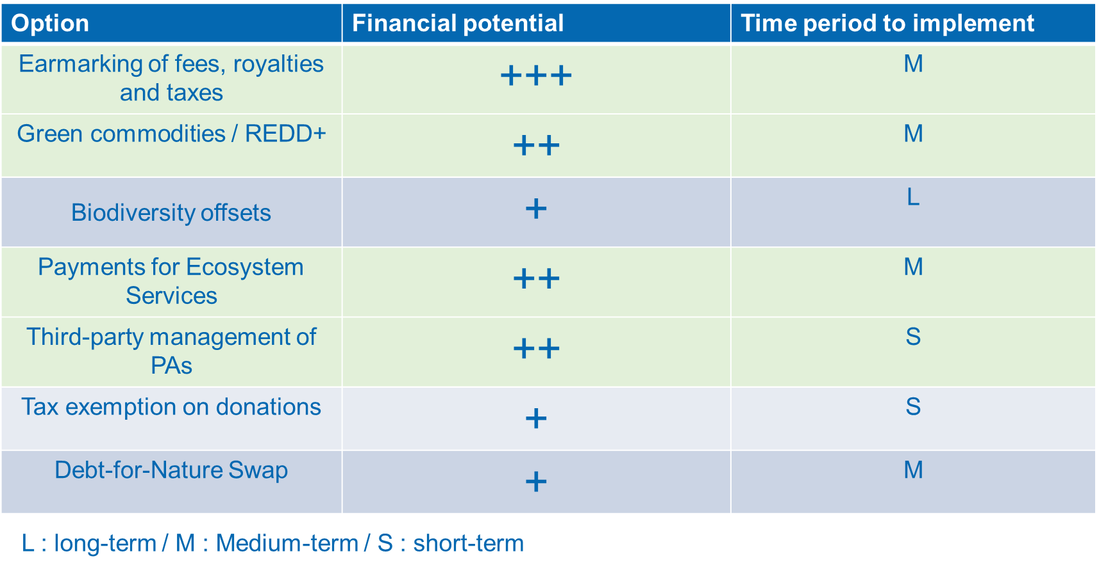
Further looking at another parameter, such as the technical difficulty to implement, one can identify the following positioning of financial options. The figures below provide a simplified view of their relative importance and specify how the different options can help match the funding needs for the different PA system costs assessed in Chapter 2, based on different scenarios.
Interestingly, the first scenario (“conservative”) can easily be achieved with the analyzed financial options, even with quite conservative assumptions. It also appears realistic to implement the Scenario 2, and possibly Scenario 3 with significant efforts.
Figure 26: Prioritization of financial options - financial impact & technical difficulty
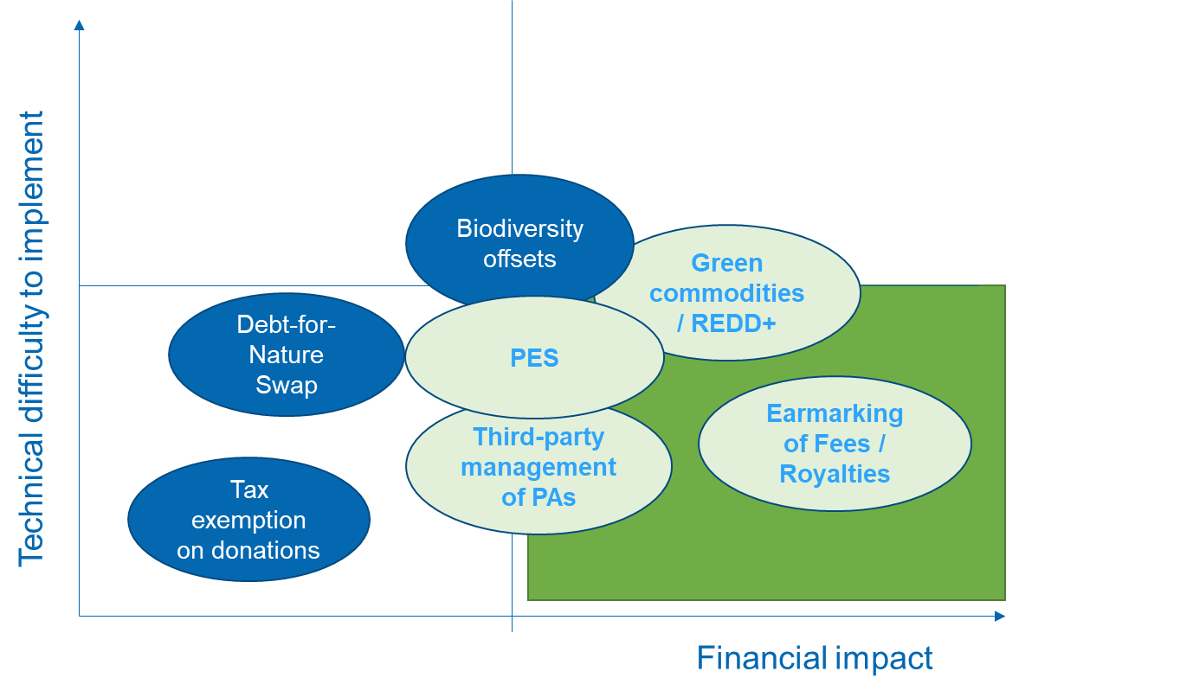

Figure 27: Relative importance of analyzed financing options – simplified view
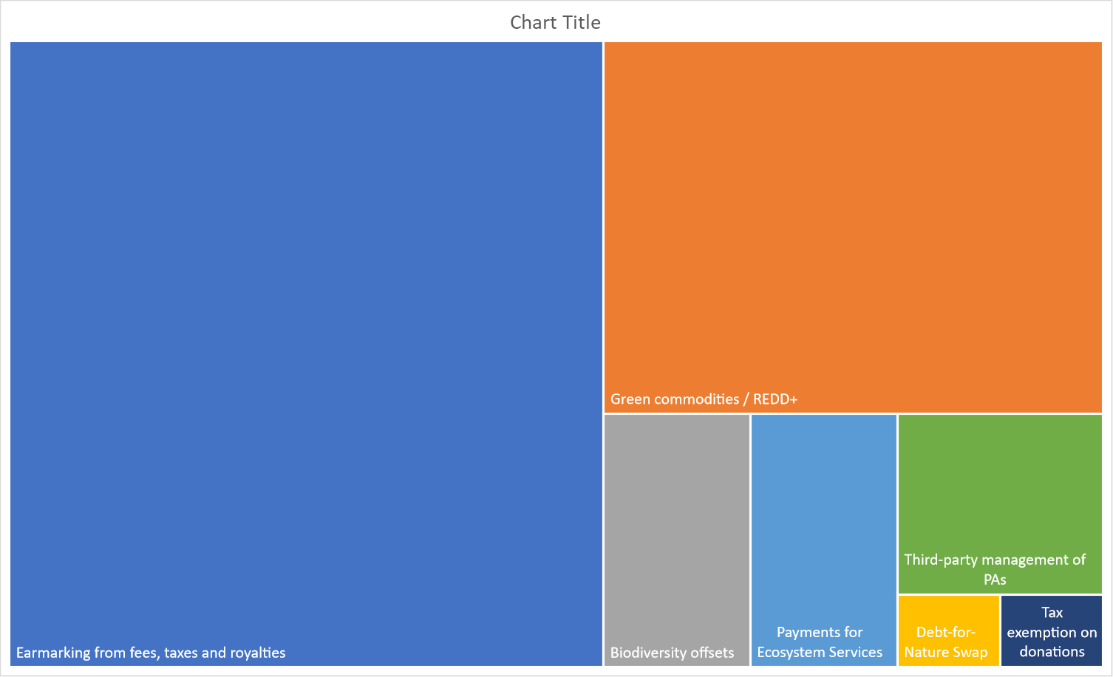

Figure 28: Matching financing objectives with analyzed financing options
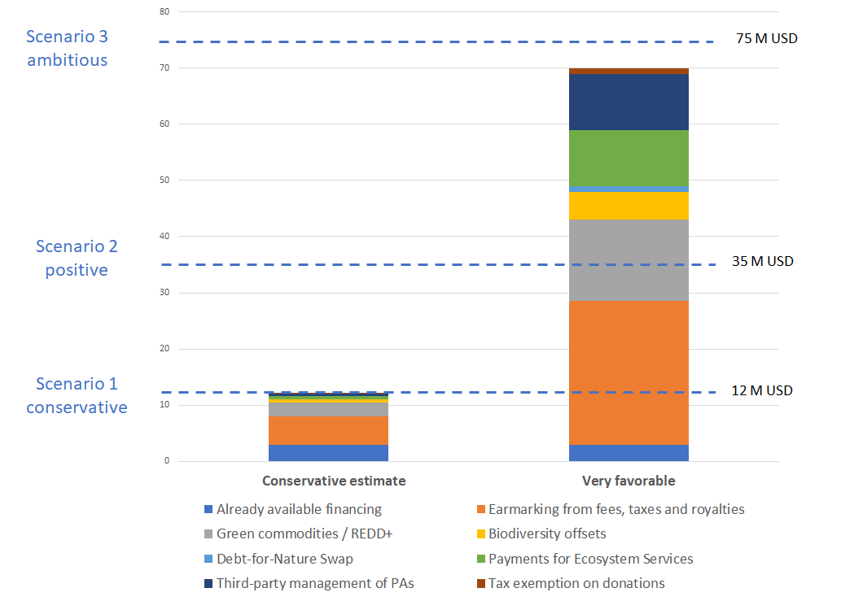

Importance of a Conservation Trust Fund
A Conservation Trust Fund (in the case of PNG, with the BCCTF) is critical to channel resources and distribute them wisely. Most above-mentioned financial options may have a strong link with a CTF, and in many cases the CTF can even be seen as a precondition for the successful implementation of financial options at the scale required (Table 32).
Table 32: Financial options and CTF role
Financial option | Possible CTF role | Relevant CTF window(s)
Earmarking of fees, royalties and taxes | Capitalization of fees and royalty revenues | - Revolving fund  - Endowment fund
Commodities / REDD+ | - CTF can help capitalize and channel REDD+ financing  - More and more CTFs promote an impact fund approach | - Revolving fund  - Impact fund
Biodiversity offsets | CTF plays a financial intermediary role | Revolving fund
Debt-for-Nature Swap | Capitalization of the debt swap | Endowment fund
Payments for Ecosystem Services | - CTF plays a financial intermediary role  - Capitalization of PES revenues  - Channeling PES resources to beneficiaries | Revolving fund
Third-party management of PAs | - Concession fees/rental fees can be capitalized in a CTF  - Possibly the CTF can help finance projects within PAs under concession | Revolving fund
Tax exemption on donations | Capitalization of donations is eased by the CTF | Revolving fund

It seems thus very critical to have the BCCTF designed in parallel, or even prior to the establishment of the proposed financial options.
The potential sequence of financial options design and implementation could be as shown in the graphic below. In all cases, a bit more than a year may be necessary to design a given option. While it appears as an ambitious sequence in a quite limited time, it seems important that momentum be maintained to achieve as many of these options as possible.
Figure 29: Possible sequence of financial options design
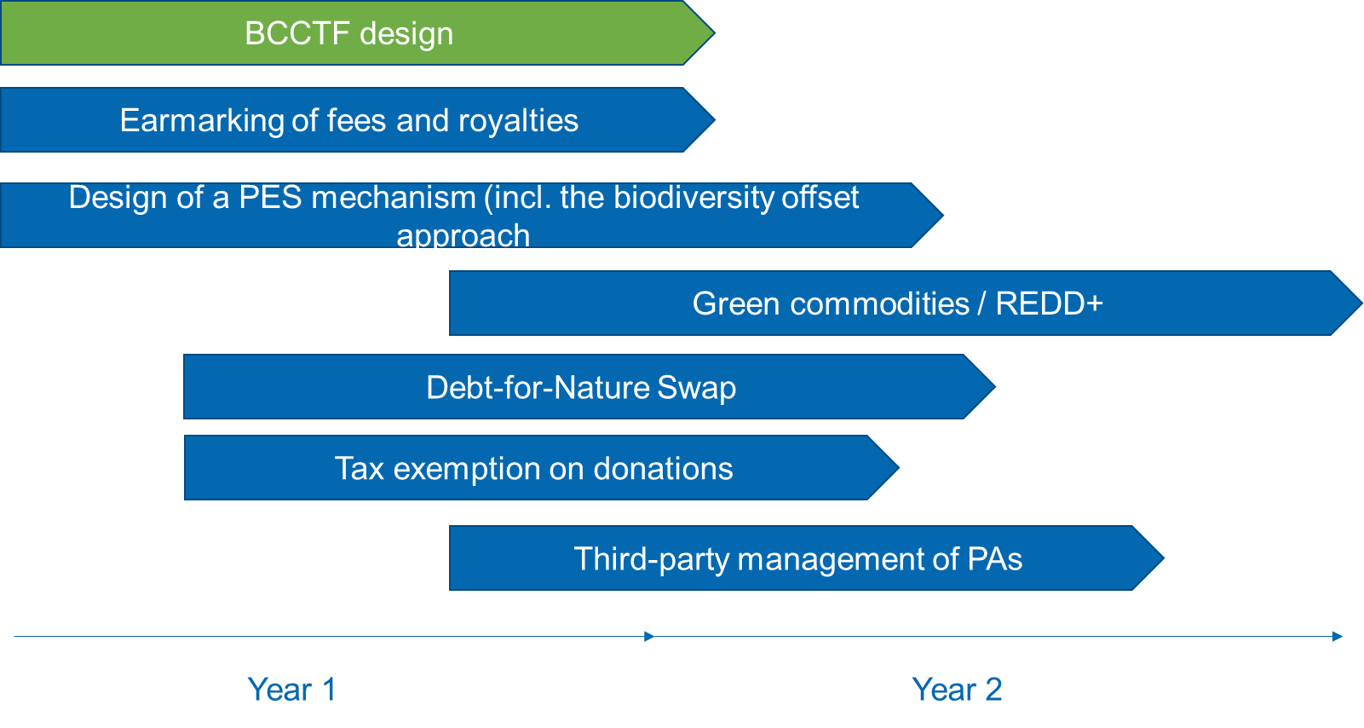

First steps in the implementation of a PA finance plan

The first steps of the finance plan implementation will be critical to ensure the whole process is successful.
In particular, in the early stage of the plan implementation the governance approach has to be considered carefully.
Indeed, a number of steps will have to be implemented to ensure i) ownership of the process and ii) that the relevant stakeholders bear responsibility for the plan implementation.
Among the key steps, it is suggested:
- The nomination of a CEPA focal point on sustainable financing;
- The creation of an interministerial working group on sustainable PA financing, directly reporting to the prime minister office (CEPA focal point has the mandate to coordinate the interministerial working group);
- Decision made on the prioritization of financing options;
- The development of a roadmap, with timelines and identification of responsible stakeholders, addressing the diversity of financing options.

Figure 30: Governance of the PA finance plan implementation – a simplified view.
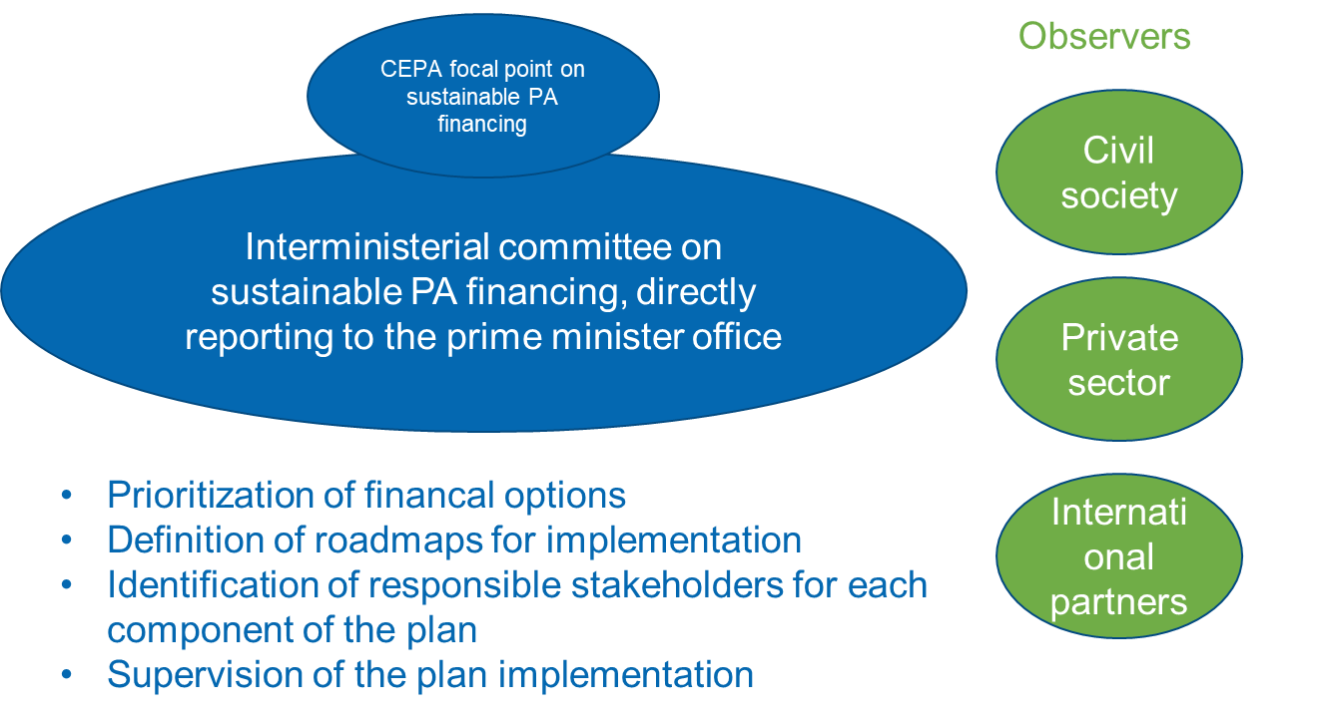

Towards an implementation roadmap

The below tables form a series of roadmaps for the top 3 financial options proposed in this work. With a modular approach, they can be seen as the different blocks of a full implementation plan. Not exhaustive and requiring further stakeholders’ consultations, these roadmaps are meant to provide a starting point for future planning, decision-making, and the sharing of responsibilities for implementation.
Table 33: Implementation roadmap - Earmarking revenues from the extractive sector
Key activities | More in details | Responsible  + Co-implementers | Deadline/Timeline | External support needed (technical a/o financial), including capacity development needs | Performance indicators
Finance Option 2: Earmarking revenues from the extractive sector
Enabling environment / design
Act 1: Agree on mechanism and pricing | A meeting should be held with National treasury, CEPA, MRA and DPE to discuss which option(s) are most appealing and the mechanisms and rates to be applied | MRA/DPE +CEPA, NT | Month 1 | Possible technical | Mechanism selected and rates identified (e.g., 05% royalty increase or 1% levy)
Act 2: Discuss with extractive sector | Discuss proposed increases and mechanisms with extractive industry | MRA/DPE | Month 2 | None | Meeting Held
Act 3: If royalties, place notice in National Gazette |  | MRA/DPE | Month 3 | Financial (cost for establishing?) | Notice
Act 4: Amend existing legislation | Amend environmental Act and CEPA, allowing for collection and retention of fees and levies, and the establishment of a trust account for CEPA | CEPA +National Treasury and Department of justice | End of Year 1 | Legal technical support; finances- workshops, consultant | Revised and enabling legislation
Act 5: Support the establishment of the BCCTF | Support efforts to establish a trust fund and lobby for a PA thematic window | CEPA | End of Year 1 | Technical | Trust Fund established
Act 6: Ensure appropriate planning and budgeting for PAs | Develop open and transparent financial management processes for PAs, including annual planning and budgeting | CEPA | End of Year 1 | Technical, capacity building for annual planning and budgeting and financial management; Finances-for relevant training needs | Annual plans and budgets for PA management available
Implementation
Act 7: Collect Revenues from royalties | Implement additional royalty rates earmarked for PAs | MRA/DPE | Month 4 | None | Revenue earmarked for PAs
Act 8: Allocate funds for PA management | Provide funds to PA management authorities based on annual plans and budgets | CEPA | Ongoing | Capacity building for PA management on annual planning, budgeting and financial management | PAs sufficiently financed to meet management needs
Financial potential | Royalties  - Between approximately US$11.5million –50million per annum  Levies  - Between approximately US$13.5million-59million per annum  MoAs/UBSAs  - Up to US$20million per project
Cost & estimated budget | Finances required to implement this financing mechanism will be variable depending on whether legal advice and training and capacity needs would be provided by government experts or externally sourced

Table 34: Implementation roadmap - Commodities promotion through Project Based REDD+
Key activities | More in details | Responsible  + Co-implementers | Deadline/Timeline | External support needed (technical a/o financial), including capacity development needs | Performance indicators
Finance Option 1: REDD+ and carbon markets, in connection with impact investments
Enabling environment
Act 1: Robust GHG inventory and Registry | A greenhouse gas (GHG) inventory is a list of emission sources by sector and the associated emissions quantified using standardized methods. GHG inventories are used to develop strategies and policies for emissions reductions and to track the progress of those policies.  A GHG registry is a database for collecting, verifying, and tracking emissions data from emitters, such as facilities or companies.  A national or state GHG inventory is a top-down comprehensive summary of the total emissions of a state or country and is critical for identifying aggregate and sectoral trends in emissions but does not attribute those emissions to individual parties. In contrast, a registry collects project, facility, or corporate-level data. |  | Mid-Year 1 |  | GHG inventory and Registry in place
Act 2: Nesting Solution | The term “nesting” is variously used to refer to state- and province-level accounting integrated into national level systems, as well as to project-level activities sitting within broader national (or subnational) systems. Due to emerging market opportunities, there is a growing consensus about the need for and value of nested REDD+ projects, i.e., projects that are integrated within national or subnational REDD+ accounting systems. |  | Mid-Year 1 |  | Nesting Solution designed
Act 3: National Forest Monitoring System | A functional REDD+ mechanism requires national institutions capable of managing forests measurement, reporting and verification systems. These are expected to be based on a range of activities that include forest inventories, soil surveys, satellite monitoring of forest and land-cover changes. It also requires much institutional coordination as well as a capacity to synthesize information into a reliable and transparent reporting system. An effective MRV system must engage local and national governments, and the expertise of various non-governmental organizations. It must also be transparent to warrant the confidence of stakeholder groups and international investors that underpin a "pay-for-performance" system. |  | Mid-Year 1 |  | NFMS in place
Act 4: Financial Mechanism | Under a nested system it is recommended that funding from investors be placed into a fund with benefits being distributed down the vertical scale (e.g., national to provincial and provincial to ILGs). From there it can be distributed across the horizontal scale within government to cover operational costs or be re-invested in in-kind benefits and capacity building while distributing a share of funding down the scale to the next vertical level as appropriate. A common financial vehicle should be used to guarantee proper management of funds, market carbon offsets and even raise funds from multilateral organizations and other institutions. The financial vehicle could then use a blended finance approach to promote and de-risk commodities impact investment opportunities in the same landscapes. |  | Mid-Year 1 |  | Financial vehicle designed
Design
Act 5: Pre-identified potential PAs | Need to conduct a detailed analysis on a selection of PAs to confirm potential and identify local characteristics. |  | End-Year 1 |  | List of selected PAs
Act 6: Governance and  Benefit sharing structure | Each PA would create a management unit, usually involving a CSO (though this could also be a private company) and local communities. The management unit is responsible for the designs of the REDD+ project aiming at reducing deforestation, preserving carbon stocks, and promoting sustainable economic activities in the area of influence of that particular PA, creating further impact investment opportunities.  Benefit sharing systems are needed to create transparency relating to receiving, storing, distributing, and using funds by the various stakeholders involved to avoid corruption and misuse/inefficient use of REDD+ funds and to hold parties accountable when misuse occurs |  | End-Year 1 |  | Governance mechanism in place, as well as a benefit sharing mechanism
Act 7: Setting projects baseline | For each PA / Project, there will be a need to design a proper deforestation baseline to understand the Business-as-Usual Case and the project's goals in terms of reducing deforestation and forest degradation. |  | End-Year 1 |  | Projects Baseline developed
Act 8: Identifying deforestation and degradation drivers and agents in each PA | Drivers and agents of deforestation need to be understood in order to propose viable alternatives to reduce land use change and pressure into forest areas. |  | End-Year 1 |  | Deforestation drivers identified
Act 9: Social and land mapping for each selected PA and buffer zone | Needed to clearly assess social structures, identify local communities as well as rights over land and resources in the area. |  | End-Year 1 |  | Social and land maps
Act 10: Project Idea Note development for selected PAs | A brief project concept note needs to be developed in order to better understand each opportunity and promote the project to donors / funders / investors. |  | Mid-Year 2 |  | PINs available for selected PAs
Act 11: Stakeholder engagement and communication plan for each PA | Lack of participation has proven to be one of the major causes of failures of natural-based initiatives including REDD+, as communities argue that they are not consulted during the design and selection of the interventions that are proposed to address deforestation and degradation in their territories. Each project will have to design and implement a plan to include different stakeholders starting during the early stages of the project. |  | Mid-Year 2 |  | Stakeholder engagement and communication plan for each PA
Act 12: Identification of impact investment opportunities and investors | Currently, there is no publicly available pipeline of bankable and non-bankable REDD+ and sustainable agriculture and forestry projects for PNG. Developing a strong pipeline of bankable and socially inclusive and environmentally sustainable land management projects to attract climate finance and impact investment into a co-management model for PAs would be necessary. REDD+ projects can be seen as a catalyst to draw-in further sustainable land use investment in determined areas. |  | Mid-Year 2 |  | Impact investment opportunities identified
Implementation
Act 13: Promotion of impact investment opportunities and due diligence of investors | A basic requirement of this model is the need for an investment promotion institution / fund to identify and promote a portfolio of commodities impact investing opportunities associated with relevant value chains in different REDD+ projects. Funds would be managed professionally and transparently according to the highest ESG standards and would be mostly used to reduce pressure on forests based on a protection - production – inclusion approach. |  | End-Year 2 |  | Impact investment opportunities assessed
Act 14: Deal Structuring | Once an agreement between project proponents and investors / funders has been reached, it has to be reflected into a contract. Futures contracts could be established for the sale of a portion of expected carbon offsets, so that upfront finance for development and initial implementation can be secured. |  | End-Year 2 |  | Deals structured
Act 15: Implementation of Stakeholder engagement and communication Plan for each PA | A strong multi-stakeholder process to identify perceptions, interests, and expectations of the different actors in each project is key. A communication plan to properly address the concerns raised is also vital. This process should be ideally articulated with ongoing national efforts. |  | End-Year 2 |  | Stakeholder engagement and communication Plan implemented
Act 16: Partnership Agreements with local stakeholders for each PA | Formal agreements with local communities and other stakeholders will be required. These agreements should clearly state the roles, responsibilities and rights of each project partner. |  | End-Year 2
Act 17: Development and submission of Project Design Document for each PA | The project design document includes information of different studies and describes the design of a project, its goals, the ways in which it meets each of the requirements of a given standard and an estimation of verified emissions reductions to be generated. |  | End-Year 2 |  | Project Design Document available for each selected PA
Act 18: Implementation of on the ground activities. | A specific set of activities implemented as part of the project that are expected to provide climate, environmental and social benefits. |  | Mid-Year 3 |  | Activities implemented on the ground
Act 19: PDD validation, verification and registry of each PA project. | A process by which an independent third-party organization, which has been certified to evaluate projects according to a specific standard, thoroughly reviews the design, methodologies, calculations and strategies employed in a project, ensuring the project follows the rules of the chosen standard so it can formally register as a validated project. |  | Mid-Year 3 |  | PDD validation
Act 20: Marketing of Certified Emission Reductions | Promotional efforts to sell verified emissions reductions are required in order to guarantee adequate prices for each of the projects. |  | Mid-Year 3 |  | Markets identified and contracts under negotiation for ER certificates
Financial potential | - The implementation of REDD+ in 11 high potential PAs could avoid the loss of 15,150 hectares of tree cover and more than 8 million tons of CO2 emissions. Using a conservative price of $5 per ton of CO2e, our estimates show a potential revenue generation of $37 million in a 10-year period  - Among the selected PAs, Tonda WMA, Aramba WMA, Managalas CA, Torricelli Mt. Range CA and Crater Mountain WMA show the greatest feasibility, representing together more than 80% of the total emission reduction potential in our analysis.  - Most likely results, using a $5 price per CO2 ton, range from $25 million for low levels of per hectare CO2 emissions to $48 million for high per hectare CO2 emission levels. This gives a per year potential revenue of $2.5 million to $4.8 million for the 11 PA’s selected. It is important to mention that per year revenues will likely not be identical each year and rather increase gradually in line with success towards reducing deforestation.  - Estimates from the assessment mentioned above show that, in a conservative scenario (Sc1), the total annual financial needs of the actual Protected Area Network in PNG are around $12 million. In the case of the optimistic scenario (Sc2), the total annual financial needs reach $35 million. Based on this figure and considering the estimated carbon value in the average case, we conclude that, over a 10-year period and at $5 per CO2 per ton, REDD+ could generate the equivalent of 30% of the costs needed by the Protected Area Network in a conservative scenario, and 11% of the costs in an optimistic scenario.
Cost & estimated budget | - Based on average figures from the industry, we estimate project design, validation, registration and verification costs to be around $200,000 – 300,000 for each project  - Nevertheless, these costs are expected to be reduced significantly during the next few years as information technology and digital solutions are deployed in the forest carbon sector at scale. We consider that these costs, at least partially, could be covered by Civil Society Organizations and carbon developers involved in each of the projects.  - We have not estimated additional REDD+ implementation costs in the analysis, since we assume that conservation and sustainable land management efforts are aligned with those included on the Costing & Financial Needs Assessment for PAs in PNG, recently developed by Natural Strategies.

Table 35: Implementation roadmap – biodiversity offsets
Key activities | More in details | Responsible  + Co-implementers | Deadline/Timeline | External support needed (technical a/o financial), including capacity development needs | Performance indicators
Finance Option 3: Biodiversity Offsets
Enabling environment
Act 1: Finalizing the policy framework | Finalizing and enacting a policy framework on biodiversity-offsets; including E&S safeguards | CEPA | End-Year 1 | Taking stock of already existing study; external coaching | Legal framework endorsed
Act 2: Awareness raising of key decision-makers on key offset modalities | Engaging awareness raising and negotiations with two or three pilot sectors (e.g., oil & gas, mining, palm oil) in order to define offsets rules and procedures (including on ecological equivalence), including transactions modalities and payments rates | CEPA + partner sectors | End-Year 1 | External coaching | Several sectors engage in offsetting their impacts through the proposed framework (MoU signed/statements of intent)
 | …
Design
Act 3: Financing mechanism design | -Defining what the financial vehicle will be, ideally in connection to the planned BCCTF  -Specify the transaction process and modalities of payments | CEPA + Finance Min. | Mid-Year 2 | Additional financial analyses required (could be finalized in the context of the BCCTF design) | Financial architecture approved
Act 4: Plan for the use of revenues | Plan for the spending of resources for relevant activities in PAs; select PAs (established or in design) that could be eligible | CEPA | Mid-Year 2 | Additional technical analyses required | Action plan for the use of offset revenues developed
Implementation
Act 5: Select an independent offset operator, and build their capacities | Selecting the team in charge of the daily management of the BO mechanism (an independent offset operator); issuing a request for proposal/a tender process; Building capacities of the selected operator will be critical | CEPA | Mid-Year 2 | An international NGO may be selected to lead the management of the offset mechanism | Independent offset operator selected
Act 6: Piloting the biodiversity-offset operationalization | Piloting the BO approach with the selected pilot sectors in selected regions, engaging the local level governments | CEPA + offset operator | End-Year 2 | The offset operator capacities will be key to supervise implementation of offset revenues on the ground | Offset mechanism implemented in pilot areas
Financial potential | - From our estimation, based on an assessment from two sectors/subsectors (mining, oil & gas; palm oil) it seems the potential is significant (it could reach between 0.5 till 5 M USD/year, depending on the diversity of sectors included in the scheme, and the costs/Ha serving the calculation)  - It is thus a less promising option than the 2 first ones assessed. Nonetheless it could be part of a relevant financing mix.
Cost & estimated budget | - The technical challenges linked to BO mechanisms require sound preparation and the design phase should not be underestimated.  - Between 0.2 and 0.5 USD may be required for building the enabling environment and conducting the design phase, prior to the piloting of the mechanism.

References

Key references include :
UNDP-TBC study (2019). Costs of establishing and implementing PAs establishment and ongoing management in PNG. Draft Report to CEPA and UNDP
METT study (2017) “A method for assessing effectiveness in Papua new guinea’s PAs (2017)”
GEF Prodoc for the project “Sustainable Finance of Papua New Guinea’s Protected Area Network”
TNC-UNDP (2010). Financial Sustainability of PAs in Latin America and the Caribbean: Investment Policy Guidance.

Varirata National Park –Business plan ideas and concepts to deliver business plan draft, December 2020

Government of Papua New Guinea (2015) National Marine Conservation Assessment for Papua New Guinea; Conservation and Environment Protection Authority, 51pp.

Balmford & al. (2004). The worldwide costs of marine PAs. Andrew Balmford*†, Pippa Gravestock‡, Neal Hockley*§, Colin J. McClean¶, and Callum M. Roberts

UNDP-TBC, 2019. Draft policy framework for PNG National Biodiversity Offsets Policy Draft Report to CEPA and UNDP
ESPA. The social impacts of biodiversity offsetting in a low income, high-biodiversity country context. Example of Ambatovy mine, Madagascar
ExxonMobil. 2017. ExxonMobil Biodiversity Strategy, PNG
Bezombes, L. & al. 2018. Ecological equivalence assessment methods: what trade-offs between operationality, scientific basis and comprehensiveness?

The GCF - Implementation of Papua New Guinea’s REDD+ Finance and Investment Plan (2018)
Summary Report Department of Lands & Physical Planning Retreat & Summary Report Papua New Guinea Forest Authority Retreat (2017)

Government of Papua New Guinea (2014) Policy on PAs

Strengthening the capacity of decision making on REDD+ in Papua New Guinea A recommended REDD+ benefit sharing system for Papua New Guinea (2019)

Strengthening the capacity of decision making on REDD+ in PNG - Strategic assessment of international climate finance and investment opportunities for REDD+ and sustainable land management in PNG (2019)

Papua New Guinea REDD+ Finance and Investment Prospectus (RFIP)

Lee, D., Llopis, P., Waterworth, R., Roberts, G., & Pearson, T. (2018). Approaches to REDD+ Nesting: Lessons Learned from Country Experiences. World Bank.
World Wildlife Fund 2009. A guide to conservation financing
Otto et al. 2006. Mining Royalties: A Global Study of Their Impact on Investors, Government, and Civil Society
Maroun, W., Jaywant Ram, A., & Kok, M. (2019). A review of mining taxes in Africa: Tax burden, the strength of democratic systems and levels of corruption. South African Journal of Business Management, 50(1), a941. https://doi.org/10. 4102/ sajbm.v50i1.941
IUCN (2014). Biodiversity management in the cement and aggregates sector: Regulatory
tools. Gland, Switzerland

Papua New Guinea Extractive Industries Transparency Initiative (PNG EITI) 2018 Report
Otto et al. 2006. Mining Royalties: A Global Study of Their Impact on Investors, Government, and Civil Society
IMF (2020). PAPUA NEW GUINEA STAFF REPORT FOR THE 2019 ARTICLE IV CONSULTATION AND REQUEST FOR A STAFF-MONITORED PROGRAM — DEBT SUSTAINABILITY ANALYSIS
Liagre, & al. (2020) How can National Forest Funds catalyse the provision of ecosystem services? Lessons learned from Costa Rica, Vietnam, and Morocco
CATIE. 2013. Workshop report of the Expert Meeting on Strengthening Finance for Sustainable Forest Management through National Forest Funds for Latin America and the Caribbean, held at Turrialba, Costa Rica, 28–30 January 2013. Centro Agronómico Tropical de Investigación y Enseñanza (CATIE).
FAO. 2015. Towards effective national forest funds, by R. Matta. FAO Forestry Paper No. 174. Rome, Italy.
FAO-GIZ. 2013. National forest funds (NFFs): Towards a solid architecture and good financial governance. Forestry Financing Working Paper No.16. Rome, Italy, FAO.
FONAFIFO (2015). FONAFIFO and Payments for Ecosystem Services. Jorge M. Rodriguez Zuñiga, Oscar Sanchez, Gilmar Navarette, Costa Rica
GIZ (2013). REDD+ cost benefit analysis in Morocco. Unpublished
GIZ (2015). Élaboration d’un modèle de schéma de paiements des services écosystémiques dans la région d’Ifrane. Analyse des services : approvisionnement en ressources hydriques et écotourisme. Unpublished. Anonymous.
HCEFLCD (2014). Compensación para la implementación y restauración de los ecosistemas forestales marroquíes. Said Moukrim.
iPFES (2017). Improving Payment for Forest Ecosystem Service Implementation in Vietnam. Best practices and lessons learned (ADB CDTA 8592 VIE)
IUCN (2012). Facts and figures on Forests.
Liagre, L. (2013). Moroccan National Forest Fund. Objectives, Financial resources, Compensation mechanism, Perspectives.
Masiero, M. and Pettenella, D. (2017). Economics and marketing of ecosystem services: experiences, challenges and opportunities. Quo vadis agriculture, forestry and society under global change? Velké Karlovice, Czech Republic, 02-04 October 2017
Nguyen Chien, C. (2019). Payments for Forest Ecosystem Services in Vietnam. Achievement and evolution.
Pagiola, S. (2005). Market-ish instruments and other strange beasts. A personal wrap-up view. ZEF-CIFOR workshop: Payments for environmental services. Methods and design in developing and developed countries. Titisee, Germany, 15-18 June 2005
Pettenella & Masiero (2018). Payment for Environmental Services: a new tool or only a new discourse?
Pettenella, D. (2018). Woodlands for Water PES in Italy. COST Action CA15206 Meeting. Payments for Ecosystem Services (Forests for Water), Castelfranco, Italy, 13 March 2018.
Rosenbaum & Lindsay. 2001. An Overview of National Forest Funds: Current Approaches and Future Opportunities.
Trung, P. (2014). Vietnam Forest Protection & Development Fund – Key characteristics of the national Redd+ Fund
Wunder, S. (2005). Payments for environmental services: Some nuts and bolts. Center for International Forestry Research (CIFOR), Occasional paper n°42. ISSN 0854-9818. Jakarta, Indonesia
CEPA-UNDP (2015). PAYMENT FOR ECOSYSTEM SERVICES OPTIONS AND OPPORTUNITIES FOR NEW BRITAIN ISLAND PAPUA NEW GUINEA November 2015
Wyman & al. 2011. Best Practices for Tourism Concessions in PAs: A Review of the Field; Forests
CFA (2008). Rapid Review of Conservation Trust Funds May 2008
CFA (2020). Global Review of Conservation Trust Funds

ANNEXES

Annex I: Questionnaire

Questionnaire for PA managers in Papua New Guinea

Introduction:
Our company, Natural Strategies, has been tasked to develop finance and investment solutions for the PAs system in Papua New Guinea. This work is conducted with the support of the Global Environment Facility (GEF) and the United Nations Development Programme (UNDP), with the Conservation and Environment Protection Authority (CEPA) as lead government agency.
The overall objective is to establish a long-term financing approach for PNG’s protected area network and secure stable and long-term financial resources for the management of PAs across the country. To contribute to this objective, Natural Strategies will develop a national level PA finance and investment plan for PNG. This will be complemented with a national level training for public and private stakeholders on environmental cost-benefit analysis.
In a first step and building on the related work conducted by another consultant team last year, we will conduct a financial needs assessment of PAs, comparing their costs with the currently available funding mechanisms.
The idea is to model the typical costs to establish and manage current PAs (PA). We can’t access data for all PAs, so we will look at the costs of a subset of PAs and extrapolate. In addition, to make sure that the resulting assessment will be ‘future-proof’, we will also develop three cost scenarios for different assumed scales and management types of the PA system in the next 10 years.
In parallel, we will conduct a review of the type and value of financial mechanisms that are currently used for PAs in PNG as well as any current payments generated from the environment sector.
Then, by comparing the modelled costs with available financing, we would like to assess to which extent the used financial mechanisms have the potential and characteristics to cover current and projected financial needs of PAs in the country and identify any resulting financial needs & gaps.
In this context we are very grateful for the opportunity to ask you a few questions about the costs and available funding of the Protected Area your organization is managing. Your input will certainly be very valuable to produce a high-quality output.

Questions on costing:

Questions | Your answer
- You shared the cost structure with the Biodiversity Consultancy last year. In case you are aware of the cost table produced (please see attached for memory), are these figures still up to date? Are the cost items in there complete or are there any missing? If relevant, can you share the latest figures with us?
- The file we received includes costs at the PA level. Are there additional costs that you are aware of at the national level? E.g., country wide wildlife trade surveillance, data management, monitoring?
- To your knowledge, which are the strongest costs drivers for the management of the PA under your supervision?
- Looking into the future, can you estimate what impact on PA management costs it would have if the area was going to be enlarged? Is this realistic?
- What if local management would be strengthened – would that increase the costs significantly? Can you please specify data on additional costs? or do you also see cost savings, e.g., by increasing efficiency?
- What could be additional costs induced by ecosystem restoration? What levels of ecosystem restoration are realistic in the PA under your management (in the next 10 years), in a number of hectares? And do you know how many hectares are degraded and could be restored in an ideal scenario? What would be an estimate of the cost of ecosystem restoration per hectare in your context?
- In the next 10 years, are there new types of costs that you would expect to appear that might not exist at this stage, or do you expect any of the current costs items to change significantly?

Questions on currently available funding sources:
- Is there an overview that you could share with us that would show the available funding sources for the PA under your management? We would like to get a sense of how much of the PA’s current costs are covered through current funds, or if there are any funding gaps remaining.
- We would also like to understand what the available funding is used for – ultimately, this would help us to assess better which PA costs items might benefit from mobilizing additional finance, be it conventional or innovative sources such as carbon finance, PES, impact investments, green bonds or similar. Is there data on this that you could share with us?
- Additional question if your time permits: Which, if any, of the above innovative finance sources did you already consider (or even secure) for your PA? Would you be available to talk more in detail with us about these in the coming weeks?

Annex II: Stakeholder Outreach

In preparing the costing assessment, the consultant team held interviews with the following persons:
Organization | Interviewee name | Position
CEPA | Kay Kumaras Kalim | Director - Sustainable Environment Programs
CEPA | James Sabi | Manager - Terrestrial Ecosystems
CEPA | Bernard Kuruman | Manager - Marine PAs
UNDP | Andrew Rylance | Chief Technical Advisor
UNDP | Ted Mamu | Project Manager (GEF 6)
Tree Kangaroo Programme | Lisa Dabek | Senior Conservation Scientist/Director of the Papua New Guinea Tree Kangaroo Conservation Program
Tree Kangaroo Programme | Trevor Holbrock | Field Conservation Program Manager
Tenkile Conservation Alliance | Jim Thomas | CEO
WCS | Sylvia Noble | WCS Manus Program Manager
WCS | Annisah Sapul | WCS New Ireland Program Manager
JICA | Saina Jeffrey | JICA Local Terrestrial Expert, CEPA-JICA Biodiversity Project
JICA | Koji Asano | Head of programme, CEPA-JICA Biodiversity Project
PwM | Kenn Mondiai | Executive Director/Senior Forestry Officer
TBC | Guy Dutson | Senior expert
TBC | Bensolo Ken | Senior expert

In addition to the interviews above, over the course of the project, the below table reflects the efforts to contact key stakeholders and the outcome of those efforts including additional interviews/meetings held.
Date | Individual/Organisation | Action | Outcome
15-Mar-2021 | Ian Kemish | Email request | No response
11-Mar-2021 | Pegora Mine | Phone call | Spoke to individual mine closed no-one working there any more
11-Mar-2021 | Lihir Mine | Phone call | unable to get hold of anyone
11-Mar-2021 | PNG chambers of mines and petroleum | Email request for meeting and contact details for companies | No response
11-Mar-2021 | Department of Petroleum and Energy | Email request | 2 x email adresses bounced-address unknown
9-Mar-2021 | ExxonMobil (Banak Gamui) | Email request | No response
9-Mar-2021 | New Britain Palm Poil Ltd (Ian Orrel) | Email request | No answer
9-Mar-2021 | Ramu Agro (Arison Arihafa) | Email request | No answer
23-Feb-2021 | PNG travel | Email request | Remote Meeting held
22-Feb-2021 | Department of Treasury | Email request | Remote Meeting held
15-Feb-2021 & 21-Feb-2021 | Mineral Resource Authority | Email request | No response
15-Feb-2021 & 21-Feb-2021 | CEPA | Email request | Reponse that somoeone would contact for meeting -no contact
29-Oct-2020 | Bank of South Pacific (BSP) (Paul Thornton) | Email request with CEPA invitation letter | No response
29-Oct-2020 | Kina Bank (Johnson Kalo) | Email request with CEPA invitation letter | No response
29-Oct-2020 | Nation Wide Microfinance Ltd (Tony Westaway) | Email request with CEPA invitation letter | No response
29-Oct-2020 | Women's Micro Bank (Gunandindhi Das) | Email request with CEPA invitation letter | No response
29-Oct-2020 | PNG Microfinance Ltd (George Mathew) | Email request with CEPA invitation letter | No response
29-Oct-2020 | Exxon Mobil (Banak Gamui) | Email request with CEPA invitation letter | No response
29-Oct-2020 | Ok Tedi Development Foundation (Eric Kuman) | Email request with CEPA invitation letter | Remote Meeting held
29-Oct-2020 | CEPF - IUCN (Zola Sangga) | Email request with CEPA invitation letter | Remote Meeting held
29-Oct-2020 | PNG Centre for Locally Managed Areas Inc (Maxine Anjiga) | Email request with CEPA invitation letter | No response
14-Oct-2020 | CCDA (Ruel Yamuna) | Email request & follow up | No response
14-Oct-2020 | DNPM (Dan Lyanda) | Email request with CEPA invitation letter | Remote Meeting held
14-Oct-2020 | Financial Analyst and Supervision Unit (Benny Popotai) | Email request with CEPA invitation letter | Answered and set up remote meeting
14-Oct-2020 | Treasury (Timothy Mais) | Email request with CEPA invitation letter | No response
14-Oct-2020 | US AID (Maurice Knight) | Email request with CEPA invitation letter | No response
14-Oct-2020 | Department of Petroleum and Energy (David Manau) | Email request with CEPA invitation letter | No response
14-Oct-2020 | Internal Revenue Commission (Sam Koim) | Email request with CEPA invitation letter | No response
14-Oct-2020 | Kumul Consolidated Holdings (KCH) (Isikeli Taureka & Rachiel Ani) | Email request with CEPA invitation letter | No response
14-Oct-2020 | Mineral Resource Authority (Jerry Garry) | Email request with CEPA invitation letter | Remote Meeting held
14-Oct-2020 | PNG National Procurement Commission (Simon Bole) | Email request with CEPA invitation letter | No response
14-Oct-2020 | PNG Forest Authority (Tunou Subuin) | Email request with CEPA invitation letter | No response
14-Oct-2020 | National Research Institute (Osborne Sanida) | Email request with CEPA invitation letter | No response
14-Oct-2020 | PNG Tourism Promotion Authority (Jerry Agus & Cleopatra Aramanat) | Email request with CEPA invitation letter | No response
14-Oct-2020 | WWF (Paul Chatterton) | Email request with CEPA invitation letter | No response
25-Aug-2020 | WCS (Annisah Sapul & Jonathan Booth) | Email request | Remote Meeting held
18-Aug-2020 | PwM (Kenn Mondiai) | Email request | Remote Meeting held
18-Aug-2020 | WCS (Sylvia Noble) | Email request | Responses - meetings were canceled 2x
12-Aug-2020 | Tenkile Conservation Area (Jim Thomas) | Email request | Remote Meeting held
11-Aug-2020 | Tree Kangaroo Programme (Lisa Dabek & Trevor Holbrok) | Email request | Remote Meeting held
31-Jul-2020 | TBC (Guy Dutson & Bensolo Ken) | Email request | Remote Meeting held
17-Jul-2020 | Tree Kangoroo Conservation Society (Modi Pontio) | Email request | Remote Meeting held
16-Jul-2020 | CEPA (Gunter Joku) | Email requests & follow up | No response
11-Apr-2020 | New Britain Palm Oil Company (Robert Nilkare) | Email request with CEPA invitation letter | No response
11-Apr-2020 | Thomas Legrand (REDD+ expert) | Email request | Remote Meeting held
11-Mar-2020 | Kada Poroman Microfinance Ltd (Mr Sankar Chitteti) | Email request with CEPA invitation letter | No response
11-Mar-2020 | National Superannuation Fund (Ian Tarutia) | Email request with CEPA invitation letter | No response
11-Mar-2020 | National Fisheries Authority (Brian Kumasi) | Email request with CEPA invitation letter | Remote Meeting held
11-Mar-2020 | Digicel Foundation (Serena Sasingian) | Email request with CEPA invitation letter | No response
11-Mar-2020 | Institute of National Affairs (Paul Barker | Email request with CEPA invitation letter | No response
8-Feb-2020 | WCS (Ambroise Brenier, Stacy Jupiter, Mr Kuange) | Email request & follow up on 14/10/2020 | Remote Meeting held
8-Feb-2020 | JICA (Koji Asano and Saina Jeffrey) | Email request & follow up on 14/10/2020 | Remote Meeting held

The below list includes the participants at Grand Papua Hotel and CEPA from 16 - 18 November 2020. In addition, 13 people connected online on each day of the training. An average of about 40 people attended the meeting over the 3 days.

Day 1, 16 November 2020
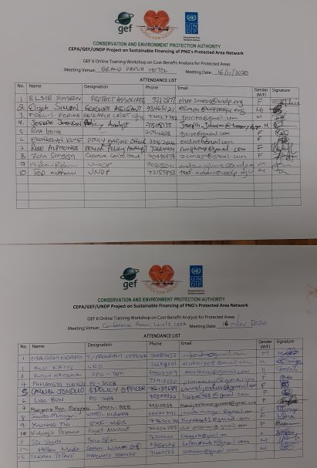

Day 2, 17 November 2020
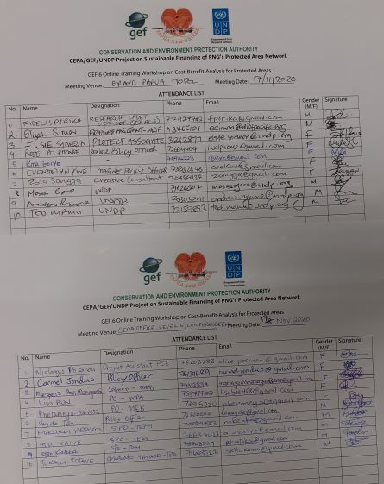

Day 3, 18 November 2020
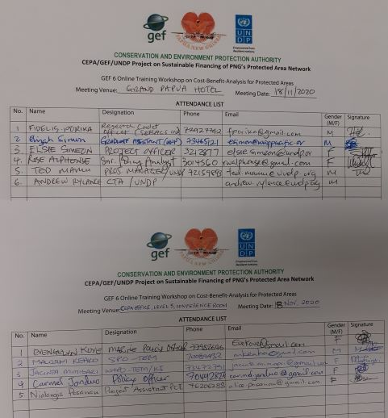

Online participants
# | Participant Name | Organisation | Position/title | Email contact
1 | Ms. Michelle McGeorge | Port Moresby Nature Park | General Manager | michelle.pomnp@gmail.com
2 | Kay Kalim | CEPA | Director - Sustainable Environment Program | kaykalim@gmail.com
3 | James Sabi | CEPA | Manager - Terrestrial Eco-systems | james.sabi.roaming@gmail.com
4 | Bernard Suruman | CEPA | Manager - Marine Protected Areas | bsuruman2020@gmail.com
5 | Vagi Rei | CEPA | Manager - Marine Ecosystems | rei.vagi@gmail.com
6 | Raymon Joshua | UNDP-GEF 6 | ES Provincial Coordinator | Raymonjoshua25@gmail.com
7 | Tom Pringel | USAID | Deputy Chief of Party | Tom.pringel@cardno.com
8 | Alu Kaiye | CEPA | Senior Program officer | alukaiye@gmail.com
9 | Peter Dam | FORCERT | Technical Advisor | Pdam.forcert@gmail.com
10 | Verolyn Daugil | Dept of Treasury | Economist | Verolyn_Daugil@treasury,gov.pg
11 | Joseph Johnson | Dept of Treasury |  | Joseph_Johnson@treasury.gov.pg
12 | Carmel Jonduo | CEPA | Policy Officer | Carmel.jonduo@gmail.com
13 | Paul Baker | CIMC | Director | Paul.baker@cimcpng.org

Note: Online participation also included three Natural Strategies team members (Alexander Koch, Ludwig Liagre and Bruno Paino).

Annex III: Surface data for terrestrial and marine PAs, and projected surface extension

 | Terrestrial PAs | Marine PAs | Total
PA number | 56.5 | 5.5 | 62
Surface (Ha) - Baseline | 2871226 | 251,617 | 3122843
Surface (Ha) - Conservative scenario (1) | 2871226 | 251,617 | 3122843
Surface (Ha) - Positive scenario (2) | 3934140 | 8730000 | 12664140
Surface (Ha) - Ambitious scenario (3) | 7868280 | 17460000 | 25328280
Marine PA extension Scenario 2 | NN | 8,478,383 | 8,478,383
Marine PA extension Scenario 3 | NN | 17,208,383 | 17,208,383
Terrestrial PAs extension Scenario 2 | 1062914 |  | 1062914
Terrestrial PAs extension Scenario 3 | 4997054 |  | 4997054

Assumptions | Conservative scenario does not include surface extension
 | Positive scenario leads to achieve 50% of the Aichi target 11
 | Ambitious scenario leads to achieve the Aichi target 11
PNG terrestrial surface (Ha) | 46284000
PNG marine surface (Ha) | 174600000 | Source : National marine conservation assessment for PNG, 2015
Aichi target 11 - terrestrial factor | 0.17
Aichi target 11 - marine factor | 0.1
Terrestrial PA surface - 50% AT 11 | 3934140
Marine PA surface - 50% AT 11 | 8730000
Terrestrial PA surface - 100% AT 11 | 7868280
Marine PA surface - 100% AT 11 | 17460000

Annex IV: Assumptions for the summary of financing options potential

In million USD
 | Bottom line | Very favorable
Earmarking from fees, taxes and royalties | 5 | 25.5
Commodities / REDD+ | 2.5 | 14.5
Biodiversity offsets | 0.5 | 5
Debt-for-Nature Swap | 0.1 | 1
Payments for Ecosystem Services | 0.5 | 10
Third-party management of PAs | 0.5 | 10
Tax exemption on donations | 0.1 | 1
Already available financing | 3 | 3
Total | 12.2 | 70

Annex V: Diagrams showing flows of royalties, levies and contributions
Current state flows
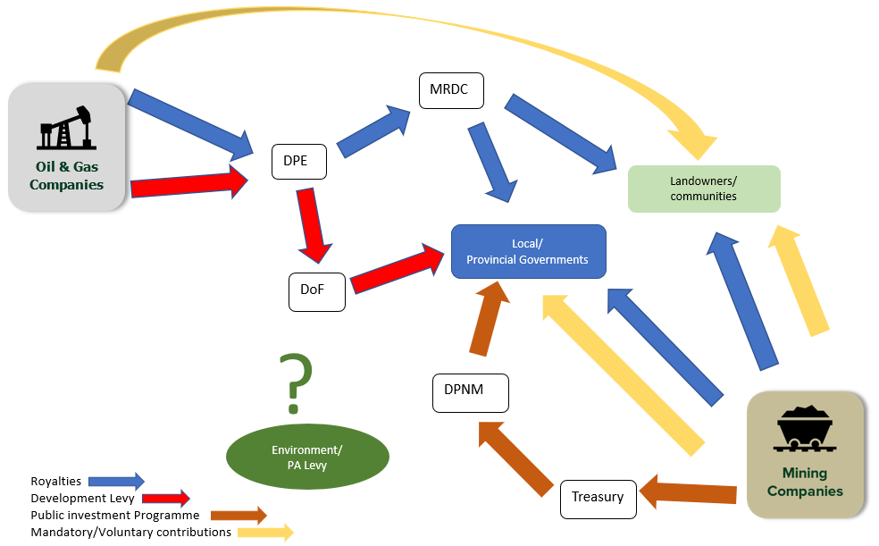

Proposed revenue flow of royalties and contributions into the BCCTF
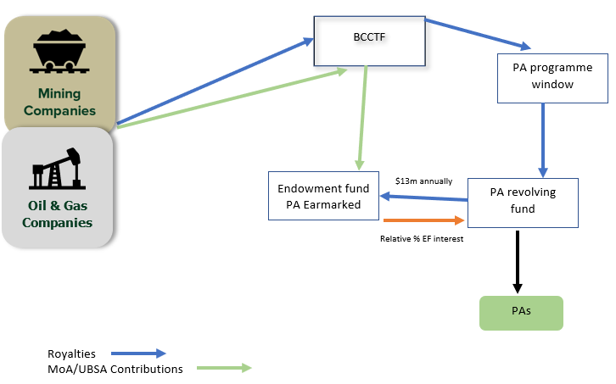

From Varirata Draft Business Plan, 2019
Dommen, E. 1993. Fair principles for sustainable development: essays on environmental policy in developing countries. United Nations Conference on Trade and Development (UNCTAD), London UK.
Mudd, G.M., Roche, C., Northey, S.A., Jowitt, S.M., and Gamato, G. 2020. Mining in Papua New Guinea: A complex story of trends, impacts and governance, Science of The Total Environment, Volume 741. https://doi.org/10.1016/j.scitotenv.2020.140375
Veiga, M. M., Scoble, M., & McAllister, M. L. (2001). Mining with communities. Natural Resources Forum, 25, 191-202.
Department of Treasury 2021 National Budget, PNG
https://www.thenational.com.pg/new-levies-fees-harsh-nilkare/
International Council for Minerals and Metals ‘Mining Contribution Index’. https://www.icmm.com/romine/index
https://pngchamberminpet.com.pg/our-resource-industry/mining
Source: http://www.eia.gov/cfapps/ipdbproject/
https://pngchamberminpet.com.pg/our-resource-industry/petroleum
Grice, T. 2019. Subnational payments in Papua New Guinea’s extractive sector: Scoping study for PNG Extractive Industries Transparency Initiative. http://www.pngeiti.org.pg.
Leverington, F., et al., 2017 Assessment of management effectiveness for Papua New Guinea’s protected areas 2017. Final Report. SPREP, Apia, Samoa
Grice, T. 2019. Subnational payments in Papua New Guinea’s extractive sector: Scoping study for PNG Extractive Industries Transparency Initiative. http://www.pngeiti.org.pg.
https://www.herald.co.zw/environment-levy-for-miners-on-the-cards/
World Wildlife Fund 2009. A guide to conservation financing
Otto et al. 2006. Mining Royalties: A Global Study of Their Impact on Investors, Government, and Civil Society
Maroun, W., Jaywant Ram, A., & Kok, M. (2019). A review of mining taxes in Africa: Tax burden, the strength of democratic systems and levels of corruption. South African Journal of Business Management, 50(1), a941. https://doi.org/10. 4102/ sajbm.v50i1.941
IUCN (2014). Biodiversity management in the cement and aggregates sector: Regulatory tools. Gland, Switzerland
Papua New Guinea Extractive Industries Transparency Initiative (PNG EITI) 2018 Report
Otto et al. 2006. Mining Royalties: A Global Study of Their Impact on Investors, Government, and Civil Society
https://www.fraserinstitute.org/studies/annual-survey-of-mining-companies-2019
Source: Yannick Bouterige, Céline de Quatrebarbes, Bertrand Laporte.2019. Mining taxation in Africa: What recent evolution in 2018? hal-02438175
https://pngchamberminpet.com.pg/our-resource-industry/petroleum
Grice, T. 2019. Subnational payments in Papua New Guinea’s extractive sector: Scoping study for PNG Extractive Industries Transparency Initiative. http://www.pngeiti.org.pg.
The Biodiversity consultancy 2015. A cross-sector guide for implementing the mitigation hierarchy
Leverington, F., et al., 2017 Assessment of management effectiveness for Papua New Guinea’s protected areas 2017. Final Report. SPREP, Apia, Samoa
Grice, T. 2019. Subnational payments in Papua New Guinea’s extractive sector: Scoping study for PNG Extractive Industries Transparency Initiative. http://www.pngeiti.org.pg
http://teebweb.org/agrifood/wp-content/uploads/2018/10/Layout_synthesis_sept.pdf
http://www.fao.org/3/a-i1688e.pdf
https://www.un.org/sustainabledevelopment/blog/2019/05/nature-decline-unprecedented-report/
https://globalforestatlas.yale.edu/land-use/industrial-agriculture
https://forestdeclaration.org/images/uploads/resource/2019NYDFReport.pdf
https://www.wri.org/blog/2021/02/global-deforestation-agricultural-commodities
Poore, J., & Nemecek, T. (2018). Reducing food’s environmental impacts through producers and consumers. Science, 360(6392), 987-992.
https://www.decadeonrestoration.org/
Natural Climate Solutions: https://www.pnas.org/content/114/44/11645
https://nature4climate.org/
Idem
https://www.weforum.org/natural-climate-solutions-alliance
These early initiatives include April Salumei, Central Suau, Almami and Manus. Other Agriculture Forestry and Other Land Use projects in VCS database include NIHT TOPAIYO REDD + project by NIHT Inc. in partnership with the traditional landowners of New Ireland and East New Britain. The project aims at putting an end to deforestation initiated by industrial logging in the region and is expected to generate 2,262,521 CO2e tons a year in emission reductions.
Fearnehough, H., Kachi, A., Mooldijk, S., Warnecke, C., & Schneider, L. (2020). Future role for voluntary carbon markets in the Paris era. Dessau: German Emission Trading Authority (DEHSt) at the Federal Environment Agency (UBA). Available at: https://newclimate. org/wp-content/uploads/2020/11/NewClimate_future-rolevoluntary-carbon-markets-executive_summary_Nov20. pdf.
https://www.goldstandard.org/sites/default/files/documents/voluntary_carbon_market_post-2020_part_2.pdf
In the FERM,l the mitigation impact is intentionally double claimed by the host-country towards its NDC and the buyer of the emissions reduction/removal. This may be acceptable if the target of the buyer is not to use them for voluntary offsetting or for meeting a carbon neutrality target. This may be useful, for example in the case of domestic voluntary schemes designed to contribute to NDC targets or where companies simply wish to support a given country without a need for offsetting. This implies a consideration by the host-country of the appropriateness and regulation of claims under the scheme to avoid confusion.
Government of Papua New Guinea (2017). Papua New Guinea National REDD+ Strategy for the period 2017-2027
Idem
Strengthening the capacity of decision making on REDD+ in PNG. Strategic assessment of international climate finance and investment opportunities for REDD+ and sustainable land management in PNG (2019)
Summary Report Papua New Guinea Forest Authority Retreat (2017)
This policy identified key areas for action on climate change including targets of a 50% reduction in GHG emissions by 2050 and carbon neutrality by 2050.
Summary Report Papua New Guinea Forest Authority Retreat (2017)
Strengthening the capacity of decision making on REDD+ in PNG - Strategic assessment of international climate finance and investment opportunities for REDD+ and sustainable land management in PNG (2019)
Papua New Guinea Climate and Environment Fund (PNG-CEF) UNDP Concept Note
CIFOR (2021) https://www2.cifor.org/knowledge-tree/design/types-of-benefits/direct-cash-compensation/
CIFOR (2014) https://www.cifor.org/publications/pdf_files/infobrief/5197-infobrief.pdf
CIFOR (2021). https://cutt.ly/ck9tSmT
Government of Papua New Guinea (2017). Papua New Guinea National REDD+ Strategy for the period 2017-2027
Government of Papua New Guinea (2014) Policy On PAs
Government of Papua New Guinea (2019) Vision 2050
It is expected that in May 2021, the Conference of Parties to the Convention on Biodiversity (CBD) will agree on a new target to place at least 30 percent of the Earth’s surface under conservation status by 2030. The target is stated in a draft agreement called the ‘Post-2020 Global Biodiversity Framework’, which is currently being prepared and negotiated amongst the 186 governments which are signatories to the Convention for Biological Diversity (CBD).
Strengthening the capacity of decision making on REDD+ in PNG - Strategic assessment of international climate finance and investment opportunities for REDD+ and sustainable land management in PNG (2019)
Idem
https://www.thebluecarboninitiative.org/about-blue-carbon#where
https://www.cbd.int/countries/profile/?country=pg
https://www.coraltrianglecenter.org/2020/04/30/ctc-embarks-on-blue-carbon-capacity-building-project-in-indonesia-and-papua-new-guinea/
https://www.cifor.org/publications/pdf_files/infobrief/7554-infobrief.pdf
https://bluecarbonpartnership.org/
Lee, D., Llopis, P., Waterworth, R., Roberts, G., & Pearson, T. (2018). Approaches to REDD+ Nesting: Lessons Learned from Country Experiences. World Bank.
https://guatecarbon.com/
VCS Database (2021) https://registry.verra.org/app/projectDetail/VCS/1311
ISFL BioCarbon Fund (2017) https://cutt.ly/kk9tiwX
Idem
Idem
Idem
Government of Papua New Guinea (2014) Policy On PAs
Strengthening the capacity of decision making on REDD+ in Papua New Guinea A recommended REDD+ benefit sharing system for Papua New Guinea (2019)
Strengthening the capacity of decision making on REDD+ in PNG - Strategic assessment of international climate finance and investment opportunities for REDD+ and sustainable land management in PNG (2019)
Insetting is an opportunity for businesses to link greenhouse gas (GHG) emissions reductions and carbon sequestration to their sourcing landscapes. This creates meaningful climate action that develops a sustainable land use model by protecting and valuing nature, and results in benefits for people and local communities throughout a company’s value chain. https://www.insettingplatform.com/
Papua New Guinea REDD+ Finance and Investment Prospectus (RFIP)
IUCN (2010) https://www.iucn.org/sites/dev/files/import/downloads/iucn_ips_redd_brochure_internet_lv_sp.pdf
PROCLIMA (2020) https://proclima.net.co/wp-content/uploads/2020/07/dm-afolu-redd.pdf
Awung (2017) https://www.tandfonline.com/doi/abs/10.1080/23251042.2017.1363144?journalCode=rens20&
UNFCC (2010) https://unfccc.int/resource/docs/2010/cop16/eng/07a01.pdf
VCS standard (2017) https://verra.org/project/vcs-program/rules-and-requirements/
CCB standard (2017) https://verra.org/project/ccb-program/rules-requirements-and-guidance/
CCB standard (2017) https://verra.org/project/ccb-program/rules-requirements-and-guidance/
https://www.mckinsey.com/business-functions/sustainability/our-insights/a-blueprint-for-scaling-voluntary-carbon-markets-to-meet-the-climate-challenge
https://www.spglobal.com/platts/en/market-insights/latest-news/natural-gas/051320-global-carbon-offsets-market-could-be-worth-200-bil-by-2050-berenberg3
Total forest land reported by GoPNG (2016) Papua New Guinea’s National REDD+ Forest Reference Level, Submission for UNFCCC Technical Assessment in 2017.
PAs Costing & Financial Needs Assessment for Papua New Guinea
Sc1 aims at covering the basic costs for the existing 62 PAs in the country.
Sc2 aims at covering reaching 50% of Aichi target 11. This means reaching 5% of national marine area with marine & coastal PAs, and %8.5% of the national territory with terrestrial PAs.
Summary Report Department of Lands & Physical Planning Retreat & Summary Report Papua New Guinea Forest Authority Retreat (2017)
The GCF - Implementation of Papua New Guinea’s REDD+ Finance and Investment Plan (2018)
UNDP-TBC, 2019. Draft policy framework for PNG National Biodiversity Offsets Policy Draft Report to CEPA and UNDP
ExxonMobil PNG Limited Production Operations – Biodiversity Strategy (2017). https://pnglng.com/media/PNG-LNG-Media/Files/Environment/Biodiversity%20strategy/PGGP-EH-SSZZZ-000003_Biodiversity-Strategy_Rev4.pdf
https://cieem.net/wp-content/uploads/2019/02/Biodiversity-Net-Gain-Principles.pdf
Cost/ha (USD), Sc1 = 4.17
https://www.greencommodities.org/content/gcp/en/home/countries-and-commodities/papua-new-guinea-palm-oil.html
https://www.agriculture.gov.pg/commodity-boards-a/oil-palm-industry-corporation/
RSPO has set up a two-year grace period, hence liability is being calculated over the period 2007 to April 2014
https://rspo.org/certification/remediation-and-compensation#why-remediate-and-compensate
it should however be noted here that only concessions, which have not conducted HCV assessment prior to clearing will be liable under the RSPO rules, meaning that concessions that have cleared forest in accordance with their HCV management plan will not be held liable for potential deforestation that has occurred within the boundaries of their concession.
https://climateanalytics.org/media/debt_for_climate_swap_impact_briefing.pdf
The Nature Conservancy 2020, https://n9.cl/x1b93
https://www.nature.org/en-us/about-us/where-we-work/africa/stories-in-africa/seychelles-conservation-commitment-comes-to-life/
the Seychelles Conservation and Climate Adaptation Trust (SeyCCAT), https://seyccat.org
The Nature Conservancy 2020, https://n9.cl/x1b93
The Nature Conservancy 2020, https://n9.cl/x1b93
https://www.interaction.org/wp-content/uploads/2019/02/Innovative-Finance-for-Development-A-Guide-for-International-NGOs.pdf
The Nature Conservancy 2021 https://n9.cl/x1b93
Jamaica’s Government https://n9.cl/nn63j
Agreement Between the UNITED STATES OF AMERICA and JAMAICA 2004, https://n9.cl/yvn4w
U.S Department of State 2004, https://2001-2009.state.gov/r/pa/prs/ps/2004/36929.htm
Jamaica’s Government https://n9.cl/nn63j
https://www.reuters.com/article/us-global-debtrenegotiation-nature-clima-idUSKBN25Y26P
http://www.oecd.org/env/outreach/39352290.pdf
www.fonafifo.go.cr
Average in the last 5 years (2015-2019)
www.fonafifo.go.cr
www.vnff.vn
More information about the VNFF case and PFES in Vietnam can be found under this link: http://www.gms-eoc.org/resources/improving-payment-for-forest-ecosystem-services-implementation-ta-8592-vie
https://www.conservation.org/docs/default-source/publication-pdfs/alto-mayo_factsheet.pdf?Status=Master&sfvrsn=706181c7_3
https://www.weforest.org/
https://www.globalnature.org/
Assumptions in Annex 4
Sc1 aims at covering the basic costs for the existing 62 PAs in the country.
Sc2 aims at covering reaching 50% of Aichi target 11. This means reaching 5% of national marine area with marine & coastal PAs, and %8.5% of the national territory with terrestrial PAs.

