Theory of Change
(2021 -2025)
Inclusion of Persons with Disabilities at UNV
(Personnel, UN Volunteers and on-line volunteers)
Vision
UNV is an organization that acknowledges and removes barriers to allow full and equal participation of UN Volunteers and on-line volunteers and UNV personnel with disability in sustainable peace and development (UNV)
UNCRPD Article 26 is about the right to be independent and to be fully included in society. It sets out the things that government must do. This includes supporting participation and inclusion in all parts of society and making sure professionals get training to help them uphold the rights in the Convention.
Outcomes
- PWD have equal opportunities to serve as UN Volunteers, on-line volunteers and UNV personnel in line with the UN Disability Inclusion Strategy
- UN partners and Member States are enabled to expand diversity and inclusion of persons with disabilities in their workforce worldwide and efforts towards 2030 agenda

Key KPIs to be reflected in the next generation of the UNV SF
- Number of persons with disabilities serving as UN Volunteers, on-line Volunteers and personnel through targeted or mainstream recruitment practices has increased (personnel) by %
- Total funds (US$) allocation for inclusion at UNV including Reasonable Accommodation fund
- Number of UNV personnel proficient in matters of inclusion and engagement UN Volunteers and on-line volunteers PWD
- UNV meets 100% of the UNDIS indicators
Barriers UNV shall remove through interventions indicated below
Internal: attitudinal, information, economic, policy, physical
External: attitudinal, information, economic, policy, physical
Key external barriers UNV is facing are of policy and economic nature:
UNV is a common service provider to the entire UN System and hence depends on policy, funding, accessibility, and readiness of Host Entities
Key internal barriers:
- accessibility at all levels (i.e. information, systems, tools, procured services and goods, funding),
- low awareness and readiness level of personnel to support engagement of UN and on-line volunteers with disabilities

Outputs (aligned to UNDIS indicators to exceed UNDIS requirements)
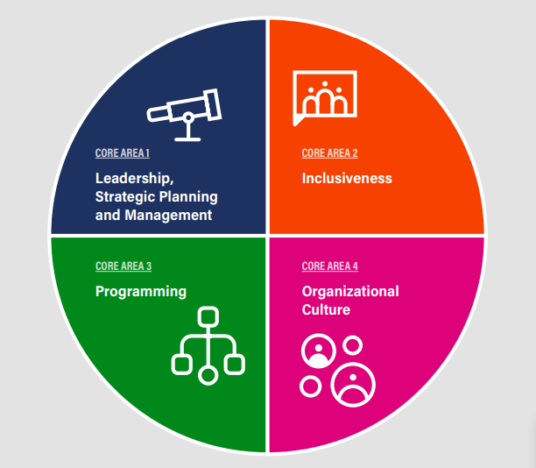
Leadership, Strategic planning and management
- A specific senior-level mechanism is in place for ensuring accountability for disability inclusion (ind. 1)
- Entity commitment to targeted and mainstream disability inclusion reflected in overview/preamble, results statements and disaggregated indicators of the UNV Strategic Framework (ind. 2)
- Strategy on mainstreaming disability inclusion in place and implemented (ind. 3)
- A unit/individual with substantive expertise on a human rights-based approach to disability (ind. 4)
- A focal point network on diversity and disability including all relevant sections, regional offices and field units (ind. 4)
Inclusiveness
- A partnership with organizations of persons with disabilities at the headquarters level and guidance on engagement with a diversity of organizations of persons with disabilities at the regional/country levels (ind. 5)
- Accessibility policy/strategy for UN Volunteers and personnel in place, including accompanying accessibility guidance on conference services and facilities. (ind.6)
- Reasonable accommodation strategy including adequately funded mechanism
- Measures to support UN Volunteers with dependents with disabilities
- A record of reasonable accommodations requested and provided to UN Volunteers and personnel and the level of satisfaction with the provision of reasonable accommodation
- Procurement policies and guidelines ensure that relevant goods and services acquired are accessible or do not create new barriers and promote purchasing from disability-inclusive suppliers.
- Accessible procurement process
- Number/percentage of relevant procurement documents that have accessibility as a mandatory requirement
Programming
- Guidance note or equivalent adopted on mainstreaming disability inclusion at all stages of the Volunteer Management Cycle
- Evaluation guidelines containing guidance on how to address disability inclusion
- Terms of reference, inception and evaluation report(s) reflect disability inclusion
- Knowledge management practices promoting improved mainstreaming of disability inclusion
- Inter-agency coordination mechanism(s) on disability inclusion
Organizational culture
- Volunteers PWD placed with UN Entities and partners
- PWD employed by UNV (personnel)
- Employment policy/strategy and other human resources-related policies/strategies include provisions to attract, recruit, retain, and promote career development of employees and UN Volunteers and on-line volunteers with disabilities
- Twin track approach adopted: mainstreamed and targeted efforts to engage personnel, UN Volunteers and on-line volunteers PWD
- Reporting tools capture level of satisfaction by personnel, UN Volunteers and on-line volunteers persons of disabilities
- Entity-wide learning and training opportunities on disability inclusion
- Accessible UN Volunteer learning journey
- Guideline(s)/procedures on internal and external communication with PWD reflected in mainstream communications.
- Effective system to address problems and complaints by personnel and Volunteers PWD
(Article 27 gives disabled people the right to work in jobs they have freely chosen in inclusive workplaces. It says that employment discrimination against disabled people must be against the law. The rights of disabled and non-disabled people in work must be protected – this includes the right to have an effective system to sort out problems and complaints)

Interventions and addressed barriers
- Reflect disability inclusion in SF document, results statements and disaggregated indicators (sex, age, north south) (Attitudinal, Information)
- System implemented to track resource allocation to disability inclusion across UNV (UN Volunteers and personnel) (Economic, Information)
- Establish reasonable accommodation fund for personnel and UN Volunteers serving with UNV and adjust the budget as required($) (Economic)
- Develop a partnership with organizations of persons with disabilities at the headquarters, regional and country level for provision of advice, consultations and talent sourcing (Attitudinal, Information)
- Put in place entity-wide learning and/or training opportunities on disability inclusion ($) (Attitudinal, information)
- Develop and enhance aaccessible volunteer platforms, functionalities, website ($) (Physical, Information)
- Develop and enhance fully accessible UN Volunteer learning journey ($) Attitudinal, Information, physical)
- Targeted UN system-wide advocacy on engagement of UN Volunteers with disabilities in the UN workforce (Attitudinal, Information)
- Conditions of Service include provisions for eligible dependents persons with disabilities (Policy, Economic)
- Promote the placement of UN Volunteers and on-line volunteers with disabilities to support UN Entities and UN Country Teams to meet the UNDIS score card targets (Attitudinal)
- Ensure talent pool has candidates PWD in top requested occupational groups for key partners (Attitudinal)
- Generate knowledge, evidence and policy recommendations on volunteerism and inclusion including disability issues especially in the context of leaving no one behind (Information, Policy)
- Promote disability and inclusion in Volunteer Infrastructure (VI) advisory services provided to Member States (Information)
- Communication campaign on disability inclusion is undertaken at least every two years (Attitudinal, Information)
- involvement of staff with disabilities and staff with dependents with disabilities into staff association (Attitudinal, Information)
- Affirmative action a) at least one candidate PWD per submission b) tailored initiatives (age, experience) (Policy)
- Procure goods and services in line with the universal design standard (Attitudinal, Physical, Policy)
- An effective mechanism for managing and responding to feedback, comments and complaints about accessibility

Inputs
- UNDP guidance note on Reasonable Accommodation
- UNV personnel time
- Knowledge and expertise
- Positioning with networks (enablers: IASG, UNPRPD, DCO, IASC, UNSDG results groups)
- Established relations
- Evidence
- Specific accessible tools Unified Volunteer Platform, Volunteer Reporting Application, Website
- Trainings and funding for learning
- Tech solutions
- Allocated budget (annually $170.000)
  - reasonable accommodation fund (USD$30.000)
  - accessible platforms and website DT budget (US$40.000)
  - accessibility of learning journey (US$50.000)
  - capacity at Volunteer Service Center (US$ 50.000)

Assumptions
- UNV is a partner of choice for providing support to UN Entities and UN Country Teams to meet the UNDIS score card targets through promoting the placement of UN Volunteers and on-line volunteers with disabilities
- UNV has strong supply mechanisms to source qualified candidates PWD in occupational groups required by UN Entities
- UN Entities are getting gradually ready, accessible and have policies, funds and capacities to engage UN Volunteer PWD
- PWD are yet to access UN Volunteers assignments because of age and experience criteria

UNV to continue doing in line with UNDIS Accountability Framework and indicators
- Senior managers internally and publicly to champion disability inclusion
- Implementation of organizational disability inclusion approaches is reviewed by senior management annually, with remedial action taken as needed, through means of UNDIS reporting mechanism, UNV SF indicators and AWPs
- Develop and refine Standard Operating Procedures and tools for disability inclusion
- Represent UNV in existent inter-agency coordination mechanisms, UNDIS and disability inclusion related working groups (enablers: IASG, UNPRPD, DCO, IASC, UNSDG results groups)
- Raise awareness of Host Entities on specific responsibilities concerning engagement of UN Volunteers persons with disabilities
- Provide tools for self-assessment of host entity accessibility and readiness to host UN Volunteers with disabilities during the DOA design stage
- Develop and refine talent acquisition strategy to attract talent
- Hold a focal point inclusion and diversity network meeting at least once a year
- Develop, implement and review accessibility approach/ strategy for UN Volunteers and personnel
- Assess every year and revise the accessibility action plan for conference services and events
- Persons with disabilities are reflected in mainstream communications
- Health and life insurance for UN Volunteers cater for persons with disabilities
- UNV to consistently use and apply UNCPRD, UNDIS and WHO taxonomies

TOC Visual

