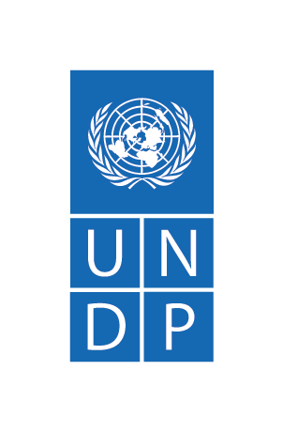
Youth Employment and Empowerment through Private Sector and Value Chain Development
Agreement Number: 6003382
UNDP Project Number: 00113334
2020 Annual Report
February 2021

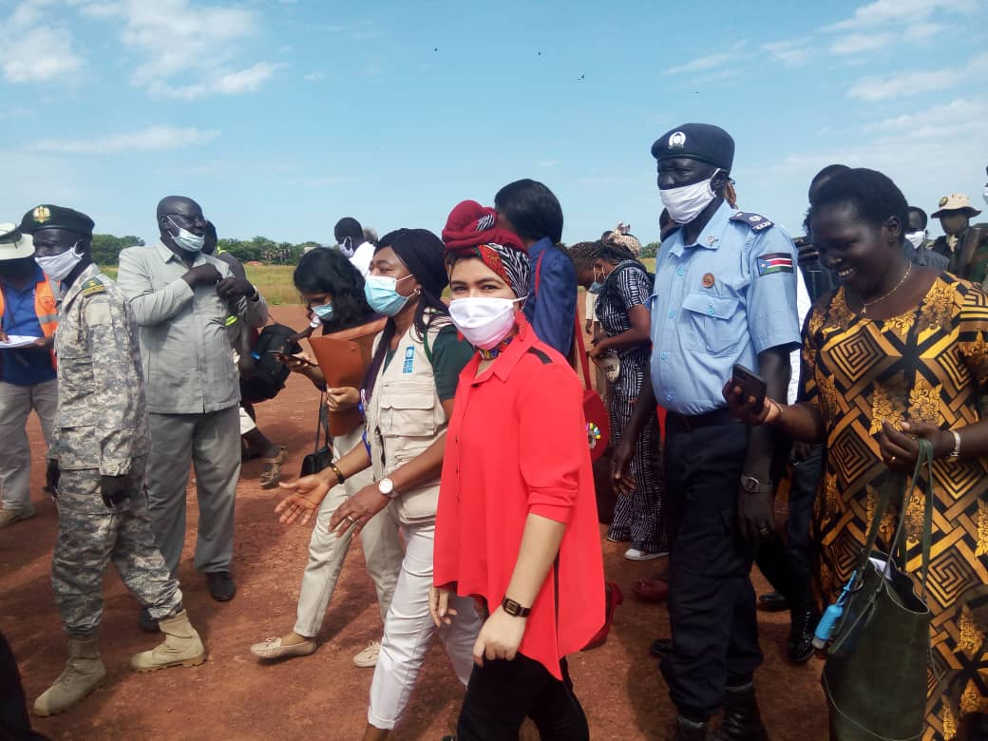
H.E. Aya Chebbi , African UnionYouth Envoy and Christy Ahenkora UNDP Deputy Resident Representative during the visit to Greater Lakes State
(October 2020, UNDP)

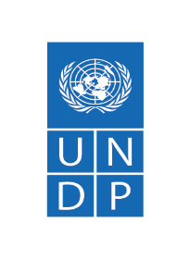
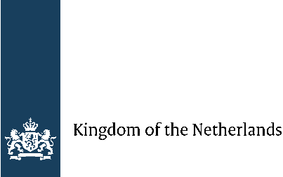

Project Summary | Country: South Sudan  Project Duration: October 2018 – 31 December 2022  Project Budget: US$ 15,450,710  Annual Budget: US$ 4,667,275  Donor Annual Budget in USD Cumulative Expenditures  Netherlands 3,431,068.00 3,145,405.22  SURGE 85,158.00 76,691.80  UNDP 1,151,050.00 1,090,992.39  TOTAL 4,667,275.00 4,313,089.41  Cumulative expenditure: US$ 4,313,089.41  Contact Persons:  Samuel Doe  Resident Representative  Tel. +211 926 221 701  samuel.doe@undp.org  Daniel Kir  Team Leader  Stabilisation, Recovery and Stabilisation (STARR)  Tel. +211 920887780  daniel.kir@undp.org
Responsible Parties: Ministry of Labour, Public Services and Human Resources Development, Ministry of Culture, Youth and Sport, Chamber of Commerce and Industry, collaborating UN Agencies, and Civil Society Organizations.

Table of Contents
Table of Contents iii
Acronyms 1
1. Executive Summary 2
2. Progress towards development results 6
2.1 Contribution to longer-term results 6
2.2 Progress towards programme outputs 8
Human Interest Story 14
3. Cross Cutting Issues 15
3.1 Gender Results 15
3.2 Partnerships 16
3.3 Environmental considerations 17
3.4 South-to-South and triangular cooperation 17
3.5 Strengthening national capacity 17
4. Monitoring and evaluation 18
5. Risk Management: 20
6. Challenges 20
7. Lessons Learned: 21
8. Conclusions and way forward: 21
9. Financial Summary: 23

Acronyms

AU  AWP  B2B | African Union  Annual Work Plan  Business-to-business
CAPS | Career Advice and Placement Services
CPD  GoSS | Country Programmeme Document  Government of South Sudan
HDIGU | Human Development and Inclusive Growth Unit
IDO | Integrated Development Organization
IDP | Internally Displaced Person
IOM  MSE  MTC | International Organization for Migration  Micro- and small-scale enterprise  Multi-Purpose Training Centre
M&E | Monitoring and Evaluation
PaCC | Peace and Community Cohesion
PBF | Peacebuilding Fund
PfRR | Partnership for Recovery and Resilience
PMSU | Partnership and Management Support Unit
PoC | Protection of Civilians site
TVET | Technical vocational education and training
UN | United Nations
UNCT | United Nations Country Team
UNDP | United Nations Development Programmeme
UNICEF  UNIDO  UNMISS | United Nations Children’s Fund  United Nations Industrial Development Organization  United Nations Mission in South Sudan
VTC | Vocational Training Centre
YEEP | Youth Employment and Empowerment through Private Sector and Value Chain Development Project

Executive Summary

The Resilience and Recovery portfolio aims to contribute towards setting South Sudan on a pathway to sustainable peace and development through: a) empowering youth and young women with vocational, market-linked skills and engagement platforms that enable improved socio-economic outcomes and participation in nation-building; b) reestablishment and improvement of institutions of higher learning and innovation; c) enhancing protection and solutions seeking transitional and/or durable measures while prioritizing self-reliance, local integration through improved access to social services and markets; d) youth employment promotion and private sector development in climate-smart agriculture (CSA) and natural resource management (NRM) value chain; and e) provision of livelihoods, skills development and rehabilitation of basic community infrastructure.

Youth Empowerment and Employment through Private Sector and Value Chain Development Project (YEEP) is a four-year (December 2018-December 2022) project implemented by UNDP and the Ministry of Labour, with the financial support from the Kingdom of the Netherlands and UNDP. The project seeks to empower youth in the five targeted locations of Bor, Juba, Rumbek, Torit and Yambio through nurturing of their entrepreneurial culture and market-linked skills to enhance their employability and productive engagement in economic activities. The YEEP aims at contributing to the progressive transformation of South Sudan towards durable peace and sustainable development by supporting livelihoods trainings, infrastructure renovations and rehabilitations; re-establishing and improving institutions that can effectively serve the youth of South Sudan.

The YEEP is implemented following the United Nations Country Team’s (UNCT) Interim Cooperation Framework, the joint United Nations (UN) Recovery and Stabilization framework and the UNDP Country Programmeme Document (CPD) 2019-2021. The project is implemented in five locations: Central Equatoria (Juba), Western Equatoria (Yambio), Eastern Equatoria (Torit), Jonglei (Bor) and Lakes (Rumbek). It is being implemented in collaboration with partners that include the Ministry of Labour, Public Services and Human Resources Development, Ministry ofYouth and Sport, Chamber of Commerce and Industry, UN Agencies, and Civil Society Organizations.

The COVID-19 pandemic greatly hindered the progress of project implementation following a lockdown of the country in March 2020 and the substantive easing of the restrictions of the presidential decree towards the end of the year. Despite the easing, activities picked up albeit at a slower pace observing WHO’s and the government’s guidelines on COVID-19 mitigation and control pertaining to conduct of business.

Main achievements during the year
- Enhanced sustainable livelihoods skills training – The project successfully facilitated Community mobile based and sustainable livelihood skills training. A total of 3,827 youth (87% women) completed sustainable livelihoods skills training focusing on agribusiness, tailoring, hairdressing, food preparation, among other areas. Of this total 1,591 have been graduated and they received start-up kits to support start their own businesses and improve their resilience coping capacity with the income they make from their economic activitiesThe remaining 2,236 (1,614 females) community members from 4 locations (Torit, Rumbek, Juba, and Yambio) completed training in 7 trade areas which include apiculture, frontline hospitality, baking and pastry making, dairy processing, among others and are awaiting graduation and reception of start-up kits to kick start their businesses.
- Enhanced Vocational Skills Training (Institutional based vocational training): The project successfully facilitated the competency based modular vocation training. A total of 1,019 trainees (180 females) completed vocational training in 14 trades in four Vocational Training Centres (VTCs). The 1,019 trainees await graduation which is planned for the first quarter of 2021.
- Improved livelihoods: In support to enhanced and improved livelihoods through income earning capacities, 47 individual and 36 group businesses in agriculture, catering and hairdressing have been established by graduands of the sustainable livelihoods skills training. These businesses were further organized into 25 Village Savings and Lending Associations that are currently operating. This support has enhanced their income earning capacities and also empowered the groups and individuals with savings capabilities to support future growth. Some of these have continued to grow their business and provide additional employment to some of their classmates.
- Face mask production and distribution- Close to a million face masks (972,815) were produced and distributed to vulnerable persons in seven states. A total of eight facilities (3 in Juba and 1 each in Torit, Rumbek, Bor, Yambio and Aweil) were established for facemasks production to allow for decentralized and increased facemask production and distribution. The facemask initiative is a primary intervention on COVID-19 infection prevention and control and was undertaken in collaboration with IOM, UNICEF, WFP, Office of the Vice President, and various state governments. A total of 448 persons (79%) female were engaged in this project.
- Youth empowerment and employment in the private sector: A total of 1,184 (41% women) persons were gainfully employed in various trades through the programmeme’s intervention. Of the total, 448 persons (79% female) were engaged as tailors, quality assurers and production support staff for the COVID-19 response initiative through face mask production and distribution while 340 persons (5% females) were employed in construction and rehabilitation work in Upper Nile University. An additional 60 women who were graduands of sustainable livelihoods skills gained employment in various trades. 107 jobs (45% of which were filled by women) were created by the small businesses established by youth and women who have been trained by the project. 116 persons remained employed through jobs traded during the 2019 job fairs. Additionally 113 Students benefited from work related learning which was supported with a stipend.
- Studies completed to inform the Agricultural Value chain:: Agricultural Value chain and Labour market have been completed and are used to inform the value chains that will be established through the community-based livelihood skills training and vocational skills training to be offered and that are needed in the participating states (Rumbek, Juba, Torit, Yambio and Bor.

Challenges faced during the implementation period;

During the reporting period, the project faced several challenges that slowed the pace of implementation of activities at both the national and sub-national levels as follows:
- The Corona Virus (COVID-19) pandemic brought immense challenges in implementation as the Presidential Decree suspending the conduct of trainings and other gatherings impacted on the achievement of the indicators.
- The relaunching of the labour market and agricultural value chain and natural resources management studies delayed the identification of trades and livelihood skills training to be offered to the youth.
- Delays in provision of start-up kits for the graduates/ trainees impacted on the timely graduation of trainees.

Lessons Learnt;
- Partnership: The engagement of national implementing partners boosts indicator delivery thereby contributing to the achievement of the project's goals.
- Responsiveness: The engaged National Non- Governmental Organisations quickly came to action soon as the COVID-19 restrictions were relaxed to enable completion of trainings and eventual graduation of the first batch of the sustainable livelihood skills trainees.
- Flexibility and realistic contingency planning: As a result of COVID-19 and in response to the crisis and needs for facemasks for the most vulnerable, the project converted 8 facilities to produce OVID-19 facemasksCapacity Building of local Institutions: Experiences in the capacity of contracted local institutions to conduct studies and provide the sustainable livelihoods skills training has shown the need for enhanced and strengthened capacities to deliver trainings for vulnerable people of South Sudan.

Budget Performance
The total cumulative programmeme expenditure for 2020 was US$4,313,089.41, representing 92.41% percent delivery of the total 2020 programmeme budget of US$4,667,275.00.

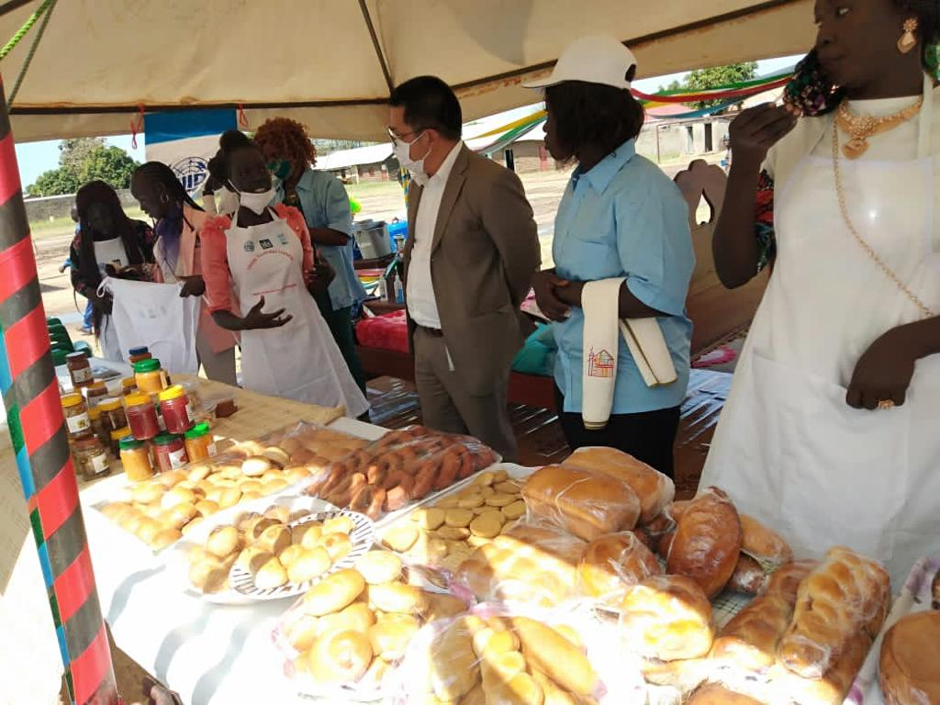
Community based training graduates showcasing their wares during the Juba graduation; UNDP, November 2020
- Situation Background

The Revitalised Agreement on the Resolution of Conflict in the Republic of South Sudan (R-ARCSS) of September 2018 laid the foundation for ceasefire and negotiations for a transitional political roadmap that led to the formation of Transitional Government of National Unity (TGoNU) in February 2020 brought hope and renewed impetus towards stabilizing the fragile situation in the country. Even so, South Sudan continues to face immense political, institutional, social and economic challenges which include the exclusion of women, youth, minorities and other special interest groups in livelihood initiatives that enable nation-building. R-ARCSS provides the Revitalized Transitional Government of National Unity (R-TGONU) with a mandate to implement the agreement with the promise of no return to war; to reintegrate refugees and IDPs; to undertake legal and institutional reforms; and to develop national security architecture. It also offers special consideration to conflict-affected persons (children, orphans, women, people with special needs, etc.), in the public services delivery, including access to education services.

On 11 March 2020, the World Health Organization declared COVID-19 a pandemic. This declaration resulted on a quick and sudden global chain of events that did not spare South Sudan. By 16 March, a presidential statement ordering the mandatory self-quarantine for travelers from countries with escalating confirmed cases, postponement of social gatherings as well as other preventive measures was issued. A national directive closing all schools, training centers, among other actions was decreed on 20 March. With the threat lurking at the South Sudanese borders, the country closed its borders to travelers particularly its international airport and major border crossings with enhanced border controls on 23 March. A national curfew was then imposed and remains in effect in the country.

The COVID-19 pandemic has brought with it a new normal in South Sudan despite having come with “a crisis on top of crises”. The pandemic is negatively impacting the multiple transitions that are ongoing in South Sudan; from war to peace to stability, humanitarian to development, and from pre-transition to transition phase in the implementation of the peace agreement. The socio-economic impact of the pandemic is already evident. A palpable concern is shared by citizens with regards to COVID-19, cognizant of the limits of the health system that can be exacerbated by cultural practices on the sick and the deceased. Social distancing measures are not strictly observed despite the effort being made to raise awareness on preventive and mitigation measures. Food prices have escalated as movement restrictions make it more difficult for logistics in this landlocked country to flow and businesses have closed and many people who are daily wage earners have lost jobs and income. Moreover, basic protective materials like face masks which are a major factor in deterring the spread of the virus are in extremely short supply and with prices inflated by several folds due to the sudden spike in demand.

UNDP’s efforts through the programme are anchored in the United Cooperation Framework (UNCF), the Partnership for Resilience and Recovery (PfRR) and the UNDP CPD 2019-2021. Most significantly, it supports the CPD’s Pillar II: ‘Inclusive and risk-informed economic development’. The implementation strategy is embedded within the UNCT’s programme criticality principles of addressing the immediate needs of the conflict-affected population as well as build the foundations for early recovery. The programme therefore is responding to the COVID-19 pandemic through production and distribution of face masks and the sanitation of various government buildings.

The programme seeks to engage the youth to ensure their productive capacities are enhanced through the nurturing of their livelihood and employable skills to improve their economic well-being. In improving the wellbeing, resilience and peaceful co-existence among youth in and around targeted areas in South Sudan (impact); using a two-pronged outcome approach in its theory of change:
- If local private sector enterprises, agricultural and natural resource -linked value chains and services for young men and women are enhanced then new business and income generating opportunities will be created whilst productivity and labour absorptive capacities of new and existing local private sector enterprises and value chains will be boosted (outcome 1).
- If the youth are provided with vocational, technical and entrepreneurial skills, psychosocial and business management advisory support then the employability and engagement in economic and livelihood initiatives and productivity and incomes for young men and women in targeted areas will be increased (outcome 2).

Progress towards development results

2.1 Contribution to longer-term results
- CPD Outcome 2: 'Inclusive and risk-informed economic development'
Summary achievements based on CPD Outcome 2.3 target
CPD outcome target 2.3 | Summary achievement | Status
Indicator 2.3: Number of micro-, small- and medium-sized enterprises utilizing supplier development platforms for inclusive and sustainable value chains  Target (2020): 100 | 416 small enterprises established and supported through agricultural and natural resources value chain. Additional 44 businesses identified and due diligence assessment conducted for asset linked internship programme | Achieved
Overall status |  | Achieved
- CPD Output 2.1: Increased access to emergency assistance, alternative livelihood and employment opportunities for families in conflict and disaster-prone communities
Summary achievement based on CPD output targets
CPD output targets | Summary achievement | Status: achieved, delayed, or partially
Indicator 2.1.2: Number of people reached with entrepreneurship and skills development, emergency employment and business support services  Target (2020): 1,600 (60% women) | 4,846 (68% women) people reached with entrepreneurship and skills development under the sustainable livelihoods skills, community- based skills and vocational skills training in various vocations which include agribusiness, tailoring, hairdressing, food preparation, agriculture among other areas. | Achieved
Indicator 2.1.3: Number of people benefitting from jobs and improved livelihoods in crisis or post-crisis settings, disaggregated by sex  Target (2020): 600 (49% women) | 1,184 (41% women) persons gainfully employed in various trades. 448 (79% females) people gained employment in the facemask initiative, 60 sustainable livelihoods skills graduates have gained employment in various trades. 340 persons were engaged in construction and rehabilitation work in UNU; 116 persons got jobs from the job fairs whereas 107 jobs were created by newly established businesses of the skills training graduates; 113 students were engaged for work-related learning. | Achieved
Overall status |  | Partially Achieved

Indicator 2.1.2: Number of people reached with entrepreneurship and skills development, emergency employment and business support services
A total of 4,846 (68% women) people benefited from entrepreneurship and skills development under the sustainable livelihoods skills, community- based skills and vocational skills training in various vocations which include agribusiness, tailoring, hairdressing, food preparation, agriculture among other areas. Of the total number, 1,591 have been graduated and supported with start-up kits to help kick start their small enterprises, while the remaining 3,255 persons are awaiting graduation and reception of start-up kits in the first quarter of 2021. The provision of start-up kits and trainings is a way to support improve livelihoods and income generation opportunities or vulnerable youth of South Sudan.

Indicator 2.1.3: Number of people benefitting from jobs and improved livelihoods in crisis or post-crisis settings, disaggregated by sex
Table 1: women benefitting from jobs and improved livelihoods

A total of 448 persons (79% females) gained employment in the COVID-19 facemask production initiative. An additional 60 persons who graduated from the sustainable livelihoods skills training gained employment in various trades. 116 jobs – NGO workers, drivers, security guards, etc. - were filled through the job vacancies traded in the three job fairs (Yambio, Torit, Bor) of 2019 and 340 persons (15 females) were engaged in construction and rehabilitation work of the UNU Malakal campus bringing the cumulative total of persons gainfully employed to 1, 1844 (41% women). Furthermore, 25 Village Lending and Savings Association (VLSA) groups were formed, boosting the livelihoods of over 1,591 women who received start- up kits and are being supported to engage in business as groups (36 groups have so far been formed) or as individulas (47 individual businesses formed). Those employed and who formed businesses are currently benefiting from incomes that allow families to have access to food and improved housing conditions.

Location | Number of women benefiting from jobs and improved livelihoods
 | Female | Number of groups formed | Number of women gainfully employed
Yambio | 482 | 4 VLSA, 15 group business, | 33
Wau | 300 | 2 VLSA, 6 group business | 12
Torit | 406 | 12 VLSA, 11 group business | 13
Rumbek | 403 | 7 VLSA, 7 group business | 14
TOTAL | 1,591 | 25 VLSA, 36 group business | 60

2.2 Progress towards programme outputs
Project Output 1.1: Young men and women in Bor, Jubek, Rumbek, Torit, Bentiu, Aweil and Yambio are provided with vocational and entrepreneurial skills
Summary achievement against 2020 Annual Work Plan (AWP) target
Indicator | Target (2020) | Summary achievement | Status
1.1.1 Number of enrolled youth that complete the vocational, technical and entrepreneurship skills training, disaggregated by gender and location | 1,600 | 4,846 (3,313 women) youth completed vocational, technical and entrepreneurship training. 1,591 women graduated with sustainable livelihoods skills in Bor, Juba, Rumbek, Torit, Wau and Yambio. | Achieved
1.1.2 Proportion of young entrepreneurs utilizing innovation centers, business incubators and development hubs for skills enhancement | 50% | 60% (30 of the 50) of young entrepreneurs seconded to the Tony Elumulu at beginning of year benefited from global mentoring and networking | Achieved
1.1.3 Proportion of youth previously involved in conflict recruited for skills training | 20% | 11% of the youths enrolled for skills training were previously involved in conflict | Partially achieved
 | Overall status |  | Ongoing

Indicator 1.1.1: Number of enrolled youth that complete the vocational, technical and entrepreneurship skills training, disaggregated by gender and location
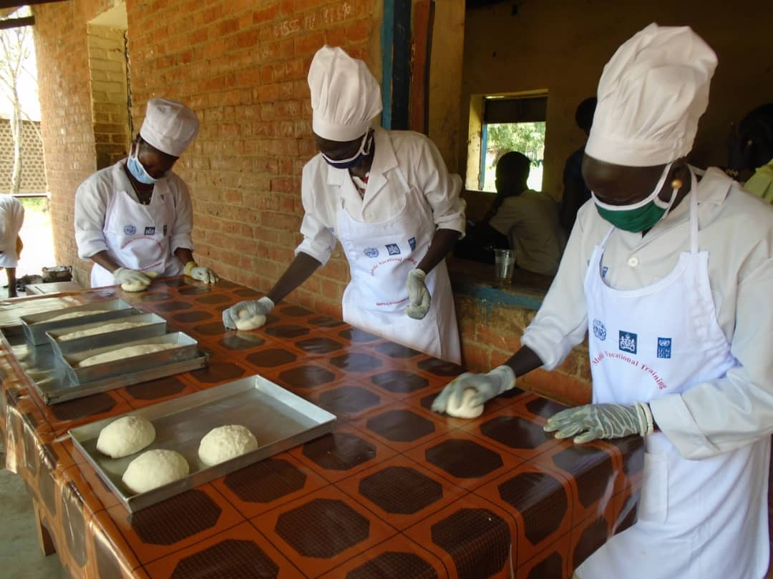
4,846 (3,313 women) youth were enrolled and completed various skills training including vocational, technical and entrepreneurship. 1,591 women graduated with sustainable livelihoods skills in seven trades. The trainings were facilitated by four implementing partners in Wau, Torit, Rumbek and Yambio. Additionally, 2,236 (1,614 women) community members completed community based training/ mobile training in seven trades (apiculture, food preservation and processing, housekeeping, food preparation, bakery and dairy processing) in Yambio, Torit, Rumbek and Juba. 590 members from Torit graduated in the community based trainings. 1,019 (180 women) youths were enrolled for vocational training at the 4 vocational training centres (Yambio, Torit, Bor and Juba) in fourteen different trades. Though the community and institutional based training students completed training, they are meant to graduate and receive their start up kits in the first quarter of 2021. The trainings are meant to boost market skills for employability as well as enhanced livelihood skills for coping with shocks.
Baking trainees during a lesson in Torit, September 2020, UNDP
The renovation of Rumbek VTC is penciled to begin in first quarter of 2021 as the assessments and BOQ for the construction have been done. This will bring to a total five VTCs in operation for the YEEP project.

Indicator 1.1.2: Proportion of young entrepreneurs utilizing innovation centers, business incubators and development hubs for skills enhancement
30 of the 50 youth (60%) entrepreneurs successfully completed the training and were able to benefit from global coaching, mentoring, and networking through the Tony Elumelu Foundation (TEF)in the first quarter of 2020.

Furthermore, the programme managed to complete two online portals (business portal and employment portal) which are meant to provide remote support to businesses and job seekers. The Employment Portal is hosted by the Ministry of Labour and is linked to business networks and the Chamber of Commerce inorder to raise the level of accessibility and transparency of jobs to the youth. On the other hand, the Business Portal is made part of the e-commerce initiative of the Ministry of Trade. An e-commerce hub is being established through UNDP support and the Business Portal will be featured in the said hub as a more effective means of business networking and linkaging towards trade enhancement. Young entrepreneurs and private sector businessed registered with the Chamber of Commerce are likely to benefit from the linkages and relationship building to be promoted by the portal.

The business development hubs in Torit, Yambio, Bor and Juba received materials and equipment (furniture and ICT equipment) to allow for starting of activities in the hubs. All the centres will be linked to the two online portals (business portal linked with the business and e-commerce initiative - hosted by the Ministry of Trade and employment portal linked with business networks- hosted by the Ministry of Labour) which are meant to provide remote support to businesses and job seekers. Young entrepreneurs and private sector businessed registered with the Chamber of Commerce are likely to benefit from the linkages and relationship building to be promoted by the portal.

Indicator 1.1.3: Proportion of youth previously involved in conflict recruited for skills training
Despite challenges in collecting this sensitive data, the project reports 569 people or 11% of those enrolled for training to have been previously involved in conflict. Vulnerable groups (including Internally Displaced Person (IDP)s, returnees, former soldiers/ fighters, Children Associated with Armed Forces and Armed Groups (CAAFAGs) as well as women associated with armed forces) are also benefiting from the trainings.

Programmeme Output 1.2: TVET and university graduates have increased access to career development and employment opportunities
Summary achievement against 2020 AWP target
Indicator | Target (2020) | Summary achievement | Status
1.2.1 Number of skills training graduates that secure jobs from UNDP-supported private sector enterprises and value chains disaggregated by gender | 450 | 113 (74 females) skills training graduates engaged in gainful livelihood activities. | Not achieved
1.2.2 Proportion of tertiary education students in the targeted locations receiving career guidance and mentoring through CAPS, disaggregated by gender | 30% | 3 centres renovated and equipped so as to start supporting CAPS | Delayed
1.2.3 Number of jobs traded through jobs fairs | 150 | None as no job fairs conducted due to COVID-19. | Delayed
 | Overall status |  | Ongoing

Indicator 2.1.1 Number of skills training graduates that secure jobs from UNDP-supported private sector enterprises and value chains disaggregated by gender
A total of 113 (74 females) skills training graduates from the sustainable livelihoods, vocational and community skills training secured jobs from UNDP-supported private sector enterprises and value chain. The graduates were engaged in carpentry, masonry, hairdressing, food preparation and processing among others in the five programme implementation locations (Toirt, Juba, Yambio, Rumbek and Bor). The graduates now have a source of income which has enhanced their resilience and respond to shocks.
The programme is also following up on the 44 organisations that underwent the screening (due diligence exercise) during the course of 2020 for their engagement in the enterprise based training (internship) and asset linkage programme which will benefit the private sector organisations and more than 500 vocational skills graduates. The programme will identify and engage more organisations for the asset linkages initiative in 2021.

Indicator 2.1.2 Proportion of tertiary education students in the targeted locations receiving career guidance and mentoring through Career Advice and Placement Services (CAPS), disaggregated by gender.
At time of reporting, no students in the YEEP five programme locations (Bor, Juba, Rumbek, Torit and Yambio) benefitted from the Career Advice and Placement Services (CAPS) initiative. Yambio VTC, Juba Multi-purpose Training Centre, Bor Business Development Centre and Torit VTC have dedicated spaces/ acting as the locations for the One-Stop Business, Employment, and Innovation Centre. The same spaces (BDCs) will be used for CAPS. All four locations received ICT equipment comprised of 50 top-of-the line desktop computers, 5 printers, 5 public address systems, 5 LCD projectors and screens, 5 generators, and furniture to allow interaction with the forementioned online portals. These centres are in various stages of setting up. The programme is also in process of identifying partners to man the BDCs as well as assist with CAPS for tertiary education students.

Indicator 2.1.3 Number of jobs traded through jobs fairs
Job fairs are a platform where jobs are traded. 450 jobs were traded during the 2019 job fairs in Bor, Yambio and Torit which saw 116 people getting gainfully employed. The programme will followup and conduct an assessment to verify and check if the 116 people are still employed as well as check whether the 75 pipeline jobs previously reported were filled. The conduct of the Juba Job Fair was affected by the COVID- 19 pandemic that prohibited public gatherings. The programme continues to monitor the trends and will organise the nationwide job fair in the second quarter of 2021.
Job fairs are a platform for bringing together for job seekers and employers, providing career guidance and targeted capacity building in CV writing and interview techniques. Those who got employed with positions advertised at the job fairs now have incomes to cater for their and their families’ needs.

Project Output 2.1: Young men and women in targeted areas benefit from jobs, livelihood and income-generating initiatives created through strengthened private sector enterprises and local value chains
Summary achievement against 2020 AWP target
Indicator | Target (2020) | Summary achievement | Status
2.1.1 Number of new jobs created through value chains and private sector enterprises supported by UNDP | 600 | 2,181 (92 % females) skills training graduates got engaged in gainful livelihood activities within the agricultural value chains and private sector. | Achieved
2.1.2 Number of new MSEs created by supported youth | 40 | 60 new MSEs were formed. In addition, 36 groups have been established and 25 VLSAs formed. | Achieved
2.1.3 Proportion of trained youth engaging in livelihood and income-generating activities (individually or in groups) | 30% | 45% of the trained youth received start-up kits and are engaged in their own businesses. | Achieved
2.1.4 Number of youth-oriented facilities benefiting from clean energy solutions | 4 | 4 VTCs are supported by a renewable energy source. | Achieved
 | Overall status |  | Ongoing

Indicator 2.1.1 Number of new jobs created through value chains and private sector enterprises supported by UNDP
A total of 2,181(92 % females) skills training graduates got engaged in gainful livelihood activities within the agricultural value chains and private sector. Additionally, the project managed to conduct the Agricultural and Natural Resources Management Value Chain study. This study will inform the type of support which the project will provide toward enhancing agricultural value chain and private sector actors in the project implementation areas in 2021. Furthermore, the study will help inform the jobs and job types that will be created by the various agricultural trade and crops which are worth investing in. The study will also compliment the market study assessment which was conducted by UNIDO and the other implementing partners who are providing sustainable livelihood skills training.
Furthermore, the project conducted a due diligence assessment for 44 organisations in the private sector. This will help consolidate efforts made by the business to business linkages events conducted in 2019 which saw horizontal and vertical linkages formed.

Indicator 2.1.2 Number of new micro- and small-scale enterprises (MSEs) created by supported youth
The project was able to support 60 new MSEs were formed and registered with the Chamaber of Commerce during 2020. Cumulativelys, 86 MSEs are receiving technical and financial support from UNDP. This is through the innovation challenge grants for the innovation challenge winners and technical mentorship and coaching from partnership with the Tony Elumulu Foundation. A total of 396 youth entreprenuers have benefitted from support of the project with emphasis on micro and small-scale enteprises business formation support. The project continues to monitor progress of the 4,846 graduands who completed their trainings from the VTCs and community trainings facilitated..

Indicator 2.1.3 Proportion of trained youth engaging in livelihood and income-generating activities (individually or in groups)
To date 45% of the trained youth for vocational, community and sustainable skills training managed to complete their trainings and received start-up kits in the reportiong quarter. The formation of 36 coorperative groups was facilitated and these have started operations of their businesses additionally, 25 VLSA groups were also formed. The programme is to graduate the remaining 2,662 graduates and will follow up with groups and businesses formation and distribution of starr-up kits in the first Quarter.

Indicator 2.1.4 Number of youth-oriented facilities benefiting from clean energy solutions
During the reporting period, the programme established a renewable energy source using solar to power 31 structures in Upper Nile University. In addition, the three institutions (Bor VTC, Torit VTC, and Yambio VTC) which were equipped with solar panels continue to operate are are relying on solar energy in providing lighting and power for the administration and classroom blocks. Moreover, the boreholes of all the three VTCs are powered by wind and solar energy and this has minimized environmental pollution including those associated with oil spillage, carbon emission and sound pollution that may arise from the use of fossil fuels during the operation of generators.

Human Interest Story
Applying Sustainable Livelihood Skills Training to Practice- From Student to Business Owner
Sophia Yom Dhokpou, 32, is a mother of five, who lives with her family in Akuac, a residential area in Rumbek. She holds a High School certificate. Due to financial constraints she could not further her studies at tertiary level.
She first heard of the sustainable livelihoods training opportunity via a radio advertisement in November 2019 and she decided to enroll. She thought of challenges faced by her family which is depending on government salary which at times can take ages to be paid. Her family supported the her when she decided she wanted to enroll for the Food Processing course. Her dream of forming her own business was a step away.
Diligently, she attended all sessions. The coming of COVID-19 almost spoiled her dream. “I was frustrated when our training came to an indefinite close. However, the kwnoledge and skills I gained in Business Management and the three-week food processing training were eye-opening. With the support I got from my husband, I started a tea place where I sell tea and make quality bread and mandazi."
Sophia admittedly said that the tea business is rewarding. She got a range of customers from young children to adults. She uses her income to support her family." I used to depend on my husband for almost everything. But now, I have reduced his burden. My needs and those of children are no longer the problems." said Sophia. She said when schools open, she could pay school fees for her children.
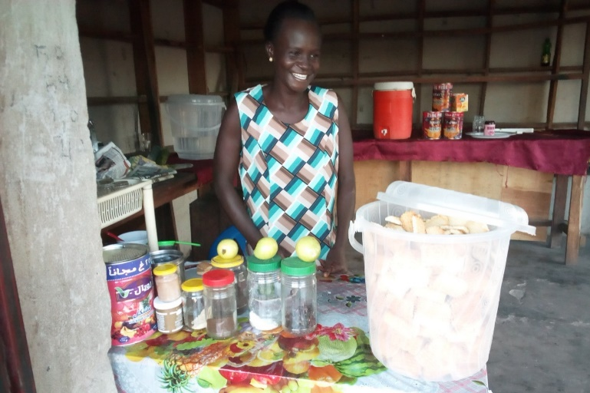
Sophia believes that she has gained appropriate skills necessary to make fresh food and cakes. What thrill her so much is her ability to make birthday and wedding cakes.
Sofia confessed that before she joined the training, she used to face a lot of financial-related challenges, and sometimes it could be very difficult to put the daily bread on the table for her family. "...I make an average of 28000 South Sudanese Pounds per week. It is an enormous sum of money if I could save most of it. But due to overdependence of other close family members, I save a little money."
Sophia preparing to serve her guests tea.
After the graduation, she received a startup kit. Sophia planned to maintain her business but would venture into a restaurant business with a group of women. She has received respect from her community. Some men encouraged their wives to take her as their role model so that her success can inspire them.
Sophia saves in a VSLA group at their residential area and her ambition is to open her restaurant next year with the savings she would have accumulated then.

Cross Cutting Issues

3.1 Gender Results

Gender results | Evidence
Gender result 1: Increased access to emergency assistance, alternative livelihood and employment opportunities for families in conflict and disaster-prone communities.  - 1,124 (41% women) persons gainfully employed in various trades.  - 448 (79% females) for facemask initiative.  - 60 (100% women) sustainable livelihoods skills graduates. | Evidence 1: Project reports and and Contsruction engineer reports.
Gender result 2: Young men and women in Bor, Jubek, Rumbek, Torit, Bentiu, Aweil and Yambio are provided with vocational and entrepreneurial skills  - 1,019 (180 women) completed vocational, technical and entrepreneurship training in Juba, Torit, Bor and Yambio .  - 1.591 women in Rumbek, Yambio, Torit, and Wau completed sustainable livelihoods skills training.  - 2,236 (1,614 women) completed community based training in Rumbek, Torit, Juba and Yambio | Evidence 1: UNDP field staff reports, Implementing partners reports.
Gender result 2: Young men and women in targeted areas benefit from jobs, livelihood and income generating initiatives created through strengthened private sector enterprises and local value chains.  - 2,181(92 % females) skills training graduates | Evidence 1: UNDP field staff reports,

Partnerships

The Recovery and Resilience Programme is under the Stabilization, Recovery,and Resilience (STARR) Team of UNDP.
- Projects within UNDP: The programme collaborates and works closely with projects and units within UNDP. For example, the programme is leading in face masks production and is partnering with Access to Justice and Rule of Law (A2J/ RoL) and the Peace and Community Cohesion (PACC) on production and distribution. A total of 972,815 facemasks have been produced and distributed. The programme is also partnering with the Accelerator Lab in following up with the innovation challenge winners in development of prototypes and testing of inventions.
- UN Agencies: The programme also collaborates and works closely with other UN agencies in programmeme implementation. UNIDO is a sub-recipient under the YEEP for the provision of vocational and entrepreneurial skills within the five VTCs of programmeme implementation. UNIDO together with the VTCs completed training for 1,019 trainees in 14 different trades. Additionaly, UNIDO conducted community based trainings which targeted 2,236 community members. UNICEF, UNMISS, UNOPS and WFP are partnering with UNDP on the COVID- 19 risk reduction initiative.
- Local NGOs:The programme works closely with local NGOs in the provision of sustainable livelihood skills training for 1,500 women in four locations Yambio (Star Trust Organisation- STO), Torit (Action for Recovery and Transformation- ART), Wau (RCDI) and Rumbek (Vocational Skills Development Organisation- VOSDO). The local NGOs worked on an accelerated delivery plan for completion of the women’s sustainable livelihoods training that graduated 1,585 women from the four mentioned states.
- Government: UNDP works closely with the Government of South Sudan (GoSS). For the conducting of the vocational skills training, the program works in close cooperation with the Ministries of Labour, Youth Agriculture and Education both at national and state level. The programmeme works also in close collaboration with local authorities such as the State Government and municipal authorities as well as the Vocational Training Centres. The programmeme also is working with the COVID reponse taskforces at national and state level.
Partnership for Recovery and Resilience: The programme is working on the recovery and resilience front through its active involvement and engagement in the Partnership for Recovery and Resilience. At the national level, UNDP is a member of the Joint Analysis, Monitoring and Measurement Group (JAMMG), the Technical Advisory Group (TAG) as well as the communication task force. At the local/ state level, in Yambio, UNDP is the co-leader for Pillars 1 and 4, and it is also a member of Pillar 3 of the PfRR. It also acts as the Secretariat for the UN Joint Programmeme for Recovery and Resilience in Yambio. Menawhile , in Torit, where the initiative is in its first stages, UNDP acts as the secretariat together with United Nations Mission in South Sudan (UNMISS).

Environmental considerations
- The programmeme thrives to ensure compliance with UNDP environmental policies and standards. The construction and rehabilitation works underwent environmental impact assessments to minimize damage to the environment. The programmeme ensured that no existing trees were cut during the implementation. Most construction wastes like cement bags were collected and disposed off by contractors away from site to designated disposal points in an enviromental friendly manner.
- The programmeme made use of existing structures for facemask production initiative thereby ensuring environmental sustainability and friendliness. Where available, recycled food carton boxes were utilized for packaging and storage.
- The project’s renovated VTCs have installed solar panels and wind powered boreholes for enhanced environmental sustainability and adoption of clean energy initiatives.

South-to-South and triangular cooperation
The programme is working to ensure South-South and triangular cooperation in its operations. The programme seconded youth entreprenuers to the tony Elumulu Foundation for global coaching and mentorship. Furthermore, the programme hosted the African Union (AU) Special Envoy on Youth in Rumbek.

Strengthening national capacity
Results achieved | Institution | National capacity strengthened
- Private sector enhancement | Ministry of Trade Industry and East African Community Affairs | Online business portal to enable business linkages.  Business to business Linkages events
- Improved monitoring and reporting capacity | 4 CSOs | Monitoring and report writing
- Provision of vocational skills trainings | Ministry of Labour | Provision of equipment and tools to facilitate vocational training at Torit, Bor, Juba and Yambio VTCs

Monitoring and evaluation

Key M&E activities conducted during the quarter:
Key M&E activity (monitoring visit, evaluation, review exercise) | Key outcomes/observations | Recommendation | Action taken
M&E activity 1: Review of progress reports (ART, STO, VOSDO, RCDI) | Progress reports to ensure activities are implemented in accordance with the implementation plan | Ensure timely submission of reports | Continue capacity building of CSOs monitoring and reporting capacity
M&E activity 2: Progress meeting with implementing partners (ART, STO, VOSDO, RCDI, UNIDO) | Progress reporting to ensure activities are implemented in accordance with the implementation plan. Accelerated delivery plan for completion of sustainable livelihoods training for women in response to the delays brought about by the pandemic | Monthly feedback meetings for review of progress | Upated reporting and activity completion timelines
M&E activity 3: Progress virtual meeting with Embassy of Netherlands for YEEP project | Progress upate provided to the donor, including highlighting implementation challenges facing the project. | Quarterly progress meetings encouraged for allowing for planning | Accelerated delivery action plan developed shared  Resource alignment plan shared with donor
M&E activity 4: Onsite Quality check visit to face mask production centers | Quality check and monitoring visits to Face masks producing centers conducted | Checking pieces of face mask produced against established protoypes agreed and approved by the Ministry of Health and high-level task force on covid-19 | Face mask quality check form shared with production centers to record accepted and rejected face masks.
M&E activity 5: Update of ME indicator matrix | The ME indicator tracking is the ME system developed to track progress against set targets quarterly and annually. Though there has been slow progress in terms of implementation of the project, there are some activities that have been fed into the tracker against the AWP. | Need to carry out verification and validation missions to the field | ME tracker updated regularly including revision of targets and indicators

Risk Management:

Risks | Mitigation Measures
Political: Changes in political leadership may impact the commitment to and ownership of projects by local governments. | The project continues to work closely with all levels of government to ensure ownership that is not depending on individual leaders.
Security: The recommencement of hostilities could prevent or hinder programmeme activities as well as access to programmeme locations. | UNDP will continue to make contingency plans. The programmeme is focused on hubs of peace and it supports stabilization and resilience.
Financial: Lack of access to micro-financing can hinder the successful establishment and running of businesses by beneficiaries trained by UNDP. | UNDP encourages innovative thinking and communal support mechanisms such as VSLAs.
Operational: Delays in operational issues, such as procurement of start-up kits, may depress the benefits of the programmeme for trained beneficiaries. | UNDP will continue to prioritize the acceleration of procurement processes and other operational issues that may delay programmeme activities.
Environmental: Delays and stop of project implementation due to the Corona Virus pandemic. | UNDP will continue monitoring trends and adjust implementation plans and targets following WHO and CDC protocols and guidelines.

Challenges

The main challenges affecting the implementation of programmeme activities are mainly of an operational nature. Below are the key challenges and the actions taken:
- The Corona Virus (COVID-19) pandemic brought immense challenges in implementation as the Government and partners close training institutions, and suspended the conduct of trainings and public gatherings.
Action: The programme is adapting to the measures and guidelines introduced by the government.
- The delays in the conduct of the Agricultural Value Chain and Natural Resources Management Study. Contract for the initial firm contracted had to be canceled and another firm was engaged.
Action: UNDP engaged another consulting firm to undertake and complete the studies.
- Delays in completion of the first batch of vocational skills training. This was caused principally by the delays in identification of training offerings on additional trades (UNIDO identified with the VTCs) as well as the COVID- 19 restrictions which required the suspension of trainings and closure of training centres.
Action: UNDP engaged partners to resume trainings which can be conducted in smaller numbers observing social distance and other COVID-19 protocols. The partners also developed plans for resumption of trainings in liason with state level authotities as guided by local state COVID-19 task forces.
- Drop-outs of trainees enrolled- a number of youths dropped out of training to join the cantonement sites. This has seen an initial number of 1,549 drop to 1,019.
Action: UNDP continues to monitor and engage state governments to ensure trainings are completed.

Lessons Learned:

- Partnership: The engagement of national implementing partners boosts indicator delivery thereby contributing to the achievement of the project's goals. 4,846 youths were reached out with skills training through the 5 implementing partners.
- Responsiveness: The engaged National Non- Governmental Organisations quickly came to action soon as the COVID-19 restrictions were relaxed to enable completion of trainings and eventual graduation of the first batch of the sustainable livelihood skills trainees.
- Enabling environment: The private sector to prosper in the states is still at a nascent stage. This limits the extent to which UNDP can support the expedition of economic growth in the country, particularly outside of the capital. Partnerships and innovation will be key to growing Pirvate sector involvement.
- Flexibility and realistic contingency planning: The need for project flexibility was quickly evident during the pandemic. Flexibitlty allowed the project to respond to urgent needs for provision of face masks through the conversion of 8 facilities to be COVID-19 facemasks mass production centres and by so doing was able to create income earning capacities of the women and trainees while also providing much needed face masks as part of COVID -19 protocols to the most vulnerable.
- Capacity Building of local Institutions: Experiences in the capacity of contracted local institutions to conduct studies and to conduct the sustainable livelihoods skills training has shown the need for enhanced and strengthened capacities to deliver trainings for vulnerable people of South Sudan.

Conclusions and way forward:

The programme has exceeded the achievement of most of its targets – number of youth trained on vocational skills, agricultural value chain, entrepreneurship, etc. – despite the major challenges brought by the COVID-19 pandemic. The ability of UNDP and its partners to re-focus and calibrate its interventions on strengthening the private sector and facilitating employment for the youths is a testament to the adaptability of the programme team and partners to use the challenge of the pandemic as an opportunity to make a significant contribution towards infection prevention and control while creating employment opportunities. The face mask initiative for instance, was able to assist local tailoring businesses which were otherwise significantly affected by the economic lockdown as well as youths whose training sessions were disrupted to engage in productive, paid livelihoods while contributing to the disease’s mitigation. As the production team was community based, in many areas, it was composed of people from several groups- local tailoring businesses, start-up tailors, tailoring trainees, demobilized youths who trained in tailoring, refugees, among others- it brought communities together in the fight against the pandemic.
With the above, other innovative modes of conducting activities were undertaken including the adjustment of the design for the engagements on the Labour-Market and Agriculture and Natural Resources Value Chain Study . Despite the restriction on movement and logistics aggravated by the pandemic, the use of digital technology created links between local CSOs and UNDP’s service provider through which CSOs worked in tandem with the service provider through virtually guided interactions. These not only enabled the facilitation of the studies despite the limits of the pandemic but also created opportunites for capacity building for the CSOs and advancing the utilization of digital tools.
Considering that a new normal has evolved, the programme will continue to ensure that it will continue to be relevant and focused on its outcomes. In this regard, it will continue to engage and strengthen relations with state institutions and partners to ensure continuity and sustainability. Guided by the SOPs from the Ministry of Labour and with support from local partners, the VTCs were re-opened and made operational. Due to the extended period of closure and suspension of training, there was only one training-cycle for Centre-based activities. However, shorter-term community based trainings were conducted and concluded.
The Labour-Market and Agriculture and Natural Resources Value Chain Study were completed towards the end of the year and findings shall inform and assist in calibrating the interventions under the programme in the coming year to ensure the relevance and sustainability. It shall also enhance the programme’s endeavor to create a training and skills development market that is demand-driven and, in the longer-term with effective the support to private enterprises, sector-led.

While the COVID pandemic has created challenges for project implementation, it also provides the project with opportunities for review to strengthen the implementation on the ground and improve on project outcomes. The project will look at means of integrating and advancing digital tools to strengthen the roll out and provide new learning opoportunities.

9. Financial Summary:

Outputs / Activity Result |  | Current Annual Budget (US$)  (Jan - Dec 2020) | Expenditure (Reporting Period) | Cumulative Expenditures | % of Expenditure  (Cumulative)
 |  | A | B | C | C/A*100
Output 1: 113334- Job & Employment creations through the development of inclusive value chains & private sector enterprises
Activity Result 1 | Vocational & Entrepreneur for Youth | 2,309,685.00 | 1,619,748.79 | 2,485,060.93 | 107.59%
Activity Result 2 | TVET Development & Employment Opportunities | 1,084,207.00 | 50,786.68 | 790,579.64 | 72.92%
Activity Result 3 | Income Generating Initiatives | 533,223.00 | 11,883.53 | 32,921.02 | 6.17%
Activity Result 4 | Effective Project Management | 655,002.00 | 276,523.11 | 940,635.15 | 143.61%
Surge Activities | Surge19 | 85,158.00 | 5,060.40 | 75,654.97 | 88.84%
Output 1 Sub-total |  | 4,667,275.00 | 1,964,002.51 | 4,313,089.41 | 92.41%

The R-TGoNU was formed on 22 February 2020 after missing two deadlines, June and November 2019
The project trained 4,846 (1,631 women for sustainable livelihoods training, 2,236 people for Community based skills training and 1,019 for vocational training). 2,181people completed training training.

