Peace and Community Cohesion Project (PaCC)
Project Number: 00125970
January - March 2021

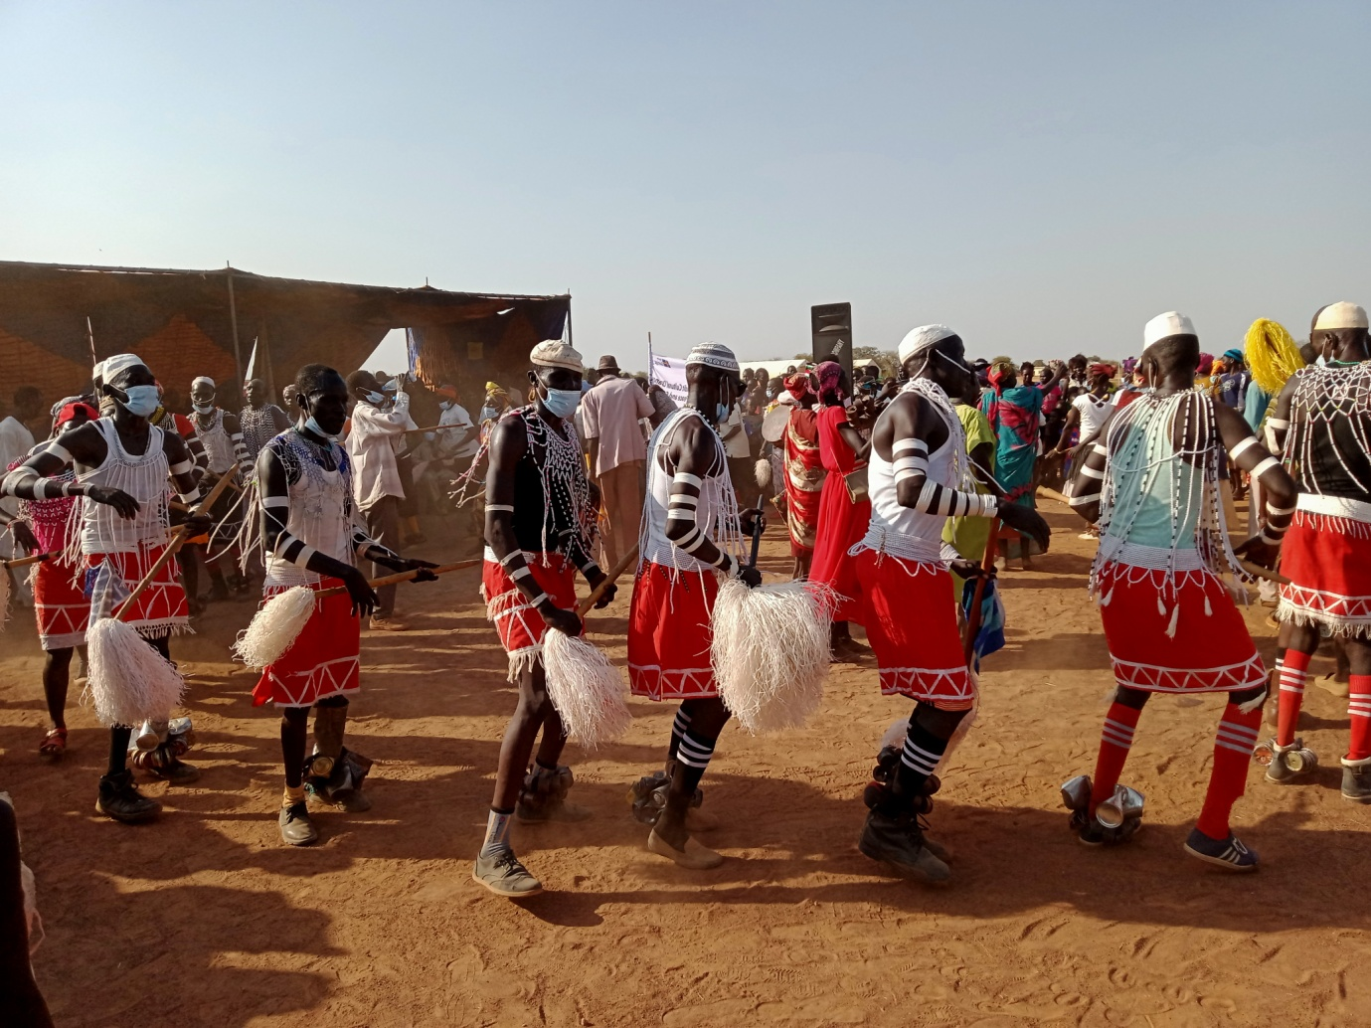
Youth performing Ayakdit dance for peace in Gomjuer Centre Payam (Nyamlel), Aweil West County, Northern Bahr el Ghazal state, Photo@Empower Youth Africa, 12 February 2021

Project Summary | Country: South Sudan  Total Project Budget: US$16,708,379  2020 Budget: US$ 2,807,990.62  Donor Budget in USD Expenditures  Sweden  JAPAN  UNDP  PBF-ND  KOREA  TOTAL  Cumulative expenditure (January – December):  Contact Persons:  Samuel Doe  UNDP Resident Representative  Tel.: +211 920 694 101  Email: samuel.doe@undp.org  Judy Wakahiu  Project Manager  Peace and Community Cohesion project  Tel.: +211920580234  Email: judy.wakahiu@undp.org
Responsible Parties: South Sudan Peace and Reconciliation Commission; South Sudan Bureau for Community Security and Small Arms Control; Ministries responsible for Gender and for Peacebuilding, Academic Institutions; and Civil society Organizations

Table of Contents

1. Executive Summary 5
2. Situation Background 9
3. Progress Towards Development Results 10
a. Contribution to Longer Term Results 10
b. Progress Towards Project Outputs 10
c. Human Interest Story: 23
4. Cross Cutting Issues 24
4.1 Gender Results 24
4.2 Partnerships 25
4.3 Environmental Considerations 26
4.4 Strengthening national capacity 26
5. Monitoring and Evaluation 26
6. Risk Management 27
7. Challenges 28
8. Lessons Learned 28
9. Conclusions, Recommendations and Opportunities for Follow-Up 29
10. Financial Expenditure 31
11. Annex I – Civil Society Partners 31

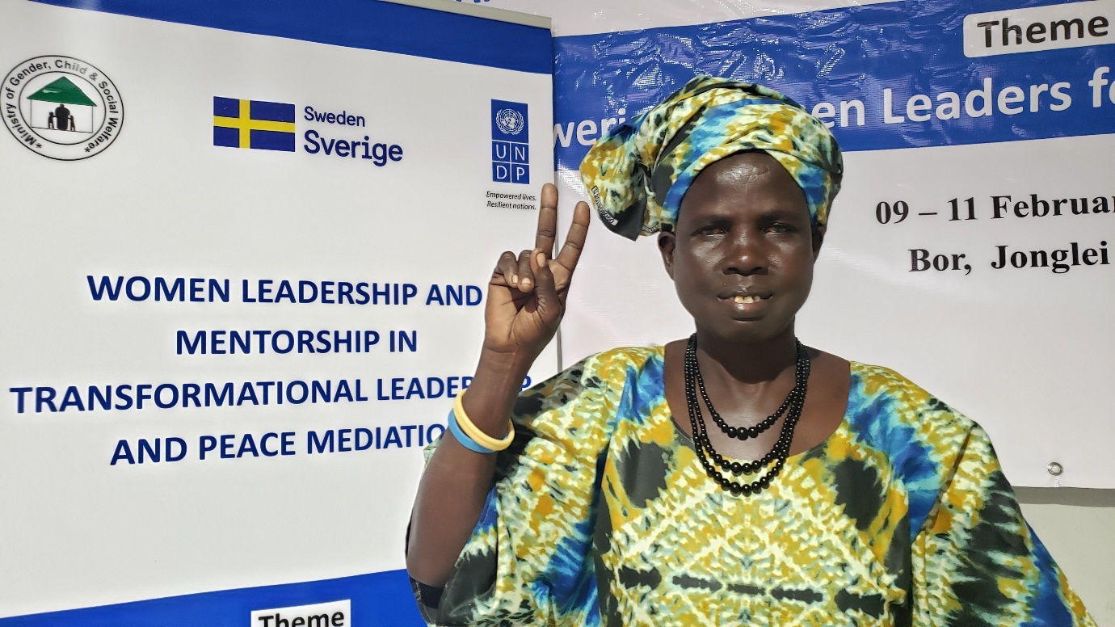
A woman attending the mentorship training in Bor, Jonglei, 09-11 Feb 2021, photo@UNDP

Acronyms
Participants at community consultations in Marial Baai, Jur-River County, 29 March 2021, photo@ChangeMakers-SS

BCSSAC  CPD  CPRM | Bureau for Community Security and Small Arms Control  Country Programme Document  County Peace and Response Mechanisms
CSO  DDRC  GBV  HDC  GUNO | Civil Society Organization  Disarmament, Demobilisation and Reintegration Commission  Gender-Based Violence  Greater Upper Nile Organization  Humanitarian and Development Consortium
HLRF  HRSS  HUMAES  KOICA  M&E  MCCCAG | High-Level Revitalisation Forum  Hope Restoration South Sudan  Human Must Access Essentials  The Korea International Cooperation Agency  Monitoring and Evaluation  Maiwut Christian Charity Community Action Group
OPRD  PaCC | Organization for Peace Relief and Development  Peace and Community Cohesion Project
PoC | Protection of Civilians
R-ARCSS  RDAA  SAADO | Revitalized Agreement on the Resolution of Conflict in the Republic of South Sudan  Rural Development Action Aid  Smile Again Africa Development Organization
SGBV  SMARD | Sexual and Gender-Based Violence  Solidarity Ministries Africa for Reconciliation and Development
SSPRC  SSWCP  UNCF  UNDP  WAV | South Sudan Peace and Reconciliation Commission  South Sudan Women’s Coalition for Peace  United Nations Cooperation Framework  United Nations Development Programme  Women Aid vision
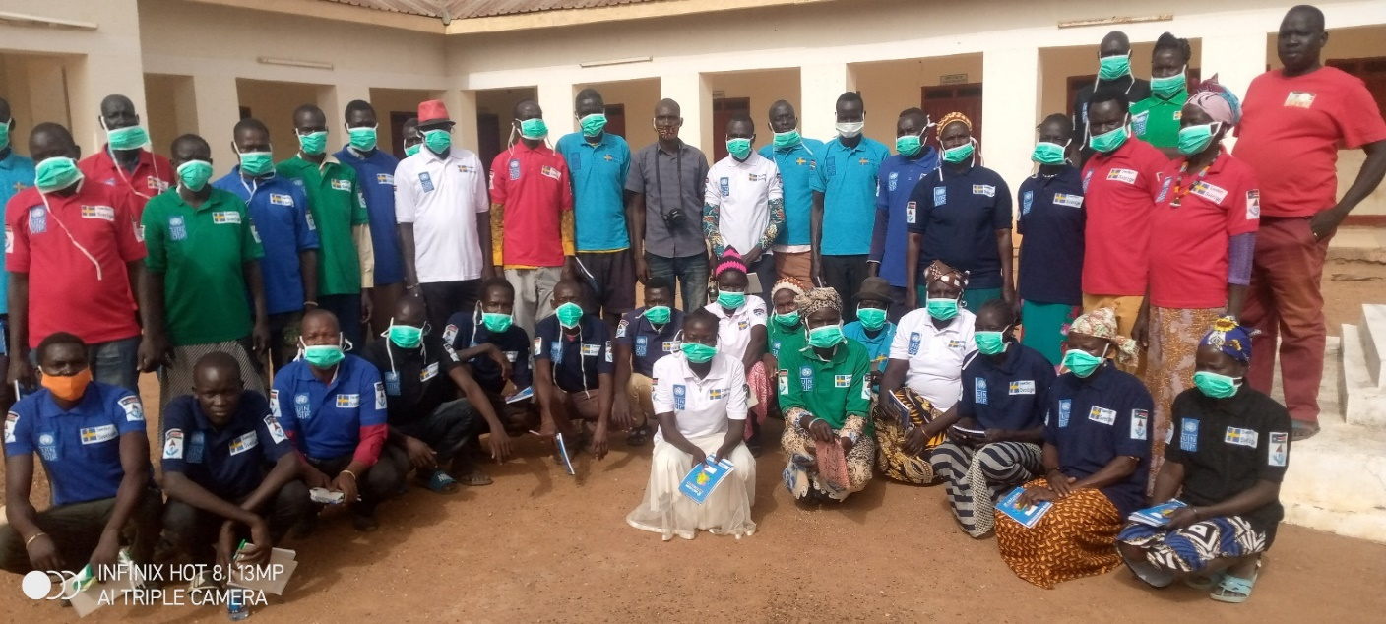

Executive Summary

The United Nations Development Programme’s (UNDP) Peace and Community Cohesion (PaCC) project Phase II contributes to the reduction and mitigation of national and local level conflict and insecurity by investing in initiatives that address the key drivers of conflict and by supporting the central and subnational governments and authorities. Specifically, PaCC supports communities, the central and subnational governments and authorities to; a) establish and enhance the capacity of peace infrastructures to manage conflicts peacefully; b) deepen social, cultural and economic cohesion among communities to foster healing, reconciliation and peaceful coexistence; c) empower citizens, with added emphasis on women, youth and other marginalised groups for voice, agency and participation in governance and peacebuilding initiatives and demand accountability; d) implement legal, policy and civilian frameworks on small arms and light weapons; and e) promote conflict-sensitive access, use and control of natural resources by pastoral and farming communities in targeted conflict clusters.
The PaCC II project also reinforces community relationships by identifying and strengthening cultural, social, and economic connectors that make communities reliant on each other in times of peace and conflict. It uses an integrated and gender-sensitive approach to effectively support the communities in preventing, managing, and resolving conflict in a non-violent manner. The project works with the government counterparts like South Sudan Peace and Reconciliation Commission (SSPRC); South Sudan Bureau for Community Security and Small Arms Control (BCSSAC); Disarmament, Demobilisation and Reintegration Commission (DDRC); Ministries in charge of Gender, Peacebuilding; Civil society Organizations and; directly with communities.
The project is implemented in seven conflict clusters: Eastern Plain (Jonglei and Eastern Equatoria states); Magwi-Kajo Keji green belt (Jonglei, Eastern and Central Equatoria states); Wau-Rumbek Mvolo Mundri axis (Western Bahr el Ghazal, Lakes and Western Equatoria states); Northern Sudan Border belt (Northern and Western Bahr el Ghazal, Abyei AA, Unity, Upper Nile, Warrap) and Subat-Bahr el Jebel-White–Nile Zone (Upper Nile, Jonglei, Unity); Kuajok coordination Cluster (Jur River, Tonj and Gogrial) and Malakal Cluster (Panyikang, Malakal and Kodok).
The support that enables the realisation of the project objectives is drawn from Sweden, The Korea International Cooperation Agency (KOICA), Japan, Peacebuilding Fund and UNDP internal resources. Overall, the project contributes to the 2019-2021 United Nations Cooperation Framework (UNCF) and UNDP Country Programme Document (CPD) Outcome 1: ‘Strengthened peace infrastructures and accountable governance at the national, state and local levels.

Key achievements:
- Mitigated cattle migration-related conflicts as a result of the signing and implementation of two local level seasonal cattle migration agreements in Aweil conflict clusters between migrating pastoralists and host communities which reduced the climate change-induced conflicts and allowed the neiggbouring communities to co-exist together and share resources. Further, consultative workshops have been held to provide a platform for the communities to discuss the development of a state level policy on seasonal cattle migration, to prevent the recurring conflict associated with the seasonal migration of cattle.
- Reinforced local structures and capacities for peaceful dialogue, conflict prevention and conflict resolution: Cumulatively, the 113 peace committees formed and trained at payam and county level by the project have resolved 390 community conflicts that had the potential to escalate. Incidences resolved ranged from cattle rustling, revenge attacks, child abductions, sexual and gender-based violence and disagreements over utilization and management of natural resources and road ambushes. The project also enhanced the local structures for early warning and reporting, where the South Sudan Peace and Reconciliation Commission (SSPRC) reconstituted and trained the County Peace and Response Mechanisms (CPRM), particularly in Eastern Equatoria. The reconstitution was aimed at improving the Counties’ capacity to document and report conflict early warning sign to relevant stakeholders for appropriate response and prevent tensions from turning into conflicts. Further, advocacy workshops have been held to create awareness on child and forced marriages as drivers of confilict, these consultations have resulted in some state ministries of gender developing plans to address the issue, for instance in Northern Bar el Ghazal.
- Improved participation of women in leadership, local governance, peace initiatives and development processes: Cummulatively, 257 women leaders’ capacities to lead and articulate priorities and concerns of women and community have been strengthened. In quarter one, 87 women leaders and women in politics were equipped with knowledge and skills on basic advocacy, lobbying and public speaking skills to enable them act and influence prevention of violence against women in both formal and informal sectors and to contribute to addressing inadequate participation in decision-making levels at state, County, Payam, Boma and village levels. The women from different political parties, community-based organizations, academia and business groups benefited from the training and mentorship. In various states, upto 4 of the beneficiaries of the mentorship trainings were elected into leadership positions in the state governments recently formed.
- Enhanced communities’ capacities to deal with psychosocial trauma associated with exposure to conflicts, sexual and gender-based violence (SGBV). In quarter one, 22 community psychosocial support groups were established and trained at the Boma level to provide communities with structures for trauma healing and psychosocial support. These groups contributed to resolutions of 10 sexual and gender-based incidents documented in quarter one. Among these cases were rape targeted at young women and girls and domestic violence. These cases have informed the engagement of women and youth in income generating activities and other social cultural events and sports to constructively engage their energy and further sensitize them during these events on their role in preventing SGBV.
- Enhanced gender mainstreaming in security sector reform: Working in partnership with community based CSO partners, the project reached 895 (315F) stakeholders, especially the security forces and civilians on discussions towards ensuring gender responsive and inclusive security services that addressed the security needs of women and girls an other gender issues.
- Strenghtened leadership and engagement in the implementation of civilian voluntary disarmament: Through the collaboration with the Bureau for Community Security and Small Arms Control (BCSSAC), UNDP supported BCSSAC to developed the Voluntary Civilian Disarmament Strategy. In quarter one, the project reached 224 (32 women/192 men) leaders and government officials at the state level aimed at increasing ownership in implementation of the strategy.
- Deepened relationships between communities through social, economic and cultural events to promote peace and reconciliation: In quarter one, 3,413 community members (1,550women) were involved in peace building initiatives aimed at rebuilding the social fabric in the community, through traditional dance for peace, sports for peace, radio talk shows, intergenerational dialogues and sensitization on chapter V of the Revitalized Agreement with emphasis on reconciliation. This further enhanced community interactions, relationship building and social cohesion among community members.
- Enhanced coordination of community peace initiatives: This resulted from monthly peace actors’ coordination meetings supported by UNDP, that brought together peace actors, the State ministry of Peace Building, Conflict Resolution and Reconciliation Commission and Regional Peace Coordination Office, and UNDP CSO partners. The coordination, for instance in Aweil cluster has successfully planned and implemented the two cattle pre-migration conferences for the Dinka and Luo, Rezeigat/Misseriya nomads in Aweil Cluster in Q1. In Torit cluster, the coordination resulted in formation of a committee to investigate Camp 15 incident, where the Governor was ambushed and two of his bodyguards killed; and to assess and support needed by the community of Budi at Camp 15.

Key challenges:
- Increased communal violence and insecurity: In the recent months, communal violence has escalated in Greater Jonglei, Warrap and Greater Lakes. This has been attributed to unauthorised possession of small arms and light weapons in the hands of the civilians and as a direct consequence of leadership gaps at state and county levels. Delay in the formation of state Governments early in the year created a power lacuna, which made it difficult to enforce laws and prevent criminal activities such as cattle raiding and revenge killings at community level. With the formation of the state governments towards the end of the quarter, some areas have been relatively calm.
- Excessive flooding: While flooding is predicted annually in some parts of the country during the heavy rains, in 2020 and early 2021, there was excessive and prolonged flooding in most parts of Upper Nile, Jonglei and parts of Eastern Equatoria and Lakes state. The prolonged flooding affected air and land movement and delayed implementation of infrastructure projects such as construction of the Kabarthe women centre in Pibor and the handover of Duk Padiet radio station because of the adverse weather.
- Delay and reschedule of Project activities due to COVID-19: The Covid-19 prevention measures and restrictions instituted by the Government to curb the spread, such as restrictions on social gathering and meetings has affected implementation of some project activities. Some CSO partners struggled to get permission to hold activities intheir states, which delayed their implementation.

Key lessons learned:
- Psychosocial support, trauma healing and reconciliation is increasingly emerging as a need by the community: The outcome of the dialoguees held at the community has continuously called for the more community based psychosocial support and trauma healing as a basis for reconciliation.
- Community-led interdependency projects contribute to community self-reliance: The economic empowerment for the women and youth has contributed to social safety nets of the community wellbeing during the COVID-19 crisis.
- The early warning linkages to early response remains a major obstacle to achieving real time solutions and peace efforts: Early response system has not been functioning effectively across the country, as the institutions which bear the responsibility either lack the capacity to respond or think that it is not their role to intervene. More joint and collaborative efforts should be pursued to ensure collective efforts bridges the early warning gap.

Budget:
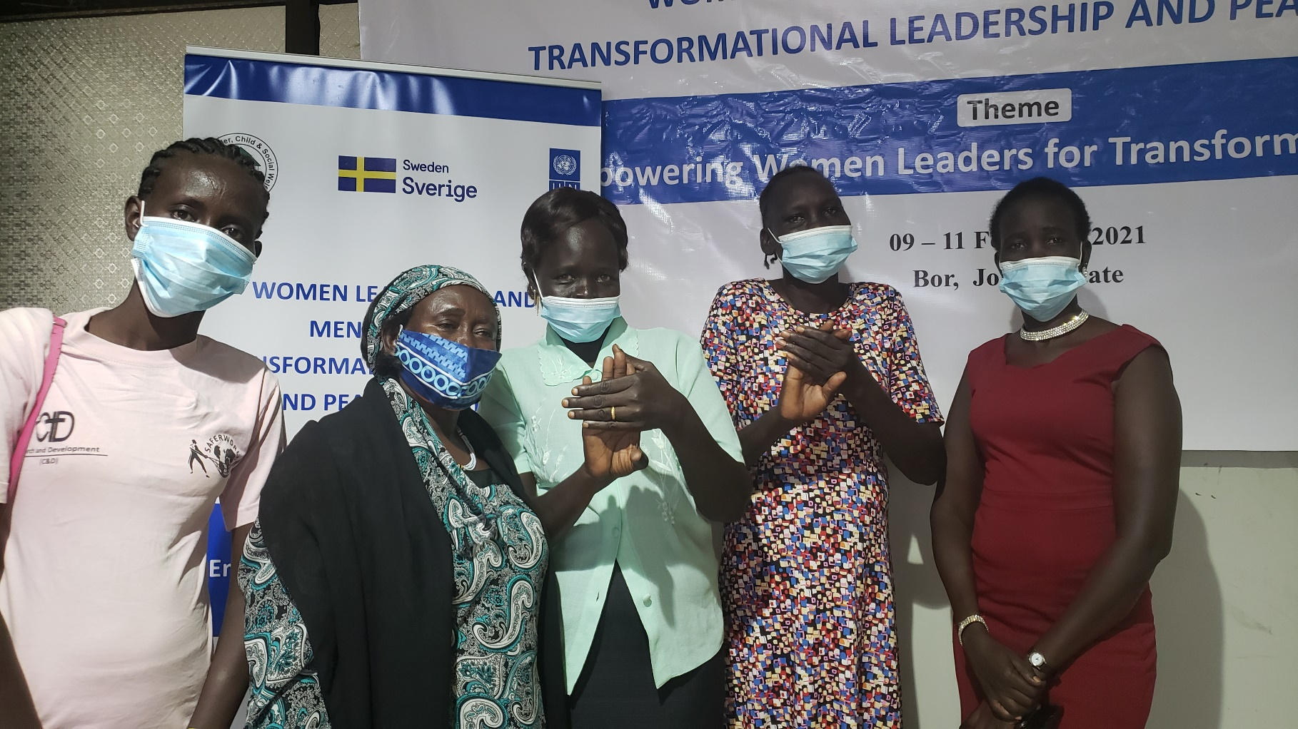
Provisional cumulative expenditure from January to March 2021 is US$ xxxx representing a delivery of xxx% of the available budget (US$ xxxxxx).
Women attending the mentorship training in Bor, Jonglei, 09-11 Feb 2021, photo@UNDP

Situation Background
South Sudan has made substantive progress towards implementation of the R-ARCSS since the signing of the agreement in September 2018. For instance, the formation of the Revitalised Transitional Government of National Unity (R-TGoNU) on 22 February 2020, and subsequently the formation of the state governments in the first quarter of 2021 and the appointment of state Governors have contributed to creating an environment for peacebuilding and development. Despite the 35% quota set-aside for gender in the R-ARCSS, only one female Governor was appointed. The full cabinet was also reconstituted in accordance to the R-ARCSS, and the appointment of Governors is completed for all the states. The reconstitution of Council of State and the Transitional National Legislative Assembly are yet to be reconstituted.
The political violence has substantially subsided and there are small numbers of Internally Displaced Persons (IDPs) and refugees returning to the country. The appointment of the Governors brought some relative calm to the subnational conflicts in most of the states. However, community conflicts are still being witnessed in different parts of the country. At the subnational level, security situation, especially in Jonglei, Pibor Administrative Area, parts of Lakes, Unity, Warrap and Western Bahr el-Ghazal states continued to deteriorate with intercommunal conflicts escalating, leading to death and displacements. Further, unauthorised possession of small arms and light weapons in the hands of the civilians continue to fuel the communal conflicts in the country.

The continuation of the global pandemic, COVID-19 in South Sudan during the quarter remains a peacebuilding challenge and a potent threat to the peace process. Before COVID-19, the ceasfire and the peace that had returned created an environment-still fragile, for development. The economy in the country was picking-up, albeit slow. These steady but fragile gains continue to be under threat especially by the impacts of COVID-19. To prevent the spread of COVID-19, restrictive measures have been put in place by the government, which has restricted holding meetings and gatherings, this has been reported to impact negatively the efforts to sustain the peace gains already made which require regular dialogues.
The onset of the rainy season in July 2020 which continued into the first quarter of 2021, saw severe flooding which affected an estimated 800,000 people. More than 39 counties were submerged, creating a new wave of humanitarian crisis as communities have fled to higher ground creating internal displacement.
The project continued to use a two-fold implementation approach: a) community security approach which focusses on strengthening local mechanisms for peace through inclusive peace committees, dialogues and conferences to prevent and mitigate conflicts, and b) social cohesion approach which focusses on supporting women, youth and other vulnerable groups to undertake interdependency initiatives to strengthen relations and social fabric of the society and enhance reconciliation, while at the national level strengthening infrastructure for peace and conflict management. UNDP’s PaCC project supports the implementation of Chapter V of the agreement, concentrating on healing and reconciliation as well as ensuring that local communities, particularly women and youth have a voice and agency in the implementation of the agreement.

Progress Towards Development Results

Contribution to Longer Term Results
UN Cooperation Framework/CPD Outcome one : ‘Strengthened peace infrastructures and accountable governance at the national, state and local levels.
CPD outcome target | Summary achievement to date
Percentage of individual respondents with confidence in peace and security disaggregated by gender.  Baseline: 47.4% (46.6% male and 48.7% female)  Target: 60% (58% male and 62% female) | As per the findings of an independent final evaluation of PaCC project (February 2020), 58.2% of respondents living in the five conflict clusters expressed increased safety and security levels in their locations compared to 32.7% of 2017.  Further, for further upto date statitsics, conflict assessments will be conducted in various conflict clusters, the findings will highlight the level of personal safety and security.
CPD output: Strengthened communities and local-level institutions' capacity to foster peaceful coexistence, management of resource-based conflicts and community cohesion.
CPD Indicators | Summary achievement to date
Indicator one: Number of local-level agreements for conflict prevention and promotion of social cohesion under implementation | 24 migration agreements between migrating pastoralist tribes and host communities signed and implemented.
Indicators two: Number of national infrastructures for peace established or strengthened, with UNDP support. | 19 national and local mechanisms on peace and reconciliation in place in 2020 in all conflict clusters. This includes the finalization of the Social Cohesion and Reconciliation Index (SCORE), national dialogue, peace committees, peace and reconciliation commission, joint migration conferences, COTAL, state ministry plans, peace dialogues, peace actor’s coordination forums and other similar mechanisms established and operationalized. A Civilian Disarmament Strategy for South Sudan developed has disseminated in some of the states.

Progress Towards Project Outputs
Project output one: Infrastructures for peace at the central and local levels are enabled to manage conflicts and foster peaceful coexistence
Indicator | Indicator Target (2021) | Summary achievement | Status
Indicator 1.1: Number of counties with functional Peace Committees | 121 | 113 (98 counties and 15 payams). No new Peace Committees were established in Q1 | Partially Achieved
Indicator 1.2: Number of local government officers with increased skills on transformational leadership and conflict management. | 160 | 120 local government officers trained. | Partially Achieved
Indicator 1.3: Proportion of reported conflict cases that are responded to | 74% | 53% | Partially Achieved
 | Overall status |  | Partially Achieved

Description of Results:
Indicator 1.1: 121 counties with functional Peace Committees (Baseline: 113)
Cumulatively, 98 counties and 15 payams have functional peace committees. In quarter one of 2021, no new peace committees were formed. the peace committees have helped improve community resilience and social cohesion by resolving conflicts in their communities. Cummulatievely, the peace committees have resolved 390 community conflicts that had the potential to escalate. In quarter one, the peace committees resolved 17 incidences ranging from cattle rustling, revenge attacks, child abductions, forced child marriage, sexual and gender-based violence, land dispute and disagreements over utilization and management of natural resources and road ambushes.

In Eastern plain cluster, in Jonglei State, through the effort of the peace committees, early warning and early response was strenghtened. In March 2021, a spiritual leader of Gawar Nuer mobilized youths to carryout cattle raid, which the peace committee reported, enhancing the response from both national and state government, hence, mitigating what would be another devasting violence.

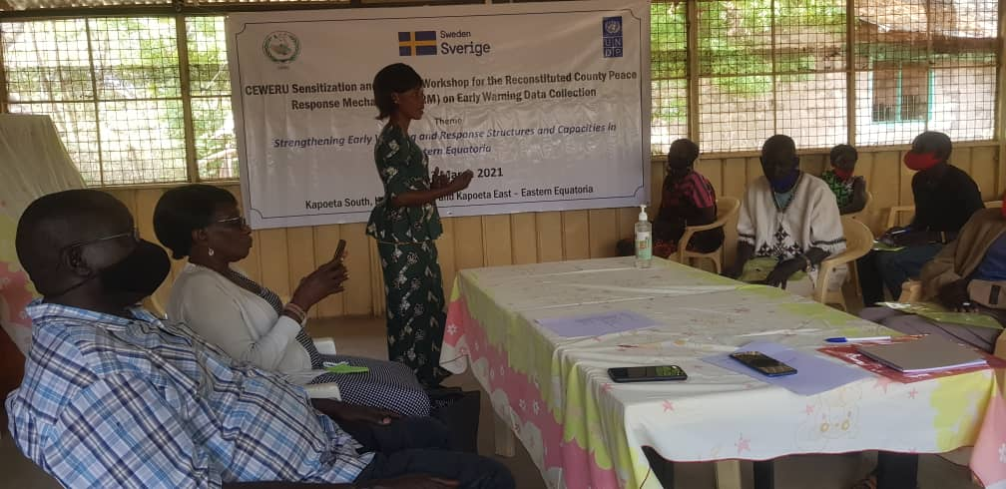
Indicator 1.2: 160 local government officers with increased skills on transformational leadership and conflict management (Baseline 19.4% (Baseline 118) Cumulatively, 120 State Government officials improved their skills in transformational leadership and conflict management. Through a partnership with South Sudan Peace and Reconciliation Commission, the Conflict Early Warning and Response Unit CEWERU) was revitalised and trained in Eastern Equatoria, reaching 60 stakeholders (40M, 20F) from Kapoeta East, Kapoeta South and Kapoeta North counties. The reconstitution was aimed at improving the Counties’ capacity to document and report conflict early warning sign to relevant stakeholders for appropriate response and prevent tensions from turning into conflicts.
Participants during the CPRM training in Kapoeta, 12 March 2021, photo@UNDP

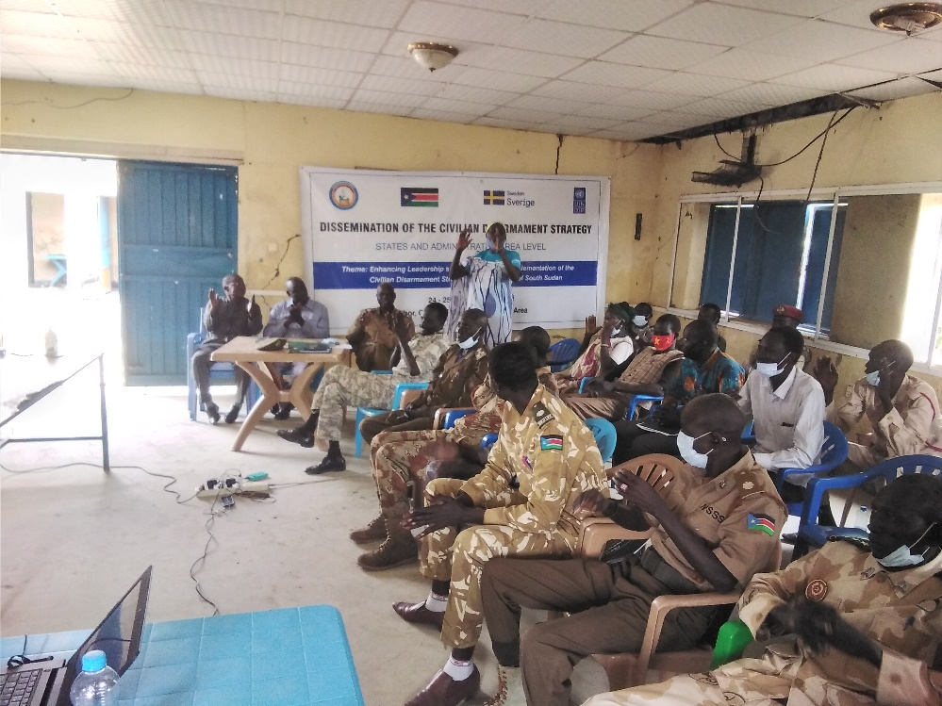
Further, working with the Bureau for Community Security and Small Arms Control, the first Civilian Disarmament Strategy was disseminated in Aweil, Rumbek, Wau, Kuajok, Ruweng, Pibor and Bentiu reaching 224 (32 women/192 men) leaders and government officials at the state level. The dissemination aimed at supporting voluntary civilian disarmament initiatives and peace education to disarm the mind at the community. Key recommendations from the discussions include: dissemination of the strategy to be done at the county, payam and boma levels; holistic and simultaneous disarmament in negibouring communities to boost confidence and avert suspicion among the communities; address the root causes of communities taking up arms; developing alternative livelihood for young people who are often easily incentivised to carry arms; prioritise gender aspects in disarmament; and formation of local disarmament committees to monitor and evaluate the implementation of the Voluntary Civilian Disarmament Strategy.
A Woman making remaks during the dissemination of the civilian disarmament strategy in Pibor, 24-25 February 2021, photo@BCSSAC

Indicator 1.3: 74% of reported conflict cases that are responded to. (Baseline: 50.4%)
Cumulatively, peace committees resolved 390 disputes/conflict incidences. Inquarter one, the peace committees resolved 54% of the cases reported. The peace committees attributed the low percentage of resolution to the COVID-19 prevention measures that led to restricted movement to reach the communities where the incidences were reported. Most of these unresolved cases were referred to local authorities, especially the local sultans, who in most cases are members of peace committees, and thus were able to ensure parties did not continue to engage in violent acts pending mediation meetings.

Examples of conflict resolved include:
- In Eastern plain cluster, the peace committees facilitated community dialogues. For instance, the Murle Communities of Greater Pibor Administrative Area (GPAA) held dialogues (Akobo dialogue) with Lou Nuer of Jonglei in Akobo over conflict drivers such as child abduction, cattle theft and rustling, highway ambushes and competition over sharing of natural resources such as water points and pastures. The dialogue passed 7 resolutions that shall reduce the relapse to violence between Murle and Lou Nuer. The Communities of Nyandit of Jonglei state on the other hand signed an agreement with Likuangule community of GPAA to curb the conflict drivers and strengthen intercommunal trade between the two communities.
The Akobo dialogue between Lou Nuer and Murle coupled with December 2020 dialogues held in Pochalla (amongst Anyuak and Murle) and Marou Hills (amongst Jie, Kachippo and Murle) both supported by UNDP, have improved social cohesion amongst communities of Greater Pibor Administrative Area and the neighbouring communities of Lou Nuer. Through the agreements from the dialogues: 1) The interdependency through trade between the Lou Nuer and Murle have increase, as over 50 Lou Nuer traders have come to Pibor town to buy goods that they take to Akobo and other interior part of Jonglei states; 2) 55 women and children who were abducted amongst communities of Anyuak, Lou Nuer, Murle and Jie were retrieved and reunited with their families; 3) over 200 cows which were stolen by Murle youths from Lou Nuer were collected and returned to the rightful owners; 4) Murle herders were able to peacefully share river Oboth with Anyuak fishermen during 2021 dry season, for the first time since 2012.

Project output two: Strengthened structures to encourage trauma healing, reconciliation and reinforce social cohesion at all levels
Indicator | Target (2021) | Summary achievement | Status
Indicator 2.1: Number of people receiving psychosocial support from trained volunteer counsellors | 350 | 296 (96%F) | Partially  Achieved
Indicator 2.2. Percentage of cattle related conflicts that are successfully resolved through traditional conflict resolution institutions | 16% | 36% of the cattle related conflicts were resolved. Two (2) agreements were signed and under implementation in Q1 2021. Consultations on state policy on cattle migration are ongoing. | Achieved
Indicator 2.3: Number of people benefited from community interdependency initiatives. | 41,007 | 34,003 (51% F). In quarter one, 3,413 community members (1,550 women) were reached. | Partially Achieved
Indicator 2.4: Number of youths involving in peacebuilding activities through youth initiative interventions | 9,928 | 9,690 (47%F) | Partially Achieved
 | Overall status |  | Partially Achieved

Description of Results:
Indicator 2.1: 350 of people receiving psychosocial support from trained volunteer counsellors (Baseline 287)
Cumulatively, 296 (96%F) people received psychosocial support from community volunteer counsellors and groups supported by UNDP and its CSO partners. The psychosocial support were complemented by community sensitization on the need for trauma healing and reconciliation among the community members. In quarter one, 22 community psychosocial support groups were established and trained at the Boma level to provide communities with structures for trauma healing and psychosocial support.
In Aweil cluster, the project conducted 8 trauma healing and GBV awareness raising workshops to establish community psychosocial support groups in 8 locations including Hai-salam boma of Aweil Town East Payam, Maper West Boma of Maper Payam, Aroyo payam, Barmayen payam and Malou-Awer boma of Aweil Town West Payam of Aweil Center County; Warawar boma of Baac Payam, Malual Baai Payam and Madhol Payam of Aweil East County. These workshops reached 200 people (160 women) and resulted in formation of 8 community psychosocial support groups (5 groups in Aweil Centre and 3 in Aweil East Counties). Each group comprises 20 members (3 men). These groups contributed to resolutions of 10 out of 13 sexual and gender-based incidents documented in Northern Bahr el Ghazal state in quarter one. Most of the cases documented and supported included rape, domestic violence and forced marriage with most survivors being women and girls.
In Malakal cluster, the project through its CSO partners, Humanitarian and Development Consortium (HDC) established 10 psychosocial support groups to support community trauma healing and reconciliation, all females. These community-based counsellors who are handling both mental and social aspects on trauma and healing have received positive reception amongst community members. The community community members noted that the psychosocial support group helps in addressing the mental health issues that have been overlooked and their effort is reflected in the increased call for reconciliation and healing amongst communities. HDC also conducted sensitisation on chapter V of the Revitalised Agreement in Tonga-Panyikang county reaching 50 (29 Male, 21 Female), where seek forgiveness and reconciliation were emphasised. Another CSO partner Smile Again Africa Development Organization (SAADO) also conducted sensitization workshops on chapter V of the revitalised agreement in Panyikang that brought together 129 (89 male and 40 females). The sensitization provided a platform for discussions around various forms of intra and intercommunal violence such as target killing, assault and sexual and gender base violence, which have negatively impacted communities. This was followed by 6 intergenerational dialogues in Panyikang (3) and Malakal (3) which reached a total of 179 (108 males and 66 females) community members. The intergenerational dialogue provided the platform for local communities to discuss negative community practices, reconciliation and forgiveness.

In Eastern plan cluster, a PaCC CSO partner, Maiwut Christian Charity Community Action Group (MCCCAG) conducted sensitization of chapter V of the Revitalized Agreement bringing together 1,720 participants (995 men and 725 Female) from communities in Ayod, Duk Padiet and Twic East. Some of the issues discussed include; addressesing the need for reconciliation amongst communities on political divides; eradication of random highway ambushes and target killings; and facilitation of the internal displaced persons to their origins of residence.

In the Rumbek cluster, two groups of 60 trauma and GBV survivors’ (all women) in 2 location of Yirol East and Terekeka (Tali) were formed and supported with small grants by UNDP through its CSO partner Solidarity Ministries Africa for Reconciliation and Development (SMARD). In addition to undertaking group counselling sessions, the women were given small grants to enable them start small businesses to support themselves and their families. Further, another CSO partner Women Aid vision (WAV) reached 80 (45M & 35F) community members sensitizing them and raising awareness on chapter V of the Revitalised Agreement.

In Bentiu cluster, another CSO partner Hope Restoration South Sudan (HRSS) reached 51(21M & 30F) community members in Rubkona sensitizing them and raising awareness on chapter V of the Revitalised Agreement. Participants recommended establishment of national reconciliation day to be held every year.

Indicator 2.2: 16% of cattle related conflicts that are successfully resolved through traditional conflict resolution institutions ( Baseline 5%)
Out of the 11 cattle related conflicts reported by peace committees in quarter one, 36% were resolved through traditional conflict resolution mechanisms. Some of the cases resolved include:

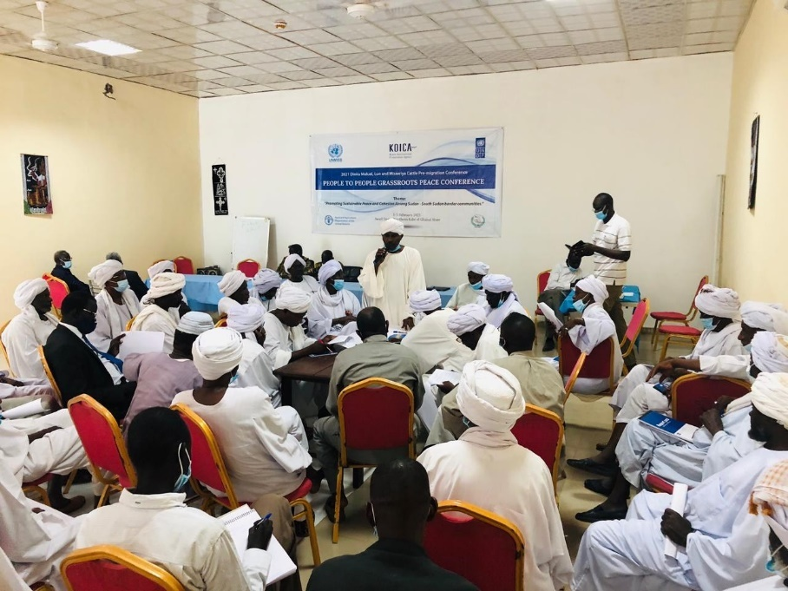
- In Aweil cluster, seasonal cattle migration agreements were signed and are under implementation to address the conflict incidences between the communities living in the South Sudan-Sudan border.
The first conference was held in Aweil, Northern Bahr el Ghazal State from 01-05 February 2021. The conference was attended by 59 community representatives (5 women) from the Dinka Malual of Aweil East County and Miseriya nomads from Western Kordofan state of Sudan. The communities signed an agreement that included resolutions and recommendations to promote peaceful co-existence among the Dinka Malual and Rezeigat nomads along Sudan-South Sudan border.
Dinka Malual, Luo and Misseriya communities participate in a pre-migration conference from 01-05 February 2021 in Aweil, Northern Bahr el Ghazal State, Photo@UNDP

- Key resolutions include blood compensation for any community member killed in cross-border incident; hefty fines for rape and cattle theft; promoting participation of women in all future peace conferences.
- The conference provided a learning opportunity for the Ngok Dinka and Misseriya of Abyei region who have similar challenges. This learning platform led to a conference in Aweil Town, Northern Bahr el Ghazal state from 22-26 February 2021 bringing together the Ngok Dinka and Misseriya of Abyei region. The two communities agreed; to conduct wider consultations on their challenges to promote peaceful co-existence; immediate cessation of hostilities; allowing the displaced persons to return to their original villages; organize grazing corridors northward and southward to reduce tension among nomads and crop growers during seasonal cattle migration; organize pre and post cattle migration conferences to promote peaceful cattle migration into Abyei area.

- The second conference was for the Dinka Malual and Luo of Aweil North, West and Centre Counties and the Rezeigat nomads from Eastern Darfur state of Sudan conducted from 28 March – 1 April 2021 and attended by 75 participants (4 women). The 3 communities signed an agreement to promote peaceful co-existence amongst the border communities. Key resolutions included: Rezeigat nomads sticking to agreed migration corridors to avoid conflict with local crop growers; Rezeigat nomads being prohibited from grazing their cattle close to residential areas and farms of the host community (Dinka, Luo); the delegates agreed to disseminate the conference resolution and recommendations to their respective communities; establishment of joint border courts to amicably resolve incidents and disputes. The conference also resolved past injustices, with the Northern Bahr el Ghazal State Governor pledging to compensate one Rezeigat man killed in 2019 by a suspected member of the local community along the border with Eastern Darfur State; and Rezeigat agreed to make compensation for killing one Dinka Malual man and his injured spouse in an incident that occurred on 2 July 2020. The Rezeigat paid SSP 150,000 to the injured wife of the man killed to meet her own medical bills.
- Further, in Aweil cluster, 7 community consultative meetings were conducted on developing a local policy that would regulate cattle migration in Northern Bahr el Ghazal state. These included 2 in Aweil North County (Malual East and East Payams); 3 in Aweil West County (Gumjuer West Ayat West and Achana Payams), 1 in Aweil East (Warawar Boma of Baac Payam) and 1 in Aweil South (Nyoc-Awany Payam) Counties, reaching out to 177 stakeholders (83 women) including paramount chiefs, Boma, Payam and County administrators, youth and women representatives. These consultations resulted in proposed community action plans to prevent and address violent incidents during cross-border cattle migrations into Northern Bahr el Ghazal state. For instance, one proposal suggests limiting the migration routes and prohibiting entry of Arab nomads with firearms into Northern Bahr el Ghazal state. These action plans would further help in developing a local policy to guide peaceful cattle migration into the state.

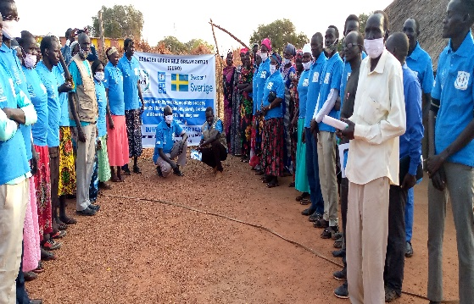
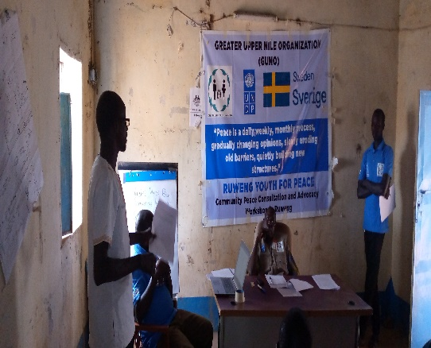
- In Bentiu cluster, consultantions on cattle migration were held in Koch County, Unity State and Pariang County, Ruweng Administrative Area bringing together 200 community members (90 M and 110 F), organised by Greater Upper Nile Organization (GUNO). Some of the recommendations made during the consultations include: disarmament of cattle keepers, provision of fishing kits to diversify economic earning to fishing; provision of agricultural tools/farming tools or tractors for alternative economic livihoods, massive awareness on ending child and forced marriages and its linkage to cattle; and development of policies and rules that guide movement of cattle within and outside the counties. In Rubkona, another PaCC CSO partner Hope Restoration South Sudan (HRSS) held similar consultations on cattle migration reaching 152 participants (111M/41F).
Participants at the induction meeting in Pariang, Ruweng AA, 01- 03 February 2021, Photo@GUNO

Participants at the consultation meeting in Pariang, Ruweng AA, 01- 03 February 2021, Photo@GUNO

- In the Rumbek cluster, peace committees reported that the communities of Mvolo and Rumbek East continue to be involved in inter and intra-communal conflicts resulting from cattle raiding and rustling. Further, the conflict between Aluak Luak and Rumbek east communities is getting worse, with reports of 800 herds of cattle raided recently from Aluak-luak which has led to security threats from both sides. The peace committee also noted that communities in Mvolo who are cattle keepers have moved their cattle for pastures and safety creating imminent farmers- cattle keepers conflicts. These calls for urgent efforts to resolve and/prevent the conflicts amongst these communities, UNDP together with its local partners are planning community dialogues in these areas.

Indicator 2.3: 41007 of people benefited from community interdependency initiatives. ( Baseline 31973)
Cummulatively, 34,003 (51% F) people have benefited from community interdependency initiatives, which has strengthened relations among conflicting groups as well as improved community livelihoods. In quarter one, 3,413 community members (1,550 women) were reached through through income generating initiatives, traditional dance for peace, sports for peace, radio talk shows, intergenerational dialogues and sensitization on chapter V of the Revitalized Agreement with emphasis on reconciliation. This further enhanced community interactions, relationship building and social cohesion among community members in locations like Aweil (West, East and South), Malakal, Mvolo, Rumbek East, Rubkona, Ayod, Duk Padiet and Twic East.

In Aweil cluster, the project supported a vegetable production group formed in Mayom-Akuakriel village, Ayat Centre Payam, Aweil West County which is benefiting 25 women living in Mayom-Akuakriel village who are mainly growing okra and onions to support their families.
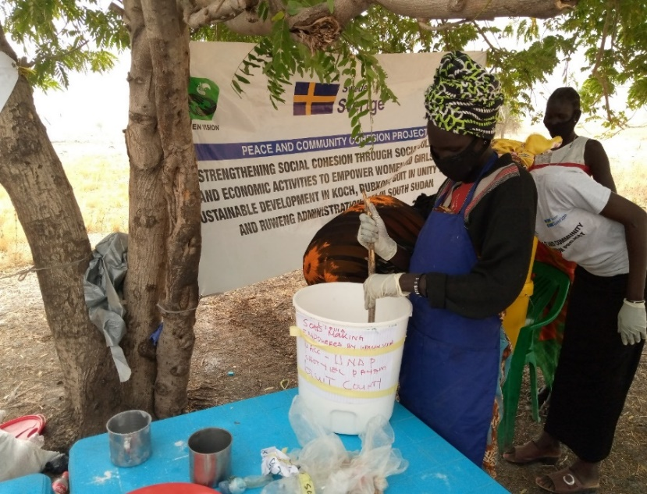
In Bentiu cluster, a UNDP partner Women Vision ,formed and trained a women’s group of 20 (10 women and 10 girls) in business skills in Chotyiel and Nying payam – Guit town and another group in Kuach payam (5 women, 5 girls). The women and girls were trained on bakery and liquid soap making. In Kuach payam, at the beginning of the training almost 100 women showed up.. The 30 women and girls trained in Chotyiel, Nying and Kuach payam also received seed capital to start their businesses using the skills they received during the training.
Women attending business skills training (liquid soap making) in Guit, Unity State, 16-18 February 2021, Photo@Women Vision

In Rumbek cluster, in Wulu County, the construction of the Women Lulu Oil works cottage was completed awaiting handover to the community women, who will use the cottage to generate income to support their families.

Indicator 2.4: Number of youths involving in peacebuilding activities through youth initiative interventions ( Baseline 9390)
Cummulatively, 9,690 (47%F) youth were engaged in peacebuilding activities. In quarter one, the youth took the lead in empoereing themselves and strengthening their voices as change agents. For example,
In the Torit cluster, UNDP partner HUMAES involved 8,005 youth (3,442 female) in various initiatives aimed at promoting social cohesion, income generation and recreation. For instance, 7,600 youth (3,280 female) were involved in sports to promote peaceful coexistence. The sports tournament encouraged the youth to continue engaging with sports training for recreation.
300 (180 male, 120 female) youth were engaged in small scale businesses, saving and credit to encourage them to be productive and to contribute to rebuilding their communities after the conflict. HUMAES monitoring shown that Pageri youth SACCO saved 39,000SSP ( 15,000SSPwere initially given to the group), while, Opari youth SACCO has saved 51,000 South Sudanese Pounds, growing the 15,000 South Sudanese Pounds initially given to the group. Another group of 105 youth (42 females) were engaged in agricultural related activities through formation of seven youth peace farming groups. The groups were supported with farm tools and seeds for vegetables. The youth already started clearing the land and are growing the seedlings as they prepare to transplant them.

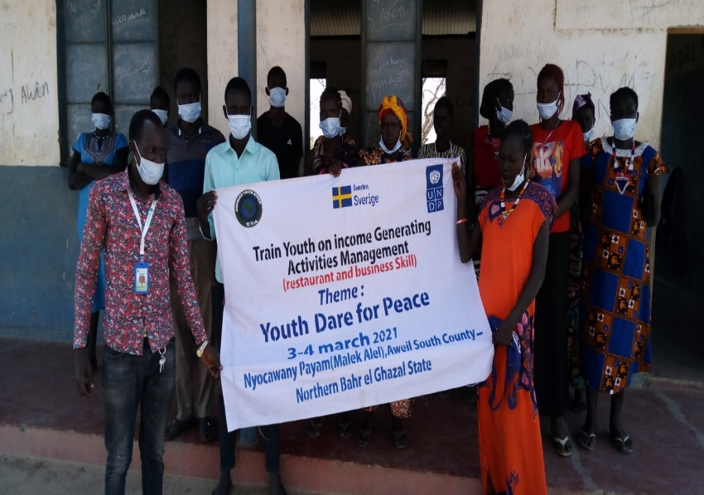
In Aweil cluster, the project conducted trainings for youth in income generating activities management (Restaurant and business skills) – one in Gomjuer Centre Payam (Nyamlel), Aweil West County which targeted 30 youth (15 young women), one in Mayen Ulem, Aweil North County that reached 40 youth (20 young women) and one in Nyoc - Awany Payam, Aweil South County. These trainings not only enhanced their restaurant management skills in preparation for establishment of restaurants but also social cohesion among the youth that could potentially contribute to communal peace in Aweil West, North and South Counties.
Youth trained in income generating activities management (restaurant and business skill) in Nyoc-Awany (Malek Alel) Payam, Aweil South County on 04 March 2021, Photo@ EYA

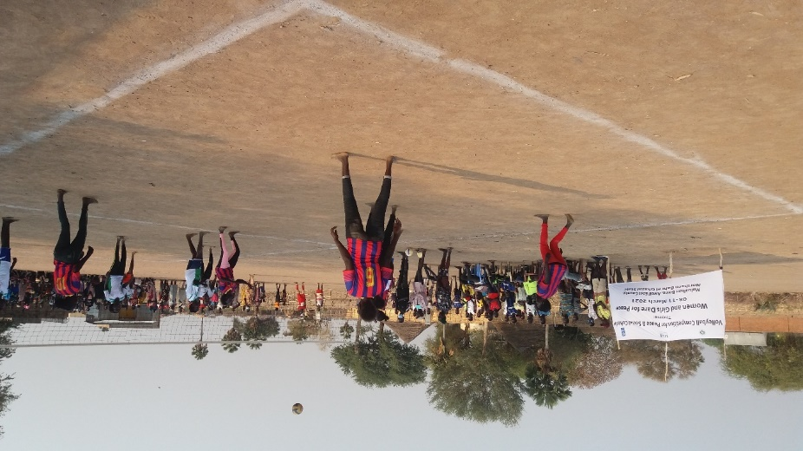
In Aweil cluster, UNDP partner HASS engaged the community, especially women and girls in in social-cultural events. A marathon run for Peace for women and girls from the Dinka and the Luo communities in Aweil Municipality, Aweil Centre County enabled 86 young women and girls to participate., 14 men also attended The marathon was used to disseminate message about peaceful co-existence and encourage women and girls to participate in local peace processes. The marathon provided a space to enhance interactions among women and girls that potentially strengthened their relationships. Further, a women and girls’ football competition for peace was conducted in Madhol Payam of Aweil East County that mobilized 200 people (176 girls, 10 women and 14 men). The tournanament women and created awareness of peaceful co-existence among the women and girls from the communities of Malualkon, Malual Baai, Wanyjok and Madhol Payams of Aweil East County. This provided opportunity for women, girls and men to interact to enhance social cohesion in the community. A volleyball competition conducted for women and girls in Malualkon Boma, Aweil East County mobilized 100 people (55 girls, 25 men and 20 women) from Malualkon Boma of Aweil East county that promoted relationships and enhanced community social cohesion potentially contributing to communal peace. Being the first of its kind for the women and girls in Malualkon Boma, the volleyball competition provided a space for an engagement and interactions between the women and girls, providing for intergenerational and peer to peer dialogue.
Girls and young women playing volleyball for peace in Malualkon, Aweil East County, 11 March 2021, photo@UNDP

Project output three: Policy frameworks and institutional mechanisms enabled at the national and sub-national levels for the peaceful management of emerging and recurring conflicts and tensions.

Indicator | Target (2021) | Summary achievement | Status
Indicator 3.1: Number of Women trained on mediation, public speaking and engagement skills, engaged in local and national peacebuilding work. | 300 | 273 women trained, in Quarter one, 88 women were trained in Bor-Jonglei State and Jebel Boma,-GPAA | Partially Achieved
Indicator 3.2: Number of youth and persons with disability trained on mediation, public speaking and engaged in local and national peacebuilding. | 247 | 70 youth, including 3 persons with disabilities in Juba), No training were conducted in Q1 | Partially Achieved
Indicator 3.3: Number of states with a formal state resolution/commitment with funded action plan to end child marriage | 2 | The consultations are underway through the partnership with CSOs. | Partially Achieved
 | Overall status

Indicator 3.1: 300 Women trained on mediation, public speaking and engagement skills, engaged in local and national peacebuilding work ( Baseline 193)
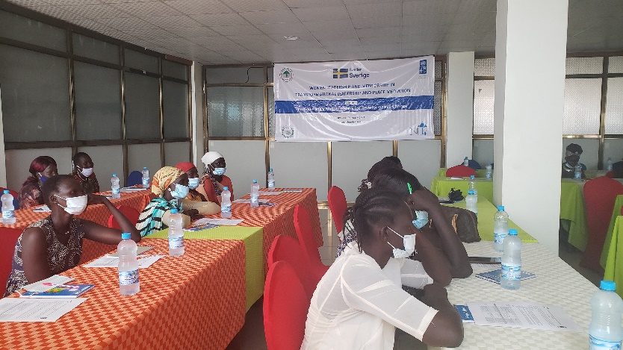
Cumulatively, 273 women have been trained in mediation, public speaking and engagement skills. In Quarter one, 88 women were trained in Bor-Jonglei State and Jebel Boma-GPAA. The women leaders gained skills that enhanced their capacities to take up leadership positions. The tailored mentorship and coaching sessions, targeted women from different political parties, business groups, academia, and community-based organizations. These skills enhanced the women's capacity to articulate priorities and concerns of women in the community effectively. In various states, upto 4 of the beneficiaries of the mentorship trainings were elected into leadership positions in the state governments recently formed.
Women attending the mentorship training in Bor, Jonglei, 09-11 February 2021, photo@UNDP

In Rumbek cluster, UNDP CSO partner Rural Development Action Aid (RDAA) reached 985 (610M and 375F) security forces and civilians through joint activities like football matches, community clean ups and community dialogues in Yambio, Nzara and Maridi counties to discuss how the security sector can be more responsive to the security needs of women and girls).

In Aweil cluster, 3 stakeholders dialogue workshops for learning and capacity building of security forces and civilian representatives on gender responsive and inclusive security services were conducted in Maper, Aroyo and Barmayen Payams of Aweil Centre County. The workshops brought together 75 individuals (45 women), each location had 25 individuals (15 female) including civilian and security sector representatives. Issues discussed included explanation of Security Sector Reform and integrating gender dimension in security sector reforms. These resulted in increased understanding of the security sector reform and gender responsive and inclusive planning regarding security sector reform.
Further, the South Sudan Women’s Coalition for Peace (SSWCP), a key stakeholder advocating for the implementation of Peace Agreement (R-ARCSS) conducted mentorship activities in 12 locations namely; Aweil, Bentiu, Bor, Kuajok, Lirya, Malakal, Nimule, Rumbek, Torit, Wau, Yambioand Yei. The workshops focused on strengthening women’s advocacy initiatives at the state level so as to sustain their involvement in the implementation of the peace agreement during and after the transition period.

Indicator 3.2: 247 youth and persons with disability trained on mediation, public speaking and engaged in local and national peacebuilding ( Baseline 70)
Cummulatively, 70 youth (49%F) in Juba benefited from coaching and mentorship in Juba, which helped them build skills and confidence for effective participation in peace and governance processes. The youth were mobilised to volunteer in a door-to-door COVID-19 prevention campaign. As a result, the youth have formed the first-ever youth volunteer movement in South Sudan. More trainings are planned for quarter two and three of 2021.

Indicator 3.3: 2 states with a formal state resolution/commitment with funded action plan to end child marriage ( Baseline 0)
Development of formal state resolution and commitment with funded action plan to end child marriage is a process. Community consultations have been held in the conflict clusters to solicit ideas and recommendations from the community on the key considerations to go into the state frameworks. For example,

In Eastern plain cluster, a UNDP partner Radio Jonglei conducted cattle camp outreach and sensitization on cattle camp youths on the effect of force and early child marriages on social cohesion in Jonglei. The youths-to-youth dialogue brought together 30 (male 19 Female 11) from the cattle camp and urban youths. The youth-to-youth dialogue gave an opportunity to cattle camp girls to voice their opinion on the social norms that are affecting their lives. The dialogue agreed that forced and child marriages have negative impact on the social cohesion of communities of Jonglei, as they always resulted to abuse and domestic violence.
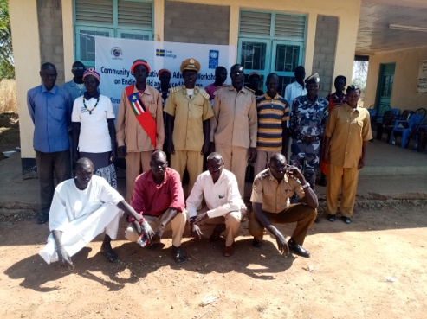
In Aweil cluster, 6 community consultative meetings were conducted on ending child and forced marriages that reached a total of 230 stakeholders (68 women) - 3 in Aweil West County (Mariam West, Gumjuer Centre and Ayat East Payams) that reached 84 people (36 women) and 2 in Aweil North County (Malual East and North Payams) that reached 56 people (24 women); 1 in Aweil South County (Nyoc-Awany Payam) that reached 30 people (8 women). These meetings resulted in the state ministry of gender developing a plan to conduct the following workshops to create aware of child and forced marriages: orkshopws with chiefs and police to strengthen them in addressing child and forced marriages as well as justice for children in the community; and workshops on child rights and the resumption of customary laws to be conducted with chiefs and police from the five Counties of Northern Bahr el Ghazal state. Further, 5 community consultative meetings on ending child abduction – 3 in Aweil North County (Malual North, West and Centre Payams) and 2 in Aweil West County (Ayat Centre and West Payams). These meetings reached a total of 200 people (60 women) in Aweil North and West Counties and enhanced awareness of child rights and protection as well as the responsibilities of parents and guardians to ending child abduction in the Counties. It further resulted in development of community action plan to prevent child abduction.
Participants attending a workshop on ending child marriage in Aweil, February 2021, photo@CIPAD

In Bentiu cluster, in Rubkona town and Guit, HRSS organised community consultations and advocacy workshops that brought together 123 participants (91M/32F) particularly decision makers and community leaders to seek views and commitment of communities on ending child marriage. The participants recommended more awareness raising on ending child marriage to be done and requested government to accelerate implementation of end child marriage law and to punish anyone found guilty of child marriage. Illiteracy was also identified during the workshop to contribute to the child marriage and participants agree on the need to send children to school.

Human Interest Story:

Abducted as child, reunited with her family as a mother
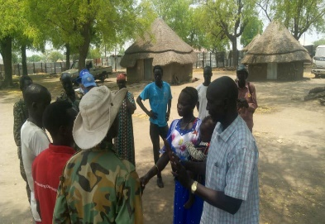
On 28-30 March 2021, Lou Nuer and Murle communities conducted intercommunal dialogue that addresses the cattle raid, child abduction, highway ambushes and improvement of trade and movement between the two communities. The dialogue was concluded with 7 resolutions that shall mitigate conflict between the two communities, and reunification of 45 women and children who were abducted from both communities with their families..
Nyajuok, (the lady in blue holding a child) getting introduced to her cousin during Murle – Lou Nuer dialogue, Akobo, Jonglei state @MCCCG – March 2021
Nyajuok, who is now 25 years old, was abducted in December 2012 when she was 16 years old by Lou Nuer of Akobo County. Nyajuok was Married to her kidnapper, a man call Ruai Tut Kong from Chiebol clan in Akobo County. She is now blessed with four children: two sons and two daughters. Nyajuok lives with her father-in law after her husband went to Ethiopia for studies.
Due to the animosity between the Lou Nuer and Murle that has been worsening over the years, Nyajuok and her husband were unable to go to Pibor in search of her relatives, although she and her husband were willing to do so.
The intercommunal dialogue organised by UNDP CSO partners that brought the Murle peace team to Akobo presented an opportunity for Nyajuok to trace her family. Since Nyajuok’s husband was away during that time the dialogue was being held, he requested her to introduce herself to the Murle peace team, with hope that she may find someone who could help in tracing her family. Luckily, one of the Murle peace team members was her cousin.
When it was confirmed by the relatives of Nyajuok’s husband that she found her cousin in the team of peace delegates from Murle, Nyajuok was accompanied by her father-in-law to meet her relatives.
“We have been longing to see this day where we meet a family member of the wife of my son. She has been a blessing to my family as she gave birth to 4 beautiful children. My grandchildren are Murle as well as Nuer. Thus, they are cord that united me with Murle. I would like to build a good relationship with my son’s in laws to redress the past mistakes. Since my son’s wife is overwhelmed by the news of meeting her relatives, I would like to let her go to Pibor with her cousin to get reunited with her family.” Nyajuok’s father-in-law said joyfully.
After the intercommunal dialogue, Nyajuok with her small child left for Pibor with her cousin to reconnect with her other relatives.

Cross Cutting Issues

Gender Results
Gender results | Evidence
Gender Result One: Increased women participation in local and regional peace and development committees  Women peace committee members (31%) are transforming the outcome of community mediation processes, especially on issues related to sexual violence. For example, they advocated for legal redress over and above the traditional compensation mechanism which was routinely the final solution in sexual violence cases.  Through a partnership with UN Women, consultations on the needs and aspirations of women and girls in the security sector reforms were undertaken as part of mainstreaming gender in the security sector.  55% of the listeners club members formed in Torit and Yei are women. This increases women’s engagement in discussing community issues and also gives the women in the community a voice and platform to also highlight issues affecting them as women. | Cluster quarter reports, List of nominated peace committee members, Cluster quarter reports, Listeners clubs training Reports.
Gender Result Two: Women playing leadership role in resolving local disputes  Increased engagement and advocacy by young women in advocating for the achievement of 35 percent gender provision in the agreement in the community processes. In this regard, young women used sports and culture to pass this message.  Women in Malakal PoC play a vital role in advocating for sustainable peace in Malakal and beyond. Women leaders in PoC in collaboration with other women leaders residing within Malakal Town, have been advocating for reconciliation and social cohesion to bridge the ethnic divides in Malakal. | Monitoring report; CSO reports
Gender Result Three: Promoting participation and representation of women in community peace and livelihoods initiatives  Out of the youth involved in the livelihoods initiatives, 40% were young women, surpassing the 35% gender provision in the revitalised agreement. Further, 50% of the 600 youth who were involved in traditional dance for peace were young women and girls in Aweil South and Aweil West Counties. | CSO partner reports,  Monitoring reports
Gender Result Four: Improvement in the reporting of the GBV cases  Trained community psychosocial support groups resolved 10 out of 13 sexual and gender-based incidents documented in Northern Bahr el Ghazal state in Q1 2021.  Reduced the risk of exposure of women to violence was one of the messages passed to the community during the traditional dances held in Aweil. | CSO partner reports, Peace Committee Reports, SGBV incident reports

Partnerships
UNDP collaborated with various institutions, including the Government, CSOs, Academia and other UN agencies. The partnerships have enabled improved delivery of results through unique expertise and competencies brought in by various institutions. Further, partnership with the Civil Affairs Division of UNMISS led to joined-up efforts to prevent conflicts related to the seasonal migration of cattle at the border with Sudan and internally within South Sudan.. Furthermore, partnership with 28 CSOs allowed UNDP to reach the last mile in community conflict management and empowerment. UNDP continues to collaborate with the Government of South Sudan at the national and sub-national levels to develop policies and legislation.
Examples of such collaboration include:
- UNDPs partnership with South Sudan Peace and Reconciliation Commission led to the revitalisation of the State Level Conflict Early Warning and Response System.
- Partnership with the Bureau for Community Security and Small Arms Control saw the development of the Voluntary Civilian Disarmament Strategy.
- Partnership with CSOs enabled formation of more psychosocial support groups in the community and enhanced the understanding of Chapter V of the Revitalised Agreement.
- UNDP started a collaborative partnership with the newly created Ministry of Peacebuilding with the aim of supporting the Ministry to develop a strategic framework for Peacebuilding in the country.
- UNDP partnered with UNMISS to conduct Kidepo Technical assessment for the consultation of the dam/Hafir.
- UNDP partnered with UN Women in implementing the gender mainstreaming in security sector reform project.
- Working with the Disarmament, Demobilisation and Reintegration Commission (DDRC), UNDP supported community violence reduction efforts, focusing on a baseline study on opportunity mapping for ex-combattants.

Environmental Considerations
The project encouraged proper disposal of non-biodegradable items (including plastic water bottles and bags), using reusable containers/ objects and sparing use of paper (such as printing on both sides) and water by the staff, implementing partners, beneficiaries and vendors. The PaCC project continued to support communities with the installation of solar energy in interdependency peace projects. As part of the gender mainstreaming in security sector reform project, the CSOs mobilised communities for town and community clean ups in Bor, Magwi, Yambio, Nzara and Maridi among others.

Strengthening national capacity
Results achieved | Institution | National capacity strengthened
Re-constitution and training of the Steering Committee of Conflict Early Warning and Early Response Unit (CEWERU) at state level | South Sudan Peace and Reconciliation Commission | Conflict Early warning and Early Response Unit (CEWERU) at state level
Improved capacity to monitor impact and document lessons learned through on the job learning on results-based learning and reporting. | 28 CSO partners | CSO structures used to monitor impact and document lessons learned.

Monitoring and Evaluation
Key M&E activity | Key outcomes | Recommendation | Action taken
Review of SGBV reports submitted by community psychosocial support groups (CPSGs) and local partners in Aweil cluster | Improved quality of the reports on SGBV cases | Ensure timely reporting on cases of SGBV and counselling of survivors of SGBV based on request. | Provided quarterly reports on cases of SGBV in the communities.
Monitoring the outcome of Jebel Marou dialogue (amongst Jie, Murle and Kachippo); Pochalla dialogue (amongst Murle and Anyuak) and Akobo dialogue amongst Lou Nuer and Murle | - 55 women and children abducted amongst communities of Murle, Lou Nuer, Gajaak and Anyuak were reunified with their families.  - Anyuak and Murle were able to peacefully share River Oboth during 2021 dry season for the first time since 2012.  - Over 200 cattle raided by Murle criminals were able to be returned to rightful owners of Lou Nuer. | Support further dialogues to consolidates the social cohesion between communities of Jonglei and Greater Pibor Administrative Area | Support Kissingor and Pochalla South dialogues to consolidate peaceful coexistence amongst Murle, Kachipo, Taposa and Jie communities.

Risk Management
Risks | Mitigation Measures
Escalation of armed violence and conflict (national or in project areas) | UNDP collaborated with peace committees and CSOs to monitor the situation in order to provide early warning information, working the South Sudan Peace and Reconciliation Commission on the early response to the conflicts, including advocating for a Government response.
Politicisation of the peace and reconciliation agenda | Engaged senior political players, and collaborated with UNMISS Civil Affairs Division (CAD) on political engagements.
Capacity of national and local  stakeholders and implementing partners | Peer-to-peer mentoring and support was provided to CSO partners.  Spot checks and monitoring visits also held to improve performance.
COVID-19 Pandemic | UNDP reduced number of participants in meetings, used bigger rooms and provided highine kits in meetings, supported local partners to procure hygiene kits for their meetings and emphasizing application of approved preventive protocols such as use of facemasks, handwashing and sanitization and practicing of social distancing during its activities’ implementation.
Flooding/rainy season. | The PaCC used the dry season to implement its critical activities in hard-to-reach areas that will be potentially cut off during the flood season.

Challenges

Key challenges:
- Slow progress in reintegration of IDPs back to the community: Many residents of Malakal PoC noted the progress made in the implementation of the Revitalized Agreement of Conflict Resolution in Republic of South Sudan is slow as they have overstayed in PoC. Some are aggravated by the occupation of their lands back at home.
- Increased communal violence and insecurity: communal violence escalated in Greater Jonglei, Warrap and Greater Lakes, and delayed implementation of some of the activities. To mitigate the challenge, the project worked with peace committees members to share timely early warning information with the Government and worked with CSOs and peace committees to hold community dialogues.

- Delay and reschedule of Project activities due to COVID-19: Following the outbreak of Covid-19, the Government instituted measures and restrictions to curb the spread, which affected the implementation of some project activities. The Project implemented the recommendations of the assessment done on adaptation to COVID-19 like remote monitoring of field activities through telephone and email by the field coordinators, additional budget to CSOs and Peace committees to procure COVID-19 prevention equipment and the peace committee's training in lesser numbers and where possible in open areas.
- Excessive flooding: While every year it is predictable that most parts of Upper Nile flood during the heavy rains, in 2020 and early 2021, there was excessive and prolonged flooding in most parts of Upper Nile, Jonglei and parts of Eastern and Lakes state. The prolonged flooding not only affected air and land movement but also delayed implementation of infrastructure projects. Increase in the rainfall, coupled with seasonal floods made it logistically impossible for UNDP to reach some areas to complete ongoing activities. For instance, the Duk Padiet community radio was inaccessible because of the floods in Duk Padiet.
- The unauthorised possession of firearms in the hands of civilians remains a challenge directly limiting the mobility of peace actors like peace committees who are keen to bring communities together for dialogue.

Lessons Learned

- The use of art and sports has shown the potential for strengthening relations and increasing social cohesion among the youth and thus should be encouraged. The use of talent among the youth as a platform for expression towards peacebuilding, social cohesion and togetherness highlighted the potential of youth capacities and energy in strengthening the social fabric amongst communities that have weakened because of conflicts. This was explemplified in the youth innovation challenge launched by the Project and SSPRC.
- Collaboration with CSOs and peace committees enable timely implementation of the project activities even under the COVID-19 pandemic.
- Community level peace committees, the elders and traditional leaders continue to be key partners in prevention and response to local conflicts. UNDP will continue to support these mechanisms and link them to early warning and response structures at national, state and county level.
- With full formation of local governments at the state level, there are chances the conflict incidences may drastically reduce in areas like Lakes, Warrap, Jonglei and Greater Pibor Administrative Area.
- Creation of survivor friendly spaces: CSO partners noted that the GBV survivors tend to shy away from psychosocial support services being rendered in the open. The psychosocial support groups suggested establishment of counselling centers where GBV survivors can privately and easily access the services.

Conclusions, Recommendations and Opportunities for Follow-Up

In quarter one of 2021, the project has started the focus on strengthening infrastructure for peace through support to the Ministry of Peacebuilding, deepening efforts towards small arms and community violence reductions, and dealing with other conflict drivers such as climate induced seasonal movement of cattles, cattle raiding and early marriage. The project has continued its focus on youth peace and security through its work with CSOs and through the youth innovation challenge. Importantly, community consultations on reconciliation and healing were an emphasis in quarter one of 2021 in order to support communities to sustain peace. The women peace and security and the mentorship initiative continued to pick momentum with some beneficiaries having been elected to the new state governments.
Recommendations:
- Increase efforts on healing and reconciliation to pave way for sustained peace, and to provide support to the communities who had been displaced who are returning from the IDP camps and other areas.
- Increase the use of innovative approaches to peacebuilding among the youth through activities like sports and technology, to reach more youth, empower them and engage them in community processes that impact on their lives.
- Economic empowerment as a peace dividend should be enhanced to strengthen reconstruction of the communities emerging from conflict. The engagement of youth and women in economic empowerment is highly recommended given that they are the majority of the population in South Sudan.
- The use of community radio stations should be sustained and enhanced, to reach out to more people who have limited access to internet, network coverage and electricity.
- Strengthen the local capacities for peace and early warning and response structures at national, state and county level.

- Going forward, UNDP will continue working with local and national stakeholders to ensure a wider reach of the project and to strengthen the ownership of the project interventions. UNDP will continue to utilize a participatory and inclusive approach in implementing its activities.

- Establishment of new institutions including the State Ministry of Peace Building and Conflict Resolution and Reconciliation Commission provides an opportunity for collaboration in supporting community peace initiatives and linking local peace initiatives to national policies.

Financial Expenditure

Annex I – Civil Society Partners

ORGANIZATION NAME | Location/Cluster | Slot | BUDGET (2020-2021)
Low Value Grants Agreements
Help a Child South Sudan | Kuajok | 1 | 35,000
Smile Again Africa Development Organization (SAADO) | Malakal | 2 | 35,000
Change Makers-South Sudan, CMSS | Kuajok-Wau | 2 | 35,000
Community Psychosocial Support Organization (CPSO) | Torit | 2 | 35,000
Humanitarian and Development Consortium (HDC) | Malakal | 2&PBF | 78,000
The Organization for Children’s Harmony (TOCH) | Kuajok | 1&2 | 70,000
Recovery and Access to Commonly Best Optimism- South Sudan (RACBO-SS) | Aweil | 1&2 | 70,000
Maiwut Christian Charity Community Action Group (MCCCAG) | Bor | 1&2 | 70,000
Greater Upper Nile Organisation (GUNO) | Bentiu | 1&2 | 70,000
Justice and Peace Commission-Catholic Diocese of Torit | Torit | 1&2 | 70,000
Community Integrated Rural Development Initiative (CIRDI) | Rumbek | 1&2 | 70,000
Community Development Support Services (CDSS) | Torit (Chikudum) | 1&2 | 70,000
Hope Restoration South Sudan (HRSS) | Bentiu | 1&2&PBF | 113,000
Upper Nile Youth Mobilization for Peace and Development Agency (UNYMPDA) | Bor | 1&2&PBF | 88,000
Community Initiative for Partnership And Development (CIPAD) | Aweil | 1&2&PBF | 88,000
Women Aid Vision (WAV) | Rumbek | 1&2&3-Women | 121,000
Junub Aid | Juba | 3-Women | 50,000
Wulu Development and Rescue Organization (WDRO) | Rumbek | 3-Women | 70,000
Jonglei Women Empowerment Programme (JWEP) | Bor | 3-Women | 40,000
Women Vision (WV) | Bentiu | 3-Women | 40,780
Peace Link Foundation (PLF) | Torit | 3-Women & PBF | 68,000
Sudan Evangelical Mission (SEM) | Kuajok | 3-Women | 40,000
Human Must Access Essentials (HUMAES) | Torit | 3-Youth | 40,000
GoGirls ICT Initiative (GoGirls) | Juba | 3-Youth | 40,000
Empower Youth Africa - EYA | Aweil | 3-Youth | 40,000
Salaam Junub | Rumbek | 3-Youth | 40,000
Upper Nile Youth Development Association (UNYDA) | Malakal | 3-Youth | 40,000
Agency for Peace and Development (APD) | Bor | 3-Youth | 40,000
Lukluk Community Association for Development (LCAD) | Kuajok | 3-Youth | 40,000
Hope Africa South Sudan (HASS) | Aweil | 3-Youth | 40,000
Community Media Network South Sudan (CoMNeTSS) | Juba | 4-Media | 82,200
Radio Jonglei (under Sudanese Christian Ministry (SCM) | Bor | 4-Media | 40,000
Rural Development Action Aid (RDAA) | Rumbek/Yambio | 4&PBF | 68,000
Institute of Peace, Development and Security Studies (IPDSS) of University of Juba | All clusters | 4 | 50,000
Helping Hands | Juba | 4 | 68,000
TOTAL FOR GRANTS |  |  | 2,054,980
Organization for Peace, Relief and Development (OPRD) | Bor | 1&2 | 70,000
Solidarity Ministries Africa (SMARD) | Rumbek | 1&2 | 70,000
Eve Organisation | All clusters | 4&PBF | 200,000
NTLI | All clusters |  | 378,677
TOTAL FOR RPAs |  |  | 718,677

60 participants (Male 40, Female 20) from Kapoeta East, Kapoeta South and Kapoeta North counties
40 women in Aweil; 37 in Bentiu; 49 in Wau; 44 in Juba; 45 in Jebel Boma; 42 in Bor (In Q1=Jebel Boma and Bor)
https://data2.unhcr.org/en/situations/southsudan?id=251
(Aweil=8, Malakal=10, Lakes=2, Bentiu=2)

