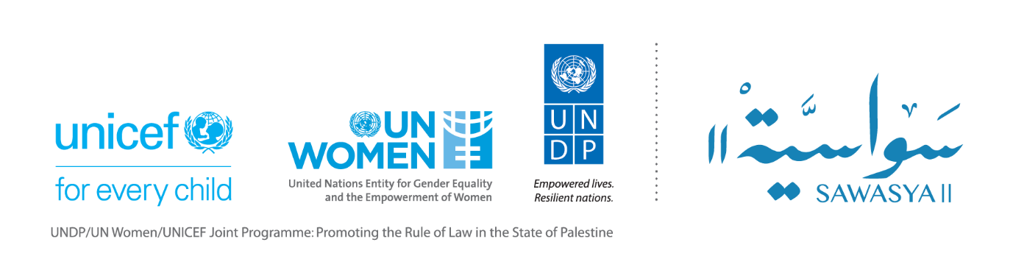

Sawasya II Update on Progress in Relation to Recommendation # 6 of the Mid Term Evaluation on the Family Protection Bill

The mid-term evaluation of Sawasya II recommended the programme to increase efforts to support the social and political alliances required to get the Family Protection Bill (FPB) passed. This will require a more explicit programme strategy and monitoring of its impact on societal and institutional resistance to change.

In response to this recommendation, the programme will develop a strategy to effectively support the social and political alliances to get the FPB passed. To that end, the programme is preparing a socio-political analysis on the factors affecting the endorsement of the FPB. The analysis will guide the development of the Strategy, which is expected to be ready by the end of 2021, and to be implemented during the period extending from (January 2022 to June 2023).
The development of the strategy will consider the below four points:
- Building an effective understanding of socio-political dynamics and politics affecting the passing and endorsement of the Family Protection Bill (FPB):
The programme recently contracted a senior international political analyst, to develop a socio-political analysis around the FPB, and to propose actionable recommendations to support alliances in developing and passing a responsive FPB. The objectives of the analysis are twofold: (a) to develop a socio- political analysis that takes into consideration factors and dynamics affecting the development and endorsement of the FPB, by looking at stakeholders’ institutions, interests, individual interests, ideas, power relations, concerns, risks, opportunities, and (b) to develop key actionable recommendations based on the analysis to support the endorsement of a responsive FPB.
The findings and recommendations of the analysis will support the programme and its partners, including the international community to effectively strategize, lobby and lead advocacy on the Bill .
- Supporting civil society organizations, including coalitions to lead on awareness, advocacy, and lobbying campaigns to pass and endorse the FPB:
While the programme will continue supporting CSOs in their advocacy on the FPB, it will support key platforms\coalitions, such as Al- Muntada, to explore new tools of advocacy and communication, for wide reach out and influence on community members, including men, women, boys, and girls. These tools will include as examples; establishing peer to peer groups of youth from different governorates, to discuss and share opinions about the Bill, its clause; to establish media platforms to raise the community awareness about the Bill, and others.
The programme will also explore capacity building opportunities to CSOs in advocacy and lobbying, to strengthen their skills and capacities, and will encourage strengthening coordination and networking platforms between Gaza and West Bank CSOs and coalitions.
- Learning from the experience of positive deviants:
This approach emphasizes on the importance of learning from those who managed to succeed within the contexts where failure is more normal and focuses especially on learning about strategies adopted to find and fit effective solutions.
Many countries in the region, such as Jordan, Lebanon, Tunisia, Morocco, Kuwait and others succeeded in passing FPB , despite challenges and limited resources. The programme will either, produce an analysis on the approaches, tools and strategies that were used by these countries, to guide political and social alliances in Palestine, or will provide learning and sharing experience opportunities to alliances to learn from the experiences of others.
- Mainstreaming gender transformative and ecological model approaches in the programme’ s and its partners interventions:
The harsh resistance that the Palestinian community witnessed against the FPB and CEDAW, which included threats and attack against women and human rights organizations and activists, highlighted the gap in gender equality related perceptions between those who are in favor of the Bill and those who are against it. This has also raised questions around the strategies and tools that have been used by stakeholders, to increase people’s awareness and sensitivity towards gender equality and women’s rights.
To address this gap, and to strengthen the tools and approaches used in raising awareness and sensitization towards gender equality, the programme will be mindful of specific mixed approaches, to effectively address social biases, misperceptions, and social judgments and conceptions around gender equality, VAW and the FPB. This will include in particular gender transformative approaches and ecological model approaches.
Gender transformative approaches will support reshaping gender relations to be more gender equitable, largely through approaches that free both women and men from the impact of destructive gender and sexual norms. This could be achieved through raising awareness about unhealthy gender norms, questioning the costs of adhering to these norms and replacing unhealthy, inequitable gender norms with redefined healthy ones; empowering women/girls and people with diverse gender and/or sexual identities/orientations, and engaging boys and men in gender equality.
Simultaneously, using a socioecological model will help us and our partners to understand and track changes in social expectations of male and female roles, and in gender-based values, beliefs and practices. This could be done, either by the programme and its partners, or through coordinating with other UN programmes, such as “Men and Women for Gender Equality” programme that is run by UN Women, which assesses and detects changes in social beliefs and perceptions of girls, boys, women and men.

