Project Status Monthly Report

Quality Education intervention- PHASE II
Implementing Partner Name: Al Saraya Center for Community Service Donor Norway & IDB  Reporting Period: 01Sep. 2020 – 30 June 2021 Project Number: 00103834  Project Start Date: 4 Aug. 2020 Project End Date: 30 June 2021  Project Status: Completed Project Completion: 30 June 2021 |  |  |  |  |  |  | :

Brief Summary:

Project Output/s | Indicators | Progress against output/s | Challenges
Output 1: The targeted groups (Including children and parents) showed an improved awareness, knowledge, attitudes and practices toward TVET, as well as the children groups demonstrated enhanced abilities in expressing their vocational tendencies. | - 350 children (170 male and 180 female, aged 6-17) participated in the project activities, as well as showed enhanced abilities in expressing their vocational tendencies.  - 50 parents (all females) participated and benefited from the project activities. | 341 children (168 boys and 173 girls participated in the project activities that included filling out the the occupational inclination questionnaire, participation in the vocational camp and participation in the vocational counselling sessions.  These activities helped the children discover their tendencies and their choices in vocational education  - An occupational and vocational tendency test was designed specifically for this project. It built on very famous tests like Holland Code Assessment and was adapted to the Palestinian and Jerusalemite contexts since other tests were lengthy and did not take the Palestinian context into consideration. An expert was contracted to develop the test for the students from five participating schools in Jerusalem and were between the ages of 14 and 17.  - Five introductory meetings were delivered to 121 students (83 boys and 39 girls) in five schools by Mr. Ayed Hoshieh.  - After that 83 students (55 boys and 28 girls) filled the questionnaire.  - Fifty individual interviews were conducted between the students and Mr. Ayed, for fifty children (35 boys and 15 girls) participated in these meetings. The purpose of these meetings was to discuss the outcomes and the analysis of the questionnaires with the students and to provide guidance on vocational tendencies and choices.  - 20 of the children who participated in the summer camp (7 Males, 13 Females) participated in a three-hour TVET guidance session with Samar Al-Hidmi and Hanin Farrah from CAC.  - 47 Children (19 Males, 28 Females) Participated in 3 TVET guidance sessions (14 hours) with Hala Liddawieh and Aisheh Firawi from Al-Saraya Center.  - 164 students (67 boys and 97 girls) between the ages of 6 and 15 years old participated in the vocational camp (Pave Your Way). The camp included 24 fields and vocations that the children were introduced to and got the chance to practice such as Carpentry, blacksmithing, pottery, car mechanics, chef, electronics, air conditioning and refrigeration, binding and printing, bamboo making, sewing, catering and hotel management, electro mechanics, wax making, accessories making, chocolate and sweets making, sewing and fashion, programming and Arduino robots, men's barbering, women's hairdressing, firefighting, doctor, storytelling and scientific experimentation. This was implemented with the coordination with Al yateem Al Arabi School, Lutheran World Federation School, Al Aytam vocational school.  - 61 children (23 Males, 38 Females) participated in 6 Field visits to three vocational training institutions; Lutheran world Federation, Dar Al-Aytam Institution and Al-Yateem Al-Arabi School with a total of 18 hours.  - 34 parents (5 Male, 29 Females) participated in five TVET guidance sessions with the expert Munjed Husseini. The main subjects that were addressed are: Vocational Education and what it is, the difference between Vocational and academic education, parents and Vocational Education, there was also an introduction to the Holland Test.  - In addition to that, 12 videos were showed to parents. These videos included international experiences in vocational education and aimed to raise the awareness of the parents on the field.  - 11 videos of TVET local institutions have been published to the Facebook page of Al-Saraya center. | - The spread of covid-19 decreased and limited our chance to do face-to-face activities.  - The closure of schools made it hard for us to contact people responsible.  - Coordination with Al Ibrahimieh School was a hindrance in the beginning of our intervention. Then a face to face meeting was conducted with them and several phone coordinations were conducted until the coordination was back on track with them.
Output 2: The targeted teachers showed an improved awareness, skills and practices in using innovative and non-traditional educational methods in educating the students and exploring their tendencies. | 20 teachers (10 female and 10 male) participated in the specialized training (10 hours) on the use of innovative and non-traditional educational methods in implementing the current curriculum. | - 20 teachers (8 Males, 12 Females) participated in 5 TVET guidance sessions (10 hours) via Zoom with the trainer Jihad Shoja’ya. The training focused on the importance of TVET guidance and the factors that influence the choice of specialties in the future. The trainer also displayed theories and tests that they can benefit when providing consultation to students. Finally, the trainer showed the teachers international experiences of success stories about TVET guidance.  - Ten videos demonstrating international experiences on vocational education were showed to teachers.

Success Stories:
- The active and invaluable participation of female students was remarkable. We did not expect neither the number nor quality of participation of the girls in the vocational activities. Girls were part of carpentry, blacksmithing and car mechanics activities and they actually enjoyed it. One of the girls who participated in carpentry said: I was hesitant to even participate in today’s activity, but after I spent the first hour I felt that I have a passion for such an artistic exercise. I thought this is solely a boys thing…now I changed my mind and I really enjoyed my time.”
- Another success story was the diversified fields of vocational specializations combining the traditional with the non-traditional fields which gave the students a variety of field to be exposed to.
- The availability of high cost raining programs for free for the students was a huge success story. An example of such a program is the Arduino which usually costs 1000 NIS per course if a student wants to cover individually.
- Tailor making of a questionnaire that takes into consideration the Palestinian and Jerusalemite contexts when it comes to vocational education.
- Active coordination with 14vocational schools and centers such as the YMCA, Dar Al Kalima, Lutheran World Federation in addition to 5 Jerusalemite schools.

Challenges:
- The spread of Corona and the recurrent closure of schools.
- The political instabilities in Jerusalem after the incidents in Damascus Gate and Sheikh Jararh.
- The resistance of the parents and the stigma associated with vocational trainings.
- The limited knowledge of teachers on vocational trainings and education.
- The presence of multiple administrative references in some schools in Jerusalem as with the case of Al Aytam School which forced us not to publish a taped material on the school.

Feedbacks from participants:
- Aya, 15 years old, said: The experience is very new to me. At first, I was afraid and hesitant to try blacksmithing, especially since there are no girls who work as blacksmiths. It is not accepted socially to do so. But after I built a sculpture and dealt with the tools, I felt happy and content with the experience. Now I know I have an option to use metals to build artistic things. It might be my future profession or hobby. Thanks to everyone who supported us.
- Myassar, 13 years old, said: This experience was about breaking the social taboos and undergoing new experiences. I liked most the carpentry and I started to think of it in a non-traditional way. You don’t need to doors to tables, but you can tailor make small things in a non-traditional way. I really enjoyed the experience.
- Mahmoud, 13 years old, said: I tried the sewing, and I had no patience, it was not easy. But the experience is definitely something I would do again. The whole camp was brilliant and the idea of having boys and girls work together and experience different professions was good and inspiring.
- Sawsan, 11 years old, said: I felt embarrassed a little bit since I confused ceramics and pottery making with sewing. After my participation in this camp, I felt that pottery making is my “thing”. It served as an activity to vent out and it was very relaxing to me.
- Many parents were very pleased when we were implementing the project, especially when carried out the questionnaire and the one-on-one sessions.
- Mohammad’s mother from “Dar Alhikma School” said that her son needed this session because he did not know what he was going to do in the future.
- The father of Lujain said “I present my thanks to al Saraya center for applying such a beneficial activity for children at schools.
- Also, many of the parents who participated in the awareness raising activity on Vocational education showed an altered opinion about TVET, when they started they did not accept the fact that their children would join TVET institutions, however and after the discussion with the expert, they had a different idea, and there was a different result to the test that was held before and after the sessions.

Selected photos:

We added photos of the links and the comments of parents on the vocational camp posted on Alsaraya Page on Facebook.
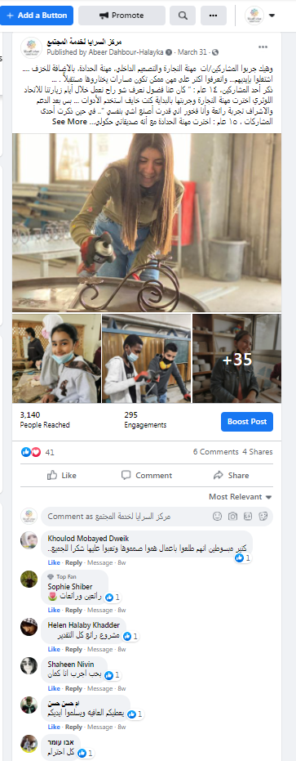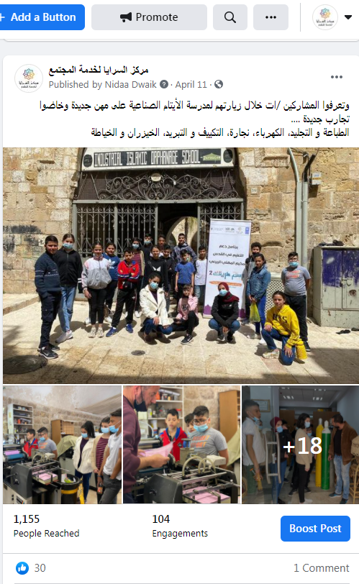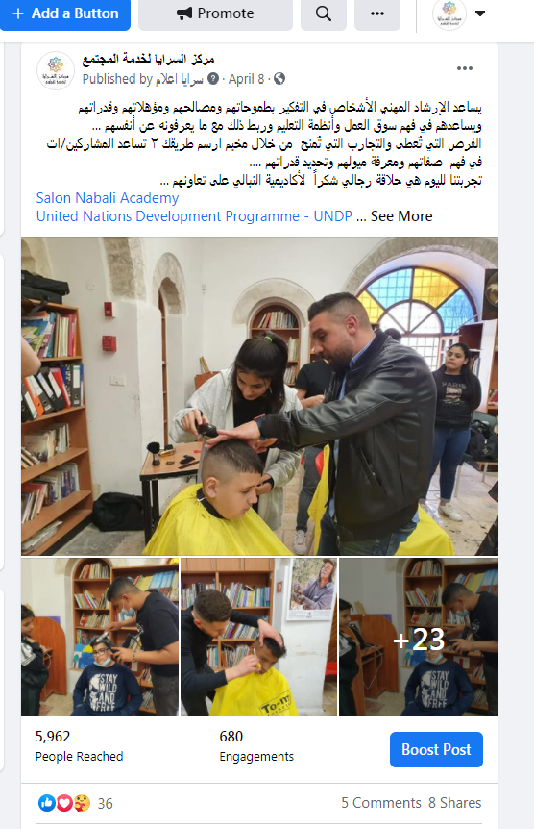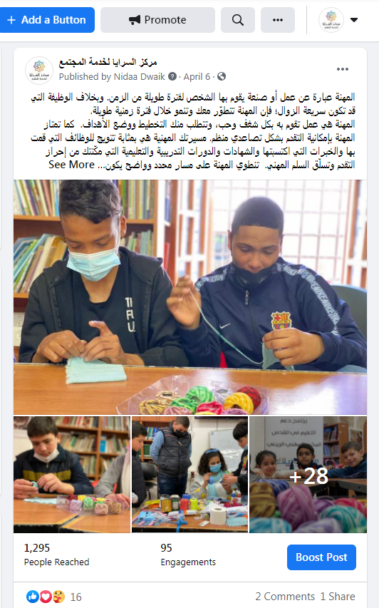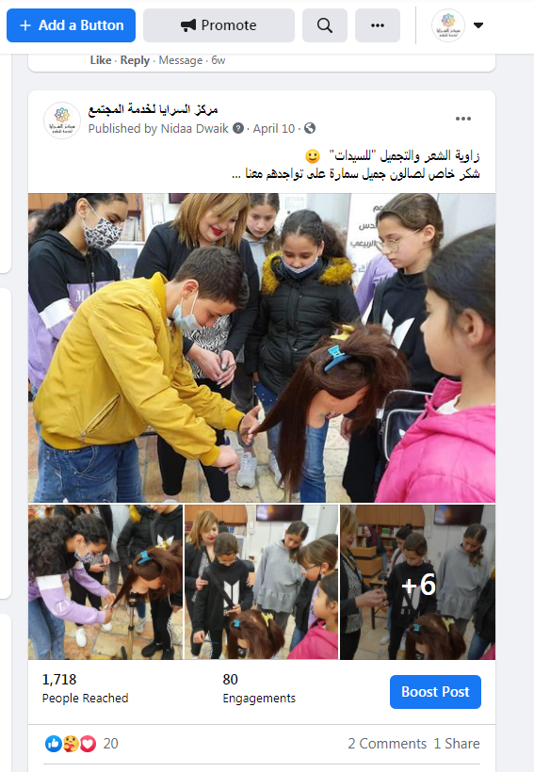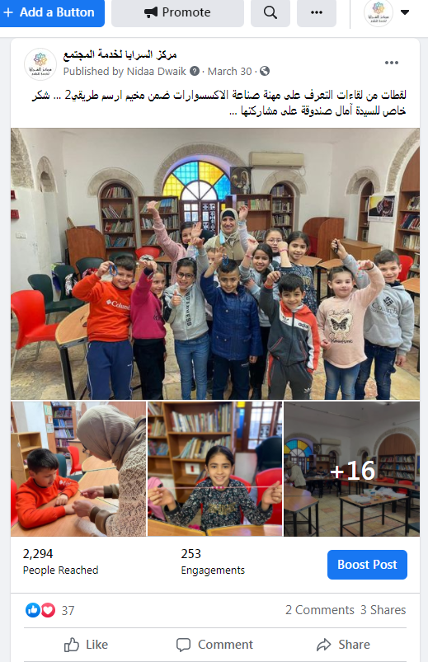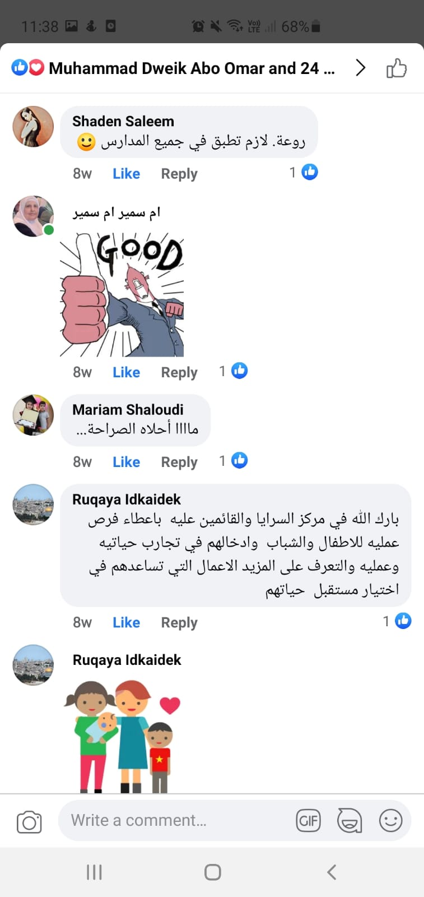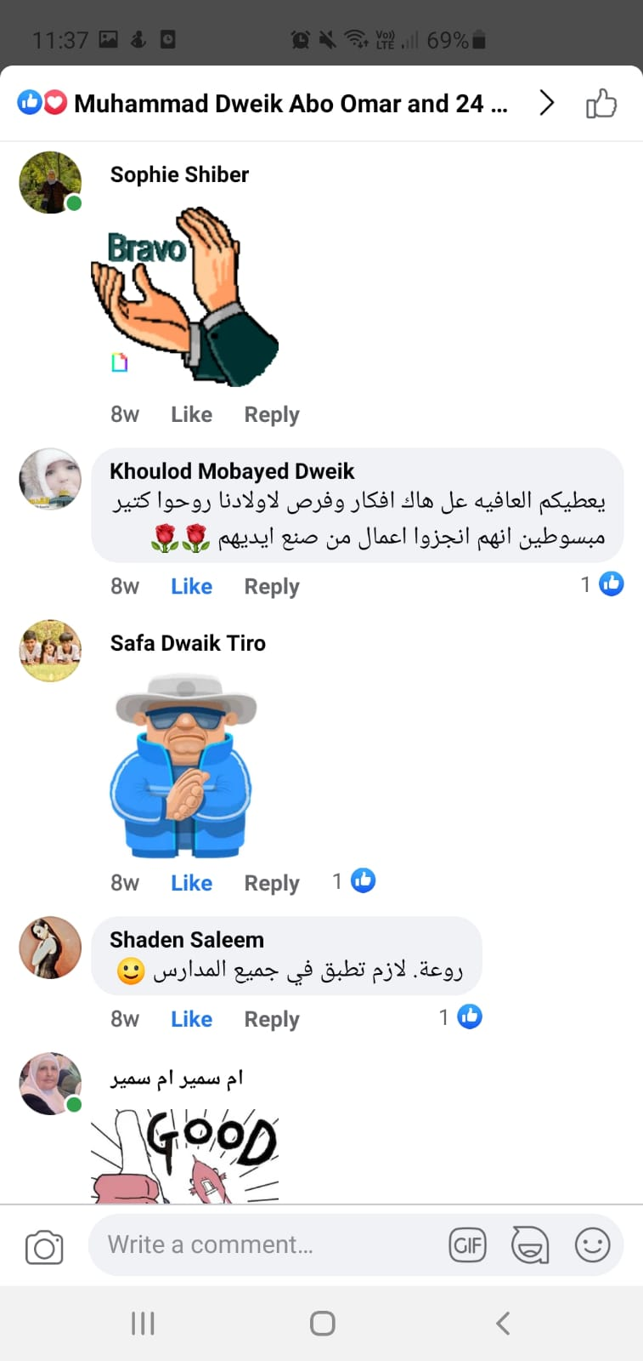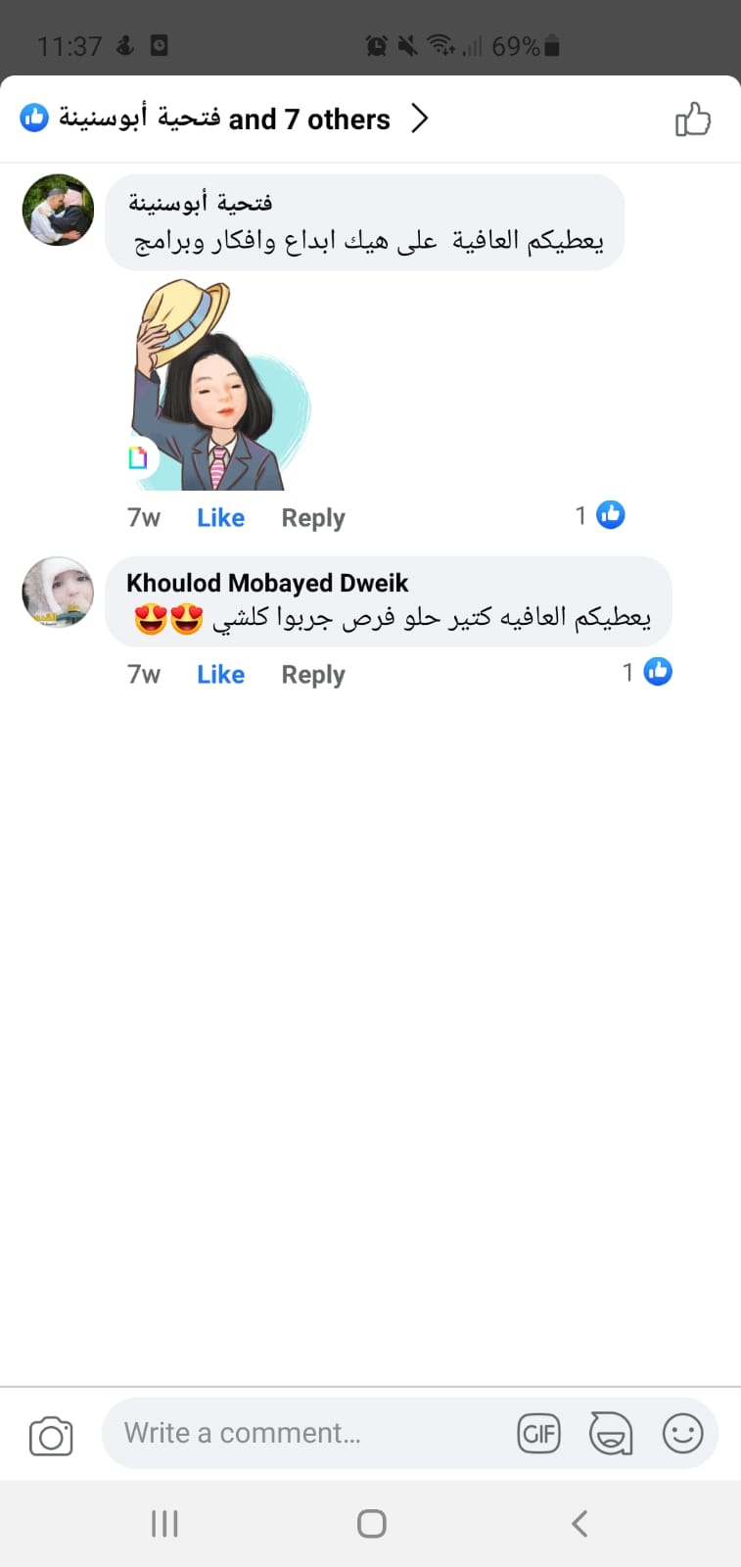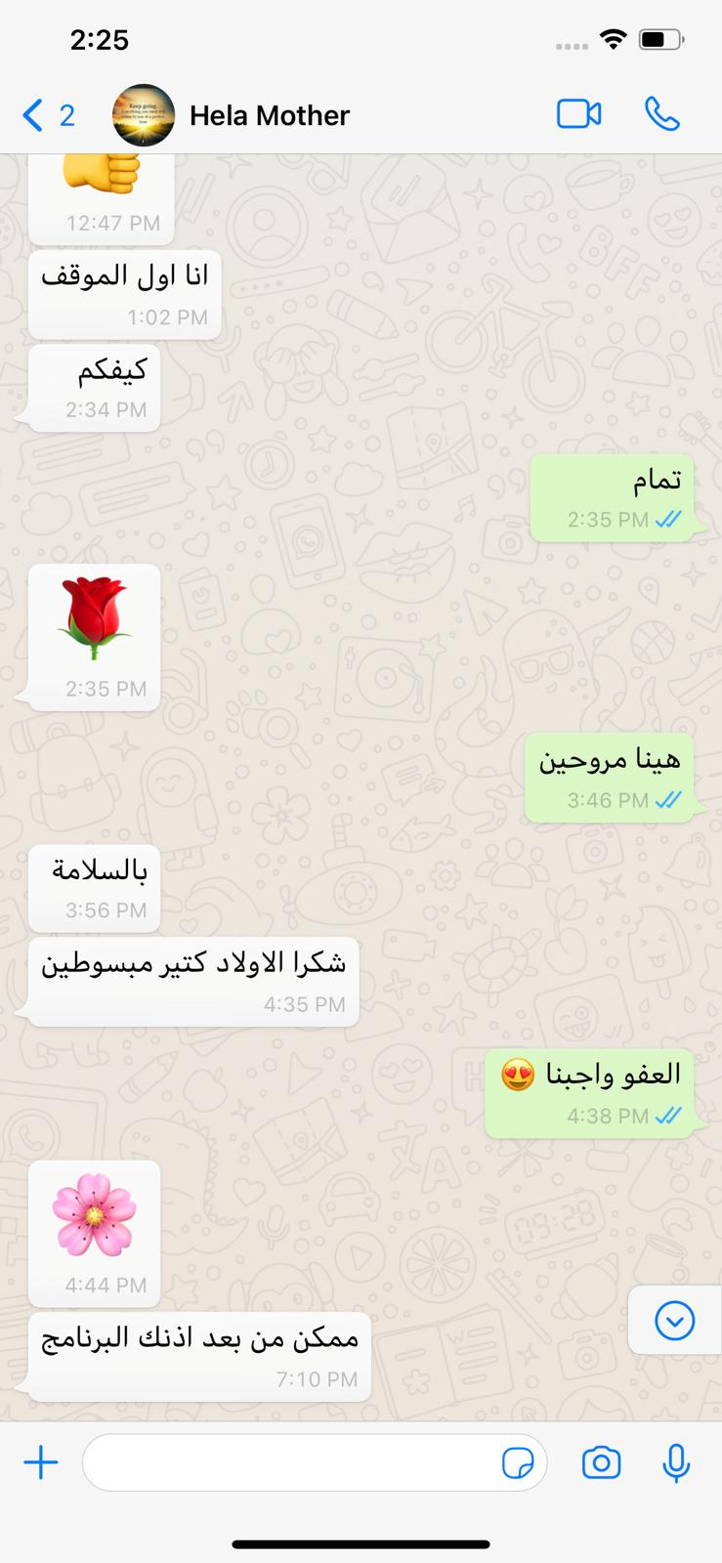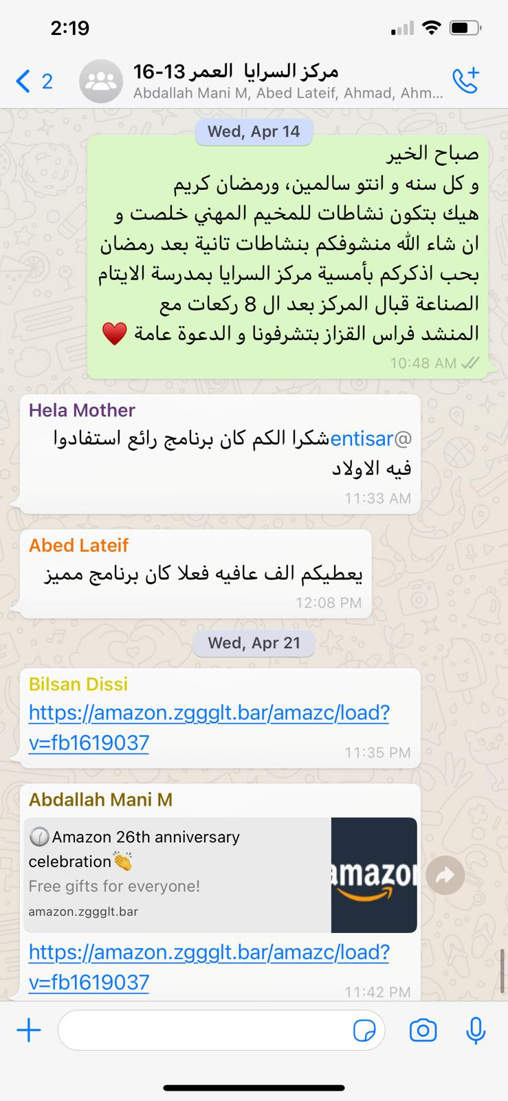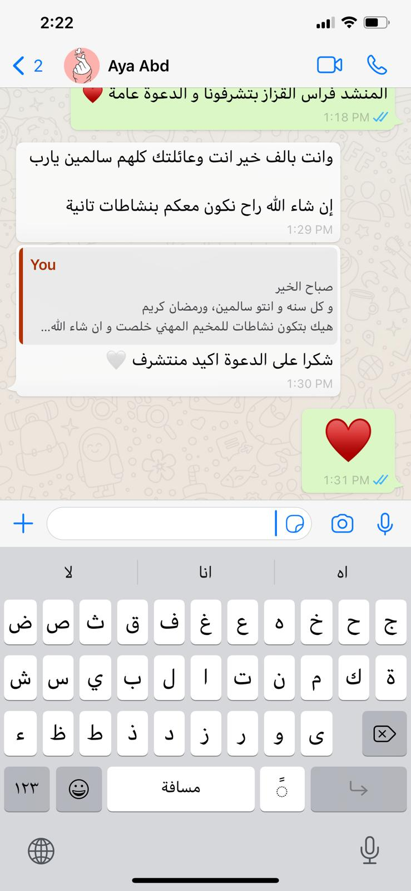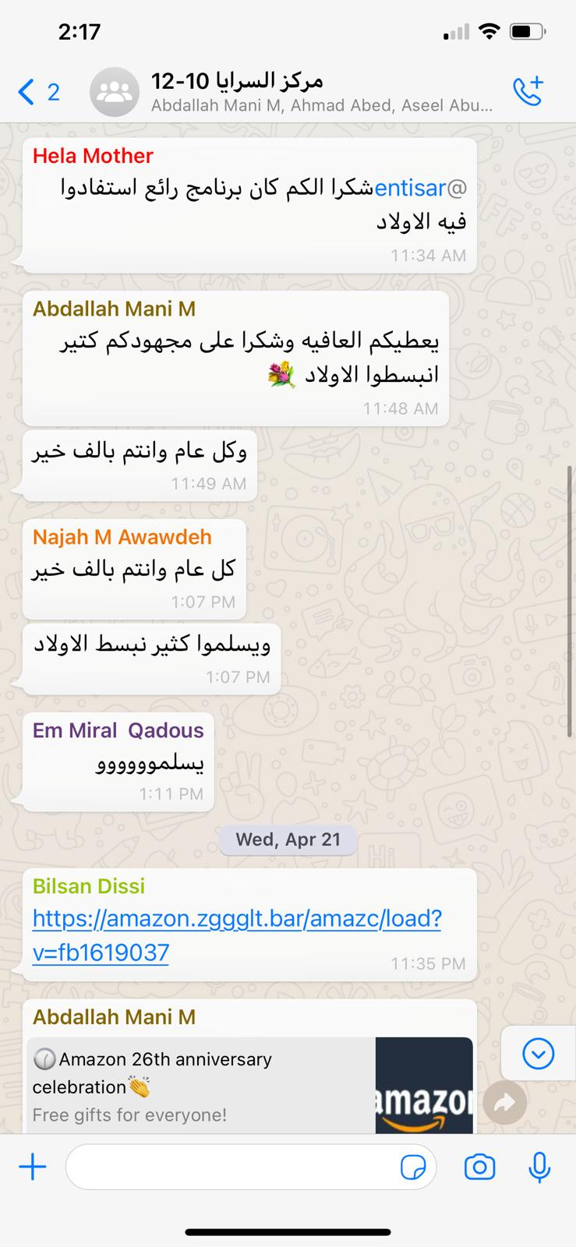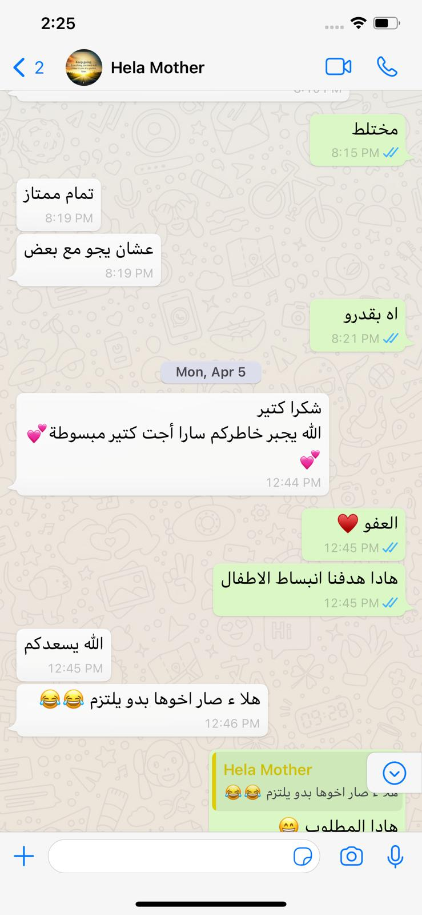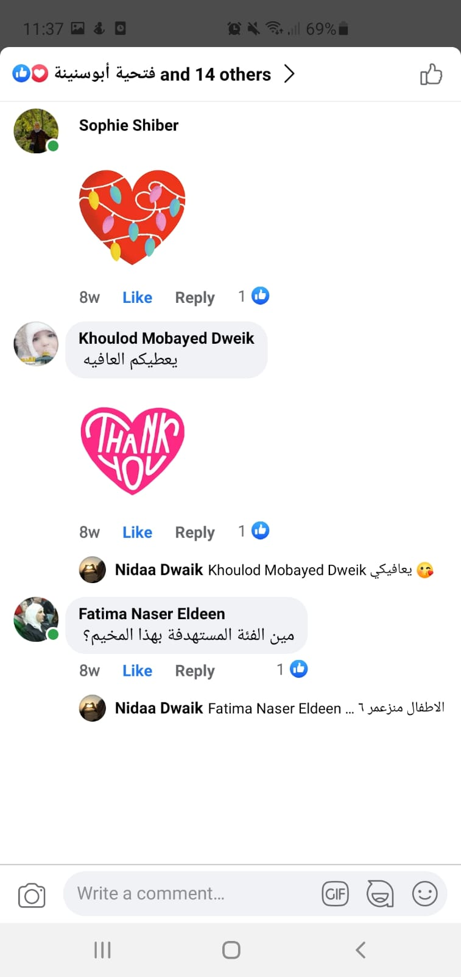

Annexes:
Attendance Sheet/s

