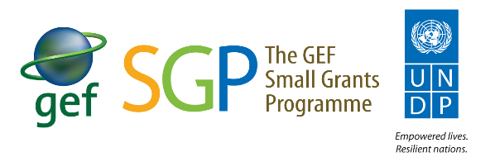

SGP Private Sector Survey Results and Analysis (2021)

The private sector survey was conducted as a scoping exercise to assess the level of private sector engagement at the SGP Country Programmes. The objective of the survey was to collect basic field information towards developing an OP7 private sector guidance note.

Engagement with Private Sector
- Out of 90 survey respondents, 70 indicated that they established partnerships with the private sector while 20 respondents indicated that they have not.
- Initial analysis of the qualitative responses indicates that most of these engagements occur at the project level.
- Most engagements are not ‘formalized’ by MOUs/legal agreements with SGP/UNDP/UNOPS etc. (this was not clearly indicated in the survey responses).
- In many cases the engagements take place directly between the grantee and the private sector with SGP acting as a facilitator (grant maker+).
Answer Choices | Responses
Yes | 77% | 70
No | 22% | 20
Total responses |  | 90

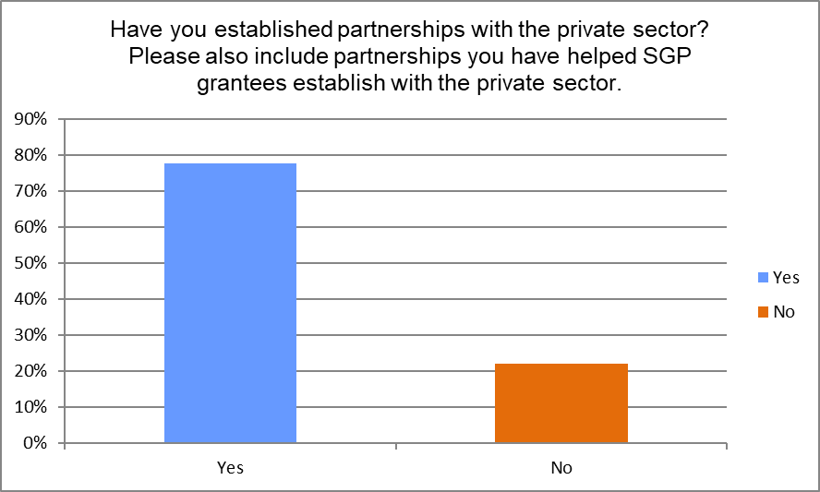

Types of Partnerships Established
- 57% of SGP Country Programmes indicated that engagement with the private sector was primarily provided via technical assistance to programme/project activities at a reduced cost or at no cost.
- This was followed closely by capacity development contributions to grantees at 48%, and in-kind contributions at 47% (venue, food, transport, equipment etc.).
- 33% of private sector engagement accounted for cash contributions (direct/ parallel co-financing of SGP grants).

Answer Choices | Responses
In- kind contribution (e.g. providing venue, food, transportation, equipment for meetings/events/activities) | 47%
Cash contribution (e.g. direct or parallel co-financing of SGP grants) | 33%
Technical assistance and capacity development to program/project activities for free or with reduced cost (i.e. business advisory services, etc.) | 57%
Contribution to capacity development of grantees | 48%
Provision of parallel matchmaking to SGP grants | 11%
Advocacy and marketing of SGP causes | 24%
Policy dialogue | 13%
Other | 22%
Other (please specify)

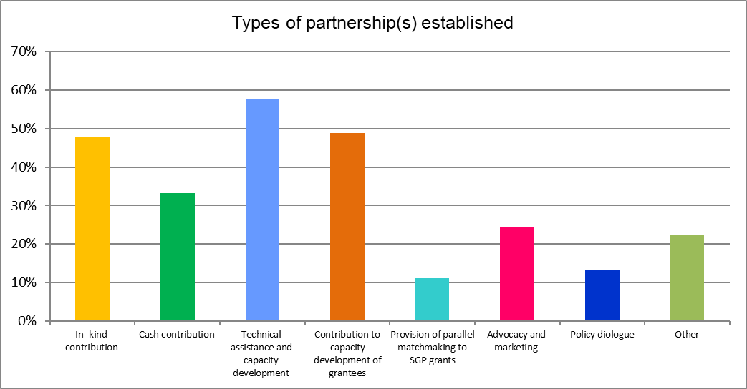

Comments of Interest and Challenges Engaging with the Private Sector
Country programmes identified a range of challenges and comments of interest when engaging with the private sector including:
- Some private sector companies only operate in a certain geographic area which may not be aligned to the SGP landscapes/seascapes in the country.
- Private sector branding and recognition of their contributions are important factors to discuss when working with the private sector.
- Establishing relationships can be complicated and time consuming. Partnerships demand time and ongoing coordination efforts. Relationship building is a process.
- Sometimes although a partnership is established with private sector- the grantees may not benefit in the best way, sometimes the private sector has the advantage over the grantee and the agreement. They may offer the grantee lower prices for the products. This needs to be carefully understood and managed from early in the partnership.
- In Ecuador, it was difficult for the communities to adapt to the private sector agenda, focus, and way of working. We must think about ‘translating’ the ideas and strategies for market insertion and commerce. Private enterprise is vital to link rural communities to the urban areas, not only via marketing or commercialization but through social media presence and news. Furthermore, the private sector is more involved each passing year with new and innovative social responsibility strategies, and this should be explored further.
- Panama- SGP grantee products (food/health related) sometime lack ‘health’ certification which prevents private sector from working with them.
- Some private sector companies are not willing to sign an agreement. The lesson is involving the private sector throughout the process. This facilitate understanding and sharing of knowledge. This will encourage them to participate and work with the local community.
- Private sector motivation is different from community and public sector actors. Each group has their own interest/motivation.
- Both Mauritius and Nigeria noted that there is no standard legal template for collaboration between the private sector and SGP. This leads to extra work and delays, and further complicates the process. In Nigeria, payment of funds to UNDP has not been possible to date because UNDP does not have any template or arrangement to accept and disburse the fund from the Foundation/private sector. Others NCs also noted that there is a need for adequate formats, templates, procedures and reports.
- In Guatemala, one challenge is the relation between producers and private sector, as many times rural producers do not trust private sector as a partner, so time needs to be invested in gaining trust and providing information about the objectives and results of the project.
- Partnership between CSOs, government and private sector strengthens project design, implementation, and impact. It builds trust, transparency, and accountability.
- In some cases, interaction with the private sector, the state and non-profit organizations was very effective in achieving the project's goals and overall sustainability.
- Tajikistan noted that projects are more financially and institutionally sustainable when they are owned and operated under private sector leadership and stewardship.

Country Examples for Further Follow Up
The following are a few countries that provided interesting examples of private sector engagement that can be further explored.
Country | Brief Example
China | Solar PV company donated PV equipment to some projects.
Ghana | 2 strong examples of private sector partnerships involving shea butter processing - specifically focused on women empowerment, access to markets, fair trade certification, improving processing etc.
Armenia | Partnership was established through cooperation and agreement of UNDP CO and Coca Cola Foundation in Armenia. USD cash provided. Another partnership was established with the Global Credit Universal Credit Organization to scale up waste collection project.
Morocco | Morocco Agricultural Credit Foundation for Sustainable Development provided cash funding, training on good agriculture practices, eco certification and access to markets for grantees.
Lesotho | Private sector provided cash and technical support to help scale up an SGP dairy project.
Vietnam | Various engagements with private sector- cash, technical assistance, and capacity development- on medicinal plants, cassava production, LED lights.
Belarus | 23 initiatives were developed and supported with the help of private sector (technical assistance, capacity development, policy dialogue). Established partnerships allowed development and testing of mechanism for the collection, preparation, transboundary transportation and destruction of POPs - containing wastes outside Belarus. Partnership between more than 16 private and state enterprises together with NGOs/CBOs was created.
Kenya | A private company has co-financed a project with USD37,628 in cash for the up-front purchase of 950 solar lamps and USD8,000 in-kind to cater for the accommodation of staff and transport of solar power lamps. The private sector has provided co-financing of USD2,000 towards training community members on the use of the water meters and are providing maintenance services.
Dominica | Partnership with the Dominica Solid Waste Management Corporation to utilize  their collection trucks. The DSWMC worked with the grantees to develop schedules and strengthen the collection system for two pilot communities. Regular waste and recyclable waste are now collected by the DSWMC trucks at no cost to the project. The Corporation also supports the public education and awareness activities.
Peru | SGP Peru established a partnership from 2005 to 2010 with Cementos Lima company, through its social responsible association- Atocongo. The partnership allowed 1:1 in cash parallel funding with SGP, levering more than USD500,000 from the private sector. The objective was to strengthen local capacities to develop urban agriculture as ecological integral farms, supporting food security of vulnerable sectors, bio-gardens, and commercial articulation of products and services with tourists and by participating in fairs. This took place in a "Lomas" ecosystem, therefore fog catchers were installed to obtain water for agriculture. The local capacities installed by this group of projects helped to acknowledge the importance of the Lomas ecosystem by the citizens and to generate ideas for designing a UNDP GEF 6 project which has been instrumental for the declaration of a Regional Conservation Area that protects the Lomas 10 years after.

Additional Resources:
- GEF Private Sector Engagement Strategy (2020) - https://www.thegef.org/sites/default/files/council-meeting-documents/EN_GEF.C.59.07.Rev_.01_GEFs%20Private%20Sector%20Engagement%20Strategy_.pdf (section 5 is particularly relevant with IPs, CSOs, etc link)
- UNDP Private Sector Strategy (2018-2022) - https://www.undp.org/content/undp/en/home/librarypage/poverty-reduction/private_sector/undp-private-sector-strategy-2018-2022.html

