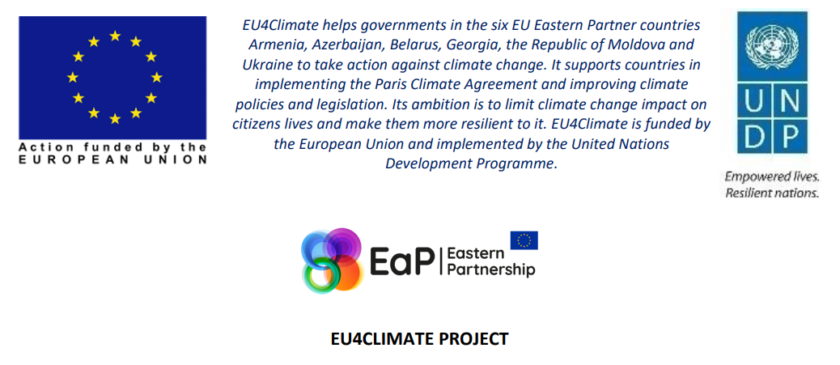

WEBINAR ON MEASURES TO REDUCE THE CONSUMPTION OF CONTROLLED SUBSTANCES AND CONTROL SUBSTANCES DESTRUCTION TECHNOLOGIES

Webinar objectives and agenda

Exchange of international experience and practices in the definition and implementation of measures to reduce the consumption of controlled substances (ozone-depleting substances and fluorinated greenhouse gases) and destruction technologies for controlled substances.

15 April 2021
Zoom
Passcode: 791334

Time (Kyiv time zone, GMT+2)
11:00 – 11:10 | Welcoming remarks  UNDP  Ministry of Environmental Protection and Natural Resources of Ukraine
11:10 – 11:15 | Setting goals for the webinar
11:15 – 11:30 | Measures to reduce the consumption of controlled substances – entry point for discussion
11:30 – 12:00 | Measures to reduce the consumption of controlled substances in Uzbekistan  Gulnara Khojibekova, Lead Specialist, Atmosphere Air Protection Department, State Committee of the Republic of Uzbekistan for Ecology and Environmental protection
12:00 – 12:30 | Discussion  Representatives of NGOs and businesses of the countries participating in the seminar  Secretary General of the Association of Refrigeration Equipment and Air Conditioners of Bulgaria  Director of the National Forum on Refrigeration Equipment Poland  National Refrigeration Association Lithuania
12:30 – 13:15 | Break
13:15 – 13:30 | Czech experience with ODS and F-gas regulation  Stepan Stojanov, Director of SCHKT training centre ve společnosti Školicí středisko CHKT a TČ, s.r.o.
13:30 – 13:45 | Measures to reduce the consumption of controlled substances in Uzbekistan  Isroiljon Khasanov, Manager, UNDP-GEF Project “Complete HCFC Phase-out in Uzbekistan through promotion of zero ODS low GWP energy efficient”
13:45 – 14:00 | Measures to reduce the consumption of ODS and F-gases by their recovery, recycling, regeneration and waste disposal  Sébastien Gallet, Regulatory Affairs Manager for Fluorinated products, Solvay
14:00 – 14:45 | Open discussion
14:45 – 15:00 | Wrap-up and closing remarks

