Facilitating Digitally Enabled Livelihoods for forcibly displaced populations and host communities

Digitalization is changing the nature of work and the way of doing business. Advances in technology have expanded livelihoods opportunities, as well as the means for accessing them. The OECD estimates that 14% of jobs could be automated in the coming years, making some jobs obsolete, but also creating new jobs through innovation. These new jobs require higher levels of skills and create the need for lifelong learning for workers to continue acquiring relevant skills as technologies advance. Companies are seeking workers with high cognitive skills and adaptability to keep up with changes.
COVID-19 has accelerated the pace of digitalization and deepened inequalities between those who can keep up and those who cannot. To continue working amidst lockdowns, workers and businesses have had to adopt digital tools or risk losing their means of livelihood. Companies brought operations online and implemented remote and flexible working arrangements. Governments have also had to embrace digitalization, to continue providing critical information and services to people during the pandemic. UNDP has supported this transition by equipping governments with digital infrastructure, supporting micro and small businesses to bring their businesses online, and equipping people with digital skills. While there were many successes, we have also witnessed the risk of leaving those most vulnerable, including forcibly displaced people, behind, without interventions to help them be part of the digital transformation journey.
Because people on the move have been hit particularly hard by the COVID-19 crisis and are more likely to be affected by the digital divide, it is key to invest in initiatives that address the needs of those furthest behind, especially youth and women. Youth who lack digital skills and who live in remote areas with weak digital infrastructure are at risk of not being able to capture education, training and job opportunities created through technology. Women are also at risk of being left behind with 327 million fewer women having access to smartphone and mobile internet than men worldwide.
Digitally enabled livelihoods are defined as the use of digital tools to build the six livelihood capitals (financial, physical, natural, human, political and social).
People whose lives are disrupted by crises often lack access to infrastructure and opportunities to learn how to use digital technology to rebuild their lives. In particular, forcibly displaced populations are at risk of being unable to capture opportunities, often losing credentials and lacking livelihood opportunities and access to markets in places they transit through or settle in. Digital technologies can be a bridge for both internally and cross-border displaced people to build sustainable livelihoods and contribute to sustainable development. Investing in initiatives that enable forcibly displaced populations and host communities to capture opportunities from digitalization not only helps reduce the risk and vulnerabilities they face, but also opens the door to develop innovative solutions that serve the wider community.
UNDP is committed to investing in meeting the needs of those most likely to be left behind through digitalization. At the Global Refugee Forum in 2019, UNDP committed to working with UNHCR and other partners to reach at least 50% of the total number of refugees in 20 priority countries, where UNDP and UNHCR have partnered on the ground, as well as host communities in these countries by 2023. We pursue this work through 4 components: (i) enabling access to and usage of transformative technologies for livelihoods , (ii) ensuring an enabling policy and regulatory environment for digital transformation, (iii) promoting investment and innovation, (iv) research, prototyping and dialogue on solutions to promote digitally enabled livelihoods. This is in line with UNDP’s Strategic Plan (2018-21) and Digital Strategy, which calls for leveraging technology for sustainable development.
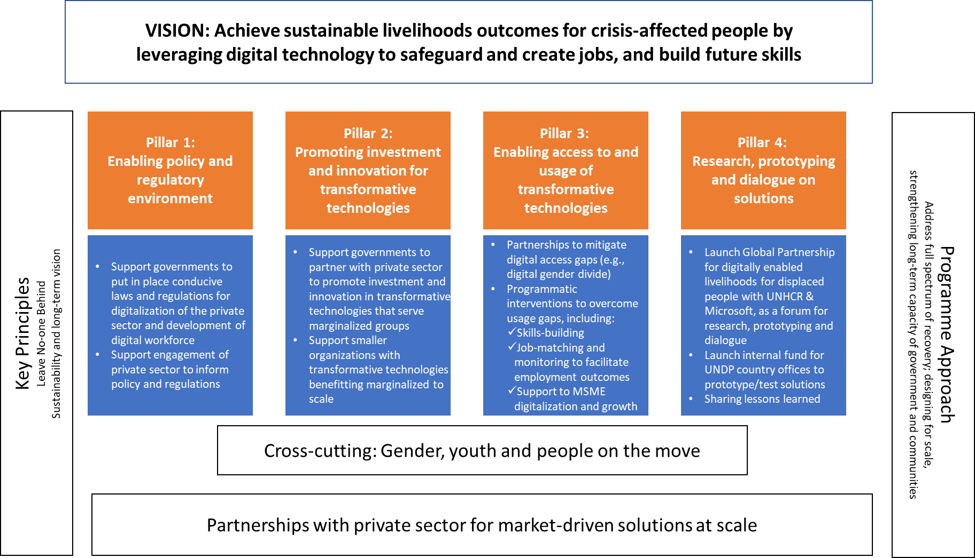
Solutions build on those that have been proven to be effective within and outside UNDP. The initial emphasis will be on scaling solutions developed by UNDP country offices with proven results and with the potential to be adapted to other contexts. Adaptation and implementation will be pursued with partners with presence on the ground who have strong relationships with forcibly displaced people and their host communities, as well as with key actors in the private sector, who are technology holders and seekers of skilled labour.
In parallel to scaling existing solutions, new solutions will be developed and tested at the country-level as new evidence and needs emerge, and as new partnerships are built.

Example of solutions in action
Highlights from a2i (Aspire to Innovate) Bangladesh
- Future of Work Lab:
  - National Skills Portal (skills.gov.bd):
In Bangladesh, 28 departments under 23 ministries are involved in skills development and employment generation. The national skills portal has been developed to make effective coordination among these ministries and ensure matchmaking among unemployed youth, Skills Providers and Job Providers. 300k youth, 1000+ industries, 100+ training centers, 10+ departments are registered in this platform. This platform is now being scaled up to serve Syrian refugees and host communities in Turkey and Jordan.

- eCommerce platform (eKShop): connecting rural buyers and producers to urban and international e-Commerce marketplaces (unique aggregation API links to 33 eCommerce sites), aggregated logistics and payment networks for national and cross-border trade
  - Shoron pilot: Connecting products made by 30 Rohingya women and packaged by 15 women from the host community to Thailand and other markets.
  - This platform is now being scaled up to serve migrants from Venezuela in Colombia.

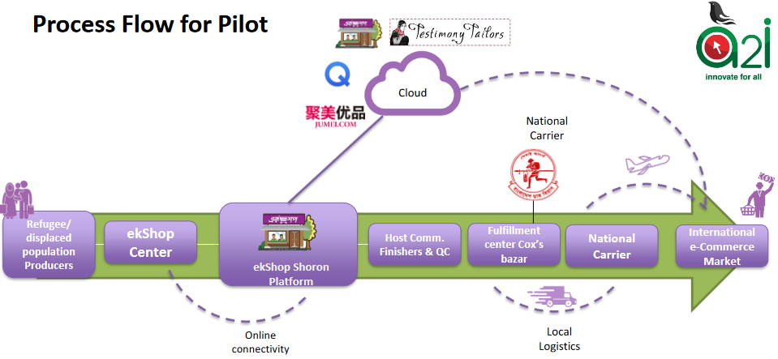
Adaptation in other country contexts
- Turkey: designing digital work platform pilot enabling Syrian refugees to access online freelancing work, linked to large-scale platforms such as UpWork, Fiverr.
- Jordan: adapting National Skills Portal to serve Syrian refugees and host communities members most affected by COVID-19.
- Colombia: adapting the eCommerce platform to enable migrant entrepreneurs at the border with Venezuela to better access markets.

UNDP Accelerator Labs
In 2019, UNDP built the world’s largest and fastest learning network on sustainable development challenges. We started with 60 Lab teams covering 78 countries and are now expanding to 90 Labs covering 114 countries. We create actionable intelligence, test solutions with national partners. It’s early, but so far we are winning awards. For example, Apolitical's Global Public Service Teams of the Year Award.
Labs are part of UNDP’s global policy teams and country offices. Our 270 Lab team members bring bright, unusual talent into the development sector. 68 percent of them have experience in prototyping; 55 percent can work with citizen generated data; and 29 percent can perform tasks related to artificial intelligence and machine learning.
Aligned with UNDP’s vision of gender equality, more than 50 percent of our new innovation experts are women, driving our exploration and elevation of women-led solutions. 24 percent of the lab teams are returnees — a source of pride that our Labs are attracting national talent back to developing countries.
The Accelerator Labs are designed to close the gap between the current practices of international development in an accelerated pace of change. They model a new capability to make breakthroughs on the future of development: inequality, decarbonization, the 4thindustrial revolution and new forms of governance.
Up to date, we are exploring support to scale up solutions for displaced populations and host community members identified in Iraq, Somalia and Sudan. These solutions aim at supporting innovative solutions linking digital technologies, renewable energies and livelihoods in rural areas.
Partnerships
- Global consortium on digital work for refugees
  - UNHCR and Microsoft: preparing to launch a coalition of partners to facilitate digitally enabled livelihoods for displaced populations, with joint implementation on the ground. Strong emphasis on private sector partners who own key technology platforms and can provide remote employment opportunities to refugees at scale.

Planned activities (2021-2022)
Over the next two years, UNDP will work at the local and global levels to pilot and scale digitally enabled livelihood solutions for forcibly displaced populations and host communities, with the goal of delivering on our GRF commitments by 2023.
Solutions will be pursued in three tracks:
- Adapt and scale up digital platforms for skills, markets and digital work (local and regional)
- Scale up local livelihoods solutions for forcibly displaced people through AccLabs (local)
- Launch and pilot new solutions through the global consortium on digital work (global)

Priority countries for this work include (but are not limited to):
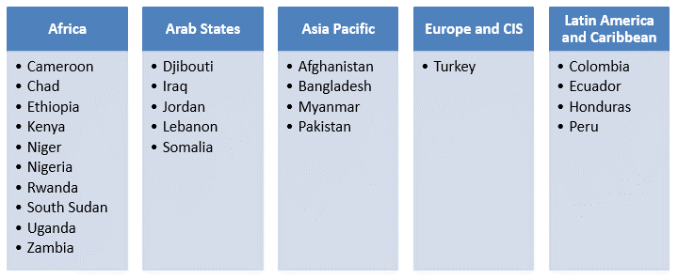
The initiative will also prioritize additional countries where Accelerator Labs have identified ready-to-scale digital solutions that support livelihoods of the forcibly displaced (e.g., Sudan).
To ensure that initiatives successfully reach displaced populations, the programme will focus on design and implementation of livelihoods initiatives that directly involve displaced people and host communities, using area-based targeting (in and around refugee camps, but also urban neighbourhoods and rural areas with a strong concentration of IDPs and/or refugees) and careful selection of beneficiaries in partnership with UNHCR and other organizations on the ground. It will also offer participation to vulnerable members of host communities to foster social cohesion.
Learning across activities is a key priority to build knowledge of what works in leveraging digital technologies for displaced populations’ livelihoods and sharing this widely to encourage further investments. Opportunities to share these findings include the High-level Officials Meeting for GRF planned in December 2021.

Provisional budget (2021-2022)
The anticipated budget for this work is USD 800,000 over 2021-2022, with breakdown as follows. Target regions and countries will be determined based on demand and readiness to implement livelihoods initiatives directly involving displaced people and host communities.
Track | Activities |  | Budget
 | 2021 | 2022 | 2021 | 2022
Digital platforms | - Scale platform in LAC region (ecommerce)  - Scale platform in Middle East (skills/digital work) | - Adapt and scale platform(s) in Africa region | 190,000 | 160,000
AccLabs | - Vet and scale solutions in 3 countries (e.g., Iraq, Sudan, Somalia) | - Vet and scale solutions in 3 additional countries | 120,000 | 160,000
Global consortium | - Onboard anchor partners and launch consortium | - Pilot new solutions in priority countries | 45,000 | 40,000
Learning | - Case studies & lessons learned publication (interactive) | - Guidance on good practices for scaling digitally enabled livelihood solutions for forcibly displaced | 45,000 | 40,000
Total |  |  | 400,000 | 400,000

http://www.oecd.org/digital/bridging-the-digital-gender-divide.pdf
Global Refugee Forum 2019: Defining UNDP’s Development Commitments and Contributions. The 20+ priority countries are: Cameroon, Chad, Ethiopia, Kenya, Niger, Nigeria, Rwanda, South Sudan, Uganda, Zambia; Djibouti, Iraq, Jordan, Lebanon, Somalia; Afghanistan, Bangladesh, Myanmar, Pakistan; Turkey; Colombia, Ecuador, Honduras, Peru.
Presentation of ekShop Shoron Pilot. https://data2.unhcr.org/ar/documents/download/75036

