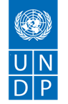
(Annex) Category 1 Climate Change: Country Plan

Language: English (Other languages are not accepted by the GoJ)
Project Period: Maximum 12 months

Country/territory name: Guinea Bissau
Office name: UNDP Country Office Guinea Bissau
Project officer name: Jihene Touil, Head of Sustainable Development Unit, UNDP CO
Climate Promise counterpart name: Liam Fee

- SITUATION ANALYSIS

Development Challenge – about 2 paragraphs

Located in the West Africa, Guinea-Bissau is one of the poorest and most fragile countries in the world and classified as a Least Developed Country (LDCs) and a Small Island Developing State (SIDS) with GDP per capita of 778.4 USD in 2018. The country is ranked 175 out of 189 countries in the 2019 Human Development Index) and nearly 70 percent of its population live below the poverty line (WFP, 2020). Economic growth is highly erratic, fragile, and narrowly-based. A lack of developed infrastructure, including educational and healthcare facilities, rural roads, markets and, critically, electricity generation or distribution are a major barrier to economic development and reinforce the dependence on firewood. Guinea Bissau also is highly vulnerable to climate risks. It ranks 175 out of 181 countries in the 2018 ND-GAIN country Index. This index indicates that the country is relatively unprepared to address potential climatic disturbances that could drastically affect its population and livelihoods. The country faces many environmental problems, including deforestation, soil and costal degradation, and water contamination (UNESCO,2018). 95% of energy production in the country relies on biomass. This means that cutting trees and mangroves for charcoal production, along with commercial deforestation are among the greatest environmental challenges the country faces. The continuous degradation of its natural capital (forest, soil and water resources) due to mismanagement and over-exploitation exacerbates climate change-related risks, such as floods, storms, droughts, swarms of grasshoppers, disease epidemics (cholera, meningitis, malaria, and COVID-19) create further barriers to development and economic growth.

Furthermore, the lack of quality data and information on vulnerability to climate change and the potential of natural capital makes it difficult for mid and long-term low carbon emission development planning in Guinea Bissau. For example, forests are neither demarcated, or mapped with precision, which hinders effective management, even within protected areas. The last forest inventory dated 1985, and the inventory could not be fulfilled as part of the first NDC. Guinea Bissau also does not have a comprehensive national GHG inventory with a reliable methodology, quality data. And if this will not be improved through accelerated capacity building and quality data collection, it will be very difficult for the country to prepare transparency reports every 2 years from 2024, as per the Paris Agreement rule book.
With regard to the global climate commitment, Guinea Bissau submitted its first NDC in September 2015 and ratified Paris Agreement in October 2018, which reflects a political will and high-level commitment to contribute to the international community goal against global warming. However, the stock takes of the first NDC implementation confirm that weak Governance of the NDC, including absence of clear objectives, quantitative targets and indicators to ensure reliable monitoring and evaluation hindered the implementation of the 2015 NDC and therefore the achievement of Guinea Bissau’s commitments to the Paris Agreement. The stock takes highlighted that few mitigation or adaptation measures were actually implemented, except, for example, the increase in the percentage of protected areas from 15% to 26% of Guinea Bissau’s land area. A lack of reliable data is another of the shortcomings of the first NDC, which was underlined in the 2015 NDC itself.
The country is part of the UNDP Climate Promise that is currently supporting NDC update considering both the rules and procedures for operationalizing the Paris Agreement and the socio-economic specificities of the national context. The revised NDC is expected to be submitted to the UNFCCC before the COP26.
The NDC update represents an opportunity for Guinea Bissau to strengthen its climate commitments, including mitigation actions in key economic sectors to accelerate its green and resilient economic growth. For that purpose, and beyond the NDC update process, the UNDP Climate Promise also aims to strengthen national capacities with a roadmap for the implementation of the updated NDC over the upcoming 3 years. This road map will include the main technical, institutional, and financial capacity building needs that will have to be in place to ensure an efficient implementation and monitoring of the NDC over the period 2022-24.
The current proposal aims to address the key capacity building needs that will contribute to the NDC implementation as one of the key drivers for the Agenda 2030 in Guinea Bissau. The main focus of this will be to support the acceleration of SDG 7 “Ensure access to affordable, reliable, sustainable and modern energy for all”. and SDG 15 “Protect, restore and promote sustainable use of terrestrial ecosystems, sustainably manage forests, combat desertification, and halt and reverse land degradation and halt biodiversity loss” achievement through the SDG13.

Strategy – about 3 paragraphs

The long-term impact level of the project is to enhance nationally determined contribution (NDC) in Guinea Bissau towards net-zero emissions and climate-resilient development, in response to the climate emergency in the country. The project is built on national development priorities and will directly support the Government of Guinea-Bissau and all national stakeholders to accelerate NDC implementation after its submission to the UNFCCC ahead of CoP26. Guinea Bissau will have for the first time an NDC aligned to the standards of the Paris Agreement, and including a national GHG inventory with IPCC 2006 methodology to ensure quality of the mitigation scenarios. The country will also have both an NDC financing strategy and a comprehensive road map that will tackle governance, technical assistance and climate finance capacity building related challenges for the upcoming 3 years. The project will support directly key priorities implementation from the financing strategy and road map.

Despite the high level of ownership and commitment to the NDC update process, the national capacities need to be strengthened so that the implementation of the revised NDC will be enhanced and start as soon as the road map of the NDC implementation is established.
To address this capacity gap, the project intends to develop a climate governance framework to make sure the NDC is implemented in a coordinated way by all the key stakeholders. This will be addressed by the activities under Output 1 “Governance framework in place with adequate capacity at the national level”. This output will address weaknesses in climato-coordination mechanisms, cross-sectorial engagement. It aims to develop a long-term framework that can support and contribute to the NDC implementation and future revisions to the NDC in Guinea Bissau. It will also support establishing a methodology to prepare for the 2050 low carbon development strategy (LEDS) as well as operationalise NDC financing strategy.

Yet, there is serious issue of availability of data. Indeed, existing data is not harmonized and there is no platform to support establishment of a monitoring, reporting and verification system of the NDC in Guinea Bissau. Therefore, there is a need to strengthen data collection and analysis at least targeting key sectors by developing quality database.
With respect to this gap and to ensure the sustainability of the NDC process, the project will assist through the Output 2 “MRV system enhanced in Guinea Bissa” to set up systems that will allow frequent and regular updates and monitoring and reporting on climate actions in key sectors.
This Output will focus on enhancing data collection for the energy and forest sectors as one of the sectors with most important potential in mitigation. This will be through (ii) training and capacity building to the national GHG inventory working group (WG) in the framework of strengthening the national system for GHG inventory; (iii) elaborating solar and wind energy Atlas and (iv) conducting the Forest Inventory for Guinea Bissau.

As it highly recommended to strengthen involvement of non-state actors in the NDC process to make sure it is inclusive, the project intends to work with civil society organizations and community-based organizations in this filed.
The involvement of the local actors, youth and women is key to support the whole of society dialogue around the climate emergency and actions. As energy sector is considered one of the most important drivers to the green growth for Guinea Bissau, it is proposed to contribute to local communities livelihoods and well being through access to sustainable energy. The Output 3 “Access to sustainable energy is strengthened for the local coastal community” will fill this gap through low carbon technologies (e.g solar system, cook stove, solar fish dryer …) for a vulnerable community livelihoods such as fishermen and women, farmers. This output will also contribute to decrease the pression on the natural resources such as mangrove forest in coastal zones. The intervention is complementary to the ongoing project on coastal communities’ resilience. It will enhance synergy between adaptation and mitigation on the ground and support dialogue on community-based organizations and CSO’s role in the NDC implementation.
It is noteworthy to mention the synergy that exists between the different above-mentioned outputs. Indeed, the quality of the data collection and analysis and supporting the establishment of an MRV in the key sectors will enhance climate finance mobilization for the country and back the NDC finance strategy. In addition, the NDC governance framework is key for the non-state actors, including local communities, participation and involvement, as climate emergency affects the most vulnerable first.

Partnership and communication will focus on supporting NDC mainstreaming with a communication and outreach strategy to sensitize policy makers, local actors and all stakeholders, including the general public, on the best practices and lessons learned from the project.

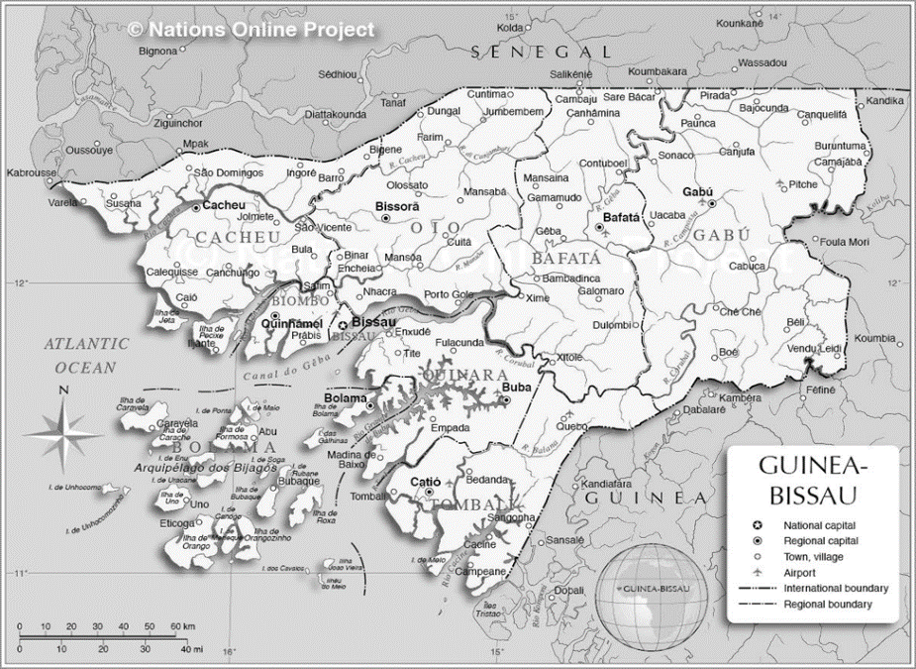
Varela-Cacheu
Mansoa-Buba-Cufada

The proposed project results framework is as following:

Output 1) Governance framework in place with adequate capacity at the national level. This would be achieved by the following activities:
1.1) Methodology for the development of a 2050 low-carbon development strategy established
1.2) Framework for society-wide dialogue on period NDC updates in place
1.3) NDC financing strategy is operationalized by elaborating an investment plan for one of the key NDC sectors

Output 2) MRV system enhanced in Guinea Bissau. This would be achieved by the following activities:
2.1) Database established and information quality improved in the energy and forest sectors
2.2) Technical support is provided to the national GHG inventory working group to enhance sustainability of the national system for GHG inventory
2.3) Solar and wind energy atlas developed
2.4) Forest inventory Elaborated

Output 3) Access to sustainable energy is strengthened for the local coastal community
3.1) Enhance livelihood of the vulnerable coastal community in the project areas through access to solar system
3.2) Decrease pression on natural resources in the coastal areas of the project through low carbon emission technologies

Output 4) Partnership and communication are strengthened
4.1) A international staff to enhance partnership, reporting and communication of the project
4.2) Communication and knowledge management on best practices and lessons learned from the project

1.3. Stakeholder Engagement - about 1 paragraph

The project will be implemented in collaboration with the Ministry of Environment and Biodiversity, the national focal point for the UNFCCC and in charge of the NDC revision and implementation coordination at national level. It will involve all the key sectoral partners such as the Ministry of Natural Resources and Energy, the Institute for Biodiversity and protected Areas, the Ministry of Agriculture and rural development (including Forest Department).
The project will also hire a Japanese Partnership and reporting Analyst (JPO or iUNV), who will develop partnerships with Japanese private companies, NGOs and/or academia to build collaboration. Besides, UNDP will seek partnership with JICA through the liaison office in Dakar to ensure synergies and collaboration in the different fields of interventions. Among the partnerships sought will be a provider of low-cost Japanese technology to provide solar energy and other related technology to implement activities under Output 3.
2. ANNUAL WORK PLAN BUDGET SHEET
Intended Outcome as stated in the UNDAF/Country [or Global/Regional] Programme Results and Resource Framework:
Outcome indicators as stated in the Country Programme [or Global/Regional] Results and Resources Framework, including baseline and targets:
Applicable Output(s) from the UNDP Strategic Plan: Enhance prevention and recovery for resilient society
Expected outputs | Output Indicators | Activities | Proposed budget (USD)
OUTPUT 1: Governance framework in place with adequate capacity at the national level | 1.1 # of methodology for the 2050 LEDS in Guinea Bissau is elaborated in a consultative way  1.2.1 # of national dialogue on whole of society approach for the NDC implementation is conducted  1.2,2 # of the climate change coordination mechanism in place that are strengthened  1.3 # of new suggested climate Governance Framework  1.4 # of investment plan elaborated | 1.1 Activity: Establish a methodology to prepare for the 2050 low carbon development strategy (LEDS) elaboration in Guinea Bissau | 50,000
 |  | 1.2 Activity: Conduct a national dialogue on whole of society approach for the NDC implementation with decision makers, parliamentarians, CSO, private sectors on NDC implementation | 100,000
 |  | 1.3 Activity: Suggest a new climate governance framework that can support and contribute to the revised NDC implementation | 70,000
 |  | 1.4 Activity: Operationalise NDC financing strategy through elaborating an investment plan for one of the key NDC sectors | 80,000
OUTPUT 2: MRV system enhanced in Guinea Bissau | 2.1 Quality of the data base assessed  2.2 # of capacity building programme implemented for the GHG inventory WG  2.3 #of renewable energy Atlas elaborated  2.4 # of Forest inventory elaborated | 2.1 Activity: Database established and information quality improved in the energy and forest sectors | 80,000
 |  | 2.2 Activity: training and capacity building to the GHG inventory working group (WG) in the framework of strengthening the national system for GHG inventory | 50,000
 |  | 2.3 Activity: Elaborate solar and wind energy Atlas | 200,000
 |  | 2.4 Activity: Conducting the Forest Inventory of Guinea Bissau | 200,000
OUTPUT 3: Access to sustainable energy is strengthened for the local coastal community of fishermen and women (pilot intervention) | 3.1 # of direct beneficiaries of the sustainable access to energy | 3.1) Enhance livelihood of the vulnerable coastal community in the project areas through access to solar system | 300,000
 | # of low carbon emission technology solutions provided | 3.2) Decrease pression on natural resources in the coastal areas of the project through low carbon emission technologies | 100,000
OUTPUT 4: Partnership and communication are strengthened |  | 4.1 Activity: A international staff to enhance partnership, reporting and communication of the project. | 85,000
 |  | 4.2 Activity: Communication and knowledge management on best practices and lessons learned from the project | 50,000
Direct Project Cost (5%) | Coordination fee for the Climate Promise global programme |  | 68,250
Subtotal 1 |  |  | 1,433,250
GMS (8%) |  |  | 114,660
Subtotal 2 |  |  | 1,547,910
UNRC Coordination Levy (1%) |  |  | 15,479
TOTAL |  |  | 1,563,389

https://www.worldbank.org/en/country/guineabissau/overview
https://data.un.org/en/iso/gw.html
The stocktake of the 1st NDC consulted in 2020 showed that this target was not achieved and that so far no support is expected to be provided to fill this gap.
Source: the stock take report was elaborated with the support of the “GLOBAL ALLIANCE AGAINST CLIMATE CHANGE-WEST AFRICA” PROJECT (AMCC + AO / GCCA + WA)
GMS should be computed by charging 8% against the total JSB programmable budget, and NOT against the total budget (cf. GMS calculator). For example, if the total budget is USD 1 million, GMS of the project will be USD 74,074 (being 8% against USD 925,926), not USD 80,000.
Use the levy calculator to calculate the amount of the levy correctly.

