Mainstreaming sustainable marine fisheries value chains into a Blue Economy for Targeted Large Marine Ecosystems

Concept Note

December 2021

CONTENTS
Overview 3
Key Issues to Address 5
GMC Phase I: Achievements and remaining challenges 6
GMC-I Context 7
GMC-I Achievements 8
Full-spectrum actions for expanding GMC-I achievements 9
Integrating the social and expanding the ecological dimensions into a Blue Economy 9
Proposed intervention for GMC second phase (GMC-II) 11
Objectives and Proposed Components 12
Participating countries 12
Preliminary target fisheries and supply chains 13
GMC-II Global Contribution 15
Linkages to the GEF Indicator Framework 16
Bibliography 18
ANNEX 1: Summary of Recommended Components, and preliminary Outcomes and Outputs 21
ANNEX 2: Preliminary Theory of Change 24

Mainstreaming sustainable marine fisheries value chains into a Blue Economy for Targeted Large Marine Ecosystems
A Concept Note

Overview
Currently, one-third of marine fish stocks are fished at biologically, ecologically, and socially unsustainable levels. Unless urgent action is taken, the increased global demands for seafood products in the coming decades will continue to drive more intensive extraction and undermine the foundation of resilient ecosystem services and the livelihoods upon which most of the world’s coastal communities depend for their present and future well-being.

Fishery improvement projects (FIPs) have proven to be effective for moving many of the world’s marine fishery value chains to more sustainable levels. They offer an adaptive governance framework for convening, educating and advising a broad range of supply chain stakeholders, including large retailers, restaurant chains, owners of fish brands, buyers, producers (fishers), as well as fisheries management and scientific institutions to improve fisheries practices and policies (SFP, 2017).

The recently completed Global Supply Chains for Marine Commodities (GMC-1) project demonstrated the value of engaging entire supply chains to drive sustainable fisheries, as well as the relevance of pre-competitive collaboration at different levels and the crucial importance of public-private partnerships to build trust for improving fisheries governance and addressing environmental challenges. The GMC-1 model, which focused on the core of the supply-demand of entire seafood value chains, embraced multiple stakeholders that coupled top-down market-driven incentives, such as fostering international market demand of sustainable seafood products, with a bottom-up approach to increase the availability of sustainable seafood products in the marketplace that were mainstreamed into industry-led Fishery Improvement Project (FIPs) and government-led Governance Platforms. An external and independent Terminal Evaluation (TE) assessed the effectiveness of GMC-1 and found that the project achieved some impressive numbers, with 15 of its 16 indicators achieved (nine of which were even exceeded) and was rated as being Highly Satisfactory. The overall Sustainability of the project was rated as being Likely to be Sustained and the TE recommended the model to be replicated in new fisheries within the original partner countries, refine and scale-up the model, and test it in other countries and a diverse range of fisheries and markets. However, the TE pointed out that many challenges remain for covering a broader range of sustainability niches that expand several ecological and environmental concerns by placing greater attention on reducing bycatch of CITES Red-listed species and destruction of ecologically important bottom habitats, as well addressing ethical aspects (Robinson et al. 2021) related to gender equality and human/labor rights. This is not surprising, because sustainability is an imperfectly defined moving target that requires periodic improvements.

Finally, the TE found that the GMC-1 not only provided evidence of that the model was effective, but it also served to develop a number of important lessons to refine the GMC model in order to adapt and expand its impact to new, highly diverse and complex fisheries. Amongst them, the model needs to: a) place greater focus on the social dimensions of fisheries sustainability (food security, labor and human rights, gender equality, livelihood and economic security) and “Life Above Water” targets, as well as b) create new market-based tools adapted to the nuanced complexities of fisheries targeting supply chains with lack of interest in sustainability.

The Concept Note presented herein outlines an approach for a new project (GMC-II) that builds upon the original GMC model. It aims to integrate and mainstream specific social aspects of sustainability (gender equality, human rights, reduced bycatch of ETP species) in support of emerging Blue Economies in Asia, Africa and Latin America. Four Immediate Objectives will help guide the project to its overall objectives: i) Increase global demand for sustainable marine commodities supply chains that contribute to social and ecosystem resilience; ii) Develop and execute co-management platforms linked to the policy level.; iii) Develop and implement replicable fisheries improvement projects (FIP) based on effective social and ecological practices that drive sustainable fisheries within Blue Economies of target countries; iv) Develop integrated monitoring, evaluation and knowledge/learning platforms for measuring the effectiveness of GMC and disseminate good practices within and outside Blue Economies of target countries.
The project entails three Components:
1. Demand for Sustainable Products;
2. Promote the Supply of Sustainable Products;
3. Knowledge management.
The project will work with two types of supply chains:
- Export-oriented. These supply chains generate seafood products that have a consistent demand in international markets.
- Non-export oriented. These supply chains deliver seafood products to domestic markets such as fresh seafood sold to hotels, in local markets, salted-dried fish or frozen fillets. The basis of these supply chains are artisanal and small-scale fishers.
GMC II would yield the following triple line development impacts:
GEF Core Indicator |  |  | Where
2 | Marine protected areas under improved management for conservation and sustainable use | >1 million ha | Indonesia, Philippines, Mauritania
5 | Area of marine habitat under improved practices to benefit biodiversity (excluding MPAs) | >2 million ha | Indonesia, Philippines, Mauritania, Morocco, Senegal
7 | Number of shared water ecosystems under new or improved cooperative management | 5 | Pacific-Central American Coastal, Humboldt, Canary, Sulu-Celebes Sea &Indonesia Sea (together, part of the Coral Triangle),
8 | Globally over-exploited fisheries moved to more sustainable levels | 1,032,482 Metric Tons | Includes large and small pelagics, as well as reduced bycatch of CITES fish/shark species
11 | Number of direct beneficiaries disaggregated by gender as co-benefitting from the GEF investment | 2.5 million | Includes disaggregated gender and human/labor rights targets

Given its ambitious nature, GMC II requires a major multilateral, multilevel and intersectoral effort and will entail a series of specific goals like eliminating illegal, unreported, and unregulated (IUU) fishing and fisheries subsidies, as well as mainstreaming gender equality and human/labor rights, reduced bycatch of ecologically important of non-target or internationally protected species in selected seafood value chains.

Key Issues to Address
Although sustainably managed marine capture fisheries contribute significantly to the provision of food and nutrition security, livelihoods, cultures, subsistence, employment and biodiversity resilience, it is unlikely that countries will meet Target 14.4 of Sustainable Development Goal 14 by 2030 unless good practices are diversified and scaled up.

Despite important advances in improving fisheries management worldwide, the percentage of fish stocks considered to be biologically sustainable levels have declined continuously since 1974, while seafood demands and prices have continuously risen since the 1990s. Both trends are likely to continue during the following decade, given that the expected increases in the world’s population, their improved purchasing power and increased per capita fish consumption . Future seafood price increases unsustainable exploitation of marine stocks, which in turn will reduce poor and vulnerable seafood consumers’ access to seafood, which will threaten food security in those developing economies that depend on seafood as a basic staple food. This will further exacerbate poverty and make the poor more vulnerable to labor rights violations and susceptible to human rights violations at sea (Figure 1).

Skyrocketing market demands are driving unsustainable practices in the race to maximize profits. This often undermines ecosystem resilience and increases the exploitation of seafood industry workers, where human right abuses, unfair wages and violations of other aspects of labour rights, such as women’s rights to access equal opportunities and decision making within fisheries supply chains are amongst the most urgent issues that need to be addressed by the seafood industry. While social issues have attracted increasingly greater attention by media and NGOs, they have mainly been limited to an activist-campaigning approach. Therefore, solution-oriented approaches to these issues need to focus on addressing the weaknesses in operational definitions, the gaps in information systems available for decision making by suppliers and buyers (e.g., through purchasing policies) and the lack of attention to social and economic aspects within fisheries management.

Figure 1: Effect of growing seafood demand on marine fisheries and biodiversity and poverty (modified from Ryan 2021).

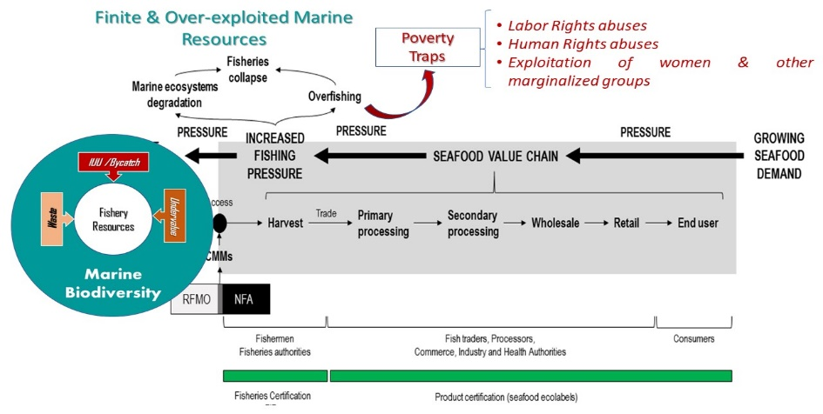

While sustainable fisheries management should theoretically include the three dimensions of sustainable development (social, economic and environmental), measurements of sustainability in fisheries have been limited to a small set of biological and economic considerations over that past four decades, paying little, if any attention to the cultural, institutional, and ethical aspects of the social dimensions of fisheries. Promises to develop and implement full-spectrum fisheries management systems that integrate the social dimension have also fallen short of their mark. As a result, sustainable fishery certifications have largely focused on the environmental and economic dimensions, while excluding social considerations. Finally, most certifications related to the environmental dimension have focused on improving the health of single-species stocks, while often turning a blind eye to the bycatch of ecologically important species, as well as others listed in the CITES Appendices. This low attention to the impacts of the fishery in the ecosystems is disrupting migratory routes that are essential for completing life cycles of recruits into annual fisheries, destroying ecologically important bottom habitats, as well as other biologically and ecologically important requirements for maintaining resilient marine food webs.

GMC Phase I: Achievements and remaining challenges

During the past decades, the Sustainable Seafood Movement has used market forces to promote improvements in fisheries sustainability. The basic theory of change of the Sustainable Seafood Movement is that with the provision of a market signal (e.g., market access), fishers and processors will be incentivised to adopt sustainable practices. Along this line, the tools for market transformation have proven to be very effective. Instruments include (i) eco-labelling and rating systems, (ii) buyers’ roundtables, (iii) responsible seafood procurement policies, and (iv) information and education to processors, retailers, and consumers.

While fisheries certification and ecolabelling have been a centrepiece of market transformation, it is increasingly recognised that a more comprehensive approach is needed to include (i) a deeper transformation along the production chain to address gender equality, meeting international agreements on human/labor rights and reducing bycatch, (ii) implementation of well-enforced policies and regulations for fisheries management, and (iii) ensuring access to safe and affordable produce for human nutrition.

GMC-I Context

The UNDP-GEF’s recently completed Global Supply Chains for Marine Commodities (GMC) project demonstrated how transparent multi-stakeholder dialogue roundtables or Platforms, coupled with emerging tools such as corporate sustainable purchasing policies and fishery improvement projects (FIPs), can lead to a shared vision and agenda for long-term action and investment on sustainable commodity production by public and private actors, thereby driving changes in national fisheries policy and governance of small-scale and industrial fisheries.

GMC-I promoted a multistakeholder dialogue process leading to a shared commitment for sustainably managing large pelagics, small pelagics, octopus and blue swimming crab along marine commodity value chains (from fishery harvests to end users) in Indonesia, Philippines, Ecuador, and Costa Rica. The GMC-1 model was based on the premise that successful fisheries management must go beyond evidence-based science and enforcement instruments to address inadequate conservation and management measures by incorporating effective governance processes that promote respect for rules and catch control measures that are essential for driving sustainable fishery management. It coupled a top-down market-driven incentive (approach) for building international market demands to "pull" the supply of sustainable seafood products, with a bottom-up approach to build sustainable seafood commodity supply chains focusing on Fishery Improvement Project (FIPs). The entire process is built around an interactive governance platform, which facilitates multi-level stakeholder dialogue that is centered on formulating and implementing actions to improve fisheries management throughout the value chain. Nonetheless, GMC-1 recognized that global fisheries are diverse and there is no simple rule book that can detail context-specific governance details.
The UNDP and Sustainable Fisheries Partnership (SFP) developed tools for engaging stakeholders into the sustainable use of diverse seafood commodities along seafood value chains (Figure 2), including polycentric governance Platforms, which led government authorities to adopt new legal frameworks (fishery management  and action plans) and policies. By assisting national seafood producers to access markets that demand sustainable seafood, they not only helped formulate | 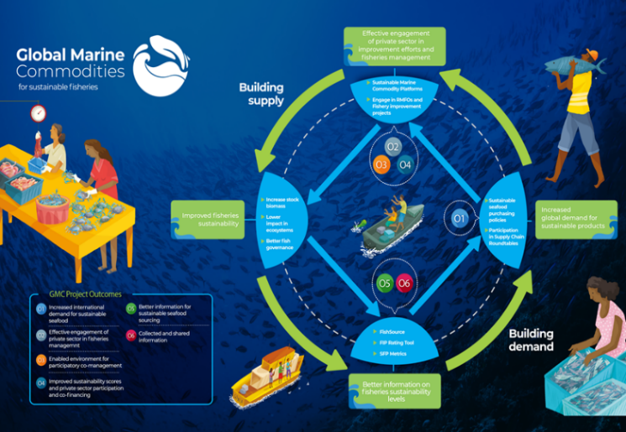  Figure 2: GMC-I sustainable marine commodity supply chain model overview.
and organize industry associations into FIPs, but fishery authorities also took concrete actions to institutionalize the governance platforms and adopt inclusive fishery co-management approaches. Increased demand for sustainable seafood products motivates positive changes along the value chain, like fisheries and product certifications or improved stock management.

GMC-I Achievements

Significant progress was made in promoting gender within Project activities and exchanging lessons learned in relation to the Sustainable Marine Commodity Platforms to promote multi-stakeholder fishery governance and the often-private sector led fishery improvement projects (FIPs) that can be scaled up to new countries and regions. These actions contribute to secured natural capital and improved social and economic performance for fishery supply chains. In terms of other quantitative results, the GMC achieved some impressive numbers (Figure 3) in which 15 of its 16 indicators were achieved, and nine of which were exceeded. Qualitative results were generated under Outcome 5, which resulted in Reliable and verifiable information being made available and used by stakeholders for decision making and engagement in FIPs, and Outcome 6, which resulted in better knowledge management for mainstreaming sustainability into seafood value chains.

Figure 3: Summary of the GMC-1 results
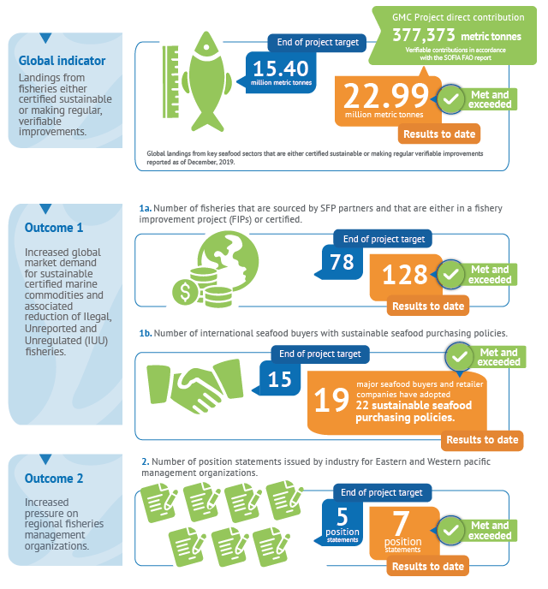 | 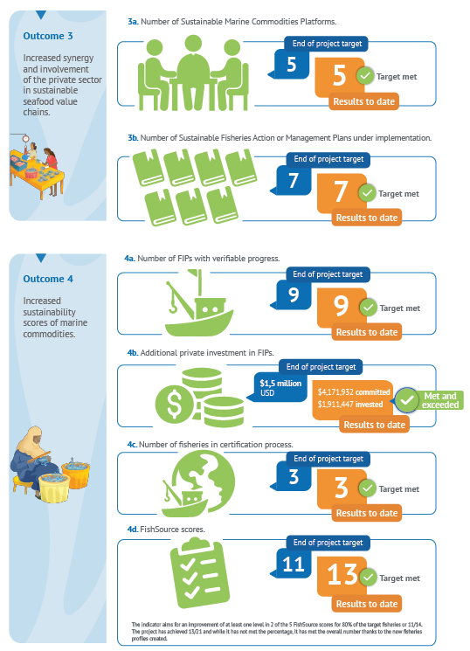
The evidence strongly indicates that the positive results will continue, and the TE highlighted that Sustainability of the GMC is rated as Likely, because there is a large upswing in private sector and even artisanal fisher investments in the FIPs in most countries. The Philippines, Indonesia, and Ecuador have some remarkable results that have increasingly gained support through external funding of badly needed scientific data, monitoring, among other investments (see Figure 3). The Blue Swimming Crab (BSC) and Octopus are now gaining support from the governments and the results

Full-spectrum actions for expanding GMC-I achievements

Although the recent external Terminal Evaluation (TE) rated the GMC-I as being highly satisfactory and recommended the model to be replicated in other fisheries of some of the original partner countries, scaled-up and tested in other countries and fisheries, the TE highlighted several lessons and recommendations that could further strengthen the GMC-I model, because the financial resources were lacking to address several key social and ecological aspects. For example, seafood value chain certifications are not limited to SDG 14 (Life Below the Water) because they deal with entire supply chains that are mainly above the water. While seafood sustainability standards primarily focus on environmental performance criteria, they are less concerned with social performance issues such as gender equality and the welfare of seafood value chain workers who produce and process the seafood. Many of these workers are reportedly being subject to slavery, human trafficking and other human rights violations.

Integrating the social and expanding the ecological dimensions into a Blue Economy

A sustainable fishery has been defined as one that respects the ecological integrity of the ocean and its resources; that is ethical, responsibly governed, economically viable and technologically appropriate; supports communities and draws on local culture, heritage, and diverse knowledge systems; and enhances health, wellbeing and the public good. Although SFP, UNDP and many of the project partners recognized that GMC-I effectively achieved sustainability certifications for single species FIP interventions by focusing on restoring and maintaining economically valuable species stocks, its modest budget limited the ability to address gender equality, and other critical issues. Interesting, the GMC-I project has formulated a strategy for multi-species fisheries (small pelagics) to initiate a process of management improvement resulted in stock recovery. The latter intervention is key as food security in developing countries is mostly based on small pelagic consumption. While the project developed a gender equality strategy around its mid-point, fishing communities and indigenous rights-holders raised concerns about human and labor rights.

The Blue Economy (BE) metaphor is theoretically at the core of the most recent sustainable oceans paradigm, for confronting many of the ecological and social problems that are reducing the resilience of the world’s oceans. While many countries have uncritically appropriated the BE metaphor to support their cause by shaping policies, development initiatives, governance practices or conservation programs, most efforts have resulted in little more than good intentions, instead of measurable changes in unsustainable practices. Fisheries are an important aspect of the BE, but adopting the conceptual framework demands concrete objectives and robust outcomes capable of measuring the desired changes in the target fisheries to be included in GMC-2. This will also require a forward-looking, full-spectrum definition of sustainable fisheries that identifies the linkages between the three dimensions of sustainability along the different links of marine commodity supply chains.

Finally, it will demand new forms of economic and social behaviour that build, rather than uncouple the bio-ecological process dynamics that are important drivers of resilient fisheries, while facilitating new equitable, long-term benefits for the ocean and the people who depend on its multiple ecosystem services. Figure 4 expands on the sustainable value chains model developed by GMC-I, by incorporating some additional parameters that are vital for ensuring ecological sustainability of the fishery and meeting basic social conditions that most of the world’s countries have ascribed to under the Universal Declaration of Human Rights, among other international agreements. The figure also provides a more holistic framework that can help guide sustainable seafood advocates to achieve a Triple Bottom-Line pathway to meet the multiple, inter-connected aspects of the Sustainable Development Goals (SDGs).
There is no sustainable Blue Economy without social equity, ecological resilience, and circular economic objectives
Sustainable, Blue economic development is at the heart of addressing many of the ecological and social problems linked to the ocean, and consequently, it requires a drastic change for ensuring an ecologically viable, socially and stakeholder-inclusive use of the services that ocean ecosystems produce for the islands. However, the blue economy term has been used without distinction by various actors who frequently perceive environmental problems differently and also propose solutions that could be contradictory. While the blue economy discourse is used by various perspectives of the ocean problems for Small Islands Developing States (SIDS), it the blue economy concept is “far from the stable development concept that it promises to be” (Childs and Hicks 2019). Consequently, the approach recommended herein for a second GMC addresses the strong need to: i) align national priorities that mainstream social equity and ecological reliance into seafood commodity value chains to achieve a triple-bottom line Blue Economic Framework; and ii) put in place an integrated and real time M&E platform with measurable SMART outcomes to provide empirical evidence for polycentric governance processes to embark on full spectrum value chain sustainability.

It departs from where GMC ended by including some key aspects of the environmental dimension that go beyond sustainable fishery stocks by introducing several important aspects (reduced bycatch, overfishing of spawning aggregations, habitat destruction by unsustainable fishing gear).

It also aims to incorporate explicit social parameters like gender equality, human and labor rights, and indigenous rights, as well as the right to resilient ecosystem services (UNHRC 2019), which is in line with the GEF’s “Healthy Planet, Healthy People” framework which explicitly recognizes the interdependency between human well-being and a healthy environment (GEF-8 2021). Furthermore, the full enjoyment of human rights, including the rights to life, health, food, and water all depend on the services provided by ecosystems. The provision of ecosystem services depends on healthy and resilient ecosystems, which in turn depend on biodiversity. Consequently, it is becoming increasingly urgent for fishery managers, policy makers and seafood buyers to examine ways to broaden the scope of existing sustainable seafood standards of certification and market rating systems. Noteworthy parameters that should be included within the “Healthy Planet, Healthy People” framework include biodiversity resilience-building, waste reduction through circular economic strategies, and a strong emphasis on human rights
and gender equality that are inherent in each of the SDGs (https://sdg.humanrights.dk/). Although integrating the social dimension by including a human rights-based approach (HRBA) with sustainable fisheries and aquaculture value chains represents a formidable challenge, it will contribute to expanding the context of sustainable development outcomes and in this way is in line with the UN Statement of Common Understanding. | Figure 4: Overview of Full Spectrum sustainable marine commodity supply chain refined model
 | 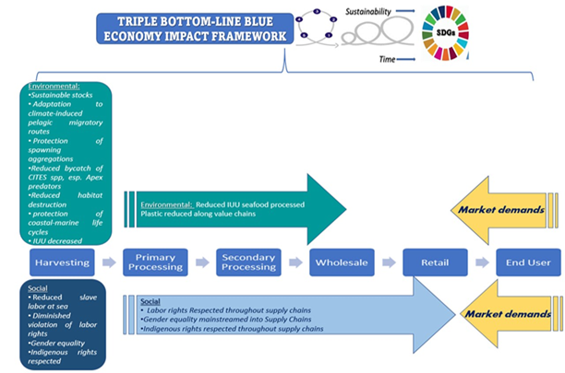

Proposed intervention for GMC second phase (GMC-II)

The diversity of good FIP practices and lessons of export-oriented industrial and artisanal fisheries in Costa Rica, Ecuador, Philippines, and Indonesia provide a solid foundation upon which to further expand the good examples into a second phase of the project. GMC-II aims to improve the performance of social and environmental sustainability, including improved livelihood benefits of key fisheries in five Large Marine Ecosystems (LMEs). It is foreseen that the project will contribute to advance sustainable fishery management objectives within the corresponding Strategic Action Programmes (SAPs),with a primary focus on Export-oriented commodities, but also considering Non-export-oriented markets:
- Export-oriented markets. These supply chains generate seafood products that have a consistent demand in international markets. Examples include fishmeal from reduction fisheries or fillets from large pelagic fish like mahimahi, swordfish or tuna. In this case, GMC tools can contribute to mainstreaming sustainability along the supply chain. A main area of work will be to adapt FIPs to the realities and complex dynamics of small-scale fisheries and to develop tools to facilitate their engagement in improvement projects.
- Non-export-oriented markets. These supply chains deliver seafood products to domestic markets such as fresh seafood sold to hotels, in local markets, salted-dried fish or frozen fillets. The basis of these supply chains are artisanal and small-scale fishers. The proposed work includes actions like developing (i) national buyers’ engagement programmes, (ii) domestic buyers’ roundtables and (iii) stakeholder platforms to improve fisheries management and governance. A main area of work will be to adapt the FIP concept to the characteristics of these fisheries and to remove barriers for market recognition of sustainable practices and fisheries improvements in domestic markets.

Objectives and Proposed Components

The overall objective of GMC-II is to mainstream gender equality, human rights and reduced bycatch in sustainable seafood value chains for Blue Economies in Asia, Africa and Latin America.

Four Immediate Objectives will help guide the project to its overall objectives:

- IO #1: Increase global demand for sustainable marine commodities supply chains that contribute to social and ecosystem resilience-
- IO #2: Develop and execute co-management platforms linked to the policy level.; -
- IO #3: Develop and implement replicable fisheries improvement projects (FIP) based on effective social and ecological practices that drive sustainable fisheries in target countries.
- IO #3: Develop integrated monitoring, evaluation and knowledge/learning platforms for measuring the effectiveness of GMC and disseminate good practices within and outside of target countries.
GMC-II would be built upon three Components;
1. Demand for Sustainable Products by developing and mainstreaming both new, and international labor standards, mainstreaming gender equity and biodiversity resilience-building criteria to guide buyers and increase market demands from private seafood companies;
2. Promote the Supply of Sustainable Products that include industry-led FIPs, government-led co-management platforms;
3. Knowledge management based on an integrated M&E and Learning platform for that systematically captures lessons from the implementation of gender, human/labor rights and bycatch resilience-building strategies through integrated monitoring, evaluation and knowledge/learning platforms that disseminate good practices within and outside of target country Blue Economies.
The three components and preliminary SMART outcomes are shown in in Annex 1 provides greater details that are presented in the GEF-PIF format. Annex 2 provides a preliminary Theory of Change framework, albeit without assumptions, as these must be developed for each country.

Participating countries

Phase II will need to include new fisheries in those countries who demonstrated their commitment to the GMC model through their actions in targeted FIPs. This would include Indonesia, Philippines and Ecuador, as the FIPs in those countries demonstrated commendable political will for taking the necessary actions to mobilize seafood markets during GMC-I, and the private sector in those countries was committed to invest and sustain the GMC model through transparent dialogue though proactive horizontal and vertical communication, as well as improving trust. These experiences and applied knowledge will help to enhance the effectiveness of new countries to select and implement new FIPs.

It also aims to expand the GMC-I work in the Equatorial (Ecuador) and Celebes-Sulu Sea and Indonesia Sea LMEs (Indonesia and Philippines) to include countries in the Canary Current LME (Morocco, Mauritania, Senegal), Pacific-Central America and Humboldt LMEs (Ecuador, Honduras, Panama, El Salvador and Guatemala). As GMC-II will work with several countries, it should be considered an 84-month Project comprised of three sub projects (Asia, Africa, Americas). The reason for having a 6-year project implementation period is necessary because GMC-I demonstrated that after 4-years, some fisheries are only now beginning to move toward reaching sustainable levels, creating the necessary public-private alliances and corresponding management plans. A ProDoc should be developed to link this approach with the preliminarily proposed components described in the next subsection.

Preliminary target fisheries and supply chains

Although GMC-I marked the first effort to adapt to the seafood industry the tools used by UNDP´s Commodities Programme in agri-businesses, one of the important lessons generated in the national platforms and the targeted seafood supply chains was the importance of monitoring evaluating the overall effectiveness and sustainability of the initial interventions. The second GMC phase aims to build upon, and expand the scope of the monitoring, evaluation and adaptive learning process as a capacity-building platform that aims to share peer-to-peer experiences, lessons and good practices related to gender and human/labor rights and reduced bycatch mainstreaming into national and regional plans, strategies and policies. It also is designed to provide real-time feedback on the effectiveness of further expanding successful FIPs within GMC-I countries and new target fishing nations, while testing the effectiveness of new tools to address the challenges that could not be addressed in the previous phase.

It would also explore new mechanisms that motivate the demand for sustainable seafood produce in non-export-oriented supply chains in developing economies based on a fish-for-food approach. The project will focus on 15 fisheries distributed in 9 countries that are part of 5 LMEs, covering a total volume of more than 3,5 million metric tons of fish (see Figure 5). Preliminary target fisheries and supply chains and their outcomes are summarized in Figure 6. | Figure 5: Distribution of Sustianable seafood Volume in target countries and LMEs.
 | 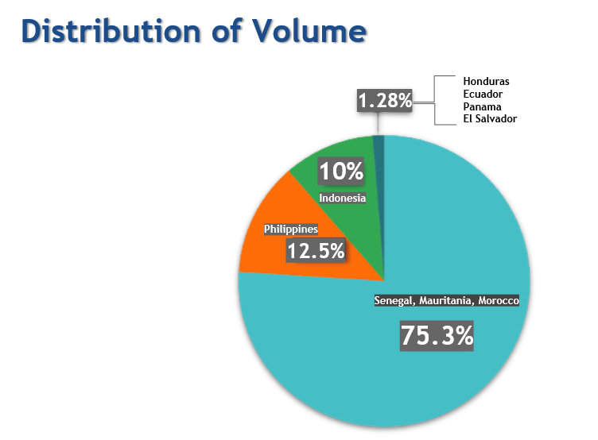
Figure 6: Summary of GMC-II’s target fisheries.
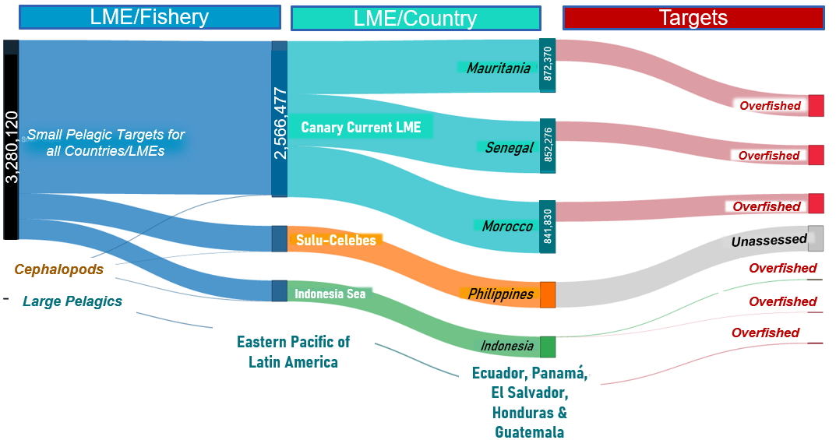
Interventions by the GMC- II project include the following:
- Sustainable value chain certifications for octopus and small pelagic fish for the Philippines and Indonesia.This includes small-scale fishers that supply local markets for direct consumption or processing and industrial fisheries that supply canneries and fish meal and fish oil processing.
- Sustainable value chain certifications for small pelagic fish in Mauritania, Morocco and Senegal. The small pelagic fish resources are shared stocks that migrate from Morocco to Guinea and are exploited by industrial fisheries for fishmeal and fish oil production for export and by diverse artisanal gears for direct human consumption in local markets.
- Sustainable value chains certifications for Common octopus (Octopus vulgaris) in Mauritania and Senegal. Octopus is a highly valuable resource, captured by artisanal fisheries, that is exported primarily to the European Union (mainly Spain and Italy).
- Sustainable value chain certifications for artisanal longline large pelagic fish in El Salvador, Guatemala, Honduras, Panama, Colombia, and Ecuador. These fisheries capture mahimahi (Coryphaena hippurus), yellowfin tuna (Thunnus albacares), billfishes and sharks sold in domestic and export markets. Note that these countries expect to form part of the GEF-funded PACA initiative (https://www.thegef.org/news/gef-announces-new-investment-central-americas-blue-economy) and the UK-funded Eastern Tropical Pacific Marine Corridor (https://blog.nationalgeographic.org/2021/11/02/cop26-colombia-costa-rica-ecuador-and-panama-announce-new-protections-for-ocean-highway/), both of which could benefit considerably from the sustainable seafood value chain certifications proposed under GMC-II.
- Reduced Appendix II Bycatch in Large Pelagics Fishery for Eastern Pacific of Latin America (2 LMEs). Sharks are among the most vulnerable species to overfishing due to their biological characteristics and slow population growth rates make them inherently less able to cope with heavy fishing pressure than many of the other fish species with which they are caught. As a result, they are easily overexploited, and once depleted, their populations are slow to recover. Oceanic pelagic sharks, which are the main shark species caught in IATTC fisheries, are particularly at risk, with 63% of assessed species considered threatened. They are intentionally targeted, as well as taken incidentally as bycatch and recently tons of Appendix II shark fins from Ecuador, Costa Rica and Colombia have been confiscated in fish markets in Hong Kong. They are key species caught in IATTC fisheries and represented over 15% of all reported catches by weight in 2010. GMC II should assess and implement techniques that will reduce the mortality of incidentally captured sharks and avoid fishing for CITES Appendix 2 species.
- Other reductions in CITES Red-Listed bycatch species and destruction of bottom habitats. Indonesia has expressed interest in including several CITES species captured in their octopus and small pelagic fisheries, as has the Philippines. More sustainable practices in the Canary Current will result in greater protection of bottom habitats and MPAs, especially in Mauritania.
- 25% fishing vessels violating human and labor rights shifted to alternative and sustainable fishing practices in targeted fisheries. The seafood supply chain is highly fragmented with the majority of the workers employed as subcontractors or through brokers making it hard to determine the sources of seafood. While the GMC-I helped raise awareness to gender equality and women's empowerment through its communication and information systems, the overall contribution was also limited, and the Terminal Evaluation recommended mainstreaming gender equality and respect for human/labor rights as cross-cutting issues to the extent possible in all of the targeted seafood value chains, whether through analytical tools or taking actions that result in measurable outcomes. The Danish Institute for Human Right’s developed the Sector-Wide Impact Assessment approach (DHRI 2019) that provides an excellent screening tool for identifying human/labor rights and gender inequality issues in the fishery sector in Bangladesh (COAST Trust et al. 2021) and Chile. A sectoral view will help stakeholders see the “bigger picture” of potential negative impacts of a sector’s activities, as well as potential opportunities for positive human rights outcomes, and to make choices based on this broader perspective

GMC-II Global Contribution

All UN member states adopted the 2030 Agenda for Sustainable Development, including the 17 Sustainable Development Goals (SDGs) and 169 targets as part of a universal call to action to end poverty, protect the planet and improve the lives and prospects of everyone, everywhere. Many of the SDGs are directly or indirectly pertinent to the sustainability of the fisheries and aquaculture sector. The 2030 Agenda is integrated and indivisible in its aim to balance the three main dimensions of sustainable development – economic, social and environmental. It also explicitly states that the SDGs seek to realize the human rights of all , and therefore it is grounded in human rights.

The GMC-II will increase the number of fisheries that incorporate sustainability considerations. In addition, it will contribute to advancements towards SDG 14 (target 14.4) as well as SDG 2 by facilitating access to seafood in selected domestic markets; SDG 5 (targets 5.1, 5.5, 5c.1) by promoting equal participation of women and men in decision making and through strengthening or building information systems on gender equality in fisheries value chains; SDG 17.4.1 by increasing synergy and participation of selected national and international actors in fisheries value chains, through strengthening governance for planning improvements towards sustainable policies and practices.

Linkages to the GEF Indicator Framework

GMC-II will also be developed around GEF Core Indicators related to Healthy Global Oceans. It would address five Core indicators (see Figure 7):

Figure 7: Summary of GMC-II’s GEF Core Indicator targets
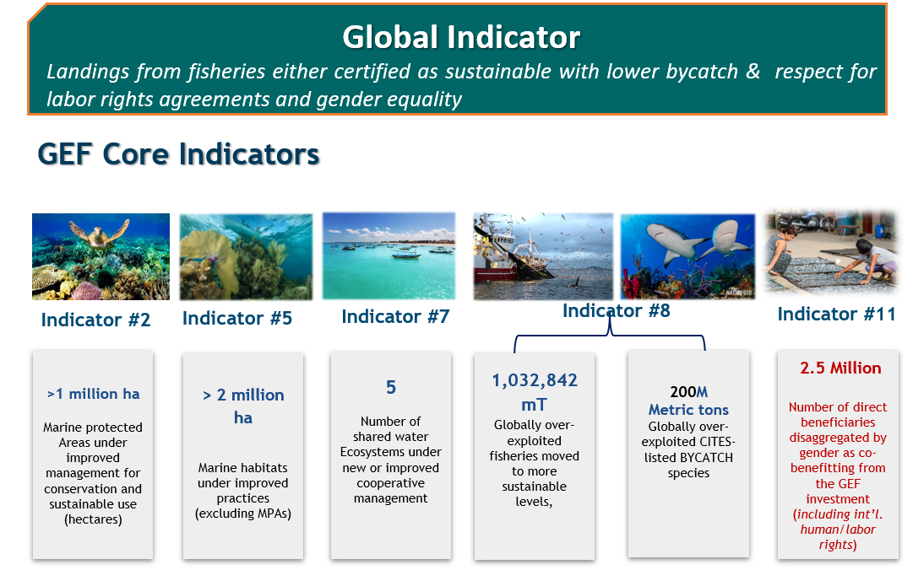

- Core Indicator #2 – the project provides sustainable fishing for small pelagics in Mauritania’s 540,000 hectare Banc d’Arguin (Trégarot et al. 2020) and over 500,000 hectares of Marine Protected Areas within the Indonesian and Philippine marine water falling within the Coral Triangle, as this will contribute toward more sustainable use as large segments of fish and invertebrate populations are able to complete their life cycles to become reproductively active individuals;
- Core Indicator #5 - 2million hectares of marine habitat under improved practices due to elimination of destructive shrimp bottom trawling in shallow coastal habitats in Honduras;
- Core Indicator #8 - restoring approximately 1 million metric tons of globally over-exploited fisheries and the number of fisheries moved to more sustainable levels. It also aims to reduce bycatch of CITES Appendix II species by 200 metric tons, while expanding gender equality throughout seafood commodity value chains.
- Core Indicator #11 - 2.5 million direct beneficiaries disaggregated by gender as co-benefitting from the GEF investment. This not only includes disaggregated gender and human/labor rights targets. Figure 8 summarizes some key baseline data for each country based on empirical data cited in the corresponding footnotes.

Figure 8: Summary of GMC-II’s baselines for Core Indicator #11 targets.
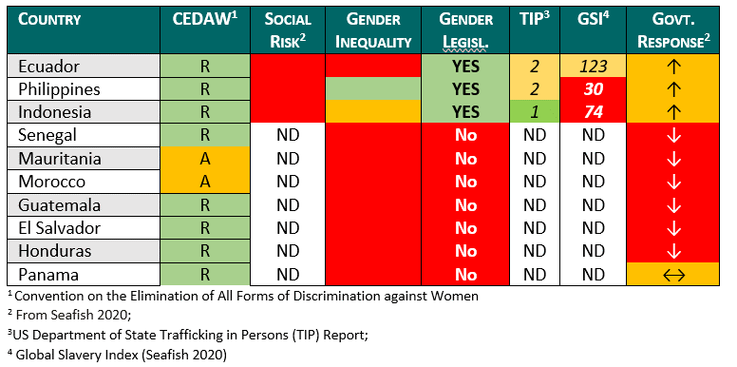
Achieving each target will require innovative market instruments that could put pressure on both the capture sector, as well all above-water parties involved to improve sustainability on marine commodity value chains, and especially to reduce Bycatch. However, the issue of certification is not the ultimate goal of the proposed project, because not all fisheries can achieve it. Further, while these issues should eventually be integrated into certifications, they should also be ensured in those processes of improvement of practices (e.g., within those FIP frameworks may not necessarily lead to certification) and especially to build such a focus on the artisanal fishing subsector).

The proposed budget is summarized in the Table below:

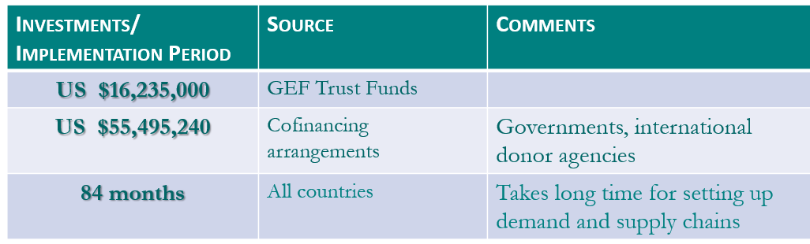

Bibliography

Angel, E., Edwards, D. N., Hawkshaw, S., Wor, C., & Parlee, C. E. (2019). An indicator framework to support comprehensive approaches to sustainable. Ecology and Society, 24(4).
Bailey, M. 2019. What Is the Role of the Market in Contemporary Fisheries Governance? Pages 344-348 in The Future of Ocean Governance and Capacity Development Brill | Nijhoff.
Barnett, W., Matson, P., Novy-Hildesley, J., Mason, J.G. & A.F. Springer. 2016. Global Fisheries: The Emergence of a Sustainable Seafood Movement. Stanford Graduate School of Business. Case Study SI141. Stanford University: 25 pp.
Belton, B., Reardon, T. & Zilberman, D. (2020). Sustainable commoditization of seafood. Nature Sustainability, 3(9), 677-684.
Bennett, A., Basurto, X., Virdin, J., Lin, X., Betances, S. J., Smith, M. D., Allison, E.H., Best, B.A., Browell, K.D., Campbell, L.M., Golden, C.D., Havice, E., Hicks, C.C., Jacques, P.J., Kleisner, K., Lindquist, N., Lobo, R., Murray, G.D., Nowlin, M., Patil, P.G., Rader, D.N., Roady, S.E., Thilsted, S.H. & Zoubek, S. (2021). Recognize fish as food in policy discourse and development funding. Ambio, 50(5), 981-989.
Bennett, A., Patil, P., Kleisner, K., Rader, D., Virdin, J., & Basurto, X. (2018). Contribution of Fisheries to Food and Nutrition Security: Current Knowledge, Policy, and Research. NI Report 18-02. Duke University, Durham, NC, USA: 45 pp.
CFFA (2020). Sustainable Fisheries Partnership Agreement negotiations between the EU and Mauritania: staying on course. Coalition for Fair Fisheries Arrangements (https://www.cffacape.org/publications-blog/sustainable-fisheries-partnership-agreement-negotiations-between-the-eu-and-mauritania-staying-on-course).
Cortés, E., et al. 2012. Expanded ecological risk assessment of pelagic sharks caught in Atlantic pelagic longline fisheries. SCRS/2012/167
Crona, B., Wassénius, E., Troell, M., Barclay, K., Mallory, T., Fabinyi, M., Zhang, W., Lam, V.W.Y., Cao, L., Henriksson, P.J.G. & H. Eriksson. 2020. China at a Crossroads: An Analysis of China's Changing Seafood Production and Consumption. One Earth 3(1): 32-44.06
COAST Trust, BILS and Manusher Jonno Foundation (2021). Sector-wide Human Rights Impact Assessment (SWIA) in small-scale artisanal fishing communities in Barguna and Cox’s Bazar district of Bangladesh. With support from the Danish Institute for Human Rights. 45. Pg.
Danish institute for Human Rights (2019). Sector Wide Impact Assessment Tool. https://www.humanrights.dk/sector-wide-impact-assessments-swia
de Jong, B. 2019. World Seafood Map 2019. Value Growth in the Global Seafood Trade Continues. April 2019. Rabo Research Food & Agribusiness. Rabobank. Utrecht, The Netherlands. https://research.rabobank.com/far/en/sectors/animal-protein/world-seafood-trade-map.html
de Jong, B. 2017. The Dragon’s changing appetite. China’s changing net trade position in seafood and implications. Rabobank. Utrecht, The Netherlands: 30 pp.
FAO. 2000. Fishery statistics. Capture production. Vol.90/1. FAO Statistics Series 166. Food and Agriculture Organization of the United Nations (FAO). Rome, Italy: 617 pp.
FAO. 2018. FAO Yearbook. Fishery and Aquaculture Statistics 2018. Food and Agriculture Organization of the United Nations (FAO). Rome, Italy: 82 pp.
FAO. 2020. The State of World Fisheries and Aquaculture 2020. Sustainability in action. Food and Agriculture Organization of the United Nations (FAO). Rome, Italy: 206 pp.
Foley, P., Pinkerton, E., Wiber, M. G., & Stephenson, R. L. (2020). Full-spectrum sustainability : an alternative to fisheries management. Ecology and Society, 25(2).
Guillen, J., Natale, F., Carvalho, N., Casey, J., Hofherr, J., Druon, J. N., Fiore, G., Gibin, M., Zansi, A. & J.T. Martinsohn. 2019. Global seafood consumption footprint. Ambio 48(2): 111-122.
ICCAT Task 1 data on nominal annual catches. Total nominal shark catches for 2010: 98 428 T.
Jackson, J. B. C., Kirby, M. X., Berger, W. H., Bjorndal, K. A., Botsford, L. W., Bourque, B. J., … Warner, R. R. (2001). Historical Overfishing and the Recent Collapse of Coastal Ecosystems. 293(July), 629–638.
Kallander, I. 2008. Participatory Guarantee Systems – PGS. Swedish Society for Nature Conservation. Stockholm, Sweden: 25 pp.
Kitchell, J. F., Essington, T. E., Boggs, C. H., Schindler, D. E., & Walters, C. J. (2002). The role of sharks and longline fisheries in a pelagic ecosystem of the Central Pacific. Ecosystems, 5(2), 202–216. https://doi.org/10.1007/s10021-001-0065-5
Lidström, S., & Johnson, A. F. (2019). Ecosystem ‐ based fisheries management: A perspective on the critique and development of the concept. GHOTI, (September), 1–7. https://doi.org/10.1111/faf.12418
Loconto, A. & M. Hatanaka. 2018. Participatory guarantee systems: Alternative ways of defining, measuring, and assessing ‘sustainability’. Sociologia Ruralis 58(2): 412-432.
Martínez-Ortiz J, Aires-da-Silva AM, Lennert-Cody CE, Maunder MN (2015) The Ecuadorian Artisanal Fishery for Large Pelagics: Species Composition and Spatio-Temporal Dynamics. PLoS ONE 10(8): e0135136. doi:10.1371/journal.pone.0135136
Mc Clanahan, T., et al. (2021). Best-practice fisheries management associated with reduced stocks and changes in life histories. Fish and Fisheries. 2021;00:1–23.
MSC. 2020. Celebrating and supporting sustainable fisheries. The Marine Stewardship Council Annual Report 2019 - 20. Marine Stewardship Council (MSC). London, UK: 51 pp.
Nakamura, K., Bishop, L., Ward, T., Pramod, G., Thomson, D., Tungpuchayakul, P., and Srakaew, S. (2018, July 25). Seeing Slavery in Seafood Supply Chains. Science Advances, E1701833. https://advances.sciencemag.org/content/4/7/e1701833
OECD & FAO. 2020. OECD-FAO Agricultural Outlook 2020-2029. Organisation for Economic Co-operation and Development (OECD) - Food and Agriculture Organization of the United Nations (FAO). https://doi.org/10.1787/1112c23b-en
Pauly, D. & D. Zeller. 2016. Catch reconstructions reveal that global marine fisheries catches are higher than reported and declining. Nature communications 7, 10244.
Pauly, D., Zeiler, D. & M.L.D. Palomares (eds.). 2020. Sea Around Us Concepts, Design and Data. Sea Around Us. seaaroundus.org.
Pérez-Ramírez, M., Castrejón, M., Gutiérrez, N. L. & O. Defeo. 2016. The Marine Stewardship Council certification in Latin America and the Caribbean: A review of experiences, potentials and pitfalls. Fisheries Research 182: 50-58.
Roa-Ureta, R.H (2020). Stock Assessment of Octopus in Four Regions of the Philippines and Nationally – Scientific Report No. 3. Honolulu: Sustainable Fisheries Partnership Foundation and Bureau of Fisheries and Aquatic Resources, Philippines. 36 pp.
Robinson, R., I. van Putten, B, Cavve, C. Longo, M. Watson, L. Bellchambers, E. Fisher, F. Boschetti (2021). Understanding societal approval of the fishing industry and the influence of third-party sustainability certification. Fish and Fisheries 2021;22:1213–1226. ﻿
Roheim, C. A., Bush, S. R., Asche, F., Sanchirico, J. N. & H. Uchida. 2018. Evolution and future of the sustainable seafood market. Nature Sustainability. 1(8): 392-398.
Ryan, J. (2021). Terminal Evaluation Report for the Global Marine Commodity Supply Chains Project. 125 pp with annexes
Sampson, G. S., Sanchirico, J. N., Roheim, C. A., Bush, S. R., Taylor, J. E., Allison, E. H., Anderson, J.L., Ban, N.C., Fujita, R., Jupiter, S. & J.R. Wilson. 2015. Secure sustainable seafood from developing countries. Science 348(6234): 504-506.
Scarborough, P., Appleby, P. N., Mizdrak, A., Briggs, A. D., Travis, R. C., Bradbury, K. E. & T.J. Key. 2014. Dietary greenhouse gas emissions of meat-eaters, fish-eaters, vegetarians and vegans in the UK. Climatic change. 125(2): 179-192.
Stephenson, R. L., S. Paul, M. Wiber, E. Angel, A. J. Benson, A. Charles, O. Chouinard, M. Clemens, D. Edwards, P. Foley, L. Jennings, O. Jones, D. Lane, J. McIsaac, C. Mussells, B. Neis, B. Nordstrom, C. Parlee, E. Pinkerton, M. Saunders, K. Squires, and U. R. Sumaila. 2018. Evaluating and implementing social-ecological systems: a comprehensive approach to sustainable fisheries. Fish and Fisheries 19(5):853-873. https://doi. org/10.1111/faf.12296
Teh LCL, Caddell R, Allison EH, Finkbeiner EM, Kittinger JN, Nakamura K, et al. (2019) The role of human rights in implementing socially responsible seafood. PLoS ONE 14(1): e0210241. https://doi.org/10.1371/journal.pone.0210241
Thomsen, S. T., de Boer, W., Pires, S. M., Devleesschauwer, B., Fagt, S., Andersen, R., Poulsen, M. & H. van der Voet. 2019. A probabilistic approach for risk-benefit assessment of food substitutions: A case study on substituting meat by fish. Food and Chemical Toxicology 126: 79-96.
Trégarot, E., B. Meissa, D. Gascuel, O. Sarr, Y. El Valy, O. Hamet Wagne, E. Abou Kane, A. Ciré Bal, M. Saleck Haidallah, A. Deda Fall, A. D. Diab & P. Failler (2020). The role of marine protected areas in sustaining fisheries: The case of the National Park of Banc d’Arguin, Mauritania. Aquaculture and Fisheries: Volume 5 (5): 253-264
Squires, D., Ballance, L. T., Dagorn, L., Dutton, P. H., Lent, R., & Harcourt, R. (2021a). Mitigating Bycatch : Novel Insights to Multidisciplinary Approaches. 8 (March), 1–19. https://doi.org/10.3389/fmars.2021.613285.
Squires, D., Lent, R., Dutton, P. H., Dagorn, L., & Ballance, L. T. (2021). Credit Systems for Bycatch and Biodiversity Conservation. 8(May), 1–14. https://doi.org/10.3389/fmars.2021.613279
Stoll, J. S., Bailey, M. & M. Jonell. 2020. Alternative pathways to sustainable seafood. Conservation Letters, 13(1): e12683.
Thomsen, S. T., Pires, S. M., Devleesschauwer, B., Poulsen, M., Fagt, S., Ygil, K. H. & R. Andersen. 2018. Investigating the risk-benefit balance of substituting red and processed meat with fish in a Danish diet. Food and chemical toxicology 120: 50-63.
Tlusty, M. F., Tyedmers, P., Bailey, M., Ziegler, F., Henriksson, P. J., Béné, C., Bush, S., Newton, R., Asche, F., Little, D.C., Troell, M. & Jonell, M. (2019). Reframing the sustainable seafood narrative. Global Environmental Change, 59, 101991.
UNDP. 2020. First Lessons learned from the Small Pelagics Sustainability Fishery Improvement Project Ecuador. October 2020. United Nations Development Programme (UNDP). New York, USA: 37 pp.
UNDP. 2020a. The GMC project: Our model and early results. February 2020. United Nations Development Programme (UNDP). New York, USA: 47 pp.
UNDP. 2020b. Key Considerations for Multi-Stakeholder Dialogue Spaces for Improved Fisheries Governance. October 2020. United Nations Development Programme (UNDP). New York, USA: 18 pp.
UNDP. 2020. Building Equal Opportunities in Fisheries: The Global Marine Commodities Project Gender Strategy. Quito, UNDP.
Human Rights Council (2017). Promotion and protection of all human rights, civil, political, economic, social and cultural rights, including the right to development. Report of the Special Rapporteur on the issue of human rights obligations relating to the enjoyment of a safe, clean, healthy and sustainable environment. Thirty-fourth session 27 February-24 March 2017, Agenda item 3. 22pg.
USDA & HHS. 2020. Dietary Guidelines for Americans, 2020-2025. 9th Edition. December 2020. U.S. Department of Agriculture (USDA) - U.S. Department of Health and Human Services (HHS): 149 pp.
Worm, B., Barbier, E. B., Beaumont, N., Duffy, E., Folke, C., Halpern, B. S., … Watson, R. (2006). Impacts of Biodiversity Loss on Ocean Ecosystem Services. 314(November), 787–790.

ANNEX 1: Summary of Recommended Components, and preliminary Outcomes and Outputs
Development Objective | To mainstream gender equality , human rights and reduced bycatch in sustainable seafood value chains for Blue Economies in Asia, Africa and Latin America
Project Components | Type | Project Outcomes | Project Outputs | Trust Fund | (in USD)
 |  |  |  |  | GEF Project Financing | Co-financing
Component 1. INCREASED DEMAND FOR SUSTAINABLE PRODUCTS | Immediate Objective 1.1: Increase global demand for sustainable marine commodities supply chains that contribute to social and ecosystem resilience.
 | Technical Assistance | Outcome 1.1. Increased global market demand for sustainable certified marine commodity supply chains demonstrating increased social vibrancy (gender equality and conformity to international labor/human rights agreements) and coastal-marine ecosystem resilience. (see Core Indicators #2,5,8 &11) | 1.1.1: Improved seafood purchasing policies and targets mainstream sourcing of expanded certification parameters in at least 25 major supply chain partners (retail and buyers) from EU, Japan and US that follow sustainability guidelines.  1.1.2: Develop sustainable seafood sourcing policy guidance toolkit for retailers, wholesale buyers and processors. | GEFTF | 500,000 | 6,000,000
 |  | Outcome 1.2. 50% reduction in CITES species Bycatch from unsustainable large pelagic fishing practices in 2 LME Eastern Pacific fisheries linked to the adoption of more sustainable and science-based practices for reducing Red-listed species through engagement of international value chains. (see Core Indicator #2 and 8) | 1.2.1: Establish CITES bycatch and habitat impact baselines for 2 LMEs  1.2.2: Build capacity to test, implement and adapt the use of bycatch-reduction tools along FIP value chains | GEFTF | 500,000 | 4,000,000
 |  | Outcome 1.3. 50% reduction in Bycatch (CITES species, habitat destruction) from unsustainable small pelagic fishing practices in the Canary Current and Coral Triangle fisheries linked to through engagement of sustainable international and national value chains. (see Core Indicator #2 & 5) | 1.3.1: Establish CITES bycatch and habitat impact baselines for 3 LMEs  1.3.2: Build capacity to test, implement and adapt the use of bycatch-reduction tools along FIP value chains | GEFTF | 200,000 | 4,000,000
 | Technical Assistance | Outcome 1.4. Increased market demand for commodities with gender equality and human/labor rights mainstreamed into targeted seafood certification systems through engagement of international and national value chains. (see Core Indicator #11) | 1.4.1: Identify pertinent national and international agreements and legislation related to gender equality and human/labor rights, and gaps that require filling  1.4.2: Establish gender equality and human/labor rights violation baselines using SWIA or similar tools throughout national and international value chains | GEFTF | 200,000 | 3,500,000
Component 2. PROMOTE THE SUPPLY OF SUSTAINABLE PRODUCTS | Immediate Objective 2.1: Develop and execute co-management platforms linked to the national and regional policy levels.
 | Technical Assistance | Outcome 2.1.1 Increased synergy and involvement of national and international players (i.e., retailers, traders, processors, fishers, science, and management authorities) in sustainable seafood value chains to expand sustainable seafood production following expanded certification standards included in Outcomes 1.1 and 1.2 (see Core Indicators #2,5,8 &11) | 2.1.1.1: Conduct Sector-wide Impact Assessments (SWIA) or similar, to establish social, economic and ecological baselines.  2.1.1.2: Develop new tools and policies to respond to root cause finings of Sector-wide Impact Assessments (SWIA) or similar and link to Component 3 to measure changes in social, economic and ecological baselines.  2.1.1.3 Establish National sustainable marine commodities platforms established in all participating countries to assist suppliers and buyers to coordinate planning improvements in the environmental performance of target supply chains.  2.1.1.4: Formulate and integrated rules on bycatch reduction, gender equality and human/labor rights for into RMFOs and LMEs with approval by pertinent Committees. | GEFTF | 300,000 | 5,500,000
 | Technical Assistance | Outcome 2.1.2: Bycatch (CITES species, habitat destruction) reduced by 50% in targeted FIP through seafood certification systems, effective governance, management and policy tools for reducing. (see Core Indicator #8) | 2.1.2.1: Develop and implement Sustainable fisheries action plans (SFAP) guidelines and effective governance, management and policy tools for reducing Bycatch (CITES species, habitat destruction) . using best practices in fish harvesting for each of the nationally targeted fisheries | GEFTF | 1,000,000 | 4,000,000
 | Technical Assistance | Outcome 2.1.3. Gender equality and compliance with National and international human/labor rights obligations mainstreamed into targeted FIP seafood certification systems. (see Core Indicator #11) | 2.1.3.1: Develop and implement Sustainable fisheries action plans (SFAP) guidelines and effective governance, management and policy tools for mainstreaming gender equality and human/labor rights into targeted FIP seafood certification systems for each of the nationally targeted fisheries. | GEFTF | 3,135,000‬ | 5,675,000‬
 | Immediate Objective 2.2: Develop and execute co-management platforms linked to the policy level.
 | Technical Assistance | Outcome 2.2.1 Institutional capacity of pertinent authorities strengthened for adaptive, ecosystem-based fishery management decision-making derived from timely and reliable scientific information (see Core Indicators #2,5 & 8) | 2.2.1.1 Develop a public-private FIP funding arrangement scientific and participatory fisherfolk research to inform national, RMFO and LME policy and decision-making | GEFTF | 1,600,000 | 3,000,000
 | Investment | Outcome 2.2.2 Increased sustainability scores of marine commodities purchased from FIPs for targeted fisheries that include gender equality, human/labor rights improvements and bycatch reduction(see Core Indicators #8 & 11) | 2.2.2.1: Establish sustainability baselines for FIPS  2.2.2.2: Implement FIPs amongst the 9 four countries | GEFTF | 2,550,000 | 1,250,000
 | Investment | Outcome 2.2.3 Increased FIP-related income sharing linked to improved social and economic well-being of beneficiaries along marine value chains, including women and other marginalized groups. (see Core Indicator #11) | 2.2.3.1: Develop more equitable revenue sharing within FIPs to improve income equity, gender equality and compliance with labor rights and fair wages for women and other marginalized groups in targeted fisheries  2.2.3.2: Mainstream equitable revenue sharing within FIPs to improve income equity, gender equality and compliance with labor rights and fair wages for women and other marginalized groups in targeted fisheries | GEFTF | 4,000,000 | 7,000,000
Component 3. KNOWLEDGE MANAGEMENT | Immediate Objective 3: Develop and execute co-management platforms linked to the policy level.
 | Investment | Outcome 3.1. Reliable and verifiable information of target marine commodities is publicly available and is used by value chain stakeholders for decision making and engagement in fishery improvement projects to mainstream expanded sustainability themes into seafood value chains. | 3.1.1: Develop integrated, and real-time M&E and knowledge/learning platforms designed and implemented continually measuring the effectiveness of policy, management and governance tools for targeted seafood certification value chains and for disseminating good practices within and outside of target country Blue Economies.  3.1.2 Finance and implement research and peer to peer fisherfolk monitoring to fill data gaps as required.  3.1.3: Profiles of all project target fisheries are developed and maintained in fisheries sustainability databases | GEFTF | 1,250,000 | 5,000,000
 | Technical Assistance | Outcome 3.2. Capacity built to transfer knowledge for public policies through participatory, peer-to-peer monitoring, evaluation and learning of gender equality and human/labor rights tools along seafood value chains, sharing lessons and good practices with other FIP beneficiaries feeding into M&E platform. | 3.2.1: Scientific working groups for key commodities are created, SFP and HRR coordinators appointed, and work plans implemented in support of expert networks. | GEFTF | 500,000 | 3,500,000
 | Technical Assistance | Outcome 3.3. Capacity built to transfer knowledge for public policies through participatory, peer-to-peer monitoring, evaluation and learning of reduced bycatch tools along seafood value chains sharing lessons and good practices with other FIP beneficiaries feeding into M&E platform. | 3.3.1: Scientific working groups for key commodities are created, Bycatch reduction coordinators appointed, and work plans implemented in support of expert networks. | GEFTF | 500,000 | 3,070,240
 | Technical Assistance | Outcome 3.4. Capacity built to integrate Indonesian Cooperative or similar model for Small Scale Fisheries economic independence. | 3.4.1: Scientific and Indonesian Peer to peer working groups for key financial sustainability capacity building strategy developed and implemented in interested countries
Subtotal |  |  |  | GEFTF | 16,235,000 | 55,495,240
Project Management Cost (PMC) |  |  |  | GEFTF | 7%? | ?
Total

ANNEX 2: Preliminary Theory of Change

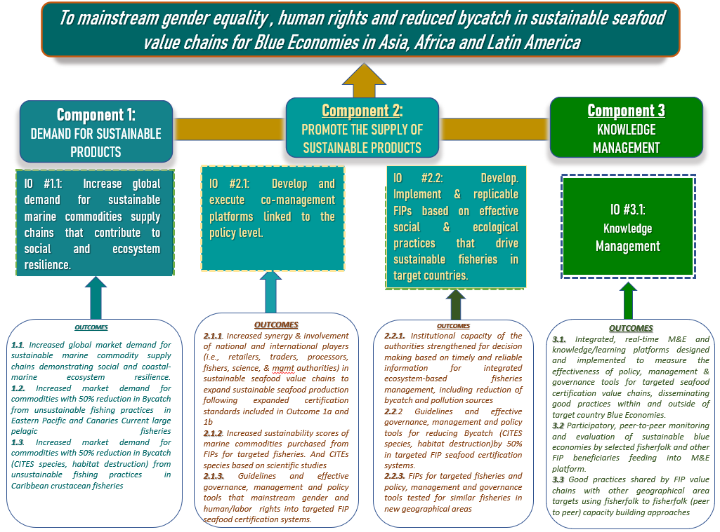

Ryan 2021
http://onesharedocean.org/LME_11_Pacific_Central-American_Coastal
http://onesharedocean.org/LME_13_Humboldt_Current
http://onesharedocean.org/LME_27_Canary_Current
http://onesharedocean.org/LME_37_Sulu-Celebes_Sea
http://onesharedocean.org/LME_38_Indonesian_Sea
The Indonesian Government has proposed to include nationally important small pelagic artisanal fisheries, together with octopus
Sumaila et al. 2021
The official figures indicate that in the past decades, the provision of marine food and ingredients has been stable. Since 1990 the annual global marine capture has fluctuated around 80 million tons (Figure 1). Between 2016 and 2018 it increased from 78.2 to 84.4 million tons (FAO, 2000; FAO, 2018; FAO, 2020). However, catch reconstruction shows a different trend, with a peak capture in 1996 (ca., 124 million tons) followed by a continuous decline to reach ca., 109.3 million tons in 2018 (Pauly & Zeller, 2016; Pauly et al., 2020) (Figure 3). Catch reconstruction reveals that between 1996 and 2018 the capture from industrial fisheries declined from 99.1 10⁶ t to 80.9 10⁶ tons, while the capture from artisanal fisheries increased from 21.1 10⁶ tons to 25.0 10⁶ tons.
Target 14.4 states that by 2020, fishing nations will effectively regulate harvesting and end overfishing, illegal, unreported and unregulated fishing and destructive fishing practices and implement science-based management plans, in order to restore fish stocks in the shortest time feasible, at least to levels that can produce maximum sustainable yield as determined by their biological characteristics. Indicator 14.4.1 measures the progress toward achieving Target 14.4 as the Proportion of fish stocks within biologically sustainable levels, which is the metric for the sustainability of the world's marine capture fisheries by their abundance. A fish stock of which abundance is at or greater than the level, that can produce the maximum sustainable yield (MSY) is classified as biologically sustainable. In contrast, when abundance falls below the MSY level, the stock is considered biologically unsustainable. The indicator will measure progress towards SDG Target 14.4.
OECD & FAO (2020) estimate that nominal prices for capture fish, fishmeal and fish oil will increase during the 2020s.
Part of the projected increased demand will be caused by the generalised recommendation to substitute the consumption of red and processed meat for seafood because of its health and nutrition benefits as well as the reduction in dietary-related greenhouse gas emissions (Scarborough et al., 2014; Thomsen et al., 2018; Thomsen et al., 2019). For example, the U.S. dietary guidelines 2020-2025 recommend increasing the consumption of seafood to at least 8 ounces per week and introducing it to children when they are around six months old (USDA & HHS, 2020). The demand from international markets is a key driver, while more than half of their demand in Europe and the USA is covered with imports (Guillen et al., 2019), and China will likely have a seafood demand gap that will need to be covered with imports (Crona et al., 2020).
Fish consumption is expected to increase from 20.4 kg to 21.4 kg by 2029.
There are far too many examples where overfishing has driven fisheries to their total collapse (Worm et al. 2006; Jackson et al. 2001) as a result of continually removing non-target species and reproductively immature individuals. Together, these cumulative impacts frequently the uncouple the physical-chemical and biological linkages that drive the resilience (sensu Carr 2018; Allen and Holling 2010) of coastal-marine ecosystems and the services they provide to coastal nations.
https://www.undp.org/sustainable-development-goals
Stephenson et al. 2018
Angel et al. 2020
Foley et al. 2020
Costa Rica and 31 other countries were placed on the NOAA/National Marine Fisheries list of IUU violators in August 2021. In May 2020, Hong Kong Authorities seized 26 tons of CITEs-protected shark fins (38,500 sharks) originating from Ecuador, and it was also given a YELLOW CARD by the European Union IUU fishing.
Barnett et al., 2016
Bennet et al., 2018; Roheim et al., 2018; Bailey, 2019; Tlusty et al., 2019; Bennet et al., 2020; Belton et al., 2020
The top-down market-driven approach worked with major traders and buyers to increase awareness, provide sound information, implement responsible purchasing policies, and facilitate dialogue through supply chain roundtables.
Besides improving the sustainability of fishing practices in different corners of the Pacific Ocean, the GMC-1 governance platforms generated stakeholder trust, which is extremely difficult to build within the fishery sector. This not only helped build and strengthen public-private alliances, but it also led to unexpected sustainable financing from the private sector to fill in government gaps, thereby helping the FIPs meet their targets and carry out participatory monitoring of the progress in achieving FIP objectives.
Other SDGs are of particular importance, including Gender Equality (SDG 5), Decent Work (SDG 8), Climate Action (SDG 13.2 and 13.b) and Strengthening the means of implementation and revitalize the global partnership for sustainable development (SDG 17, target 17.16) and are fundamental for addressing marine supply chain impacts.
The socioeconomic impacts of the COVID-19 pandemic have adversely affected recent progress on gender equality: violence against women and girls has intensified, child marriage is expected to increase after declining in previous years, and increased care work at home is affecting women disproportionately. The pandemic has highlighted the need for swift action to address the gender inequalities that remain pervasive globally and to get back on track for achieving gender equality. Source: Progress towards the Sustainable Development Goals - E/2021/58
Teh et al. 2019
Stephenson et al. 2019
Defined by the World Bank as “a range of economic and related policies that together determine whether the use of the oceanic resources is sustainable”, the blue economy “seeks to promote economic growth, social inclusion, and the preservation or improvement of livelihoods while at the same time ensuring environmental sustainability of the oceans and coastal areas” (World Bank 2017: 6). The concept mirrors the green economy concept and emerged at the Rio+20 conference.
Silver et al. 2015
Here, Bycatch paper refers to species accidentally caught other than the target species, brought on board, dead or alive, and that can therefore be either released alive, discarded, dead, or landed (Squires et al. 2021).
For the artisanal small-scale fishers have, the right to a healthy environment is under threat both in the sense that the ocean ecosystem on which their livelihood it built is under pressure from pollution, overfishing and climate change impacts that affect the fish stock – and in the sense that their housing, water and other infrastructure is under pressure from climate change induced frequent extreme weather events (COAST Trrust et al. 2021)-
UNHRC 2017
A human rights-based approach is a conceptual framework for the process of human development that is normatively based on international human rights standards and operationally directed to promoting and protecting human rights. It seeks to analyze inequalities which lie at the heart of development problems and redress discriminatory practices and unjust distributions of power that impede development progress. Office of the High Commissioner for Human Rights. The HRBA highlights the responsibilities of governments and businesses to ensure resilient livelihoods are available for workers and coastal communities involved with seafood value chains.
https://www.humanrights.dk/sites/humanrights.dk/files/media/migrated/hrba_to_sustainable_fisheries_and_aquaculture_eng.pdf
In 2003, UN agencies agreed on a Statement of Common Understanding defining the aspects of a human rights-based approach to development, stating that: i) the objective of development should be to further the realization of human rights; ii) Human rights standards and the recommendations of human rights oversight mechanisms should guide all development efforts and phases programming process; iii) Development processes should contribute to developing the capacities of ‘duty-bearers’ to meet their obligations and of ‘rights-holders’ to claim their rights; and iv) Human rights standards and principles should guide the monitoring and evaluation of development processes and outcomes (OHCHR, FAQ on HRBA to Development, p.15-16 & 35, https://www.ohchr.org/Documents/Publications/FAQen.pdf).
Preliminary target LMEs: Pacific-Central American Coastal, Humboldt Current, Canary Current, Sulu-Celebes Sea and Indonesian Sea.
The GMC model has proven that through strategic intervention, a small pelagic fishery (in Ecuador) has moved from being one of the worst in Latin America to the best fishery in just three years.
Examples include the use of the participatory guaranteed systems that have been used for organic agriculture produce (Kallander 2008; Loconto & Hatanaka, 2018) or the “blue seal” of the Chilean National Fisheries Service.
There are few data on stocks in the two countries, but a recent GMC-I assessment found that for the Philippines, the exploitation level is already at the maximum sustainable yield. The USA and the European Union, respectively, are the largest buyers of Philippine and Indonesian octopus where it is exported as “Spanish octopus” (i.e., Octopus vulgaris). -
In the case of the Philippines, the octopus would be the only fishery, because Philippines has had many limitations with its impact with that fishery because in the course of the implementation of GMC I it became clear that there is not enough market pressure on octopus’ fisheries because they are being exported as octopus vulgaris. Consequently, the country has created a new label for the Reef Octopus market, so that octopus can be put into a specific market niche with sustainability requirements, which will allow the leverage to apply pressure and the capacity to mobilize that fishery at the national level.-
Big blue octopus (Octopus cyanea) in Indonesia is a high value export commodity that is mainly captured by traditional small-scale fishers, with the aim of changing 100% of the fishery in Indonesia.
80,000 artisanal Mauritanian fishermen use 10,000 artisanal boats and 300 artisanal deck boats (less than 14m) to provide 80% of the national octopus production volume and 82% in value. The octopus fishery also provides 90% of the employment in the sector, with people working in 140 product freezing processing plants, in 12 workshops for making pirogues, a shipyard for building 14m deck boats, and in hundreds of shops selling equipment, thousands of fish wholesalers, transporters, hundreds of women processors, potters, etc. (CFFA 2020).
In Ecuador, what we are proposing is to work in a structure of fisheries in which we have not worked or have worked tangentially. And that has a lot to do with this issue of bycatch because it is pelagic fishery two large, mixed, tuna in which seasonally there is shark and now with the fall of the Mahí well, that is another story, but the problem that is having with the prices of the mahí mahí what it is doing is that everyone is turning to the shark, so well there are a number of things that are happening that are derived from the market and that are also derived from the effect of fishing on the mahimahi, but that is another story. What we are proposing in Ecuador is to work with a fishery of large pelagics, sword, tuna, tuna etcetera, etcetera, would enter mahi, but tangentially.
the removal of trailing gear from all shark and ray species in order to ensure those species are fully protected. The Council has noted that transitioning to a monofilament leader will reduce mortality of all shark and ray species that are caught, not just oceanic whitetip sharks. However, those benefits cannot be realized unless the crew also removes trailing gear for all shark and ray species.
Honduras has a serious ecological problem with coastal shrimp trawling bycatch, 90% of which consists of larvae and juvenile fauna that never reach reproductive maturity. Eliminating the practice of blocking these ecologically important migratory routes for reef fish to complete their life cycles in over 2,500 Km² of Honduras’ Caribbean MPAs and over 5000 Km² of ecologically important benthic habitats. If the littoral shrimp bycatch issue is not addressed in the Caribbean LME’ GEF project, then this might be considered as an added value, provided that an interested cofinancing partner could be engaged.
The International Labor Organization (ILO) finds that capture fisheries have one of the highest occupational fatality rates in the world and that fishers are vulnerable to human rights abuse on board fishing vessels. Workers are forced to perform difficult and sometimes hazardous work for long hours at very low pay, under the threat of force or by means of debt bondage, resulting in physical and mental abuse and even death. However, seafood sustainability standards mainly focus on environmental performance criteria, and they pay less attention to the welfare of fisheries workers, even though human rights violations such as slavery and human trafficking are widespread in global fisheries (Teh et al., 2019). Despite continuous calls incorporating human rights law and policy frameworks to shape the guiding principles of socially responsible seafood, practical guidance on how to achieve this is lacking.
While the Caribbean spiny lobster (Panulirus argus) is currently part of the Caribbean LME’ GEF project this only targets lobsters caught in traps, which have an evolving FIP certification process However, dived lobsters are impossible to certify due to labor and human rights violations and the lack of diver safety concerns by captains and/or shipowners. It is also one of the most destructive types of fishing methods (together with fish traps) and hundreds of divers are paralyzed and/or killed from decompression sickness each year.
A SWIA is carried out according to a set of widely accepted impact assessment steps. The process involves both desk-based and field research. Nakamura et al. (2018) created a framework and developed a methodology for assessing the risk of forced labor in seafood supply chains. The five-point framework, called the Labor Safe Screen, found that improved awareness of labor conditions so that food companies can remedy the problem.
https://sustainabledevelopment.un.org/post2015/transformingourworld
The GMC (phase 1) Gender Strategy (finalized in January 2020) revealed that rarely does the fishery sector offer disaggregated data on gender. Until recently, women stakeholders in the fisheries sector were invisible in the statistics collected and provided to fisheries decision and policymakers. Ensuring the sustainability of management and conservation initiatives requires recognition and understanding of the gender role differentiation in the fishery supply chains, including how men and women access, use, and benefit from natural resources and management decisions (Harper et al., 2012; Johnson et al., 2004; Agarwal, 2000) . The impacts of policies and strategies on women who work in fisheries value chains cannot be assessed without data on their roles and contributions to the sector. Governments, projects and organizations still require greater efforts to quantify the participation of men and women in the activities and decision-making derived from the fishing sector, which is crucial to define and monitor strategies that reduce or eliminate the gender gaps in the value chain, therefore contributing to gender equality.
Enhance policy coherence for sustainable development: Number of countries with mechanisms in place to enhance policy coherence of sustainable development
If Honduras´ Caribbean littoral penaeid shrimp trawl fisheries is included, then the project would contribute to improved management for conservation and sustainable use of 855,424 hectares within the country´s Bay Islands’ MPAs due to reduced bycatch allowing fish and invertebrate fauna to complete their life cycles as adults in coral reefs.

