Center for Research and Policy Making Consulting
Conducting Gender Equality and Climate Change Trainings REPORT

Marija Risteska, Slavjanka Andonova Pejcinovska, Gordana Micova Nestorovska, Biljana Matevska
6/9/2022

Contents
I. Basic information 3
II. Preparatory activities 3
III. Background information and training objectives 4
IV. Training Needs Assessment 5
Sample features 6
Results 6
TNA Conclusion 10
V. Training program and training delivery 11
VI. Training results 14
VII. Training evaluations 14
Findings 15
VIII. Conclusions and Recommendations 22
General conclusions 22
Training modality improvement 24
Recommendations for further expanding the scope of capacity building and capacities of the participants 24
IX. Photographs 26
ANNEX 1: List of targeted participants 36
ANNEX 2: TNA Questionnaire 36
ANNEX 3: Questionnaire for workshop evaluation 37
ANNEX 4: Training program 39
ANNEX 5: AGENDAS 47
ANNEX 6: Participants list 49
ANNEX 7 Scanned list of participants 56

Basic information

CRPM Consulting was engaged by UNDP in the framework of the project “Strengthening the institutional and technical capacities for improving transparency for climate change in within the Paris agreement (CBIT project)”, funded by GEF and UNDP with the cooperation of the Ministry of Environment and Physical Planning. The CRPM C was engaged to organize and deliver six trainings on gender and climate change held in the course May-June, 2022.
The assignment had the following specific objectives:
- To increase knowledge of the participants on the gender component of the climate change;
- To understand the gender perspective on climate change;
- To get insights into gender differences in Climate Change Mitigation and Adaptation
- To strengthen the participants’ skills to mainstream gender equality in their climate change programs, institutions and policies;
- To improve participants understanding of the basic elements of gender mainstreaming approach and strategies
- To prepare the procurement departments, the local councils and crisis headquarters for future planning of activities and budgets in line with climate change and gender.
- To strengthen the implementation of the Gender and Climate Change Draft Action Plan

Preparatory activities

To allow for identification of the participants the CRPM consulting team did a rapid assessment to identify representatives working in public enterprises; administrative employees working on procurement on national / local level, local councils and crisis headquarters. That was done through liaison with the Ministry of Labor and Social Policy, Ministry of Environment and Physical planning, ZELS working group on gender equality, environment protection and public procurement departments, the regional development centers and the coordination unit in Ministry of local self-government.
By doing so, relevant representatives from the above mentioned institutions were mapped and identified from all eight statistical regions in North Macedonia, giving a number of +1000 targeted representatives. All of them were (individuals working in local and central government of relevant issues to environment, climate change, gender equality, public procurement, councils and crisis headquarters) were reached out for the capacity building activities.
The data base of potential participants is presented in Annex 1 of this report.
In the preparatory activities the CRPM Consulting team designed, consulted structured questions for training needs assessment, embedded feedback and administered the TNA via online survey. The TNA structured questions are presented in Annex 2 of this report.
The results on the TNA are presented in the section training needs assessment below in this report. The TNA informed updating of the training program allowing it to be tailor made to the needs of the targeted audience for capacity building. The updated training program is explained in the section on training program and training delivery section below in this report.
In the preparation period the CRPM Consulting team designed, consulted the draft post-assessment training evaluation questionnaire, embedded feedback and after the delivery of training administered the questionnaire on-line. The pos-assessment / training evaluation questionnaire is presented in Annex 3 of this report.

Background information and training objectives

The training objectives were to strengthen knowledge and understanding on the gender dimension of climate change, acquire skills and knowledge how to introduce gender perspective in designing measures, activities as well as adaptation and mitigation plans for climate change. The aim was to support the authorities on local and national level to start with implementation of gender mainstreaming within strategic planning process, to understand the gender roles and stereotypes, how to use the sex-disaggregate data and to take into consideration the needs, priorities and benefits of all marginalized persons, men and women, children and adults in rural and urban areas. Moreover, the training aimed at boosting the capacities of the public procurement departments for gendering of the purchases on how local procurements can contribute to mitigation/adaptation to climate changes and help the relevant departments plan their programs and budgets in line with the gender and climate change. For that reason, there we developed a guide on how to prepare gender and green public procurements at local level. Moreover, the training included examples on gendering of the local action plans for the areas connected with climate (energy efficiency plans, plans for waste management, development of agriculture for rural areas, tourism plan, etc). The training was also developed to help the creators of policies related to the environment, public procurement, climate change, infrastructure, in a practical way to make a draft annual work plans.
This would support the authorities on local level to start with implementation of gender mainstreaming within strategic planning process, to understand the gender roles and stereotypes, how to use the sex-disaggregate data and to take into consideration the needs, priorities and benefits of all marginalized persons, men and women, children and adults in rural and urban areas.
Two of the trainings were delivered with physical presence in Hotel Best Western in Skopje, in) and four were held on-line using the Zoom platform. The training duality was workshop where the trainers presented the content and facilitated discussions guiding the trainees to make conclusions and or development of measures, activities and plans for adaptation to and mitigation of climate change.
The process of organizing the training was the following. First CRPM Consulting sent out email invitation by regions to all potential participants, together with an online registration form and TNA questionnaire. Afterwards, all registered were followed up via telephone call in order to confirm their participation. Having in mind the very limited time for recruiting the participants, region by region, we gave them all an open option to choose which of the offered dates and modality suits best their schedules. The offered dates and modalities were as follows:
30 May – online
31 May – online
06 June – physical presence
07 June – online
08 June – online
09 June physical presence

This procedure was made for all regions including Skopje as well. Considering that the modality of training delivery was combination of physical presence and online, the number of participants varied from one to another training ranging from 27 to 22.
The main beneficiaries were the municipal councilors, representatives from crisis centers, local and state PE representatives, national and municipal staff dealing with public procurement as well as those working with gender equality and climate change.
They as target group are very important not just if the money is spent to respond to needs of women and men but because works/services/product and their procurement a(e.g. purchasing a new car/s for the municipality, printing paper, electronic equipment, new buses, new garbage trucks, etc. or preparation of the call for subvention of replacement of existing ovens in the households with air conditioners, promotion of more usage of public transport, partially support the purchasing of bicycles, etc) have impact on climate change.The main activities performed were:

- Mapping individuals for training attendance;
- Preparing invitation;
- Developing TNA questionnaire, conducting TNA survey and preparing TNA report.
- Training program update;
- Update of the training material (PP slides and case studies);
- Development of the Training Agenda;
- Delivery of training for target group representatives from all eight eight statistical regions.
- Conducting training post-assessment.

Training Needs Assessment

The Gender and Climate Change TNA questionnaire was developed to examine the perceptions of the government units at national and local level in terms of climate change and its impact on men and women. Respectively, the targeted groups were municipal councilors, equal opportunities coordinators, and persons responsible for public procurement, environment and local economic development, councilors, associates and officers from the Crisis Management Centers.
The training needs assessment is the first step towards the development of training program tailored in accordance with the needs of the target groups. For the training needs assessment, the data was collected via quantitative research tool, i.e. an online survey was developed on the free open-source tool for data collection Kobo Toolbox, which also provides basic automatic data processing. However, for data processing the statistical software platform SPSS was used since it offers better quantitative data processing and cross-referencing for research purposes.
The survey was conducted in the period between 18-23 May 2022. The online survey was sent to over 1000 representatives, out of which 63 completed it.
Based on the findings of the analysis, a mixed team of experts on gender issues and climate change developed a training program for the administration officials at national and local level.

Sample features
A total of 63 respondents completed the Gender and Climate Change TNA Questionnaire.
Of all respondents, 59% were women (n=37) and 41% were men(n=26).
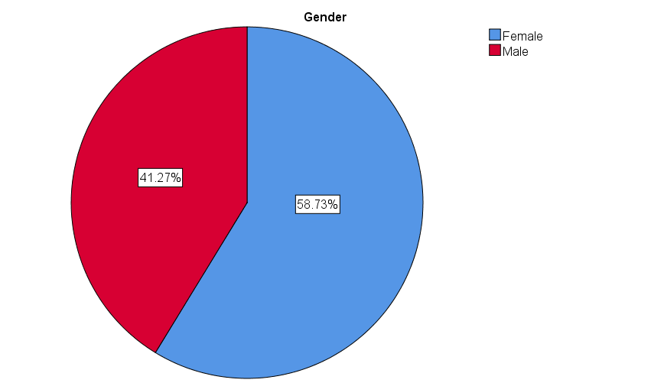
Figure 1

Results
In regards to the question ‘Is the gender perspective mainstreamed into your organization’s plans and programs, the vast majority or 84% answered positively, 5% of the respondents indicated that the gender perspective is not yet included in the plans and programs and the rest 11% answered with ‘Don’t know/No opinion.’ (Figure 2)
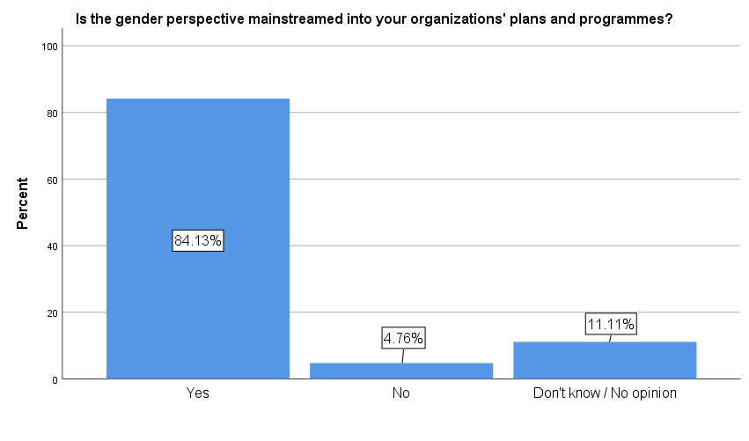
Figure 2

As for the next question’Do you think that climate change is real?’, 89% of the surveyed respondents believe that climate change is real, 3% believe otherwise and 8% do not know or have no opinion on the matter. (Figure 3)
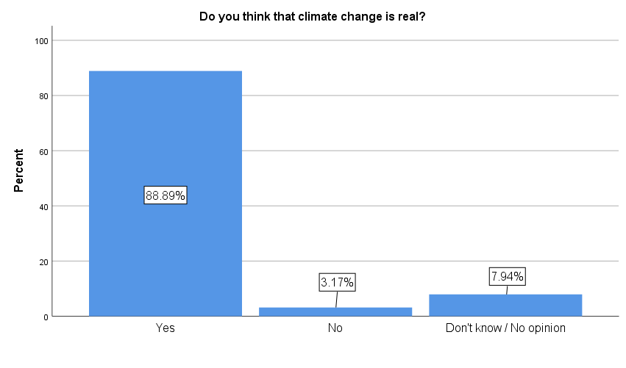
Figure 3

The next question referred to the possible connection between gender and climate change, thus slightly more than half of the respondents or 52% believe thata direct relationship between gender and climate change exists, in addition 13% believe that these two issues cannot be related in any way. The rest 35% do not know or have no opinion on the matter. (Figure 4)

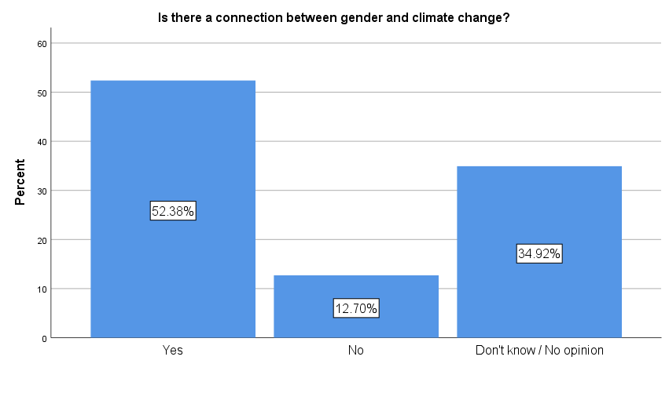
Figure 4

Regarding the question whether climate change affects men and women equally, more than half of the respondents or 54% answered positivey, 32% answered negatively and the rest 14%do not know or have no opinion on the matter. (Figure 5)

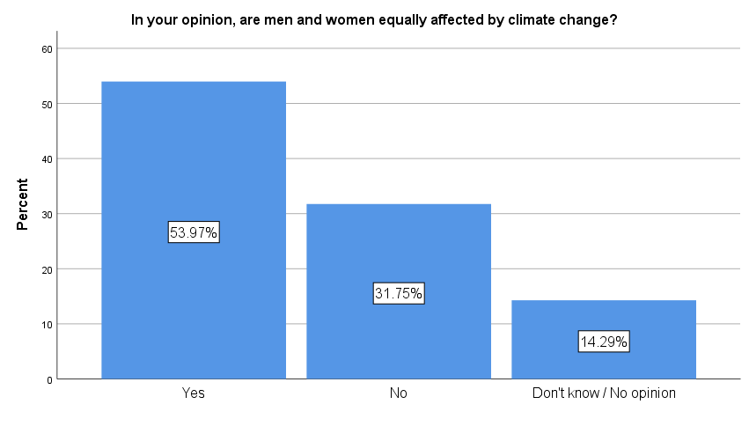
Figure 5
Foreseeable, significant 59% of the respondents are not familiar with the impact of public procurement on climate change; 16% stated that they are familiar and the rest 25%do not know or have no opinion on the matter. (Figure 6)

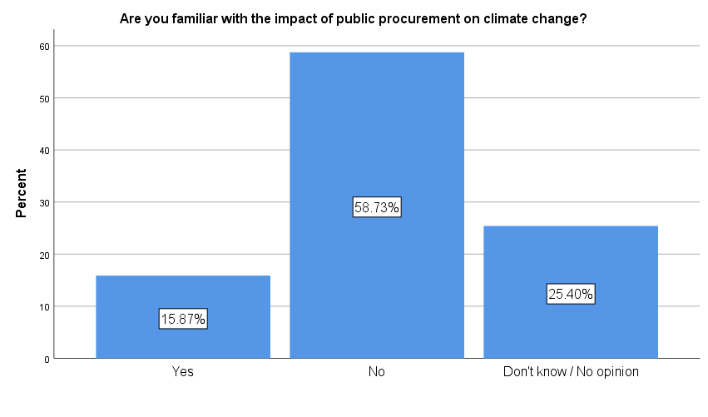
Figure 6

Similarly, more than half of the respondents or 52% are not familiar with sustainable public procurement and its benefits; 33% stated that they are and the rest 25% do not know or have no opinion on the matter. (Figure 7)
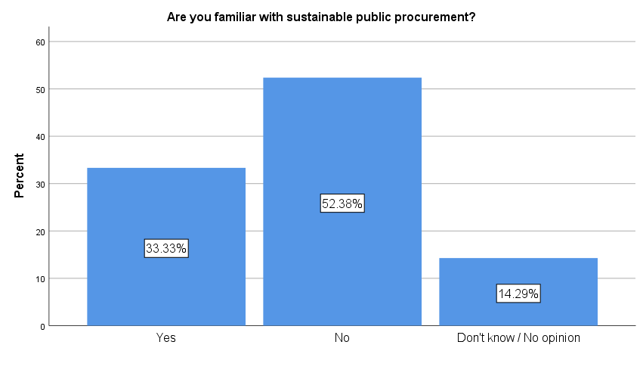
Figure 7

Using public procurement opportunities to advance promote gender equality is a novelty for most of the respondents, more specifically for 68%; moreover only 16% are familiar with gender integration concepts into public procurement and the other 16% do not know or have no opinion on the matter. (Figure 8)
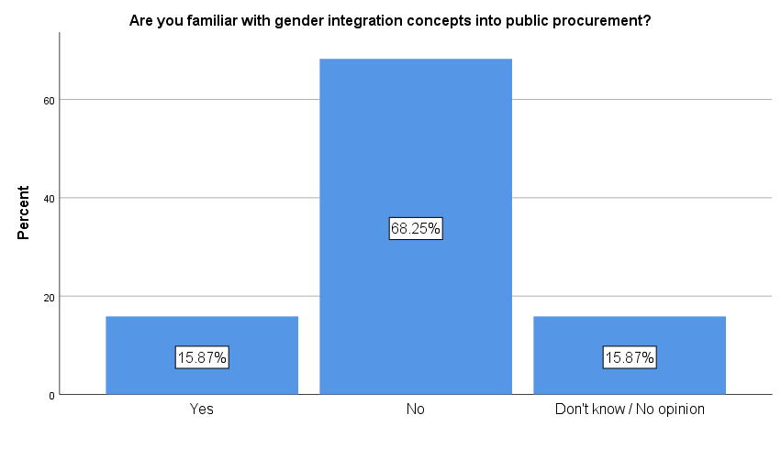
Figure 8

As for the last question, the greater majority of 54%answered that they have attended training course on gender and/or environment and climate change, contrariwise, 44% of respondents have never attended trainings that adress these issues. (Figure 9)
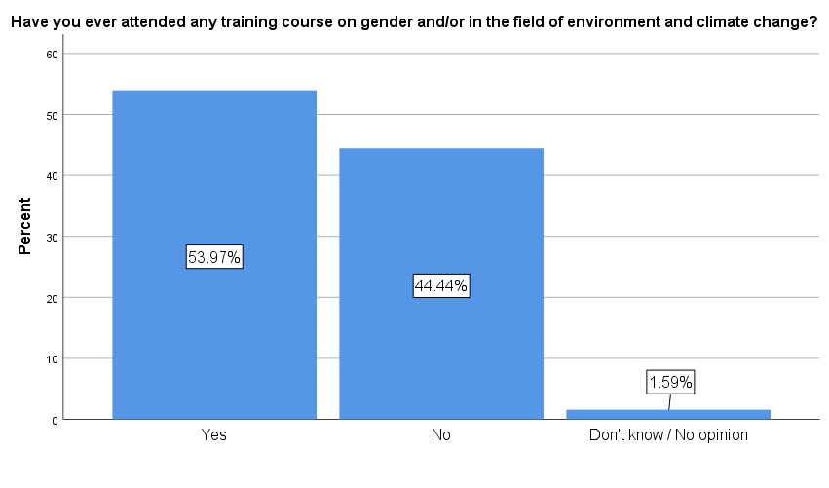
Figure 9

TNA Conclusion
The findings of this quantitative research have shown that there is still a need for capacity building related to the familiarity and knowledge among the respondents regarding the linkages gender and climate change. However, it is worth noting that there has been a significant improvement regarding the perspective of the local government units towards gender issues.
Into the bargain, the training needs analysis highlighted the rising need for capacity development in the process of public procurement, more specifically sustainable public procurement, and gender responsive public procurement. In all likelihood, our current public procurement model is not delivering the best value. More than half of the respondents or 59% are not familiar with the impact of public procurement on climate change; 52% are not familiar with sustainable public procurement; 68% are not familiar with gender integration concepts in public procurement.
Lastly, it is alarming that nearly half of the respondents have not attended training course on gender and/or environment and climate change. Therefore, further awareness raising and delivery of trainings is fundamental for enhanced understanding of the targeted groups regarding how gender and climate change intersect - in order to become an effective change maker for sustainable development.
Ultimately, gender inequalities hinder sustainable development!

Training program and training delivery

The Gender Equality and Climate Change training program was updated and supplemented with green and gender public procurement. The trainings were attended by participants from all eight statistical regions in the country including Skopje. Two one-day training were organised with physical presence in Skopje and six trainings were organized online via ZOOM.

The training program was consisted of five different sessions as follows:

Session 1 – Climate change phenomena (What is climate change?; Adaptation and mitigation; The influence of climate change on men, women, children and vulnerable citizens);
Session 2 – Adaptation and mitigation of consequences of climate change (Measures for adaptation and mitigation, Gender roles in the processes of adaptation and mitigation; Undertaken measures; Green procurement concept).
Session 3 - Understanding of gender and sex and their interconnection to climate change phenomena (Gender identity; Gender neutrality; Gender roles and needs; The influence of gender roles and stereotypes on climate change)
Session 4 - Introducing a gender perspective in public procurement (Incorporating a gender perspective into climate change policies; How to incorporate a gender perspective into public procurement)
Session 5 – International and national strategic frame for gender and climate change (International standards and mechanisms that the country has ratified in the field of gender equality and national legal frame; International standards and mechanisms that the country has ratified in the field of environment and climate change and national legal frame; Action plan for gender and climate change; Gender integration, statistics, inter-sectorial groups, SDGs, Gender mainstreaming; Aarhus Convention).

The training program is presented in Annex 4 of this report. Based on the training program that was developed on the basis of the TNA findings and the consultations with UNDP and MLSP, training agendas was determined, presented in Annex 5.
The trainers (Mrs. Slavjanka Pejchinovska Andonova and Mrs. Gordana Nestorovska) were included and contributed in the process of formation of the list of participants, the agenda and timeline for the trainings. They developed the presentations, the exercise and guidelines for the exercise. During the period of preparation of the training internal meetings were held between the experts as well with the UNDP team.
The following presents the process of delivery of training workshops.
- First training workshop conducted online (30.05.2022)
The first training that was conducted online on the zoom platform. A total of 15 participants from different municipalities (Radovish, Karposh,Gazi Baba, Shtip, Lozovo, Pehchevo, Tetovo, Vasilevo, Plasnica, Kratovo and Tearce) and national level representatives from MLSP were present. There were representatives from PEs, LEDUs, equal opportunities sectors, crisis headquarters, councilors, public procurement offices. Based on gender, 75% of the participants were women and the rest 25% were men. More details on their position may be found in the list of participants presented in Annex 7 of this report.
Few examples that were discussed during the training-workshop are presented below under results first training.
- Second training workshop conducted online (31.05.2022)
There were 24 participants from different municipalities (Sveti Nikole, Tetovo, Delcevo, Makedonski Brod, Delcevo, Karposh, Grad Skopje, Valandovo, Kavadarci, Gazi Baba, Veles, Radovish, Bitola, Vevcani) and national level representatives from MLSP. There were representatives from PEs, LEDUs, equal opportunities sectors, crisis headquarters, councilors, public procurement offices. Based on the gender, one third or 75% of the participants were women and 25% men. More details on their position may be found in the list of participants presented in Annex 7 of this report.
Few examples that were discussed during the training-workshop are presented below under results from second training.
- Third training workshop conducted in Skopje, Hotel Best Western on 06.06.2022
There were 17 participants from different municipalities (Kicevo, Karpos, Strumica, Studenicani, Kavadarci, Centar, Kisela Voda, Bitola, Grad Skopje, Butel, Mavrovo i Rostushe) and national level representatives from MLSP. Based on the gender 48% of the participants were women and 52% were men. More details on their position may be found in the list of participants presented in Annex 7 of this report.
Few examples that were discussed during the training-workshop are presented below under results from third training.
- Fourth training workshop was conducted online (07.06.2022)
There were 22 participants from different municipalities (City of Skopje, Aerodrom, Strumica, Kratovo, Radovis, Veles, Kocani, Berovo, Vevcani, Krusevo, Butel, Debarca, Karposh, Sveti Nikole, Resen, Kavadarci, Debar, Bogovinje) and national level representatives from MLSP. There were representatives from PEs, LEDUs, equal opportunities sectors, crisis headquarters, councilors, public procurement offices. Based on the gender, one third or 75% of the participants were women and 25% men. More details on their position may be found in the list of participants presented in Annex 7 of this report.
Few examples that were discussed during the training-workshop are presented below under results from second training.
- Fifth training workshop was conducted online (08.06.2022)

Out of 27 participants that expressed interest and confirmed participation, 18 participants attended from the following municipalities (Gostivar, Kratovo, Strumica, Gazi Baba, Kavadarci, Valandovo, Gevgelija, Novaci, Vevcani, Lozovo, Zrnovci, Radovish, Gazi Baba, Struga, Strumica, Stip) and national level representatives from MLSP. There were representatives from PEs, LEDUs, equal opportunities sectors, crisis headquarters, councilors, public procurement offices. Based on the gender, one third or 83% of the participants were women and 17% men. More details on their position may be found in the list of participants presented in Annex 7 of this report.
Few examples that were discussed during the training-workshop are presented below under results from second training.
- Sixth training workshop conducted in Skopje, Hotel Best Western on 09.06.2022
There were 19 participants from different municipalities (Aerodrom, Bitola, Mavrovo and Rostushe, Debar, Grad Skopje, Resen, Petrovec, Kisela Voda, Tearce, Brvenica, Vrapcishte) and national level representatives from MLSP. Based on the gender 52% of the participants were women and 48% were men. More details on their position may be found in the list of participants presented in Annex 7 of this report.
Few examples that were discussed during the training-workshop are presented below under results from third training.
It can be noted that the targeted participants were given multiple opportunities to attend the online courses, based on their schedule. In general, there were very fruitful discussions, questions raised by the participants, case studies by participant’s experience so far with public procurements / subventions and environmental challenges they have. Several of participants expressed their gratitude for excellent training, they open their mind and understand better what is the link between gender and climate change and they are ready to implement the gender mainstreaming in strategic planning process.
Participant lists are presented in Annex 6.

Training results

The results of the CRPM consulting are the following:
- Updating of the training program
- Development of pre and post assessment tools
- Development of training materials
- Training Report

For all sessions, trainers have prepared presentations that have been distributed to all participants as materials. In terms of the results achieved as a planned the training strengthened knowledge and understanding on the gender dimension of climate change, acquire skills and knowledge how to introduce gender perspective in designing measures, activities as well as adaptation and mitigation plans for climate change. Moreover, the participants acquainted their knowledge on green and gender responsive procurement concepts. This is demonstrated with the section on training evaluation from this report.
The aim to support the authorities on local and national level to start with implementation of gender mainstreaming within strategic planning process, to understand the gender roles and stereotypes, how to use the sex-disaggregate data and to take into consideration the needs, priorities and benefits of all marginalized persons, men and women, children and adults in rural and urban areas was also achieved.
The method used was gender mainstreaming. Gender mainstreaming is a strategy in achieving gender equality goals. The training centrally focused on building capacity of participants for gender mainstreaming of measures that will facilitate adaptation and mitigation of climate change on local level. The participants were therefore asked to identify propose measures for climate change or an action plan for climate change to analyse from a gender perspective and develop strategy for achieving gender equality goals through the mitigation and adaptation measures. Moreover, they were motivated to think on how to implement green and gender responsive criteria in the procurement procedures.

Training evaluations

The Gender Climate Change training program was designed to increase the understanding of the linkage between climate change and gender issues and their main causes; increase understanding of the legal provisions, internal initiatives and mechanisms ratified in the area of climate change and environment, as well as the policies and measures for dealing with climate change.
The evaluation is based on the feedback provided by 51 participants of the training. The relevant findings, correspondingly the distribution of responses are illustrated and presented in the following document bellow.

Findings
Regarding the first question “Did you acquire knowledge and skills in the field of gender and climate change during the training”, nearly all of respondents admitted that participating in the training contributed to their knowledge and skills highly. (Figure 1)
Figure 1
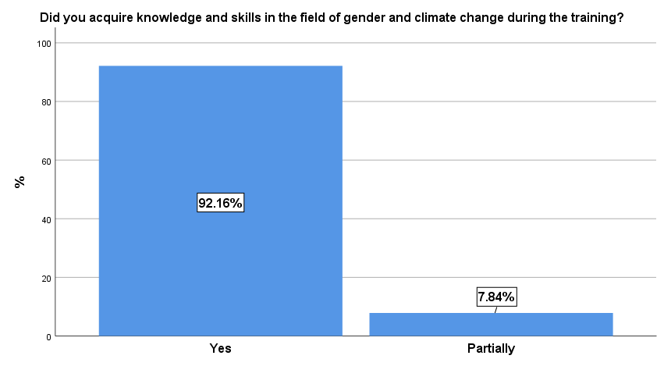
The vast majority of the participants (86.2%) will include the gender perspective in the municipality plans and programs. Only 13.7% have no opinion in regards to this matter. (Figure 2)
Figure 2
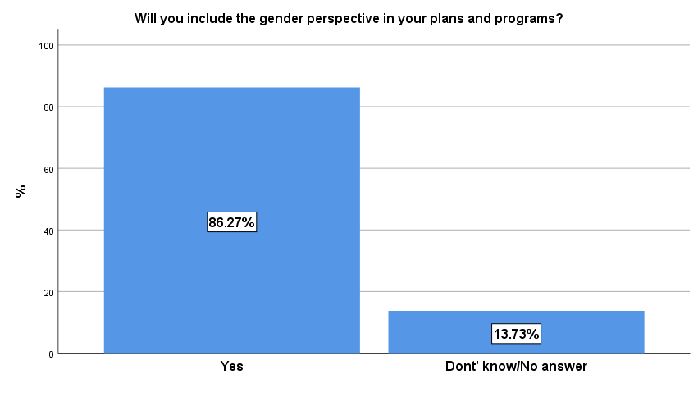
More than half of the respondents (62.7%) are to some extent familiar with the international agreements/initiatives and mechanisms that the country has ratified in the field of climate change and the environment. Consequently, 33.3% are familiar with, while only 3.9% are not familiar with at all.
Figure 3
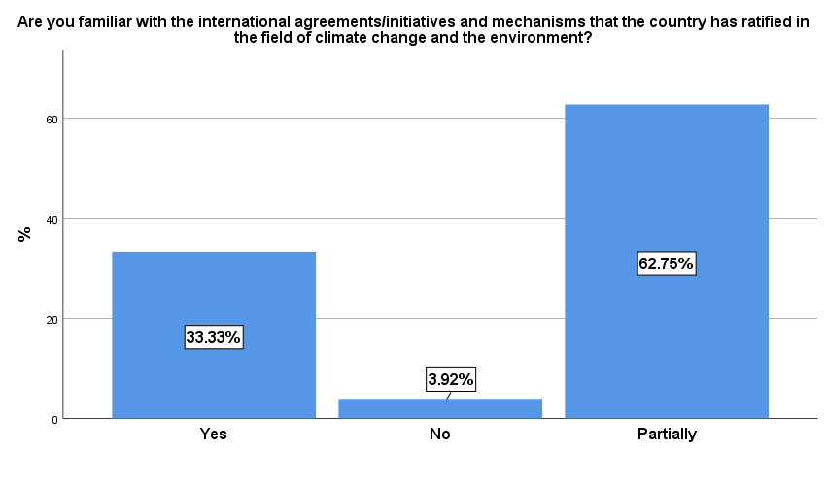

The situation regarding the next question illustrated in Figure 4 is similar to the previous one.
The bigger part of the respondents (60.7%) is partially familiar with the state policies and measures for dealing with climate change at the national and local level; 31.3% are familiar with and 7.8% are not.
Figure 4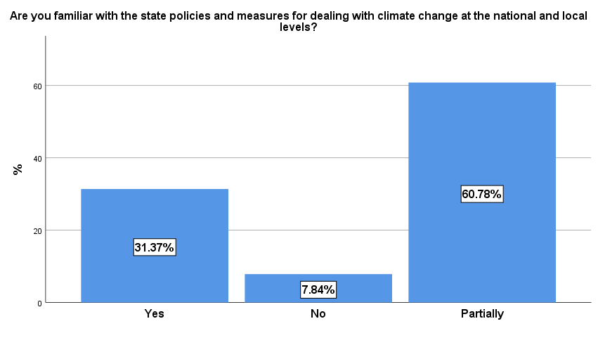

Furthermore, the greater part of the participants (66.6%) answered that they have gained or improved their knowledge on sustainable public procurement, whilst 33.3% to some extent.
Figure 5
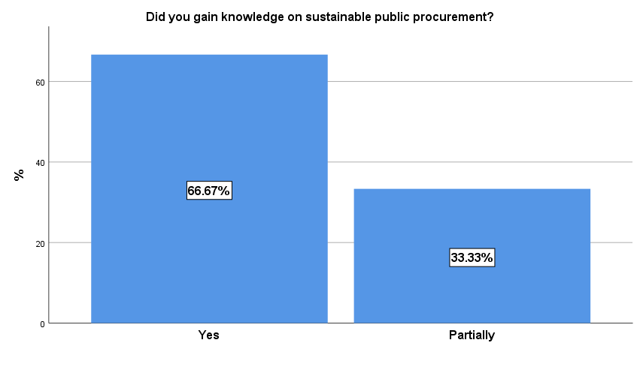

Similarly, 62.7% acknowledged how the gender perspective can be included in the public procurement, and 37.2% have acquired partial knowledge.
Figure 6
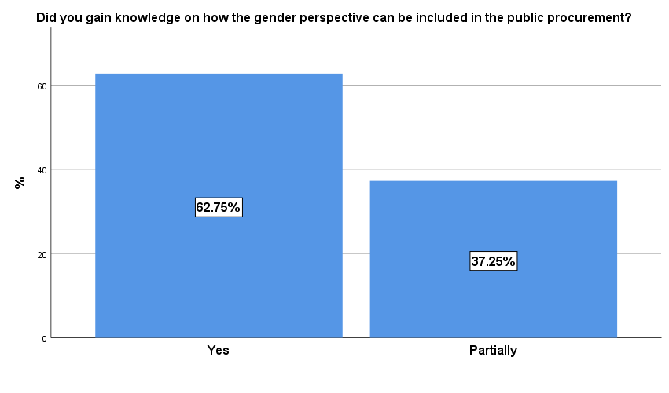

According to the majority of the respondents (86.2%), there is a direct link between gender issues and climate change. Only 3.9% think otherwise and 9.8% responded with Don’t know/No answer. (Figure 7)

Figure 7
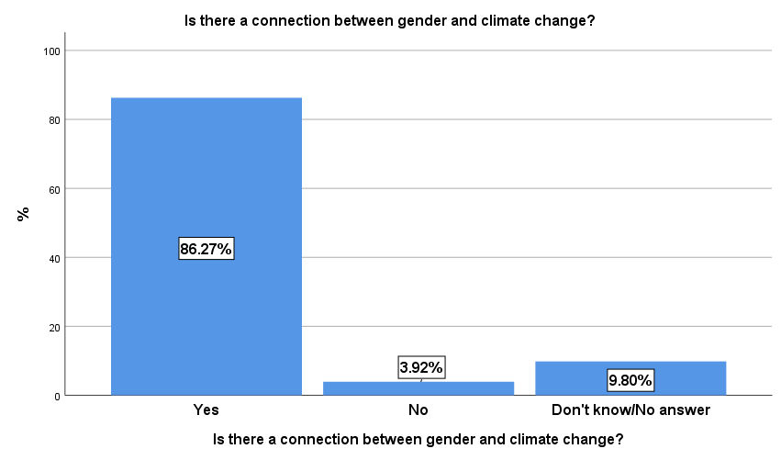

Figure 8 below illustrates divided opinions regarding the question “Are men and women affected equally by climate changes”, more specifically the bigger part of the participants (49%) expressed that they are affected in the same way. Contrariwise, 43.1% highlighted that the impacts of climate change can affect women and men differently; and 7.8% do not know or do not have an opinion in regards to that matter.
Figure 8
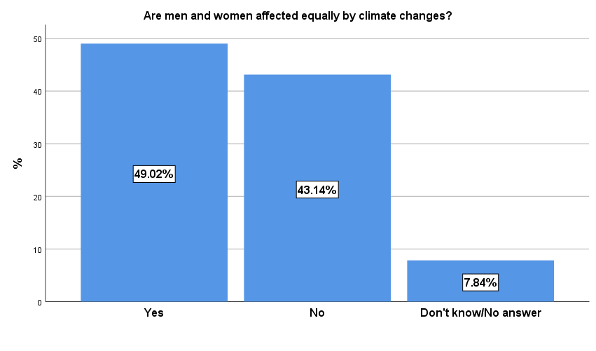

The trainer evaluations are illustrated in the next two graphs below, on a rating scale from 1 to 5 in the following segments: presentation, interaction, practical examples and exercises.
Figure 9
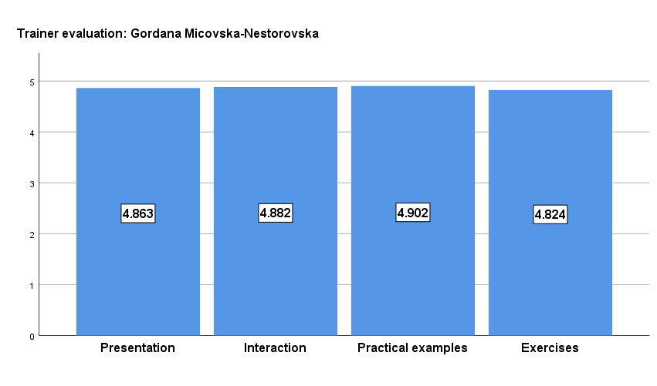
Figure 10
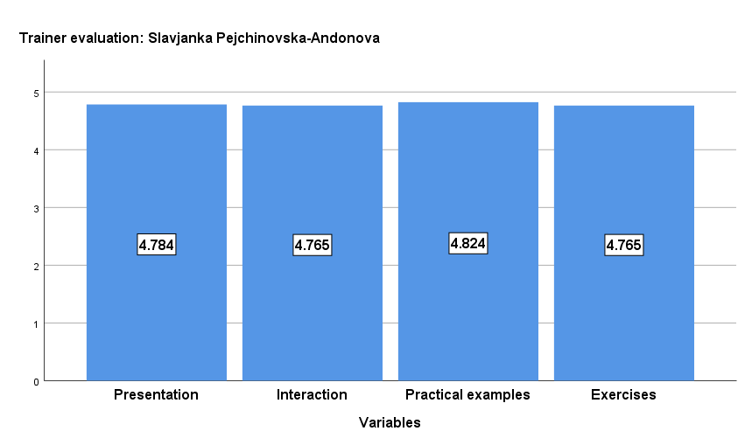

More than half of the respondents (60%) expressed the need for additional training regarding the training topic (Figure 11)

Figure 11
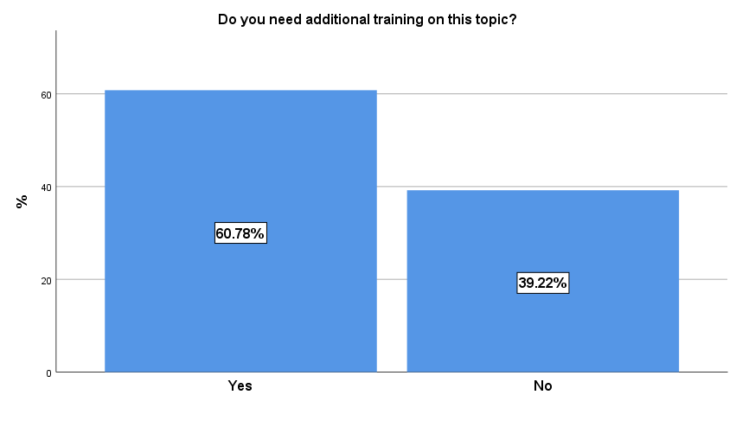

In respondents’ opinion, the length of the training was as optimal (76.4%), affecting the success of the learning objectives in a good way. (Figure 12)
Figure 12
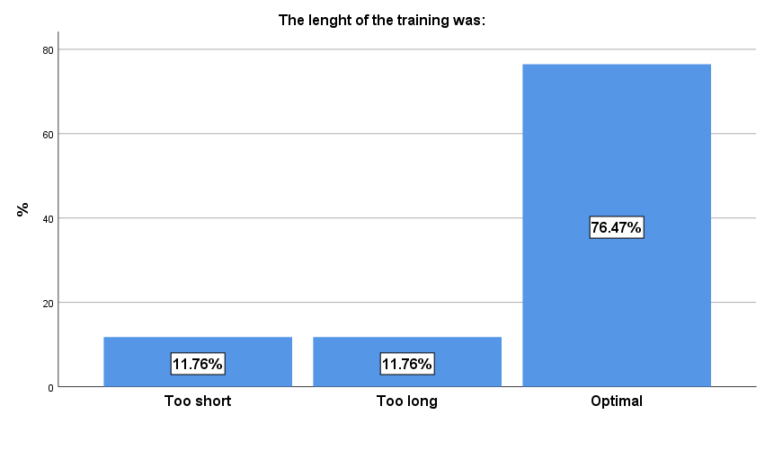

Overall, the respondents evaluated their training experience very highly (82.3%), on a scale from 1 to 5, rating the quality of the training with 5. (Figure 13)

Figure 13
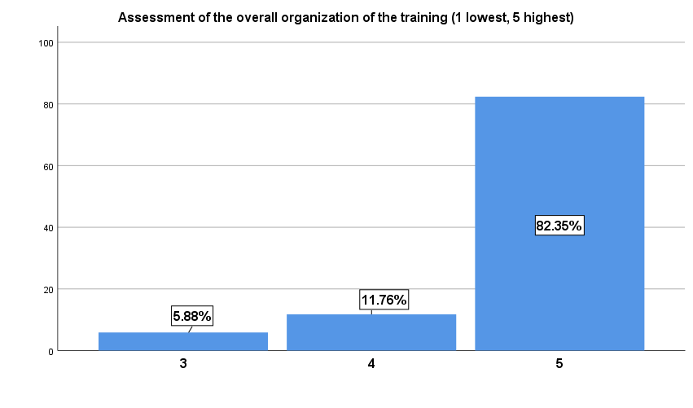

Given the importance of the training topic, the participants highlighted that the training increased their knowledge in the relevant area and their expectations were largely met (84.3%). (Figure 14)
Figure 14
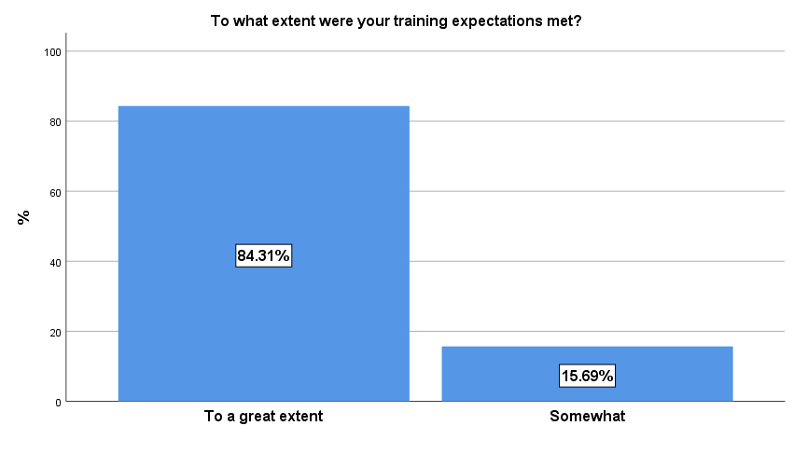

Ultimately, in their open-ended comments the participants expressed their appraisals and gave recommendations and suggestions for future organization of the training course. In addition, these are their recommendations:
- Greater interaction, use of more examples and exercises;
- To cover organizations from multiple sectors for greater promotion of gender equality;
- More frequent meetings and trainings;
- Additional training on this topic, especially on public procurement;
- Opportunity for mentoring support.

VIII. Conclusions and Recommendations

General conclusions
During the training courses there was great interest and interaction with the participants. Some of the generated reccomedations came from the participants directly, based on their actual needs. The training has managed to change perception to the participants and in some cases even dramatically. As opposed to the majority of the respondents in the TNA questionnaire, more than half of the participants after the training expanded their knowledge on sustainable public procurement and got acquainted with gender-responsive public procurement.
Although the linkage between gender and climate changes is recognized, bigger part of the respondents still believes that climate change affect men and women equally. Undoubtedly, as some of the participants requested, there is still a need for additional training on this topic for enhanced understanding regarding how gender and climate change intersect.
Since the pre and post-assessment was not made on the same group (the pre-assessment was sent out to all identified participants for the training – over 1000 individuals; and the post-assessment was filled in by the participants that took part of the training, one cannot make an individual change analysis of pre-and-post training assessments. Hence, the training could be seen as very transformative for the participants, which means that the program was well tailored according to the needs of the participants. This is evidence that good analysis of the TNA questionnaire could be crucial in designing and developing good training programs. The participants corroborated the successfulness of the training program, since the trainers were highly evaluated as well.
The local authorities will use the obtained knowledge to incorporate gender into the strategic planning of processes, policies and programs; to understand the gender roles and stereotypes; to use more frequently sex-disaggregateddata and to take into consideration the needs, priorities and benefits of all marginalized persons, men and women, children and adults in the rural and urban areas.
The acquired knowledge will be used by the participants to start with implementation of gender mainstreaming within strategic planning process. All participants now understand well the gender roles and stereotypes, how to use the sex-disaggregate data and to take into consideration the needs, priorities and benefits of all marginalized persons, men and women, children and adults in rural and urban areas. Moreover, public procurement servants and PEs are more aware of their role in terms of climate change and gender and are willing to further implement gender and climate change mainstreamed measures in their future plans and programs. The council members that participated the trainings are now fully aware of their gender and climate change responsibility when voting for some measure or local policy. The crisis headquarters are on the frontline when combating the climate change consequences, hence they are introduced with the gender approach in their policies and actions.
In order to improve the current situation by including the gender perspective in the decision-making process in the field of environment and climate change, it is necessary:
- To improve the cooperation between the LSGU and the civil society organizations on issues related to gender and climate change;
- To form networks and coalitions to monitor the problems and issues in this area, but also to monitor the level of implementation of the measures related to gender and climate change as well as to monitor the municipals’ budget credibility accordingly;
- To conduct specific trainings intended for the creators of policies related to the environment, public procurement, climate change, infrastructure, but also in other sectors within the municipalities, where in a practical way they will be helped to make a draft annual work plans;
- To conduct specific trainings for the youth councils within the municipalities, since young people are more sensitized on the climate change phenomena and they present the future of our planet.
- To conduct specific training for the social councils within the municipalities, since climate change has the greatest impact on the most vulnerable people in the societies.
- Providing further mentorship for the already trained participants/municipalities for introduction of gender and climate change measures in the local plans and programs, but also for development local Action Plans for climate change adaptation;
- To lobby the commission for equal opportunities in the municipalities for lobbying and initiating initiatives through sessions of the municipal councils on the role of women, the consequences for women and children from pollution and climate change, as well as lobbying for planning local budgets through cooperation with the budget commission which in future activities should also be included in workshops;
- To provide mentoring support for the municipalities for development of project concepts for actions related to climate change mitigation/adaptation and gender mainstreaming.
- To identify tools for raising public awareness on climate change in general but also including gender equality in cooperation of LSGUs and CSOs;

Training modality improvement
If the training continues to be delivered online the following should be taken in consideration:
- Keep the sessions max up to 40 minutes with short breaks for 10 minutes in order to allow participants to stretch and avoid long seating in front of the computers;
- For on line trainings, work in breaking rooms should be considered for different topics related to gender and climate change. It could be efficient if before the training the participants are given list of current programs and strategies of the municipalities so they could select program or measures that will be subject of analyses in the working group;
- Public utility companies do not have equipment to follow or to actively participate in trainings. They need special approach in order to understand connection between gender and climate changes which is very difficult on line and in one day. Women engineers that work in public utility companies are more aware for these issues than men but there are more men employed than women.
- Record the separate sessions and disseminate throughout the country in all LSGUs and national institutions and make them online available.
- If the training continues to be organized with physical presence, allow the participants to chose date and time scope, giving them multiple opportunities timely.

Recommendations for further expanding the scope of capacity building and capacities of the participants
The training proved successful but for sustainable results several recommendations to UNDP and MLSP are provided in terms of expanding the scope of the capacity building program through:
- Expend the training target group with members of the social and youth councils for importance of incorporation of gender perspective in preparation of all programs and especially in development programs of the municipalities that must take into consideration climate changes.
- Expend the capacity building program with mentoring - since the group that was part of the capacity building program from 2020 and 2021 took part in last year’s mentorship support. Participants have started to ask questions and to understand the connection between gender and climate change, for the next period, based on the expressed willingness, mentorship support should be further assured for those that would like for the next year budget (which is again in the line with the budget planning process at local level) to prepare programs/measures and if possible, to provide small amount to support those measures (activities) jus as an example and practical exercise.
- Expend the training target group with the creators of policies related to the environment, public procurement, climate change, infrastructure, but also in other sectors within the municipalities, where in a practical way they will be helped to make a draft annual work plans;
- The mentorship program should be for implementing green and gender just public procurement for gendering of the purchases and how local procurements can contribute to mitigation/adaptation to climate changes. Introduce the municipalities with the developed Guide on how to implement gender and green public procurements at local level.
- Moreover, the mentorship may include gendering of the local action plans for any of the areas connected with climate (energy efficiency plans, plans for waste management, development of agriculture for rural areas, tourism plans….etc), but also for developing Local Action Plans for Climate Change Adaptation
- For public utilities companies’ mentorship should be provided but divided in two phases: first phase should be analyses of the current programs and results from gender perspective and mitigation/adaptation to climate change. Second phase should be mentoring for preparation of programs based on the analyses.
- Expend the training target group with local CSOs and boost their watchdog role on how to monitor local plans having in mind both perspectives (climate change and gender).
- To provide trainings for the crisis headquarters and commissions for evacuation procedures at local level with gender approach.
Some new ideas for sub-projects were generated during the trainings delivery, but also taking into account the interest from participants side:
- Support to the municipalities to develop their Strategy on Climate change and Local Action Plans for Climate Change that could include the identification of the main impacts from climate change, main sectors impacted and how the gender roles in that sectors could be used to develop the action plan for prevention or mitigation the impacts from climate change.
- Development of the Guidance (gender sensitive) for environment and climate change that can be used by local self government units and also on national level during the developing the strategic action plans in priority sectors (energy, agriculture, water resources, waste management, transport, health, biodiversity and cultural heritage), including also gender indicators (at least 7 in each sector);
- Development of Training curriculum for strengthening capacities of the national and local authorities and CSOs on gender equality strategies and requirements from the international financing institutions (e.g., EBRD, Green Climate Fund, World Bank, KfW, etc.) in order to take them into account during applying for project funding;
- Delivery of trainings - practical work/mentoring the institution/organization and supporting them in development of project proposals and applications.
- Delivery of set of trainings for national/national/regional authorities for green and gender responsive procurement procedures (especially when they are announcing a tender for buying energy efficiency devices, vehicles, bikes and other goods directly or indirectly connected with the climate vulnerable sectors;
Maybe it is a good idea that we could support the organization of the Gender/Climate change Open day with good example of projects/activities/public procurements/ideas to be shared among the municipalities and their public utility companies.

Photographs
Pic.1. 30.05.2022 – online - zoom
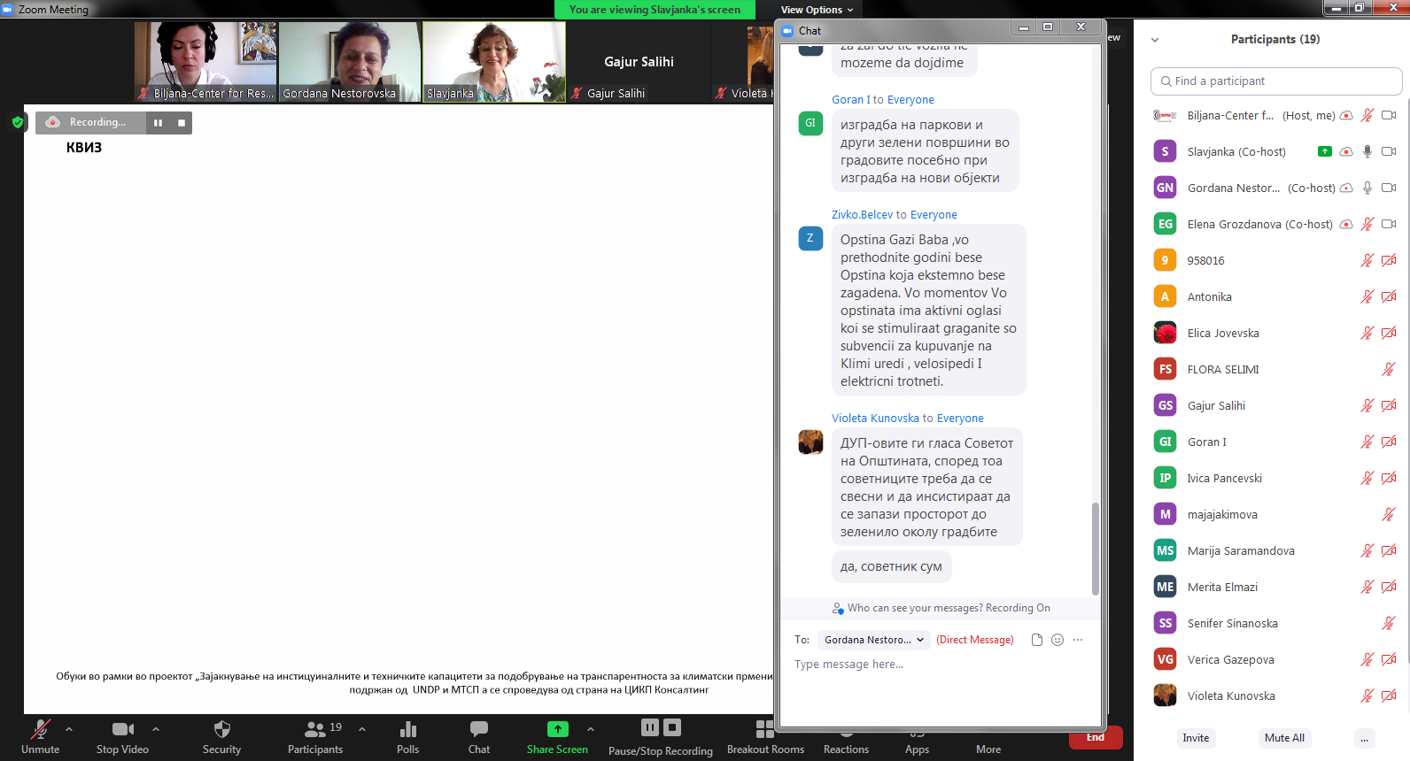

Pic.2. 30.05.2022 – online - zoom
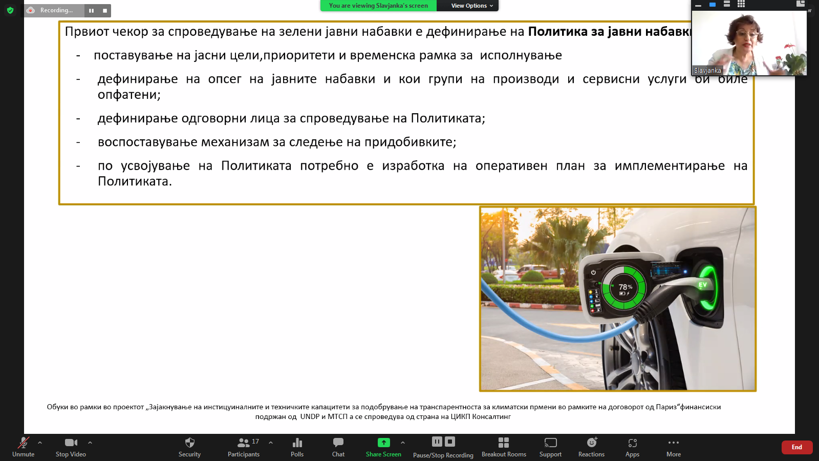

Pic.3. 30.05.2022 – online - zoom

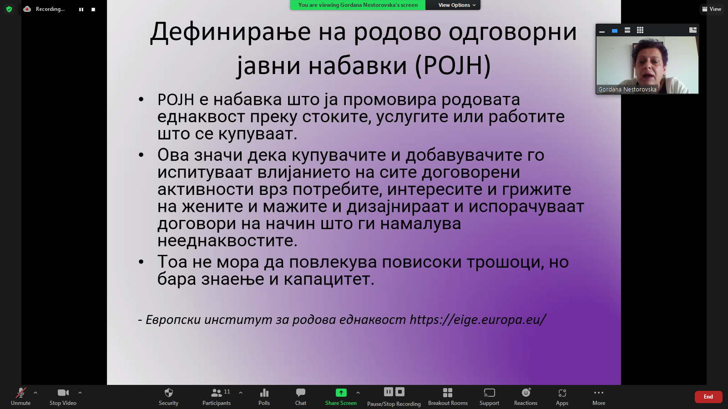

Pic.4. 31.05.2022 – Online – zoom
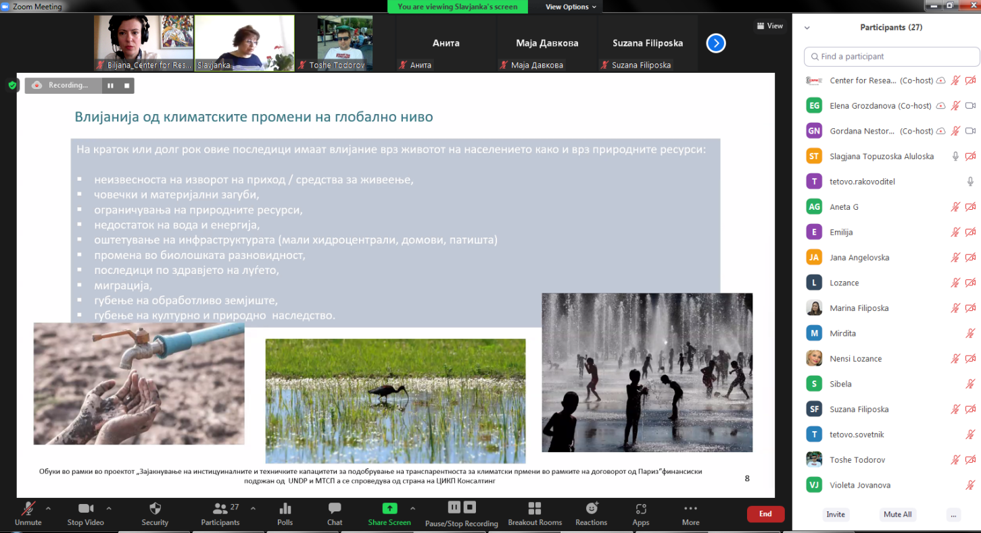

Pic.5. 31.05.2022 – Online – zoom
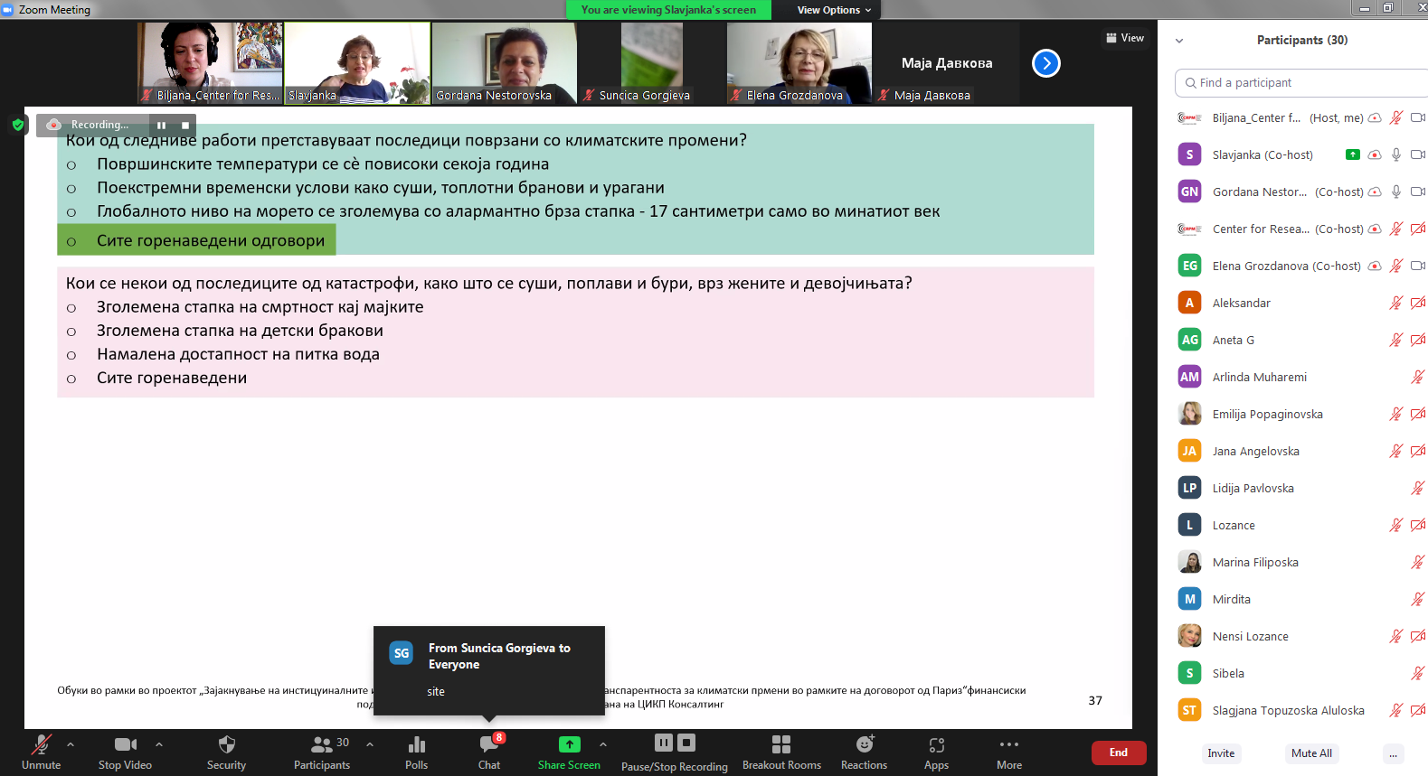

Pic.6. 31.05.2022 – Online – zoom
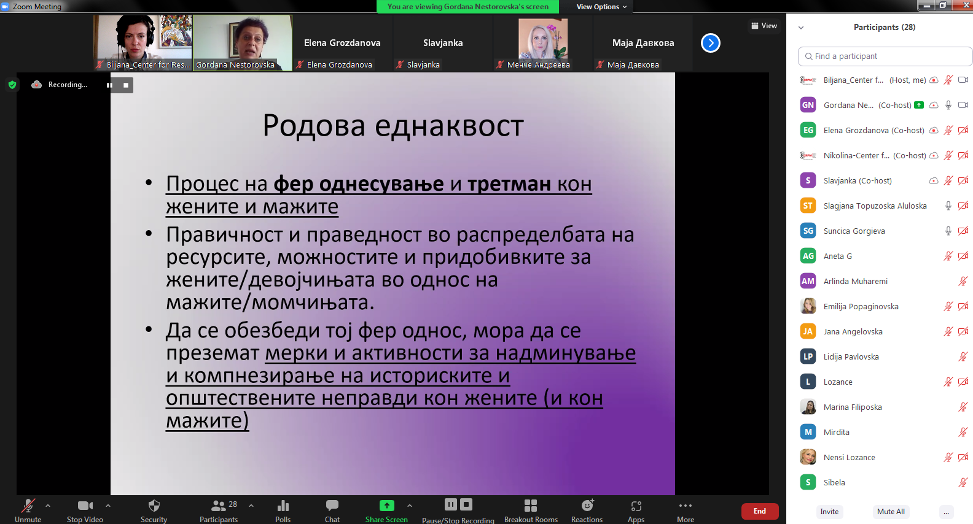

Pic.7.06.06.2022, Hotel Turist - Best Western Skopje
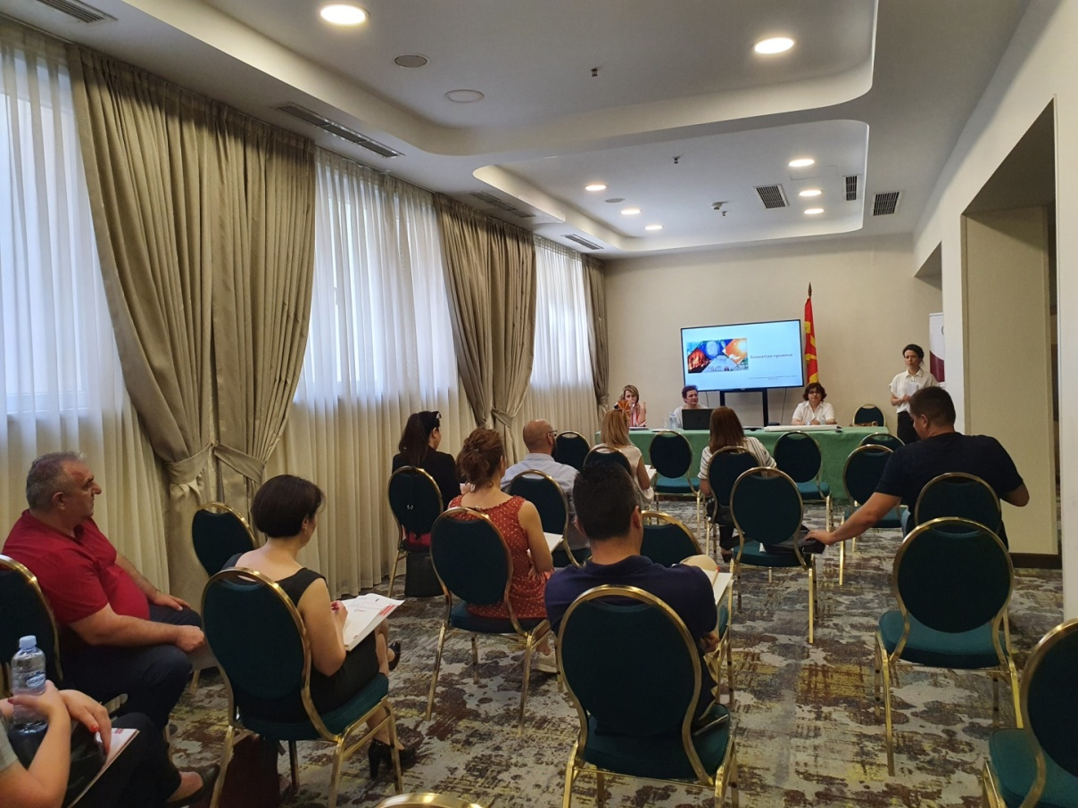
Pic.8. 06.06.2022, Hotel Turist - Best Western Skopje

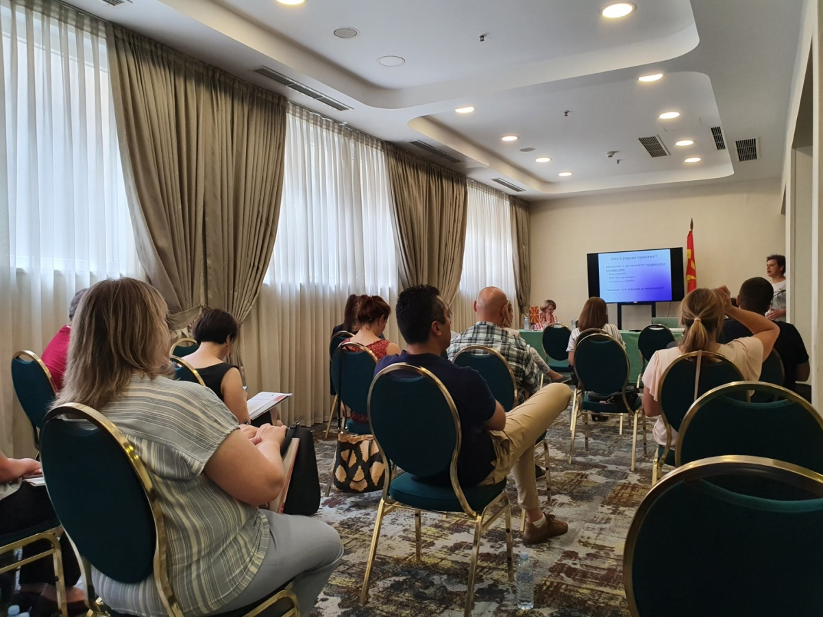

Pic.9. 07.06.2022 – Online – zoom
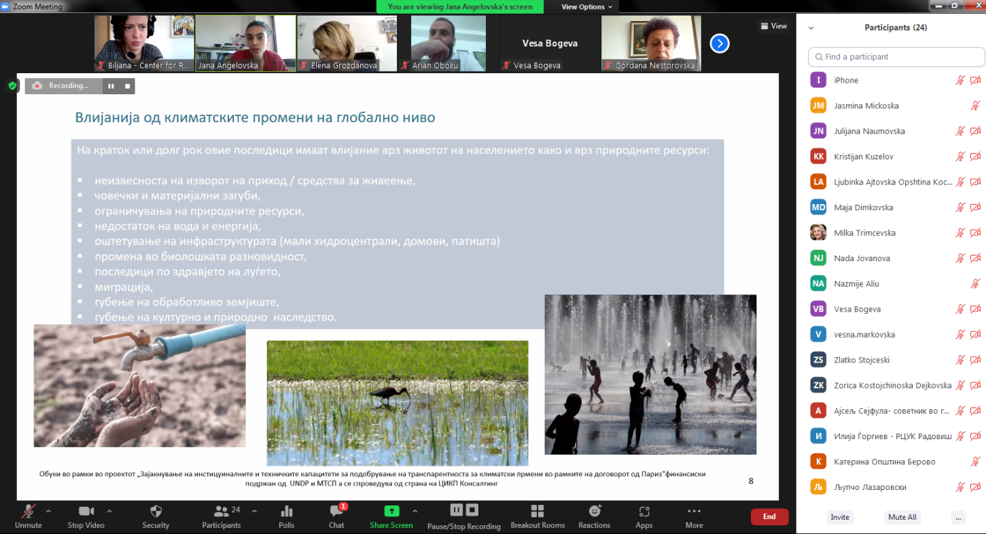
Pic.10. 07.06.2022 – Online – zoom
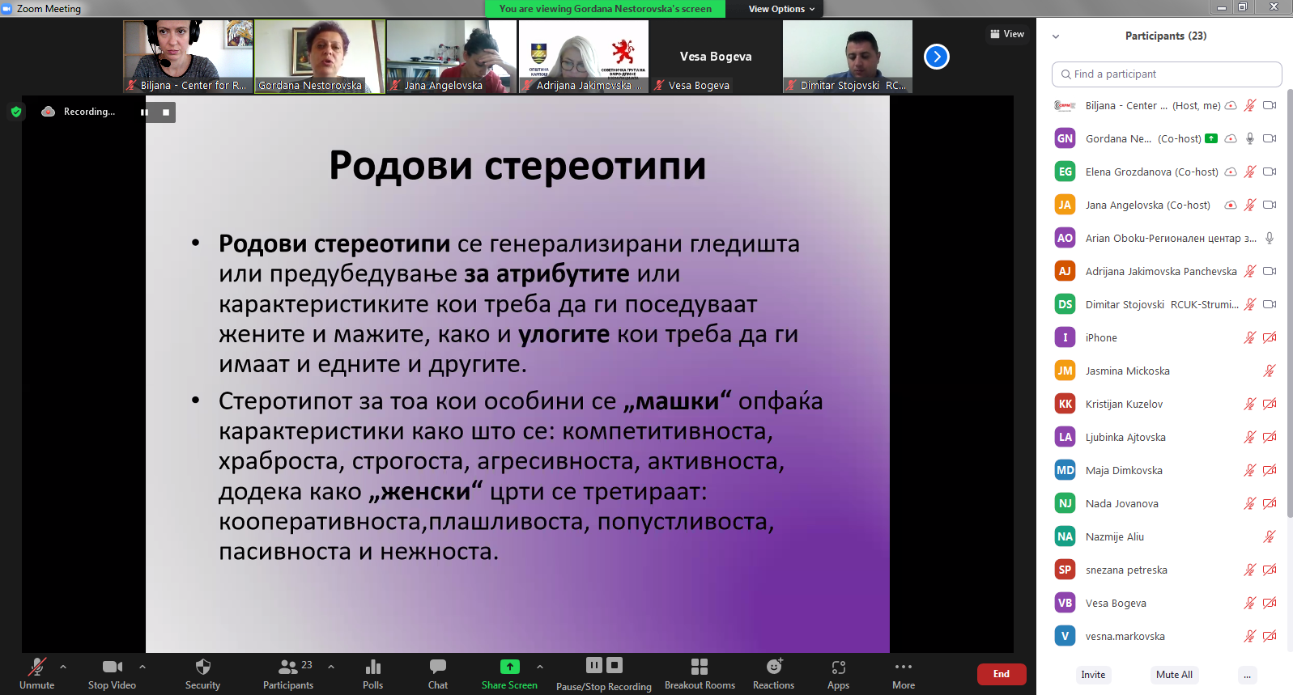

Pic.11. 07.06.2022 – Online – zoom

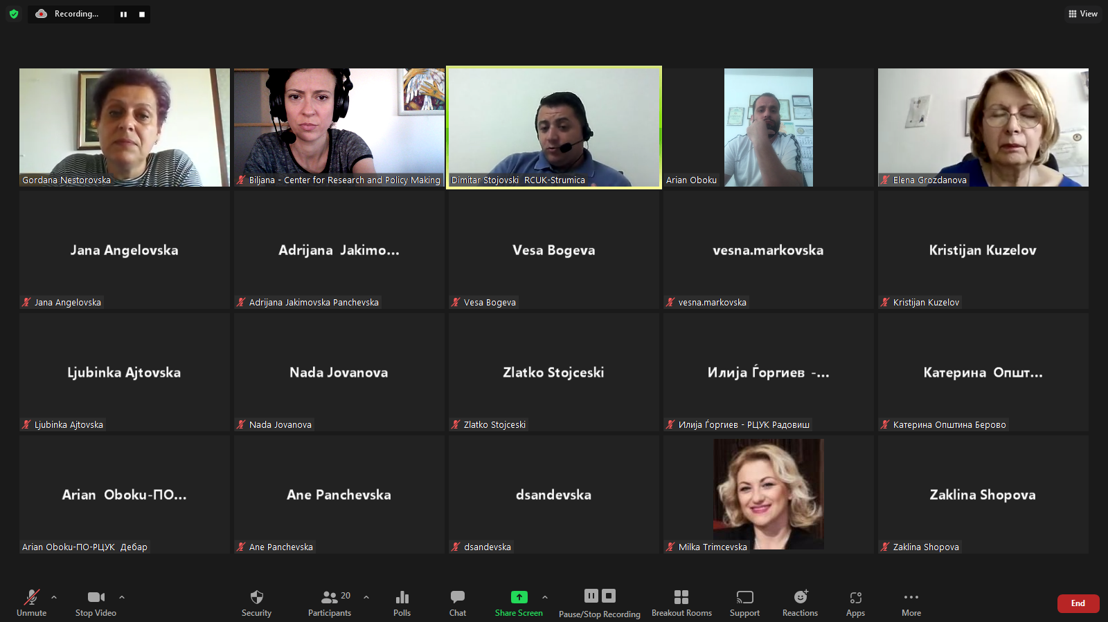

Pic.12. 08.06.2022 – Online – zoom
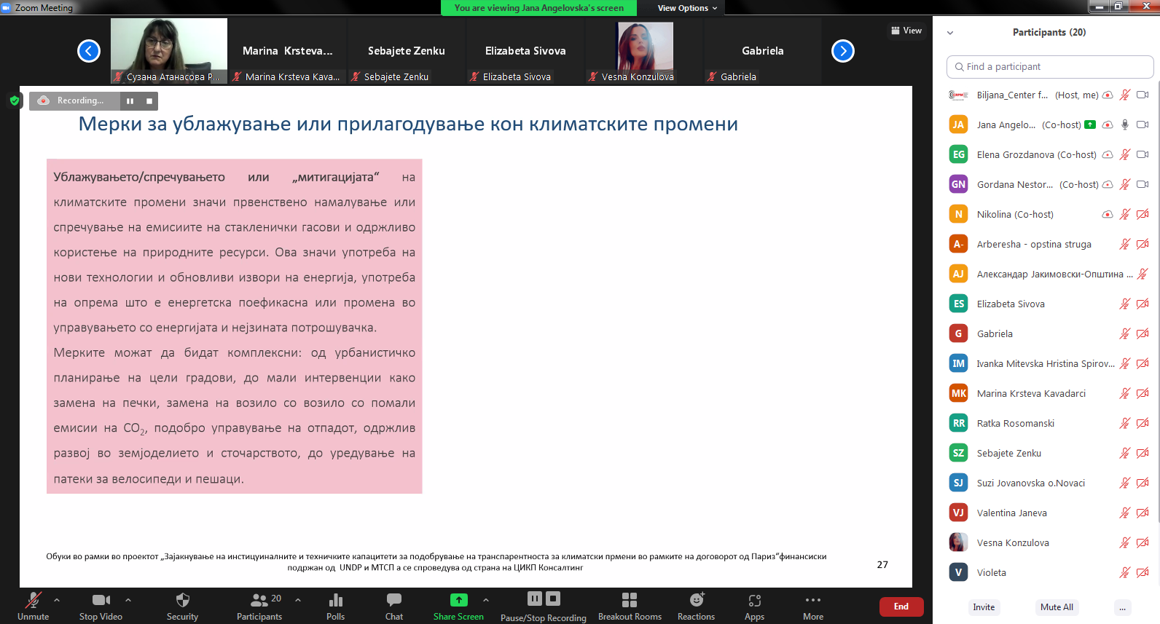

Pic.13. 08.06.2022 – Online – zoom
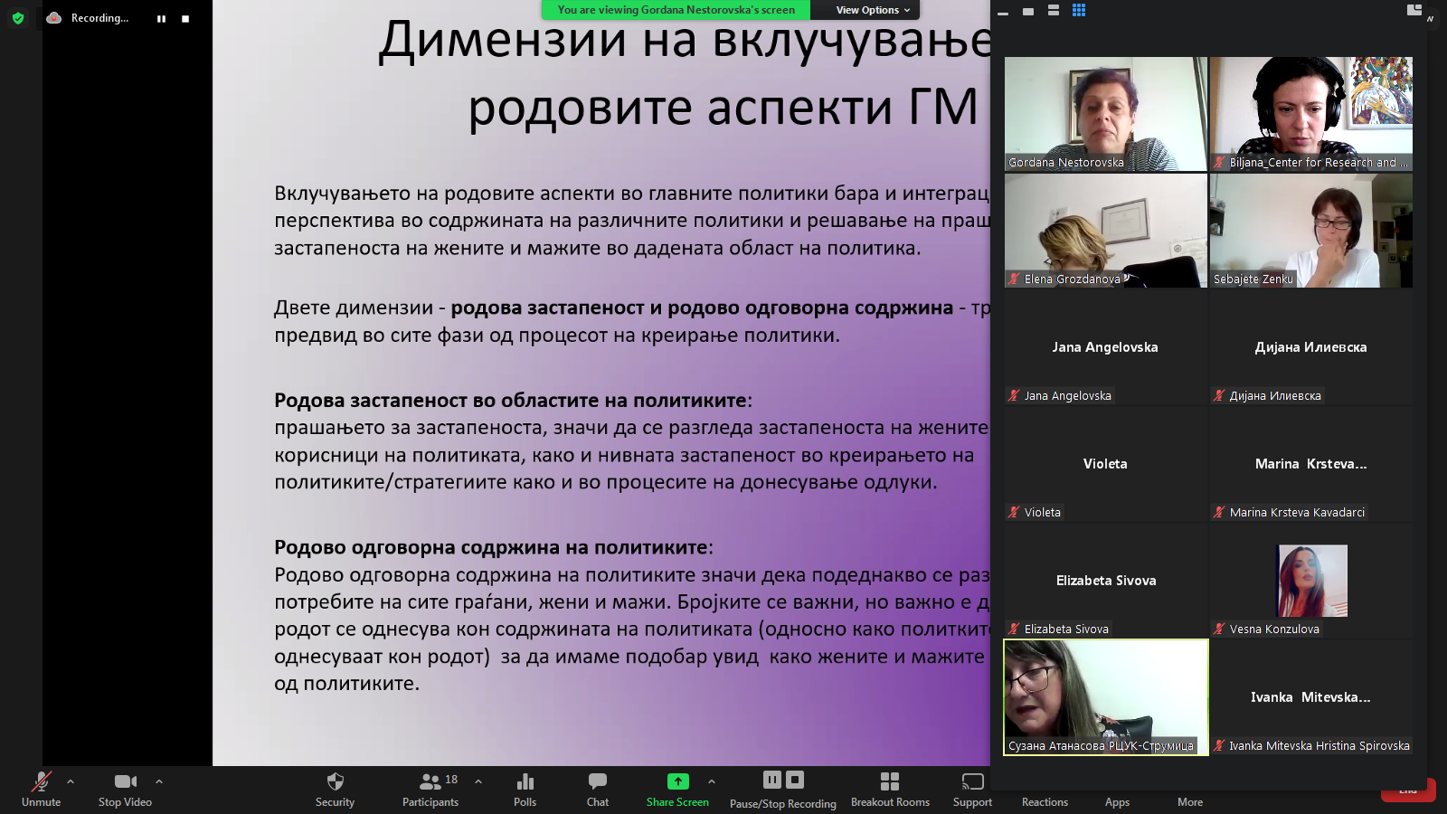

Pic.14. 08.06.2022 – Online – zoom

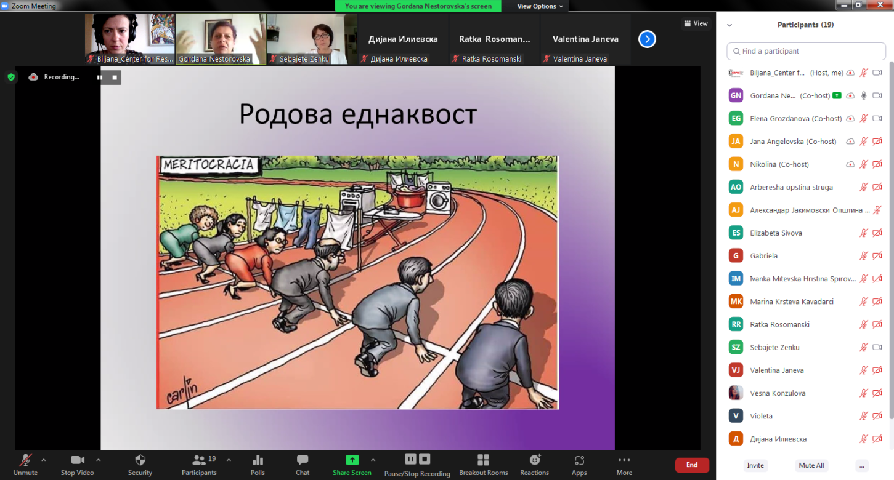

Pic.15.09.06.2022, Hotel Turist - Best Western Skopje
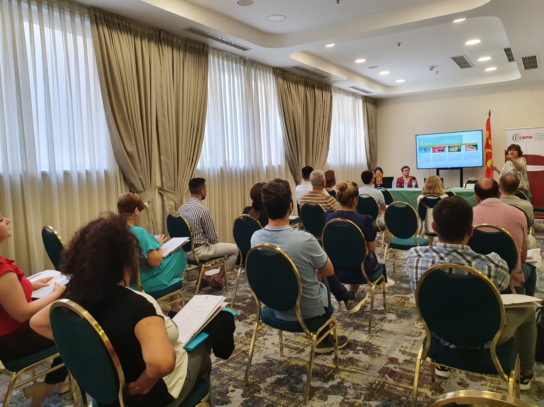
Pic.16. 09.06.2022, Hotel Turist - Best Western Skopje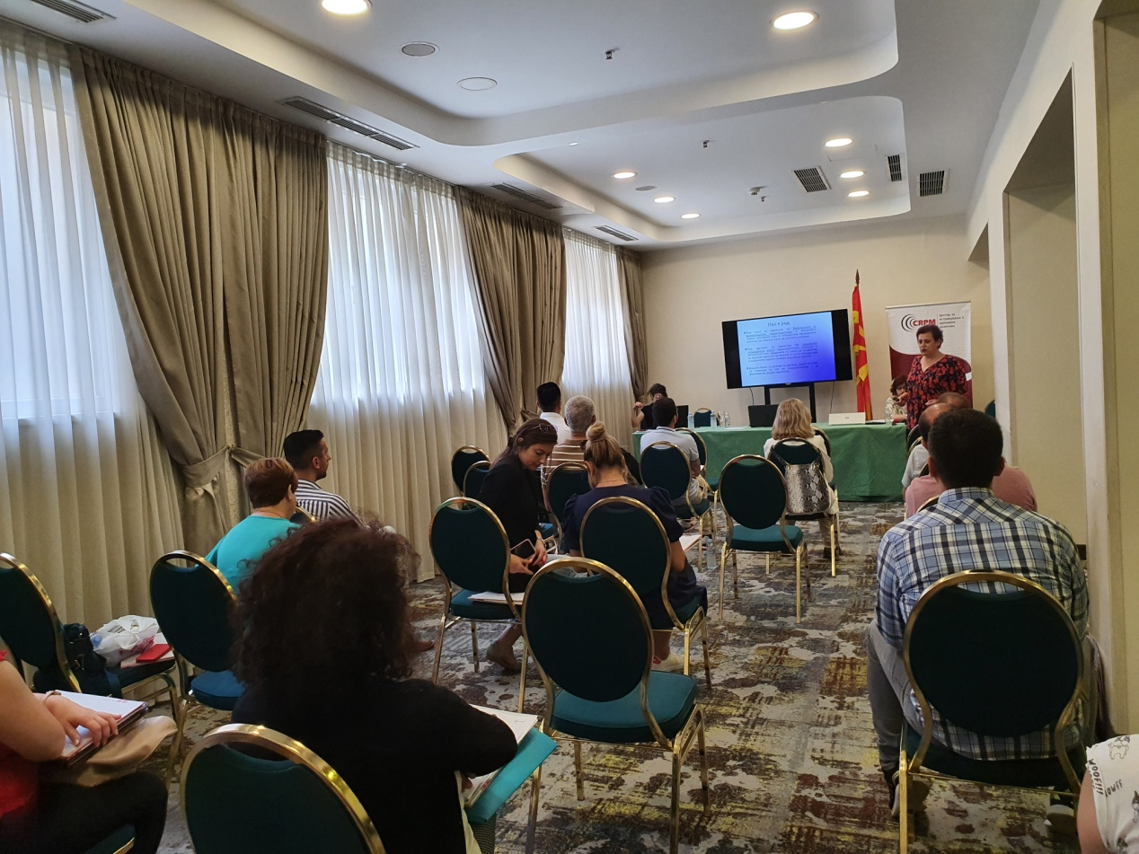
Pic.17. 09.06.2022, Hotel Turist - Best Western Skopje

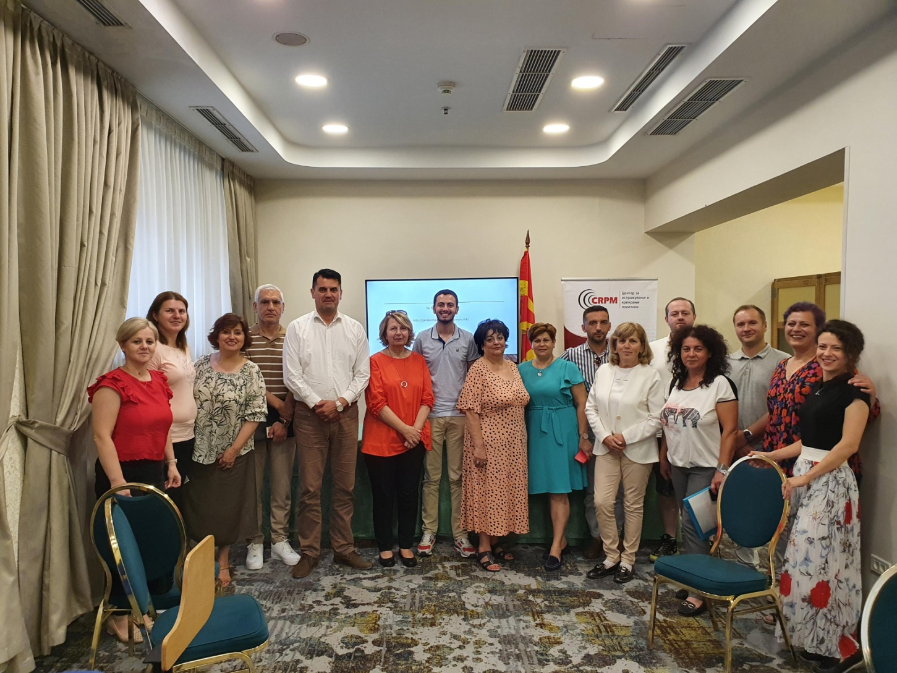

ANNEX 1: List of targeted participants
Presented in separate excel file

ANNEX 2: TNA Questionnaire

- Gender:
- Female
- Male

- Is the gender perspective mainstreamed into your plans and programs?
- Yes
- No
- Don’t know / No opinion

- Do you think that climate change is real?
- Yes
- No
- Don’t know / No opinion

- Is there a connection between gender and climate change?
- Yes
- No
- Don’t know / No opinion

- In your opinion, are men and women equally affected by climate change?
- Yes
- No
- Don’t know / No opinion

- Are you familiar with the impact of public procurement on climate change?
- Yes
- No
- Don’t know / No opinion

- Are you familiar with sustainable public procurement?
- Yes
- No
- Don’t know / No opinion

- Are you familiar with gender integration concepts into public procurement?
- Yes
- No
- Don’t know / No opinion

- Have you ever attended any training course on gender and/or in the field of environment and climate change?
- Yes
- No
- Don’t know / No opinion

ANNEX 3: Questionnaire for workshop evaluation

- Did you acquire knowledge and skills in the field of gender and climate change during the training?
- Yes
- No
- Partially

- Will you include the gender perspective in your plans and programs?
- Yes
- No
- Dont‎' know/No answer

- Are you familiar with the international agreements/initiatives and mechanisms that the country has ratified in the field of climate change and the environment?
- Yes
- No
- Partially

- Are you familiar with the state policies and measures for dealing with climate change at the national and local levels?
- Yes
- No
- Partially

- Did you gain knowledge on sustainable public procurement?
- Yes
- No
- Partially

- Did you gain knowledge on how the gender perspective can be included in the public procurement?
- Yes
- No
- Partially

- Is there a connection between gender and climate change?
- Yes
- No
- Dont‎' know/No answer

- Are men and women affected equally by climate changes?
- Yes
- No
- Dont‎' know/No answer

- Trainer evaluation: Gordana Micovska-Nestorovska (1 being lowest, 5 highest)

- Presentation 1 2 3 4 5
- Interaction 1 2 3 4 5
- Practical examples 1 2 3 4 5
- Exercises 1 2 3 4 5

- Trainer evaluation: Slavjanka Pejchinovska-Andonova (1 being lowest, 5 highest)

- Presentation 1 2 3 4 5
- Interaction 1 2 3 4 5
- Practical examples 1 2 3 4 5
- Exercises 1 2 3 4 5

- Do you need any additional training on this topic?
- Yes
- No

- The lenght of the training was:
- Too short
- Too long
- Optimal

- Assessment the overall organization of the training (1 being lowest, 5 highest)

- 2 3 4 5

- To what extent were your training expectations met?
- To a great extent
- Somewhat
- Very little
- Not at all

- Participant’s recommendations:
________________________________________________________________________________________________________________________________________________________________________________________________________________________________________________________________________________________________________________________________________

ANNEX 4: Training program

Време | Тема | Опис на сесијата
Приклучување на учесниците
10 минути | Отварање на обуката | А) Претставување на учесниците  Б) Презентација на целите на обуката и темите  В) Договор околу правила на однесување онлајн | Претставување (5 мин)  Имајќи ја предвид интердисциплинарноста на темата и потребата да знаеме со кого ќе работиме за време на обука, ќе ги замолиме учесниците на почетокот да се претстават со име, од која општина доаѓаат и на која тема работат.  Добро би било доколку пред обуката добиеме список барем на пријавени учесници за да може да одбележуваме за нас.  Презентација на целите на обуката и кои теми ќе бидат опфатени (5 мин)  Во овој дел ќе дадеме кратко претставување кои теми ќе се работат, накратко претставување што сме добиле како резултат од прашалникот за проценка на потребите
30 мин | Сесија 1: Климатски промени  5 минути дискусија  15 минути презентација  5 минути квиз  5 минути микро наративи | Климатски промени  Што се климатски промени?  Што е ублажување на климатските промени?  Што е прилагодување кон климатските промени?  Дали климатските промени различно влијаат врз мажите, жените, децата, ранливите граѓани? | Предлог:  Дискусија (5 мин.):  -Што се климатски промени? Кои се стакленички гасови и нивни извори?  - Кој придонесува во одвивање на феноменот “климатски промени“?  Човекот со своето делување ИЛИ е само природна појава?  - Дали секој од нас учествува во придонесот кон климатските промени?  Презентација за климатски промени (5 мин)  Ајде сите да дадеме по еден пример за Ваш “допринос” кон климатските промени  - Кои се влијанијата на климатските промени врз човекот, биодиверзитетот, економијата и социјалниот живот?  Размислувајте за себе, Вашето семејство, но и пошироко за заедницата, Ве молам да споделите со сите нас по едно влијание  - Дали климатските промени делуваат подеднакво на мажите и жените, на сиромашните и побогатите, децата и возрасните групи, на тие кои живеат во руралните и/или урбаните средини?  Дали може еден од присутните да сподели размислување како нивните две влијанија влијаат различно на жените и мажите?  - Кои мерки треба да спроведат за да се намалат влијанијата? Мерки за ублажување на влијанијата и/или да мерки за полесно и побрзо да се адаптираме на влијанијата од климатските промени?  Презентација (10 мин.)  Преглед на влијанија на климатските промени врз луѓето и природата, родовата перспектива и влијанијата  Интерактивен квиз (5 мин.) за идентификација на мерки за ублажување/адаптација кон климатските промени  Микро наративи поврзани со климатски промени (5 минути)
5 мин | Пауза
40 мин | Сесија 2  Прилагодување и ублажување на последиците од климатските промени  10 минути вовед  20 минути работа во групи  10 минути презентација | Мерки за прилагодување и ублажување на последиците од климатските промени  Родови улови во процесот на адаптација(ублажување) и прилагодување  Концепт на одржливи набавки | Презентација (10 мин)  Мерки за ублажување и мерки за прилагодување кон климатските промени со родова перспектива (примери од неколку сектори – земјоделие, енергија, транспорт, управување со отпад, управување со води, управување со шуми)  Вовед во концептот на набавки  Вежба(20 минути)– “Одржливи “ набавки во процесот на планирање на политиките за ублажување/прилагодување кон климатските промени и дали и како тие влијаат врз жените и мажите на локално ниво  Активности:  Учесниците да се поделат во 3 групи кои ќе изберат и разработат предизвици од влијание на климатските промени во 3 различни приоритетни сектори.  Секоја група да дефинира цел за надминување на предизвиците и дефинирање на 3 мерки (мерки за ублажување и/или адаптација) :  - Надлежности на општината и влијанијата на глобалните трендови и настани  - Кои сектори се најранливи или најмногу придонесуваат кон климатските промени – изберете сектор  - Кои предизвици во однос на климатските промени се пред Вас за решавање?  - Која е целта на политиката/мерката? За кого е наменета? Дали придонесува кон редуцирање на емисиите на стакленички гасови или кон адаптација кон климатските промени? Кој ќе има придобивка од реализацијата на политиката/мерката?  - Дефинирајте улоги на мажите/жените, улога на ранливите категории во секторот кој се разгледува;  - Каква е улогата и статусот на жените и мажите при анализа на влијанијата и дефинирање на предлог мерките?  - Кои податоци Ви се потребни за да можете да ги оцените потребите на жените и мажите и ранливите категории на граѓани при дефинирање на мерките во дадениот сектор? Дали водите ваков тип на податоци во Вашата институција?  - Што значи одржливи јавни набавки? На што треба да се внимава кога се дефинираат условите за аплицирање за субвенции поврзани со животна средина и климатска акција? Кој може да аплицира, под кои услови, на што треба да се внимава кога се дефинираат техничките спецификации?  Претставување на мерките:  - Презентација на родово одговорни мерки во делот на ублажување/прилагодување кон климатските влијанијаи насоки како да се подобрат состојбите.  Плус Ваше согледување:  - Дали во развиени и одобрени стратешки документи на ниво на општина, град, министерство се земени во предвид климатските промени и специфичните потреби на жените и мажите или пак оценка на политиката врз жените и мажите? Ваше позитивно искуство, но и предлог за подобрување во иднина.  Претставување на работата во групи (5 мин.)
15 мин | Пауза
40 минути | Сесија 3: Разбирање на род и пол и поврзаноста со климатските промени | Презентација и теми за дискусија  а)Родови улоги и стереотипи  б) Родови потреби (практични и стратешки), фактори и родови ---јазови/нееднаквост  в) Како родовите улоги, стереотипи и предрасуди, влијаат на справување со климатски промени | Презентација: родови прашања, родови улоги, родови стереотипи и прерасуди (10 мин)  Вежба (20 мин): Практични и стратешки потреби на жените и мажите и нивниот придонес во продукцијата на стакленички гасови како и улогата во справувањето со климатските промени како на пример во: (1) домот, (2) работа (економија и образование), (3)Јавниот и политичкиот живот  Заклучоци од работата во групии дискусијата (10 мин):  - Како родовите улоги, стереотипи и предрасуди (причинско-последична врска), влијаат на учеството на жените и мажите и во продукцијата но и во справувањето со климатски промени?
5 мин | Пауза
40 мин | Сесија 4: Внесување на родовата перспектива во јавните набавки | - Внесување на родовата перспектива во политиките за климатските промени  - Како да се внесе родовата перспектива во јавните набавки | Презентација со дискусија (15 мин)  - зошто и како да ги клучиме специфичните потреби на жените и мажите во развивање на (локални) планови/стратешки документи за климатски промени  Презентација со дискусија:  Што значи да се внесеродовата перспектива во јавните набавки?  Зошто е тоа важно? На кои елементи треба д асе внимава?  Во кои фази од процесот на јавни набавки може да се внесе родовата компонента и како?
5 мин | Пауза
50 мин | Сесија 5:  Меѓународна и национална стратешка рамка за род и климатски промени  Презентација (25 минути)  Презентација (15 минути) | Меѓународните стандарди и механизми кои државата ги има ратификувано во областа на родовата рамноправност и родовите прашања и национална правна рамка (15 мин.)  Меѓународните стандарди и механизми кои државата ги има ратификувано во областа на животната средина/климатски промени и национални политики (15 мин.)  Родова интеграција  Интерсекторски групи  Цели за оддржлив развој  Мејнстриминг во секој меѓународен акт за животна средина  Граѓанско учество (Аархус) | Презентација со дискусија  Преглед на стратешки документи во однос на родови прашања (цедав и останато) и зошто ни се важни како насоки и препораки (  Меѓународните препораки за родова рамноправност каде е вклучена и родовата компонента и поврзувањето со националната политика  Преглед на меѓународни и национални стратешки документи поврзани со климатски промени и приоритетни сектори  Презентација на меѓународни и национални акциони планови за борба против климатските промени и дали родовата еднаквост е земена во предвид при создавање на документите  Претставување на документ/и каде родовата перспектива е вклучена во развивање на планови/стратешки документи за климатски промени  Дискусија за сите учесници  - што значи ако државата ратификувала некој меѓународен документ?  - дали одговорноста за имплементација на меѓународните договори е само на национално ниво?  - која е врската помеѓу меѓуародниот систем-националниот систем-локален систем за заштита на некое право (на пример на здрава и чиста околина?  - како да ги поврземе родовите прашања и климатските промени? Дали има некој посебен документ кој ги поврзува?  - искуство на учесниците за примена на дел од препораките или приоритетите на локално ниво- позитивни примери?
Дискусија и заклучоци
Евалуација на обуката

ANNEX 5: AGENDAS

АГЕНДА
ВРЕМЕ ТЕМА
10:00 – 10:40 | Отворање на обуката  СЕСИЈА 1: КЛИМАТСКИ ПРОМЕНИ  - Ублажување на и прилагодување кон климатските промени  - Влијанија на климатските промени  Предавач: Славјанка Пејчиновска-Андонова, експертка за климатски  промени
10:40 – 10:45 | Пауза
10:45 – 11:25 | СЕСИЈА 2: ПРИЛАГОДУВАЊЕ И УБЛАЖУВАЊЕ НА ПОСЛЕДИЦИТЕ ОД КЛИМАТСКИТЕ ПРОМЕНИ  - Родово одговорно планирање на активности за ублажување/ адаптација кон климатските промени  - Концепт на одржливи набавки  Предавач: Славјанка Пејчиновска Андонова, експертка за климатски промени
11:25 – 11:40 | Пауза
11:40 – 12:20 | СЕСИЈА 3: РАЗБИРАЊЕ НА РОДОВИТЕ УЛОГИ И СТЕРЕОТИПИ И НИВНАТА ПОВРЗАНОСТ СО КЛИМАТСКИТЕ ПРОМЕНИ  - Родови улоги и стереотипи  - Родови потреби (практични и стратешки), фактори и родови ---јазови/ нееднаквост  - Како родовите улоги, стереотипи и предрасуди, влијаат на справување со климатски промени  Предавач: Гордана Несторовска, експертка за родова еднаквост
12:20 – 12:25 | Пауза
12:25 – 13:05 | СЕСИЈА 4: ВНЕСУВАЊЕ НА РОДОВАТА ПЕРСПЕКТИВА ВО ЈАВНИТЕ НАБАВКИ  - Внесување на родовата перспектива во политиките за климатските промени  - Како да се внесе родовата перспектива во јавните набавки  Предавач: Гордана Несторовска, експерт за родова еднаквост
13:05 – 13:10 | Пауза
13:10 – 14:00 | СЕСИЈА 5: МЕЃУНАРОДНА И НАЦИОНАЛНА СТРАТЕШКА РАМКА ЗА РОД И КЛИМАТСКИ ПРОМЕНИ  - Развојни проекти  - Националниполитикизародот и климатскитепромени
14:00 – 14:30 | Дискусија и заклучоци

А Г Е Н Д А

ВРЕМЕ ТЕМА
10:00 – 10:40 | Отворање на обуката  СЕСИЈА 1: КЛИМАТСКИ ПРОМЕНИ  - Ублажување на и прилагодување кон климатските промени  - Влијанија на климатските промени  Предавач: Славјанка Пејчиновска Андонова, експертка за климатски  промени
10:40 – 11:20 | СЕСИЈА 2: РАЗБИРАЊЕ НА РОДОВИТЕ УЛОГИ И СТЕРЕОТИПИ И НИВНАТА ПОВРЗАНОСТ СО КЛИМАТСКИТЕ ПРОМЕНИ  - Родови улоги и стереотипи  - Родови потреби (практични и стратешки), фактори и родови ---јазови/ нееднаквост  - Како родовите улоги, стереотипи и предрасуди, влијаат на справување со климатски промени  Предавач: Гордана Несторовска, експертка за родова еднаквост
11:20 – 11:35 | Кафе пауза
11:35 – 12:15 | СЕСИЈА 3: ПРИЛАГОДУВАЊЕ И УБЛАЖУВАЊЕ НА ПОСЛЕДИЦИТЕ ОД КЛИМАТСКИТЕ ПРОМЕНИ  - Родово одговорно планирање на активности за ублажување/ адаптација кон климатските промени  - Концепт на одржливи набавки  Предавач: Славјанка Пејчиновска Андонова, експертка за климатски промени
12:15 – 12:55 | СЕСИЈА 4: МЕЃУНАРОДНА И НАЦИОНАЛНА СТРАТЕШКА РАМКА ЗА РОД И КЛИМАТСКИ ПРОМЕНИ  - Развојни проекти  - Национални политики за родот и климатскитепромени
12:55 – 13:05 | Кафе пауза
13:05 – 13:45 | СЕСИЈА 5: ВНЕСУВАЊЕ НА РОДОВАТА ПЕРСПЕКТИВА ВО ЈАВНИТЕ НАБАВКИ  - Внесување на родовата перспектива во политиките за климатските промени  - Како да се внесе родовата перспектива во јавните набавки  Предавач: Гордана Несторовска, експертка за родова еднаквост
13:45 – 14:15  14:15 | Дискусија и заклучоци  Ручек

ANNEX 6: Participants list
30.05.2022 (платформа ЗООМ)
 | ИвицаПанчевски | РаководителнаОдделениезаексплоатацијанакапацитети | frjasen@yahoo.com | ЈПУЗПП Јасен
 | ВерицаГазепова | Виш соработник - ОдделениезаЛокаленекономскиразвој | verica.gazepova@gmail.com | ЕЛС Радовиш
 | ВиолетаКуновска | Советничка/ Комисијазаеднаквиможности | vkunovska2002@yahoo.com | Карпош
 | ЖивкоБелчев | Советник , Претседателнакомисијатазародоваеднаквост | belcev1978@yahoo.com | Гази Баба
 | МеритаЕлмази | Координаторказаеднаквиможности | m.rita_06@hotmail.com | Теарце
 | ГоранИвков | Секторзаоперации и координација | goran.ivkov@cuk.gov.mk | ПОРКОА РЦУК-Штип
 | АлександарЈакимовски | Одделениезаурбанизам,комуналниработи и заштитанаживотнатасредина | alexandar.83@yahoo.com | Лозово
 | ЕлицаЈовевска | Одделениезаурбанизамкомуналнидејностизаштитанаживотнатасредина и ЛЕР | elica.jovevska@yahoo.com | Пехчево
 | Марија Сарамандова | Советничказазаштита и спасување и меснасамоуправа | m.saramandova@radovis.gov.mk | ЕЛС Радовиш
 | ФљораСељими | Секторзаопштиработи/ Одделениезамеснасамоуправа, заштита и спасување | flora_1985@live.com | Тетово
 | АнтоникаИванов | Советничказаутврдување и наплатанаданоцинаимот и комуналнатакса | antonikaivanov@gmail.com | Василево
 | СениферСинаноска | Помладреферентзаадминистративнаподдршка | sinanoska@mail.com | Пласница
 | СанелаАмитоска | Помладреферент | shakiroska@gmail.com | Пласница
 | Маја Јакимова-Милошевски | Правник | jakimovamaja1@gmail.com | Кратово
 | Гајур Салихи | Советник за јавни набавки | gajur_05@hotmail.com | Теарце
 | Билјана Матевска |  |  | ЦИКП
 | Гордана Мицова Несторовска | Обучувачка
 | Славјанка Пејчиновска Андонова | Обучувачка
 | Елена Грозданова | Државен советник за еднакви можности |  | МТСП

31.05.2022 (платформа ЗООМ)
 | МајаДавкова | Советника | majadavkova1@gmail.com | Свети Николе
 | Арлинда Муареми | Раководителка на одделение | arlinda.muharemi@cuk.gov.mk | РЦУК Тетово
 | ЈасминаЌурчиска | Советничка / Претседателка на КЕМ | jkurciska@gmail.com | Делчево
 | ИгорЖежовски | Советниккоординаторзаеднаквиможности и права | zezovski_i@yahoo.com | Делчево
 | Сузана Филипоска | Одговорно лице за јавни набавки | suzanafiliposka@gmail.com | Македонски Брод
 | Сунчица Ѓорѓиева | Советничка | gsuncica992@gmail.com | Делчево
 | МаринаФилипоска | Соработник за анализа, изработка и имаплементација на проекти од областа на животната средина | marina.filiposka@karpos.gov.mk | Карпош
 | Емилија Попагиновска | Сектор екологија и енергетска ефикасност, Одделение екологија | emilija.popaginovska@karpos.gov.mk | Карпош
 | ЈованчеЦветановски | Животна средина | jovan.cvetanoski@karpos.gov.mk | Карпош
 | МирдитаСалиу | Советничка | Mirdita.Saliu@skopje.gov.mk | Град Скопје
 | ТошеТодоров | Советник | tosetodorov@gmail.com | Валандово
 | ТафијеИдризи | Операции и координација | tafije.idrizi@cuk.gov.mk | РЦУК Тетово
 | ВиолетаЈованова | Советничка | jovanova.violeta@yahoo.com | ПО РЦУК Кавадарци
 | АнитаКоцева | Советничка | dimovska.anita@yahoo.com | Валандово
 | Александар Каровски | Советник | akarovski@gmail.com | Гази Баба
 | МенкаАндреева | Советничка | mence.andreeva@yahoo.com | Велес
 | Ристе Стевков | Раководител-ЛЕР | rstevkov@gmail.com | Радовиш
 | АнетаЃоргиевска | Советничка | anetalog73@yahoo.com | Битола
 | ЛидијаПавловска | Советничка | pavlovskal@bitola.gov.mk | Битола
 | Марица Тодоровска | Советничка | todorovskam@bitola.gov.mk | Битола
 | Јулија Тушевска | Советничка | jtusevska@yahoo.com | Валандово
 | Ненси Лозанче | Советничка | lozancen@gmail.com | Битола
 | СибелаМаркова | Советничка | sibela.markova@gazibaba.gov.mk; sibela.markova@hotmail.com | Гази Баба
 | СлаѓанаТопузоска-Алулоска | Советничка | slagjana.topuzoska@hotmail.com | Вевчани
 | Гордана Мицова Несторовска | Обучувачка
 | Славјанка Пејчиновска Андонова | Обучувачка
 | Елена Грозданова | Државен советник за еднакви можности |  | МТСП
 | Билјана Матевска |  |  | ЦИКП
 | Николина Јанева |  |  | ЦИКП
 | Јана Ангелковска |  |  | ЕкоМозаик

06.06.2022 (Бест Вестерн Хотел Турист, Скопје)
 | ШенолИмери | Советникзајавнинабавки | shenol.imeri@gmail.com | Маврово и Ростуше
 | ПетарЃорѓиоски | Раководителнаодделениезастратешкоуправување и планирање и подигањенајавнатасвествоживотнатасредина | petar.gjorgjioski@skopje.gov.mk | Град Скопје
 | ТомиславАндреев | Животнасредина | tomislav.andreev@strumica.gov.mk | Струмица
 | Нела Масалковска | ЛЕР / Координаторказаеднаквиможностинамажи и жени | nela.masalkovska@strumica.gov.mk | Струмица
 | ТањаАнчевска | Советничка | tanja.ancevska@kiselavoda.gov.mk | Кисела Вода
 | СоњаЦветковиќ-Чолакова | РаководителканаСекторзазаштитанаживотнатасредина | sonja.cvetkovikjcholakova@skopje.gov.mk | Град Скопје
 | ПероНиколов | Советник | peronikolov@yahoo.com | Кавадарци
 | ОмерМуратоски | Јавни набавки | muratoski29@gmail.com | Маврово и Ростуше
 | БојанБојкоски | Советник | bojanbt@gmail.com | Битола
 | БлагицаЦветановска | Советничка | blagica.cvetanovska@karpos.gov.mk | Карпош
 | СлаѓанаПајмакоска | Советничка | pajmakoskas@gmail.com | Центар
 | ЉупчеСофрониевски | Советник за подготовки на субјектите на сиситемот од интерес | ljupce.sofronievski@cuk.gov.mk | ПО РЦУК Кичево
 | Ангела Анѓеловска | Секторзакомуналниработи, инфраструктура, собраќај и заштитанаживотнатасредина/ Одделениезаживотнасредина | angela.angjelovska@kiselavoda.gov.mk | Кисела Вода
 | Игор Николов | ПретседавачнаСовет | igor.g.nikolov@gmail.com | Бутел
 | СветланаКолариќ | Советничка | drsvetlanakolaric@yahoo.com | Кисела Вода
 | ЛидијаМалинковска | Советничка | lidija.malinkovska@kiselavoda.gov.mk | Кисела Вода
 | Едис Јукиќ | Член на Совет | 077 568 692 | Студеничани
 | Гордана Мицова Несторовска | Обучувачка
 | Славјанка Пејчиновска Андонова | Обучувачка
 | Елена Грозданова | Државен советник за еднакви можности |  | МТСП
 | Билјана Матевска |  |  | ЦИКП
 | Николина Јанева |  |  | ЦИКП

07.06.2022 (платформа ЗООМ)
 | ЖаклинаШопова | Советничка | Zhaklina.Shopova@skopje.gov.mk | Град Скопје
 | МилкаТримчевска | Советничка | milkasovet2021@gmail.com | Аеродром
 | АјсељСејфула | Советничка | ajselerdem@gmail.com | Град Скопје
 | ДимитарСтојовски | Советник | dimitar_stojovski@yahoo.com | ПО РКОА РЦУК - Струмица
 | ЉупчоЛазаровски | Советник | Ljupco_L@yahoo.com | Кратово
 | ИлијаЃоргиев | Сектор за операција и координација | ilija.gjorgiev@cuk.gov.mk | РЦУК - Радовиш
 | ВеснаМарковска | Советниккоординаторказаеднаквиможностинажените и мажите | vesna.markovska@aerodrom.gov.mk | Аеродром
 | ЗлаткоСтојчески | Помладсоработникзародоваеднаквост | zlatko.stojceski@aerodrom.gov.mk | Аеродром
 | НадаЈованова | Советничка | nadajovanova552@yahoo.com | Велес
 | ЉубинкаАјтовска | Координаторказаеднаквиможностинажените и мажите | ajtovska@mail.com | Кочани
 | КатеринаМихајловска | Инспекторка за животна средина | katjammm@hotmail.com | Берово
 | ЗорицаКостојчиноска-Дејковска | Вишсоработникзаадминистрирањеналокалниданоци, такси и надоместоци | zorica_kd@yahoo.com | Вевчани
 | Љуљзим Адеми | Советник | Lulzimademi1986@gmail.com | Крушево
 | Маја Димковска | Одделенски наставник | mj_dimkovska@yahoo.com | Бутел
 | Снежана Петреска | Директорка на ООУ “Св. Климент Охридски” | spetreska76@yahoo.com | Бутел
 | ЈасминаМицкоска | Советничкапоопшти и административниработи | mina_oh@live.com | ЈП закомуналнадејност -Дебрца
 | АдријанаЈакимовска-Панчевска | Советничка | aadrijana.panchevska@gmail.com | Карпош
 | Кристијан Кузелов | Советник |  | Свети Николе
 | ЈулијанаНаумовска | Соработник за социјална детска и здравствена заштита | julijana.naumovska@resen.gov.mk | Ресен
 | ВесаБогева | Советничка | vesabogeva@hotmail.com | Кавадарци
 | АрианОбоку | Секторот за операција и координација | arian.oboku@cuk.gov.mk | ПО РЦУК - Дебар
 | НазмијеАлији | Локален економски развој | aliunazmije1@gmail.com | Боговиње
 | Гордана Мицова Несторовска | Обучувачка
 | Славјанка Пејчиновска Андонова | Обучувачка
 | Елена Грозданова | Државен советник за еднакви можности |  | МТСП
 | Билјана Матевска |  |  | ЦИКП

08.06.2022 (платформа ЗООМ)
 | Себајете Зенку | Член КЕМ | szenku@yahoo.com | Гостивар
 | НиколаКоњановски | Советник | konjanovski@gmail.com | Кратово
 | СузанаАтанасова | Советничказааналитикананастани и појави | suzana.atanasova@cuk.gov.mk | ПОРКОА РЦУК - Струмица
 | Иванка Митевска | Советничка | ivanka.koleva@yahoo.com | Кратово
 | Христина Спировска | Советничка | tinakratovo@gmail.com | Кратово
 | ВиолетаЗдравевска | Советничка | violeta.zdravevska@gazibaba.gov.mk | Гази Баба
 | Ратка Росомански | Советничка | ratce_s@yahoo.com | Кавадарци
 | Валентина Јанева | Советничка | vale_janeva1@hotmail.com | Валандово
 | МаринаКрстева | Советничка | marina_marin4e@live.com | Кавадарци
 | ЕлизабетаСивова | ЈПКД "Комуналец" -(СоветничкавоСовет) | sivovaelizabeta@yahoo.com | Гевгелија
 | Сузана Јовановска | Советничка | suzi_1984@live.com | Новаци
 | АлександарЈакимовски | Помладсоработникзаизработканапрограмипроекти и планскадокументацијазазаштитанаживотнатасредина | alexandar.83@yahoo.com | Лозово
 | ГабриелаРадева | Советничка | Radevagabriela25@gmail.com | Зрновци
 | Весна Конзулова | Секретарка | velkova22@gmail.com | Радовиш
 | ДијанаИлиевска | Претседателка на Совет | dijana.ilievska@gazibaba.gov.mk | Гази Баба
 | АрберешаВлаши | Претседател на Совет | arbereshavlashi@gmail.com | Струга
 | ЃорѓиТанушев | Претседател на КЕМ | gorgi.tanusev@strumica.gov.mk | Струмица
 | ВеснаНичева | Советничка | vnicheva@yahoo.com | Штип
 | Гордана Мицова Несторовска | Обучувачка
 | Славјанка Пејчиновска Андонова | Обучувачка
 | Јана Ангеловска |  |  | ЕкоМозаик
 | Елена Грозданова | Државен советник за еднакви можности |  | МТСП
 | Билјана Матевска |  |  | ЦИКП
 | Николина Јанева |  |  | ЦИКП

09.06.2022 (Бест Вестерн Хотел Турист, Скопје)
 | ВисарПалоши | Член на Совет | visar.palloshi@tetova.gov.mk | Тетово
 | БорчеКорлевски | ЧленнаКомисиивоСоветотзародоваеднаквост, финасии, спорт, социјална заштита и претседателнаКомисијазаевроинтеграции | korlevskib@bitola.gov.mk | Битола
 | Златко Лозановски | Советник | lozanovskiz@bitola.gov.mk | Битола
 | Васе Канзуров | Советник | v.kanzurov@aerodrom.gov.mk | Аеродром
 | Татјана Нанкова | Член на Совет | tatjana.nankova@kiselavoda.gov.mk | Кисела Вода
 | ИлиридаАбази | Помладсоработник | didi0507@icloud.com | Врапчиште
 | Мунира Куч | Советничка | munira.kuch@skopje.gov.mk | Град Скопје
 | Филип Јаневски | Член на Совет | Filip.Janevski@skopje.gov.mk | Град Скопје
 | Теута Мирто | Претседателка на Совет | mirto.amina@gmail.com | Маврово и Ростуше
 | Лидија Стаменковска | Референт | lidijastamenkova685@gmail.com | Аеродром
 | Славица Тодороска | Советничка за животна средина | slavica-t@live.com | Брвеница
 | Гајур Салихи | Советник за јавни набавки | gajur_05@hotmail.com | Теарце
 | Наим Алији | Советник | naim.aliji@cuk.gov.mk | ЦУК
 | Марија Сарагинов | Помлад соработник | marija.saraginov@cuk.gov.mk | ЦУК
 | Ајман ал Малла | Раководител на сектор за животна средина | ajman.almalla@resen.gov.mk | Ресен
 | Наташа Стојческа | Виш соработник | Stojceskanatasa@hotmail.com | Брвеница
 | Арберор Баша | ЛЕР - Советник | Arberor.Basha@dibra.gov.mk | Дебар
 | Елена Младеновска | Помлад соработник | elena_opstinapetrovec@yahoo.com | Петровец
 | Гордана Мицова Несторовска | Обучувачка
 | Славјанка Пејчиновска Андонова | Обучувачка
 | Елена Грозданова | Државен советник за еднакви можности |  | МТСП
 | Билјана Матевска |  |  | ЦИКП
 | Николина Јанева |  |  | ЦИКП

ANNEX 7 Scanned list of participants

