UNDP Mauritius and Seychelles – Organigram - CORE June 2022

UNDP Mauritius and Seychelles - Organigram Environment Project Teams June 2022
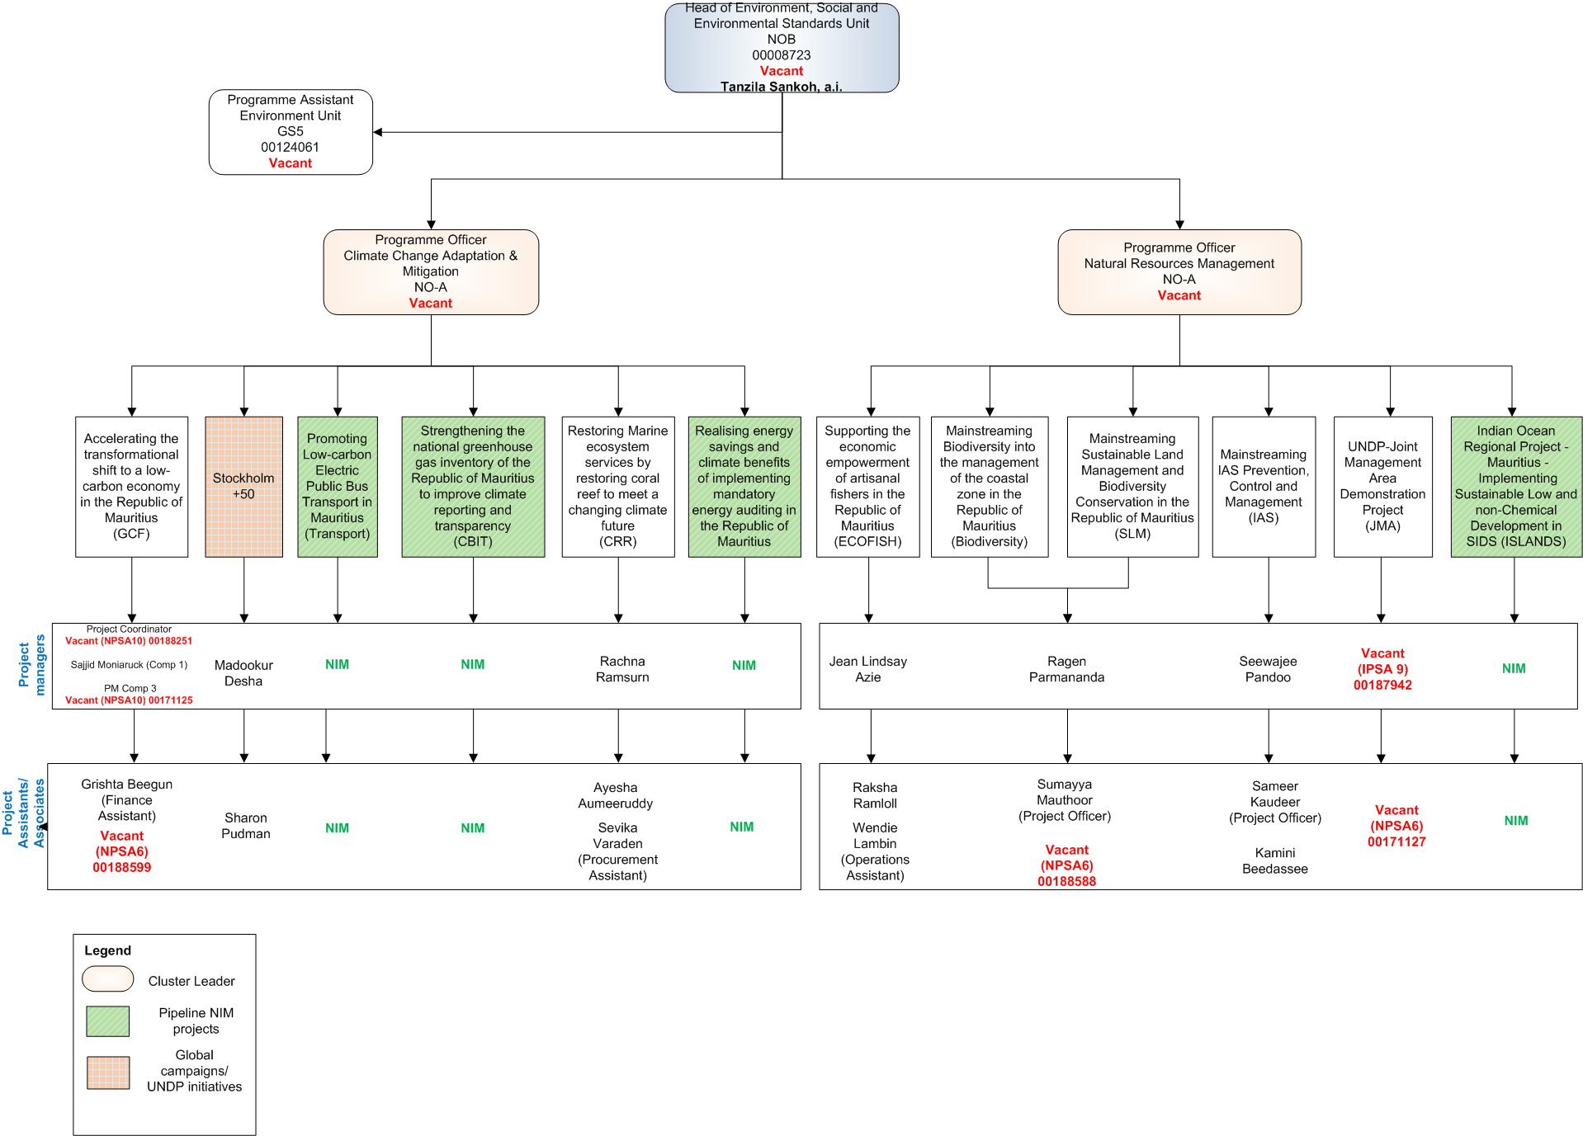

UNDP Mauritius and Seychelles - Organigram Socio-Economic Development Project Teams June 2022

UNDP Seychelles - Organigram Project Office Team June 2022

