

**CONSULTANCY TO ASSESS POTENTIAL FOR COMMUNITY FORESTRY MANAGEMENT IN PARTS OF GEF V PROJECT AREA**

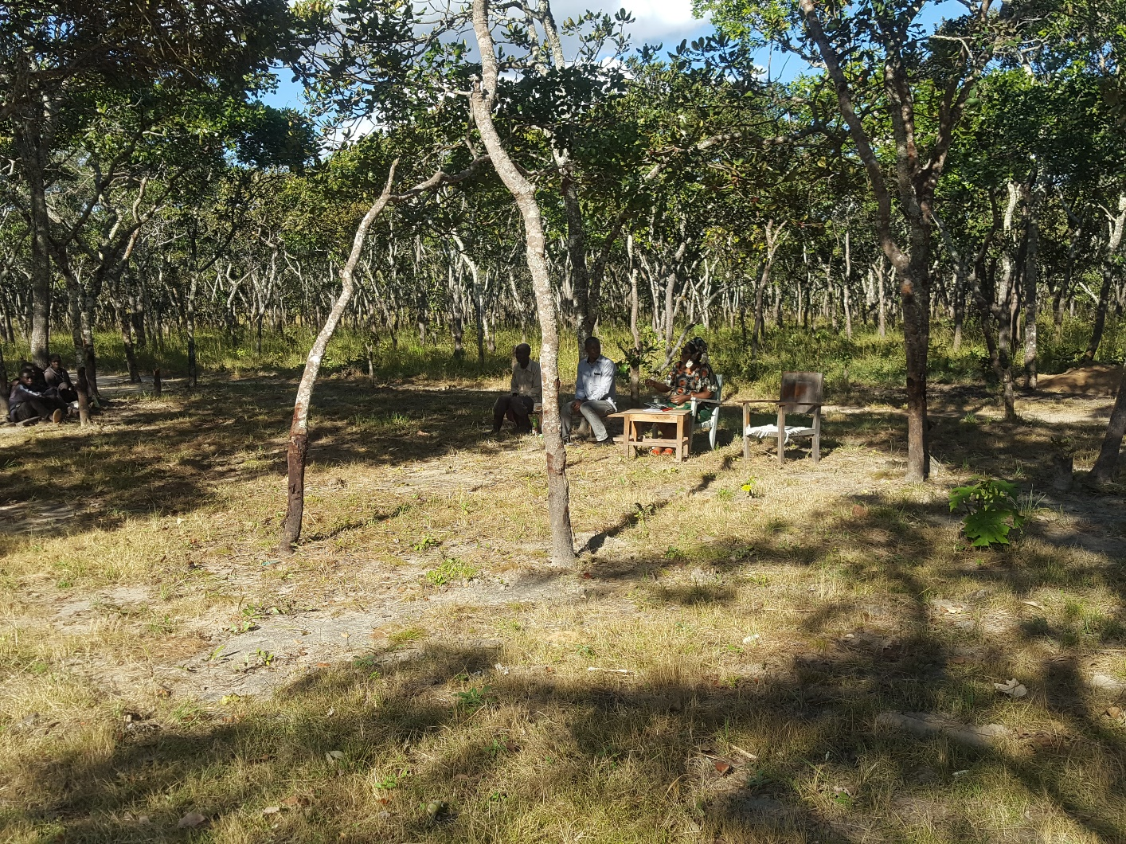

**June 2018**

# **EXECUTIVE SUMMARY**

Zambia’s bio-diversity is protected in twenty (20) Wildlife National Parks, thirty-six (36) Game Management Areas (GMAs) and four hundred and seventy-nine (479) National and Local Forest Reserves, covering 8%, 22% and 9.4% respectively, of the country s’ land area however, the area surveyed by this assignment is 67 741 km2, equivalent to 9.0% of the total land mass of Zambia. The GEF V Project Area, which is the target area of this study, covers78,185km2, comprising Kafue National Park (KNP) (22,480km2), West Lunga National Park (WLNP) (1,684km2) and thirteen (13) Game Management Areas (GMAs) (54,021km2). These cover 10.4%, 3.0%, 0.2% and 7.2% respectively, of the country s’ land area. The Project area is composed of seventy-seven (77) Village Action Groups (VAGs) of which twenty five (25) have been prioritized for the implementation of Community Forestry Management (CFM).

The objectives of this study were to assess the potential for Community Forestry Management in the Project area, and secondly, to assess the willingness of the Community in respective VAGs to participate in CFM and in the formulation of Community Forest Management Plans (CFMPs).

The potential for CFM in the Project area was assessed, in the light of, the availability of forest resources, accessibility, water logging and the current and potential economic use of the forest resources. The number of alternative income generating activities that could turn the focus of the community away from the exploitation of forest and wildlife resources also helped in the ranking of the potential for CFM.

The willingness of the communities to participate in CFM was identified by means of a questionnaire. The study findings are that the communities are very willing to participate in CFM and in the formulation of community forestry management plans, notwithstanding that sustain this activity after the Project life may be a problem. The study also revealed that communities are mostly interested in livestock development, beekeeping, diversified agriculture and fish farming, within the Project VAGs. In the recent past cost/benefit sharing was found to be the most challenging aspect of CFM to deal with. However, the enactment of SI no 11 of 2018 has improved the scenario significantly since the communities have an opportunity to decide on the cost/benefit sharing mechanism without influence from government.

In summary, the conclusion of the study is that:

* The potential for CFM is very high in the Project Area due to the fact that it is located in good wooded areas where the tree populations constitute either primary or good secondary vegetation.
* The communities in both the KNP and WLNP ecosystems are very willing to participate in the formulation of CFMPs.

The success of the CFM implementation however, will depend on a number of issues including:-

* Whether the Project will succeed in building a sense of ownership, in the community, of the natural resources around them, thereby inculcating a sense of responsibility towards these resources; and
* How long the Project will take to roll out interventions that will directly accrue to the community, as they are becoming “fatigued”, by the sense that the Project Staff and Consultants, working on behalf of the Project, are earning money at their expense.

Accordingly, the study makes the following recommendations:-

* The Directorate of Forestry has generated SI No. 11 of 2018, a very progressive, positive and significant piece of legislation which is relevant regarding the implementation of CFM. Being new, these regulations require continuous monitoring and assessment in order to ensure a better understanding; and ease implementation by all parties concerned.
* The Project staff should work with the community to determine which of the prioritized income generating activities should be implemented.

**Table of Contents**

**EXECUTIVE SUMMARY** 2

**LIST OF FIGURES** 7

**LIST OF TABLES** 7

**LIST OF ACRONYMS** 8

**1.** **INTRODUCTION** 11

**1.1** **Background and Context** 13

**1.2 GEF V Brief Project Description** 20

**1.2.1. Expected project outcomes/key results** 21

**1.3 Project Area** 22

**1.4 Biophysical Data of Zambia** 24

**1.4.1 Bio-Physical Environment** 24

**1.4.2 Bio-Physical Environment of Central Northwestern and Western Provinces** 27

**1.5 Local Context** 37

**1.5.1 Land use** 39

**1.6 Main Project Objective** 60

**2 METHODOLOGY** 62

**2.1 Outline of the Methods of Data Collection and Analysis** 65

**2.2** **Legal and Policy Frameworks in Community Based Natural Resource Management** 69

The Water Resources Management Act No 21 of 2011 69

**2.2.2** **Zambia Wildlife Act, 2015** 71

**2.2.3** **Land Act of 1995 and Land Acquisition Act of 1995, Chapter 189** 71

**2.2.4** **Environmental Management Act No. 12 of 2011** 72

**2.2.5** **National Heritage Conservation Act of 1989** 75

**2.2.6** **Forests Act No. 4 of 2015** 75

**2.2.8 The Local Government Act, 1991** 77

**2.2.9 The Mines and Mineral Development Act, 2015** 77

**2.2.10 Agricultural Lands Act** 78

**2.2.11** **Fisheries Act, 2011** 78

**2.2.12** **The International Conventions and Protocols** 79

**2.3 Analysis of Legal and policy Framework related to CBNRM** 80

**3** **STUDY FINDINGS AND DISCUSSION** 83

3.1 Primary Data 83

**3.1.1** **Potential for CFM** 83

3.1.2 Economic Activities 83

**3.1.3** **Forest Related Economic Activities** 86

**3.1.4** **Proposed Income Generating Activities** 88

3.1.5 Women Friendly Economic Activities 101

**3.1.6 Implementation Partners** 102

3.1.7 Perceptions of Plant and Animal Abundance 108

3.1.8 Community Willingness to participate in CFM 110

**3.2** **Secondary Data** 113

**3.2.7** **Lesson Learnt From Other Projects** 113

**3.2.8** **Sustainability of Project interventions** 117

**3.3** **Potential CFM Models/Types in the Project Area** 118

**3.3.7** **Participatory conservation** 119

**3.3.8** **Joint forest management** 120

**3.3.9** **Community forestry with limited devolution** 120

**3.3.10** **Community forestry with substantial or full devolution** 121

**3.3.11** **Private forest ownership** 122

**4.** **CONCLUSION** 126

**5.** **RECOMMENDATIONS** 131

**6. REFERENCES AND BIBLIOGRAPHY 134**

**7. APPENDICES 137**

# **LIST OF FIGURES**

Figure 1.1: Map of National Parks and GMAs in Zambia 12

Figure 1.2: Map of Forest Management Areas in Zambia 13

Figure 1.3: Map of Africa Showing the Extent of Adoption of CBFM by Countries 19

Figure 1.4: Agro - Ecological Regions Map of Zambia 24

Figure 2.1: Group Discussion with Key Informants 67

Figure 2.2: Group Discussion with Community Members 68

Figure 3.1: Economic Activity by Ecosystem 84

Figure 3.2: Forestry Related Economic Activities by Ecosystem 87

Figure 3.3: Current Economic Activity against recommended Economic Activity 100

Figure 3.4: Current Economic Activities against Proposed Economic Activity 100

# **LIST OF TABLES**

Table 1.1: Total Forest and Land Area under CBFM in Africa 16

Table 1.2: GEF Project Area 23

Table 1.3: Extent of Ecosystems in Zambia 25

Table 1.4: Summary of Bio-physical Environment of Zambia in Central, Northwestern and Western Provinces 27

Table 1.5: Problems, Causes and opportunities for Restoration/ Management 41

Table 1.6: Problems, root causes and opportunities for Change- Maunga VAG 46

Table 1.7: Summary of Problems, Causes and opportunities - Manyawu VAG 50

Table 1.8: Problems, Causes, opportunities for restoration –Lalafuta VAG 53

Table 1.9: Problems, Causes, Opportunities for Restoration/ Management - Kaminzekenzeke 56

Table 1.10: Problems, Causes, Opportunities for Change - Kanzenzi VAG 59

Table 1.11: Summary of Terms of Reference and Actions 61

Table 2.1: Stakeholder Map 63

Table 3.1: Income Generating Activities- Possible and Potential 90

Table 3.2: Stakeholders in the surveyed Project Area……………………………………….100

Table 3.3: Perceptions regarding Increase in Animal and Tree Population 109

Table 3.4: VAGs Prioritized for CFM 110

Table 3.5: Content of a simple Management Plan 112

Table 3.6: Proposed Alignment of CFM Models with VAGs in Project Area………………123

Table 4.1: Summary of Study Findings in Relation to the Terms of Reference 126

# **LIST OF ACRONYMS**

ALERT African Lion Environmental Research project

ADMADE Administrative Management Design for Game Management Areas

CBFM Community Based Forest Management

CBNRM Community Based Natural Resource Management

CFAs Community Forest Areas

CFM Community Forest Management

CFMG Community Forest Management Group

CFMPs Community Forest Management Plans

CFU Conservation Farming Unit

CLAs Community Liaison Assistants

CITES Convention on International trade on Endangered Species

CPWH Convention on the Protection of World Heritage

CRB Community Resource Board

CWII Convention on Wetlands of International Importance

DoA Director of Agriculture

DNPW Department of National Parks and Wildlife

EPB Environmental Project Brief

EIA Environmental Impact Assessment

FAO Food and Agriculture Organization of the United Nations

FDHQ Forestry Department Headquarters

FISP Farm Input support Programme

FMC Forest Management Committee

FMPs Forest Management Plans

FOSA Forest Outlook Study for Africa

FRMP Forest Management Project

GMA Game Management Areas

GEF Global Environmental Facility

GRZ Government of the Republic of Zambia

IGAs Income Generating Activities

ILUPs Integrated Land Use Plans

IUCN International Union for the Conservation of Nature

JFM Joint Forest Management

JFMA Joint Forest Management Area

KFNP Kafue National Park

LULUCF Land Use Land-Use Change and Forestry

MEAs Multilateral Environmental Agreements

MLNR Ministry of Lands and Natural Resources

MoA Ministry of Agriculture

MTENR Ministry of Tourism, Environment and Natural Resources

NDPs National Development Plans

NGO Non-Governmental Organization

NP National Park

NWFPs Non-Wood forest Products

PA Protected Area

PES Payment for Environmental Services

PFAP Provincial Forest Action Programme

PFM Participatory Forest Management

PPP Public Private Partnership

REDD+ Reducing Emissions from Deforestation and Forest Degradation

SFM Sustainable Forest Management

TBZ Tobacco Board of Zambia

UNCBD United Nations Convention on Biological Diversity

UNCCD United Nations Convention to Combat Desertification

UNDP United Nations Development Programme

UNFCCC United Nations Framework Convention on Climate Change

UNFF United Nations Forum on Forests

USAID United States Agency for International Development

VAGs Village Action Groups

WARMA Water Resources Management Authority

WCRF Wildlife Conservation Protection Fund

WLNP West Lunga National Park

ZAWA Zambia Wildlife authority

ZEMA Zambia Environmental management Agency

# **INTRODUCTION**

Zambia’s bio-diversity is protected in twenty (20) Wildlife National Parks, thirty-six (36) GMAs and four hundred and seventy-nine (479) National and Local Forest Reserves, covering 8%, 22% and 9.4% respectively, of the country’s land area, as shown in Figures 1.1 and 1.2 below. However, the state of most national parks and forest reserves is of much concern when considering biological diversity. Several forest reserves are at various stages of encroachment. In addition, eleven (11) out of the twenty (20) national parks are either declining or degraded in status due to poaching, and the situation is worse in GMAs.

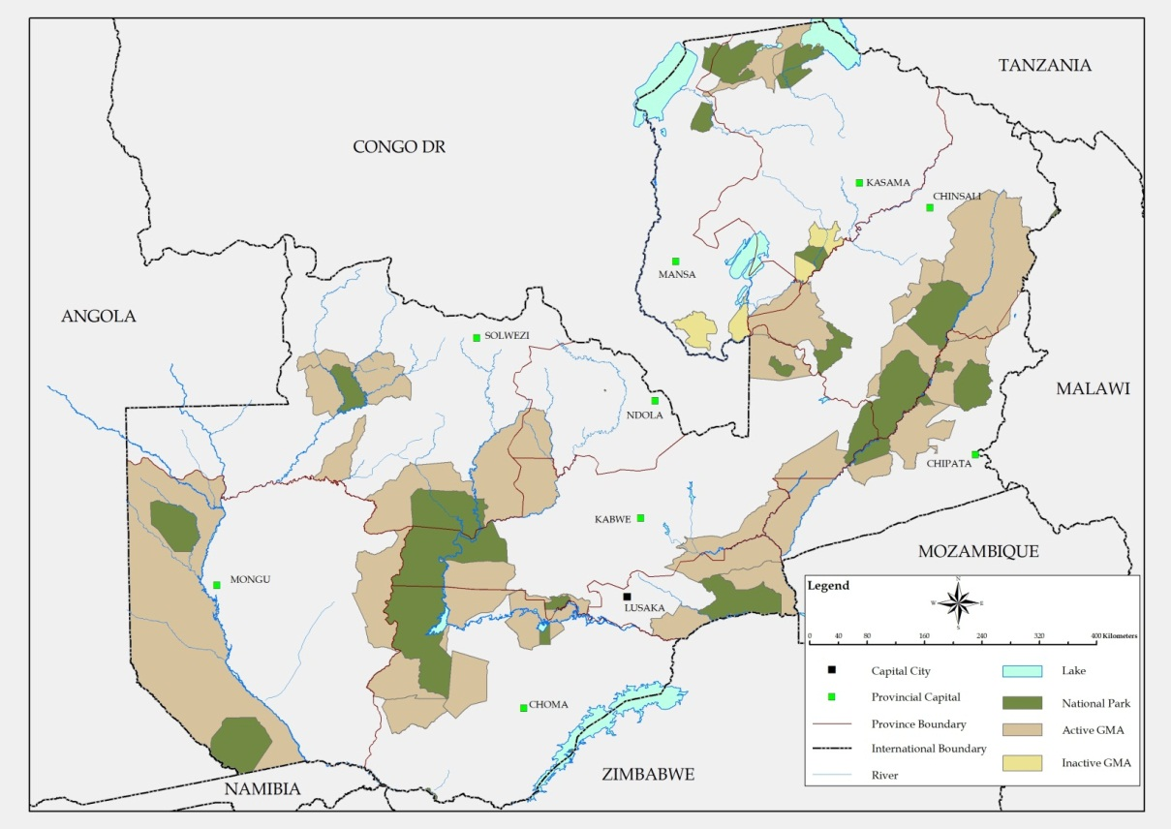

Figure 1.1: Map of National Parks and GMAs in Zambia

A report by the Government of the Republic of Zambia (GRZ, 2014), indicates that most of the rural population in Zambia live on customary land. The said population is highly dependent on forest resources for food security and livelihoods, including non-wood forest products (NWFPs), such as nuts, fruits, mushrooms, caterpillars, medicines, grass, and other products. Further, it is well known that wood resources in customary land are used for domestic consumption, construction and energy.

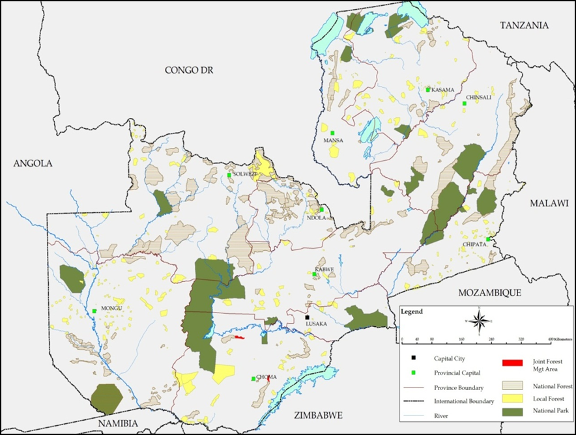

Figure 1.2: Map of Forest Management Areas in Zambia

## **Background and Context**

In this study, community forestry management is defined as a subcategory of forestry under which communities or groups of people have partial to full rights over specific forests, including the rights to establish, implement and enforce rules governing access and use of those forests. These rights may be formal legal rights, traditional or customary rights. The latter may, or may not, be legally recognized by the state.

FAO (2018) states that the concept covers a range of activities that include indigenous management of sacred sites of cultural importance, smallholder forestry schemes, small-scale forest-based enterprises, company-community partnerships, as well as decentralized and devolved forest management.

The definition given by RECOFTC Strategic Plan (2004:11) is that community forestry management involves the governance and management of forest resources by communities for commercial and non-commercial purposes, including subsistence, timber production, non-timber forest products, wildlife, conservation of biodiversity and environment, social and religious significance. It also incorporates the practices, art, science, policies, institutions and processes necessary to promote and support all aspects of community based forest management.

Thus, it is a concept of sustainable forest management (SFM) whose objective is to attain conservation of forests as well as contribute to the general development and improvement of local peoples’ livelihoods. It also seeks to empower those dependent on forest resources to be part of decision –making in all aspects of forest management plus policy formulation processes.

Suffice to state here, community forestry has been around in Africa for more than thirty years. In fact, community forestry in different forms has been around longer, for instance in the taungya system (targeting farmers), dune stabilization in the 1960s (herders), and in fuel efficient woodstoves in the 1970s (women), as reported by Catterson (2002), are good examples of this.

The first documented experience of developing a management plan under the heading of “Community-based management of natural forests” in Africa came from Niger (Heermans et al., 1986). The said management plan addressed the multiple objectives of: - i) involving surrounding communities to guard, exploit and share revenue from their nearest forest; ii) changing forest legislation to accommodate and legally recognize village groups as partners in management; and iii) devising a long-term (10-year) management plan for a state-owned forest, that included harvesting and regeneration of natural vegetation by the community.

Currently, many or most African countries have satisfactory new legislation in place that facilitates guarding and sharing revenue from forests, under participatory management (Willy, 2002). The sheer number of community forestry projects in Africa is an indicator of how widely accepted the concept has become, and this is shown in Figure 1.3 and Table 1.1 below. Additionally, the number of countries that have new and appropriate legislation, supporting CFM, indicates the seriousness with which the concept has been taken.

Table 1.1: Total Forest and Land Area under CBFM in Africa

|  |  |  |  |  |  |  |  |
| --- | --- | --- | --- | --- | --- | --- | --- |
| **Country** | **Land Area** | **Forest area in FOSA\*** | **Results from questionnaire** | | | | |
| **Forest area** | **Deviation**  **from FOSA** | **Area**  **under**  **CFM** | **Demarcated**  **area** | **CFM as**  **% of**  **overall**  **area** |
| Benin | 11 063 | 2 650 | 7 030 | 4 380 | 2 267 | 2 168 | 32.2 |
| Burkina Faso | 27 360 | n.a.** | n.a. | n.a | n.a | n.a | n.a |
| Burundi | 2 568 | 94 | 171 | 77 | 64 |  | 37.4 |
| Cameroon | 46 540 | 23 858 | 19 598 | -4 260 | 6 173 | n.a | 31.5 |
| Chad | 125 920 | 12 692 | 21 754 | 9 062 | 23 | n.a | 0.1 |
| Comoros | 186 | 8 | 12 | 4 | n.a | n.a | Na |
| Congo | 34 140 | 22 060 | 22 000 | -60 | 19 800 | n.a | 90.0 |
| Congo DR | 226 705 | 135 207 | n.a. | n.a. | n.a. | n.a. | n.a. |
| Côte d’Ivoire | 31 8000 | 7 177 | 5 500 | -1 617 | n.a. | n.a. | n.a. |
| Ethiopia | 110 430 | 4 593 | 4 505 | -88 | 450 | 50 | 10.0 |
| Gambia | 1 000 | 481 | 500 | 19 | 30 | 5 | 6.0 |
| Ghana | 22 754 | 6 335 | 2 000 | -4 335 | 400 | 0.2 | 20.0 |
| Guinea Bissau | 3 612 | 2 187 | 2 034 | -153 | 30 | 0.5 | 1.5 |
| Kenya | 56 915 | 17 096 | 37 600 | 20 504 | 250 |  | 0.7 |
| Lesotho | 3 035 | 14 | 52 | 38 | 1 | 0.8 | 1.9 |
| Madagascar | 58 154 | 11 727 | 12 00 | 273 | n.a. | n.a. | n.a. |
| Malawi | 9 409 | 2 562 | 2 642 | 80 | n.a. | n.a. | n.a. |
| Mali | 122 019 | 13 186 |  |  | n.a. | n.a. | n.a. |
| Morocco | 44 630 | 3 025 | 8 000 | 4 975 | n.a. | n.a. | n.a. |
| Mozambique | 78 409 | 30 601 | 62 000 | 31 399 | 1 000 | 150 | 1.6 |
| Niger | 126 670 | 1 328 | 8 000 | 6 672 | n.a. | n.a. | n.a. |
| Senegal | 19 252 | 6 205 | 18 201 | 11 996 | n.a. | n.a. | n.a. |
| Sierra Leone | 7 162 | 1 055 | 6 305 | 5 250 | 15 | n.a | 0.2 |
| South Africa | 121 758 | 8 917 | n.a. | n.a. | n.a. | n.a. | n.a. |
| Sudan | 237 600 | 61 627 | 46 800 | -14 827 | 124 | 12.5 | 0.3 |
| Togo | 5 439 | 510 | 3 430 | 2 920 | 5 | 5 | 0.1 |
| Tunisia | 16 362 | 510 | 971 | 461 | n.a. | n.a. | n.a. |
| Uganda | 19 964 | 4 190 | 4 949 | 759 | 3 | 3 | 0.1 |
| Zimbabwe | 38 685 | 19 040 | 19 000 | -40 | 8 800 | 88 | 46.3 |
| **Overall** | **2 978 394** | **649 866** | **1 284 901** | **1 043 336** | **39 435** | **2 483** |  |

Key: na = no answer

**Source: Adapted from Forest Outlook Study for Africa 2001 (FAO, 2002)**

The literature review (FAO, 2003) indicate that available country reports demonstrate CFM as an effective approach to Sustainable Forest Management which have since contributed to paving the way for inclusion of policies and laws in the national forest agenda of respective countries. Suffice to state here , the policy and legislative development have benefited from the experiences of the pioneering of pilot village community trials, in Zambia, it was called Joint Forest Management (JFM). Such results at Africa level, Zambia included, convincingly demonstrated that when communities are empowered with responsibilities and rights for the mangement, and receive benefits from them, they recognise the importance of SFM and respect forest management rules (Willy, 2002; Kajembe et al., 2003).



Figure 1.3: Map of Africa Showing the Extent of Adoption of CBFM by Countries

Zambia has been practicing community forestry for some time. However, past forest management strategies applied in the country, did not allow participation of local communities in the management of Forest Reserves as well as cost/benefit sharing (PFAP, 1998). The legal framework for JFM on state lands that was formulated for the country (USAID/Zambia, 2013) provided for the protection of JFM areas, but did not provide for cost/benefit sharing arrangements (PFAP, 2005). Against this background, clearly more needs to be done to further and consolidate the understanding of cost/benefit sharing from CFM areas in order for the practice to be successful and sustainable in Zambia.

In 2014 and 2015 respectively, the Zambian Government adopted a new National Forest Policy, Government of the Republic of Zambia (GRZ, 2014) and enacted Forests Act No 4 of 2015, GRZ (2015) which was also meant to support CFM, amongst other interventions. The new policy and legislative framework allows communities through subsidiary legislation (Statutory Instrument) to designate local forests as community forest management areas, for conservation and joint management with the Forestry Department.

## **1.2 GEF V Brief Project Description**

According to the GEF V Project Document (2015), the GEF V Project supported by the United Nations Development Programme (UNDP), GEF and the GRZ seeks to address wildlife poaching, deforestation and forest degradation, unsustainable land uses, extensive fire, and loss of a large, intact ecosystem that provides multiple benefits including forest protection, water and HEP, and biodiversity.

The underlying cause of these threats in GMAs is open-access exploitation of land and resources, exacerbated by centralized and uncoordinated resource management policies, poverty, land degradation and climate change. Kafue National Park was ineffectively managed whilst West Lunga National Park was neglected for many years.

The approach of the Project is to work at landscape level to promote sustainable management of carbon sinks through Forestry management, conservation of natural resources, and reducing pressures on the natural resources through promotion of alternative livelihoods.

### **1.2.1. Expected project outcomes/key results**

The project **Objective** is: Biodiversity and carbon sinks of Kafue/West Lunga Protected Area Systems in Zambia are better protected from threats and effectively managed by national and local institutions, communities, and economic actors using sustainable forestry and land management practices.

**Component 1** is: Increased management, effectiveness and financial sustainability of Kafue and West Lunga PA system

**Component 2** is: Sustainable land and forest management by local institutions in GMA buffer areas through selected CBNRM practices

This contributes to the following GEF Strategic Objectives and Programs:

* BD-1: Improve Sustainability of Protected Areas systems;
* CCM-5: Promote conservation of carbon stocks through sustainable management of land use, land-use change and forestry;
* LD-3: Integrated Landscapes: Reduce pressures on natural resources from competing land uses in the wider landscape; and
* SFM REDD+1: Reduce pressures on forest resources and generate sustainable flows of forest ecosystem services.
* “Greater” refers to the wider ecological context of the KNP and WLNPs and includes the surrounding GMAs as well as the “Open Area” corridor between the KNP and WLNPs, including the Chizera GMA.

In this regard, CFM as an intervention, should help relieve pressure on forests and other natural resources by providing alternative livelihoods such as improved farming through conservation agriculture which focuses on reducing soil disturbance, improving yields, reducing shifting cultivation, and intensifying agriculture to reduce forest conversion.

Charcoal production ought to be discouraged in GMAs through land use planning, law enforcement and where possible financial incentives.

Fuelwood is largely for cooking and heating, and in key locations for tobacco curing. An introduction of improved stoves and efficient charcoal production kilns may be useful.

Once the vegetation cover regenerates, wildlife and other biodiversity may begin to recolonize the area. It is however, vital that the communities continue to have a continued supply of alternative sources of income; which would divert their attention from unsustainable use of natural resources.

## **1.3 Project Area**

The GEF 5 Project area covers78,185 km2, comprising KNP (22,480km), WLNP (1,684km2) and thirteen (13) GMAs (54,021km2), being 10.4%, 3.0%, 0.2% and 7.2% of the country’s land mass, (see Table 1.2 below), however, the area surveyed by this assignment is 67 741 km2, equivalent to 9.0% of the total land mass of Zambia. The Project area is composed of seventy-seven (77) Village Action Groups (VAGs) of which twenty-five (25) have been prioritized for the implementation of CFM. The twenty-five (25) VAGs have been prioritized based on the availability of forest cover, proximity to forest resources, access to the forest, non-water logging, current and potential economic use of the forest resources, willingness to participate in the formulation and implementation of Community Forestry Management Plans. In some VAGs the communities are in the process of formulating the CFMPs. The project area accounts for 10.4% of the Country’s total Land area.

Table 1.2: GEF Project Area Surveyed during this Assignment

|  |  |  |  |
| --- | --- | --- | --- |
| **National Parks** | **km2** | **Project Area** | **% of Country land mass** |
| KNP | 22,480 | 22,480 | 3.0 |
| West Lunga | 1,684 | 1,684 | 0.2 |
| Total | 24,164 | 24,164 | 3.2 |
| **West Lunga GMAs** |  |  |  |
| Lukwakwa GMA | 2,540 | 2,540 | 0.3 |
| Chibwika Ntambu GMA | 1,550 | 1,550 | 0.2 |
| Musele Matebo GMA | 3,700 | 3,700 | 0.5 |
| Chizera GMA | 2,280 |  | 0.3 |
| **Eastern KNP GMAs** |  |  |  |
| Mumbwa | 3,370 | 3,370 | 0.5 |
| Namwala | 3,600 | 3,600 | 0.5 |
| **Western KNP GMAs** |  |  |  |
| Mufunta | 5,417 | 5,417 | 0.7 |
| **Northern KNP GMAs** |  |  |  |
| Kasonso Busanga | 7,780 | 7,780 | 1.0 |
| Lunga Luswishi | 13,340 | 13,340 | 1.8 |
| **GMAs** | 43, 577 | 41,297 | 5.8 |
| **Total Area** | **67, 741** | **65, 461** | **9.0** |

**Source: Adapted from GEF V Project Document, (GEF V, 2015)**

## **1.4 Biophysical Data of Zambia**

### **1.4.1 Bio-Physical Environment**

**Climate**

The climate of Zambia is sub-tropical, characterized by three (3) distinct seasons: a cool and dry season from May – August, a hot and dry season from August to November, and a wet and hot season from November to April.

Three (3) agro-ecological regions are recognized, see Figure 1.4, below. Region I covers the plateau sub-region in Southwest Zambia and the Rift Valley region in South Luangwa and Zambezi valleys. The region receives less than 800 mm annual rainfall and covers about fifteen (15) million hectares, equivalent to 20% of the country.

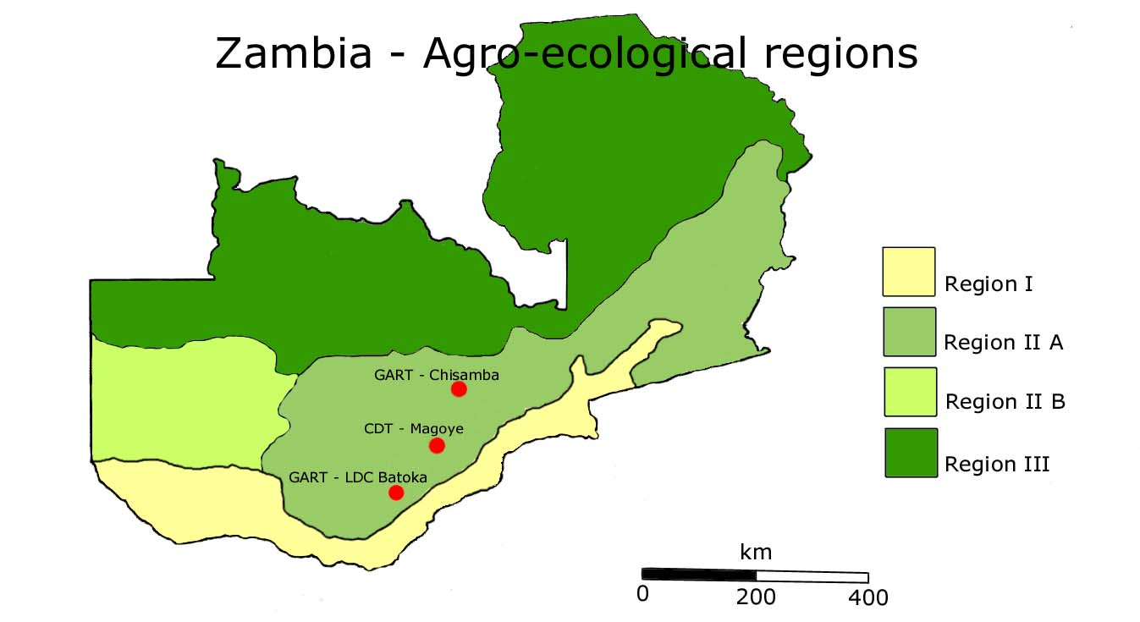

Figure 1.4: Agro - Ecological Regions Map of Zambia

Region II consists of the sand veldt plateau of Lusaka, Central, Eastern and Southern provinces and the Kalahari Sand plateau of Western Province. The region receives 800-1,000 mm annual rainfall and covers about 27 million hectares, or 36% of the country.

Region III receives over 1,000 mm annual rainfall and covers about thirty-three (33) million hectares, equivalent to 44% of the country. This region mostly covers the Copperbelt, Luapula, Northern and North-western provinces.

Floristically, Zambia lies within the Zambezi and regional center of endemism, between the rainforests to the Northwest and the semi-desert conditions to the Southwest. The vegetation is largely savanna, which comprises a mix of woodland and grassland vegetation types. The various ecosystems are listed in Table 1.3 below.

Mopani woodland characterizes Region I, and most wetlands and miombo woodland occur in Regions II and III. Together, woodland and wetland vegetation cover about 92% of the country. Although man-made ecosystems account for only 3% of the total area, natural ecosystems have been widely degraded by human influence, and especially by fire, shifting cultivation, the harvesting of wood fuel, and regulation of rivers for hydropower generation.

A large number of the plant and animal species are found only in Zambia. At least 615 species are endemic of which 174 are considered rare, and a further 31 species vulnerable or endangered.

Table 1.3: Extent of Ecosystems in Zambia

|  |  |  |  |
| --- | --- | --- | --- |
| **Biome** | **Ecosystem** | **Extent** | |
| km2 | % |
| **Forest** | Dry evergreen | 15,835 | 2.10 |
| Deciduous | 6,735 | 0.90 |
| Thicket | 1,900 | 0.25 |
| Montane | 40 | 0.01 |
|  | Sub-total | 24,510 | 3.30 |
| **Woodland** | Chipya | 15,560 | 2.10 |
| Miombo | 294,480 | 39.10 |
| Kalahari sand | 84,260 | 11.20 |
| Mopani | 37,010 | 4.90 |
| Munga | 30,595 | 4.10 |
| Termitaria | 24,260 | 3.20 |
|  | Sub-total | 486,165 | 64.60 |
| **Wetland** | Dambo grassland | 75,760 | 10.10 |
| Floodplain/swamp | 129,075 | 17.20 |
| Swamp forest | 1,530 | 0.20 |
| Riparian forest | 810 | 0.10 |
|  | Sub-total | 207,175 | 27.50 |
| **Aquatic** | Lakes and rivers | 10,500 | 1.40 |
|  | Sub-total | 10,500 | 1.40 |
| **Anthropogenic** | Farmland, plantation, built-up areas | 24,210 | 3.20 |
|  | Sub-total | 24,210 | 3.20 |
|  | **Total** | **752,578** | **100.00** |

**Source: Adapted from National Situational Analysis Report, MTENR, 2005**

### **1.4.2 Bio-Physical Environment of Central Northwestern and Western Provinces**

Table 1.4: Summary of Bio-physical Environment of Zambia in Central, Northwestern and Western Provinces

|  |  |
| --- | --- |
| **Bio-physical Environment** | |
| **Central Province** | |
| **Climate** | The climate in the project area is typically sub-tropical. The mean annual rainfall is about 900 mm and occurs mainly during October to May. The average temperatures range from 14 to 270C. The prevailing winds are from the south to the north-east. |
| **Forests/Flora** | The forests and woodlands dominate the provincial landscape especially on the plateau; Serenje and Mkushi have woodlands defined as true wet Miombo Woodlands. Botanically, the Miombo Woodlands are dominated by tree species of *Brachystegia, Julbernardia,* and *Isoberlinia,* belonging to the legume sub-family *Caesalpinioideae.* The woodlands are deciduous for at least a short period each year during the annual dry season and have a well-defined grass layer. The woodland canopy is from 6 to 20 m in height, and ranges from 20% cover to almost closed-canopy forest. |
| **Fauna** | Kasanka National Park and South Luangwa National Park in Serenje, and Blue Lagoon National Park and Kafue National Park in Mumbwa have relatively high animal diversity. Puku, Sitatunga, Bush Buck, Hippo and warthog are common in the Kasanka National Park whilst the Eland, Zebra, Genets, Leopards, Lions, Hyenas are more common in the South Luangwa National Park. The Blue Monkeys, Baboons, Hippo, Elephant, Buffalo, common Duiker and Hartebeests are found in both parks.  Kafinda, Chisomo, Kafue Flats and Mumbwa GMAs which act as buffer zones to the Kasanka, South Luangwa, Blue Lagoon, and Kafue National Parks, also hold populations of large mammals. Unfortunately, Kafinda GMA is slowly being encroached by human settlements and animal species. The Chisomo and Kafue Flats GMAs are also slowly being depleted due to rampant illegal harvest in these areas. In the past, the Lukanga swamps also held significant populations of wildlife. Red Lechwe populations have for example, declined from 800 to less than 100 individuals. Other large mammals such as elephant, roan antelope, eland, buffalo and water buck are rarely seen. |
| **Surface water** | Major water bodies include the Luapula, Kafue, and the Luangwa. Important wetlands include the Bangweulu swamps, Wasa in Kasanka, the Kafue Flats, the Lukanga swamps and the manmade Lake Lusiwashi in the north east of Serenje District and, the Mulungushi and Mita Hill dams.  Dambos scattered across the province are an important factor in creating micro-scale variation in the availability of water. Owing to a range of unique physical attributes, inter alia the shallow groundwater table, the fertile soils and the seasonality in hydrological and biological cycles, dambos are of significant importance in maintaining environmental integrity and quality, contributing to biodiversity, in local livelihoods, and in cultural associations and recreational activities. For rural communities throughout the province, dambos provide the most important contributions to peoples’ livelihoods and welfare through provision of food and water, raw materials, medicines and income. As such, the dambo is a complex natural, socio-political and economic good requiring a fine balance between conservation and utilisation, and accordingly, this valuable natural resource requires careful management as a separate entity from surrounding upland environments in the province. |
| **North-Western** | |
| **Climate** | Characteristic of Region III, Northwestern province is a high rainfall area, with annual rainfalls ranging between 1100mm - 1,386mm. Agro Ecological Zone III has the longest growing seasons in the country ranging from between 120-150 days. Temperatures range from 15 -25 degrees centigrade. October records the highest mean temperatures of around 22-25 degrees centigrade, with the mean maximum temperatures rising between 28-30 degrees centigrade. Average winter temperatures around 15-17 degrees with a mean minimum reducing to 5 degrees in Solwezi. The Province experiences dry winters and wet summers. |
| **Soils** | The soils in Northwestern province are typical of those found in Region III. Soils are generally strongly acidic and highly leached. The soil pH ranges between 4.0 – 4.5. The Province is covered by two types of soils – the very sandy and acidic Barotse Sands, which are found in Zambezi, Chavuma and Kabompo in the southwestern parts of the Province and the loamy Sandvelts in the eastern and northern part the province. |
| **Vegetation** | The vegetation of North Western province mainly comprises Miombo and Kalahari woodlands surrounded by thatching grass, dambos, swamps, shrubs and terminatarial vegetation. Woodlands consist of *Paniculata* (Mutondo), *Tomentosa* (Mutobo), *Landolphia kirkii* (Mubungo), *Faurea* d*iscolor* (Mushokoto), and *Pterocarpous angolensis* (Ndombe or Mukwa). The canopy dominants are species of *Brachystegia, Isoberlina*, Julbernardia and *Marquesia*, *Erthophiieum afrinum, Parinari Curatellifolia and Pericosis angolensis*.  The vegetation type consists of a wide variety of forests, namely *parinari*, lake basin chipya, *Baikiaea*, Montane, Swamps, *Cryptosepalum*, *Marquesia* and Mavunda. Northwestern province has a number of forest protected areas, comprising both Local and National Forests. There are thirty seven (37) local and seventeen (17) National Forests. The province still has a large number of relatively good and intact forest resources apart from Zambezi and Kabompo, which are showing signs of deforestation. Most degradation in other area is localized and is due to settlements, charcoal production and timber felling. |
| **Hydrology** | The province is endowed with a large number of rivers and streams and is home to the source of the Zambezi River, which flows up to the border with Angola, covering a distance of about hundred and fifty (150) km. Other rivers include the West Lunga with the Sweta, the Kabompo with the Muufundwa, the Mujimbezhi, the Lunga, the Lwakela, the Chilonga, the Muwozi, the West Lumwana, the Mudyanyama and the Mwanamutowa and its tributaries as well as the Kasanjiko and its main tributaries. Other river systems are Lufupa and Lunga and their tributaries. The Kafue river forms the boundary between Kasempa and Mumbwa districts and runs largely through the National Park. |
| **Fauna** | North Western Province has two national parks, namely, West Lunga National Park and, Kafue National Park. There are three Game Management Areas (GMAs) in the province. These are Chizela, Musele-Matebo, Ntumbu-Chibwika, Lukwakwa and Kasonso-Busanga. The province boasts of a wide range of animal and bird species and is home to various animal species such as elephants, lions, leopards, zebras, giraffes, hippos, crocodiles, buffalos, Impalas etc. Over seven hundred (700) species of birds exist in the parks. |
| **Western** | |
| **Climate** | Western province has three distinct seasons. However, some variations are noticeable as follows:-   * **April to May (Cool dry season).**   Following the end of the rainy season in April through May, temperatures are mild and showers are possible.   * **June to Mid – August.**   This is a cool dry season; temperatures are rather low; sometimes freezing.   * **Mid – August – November.**   This is a hot dry season with rainfall. Temperatures are high and could exceed36oC.   * **Mid – November – December.**   Early rains begin and temperatures become rather moderate.   * **January – March**   Temperatures are moderate. Rains become heavier and more regular.  Rainfall ranges from 1200mm annually in the extreme north of the province to 700mm per year in the southern part. The annual average rainfall for the province is 800mm. The potential evapo-transpiration is estimated to be between 2000mm and 2500mm annually. This leaves the province with a moisture deficit of 1000mm to 1500mm annually. |
| **Hydrology** | The Zambezi River and its tributaries is the predominant water system of the province. The Zambezi river enters the province approximately (30) km north of Lukulu Boma and flows southwards past Kalabo, Mongu, Senanga and Sesheke before turning south eastwards into southern province at the intersection of Kazungula and Kasane districts. The main tributaries of the Zambezi River found in Western Province are:-   * Kabompo, Dongwe and Lala Futa Rivers in the extreme north of the province in Lukulu district. * Luampa and Luena, Lwanginga in Kalabo District in the central region. * Lui River and Lusti River in the south west flows east of Senanga and crosses Mongu Kaoma Road? * Machile River along the boundary with southern province. * The Lueti River is the only significant tributary flowing into the Zambezi from the western side.   The Kwando River runs along the Angola -Zambia Border west of Shangombo but does not join the Zambezi River.  Ground water recharge of the Kalahari Sand aquifer is very low. Ground water reserves are therefore very low.  The central plain extends over an area of 241km while the southern plain extends a further 97 kilometers. The Barotse Plains have a maximum width of 32 kilometers. The flood regime runs from February – June with a peak in April. |
| **Topography** | Western Province lies at an elevation of between 900meters to the south (Shangombo and Sesheke and 1350 meters in the north east (Kalabo and Lukulu Districts).  Western Province is covered by two main topographical features:-   * The lowlands (Wetlands) covered by grass; and * The uplands (Drylands) which are wooded.   The lowlands cover approximately 10% of the province while the drylands cover the remaining 90%. |
| **Geology and soils** | Most of Western Province is covered by deep sands known as Kalahari Sands. The Sands are as deep as 60 meters in some places. Generally the soil types are varied and include the following:   * Drained organic wetland soils are found at the edge of the flood plains and are flooded annually. These are locally known as Sishanjo or Litongo. * Flooded outer plain soils locally known as Saana. * Mounds found on the flood plain are known locally as Mazulu. Mazulu are dome shaped mounds ranging in diameter from 20m to 150m. Mazulu have clay and loamy soils which produce forage grasses. * The dry land soils have a low mineral content and poor water retention capacity in the top soils. In the eastern part of the province (east of Kaoma) are found, siltones, schists, granites and basalts soils. These soils have a sandy top soil. |
| **Vegetation** | The vegetation of Western Province is divided into six categories as follows:-  **Kalahari Miombo Woodlands**  The Kalahari Miombo Woodlands are characterized by a canopy of broad leaf tree species especially *Julbernadia, Brachystegia* and *Erythrophlem* species. Miombo Woodlands are distributed widely in many parts of the province.  **Evergreen forests and woodlands**  The Evergreen Forests and Woodlands are characterized by a canopy dominated by *Crystosepalum* (Mukwe) and *Guiboutia* species, evergreen forests are found in the north of the province (Kalabo and Lukulu Districts), on the Kalahari Sands in the north western parts of the province (North of Kalabo), and in scattered areas of the Zambezi River.  **Zambezi Teak Forests**  Zambezi Teak (locally known as Mukusi) has a characteristic canopy. The Zambezi Teak Forests are:   * Near Machili River east of Sesheke and * Near Ngoma river also east of Sesheke.   **Munga Woodland**  Munga (Thorny) Woodlands is characterized by thorny narrow – leafed trees and shrubs of mainly *Acacia* spp, *Peltophorum* spp and *Dichrostachys* spp. Within this forest category there are also scattered broad leafed trees of the *Terminalia* and *Combretum* spp. Munga Woodland is mainly confined along the Kwando River and its tributaries along the Zambia/Angola border. Munga vegetation type is also predominant on the southern fringes of the Mulonga Plain in Shangombo and parts of Sesheke District.  **Mopani Woodland**  Mopani Woodlands are dominated by *Colophospermum Mopani* trees. Four main pockets occur in Western Province.  These are found in:-   * Sioma – Ngwezi National Park on the boundary between Shangombo and Sesheke Districts * In Sesheke East * Near Machili River East of Sesheke; and * Near Ngoma River also East of Sesheke.   **Grasslands.**  Due to the effect of floods, most of the Barotse Flood Plains are devoid of trees and are instead covered by grasslands. Grass genera that occur on the plains include *Acroceras, Cynodontis, Echinochloa, Themeda, Vossia* and *Cyperus. Hyparihemia* and *Orza* spp occur in the flood channels while *Microchlora* and *Eragnosis* spp are common as dambo grasses.  Western Province has one hundred and seventeen (117) gazzeted forests, consisting of thirty-three (33) National Forests and eighty-four (84) Local Forests. These forests have an aggregated land cover of 702,338 ha. Most of these forests are encroached in one form or another resulting in varying degrees of degradation. Despite this, the province has high value commercial tree species that significantly contributes to the overall departmental earnings yearly and GDP at the country level. |
| **Fauna** | Western Province has a wide diversity of wild animals. Due to heavy poaching pressure, most animals have been hunted down. The remaining animals are mostly confined to the two National Parks of Sioma Ngwezi and Liuwa. Large animals found in Sioma Ngwezi National Park include Elephants, Giraffe, Buffalo, Kudu, Roan, Sable, Tsessebe, Zebra and many others.  During dry years, the animals migrate to the Zambezi River for drinking water. Luena Plain National Park supports a large number of blue wild beasts. These migrate westwards over the Angola/Zambia International Boundary during the month of June. Other commonly sighted species in the area include Red Lechwe, Zebra, Tsessebe, Roan Antelope, Sable Antelope, Sitatunga, Reed Buck, Oribi, and a few buffaloes. Carnivorous species include Lions, Leopards, Cheetah and a large population of Hyenas.  A large variety of Wild Animals are also found in West Zambezi GMA and in the Zambezi River. For example large herbivores found in Luena Plain and the adjacent Ushaa flats include Buffaloes, Elands, Reedbucks and Sitatungas. Sesheke District hosts large heads of elephants which migrate over the Zambezi River into Angola and the Caprivi Strip in Namibia. On the eastern side of the province, wildlife is found along the eastern border with the Kafue National Park in Central Province.  Water fowl are particularly abundant in the Wetland area especially during the flood season. Popular species include Bubulus ibis (Cattle egrets), Egretta alba (great white egret), Ardea Cinerea (grey herons), Leptophilos Crumenifrus (Marabus Stick); Pelecanus rufescens (pelicans), theskirnis are thiopicus (sacred ibis) and Grus carunculatus (wattled cranes). |

## **1.5 Local Context**

The communities in the Project area raised the following issues, that illustrate the vulnerability of the two ecosystems such that if nothing is done, or the status quo is maintained, the country at large stands to lose in terms of biodiversity, poverty and hunger:-

**Water pollution:** Most of the VAGs access their water from shallow wells, rivers and community Boreholes (drilled by World Vision). The only water safe for drinking, according to the respondents, is the water from boreholes while the other water sources are polluted and mostly seasonal. Drilling more water boreholes and sensitization programs are the perceived solutions in providing safe drinking water for all and this can be done by the government, private sector actors, Non-Governmental Organizations (NGOs) and the CRB committees.

**Wildlife depletion**: There has been a decline in the population of wild animals in most of the VAGs. To address this issue, the VAGs suggested that, there is a need for the government, CRB and the community to work together and protect the wild animals. The communities however, seemed to be more interested in brokering jobs for their youth by suggesting that more man power (Human Resource) in terms of Village Scouts, for example be employed to increase the number and efficiency of patrols.

It was discovered that First Quantum Minerals Mine at Kalumbila in partnership with the Department of National Parks and Wildlife (DNPW) manages a project in the West Lunga Management area and have so far facilitated the employment of wildlife scouts, and refurbished some wildlife camps to enhance protection of wildlife through patrols. The community was very interested in youths within their communities being employed in such arrangements. In order to increase the sustainability of projects, such collaboration with the Private Sector should be cultivated and nurtured.

**Forest degradation**: Mumbwa and Mufunta are some of the GMAs that are experiencing rapid forest degradation due to farming, high demand for charcoal and timber. This is further exacerbated by the extensive tobacco growing and curing facilities in the two GMAs. Whereas other GMAs have good forests but specific plant species such as *Pterocarpus angolensis* (Mukwa) and Rose wood have been over-exploited due to their economic value. The Government through the Forestry Department, and the community should work together to rectify the problem according to all the respondents.

**Land degradation:** In all VAGs the people experienced land degradation with respect to lack of soil fertility which prompts many to clear new forest areas which are believed to be more fertile for farming (leading to deforestation). Those who afford apply inorganic fertilizers to their crops. Conservation farming skills and farming inputs support are what the people feel is the answer to solve the problem. Further to that, the respondents felt that the Government must improve on the delivery of the Farmer Input Support Programme (FISP) in terms of delivery of inputs and, especially fertilizers.

**Fisheries resource depletion:** Most of the fishing streams (in most VAGs) are seasonal streams hence fishing is only possible immediately after the rain season. In perennial streams the fish population has decreased due to over harvesting and harmful fishing methods, such as use of poison and very small fish mesh net sizes. Over dependence on fishing as the only income generating activity has resulted in over harvesting leading to fisheries resource depletion. In respect of the fisheries resource depletion, the response from all the VAGs was that relevant authorities should undertake sensitization programme(s) in all the communities plus construction of fish ponds and dams.

### **1.5.1 Land use**

The land use system in the project area is mainly agriculture as most people are engaged in subsistence farming. Because of this, and the increasing uptake of tobacco growing, there is also some significant change of forest land use to agriculture. Furthermore, especially in the West Lunga Ecosystem, shifting cultivation is still practiced in order to access more fertile land due to of lack of inputs and technologies that assist to improve fertility of current fields.

At the time of the study, there were only six (06) approved Integrated Land Use Plans (ILUPs) out of the forty seven (47) visited, namely Kalunzyu, Maunga, Manyawu, Lalafuta, Kaminzekenzeke and Kanzenzi.

**Kalunzyu**

The Kalunzyu VAG is located in Mumbwa GMA of Mumbwa District, Central Province of Zambia within Chibuluma’s chiefdom. The common land use practices in this VAG are farming, settlements road infrastructure, development support and burial sites.

In this VAG forests are vital to the community as they provide NWFPs such as herbal medicines, mushrooms, caterpillars for consumption and income generation, timber and timber products, habitat for wildlife, climate stabilization, charcoal/firewood, pasture for domestic and wildlife animals, soil erosion prevention, soil fertility enhancement, thatching materials and wind breaks.

A number of animal species commonly observed in the area include hare, porcupines, bush baby, common duiker, bushbuck, monkey, tortoise, fox/Jackal, honey badger, ardvark, mongoose, giant rat, cane rat, bush pig, squirrel, oribi and grysbuck. They provide revenue from hunting, local hunting, nature watch/scenery improvement, education, tourism, employment, cultural totems and are a source of proteins.

Kalunzyu VAG has three major streams, namely Kalunzyu, Katuba and Chinwamakubi. The local communities derive benefits from these water bodies that include drinking water, gardening and fish farming.

A number of institutions, namely schools, health post, VAG, Village headmen, Councillor, Neighbourhood watch and churches offer various services within the area. Institutions outside the VAG that offer services to Kalunzyu VAG include Office of the Member of Parliament (MP), traditional leadership, World Vision, Chibuluma Clinic, FD, Police, Conservation Farming Unit (CFU), Department of Agriculture, DNWP, Department of Livestock and Fisheries (DLF).

Kalunzyu VAG community members identified seven (7) key problems related to natural resources management and utilization in the area namely land degradation, inadequate land, forest degradation, wildlife depletion/reduction, depletion of water resources, depletion of fish stocks and decline in livestock. Each of these problems has been linked to a particular cause as shown in Table 1.4 below. For example, farming along river banks results in river siltation and therefore impacts negatively on the water bodies. Additionally, siting settlements close to wildlife areas results in animal-human conflicts due to animals attacking humans or livestock. Some harvesting methods such as honey hunting or use of bark hives conflicts with sustainable management of forests/woodlands.

Table 1.5: Problems, Causes and opportunities for Restoration/ Management

|  |  |  |
| --- | --- | --- |
| Problems | Causes | Opportunities |
| Land degradation | * Shifting cultivation * Inadequate farming inputs such as fertilizer * Poor farming methods such as contour ploughing | * Crop diversification * Availability of extension services/agroforestry technologies |
| Inadequate land | * Increased population. * Poor farming methods | Presence of expertise for extension services for soil fertility management (e.g. Forestry Department and Department of Agriculture). |
| Forest degradation | * Charcoal production. * Unsustainable harvesting methods. * Increased human population. * Shifting cultivation. | * Coppicing ability providing for development of sustainable silvicultural systems * Availability of extension services. * Availability of agroforestry technologies * Human population provides labour |
| Wildlife depletion/reduction | * Overexploitation * Poverty * Limited alternative livelihoods. * Habitat degradation | * Availability of habitats * Opportunities for alternative livelihoods such as agriculture * Habitat resilience |
| Depletion of water resources | * Droughts * Destruction of catchments | * Availability of underground water. * Availability of streams for damming. |
| Depletion of fish stocks. | * Unsustainable fishing methods such fish poisoning. * Droughts | * Availability of water bodies for restocking and sustainable fish farming * Availability of labour. |
| Decline in livestock | Diseases | * Availability of Veterinary services. * Availability of pasture and water. |

Source: Adapted from the ILUP for Kalunzyu VAG in Mumbwa GMA

Table 1.5 above suggests that Kalunzyu Community experiences a wide range of problems relating to natural resources management and utilization due to lack of an integrated plan that guides the use of the natural resources. However, even with such problems there exists opportunities for sustainable management of the natural resources.

The Kalunzyu community is also unique as it is one that has a historical burial site in the conservation part of the GMA. This issue needs to be managed in order to resolve the chronic encroachment into the area.

**Maunga**

The Maunga VAG is situated in Kaingu Chiefdom in the Namwala Game Management Area in Itezhi-tezhi district, Zambia

The local forests provide a wide range of benefits to the communities in Maunga VAG that include wild fruits, timber, construction materials, herbal medicine, caterpillar, charcoal/firewood, manure, food for animals, wind breakers/soil erosion, habitat/shed, rains, mushroom, honey and income from the sale of various wood products such as round wood, construction timber, sawn timber and furniture.

This VAG has numerous wildlife species that include lions, buffaloes, hyenas, monkey, duikers, hippos, elephants, leopards, snakes, roan antelopes, bush pig, genet, porcupines, rabbits, giant rats, kudu, warthog, bushbuck, birds, tortoises, mongooses, crocodiles, squirrels, bush babies, bats, cheetah, rats, zebra, hartebeest, honey badger, wildebeest, reedbuck, eland, puku and wild dogs. The presence of wildlife accords the Maunga VAG community corporate social responsibility benefits such as the classroom block built by the Safari Company at Itumbi Primary School, income generation from hunting tourism and remittances to the community through the CRB, employment at the Safari Company and village scouts, among others. Wildlife has been a source of meat protein for local communities. Equally, through the wildlife related jobs and revenues a number of community members are receiving education while the local cultural practices have been influenced by existence of wildlife for example, the naming of clans and individuals from names of wild animals.

The Maunga VAG has numerous water bodies in form of rivers, streams, hot springs and a dam. The rivers include the Kafue River. The streams include: Munyanja, Chaze, Namutekwa, Katendevwa, Chungwe, Kangabombo, Kela, Zambwe, Yongwe, Kabwe, Chinwankunku, Nakolobola, and Mwengwa streams. Other water sources include Mabiya, Mandubungwa and Nantanga hot springs. Itezhi-tezhi dam is also an important water reservoir. The Maunga VAG community has various types of fish for commercial and domestic uses.

Several types of institutions exist in the Maunga VAG, namely schools, health post, VAG, CRB, traditional leadership, Department of Social Welfare (DSW), FD, CFU, DNPW, DoA and District Council that provide various services.

This VAG has seven (7) key problems, namely reduction of wildlife, depletion of fish, deforestation, reduced water level, land degradation, reduction in livestock population, and under-exploitation of minerals see Table 1.6 below. These problems are of varying socio-economic and environmental magnitudes and severity on the local community who believe that over the years there has been biodiversity loss due to numerous internal and external reasons. Apparently, the increase in human population has contributed significantly to natural resource degradation. In some cases, conflicts have arisen among various parties, and between people and natural resources such as wildlife. Such conflicts, require a strong presence and collaboration with external actors such as relevant government departments and non-governmental organizations (NGOs) to strengthen natural resource protection in areas which are under customary authority in order to maximize benefits and minimize losses to the resource dependent local communities.

As shown in Table 1.6 below, the Maunga community identified various alternative opportunities for change that include exploitation of abundant existing natural resources, use of technology, extension services, and deeper local community involvement, use of traditional structures and sustainable cultural practices as well as taking advantage of economic opportunities such as availability of markets with high demand for much of the natural resources such as wildlife, forest products and fish. Since the Maunga VAG community is willing to change, it is possible to tap into existing skills at community level and stakeholders such as government and private actors. The community can also engage in CFU. There are also existing strategies and policies such as decentralization and Public Private Partnerships (PPP), and various benefit sharing mechanisms.

Table 1.6: Problems, root causes and opportunities for Change- Maunga VAG

|  |  |  |
| --- | --- | --- |
| **Problems** | **Root Causes** | **Opportunities** |
| Reduction of wildlife | * Poaching * Lack of extension services * Habitat fragmentation * Quick sources of income (availability of markets) * Corruption * Inadequate man power (wildlife police officers) * Increased human population | * Availability of labour (Village scouts). * Availability of water for animals. * Habitat availability. |
| Depletion of fish | * Poor fish methods * Illegal fishing * Increased population of fishermen * Poor law enforcement * Reduced water levels impacting on breeding habitats * Poor extension services * Increased demand for fish | * Availability of water bodies * Availability of fisheries officers * Presence of VAG and traditional structures * Availability of land for fish farming. |
| Deforestation | * Poor farming methods * Poor harvesting methods * Indiscriminate cutting of trees * Charcoal production * Bad tobacco curing methods * Poor extension services * Burning of stems during land preparation * Firewood for fish preservation * Increased human population | * Potential for by-laws. * Regeneration of forests * Labour for tree planting * Presence of forests * Availability of land for forest resource * Good rainfall |
| Reduced water levels | * Poor rainfall patterns | * Availability of Kafue river * Availability of streams which can be dammed. * Availability of ponds. |
| Land degradation | * Poor farming methods * Mono cropping * Lack of natural replenishment due to clearing of farming areas and burning * Use of inorganic fertilizers | * Presence of CFU * Land can support crop diversification * Availability of land |
| Reduction in livestock population | * Prevalence of diseases * Poor extension services * Attacks from wild animals | * Presence of VET * Availability of pasture land * Labour for herding * Availability of water * Culture on animal rearing |
| Under-exploitation of minerals | * Lack of capacity to extract minerals | * -availability of minerals. |

Source: Adapted from the ILUP for Maunga Village of Namwala GMA

Maunga VAG community identified five (5) key promising land use types for their area: forests, fishing, grazing, settlements and wildlife.

**Manyawu**

Manyawu VAG is located in Lukwakwa Chiefdom situated in Manyinga district sharing borders with Kanzenzi VAG of Chibwika Ntambo GMA in the north, West Lunga National Park in the East and an International Boundary with the Republic of Angola in the West.

The forests in this VAG provide several benefits in form of NFWPs and woody forest products to the community. NFWPs include mushrooms, caterpillars, honey and wild tuber, which act as sources of food and income for the local people. Woody forest products include timber, charcoal, pasture, thatching materials and medicinal herbs. Indirect benefits include habitat for wildlife and carbon sequestration. However, these forest resources are increasingly under threat of depletion due to unsustainable exploitation methods by local communities.

Manyawu VAG harbors numerous wildlife species, namely mammals (Duikers, Water buck, Bush pig, Bush baby, Rabbit/Hares, Impala, Baboon, Giant Rat, Cane Rat, Hyena, etc.), reptiles (Tortoise, Python, Black mamba; Cobra, crocodile, etcetera.) and several species of birds and amphibians.

Manyawu VAG has numerous water bodies, namely streams (Manyawu; Kanyikun’ga, Chakonda, Lwasamashima, Lubuzhi, Lusongi, Shabila, Chizhiya, Ndazhi, Isekesa, Kabang’a, Kanyankung’u, Katema, Nyan’wangwa), rivers (Kalandambinga, Chanachenene, Nyan’wangwa) and lakes ( Chizhiya, Kayilumbi, Kashima kamwambu). While most of the streams are seasonal, all the rivers and lakes are perennial in nature. Collectively, these water bodies provide multiple benefits to the local people such as a source of water for both irrigation and domestic use as well as major sources of fish for the local people. Fish harvested from these water bodies is used as a source of both income and food. These water bodies are also key habitat for aquatic based wildlife, especially Crocodile, Hippopotamus and Water monitors prevalent in the VAG.

According to the Manyawu VAG community, the area is rich in mineral resources, namely Quartz, Green tourmaline, Iron, Purple ruby, Amethyst, Copper, Nickel and Gold. However, the foregoing is subject to confirmation due to lack of documentary evidence.

Manyawu VAG is supported by a number of institutions namely schools, health centres, DNWP, traditional leadership, Councillors, Food Reserve Agency Depot, MP, Shops, Church and Neighbourhood watch.

The Manyawu VAG community identified several problems related to natural resources utilization and management, namely wildlife depletion, fish depletion, forest degradation, decline in livestock, food insecurity and poor access to markets (see Table 1.6 below). The problems impact directly on the livelihoods of communities in the VAG due to their dependence on natural resources for their socio-economic wellbeing. The potential opportunities existing to address these problems should aim at promoting environmental sustainability and encouraging communities to exploit natural resources using methods that provide for resources sustainability, for instance adaptation of sustainable farming practices and preservation of their pasture land. Avoid farming or rearing livestock in areas that increases interaction with wild animals, as this increases threats of crop damage as well as zoonotic disease and attacks on their livestock. Freshwater sources provide an opportunity for the restoration of depleted wildlife resources, fish restocking and fish farming. Fish restocking should be accompanied with increased extension services to create awareness for conservation of fish stocks in natural fisheries or freshwater ecosystems. The existence of abundant forest ecosystems provides an opportunity for conservation of these resources for the purpose of continued extraction of benefits that supports their livelihoods, for instance harvesting of both woody and non-wood forest products.

The small scale farmers in the VAG have a challenge regarding the sales of their produce since the nearest central business district of Manyinga district is located approximately 92 km. The poor communication and infrastructure network (road and phone connectivity) renders market accessibility difficult. However, there is an existing gravel road, which may just need to be rehabilitated. In addition, communication towers for mobile phone network could be erected to improve telecommunication. Although such opportunities exist, however, they need the intervention of external support for instance government, private sector or donor community to address the problem of poor access to markets.

Table 1.7: Summary of Problems, Causes and opportunities - Manyawu VAG

|  |  |  |
| --- | --- | --- |
| **Problems** | **Causes** | **Opportunities** |
| Wild depletion | * Poverty | Farming alternative livelihood (e.g. goat keeping livestock). |
| Fish depletion | * Unsustainable methods of harvesting | Availability of perennial streams for fish restocking and farming. |
| Forest degradation | * Bark hives * Late fire burning * Timber harvesting * Unsustainable harvesting of caterpillars. | * Existence of neighbourhood committee. * Proximity of DNPW at Kashinankazhi. * Availability of timber * Sustainable traditional methods of harvesting caterpillar * Availability of smaller trees. |
| Decline in Livestock | * Poor access to VET services. * Attacks from wild animals e.g. hyenas. | * Creation of Manyinga as a District for more effective service delivery. |
| Food insecurity | * Crop damages by wild animals for example, monkeys | * Creation of Manyinga as a District for more effective service delivery. |
| Poor access to markets | * Poor roads * Poor communication network | * Existing gravel road to be upgraded. * Available land sites for erection of network tower. |

**Source**: Adapted from ILUP for Manyawu VAG in Lukwakwa GMA

The six land use types identified by the people of Manyawu settlement, farming area, grazing, wildlife conservation, Fisheries conservation and forest conservation.

**Lalafuta**

The Lalafuta VAG is situated in Kahare Chiefdom in the Mufunta Game Management Area of Nkeyema district, in the Western Province of Zambia.

The forests in this VAG provides many benefits in form of NWFPs and woody forest products to the community. NFWPs include mushrooms, caterpillars, honey and wild tubers, which are a source of both food and income for the local people. Woody forest products include timber, charcoal, pasture, thatching materials and medicinal herbs. Indirectly, they also provide for wildlife and carbon sequestration.

Lalafuta VAG has numerous wildlife species which include mammals (Wildebeest, Duikers, Hares, Lion, Elephant, Aardvark, Monkey, Hyena, Buffalo, Duikers, Reedbuck, Porcupine, Kudu, Hippo, Jackal, Zebra, Squirrel, Bush baby, Mouse, Mole, Sitatunga, Warthog, Mongoose, and Leopard), Reptiles (Monitor Lizard, Tortoise, Python, Black mamba; Cobra, Crocodile, etcetera.) and several species of birds and amphibians.

Lalafuta VAG has numerous water bodies, namely streams Kamakowa, (Kamulola, Kanemuna, Namamono, Kalale, Kamayoka and Kampombo), Rivers (Lalafuta and Munkuye) and Dambos or flood plains (Nakuyuna, Mukwemba, Kamayoka, Mbumisha, Nkeyema, Shambilamina, Mukandakanda, Kanemuna, Shakana and Shamandanda). While most of the streams and dambos are seasonal, all the rivers are perennial in nature. Collectively, these water bodies provide multiple benefits to the local people that include being a source of water for both irrigation and other domestic use, major sources of fish for consumption and income generation..

There are speculations that Lalafuta VAG has numerous mineral resources, namely Red garnet, Black tourmaline, Emerald, Iron, Blue sky and Crude oil. Regrettably, this assertion is not backed by documentary information.

Numerous institutions support Lalafuta, namely schools, traditional leadership, council, Councilor, FAWEZA, cooperatives, neighborhood watch, DPNW, Ministry of Agriculture (MoA), VAG, WDC/ADC, church, JTI, FTC, TBZ, MP and BH regarding the provision of necessary services.

Lalafuta VAG has six (6) key problems related to natural resources management and utilization in area namely land degradation, forest degradation, wildlife depletion/reduction, depletion of water resources, depletion of fish stocks and decline in livestock. Each of these problems has been linked to a particular cause as shown in Table 1.7 below. The said table also illustrates the existing opportunities in the area that may assist the community to sustainably manage the natural resources.

Table 1.8: Problems, Causes, opportunities for restoration –Lalafuta VAG

|  |  |  |
| --- | --- | --- |
| **Problems** | **Causes** | **Opportunities** |
| Land degradations | * Mono cropping * Poor farming practices * Poor extension services | * Good soils for a variety of crops * Enough land * Availability of labour |
| Forest Deforestation | * Tobacco farmers * Caterpillar harvesters * Poor farming methods * Charcoal burning * Construction of houses * Poor extension services * Bush fires * Bark hive harvest | * Presence of TTI * Natural regeneration * Practice early burning * Presence of extension officers * Presence REA for the provision of HEP * Existence of traditional methods of caterpillar harvesting |
| Depletion of wildlife populations | * Human population increases * Destruction of habitats * Poaching/ Illegal hunting * Human wildlife conflicts | * Presence of the CRB and the VAG * Potential for domestic animals rearing * Potential for co-management * Availability of habitats for re-stocking |
| Depletion of water resources | * Drought * Shallow streams * Siltation/erosion from agricultural activities | * Presence of government institutions * Attitude change * Presence of traditional leaders in the area for enforcing management regulations * Traditional beliefs and norms |

Source: Adapted from ILUP for Lalafuta VAG of Mufunta GMA

The people of Lalafuta listed five (5) land use types that could potentially be implemented in their VAG, namely forest, fisheries and wildlife conservation, settlements and grazing areas.

**Kaminzekenzeke**

Kaminzekenze VAG is located in Kasonso Busanga Game Management Area in Mufumbwe District, North-Western Province of Zambia within Mushima Mubambe’s chiefdom.

The forests provide benefits to the local community through NWFPs such as herbal medicines, mushrooms, caterpillars for use and income generation, timber and timber products, habitat for wildlife, climate stabilization, charcoal/firewood, pasture for both domestic and wildlife, soil erosion prevention, soil fertility enhancement, wind break and thatching materials.

The wildlife species found in Kaminzekenzeke VAG include Hartebeest, elephant, sable antelope, impala, sitatunga, lion, warthog, leopard, kudu, eland, bush pig, red lechwe, genet, crocodile, grysbok, ardvark, hyena, buffalo, zebra, baboon, common duiker, wildebeest, waterbuck, roan antelope, puku, porcupine, bushbuck, monkey, bush baby, reedbuck, hippo, wild dog, hare and tortoise. The benefits derived from the wildlife are revenue from hunting, local hunting and nature watch/aesthetic value.

The VAG has numerous water resources in form of streams and rivers. The streams are Karundu, Lumba, Kamisongu, Kampande, Katamba, Kamikenga, Kyambalumina, Shesha, Kullongelo, Kaminzekenzeke, Kalanyanga, Lufupa, Ntampe, Kamikomba, Kabifwifwi, Lushimba, Kanyongolo, Kabanga, Kibila, Mwenemutobo, Kasompe, Kokaweni) and rivers (Mufumbwe and Munte) support Kaminzekenzeke community as a source of drinking water, gardening, fish farming and fishing. The hot springs in the area are Kanyongolo, Kasalamakanga, Kabonga, Kamalondo, Kamwedi, Shesha, Mwanamutobo, Kalongelo, Kitusha and Kyasalaula. These springs act as water points and sources of water for both humans and wildlife during the dry season.

The VAG is supported by many institutions that include schools, health post, VAG, traditional leadership, Council, MP, Neighborhood watch, DNPW and DLF.

The problems that impact negatively on sustainable natural resources management in the area (see Table 1.9 below) include poor harvesting methods such as contour ploughing and mono cropping that tend to impact on the quality of soils. Siting settlements near areas for game results in animal-human conflicts as a result of animals attacking humans or livestock. Some harvesting methods such as honey hunting or use of bark hives conflicts with sustainable management of forests/woodlands.

Table 1.9: Problems, Causes, Opportunities for Restoration/ Management - Kaminzekenzeke

|  |  |  |
| --- | --- | --- |
| Problems | Causes | Opportunities |
| Land degradation | * Shifting cultivation * Soil erosion | Crop diversification |
| Inadequate land | * Increased population. * Investor taking upland. | Presence of expertise for extension services. |
| Forest degradation | * Charcoal production. * Unsustainable harvesting methods. * Increased human population. * Shifting cultivation. | Availability of extension services. |
| Wildlife depletion/reduction | * Overexploitation * Poverty * Limited alternative livelihoods. | Availability of habitats |
| Inadequate capacity for mineral exploitation. | Lack of equipment and skills. | Availability of minerals. |
| Depletion of water resources | * Droughts * Destruction of catchments | * Availability of underground water. * Availability of streams for damming. |
| Depletion of fish stocks. | * Unsustainable fishing methods. * Droughts | * Availability of water bodies for restocking and sustainable fish farming * Availability of labour. |
| Decline in livestock | Diseases | * Availability of Veterinary services. * Availability of pasture and water. |

Source: Adapted from the ILUP for Kaminzekenze VAG in Kasonso Busanga GMA

The six (6) land use types identified by the community are forest management, farming, settlement, grazing, fishing and wildlife management.

**Kanzenzi**

The Kanzenzi VAG is situated in Chibwika Chiefdom in the Chibwika-Ntambu Game Management Area in Mwinilunga district, Zambia.

The forests in Kanzenzi VAG provide timber, wild animals for game meat, fruits, mushrooms, fibre, poles, munkhoyo roots, charcoal, caterpillar, bark for bee hives for honey collection, wild tubers, construction material, logging, carving, pottery and weaving materials, firewood, thatching materials and animal grazing.

The Kanzenzi VAG has numerous wildlife species that include sable antelopes, bush pigs, lions and baboons. Communities accrue benefits from wildlife in form of meat, contribution to cultural practices and revenue generation.

The Kanzenzi VAG has numerous water bodies, namely Lunga River and Kalemalema, Shihamba, Kanyilombi, Lunsongi, Kanzenzi, Luampanzi, Kansaka, Luvuzi, Kanyisevu, Chipembeli, Ndengechi and Kamalengi streams.

The water bodies provide water for domestic consumption and livestock as well as fish for domestic consumption and income generation. Reeds are obtained along the rivers for mat making.

Kanzenzi VAG enjoys support from numerous institutions, namely schools, Health Post, Boreholes, churches, Ministry of Community Development (MoCD), DNW, CRB, government and NGOs.

The Kanzenzi VAG community identified seven (7) key problems, namely deforestation, wildlife depletion, fisheries resource depletion, low crop yields, illegal mining, lack of communication services and limited social services, see Table 1.9 below. The situation is worsened by the absence of communication infrastructure and inadequate outreach programs by the government and the NGOs due to remoteness of the area from Mwinilunga.

Table 1.10: Problems, Causes, Opportunities for Change - Kanzenzi VAG

|  |  |  |
| --- | --- | --- |
| **Problems** | **Root causes** | **Opportunities** |
| Deforestation /Land Degradation | * Poverty, * inadequate knowledge, * traditional bee keeping methods of harvesting of NTFPs. | * Vast land and rainfall for sustainable agriculture. * Availability of timber species for modern bee hives. |
| Wildlife depletion | * Late burning * Poaching (illegal killings of animals. | * Availability of traditional structures. |
| Fisheries resources depletion | * Poor fishing methods. | * Availability of rivers for restocking. * Availability of traditional structures. |
| Low crop yields | * Inability to acquire fertilizers. |  |
| Illegal mining | * Poor enforcement of legislation. |  |
| Lack of communication services |  |  |
| Limited social services | * Absence of communication infrastructure. |  |

Source: Adapted from the ILUP for Kanzenzi VAG of Chibwika GMA

Kanzenzi VAG community identified three (3) key promising land use types for their area: sustainable agriculture, timber production and restoration of fish stocks.

## **1.6 Main Project Objective**

The objectives of this study were twofold: the first being to assess the potential for Community Forestry Management in the Project area, and secondly, to assess the willingness of the Community in respective VAGs to participate in CFM and in the Formulation of CFM plans.

**1.6.1 Terms of Reference**

The Table 1.11 below and Appendix 1 portray a summary of the Terms of Reference (TORs) for the assignment and the relevant sections of this report where the TORs have been addressed.

Table 1.11: Summary of Terms of Reference and Actions

|  |  |  |
| --- | --- | --- |
| S/N. | Terms of Reference | Section of Report that addresses. |
| 1. | Identify and summarize provisions in current environment and forest policy frameworks and legislation that support undertaking of CFM in Zambia | Table 2.1 Analysis of Legal and Policy frameworks related to CBNRM. |
| 2. | To identify areas where Community Forest Management interventions can be set up in the UNDP/GEF 5 Project areas. | 3.1.1 Potential for CFM |
| 3. | Assess the possibility of CFM providing income to the forest-dependent and surrounding communities | 3.1.2 Economic Activities  3.1.3 Forest Related Economic Activities  3.1.4 Proposed Income Generating Activities |
| 4. | Assess the willingness of the community to support preparation of a management plan developed in a participatory manner and take into account harvesting and fire control measures | 3.1.7 Community Willingness to Participate in CFM |
| 5. | Briefly indicate some of the impediments to successful implementation of CFM that the GEF 5 Project team and stakeholders must look out for and suggest corrective measures | 3.2.1. Lessons learnt from other projects |
| 6. | Review previous CFM interventions and synthesize lessons that can create a basis for successful CFM implementation in the UNDP GEF 5 Project | 3.2.1 Lessons Learnt from other Projects  3.3 Sustainability of Project Interventions |
| 7. | Identify appropriate CFM models that may be implemented in the GEF V areas |  |

# **2 METHODOLOGY**

This assignment was undertaken mainly through field study, supported by a very strong desk verification component. Primary data was generated from field work through group interviews/meetings/consultations with various stakeholders (see Table 2.1 below and Appendices 8 and 9). In total, the group interviews/meetings/consultations took a total of thirty-one (31) days, and generated highly valuable empirical data, while secondary data was generated from desktop research, in order to support the empirical findings, and all of this has in turn contributed to the development of recommendations of customized interventions for the Project Area.

Table 2.1: Stakeholder Map



**Source: Adapted from Carter and Gronow (2005).**

The process of data collection from community members must be recognized as not being simple and straight forward. Very experienced teams are required to collect data from communities that are tired and lethargic from participation and involvement in projects that they perceive to have no tangible returns for their effort and time. Such lethargy, disappointment and reluctance was observed among the communities in all the project areas visited, namely GEF V, Regeneration and JFM.

The consultancy team nevertheless, used its experience and competence to elicit active participation, from the community members, by presenting a clear and strong picture of the anticipated future direction of the GEF V Project; and by securing good will and support from the key community leaders such as the District Commissioners and traditional leaders to consolidate and anchor the ownership of the project among the local authorities and community leadership. The latter, in most cases, participated in the meetings through their headmen/women.

In addition, key project staff based at the United Nations Development Programme (UNDP) and in the field, Forestry Department Headquarters (FDHQ) and in the field, Regeneration Project Staff, the Dambwa JFM Forest Management Committee (FMC), community leaders and influential members of the community were involved at every stage of the data collection process. It was clear that possessing experience and understanding of project and community dynamics is critical in undertaking such assignments.

The methodology applied in executing the assignment included:-

* A Desk Review of existing relevant published and unpublished literature and reports, legal and policy framework and projects that Government has implemented on forestry, wildlife and natural resources, including lessons learnt from the Regeneration and PFAP (Dambwa Local Forest JFM) projects as well as ADMADE scheme were collated. Literature pertaining to the Project area, the social economic dynamics, demographics, energy demand and use, physical attributes etcetera, have been reviewed in order to produce interventions that are overarching and relevant to the needs of the Project area as well as the country, in terms of increase in natural resource management sustainability, plus increase in Biodiversity and Carbon Sinks.
* The use of established analysis frameworks to conduct analysis on Forest and Natural Resources Management in Zambia, as well as other tools, as needed, in order to achieve the best possible diagnosis of the issues that need to be addressed.
* Extensive field survey of the proposed project areas was undertaken. This covered the Project VAGs that have forests or those adjacent to forests. So in the WLNP, the study team visited a total of twenty-seven (27) VAGS in the following Community Resource Boards; Matebo and Musele in Kalumbila District, Ntambu and Chibwika in Mwinilunga and Lukwakwa in Manyinga District. In the KNP ecosystem, a total of twenty (20) VAGs were visited in Mulendema, Kabulwebulwe, Chibuluma CRBs in Mumbwa GMA, Mufunta – Kahare, Lunga Luswishi and Kasonso Busanga. In total therefore, apart from the VAGs in the Chilyabufu and Shimbizhi CRBs of the Namwala GMA; forty-seventy (47) out of seventy-seven (77) VAGS were visited.
* The remaining thirty VAGs were not visited as in some cases they do not have adequate forest cover to support CFM such as is the case in two CRBs of Namwala GMA with about 14 VAGs. In other cases they were inaccessible due to being water logged, and as such largely dambo areas which are not expected to fully support CFM. The latter could not be visited due to lack of water transport, for example. In cases such as the foregoing, key informants were very useful. Community Liaison Assistants were also interviewed to confirm findings.
* Personal interviews were undertaken with stakeholders in the target community; private business in the area, for instance, those operating tourism business (lodges, tour guides) as well as those offering consumptive tourism packages. Interviews were extended to other parts of the country, as appropriate, and to relevant government officials, on a needs basis.

## **2.1 Outline of the Methods of Data Collection and Analysis**

The data was collected by way of questionnaires (Appendix 2), surveys, interviews, and direct observations, for example:-

Legal and Policy Framework: - Desk study and interviews.

Previous CFM interventions in Zambia

(Including cost-benefit analysis; lessons learnt) - Desk study and field study.

Major actors in the programme: - Desk study, interviews and surveys.

Governance issues: - Desk study interviews and field

**Field Data Sampling**: Convenience sampling was used for stakeholder experience analysis, taking advantage of available stakeholders. In respect of community analysis, sampling areas were selected based on parameters such as population, rate of forest degradation and biodiversity loss, and wildlife population, and other considerations.

**Semi-guided interviews**: Interviews with key informants and beneficiaries were the main sources of information for evaluation especially from the other projects that were used as a learning or comparative tool. A list including the names of all interviewed persons, affiliation and gender was kept, see Appendix 9 below.

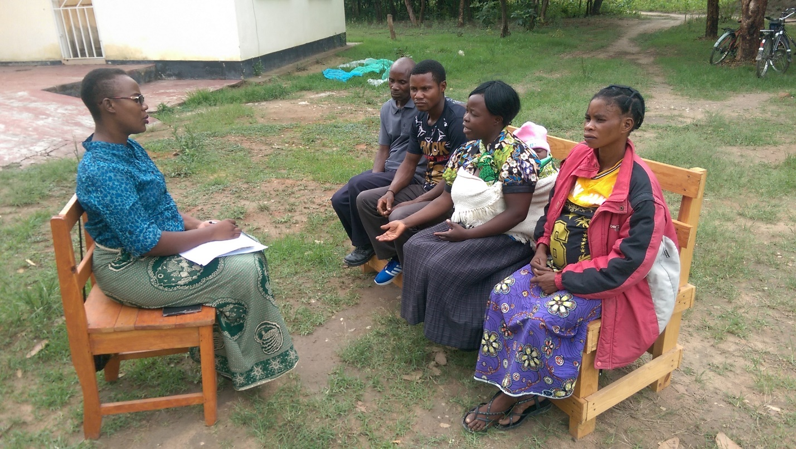

Figure 2.1: Group Discussion with Key Informants

**Group Interviews**: For the assessment, the team held meetings with groups of community members, staff of the partners, and civil society on specific issues to discuss their experience and expectations of the project. Group interviews were used for the stakeholder analysis, determination of acceptable Income Generating Activities and willingness to participate in management planning.

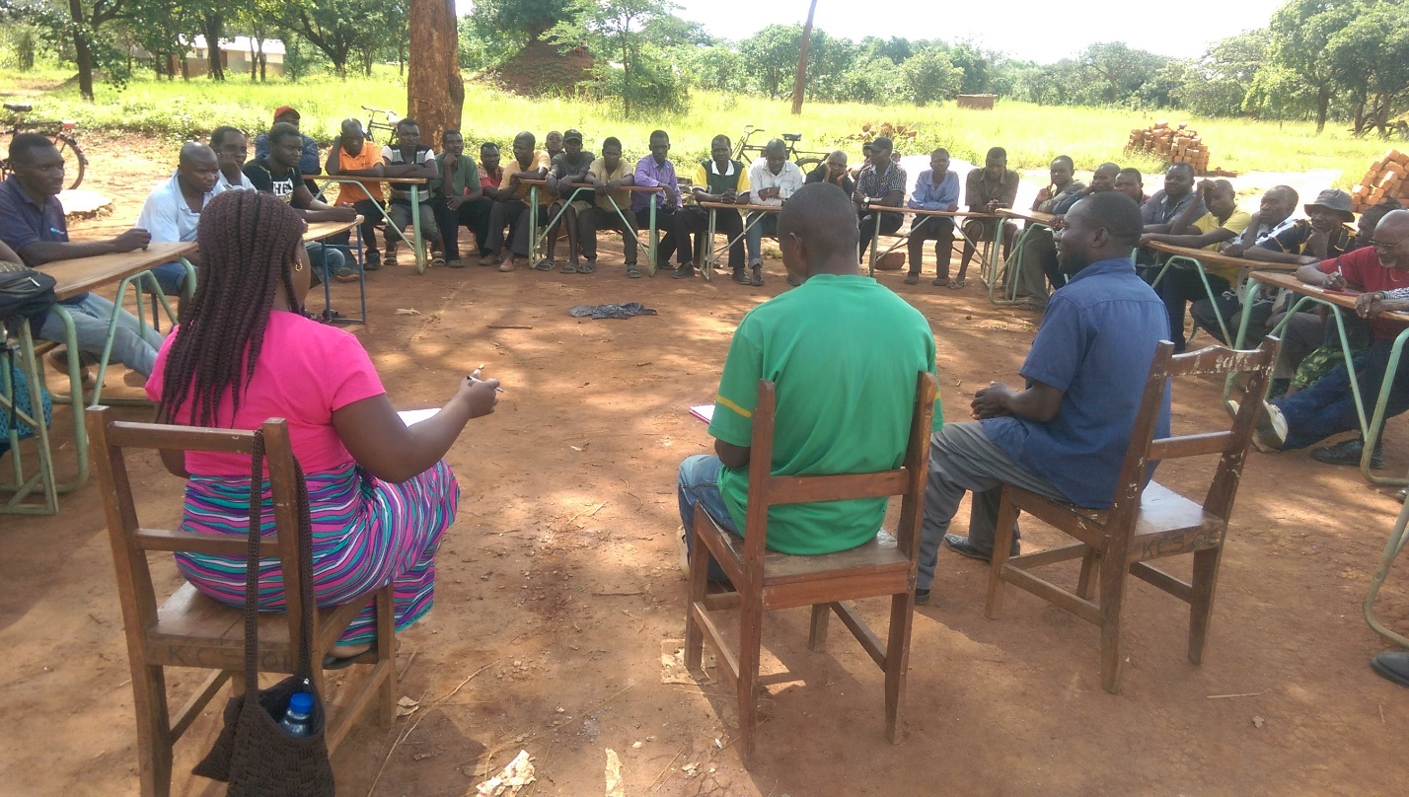

Figure 2.2: Group Discussion with Community Members

In this assignment primary data was obtained from interviews, group meetings and the inception workshop. The primary data collection instrument was a questionnaire (Appendix 2) which was tailored to collect the relevant information, at each stage.

* 1. **Data Analysis**

Given that the study data was generated as Primary and Secondary data, the analysis was conducted separately. Primary data was processed by means of the Statistical Package for Social Scientists (SPSS). Secondary data was collected to augment the primary study findings.

A Questionnaire to assess the possibility of CFM providing incomes to the Community and the willingness of the community to support preparation of management plans in the GEF V Project areas was administered in the VAGs surrounding the Project area.

## **Legal and Policy Frameworks in Community Based Natural Resource Management**

There are several Policies and Acts that have provisions concerned with CBNRM in Zambia. These include Acts and Policies in Forestry, Wildlife, Water Resources Management, Fisheries Management, and the national development documents, such as the vision 2030 and National Development Plans, which are five year planning frameworks. These policy and legal documents support CFM to various degree as shown in the discussion below.

### **The Water Resources Management Act No 21 of 2011**

The Water Resources Management Act No 21 of 2011 established the Water Resource Management Authority (WARMA) and define its function and powers; regulates the use of surface and ground water for any of the following purposes; environmental, training and research, municipal, agricultural, industrial, hydro-electric, mining, navigation and any other activity that may be specified by the water regulatory board.

Activities under these purposes may include, but are not limited to the following:-

* Use water for purposes specified under section 60, other than for domestic purposes specified under section 70 of the Water Resource Management Act No. 21 of 2011;
* Construct, acquire any water works, impound, supply or distribute water from any water or borehole to any other person;
* De-water any mine, quarry or water works;
* Drain any swamp, marsh, dambo, wetland, re-charge area or other land;
* Construct or acquire any water works for the purpose of draining into, conserving or utilizing, in any manner whatsoever, water from a water resource;
* Construct water works necessary to restore the course of a water resource that has changed its course;
* Harvest any rainwater by means of a dam, weir or barrage that is on a water resource;
* Conduct any operation that would interfere with the bank or course of a water course;
* Sink, deepen or alter any borehole for any purpose in a water shortage area; and or
* Carry out any activity in relation to a water resource as may be prescribed.

The Act provides for the control, ownership and use of water excluding the Zambezi, Luapula and Luangwa Rivers that borders with other countries. The Act establishes the Water Board and regulates the use of public water including pollution.

Closely associated with the water Act is the Water Policy of 1994, which regulates the importance of public water, food production, and the production of hydroelectric energy, the natural environment and other important aspects that enhance the quality of life such as transportation, recreation and tourism.

***Relevance:*** *The Act is relevant to CFM initiatives as it will regulate how communities in CFM areas will utilize the ground water resources, protect both surface and ground water contamination, provides for the use of inland surface water bodies, including the protection of the same from pollution.*

***Compliance there of:*** *CFM shall be supported by this Act regarding the construction of boreholes to supply additional drinking water since most wells are shallow and the water is polluted. In order to diversify family incomes, fish ponds to facilitate fish farming have to be constructed.*

*In carrying out the above stated activities CFM shall comply with the Water Act.*

### **Zambia Wildlife Act, 2015**

The Act provides for the establishment of the Department of National Parks and Wildlife, and the enabling legislation for the sustainable management of wildlife resources in Zambia. The Act provides for the protection and management of wildlife resources, national parks, bird and wildlife sanctuaries and GMAs. The Act also provides for the regulation of all wildlife activities such as hunting, poaching and keeping of wild animals. The local management of wildlife resources and habitats is partly delegated to CRBs in designated GMAs. The CRBs in turn are given commission for the income generated from GMAs.

***Relevance:*** *The need for the protection of fauna resources in all circumstances, including during the implementation of agricultural activities and CFM.*

***Compliance there of:*** *CFM is supported by this Act as it provides for the conservation of the animal and bird life which in turn has the potential to support ecotourism. This is necessary particularly when poaching has to be curtailed using relevant provisions and regulations in this Act. The study has noted that there is wildlife depletion in the area which is not good for the protection of flora and fauna. Besides, in future, ecotourism programmes may be introduced as alternative sources of income necessary to reduce pressure on flora and fauna and therefore contribute to the reduction of the threat on biodiversity in the area. The implementation of ecotourism programmes will require the provisions and regulations in this Act.*

### **Land Act of 1995 and Land Acquisition Act of 1995, Chapter 189**

The Act provides for the alienation, transfer and change of land. It also provides for compulsory acquisition of land by the President whenever he is of the opinion that it is desirable or expedient to do so in the interest of the public. The land is divided into state, private and traditional land.

**Relevance:** *Provides for the alienation of land for investment and other uses.*

Compliance there of: CFM is supported by this Act regarding the statutory recognition and continuation of customary tenure. If necessary, in the establishment of CFAs, customary tenure shall be converted into leasehold tenure as guided by the Constitution of Zambia and the Vision 2030.

### **Environmental Management Act No. 12 of 2011**

The Environmental Management Act, N0.12 of 2011 is Zambia’s overreaching legislation perpetuating the existence of the Environmental Council of Zambia and re-names it as the Zambia Environmental Management Agency (ZEMA); provides for integrated environmental management, the protection and conservation of the environment as well as the sustainable management and use of natural resources; provide for the preparation of the State of the Environmental Report, environmental management strategies and other plans for environmental management and sustainable development; provide for the prevention and control of pollution and environmental degradation; provide for public participation in environmental decision making and access to environmental information; establish the Environment Fund; provide for environmental audit and monitoring; facilitate the implementation of international environmental agreements and conventions to which Zambia is a party; repeal and replace the Environmental Protection and Pollution Control Act, 1990; and provide for matters connected with, or incidental to, the foregoing. Further, the Environmental Management (Amendment) Act, 2013 [No. 10 of 2013] is an Act to amend the Environmental Management Act, 2011. It amends the Environmental Management Act, 2011 in paragraph 7 of the First Schedule on revenue which shall form funds of the Zambia Environmental Management Agency.

The principles of the Act are listed below:-

* Adverse effects shall be prevented and minimized through long-term integrated planning and the coordination, integration and cooperation of efforts that consider the entire environment as a whole entity;
* The precautionary principle;
* The polluter pays principle;
* Equitable access to environmental resources shall be promoted and the functional integrity of ecosystems shall be taken into account to ensure the sustainability of the ecosystems and prevent adverse effects;
* People shall be involved in the development of policies, plans and programs for environmental management;
* The citizen shall have access to environmental information to enable him/her to make informed personal choices that encourage improved performance by industry and the government;
* The generation of waste should, in order of priority, be reused, recycled, recovered and disposed of safely in a manner that avoids adverse effects;
* The environment is vital to people’s livelihoods and should be used sustainably in order to achieve poverty reduction and socio-economic development;
* Non-renewable natural resources shall be used prudently, taking into account the needs of the present and future generations;
* Renewable natural resources shall be used in a manner that is sustainable and does not prejudice their viability and integrity; and
* Community participation and involvement in natural resource management and the sharing of benefits arising from the use of the resources shall be promoted and facilitated.

The rationale of the Act is founded on the Republican Constitution which states that, “every person living in Zambia has the right to a clean, healthy and safe environment”.

***Relevance:*** *Prescribes the management of the environment and provides for the conducting of environmental impact assessment and the development of impact mitigation measures, and management of the same.*

***Compliance thereof:*** *CFM will comply with the regulations in this Act in the CFM areas in so as the protection and conservation of the environment as well as the sustainable management and use of natural resources in the CFAs is concerned. Noting that that communities are experiencing water pollution, it shall be necessary to prevent and control water pollution and environmental degradation. To achieve the foregoing, public participation in environmental decision making and access to environmental information shall be necessary. Suffice to state here, the functional integrity of ecosystems shall be taken into account to ensure the sustainability of the ecosystems and prevent adverse effects. The generation of waste emanating as a result of for instance sawmilling, should in order of priority, be reused, recycled, recovered and disposed of safely in a manner that avoids adverse effects; additionally, non-renewable natural resources such as minerals shall be used prudently, taking into account the needs of the present and future generations; Community participation and involvement in natural resource management and the sharing of benefits arising from the use of the resources shall be promoted and facilitated.*

### **National Heritage Conservation Act of 1989**

The National Heritage Conservation Commission (NHCC) Act CAP 173 of 1989 stipulates preservation and protection of ancient cultural and natural heritage resources and objects of aesthetic, historical and archaeological value. In this Act, “Ancient Heritage” is defined as being among other things, any structure, settlement previously inhabited, land mark, burial place or any other item designated by the Commission which is known or believed to have been erected, constructed or used before 1st January 1924. The Act also provides for the establishment of the National Heritage and Conservation Commission which is the responsible institution.

***Relevance:*** *since the clearing of vegetation, construction of infrastructure may damage heritage sites if there are any. This Act will guide CFM implementers on what to do in case such sites are found on the designated CFM areas.*

***Compliance there of:*** *In CFM, and in particular CFAs the protection of sites of scientific, historical or cultural value is paramount. Therefore, such areas in the CFAs shall be managed in accordance with the provisions and regulations in this Act.*

### **Forests Act No. 4 of 2015**

This Act provides for the establishment and declaration of National and Local Forests as well as Joint Forest Management Areas, botanical reserves, private forest and community forest; provides for the participation of the local communities, local authorities, NGOs and other stakeholders in sustainable forest management; provides for the conservation and use of forests and trees for the sustainable management of ecosystems and biological diversity; establish the Forest Development Fund;

Provides for the implementation of the United Nations Framework Convention on Climate Change (UNFCCC), United Nations Forum on Forests (UNFF), Convention on International Trade in Endangered Species (CITES) of Wild Fauna and Flora, the Convention on Wetlands of International Importance (CWII), especially as Water Fowl Habitat, the United Nations Convention on Biological Diversity (UNCBD), the United Nations Convention to Combat Desertification (UNCCD) in those countries experiencing serious drought/desertification.

#### **The Forests (Community Forest Management) Regulations, S.I No. 11, 2018.**

Sets out the regulation of Community Forestry Management in Zambia, including setting up Community Forestry Management Groups (CFMG), Recognition of the same, where CFM may be set up in the country, and the cost benefit sharing mechanisms for the Different Types of CFM areas. Promotes integrated action with stakeholders including the traditional leadership structures, the local authorities, and other relevant agencies such as the Department of National Parks and Wildlife.

***Relevance****: Prescribes sustainable management of forests and natural resources, and the modalities of CFM in Zambia.*

***Compliance****: CFM shall adhere to the provisions and regulations that provide for the establishment and management of Joint Forest Management Areas, private forest and community forest; provides for the participation of the local communities, local authorities, NGOs and other stakeholders in sustainable forest management.*

### **2.2.8 The Local Government Act, 1991**

The Local Government Act CAP 474 of 1991 provides for a system of local government administration in Zambia at City, Municipality and District Council levels.

Each local governance level has delegated statutory functions with respect to development planning. The Act also allows Councils to implement environmental protection and natural resources management functions which include prevention of pollution of water supplies and has some control in undertaking of its farming operations.

***Relevance:*** *Prescribes functions of the local government system, and some elements of pollution control and the protection of the environment.*

***Compliance there of:*** *In this Act CFM, particularly the CFAs, shall*  *implement environmental protection and natural resources management functions which include prevention of supplying polluted water and has some control in the undertaking farming operations.*

### **2.2.9 The Mines and Mineral Development Act, 2015**

This Act provides for the issuance of licenses for exploration, mining and processing of mineral resources in Zambia and control of the same. It also provides for the protection of the environment from adverse impacts of mining. In line with the project, the Act provides for the protection of the environment from the adverse impacts of mining and mining related activities.

**Relevance**: Provide for the protection of the environment from the adverse impact of mining and mining related activities.

**Compliance**: CFM will follow the requirements of this Act as a means of monitoring and providing mitigation arrangement against the negative impacts of mining and related activities in CFM areas.

### **2.2.10 Agricultural Lands Act**

The Agricultural Lands Act Cap 187 gives provisions for the establishment of the Agricultural Lands Board; alienation of agricultural lands, tenant farming schemes, valuation of agricultural lands and powers of the Minister as far as agricultural lands is concerned. The Act also discusses the use of timber on agricultural lands.

***Relevance:*** *The relevance of the Act is to ensure that potential CFM areas within the perimeter of its land as prescribed in the title deed, while taking cognizant of the tenant farming schemes, valuation of such land and follows the provisions in relation to timber/trees on such land.*

***Compliance thereof: CFM*** *will comply with the provisions of the Act in so far as conservation and use of trees on farmlands is concerned..*

### **Fisheries Act, 2011**

The Act promotes sustainable development of fisheries and a precautionary approach in fisheries management, conservation, utilization and development. It establishes fisheries management areas and fisheries management committees and provides for the regulation of commercial fishing and aquaculture. It establishes the Fisheries and Aquaculture Development Fund. It has replaced the Fisheries Act of 1974.

The Act regulates all fishing activities in Zambia undertaken in any kind of aquatic ecosystem. This includes lakes, rivers and streams. It also regulates activities that may interfere with fisheries.

***Relevance:*** *CFM, once adopted shall take place within areas where there rivers and streams. In areas near big rivers, communities may be tempted to conduct illegal fishing or fish procurement activities especially during the fish-ban season. Fish Farming has been identified as a Viable Income Generating Activity and as such, the Fisheries Act comes into consideration.*

***Compliance there of:*** *CFM will comply with the Act in so far as fishing in rivers and streams is concerned in order to avoid illegal activities which may lead to accelerated fish depletion. In places where fish farming shall be introduced by way of constructing fish ponds, the Act shall provide relevant provisions and regulations necessary to undertake such activities.*

### **Energy Regulation Act**

The Energy Regulation Act is set primarily to set up the Energy Regulation Board, its composition, its functions, etcetera. The act also concentrates on the regulation of especially petroleum based energy and Electricity.

**Relevance**: The Act does not say anything about regulation of other forms of energy such as biofuels of which charcoal and fuelwood form a significant proportion in the country and the Project Area. The Energy Policy outlines strategies and measures to promote sustainable Biofuels; including establishment of woodlots, better kilns etcetera. this becomes problematic without a legal framework from the perspective of Energy regulation.

### **The International Conventions and Protocols**

Zambia is a signatory and party to more than thirty International Conventions and Protocols. Among the most relevant environmental conventions are; Convention on the Protection of World Heritage (CPWH) (1972) and ratified by Zambia in 1982, the United Nations Framework Convention on Climate Change (UNFCCC), statutes of the International Union for the Conservation of Nature (IUCN), and Convention on International Trade in Endangered Species of Wild Fauna and Flora (CITES), 1973, ratified in 1981. Others include the United Nations Convention on Biological Diversity (UNCBD) of 1992 and ratified in 1993, United Nations Forum on Forests (UNFF) and, last but not least, the Ramsar Convention.

**Relevance:** *Community Forest Management, if adopted, shall take place within the natural resource management areas*. *The existing natural resources need recognition and management in line with the requirements cited by the International Conventions and Protocols.*

## **2.3 Analysis of Legal and policy Framework related to CBNRM**

Most current laws and policies under which CFM is expected to be regulated or governed are inadequate in respect of some provisions (Appendix 3). In some cases, the existing provisions need to be strengthened to allow for successful implementation of CFM.

CFM, presently may face some challenges during implementation in respect of poverty reduction and forest conservation due to various issues relating to rights, privileges, roles and responsibilities.

**The Forests Act No. 4 of 2015:** The Forests Act No. 4 of 2015 supports the establishment and implementation of CFM through the provisions and regulations stipulated in Sections 29 to 35. Equally, the establishment and management of private forests (Sections 26 t0 29) and JFM (Sections 36 to 39) are addressed.

In respect of CFM, the Act outlines the provisions and regulations regarding community forest management group, recognition of the group, community forestry management agreements, rights and obligations of local community under forestry management agreements, assignment of rights under forestry management agreements, termination of community forestry agreement and registration of community forestry agreements. This is in line with the provisions of SI No. 11 of 2018.

To date, six (6) CFM groups have been formed covering 22, 000 ha in Kasonso Busanga GMA that have been formed in Kasempa, Mwinilunga and Ikelenge.

Suffice to state here, SI No. 11 of 2018 does not spell out the percentages in regard to Cost/Benefit sharing. Instead, in line with the Community Forest Management Agreement at “2” (ii) (b) namely, Community Forest Management Group Obligations has provided for the sharing mechanism. Communities will agree on percentage shares. This is not in the law because of different resources available at community level. The government will not impose a revenue sharing component, therefore communities will have to agree upon this.

**The Water Resources Management Act, 2011:** There are no guidelines in the Water Act or elsewhere to govern the public participation mechanism envisaged by the Act, and to ensure that the community involvement and gender considerations promoted by the statute are observed.

Suffice to state here, this Act is vital to CFM in respect of water rights and pollution. Currently, as earlier stated people are drinking mostly from shallow wells. The boreholes in the area are clearly insufficient to address the needs of the communities. Establishment of more boreholes, etcetera will require adherence to the Water Act on a Case by case basis.

**The Environmental Management Act, 2011:** The Act recognizes that community based management practices are still in their infancy and not widely implemented, enforced or practiced

**The Lands Act, 1995:** Land degradation and soil fertility were issues raised by people living in this area, and therefore the Land Act deserves due attention, if any interventions are to be considered in future in regard to CFM. The Act supports CFM at Part II, Section 3 and Subsection 7 respectively regarding the control of settlements, methods of cultivation and utilization of land as may be necessary for the preservation of natural resources on the land. It also supports the setting aside of land for forest reserves, GMAs and national parks and for the development and control of the same.

Regrettably, a number of existing laws and policies that regulate or govern CFM lack some key provisions (see Appendix 3). On the other hand, those in place require strengthening to adequately provide for sound community forest management. As such, the gaps identified need to be addressed to enable implementers fully realize the intended objectives of the policies and laws. If this is not corrected, community participation shall remain incomplete or continue to be ineffective causing attendant communities’ frustration. In addition, the weaknesses identified in the legal and policy framework may continue to have adverse effects, and in the long run will fail to enrich CFM.

It is also unfortunate, that in Zambia, despite having all these laws and policies that govern and regulate issues of natural resources management there is no mechanism that harmonizes the operationalization of the various policies and laws. There is no coordinating governance structure, policy or law that brings together ministries tasked with natural resources to plan, implement and monitor integrated natural resources management plans, Campbell (2010).

**The Town Country Planning Act, Cap 283 of Zambia:** Section 16 of this Act provides for the preparation of Development Plans, specifically “…16. (1) A development plan shall consist of a report of the survey in respect of the area to which the development plan relates….” and (16 (2) “…..A development plan shall include such maps and such descriptive matter as may be necessary to illustrate the proposals aforesaid with such degree of particularity as may be appropriate to the area to which the development plan relates…. “ . Clearly CFM plans which are by their nature “development plans” can be seen to be supported by this Act.

# **STUDY FINDINGS AND DISCUSSION**

## Primary Data

Findings from both the primary and secondary data are discussed as below:

### **Potential for CFM**

The potential for CFM in the project area was assessed based on the availability of Forest Resources, the current and potential economic use of the forest resources. The number of alternative income generating activities (IGAs) that would turn the focus of the community away from the Forest and Wildlife resources also helped in ranking a given area’s potential for CFM. As can be seen in Figure 3.1 below; ecosystems have a wide range of activities that can contribute to the successful implementation of CFM either by SFM or by diverting attention away from the Forest as a Survival resource. Currently, the main Economic Activities include crop diversification, livestock management, and non-sustainable charcoal production. Unfortunately, even in light of rampant timber exploitation, especially in the Chibwika and Lukwakwa CRBs, the respondents denied exploiting trees for timber citing illegal immigrants and business men from outside the CRBs as being responsible for the timber harvesting.

### **Economic Activities**

In both KNP and WLNP, the respondents are engaged in crop diversification, livestock development, beekeeping, unsustainable charcoal production, fish farming, artisanal mining, wildlife and ecotourism, timber production and processing. Evidently, the most popular activity is crop diversification which accounts for 25% of the economic activity. This is followed by livestock development at 12% and 11% respectively. Beekeeping and unsustainable charcoal production on average account for approximately 10.5% of the ongoing economic activity. Comparatively, non-wood production is higher in KNP (10%) while in WLNP it is 5%. Artisanal mining, wildlife, ecotourism, timber production and wood processing are below 5%.

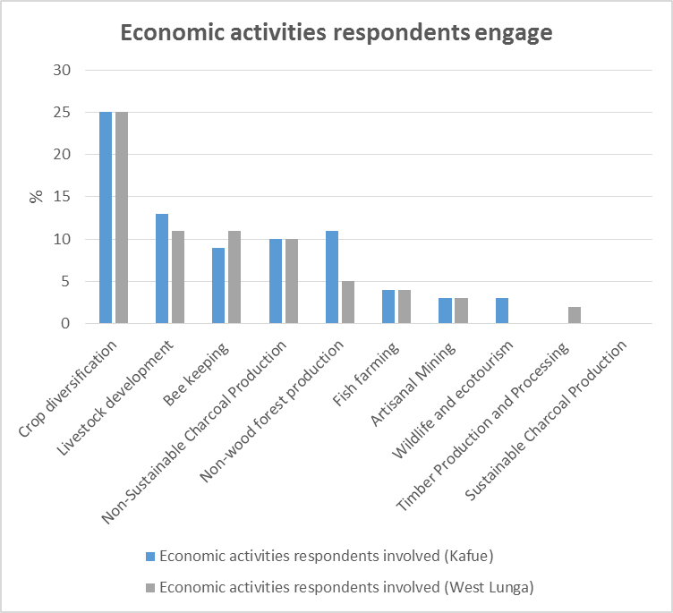

Figure 3.1: Economic Activity by Ecosystem

From Figure 3.1, the major land use systems in the two national parks (NP), in so far as the local communities are concerned, are agricultural related accounting for 25% in respect of crop diversification, and approximately 10% on average for livestock development. Suffice to state here, agriculture is one of the major drivers of deforestation and requires to be addressed adequately in order to avoid the deforestation due to increased expansion of agricultural lands in an effort to increase agricultural productivity. While it is appreciated that agricultural development is essential in order to provide food security, it should be undertaken with caution near the National Parks in order to avoid forest and land degradation. The Project could work in conjunction with the Ministry of Agriculture to promote conservation farming and other farming methods that would discourage wanton expansion of agricultural land(s) at the expense of deforestation, land and forest degradation which may lead to erosion, poor soil fertility and attendant low crop yields

Charcoal production is another activity that should be addressed appropriately. While domestic energy is necessary, it’s vital to promote sustainable charcoal production methods such as the use of efficient charcoal production kilns and efficient charcoal stoves.

In order to save the forests, people in these communities should be encouraged to engage more in forest-supporting related activities such as beekeeping, ecotourism through public-private-partnerships, fish farming, sustainable artisanal mining, sustainable timber harvesting and wood processing. If properly managed, these activities are liable to bring in more household (HH) income with minimum disturbance to the quality of land and forests, not to mention the loss of other biodiversity such as wildlife. Not with standing, this may require knowledge and skills development at the local level to enable the local people undertake their activities with due diligence, while preserving and conserving their natural resources and environment in general.

The potential for Community Forestry Management is very high in both Ecosystems (KNP, WLNP). Most of the GMAs still have good forest cover, and can thus be harnessed by use of the CFM tool. The community within the Project area, in both ecosystems are willing to participate in CFM, the concern however, is that the community seems willing to participate in all the suggested Income Generating Activities. It remains for the Project staff and the Community Liaison Assistants with specific Village Action Groups to refine the actual prescriptions according to the specific locales.

Out of the suggested income generating activities; in the West Lunga National Park, the communities were most interested in Fish farming, horticulture and timber related business. Given the current dissipated numbers of wildlife, ecotourism and wildlife tourism ranked very low among the options. The communities also seemed very keen to improve their agricultural production although in most cases this related to the cultivation of Maize, and primarily through Fertilizer support.

In the KNP ecosystem, as shown in Figure 3.1 above, the economic activities do not differ from the responses of the respondents in the West Lunga Ecosystem. The respondents are primarily preoccupied by issues of food security and then behind these, other issues of economic importance that begin to be considered, include beekeeping, and non-wood forestry products.

### **Forest Related Economic Activities**

Figure 3.2 shows that there are a number of forest related activities that the local communities are engaged in in both KNP and WLNP, namely charcoal production, forest food and fruits, timber production, grass, carpentry, weaving, poles, sawmilling and rattan. Generally, KNP accounts for a higher percentage of these activities in comparison to WLNP. In KNP, charcoal production stands at 12% while forest foods and fruits accounts for 10% followed by timber production and grass at 8% respectively. Carpentry and poles account for 5% while rattan is the least at 1%. In WLNP, charcoal production and forest fruits and foods is at 8% while timber stands at 5%. The remaining forest economic activities are below 5%.

Generally, in order of participation, people are engaged more in charcoal production, forest foods and fruits, timber production, grass, carpentry, weaving and poles though at different percentage levels in both KNP and WLNP. This suggests that forest related economic activities are still very popular in both Ecosystems, and charcoal production continues to be the highest economic activity in this genre. Like agriculture development/expansion, charcoal production is one of the major drivers of deforestation that leads to forest and

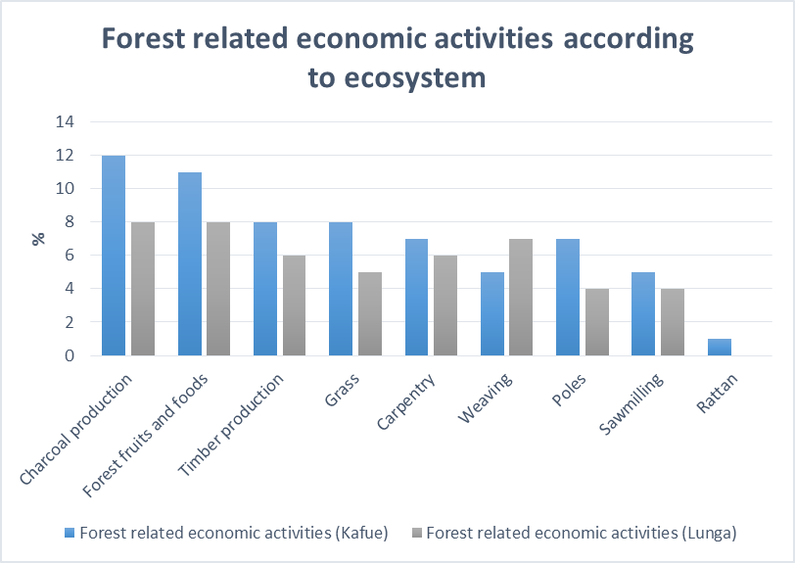

Figure 3.2: Forestry Related Economic Activities by Ecosystem

land degradation. As such, appropriate charcoal production methods ought to be promoted and strengthened in order to reduce the high deforestation rate as well as reducing emissions from deforestation and forest degradation (REDD). Equally, communities should be encouraged to establish community woodlots that can support firewood and charcoal production activities as well as use of efficient cooking stoves and charcoal production kilns.

As for beekeeping, communities can be encouraged to engage in modern apiculture that would include the cottage industry, but certainly not limited to it resource permitting, that would promote value addition using simple beekeeping equipment such as hives, setting up apiaries, cleaner and improved processing of honey and bees wax from the hives. This also calls for a departure from traditional harvesting methods which accelerate the deforestation rate.

Sawmilling and Rattan were the least developed economic activities and were mostly practiced on basis of availability of market opportunities of the relevant products. It is surprising that, at the end of the Forest Resource Management Project (FRMP) in Northwestern Province, which among other products promoted rattan, the community did not take up the trade. This raises issues of sustainability of the project activities and lasting improvement in the livelihoods and general economic standing of the target communities.

### **Proposed Income Generating Activities**

At the time the study was conducted, approved ILUPs, were only available for six VAGs out of the forty seven (47) VAGS visited. The six (6) VAGs are Kalunzyu, Maunga, Manyawu, Lalafuta, Kaminzeke and Kanzenzi.

In Kalunzyu VAG activities with potential for income generation are improved livestock production, sustainable charcoal production, fish farming, crop diversification, wildlife and tourism.

Potential income generating activities in the Maunga VAG are **l**ivestock development, fish farming, caterpillars, beekeeping/apiculture, sustainable charcoal production, carbon sequestration, wildlife and tourism.

In Manyawu potential income generating activities include fish farming, beekeeping, small livestock development, timber production and processing, establishment of commercial processing and marketing outlets for game meat to supplement proteins from pork, beef, fish, goats, chicken; and reduce illegal poaching of wildlife. Tourism, ecotourism, sustainable charcoal production and conservation farming are additional opportunities.

In Lalafuta potential income generating activities include wildlife, ecotourism, fish farming, commercial game meat marketing, crop diversification, caterpillar harvesting, beekeeping, timber production and processing, sustainable charcoal production, and improved livestock production and development.

In Kaminzekenzeke VAG, potential income generating activities are caterpillars, beekeeping/apiculture, improved livestock production and carbon sequestration.

In Kanzenzi VAG, potential income generating activities are wildlife, ecotourism, fish farming, crop diversification, caterpillars, beekeeping/apiculture, sustainable charcoal production, carbon sequestration, timber production and processing.

In order to ensure that communities reduce and ultimately desist from unsustainable utilization of the natural resources in KNP and WLNP, in particular deforestation and wildlife depletion, they need to be provided with alternative sources of income. According to the study findings, as shown in Table 3.1 and Figure 3.3 below as well as Appendices 4, 6 and 7 plus the six ILUPS discussed in the preceding paragraphs; the communities are most interested in Diversified Agriculture, Fish Farming, Beekeeping and Livestock Development, particularly small livestock such as Goats and Chickens though at different percentage levels. In this regard, it shall be necessary to equip the local communities with the knowledge and skills that will assist in the management of the above listed activities (businesses) in order to maximize their returns from the sales. They may also require startup capital to commence their businesses either in groups or individually. Basic skills in book keeping may be required as well.

Table 3.1: Income Generating Activities- Possible and Potential

| **GMA** | **VAG** | **Current**  **IGAs** | **POSSIBLE BUT NOT VIABLE** | **VIABLE, NOT POSSIBLE** | **POSSIBLE AND VIABLE** | **COMMENTS** |
| --- | --- | --- | --- | --- | --- | --- |
| Musele Matebo | Kalende | * 1. Subsistent Farming,   2. Beekeeping   3. Charcoal production | Chikanda, Wood products | Wildlife based Tourism | Agriculture based; crop diversification,  Fish Farming, Beekeeping | 1. The area vegetation was mainly secondary, therefore need for more growth, which would also increase the wildlife populations. 2. Potential for Rice production is high as it is grown nearby in the refugee camp. |
| Z | Old Matebo |
| Chibwika Ntambu | Chibwika |  | Chikanda,  Wildlife based, Tourism |  | Wood based, Bee keeping, Fish Farming, Agriculture, | 1. Reasonably stocked with wildlife seen near some VAGs, however, due to remoteness, more work would be required for access, and facilities. Issue of the road would be very key especially in the Ntambu CRB. 2. Although agriculture improvement is very key to household food security, the soils of Chibwika CRB are quite leached and crop Agriculture businesses would generally not be too profitable unless soil improvement techniques are employed extensively. |
| Kasanjiko | 1. Agriculture  2. Chikanda  3. Beekeeping  4. Wood based |
| Mwanamutowa |
| Mumpulumba |
| Chiwoma |
| Lwamisamba |
| Lukwakwa | Kashinankazhi | 1. Agriculture  2. Beekeeping  3. Timber based | Crop Agriculture based | Wildlife Tourism | Wood Products, Beekeeping, Fish Farming | 1. Area is well wooded, but too much illegal activity at present; with proper policing, the potential for sustainable timber is high. 2. Lukwakwa Soils are also quite leached so Agriculture is important for food security, but not really for household income generation. 3. Wildlife tourism would need good access (Mwinilinga – Manyinga road is still a gravel road), good housing/ camping facilities and proper advertising. |
| Chiteve |
| Mayahu |
| Mumbwa | Lukanga | 1. Agriculture  2. Charcoal  3. Beekeeping  4. Tourism based  5. Livestock – small livestock |  | Wildlife based tourism | Agriculture, Fish farming, Small livestock, Beekeeping, | 1. The soils in this GMA are very good for agriculture and some respondents, for example, at personal level, produce enough beans to supply boarding schools in the area. Agriculture as a business has a very high potential here. 2. The wildlife tourism sector is very developed in the KNP which is very close to these selected VAGs, the startup of tourism ventures, though viable, would be quite expensive, and might be discouraging without returns in the short term. |
| Kapepe |
| Namwanja |
| Kalunzhyu |
| Namwala | Mbuma | 1. Agriculture  2. Munkoyo  3. Charcoal  4. Fishing |  | Livestock rearing | Non wood (Mungongo), Agricultural Diversification, Fish Farming | 1. There is high deforestation in the Maunga area such that Timber based business are not viable. 2. Agriculture has potential as a business here in both priority VAGS. 3. Mbuma also has a lot of Mungongo that could be utilized for its oils that can be supplied to cosmetics industry. Further research into the value chain may be necessary. 4. Livestock is not very viable due to the nearness of the VAG from the park. Incidences of lions and other predators attacking Domestic animals have been recorded. |
| Maunga |
| Mufunta | Litoya | 1. Agriculture  2. Charcoal  3. Timber based  4. Livestock | Beekeeping. |  | Agriculture, Fish Farming, Livestock rearing | 1. Although vegetation is suitable for beekeeping, so far beekeeping is not viable because there are uncertainties in the chemical quality owing to the high use of chemical use in tobacco growing, which is wide spread; Concern of contamination. 2. The soils are quite fertile and suitable for Agriculture, and Conservation agriculture could be explored for food security assurance. |
| Lalafuta |
| Miluji (Lalafuta East) |
| Kasonso Busanga | Shimuka |  | Munkoyo roots. | Caterpillar harvesting, | Wildlife tourism, Agriculture, Fish Farming, beekeeping. | 1. There is quite high incidence of caterpillars, but harvesting by cutting trees is not sustainable, maybe, harvesting by pollarding could be explored before out rightly discarding the trade, as caterpillars have market. 2. Munkoyo seems to have been over exploited and may need some regenerating time. 3. With the Creeping in Tobacco agriculture, it is vital to reassess the Beekeeping, especially in light of the chemical contamination concerns in Mufunta GMA. |
| Kamufuwe | 1. Agriculture  2. Caterpillars  3. Beekeeping  4. Munkoyo |
| Lalafuta West |
| Kaminzekenzeke |
| Lunga Luswishi | Lunga | 1.Fishing  2. Agriculture  3. Illegal hunting |  | Livestock, | Fish Farming, Agriculture, Wildlife Tourism | 1. Livestock is not very possible here due to the threat of tsetse. 2. Potential for agriculture as a business is quite high. |

**Mineral Resources**

It was observed that there are a lot of minerals in the Project Area, from which the communities would like to benefit. This IGA could be strengthened particularly in the Shirenda VAG where Mining Concessions are prevalent. This IGA has a lot of potential in Maunga VAG too.

To facilitate, this, the Project should liaise with the Ministry of Mines and Minerals to maximise the benefits. There are a number of potential routes through which this can be done.

(i) The first one is through the use of the VAGs as mining co-operatives, which then can be awarded Artisanal Mining concessions under the Mines Act Section 13 (3).

(ii) The second route is through employment opportunities. Section 20 (2) (a) of the Mines and Minerals Act No 11 of 2015, states that “… The holder of a mining right or mineral processing licence shall, in the course of operations give preference in employment to citizens with relevant qualifications or skills…”

It must be recognised that mining is a competing landuse to forest conservation. In this regard, the granting of access to mineral resources under Section 22 (1)(c ) of the Mines and Minerals Act No 11 of 2015, where the land is within, National Forests and Local Forests, is subject to approval from appropriate authorities, which in this case for forestry resources it would be the Forestry Department. This therefore, can provide a protection of forestry resources for conservation, from mining, especially where such forests are deemed to be certified as Community Forest Management Areas by the Forest Department under SI 11 of 2018.

To ensure success and sustainability, the project may be pivotal in establishing strong Market linkages between the communities and potential markets. This is essential, particularly when crop yields increase, and central storage sheds are required. To get the produce from such centers there shall be need to develop the infrastructure in terms of roads and appropriate storage sheds. Where applicable, some agricultural and forest produce would require value addition in order to maximize return on sale, for instance round wood needs to be processed into sawn timber, raw honey converted to processed honey, dried Caterpillars and mushrooms to mention but a few. Where applicable, fruits like mango, mpundu *(Parinari curatelifolia)* and masuku (*Uapaca kirkiana)* which grow in abundance, could be processed into jams, juices or wine depending on expertise and availability of capital investment to purchase simple processing plants. Such investments can create employment, increase the income at the HH level and improve people’s livelihoods immensely.

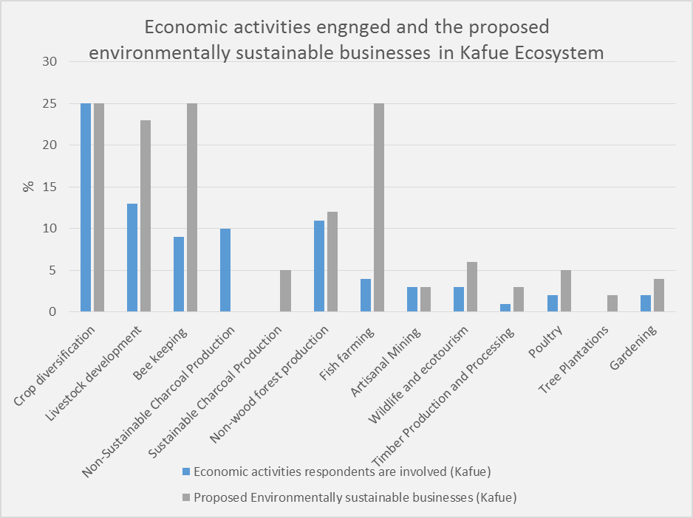

Figure 3.3: Current Economic Activity against recommended Economic Activity

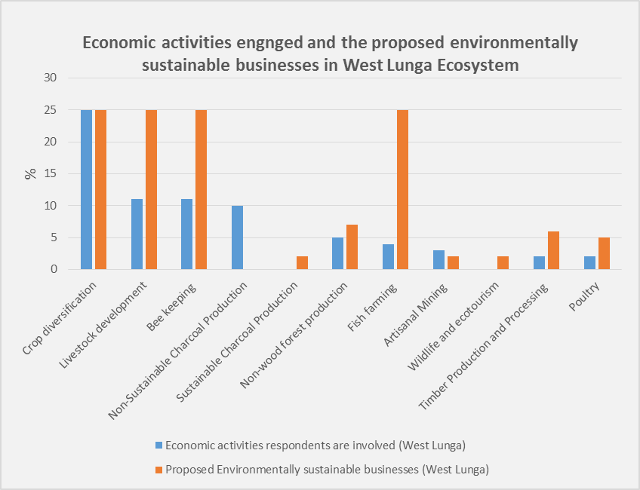

Figure 3.4: Current Economic Activities against Proposed Economic Activity

### **Women Friendly Economic Activities**

With regard to gender roles and relations in the context of potential income generating activities (Appendix 4), there was no difference whatsoever between the men and women; except in the case of traditional beekeeping which involved climbing of trees, for example. In fact, the four priority Income Generating Activities, namely Diversified Agriculture (this would include Development of Fish Farming and Development of Livestock Rearing), Beekeeping, Horticulture and Timber related business. These are activities that both Men and Women can comfortably undertake as and when need arises. Although the study did not reveal any challenges in men and women working together, it would be interesting to have men and women working alone and working together to observe which configuration of the IGAs would be successful beyond the project.

The Study also revealed that traditionally, only women were involved in such activities as harvesting and sale of Munkoyo (specific root fibers for a traditional beverage) and Chikanda (an Edible Wild Orchid Species), but as the monetary returns increase, men are also increasingly engaging in the same. One community in Kaingu CRB in Namwala GMA brought out the abundance of the Mungongo tree, whose oil has proven value chains that could really make a difference in the social economic development of the community.

In some areas of the Project area, edible caterpillars (ifishimu/Mopani worms), occur quite frequently. However, the traditional harvest method that involves cutting down of trees is not sustainable. A lesson from the Regeneration Project in Serenje where one community suggested pollarding of trees after a certain height is worth investigating.

### **3.1.6 Implementation Partners**

One of the most important actions in a project is the identification of Implementation Partners (IP) and other stakeholders as shown in Table 3.2 below, for this Project. In order for the CFM, being proposed, and the IGAs to work, there needs to be put in place working arrangements both with the community and other entities also operating within the project areas.

*Table 3.2: Stakeholders in the surveyed Project Area*

|  |  |  |  |
| --- | --- | --- | --- |
| **Stakeholder**  **Groups** | **Responsibility/Interest** | **Stakeholder**  **Subgroups** | **Potential Points of Conflict with other interest Groups** |
| Users | Monitor the resource and respond to threats such as fire, poaching, illegal timber harvesting, etcetera. | * CRBs – engaged in wildlife conservation. * Farmers – engaged in agricultural production for food security * Saw millers – engaged in unsustainable timber production and processing * Beekeepers – engaged in unsustainable honey harvesting. * Conserva-   tionists or  naturalists   * Charcoal production – unsustainable charcoal production methods * Miners – Promotes mineral exploration | * Illegal poaching & deforestation leads to wildlife depletion. * Accelerated deforestation and loss of biodiversity * Accelerated deforestation, loss of biodiversity and accumulation of saw dust * Promotes deforestation and loss of biodiversity. * Promotes biodiversity conservation, however there are a lot of illegal activities that hamper progressive conservation of the natural resources. * Accelerates deforestation and loss of biodiversity. * Accelerates forest and land degradation plus loss of biodiversity. |
| Government | Formulate policies and legislation/regulators | * Politicians – Lawmakers meant to uphold policies and laws governing forest resources. * Govt Officials - Law enforcement regarding the management of forest resources * Field Assistants; and * Institutions   (education  and  training) - Provide formal and informal (for example, forest extension services) education and training regarding the management of forest resources. | * Political interference in the management of forest resources * other stakeholders involved in illegal activities may be hostile to the Government officers      * As for Govt officials * Some community members may shun informal education and training. |
| Development  Partners | Provide Technical support and expertise | * International   Donors   * Consultants; * Multilateral and   Bilateral  Donors   * NGOs; and * Research   and  training orgs. | * May promote an Agenda that serves their interest and not that of the community * May fail to engage the communities adequately and therefore fail to deliver on their TORs, and community interests. * As for International donors above * Their interests and project objectives may be in conflict with those of local communities. * May develop advocacy positions that may be in conflict with Government provisions * At variance with indigenous knowledge systems. There is need to reconcile scientific and indigenous knowledge systems. |
| Private  Sector | Bring investment and links to markets | * Private enterprises * Entrepreneurs. | Private and commercial interests may conflict with those of the community members. |

Mumbwa, Mufunta and now increasingly, Kasonso Busanga GMAs are involved in extensive tobacco production and there is therefore presence of private sector players in the tobacco industry such as Tombwe, and Alliance one. These companies also support reforestation by supplying tree seedlings to their farmers. The project entry point could be to ensure that the growth potential of these trees is increased, as most respondents did not have a positive outlook on the tree planting exercise(s). Also such NGOs, as World Vision, CFU, had some presence in some GMAs where they are promoting Water and Sanitation as well as conservation farming respectively. However, in Mumbwa and Mufunta, and some areas of Lunga Luswishi, the CFU presence was as a result of being contracted by the project to conduct conservation farming interventions in the project area. In respect of the WLNP GMAs, the major private sector player at the moment is the First Quantum Mines; more so the Kalumbila Mine which has a project running with the DNPW to improve protection and conservation of the park in order to improve the wildlife population. They are in the initial stages of establishing the same arrangements with the FD for the better protection of the forests in the Project area.

### **Perceptions of Plant and Animal Abundance**

The common activities that are carried out in most of the VAGs’ local forests are; hunting, collection of firewood, fiber, forest foods, medicinal herbs, honey, fishing, farming and logging. According to most of the respondents, the population of animals in most VAGs has reduced due to a number of factors which include; poaching, logging, human population increase (creation of new settlements) and farming (establishment of new farming blocks by clearing forest areas). On the other hand, the respondents perceived the population of trees in some VAGs to have increased due to rapid regeneration of the trees especially in the West Lunga Ecosystem which has favorable climatic conditions. However, plant species such as Mukwa and Rose wood have been exploited in most VAGs due to their economic value. Shimuka, Kamufuwe, Lalafuta-west and Miluji, in the North of the KNP are the four VAGs that had an increase in both plants and animal population. Animal population was perceived to have increased due to the increased incidents of Human Animal Conflicts in the area, according to the respondents.

Given the foregoing, it is proposed that the under listed VAGs in Table 3.2 below be given priority in respect to CFM as they have more forest cover and fauna which continue to increase as observed by the respondents.

Table 3.3: Perceptions regarding Increase in Animal and Tree Population

|  |  |  |  |  |
| --- | --- | --- | --- | --- |
| VAG NAME | WILDLIFE POPULATION | | TREE POPULATION | |
| INCREASE | DECREASE | INCREASE | DECREASE |
| Lukanga |  | √ | √ |  |
| Kapepe |  | √ |  | √ |
| Namwanja |  | √ |  | √ |
| Kalunzhyu |  | √ |  | √ |
| Mbuma | √ |  |  | √ |
| Maunga |  | √ |  | √ |
| Litoya |  | √ |  | √ |
| Lalafuta |  | √ |  | √ |
| Shimuka | √ |  | √ |  |
| Lunga |  | √ |  | √ |
| Kamufuwe | √ |  | √ |  |
| Kaminzekenzeke |  | √ | √ |  |
| Lalafuta West | √ |  | √ |  |
| Miluji (Lalafuta East) | √ |  | √ |  |
| Chibwika |  | √ | √ |  |
| Mwanamutowa |  | √ | √ |  |
| Chiwoma (Chibwika Central) |  | √ | √ |  |
| Mumpulumba |  | √ | √ |  |
| Lwamisamba |  | √ |  | √ |
| Kasanjiko |  | √ |  | √ |
| Old Matebo |  | √ | √ |  |
| Kalende |  | √ | √ |  |
| Manyawu |  | √ |  | √ |
| Kashinakazhi |  | √ | √ |  |
| Chiteve |  | √ | √ |  |

Table 3.4: VAGs Prioritized for CFM

1. Kalunzhyu 2. Maunga 3. Lalafuta 4. Kaminzekenzeke 5.Manyawu 6. Kanzenzi

### **Community Willingness to participate in CFM**

In order to ensure sustainable utilization of natural resources and forestry resources in particular, a careful balance of use and conservation has to be observed. One of the two critical outcomes of this study was the assessment of the willingness of the community to participate in the formulation of Community Forestry Management Plans.

The preparation of community forest management plans follows distinct steps namely:

* + 1. Blocking of the village forest area;
    2. Participatory forest resource inventory;
    3. Assessment of village timber demand;
    4. Defining forest management objectives;
    5. Proposing suitable management activities for each forest block; and
    6. Development of the setup of an appropriate organizational structure at village level and the elaboration of forest protection and development regulations.

The study found that a hundred percent (100%) of the communities were willing to participate in the preparation of CFMPs, more so after the idea of what a CFMP was explained to them. Most of the communities visited had actually already started the process of land use planning with the Community Liaison Assistants (CLAs) and were quite eager to finish the process. The concept of ownership is critical in this instance because without a feeling of ownership, a sense of responsibility is passed onto another party. More and more communities are beginning to develop a sense of responsibility towards the management of the natural resources. Almost unanimously, the reason given for compliance to the CFMP by-laws was that self-generated laws would be easy to observe, that is the issue of self-determination.

Overall, the respondents in the VAGs visited expressed opinions regarding project implementation in their communities. Specifically, they are willing to participate in the preparation of CFMPs. The CFMPs, in principle, should consider inclusion of the under listed components shown in Table 3.2 below.

Table 3.5: Content of a simple Management Plan

* Background Information
* Introduction
* Description of the forest
* Short- term and long-term objectives of the forest management plan
* Forest management activities (Protection, utilization, development and monitoring)
* Collaborative monitoring and learning
* Approval of the plan

During the consultative meetings the community members in the VAGs raised concerns regarding project implementation. The major concerns of the communities included:-

* The time that project benefits take to accrue to the community;
* The fact that most project prescriptions are not community driven;
* Most benefits are intangible and therefore not really appreciated; and
* Poor infrastructure, especially roads that would enhance access to markets for their products.

## **Secondary Data**

In the most part, the desk study supports CFM in the management of natural resources for sustainability. Most countries in the Southern African region are pursuing aspects of Participatory Forest Management (PFM) including CFM. Countries such as Malawi, Mozambique and Namibia among others are conducting projects and studies in Community Forestry participation.

### **Lessons Learnt From Other Projects**

In the process of this study, the consultant undertook two trips to understand the operations of two existing projects with a strong Community engagement component; that is the Regeneration Project in Serenje and Chitambo Districts; and the Dambwa Joint Forestry Management Project in Livingstone. The team also reviewed theAdministrative Design for Game Management Areas (ADMADE).

#### **Dambwa Joint Forestry Management Project**

Among the aspects of CFM that are the most challenging is the aspect of Cost/Benefit Sharing. Lessons learnt from the Provincial Action Programmes (PFAP I and II) in Zambia in respect of the JFM initiative established to reduce management costs, have a positive impact on the quality of forest resources; and improve the livelihoods of the local communities over time (GRZ 1998; Murali et al., 2003; PFAP, 2005), have shown that more thought needs to be given to the aspect of cost/benefit sharing if the project and CFM is to be successful in Zambia and elsewhere.

In the case of the Dambwa JFM for example; the African Lion Environment Research Trust (ALERT) remits funds into the JFM account since the contract was signed in 2009. However, to date, because of inadequate clarity on the cost/benefit sharing mechanisms, including share percentages, bank signatory arrangements, and signing authority thresholds the community has not accessed any of the funds due to them. This leads in most to discouragement in the community which in turn contributes to forest degradation as the community turns to the natural resource for survival. This in turn, suggests that the programme was not successful, particularly regarding the improvement of local people’s livelihoods. According to the Forest Management Committee (FMC) and the Women Group interviewed, the Forestry Department has failed to devolve power to the local people in Dambwa which has subsequently frustrated the local communities.

In the Zambian context, because of the legal and policy framework, it is currently not possible for the government to share financial benefit with the community especially in hard currency. For their part, the community would probably prefer to receive their benefit in currency rather than in infrastructure and services. There is therefore need to rethink the financial and natural resources policy and legal frame work to include this aspect, otherwise the sense of ownership that is required in order to ensure prudent management of the resource would be absent and any sustainability of the project interventions would be seriously compromised

#### **Administrative Design for Game Management Areas**

The ADMADE scheme established by the then National Parks and Wildlife Service (NPWS) to increase and enhance community capacity to meet basic needs through sustainable utilization and conservation of natural ecosystems, failed after ten (10) years due to among other things:-

* The Chiefs, who were the Sub-Authority Chairmen, together with their advisors, developed autocratic leadership qualities at the expense of the broader community and they misapplied funds meant for community development and wildlife conservation for their own personal aggrandizement;
* The Wildlife Conservation Revolving Fund (WCRF) funds were misappropriated at NPWS Headquarters (HQ);
* The power was not significantly devolved from the NPWS to the local communities and this disempowered them politically in voicing their concern on issues that affected their welfare;
* The Sub-Authorities were dysfunctional; and
* There were incidences of abuse and interference of safari operators**.**

#### **Regeneration Project**

The Forestry Department is presently implementing the Regeneration Project supported by the UNDP in Central Province. The project has interventions in; i) Natural Regeneration, ii) Fire Management and ii) Energy. The specific sites in question are located in Kanona and Chitambo. In total, five communities were visited. The said communities were very willing to share their experiences with the consulting team.

To date, the community members have been trained in fire management, gardening, and small livestock (goats and chickens) rearing and nursery establishment. Alternative livelihoods have been identified whose aim is to assist in alleviating pressure on the forests such as gardening, beekeeping, small livestock rearing and possible alternatives of efficient charcoal production as well as cook stoves. They also carry out early burning to avoid late fires. In an effort to boost their income at homestead level, they are also engaged in the cash for work programme.

In respect of forests, they establish forest nurseries, and the resultant seedlings are used in enrich planting or most probably community woodlots to cater for domestic energy and construction. Currently, they are planting agroforestry species, namely *Tephrosia* and *Cajanas cajan*.

The project is working with the community to encourage secondary natural and assisted regeneration of degraded forests. The communities are enthusiastic about the project and within the short term of the project so far, claim that they have already started observing some improvement in the stocking of especially non timber products such as caterpillars and mushrooms. It was from this project that the concept of pollarding of trees as opposed to cutting the whole tree for Caterpillars arose.

In this project, CFM has not yet commenced due to delays in securing land as the traditional leaders were not keen to give land fearing that it was merely being grabbed from them by the relevant authorities. Eventually, land was secured in Serenje (two pieces of land) and Kanona (three pieces of land) districts. Regrettably, the actual hectare was not given.

In total the Project has thirty (30) registered VAGs in all sites with functioning committees and user groups. There are five (5) Assisted Natural Regeneration Sites which have three (3) to eleven (11) VAGs in each. The VAGs are registered as associations.

Unfortunately, community fatigue has begun to set in the communities due to the long gestation period between project start up, training in various skills, financial disbursement to commence project and, actual CFM commencement.

* **Lessons learnt from these projects include:**
* Inadequate provisions in the legislative framework to cater for CFM
* The aspect of ownership is critical in the success of any community based forestry management approach.
* The use of indigenous knowledge is important and in combination with scientific knowledge can lead to sustainable use of the resources.
* The issue of cost and benefit sharing is a delicate issue, and being linked to legal and policy frameworks, is also the most challenging to tackle.

### **Sustainability of Project interventions**

In the execution of this study, and in reading various literature, the issue of sustainability of project interventions has arisen. The respondents readily agreed to the implementation of the GEF 4 Project which among other things, offered support for livelihood improvement. However, to date nothing much was on the ground as a lasting legacy. This scenario is true of the FRMP, as well. As soon as the project comes to an end, the communities abandon the project activities, including the livelihood activities they had been trained in. This begs the question: How can the project ensure sustainability of project interventions? Particularly as they relate to livelihood improvement. A few suggestions from the study are as follows:-

* Community consultation mandates should be accompanied by detailed procedural guidelines on the form, method and process that these consultations should take;
* Undertake law reforms that integrate, harmonizes and revises laws that relate to the implementation of Reducing Emissions from Deforestation and forest Degradation and other sources (REDD+);
* Adequate time must be given to the process of training, and mentoring in the project cycle.
* Formation and maintenance of market linkages. As long as there is market, the supply will be guaranteed.
* Proper feasibility studies of the individual proposed community livelihoods interventions in a case by case to determine the workability, practicability and even the willingness of the community to undertake the proposed projects.
* A sense of ownership is paramount. As long as the community view the resources as belonging to a third party, they are prone to not care about the potential destruction of the resource, and will care more about being caught.
* Put in place effective enforcement monitoring mechanism to ensure that the CFM directives enshrined in laws and policies are complied with

### **Potential CFM Models/Types in the Project Area**

Anumber of CFM models or types that have been tried in different countries in Africa and outside Africa, vary in extent of decentralization and devolution of power, defined responsibilities, rights and ownership (Willy, 2002 and FAO, 2018). These rights largely determine the extent of empowerment. The ideal situation, is to establish a CFM model in which jurisdiction is fully devolved and sometimes includes ownership of the estate. However, this may not be acceptable presently and may require further elaboration by relevant authorities both in government, community and traditional leadership. Against this background, consideration should be given to the under listed CFM types. The CFM models/types are presented in order of increasing rights to be devolved:-

* Participatory conservation;
* Joint Forest Management;
* Community forestry with limited devolution;
* Community forestry with full devolution; and

Private ownership.

### **3.3.1 Participatory conservation**

This provides some community responsibility to protect forests, but little authority to make decisions. There are very few (or no) rights for local communities to access and use forest products.

The pressure on use of forest products is reduced by application of outside managed integrated conservation and development approaches often in buffer zones of protected areas. This includes encouraging alternative livelihoods and enforcing protection through external agents or by delegating protection functions to local people. Limited collection NFWPs is allowed sometimes.

In this arrangement the indicative rights are:

* Access-Rights to access forest
* Withdrawal-Sometimes limited rights to harvest prescribed NWFPs
* Management-No rights to make forest management decisions
* Exclusion-No rights to determine who will have access to the forest
* Alienation-No right to sell or lease either or both of the management or exclusion rights or to use them as collateral
* Duration of rights-No defined term
* Rights to compensation-No rights to obtain compensation if rights are withdrawn

### **3.3.2 Joint forest management**

Shared authority - Limited and highly prescribed rights for local people to access and use forest products.

Forest products and related benefits from government owned forests shared between government and local communities to encourage communities to protect the forests. Employment in forest management activities sometimes available.

In this arrangement the indicative rights are:

* Access-Rights to access forest
* Withdrawal-Generally rights to harvest NWFPs, but rights to harvest timber held by government agencies
* Management-Rights to make forest management decisions held by government agencies
* Exclusion-No rights to determine who will have access to the forest
* Alienation-No right to sell or lease either or both of the management or exclusion rights or to use them as collateral
* Duration of rights-May be a defined term fixed by a management plan
* Rights to compensation-No rights to obtain compensation if rights are withdrawn

### **3.3.3 Community forestry with limited devolution**

This provides limited rights for defined local communities to manage forests, access and use forest products. However, there is significant government authority and oversight.

The rights to manage forests and use some forest goods, usually NWFPs and subsistence products, are devolved to local communities, generally subject to the development of a management plan. The rights generally do not include selling timber into the open market, but selling NWFPs may be allowed.

In this arrangement the indicative rights are:

* Access-Rights to access forest
* Withdrawal-Rights to harvest NWFPs (may be subject to a management plan)
* Management-Rights to make forest management decisions held by government agencies
* Exclusion-Limited rights to determine who will have access to the forest
* Alienation-No right to sell or lease either or both of the management or exclusion rights or to use them as collateral
* Duration of rights-Generally defined term fixed by a management plan
* Rights to compensation-No rights to obtain compensation if rights are withdrawn

### **3.3.4 Community forestry with substantial or full devolution**

There are significant rights for defined local communities to manage forests, access and use forest products. Generally, there is also some government authority and oversight.

The rights to manage and use forests are devolved to local communities, generally subject to the development of a management plan. The rights include harvesting of timber and selling forest products into the open market.

In this arrangement the indicative rights are:

* Access-Rights to access forest
* Withdrawal-Rights to harvest NWFPs and timber (generally prescribed in a management plan)
* Management-Rights to make forest management decisions (generally prescribed in a management plan)
* Exclusion-Rights to determine who will have access to the forest
* Alienation-No right to sell or lease either or both of the management or exclusion rights or to use them as collateral
* Duration of rights-Generally defined term fixed by a management plan
* Rights to compensation-No rights to obtain compensation if rights are withdrawn

### **3.3.5 Private forest ownership**

Most rights to access and use forest products held by forest owners. Government may or may not exercise authority over some aspects of forest management, including harvesting and marketing forest products.

Ownership and use rights held by individuals, households, groups or communities to manage forests and receive benefits. (Includes smallholder forestry)

The indicative rights in this arrangement are:

* Access-Rights to access forest
* Withdrawal-Rights to harvest NWFPs and timber
* Management-Rights make forest management decisions
* Exclusion-Rights to determine who will have access to the forest
* Alienation-Rights to sell or lease either or both of the management or exclusion rights or to use them as collateral
* Duration of rights-Generally perpetual
* Rights to compensation-May be rights to obtain compensation if rights are withdrawn

In principle, it is important to consider inclusion of the following in the model/type:-

* **Legislative Governance –** This refers to the legislation governing CFM

1. Legislative provisions in terms of the laws and policies
2. Size of the forest estate to be used for CFM
3. Tenure duration;
4. Legal entity of the CFMG
5. Land entitlement and exploitation of NWFPs

* **Procedure for the Formation of the CFMG**

1. Public consultation
2. Requirements of the management plan
3. Submission of application and average time to procure the necessary permit or license for the CFMG
4. Review of the application
5. Decision-making and authority concerned

* **Administration and oversight of CFMG**

1. Competent authority (FD through the Ministry of lands an Natural Resources (MLNR))
2. Level of cooperation among relevant administrative bodies (FD and VAGs)

* **Other Measures of Maintaining and Improving Cooperation**

1. Reporting procedures
2. Monitoring and enforcement
3. Expertise and training in the management of the community forest
4. Customer relationship and distribution channels of forest products

* **Reforestation, afforestation and rehabilitation**

Given the foregoing, the VAGs can be managed in respective models in line with the intensity for management and control; that is those requiring more Government control while CFM is in force while in others the communities have an upper hand. Table 3.5 shows the proposed alignment of CFM models with the VAGs in the Project Area, based on the field survey of this assignment, subject to verification by a subsequent full forest resource assessment.

*Table 3.6: Proposed Alignment of CFM Models with VAGs in Project*

*Area*

|  |  |  |  |
| --- | --- | --- | --- |
| GMA | VAGs | | |
|  | Joint Forest Management | Limited Devolution | Full Devolution |
| Mumbwa | Lukanga  Kapepe  Namwanja  All these VAGs have low forest cover |  | Kalunzyu  This VAG has good forest cover |
| Namwala | Maunga  Mbuma plus 14 0ther VAGs with low forest cover |  |  |
| Lukwakwa |  |  | Manyawu  Kashinankazi  Chiteye  All these VAGs have good forest cover |
| Mufunta |  | Lalafuta  Litoya  Miluji (Lalafuta East)  These VAGs have good primary and secondary vegetation |  |
| Kasonso Busanga |  | Kaminzenzeke  Kamufuwe  Lalafuta West  Shimuka  All these VAGs have good primary and secondary vegetation |  |
| Chibwika Ntambo | Kanzensi  Low forest cover |  | Chibwika  Kasanjiko  Mwanamutowa  Mumpulumba  Chiwoma  Lwamisamba  All these VAGs have good forest cover |
| Musele Matabo | Kalende  Old Matebo  Low forest cover |  |  |
| Lunga Luswihi | Lunga  Low forest cover |  |  |

# **CONCLUSION**

The conclusions of the study are that:

1. The potential for CFM is very high in the project area due to the presence of reasonably stocked primary/secondary vegetation.
2. The communities in both the KNP and WLNP ecosystems are very willing to participate in the formulation FMPs.

The success of the CFM implementation however, will depend on a number of issues including:

1. Whether the project will succeed in building a sense of ownership among VAGs, in the natural resources around them, and therefore develop a sense of responsibility towards the resources.
2. How long the project will take to roll out the interventions as the community are becoming ‘fatigued’ in the sense that their perception is that the project staff and consultants working on behalf of the project are earning money at their expense.

Table 4.1: Summary of Study Findings in Relation to the Terms of Reference

|  |  |  |
| --- | --- | --- |
| **No** | **TOR** | **Findings** |
|  | a. Identify and summarize provisions of current legislation that support community forest management (CFM) in Zambia. | The relevant legislation is:  (i) Water Management Act No 21 of 2011;  (ii) Zambia Wildlife Act, 2015;  (iii) Land Act of 1995;  (iv) Land Acquisition Act of 1995;  (v) Environmental Management Act No 12 of 2011;  (vi) Forests Act No 4 of 2015;  (vii) Local government Act, 1991;  (viii) Mines and Minerals Development Act 2015;  (ix) Agricultural Lands Act; and  (x) Fisheries Act 2011.  **Gaps identified in the legislation and implementation framework**:   * There are a large number of existing laws (at least 10 Acts) that govern the CFM operational environment. Most of these have inadequate provisions for CFM, and would therefore require strengthening. * There are no mechanisms to harmonize the operationalization of the various laws and policies that govern and regulate natural resources management in Zambia. * There is no coordinating governance structure, policy or law that brings together all the ministries and Government Agencies tasked with the responsibilities of natural resources management, to facilitate coordinated planning, implementation and monitoring of natural resources management plans. |
| b. | Identify areas within the Project Area where CFM interventions can be set up. | **Ranking criteria for CFM interventions**   * Presence of forest cover * Proximity to forest resources * Current and potential economic use of the forest resources * willingness to participate in the formulation and implementation of CFMPs * Absence of water logging * Site accessibility   **Chosen CFM intervention VAGs**   1. **Joint Forest Management:-** Maunga and Kanzesi 2. **Limited Devolution:**- Lalafuta and Kaminzekenze; and 3. **Full Devolution:**- Kalunzyu and Manyawu. |
| c. | Assess the possibility of CFM providing incomes to the Forest Dependent surrounding Community. | **Income Generating Activities:-**   * Sustainable Diversified Agriculture includes Agronomy, Development of Fish Farming and Development of Livestock Rearing; * Beekeeping; * Horticulture; and * Sustainable timber related business.   **Value Chains**   * Crop, fish and meat processing; * Honey and bee product processing (beeswax, propolis, etcetera); * Processing of citrus, mango, musuku Mpundu and mungongo and other fruits into jams, wine, oil etcetera; * Processing round wood into sawn timber. |
| d. | Assess the willingness of the community to support preparation of a management plan. | Communities in KNP and WLNP ecosystems are willing to participate in the formulation FMPs |
| e. | Briefly indicate some impediments to successful implementation of CFM. | * Inadequate provisions in the legislative framework; * Delayed project benefits accrual to community; * most project prescriptions are not community driven; * Most benefits are intangible and therefore not really appreciated; and * Poor infrastructure, especially roads that would enhance access to markets for their products. |
| f. | Review previous CFM interventions and synthesize lessons. | * Ownership is critical in the success of any CBFM approach. * Indigenous knowledge is important and in combination with scientific knowledge can lead to sustainable use of the resources. * Cost/benefit sharing is a delicate issue, and being linked to legal and policy frameworks, is also the most challenging to tackle. However, the enactment of SI 11 of 2018 will alleviate this seemingly challenging issue once implemented in line with the provisions therein, to the letter. |
| g. | Identify Appropriate CFM Models that may be implemented. | **CFM models/types for consideration:-**   * Participatory conservation; * Joint Forest Management; * Community forestry with limited devolution; * Community forestry with full devolution; and * Private ownership. |
|  |  |  |

Based on the findings, analysis and conclusion drawn from the study, it is essential that the following be addressed going forward:

* The FD has made significant changes to the status call due to the enactment of subsidiary legislation SI No. 11 of 2018. This is a “Game Changer” regarding the Cost/Benefit sharing regarding the implementation of CFM since communities have the opportunity to issue permits, make decisions on sharing the benefits etcetera.

Since in some provinces, for instance Muchinga and North western the Director of Forestry has already signed CFM Agreements regarding the implementation of CFM, it is recommended that a baseline survey be conducted in order to assess the attitude (perception) of communities towards CFM in a years’ time. A number of parameters can be included in this study that could be assessed periodically, for example peoples’ attitude in a year, forest cover in five years, and recolonization of wildlife at “x” years.

* With respect to the project budget, the project staff will have to work with the community to determine which of the prioritized income generating activities will actually be implemented.

# **RECOMMENDATIONS**

The study has determined that the potential of Community Forestry Management is high, and that the communities are very willing to participate in CFM. However, models of what to do and how to do it should be developed further to ensure that communities attain maximum benefits as well as the project and the nation in terms of improved natural resource management.

Suffice to state here, in the past, the Forestry Department had challenges regarding the implementation of CFM due to the legislative framework that did not adequately support cost/benefit sharing mechanism, access rights and attendant incentives.

This study makes the following consolidated recommendations:

* The Directorate of Forestry has generated subsidiary legislation, namely SI No. 11 of 2018 which is a very positive and significant step regarding the implementation of CFM. It requires continuous assessment since it’s new on the ground to ensure understanding and easy implementation by all parties concerned.
* The expectations of the communities must be managed; they are willing to participate in all the income generating activities; this would overstretch any project’s budget. Prioritize the interventions in consultation with the community members.
* The project should consider addressing some of the important issues the communities raise in respect of their development such as a dam or road improvement where possible.
* CFM should only be initiated in areas where it can be sustained or where the chances are high. The perceived failure of Dambwa Joint Forest management Area (JFMA) may undermine both the Forestry Department, local community confidence and future donor cooperation.
* Community-Public-Private Partnership should be encouraged in potential CFM areas in order to increase economic benefits to the local community thereby improving their livelihoods and ensure long-term forest conservation.
* Local communities should be supported by CSOs regarding advocacy and lobbying for access and user rights plus benefits.
* Translate SI No. 11 of 2018 into relevant local languages in VAGs and sensitize communities on the importance of the legislation regarding the implementation of CFM.
* Sensitize communities on CFM interventions, modalities and benefits; clarify what the Project can and cannot do, plus identified IGAs.
* Ensure community empowerment by disbursing Project Micro Grants using models that would directly benefit them.
* Initiate and strengthen entrepreneurial and financial skills through training and access to extension services
* CRBs should be considered as Community Forestry Management Groups by simply extending their mandate to include CFM responsibilities. This would be on the basis that they represent communities that reside within or near natural resources including, flora and fauna, and the beneficiaries of such process would be the same. This approach would facilitate the rapid and sustainable establishment of CFM Groups in locations where CRBs, and protected forests areas.