MINUTES OF THE M&E WORKSHOP
INTRODUCTION:
The M&E workshop and development of common reporting template for reporting of activities of the IPs of UNDP was held from 15th – 16th June 2022. It is aimed at building the capacities of IPs of UNDP to basic M&E concepts and processes to enhance their reporting skills and develop a unified reporting template. The workshop was design to be interactive session and participatory.
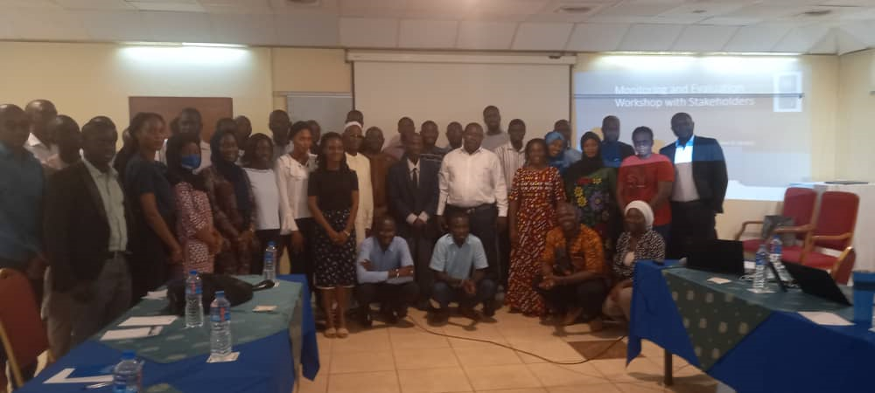
The first day of the workshop was attended by 42 participants from various IPs in which 33 of them are male while nine (9) participants are female.

The second day of the workshop was attended by 39 participants in which 30 participants are male while nine (9) participants are female.

These charts explains that the workshop have more male representation than their female counterparts. However, female participants are constant for both days while male participant were less by 3 in the second day of the workshop.
AGENDA OF THE WORKSHOP:
The workshop began with introduction of participants and facilitators as well as setting out ground rules and ice breaker exercise.
- Presentation of monitoring and evaluation (with focus on monitoring) – Fatoumatta Ceesay
- Presentation on Result-Based reporting – Shella Ngwa
- Presentation of the draft reporting template – Marie Chorr Bah
- Finalization of the template – Sunkung Danso
However, there are several groups work or brainstorming exercises on project monitoring and track the project indicators for an impactful project.
Ms Ceesay started her presentation with a question to participants that when they heard of Monitoring and evaluation, what comes to their mind. In response, participants stated that monitoring and evaluation is a continuous process while other emphasis that it is participatory in nature. At that juncture, she stated this workshop will focus more on monitoring rather than both.
She further elaborates on what is M&E, why M&E, and who is responsible for M&E? She then provides difference between monitoring and evaluation which was presented in a tabular format. It was established that monitoring and evaluation are used interchangeably but they are different in many aspects. The difference is highlighted below.
Monitoring | Evaluation
An ongoing process during implementation | Done on a periodic basis
Systematic and routine collection of information about the programs/projects’ activities | Periodic assessment of the programme/project activities
Carried out internally | Carried out by both internal and external
Focus is on Inputs, activities, outputs | Focus is on Outcomes and impacts
Usually utilizes quantitative data | Utilizes both qualitative and quantitative data
Helps improve current project implementation | Helps improve future project design
Observation | Judgment

Monitoring is described as continuous internal management activity, it ensures that project is on track, measures progress to the objectives and identify problems to improve upon them.
This led us to some of the misconception of M&E such as investigation, inspection, and audit which has nothing to do with M&E. It is noted that M&E has an oversight function, impartial and independent, track progress against plans, verify compliance with indicators, identify trends and patterns as well as adjust strategy and guide management decisions.
M&E is important in five main ways, but it is not limited to these few listed below.
- Support Project implementation through accurate, timely and evidence- based reporting
- Contribute to organizational learning and knowledge sharing
- Uphold and demonstrate accountability and compliance
- Provide opportunities for stakeholder feedback
- Promote and celebrate our work which is an advantage in upscaling and resource mobilization
At this stage, a participant interjects and indicates that the importance of M&E cannot be over emphasis but in most cases M&E is not budgeted and reiterate the impartiality in M&E work.
Though, evaluation is done by an external person while monitoring is management activity which often follow the result chain. It was made clear to the participants that theory of change is at programme level while M&E uses log frame to monitor the indicators of a programme or project.
The participants are grouped into four and each grouping was assigned to design a project and how to monitor the project indicators. The time allocated for this activity is 30 minutes and ten minutes presentation in which the minute taker serves as a timekeeper. The groups presented on various topics below.
GROUP ACTIVITY
GROUP 2: Horticultural Gardening and project life span is one
GROUP 4: Provision of water supply
GROUP 3: Integrated Waste Management for GBA
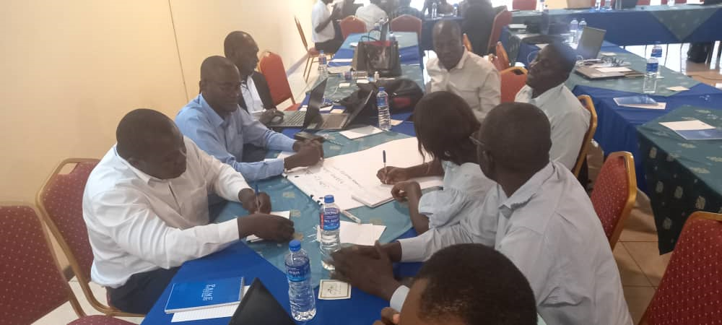
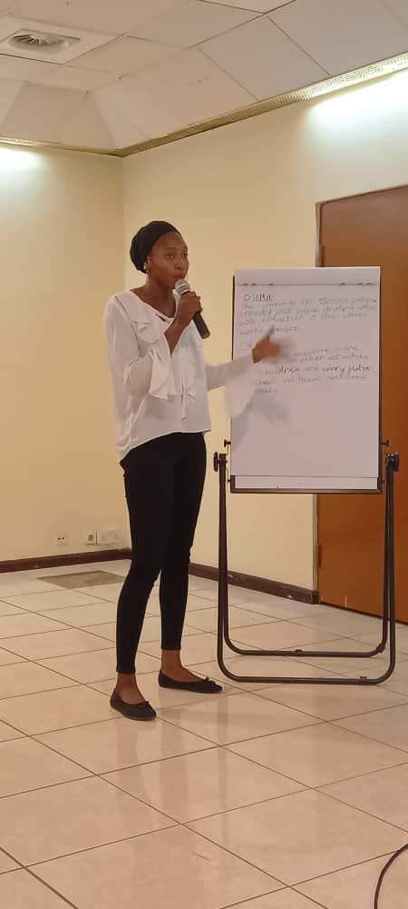
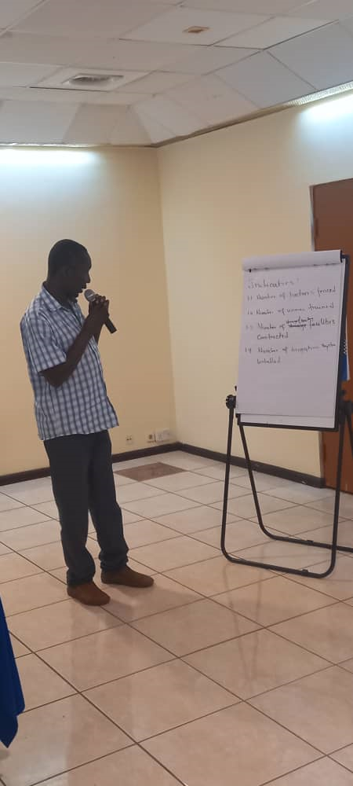
GROUP 1. Provision of Safe Drinking water
After lunch, Shella presented on result-based reporting, and she describes result-based reporting as comprehensive approach to project management that focuses on defining measurable results and the methodologies and tools to be used to achieve those results. Also explained the composite of results (performance) indicators for effectiveness, efficiency, equity, and sustainability. Further, reporting is required in every 3, 6, 9, and 12 months which is divided in to four quarters accordingly. Usually, we are challenge to report changes made and report what has not work and why it has not work.
When reporting results put the people affected or product generated by the activities at the centre of your statements and not the person doing the activity. If you think that you are describing an activity, ask the “so what” question. It is important to note that when reporting results, one should be guided by your results framework, outputs, outcomes, and impacts.
The participants are asked to go back to their various groups for a group exercise to formulate results statement for the outputs and outcomes of indicators of their proposed project. They were given 10 minutes to discuss and formulate their results statement while each group is given five minutes for presentation in which their fellow participants could provide inputs to them.
After group presentation, some examples of results statement are shared with participants and shared a guide in results reporting as well as some key reporting questions. This led us to question/answer session. A concern was raised for a government to have a consolidated M&E system. After that the session was declared clos.
DAY 2:
The day two started with brief presentation of the draft Reporting Template by Marie Chorr Bah and Mrs. Bah took the participants through the reporting template. She explains that why we need reporting template is for standardization, ensure key results are captured and consolidated for future reference, helps identify trends and patterns and provide important details that can be used to help develop future designs, guide budget planning, and improve decision-making.
It was established that IPs report to UNDP while UNDP also report to her donors. Therefore, she reviewed the UNDP reporting platforms such as ROAR, UNINFO, QUANTUM, with participant to increase their understanding on why we ask certain information from IPs.
The participants were asked to regroup according to clusters of UNDP such as Environment Cluster, Governance and Rule of Law Cluster, and Poverty and Economic Inclusion Cluster to review the draft reporting template according to their reporting needs. They have review and revise the reporting template according to their cluster need which was presented to colleagues for their inputs. The presentation of the revise reporting template was facilitated by Mr. Sunkung Danso and upon completion of the presentations, participants are asked to incorporate the recommendations from the other participant and send to their Cluster M&Es for circulation.
At the end, the participants filled the evaluation form of the workshop, and their response is summarized below.

In general, the participants have good impression on the presentation on monitoring and evaluation and above words are used to describe their satisfaction with M&E presentation.
The participants are impressed with the presentation on results-based reporting and above words are used to represent their satisfaction.
Th reporting template received high rating which are usefulness (4.1), relevance (4), and simplicity (4.1). This means that must of the participants agreed that the reporting template is useful, relevant, and simple to use.
The participants believed that the reporting template could be improved to further simplify it or use pictorial. Some recommend more workshop of this kind.
The workshop ended with prayer and participants went to GTBank staff to receive their transport refund while the facilitator of the workshop gather their materials and take note of those who did not receive their transport refund.

