

**WATER RESOURCES QUALITY WORKSHOP REPORT**

**17th – 19th August 2022**

**Holiday Inn Johannesburg Airport, Boksburg, Johannesburg**

Table of Contents

Introduction 2

Objectives of the Workshop 2

Workshop Opening and Objectives 3

Welcome and Workshop Opening – ORASECOM 3

Panel Session – Reflections on the Joint Basin Survey (JBS III) and Water Quality Objectives (WQO) Consultancies 3

Status of Water Resources Quality management 4

Panel Session – Status of Water Resource Quality management within Basin states 4

South Africa status 4

Namibia Status 5

Botswana Status 7

Lesotho Status 8

Development of the ORASECOM WRQC Work Program 10

Objectives of the WRQC 10

Water Resources Quality Data sharing 10

Capacity Building 11

Resources Quality Objectives 11

Awareness Raising 11

Demonstration projects 12

Annex 1 – Terms of Reference of ORASECOM WRQC 13

Annex 2 – Work program of the ORASECOM WRQC 18

Annex 3 – Proposed Budget of the ORASECOM WRQC 21

Annex 4 - Workshop program 24

Annex 5 – List of Participants 27

Annex 6 – Country presentations 28

Namibia 28

Botswana 31

Lesotho 33

# Introduction

ORASECOM, with support from UNDP, managed to secure further financial support from GEF to implement selected priority activities of SAP. The UNDP-GEF project titled, Support to the Orange-Senqu River Strategic Action Programme Implementation, will be implemented by UNDP and executed by ORASECOM in the next 5 years to support ORASECOM and its member states to implement SAP. The project has been built on the Transboundary Diagnostic Analysis (TDA) which has carried out the necessary causal chain analyses in order to identify the transboundary threats to the sustainable development and management of the water resources of the Orange-Senqu Basin. Having identified and understood the threats and their causes, it was possible to identify the barriers which are preventing the removal of these threats, so that sustainable development/management of the basin's water and related resources can proceed. The overall objective of the SAP Implementation project is the strengthening of joint management capacity for implementation of the basin-wide IWRM Plan and demonstrating environmental and socioeconomic benefits of ecosystem-based approach to water resources management through the implementation of SAP priority actions in the Orange-Senqu River basin. The project is being implemented through four components;

* **Component 1:** Institutional and policy reform and technical capacity building towards enhanced transboundary basin planning and joint management.
* **Component 2:** Reducing stress on Water Resources Quality.
* **Component 3:** Addressing Changes to the Hydrological Regime through the source-to-sea application.
* **Component 4:** Addressing Land Degradation through community based ecosystem management.

## Objectives of the Workshop

WRQWG is an ad hoc committee charged with implementing interventions related to Water Quality. They are responsible for undertaking the Joint Basin Survey (JBS). ORASECOM has over time realised that water quality is becoming more important thus a need to have a permanent structure that will address water quality issues. The evolution of the WRQWG from an ad hoc to a permanent ORASECOM Structure.

It was emphasized that the establishment of the Water Quality Technical Task Team will allow member states to build capacity together. With the collective long terms vision that the member states will in future undertake the JBS internally.

Thus, the objective of this workshop was to provide a platform for all member countries to work towards providing justification for establishing a Water Quality technical Task Team. Then collectively developing the program and Terms of reference of the proposed technical Team. This would be achieved through the following key activities:

* Presentation on the existing Water resources quality management capacity within each member state. With emphasis on what the key challenges are, what opportunities exist and where synergies can be build.
* What activities can be undertaken by the Technical Team (as would be reflected in their Terms of Reference)
* Budget for the Technical Water Quality technical Task Team (How much will having this committee as permanent structure cost the state parties? )
* to highlight capacity of water resources quality management within each member state

# Workshop Opening and Objectives

## Welcome and Workshop Opening – ORASECOM

Speaking on behalf of ORASECOM Micheal Ramaano welcomed all to the workshop. Micheal welcomed all to the workshop. Highlighted that this is a self reflection and planning workshop. He went on to emphasize that the Water Quality Working Group only meet during the Joint Basin Survey planning. Also went to highlight that there is a need for the working group to have close working sessions without the JBS consultant.

He then invented the member states to reflect on how the JBS and Resource Water Quality Objective assignments are progressing.

## Panel Session – Reflections on the Joint Basin Survey (JBS III) and Water Quality Objectives (WQO) Consultancies

The main objective of this session was for the member states to provide feedback on areas of improvements and some of the lessons learnt from these assignments. So, the two assignments can yield the desired results both at national and basin level. Below are summaries or inputs made by each member state:

**Botswana** –the deliverables thus received were aligned to the TORs as drafted by this working group.

**South Africa** – pointed out that these assignments present an opportunity for a new chapter for more effective collaboration within the Basin. Went on to add that these called on the practitioners to move towards management of water quality beyond just data and information.

**Namibia** – highlighted that the resource units and sampling zones were strategically well positioned, and this was highly welcomed.

**Lesotho –** recommendations made in the JBS III are feasible, they just need each member state to endorse them so they can be implemented. It was also recommended that during the undertaking of JBS collaboration between consultant and national DWA should be strengthened.

The collective reflection from all member states on the RQO’s consultant, was that there is a need for more effective collaboration between the member states and the consultant.

# Status of Water Resources Quality management

The purpose of this session was for each basin state to briefly highlight the status of water quality management within their country. With emphasis on the following:

* legislative framework
* institutional set up (key role players both state and non-state actors)
* existing monitoring programs (who is doing what where, the water quality parameters monitored and the frequency of monitoring)
* water quality data / information management (how is the collected data store, archived and how is it used to inform Policy makers etc.)
* highlight what challenges and opportunities exist at national level.

## Panel Session – Status of Water Resource Quality management within Basin states

### South Africa status

The Presentation pointed out the key pieces of legislature governing water resources quality management in RSA is the National water Act 1998, Water Services Act 1997, NaClimte Change Policy 2007.

The key institution mandated with Water Resources management including water quality management is Department of Water and Sanitation. Then went on to highlight there are three regional offices that coordinate water quality management of the Orange river in SA. The National of Department of Water and Sanitation regional offices in Free State, Gauteng and Northern Cape. Within the regional offices there are Catchment Management agencies (CMA’s), these multistakeholder CMA’s are made up of farmers and users association and municipalities.

The following standards have been developed and are used for of water resources quality management within the Orange river basin in South Africa:

**Water Quality monitoring program**

In terms of water quality monitoring frequency, it was highlighted that the this is carried out least annually, for all water resources within South Africa. While within the Vaal catchment the monitoring is carried out quarterly.

The water quality monitoring program includes the following key parameters: Quality, quantity, biota (SASS - MERIA model ), Habitat Integrity, Geomorphology, *In-situ* parameters and physio-chemical parameters.

**Data**

Highlighted that the water quality Data storage is done within the Rivers Database linked to Information system. This includes information also on Wetlands. Also reported that there is an upgrading toads and frogs’ data

Currently the data is used for planning purposes. There are Orange River models these are water resources modeling that are used to project water demands (stochastic model). It was also highlighted that the water quality data will be used in future to manage WQO.

It was presented that currently the Hydrology data is currently saved in different databases. Thus, making it difficult to compute and manage load for water quality management practitioners. This fragmented data sets makes it difficult to determine and calculate nutrient loading.

There is also the National Integrated Water Information System (NIWIS) (metadata base climate, disaster management data, monitoring network, water quality, water supply

**Challenges**

The following were presented as challenges facing Water resources quality monitoring and management within SA:

* there is an urgent need to resume effective monitoring
* because of the disjointed databases: it is a challenge to determine Loads (Flow and water quality )
* How do you set the standard in the license so you achieve the upstream objective – load information would make it easier to calculate the license objective

**Question**

**Question 1:** There are a number of databases? How do you ensure accessibility

**Answer** - Groundwater, lab analysis, water quality, hydrology. To access all these databases

NWIS is the dashboard. It’s a web-based instrument. It will interface the data from all databases for the preferred location.

Different types of databases. There’s a strategy to incorporate the databases to get an Integrated Water Resources National Database.

### Namibia Status

The presentation highlighted that the key pieces of legislature in management of water quality within Namibia are Water Act 1956 and the Water Resources Management Act 2013.

The key institutions are Ministry of Agriculture, Water and land Reform. The institution designated with management of water resources is Department of Water Affairs. Within the DWA there are the following sections: Hydrology (Surface Water), Geohydrology (Groundwater), Policy and Water Law Administration (Law Enforcement) and Water Basin Management (Basins Management and Water Environment (Water Quality).

The other role players within water quality management include water user associations, farmers association, mines and the water utility company NAMWater.

**Water quality monitoring program**

The presentation highlighted that the water quality monitoring operations within the Orange River basin including both surface and groundwater water resources.

It was reported that the Orange Surface water quality monitoring started just before JBS1 and is still on-going. There are a total twelve (12) monitoring stations. These re sampled at least twice a year (within low and high flow). While, groundwater quality monitoring of Stampriet Transboundary aquifer is also undertaken bi-annually. There are around 30 monitoring boreholes on this aquifer.

Water quality sample analysis for the DWS is undertaken by a private laboratory. NAMWater also carries out routine water testing of their raw from their abstraction sources.

The monitoring parameters include the following: Physical and Chemical parameters (EC, Turbidity, Temp, DO, pH, TDS, Turbidity, Total Nitrogen (nitrate, nitrite, ammonia), Orthophosphate, Chlorophyll a, and heavy metals (arsenic, zinc, etc).

The water quality monitoring also includes Macroinvertebrates using SASS methodology. The presenter highlighted that this methodology has been modified and calibrated.

**Data Management**

The data is stored and archived within DWA. The data is stored within Excel database. The surface water quality data used to be store within Water Quality database (WAQIS). The Groundwater Data is stored within GROWAS database. The Surface Water is stored within HYDSTRA database

While the Vegetation and habitat data is stored within NBRI.

It was further presented that the data analysis is done using the following Ecostatus models: MIRAI, VEGRAI, HI.

The Data is currently used for Risk-based assessment. To inform decision-making. The data is also used for compliance monitoring and reporting. While the farmers and the utility operator use the water quality data to optimise water treatment systems operations.

**Challenges**

The presentations highlighted that there is currently no functional WQ database. Went on to further point out that there is a need to upgrade the WAQIS .

In addition, it was presented DWA has experienced budget cuts and this has affected water quality monitoring capacity. This affects the ability of DWA to effectively manage the water resources. It was pointed out that only NAMwater has capacity to analyse for microbiological samples. The presentation further highlighted that there is growing water quality concerns as a result of rapid urbanisation. One of the major threats is poor management of wastewater and there is low level of compliance by local authorities. There is an urgent need for DWA to effectively monitor and manage the sources of pollution, manage aquatic weeds and exotic fish species.

It was highlighted that there is a need to increase local capacity in Ecostatus model, citizen science. Went on to highlight that the current curriculum does not include environmental or ecological studies. As a result there is a need to create environmental awareness amongst all water users and citizens within the basin.

**Opportunities**

The following were presented opportunities that exist within Namibia water quality management. There are efforts underway to promote citizen science. This is an opportunity to get more stakeholders involved in monitoring and management of their water resources.

It was also highlighted that there are efforts underway to include macroplastics monitoring capacity with DWA water testing laboratory. This is one of parameters required in JBS monitoring.

### Botswana Status

The Water resources quality management in Botswana, is guided by the Water Act of 1968. The supporting policy document is the Botswana National Water Policy of 2012. The following standards are used to manage water quality management ( BOS 32: 2000 Water Quality drinking water, BOS 39 Water Quality wastewater).

The Department of Water Affairs is one of three technical Departments within the Ministry of Minerals, Energy and Water Resources (MMEWR). The Water Conservation and Quality division is one of the technical divisions within department of Water Affairs.

**Water quality monitoring program**

The presenter highlighted that two shared aquifers within the Orange-Senqu basin are: Khakhea/Bray (Kgalagadi-Southern district) Shared by Botswana and South Africa and the Stampriet (in Kgalagadi-Ghanzi district), shared between Botswana, Namibia and South Africa

It was reported that the monitoring network within the Orange River basin, in Botswana. Is made up of the following sampling locations: Twenty (21) Boreholes, Four (4) wells, One (1) Agric Dam for the community in Mabule and Four (4) public distribution reservoirs for major settlements.

The sample analysis is carried out with the Department of Water laboratory. The laboratory is not accredited (ISO 17025). The analytical capacity of the laboratory includes Microbiological: The laboratory has the capacity to test for the presence of 4 bacteria in water; E.coli, faecal coliform, total coliform & intestinal enterococci.

In addition the laboratory analyses for Inorganic determinants: Calcium, Magnesium, sodium, potassium, Manganese, iron, chloride, fluoride, bromide, nitrite, nitrate, orthophosphate, sulphate.

As well as Physical and organoleptic requirements: Electric conductivity, total suspended solids, Total dissolved solids, PH, and turbidity.

**Data Management**

It was presented that, all the electronic water quality data from the laboratory is localised in the Departmental database namely Aquabase. Then went on to highlight that a new data management system (LABWARE-LIMS) is still under development to be used in place of the latter.

The information and Data analysis and trends are then ensured by the government

**Challenges**

The following were highlighted as challenges facing water quality monitoring within Botswana. The current monitoring capacity does not allow effective monitoring in both aquifers. The Microbiological analysis is not effectively done. As the aquifers are too far away form the water testing laboratory. There are budget cuts and human resources challenges and this affects the water quality resource management operations.

It was also pointed out that there is a need to improve in confidence relating to the quality of water testing laboratory analysis data.

**Opportunities**

The shared aquifer provides an opportunity for joint data storage, archiving, analysis and sharing between concerned member states and or interested parties.

The joint management of the Basin resources will assist member states to increasing their analytical testing capacity. Within each member state water testing laboratories.

**Questions**

1. **Question** – Does Botswana, have wastewater quality guidelines?

**Answer** - The standard is in place it is the BoS 1993

1. **Question** - Aquifer – Transboundary aquifer.

**Answer** - Botswana has not been using the aquifer but there has been recent developments within the catchment within Botswana.

### Lesotho Status

The presented highlighted that the key pieces of legislature in water resources management within Lesotho are Water act 2008, Environment Act 2008. The institutions involved in water quality management and or monitoring are: Department of water Affairs for both surface and ground water resources. The water utility company WASCo. The independent mines also do monitoring of water resources within their mine lease areas. Water resources development projects also carry out routine monitoring these are Lesotho Highlands Development authority, Metolong and the Lesotho lowlands Water Development Project.

Lesotho has draft water quality standards. But these cannot be published. The Standards development process is held up by Establishment of Lesotho Bureau of Standards. That shall be the secretariat of the standards for Lesotho

**Water quality monitoring program**

* Physicochemical parameters
* River health monitoring parameters (benthic macro-inverts, diatoms, fish, geomorphology,
* Microbiological parameters
* Monthly, quarterly and bi-annually

**Data management**

Water resources Models

* Hysdra
* Hycos
* Weap

**Challenges**

1. Decentralization - Local government decentralization has a challenge in water quality management
2. Budget / Resources allocation

**Opportunities**

1. Shadowing – of regional best practices
2. Modelling (Lesotho)
3. How to ensure self-monitoring is implemented as per the requirement of the state entity
4. Water quality objectives – upstream and downstream water quality allocation
5. Funds – recurrent budget not sufficient
6. Mobility
7. Fragmented data collection and housing
8. No accredited water lab in the country
9. Laboratory not up to standard

# Development of the ORASECOM WRQC Work Program

The participants collectively agreed that there is a need to facilitate implementation of the JBSII recommendations. As well as coordinating and facilitating the long terms water resources quality management of the Orange-Senqu river basin. That includes amongst others the capacity for ORASECOM to undertake the JBS internally. How member states can build capacity together and support water resources quality management activities within the Basin.

To this end members discussed the need to transform the current ad-hoc Water Quality working committee of ORASECOM. Into a permanent Water Resources Quality Committee as a Technical Sub-committee within ORASECOM.

The parties resolved that they would need to develop a joint Terms of Reference and work program. That would serve as justification to Council regarding the establishment of the WRQC. The following were discussed as key inputs into the into the development of the Terms of Reference and work program: Objectives of WRQC, Water Resources Quality data sharing, Capacity Building, Capacity Building, Demonstration Transboundary projects

## Objectives of the WRQC

The parties resolved that the objectives of the WRQC of ORASECOM would be the following:

1. To coordinate joint water resource quality monitoring and reporting on a regular basis;
2. To Facilitate water resource quality awareness raising amongst all stakeholders
3. To Oversee (development, implementation, monitoring and review) the roll-out of the transboundary Resource Quality Objectives within the Basin
4. Implementation of the relevant provisions of the ORASECOM Agreement and its revised versions, including the standardized form of collecting, processing and disseminating water resource quality data or information;
5. To facilitate collaboration with ORASECOM structures

## Water Resources Quality Data sharing

The parties all confirmed that there is a need for an efficient and effective functional water quality data information sharing platform. The members reflected on the current Water quality data sharing platform for the basin: ORASECOM water Information system (WIS). The challenges to the ORASECOM-WIS were raised and recommended improvements are summarized below.

1. The parties highlighted the following challenges with the current Basin wide Water Information System:
   * user interface for member states to upload information is complicated
   * interface for data users is complicated
   * there is no operators manual to guide how members states can upload information
   * the WIS is not linked to the main ORASECOM website
2. The parties resolved that the following should be incorporated as recommended changes that will facilitate effective water quality data sharing within the basin:
3. The data to be shared should include only Transboundary data, not duplicates of national data sets
4. The WIS should include Spatial data presentation
5. The WIS must be linked to the ORASECOM website
6. The Transboundary data to be shared by member states should including the following:

* **Ground water** (pH, EC, turbidity, DO, TDS, total hardness, microbiological (e-coli, total coliforms), heavy metals (Arsenic, total alkalinity, bicarbonate, carbonate, nitrates, phosphates, fluoride, Chloride, Cu.
* **Surface water** (DO, pH, SS, TDS, nitrates, ammonia, phosphates, total phosphates and nitrates, nitrites, turbidity, chlorophyll ‘a’, heavy metals (arsenic, Pb, Ni, Zn, Co, Cu, Hg,….etc),microbiology( e-coli, total coliforms).
* **Wetlands** (SASS-5, birds, fish, vegetation, amphibians)
* **Estuary** (fish, birds, vegetation)

## Capacity Building

All members highlighted their needs for capacity building within Water Resources Quality management. The following were highlighted as common transboundary capacity constraints. That could affect effective water resources quality management within the basin:

* Water resources quality analytical capacity
* National Budget and resources allocation to water quality management
* Human resources capacity

## Resources Quality Objectives

The Secretariat highlighted that the RQO consultant was waiting the final report of the JBSII. As the state data was not readily available and or had gaps. The parties all agreed that this committee would need to collaborate with the RQO consultant. It was further emphasized that these RQO’s are important as they would assist enforcement agencies within member states.

The parties also highlighted that this WRQC would facilitate the implementation of the RQO’s within the member states. To ensure this there would be a need for capacity building so member states can fully comprehend the RQO and their application.

## Awareness Raising

The end goal of the awareness raising within the Basin. Is to promote involvement of more stakeholders within the basin in the water quality management of the water resources of the basin. To this end the parties’ made recommendations for the committee to carry out the following key activities:

* Disseminate the key findings of the JBSII within member states
* Promote the adoption and implementation of the RQO’s within member

## Demonstration projects

The Secretariat highlighted that the current demonstration projects in water resources quality management with the basin are: Mohokare demonstration project and the Joint River mouth management demonstration project.

The committee would be charged with coordinating and supervising these existing demonstration projects. Including the proposed the groundwater resources management project. The Transboundary demonstration projects are listed below:

* Joint river mouth management (RSA-Namibia)
* Joint aquifer management (Namibia, Botswana)
* Joint Mohokare /Caledon catchment management (Lesotho, RSA)

# Annex 1 – Terms of Reference of ORASECOM WRQC



**Terms of Reference**

**of the**

**ORASECOM Water Resource Quality Committee (WRQC)**

**DEFINITIONS**

|  |  |
| --- | --- |
| **Term** | **Definition** |
| **Pollution Incidence** | Undesired act that has potential to lead to an accident or harm to the environment. Pollution can be from both point and non-point sources. |
| **Transboundary Water Pollution** | Pollution Incidence that originates in one country then causes damage or impact in another country’s water resources or within shared water resources |
| **Water Resource health** | The degree to which a Water Resources’ physical condition, composition, structure and function are intact (that is, have not been degraded or altered). |
| **Water Resource Quality** | Description or categorization of a water resources body in relation to its natural quality and intended uses, particularly those uses which may affect human health and/or the aquatic ecosystem.  Water Resources Quality is defined through the Physical, chemical, biological and organoleptic properties of a water body/ water resources. |
| **Water Resources** | Water available or capable of being made available for use, in sufficient quantity and adequate quality, at a location and over a period of time appropriate for an identifiable demand |

**BACKGROUND**

The Orange-Senqu River Commission (ORASECOM) was established, through a signed Agreement, on 3 November 2000 by the Countries sharing the Orange-Senqu River Basin, namely Botswana, Lesotho, Namibia, and South Africa (Hereinafter referred to as State Parties). ORASECOM was established to serve as an advisory body to the State Parties on matters relating to the development, utilization and conservation of the water resources in the River System, and such other functions pertaining to the development and utilization of the water resources as the State Parties may agree to assign to the Commission.

The Agreement was revised and signed in 2018, to address identified inconsistences, for instance the need to incorporate the Secretariat and the Forum of the Parties (Committee of Ministers Responsible for Water in the State Parties), as part of the institutions of ORASECOM.

From 2000 to 2014, ORASECOM undertook a number of studies and projects aimed at:- (i) creating a common understanding of issues relating to the development & management of the water resources of the Basin, and (ii) development of an Integrated Water Resources Management Plan (IWRM) for the Orange-Senqu River Basin.

The drafting of the functions of the task teams has been done under the provision of Article 6: ***6.1 The Council may establish ad hoc or standing working groups or committees comprising of representatives of the Parties as each Party may determine***

The task teams are the technical and expert arm of ORASECOM; and their mandate is to advise Council on matters related to their area of expertise to support the effectiveness of the Commission. Provision of oversight and technical advice regarding surface water hydrological studies and activities in the Basin has been the responsibility of the Technical Task Team (TTT).

Due to the specialized nature of the Water Quality activities, the TTT co-opted Water Quality officials from the State Parties, particularly with regard to water resources water quality monitoring and management. One of the flagship activities of the Water Quality working group was the development of a Joint Bain survey. This was conceptualized in 2009.

The TTT is the backbone of the work carried out by ORASECOM. Due to its complex and diverse nature, often too many specialized areas are bundled into the TTT which affect its effectiveness and in some instances they lack the relevant skills to bring optimal value.

The Water Quality Resource Committee is established to respond to the responsibilities coming out of the IWRM plan and SAP: to include the influences on downstream receiving waters, water supply, sanitation and water security issues. This TTT will look at the availability of an acceptable quantity and quality of water for health, livelihoods, ecosystems and production, coupled with an acceptable level of water-related risks to people, environments and economies.

The purpose of this document is to therefore stipulate the Terms of Reference (TORs) for the ORASECOM’s Water Quality Working Group (WRQC).

**ESTABLISHMENT OF THE WATER RESOURCE QUALITY COMMITTEE (WRQC)**

The WRQC is established by Council as a standing working committee under the powers granted to it by the 2000 ORASECOM Agreement and its revised versions, where applicable.

**OBJECTIVE OF THE WRQC**

The objective of the WRQC will be to oversee and advise the TTT and the Commission on water resource quality management of the Orange-Senqu River Basin.

**INSTITUTIONS OF THE WRQC**

Each Party will provide one official and one alternate official, both with water resources quality background.

Ex-Officio alternate officials can be nominated by each party. Upon instruction and recommendation of the Secretariat. These shall be members with skills complementary and or relevant for Water Resources Quality management. These include but are not limited to the following: members with environmental, wetland and or catchment management background.

**FUNCTIONS OF THE WRQC**

The WRQC will oversee and advise the TTT and the Commission on, but not limited to, the following functions:-

* Coordinate joint water resource quality monitoring and reporting on a regular basis;
* Management and sharing of transboundary water resource quality data and information
* Plan, coordinate and implement Joint Basin Surveys;
* Implementation of the relevant provisions of the ORASECOM Agreement and its revised versions, including the standardized form of collecting, processing and disseminating water resource quality data or information;
* Coordinate and facilitate Capacity building on Water Resource Quality management within the basin
* Facilitate water resource quality awareness raising amongst all stakeholders
* Oversee (development, implementation, monitoring and review) the roll-out of the transboundary Resource Quality Objectives in the Basin
* Support implementation of the Transboundary Water Resource Quality projects
* Develop and implement transboundary water resource quality pollution incident notification
* Collaboration with ORASECOM structures

**MEETINGS OF THE WRQC**

The meetings of the WRQC will be conducted as follows:-

* The WRQC and its meetings will be chaired on a rotational basis, following the TTT chairpersonship;
* The WRQC will meet at least twice a year prior to the meetings of the TTT, but may conduct extraordinary meetings on a needs-basis;
* Quorum for meetings of the WRQC will be formed when at least three State Parties are represented;
* Ordinary meetings of the WRQC will be convened ahead of those of the TTT to enable preparation of related submissions to the TTT;
* The venue for ordinary meetings of the WRQC will follow those of the TTT; and
* The Chairperson of the WRQC will report to the TTT.

**FINANCIAL ARRANGEMENTS**

The Parties shall cover the costs of travel and participation for their respective WRQC officials to the ordinary meetings.

In order to ensure that the operations of the WRQC are cost effective and financial burden on State Parties is reduced, measures such as:- holding of the ordinary meetings of the WRQC back-to-back with events of externally funded similar activities; reduction of the number of ordinary meetings of the WRQC from two to one, per year, when need arises; and holding of ordinary meetings of the WRQC using tele-conferencing facilities such as skype, video conferencing, etc, where such technology exists, will be considered, from time to time.

The Secretariat will mobilise funds for extra ordinary meetings of the WRQC. In cases where the Secretariat is not successful in raising funds for extra-ordinary meetings of the WRQC, the State Parties shall cover costs of travel and participation of their respective WRQC officials to the extra-ordinary meetings of the WRQC.

# Annex 2 – Work program of the ORASECOM WRQC

| Objective | Task | Follow-up activities | Resource requirements |
| --- | --- | --- | --- |
| To coordinate joint water resource quality monitoring and reporting on a regular basis; | Joint Basin Survey | 1. Carry out member state Analytical capacity assessments 2. Allocate the sample analysis to designate laboratories within member states 3. Develop and Sign Agreements including Public private partnership agreements with selected laboratories with member states 4. Review and adopt the Transboundary sampling protocols 5. Facilitate the carrying out of Bi-Annual monitoring of the following parameters within the basin:    1. Ground water (pH, EC, turbidity, DO, TDS, total hardness, microbiological (e-coli, total coliforms), heavy metals (Arsenic, total alkalinity, bicarbonate, carbonate, nitrates, phosphates, fluoride, Chloride, Cu.    2. Surface water (DO, pH, SS, TDS, nitrates, ammonia, phosphates, total phosphates and nitrates, nitrites, turbidity, chlorophyll ‘a’, heavy metals (arsenic, Pb, Ni, Zn, Co, Cu, Hg,….etc),microbiology( e-coli, total coliforms).    3. Wetlands (SASS-5, birds, fish, vegetation, amphibians)    4. Estuary (fish, birds, vegetation) | * Legal Personnel to draft agreements * Laboratory analytical capacity assessment tool * People * Equipment (ground water pumps submissive pump – borehole sampler) /consumables /PPE / data logger /microscope/FT-IR microscope/ field multi-parameter (XRF)/ Auto titrator * Vehicles rentals * Accommodation * DSA * In-situ Data collection forms * Sample analysis cost * Courier logistic |
|  | Capacity building | 1. Improve local analytical capacity to undertake the following analysis required for JBS within member states:  * Diatom analysis * Radioactivity * water quality Report writing (data analysis and interpretation) * Fish analysis * Standardized data collection (ECO status assessment method) * SASS-5 accreditation * Citizen science  1. Facilitate inter- laboratory proficiency testing between member states 2. Provide capacity building for member states to use the WIS 3. Coordinate and improve capacity of member states to collect, process and disseminate WRQ transboundary data | * Training of trainers (equipment use, diatom analysis, radio activity analysis, report writing, fish analysis, data analysis, modelling,) * Service and maintenance * Training of SASS-5 accessors/analysts. * Data management/ Dashboard development. |
| To Facilitate water resource quality awareness raising amongst all stakeholders | Awareness raising | 1. Coordinate and facilitate National launch of the JBS II report. 2. Coordinate dialogue within member states on the RQO’s through strategic workshops 3. Promote the adoption and implementation of the RQO’s within member states through strategic partnerships (ie. with on-going national programs aimed at promoting ICM within member states | * Media (print, visuals) * Workshops * DSA * Travel * People |
| To Oversee (development, implementation, monitoring and review) the roll-out of the transboundary Resource Quality Objectives in the Basin | Resource quality objective | 1. Supervise and coordinate the Resource Quality Objective consultant 2. Harmonize and adopt transboundary aquatic ecosystem guidelines/standard 3. Coordinate and facilitate adoption and implementation RQO’s within member states |  |
| Implementation of the relevant provisions of the ORASECOM Agreement and its revised versions, including the standardized form of collecting, processing and disseminating water resource quality data or information; | Water Information sharing | 1. Develop and update the ORASECOM – Water Information system with the following attributes: 2. a user friendly interface for member states to upload information 3. Develop a user friendly interface for data users 4. Data to be shared on WIS to be transboundary and not duplicate of national databases – member states to agree on data to be shared. 5. Provide uplink to member states database sets 6. Link the WIS to the main ORASECOM website 7. WIS should have option for spatial data presentation (GIS tools) 8. Develop and implement transboundary water resource quality pollution incident notification | * Website Development consultant * National water resources quality servers * National data meta-database (with multistakeholder data inputs on groundwater, surface, estruarues, wetlands * Transboundary water quality pollution expert * DSA * Accommodation * Travel |
| To facilitate collaboration with ORASECOM structures | Demonstration project | Coordinate successful implementation of demonstration projects. That demonstrate the importance of WQR management within the basin.   1. Joint river mouth management (RSA-Namibia) 2. Joint aquifer management (Namibia, Botswana) 3. Joint Mohokare /Caledon catchment management (Lesotho, RSA) | * Mohokare/Caledon catchment water discharge permits. * Tools on design of dry and wet sanitation (pit-latrines, solid waste and wastewater treatment plants). * Farming tools (irrigation and mining discharge permits) * Sand mining * Best Land use management practices |

# Annex 3 – Proposed Budget of the ORASECOM WRQC

| Objective | Follow-up activities | Resource requirement | Budget (USD) |
| --- | --- | --- | --- |
| To coordinate joint water resource quality monitoring and reporting on a regular basis; | 1. Carry out member state Analytical capacity assessments 2. Allocate the sample analysis to designate laboratories within member states 3. Develop and Sign Agreements including Public private partnership agreements with selected laboratories with member states 4. Review and adopt the Transboundary sampling protocols 5. Facilitate the carrying out of Bi-Annual monitoring of the following parameters within the basin:    1. Ground water (pH, EC, turbidity, DO, TDS, total hardness, microbiological (e-coli, total coliforms), heavy metals (Arsenic, total alkalinity, bicarbonate, carbonate, nitrates, phosphates, fluoride, Chloride, Cu.    2. Surface water (DO, pH, SS, TDS, nitrates, ammonia, phosphates, total phosphates and nitrates, nitrites, turbidity, chlorophyll ‘a’, heavy metals (arsenic, Pb, Ni, Zn, Co, Cu, Hg,….etc),microbiology( e-coli, total coliforms).    3. Wetlands (SASS-5, birds, fish, vegetation, amphibians)    4. Estuary (fish, birds, vegetation) | * Legal Personnel to draft agreements * Laboratory analytical capacity assessment tool * People * Equipment (ground water pumps submissive pump – borehole sampler) /consumables /PPE / data logger /microscope/FT-IR microscope/ field multi-parameter (XRF)/ Auto titrator * Vehicles rentals * Accommodation * DSA * In-situ Data collection forms * Sample analysis cost * Courier logistic |  |
|  | 1. Improve local analytical capacity to undertake the following analysis required for JBS within member states:  * Diatom analysis * Radioactivity * water quality Report writing (data analysis and interpretation) * Fish analysis * Standardized data collection (ECO status assessment method) * SASS-5 accreditation * Citizen science  1. Facilitate inter- laboratory proficiency testing between member states 2. Provide capacity building for member states to use the WIS 3. Coordinate and improve capacity of member states to collect, process and disseminate WRQ transboundary data | * Training of trainers (equipment use, diatom analysis, radio activity analysis, report writing, fish analysis, data analysis, modelling,) * Service and maintenance * Training of SASS-5 accessors/analysts. * Data management/ Dashboard development. |  |
| To Facilitate water resource quality awareness raising amongst all stakeholders | 1. Coordinate and facilitate National launch of the JBS II report. 2. Coordinate dialogue within member states on the RQO’s through strategic workshops 3. Promote the adoption and implementation of the RQO’s within member states through strategic partnerships (ie. with on-going national programs aimed at promoting ICM within member states | * Media (print, visuals) * Workshops * DSA * Travel * People |  |
| To Oversee (development, implementation, monitoring and review) the roll-out of the transboundary Resource Quality Objectives in the Basin | 1. Supervise and coordinate the Resource Quality Objective consultant 2. Harmonize and adopt transboundary aquatic ecosystem guidelines/standard 3. Coordinate and facilitate adoption and implementation RQO’s within member states |  |  |
| Implementation of the relevant provisions of the ORASECOM Agreement and its revised versions, including the standardized form of collecting, processing and disseminating water resource quality data or information; | 1. Develop and update the ORASECOM – Water Information system with the following attributes: 2. a user friendly interface for member states to upload information 3. Develop a user friendly interface for data users 4. Data to be shared on WIS to be transboundary and not duplicate of national databases – member states to agree on data to be shared. 5. Provide uplink to member states database sets 6. Link the WIS to the main ORASECOM website 7. WIS should have option for spatial data presentation (GIS tools) 8. Develop and implement transboundary water resource quality pollution incident notification | * Website Development consultant * National water resources quality servers * National data meta-database (with multistakeholder data inputs on groundwater, surface, estruarues, wetlands * Transboundary water quality pollution expert * DSA * Accommodation * Travel |  |
| To facilitate collaboration with ORASECOM structures | Coordinate successful implementation of demonstration projects. That demonstrate the importance of WQR management within the basin.   * Joint river mouth management (RSA-Namibia) * Joint aquifer management (Namibia, Botswana) * Joint Mohokare /Caledon catchment management (Lesotho, RSA) | * Mohokare/Caledon catchment water discharge permits. * Tools on design of dry and wet sanitation (pit-latrines, solid waste and wastewater treatment plants). * Farming tools (irrigation and mining discharge permits) * Sand mining permits guidelines * Best Land use management practices |  |

# Annex 4 - Workshop program

**DAY THREE: WORKPLAN FOR THE WRQWG 2022 – 2024**

| **Date** | | **17 August 2022** | | |
| --- | --- | --- | --- | --- |
| **Venue** | | **Holiday Inn Johannesburg Airport, Boksburg, Johannesburg** | | |
| **Virtual** | | **Zoom Meeting** | | |
| **Time** | | **09h00 to 16h00** | | |
| **AGENDA** | | | |  |
| Tea, Meet and Greet | | | | |
| 1 | WELCOME AND INTRODUCTION | | ORASECOM | 09:00 – 09:20 |
| 2 | ATTENDANCE AND APOLOGIES | | ALL | 09:20 – 09:30 |
| 3 | OBJECTIVE OF THE WORKSHOP | | Viviane Kinyaga | 09:30 – 09:40 |
| 4 | Recommendations from the JBS 3 Survey  What are the key recommendations?  How to address them? | | ALL |  |
| 5 | Water Quality Monitoring at National level (Status, challenges & opportunities)  Botswana  Lesotho | | MS | 10:00 – 10:45 |
| Tea Break | | | | |
| 6 | Water Quality Monitoring at National level (Status, challenges & opportunities)  Namibia  South Africa | | MS | 11:00 – 11:30 |
| 7 | Development of the Transboundary Monitoring Program / Work Plan for 2022 -2024  Objectives, Activities, Outputs | | All | 11:30 – 13:00 |
| Lunch Break | | | | |
|  | Development of the Transboundary Monitoring Program / Work Plan for 2022 -2024  Objectives, Activities, Outputs | | All | 14:00 – 15:30 |
| Tea Break | | | | |
| 8 | CLOSURE | | ORASECOM | 16:30 |

DAY 4: IMPLEMENTATION OF THE WORKPLAN

| Date | | | 18 August 2022 | | |
| --- | --- | --- | --- | --- | --- |
| Venue | | | Holiday Inn Johannesburg Airport, Boksburg, Johannesburg | | |
| Virtual | | | Zoom Meeting | | |
| Time | | | 09h00 to 16h00 | | |
| AGENDA | | | | |  |
| Tea, Meet and Greet | | | | | |
| 1 | RECAP OF THE PREVIOUS DAY | | | ORASECOM | 09:00 – 09:20 |
| 2 | RESOURCES NEEDED FOR THE WORK PLAN  (Equipment, skills, personnel, costing) | | | ALL | 09:20 – 10:30 |
| Tea Break | | | | | |
| 3 | Water Quality Data Sharing:  What data to share on the ORASECOM WIS?  How should it be shared, how often?  Data sharing protocol in place? | | | MS | 11:00 – 13:00 |
| 4 | Introduction to the TORs for the WRQWG as a standing ORASECOM Group | | | ORASECOM | 16:00 – 16:20 |
| Lunch Break | | | | | |
| 5 | Development of the Terms of Reference for the WRQWG  WRQWG as a standing ORASECOM structure  Development of the TORs | | | ALL | 09:20 – 12:00 |
| Tea Break | | | | | |
| 6 | | Closure of the Workshop | | ORASECOM | 16:20 – 16:30 |

# Annex 5 – List of Participants

|  |  |  |  |
| --- | --- | --- | --- |
| Name | Country | Contacts | |
| Mobile/ Telephone | Email |
| Bethel Koontse | Botswana |  | bethelpusokoontse@gmail.com |
| R Wantle | Botswana |  | rwantle@ymail.com |
| Sephooko Sepono | Lesotho |  | seponono.sepono@gmail.com |
| Nthati Toae | Lesotho |  | toaenthati@gmail.com |
| Elise Mbandeka | Namibia |  | elise.mbandeka@mawf.gov.na>; |
| Shishani Munyika | Namibia |  | namutenyamunyika@gmail.com |
| Jurgo Van Wyk | South Africa | +27 828095420 | jurgo@dws.gov.za |
|  | South Africa |  |  |
| Micheal Ramaano | ORASECOM |  | mike.ramaano@orasecom.org |
| Monica N. Rakhuhu | ORASECOM |  | monica.rakhuhu@orasecom.org> |
| Viviane kinyaga | ORASECOM |  | viviane.kinyaga@orasecom.org |
| Vuyani Monyake | Facilitator | +26658780377 | vuyani@multinodal.co.ls |

# Annex 6 – Country presentations

## Namibia

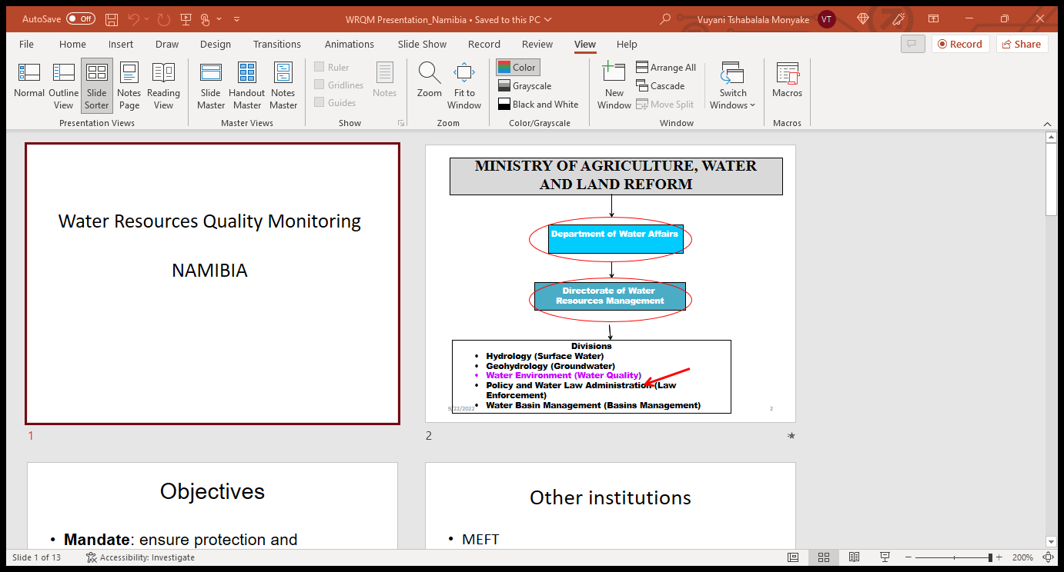

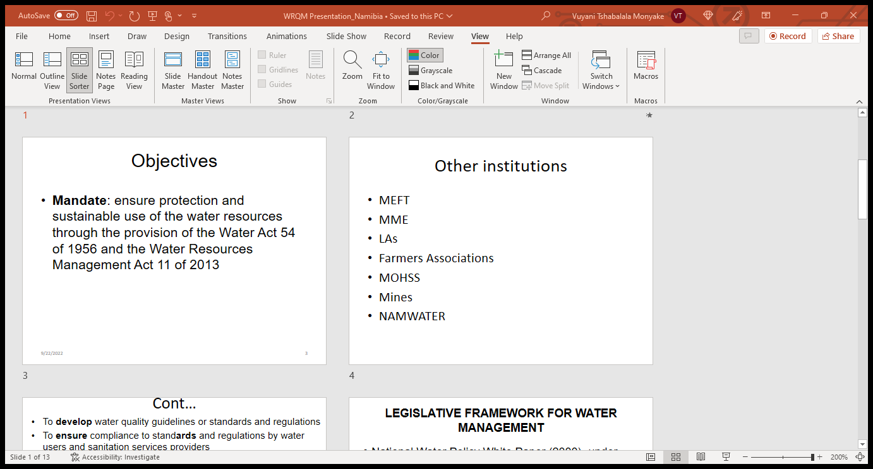

## Botswana

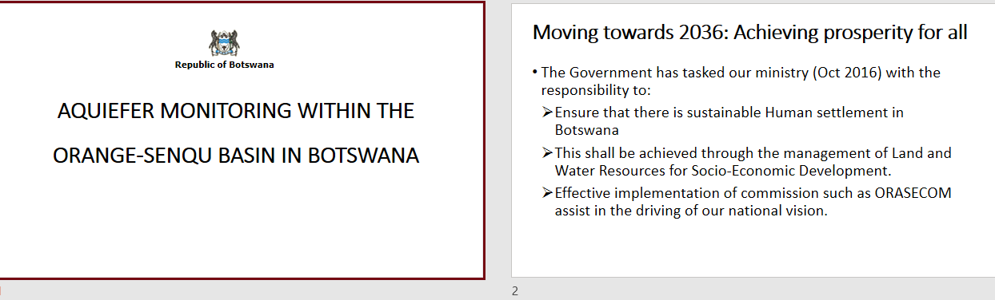

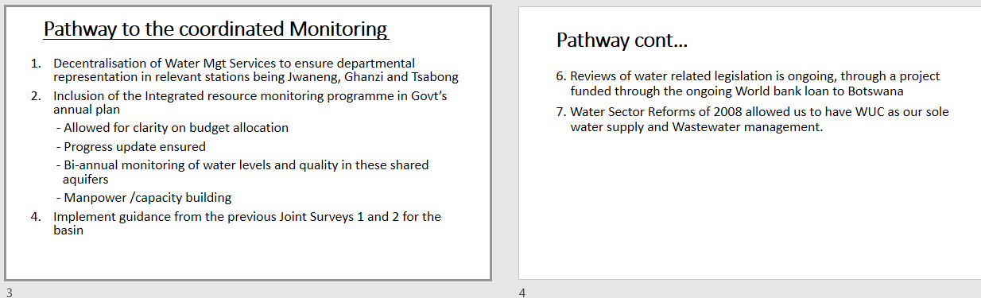

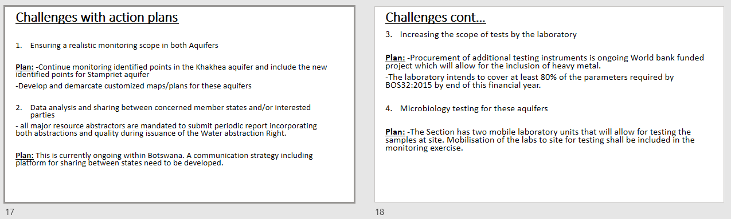

## Lesotho



